Module 4

A market is an institutional arrangement under which buyers and sellers can exchange some quantity of a good or service at a mutually agreeable price. The word “Market” denotes exchange. Markets provide the framework for the analysis of the forces of demand and supply that, together determine commodity and resource prices. And as we know prices play the central role in microeconomic analysis.
A market can, but need not, be a specific place or location where buyers and sellers actually come face to face for the purpose of transacting their business. For example, the New York Stock Exchange is located in a building at 11 Wall Street in New York City. On the other hand the market for college professors has no specific location; rather it refers to all the formal and informal information networks on teaching opportunities throughout the nation. There is a market for each good, service, or resource bought and sold in the economy. Some of these markets are local, some are regional, and others are national or international in character.
  - Market Structure and Degree of Competition:-
The process by which price and output are determined in the real world is strongly affected by the structure of the market. A Market consists of all the actual and potential buyers and sellers of a particular product. A Market structure refers to the competitive environment in which the buyers and sellers of the products operate.
The different types of market structure or organization are defined and distinguished from one another in the following terms:-
A) Number and size of the buyers and sellers of the product and the extent to which firms in the industry take into account the reactions of competitors,
B) The type of product bought and sold (i.e. standardized or homogenous as contrasted with differentiated, existence and closeness of substitutes/ degree of Product Substitutability),
C) The degree of mobility of resources (i.e. the ease with which inputs have geographical or occupational mobility),
D) The degree of knowledge that economic agents (i.e. firms, suppliers of inputs, and consumers) have of prices and costs,
E) Demand and supply conditions.
F) Ease of entry and exit

The above market characteristics are used to define the four basic different types of market structure, which are as follows:
a) Perfect Competition is the form of market organization in which 1) there are many buyers and sellers of a product, each too small to affect the price of the product; 2) the product is homogenous 3) there is perfect mobility of resources; and 4) economic agents have perfect knowledge of market conditions.
b) Monopoly is the form of market organization in which a single firm sells a product for which there are no close substitutes. Entry into the industry is very difficult or impossible (as evidenced by the fact that there is a single firm in the industry)
c) Monopolistic competition refers to the case where there are many sellers of a differentiated product and entry into or exit from the industry is rather easy in the long run.
d) Oligopoly is the case where there are few sellers of a homogenous or differentiated product. While entry into the industry is possible, it is not easy (as evidenced by the small number of firms in the industry)
Monopoly, monopolistic competition, and oligopoly are often referred to as imperfect competition to distinguish them from perfect competition.

Monopsony is a market situation with one buyer. Oligopsony is a market situation with few buyers. Bilateral Monopoly is a market situation with one buyer and one seller.

Remember that economists define market structure as the characteristics that affect the behavior and performance of firms that sell in that market. These characteristics determine, along with other things, the relationship between the market demand curve for the industry’s product and the demand curve facing each firm in the industry. To reduce the analysis of market structure to manageable proportions, economists focus on four theoretical market structures that cover most of the actual cases.
Economists distinguish among different kinds of markets according to how many firms they include, whether the products of the different firms are identical or different, and how easy it is for new firms to enter the markets. Perfect competition is at one extreme (many small firms selling an identical product, with easy entry) and pure monopoly (a single firm) is at the other extreme. In between are hybrid forms called monopolistic competition (many small, each selling slightly different products) and oligopoly (a few large rival firms) - that share some of the characteristics of both perfect competition and monopoly.
4.2 Perfect Competition

Meaning and Definition of Perfect Competition:
A Perfect Competition market is that type of market in which the number of buyers and sellers is very large, all are engaged in buying and selling a homogeneous product without any artificial restrictions and possessing perfect knowledge of the market at a time.
In other words it can be said—”A market is said to be perfect when all the potential buyers and sellers are promptly aware of the prices at which the transaction take place. Under such conditions the price of the commodity will tend to be equal everywhere.”
In this connection Mrs. Joan Robinson has said—”Perfect Competition prevails when the demand for the output of each producer is perfectly elastic.”
According to Boulding—”A Perfect Competition market may be defined as a large number of buyers and sellers all engaged in the purchase and sale of identically similar commodities, who are in close contact with one another and who buy and sell freely among themselves.”

Characteristics of Perfect Competition:
The following characteristics are essential for the existence of Perfect Competition:

1. Large Number of Buyers and Sellers:
The first condition is that the number of buyers and sellers must be so large that none of them individually is in a position to influence the price and output of the industry as a whole. In the market the position of a purchaser or a seller is just like a drop of water in an ocean.

2. Homogeneity of the Product:
Each firm should produce and sell a homogeneous product so that no buyer has any preference for the product of any individual seller over others. If goods will be homogeneous then price will also be uniform everywhere.

3. Free Entry and Exit of Firms:
The firm should be free to enter or leave the firm. If there is hope of profit the firm will enter in business and if there is profitability of loss, the firm will leave the business.

4. Perfect Knowledge of the Market:
Buyers and sellers must possess complete knowledge about the prices at which goods are being bought and sold and of the prices at which others are prepared to buy and sell. This will help in having uniformity in prices.

5. Perfect Mobility of the Factors of Production and Goods:
There should be perfect mobility of goods and factors between industries. Goods should be free to move to those places where they can fetch the highest price.

6. Absence of Price Control:
There should be complete openness in buying and selling of goods. Here prices are liable to change freely in response to demand and supply conditions.

7. Perfect Competition among Buyers and Sellers:
In this purchasers and sellers have got complete freedom for bargaining, no restrictions in charging more or demanding less, competition feeling must be present there.

8. Absence of Transport Cost:
There must be absence of transport cost. In having less or negligible transport cost will help complete market in maintaining uniformity in price.

9. One Price of the Commodity:
There is always one price of the commodity available in the market.

10. Independent Relationship between Buyers and Sellers:
There should not be any attachment between sellers and purchasers in the market. Here, the seller should not show prick and choose method in accepting the price of the commodity. If we will see from the close we will find that in real life “Perfect Competition is a pure myth.”

Equilibrium of a Firm under Perfect Competition

A firm is said to be in equilibrium when it has no tendency either to increase or to contract its output. A firm is in equilibrium when it is earning maximum profit.

Conditions of Equilibrium:
A firm would be in equilibrium when the following two conditions are fulfilled:
1. MC = MR.
2. MC curve cuts MR curve from below.
Under perfect competition, an individual firm has to accept price which is determined by industry. The firm under perfect competition is a price taker and not price-maker. Demand curve or average revenue curve of the firm is a horizontal straight line (i.e., parallel to X-axis).
Since perfectly competitive firms sell additional units of output at the same price, marginal revenue curve coincides with average revenue curve. To decide about its equilibrium output, the firm will compare marginal cost with marginal revenue. It will be in equilibrium at the level of output at which marginal cost is equal to marginal revenue and marginal cost curve cuts marginal revenue curve from below.
Consider the Fig. 8.1 in which price 0P is prevailing in the market. Marginal cost curve cuts MR curve at two different points E₀ and E₁ and marginal cost and marginal revenue are equal at these two points. E₀ cannot be the position of equilibrium since at E₀ second order condition of the firms equilibrium is not satisfied.
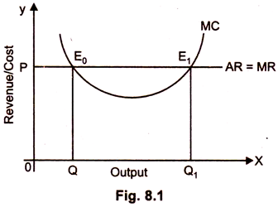
The firm can increase its profits by increasing production beyond E₀ because marginal revenue is greater than marginal cost. The firm will be in equilibrium at point E₁ or output 0Q₁ since at E₁ marginal cost equals to marginal revenue as well as marginal cost curve cuts marginal revenue curve from below.

Equilibrium of the Firm in the Short Period:
Short run means period of time within which the firms can alter their level of output only by increasing or decreasing the amount of variable factors such as labour and raw material, while fixed factors, like capital equipment remain unchanged. Moreover, in the short run, new firms can neither enter the industry nor the existing firms can leave it.
For the sake of simplicity of study, let us suppose that in an industry all factors of production, are homogenous. All the firms are equally efficient such as they have identical cost curve.
Under the circumstances each firm of a given industry, in equilibrium may get either:
(i) Super normal profit.
(ii) Normal profit.
(iii) Suffer losses
All the three situations depend upon the price determined by the industry.
All the three situations faced by the firms in equilibrium in short run are explained figuratively.
(i) Equilibrium with Super Normal Profits:
A firm is in equilibrium when its marginal cost is equal to marginal revenue and marginal cost curve cuts marginal revenue curve from below. A firm in equilibrium earns super normal profits, when average revenue (Price) determined by industry is more than its average cost.
In the Fig. 8.2 SAC and SMC are short run average and marginal cost curves of the firm. PP, is the average and marginal revenue curves, which are parallel to X-axis. The reason being, under perfect competition, firm is a price taker not price-maker. The firm’s equilibrium will be at point E.
A perpendicular parallel to the Y-axis is drawn at point E connecting the X-axis at Q. EQ is the equilibrium price because point E lies on the demand curve, and price is determined by demand curve. Average cost is equal to CQ. Since average revenue is greater than average cost. Thus, firms per unit excess profit is EC which is the difference between price (EQ) and the corresponding average cost (CQ). Total supernormal profit of a firm is PECD.
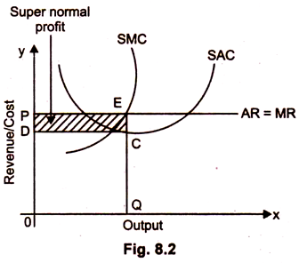
(iii) Equilibrium with Normal Profit:
In the short period, it is possible that firm earns only normal profit. This happens only when the average cost curve of the firm is tangent to its average revenue curve. Equilibrium of the firm has been explained in the Fig. 8.3.
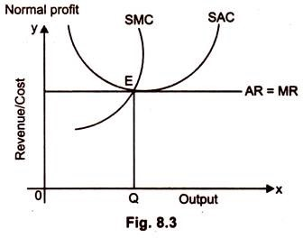
E is the equilibrium point because at this point MC = MR. MC curve cuts MR curve from below. 0Q is the equilibrium output. At 0Q level of output the firms AC curve is tangent to AR curve. Thus, the firm will earn only normal profit because average revenue (EQ) being equal to average cost (EQ).
(iii) Equilibrium with Losses:
A firm in equilibrium may incur losses when at the equilibrium level of output firm’s average cost is greater than average revenue. The equilibrium of the firm can be explained with the help of Fig. 8.4.
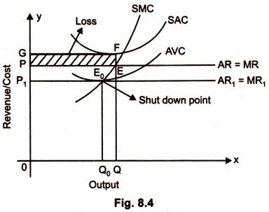
In the Fig. 8.4 marginal cost is equal to marginal revenue at point E. MC curve cuts MR curve from below. 0Q is the equilibrium level of output. Average revenue and average cost of the firm are equal to EQ and FQ, respectively. At 0Q level of output, firms average cost is greater than average revenue. Firm’s per unit loss is equal to EF and total loss is equal to area EFPG.
Now the question arises why the firm continues production even at losses. The reason being, in the short period fixed factors like machinery and plants cannot be changed. Therefore, if the firm stops production due to loss, then it will have to bear losses equivalent to fixed cost.
If the firm in the short period earns revenue which covers not only its average variable cost but also some part of fixed cost, the firm will continue its production.
In such circumstances, firm will incur more losses if it stops production. Therefore, it is better for the firm to continue to produce so long as it earns revenue more than or equivalent to minimum average variable cost, then firm will incur minimum losses. But when the firm’s price or average revenue falls below minimum average variable cost the firm will prefer to discontinue its production. The firm can avoid cost of variable factors of production.
The above argument has been elaborated by the Fig. 8.4. When price is 0P then firm’s equilibrium is at point E and it will produce 0Q level of output. The firm experiences loss equivalent to area FEPG The firm will continue its production in such situation, because price is greater than minimum average variable cost.
If the price of the commodity is 0P₁ then the equilibrium of the firm will be at point E and price is equivalent to minimum of average variable cost.
At point E₀, the firm is covering its minimum average variable cost. But at this point no part of fixed cost is being covered. Therefore, the loss of firm is equivalent to total fixed cost, at 0Q₀ level of output Point E₀ is known as ‘shut down point’. If price falls below 0P₁ then production will be stopped because firm’s loss is more than total fixed cost.

Long-Run Equilibrium of the Firm:
The long run is a period of time which is sufficiently long to allow the firm to make changes in all factors of production. The firms in the long run, can increase their output by changing their capital equipment, they may expand their old plant or replace the old lower capacity plants by the new higher capacity plant. Besides, in the long run new firm can enter the industry to complete with existing firm.
The long-run equilibrium refers to the situation where free and full adjustment in the capital equipment as well as in the number of firms has been allowed to take place.
A firm is in equilibrium under perfect competition when MC = MR and MC curve must cut MR curve from below. But for the firm to be in long run equilibrium, besides the equality of MC and MR, there must be equality of AR and AC. In other words, the firm will get only normal profits. If the price is greater than the average cost, the firms will earn super normal profits. The supernormal profits will attract other firms into the industry.
The price of the product will go down as a result of increase in supply of output and the cost will go up as a result of more intensive competition for factors of production. The firms will continue entering into the industry until the price is equal to average cost so that all firms are earning only normal profits.
On the contrary, if the price is lower than the average cost, the firm would make losses. These losses will induce some of the existing firms to quit the industry. Supply of output will decrease and price will increase because of increase in the average cost. Thus, the firms will get only normal profit in the long run.
From this analysis we conclude that for the firm to be in equilibrium in the long run following two conditions should be fulfilled:
(i) MC = MR and MC curve must cut MR curve from below.
(ii) Average Revenue must be equal to average Cost (AR = AC).
Because in the perfect competition, AR = MR, the above the condition can also be written as:
Price = AR = MR = LMC = LAC.
Price = LMC = LAC.
The relationship MC and AC also reveals that MC curve cuts AC curve at its minimum point.
These, conditions for long run equilibrium of the firm can also be written as:
Price = MC = Minimum Average Cost
The Fig. 8.5 represents long run equilibrium of firm under perfect competition.
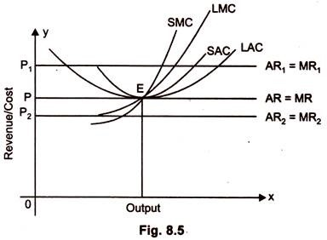
LAC and LMC are the long-run average and marginal cost curves, respectively. The firm will be in equilibrium at point E, at which marginal cost is equal to marginal revenue and marginal cost curve is rising.
The firm will get only normal profits because at point E, LAC curve is tangent to AR curve.
If price is increases from 0P to 0P₁ where the firm is earning abnormal profits. There will be tendency for new firms to enter and compete away these abnormal profits. The firms cannot be in long-run equilibrium at any price higher than 0P.
On the contrary, if price declines from 0P to 0P₂ then price will be less than marginal cost, and consequently the firms will incur losses. Some of existing firms will quit the industry due to which supply of the commodity will decline. The price will increase due to decrease in supply. In the long- run, the equilibrium of the firm will be at 0P price because firm will get only normal profits at the price.

Equilibrium of Industry under Perfect Competition:
The industry will be in equilibrium when industry has no tendency to either increase or decrease its level of output. An industry is said to be in equilibrium when industry is no tendency for it to expand or contract. It means demand for the product of industry and supply of it are in equilibrium. The industry has no tendency to vary its output.
If at a prevailing price, demand for the commodity is more than supply, the industry will try to expand its output. On the other hand, if at prevailing price, quantity demanded of a product falls short of quantity supplied, the price and output of the industry will tend to fall.
When demand for the commodity is equal to supply of commodity, then industry will have no tendency to vary its output. Thus, we conclude that industry will be in equilibrium at that level of price end output, where demand curve and supply curve intersect each other.

Conditions of Equilibrium of the Industry:
For the industry to be in equilibrium following three conditions should be fulfilled:
(i) Demand for and supply of product of the industry must be equal.
(ii) All the firms in the industry should be in equilibrium.
(iii) There should be no tendency to change the number of firms in the industry, i.e., the firms are earning only normal profits.

Short Run Equilibrium of the Industry:
In the short run, new firms can neither enter in the industry nor the old firms exit from the industry. Therefore, industry will be in equilibrium when above given first two conditions are fulfilled. The short-run equilibrium of industry has been shown in the Fig. 8.6.
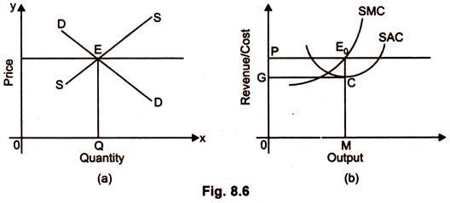
In part A of the Figure, the equilibrium of the industry has been shown. Demand curve and supply curve of the industry intersect each other at point E. 0P is the equilibrium price and 0Q is the equilibrium output.
The firm will take 0P price as given and adjust its output in such a way that it may earn maximum profit. In part B of the diagram equilibrium of the firm has been shown. E₀ is the firm’s equilibrium. 0M is the equilibrium output. Average revenue and average cost are equal to E₀M and CM, respectively.
Since average revenue is greater than average cost, the firm is earning super normal profit equal to area EoCGP. Suppose; cost of all the firms are identical, all the firms are earning normal profit. If the demand for the product declines, the price of the product will also decline and the equilibrium will be at lower level of output. The industry will be in equilibrium, although firms might be incurring losses.
In this case too the industry will be in short-run equilibrium.

Long-Run Equilibrium of the Industry:
Long run is that period of time under which new firms can enter and old firms can leave the industry. If firms in the industry are earning super normal profits, new firms will enter in the industry. On the other hand if the firms in the industry are incurring losses, then some existing firms will leave the industry.
Therefore, the industry will be in equilibrium, when above given conditions are fulfilled.
In part A of Fig. 8.7, industry equilibrium is shown. E is the equilibrium point. 0P and 0Q are the equilibrium level of price and output. The firms will adjust their output in such a way that it may earn maximum profits. In part B of Figure, equilibrium of the firm has been shown.
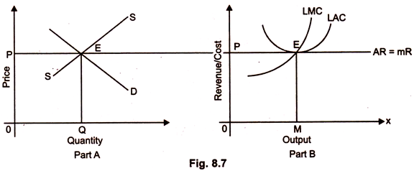
0M is the equilibrium level of output. The firm will get only normal profits because LAC curve is tangent to AR curve at equilibrium level of output 0M. If cost curve of all the firms are identical all the firms in the industry will earn only normal profits. Under these circumstances, there will be no tendency for the firms to enter or leave the industry.

4.3 Monopoly
The word monopoly has been derived from the combination of two words i.e., ‘Mono’ and ‘Poly’. Mono refers to a single and poly to control.
In this way, monopoly refers to a market situation in which there is only one seller of a commodity.
There are no close substitutes for the commodity it produces and there are barriers to entry. The single producer may be in the form of individual owner or a single partnership or a joint stock company. In other words, under monopoly there is no difference between firm and industry.
Monopolist has full control over the supply of commodity. Having control over the supply of the commodity he possesses the market power to set the price. Thus, as a single seller, monopolist may be a king without a crown. If there is to be monopoly, the cross elasticity of demand between the product of the monopolist and the product of any other seller must be very small.

Definitions:
“Pure monopoly is represented by a market situation in which there is a single seller of a product for which there are no substitutes; this single seller is unaffected by and does not affect the prices and outputs of other products sold in the economy.” Bilas
“Monopoly is a market situation in which there is a single seller. There are no close substitutes of the commodity it produces, there are barriers to entry”. -Koutsoyiannis
“Under pure monopoly there is a single seller in the market. The monopolist demand is market demand. The monopolist is a price-maker. Pure monopoly suggests no substitute situation”. -A. J. Braff
“A pure monopoly exists when there is only one producer in the market. There are no dire competitions.” -Ferguson
“Pure or absolute monopoly exists when a single firm is the sole producer for a product for which there are no close substitutes.” -McConnel

Features:

1. One Seller and Large Number of Buyers:
The monopolist’s firm is the only firm; it is an industry. But the number of buyers is assumed to be large.

2. No Close Substitutes:
There shall not be any close substitutes for the product sold by the monopolist. The cross elasticity of demand between the product of the monopolist and others must be negligible or zero.

3. Difficulty of Entry of New Firms:
There are either natural or artificial restrictions on the entry of firms into the industry, even when the firm is making abnormal profits.

4. Monopoly is also an Industry:
Under monopoly there is only one firm which constitutes the industry. Difference between firm and industry comes to an end.

5. Price Maker:
Under monopoly, monopolist has full control over the supply of the commodity. But due to large number of buyers, demand of any one buyer constitutes an infinitely small part of the total demand. Therefore, buyers have to pay the price fixed by the monopolist.
SOURCES OF MONOPOLY POWER
A monopolist is a sole supplier of a good for which no close substitutes exist, and can exclude competitors. The monopolist’s control over the supply of a commodity may be either in its production or sale. The conditions that make monopoly possible are the sources of its power. These are:-
i. Natural Monopoly
When a producer has control over the source of raw material or owns the raw materials used to produce a particular commodity, other competitors cannot have access to it. This means the owner of the raw material can use it in production to enjoy monopoly power. A similar product can therefore not be produced to compete with the monopolist.
ii. Legal Monopoly
These are of two forms:
a. Statutory Monopoly
This is the type of monopoly which is instituted by an Act of Parliament in democratic states. Providers of utility services such as water and electricity are usually statutory monopolies. The government regulates such companies by controlling the prices they are allowed to charge. The government may also choose to supply the commodity involved by itself. With the establishment of such monopolies, competition is eliminated sectors. This is to avoid efforts being duplicated as this could lead to scarce resources being wasted.
b. Patent right and copyright
This is another type of legal monopoly. When a firm invents in a technique of producing a product, the patent law gives that inventor exclusive control in the use of the invented means of production. This makes competition virtually impossible because no other person or group of people can use this means of production. Production will therefore be restricted and the inventor enjoys monopoly power. A copyright may be given to authors and musicians to protect them from having their work copied by other people.
iii. Collusive Monopoly
Firms may sometimes decide to come together to form a stronger unified force, so that the reaping of supernormal profit becomes much easier than when they compete among themselves. Firm sometimes enter into collusion this way in order to drive away potential competitors. In this regard, a strong monopoly is formed that can determine the price and output of the product. For example the main oil- producing nations belong to OPEC – Organization of Petroleum Exporting Countries, who decides the price of oil, due to the monopoly power it has in the supply of oil. Between 1973 and 1974, the organization increased price of oil from $2.90 to $9.00 per barrel. There was another sharp increase between 1978 and 1980 from $12 to $30 per barrel.
iv. Large Scale Production
Monopolies may also arise because of economies of scale. The established firms may retain a monopoly through a cost advantage because it can produce at a lower cost than any other smaller potential competitor could.
v. Market Franchise
A market franchise is a right granted a business firm by a governmental unit to produce or market a particular commodity with an instituted trade mark. The firm must submit to the governmental unit so that it controls certain aspect of the firms’ market operations. The franchise enables the firm to become a monopolist, as it becomes the single producer or distributor of the commodity within its area of operation.
vi. Technology and capital needed
Where there is need for an exclusive technology to be able to produce a particular commodity, only firms with the know-how can engage in the production of such a good. For example only a few firms have the technology to manufacture aircraft in the world. Sometimes monopoly power is enjoyed by already established firms because the capital requirement in setting up the industry is huge. This makes it almost impossible for potential competitors to obtain the needed capital to invest in similar type of business.

Three Degrees of Price Discrimination
Price discrimination is a strategy that consists of a business or seller charging a different price to various customers for the same product or service.It is one of the competitive practices used by larger, established businesses in an attempt to profit from differences in supply and demand from consumers.
A company can enhance its profits by charging each customer the maximum amount he is willing to pay, eliminating consumer surplus, but it is often a challenge to determine what that exact price is for every buyer. For price discrimination to succeed, businesses must understand their customer base and its needs, and there must be familiarity with the various types of price discrimination used in economics. The most common types of price discrimination are first, second, and third-degree discrimination.

First-Degree Price Discrimination
In an ideal business world, companies would be able to eliminate all consumer surplus through first-degree price discrimination. This type of pricing strategy takes place when businesses can accurately determine what each customer is willing to pay for a specific product or service and selling that good or service for that exact price.
In some industries, such as used car or truck sales, an expectation to negotiate final purchase price is part of the buying process. The company selling the used car can gather information through data mining relating to each buyer's past purchase habits, income, budget, and maximum available output to determine what to charge for each car sold. This pricing strategy is time-consuming and difficult to perfect for most businesses, but it allows the seller to capture the highest amount of available profit for each sale.
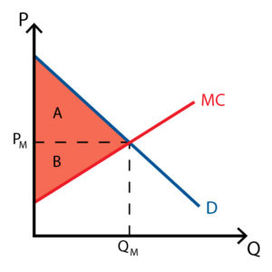

Second-Degree Price Discrimination
In second-degree price discrimination, the ability to gather information on every potential buyer is not present. Instead, companies price products or services differently based on the preferences of various groups of consumers.
Most often, businesses apply second-degree price discrimination through quantity discounts; customers who buy in bulk receive special offers not granted to those who buy a single product. This type of pricing strategy is used most often in warehouse retailers, such as Sam's Club or Costco (COST), but it can also be seen in companies that offer loyalty or rewards cards to frequent customers.
Second-degree price discrimination does not altogether eliminate consumer surplus, but it does allow a company to increase its profit margin on a subset of its consumer base.
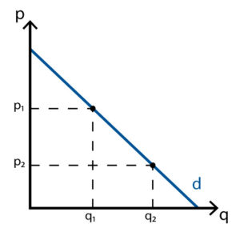

Third-Degree Price Discrimination
Third-degree price discrimination occurs when companies price products and services differently based on the unique demographics of subsets of its consumer base, such as students, military personnel, or seniors.
Companies can understand the broad characteristics of consumers more easily than the buying preferences of individual buyers. Third-degree price discrimination provides a way to reduce consumer surplus by catering to the price elasticity of demand of specific consumer subsets.
This type of pricing strategy is often seen in movie theater ticket sales, admission prices to amusement parks, or restaurant offers. Consumer groups that may otherwise not be able or willing to purchase a product due to their lower income are captured by this pricing strategy, increasing company profits.
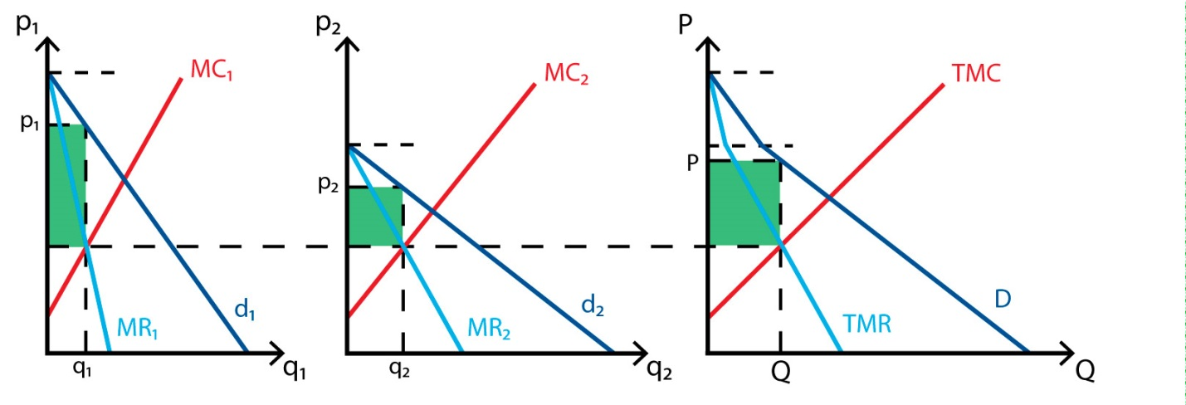

4.4 Monopolistic Competition
The two important subdivisions of imperfect competition are monopolistic competition and oligopoly. Most of the economic situations “are composites of both perfect competition and monopoly”. Chamberlin’s monopolistic competition is an amalgam or an admixture of perfect competition and monopoly.
Thus, monopolistic competition has elements of both perfect competition and monopoly. That is why it is said that this market form, in some sense, is akin to perfect competition and, in some other sense, is akin to monopoly. Since monopolists compete among themselves we call such market monopolistic competition.

Characteristics Monopolistic Competition:
Chamberlin’s theory of monopolistic competition has the following characteristics:

i. Large Number of Sellers:
Like perfect competition, there are a large number of sellers and buyers. But the ‘number’ is not too large like perfect competition. As a result, each firm has an insignificant share in the market so that action of one seller does not affect rival sellers to any great extent. Every seller in this market form believes that his actions will go unnoticed by his rivals in the market. Thus, each seller behaves independently in the market.

ii. Differentiated Products:
Sellers sell differentiated products, but they are close— but not perfect—substitutes. Buyers may not mind if they do not get Lux soap rather than Rexona. Different varieties of soap that are available in the Indian market are slightly differentiated products and, hence, close substitutes. It is the degree of differentiation that creates both monopoly and competitive elements.
Every product is unique to the buyers. So every seller enjoys some degree of monopoly of his own product over other sellers. But since these goods are close substitutes, sellers face competition. Because of brand loyalty of buyers, sellers exercise some monopoly power.
And sales of closely related goods create a competitive environment. Thus monopolists compete among themselves. It is product differentiation that enables monopolistically competitive firms to possess market power with competition amongst the firms. In this market, monopoly power is, therefore, small.

iii. Elastic Demand Curve:
Since product of each seller is slightly different from his rivals he enjoys some degree of monopoly power and, hence, can raise the price of his product without losing most customers. But as other rival firms produce closely related goods, every firm faces competition and its influence over the price of the product is rather limited.
Thus, each firm has a downward sloping demand curve implying that it behaves as a price-maker. Since a seller faces a large number of competitors to whom buyers may turn, the demand curve is more elastic.

iv. Non-Price Competition:
Besides price competition, Chamberlin suggested cases of non-price competition that arise due to product variation and selling activities. Seller always tries to establish the fact that his product is superior to others by improving the quality of his product.
And in doing so, he incurs selling costs or makes advertisement to attract more customers in his fold. It is the product differentiation that causes selling costs to emerge, in addition to production costs.
In Chamberlin’s model, demand for any commodity is not only affected by the price of a commodity but also by non-price competition (i.e., product variation and selling activities). Selling costs or advertising outlays are peculiar to this market.

v. Free Entry and Exit:
Like perfect competition, there is complete freedom of entry and exit.

vi. Product Group:
Chamberlin used the term ‘group’ rather than industry. An industry is a set of firms that produces homogeneous goods. But under monopolistic competition, goods are heterogeneous or slightly differentiated. Thus, the term ‘industry’ cannot be applied here. That is why Chamberlin used ‘product group’ which is defined as a collection of firms producing almost similar goods, but not identical goods.

4.5 Oligopoly
The word Oligopoly is derived from two Greek words – ‘Oligi’ meaning ‘few’ and ‘Polein’ meaning ‘to sell’. An Oligopoly market situation is also called ‘competition among the few’. In this article, we will look at Oligopoly definition and some important characteristics of this market structure.
An oligopoly is an industry which is dominated by a few firms. In this market, there are a few firms which sell homogeneous or differentiated products.
Also, as there are few sellers in the market, every seller influences the behavior of the other firms and other firms influence it.
Oligopoly is either perfect or imperfect/differentiated. In India, some examples of an oligopolistic market are automobiles, cement, steel, aluminum, etc.

Characteristics of Oligopoly
Now that the Oligopoly definition is clear, it’s time to look at the characteristics of Oligopoly:

Few firms
Under Oligopoly, there are a few large firms although the exact number of firms is undefined. Also, there is severe competition since each firm produces a significant portion of the total output.

Barriers to Entry
Under Oligopoly, a firm can earn super-normal profits in the long run as there are barriers to entry like patents, licenses, control over crucial raw materials, etc. These barriers prevent the entry of new firms into the industry.

Non-Price Competition
Firms try to avoid price competition due to the fear of price wars and hence depend on non-price methods like advertising, after sales services, warranties, etc. This ensures that firms can influence demand and build brand recognition.

Interdependence
Under Oligopoly, since a few firms hold a significant share in the total output of the industry, each firm is affected by the price and output decisions of rival firms. Therefore, there is a lot of interdependence among firms in an oligopoly. Hence, a firm takes into account the action and reaction of its competing firms while determining its price and output levels.

Nature of the Product
Under oligopoly, the products of the firms are either homogeneous or differentiated.

Selling Costs
Since firms try to avoid price competition and there is a huge interdependence among firms, selling costs are highly important for competing against rival firms for a larger market share.

No unique pattern of pricing behavior
Under Oligopoly, firms want to act independently and earn maximum profits on one hand and cooperate with rivals to remove uncertainty on the other hand.
Depending on their motives, situations in real-life can vary making predicting the pattern of pricing behavior among firms impossible. The firms can compete or collude with other firms which can lead to different pricing situations.

Indeterminateness of the Demand Curve

Unlike other market structures, under Oligopoly, it is not possible to determine the demand curve of a firm. This is because on one hand, there is a huge interdependence among rivals. And on the other hand there is uncertainty regarding the reaction of the rivals. The rivals can react in different ways when a firm changes its price and that makes the demand curve indeterminate.

Sweezy’s Kinked Demand Curve Model:
The kinked demand curve of oligopoly was developed by Paul M. Sweezy in 1939. Instead of laying emphasis on price-output determination, the model explains the behavior of oligopolistic organizations. The model advocates that the behavior of oligopolistic organizations remain stable when the price and output are determined.
This implies that an oligopolistic market is characterized by a certain degree of price rigidity or stability, especially when there is a change in prices in downward direction. For example, if an organization under oligopoly reduces price of products, the competitor organizations would also follow it and neutralize the expected gain from the price reduction.
On the other hand, if the organization increases the price, the competitor organizations would also cut down their prices. In such a case, the organization that has raised its prices would lose some part of its market share.
The kinked demand curve model seeks to explain the reason of price rigidity under oligopolistic market situations. Therefore, to understand the kinked demand curve model, it is important to note the reactions of rival organizations on the price changes made by respective oligopolistic organizations.
There can be two possible reactions of rival organizations when there are changes in the price of a particular oligopolistic organization. The rival organizations would either follow price cuts, but not price hikes or they may not follow changes in prices at all.
A kinked demand curve represents the behavior pattern of oligopolistic organizations in which rival organizations lower down the prices to secure their market share, but restrict an increase in the prices.
Following are the assumption of a kinked demand curve:
i. Assumes that if one oligopolistic organization reduces the prices, then other organizations would also cut their prices
ii. Assumes that if one oligopolistic organization increases the prices, then other organizations would not follow increase in prices
iii. Assumes that there is always a prevailing price
A kinked demand curve model is explained with the help of Figure-2:
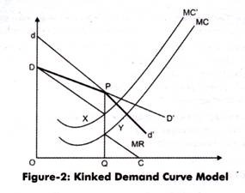
The slope of a kinked demand curve differs in different conditions, such as price increase and price decrease. In this model, every organization faces two demand curves. In case of high prices, an oligopolistic organization faces highly elastic demand curve, which is dd’ in Figure-2.
On the other hand, in case of low prices, the oligopolistic organization faces inelastic demand curve, which is DD’ (Figure-2). Suppose the prevailing price of a product is PQ, as shown in Figure-2. If one of the oligopolistic organizations makes changes in its prices, then there can be three reactions of rival organizations.
Firstly, when the oligopolistic organization would increase its prices, its demand curve would shift to dd’ from DD’. In such a case, consumers would switch to rivals, which would lead to fall in the sales of the oligopolistic organization. In addition, the dP portion of dd’ would be more elastic, which lies above the prevailing price.
On the other hand, if price falls, the rivals would also reduce their prices, thus, the sales of the oligopolistic organization would be less. In such a case, the demand curve faced by the oligopolistic organization is PD’, which lies below the prevailing price.
Secondly, rival organizations will not react with respect to changes in the price of the oligopolistic organization. In such a case, the oligopolistic organization would face DD’ demand curve.
Thirdly, the rival organizations may follow price cut, but not price hike. If the oligopolistic organization increases the price and rivals do not follow it, then consumers may switch to rivals. Thus, the rivals would gain control over the market. Thus, the oligopolistic organization would be forced from dP demand curve to DP demand curve, so that it can prevent losing its customers.
This would result in producing the kinked demand curve. On the other hand, if the oligopolistic organization reduces the price, the rival organizations would also reduce prices for securing their customers. Here, the relevant demand curve is Pd’. The two parts of the demand curve are DP and Pd’, which is DPd’ with a kink at point P.
Let us draw the MR curve of the oligopolistic organization. The MR curve would take the discontinuous shape, which is DXYC, where DX and YC correspond directly to DP and Pd’ segments of the kinked demand curve. The equilibrium point is attained when MR = MC. In Figure-2, the MC curve intersects MR at point Y where at output OQ.
At point Y, the organization would achieve maximum profit. Now, if cost increases, the MC curve would move upwards to MC. In such a case, the oligopolistic organization cannot increase the prices. This is because if the organization would increase the prices, the rival organizations would decrease their prices and gain the market share. Moreover, the profits would remain same between point X and Y. Thus, there is no motivation for increasing or decreasing prices. Therefore, price and output would remain stable.
However, kinked demand curve model is criticized by various economists.
Some of the major points of criticism are as follows:
i. Lays emphasis on price rigidity, but does not explain price itself.
ii. Assumes that rival organizations only follow price decrease, which does not hold true empirically.
iii. Ignores non-price competition among organizations. Non-price competition can be in terms of product differentiation, advertising, and other tools used by organizations to promote their sales.
iv. Ignores the application of price leadership and cartels, which account for larger share of the oligopolistic market.

Cartels
We saw that, in the absence of collusion, the monopoly solution in the industry (the solution at which the joint industry profit is maximized) can be achieved under the rare conditions that;
(a) each firm knows the monopoly price, that is, has a correct knowledge of the market demand and of the costs of all firms,
(b) that each firm recognizes its interdependence with the others in the industry,
(c) all firms have identical costs and identical demands. (Actually condition (c) implies condition (a))
We will examine two typical forms of cartels:
(a) Cartels aiming at joint-profit maximization, that is, maximization of the industry profit, and
(b) Cartels aiming at the sharing of the market.

A. Cartels aiming at joint-profit maximization:
Cartels imply direct (although secret) agreements among the competing oligopolist with the aim of reducing the uncertainty arising from their mutual interdependence. In this particular case the aim of the cartel is the maximisation of the industry (joint) profit. The situation is identical with that of a multiplant monopolist who seeks the maximisation of his profit. We concentrate on a homogeneous or pure oligopoly, that is, an oligopoly where all firms produce a homogeneous product. The case of differentiated oligopoly will be examined in a separate section.
The firms appoint a central agency, to which they delegate the authority to decide not only the total quantity and the price at which it must be sold so as to attain maximum
group profits, but also the allocation of production among the members of the cartel, and the distribution of the maximum joint profit among the participating members.
The authority of the central cartel agency is complete. Clearly the central agency will have access to the cost figures of the individual firms, and for the purposes of the present theory we unrealistically suppose that it will calculate the market-demand curve and the corresponding MR curve. From the horizontal summation of the MC curves of individual firms the market MC curve is derived.

The central agency, acting as a multi- plant monopolist, will set the price defined by the intersection of the industry MR and MC curves. For simplicity assume that there are only two firms in the cartel. Their cost structure is shown in figures 10.1 and 10.2. From the horizontal summation of the MC curves we obtain the market MC curve.
This is implied by the profit-maximisation goal of the cartel each level of industry output should be produced at the least possible cost. Thus if we add the outputs of A and B that can be produced at the same MC, clearly the resulting total output is the output that can be produced at this common lowest cost. Given the market demand DD (in figure 10.3) the monopoly solution, which maximises joint profits, is determined by the intersection of MC and MR (point e in figure 10.3).
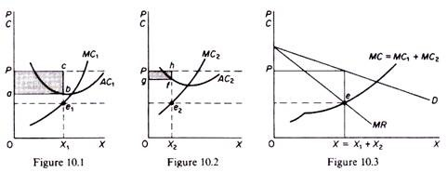
The total output is X and it will be sold at price P. Now the central agency allocates the production among firm A and firm B as a monopolist would do, that is, by equating the MR to the individual MCs. Thus firm A will produce X₁ and firm B will produce X₂. Note that the firm with the lower costs produces a larger amount of output. However, this does not mean that A will also take the larger share of the attained joint profit. The total industry profit is the sum of the profits from the output of the two firms, denoted by the shaded areas of figures 10.1 and 10.2. The distribution of profits is decided by the central agency of the cartel.

Oligopoly - Game Theory Explained and Applied
Game theory is concerned with predicting the outcome of games of strategy in which the participants (for example two or more businesses competing in a market) have incomplete information about the others' intentions
Applying game theory in your economics exams
- Game theory analysis has direct relevance to the study of the conduct and behaviour of firms in oligopolistic markets – for example the decisions that firms must take over pricing and levels of production, and also how much money to invest in research and development spending.
- Costly research projects represent a risk for any business – but if one firm invests in R&D, can a rival firm decide not to follow? They might lose the competitive edge in the market and suffer a long term decline in market share and profitability.
- The dominant strategy for both firms is probably to go ahead with R&D spending. If they do not and the other firm does, then their profits fall and they lose market share. However, there are only a limited number of patents available to be won and if all of the leading firms in a market spend heavily on R&D, this may ultimately yield a lower total rate of return than if only one firm opts to proceed.
The Prisoner's Dilemma
- The classic example of game theory is the Prisoner's Dilemma, a situation where two prisoners are being questioned over their guilt or innocence of a crime.
- They have a simple choice, either to confess to the crime (thereby implicating their accomplice) and accept the consequences, or to deny all involvement and hope that their partner does likewise.
Confess or keep quiet? The Prisoner's Dilemma is a classic example of basic game theory in action!
- The "pay-off" in this game is measured in terms of years in prison arising from their choices and this is summarised in the table below.
- No communication is permitted between the two suspects – in other words, each must make an independent decision, but clearly they will take into account the likely behaviour of the other when under-interrogation. This highlights the importance of uncertainty in an oligopoly.
Nash Equilibrium
Nash Equilibrium is an important idea in game theory – it describes any situation where all of the participants in a game are pursuing their best possible strategy given the strategies of all of the other participants.
In a Nash Equilibrium, the outcome of a game that occurs is when player A takes the best possible action given the action of player B, and player B takes the best possible action given the action of player A
Two prisoners are held in a separate room and cannot communicate  They are both suspected of a crime  They can either confess or they can deny the crime  Payoffs shown in the matrix are years in prison from their chosen course of action |  | Prisoner A
 |  | Confess | Deny
Prisoner B | Confess | (3 years, 3 years) | (1 year, 10 years)
Prisoner B | Deny | (10 years, 1 year) | (2 years, 2 years)
- What is the best strategy for each prisoner?
- Equilibrium happens when each player takes decisions which maximise the outcome for them given the actions of the other player in the game.
- In our example of the Prisoners' Dilemma, the dominant strategy for each player is to confess since this is a course of action likely to minimise the average number of years they might expect to remain in prison.
- But if both prisoners choose to confess, their "pay-off" i.e. 3 years each in prison is higher than if they both choose to deny any involvement in the crime.
- In following narrowly defined self-interest, both prisoners make themselves worse off
- That said, even if both prisoners chose to deny the crime (and indeed could communicate to agree this course of action), then each prisoner has an incentive to cheat on any agreement and confess, thereby reducing their own spell in custody.
The equilibrium in the Prisoners' Dilemma occurs when each player takes the best possible action for themselves given the action of the other player.  The dominant strategy is each prisoners' unique best strategy regardless of the other players' action  Best strategy? Confess?  A bad outcome! – Both prisoners could do better by both denying – but once collusion sets in, each prisoner has an incentive to cheat! |  | Prisoner A
 |  | Confess | Deny
Prisoner B | Confess | (3 years, 3 years) | (1 year, 10 years)
Prisoner B | Deny | (10 years, 1 year) | (2 years, 2 years)
Applying the Prisoner's Dilemma to Business Decisions
- Game theory examples revolve around the pay-offs that come from making different decisions.
- In the prisoner's dilemma the reward to defecting is greater than mutual cooperation which itself brings a higher reward than mutual defection which itself is better than the sucker's pay-off.
- Critically, the reward for two players cooperating with each other is higher than the average reward from defection and the sucker's pay-off.

Short Run Analysis (Partial Equilibrium):
As the typical firm is one of a large number of firms in the group, increase in its sales as a result of reduction in the price will produce loss of sales distributed more or less equally over the other firms. Consequently, each rival firm will suffer too little loss in customers to induce it to change the price.
Thus, the AR curve in Fig. 15.1 is drawn on the assumption that the competitors will not react to changes in the particular firm’s price, besides usual ceteris paribus assumption. Though Chamberlin does not use marginal revenue (MR) and marginal cost (MC) curves, these curves are included in our diagram facilitating exposition and comparison with other market structures.
Given demand and cost curves, it maximises the profit by producing OQ output at price OP corresponding to equilibrium point ‘E’ in Fig. 15.1, where MC equals MR. The firm may earn supernormal profits (shown by shaded area Fig 15.1 (a)), suffer losses (shown by shaded area in Fig 15.1 (b)) or may get just normal profits (Fig. 15.1 (c)).
The short run average cost (SAC) curve will lie below; above and just pass through demand curve AR in these three cases respectively. Thus, short-run equilibrium of a firm under imperfect competition
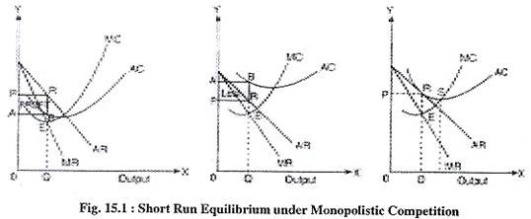
On account of different degrees of consumer preferences, elasticities of demand curves of different firms may be different under monopolistic competition. Further, cost curves of the firms may also differ from each other. Accordingly, prices charged by various firms may not be identical.
Therefore, some firms may earn profits, while others may suffer losses depending upon the position of the average cost curve relative to the position of demand curve. Still others may get only normal profits even in the short run, if the average cost curve happens to be tangent to the demand curve.
Table 1.2 Types of Market
Parameters | Perfect competition | Monopolistic competition | Oligopoly | Monopoly
No. of Sellers and Buyers | Large number of sellers and buyers | Fairly large number of sellers and large number of buyers | Few Sellers and large number of buyers | One Seller and large number of buyers
Nature of the product | Identical/Homogenous product | Differentiated product | Identical/Homogenous or differentiated product | Identical/Homogenous product- No Close Substitutes are available in the market
Part of economy where its prevalent | Financial Markets and Agricultural products | Retail Trade  (Readymade garments, Laptops) | Identical/Homogenous product- Cement, Steel, Chemicals; Differentiated product- Automobiles, software designing | Government franchises- postal services, electricity, water, roads
Nature of Knowledge | Perfect Knowledge | Some knowledge | Some knowledge | Some knowledge
Nature of Entry or Exit | Free entry and exit | Free entry and exit | Can be closed as well as free entry and exit | Closed entry
Market Power | No Power | Slight power | Significant power | Large Power
Firm’s degree of control over price | None  (Price Taker) | Some  (Price Maker) | Some  (Price Maker) | Considerable  (Price Maker)
Selling Cost | Does not exist | Exists | Exists | Does Not exist.
Methods of Marketing | Market exchange/auction | Selling activities, advertising, quality rivalry, administrative prices | Selling activities, advertising, quality rivalry, administrative prices | Advertising
Slope of the Demand Curve of the firm – price is on vertical axis and quantity on horizontal axis | Perfectly elastic | Negatively sloped but more elastic | Kinked demand curve | Negatively stopped but less elastic
Relationship with AR and MR | AR=MR | AR>MR  (there are two demand curves {D= AR} - the flatter demand curve is planned demand curve and the steeper demand curve is actual market share demand curve: so accordingly we get respective MR curves) | AR>MR  ( deriving from the monopolistic demand curve we get the kinked demand curve under oligopoly ) | AR>MR
Nature of Profits  (long run) | Normal | Normal | Super normal | Super normal

Producer’s Equilibrium:
Equilibrium refers to a state of rest when no change is required. A firm (producer) is said to be in equilibrium when it has no inclination to expand or to contract its output. This state either reflects maximum profits or minimum losses.
There are two methods for determination of Producer’s Equilibrium:
1. Total Revenue and Total Cost Approach (TR-TC Approach)
2. Marginal Revenue and Marginal Cost Approach (MR-MC Approach)
It must be noted that scope of syllabus is restricted to “Producer’s Equilibrium by MR- MC Approach”. Still, for better understanding, “Producer’s Equilibrium by TR-TC approach” is given.

Total Revenue-Total Cost Approach (TR-TC Approach):
A firm attains the stage of equilibrium when it maximises its profits, i.e. when he maximises the difference between TR and TC. After reaching such a position, there will be no incentive for the producer to increase or decrease the output and the producer will be said to be at equilibrium.
According to TR-TC approach, producer’s equilibrium refers to stage of that output level at which the difference between TR and TC is positively maximized and total profits fall as more units of output are produced. So, two essential conditions for producer’s equilibrium are:
The difference between TR and TC is positively maximized;
Total profits fall after that level of output.
The first condition is an essential condition. But, it must be supplemented with the second condition. So, both the conditions are necessary to attain the producer’s equilibrium.

Producer’s Equilibrium (When Price remains Constant):
When price remains same at all output levels (like in case of perfect competition), each producer aims to produce that level of output at which he can earn maximum profits, i.e. when difference between TR and TC is the maximum. Let us understand this with the help of Table 8.1, where market price is fixed at Rs. 10 per unit:
Table 8.1: Producer’s Equilibrium (When Price remains Constant):
Output (units) | Price (Rs.) | TR (Rs.) | TC (Rs.) | Profit = TR-TC (Rs.) | Remarks
0 | 10 | 0 | 5 | -5 | Profit rises
1 | 10 | 10 | 8 | 2 | with increase
2 | 10 | 20 | 15 | 5 | in output
3 | 10 | 30 | 21 | 9
4 | 10 | 40 | 31 | 9 | Producer’s Equilibrium
5 | 10 | 50 | 42 | 8 | Profit falls with
6 | 10 | 60 | 54 | 6 | increase in output
According to Table 8.1, the maximum profit of Rs. 9 can be achieved by producing either 3 units or 4 units. But, the producer will be at equilibrium at 4 units of output because at this level, both the conditions of producer’s equilibrium are satisfied:
1. Producer is earning maximum profit of Rs. 9;
2. Total profit falls to Rs. 8 after 4 units of output.
In Fig. 8.1, Producer’s equilibrium will be determined at P OQ level of output at which the vertical distance between TR and TC curves is the greatest. At this level of output, tangent to TC curve (at point G) is parallel to TR curve and difference between both the curves (represented by distance GH) is maximum.
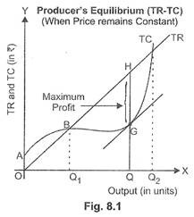
At quantities smaller or larger than OQ, such as OQ₁ or OQ₂ units, the tangent to TC curve would not be parallel to the TR curve. So, the producer is at equilibrium at OQ units of output.

