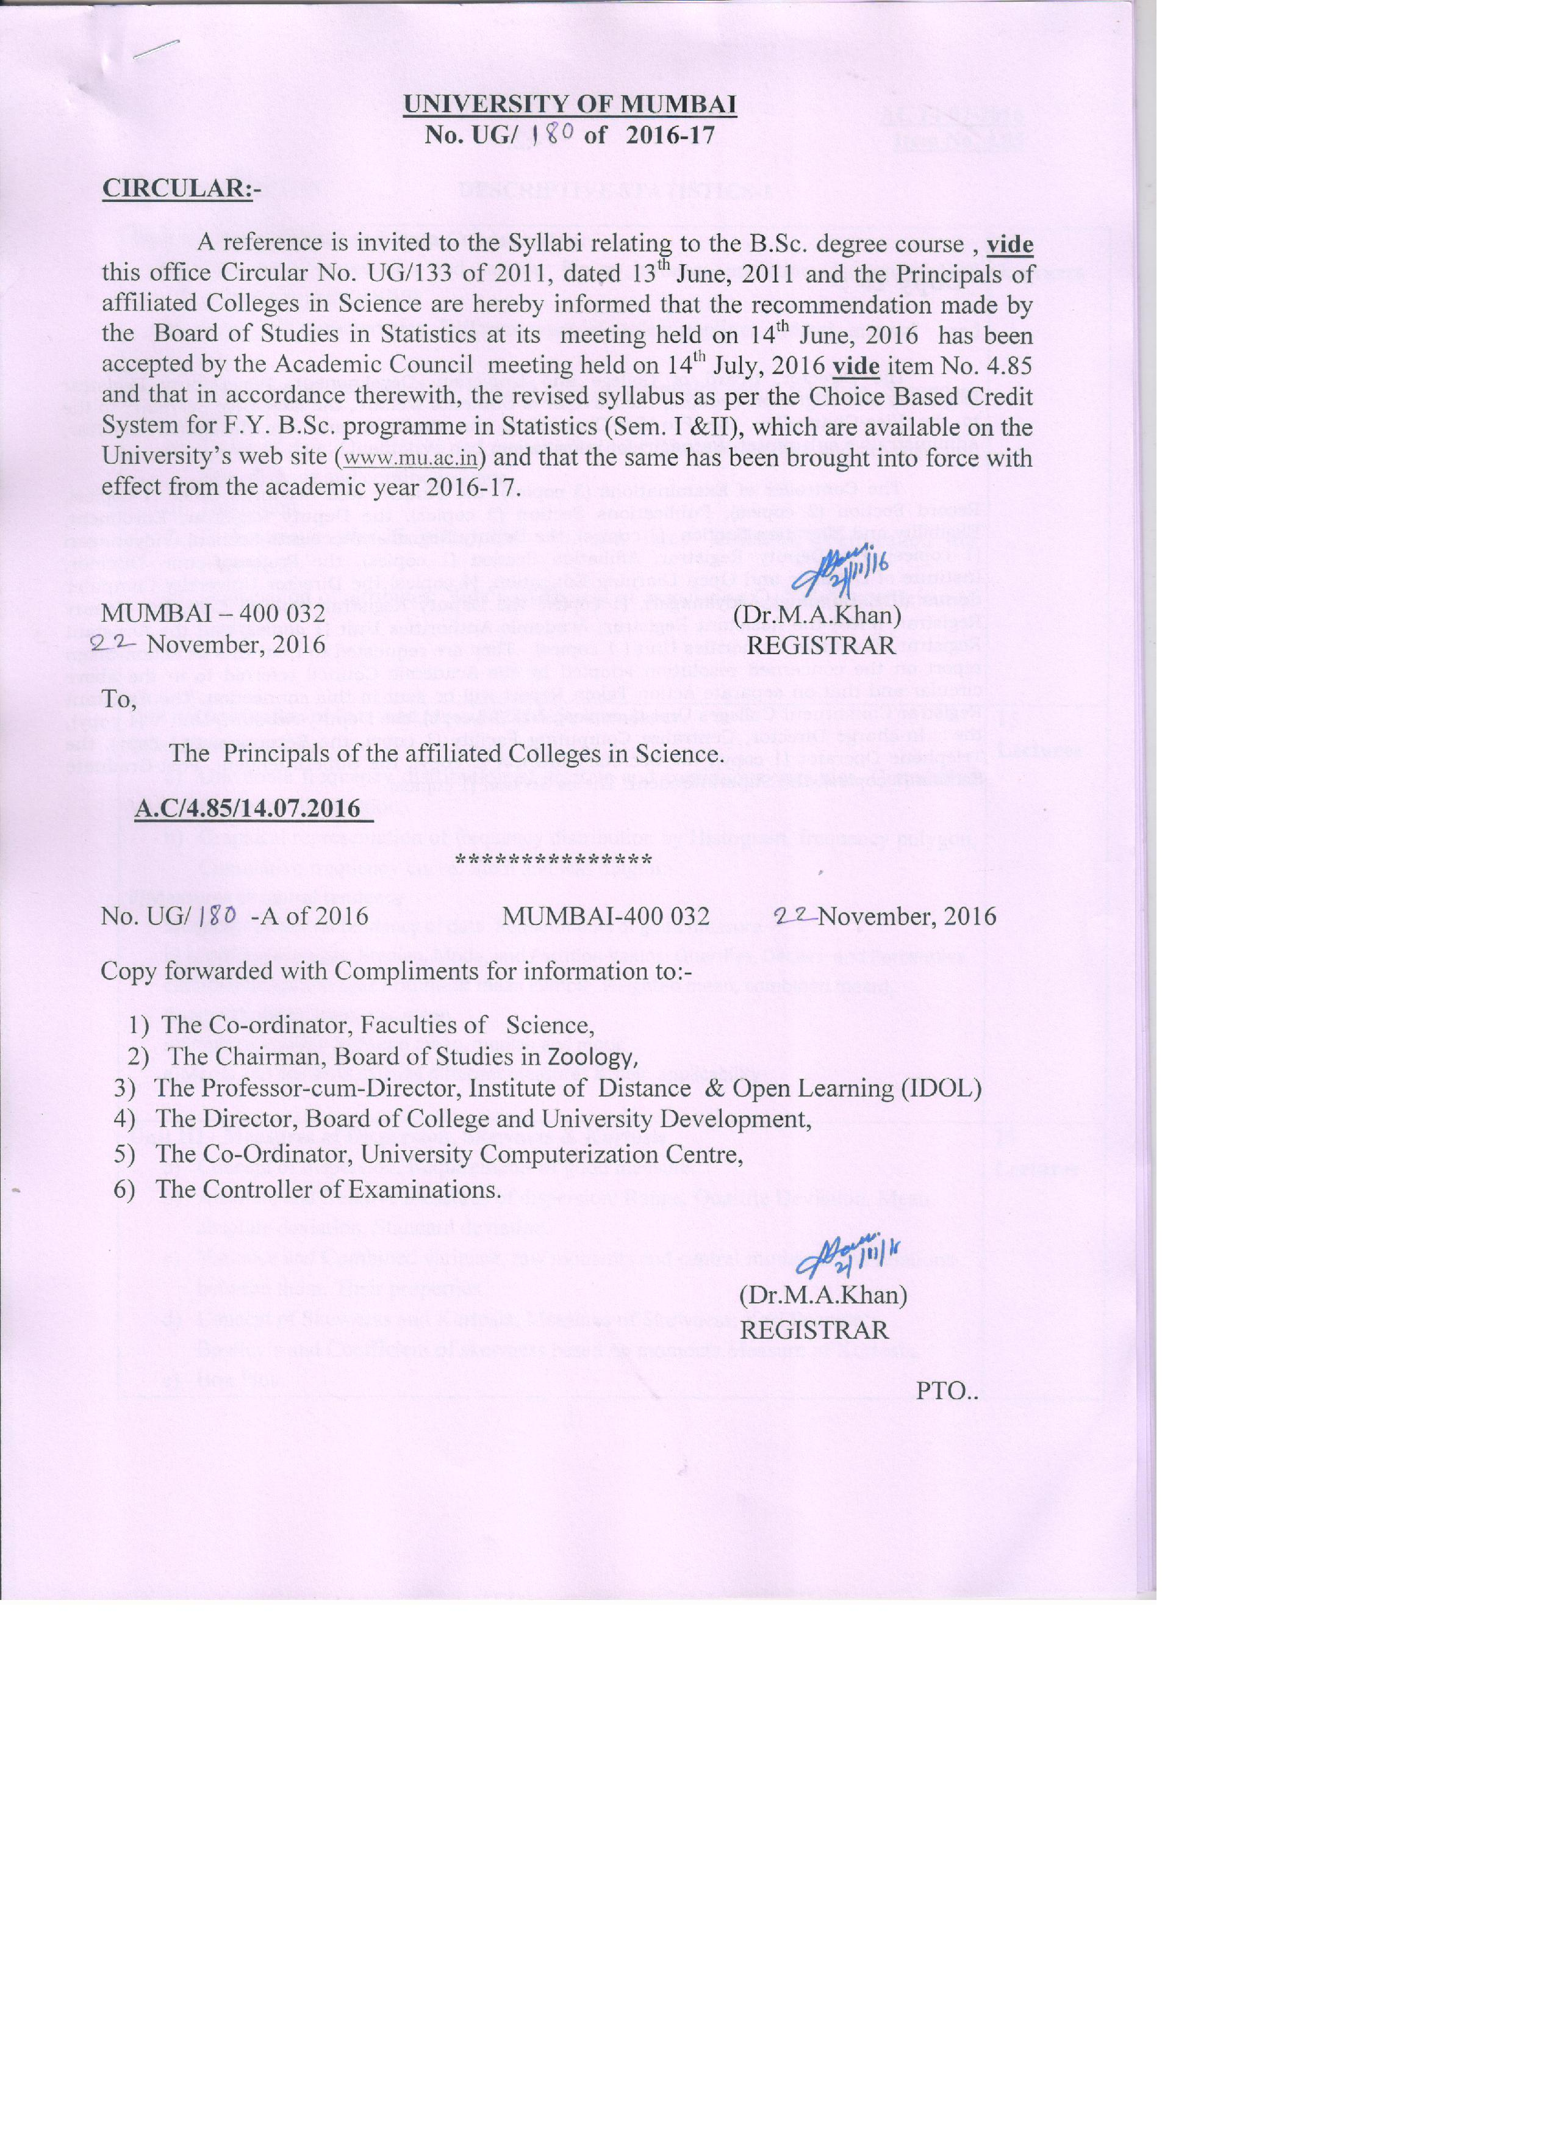

 | DESCRIPTIVE STATISTICS-1
Unit I - Types of Data and Data Condensation: |  | 15

- Concept of population and sample. Finite ,Infinite population ,Notion of SRS Lectures ,SRSWOR and SRSWR

b) Types of Characteristics, Different types of scales: nominal, ordinal, interval and ratio.
- Collection of Primary data: concept of a questionnaire and a schedule, Secondary data
- Types of data: Qualitative and quantitative data; Time series data and cross section data, discrete and continuous data.
- Tabulation.

- Dichotomous classification- for two and three attributes, Verification for consistency.
- Association of attributes: Yule’s coefficient of association Q. Yule’s coefficient of Colligation,

Unit II–Classification of Data and Measures of central tendency |  | 15
i)Classification of Data |  | Lectures
a) | Univariate frequency distribution of discrete and continuous variables. Cumulative
 | frequency distribution.
b) | Graphical representation of frequency distribution by Histogram, frequency polygon,
 | Cumulative frequency curve. Stem and leaf diagram.
ii)Measures of central tendency
a)Concept of central tendency of data. Requirements of good measure
b) Locationalaverages: Median, Mode, and Partition Values: Quartiles, Deciles, and Percentiles.
c)Mathematical averages Arithmetic mean (Simple, weighted mean, combined mean),
Geometric mean, Harmonic mean,
d)Empirical relation between mean, median and mode
e)Merits and demerits of using different measures &their applicability
Unit III - Measures of Dispersion, Skewness & Kurtosis |  | 15
a) | Concept of dispersion. Requirements of good measure. | Lectures
b) | Absolute and Relative measures of dispersion: Range, Quartile Deviation, Mean
 | absolute deviation, Standard deviation.
c) | Variance and Combined variance, raw moments and central moments and relations
 | between them. Their properties
d) | Concept of Skewness and Kurtosis: Measures of Skewness: Karl Pearson’s,
 | Bowley’s and Coefficient of skewness based on moments.Measure of Kurtosis,
e) | Box Plot
 | 1

 |  | DESCRIPTIVE STATISTICS-1I
UNIT – I:Correlation and regression analysis |  |  | 15
a) | Scatter Diagram, Product moment correlation coefficient and its properties. |  | Lectures
 | Spearman’s Rank correlation.(With and without ties)
b) | Concept of linear regression. Principle of least squares. Fitting a straight line
 | by method of least squares.
c) | Relation between regression coefficients and correlation coefficient.
d) | Fitting of curves reducible to linear form by transformation. Concept and use
e) | of coefficient of determination (R²).
e) | Fitting a quadratic curve by method of least squares.
UNIT – II : Time Series |  |  | 15
Definition of time series .Its component. Models of time series. |  |  | Lectures
Estimation of trend by: i) Freehand curve method ii) method of semi average
iii)Method of Moving average iv) Method of least squares(linear trend only)
Estimation of seasonal component by i) method of simple average ii) Ratio to moving
average iii)Ratio to trend method .
Unit III - Index Numbers |  |  | 15
a) | Index numbers as comparative tool. Stages in the construction of Price Index |  | Lectures
 | Numbers.
b) | Measures of Simple and Composite Index Numbers. Laspeyre’s, Paasche’s,
 | Marshal-Edgeworth’s, Dobisch & Bowley’s and Fisher’s Index Numbers
 | formula.
c) | Quantity Index Numbers and Value Index Numbers Time reversal test,Factor
 | reversal test, Circular test.
d) | Fixed base Index Numbers, Chain base Index Numbers.Base shifting, splicing
 | and deflating.
e) | Cost of Living Index Number.Concept of Real Income based on Wholesale
 | Price Index Number

2

SEMESTER I : Practicals

- Tabulation

- Attributes

- Classification of Data

- Diagrammatic representation.

- Measures of central tendency

- Measures of dispersion

- Practical using Excel and R

i)Classification of Data and Diagrammatic representation. ii)Measures of central tendency

iii)Measures of dispersion

SEMESTER II: Practicals

- Correlation analysis

- Regression analysis

- Fitting of curve

- Time series

- Index number-I

- Index number-II

- Practical using Excel and R i) Correlation analysis

ii) Regression analysis

iii) Fitting of curve

3

Proposed syllabus F.Y.B.Sc

SEMESTER I

STATISTICAL METHODS-1

UNIT – I

Elementary Probability Theory :

Trial, random experiment, sample point and sample space.

Definition of an event. Operation of events, mutually exclusive and exhaustive events.

Classical (Mathematical) and Empirical definitions of Probability and their properties.

Theorems on Addition and Multiplication of probabilities.

Independence of events, pairwise and mutual independence for three event Conditional probability, Bayes theorem and its applications.

UNIT – II

Concept of Discrete random variable and properties of its probability distribution :

Random variable. Definition and properties of probability distribution and cumulative distribution function of discrete random variable.

Raw and Central moments(definition only) and their relationship.(upto order four ).

Concepts of Skewness and Kurtosis and their uses.

Expectation of a random variable. Theorems on Expectation & Variance.

Joint probability mass function of two discrete random variables.

Marginal and conditional distributions. Theorems on Expectation &Variance, Covariance and Coefficient of Correlation. Independence of two random variables.
Moment Generating Function
UNIT – III

Some Standard Discrete Distributions:

4

Discrete Uniform, Binomial and Poisson distributions and derivation of their mean and variance.

Recurrence relation for probabilities of Binomial and Poisson distributions .Poisson approximation to Binomial distribution .Hyper geometric distribution, Binomial approximation to hyper geometric distribution. Geometric and Negative Binomial Distribution.

SEMESTER II

STATISTICAL METHODS-2

UNIT – IV

Continuous random variable :

Concept of Continuous random variable and properties of its probability distribution

Probability density function and cumulative distribution function.

Their graphical representation.

Expectation of a random variable and its properties. Measures of location, dispersion, skewness and kurtosis. Raw and central moments (simple illustrations).
UNIT – V

Some Standard Continuous Distributions :

Uniform, Exponential (location scale parameter ) , memory less property of exponential distribution and Normal distribution.

Derivations of mean, median and variance for Uniform and Exponential distributions. Properties of Normal distribution (without proof). Normal approximation to Binomial and Poisson distribution (statement only). Properties of Normal curve. Use of normal tables.
Exponential Distribution. Beta and Gamma Distribution

5

UNIT – VI

Elementary topics on Estimation and Testing of hypothesis:

Sample from a distribution :

Concept of a statistic, estimate and its sampling distribution. Parameter and it’s estimator.

Concept of bias and standard error of an estimator.

Central Limit theorem (statement only).

Sampling distribution of sample mean and sample proportion. (For large sample only) Standard errors of sample mean and sample proportion.

Point and Interval estimate of single mean, single proportion from sample of large size.

Statistical tests :

Concept of hypothesis

Null and alternate hypothesis,

Types of errors, Critical region, Level of significance.

Large sample tests (using central limit theorem, if necessary)

For testing specified value of population mean

For testing specified value in difference of two means For testing specified value of population proportion

For testing specified value of difference of population proportion (Development of critical region is not expected.) Use of central limit theorem.

6

 |  |  |  |  | PRACTICALS IN STATISTICS
 |  |  | Distribution of the topics for the practicals
 |  |  |  | SEMESTER I
1 | Probability.
2 | Discrete Random Variables
3 | Bivariate Probability Distributions.
4 | Binomial | distribution
5 | Poisson distribution
6 | Hyper geometric distribution
7 | Practicals | Using R
 | Binomial, | Poisson, |  | Hyper |  | geometric
 | distribution

7

SEMESTER II

Sr.No (B)

- Continuous Random Variables

- Uniform, Exponential and Normal Distributions

- Applications of central limit theorem and normal approximation

- Testing of Hypothesis

- Large Sample Tests

- 2,3,4,5, Practicals Using R

REFERENCES .

- Medhi J. : Statistical Methods, An Introductory Text, Second Edition, New Age International Ltd.

- Agarwal B.L. : Basic Statistics, New Age International Ltd.

- Spiegel M.R. : Theory and Problems of Statistics, Schaum’ s Publications series. Tata McGraw-Hill.

- Kothari C.R. : Research Methodology, Wiley Eastern Limited.

- David S. : Elementary Probability, Cambridge University Press.

- Hoel P.G. : Introduction to Mathematical Statistics, Asia Publishing House.

- Hogg R.V. and Tannis E.P. : Probability and Statistical Inference.

- Pitan Jim : Probability, Narosa Publishing House.

- Goon A.M., Gupta M.K., Dasgupta B. : Fundamentals of Statistics, Volume II : The World Press Private Limited, Calcutta.

**********

8

