https://www.investopedia.com/terms/t/timevalueofmoney.asp

Time Value of Money (TVM)
By JAMES CHEN
Reviewed By DAVID KINDNESS
Updated Apr 21, 2020

What Is the Time Value of Money (TVM)?
The time value of money (TVM) is the concept that money you have now is worth more than the identical sum in the future due to its potential earning capacity. This core principle of finance holds that provided money can earn interest, any amount of money is worth more the sooner it is received. TVM is also sometimes referred to as present discounted value.
Volume 75%

1:14

Understanding The Time Value Of Money

Understanding Time Value of Money (TVM)
The time value of money draws from the idea that rational investors prefer to receive money today rather than the same amount of money in the future because of money's potential to grow in value over a given period of time. For example, money deposited into a savings account earns a certain interest rate and is therefore said to be compounding in value.

KEY TAKEAWAYS
- Time value of money is based on the idea that people would rather have money today than in the future.
- Given that money can earn compound interest, it is more valuable in the present rather than the future.
- The formula for computing time value of money considers the payment now, the future value, the interest rate, and the time frame.
- The number of compounding periods during each time frame is an important determinant in the time value of money formula as well.
Further illustrating the rational investor's preference, assume you have the option to choose between receiving $10,000 now versus $10,000 in two years. It's reasonable to assume most people would choose the first option. Despite the equal value at the time of disbursement, receiving the $10,000 today has more value and utility to the beneficiary than receiving it in the future due to the opportunity costs associated with the wait. Such opportunity costs could include the potential gain on interest were that money received today and held in a savings account for two years.

Time Value of Money Formula
Depending on the exact situation in question, the time value of money formula may change slightly. For example, in the case of annuity or perpetuity payments, the generalized formula has additional or less factors. But in general, the most fundamental TVM formula takes into account the following variables:
- FV = Future value of money
- PV = Present value of money
- i = interest rate
- n = number of compounding periods per year
- t = number of years
Based on these variables, the formula for TVM is:
FV = PV x [ 1 + (i / n) ] ^{(n x t)}

Time Value of Money Examples
Assume a sum of $10,000 is invested for one year at 10% interest. The future value of that money is:
FV = $10,000 x [1 + (10% / 1)] ^ (1 x 1) = $11,000
The formula can also be rearranged to find the value of the future sum in present day dollars. For example, the value of $5,000 one year from today, compounded at 7% interest, is:
PV = $5,000 / [1 + (7% / 1)] ^ (1 x 1) = $4,673

Effect of Compounding Periods on Future Value
The number of compounding periods can have a drastic effect on the TVM calculations. Taking the $10,000 example above, if the number of compounding periods is increased to quarterly, monthly, or daily, the ending future value calculations are:
- Quarterly Compounding: FV = $10,000 x [1 + (10% / 4)] ^ (4 x 1) = $11,038
- Monthly Compounding: FV = $10,000 x [1 + (10% / 12)] ^ (12 x 1) = $11,047
- Daily Compounding: FV = $10,000 x [1 + (10% / 365)] ^ (365 x 1) = $11,052
This shows TVM depends not only on interest rate and time horizon, but also on how many times the compounding calculations are computed each year.
https://corporatefinanceinstitute.com/resources/knowledge/valuation/time-value-of-money/

What is the Time Value of Money?
The time value of money is a basic financial concept that holds that money in the present is worth more than the same sum of money to be received in the future. This is true because money that you have right now can be invested and earn a return, thus creating a larger amount of money in the future. (Also, with future money, there is the additional risk that the money may never actually be received, for one reason or another.) The time value of money is sometimes referred to as the net present value (NPV) of money.



How the Time Value of Money Works
A simple example can be used to show the time value of money. Assume that someone offers to pay you one of two ways for some work you are doing for them: They will either pay you $1,000 now or $1,100 one year from now.
Which pay option should you take? It depends on what kind of investment return you can earn on the money at the present time. Since $1,100 is 110% of $1,000, then if you believe you can make more than a 10% return on the money by investing it over the next year, you should opt to take the $1,000 now. On the other hand, if you don’t think you could earn more than 9% in the next year by investing the money, then you should take the future payment of $1,100 – as long as you trust the person to pay you then.

Time Value and Purchasing Power
The time value of money is also related to the concepts of inflation and purchasing power. Both factors need to be taken into consideration along with whatever rate of return may be realized by investing the money.
Why is this important? Because inflation constantly erodes the value, and therefore the purchasing power, of money. It is best exemplified by the prices of commodities such as gas or food. If, for example, you were given a certificate for $100 of free gasoline in 1990, you could have bought a lot more gallons of gas than you could have if you were given $100 of free gas a decade later.

Inflation and purchasing power must be factored in when you invest money because to calculate your real return on an investment, you must subtract the rate of inflation from whatever percentage return you earn on your money. If the rate of inflation is actually higher than the rate of your investment return, then even though your investment shows a nominal positive return, you are actually losing money in terms of purchasing power. For example, if you earn a 10% on investments, but the rate of inflation is 15%, you’re actually losing 5% in purchasing power each year (10% – 15% = -5%).

Time Value of Money Formula
The time value of money is an important concept not just for individuals, but also for making business decisions. Companies consider the time value of money in making decisions about investing in new product development, acquiring new business equipment or facilities, and establishing credit terms for the sale of their products or services.
A specific formula can be used for calculating the future value of money so that it can be compared to the present value:



Where:
FV = the future value of money
PV = the present value
i = the interest rate or other return that can be earned on the money
t = the number of years to take into consideration
n = the number of compounding periods of interest per year

Using the formula above, let’s look at an example where you have $5,000 and can expect to earn 5% interest on that sum each year for the next two years. Assuming the interest is only compounded annually, the future value of your $5,000 today can be calculated as follows:
FV = $5,000 x (1 + (5% / 1) ^ (1 x 2) = $5,512.50

Present Value of Future Money Formula
The formula can also be used to calculate the present value of money to be received in the future. You simply divide the future value rather than multiplying the present value. This can be helpful in considering two varying present and future amounts. In our original example, we considered the options of someone paying your $1,000 today versus $1,100 a year from now. If you could earn 5% on investing the money now, and wanted to know what present value would equal the future value of $1,100 – or how much money you would need in hand now in order to have $1,100 a year from now – the formula would be as follows:
PV = $1,100 / (1 + (5% / 1) ^ (1 x 1) = $1,047

The calculation above shows you that, with an available return of 5% annually, you would need to receive $1,047 in the present to equal the future value of $1,100 to be received a year from now.
To make things easy for you, there are a number of online calculators to figure the future value or present value of money.

Net Present Value Example
Below is an illustration of what the Net Present Value of a series of cash flows looks like. As you can see, the Future Value of cash flows are listed across the top of the diagram and the Present Value of cash flows are shown in blue bars along the bottom of the diagram.
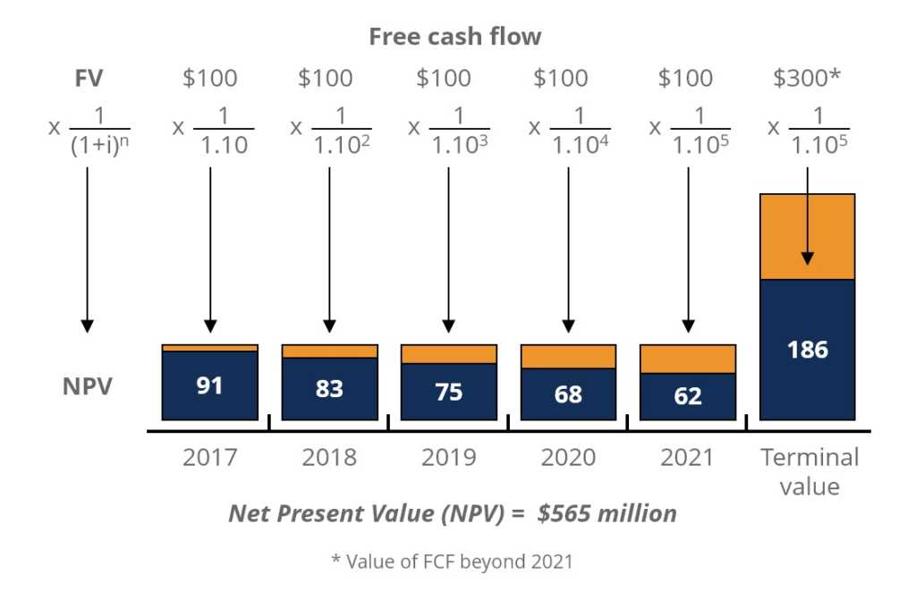

This example is taken from CFI’s Free Introduction to Corporate Finance Course, which covers the topic in more detail.

Additional Resources
We hope you’ve enjoyed CFI’s explanation of the time value of money. To learn more about money and investing, check out the following resources:
- Adjusted Present Value
- Forecasting Methods
- NPV Formula
- Valuation Methods

Valuation Techniques
Learn the most important valuation techniques in CFI’s Business Valuation course!
Step by step instruction on how the professionals on Wall Street value a company.

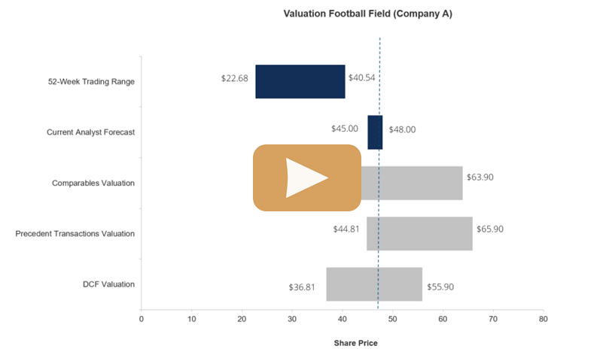
https://cleartax.in/s/time-value-money-tvm

Time Value of Money ( TVM ) – Definition, Formula & Example
Updated on Sep 09, 2020 - 08:03:57 PM
‘A bird in hand is worth two in the bush’ – this adage applies to financial transactions too. Say, someone borrowed a certain amount from you and it is due. Just as you are expecting the money to be credited to your account, you get a call from the borrower saying that he will pay you after 3 months. You are not happy about this. This is because you are aware of time value of money or TVM, albeit subconsciously. In this article, we will discuss the concept of time value of money, also called as present value through the following topics.
- What is Time Value of Money – Definition
- TVM with an example
- Present Value and Future Value
- Basic TVM Formula
- TVM and Compounding Periods

1.What is Time Value of Money – Definition
There is no reason for any rational person to delay taking an amount owed to him or her. More than financial principles, this is basic instinct. The money you have in hand at the moment is worth more than the same amount you ‘may’ get in future. One reason for this is inflation and another is possible earning capacity. The fundamental code of finance maintains that, given money can generate interest, the value of a certain sum is more if you receive it sooner. This is why it is called as the present value.
Basically, the time value of money validates that it is more beneficial to have cash now than later. Say, if you invest a Rs. 100 today – the returns will be more compared to the same investment made 2 months from now. Moreover, there is always a risk that the borrower might delay even more or not pay at all in the future.

2. TVM with an example
The relevance of TVM depends on how much returns you can generate from the capital available. Money has immense growth potential and the more you delay employing this potential, the more you lose the chance to earn on it. For instance, if a friend or lender gives you two options – to take Rs. 10,000 today or to take Rs, 10,500 next year.
Now, even if this promise is from someone or an entity you trust implicitly, chances are more that the second option is a raw deal. With more and more schemes ranging from low-risk to high-risk – tax-saving FDs, ELSS et. – there is a high chance that you can make at least 7% on this sum, which is Rs. 10,700. But if the interest rate offered is less than 5%, then you may consider taking the money next year. So, it depends on the possible returns as per the RBI guidelines or the market.

3. Present Value and Future Value
Present Value is the same as Time Value as elaborated above. It is the money you have currently that is equal to a future one-time disbursal or several part-payments – discounted by a suitable rate of interest.
Future Value is the sum of money that any saving scheme with a compounded interest will build to by a pre-decided future date. It applies to both lumpsum as well as recurring investments like SIP.

4. Basic TVM Formula
Based on your financial circumstances at the time, the TVM formula can vary to some extent. Example, in the case of annuity (income) or perpetuity (until death) pension payments, the general formula can have more components. But as a whole, the basic TVM formula is as shown in the image.

FV = PV x [ 1 + (I/ N) ] (N*T)
Where,
FV is Future value of money,
PV is Present value of money,
I is the interest rate,
N is the number of compounding periods annually and
T is the number of years in the tenure.
For instance, if you invest Rs. 1 lakh for 5 years at 10% interest, the future value of this one lakh will be Rs. 161,051 as per the formula. This formula can help you to analyze different investments over different time periods, enabling you to make optimal and informed financial decisions.

5. TVM and Compounding Periods
How often the invested amount compounds too has a huge impact on future value. See how increasing the compounding frequency in the above example make a difference to the earnings.
Monthly: Rs. 164530.89
Quarterly: Rs. 163,861.64
Semi-annually: Rs. 162889.46
Annually: Rs. 161,051
This is where the power of compounding works. It proves that TVM is dependent on interest rate, tenure as well as the number of compounding periods per financial year.
Now that you have grasped the concept of time value and future value, we hope you also understand why it is important to start investing. If you invest with Cleartax Invest, you have handpicked funds from top fund houses presented before you to choose from. They are well-researched and have generated good returns historically. Invest Now.

https://en.wikipedia.org/wiki/Capital_budgeting#:~:text=Capital%20budgeting%2C%20and%20investment%20appraisal,through%20the%20firm's%20capitalization%20structure%20(
Capital budgeting, and investment appraisal, is the planning process used to determine whether an organization's long term investments such as new machinery, replacement of machinery, new plants, new products, and research development projects are worth the funding of cash through the firm's capitalization structure (debt, equity or retained earnings). It is the process of allocating resources for major capital, or investment, expenditures.^{[1]} One of the primary goals of capital budgeting investments is to increase the value of the firm to the shareholders.
Many formal methods are used in capital budgeting, including the techniques such as
- Accounting rate of return
- Average accounting return
- Payback period
- Net present value
- Profitability index
- Internal rate of return
- Modified internal rate of return
- Equivalent annual cost
- Real options valuation
These methods use the incremental cash flows from each potential investment, or project. Techniques based on accounting earnings and accounting rules are sometimes used - though economists consider this to be improper - such as the accounting rate of return, and "return on investment." Simplified and hybrid methods are used as well, such as payback period and discounted payback period.

Contents
- 1Net present value
- 2Internal rate of return
- 3Equivalent annuity method
- 4Real options
- 5Ranked projects
- 6Funding sources
- 7Need
- 8See also
- 9External links and references

Net present value[edit]
Main article: Corporate finance § Investment and project valuation
Cash flows are discounted at the cost of capital to give the net present value (NPV) added to the firm. Unless capital is constrained, or there are dependencies between projects, in order to maximize the value added to the firm, the firm would accept all projects with positive NPV. This method accounts for the time value of money. For the mechanics of the valuation here, see Valuation using discounted cash flows.
Mutually exclusive projects are a set of projects from which at most one will be accepted, for example, a set of projects which accomplish the same task. Thus when choosing between mutually exclusive projects, more than one of the projects may satisfy the capital budgeting criterion, but only one project can be accepted; see below #Ranked projects.

Internal rate of return[edit]
Main article: Internal rate of return
The internal rate of return (IRR) is the discount rate that gives a net present value (NPV) of zero. It is a widely used measure of investment efficiency. To maximize return, sort projects in order of IRR.
Many projects have a simple cash flow structure, with a negative cash flow at the start, and subsequent cash flows are positive. In such a case, if the IRR is greater than the cost of capital, the NPV is positive, so for non-mutually exclusive projects in an unconstrained environment, applying this criterion will result in the same decision as the NPV method.
An example of a project with cash flows which do not conform to this pattern is a loan, consisting of a positive cash flow at the beginning, followed by negative cash flows later. The greater the IRR of the loan, the higher the rate the borrower must pay, so clearly, a lower IRR is preferable in this case. Any such loan with IRR less than the cost of capital has a positive NPV.
Excluding such cases, for investment projects, where the pattern of cash flows is such that the higher the IRR, the higher the NPV, for mutually exclusive projects, the decision rule of taking the project with the highest IRR will maximize the return, but it may select a project with a lower NPV.
In some cases, several solutions to the equation NPV = 0 may exist, meaning there is more than one possible IRR. The IRR exists and is unique if one or more years of net investment (negative cash flow) are followed by years of net revenues. But if the signs of the cash flows change more than once, there may be several IRRs. The IRR equation generally cannot be solved analytically but only via iterations.
IRR is the return on capital invested, over the sub-period it is invested. It may be impossible to reinvest intermediate cash flows at the same rate as the IRR. Accordingly, a measure called Modified Internal Rate of Return (MIRR) is designed to overcome this issue, by simulating reinvestment of cash flows at a second rate of return.
Despite a strong academic preference for maximizing the value of the firm according to NPV, surveys indicate that executives prefer to maximize returns^{[citation needed]}.

Equivalent annuity method[edit]
Main article: Equivalent annual cost
The equivalent annuity method expresses the NPV as an annualized cash flow by dividing it by the present value of the annuity factor. It is often used when assessing only the costs of specific projects that have the same cash inflows. In this form it is known as the equivalent annual cost (EAC) method and is the cost per year of owning and operating an asset over its entire lifespan.
It is often used when comparing investment projects of unequal lifespans. For example, if project A has an expected lifetime of 7 years, and project B has an expected lifetime of 11 years it would be improper to simply compare the net present values (NPVs) of the two projects, unless the projects could not be repeated.
The use of the EAC method implies that the project will be replaced by an identical project.
Alternatively the chain method can be used with the NPV method under the assumption that the projects will be replaced with the same cash flows each time. To compare projects of unequal length, say 3 years and 4 years, the projects are chained together, i.e. four repetitions of the 3-year project are compare to three repetitions of the 4-year project. The chain method and the EAC method give mathematically equivalent answers.
The assumption of the same cash flows for each link in the chain is essentially an assumption of zero inflation, so a real interest rate rather than a nominal interest rate is commonly used in the calculations.

Real options[edit]
Main article: Real options analysis
Real options analysis has become important since the 1970s as option pricing models have gotten more sophisticated. The discounted cash flow methods essentially value projects as if they were risky bonds, with the promised cash flows known. But managers will have many choices of how to increase future cash inflows, or to decrease future cash outflows. In other words, managers get to manage the projects - not simply accept or reject them. Real options analysis tries to value the choices - the option value - that the managers will have in the future and adds these values to the NPV.

Ranked projects[edit]
The real value of capital budgeting is to rank projects. Most organizations have many projects that could potentially be financially rewarding. Once it has been determined that a particular project has exceeded its hurdle, then it should be ranked against peer projects (e.g. - highest Profitability index to lowest Profitability index). The highest ranking projects should be implemented until the budgeted capital has been expended.

Funding sources[edit]
Capital budgeting investments and projects must be funded through excess cash provided through the raising of debt capital, equity capital, or the use of retained earnings. Debt capital is borrowed cash, usually in the form of bank loans, or bonds issued to creditors. Equity capital are investments made by shareholders, who purchase shares in the company's stock. Retained earnings are excess cash surplus from the company's present and past earnings.

https://quickbooks.intuit.com/in/resources/budget/capital-budgeting/

Capital Budgeting: Meaning, Process and Techniques
By PRADEEPA H
7 min read

In this article, you will learn:
- What is Capital Budgeting?
- Process of Capital Budgeting
- Techniques of Capital Budgeting
Try QuickBooks Invoicing & Accounting Software – 30 Days Free Trial.
A company’s manager has to plan for the expenditure and benefits an entity would derive from investing in an underlying project.
These investment decisions are typically pertaining to the long term assets that are expected to produce benefits over more than one year. All such evaluation forms part of the capital budgeting process.
In this article, you will learn what is capital budgeting, capital budgeting process and techniques of capital budgeting.

What is a Capital Budgeting?
Capital budgeting is the process of making investment decisions in long term assets. It is the process of deciding whether or not to invest in a particular project as all the investment possibilities may not be rewarding.
Thus, the manager has to choose a project that gives a rate of return more than the cost financing such a project. That is why he has to value a project in terms of cost and benefit.
Following are the categories of projects that can be examined using capital budgeting process:
- The decision to buy new machinery
- Expansion of business in other geographical areas
- Replacement of an obsolete equipment
- New product or market development etc
Thus, capital budgeting is the most important responsibility undertaken by a financial manager. This is because:
- It involves the purchase of long term assets and such decisions may determine the future success of the firm.
- These decisions help in maximizing shareholder’s value.
- Principles applicable to capital budgeting process also apply to other corporate decisions like working capital management.

Process of Capital Budgeting
Following are the steps of capital budgeting process:

Idea Generation
The most important step of the capital budgeting process is generating good investment ideas. These investment ideas can come from a number of sources like the senior management, any department or functional area, employees, or sources outside the company.

Analyzing Individual Proposals
A manager must gather information to forecast cash flows for each project in order to determine its expected profitability. This is because the decision to accept or reject a capital investment is based on such an investment’s future expected cash flows.

Planning Capital Budget
An entity must give priority to profitable projects as per the timing of the project’s cash flows, available company resources, and a company’s overall strategies. The projects that look promising individually may be undesirable strategically. Thus, prioritizing and scheduling projects is important because of the financial and other resource issues.

Monitoring and Conducting a Post Audit
It is important for a manager to follow up or track all the capital budgeting decisions. He should compare actual with projected results and give reasons as to why projections did not match with actual performance. Therefore, a systematic post-audit is essential in order to find out systematic errors in the forecasting process and hence enhance company operations.

Techniques of Capital Budgeting
Capital budgeting techniques are the methods to evaluate an investment proposal in order to help the company decide upon the desirability of such a proposal. These techniques are categorized into two heads : traditional methods and discounted cash flow methods.
Traditional Methods
Traditional methods determine the desirability of an investment project based on its useful life and expected returns. Furthermore, these methods do not take into account the concept of time value of money.
Pay Back Period Method
Payback period refers to the number of years it takes to recover the initial cost of an investment. Therefore, it is a measure of liquidity for a firm. Thus, if an entity has liquidity issues, in such a case, shorter a project’s payback period, better it is for the firm.
Therefore,
Payback period = Full years until recovery + (unrecovered cost at the beginning of the last year)/
Cash flow during the last year
Here, full years until recovery is nothing but the payback that occurs when cumulative net cash flow equals to zero. Cumulative net cash flow is the running total of cash flows at the end of each time period.
Average Rate of Return Method (ARR)
Under ARR method, the profitability of an investment proposal can be determined by dividing average income after taxes by average investment, which is average book value after depreciation.
Thus, ARR = Average Net Income After Taxes/Average Investment x 100
Where, Average Income After Taxes = Total Income After Taxes/Total Number of Years
Average Investment = Total Investment/2
Based on this method, a company can select those projects that have ARR higher than the minimum rate established by the company. And, it can reject the projects having ARR less than the expected rate of return.
Discounted Cash Flow Methods
As mentioned above, traditional methods do not take into the account time value of money. Rather, these methods take into consideration present and future flow of incomes. However, the DCF method accounts for the concept that a rupee earned today is worth more than a rupee earned tomorrow. This means that DCF methods take into account both profitability and time value of money.
Net Present Value Method (NPV)
NPV is the sum of the present values of all the expected incremental cash flows of a project discounted at a required rate of return less than the present value of the cost of the investment.
In other words, NPV is the difference between the present value of cash inflows of a project and the initial cost of the project. As per this technique, the projects whose NPV is positive or above zero shall be selected.
If a project’s NPV is less than zero or negative, the same must be rejected. Further, if there is more than one project with positive NPV, then the project with the highest NPV shall be selected.
NPV = CF1/(1 + k)1 + ……….. CFn/ (1 + k)n + CF0
where CF0 = Initial Investment Outlay (Negative Cash flow)
CFt = after tax cash flow at time t
k = required rate of return
Internal Rate of Return (IRR)
Internal Rate of Return refers to the discount rate that makes the present value of expected after-tax cash inflows equal to the initial cost of the project.
In other words, IRR is the discount rate that makes present values of a project’s estimated cash inflows equal to the present value of the project’s estimated cash outflows.
If IRR is greater than the required rate of return for the project, then accept the project. And if IRR is less than the required rate of return, then reject the project.
PV (inflows) = PV (outflows)
NPV = 0 = CF0 + CF1/(1 + IRR)1 + ……….. CFn/ (1 + IRR)n + CF0
Profitability Index
Profitability Index is the present value of a project’s future cash flows divided by initial cash outlay. Thus, it si closely related to NPV. NPV is the difference between the present value of future cash flows and the initial cash outlay.
Whereas, PI is the ratio of the present value of future cash flows and initial cash outlay.
PI = PV of future cash flows/CF0 = 1 + NPV/CF0
Thus, if the NPV of a project is positive, PI will be greater than 1. If NPV is negative, PI will be less than 1. Therefore, based on this, if PI is greater than 1, accept the project otherwise reject.
Reference Material
Thus, the manager has to evaluate the project in terms of costs and benefits as all the investment possibilities may not be rewarding. This evaluation is done based on the incremental cash flows from a project, opportunity costs of undertaking the project, timing of cash flows and financing costs.
Therefore, it is the planning of expenditure and benefit that spreads over a number of years.
Capital budgeting process used by managers depends upon size and complexity of the project to be evaluated, size of the organization and the position of the manager in the organization.
establish norms for a company on the basis of which it either accepts or rejects an investment project. The most widely used techniques in estimating cost-benefit of investment projects.
These methods are used to evaluate the worth of an investment project depending upon the accounting information available from a company’s books of accounts.
Which is a significant factor to determine the desirability of an investment project in terms of present value?
payback period is determined from the cumulative cash flows in the following way
- Capital Budgeting
- Process of Capital Budgeting
- Techniques of Capital Budgeting
https://cleartax.in/s/capital-budgeting

Capital Budgeting
Updated on Mar 06, 2020 - 12:46:03 PM
Capital budgeting is made up of two words ‘capital’ and ‘budgeting.’ In this context, capital expenditure is the spending of funds for large expenditures like purchasing fixed assets and equipment, repairs to fixed assets or equipment, research and development, expansion and the like. Budgeting is setting targets for projects to ensure maximum profitability.
- What is Capital Budgeting?
- Objectives of Capital budgeting?
- Capital Budgeting Process
- Capital Budgeting Techniques
- Conclusion

What is Capital Budgeting?
Capital budgeting is a process of evaluating investments and huge expenses in order to obtain the best returns on investment.
An organization is often faced with the challenges of selecting between two projects/investments or the buy vs replace decision. Ideally, an organization would like to invest in all profitable projects but due to the limitation on the availability of capital an organization has to choose between different projects/investments.
Capital budgeting as a concept affects our daily lives. Let’s look at an example-

Your mobile phone has stopped working! Now, you have two choices: Either buy a new one or get the same mobile repaired. Here, you may conclude that the costs of repairing the mobile increases the life of the phone. However, there could be a possibility that the cost to buy a new cell phone would be lesser than its repair costs. So, you decide to replace your cell phone and you proceed to look at different phones that fit your budget!

What are the objectives of Capital budgeting?
Capital expenditures are huge and have a long-term effect. Therefore, while performing a capital budgeting analysis an organization must keep the following objectives in mind:

1. Selecting profitable projects
An organization comes across various profitable projects frequently. But due to capital restrictions, an organization needs to select the right mix of profitable projects that will increase its shareholders’ wealth.

2. Capital expenditure control
Selecting the most profitable investment is the main objective of capital budgeting. However, controlling capital costs is also an important objective. Forecasting capital expenditure requirements and budgeting for it, and ensuring no investment opportunities are lost is the crux of budgeting.

3. Finding the right sources for funds
Determining the quantum of funds and the sources for procuring them is another important objective of capital budgeting. Finding the balance between the cost of borrowing and returns on investment is an important goal of Capital Budgeting.

Capital Budgeting Process
The process of capital budgeting is as follows:
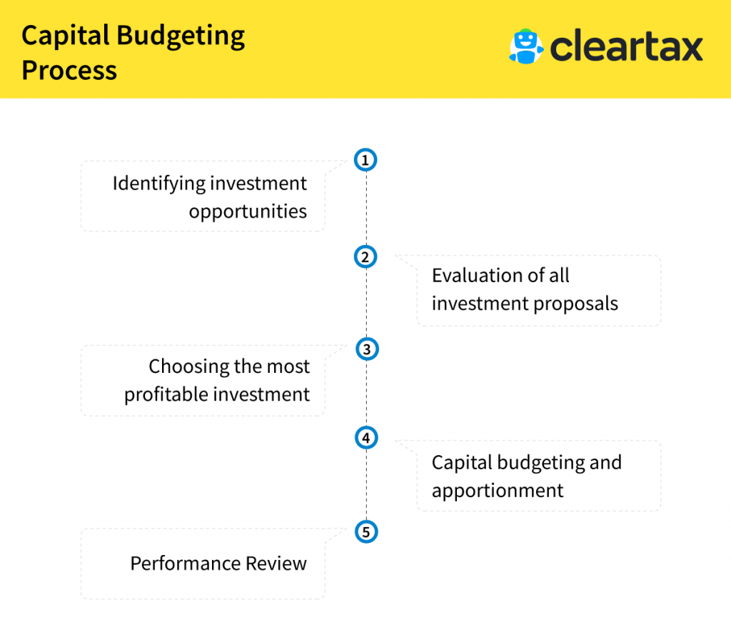

1. Identifying investment opportunities
An organization needs to first identify an investment opportunity. An investment opportunity can be anything from a new business line to product expansion to purchasing a new asset. For example, a company finds two new products that they can add to their product line.

2. Evaluating investment proposals
Once an investment opportunity has been recognized an organization needs to evaluate its options for investment. That is to say, once it is decided that new product/products should be added to the product line, the next step would be deciding on how to acquire these products. There might be multiple ways of acquiring them. Some of these products could be:
- Manufactured In-house
- Manufactured by Outsourcing manufacturing the process, or
- Purchased from the market

3. Choosing a profitable investment
Once the investment opportunities are identified and all proposals are evaluated an organization needs to decide the most profitable investment and select it. While selecting a particular project an organization may have to use the technique of capital rationing to rank the projects as per returns and select the best option available.
In our example, the company here has to decide what is more profitable for them. Manufacturing or purchasing one or both of the products or scrapping the idea of acquiring both.

4. Capital Budgeting and Apportionment
After the project is selected an organization needs to fund this project. To fund the project it needs to identify the sources of funds and allocate it accordingly.
The sources of these funds could be reserves, investments, loans or any other available channel.

5. Performance Review
The last step in the process of capital budgeting is reviewing the investment. Initially, the organization had selected a particular investment for a predicted return. So now, they will compare the investments expected performance to the actual performance.
In our example, when the screening for the most profitable investment happened, an expected return would have been worked out. Once the investment is made, the products are released in the market, the profits earned from its sales should be compared to the set expected returns. This will help in the performance review.

Capital Budgeting Techniques
To assist the organization in selecting the best investment there are various techniques available based on the comparison of cash inflows and outflows.
These techniques are:

1. Payback period method
In this technique, the entity calculates the time period required to earn the initial investment of the project or investment. The project or investment with the shortest duration is opted for.

2. Net Present value
The net present value is calculated by taking the difference between the present value of cash inflows and the present value of cash outflows over a period of time. The investment with a positive NPV will be considered. In case there are multiple projects, the project with a higher NPV is more likely to be selected.

3. Accounting Rate of Return
In this technique, the total net income of the investment is divided by the initial or average investment to derive at the most profitable investment.

4. Internal Rate of Return (IRR)
For NPV computation a discount rate is used. IRR is the rate at which the NPV becomes zero. The project with higher IRR is usually selected.

5. Profitability Index
Profitability Index is the ratio of the present value of future cash flows of the project to the initial investment required for the project.
Each technique comes with inherent advantages and disadvantages. An organization needs to use the best-suited technique to assist it in budgeting. It can also select different techniques and compare the results to derive at the best profitable projects.

Conclusion
Capital budgeting is a predominant function of management. Right decisions taken can lead the business to great heights. However, a single wrong decision can inch the business closer to shut down due to the number of funds involved and the tenure of these projects.
https://www.investopedia.com/terms/i/irr.asp#:~:text=IRR%20is%20the%20annual%20rate,of%20annual%20return%20over%20time.

What Is Internal Rate of Return (IRR)?
The internal rate of return is a metric used in financial analysis to estimate the profitability of potential investments. The internal rate of return is a discount rate that makes the net present value (NPV) of all cash flows equal to zero in a discounted cash flow analysis. IRR calculations rely on the same formula as NPV does.

KEY TAKEAWAYS
- IRR is the annual rate of growth an investment is expected to generate.
- IRR is calculated using the same concept as NPV, except it sets the NPV equal to zero.
- IRR is ideal for analyzing capital budgeting projects to understand and compare potential rates of annual return over time.

Formula and Calculation for IRR
The formula and calculation used to determine this figure is as follows.
\begin{aligned} &\text{0}=\text{NPV}=\sum_{t=1}^{T}\frac{C_t}{\left(1+IRR\right)^t}-C_0\\ &\textbf{where:}\\ &C_t=\text{Net cash inflow during the period t}\\ &C_0=\text{Total initial investment costs}\\ &IRR=\text{The internal rate of return}\\ &t=\text{The number of time periods}\\ \end{aligned}​0=NPV=t=1∑T​(1+IRR)tCt​​−C0​where:Ct​=Net cash inflow during the period tC0​=Total initial investment costsIRR=The internal rate of returnt=The number of time periods​﻿
To calculate IRR using the formula, one would set NPV equal to zero and solve for the discount rate, which is the IRR. However, because of the nature of the formula, IRR cannot be easily calculated analytically and therefore must instead be calculated either through trial-and-error or by using software programmed to calculate IRR. This can be done in Excel.¹﻿
Generally speaking, the higher an internal rate of return, the more desirable an investment is to undertake. IRR is uniform for investments of varying types and, as such, IRR can be used to rank multiple prospective investments or projects on a relatively even basis. In general, when comparing investment options, the investment with the highest IRR would probably be considered the best.

How to Calculate IRR in Excel
Using the IRR function in Excel makes calculating the IRR easy. Excel does all the necessary work for you, arriving at the discount rate you are seeking to find. All you need to do is combine your cash flows, including the initial outlay as well as subsequent inflows, with the IRR function.¹﻿ The IRR function can be found by clicking on the Formulas Insert (fx) icon.²﻿
Here is a simple example of an IRR analysis with cash flows that are known and annually periodic (one year apart). Assume a company is assessing the profitability of Project X. Project X requires $250,000 in funding and is expected to generate $100,000 in after-tax cash flows the first year and grow by $50,000 for each of the next four years.

Image by Sabrina Jiang © Investopedia 2020
The initial investment is always negative because it represents an outflow. Each subsequent cash flow could be positive or negative, depending on the estimates of what the project delivers in the future. In this case, the IRR is 56.72%, which is quite high.
Keep in mind that the IRR is not the actual dollar value of the project. It is the annual return that makes the net present value equal to zero.
Excel also offers two other functions that can be used in IRR calculations, the XIRR and the MIRR. XIRR is used when the cash flow model does not exactly have annual periodic cash flows.³﻿ The MIRR is a rate of return measure that also includes the integration of cost of capital as well as the risk-free rate.⁴﻿
Excel includes IRR, XIRR, and MIRR functions for use in IRR analysis.⁵﻿

When to Use IRR
There are several formulas and concepts that can be used when seeking to identify an expected return. The IRR is generally most ideal for analyzing the potential return of a new project that a company is considering undertaking.
You can think of the internal rate of return as the rate of growth an investment is expected to generate annually. Thus, it can be most similar to a compound annual growth rate (CAGR). In reality, an investment will usually not have the same rate of return each year. Usually, the actual rate of return that a given investment ends up generating will differ from its estimated IRR.
In capital planning, one popular scenario for IRR is comparing the profitability of establishing new operations with that of expanding existing ones. For example, an energy company may use IRR in deciding whether to open a new power plant or to renovate and expand a previously existing one. While both projects could add value to the company, it is likely that one will be the more logical decision as prescribed by IRR.

What IRR Tells You
Most IRR analysis will be done in conjunction with a view of a company’s weighted average cost of capital (WACC) and net present value calculations. IRR is typically a relatively high value, which allows it to arrive at a NPV of zero. Most companies will require an IRR calculation to be above the WACC. Analysis will also typically involve NPV calculations at different assumed discount rates.
In theory, any project with an IRR greater than its cost of capital should be a profitable one. In planning investment projects, firms will often establish a required rate of return (RRR) to determine the minimum acceptable return percentage that the investment in question must earn in order to be worthwhile. The RRR will be higher than the WACC.
Any project with an IRR that exceeds the RRR will likely be deemed a profitable one, although companies will not necessarily pursue a project on this basis alone. Rather, they will likely pursue projects with the highest difference between IRR and RRR, as these likely will be the most profitable.
IRR may also be compared against prevailing rates of return in the securities market. If a firm can't find any projects with IRR greater than the returns that can be generated in the financial markets, it may simply choose to invest money into the market. Market returns can also be a factor in setting a required rate of return.

IRR vs. Compound Annual Growth Rate
The CAGR measures the annual return on an investment over a period of time. The IRR is also an annual rate of return. However, CAGR typically uses only a beginning and ending value to provide an estimated annual rate of return. IRR differs in that it involves multiple periodic cash flows–reflecting the fact that cash inflows and outflows often constantly occur when it comes to investments. Another distinction is that CAGR is simple enough that it can be calculated easily.

IRR vs. Return on Investment (ROI)
Companies and analysts may also look at the return on investment when making capital budgeting decisions. ROI tells an investor about the total growth, start to finish, of the investment. It is not an annual rate of return. IRR tells the investor what the annual growth rate is. The two numbers would normally be the same over the course of one year, but they won't be the same for longer periods of time.
Return on investment is the percentage increase or decrease of an investment from beginning to end. It is calculated by taking the difference between the current or expected future value and the original, beginning value, divided by the original value and multiplied by 100.
ROI figures can be calculated for nearly any activity into which an investment has been made and an outcome can be measured. However, ROI is not necessarily the most helpful for long time frames. It also has limitations in capital budgeting, where the focus is often on periodic cash flows and returns.

Limitations of the IRR
IRR is generally most ideal for use in analyzing capital budgeting projects. It can be misconstrued or misinterpreted if used outside of appropriate scenarios.
Within its realm of uses, IRR is a very popular metric for estimating a project’s annual return. However, it is not necessarily intended to be used alone. IRR is typically a relatively high value, which allows it to arrive at a NPV of zero. The IRR itself is only a single estimated figure that provides an annual return value based on estimates. Since estimates in both IRR and NPV can differ drastically from actual results, most analysts will choose to combine IRR analysis with scenarios analysis. Scenarios can show different possible NPVs based on varying assumptions.
As mentioned, most companies do not rely on IRR and NPV analysis alone. These calculations are usually also studied in conjunction with a company’s WACC and a RRR, which provides for further consideration.
Companies usually compare IRR analysis to other tradeoffs. If another project has a similar IRR with less upfront capital or simpler extraneous considerations then a simpler investment may be chosen despite IRRs.
In some cases, issues can also arise when using IRR to compare projects of different lengths. For example, a project of short duration may have a high IRR, making it appear to be an excellent investment. Conversely, a longer project may have a low IRR, earning returns slowly and steadily. The ROI metric can provide some more clarity in these cases. Though some managers may not want to wait out the longer time frame.

Investing Based on IRR
The internal rate of return rule is a guideline for evaluating whether to proceed with a project or investment. The IRR rule states that if the internal rate of return on a project or investment is greater than the minimum required rate of return, typically the cost of capital, then the project or investment can be pursued. Conversely, if the IRR on a project or investment is lower than the cost of capital, then the best course of action may be to reject it. Overall, while there are some limitations to IRR, it is an industry standard for analyzing capital budgeting projects.
https://cleartax.in/s/internal-rate-of-return-irr

Internal Rate of Return – Meaning, Formula and Usage
Updated on Nov 27, 2019 - 12:05:47 PM
Capital budgeting is a function of management, which uses various techniques to assist in decision making. Internal Rate of Return (IRR) is one such technique of capital budgeting. It is the rate of return at which the net present value of a project becomes zero. They call it ‘internal’ because it does not take any external factor (like inflation) into consideration.
- Introduction
- How is the Internal Rate of Return computed?
- How is IRR used for capital budgeting?
- What are the shortcomings of the method?

1.Introduction
The internal rate of return (IRR) is a discounting cash flow technique which gives a rate of return earned by a project. The internal rate of return is the discounting rate where the total of initial cash outlay and discounted cash inflows are equal to zero. In other words, it is the discounting rate at which the net present value(NPV) is equal to zero.

2.How is the Internal Rate of Return computed?
For the computation of the internal rate of return, we use the same formula as NPV. To derive the IRR, an analyst has to rely on trial and error method and cannot use analytical methods. With automation, various software (like Microsoft Excel) is also available to calculate IRR. In Excel, there is a financial function that uses cash flows at regular intervals for calculation.
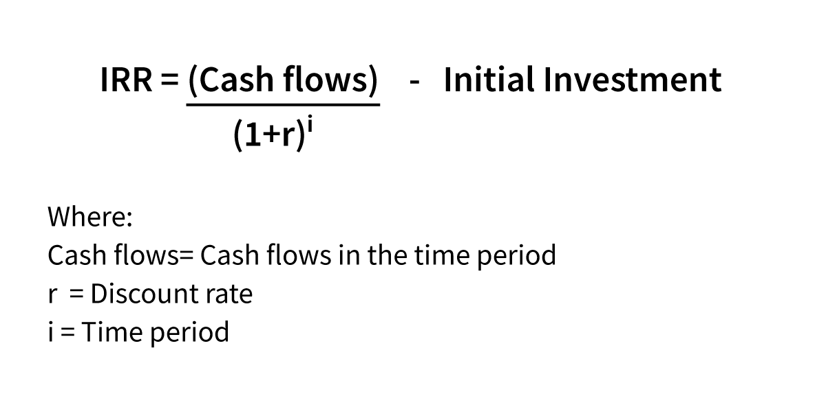
The rate at which the cost of investment and the present value of future cash flows match will be considered as the ideal rate of return. A project that can achieve this is a profitable project. In other words, at this rate the cash outflows and the present value of inflows are equal, making the project attractive.

3.How is IRR used for capital budgeting?
If the same costs apply for different projects, then the project with the highest IRR will be selected. If an organization needs to choose between multiple investment options wherein the cost of investment remains constant, then IRR will be used to rank the projects and select the most profitable one. Ideally, the IRR higher than the cost of capital is selected.
In real life scenarios, since the investment in any project will be huge and will have a long-term effect, an organization uses a combination of various techniques of capital budgeting like NPV, IRR and payback period to select the best project.
Illustration
Let us say a company has an option to replace its machinery. The cost and return are as follows:
Initial investment = Rs.5,00,000
Incremental increase per year = Rs.2,00,000
Replacement value = Rs.45,270
Life of asset = 3 years
If we assume IRR to be 13%, the computation will be as follows.
Year | Cash flows | Discounted cash flows
0 | -500000 | (500000) (5,00,000 * 1)
1 | 200000 | 176991
 |  | (2,00,000 * [1/1.13])
2 | 200000 | 156229 (2,00,000 * [1/1.13]2
3 | 200000 | 138610
 |  | (2,00,000 * [1/1.13]3
4 | 45270 | 27765(45,270 * [1/1.13]4
The total of the column Discounted Cash Flows approximately sums up to zero making the NPV equal to Zero. Hence, this discounted rate is the best rate.
As can be seen from the above, using the rate of 13%, the cash flows, both positive and negative become minimum. Hence, it is the best rate of return on investment.
The cost of capital of the company is 10%. Since the IRR is higher than the cost of capital, the project can be selected.
If the company has another opportunity to invest the money in a project that gives a 12% return, the company will still go in for the machinery replacement since it gives the highest IRR.

4.What are the shortcomings of the method?
As mentioned earlier, IRR is widely used and adopted by many companies in combination with other techniques for capital budgeting. However, this method has some shortcomings.
- IRR does not take into consideration the duration of the project. Example, if the company has to choose between two projects – Project A with IRR 15% and duration is one year and Project B with IRR 20% and project duration is 5 years and the cost of capital of the company is 10% – both the projects are profitable. If the company selects Project B because it has a higher IRR it would be incorrect as the duration of Project B is longer.
- IRR assumes that the cash flows are reinvested at the same rate as the project, instead of the cost of capital. Hence, IRR may not give a true picture of the profitability.
Given the shortcomings of the method, analysts are using the Modified Internal Rate of Return. It assumes that the positive cash flows are reinvested at the cost of capital and not IRR.
IRR and NPV together can help one understand the profitability of the project and also choose the most suitable project with a positive NPV. Further, users can compare the IRR of different projects and go for the most profitable one.
https://www.investopedia.com/terms/n/npv.asp#:~:text=Net%20present%20value%20(NPV)%20is,a%20projected%20investment%20or%20project.

Net Present Value (NPV)
By WILL KENTON
Reviewed By JULIUS MANSA
Updated Aug 17, 2020

What is Net Present Value (NPV)?
Net present value (NPV) is the difference between the present value of cash inflows and the present value of cash outflows over a period of time. NPV is used in capital budgeting and investment planning to analyze the profitability of a projected investment or project.
The following formula is used to calculate NPV:
\begin{aligned} &NPV = \sum_{t = 1}^n \frac { R_t }{ (1 + i)^t } \\ &\textbf{where:} \\ &R_t=\text{Net cash inflow-outflows during a single period }t \\ &i=\text{Discount rate or return that could be earned in} \\ &\text{alternative investments} \\ &t=\text{Number of timer periods} \\ \end{aligned}​NPV=t=1∑n​(1+i)tRt​​where:Rt​=Net cash inflow-outflows during a single period ti=Discount rate or return that could be earned inalternative investmentst=Number of timer periods​﻿
If you are unfamiliar with summation notation – here is an easier way to remember the concept of NPV:
\begin{aligned} &\textit{NPV} = \text{TVECF} - \text{TVIC} \\ &\textbf{where:} \\ &\text{TVECF} = \text{Today's value of the expected cash flows} \\ &\text{TVIC} = \text{Today's value of invested cash} \\ \end{aligned}​NPV=TVECF−TVICwhere:TVECF=Today’s value of the expected cash flowsTVIC=Today’s value of invested cash​﻿
A positive net present value indicates that the projected earnings generated by a project or investment - in present dollars - exceeds the anticipated costs, also in present dollars. It is assumed that an investment with a positive NPV will be profitable, and an investment with a negative NPV will result in a net loss. This concept is the basis for the Net Present Value Rule, which dictates that only investments with positive NPV values should be considered.
Apart from the formula itself, net present value can be calculated using tables, spreadsheets, or calculators.
Volume 75%

0:22

Understanding Net Present Value

How to Calculate Net Present Value (NPV)
Money in the present is worth more than the same amount in the future due to inflation and to earnings from alternative investments that could be made during the intervening time. In other words, a dollar earned in the future won’t be worth as much as one earned in the present. The discount rate element of the NPV formula is a way to account for this.
For example, assume that an investor could choose a $100 payment today or in a year. A rational investor would not be willing to postpone payment. However, what if an investor could choose to receive $100 today or $105 in a year? If the payer was reliable, that extra 5% may be worth the wait, but only if there wasn’t anything else the investors could do with the $100 that would earn more than 5%.
An investor might be willing to wait a year to earn an extra 5%, but that may not be acceptable for all investors. In this case, the 5% is the discount rate which will vary depending on the investor. If an investor knew they could earn 8% from a relatively safe investment over the next year, they would not be willing to postpone payment for 5%. In this case, the investor’s discount rate is 8%.
A company may determine the discount rate using the expected return of other projects with a similar level of risk or the cost of borrowing money needed to finance the project. For example, a company may avoid a project that is expected to return 10% per year if it costs 12% to finance the project or an alternative project is expected to return 14% per year.
Imagine a company can invest in equipment that will cost $1,000,000 and is expected to generate $25,000 a month in revenue for five years. The company has the capital available for the equipment and could alternatively invest it in the stock market for an expected return of 8% per year. The managers feel that buying the equipment or investing in the stock market are similar risks.

Step One: NPV of the Initial Investment
Because the equipment is paid for up front, this is the first cash flow included in the calculation. There is no elapsed time that needs to be accounted for so today’s outflow of $1,000,000 doesn’t need to be discounted.

Identify the number of periods (t)
The equipment is expected to generate monthly cash flow and last for five years, which means there will be 60 cash flows and 60 periods included in the calculation.

Identify the discount rate (i)
The alternative investment is expected to pay 8% per year. However, because the equipment generates a monthly stream of cash flows, the annual discount rate needs to be turned into a periodic or monthly rate. Using the following formula, we find that the periodic rate is 0.64%.
\text{Periodic Rate} = (( 1 + 0.08)^{\frac{1}{12}}) - 1 = 0.64\%Periodic Rate=((1+0.08)121​)−1=0.64%﻿

Step Two: NPV of Future Cash Flows
Assume the monthly cash flows are earned at the end of the month, with the first payment arriving exactly one month after the equipment has been purchased. This is a future payment, so it needs to be adjusted for the time value of money. An investor can perform this calculation easily with a spreadsheet or calculator. To illustrate the concept, the first five payments are displayed in the table below.

Image by Sabrina Jiang © Investopedia 2020
The full calculation of the present value is equal to the present value of all 60 future cash flows, minus the $1,000,000 investment. The calculation could be more complicated if the equipment was expected to have any value left at the end of its life, but, in this example, it is assumed to be worthless.
NPV = -\$1,000,000 + \sum_{t = 1}^{60} \frac{25,000_{60}}{(1 + 0.0064)^{60}}NPV=−$1,000,000+∑t=160​(1+0.0064)6025,00060​​﻿
That formula can be simplified to the following calculation:
NPV = -\$1,000,000 + \$1,242,322.82 = \$242,322.82NPV=−$1,000,000+$1,242,322.82=$242,322.82﻿
In this case, the NPV is positive; the equipment should be purchased. If the present value of these cash flows had been negative because the discount rate was larger, or the net cash flows were smaller, the investment should have been avoided.

Net Present Value Drawbacks and Alternatives
Gauging an investment’s profitability with NPV relies heavily on assumptions and estimates, so there can be substantial room for error. Estimated factors include investment costs, discount rate, and projected returns. A project may often require unforeseen expenditures to get off the ground or may require additional expenditures at the project’s end.
Payback period, or “payback method,” is a simpler alternative to NPV. The payback method calculates how long it will take for the original investment to be repaid. A drawback is that this method fails to account for the time value of money. For this reason, payback periods calculated for longer investments have a greater potential for inaccuracy.
Moreover, the payback period is strictly limited to the amount of time required to earn back initial investment costs. It is possible that the investment’s rate of return could experience sharp movements. Comparisons using payback periods do not account for the long-term profitability of alternative investments.

Net Present Value vs. Internal Rate of Return
Internal rate of return (IRR) is very similar to NPV except that the discount rate is the rate that reduces the NPV of an investment to zero. This method is used to compare projects with different lifespans or amount of required capital.
For example, IRR could be used to compare the anticipated profitability of a three-year project that requires a $50,000 investment with that of a 10-year project that requires a $200,000 investment. Although the IRR is useful, it is usually considered inferior to NPV because it makes too many assumptions about reinvestment risk and capital allocation.

The Bottom Line
Net present value (NPV) is the calculation used to find today’s value of a future stream of payments. It accounts for the time value of money and can be used to compare investment alternatives that are similar. The NPV relies on a discount rate of return that may be derived from the cost of the capital required to make the investment, and any project or investment with a negative NPV should be avoided. An important drawback of using an NPV analysis is that it makes assumptions about future events that may not be reliable.
https://corporatefinanceinstitute.com/resources/knowledge/valuation/net-present-value-npv/

What is Net Present Value (NPV)?
Net Present Value (NPV) is the value of all future cash flows (positive and negative) over the entire life of an investment discounted to the present. NPV analysis is a form of intrinsic valuation and is used extensively across finance and accounting for determining the value of a business, investment security, capital project, new venture, cost reduction program, and anything that involves cash flow.

NPV Formula
The formula for Net Present Value is:

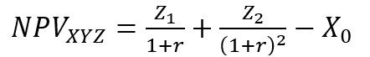

Where:
- Z₁ = Cash flow in time 1
- Z₂ = Cash flow in time 2
- r = Discount rate
- X₀ = Cash outflow in time 0 (i.e. the purchase price / initial investment)

Why is Net Present Value (NPV) Analysis Used?
NPV analysis is used to help determine how much an investment, project, or any series of cash flows is worth. It is an all-encompassing metric, as it takes into account all revenues, expenses, and capital costs associated with an investment in its Free Cash Flow (FCF).
In addition to factoring all revenues and costs, it also takes into account the timing of each cash flow that can result in a large impact on the present value of an investment. For example, it’s better to see cash inflows sooner and cash outflows later, compared to the opposite.

Why Are Cash Flows Discounted?
The cash flows in net present value analysis are discounted for two main reasons, (1) to adjust for the risk of an investment opportunity, and (2) to account for the time value of money (TVM).
The first point (to adjust for risk) is necessary because not all businesses, projects, or investment opportunities have the same level of risk. Put another way, the probability of receiving cash flow from a US Treasury bill is much higher than the probability of receiving cash flow from a young technology startup.
To account for the risk, the discount rate is higher for riskier investments and lower for a safer one. The US treasury example is considered to be the risk-free rate, and all other investments are measured by how much more risk they bear relative to that.
The second point (to account for the time value of money) is required because due to inflation, interest rates, and opportunity costs, money is more valuable the sooner it’s received. For example, receiving $1 million today is much better than $1 million received five years from now. If the money is received today, it can be invested and earn interest, so it will be worth more than $1 million in five years’ time.

Example of Net Present Value (NPV)
Let’s look at an example of how to calculate the net present value of a series of cash flows. As you can see in the screenshot below, the assumption is that an investment will return $10,000 per year over a period of 10 years, and the discount rate required is 10%.

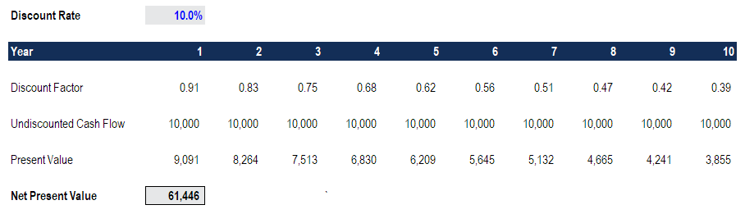

The final result is that the value of this investment is worth $61,446 today. It means a rational investor would be willing to pay up to $61,466 today to receive $10,000 every year over 10 years. By paying this price, the investor would receive an internal rate of return (IRR) of 10%. By paying anything less than $61,000, the investor would earn an internal rate of return that’s greater than 10%.

Download the Free Template
Enter your name and email in the form below and download the free template now!
Top of Form

Net Present Value Template
Download the free Excel template now to advance your finance knowledge!

* By submitting your email address, you consent to receive email messages (including discounts and newsletters) regarding Corporate Finance Institute and its products and services and other matters (including the products and services of Corporate Finance Institute's affiliates and other organizations). You may withdraw your consent at any time. This request for consent is made by Corporate Finance Institute, 801-750 W Pender Street, Vancouver, British Columbia, Canada V6C 2T8. www.corporatefinanceinstitute.com. learning@corporatefinanceinstitute.com. Please click here to view CFI`s privacy policy.
Bottom of Form

NPV Functions in Excel
Excel offers two functions for calculating net present value: NPV and XNPV. The two functions use the same math formula shown above, but save an analyst the time for calculating it in long form.
The regular NPV function =NPV() assumes that all cash flows in a series occur at regular intervals (i.e. years, quarters, month) and doesn’t allow for any variability in those time period.
The XNPV function =XNPV() allows for specific dates to be applied to each cash flow so they can be at irregular intervals. The function can be very useful as cash flows are often unevenly spaced out, and this enhanced level of precision is required.

Internal Rate of Return (IRR) and NPV
The internal rate of return (IRR) is the discount rate at which the net present value of an investment is equal to zero. Put another way, it is the compound annual return an investor expects to earn (or actually earned) over the life of an investment.
For example, if a security offers a series of cash flows with an NPV of $50,000 and an investor pays exactly $50,000 for it, then the investor’s NPV is $0. It means they will earn whatever the discount rate is on the security. Ideally, an investor would pay less than $50,000 and therefore earn an IRR that’s greater than the discount rate.
Typically, investors and managers of business look at both NPV and IRR in conjunction with other figures when making a decision. Learn about IRR vs XIRR in Excel.

Negative vs Positive Net Present Value
If the net present value of a project or investment, is negative it means the expected rate of return that will be earned on it is less than the discount rate (required rate of return or hurdle rate). This doesn’t necessarily mean the project will “lose money.” It may very well generate accounting profit (net income), but, since the rate of return generated is less than the discount rate, it is considered to destroy value. If the NPV is positive, it creates value.

Applications in Financial Modeling

NPV of a Business
To value a business an analyst will build a detailed discounted cash flow DCF model in Excel. This financial model will include all revenues, expenses, capital costs, and details of the business. Once the key assumptions are in place, the analyst can build a five-year forecast of the three financial statements (income statement, balance sheet, and cash flow) and calculate the free cash flow of the firm (FCFF), also known as the unlevered free cash flow. Finally, a terminal value is used to value the company beyond the forecast period, and all cash flows are discounted back to the present at the firm’s weighted average cost of capital. To learn more, check out CFI’s free detailed financial modeling course.

NPV of a Project
To value a project is typically more straightforward than an entire business. A similar approach is taken, where all the details of the project are modeled into Excel, however, the forecast period will be for the life of the project and there will be no terminal value. Once the free cash flow is calculated, it can be discounted back to the present at either the firm’s WACC or the appropriate hurdle rate.

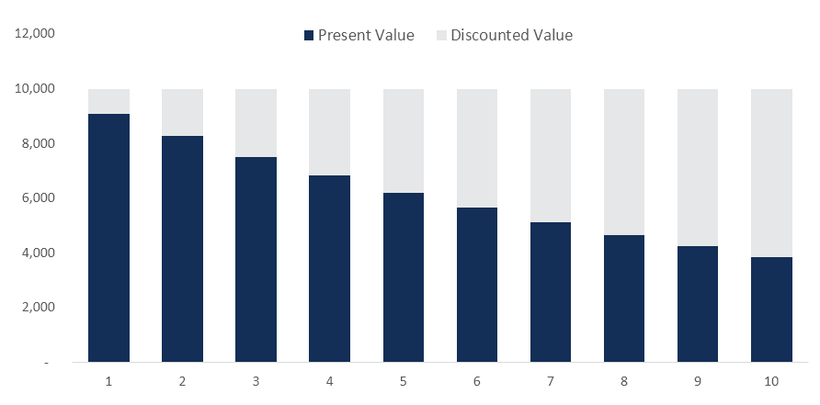

Drawbacks of Net Present Value
While net present value (NPV) is the most commonly used method for evaluating investment opportunities, it does have some drawbacks that should be carefully considered.
Key challenges to NPV analysis include:
- A long list of assumptions has to be made
- Sensitive to small changes in assumptions and drivers
- Easily manipulated to produce the desired output
- May not capture second- and third-order benefits/impacts (i.e. on other parts of a business)
- Assumes a constant discount rate over time
- Accurate risk-adjustment is challenging to perform (hard to get data on correlations, probabilities)

Additional Resources
Net Present Value (NPV) is the most detailed and widely used method for evaluating the attractiveness of an investment. Hopefully, this guide’s been helpful in increasing your understanding of how it works, why it’s used, and the pros/cons.
CFI is the official provider of the Financial Modeling & Valuation Analyst certification program. To continue advancing your career, check out these relevant resources:
- Guide to Financial Modeling
- Financial Modeling Best Practices
- Advanced Excel Formulas
- All Valuation Articles

Valuation Techniques
Learn the most important valuation techniques in CFI’s Business Valuation course!
Step by step instruction on how the professionals on Wall Street value a company.

Learn valuation
the easy way with templates and step by step instruction!

