Cost and price are often used interchangeably, however, the two words mean something different when it comes to accounting and financial statements. When conducting financial analysis or making investment decisions, it's important to understand the difference between cost and price and how they impact a company's financial profile.

Cost vs. Price
Cost is typically the expense incurred for creating a product or service a company sells. The cost to manufacture a product might include the cost of raw materials used. The amount of cost that goes into producing a product can directly impact its price and profit earned from each sale.
Price is the amount a customer is willing to pay for a product or service. The difference between price paid and costs incurred is profit. If a customer pays Rs100 for a product that costs Rs60 to make and sell, the company earns Rs40 in profit.
Difference between Cost and Price
Cost | Price
Cost is ascertained from Producer’s point of view. | Price is ascertained from customers perspective
Cost is the amount of expense that incurred by the producers to produce goods and services | Price is charged from customers for the goods and services sold to them.
The cost of a product or service is the monetary outlay incurred to create a product or service. | Price, determined by supply and demand in a free market, is what an individual is willing to pay and a seller is willing to sell for a product or service
A margin is applied to the cost. | Mark up is applied on Price.
The cost of a product depends on various numbers of factors: – Number of vendors present in the market for that product, bargaining power of the company, Nature of raw material required to produce the product, Supply and demand factors that are associated with the product | The price of a product depends on various numbers of factors: –Nature of Competition in the market, Number of buyers and sellers in the market, Target market audiences, buying power of the customer, Bargaining power of the customer

Price Discrimination
Price discrimination exists within a market when the sales of identical goods or services are sold at different prices by the same provider. The goal of price discrimination is for the seller to make the most profit possible. Although the cost of producing the products is the same, the seller has the ability to increase the price based on location, consumer financial status, product demand, etc.

Different Types of Price Discrimination

1. First Degree Price Discrimination
Also known as perfect price discrimination, first-degree price discrimination involves charging consumers the maximum price that they are willing to pay for a good or service. Here, consumer surplus is entirely captured by the firm. In practice, a consumer’s maximum willingness to pay is difficult to determine. Therefore, such a pricing strategy is rarely employed.
First-degree price discrimination occurs when firms are able to charge the maximum price that each customer is willing to pay.As a ‘perfect price discriminator’, all consumer surplus disappears and goes to producers who now gain surplus of A + BThe firm enjoys significantly higher revenue (and most likely higher profits) than if it were charging a single price
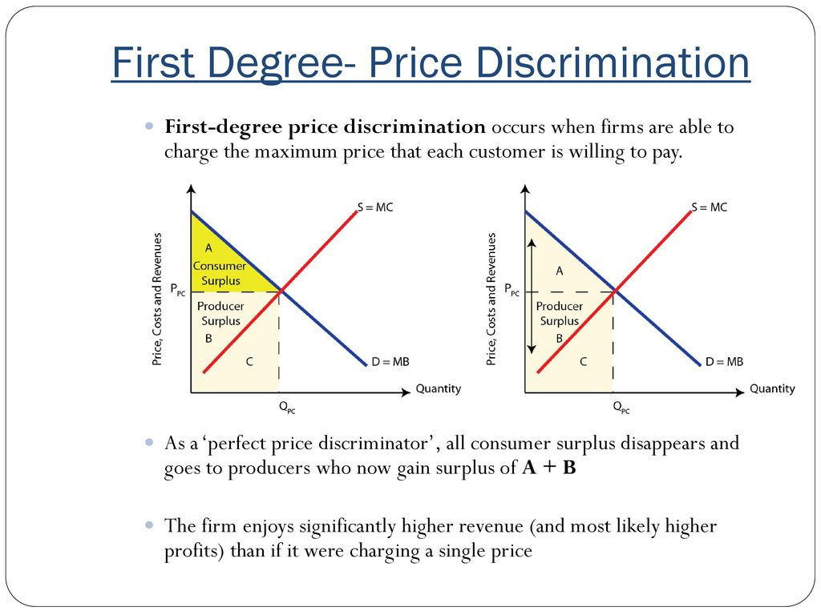

2. Second Degree Price Discrimination
Second-degree price discrimination involves charging consumers a different price for the amount or quantity consumed. Examples include:
- A phone plan that charges a higher rate after a determined number of minutes are used
- Reward cards that provide frequent shoppers with a discount on future products
- Quantity discounts for consumers that purchase a specified number of more of a certain good
In second degree price discrimination, price varies according to quantity demanded. Larger quantities are available at a lower unit price. Example; ‘Buy two, get one free’ offers in retail markets of food and consumer items. Second-degree price discriminators earn extra revenue in distinct blocks which corresponds to the discounted price levels. Total revenue increases over the single-price firm
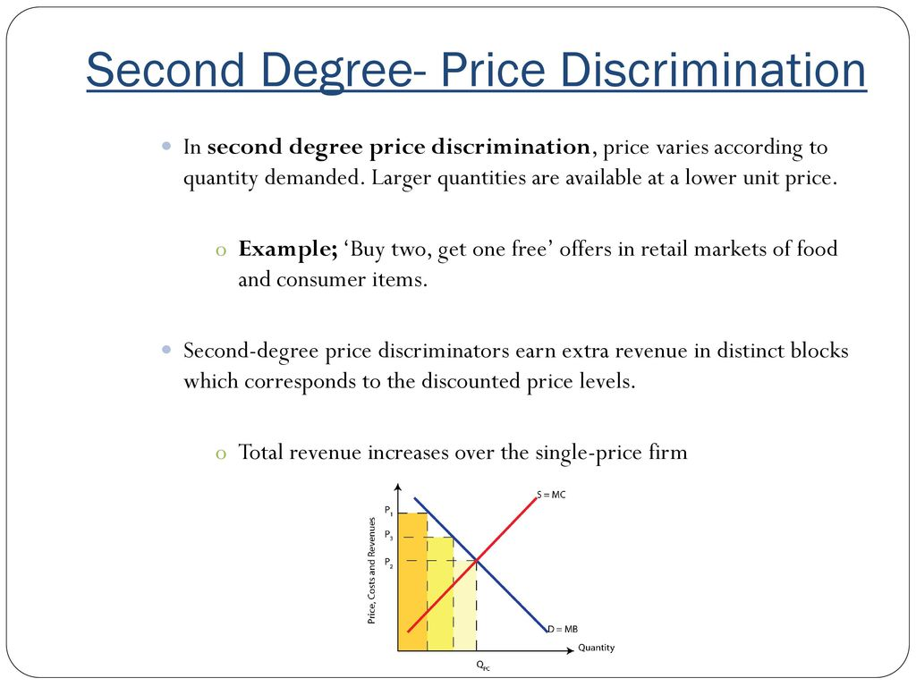

3. Third Degree Price Discrimination
Also known as group price discrimination, third-degree price discrimination involves charging different prices depending on a particular market segment or consumer group. It is commonly seen in the entertainment industry.
For example, when an individual wants to see a movie, prices for the same screening are different depending on if you are a minor, adult, or senior.
Conditions Necessary for Price Discrimination
- The seller must have some control over the supply of his product. Such monopoly power is necessary to discriminate the price.
- The seller should be able to divide the market into at least two sub-markets (or more).
- The price-elasticity of the product must be different in different markets. Therefore, the monopolist can set a high price for those buyers whose price-elasticity of demand for the product is less than 1. In simple words, even if the seller increases the price, such buyers do not reduce the purchase volume.
- Buyers from the low-priced market should not be able to sell the product to buyers from the high-priced market.

5.The firm must be able to identify different market segments, such as domestic users and industrial users.

Application of Price Discrimination
Practice of Price Discrimination is evident throughout markets and producers’ behaviour. It generates the highest revenue possible by shifting the price of a product based on the consumer’s willingness to pay, quantity demanded, and consumer attributes. Following are the few applications of Price Discrimination
Travel industry: airlines and other travel companies use price discrimination regularly in order to generate commerce. Prices vary according to seat selection, time of day, day of the week, time of year, and how close a purchase is made to the date of travel.
Coupons: coupons are used in commerce to distinguish consumers by their reserve price. A manufacturer can charge a higher price for a product which most consumers will pay. Coupons attract sensitive consumers to the same product by offering a discount. By using price discrimination, the seller makes more revenue, even off of the price sensitive consumers.
Age discount: A popular way to segment the market is by age category, e. g. students and OAPs often get discounts, such as 10% off. For rail travel, people with rail cards can get upto 33% off.

Premium pricing: uses price discrimination to price products higher than the marginal cost of production. Regular coffee is priced at $1 while premium coffee is $2.50. The marginal cost of production is only $0.90 and $1.25. The difference in price results in increased revenue because consumers are willing to pay more for the specific product.

Gender based prices: uses price discrimination based on gender. For example, bars that have Ladies Nights are price discriminating based on gender.

Retail incentives: uses price discrimination to offer special discounts to consumers in order to increase revenue. Incentives include rebates, bulk pricing, seasonal discounts, and frequent buyer discounts.
Equilibrium under Price Discrimination
Under price discrimination, a monopolist charges different prices in different sub-markets. To begin with, he divides the market into sub-markets based on their elasticity of demand. We will take the case when a market is divided into two sub-markets, for simplicity.
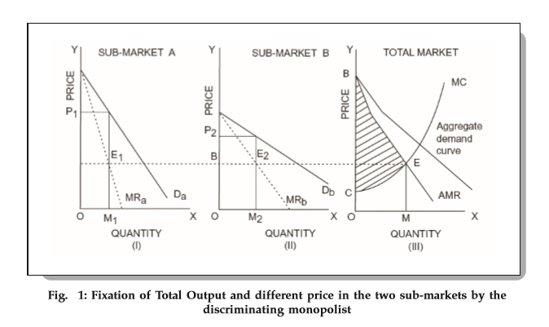
Figure:3.1
In Fig3.1 MR_{a} is the marginal revenue curve in the sub-market A having a demand curve D_{a}. Similarly, MR_{b} is the marginal revenue curve in the sub-market B having a demand curve D_{b}. The aggregate marginal revenue curve (AMR), shown in III above, is an addition of MR_{a} and MR_{b}. The AMR curve shows the total amount of output sold in both the sub-markets. Further, the marginal cost curve (MC) is also depicted in III above.
The monopolist maximizes his profits by producing the level of output at which MC intersects AMR. From III above, we can see that the intersecting point is E which corresponds to OM level of output. Once the monopolist determines the total output to be produced, he starts planning about distributing the output between the two sub-markets. He distributes it in a manner that the marginal revenues in both the sub-markets are equal. This ensures maximum profits.
If he does not ensure that the marginal revenues in the two sub-markets are equal, then he will transfer from one to another since it offers him profits. Once the MRs are equal, the transfer becomes unprofitable. However, for price discrimination, he must also ensure that the MRs are equal to the marginal cost of the total output. This ensures that the amount sold in both the sub-markets is equal to the whole output OM which is fixed after equalizing AMR with the marginal cost. From figure III above, we can see that at equilibrium output (OM), the marginal cost is ME.
From figure I above, we can see that OM₁ must be sold in sub-market A because the marginal revenue at M₁E₁ at amount OM₁ = marginal cost ME. Similarly, OM₂ must be sold in sub-market B because the marginal revenue at M₂E₂ at amount OM₂ = marginal cost ME. It is important to note that OM = OM₁ + OM₂.
Finally, to determine the price for markets A and B, the monopolist looks at the demand curve and does the following:
- Sets the price in sub-market A = OP₁.
- Sets the price in sub-market B = OP₂.
Since, the price in A > the price in B (because demand in A is less elastic than in B), OP₁ > OP₂.
In other words, the equilibrium condition of a discriminating monopolist becomes:
MR₁ (marginal revenue in market A) = MR₂ (marginal revenue in market B) = MC.

These two conditions are nothing more than an application of the general principle of equilibrium, i.e., MR = MC.

Dumping and Anti-Dumping
Dumping in the financial world occurs when a company or a country exports its products at a price lower than its domestic price. Exporters dump to compete with the producers and sellers in the importing country.
Dumping enables consumers in the importing country to obtain access to goods at an affordable price. However, it can also destroy the local market of the importing country, which can result in layoffs and the closure of businesses.
- The WTO and EU regulate dumping by putting tariffs and taxes on trading partners. Sufficient proof must be provided that dumping has happened.
- Dumping can also take place in the exporter’s home market. If the product can be priced at a higher cost abroad, the company can sell at a lower price at home.

Types of Dumping
Below are the four types of dumping in international trade:

Sporadic dumping
Companies dump excess unsold inventories to avoid price wars in the home market and preserve their competitive position. They can either dump by destroying excess supplies or export them to a foreign market where the products are not sold.
Predatory dumping
Unlike sporadic dumping, which is occasional, predatory dumping is permanent. It involves the sale of goods in a foreign market at a price lower than the home market. Predatory dumping is done to gain access to the foreign market and eliminate competition. It creates a monopoly in the market.
Persistent dumping
When a country consistently sells products at a lower price in the foreign market than the local prices, it is called persistent dumping. It happens when there is a constant demand for the product in the foreign market.
Reverse dumping
Reverse dumping happens when the demand for the product in the foreign market is less elastic. It means that price changes do not impact demand. Therefore, the company can charge a higher price in the foreign market and a lower price in the local market.
Motives for dumping:
i. To dispose an excess stock produced due to wrong judgment of demand
ii. To develop new trade relations with countries
iii. To benefit from economies of scale
iv. To drive competitors out of the foreign market
The concept of dumping can be explained with the help of the Figure below-:
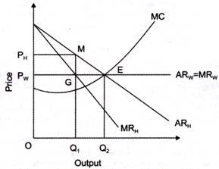
Figure: 3.2

In Figure 3.2 AR_{H} = Average revenue in home market
MR_{H} = marginal revenue in home market
AR_{W} = MR_{W} = Foreign market demand curve
P_{H} = Price in home market (monopoly price)
P_{W} = Price in world market (competitive price)
In this Figure, an assumption is taken that there are two markets that is domestic market (home market) and foreign market (world market) faced by an organization. In domestic market, the organization enjoys monopoly, whereas in foreign market, the organization faces perfect competition. Monopolist is in equilibrium when profits are maximum that is when MR=MC.
In Figure3.2 , the equilibrium is achieved at point E, with quantity as OQ₂, out of which OQ₁ is sold in home market at P_{H} price and Q₁Q₂ is sold at price P_{W} in world market. The price charged in world market is lower than the price charged in the home market.
Dumping is a kind of predatory pricing in which a foreign organization charges high prices and earns profits in its own country and uses these profits to sell the products at lower prices to build market share in other countries.

What Is Anti-Dumping Duty?
An anti-dumping duty is a protectionist tariff that a domestic government imposes on foreign imports that it believes are priced below fair market value. Dumping is a process wherein a company exports a product at a price that is significantly lower than the price it normally charges in its home (or its domestic) market.
- An anti-dumping duty is a protectionist tariff that a domestic government imposes on foreign imports that it believes are priced below fair market value.
- In order to protect their respective economy, many countries impose duties on products they believe are being dumped in their national market; this is done with the rationale that these products have the potential to undercut local businesses and the local economy.
- While the intention of anti-dumping duties is to save domestic jobs, these tariffs can also lead to higher prices for domestic consumers.
- In the long-term, anti-dumping duties can reduce the international competition of domestic companies producing similar goods.
- In the U.S., the International Trade Commission (ITC)–an independent government agency–is tasked with imposing anti-dumping duties.
- The World Trade Organization (WTO)–an international organization that deals with the rules of trade between nations–also operates a set of international trade rules, including the international regulation of anti-dumping measures.

Role of the WTO in Regulating Anti-Dumping Measures
- The World Trade Organization (WTO) plays a critical role in the regulation of anti-dumping measures. As an international organization, the WTO does not regulate firms accused of engaging in dumping activities, but it possesses the power to regulate how governments react to dumping activities in their territories.
- Some government sometimes react harshly to foreign companies engaging in dumping activities by introducing punitive anti-dumping duties on foreign imports, and the WTO may come in to determine if the actions are genuine, or if they go against the WTO free-market principle.
- According to the WTO Anti-Dumping Agreement, dumping is legal unless it threatens to cause material injury in the importing country domestic market. Also, the organization prohibits dumping when the action causes material retardation in the domestic market.
- Where dumping occurs, the WTO allows the government of the affected country to take legal action against the dumping country as long as there is evidence of genuine material injury to industries in the domestic market. The government must show that dumping took place, the extent of the dumping in terms of costs, and the injury or threat to cause injury to the domestic market.

