CAPITAL MARKET
Definition
Capital market means a common place where the borrowers and lenders meet to finance the requirement of long-term funding. In a broader aspect, it involves all those channels from where the savings are mobilized and the same are used in funding the industrial and government expenditure. It comprises savings that includes both corporate as well as personal savings which are utilized for making investments in the new IPOs and other public offerings that are issued by the government authorities.
So, a capital market is a well organized market structure where the money is transferred from the lender to the borrower in lieu of certain interest or other compensatory benefits. The individual investors are the primary savers who lend the same to the entrepreneurs for circulation of money in the industry which may be either owned privately or belong to the government.

According to P.K. Dhar :
"This is not a market for capital goods; rather it is a market for raising and advancing money capital for investment purposes".

According to M.Y. Khan :
"It is a market for long term funds. Its focus is on financing fixed investments in contrast to the money market which is the institutional source of working capital finance".

Functions of Capital Market

Following are the main functions of the capital market :

1) Allocation Function :
Many times the investors are unaware about the investment opportunities that are available to them and thus are deprived of investing. Capital market in this situation assists in channelizing the savings on behalf of the investors in different available modes. So, the present savings are attributed among the respective borrowers. The market acts as a magnet where different lenders having different perspectives are invited for making their investment.

2) Liquidity Function :
Capital market aims at bringing the lenders and the borrowers to a common platform where they can exchange their funds at mutually agreed interest rates and lending periods. Thus, the liquidity is always available at the discretion of both the parties.

3) Other Functions :
Apart from the basic function of allocating the funds and the liquidity function, capital market also important functions: serves the following

i) Indicative Function :
In addition to showing the progress of a company, the capital market is also a good indicator of the economic position of a country.

ii) Savings and Investment Function :
The long-term debts can be easily converted into liquid funds in less time. Thereby, the lenders can redeem their funds at their own will. This helps in restoring the confidence of the lenders as they earn a good rate of interest with an assurance of liquid funds.

iii) Transfer Function :
This market organizes the movement of the assets i.e. the tangible assets and the intangible assets in different individual units or the groups.

iv) Merger Function :
This market facilitates merging between the willing companies and companies having a slack in their management with the pioneers of the industry.

Capital Market Instruments

Following instruments are found in the capital market :

1) Equity Shares :
They are also termed as ordinary shares or common stock. One might understand both the terms 'shares' and 'stocks' as the same but there is some basic difference that is involved. Shares denote the small units of equal denomination constituting the share capital of the company. On the other hand, stock is the aggregate of fully paid shares of the company that is taken together. In other words, it is the collection of the shares. A stock has a value and represents what quantum it contains. Thus, stock can be further divided into fractions but again the denomination will be in terms of money and not in terms of number of shares.

2) Preference Shares :
Preference shares are like a hybrid instrument as they possess the features of a bond as well as that of an equity share. Unlike bonds, the preferred shareholders have the right to receive dividends even if there are no profits or less profits. Also in the event of liquidation of a company, their money is paid in preference to the equity shares. And unlike equity shares, they possess the characteristic of perpetual liability. Only the rate of dividend is fixed, but it is at the discretion of the Board of Directors to pay a dividend or not.

3) Sweat Equity :
Such shares are issued by the company to their internal staff i.e., directors or employees at a discounted rate in lieu of services rendered by them to the company which have brought certain know-how or value addition.

4) Debentures :
They constitute a type of debt payment and a substitute to the shares. Basically, they are issued by the private sector companies for raising desired funds from the general public. Under this, the money is borrowed with a promise of redemption on a certain fixed date and with the promise of periodic payment of interest. In India, Debentures are treated like bonds only but generally the bonds are issued by public sector companies.

5) Warrants :
It is a bearer document where the buyer agrees to purchase a certain amount of equity shares at a specific price. Normally, this right to purchase can be exercised over a long period and the aim is to make the offer lucrative for the investors, so that they may subscribe for the bonds or preference shares.

6) Secured Premium Notes (SPNs) :
SPN has the characteristics of medium and long-term notes. They are issued alongside a warrant and the redemption is done at the end of the specific periods.

7) Derivatives :
Derivatives are the instruments whose value is determined from the underlying instruments.

LIMITATIONS

- The limitations of capital market are as follows :
- The capital market has the risk of losing money.The capital market involves various charges which decrease profit from various investments.
- The capital market has the problem of volatility as it does not remain stable for a long time especially in the case of long-term investments.
- The capital market has the risk for the people who pursue their career in the capital market.
- The businesses in which the investment is done is liable for the working performance and also has the burden of delivering goods. If the goods are not according to the customers, it will indirectly lead to losing the investors.
STRUCTURE
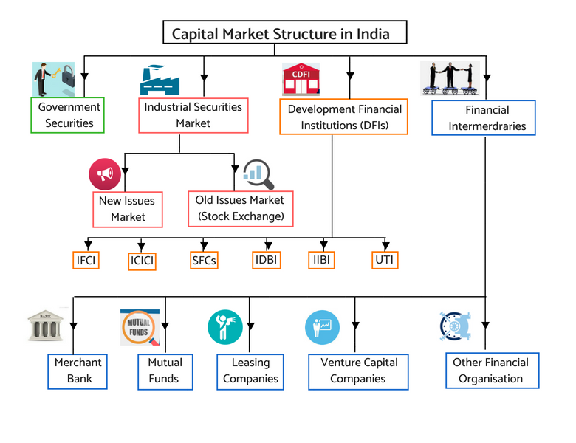
Government Securities:
Investors are able to acquire bonds, treasury bills, and notes. India’s national or state governments may issue these investment products. Typically, they are issued to compensate maturing securities, provide an early refund for securities that are not yet due, and offer new liquid liquidity sources. They are considered risk-free government securities despite the fact that they are not harmful.

Industrial Securities Market:

- Primary Market
    - It is also known as the new issue market; as in this market securities are sold for the first time. new securities are issued from the company
    - The common securities issued in the primary market are equity shares, debentures, bonds, preference shares and other innovative securities.
b.Secondary Market
    - The secondary market is the market for the sale and purchase of previously issued or second hand securities
    - Here, securities are not directly issued by the company to investors; instead the securities are sold by existing investors to other investors.
Development Financial Institution:
A Development Financial Institution(DFI) is an institution that has an important role in providing risk capital to the public and private sectors for investments. The owner of the Development Financial Institutions is the Government or Charitable Institution. DFIs are also known as a Development Bank or Development Finance Company(DFC). The finance provided to the private companies is invested especially in the countries where there are many restrictions on the market. The types of Finances provided are Medium(1-5 years)
Some of the important Development Financial Institutions are listed below:
IFCI
Industrial Finance Corporation of India(IFCI) is the first Development Financial Institution of India. IFCI was established in 1948.
ICICI
Industrial Credit and Investment Corporation of India (ICICI) Limited was an initiative of the World Bank and was established in the year 1955. ICICI Bank, the subsidiary company of ICICI Limited was established in 1994. In 2002, ICICI Limited got merged into ICICI Bank Limited and became the first universal bank of India. This became a Financial institution that performed dual function both of a Commercial Bank as well as Development Financial Institute. It still remains the only DFI in the private sector.
IDBI
Industrial Development Bank of India(IDBI) was established in 1964 under the Reserve Bank of India(RBI) and autonomy was granted in 1976. It was made a Universal Bank in 2003. IDBI is responsible for maintaining adequate credit flow to various sectors.
IRCI
Industrial Reconstruction Corporation of India(IRCI) was established in 1971. IRCI was made to overcome the weak units and provide financial as well as technical assistance. SIDBI
Small Industries Development Bank of India(SIDBI) was established in 1989. SIDBI was the subsidiary of IDBI. The autonomy was granted to SIDBI in 1998.
Exim Bank
Export-Import Bank was set up in January, 1982. The main purpose to establish Exim Bank was to provide technical assistance and loan to exports.
NABARD
On the recommendation of Shivaraman Committee National Bank for Agriculture and Rural Development(NABARD) was set up in July, 1982. NABARD worked as a refinancing institution. In the area of agriculture and rural sectors NABARD acts as the topmost institute.

GROWTH OF CAPITAL MARKET IN INDIA

Strong economic growth in the first quarter of FY 2022-23 helped India overcome the UK to become the fifth-largest economy after it recovered from repeated waves of COVID-19 pandemic shock. Real GDP in the first quarter of 2022–23 is currently about 4% higher than its corresponding 2019-20, indicating a strong start for India's recovery from the pandemic. Given the release of pent-up demand and the widespread vaccination coverage, the contact-intensive services sector will probably be the main driver of development in 2022–2023.
saRising employment and substantially increasing private consumption, supported by rising covsensumer sentiment, will support GDP growth in the coming months.

Future capital spending of the government in the economy is expected to be supported by factors such as tax buoyancy, the streamlined tax system with low rates, a thorough assessment and rationalization of the tariff structure, and the digitization of tax filing.
In the medium run, increased capital spending on infrastructure and asset-building projects is set to increase growth multipliers, and with the revival in monsoon and the Kharif sowing, agriculture is also picking up momentum. The contact-based services sector has largely demonstrated promise to boost growth by unleashing the pent-up demand over the period of April-September 2022. The sector's success is being captured by a number of HFIs (High-Frequency Indicators) that are performing well, indicating the beginnings of a comeback.India has emerged as the fastest-growing major economy in the world and is expected to be one of the top three economic powers in the world over the next 10-15 years, backed by its robust democracy and strong partnerships.

REFORMS IN THE CAPITAL MARKET IN INDIA
The following are the major reforms implemented in India's capital market:

Establishment of SEBI
The Securities and Exchange Board of India (SEBI) was established in 1988. It was granted legal status in 1992.SEBI was established primarily to regulate the activities of merchant banks, to control the operations of mutual funds, to act as a promoter of stock exchange activities, and to act as a regulatory authority of new issue activities of various companies.The SEBI was established with the primary goal of "protecting the interests of investors in the securities market and for matters connected with or incidental thereto."

Establishment of Creditors Rating Agencies
Three creditors rating agencies have been set up, namely, The Credit Rating Information Services of India Limited (CRISIL - 1988), the Investment Information and Credit Rating Agency of India Limited (ICRA - 1991), and Credit Analysis and Research Limited (CARE).They were established to assess the financial health of various financial institutions and stock market-related agencies.It also serves as a guide for investors in assessing the risk of their investments.

Increased Merchant Banking Activities
In recent years, many Indian and foreign commercial banks have established merchant banking divisions.These divisions offer financial services such as underwriting, organising issues, and consulting.It has proven to be beneficial to factors related to the capital market.

Indian Economy's Honest Performance
The Indian economy has been growing at a rapid pace in recent years. It has attracted a significant amount of Foreign Institutional Investment (FII).In recent times, the massive entry of FIIs into the Indian capital market has resulted in a positive appreciation for Indian investors.Similarly, many new companies are emerging on the Indian capital market's horizon to raise capital for their expansions.

Rising Electronic Transactions
As a result of technological advancements in recent years, the physical transaction with regards to the amount of paperwork is reduced.Paperless transactions are now increasing at an alarming rate. It saves investors money, time, and energy.As a result, it has made investing more secure and convenient, encouraging more people to participate in the capital market.

Growing Mutual Fund Industry
The expansion of mutual funds in India has undoubtedly aided the growth of the capital market.Many new funds have been launched by public sector banks, foreign banks, financial institutions, and joint mutual funds between Indian and foreign firms.Mutual funds in India have undergone significant diversification in terms of schemes, maturity, and so on.It has made it easier for ordinary investors to enter the capital market.

Growing Stock Exchanges
Initially, the BSE was the primary exchange, but with the establishment of the NSE and the OTCEI, stock exchanges have spread throughout the country.A new interconnected stock exchange in India has recently joined the existing stock exchanges.

Investor Protection
In 2001, the Central Government of India established the Investors Education and Protection Fund (IEPF) under the aegis of the SEBI.It is effective in educating and guiding investors. It tries to protect the interests of small investors from capital market frauds and malpractices.

Increase in Derivative Transactions
The NSE has allowed derivatives trading in equities since June 2000. It also introduced futures and options transactions in November 2001.These innovative products have increased the variety of investment options, resulting in the expansion of the capital market.

Insurance Sector Reforms
The Indian insurance sector has undergone massive reforms in recent years.In the year 2000, the Insurance Regulatory and Development Authority (IRDA) was established.It paved the way for private insurance companies to enter India.It has grown in size as more insurance companies invest their money in the capital market.

Commodity Trading
In addition to the trading of ordinary securities, commodity trading has recently been encouraged.The Multi Commodity Exchange (MCX) has been established..The volume of such transactions is rapidly increasing.
s

