Module 2and 3

2.1 Demand
It must be remembered that demand in Economics is always stated with reference to a particular price. Any change in price will normally bring about a change in the quantity demanded. In addition to price, demand is also used in reference to a particular period of time. For Example- demand for umbrellas will not be as high in winter as during rains. The demand for any commodity or service, therefore, must be stated with reference to the price and the relevant point of time.

We know that people have numerous wants which vary in intensity and quality. Just desiring or wanting things is not enough to create a demand. Suppose, a mill worker desires or wants to have a car but does not have the necessary means to buy it.

This desire is ineffective and will not become a demand. Similarly, a miser may desire to have the car, has means to purchase it, but will not spend the money. His desire would also not constitute a demand. Thus, we define demand for a commodity or service as an effective desire, i.e., a desire backed by means as well as willingness to pay for it.

The demand arises out of the following three things:
i. Desire or want of the commodity.
ii. Ability to pay,
iii. Willingness to pay.
Only when all these three things are present then the consumer presents his demand in the market.

Definitions:
“Demand for a commodity is the quantity which a consumer is willing to buy at a particular price at a particular time.”
“The demand for anything, at a given price, is the amount of it which will be bought per unit of time at that price.” -PROF. BENHAM
“By demand, we mean the quantity of a commodity that will be purchased at a particular price and not merely the desire of a thing.”-HANSEN

Demand Function:
Demand function shows the relationship between quantity demanded for a particular commodity and the factors influencing it. It can be either with respect to one consumer or to all the consumers in the market.
A consumer’s demand for a commodity is influenced by the following factors:
1. A consumer’s demand for a commodity is influenced by the price of that commodity. Usually the higher the price, the lower will be the quantity demanded.
2. A consumer’s demand for a commodity is influenced by the size of his income. In most cases, the larger the income, the greater will be the quantity demanded.
3. A consumer’s demand for a commodity is influenced by the prices of related commodities. They may be complementary or substitutes.
4. The tastes of the consumers.
In technical language, it is said that the demand for a commodity is a function of the four variables like:
q = f(P, Y, Pr, T)
Where q stands for quantity demanded, P stands for the price of the commodity in question, Y stands for the income of the consumer, Pr indicates prices of the related commodities and T denotes the Tastes of the consumer and f stands for function. But in practice the three of these four variables remain constant. And hence the demand function takes the form of-
q = f(P)

Factors Determining Individual Demand:
Demand is not dependent on price alone. There are many other factors which affect the demand of a product.

These factors are as follows:
1.Price of the Product: Demand for a commodity depends on its price. As price rises, for a normal good, demand falls and vice-versa. However, there are exceptions, i.e., for Giffen goods, as price rises demand also rises.

2. Income of the Consumer: A key determinant of demand is the level of income i.e., the higher the level of income the higher the demand for a given commodity. Consumer’s income and quantity demanded are generally related positively. It means that when income of the consumer rises he wants to have more units of that commodity and when his income falls he reduces the demand.
In consumer theory, an inferior good is a good that decreases in demand when consumer income rises i.e., increase in income reduces the demand because the consumer shifts his consumption to superior goods and forgoes his existing product. Thus reducing its demand.

Cheaper cars are examples of the inferior goods. Consumers will generally prefer cheaper cars when their income is constricted. As a consumer’s income increases the demand for cheap cars decreases and demand for costly cars increases.

3. Prices of Related Goods: Consumption choices are also influenced by the alternative options available to users in the relevant market place. Market information regarding alternative products, quality, convenience and dependability all influence choices.
The two products may be related in two ways- Firstly, as complementary goods and secondly as substitute goods.
Complementary goods are those goods which are used jointly and consumed together like tennis ball and a racket, petrol and car. The relationship between the price of a product and the quantity demanded of another is inverse. For example if the price of cars were to rise, less people would choose to buy and use cars, switching perhaps to public transport-trains. It follows that under these circumstances the demand for the complementary good petrol would also decrease.
Goods which are perceived by the consumer to be alternatives to a product are termed as substitute goods. There is direct relationship between the demand for a product and the price of its substitute. Example- scooter and a motorcycle, tea and coffee.
The increase in price of tea would decrease its quantity demanded and people would switch over to its substitute commodity coffee.

4. Consumer’s Tastes and Preferences: Demand for a product is also affected by the tastes and preferences of the consumers. As tastes and preferences shift from one commodity to the other, demand for the first commodity reduces and that of the other rises.

5. Expectation of Future Prices: The current demand of a product also depends on its expected price in future. If future price is expected to rise, its present demand immediately increases because the consumer has a tendency to store it at low prices for his future consumption. If, however the price of a product is expected to fall then he has a tendency to postpone its consumption and as a result the present demand would also fall.
This is often the case on Budget Day, when consumers rush to fill their petrol tanks prior to an expected increase in taxation. The reverse is also true, in that an expectation that prices are about to fall, will decrease current demand, as consumers will await for the expected price reduction.

6. Economic Conditions: The demand for commodities also depends upon prevailing business conditions in the country. For, example- during the inflationary period, more money is in circulation and people have more purchasing power. This causes an increase in demand of various goods even at higher prices. Similarly, during deflation (depression), the demand for various goods reduces in spite of lower prices because people do not have enough money to buy.

Factors Determining Market Demand:
Market demand for a commodity means the sum total of the demand of all individuals. Market demand depends, not only on the prices of the commodity and prices of related commodities but also on the number of factors.
These are:

1.Pattern of Income Distribution: If National income is equitably distributed, there will be more demand and vice-versa. If income distribution moves in favour of down¬trodden people, then demand for such commodities, which are used by common people would increase. On the other hand, if the major part of National income is concentrated in the hands of only some rich people, the demand for luxury goods will increase.

2. Demographic Structure: Market demand is influenced by change in size and composition of population. Increase in population leads to more demand for all types of goods and decrease in population means less demand for them. Composition of population also affects its demand. Composition refers to the number of children, adults, males, females etc., in the population.
When the composition changes, for example, when the number of females exceeds to that of the males, then there will be more demand for goods required by women folk.

3. Government Policy: Government policy of a country can also affect the demand for a particular commodity or commodities through taxation. Reduction in the taxes and duties will allow more persons to enter a particular market and thus raising the demand for a particular product.

4. Season and Weather: Demands for commodities also depend upon the climate of an area and weather. In cold hilly areas woolens are demanded. During summer and rainy season demand for umbrellas may rise. In winter ice is not so much demanded.
5. State of Business: The levels of demand in a market for different goods depend upon the business condition of the country. If the country is passing through boom, the trade is active and brisk. The demand for all commodities tends to rise. But in the days of depression, when trade is dull and slow, demand tends to fall.

Demand Schedule:
The demand schedule in economics is a table of quantity demanded of a good at different price levels. Given the price level, it is easy to determine the expected quantity demanded. This demand schedule can be graphed as a continuous demand curve on a chart where the Y-axis represents price and the X-axis represents the quantity.

According to PROF. ALFRED MARSHALL, “Demand schedule is a list of prices and quantities”. In other words, a tabular statement of price-quantity relationship between two variables is known as the demand schedule.

The demand schedule in the table represents different quantities of commodities that are purchased at different prices during a certain specified period (it can be a day or a week or a month).

The demand schedule can be classified into two categories:
1. Individual demand schedule;
2. Market demand schedule.

1. Individual Demand Schedule:
It represents the demand of an individual’ for a commodity at different prices at a particular time period. The adjoining table 7.1 shows a demand schedule for oranges
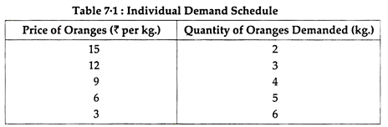

2. Market Demand Schedule:
Market Demand Schedule is defined as the quantities of a given commodity which all consumers will buy at all possible prices at given moment of time. In a market, there are several consumers, and each has a different liking, taste, preference and income. Every consumer has a different demand.
The market demand actually represents the demand of all the consumers combined together. When a particular commodity has several brands or types of commodities, the market demand schedule becomes very complicated because of various factors. However, for a single item, the market demand schedule is rather simple. Study the market demand schedule for milk in table 7.2.

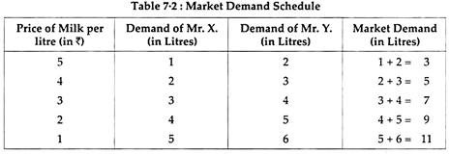

Demand Curves (Diagram):
The demand curve is a graphic statement or presentation of the relationship between product price and the quantity of the product demanded. It is drawn with price on the vertical axis of the graph and quantity demanded on the horizontal axis.

Demand curve does not tell us the price. It only tells us how much quantity of goods would be purchased by the consumer at various possible prices.
Depending upon the demand schedule, the demand curve can be as follows:
1. Individual Demand Curve
2. Market Demand Curve

1. Individual Demand Curve:
An Individual Demand Curve is a graphical representation of the quantities of a commodity that an individual (a particular consumer) stands ready to take off the market at a given instant of time against different prices. In Fig. 7.1, an Individual Demand Curve is drawn on the basis of Individual Demand Schedule given above in table 7.1.
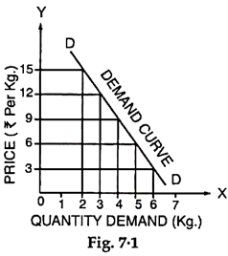

2. Market Demand Curve:
A Market Demand Curve is a graphical representation of the quantities of a commodity which all the buyers in the market stand ready to take off at all possible prices at a given moment of time. In Figure 7.2 a Market Demand Curve is drawn on the basis of Market Demand Schedule given in Table 7.2.
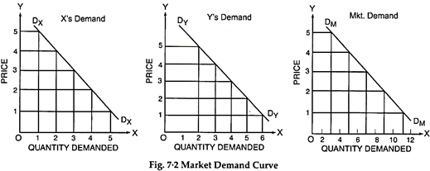
Both, the individual consumer’s demand curve is a straight line. A demand curve will slope downward to the right.
It is not necessary, that the demand curve is a straight line. A demand curve may be a convex curve or a concave curve. It may take any shape provided it is negatively sloped.

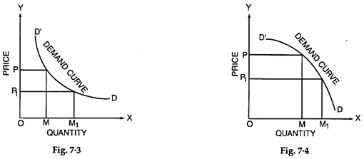
Notes on Law of Demand:
The law of demand expresses functional relationship between price and the quantity. It has been universally observed that people buy more quantity of goods when, they are available at a lower price and the quantity purchased declines with an increase in its price.
“A rise in the price of a commodity or service is followed by a fall in quantity demanded, and a fall in price is followed by an increase in quantity demanded”. Thus, lower the price, the larger is the quantity demanded of a commodity and vice-versa.
The law thus, states that other things being equal the quantity demanded varies inversely with price. Lower the price, greater is the effective demand; higher the price; lesser is the effective demand.
Characteristics of Law of Demand:
The law of demand has three specific characteristics:
1. General Tendency,
2. Relation to Time, and
3. Price and Demand Relationship.
1. General Tendency:
The law simply indicates a general tendency of changes in quantity demanded with the changes in prices. However, it does not mention any specific propositions of changes in quantity demanded with changes in prices.
2. Relation to Time:
The law of demand is always related to time, because the price changes from time to time and these are never fixed. Thus, the co-relation between the prices and the quantities demanded should be considered for a specific time or at particular instant.
3. Price and Demand Relationship:
The increase or decrease in the prices does affect the quantity demanded at a particular time. Thus, the change in the quantity demanded cannot be considered without change in prices. It must, therefore, be noted that the relationship between price and quantity demanded is relative.
Assumptions of Law of Demand:
i. The income of the consumer remains same during the period under consideration.
ii. The prices of related goods remain unchanged during the period.
iii. The preferences and tastes of consumers must remain the same during the period of consumption.
iv. The quality of similar goods available in the market is almost unchanged.
v. During the period under study, it is presumed that prices are not likely to change in near future.
vi. No substitutes for the commodity in question are available.
Exceptions to the Law of Demand:
There are certain exceptions to the law of demand. It means that under certain circumstances, consumers buy more when the price of a commodity rises and less when the price falls. In such case the demand curve slopes upward from left to right i.e. demand curve has a positive slope as is shown in Fig. 7.5. Many causes can be attributed to an upward sloping demand curve.

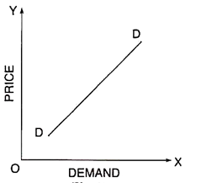

Exception to Law of Demand:

1.Ignorance: Sometimes consumers are fascinated with the high priced goods from the idea of getting a superior quality. However, this may not be always true. Superior/deceptive packing and high price deceive the people. This can be called as ‘Ignorance effect’.

2.Speculative Effect: When the price of a commodity goes up, people may buy larger quantity than before, if they anticipate or speculate a further rise in its price. On the other hand, when the price falls, people may not react immediately and may still purchase the same quantity as before, waiting for another fall in the price. In both the cases, the law of demand fails to operate. This is known as speculative effect.

3. The Giffen Effect: A fall in the price of inferior goods (Giffen Goods) tends to reduce its demand and a rise in its price tends to extend its demand. This phenomenon was first observed by SIR ROBERT GIFFEN, popularly known as Giffen effect.

He observed that the working class families of U.K. were compelled to curtail their consumption of meat in order to be able to spend more on bread Mr. Giffen, British economist, observed that rise in the price of bread caused the low paid British workers to buy more bread.

These workers lived mainly on the diet of bread, when price rose, as they had to spend more for a given quantity of bread, they could not buy as much meat as before. Bread still being comparatively cheaper was substituted for meat even at its high price.

4. Fear of Shortage: People may buy more of a commodity even at higher prices when they fear of a shortage of that commodity in near future. This is contrary to the law of demand. It may happen during times of war and inflation and mostly in the case of goods which fall in the category of necessities of life like sugar, kerosene oil, etc.

5. Prestigious Goods: This is explained by Prof. Thorsfein Vebler Veblen. If consumers measure the desirability of a good entirely by its price and not by its use, then they buy more of a good at high price and less of a good at low price, Diamond, Jewellery and big cars etc., are such prestigious goods. In their case demand relates to consumers who use them as status symbol.
As their prices go up and become costlier, rich people think it is more prestigious to have them. So they purchase more. On the other hand, when their prices fall sharply, they buy less, as they are no more prestigious goods. This is known as (Veblen effect) or (Demonstration effect).

6. Conspicuous Necessities: Another exception occurs in use of such commodities as due to their constant use, have become necessities of life. For example, inspite of the fact that the prices of television sets, refrigerators, washing machines, cooking gas, scooters, etc., have been continuously rising, their demand does not show any tendency to fall. More or less same tendency can be observed in case of most of other commodities that can be termed as ‘Upper-Sector Goods’.

7. Bandwagon Effect: The consumer’s demand for a good may be affected by the tastes & preferences of the social class to which he belongs. If purchasing diamond becomes fashionable, then, as the price of diamond rises, rich people may increase their demand for diamonds in order to show that they are rich.

8. Snob Effect: People sometimes buy certain commodities like diamonds at high prices not due to their intrinsic worth but for a different reason. The basic object is to display their riches to the other members of the community to which they themselves belong. This is known as Snob appeal.

Movement along a Demand Curve and Shifts in the Demand Curve (Diagrams):

1. Change in Quantity Demanded — Movement along a Demand Curve:
Extension and Contraction of Demand- The quantity demanded of a product does not remain constant, but keeps on changing due to various factors. If the quantity demanded changes due to change in price only, it is called expansion and contraction of demand. If price decreases, it results in expansion of demand and if price increases it results in contraction of demand. This situation is shown by movement along the same demand curve.
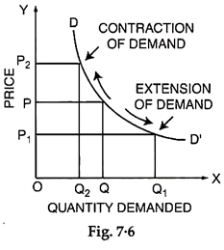
In figure 7.6, we have shown expansion and contraction of demand. At price OP, quantity demanded is OQ. If price reduces to OP1, the quantity demanded increase to OQ1. This increase of quantity demanded would be called expansion of demand. If, however, price increases from OP to OP2, then quantity demanded decrease in equality would be called contraction of demand.

2. Change in Demand— Shifts in the Demand Curve:
Increase and Decrease of Demand:
If the change in quantity demanded of a product takes place due to any factor, other than price of the product, then it is called increase or decrease of demand. This phenomenon is shown by a shift in the entire demand curve. For example- if the income of the consumer rises then his entire demand curve shifts to right which shows that consumer’s demand for the product has increased for every given price.

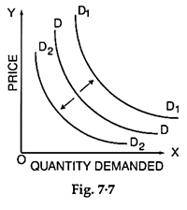
In the figure 7.7 we can say if demand increases due to increase in income then demand curve shifts to right from DD to D1D1. If, however, the demand decreases due to fall in income then the demand curve shifts to left from DD to D2D2.
Kinds of Demand:
The demands can be classified as:
1. Price Demand
2. Income Demand
1. Price Demand:
The price demand refers to various quantities of a commodity or services that are purchased at a given time and at given prices from the market. However, in such studies, the consumer’s taste, his income, habit and prices of related goods are assumed to be unchanged. Price demand has inverse relation with the price i.e., if the price of a commodity increases, its demand decreases and as the price decreases, its demand increases.

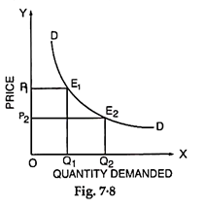
It can be seen in Fig. 7.8, when the price of the commodity was OP1, the quantity demanded was OQ1. When the price reduced to OP2, the quantity demanded increased to OQ2. Hence the price and the quantity demanded of a commodity show an inverse relationship.
2. Income Demand:
The income demand refers to the various quantities of a commodity or service purchased by the consumers at different income levels. It is assumed that the price of commodity, price of related goods and consu¬mers’ tastes do not change. Under such conditions, with the increase in income, a consumer may purchase increased quantity of the commodity even though there may not be any fall in price.
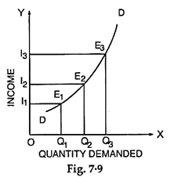
Fig. 7.9 exhibits the direct relationship between income of a consumer and demand of a commodity. As can be seen in the figure that as the income of the consumer increases from OI1 to OI2, the demand of the commodity increases from OQ1 to OQ2. Similarly when the income increases from OI2 to OI3, the demand of the commodity raises from OQ2 to OQ3.
3. Cross Demand:
Cross demand refers to the quantity of a commodity which would be demanded as a consequence of changes in price of related complementary or substitute goods.
(i) In the Case of Substitutes:
A rise in the price of good y (say Coffee) raises the demand for good x (Say Tea), similarly, a fall in the price of y, (Coffee) the demand for x (Tea) falls. Fig. 7.10. illustrates it.

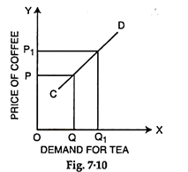
When the price of good y (Coffee) increases from OP to OP1 the quantity of good x (Tea) also increases from OQ to OQ1. The cross demand curve CD for substitutes is positively sloping.
(ii) In the Case of Complementary:
In case of comple¬mentary goods such as pant and shirt, pen and ink, car and petrol, etc., a fall in the price of one good y (Say car) will raise the demand for good x (Say petrol). Conversely a rise in the price of y (Car) will bring a fall in the demand for x (Petrol). This is illustrated in Fig. 7.11.
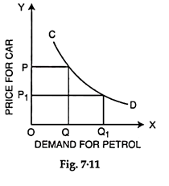
When the price of y (Car) falls from OP to OP1, the demand for x (Petrol) increases from OQ to OQ1. The cross demand curve in case of complementary goods CD is negatively sloping.
Inter-Related Demands:
It has been assumed that demand of a particular commodity is quite independent of demand for other goods. But in actual life, most of the demands are closely inter-related.
From a practical point of view, the inter-related demands can be classified as:
1. Joint Demand
2. Direct Demand and Derived Demand
3. Composite Demand
1. Joint Demand:
When several items are demanded for one particular purpose such demand is known as Joint Demand. Demand for complementary goods is also known as Joint Demand. For example, for fabrication of furniture, the items required are wood, nails, varnish, etc.
Thus, whenever the demand of furniture increases, the demand of wood, nails, etc., also increases. This is called a Joint Demand. Similarly, for the construction of the houses, the demand for bricks, cement, masons, labourers, etc., will constitute a Joint Demand. The Joint Demand for coffee is denoted by the given line diagram (Fig. 7.12).

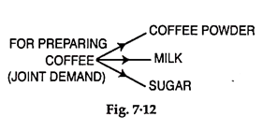
2. Direct Demand and Derived Demand:
Whenever several items are required to make a particular commodity, the demand for various commodities is termed as the Derived Demand and demand of ultimate commodity is called as Direct Demand. For example, the demand for building is a direct demand and demands for cement, bricks, sand, timber, etc., are called as derived demands. It is denoted by the given line diagram (Fig. 7.13).

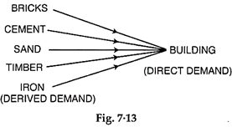
3. Composite Demand:
A commodity can be used for several purposes and its demand is directly linked to its sweets various uses such a demand is known as Composite Demand. For example, milk is used for making tea, coffee, butter, cheese, curd, sweets and for direct consumption. The total demand of milk in the market is for all such purposes and it is called composite demand, denoted by the given line diagram (Fig. 7.14).

2.2. Supply
Meaning of Supply:
Supply means the quantities that a seller is willing and able to sell at different prices. It is obvious that if the price goes up, he will offer more for sale.

But if the price goes down, he will be reluctant to sell and will offer to sell less. Supply thus varies with price. Just as we cannot speak of demand without reference to price and time, similarly we cannot speak of supply without reference to price and time.

Supply is always at a price. The supply of any good may then be defined “as a schedule of respective quantities of the good which people are ready to offer for sale at all possible prices.” Just as demand implies willingness and ability to pay, in the same manner the phrase ‘ready to offer for sale’ in the definition of supply given above implies both willingness and ability to deliver the goods.

Like demand, supply is also relative to a person, place and time: It would be different in a different place, at a different time and with a different person. When we say that A is willing to supply 100 quintals of wheat at Rs. 100 per quintal, we mean that he will do it in a particular set of circumstances. Any change in these circumstances will bring about a change in the supply.

Distinction between Supply and Stock:
The terms ‘supply’ and ‘stock’ are often confused. A clear understanding of the difference between the two is essential. Stock is at the back of supply. It constitutes potential supply. Supply means the quantity actually offered for sale at a certain price, but stock means the total quantity which can be offered for sale if the conditions are favorable. At any time, the godowns in the ‘mandi’ may be full of wheat. This is the stock. If the price is low, very little wheat will come out of the godowns.

The quantity that actually comes out is the supply. The stock will change into supply and vice versa according as the market price raises or falls. In case of perishable articles, like fresh milk and vegetables, there is no difference between stock and supply. The entire stock is supply and has to be sold off for unless it is disposed of quickly, it will perish.

Supply Schedule:
Corresponding to the demand schedule of milk, we have a supply schedule of the milkman in a village. We notice that as the price falls, less milk is being offered for sale, and as price rises, the milkman is prepared to sell more.

Quantity of Milk Offered (in Litres):
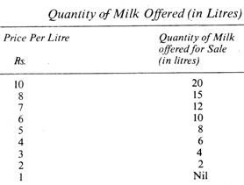
Supply Curve of an Individual Seller:
The supply schedule can be represented in the form of a curve, as given below (Fig. 24.1).
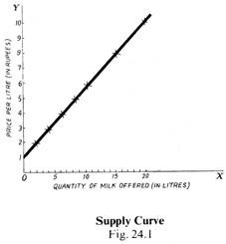
Quantities of milk offered for sale are measured along OX and prices along OY. The supply curve SS’ slopes upwards as we go from the left to the right. This means that as the price rises, more is being offered for sale and vice versa.

Law of Supply:
From a study of the supply schedule and supply curve, we can formulate the law of supply thus:
“In a given market, at any time, the quantity of any goods which people are ready to offer for sale generally varies directly with the price.”

‘Varies directly means that as price rises the quantity offered increases, and as it falls, the quantity offered decreases. It should be noted that, in the case of demand, the quantity demanded varies inversely with the price, i.e., as price rises, demand decreases, and vice versa.
The law of supply may be put in another way. “Other things remaining the same, as the price of a commodity rises, its supply is extended, and as the price falls, its supply is contracted.”

When prices are low many individuals and firms do not find it worth-while to sell, for their costs may be high and profits will be low. But, when prices rise, they are in a position to carry on production with profit and sell more. Higher prices mean higher profits. The desire for larger profits carries production to the farthest limit yielding a net profit.

Some Exceptions:
There are some exceptions to the law of supply:
(a) In an auction, goods are sold away whatever the bid. It is possible that the seller is badly in need of money and wants a certain amount of it. As soon as that amount is made up, he will refuse to sell more. The higher the price, the smaller the quantity he will need to sell in order to get the required amount. It is also possible that a person wants to get rid of a quantity of goods as in the case of a person going abroad. In such a case, he will sell away all that he has, whatever the price offered.
(b) When a further heavy fall in price is expected, the sellers may become panicky. They will sell more even if the price falls.

These exceptions, however, do not falsify the law of supply enunciated above. Generally the law holds good. Extension and Contraction of Supply and Increase and Decrease of Supply. As in the case of demand, so in the case of supply, a distinction must be made between extension and contraction on the one hand, and increase and decrease, on the other. This is in fact a distinction between a movement along the supply curve and shift of supply Curve.

Extension and Contraction, i.e. Movement along the Supply Curve:
When the quantity offered for sale increases or decreases merely because price has risen or fallen, we use the terms extension and contraction of supply. The supply schedule is the same and we travel up and down the same supply curve.

Increase and Decrease, i.e., Shift of the Supply Curve:
If, on the other hand, the change in the quantity offered for sale is caused, not by a change in price, but by a change in the conditions of supply, we say that supply has increased or decreased or the supply curve has shifted from its previous position. The change in the condition of supply implies a change in the technical conditions: perhaps a new process or a new material has been discovered, a new labour-saving device has been discovered, or raw materials and other factors have become cheaper.

On account of these new developments, the manufacturer may be able to offer more for sale even if the price has remained the same or gone down. If the conditions have become unfavorable, he will not be able to supply the same quantity at the old price. Extension of supply means that more is offered at a higher price, while increase in supply signifies that either more is offered at the same price or the same quantity is offered at a lower price.

Contraction and decrease in supply are the opposites of extension and increase in supply respectively. Contraction of supply means that less is offered at a lower price, but decrease in supply means that less is offered at the same price or the same quantity is offered at a higher price.

These changes can be illustrated with the help of diagrams as under:
Prices are measured along OY and quantities offered for sale along OX. SS’ is the old supply curve and BB’ is the new supply curve. Fig. 24.6 shows extension and contraction of demand. At PM Price, amount OM is offered, but at the price P’M’ (which is higher than PM), OM’ is offered, which is more. Fig. 24.7 shows an increase in supply, for OM’ (i.e., more) is offered instead of OM at the same price (PM = P’M’). Also, the same quantity OM is offered at a lower price LM. In Fig. 24.8, OM’ (i.e., less) is offered in place of OM, although price is the same (P’M’=PM). Also, the same quantity OM is offered at a higher price LM. This means a decrease in supply.
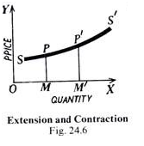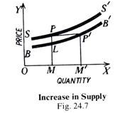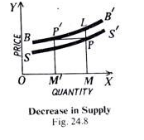
Elasticity of Supply:
Meaning of Elasticity of Supply:
The law of supply says that the supply varies directly with the price. If the price rises, the quantity offered will extend, and as it falls the quantity offered will contract. This attribute of supply, by virtue of which it extends or contracts with a rise or fall in price, is known as the Elasticity of Supply. It refers to the sensitiveness or responsiveness of the supply to changes in price.

Cases of Inelastic Supply:
But supply may not always respond to the changes in price at the same rate If the commodity is perishable, e.g., fresh milk, ripe fruits, fresh vegetables, etc. the supply cannot be withheld and the whole of it must be offered for sale, whatever the price. In this case, as already pointed out, there is no difference between stock and supply. In other words, the supply is inelastic, i.e., it is insensitive to a change in price. The: price may be falling but the commodity will have to be sold away.

In the same manner, if the production of a commodity requires a large fixed «.4pital, say, iron and steel products, cement, aero-planes, motor-cars, etc., the apply cannot be quickly increased when the price rises, or decreased when it falls.

The same is the case with a commodity which takes a long time to be put on the market. For example, you can increase the supply of wheat or cotton only in a year’s time at the next harvest. In this case too, it is difficult to adjust the supply to demand immediately. In such cases, the supply is called inelastic or less elastic.

Elastic Supply:
But if there is a very large stock of commodity already in existence and the commodity can be stocked, or kept back without loss, then the supply put on the market will vary with price. More will be offered when the price is high, and less when it is low. The supply of such a commodity is said to be elastic.

To sum up:
We can say that if a small change in price (rise or fall) leads to a big change in supply (extension or contraction), the supply is elastic; on the other hand, if a considerable change in price (rise or fall) leads to only a small change in supply (extension or contraction), it is inelastic or less elastic. It should, however be noted that the supply of no commodity is absolutely inelastic; hence, as Marshall says, we should call it comparatively inelastic or less elastic.

Diagrammatic Representation:
Figure 24.9 represents inelastic supply and Fig. 24.10 elastic supply. Price is measured along OY and quantity offered along OX.
In Fig. 24.9, when the price rises from PM to P’ M ‘ (which is a considerable rise), the quantity offered extends from OM to OM’ only, which is not much. Hence supply is less elastic.
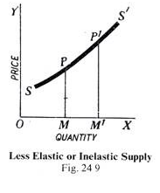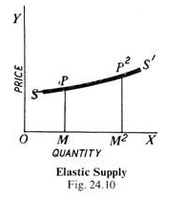

In Fig. 24.10, the-rise from PM to P M is not so large, but the extension of supply from OM to OM ² is quite considerable. Hence the supply is elastic.

Elasticity of Supply and Marginal Costs:
The elasticity of supply is really the measure of the ease with which an industry can be expanded, and it can be judged from the behaviour of the marginal costs. If a slight increase in price is followed by the entry of many new firms having minimum average cost equal to price and the marginal cost does not rise, the supply is said to be perfectly elastic.
In case, however, the increased output can be obtained only by an infinite increase in price and yet no new firm is attracted to the industry, the supply will be inelastic. In between these two extremes, there will be different degrees of elasticity. The degree of elasticity will depend, in a particular case, on the slope of the marginal cost curve and the shape of the average cost curves of the successive firms.

“The relation between price and the quantity supplied is rather like the relation between a whistle and a dog—the louder the whistle the faster comes the dog; raise the price and the quantity supplied increases. If the dog is responsive—in economic terminology elastic—quite a small crescendo in the whistle will send him bouncing along. If the dog is unresponsive or ‘inelastic’, we may have to whistle very loudly before he comes along at all.”

Law of Supply
Law of supply expresses a relationship between the supply and price of a product. It states a direct relationship between the price of a product and its supply, while other factors are kept constant.
For example, in case the price of a product increases, sellers would prefer to increase the production of the product to earn high profits, which would automatically lead to increase in supply.
Similarly, if the price of the product decreases, the supplier would decrease the supply of the product in market as he/she would wait for rise in the price of the product in future.

The statement given for the law of supply is as follows:
“Other things remaining unchanged, the supply of a commodity expands with a rise in its price and contracts with a fall in its price.”
The law of supply can be better understood with the help of supply schedule, supply curve, and supply function. Let us discuss these concepts in detail in the next sections.

Supply Schedule:
Supply schedule shows a tabular representation of law of supply. It presents the different quantities of a product that a seller is willing to sell at different price levels of that product.
A supply schedule can be of two types, which are as follows:
i. Individual Supply Schedule:
Refers to a supply schedule that represents the different quantities of a product supplied by an individual seller at different prices.
Table-8 shows the supply schedule for the different quantities of milk supplied in the market at different prices:
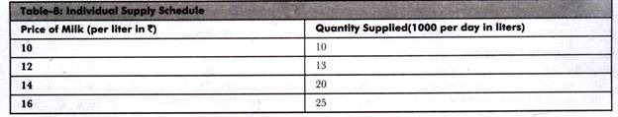

ii. Market Supply Schedule:
Refers to a supply schedule that represents the different quantities of a product that all the suppliers in the market are willing to supply at different prices. Market supply schedule can be drawn by aggregating the individual supply schedules of all individual suppliers in the market.
Table-9 shows the market supply schedule of a product supplied by three suppliers. A, B, and C:
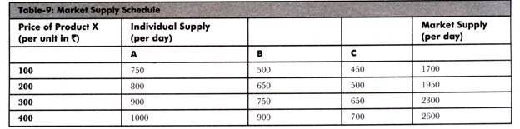

Supply Curve:
The graphical representation of supply schedule is called supply curve. In a graph, price of a product is represented on Y-axis and quantity supplied is represented on X-axis. Supply curve can be of two types, individual supply curve and market supply curve. Individual supply curve is the graphical representation of individual supply schedule, whereas market supply curve is the representation of market supply schedule.
Figure-14 shows the individual supply curve for the individual supply schedule (represented in Table-8):
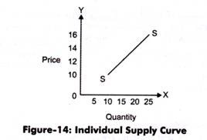
In Figure-14, the supply curve is showing a straight line and an upward slope. This implies that the supply of a product increases with increase in the price of a product.
Figure-15 shows the market supply curve of market supply schedule (represented in Table-9):
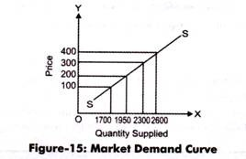
The slope of market supply curve can be obtained by calculating the supply of the slopes of individual supply curves. Market supply curve also represents the direct relationship between the quantity supplied and price of a product.

Supply Function:
Supply function is the mathematical expression of law of supply. In other words, supply function quantifies the relationship between quantity supplied and price of a product, while keeping the other factors at constant. The law of supply expresses the nature of relationship between quantity supplied and price of a product, while the supply function measures that relationship.
The supply function can be expressed as:
Sx = f (Px)
Where:
Sx = Quantity supplied for product X
Px = Price of product X
f = Constant representing change produced in Sx with one unit change in Px

Assumptions in Law of Supply:
The law of supply expresses the change in supply with relation to change in price. In other words the main assumption of law of supply is that it studies the effect of price on supply of a product, while keeping other determinants of supply at constant.
Apart from this, there are certain assumptions that are necessary for the application of law of supply, which are as follows:
i. Assumes that the price of a product changes, but the change in the cost of production is constant. This is because if the cost of production rises with increase in price, then sellers would not supply more due to the reduction in their profit margin. Therefore, law of supply would be applicable only when the cost of production remains constant.
ii. Assumes that there is no change in the technique of production. This is because the advanced technique would reduce the cost of production and make the seller supply more at a lower price.
iii. Assumes that there is no change in the scale of production. This is because if the scale of production changes with a period of time, then it would affect the supply. In such a case, the law of supply would not be applicable.
iv. Assumes that the policies of the government remain constant. If there is an increase in tax rates, then the supply of product would decrease even at the higher price. Therefore, for the application of law of supply, it is necessary that government policies should remain constant.
v. Assumes that the transportation cost remain the same. In case the transportation cost reduces, then the supply would increase, which is invalid according to the law of supply.
vi. Assumes that there is no speculation about prices in future, which otherwise can affect the supply of a product. If there is no speculation about products, then the economy is assumed to be at balance and people are satisfied with the available products and do not require any change.

Exception to Law of Supply: According to the law of supply, if the price of a product rises, then the supply of the product also rises and vice versa. However, there are certain conditions where the law of supply is not applicable. These conditions are known as exceptions to law of supply. In such cases, the supply of a product falls with the increase in price of a product at a particular point of time.

For example, there would be decrease in the supply of labor in an organization when the rate of wages is high. The exception of law of supply is represented on the regressive supply cure or backward sloping curve. It is also known as exceptional supply curve, which is shown in Figure-16:
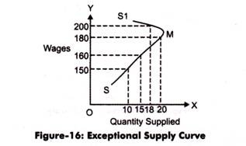
In Figure-16, SMS1 is the exceptional supply curve for labor. In this case, wages are regarded as the price of labor. It can be interpreted from the graph that as the wages of a worker increases, its quantity supplied that is working hours decreases, which is an exception to the law of supply.

Some of the exceptions of law of supply are as follows:
i. Speculation: Refers to the fact that the supply of a product decreases instead of increasing in present when there is an expected increase in the price of the product. In such a case, sellers would not supply the whole quantity of the product and would wait for the increase in price in future to earn high profits. This case is an exception to law of demand.

ii. Agricultural Products: Imply that law of supply is not valid in case of agricultural products as the supply of these products depends on particular seasons or climatic conditions. Thus, the supply of these products cannot be increased after a certain limit in spite of rise in their prices.

iii. Changes in Other Situations: Refers to the fact that law of supply ignores other factors (except price) that can influence the supply of a product. These factors can be natural factors, transportation conditions, and government policies.

2.3 Elasticity of Demand

Meaning of Elasticity of Demand:
Demand extends or contracts respectively with a fall or rise in price. This quality of demand by virtue of which it changes (increases or decreases) when price changes (decreases or increases) is called Elasticity of Demand.

“The elasticity (or responsiveness) of demand in a market is great or small according as the amount demanded increases much or little for a given fall in price, and diminishes much or little for a given rise in price”. – Dr. Marshall.

Elasticity means sensitiveness or responsiveness of demand to the change in price. This change, sensitiveness or responsiveness, may be small or great. Take the case of salt. Even a big fall in its price may not induce an appreciable ex appreciable extension in its demand. On the other hand, a slight fall in the price of oranges may cause a considerable extension in their demand. That is why we say that the demand in the former case is ‘inelastic’ and in the latter case it is ‘elastic’.

The demand is elastic when with a small change in price there is a great change in demand; it is inelastic or less elastic when even a big change in price induces only a slight change in demand. In the words of Dr. Marshall, “The elasticity (or responsiveness) of demand in a market is great or small according as the amount demanded increases much or little for a given fall in price, and diminishes much or little for a given rise in price. “But the demand cannot be perfectly ‘elastic’ or ‘inelastic’.

Completely elastic demand will mean that a slight fall (or rise) in the price of the commodity concerned induces an infinite extension (or contraction) in its demand. Completely inelastic demand will mean that any amount of fall (or rise) in the price of the commodity would not induce any extension (or contraction) in its demand. Both these conditions are unrealistic. That is why we say that elasticity of demand may be ‘more or less’, but it is seldom perfectly elastic or absolutely inelastic.

Types of Elasticity: Distinction may be made between Price Elasticity, Income Elasticity and Cross Elasticity. Price Elasticity is the responsiveness of demand to change in price; income elasticity means a change in demand in response to a change in the consumer’s income; and cross elasticity means a change in the demand for a commodity owing to change in the price of another commodity.

Price Elasticity of Demand:
The extent of responsiveness of demand with change in the price is not always the same.
The demand for a product can be elastic or inelastic, depending on the rate of change in the demand with respect to change in price of a product.

Elastic demand is the one when the response of demand is greater with a small proportionate change in the price. On the other hand, inelastic demand is the one when there is relatively a less change in the demand with a greater change in the price.

For better understanding the concepts of elastic and inelastic demand, the price elasticity of demand has been divided into five types, which are shown in Figure-1:
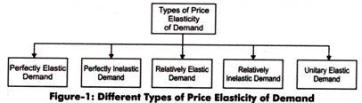
Let us discuss the different types of price elasticity of demand (as shown in Figure-1).

1. Perfectly Elastic Demand:
When a small change in price of a product causes a major change in its demand, it is said to be perfectly elastic demand. In perfectly elastic demand, a small rise in price results in fall in demand to zero, while a small fall in price causes increase in demand to infinity. In such a case, the demand is perfectly elastic or e_{p} = 00.

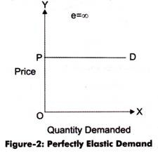
The degree of elasticity of demand helps in defining the shape and slope of a demand curve. Therefore, the elasticity of demand can be determined by the slope of the demand curve. Flatter the slope of the demand curve, higher the elasticity of demand.
In perfectly elastic demand, the demand curve is represented as a horizontal straight line, which is shown in Figure-2:
From Figure-2 it can be interpreted that at price OP, demand is infinite; however, a slight rise in price would result in fall in demand to zero. It can also be interpreted from Figure-2 that at price P consumers are ready to buy as much quantity of the product as they want. However, a small rise in price would resist consumers to buy the product.

Though, perfectly elastic demand is a theoretical concept and cannot be applied in the real situation. However, it can be applied in cases, such as perfectly competitive market and homogeneity products. In such cases, the demand for a product of an organization is assumed to be perfectly elastic.

From an organization’s point of view, in a perfectly elastic demand situation, the organization can sell as much as much as it wants as consumers are ready to purchase a large quantity of product. However, a slight increase in price would stop the demand.

2. Perfectly Inelastic Demand:
A perfectly inelastic demand is one when there is no change produced in the demand of a product with change in its price. The numerical value for perfectly inelastic demand is zero (e_{p}=0).
In case of perfectly inelastic demand, demand curve is represented as a straight vertical line, which is shown in Figure-3:
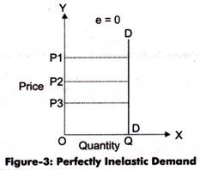
It can be interpreted from Figure-3 that the movement in price from OP1 to OP2 and OP2 to OP3 does not show any change in the demand of a product (OQ). The demand remains constant for any value of price. Perfectly inelastic demand is a theoretical concept and cannot be applied in a practical situation. However, in case of essential goods, such as salt, the demand does not change with change in price. Therefore, the demand for essential goods is perfectly inelastic.

3. Relatively Elastic Demand:
Relatively elastic demand refers to the demand when the proportionate change produced in demand is greater than the proportionate change in price of a product. The numerical value of relatively elastic demand ranges between one to infinity.
Mathematically, relatively elastic demand is known as more than unit elastic demand (e_{p}>1). For example, if the price of a product increases by 20% and the demand of the product decreases by 25%, then the demand would be relatively elastic.
The demand curve of relatively elastic demand is gradually sloping, as shown in Figure-4:
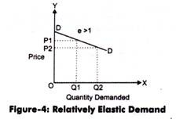
It can be interpreted from Figure-4 that the proportionate change in demand from OQ1 to OQ2 is relatively larger than the proportionate change in price from OP1 to OP2. Relatively elastic demand has a practical application as demand for many of products respond in the same manner with respect to change in their prices.
For example, the price of a particular brand of cold drink increases from Rs. 15 to Rs. 20. In such a case, consumers may switch to another brand of cold drink. However, some of the consumers still consume the same brand. Therefore, a small change in price produces a larger change in demand of the product.

4. Relatively Inelastic Demand:
Relatively inelastic demand is one when the percentage change produced in demand is less than the percentage change in the price of a product. For example, if the price of a product increases by 30% and the demand for the product decreases only by 10%, then the demand would be called relatively inelastic. The numerical value of relatively elastic demand ranges between zero to one (e_{p}<1). Marshall has termed relatively inelastic demand as elasticity being less than unity.
The demand curve of relatively inelastic demand is rapidly sloping, as shown in Figure-5:
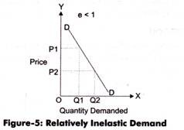
It can be interpreted from Figure-5 that the proportionate change in demand from OQ1 to OQ2 is relatively smaller than the proportionate change in price from OP1 to OP2. Relatively inelastic demand has a practical application as demand for many of products respond in the same manner with respect to change in their prices. Let us understand the implication of relatively inelastic demand with the help of an example.
Example-3:
The demand schedule for milk is given in Table-3:
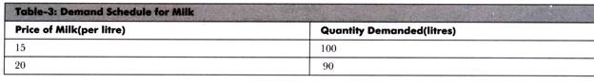
Calculate the price elasticity of demand and determine the type of price elasticity.
Solution:
P= 15
Q = 100
P1 = 20
Q1 = 90
Therefore, change in the price of milk is:
∆P = P1 – P
∆P = 20 – 15
∆P = 5
Similarly, change in quantity demanded of milk is:
∆Q = Q1 – Q
∆Q = 90 – 100
∆Q = -10
The change in demand shows a negative sign, which can be ignored. This is because of the reason that the relationship between price and demand is inverse that can yield a negative value of price or demand.
Price elasticity of demand for milk is:
e_{p} = ∆Q/∆P * P/Q
e_{p} = 10/5 * 15/100
e_{p} = 0.3
The price elasticity of demand for milk is 0.3, which is less than one. Therefore, in such a case, the demand for milk is relatively inelastic.

5. Unitary Elastic Demand:
When the proportionate change in demand produces the same change in the price of the product, the demand is referred as unitary elastic demand. The numerical value for unitary elastic demand is equal to one (e_{p}=1).
The demand curve for unitary elastic demand is represented as a rectangular hyperbola, as shown in Figure-6:
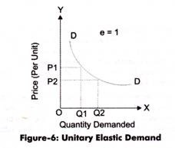
From Figure-6, it can be interpreted that change in price OP1 to OP2 produces the same change in demand from OQ1 to OQ2. Therefore, the demand is unitary elastic.

The different types of price elasticity of demand are summarized in Table-4: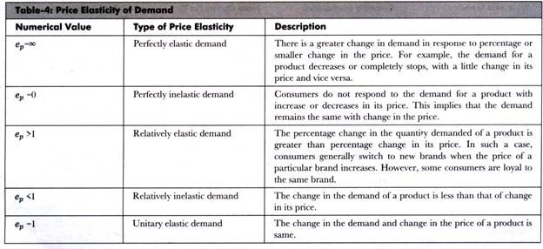

Cross Elasticity of Demand:
The cross elasticity of demand for good X may be positive, negative or zero which depends on the nature of relation between the goods X and Y. This relation may be as substitutes, complementary or unrelated goods.

1. Substitute Goods: If X and 7 are substitute goods, a fall in the price of good Twill reduce the quantity demanded of good X. Similarly, an increase in the price of good Y will raise the demand for good X. Their cross elasticity is positive because, given the price of X, a change in the price of Twill lead to a change in the quantity demanded of X in the same direction as in the price of Y.
The cross elasticity of substitute goods is explained in Table 5.
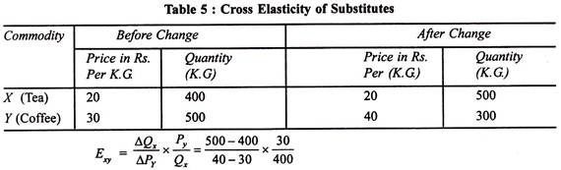
It is clear from the above that the coefficient of cross elasticity of substitute goods such as tea (X) and coffee (Y) is positive (+0.75) when with the rise in price of coffee, the price of tea being constant, the demand for tea also increases.
This is shown in Fig. 6 where the quantity of good X (tea) is taken on X-axis and the quantity of good Y is plotted on Y-axis. When the price of Y increases from OY to OY₁, the quantity demanded of X rises from OX to OX₁. The slope of the demand curve downwards to the right shows positive elasticity of both the goods.
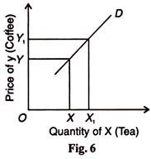
2. Complementary Goods: If two goods are complementary (jointly demanded), rise in the price of one leads to a fall in the demand for the other. Rise in the prices of cars will bring a fall in their demand together with the demand for petrol. Similarly, a fall in the prices of cars will raise the demand for petrol. Since price and demand vary in the opposite direction, the cross elasticity of demand is negative.
The cross elasticity of complementary goods is explained in Table 6.
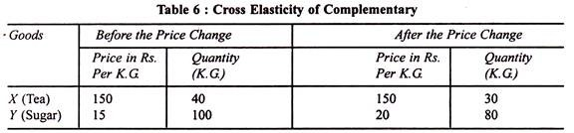
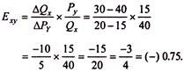
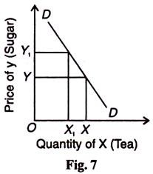
In this case, the cross elasticity coefficient of complementary goods such as tea and sugar or car and petrol is negative.
This is explained in Fig.7 where with the rise in the price of Y (Sugar) from OY to OY₁ the demand for X (tea) falls from OX to OX₁. The slope of the demand curve downwards to the right indicates negative cross elasticity.

3. Unrelated Goods:
If the two goods are unrelated, a fall in the price of good Y has no effect whatsoever on the demand for good X. In such a case, the cross elasticity of demand is zero. For example, a fall in the price of tea has no effect on the quantity demanded of car. The cross elasticity of demand for unrelated goods is shown in Fig. 8. Even an increase in the price of good Y from OY to OY₁, the demand for good X remains the same as OD. Hence, the cross elasticity of demand for unrelated goods is zero.
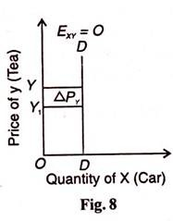
Some Conclusions:
We may draw certain inferences from this analysis of the cross elasticity of demand.
(a) The cross elasticity between two goods, whether substitutes or complementary, is only a one-way traffic. The cross elasticity between butter and jam may not be the same as the cross elasticity of jam to butter. A 10% fall in the price of butter may cause a fall in the demand for jam by 5%.
But a 10% fall in the price of jam may lower the demand for butter by 2%. It shows that in the first case the coefficient is 0.5 and in the second case 0.2. The superior the substitute whose price changes, the higher is the cross elasticity of demand.
This rule also applies in the case of complementary goods. If the price of car falls by 5%, the demand for petrol may go up by 15%, giving a high coefficient of 3. But a fall in the price of petrol by 5% may lead to a rise in the demand for cars by 1%, giving a low coefficient of 0.2.

(b) Cross elasticities for both substitutes and complementary vary between zero and infinity. Generally, cross elasticity for substitutes is positive, but in exceptional circumstances it may also be negative.

(c) Commodities which are close substitutes have high cross elasticity and commodities with low cross elasticities are poor substitutes for each other. This distinction helps to define an industry. If some goods have high cross elasticity, it means that they are close substitutes.
Firms producing them can be regarded as one industry. A good having a low cross elasticity in relation to other goods may be regarded a monopoly product and its manufacturing firm becomes an industry by determining the boundary of an industry. Thus cross elasticities are simply guidelines.

Income Elasticity of Demand:
Domestically produced goods being close substitutes if the cross elasticity of demand for imports is high and if the prices of domestic goods increase due to inflation, the demand for imports will increase substantially which will deteriorate the balance of payments position.

If an increase in income leads to an increased demand for a commodity, the income elasticity coefficient (E_{y}) is positive. A commodity whose income elasticity is positive is a normal good because more of it is purchased as the consumer’s income increases.

On the other hand, if an increase in income leads to a fall in the demand for a commodity, its income elasticity coefficient (E_{y}) is negative. Such a commodity is called inferior good because less of it is purchased as income increases. If the quantity of a commodity purchased remains unchanged regardless of the change in income, the income elasticity of demand is zero (E_{y} =0).

Normal goods are of three types necessaries, luxuries and comforts. In the case of luxuries, the coefficient of income elasticity is positive but high, E_{y} >1. Income elasticity of demand is high when the demand for a commodity rises more than proportionate to the increase in income.

Assuming prices of all other goods as constant, if the income of the consumer increases by 5% and as a result his purchases of the commodity increase by 10%, then E_{y} = 10/5 = 2(>1). Taking income on the vertical axis and the quantity demanded on the horizontal axis, the increase in demand Q₁Q₂ is more than the rise in income Y₁ Y₂, as shown in Figure 9. The curve Dy shows a positive and elastic income demand.
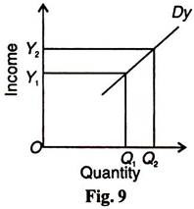
In the case of necessities, the coefficient of income elasticity is positive but low, E_{y} <1. Income elasticity of demand is low when the demand for a commodity rises less than proportionate to the rise in the income. If the proportion of income spent on a commodity increases by 2% when the consumer’s income goes up by 5%, E_{y} = 2/5(<1) Figure 10 shows a positive but inelastic income demand curve Dy because the increase in demand Q₁ Q₂ is less than proportionate to the rise in income Y₁ Y₂.
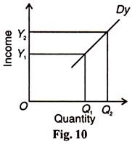
In the case of comforts, the coefficient of income elasticity is unity (E_{y} =1) when the demand for a commodity rises in the same proportion as the increase in income. For example, a 5% increase in income leads to 5% rise in demand, E_{y} =5/5 = 1. The curve Dy in Figure 11 shows unitary income elasticity of demand. The increase in quantity demanded Q₁ Q₂ exactly equals the increase in income Y₁ Y₂.
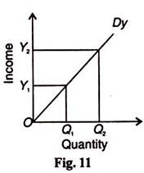
The coefficient of income elasticity of demand in the case of inferior goods is negative. In the case of an inferior goods, the consumer will reduce his purchases of it, when his income increases. If a 5% increase in income leads to 2% reduction in demand, E_{y} = -2/5 (<0). Figure 12 shows the Dy curve for an inferior goods which bends upwards from A to B when the quantity demanded decreases by Q₁ Q₂ with the rise in income by Y₁ Y₂.
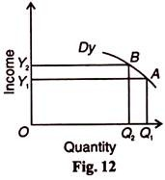
If with increase in income, the quantity demanded remains unchanged, the coefficient of income elasticity, E_{y} = 0. If, say, with 5% increase in income, there is no change in the quantity demanded, then E_{y} = 0/5 = 0. Figure 13 shows a vertical income demand curve Dy with zero elasticity.
