UNIT-II
Theories of communication I – Media Effects
- Agenda-Setting
- Sadharanikaran, Priming
- Strategic Communication
- Advertising- Elaboration Likelihood Model
- Heuristic- Systematic Model of Information Processing
- Communication Campaigns
- Crisis Communication
- Risk Management
- Inoculation
- Third-Person Effect
- Social Comparison
- Two Step Flow
- Attitude Change

VI. COMMUNICATION CAMPAIGNS
Introduction
Communication campaigns are important because they help organizations set goals, identify strategies and generate effective approaches for sharing specific messaging. Using a well-researched and thoroughly planned approach, organizations can use their communication campaigns to reach audiences successfully, even while competing with other sources of information and media coverage.
Therefore, communication campaigns can give organizations the ability to convey complex, multifaceted messages to a variety of target demographics engage with their audiences and promote their brand while adhering to principles that can help ensure a return on investment (ROI).
How to develop communication campaigns
Developing an effective communication campaign can be a challenging process that may differ depending on your objectives. Despite this, there are a few essential steps you can take to plan your campaign and its various components. Here's a step-by-step guide for developing a communication campaign:
1. Conduct research and audit your current approach
Before you develop your campaign, it may be helpful to conduct some research and audit your organization's current approach. Consider what tactics you've used in the past to reach audiences and evaluate how effective they've been. Then, identify the tools from your current approach that you can continue using, determine what gaps exist and research new tactics of which you might be able to take advantage.
2. Develop a strategy
Once you perform an audit of your current approach and evaluate how effective you've been in the past, you can start to develop your strategy. The term communication strategy refers to a summary of your campaign and its various essential components. To develop a strategy, identify items like your campaign's goals, the target audiences you've identified, the messages you intend to develop—including a matrix of messages if your communication is to be multifaceted—and the tone you plan to use. During this stage, consider:
- What you're trying to accomplish
- Who you're trying to reach
- What you're going to say to your audience
- How you can say this in a way that causes them to take notice
3. Determine how to reach your audience
Once you've developed a strategy for your campaign, you can determine pathways for reaching your audience effectively. There are various communication channels available for sharing messaging, and you can use multiple channels throughout your campaign, but try to identify which ones might be most helpful for engaging with your specific audience. For instance, if your target audience includes young adults and teenagers, you might consider prioritizing social media, as these individuals of this demographic typically frequent such platforms. Here are a few examples of channels you can consider including in your approach:
- Blog
- Website
- Email
- SMS
- Broadcast
- Print media
- Podcasts
- Digital marketing
- Social media
4. Identify a spokesperson
At this point in the development of your campaign, it may be helpful to identify a spokesperson. While not all communication campaigns employ a spokesperson, doing may help your organization convey authority and trust while disseminating your message. If you choose to use a spokesperson in your campaign, try to identify one by first gaining an understanding of who your target audience likes and trusts. Then, determine who can offer a compelling, believable and engaging narrative on behalf of your organization.
5. Set a budget
After you have the various components of your campaign established, you can set a budget for your project. Consider what resources are available to you and how you can use them most strategically. Itemize the costs of creating materials, disseminating your message, engaging with your audience, hiring a spokesperson and overcoming possible challenges. From here, you can tally these costs up and reconfigure your approach depending on what you want to prioritize in your campaign and how you want to allocate your money.
6. Consider potential obstacles and establish a plan for evaluation
Prior to launching your campaign, it's important that you consider potential obstacles to success and create a plan for overcoming them. You may encounter challenges in reaching your audience members or relaying your message effectively, and it's vital that you're prepared to shift your approach whenever necessary. Then, try to establish a plan for evaluating your campaign's effectiveness by determining what metrics you can use to measure your goals and how you can track them.
VII. CRISIS COMMUNICATION
Introduction
Crisis refers to sequence of unwanted events at the workplace which lead to disturbances and major unrest amongst the individuals. Crisis generally arises on a short notice and triggers a feeling of threat and fear in the employees. In simpler words crisis leads to uncertainty and causes major harm to the organization and its employees.
It is essential for the employees to sense the early signs of crisis and warn the employees against the negative consequences of the same. Crisis not only affects the smooth functioning of the organization but also pose a threat to its brand name.
A. What is Crisis Communication?
Crisis Communication refers to a special wing which deals with the reputation of the individuals as well as the organization. Crisis communication is an initiative which aims at protecting the reputation of the organization and maintaining its public image. Various factors such as criminal attacks, government investigations, media enquiry can tarnish the image of an organization.
Crisis Communication specialists fight against several challenges which tend to harm the reputation and image of the organization.
B. Need for Crisis Communication
Crisis can have a negative effect on brand image. Crisis Communication experts are employed to save an organization’s reputation against various threats and unwanted challenges.
Brand identity is one of the most valuable assets of an organization. The main purpose of Crisis Communication team is to protect the brand identity and maintain the organization’s firm standing within the industry.
Crisis Communication specialists strive hard to overcome tough situations and help the organization come out of difficult situations in the best possible and quickest way.
C. Crisis Communication Process
Employees should not ignore any of the external parties and important clients Come out, meet them and discuss the problem with them. There is nothing to be ashamed of. If needed, seek their help. Media must not be ignored. Answer their questions. Avoiding media makes situation all the more worse.
- Don’t criticize individuals. Show a feeling of care and concern for them. Share their feelings and encourage them not to lose hope. Encourage them to deliver their level best. Put yourself in their place. Respect them and avoid playing blame games.
- Effective communication must be encouraged at the workplace during emergency situations. Employees should have an easy access to superior’s cabins to discuss critical issues with them and reach to a mutually acceptable solution.
- Information must flow across all departments in its desired form. One should not rely on mere guess works or assumptions during crisis. Make sure the information you have is accurate.
- Crisis communication specialists must learn to take quick decisions. Remember one needs to respond quickly and effectively during unstable situations. Think out of the box and devise alternate plans for the smooth functioning of organization.
- Make sure information is kept confidential. Serious action must be taken against employees sharing information and data with external parties. Such things are considered highly unprofessional and unethical and spoil the reputation of the organization.
- The superiors must evaluate performance of employees on a regular basis. Ask for feedbacks and reports to know what they are up to. Conduct surprise audits to track performance of employees.
VIII. RISK MANAGEMENT
A. What is Risk Communication?
Risk communication is an interactive process of exchanging information and opinion among individuals, groups, and institutions. It deals with risk, an uncertain future event or consequence that could have an adverse impact on individuals, groups, organizations, or society.
The purpose of risk communication is to help people understand and manage risks. It involves sending messages about risks and risk management to different audiences, such as the media, the general public, employees, and clients.
Risk communication is a complex process that requires the use of different channels and strategies. It must take into account the needs of different audiences and the responsibility of the sender.
B. Why is it Important?
The main goals of risk communication are to help people understand the risks and make informed decisions about how to protect themselves, their families, and their property.
There are three main objectives of risk communication:
- To provide information that people can use to make informed decisions about how to protect themselves from harm
- To reduce the level of fear and anxiety that people may feel about a potential hazard
- To build trust between the organization
Risk communication is an important part of emergency management and public health initiatives. It is also a valuable tool for businesses, governments, and other organizations when they need to share information about risks with their employees, customers, or the general public.
C. Principles of Risk Communication
To effectively communicate risks to relevant stakeholders in your business, it’s essential to know the following principles:
1. Know the Audience
Knowing the audience is critical to risk communication. Without understanding the audience, it is difficult to determine how best to communicate the risks and benefits of a given situation.
2. Keep It Simple
When communicating risks, it is important to keep the message simple. The more complex the message, the more likely it is that the audience will not understand or be confused by the information.
3. Be Clear with Your Message
It is important to be clear when communicating risks. Ambiguous messages can lead to misunderstandings, resulting in increased anxiety or fear.
4. Be Honest
Honesty is critical in risk communication. Misinformation or withholding information can erode trust and credibility, which are essential for effective risk communication. Make sure to verify the accuracy of the information you have and relay your message in a straightforward manner.
5. Listen to Your Audience
Risk communication is a two-way process. It is important to listen to the audience and to understand their concerns. Only then can effective risk communication take place.
D. What are its Types?
- Public Relations: The use of persuasion to manage the public’s perception of a company or product.
- Social Media: The use of online platforms like Twitter and Facebook to communicate with the public.
- Media Relations: The proactive and reactive management of media coverage.
- Crisis Communications: Planning for and managing communications during a crisis situation.
E. Risk Communication Process
Risk communication is the process of sharing information to help others make better decisions. It involves the following principles:’
- Identify the Risk. Risk identification is the first and foremost task in the risk communication process. Different individuals and groups will have different perceptions of what is risky, so it is important to be clear about the source and nature of the risk.
- Assess Its Impact and Likelihood. After the risk has been identified, it must be assessed in order to determine its severity and likelihood. This will help prioritize risks and focus on communicating those that are more likely to cause harm.
- Communicate the Risk. Risk cannot be managed effectively unless it is communicated openly and honestly. The audience must be given accurate information about the risk in order to make informed decisions. Following the principles of risk communication will help you in this process.
- Manage the Risk. Once the risk has been communicated, it must be managed effectively in order to minimize its impact. This may involve taking steps to reduce the severity of the risk or implementing controls to prevent it from occurring.
- Monitor the Results of Your Risk Communication Campaign. Your risk communication strategy should be monitored over time to ensure that they are effective at sending the right message. This may involve periodically reassessing materials, recording your audience’s reactions, and modifying the communication strategy as necessary.
IX. INOCULATION
Introduction
The inoculation theory was proposed by McGuire in response to a situation where the goal is to persuade someone not to be persuaded by another. The theory is a model for building resistance to persuasion attempts by exposing people to arguments against their beliefs and giving them counter arguments to refute attacks. The theory therefore offers mechanisms by which communication is used to help people defend their beliefs.
A. What is Attitude Inoculation?
As hard as it is to imagine, over 60 years ago, one of the most powerful and persuasive social, psychological, and communication theories was formulated from an experiment about brushing teeth. In 1961, William McGuire, a social psychologist, developed Attitude Inoculation, a methodology for arming an individual with sociological techniques for defending against unwanted arguments. To quote the National Library of Medicine, it was a process of "Persuading Others to Avoid Persuasion."
The best way to describe how attitude inoculation works is through a comparison of vaccination. With vaccinations, a smaller version of the disease is introduced into the body. This "inoculation" strengthens the immune system to develop antibodies as a defence against a stronger version of the same disease. With attitude inoculation, the vaccine is the weaker, watered-down version of an argument. When a person is exposed to portions of a stronger argument, it prepares them with a persuasive counter-arsenal of arguments, which they may use later to defend against future unwanted persuasive arguments.
B. Need for the Theory
In today’s world we are bombarded by information from all angles. There are a number of attempts being made on an everyday basis to persuade us in one direction or another. Therefore there is a need to know how such persuasion attempts can be fought. The theory offers up a way in which resistance to persuasion can be achieved.
C. William McGuire's Experiment
But, how did 'teeth brushing discussions' become an impetus for William McGuire's attitude inoculation experiment? A test variable, which is a commonly accepted belief that daily 'tooth brushing' is beneficial, was proposed as the main point of discussion to his test groups. In one group, he introduced some partial arguments that tooth brushing may not be beneficial. In the other group, he did not prepare them with any pre-discussion of the potential negative effects of tooth brushing.
When an argument later was proposed to both groups that tooth brushing was not always beneficial, the group that had been 'inoculated' or exposed to small versions of the argument was better prepared to take a stance against the idea that brushing one's teeth is not beneficial. After this experiment, McGuire theorized- the group that was not prepared in advance had fewer arguments against the anti-tooth brushing statement because they had not been inoculated with the smaller argument.
Significance of Inoculation Theory
William McGuire postulated, "The experiments supported the effectiveness of inoculation pretreatments, with refutational pretreatments being most effective in building resistance to future attacks (McGuire, 1964)." His experiment supported the idea that 'inoculating' individuals helped them to build 'communication or mental antibodies' to resist persuasion.

For more than 60 years, attitude inoculation has been positively received within medical, psychological, and sociological communities. It has been tested in a variety of sectors, such as health, politics, advertising, anti-smoking, anti-alcohol, anti-drug campaigns, and more. In 2010, Media Ecology and Strategic Analogy Group (MESA) did a data research study on the inoculation theory and analysed over 54 studies with 10,000 participants, supporting the effectiveness of the approach.
By arming individuals with a persuasion technique, it is easier to counter potentially harmful or dangerous arguments that are often faced in society. People are bombarded with social media that have inaccurate news and high-pressured advertising, which can expose them to harmful substances on a daily basis. Attitude inoculation is a tool that helps in carefully sorting challenging choices that people face on a daily basis.
X. THIRD PERSON EFFECT
Introduction
The third-person effect determines that we tend to perceive that mass media messages have a greater effect on others than on ourselves.
One of the most intriguing things about the psychology of persuasion is how many people claim that persuasion attempts have little or no effect on them.
According to Davison, “The third-person effect hypothesis is defined as the probability that "individuals who are members of an audience who are exposed to persuasive communication would expect the communication to have a bigger influence on others than on themselves,"
1. Defining the third-person effect
The third-person effect is often measured by asking individuals two sorts of questions, one focused on one's views of media impact on oneself and the other on one's perceptions of media influence on others. The third-person effect is defined as those who report that the media impacts others more than they influence them.
Based on personal biases, the third-person effect theory predicts that people would perceive mass media messages to have a larger impact on others than on themselves. An individual's overestimation of the influence of a mass communicated message on the generalized other or underestimating the effect of a mass communicated message on themselves is known as the third-person effect.
Self-motivated social desirability, a social-distance result, and perceived exposure to a message all contribute to these kinds of impressions. The phenomenon is also known as "Third-person perception" or "Web Third-person effect." When the impact is proven in social media, media websites, blogs, and websites in general, Since 2015, The "Web Third-person Effect" has been coined."
2. What is the third person effect?
We all like to think we're immune to advertising. That we only buy what we need when we need it. With that in mind, we tend to presume that mass media marketing has no effect on us. But other people, oh sure, adverts, work on them! Not you and I, though, we’re too clever for that.
In other words, people are likely to be influenced more than they think on subjects that are currently of little or no interest to them.
3. Components of the third-person effect
In addition to examining the third-person effect concerning various types of media content and studying the behavioral component of the third-person effect, researchers have looked at a variety of other variables to understand better the third-person effect and how it works for different people. In the context of the third-person effect, three aspects are investigated: social distance, perceived knowledge, and media exposure.
A. Social distance
According to Davison, the notion of reference groups might help explain the third-person effect. Are persuasive communications more effective on individuals "like me" or "different from me"? Is the degree of resemblance a meaningful element, or is it not? Suppose perceived congruence of others' attitudes and values with one's own is a role in choosing normative reference groups. In that case, one will anticipate little exaggeration in the perceived impact of a message on members of such groups.
B. Perceived knowledge
The study of cognitive distance aims to affect research participants' judgments of their expertise regarding that of others. In several third-person effect studies, the variable of self-perceived knowledge has been investigated independently of the idea of cognitive distance. Perceived knowledge, also known as subjective competence, is not the same as real knowledge of a topic, described as objective competence. Subjective competence is described as one's belief in one's own capacity to comprehend events and confidence in one's ability to make views on certain subjects. The third-person effect has not been linked to measures of objective competence. The findings on self-perceived knowledge and the third-person effect, on the other hand, were equivocal.
4. Third person effect tactics
When it comes to communication with shoppers either in-store or online, there are a number of tactics we can employ.
- New for how long – put a ‘New’ message in a duty-free store and it will be effective for a year or more. Why? Because most shoppers only take one overseas trip per year, so just because a message seems too old-hat for your brand, what about for shoppers?
- Monkey see, monkey do – it’s a positive that so many shoppers say they aren’t influenced, when they are. So, you don’t have to come up with new activations all the time; the tried and tested stuff mostly still works, shoppers just don’t admit it.
- Belief is key – there’s nothing wrong with shoppers believing others will be influenced more than they are because, frankly, it’s not the case! We’re all influenced more than we think.
Once we acknowledge our own thought processes are flawed, we can then understand the power of advertising and messages of influence both in-store and online.
XI. SOCIAL COMPARISON
Introduction
Social comparison theory suggests that people value their own personal and social worth by assessing how they compare to others. Introduced by Leon Festinger in 1954, the theory describes the comparison processes people utilize to evaluate their actions, accomplishments, and opinions in contrast to those of other people.
We all compare ourselves to others in our social worlds, whether by comparing our looks to those of celebrities we see in the media or our talents to those of our co-workers. In psychology, social comparison theory is one explanation for this tendency we have to make comparisons between ourselves and others.
Let's take a closer look at how social comparison theory works and how the comparisons we make influence the views we may hold of ourselves.
Background
Social comparison theory was first proposed in 1954 by psychologist Leon Festinger and suggested that people have an innate drive to evaluate themselves, often in comparison to others.﻿ People make all kinds of judgments about themselves, and one of the key ways that we do this is through social comparison, or analysing the self in relation to others.
For example, imagine that a high school student has just signed up for band class to learn how to play the clarinet. As she evaluates her skills and progress, she will compare her performance to other students in the class.
She might initially compare her abilities to the other members of the clarinet section, particularly noting those who are better than her as well as those who are worse. She may also compare her abilities to those of students who play other instruments as well.
For example, a music student might compare herself to the star student of the class. If she finds that her abilities do not measure up to her peer's talents, she might be driven to achieve more and improve her abilities.

How Social Comparison Process Works
The social comparison process involves people coming to know themselves by evaluating their own attitudes, abilities, and traits in comparison with others. In most cases, we try to compare ourselves to those in our peer group or with whom we are similar.2﻿ There are two kinds of social comparison—upward social comparison and downward social comparison.
1. Upward Social Comparison
This takes place when we compare ourselves with those who we believe are better than us. These upward comparisons often focus on the desire to improve our current status or level of ability. We might compare ourselves to someone better off and look for ways that we can achieve similar results.
2. Downward Social Comparison
This takes place when we compare ourselves to others who are worse off than us. Such downward comparisons are often centred on making ourselves feel better about our abilities or traits. We might not be great at something, but at least we are better off than someone else.
XII. TWO STEP FLOW
Introduction
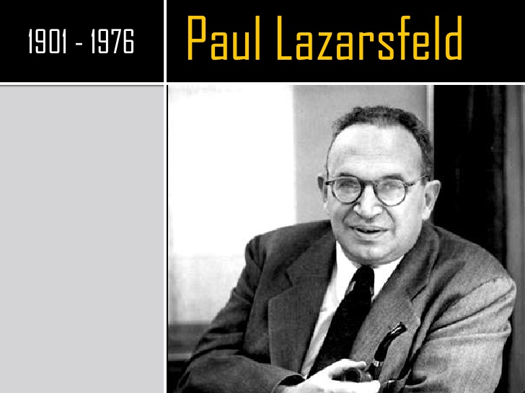
The Free Press published Elihu Katz and Paul F. Lazarsfeld’s (1955) soon-to-be-classic study, Personal Influence: The Part Played by People in the Flow of Mass Communications. Though the concept had earlier roots (Berelson, Lazarsfeld, and McPhee 1954, especially chap. 6; Lazarsfeld, Berelson, and Gaudet 1944), it is to this volume that contemporary scholars turn for the classic statement of the “two-step flow of communication” hypothesis.
- In the first step, messages are issued by the mass media to what is, to all outward appearances, a more or less homogeneous mass audience.
- In the second, innumerable small group interactions powered by horizontal opinion leaders interpret and contextualize these mediated messages for their participants, who then internalize the resulting content.
- The end result is a more or less differentiated understanding of the message across various social boundaries.
The two-step flow theory of communications explains how information from the media moves in two distinct stages. According to above hypothesis we can say that certain people have a lot of influence, one way or another, and those people are influencers because they have an audience (followers), one that listens to and often believes or is at least affected by what they say.
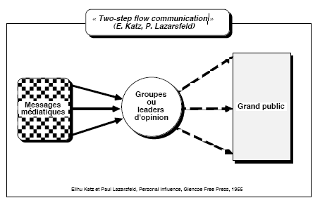
Origin of theory
- The two-step flow theory was first formulized by Paul Lazarsfeld, Bernard Berelson and Hazel Gaudet in The People’s Choice (1944).
- The study primarily focused on the process of decision making during a Presidential election campaign.
- The three researchers were expecting that evidence would point to direct influence of media messages on voting intentions. However, they were surprised to find that personal contacts were mentioned more frequently than exposure to mass media as sources of influence on voting behaviour.
- Friends, family and opinion leaders were more likely to sway and change opinions of large audiences over radio or newspaper.
- The researchers’ image of a disconnected mass audience of individuals failed to explain how interpersonal relations came into play when making decisions. From this information, the two-step flow theory of communications originated.

Who are opinion leaders?
Opinion leadership comes from the theory of two-step flow of communication propounded by Paul Lazarsfeld and Elihu Katz Significant developers of the theory have been Robert K. Merton, C. Wright Mills and Bernard Berelson.
According to Paul Lazarsfeld's Two-step flow theory, the audience are indirectly passive to the media message. In his theory he has detailed that the messages from the media channels are not directly influential on +the audience but the 'opinion leaders' act as messengers, whether or not the message is distorted. Here, opinion leaders are those who intake the media messages and form their own opinion about it.
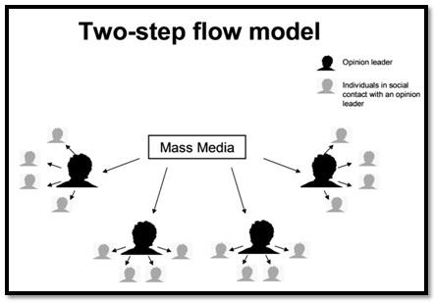
Advantages of theory
- It developed understanding of how the mass media influence decision making of the masses.
- It empower masses to be active participants in the communication process.
- It helps to forecast the power of media messages on audience behaviour.
- It also deliver a very convincing explanation for information flow.
- It recognizes that audiences are composed of individuals who are part of a society.
- Opinion leaders are quite influential in getting people to change their attitude and behaviours.
- The opinion leaders do not replace media, but rather guide conversation of media.
- In this flow of communication audiences are inactive participants who take in every little thing the media puts out.
Disadvantages of theory
- Individuals use mass media in order to enhance their common understanding.
- In modern times masses now use the media according to their own awareness.
- The flow of influence is overlapping to each other.
- Individuals could now decide how they wanted to use the media and how to interpret it.
- Opinion leaders pass on their own interpretations in addition to the actual media content.
- The diverse nature of media provides so much information to masses which in turn prove more challenging to influence masses. Once a time Socrates says, “the more you know, the more you know how little you know”
XIII. ATTITUDE CHANGE
Introduction
What is attitude?
How are the attitudes shaped and how do they change? A number of theories have been formulated to explain the attitude formation and change. Attitudes are linked with beliefs and behaviours to some purpose. Unlike behaviour, attitudes are likely to change as a function of involvement. They are not constant, and because of the communication with each other it may change by social influences.
Attitudes can be changed through influence. An attitude usually involves liking or disliking something. Thumbs up or thumbs down. Attitudes are inclinations to favour or disfavour particular thoughts or beliefs. Social psychologists highlight that an attitude is preparation for behaviour. Otherwise, nobody would care about attitudes.
Attitude Change Theory
Origin of theory
The research work of researchers led by Carl Hovland was recognized as attitude change theory. The chief contributors to this theory were Hovland, Lumsdaine, and Sheffield. Hovland's first opportunity to work intensively in the underdeveloped area of social psychology arose during World War II, when he took a leave of absence from Yale for over 3 years to serve as a senior psychologist in the War Department.
He was recruited by Samuel Stouffer, also a sociologist who was on leave from University of Chicago. Carl had the responsibility of leading a research team of fifteen researchers. His main role was to conduct experiments on the effectiveness of training and information programs that were intended to influence the motivation of men in the American armed forces.
The Attitude Change Methodology
The theory was first studied by Carl Hovland and his colleagues at Yale University, and thus was known later on as The Yale Attitude Change Approach. The Yale Attitude Change Approach is a method to making persuasive communications effective a study started by Carl Hovland, based on his experiences during World War II while attempting to boost morale in U.S. soldiers through wartime propaganda.
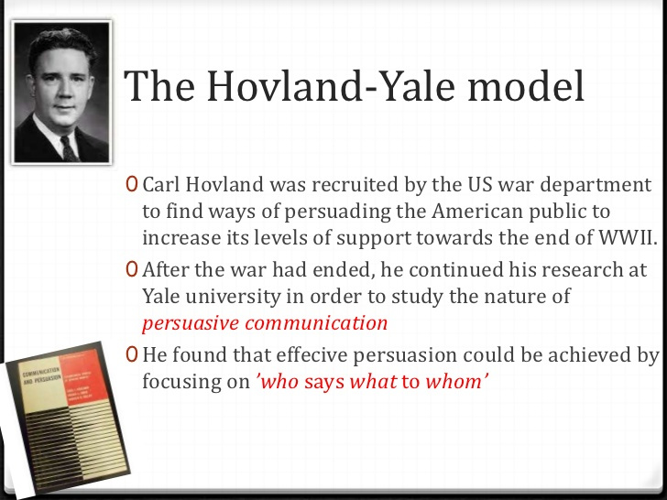
The Yale group developed a general theoretical structure linking individual attributes and persuasion based on three major factors: the source of the communication, the nature of the communication, and the nature of the audience.
The basic paradigm of this approach can be described as “who said what to whom” the source of the communication, the nature of the communication, and the nature of the audience. There are many factors and effects that come into play in each of the components of a persuasive communication, according to this approach. For example,
- The credibility and attractiveness of the communicator (source)
- The quality and sincerity of the message (nature of the communication)
- The attention, intelligence and age of the audience (nature of the audience)
Above all influence the effects of the audience’s observed attitude change through an influential communication. For example, independent variables would include the source, message, medium and audience with the dependent variable being the effect, or impact of the persuasion.
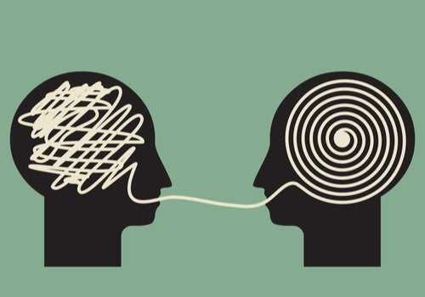
Hovland's Analysis of Persuasion
The first generation of research on persuasion and attitude change was led by Carl Hovland of Yale University from the late 1940s through the 1950s. Hovland started out his career studying Pavlovian conditioning in the 1930s.
By the late 1940s, Hovland was studying films made by the U.S. Army during WW II. His was asked to find out how effec­tive they were at persuading soldiers.
Hovland and colleagues set out to deter­mine which factors influenced the suc­cess or failure of persuasion. Hovland highlighted three variables.
- Characteristics of the communicator (the person conveying the message) such as whether the person is an expert
- Characteristics of the communication (what information is con­veyed) such as the arguments used
- Characteristics of the situation (the circumstances in which the message is conveyed) such as whether the person receiving a message was comfortable

