Commodity Markets in India

Commodities can be traded in both the spot market (cash segment) as well as the derivatives segment (forward and futures) market. Although the two markets are different in terms of time of delivery and other terms of trade, they are inter-related. The commodities are physically bought or sold on a negotiated basis in the spot market, where immediate delivery takes place. The physical markets for commodities deal in cash (spot) transactions for ready delivery and payment.
There are two main types of commodities that trade in the spot and derivatives markets:
- Soft commodities: These are the perishable agricultural products such as corn, wheat, coffee, cocoa, sugar, soybean, etc.
- Hard commodities: These are natural resources that are mined or processed such as the crude oil, gold, silver, etc.
- Spot Market
- Spot market is a place where commodity is traded and the transfer of ownership takes place immediately. This concept is also termed as “ready delivery contract” under which payment and delivery of good happens immediately. There are two variants of spot market: physical spot market and electronic spot market.
- Physical Spot Market
- In a physical spot market, the commodities are physically bought and sold by the buyers and sellers respectively for immediate delivery. In addition to the buyers and the sellers, the spot market has traders who are licensed by the mandi to trade in the market. These traders have to pay mandi fees. In a spot market, a physical commodity is sold or bought at a price negotiated between the buyer and the seller. The spot markets can be either a retail market i.e., targeted towards the actual consumers or a wholesale market i.e., market for intermediate traders.
- In a Mandi, the farmers bring their produce, and the traders or middlemen known as commission agents or ‘aadhatiyas’ inspect the quality and bid for the same. The buyer with the highest bid acquires the produce. Thus, the traditional ‘Mandi’ system leaves the farmer with no bargaining power as the price setting power completely rests in the hands of the traders and middlemen (though the recent reforms are changing this situation). This results in a very inefficient price discovery mechanism.
- Electronic Spot Exchange/Spot Commodity Exchange
- A spot commodity exchange is an organized marketplace where buyers and sellers come together to trade commodity-related contracts following the rules set by the respective commodities exchange. An electronic spot commodity exchange provides a market place where the farmers or their Farmer Producer Organisation (FPO) can sell their produce and the processors, exporters, traders and other users can buy such produce through an electronic trading system. Electronic Spot Exchanges for agricultural produce were setup to bring large number of buyers and sellers on the same platform for better price realization for the farmers. Unlike in a traditional mandi market, here the farmer plays a role in the price discovery and is not a mere witness to the sale of the agricultural commodity.
- National Agriculture Market (eNAM) plays a key role in the electronic spot market of agricultural produce. eNAM is a pan-India electronic trading portal which networks the existing APMCs (mandis) to create a unified national market for agricultural commodities. Small Farmers Agribusiness Consortium (SFAC) is the lead agency for implementing eNAM under the aegis of Ministry of Agriculture and Farmers’ Welfare, Government of India.
- eNAM is set up to promote uniformity in agriculture marketing by streamlining the procedures across the integrated markets, removing information asymmetry between buyers and sellers and promoting real time price discovery based on actual demand and supply. The idea behind eNAM is the integration of APMCs across the country through a common online market platform to facilitate pan-India trade in agriculture commodities, providing better price discovery through transparent auction process based on quality of produce along with timely online payment.

Commodity Exchanges in India

Commodity exchanges, often called the lifeblood of economic activities, are dynamic marketplaces where many raw materials and primary agricultural products change hands. These exchanges provide a structured and highly organized platform, empowering both seasoned traders and businesses to navigate the unpredictable seas of price fluctuations, seek fair market valuations, and ensure the efficient operation of the commodities market.
At the core of these exchanges lies the elemental principle of supply and demand. The intricate dance of market dynamics sets the stage for price determination. To facilitate these complex transactions, commodity exchanges offer an array of contracts, including the widely utilized futures and options. These contractual instruments endow market participants with the ability to buy or sell commodities at predetermined prices on dates in the future.
Commodity exchanges

1. Multi Commodity Exchange of India (MCX)
The Multi Commodity Exchange of India Limited (MCX) is a state-of-the-art, commodity derivatives exchange that facilitates online trading of commodity derivatives transactions, thereby providing a platform for price discovery and risk management. The Exchange, which started operations in November 2003, operates under the regulatory framework of Securities and Exchange Board of India (SEBI).
MCX offers trading in commodity derivative contracts across varied segments including bullion, industrial metals, energy and agricultural commodities, as also on indices constituted from these contracts. It is India’s first Exchange to introduce commodity options, and futures contracts on bullion, base metals and energy indices. The Exchange focuses on providing commodity value chain participants with neutral, secure and transparent trade mechanisms, and formulates quality parameters and trade regulations, in conformity with the regulatory framework. The Exchange has an extensive national reach, with 547 registered members and 36,312 Authorised Persons with its presence in around 687 cities and towns across India as on 31st March 2024. MCX is India’s leading commodity derivatives exchange with a market share of about 95.93 per cent in terms of the value of commodity futures contracts traded in financial year 2023-24 (April 2023 – March 2024).
The Exchange’s flagship index series, MCX iCOMDEX, is a series of real-time commodity futures price indices, which give information on market movements in key commodities/ segments traded on MCX. The MCX iCOMDEX series consists of a Composite index, apart from three sectoral indices: the Base Metal index (MCX METLDEX), the Bullion index (MCX BULLDEX) and the Energy index (MCX ENRGDEX), and also eight single-commodity indices: Gold, Silver, Aluminium, Copper, Lead, Zinc, Crude Oil and Natural Gas indices.
Multi Commodity Exchange Clearing Corporation Limited (MCXCCL), a wholly-owned subsidiary of MCX, is the first clearing corporation in the Indian commodity derivatives market. The clearing corporation provides collateral management and risk management services, along with clearing and settlement of trades executed on the Exchange. MCXCCL, having state of art risk management system, is the central counterparty for all trades executed on MCX’s trading platform. It also provides Electronic Commodity Accounting and Receipts Tracking System through a web based portal ‘Commodity Receipts Information Systems’ (COMRIS). Further, it provides settlement guarantee to all trades executed on MCX via its Settlement Guarantee Fund (SGF).
With an aim to seamlessly integrate with the global commodities ecosystem, MCX has forged strategic alliances with leading international exchanges such as CME Group and London Metal Exchange (LME). The Exchange has signed Memoranda of Understanding with renowned global exchanges viz. Dalian Commodity Exchange (DCE), Taiwan Futures Exchange (TAIFEX), Zhengzhou Commodity Exchange (ZCE), Jakarta Futures Exchange (JFX) and European Energy Exchange AG (EEX) to facilitate cooperation in areas of sharing knowledge and expertise, education & training, etc. MCX is currently undertaking a consultancy project to set up a commodity derivatives platform at Chittagong Stock Exchange, which will be the first such platform in Bangladesh. The Exchange has also tied-up with various trade bodies, industry associations and educational institutions across the country. These partnerships enable the Exchange to improve trade practices, increase awareness, and facilitate overall growth and development of the commodity market.

2. National Commodity and Derivatives Exchange (NCDEX)
National Commodity & Derivatives Exchange Limited (NCDEX/ the Exchange) is a professionally managed on-line, commodity Exchange, with diverse product offerings setting a benchmark for both agriculture and non agri commodities derivatives segment. NCDEX was incorporated on April 23, 2003 as a public limited company and commenced operations on December 15, 2003 as a recognised association under The Forward Contracts (Regulation) Act, 1952. The Corporate Identity Number of the Exchange is U51909MH2003PLC140116. Effective September 28, 2015, the Exchange became a deemed recognized stock exchange under the Securities Contracts (Regulation) Act, 1956 under the regulation of the Securities and Exchange Board of India (SEBI).

NCDEX’s Raison d’ etre is to serve as an efficient platform for Price Discovery and Price Risk Management and this has been consistently demonstrated over the past two decades. It offers a diverse range of products such as commodity futures, options in goods and index futures that open a plethora of opportunities to cater to the needs of various sets of participants in the commodity derivatives value chain. NCDEX prices are widely recognised as benchmark in both domestic and international commodities market. and the NCDEX prices are widely recognized as international benchmark prices. Our product basket has been evolving over the years and it is our endeavor to offer product portfolio that are inclusive, meeting the needs of all stakeholders in the ecosystem. Technology is core to Exchange functioning and we are the first domestic Exchange to operate from an Uptime-certified Tier-IV data center.

The larger NCDEX Group through its subsidiaries, provides an integrated and holistic market infrastructure including Clearing & Settlement services, Repository services and even an e-Auction Platform.
NCDEX is deeply committed to the national objective of upliftment and development of farmers and the agricultural sector in general and our relentless efforts to connect the primary producer to the Exchange has paved the way for sustainable and inclusive growth of our agrarian economy.

Key shareholders like Life Insurance Corporation of India (LIC), National Bank for Agriculture and Rural Development (NABARD), National Stock Exchange of India Limited (NSE), Canara Bank, Punjab National Bank (PNB), and Indian Farmers Fertiliser Cooperative Limited (IFFCO) are among the architects of India’s economic success story in the past few decades.

3. National Multi Commodity Exchange (NMCE)
NMCE is another commodity exchange focusing on agricultural and non-agricultural commodities. Established in 2002, it provides a platform for trading in various goods, including spices, oilseeds, metals, and energy products. NMCE offers futures contracts and electronic trading facilities to market participants.
NMCE also plays a pivotal role in the agricultural sector, helping farmers, traders, and other stakeholders manage their price risks and improve their income stability. It stands out for its comprehensive basket of commodities and an efficient trading infrastructure.

4. Indian Commodity Exchange (ICEX)
Indian Commodity Exchange Limited (ICEX) is SEBI regulated online Commodity Derivative Exchange. Headquartered at Mumbai, the Exchange provide nationwide trading platform through its appointed brokers.
Some of Prominent shareholders are MMTC Ltd, Central Warehousing Corporation, Indian Potash Ltd, KRIBHCO, Punjab National Bank, IDFC Bank Ltd, Gujarat Agro Industries Corporation, Reliance Exchangenext Ltd, Bajaj Holdings & Investment Ltd, Gujarat State Agricultural Marketing Board, NAFED and Indiabulls Housing Finance Ltd.
The Exchange launched world’s first ever Diamond derivative contracts. ICEX aims to provide futures trading products in India’s all economically relevant commodity. At present it offers futures contract in Diamond. Providing desired price risk hedging solution to the trade through innovative contract designing forms core value of ICEX.
This Exchange is ideally positioned to leverage the huge potential of commodities market and encourage participation of actual users to benefit from the opportunities of hedging, risk management and supply chain management in the commodities markets.
ICEX is the first Exchange in India to adopt global hi-tech platform that ensures automatic and seamless switch-over from its Data Center (DC) to the Disaster Recovery (DR) site with zero data loss in case of exigencies. The technology platform has highly optimized processing techniques, which enables the system to handle very large orders with latencies under 300 microseconds.
5. ACE Derivatives & Commodity Exchange Limited
ACE Derivatives & Commodity Exchange Limited is a commodity exchange founded in 2010. It offers trading opportunities in various agricultural and non-agricultural commodities, including guar gum, guar seeds, soya oil, and mustard seeds. ACE is recognized for its strong technology infrastructure and innovative trading solutions.

6. Universal Commodity Exchange Limited
Universal Commodity Exchange Limited, established in 2012, is yet another platform for trading in a wide spectrum of commodities, including agricultural products, metals, and energy commodities. It is known for its commitment to providing transparent and efficient trading mechanisms.
Role of information in Commodity Markets
Efficient market information provision can be shown to have positive benefits for farmers, traders and policymakers. Up-to-date, or current, market information enables farmers to negotiate with traders from a position of greater strength. It also facilitates spatial distribution of products from rural areas to urban areas and between urban markets by sending clear price signals from urban consumers to rural producers regarding quantities and varieties required.
Well-analysed historical market information enables farmers to make planting decisions in line with urban consumer demand, including those related to new crops. It also permits traders to make better decisions regarding the viability of intra and, perhaps, inter-seasonal storage. Moreover, information of this type assists agricultural planners and researchers and can make an important contribution to our knowledge of urban food marketing systems.
Market information can be regarded as a public good, particularly where there are numerous small farmers who are unable to pay for information. The availability of timely and accurate information to all interested parties is therefore essential, whether it be provided by the government itself or by the private sector. Many countries have attempted to provide market information but their success rate has been poor. Market Information Services have repeatedly proven to be unsustainable and where they have endured they have often failed to provide commercially useful advice, confining themselves to the gathering of, frequently unused, data.
We can differentiate between “current” market information, which meets the immediate commercial needs of farmers and traders and “historical” information which, when analysed, can be used for planning purposes by farmers and policy makers.
Access to timely information on prices and quantities plays a crucial role in reducing the risk of losing money on a market transaction. High risks lead to high marketing costs, as high margins are necessary to compensate for possible losses. In the extreme case, farmers with information can decide whether or not to harvest, so avoiding sending produce to market in times of glut only to discover that the price received does not cover harvest, packaging and transport costs.
All exchange relationships tend to have elements of market power on one side of the exchange or the other. In agricultural marketing transactions the party with more knowledge usually, but not always, sets the initial price. The other party then decides whether to accept or reject the offered price. If only limited competition exists, there will be little pressure to set the offered price close to the actual costs. Competition, however, can increase the weaker party’s knowledge of market conditions and trigger an adjustment in the price, either by direct negotiation or by the patronising of alternative dealers. In such a framework of price formation, market knowledge implies market power. One of the main steps governments can take to improve the fairness of market price formation is thus to ensure that timely and accurate information about actual market conditions is available to all.
It is important that the farmer should be able to sell his or her produce at a convenient stage of the marketing channel. For example, some farmers have the option of selling at farm gate, of delivering to a local assembly market, of supplying a wholesale market direct or of selling directly to retailers or even to consumers. However, a maximum value added for the farmer is not always an optimal solution. This depends on the costs (e.g. transport, risk bearing and time) involved when the farmer decides to sell in a market segment closer to the final consumer. Availability of information on market conditions at different locations or different points in the marketing chain is necessary for choosing where to market.
Farmers often have limited outlets for their produce and are often bound by traditional trading relationships, which may include an element of credit provision by the trader. Opportunities for farmers to take advantage of spatial arbitrage possibilities are therefore restricted. Such opportunities are further hindered by the small quantities produced by most.
While there may be few spatial arbitrage opportunities for small farmers, it cannot be concluded that market information is of little value to them. Indeed, while the opportunities for arbitrage may provide much of the theoretical justification for the provision of market information, the reality is that traders often already have accurate and widespread information networks and the introduction of an official MIS may add little to arbitrage possibilities. However, the practical benefits to farmers are often much greater than the theoretical arbitrage possibilities for traders. At the simplest level, the availability of market information can enable farmers to check on the prices they receive, vis-à-vis the prevailing market prices. If farmers receive prices lower than those broadcast they may, for example, conclude that they should seek out other traders in future, negotiate more forcefully or try to improve the quality and presentation of their produce. Information on market conditions may also change farmers’ marketing strategies. While, individually, farmers may be unable to take advantage of spatial arbitrage possibilities, collectively they may be able to organise transport to more distant and profitable markets.
Information about prices over a season or more can provide valuable information for farmers. It has been shown that market information has led to farmers diversifying into new crops, for example. An upward trend in prices for a crop can indicate profitable production opportunities and may lead to some farmers ceasing to grow a crop where prices are declining. All of this should, over time, contribute to a more equitable balance between urban demand and farmer supply. Market information can be particularly valuable where countries are changing over from a state-controlled marketing system to one of private enterprise.
Linkages between equity and commodity markets
The factors affecting the equity and commodity markets’ movement are different. However the macroeconomic factors affect both the markets in the same way. However commodity markets are affected more by the demand and supply factors and global geopolitics and logistical factors. Scarcity produces price fluctuations and corresponding inflation. Inflation if it persists affects equity markets as profitability of companies and disposable income is affected.
Different commodidties react differently and hence all the commodities donot react similarly with the equity market. To understand the linkages let us analyse the price movement graphs. For equities NIFTY, DJIA (NYSE) and Nikkei 225 (Tokyo Stock Exchange) are considered. For commodities the categories of metals, energy and agriculture is considered. We will examine the Gold, Silver and Copper for metals, Crude petroleum and Natural gas for energy and rice, wheat for agricultural products.
Gold is used mainly for inflation hedging, safe haven investment and ornamental value. Silver is used both as a precious metal and industrial uses. Copper is used mainly for industrial uses and electrification. Energy needs has a link with the consumption in the economy and propelled by GDP growth. Agricultural products are basic in nature and price movements are dominated mainly by the demand supply dynamics.

Graphical analysis :
NIFTY
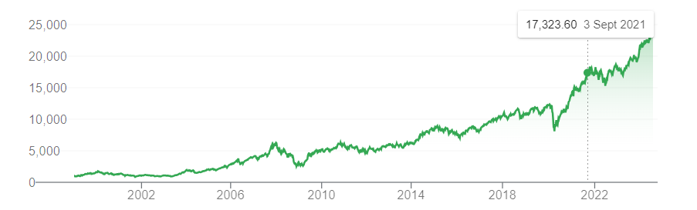

DJIA
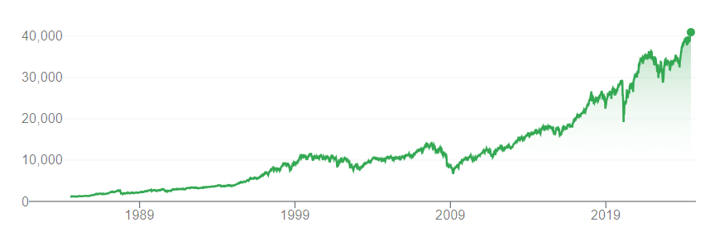

Nikkei 225
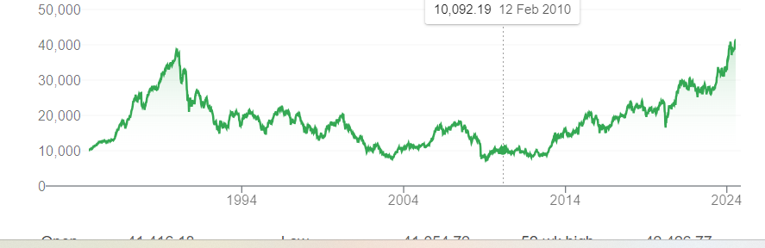

Gold
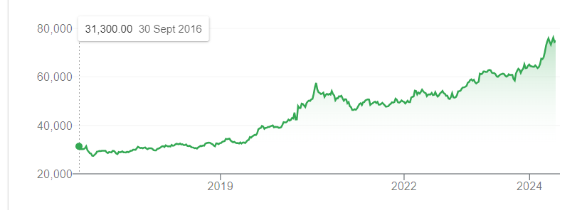
Silver
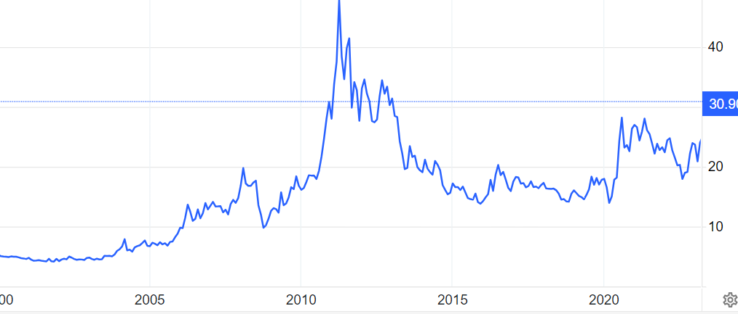
Copper
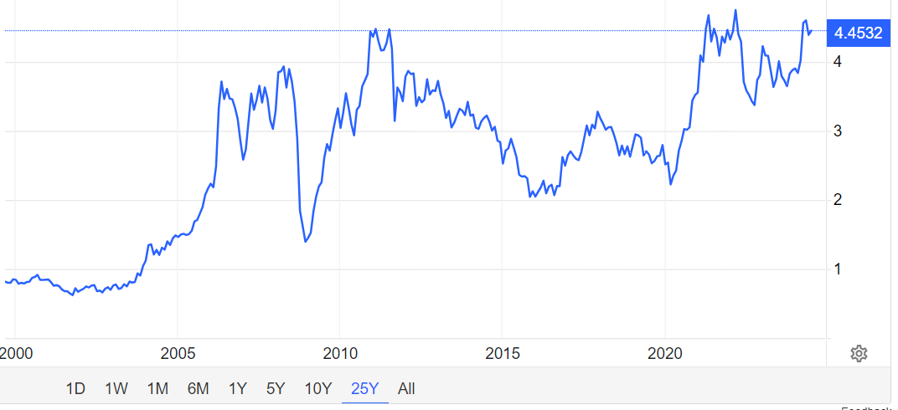
Crude petroleum
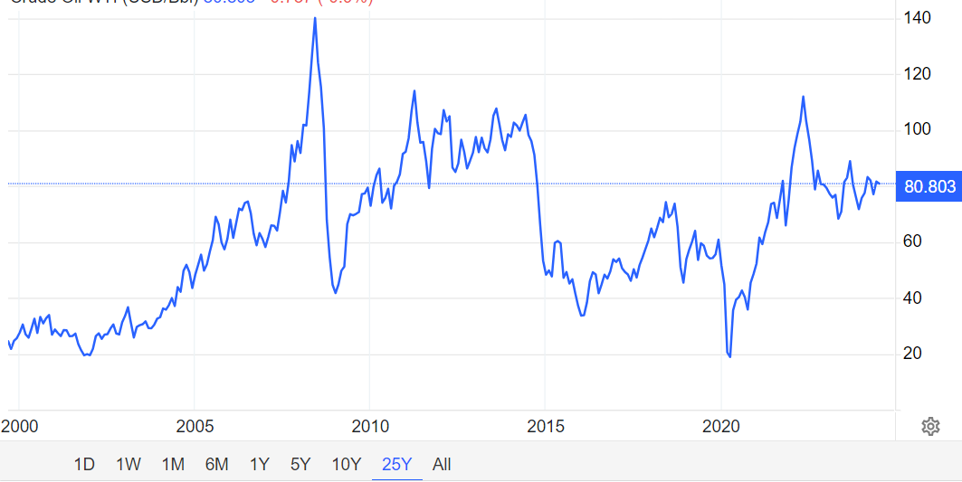

Natural Gas
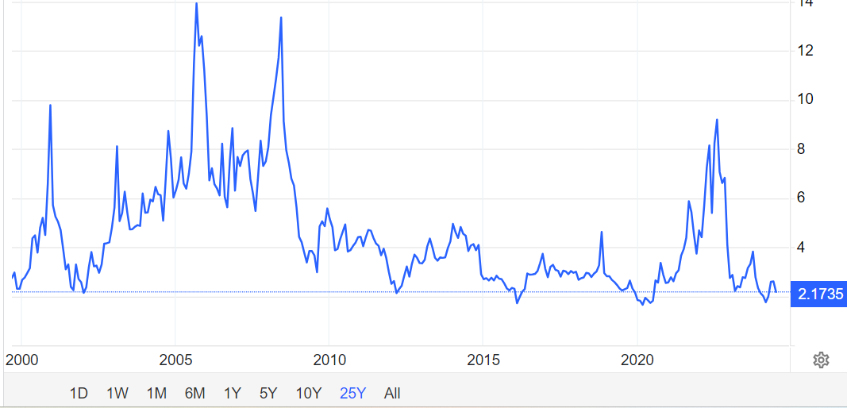

Rice
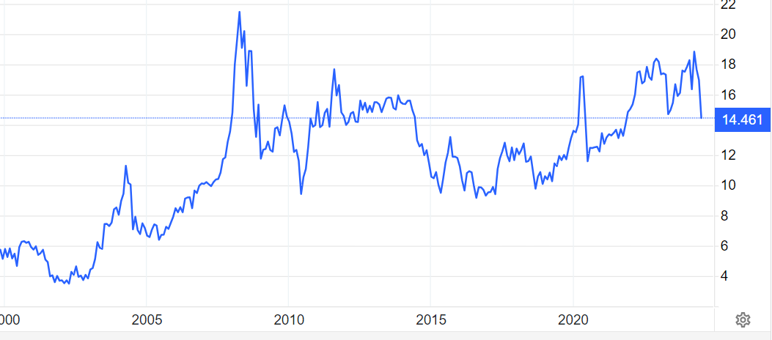

Wheat
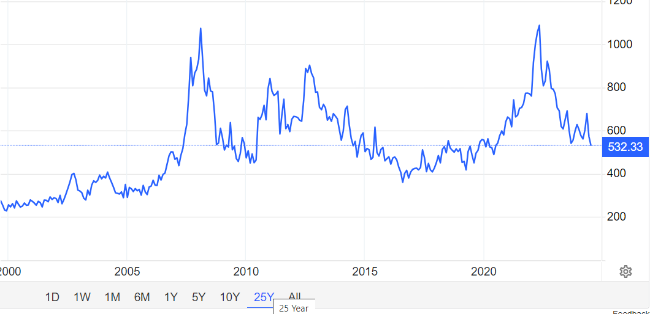
Analysis shows :
  - Indian equity markets are more or less having the same trend as global indices. The global equity indices dipped in 2020 owing to stoppage of activity due to pandemic, but Indian equity indices went up due to FII interest in Reliance Jo
  - Gold price rise prior to pandemic was stable with a lesser slope . But equity indices registered sharper rises.
  - At the time of pandemic equities registered a dip but gold prices rose sharpest. The equity indices started their upward climb in the last few years. But gold prices have stabilised in a moderate band.
  - This implies equity markets and gold are sharing an inverse relationship. Equities are conceived as riskier asset class whereas gold is perceived as a safe haven investment. When the macroeconomic fundamentals are showing an uncertain future investors tend to withdraw from the riskier equities and park their funds in Gold.
  - Silver and Copper are showing a similar trend but is different from gold. The reason is that both these metals are related to industrial production and economic development.
  - The equity indices are moving upwards after the silver and copper prices are moving upwards in the years following subprime crisis. This may be because of the liquidity infusion by central banks. The industrial demand increases the GDP and stock markets react positively. However there is no continuous relationship seen.
  - Both oil and natural gas peaks at the same time but crude petroleum exhibited a more volatile nature than natural gas. The developed countries are more dependent on natural gas but most of the world is dependent on the crude petroleum. Hence geopolitics influences its prices. The effect of geopolitics is less on the equity markets. Hence the equities were steadily on the rise but natural gas prices were showing a rangebound movement. So we cannot infer a direct relationship, but economic growth drives the prices of energies and GDP has a favourable effect on equities.
  - Agricultural products like rice and wheat were following a similar trend, affected by demand and supply. However, prices of rice and wheat if rises, decreases the disposable income. Thus equity investment by retail investors decreases.

Logistics and warehousing
Warehousing is the process of storing products at a facility before they are sent for distribution. Depending on the business size, the warehouse could be in a rented space, such as in a basement or spare room. However, large businesses that can afford to buy a building often outsource warehousing to an agency or firm specializing in that function. This lessens their burden so they can focus on their core activities.
Warehousing usually involves receiving, storing, and distributing products. In some instances, warehousing may include the following functions:

On the other hand, logistics refers to managing the flow of raw materials and finished products from manufacturing to final delivery. It integrates information flow, production, inventory, security, materials handling, transportation, and warehousing. Logistics is usually divided into two parts:
- Inbound logistics. This refers to the movement of goods and raw materials into production facilities.
- Outbound Logistics. This refers to the transfer of finished products to the point of consumption. This is another term for order fulfillment.

Logistics refers to managing the flow of goods between the origin and destination point. It deals with the overall strategy and planning of the flow of goods from the warehouse to the endpoint. It is about the implementation and control of the movement of goods from the first step of raw materials all the way through to the delivery of goods to their destination.
Commodity trading is a significant industry that involves buying and selling physical commodities such as raw materials, energy, and agricultural products. The success of a commodity trading business depends on many factors, including storage and logistics. Commodity delivery trading refers to buying and selling commodities with the intention of physically delivering the goods. In commodity delivery trading, the buyer and seller agree on the terms of the trade, including the price, quantity, and delivery date. Then, the buyer takes the physical delivery of the commodity and pays for it either at the time of delivery or before delivery. Finally, the seller delivers the commodity to a specified location, usually a warehouse or a port.
Role of a Warehouse in Commodity Trading
Storage is a crucial aspect of commodity trading. Commodity traders buy and sell physical commodities, which are often stored in specialized warehouses, storage facilities, and tank farms before they are sold.
A warehouse is essential for commodity traders for several reasons.
- Control of Supply: Traders can store commodities in large quantities during periods of low demand to sell later when prices are higher. This allows traders to take advantage of lower prices and sells the commodity later when prices are higher.
- Management of Price Volatility: The price of commodities can be volatile, and storage can help traders manage this volatility. By storing commodities during periods of low demand, traders can avoid selling during times of low prices and wait until prices have stabilized or risen.
- Facilitation of Movement: Commodities are often stored close to where they will be needed, making it easier to transport the commodities when they are ready to be sold.
The Role of Logistics in Commodity Trading
Logistics is also a critical aspect of commodity trading, as it involves the transportation of commodities from one location to another. This includes transportation by land, sea, and air.
Logistics is essential for commodity traders for several reasons:
- Transportation of Commodities: The efficient and effective transportation of commodities from the point of production to the point of consumption is crucial for the success of a commodity trading business. Effective logistics management helps to ensure that commodities are transported quickly and safely.
- Cost Management: Logistics can greatly impact the cost of trading, and effective logistics management can help commodity traders keep transportation costs under control.
- Time Management: Time is an important factor in commodity trading, and efficient logistics can help traders manage their time more effectively. By ensuring that commodities are transported quickly and efficiently, traders can avoid delays and complete trades more quickly.

