What Is Capital Structure Theory?
In financial management, capital structure theory refers to a systematic approach to financing business activities through a combination of equities and liabilities. There are several competing capital structure theories, each of which explores the relationship between debt financing, equity financing, and the market value of the firm slightly differently.

Net Income Approach to Capital Structure Theory
David Durand first suggested this approach in 1952, and he was a proponent of financial leverage. He postulated that a change in financial leverage results in a change in capital costs.¹﻿ In other words, if there's an increase in the debt ratio, capital structure increases, and the weighted average cost of capital (WACC) decreases, which results in higher firm value.¹﻿
Also proposed by Durand, this approach is the opposite of the Net Income Approach, in the absence of taxes. In this approach, WACC remains constant. It postulates that the market analyzes a whole firm, and any discount has no relation to the debt/equity ratio. If tax information is provided, it states that WACC reduces with an increase in debt financing, and the value of a firm will increase.²﻿
In this approach to Capital Structure Theory, the cost of capital is a function of the capital structure. It's important to remember, however, that this approach assumes an optimal capital structure. Optimal capital structure implies that at a certain ratio of debt and equity, the cost of capital is at a minimum, and the value of the firm is at a maximum.
The M&M theorem is a capital structure approach named after Franco Modigliani and Merton Miller in the 1950s. Modigliani and Miller were two professors who studied capital structure theory and collaborated to develop the capital-structure irrelevance proposition. This proposition states that in perfect markets, the capital structure a company uses doesn't matter because the market value of a firm is determined by its earning power and the risk of its underlying assets. According to Modigliani and Miller, value is independent of the method of financing used and a company's investments. The M&M theorem made two propositions:³﻿
- Proposition I: This proposition says that the capital structure is irrelevant to the value of a firm. The value of two identical firms would remain the same, and value would not be affected by choice of finance adopted to finance the assets. The value of a firm is dependent on the expected future earnings. It is when there are no taxes.
- Proposition II: This proposition says that the financial leverage boosts the value of a firm and reduces WACC. It is when tax information is available.

Pecking Order Theory
The pecking order theory focuses on asymmetrical information costs. This approach assumes that companies prioritize their financing strategy based on the path of least resistance. Internal financing is the first preferred method, followed by debt and external equity financing as a last resort.

Conclusion
To summarize, it is essential for finance professionals to know about the capital structure. Accurate analysis of capital structure can help a company by optimizing the cost of capital and hence improving profitability.
https://www.investopedia.com/ask/answers/031915/what-capital-structure-theory.asp#:~:text=In%20financial%20management%2C%20capital%20structure,combination%20of%20equities%20and%20liabilities.
https://efinancemanagement.com/financial-leverage/capital-structure-and-its-theories
Home
Financial Leverage

Capital Structure and its Theories
Capital Structure means a combination of all long-term sources of finance. It includes Equity Share Capital, Reserves and Surplus, Preference Share capital, Loan, Debentures and other such long-term sources of finance. A company has to decide the proportion in which it should have its own finance and outsider’s finance particularly debt finance. Based on the proportion of finance, WACC and Value of a firm are affected. There are four capital structure theories for this, viz. net income, net operating income, traditional and M&M approach.
Table of Contents
- 1 Capital Structure
- 2 How can Financial Leverage affect the Value?
- 3 Net Income Approach
- 4 Net Operating Income Approach
- 5 Traditional Approach
- 6 Modigliani and Miller Approach (MM Approach)

CAPITAL STRUCTURE
Capital structure is the proportion of all types of capital viz. equity, debt, preference etc. It is synonymously used as financial leverage or financing mix. Capital structure is also referred to as the degree of debts in the financing or capital of a business firm.
You may like watching Video PPT of the content.
Financial leverage is the extent to which a business firm employs borrowed money or debts. In financial management, it is a significant term and it is a very important decision in business. In the capital structure of a company, broadly, there are mainly two types of capital i.e. Equity and Debt. Out of the two, debt is a cheaper source of finance because the rate of interest will be less than the cost of equity and the interest payments are a tax-deductible expense.

Capital structure or financial leverage deals with a very important financial management question. The question is – ‘what should be the ratio of debt and equity?’ Before scratching our minds to find the answer to this question, we should know the objective of doing all this. In the financial management context, the objective of any financial decision is to maximize the shareholder’s wealth or increase the value of the firm. The other question which hits the mind in the first place is whether a change in the financing mix would have any impact on the value of the firm or not. The question is a valid question as there are some theories which believe that financial mix has an impact on the value and others believe it has no connection.

HOW CAN FINANCIAL LEVERAGE AFFECT THE VALUE?
One thing is sure that wherever and whatever way one sources the finance from, it cannot change the operating income levels. Financial leverage can, at the max, have an impact on the net income or the EPS (Earning per Share). The reason we are discussing later. Changing the financing mix means changing the level of debts. This change in levels of debt can impact the interest payable by that firm. The decrease in interest would increase the net income and thereby the EPS and it is a general belief that the increase in EPS leads to an increase in the value of the firm.
Apparently, under this view, financial leverage is a useful tool to increase value but, at the same time, nothing comes without a cost. Financial leverage increases the risk of bankruptcy. It is because higher the level of debt, higher would be the fixed obligation to honor the interest payments to the debts providers.
Discussion of financial leverage has an obvious objective of finding an optimum capital structure leading to maximization of the value of the firm. If the cost of capital is high
Important theories or approaches to financial leverage or capital structure or financing mix are as follows:
Discussion of financial leverage has an obvious objective of finding an optimum capital structure leading to maximization of the value of the firm. If the cost of capital is high
Important theories or approaches to financial leverage or capital structure or financing mix are as follows:

NET INCOME APPROACH
This approach was suggested by Durand and he was in favor of financial leverage decision. According to him, a change in financial leverage would lead to a change in the cost of capital. In short, if the ratio of debt in the capital structure increases, the weighted average cost of capital decreases and hence the value of the firm increases. For more – Net Income Approach.

NET OPERATING INCOME APPROACH
This approach is also provided by Durand. It is opposite of the Net Income Approach if there are no taxes. This approach says that the weighted average cost of capital remains constant. It believes in the fact that the market analyses a firm as a whole and discounts at a particular rate which has no relation to debt-equity ratio. If tax information is given, it recommends that with an increase in debt financing WACC reduces and value of the firm will start increasing. For more – Net Operating Income Approach.

TRADITIONAL APPROACH
This approach does not define hard and fast facts. It says that the cost of capital is a function of the capital structure. The special thing about this approach is that it believes an optimal capital structure. Optimal capital structure implies that at a particular ratio of debt and equity, the cost of capital is minimum and value of the firm is maximum. For more – Traditional Approach.

MODIGLIANI AND MILLER APPROACH (MM APPROACH)
It is a capital structure theory named after Franco Modigliani and Merton Miller. MM theory proposed two propositions.
- Proposition I: It says that the capital structure is irrelevant to the value of a firm. The value of two identical firms would remain the same and value would not affect by the choice of finance adopted to finance the assets. The value of a firm is dependent on the expected future earnings. It is when there are no taxes.
- Proposition II: It says that the financial leverage boosts the value of a firm and reduces WACC. It is when tax information is available.
For more about Modigliani and Miller Approach of Capital Structure.
To summarize, it is essential for finance professionals to know about the capital structure. Accurate analysis of capital structure can help a company by optimizing the cost of capital and hence improve profitability.
http://financialmanagementpro.com/ebit-eps-analysis/#:~:text=EBIT%2DEPS%20analysis%20is%20a,interest%20and%20taxes%20(EBIT).

Definition
EBIT-EPS analysis is a technique used to determine the optimal capital structure in which the value of earnings per share (EPS) has the highest amount for a given amount of earnings before interest and taxes (EBIT). In other words, the objective of EBIT-EPS analysis is to determine the effect of using different sources of financing on EPS.

Formula
EBIT-EPS indifference point is an important tool used to choose between two alternative financing plans. The formula to calculate it is as follows:
(EBIT - I_{A})(1 - T) - PD_{A} | = | (EBIT - I_{B})(1 - T) - PD_{B}
S_{A} | = | S_{B}
where:
EBIT – earnings before interest and taxes
I_{A} – interest expense in financing plan A
I_{B} – interest expense in financing plan B
T – corporate income tax rate
PD_{A} – preferred dividends payable in financing plan A
PD_{B} – preferred dividends payable in financing plan B
S_{A} – amount of common stock outstanding in financing plan A
S_{B} – amount of common stock outstanding in financing plan B
The indifference point is the value of EBIT where both financing plans would bring the same EPS. In other words, there is no difference in the two alternative financing plans.

EBIT-EPS graph
Let’s assume that management of a company is considering two alternative capital structures.
- Financing plan A with high financial leverage (debt financing)
- Financing plan B with low financial leverage (equity financing)
The EBIT-EPS graph for both alternative capital structures is given in the figure below.
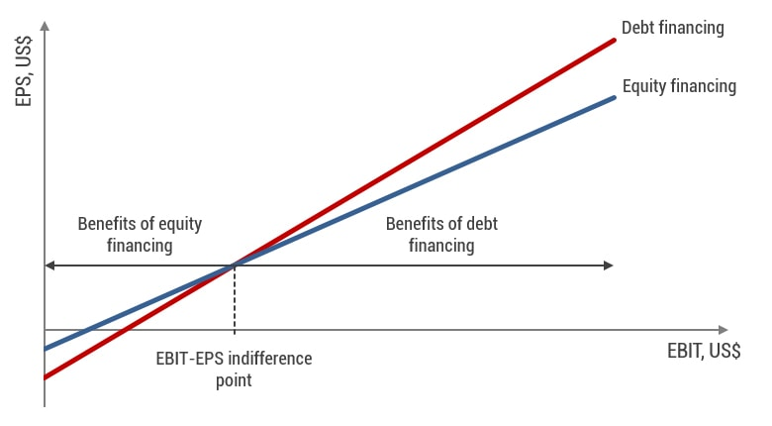
When EBIT reaches the EBIT-EPS indifference point, both financing plans generate equal EPS. However, if EBIT has a lower value, equity financing will generate higher EPS than debt financing. For any value of EBIT to the right of the indifference point, debt financing will give a higher value of EPS because of a higher degree of financial leverage.

Example
Management of Total S.E. Inc. is considering two alternative financing plans. The detailed information is given in the table below.
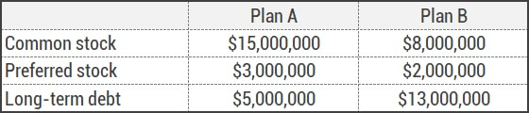
The par value of common stock is $10, preferred stock has $100 par value and 15% dividend, and long-term debt is presented by 10-year bonds of $1,000 par value and a fixed annual coupon rate of 8%. The corporate income tax rate is 30%.
The first step of EBIT-EPS analysis is to find the indifference point. Thus, we have to calculate interest expense and preferred dividends for each financing plan.
I_{A} = $5,000,000 × 8% = $400,000
I_{B} = $13,000,000 × 8% = 1,040,000
PD_{A} = $3,000,000 × 15% = $450,000
PD_{B} = $2,000,000 × 15% = $300,000
S_{A} = $15,000,000 ÷ 10 = 1,500,000
S_{B} = $8,000,000 ÷ 10 = 800,000
Let’s make an equation using the data above.
(EBIT - $400,000)(1 - 0.3) - $450,000 | = | (EBIT - $1,040,000)(1 - 0.3) - $300,000
1,500,000 | = | 800,000
Having solved this equation, we get an indifference point of $1,955,102, that is, for such a value of EBIT, each financing plan will give the same earnings per share of $0.4257. The EBIT-EPS graph is shown below.
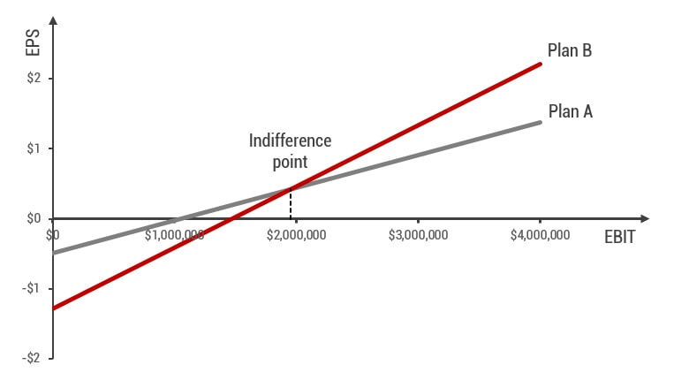
If the expected EBIT is lower than $1,955,102, financing plan A will demonstrate a higher EPS. Otherwise, the capital structure of financing plan B should be preferred.

Advantages and disadvantages of EBIT-EPS analysis

Advantages
- Financial planning. Applying EBIT-EPS analysis allows earnings per share to be maximized for any given value of earnings before interest and taxes. It helps to choose the best financing plan.
- Comparative analysis. Such analysis is possible not only for a company as a whole but also for a specific product, project, department, or market.
- Determination of target capital structure. Depending on the expected EBIT, management of a company is able to determine the target capital structure for maximizing EPS.

Disadvantages
- Risk is not taken into account. EBIT-EPS analysis does not take into account the risks associated with debt financing. In other words, a higher EPS associated with using financial leverage implies a higher risk that has to be taken into account by management.
- Complexity. The more alternative financing plans are considered, the higher the complexity of the calculations.
- Limitations. The technique does not account for limitations in raising various sources of financing.

https://www.yourarticlelibrary.com/financial-management/ebit-eps-analysis-in-leverage-concept-advantages-and-other-details/44224

EBIT-EPS Analysis in Leverage: Concept, Advantages and Other Details
Article shared by : <="" div="" style="margin: 0px; padding: 0px; border: 0px; outline: 0px; font-size: 16px; vertical-align: bottom; background: transparent; max-width: 100%;">
ADVERTISEMENTS:
EBIT-EPS analysis gives a scientific basis for comparison among various financial plans and shows ways to maximize EPS. Hence EBIT-EPS analysis may be defined as ‘a tool of financial planning that evaluates various alternatives of financing a project under varying levels of EBIT and suggests the best alternative having highest EPS and determines the most profitable level of EBIT’.
Concept of EBIT-EPS Analysis:
The EBIT-EBT analysis is the method that studies the leverage, i.e. comparing alternative methods of financing at different levels of EBIT. Simply put, EBIT-EPS analysis examines the effect of financial leverage on the EPS with varying levels of EBIT or under alternative financial plans.
ADVERTISEMENTS:
It examines the effect of financial leverage on the behavior of EPS under different financing alternatives and with varying levels of EBIT. EBIT-EPS analysis is used for making the choice of the combination and of the various sources. It helps select the alternative that yields the highest EPS.
We know that a firm can finance its investment from various sources such as borrowed capital or equity capital. The proportion of various sources may also be different under various financial plans. In every financing plan the firm’s objectives lie in maximizing EPS.
Advantages of EBIT-EPS Analysis:
We have seen that EBIT-EPS analysis examines the effect of financial leverage on the behavior of EPS under various financing plans with varying levels of EBIT. It helps a firm in determining optimum financial planning having highest EPS.
ADVERTISEMENTS:
Various advantages derived from EBIT-EPS analysis may be enumerated below:
Financial Planning:
Use of EBIT-EPS analysis is indispensable for determining sources of funds. In case of financial planning the objective of the firm lies in maximizing EPS. EBIT-EPS analysis evaluates the alternatives and finds the level of EBIT that maximizes EPS.
Comparative Analysis:
ADVERTISEMENTS:
EBIT-EPS analysis is useful in evaluating the relative efficiency of departments, product lines and markets. It identifies the EBIT earned by these different departments, product lines and from various markets, which helps financial planners rank them according to profitability and also assess the risk associated with each.
Performance Evaluation:
This analysis is useful in comparative evaluation of performances of various sources of funds. It evaluates whether a fund obtained from a source is used in a project that produces a rate of return higher than its cost.
Determining Optimum Mix:
ADVERTISEMENTS:
EBIT-EPS analysis is advantageous in selecting the optimum mix of debt and equity. By emphasizing on the relative value of EPS, this analysis determines the optimum mix of debt and equity in the capital structure. It helps determine the alternative that gives the highest value of EPS as the most profitable financing plan or the most profitable level of EBIT as the case may be.
Limitations of EBIT-EPS Analysis:
Finance managers are very much interested in knowing the sensitivity of the earnings per share with the changes in EBIT; this is clearly available with the help of EBIT-EPS analysis but this technique also suffers from certain limitations, as described below
No Consideration for Risk:
ADVERTISEMENTS:
Leverage increases the level of risk, but this technique ignores the risk factor. When a corporation, on its borrowed capital, earns more than the interest it has to pay on debt, any financial planning can be accepted irrespective of risk. But in times of poor business the reverse of this situation arises—which attracts high degree of risk. This aspect is not dealt in EBIT-EPS analysis.
Contradictory Results:
It gives a contradictory result where under different alternative financing plans new equity shares are not taken into consideration. Even the comparison becomes difficult if the number of alternatives increase and sometimes it also gives erroneous result under such situation.
Over-capitalization:
This analysis cannot determine the state of over-capitalization of a firm. Beyond a certain point, additional capital cannot be employed to produce a return in excess of the payments that must be made for its use. But this aspect is ignored in EBIT-EPS analysis.
Example 5.1:
Ankim Ltd., has an EBIT of Rs 3, 20,000. Its capital structure is given as under:
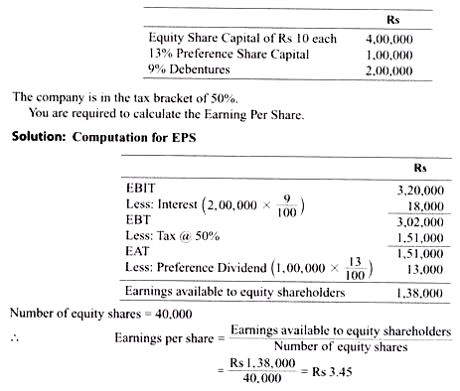
Indifference Points:
The indifference point, often called as a breakeven point, is highly important in financial planning because, at EBIT amounts in excess of the EBIT indifference level, the more heavily levered financing plan will generate a higher EPS. On the other hand, at EBIT amounts below the EBIT indifference points the financing plan involving less leverage will generate a higher EPS.
i. Concept:
Indifference points refer to the EBIT level at which the EPS is same for two alternative financial plans. According to J. C. Van Home, ‘Indifference point refers to that EBIT level at which EPS remains the same irrespective of debt equity mix’. The management is indifferent in choosing any of the alternative financial plans at this level because all the financial plans are equally desirable. The indifference point is the cut-off level of EBIT below which financial leverage is disadvantageous. Beyond the indifference point level of EBIT the benefit of financial leverage with respect to EPS starts operating.
The indifference level of EBIT is significant because the financial planner may decide to take the debt advantage if the expected EBIT crosses this level. Beyond this level of EBIT the firm will be able to magnify the effect of increase in EBIT on the EPS.
In other words, financial leverage will be favorable beyond the indifference level of EBIT and will lead to an increase in the EPS. If the expected EBIT is less than the indifference point then the financial planners will opt for equity for financing projects, because below this level, EPS will be more for less levered firm.
ADVERTISEMENTS:
ii. Computation:
We have seen that indifference point refers to the level of EBIT at which EPS is the same for two different financial plans. So the level of that EBIT can easily be computed. There are two approaches to calculate indifference point: Mathematical approach and graphical approach.
Mathematical Approach:
Under the mathematical approach, the indifference point may be obtained by solving equations. Let us present the income statement given in Table 5.1 with the following symbols in Table 5.4. We are starting from EBIT only.
ADVERTISEMENTS:
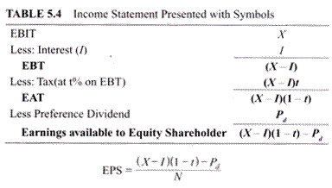
Where, N represents number of equity shares.
In case of financing, three types of sources may be opted: Equity, debt and preference shares. So we may have four possible combinations Equity, Equity-Debt, Equity- Preference Shares and Equity- Debt-Preference Shares.
So, EPS under various alternatives will be as follows:
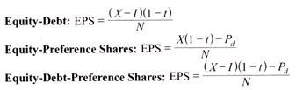
Note:
The symbols have their usual meaning.
The indifference point between any two financial plans may be obtained by equalizing the respective equations of EPS and solving them to find the value of X.
Example 5.2:
Debarathi Co. Ltd., is planning an expansion programme. It requires Rs 20 lakhs of external financing for which it is considering two alternatives. The first alternative calls for issuing 15,000 equity shares of Rs 100 each and 5,000 10% Preference Shares of Rs 100 each; the second alternative requires 10,000 equity shares of Rs 100 each, 2,000 10% Preference Shares of Rs 100 each and Rs 8,00,000 Debentures carrying 9% interest. The company is in the tax bracket of 50%. You are required to calculate the indifference point for the plans and verify your answer by calculating the EPS.
Solution:
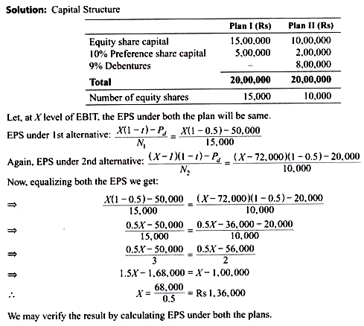
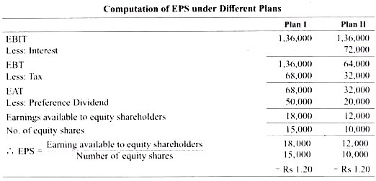
Graphical Approach:
The indifference point may also be obtained using a graphical approach. In Figure 5.1 we have measured EBIT along the horizontal axis and EPS along the vertical axis. Suppose we have two financial plans before us: Financing by equity only and financing by equity and debt. Different combinations of EBIT and EPS may be plotted against each plan. Under Plan-I the EPS will be zero when EBIT is nil so it will start from the origin.
The curve depicting Plan I in Figure 5.1 starts from the origin. For Plan-II EBIT will have some positive figure equal to the amount of interest to make EPS zero. So the curve depicting Plan-II in Figure 5.1 will start from the positive intercept of X axis. The two lines intersect at point E where the level of EBIT and EPS both are same under both the financial plans. Point E is the indifference point. The value corresponding to X axis is EBIT and the value corresponding to 7 axis is EPS.
These can be found drawing two perpendiculars from the indifference point—one on X axis and the other on Taxis. Similarly we can obtain the indifference point between any two financial plans having various financing options. The area above the indifference point is the debt advantage zone and the area below the indifference point is equity advantage zone.
Above the indifference point the Plan-II is profitable, i.e. financial leverage is advantageous. Below the indifference point Plan I is advantageous, i.e. financial leverage is not profitable. This can be found by observing Figure 5.1. Above the indifference point EPS will be higher for same level of EBIT for Plan II. Below the indifference point EPS will be higher for same level of EBIT for Plan I. The graphical approach of indifference point gives a better understanding of EBIT-EPS analysis.
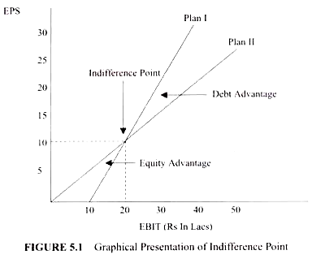Financial Breakeven Point:
In general, the term Breakeven Point (BEP) refers to the point where the total cost line and sales line intersect. It indicates the level of production and sales where there is no profit and no loss because here the contribution just equals to the fixed costs. Similarly financial breakeven point is the level of EBIT at which after paying interest, tax and preference dividend, nothing remains for the equity shareholders.
In other words, financial breakeven point refers to that level of EBIT at which the firm can satisfy all fixed financial charges. EBIT less than this level will result in negative EPS. Therefore EPS is zero at this level of EBIT. Thus financial breakeven point refers to the level of EBIT at which financial profit is nil.
Financial Break Even Point (FBEP) is expressed as ratio with the following equation:
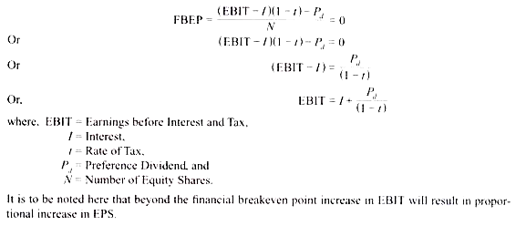
Example 5.3:
A company has formulated the following financing plans to finance Rs 15, 00,000 which is required for financing a new project.
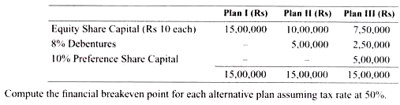
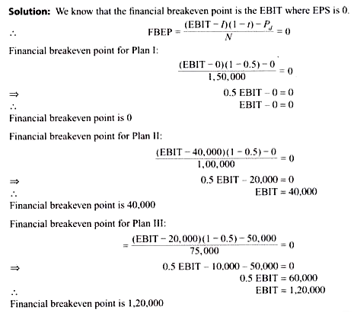

https://www.investopedia.com/terms/c/costofcapital.asp

Cost of Capital Definition
By WILL KENTON
Reviewed By AMY DRURY
Updated Apr 23, 2020

What Is 'Cost of Capital?'
Cost of capital is the required return necessary to make a capital budgeting project, such as building a new factory, worthwhile. When analysts and investors discuss the cost of capital, they typically mean the weighted average of a firm's cost of debt and cost of equity blended together.
The cost of capital metric is used by companies internally to judge whether a capital project is worth the expenditure of resources, and by investors who use it to determine whether an investment is worth the risk compared to the return. The cost of capital depends on the mode of financing used. It refers to the cost of equity if the business is financed solely through equity, or to the cost of debt if it is financed solely through debt.
Many companies use a combination of debt and equity to finance their businesses and, for such companies, the overall cost of capital is derived from the weighted average cost of all capital sources, widely known as the weighted average cost of capital (WACC).
Volume 75%

1:34

Cost Of Capital

What Does the Cost of Capital Tell You?
Cost of capital represents a hurdle rate that a company must overcome before it can generate value, and it is used extensively in the capital budgeting process to determine whether a company should proceed with a project.
The cost of capital concept is also widely used in economics and accounting. Another way to describe the cost of capital is the opportunity cost of making an investment in a business. Wise company management will only invest in initiatives and projects that will provide returns that exceed the cost of their capital.
Cost of capital, from the perspective on an investor, is the return expected by whoever is providing the capital for a business. In other words, it is an assessment of the risk of a company's equity. In doing this an investor may look at the volatility (beta) of a company's financial results to determine whether a certain stock is too risky or would make a good investment.

KEY TAKEAWAYS
- Cost of capital represents the return a company needs in order to take on a capital project, such as purchasing new equipment or constructing a new building.
- Cost of capital typically encompasses the cost of both equity and debt, weighted according to the company's preferred or existing capital structure, known as the weighted-average cost of capital (WACC).
- A company's investment decisions for new projects should always generate a return that exceeds the firm's cost of the capital used to finance the project—otherwise, the project will not generate a return for investors.

Weighted Average Cost of Capital
A firm's cost of capital is typically calculated using the weighted average cost of capital formula that considers the cost of both debt and equity capital. Each category of the firm's capital is weighted proportionately to arrive at a blended rate, and the formula considers every type of debt and equity on the company's balance sheet, including common and preferred stock, bonds and other forms of debt.

Finding the Cost of Debt
Every company has to chart out its financing strategy at an early stage. The cost of capital becomes a critical factor in deciding which financing track to follow—debt, equity, or a combination of the two.
Early-stage companies seldom have sizable assets to pledge as collateral for debt financing, so equity financing becomes the default mode of funding for most of them. Less-established companies with limited operating histories will pay a higher cost for capital than older companies with solid track records since lenders and investors will demand a higher risk premium for the former.
The cost of debt is merely the interest rate paid by the company on its debt. However, since interest expense is tax-deductible, the debt is calculated on an after-tax basis as follows:
\begin{aligned} &\text{Cost of debt}=\frac{\text{Interest expense}}{\text{Total debt}} \times (1 - T) \\ &\textbf{where:}\\ &\text{Interest expense}=\text{Int. paid on the firm's current debt}\\ &T=\text{The company’s marginal tax rate}\\ \end{aligned}​Cost of debt=Total debtInterest expense​×(1−T)where:Interest expense=Int. paid on the firm’s current debtT=The company’s marginal tax rate​﻿
The cost of debt can also be estimated by adding a credit spread to the risk-free rate and multiplying the result by (1 - T).

Finding the Cost of Equity
The cost of equity is more complicated since the rate of return demanded by equity investors is not as clearly defined as it is by lenders. The cost of equity is approximated by the capital asset pricing model as follows:
\begin{aligned} &CAPM(\text{Cost of equity})= R_f + \beta(R_m - R_f) \\ &\textbf{where:}\\ &R_f=\text{risk-free rate of return}\\ &R_m=\text{market rate of return}\\ \end{aligned}​CAPM(Cost of equity)=Rf​+β(Rm​−Rf​)where:Rf​=risk-free rate of returnRm​=market rate of return​﻿
Beta is used in the CAPM formula to estimate risk, and the formula would require a public company's own stock beta. For private companies, a beta is estimated based on the average beta of a group of similar, public firms. Analysts may refine this beta by calculating it on an unlevered, after-tax basis. The assumption is that a private firm's beta will become the same as the industry average beta.
The firm’s overall cost of capital is based on the weighted average of these costs. For example, consider an enterprise with a capital structure consisting of 70% equity and 30% debt; its cost of equity is 10% and the after-tax cost of debt is 7%.
Therefore, its WACC would be:
(0.7 \times 10\%) + (0.3 \times 7\%) = 9.1\%(0.7×10%)+(0.3×7%)=9.1%﻿
This is the cost of capital that would be used to discount future cash flows from potential projects and other opportunities to estimate their net present value (NPV) and the ability to generate value.
Companies strive to attain the optimal financing mix based on the cost of capital for various funding sources. Debt financing has the advantage of being more tax efficient than equity financing since interest expenses are tax deductible and dividends on common shares are paid with after-tax dollars. However, too much debt can result in dangerously high leverage, resulting in higher interest rates sought by lenders to offset the higher default risk.

The Cost of Capital and Tax Considerations
One element to consider in deciding to finance capital projects via equity or debt is the possibility of any tax savings from taking on debt since the interest expense can lower a firm's taxable income, and thus, its income tax liability.
However, the Modigliani-Miller Theorem (M&M) states that the market value of a company is independent of the way it finances itself and shows that under certain assumptions, the value of leveraged versus non-leveraged firms are equal, in part because other costs offset any tax savings that come from increased debt financing.

Example of the Cost of Capital in Use
Every industry has its own prevailing cost of capital. For some companies, the cost of capital is lower than their discount rate. Some finance departments may lower their discount rates to attract capital or raise it incrementally to build in a cushion depending on how much risk they are comfortable with.
As of January 2019, diversified chemical companies have the highest cost of capital at 10.72%. The lowest cost of capital can be claimed by non-bank and insurance financial services companies at 3.44%. Cost of capital is also high among both biotech and pharmaceutical drug companies, steel manufacturers, food wholesalers, Internet (software) companies, and integrated oil and gas companies.
Those industries tend to require significant capital investment in research, development, equipment, and factories. Among the industries with lower capital costs are money center banks, hospitals, and healthcare facilities, power companies, real estate investment trusts (REITs), reinsurers, retail grocery and food companies, and utilities (both general and water). Such companies may require less equipment or benefit from very steady cash flows.

The Difference Between Cost of Capital and Discount Rate
The cost of capital and discount rate are somewhat similar and are often used interchangeably. Cost of capital is often calculated by a company's finance department and used by management to set a discount rate (or hurdle rate) that must be beaten to justify an investment.
That said, a company's management should challenge its internally-generated cost of capital number, as it may be so conservative as to deter investment. Cost of capital may also differ based on the type of project or initiative; a highly innovative but risky initiative should carry a higher cost of capital than a project to update essential equipment or software with proven performance.
https://www.investopedia.com/terms/w/wacc.asp

Weighted Average Cost of Capital – WACC
By MARSHALL HARGRAVE
Reviewed By DAVID KINDNESS
Updated Apr 20, 2020
TABLE OF CONTENTS
EXPAND
- What Is WACC?
- WACC Formula and Calculation
- Calculating WACC in Excel
- Explaining the Formula Elements
- Learning From WACC
- Who Uses WACC?
- WACC vs. RRR
- Limitations of WACC
- Example of How to Use WACC

What Is Weighted Average Cost of Capital – WACC?
The weighted average cost of capital (WACC) is a calculation of a firm's cost of capital in which each category of capital is proportionately weighted. All sources of capital, including common stock, preferred stock, bonds, and any other long-term debt, are included in a WACC calculation.
A firm’s WACC increases as the beta and rate of return on equity increase because an increase in WACC denotes a decrease in valuation and an increase in risk.
Volume 75%

2:34

Weighted Average Cost Of Capital (WACC)

WACC Formula and Calculation
\begin{aligned} &\text{WACC} = \frac{E}{V} * Re + \frac{D}{V} * Rd * (1 - Tc)\\ &\textbf{where:}\\ &\text{Re = Cost of equity}\\ &\text{Rd = Cost of debt}\\ &\text{E = Market value of the firm's equity}\\ &\text{D = Market value of the firm's debt}\\ &\text{V = E + D = Total market value of the firm’s financing}\\ &\text{E/V = Percentage of financing that is equity}\\ &\text{D/V = Percentage of financing that is debt}\\ &\text{Tc = Corporate tax rate}\\ \end{aligned}​WACC=VE​∗Re+VD​∗Rd∗(1−Tc)where:Re = Cost of equityRd = Cost of debtE = Market value of the firm’s equityD = Market value of the firm’s debtV = E + D = Total market value of the firm’s financingE/V = Percentage of financing that is equityD/V = Percentage of financing that is debtTc = Corporate tax rate​﻿
To calculate WACC the analyst will multiply the cost of each capital component by its proportional weight. The sum of these results, in turn, is multiplied by 1 minus the corporate tax rate. Apply the following values to the formula listed above:
- Re = cost of equity
- Rd = cost of debt
- E = market value of the firm's equity
- D = market value of the firm's debt
- V = E + D = total market value of the firm’s financing (equity and debt)
- E/V = percentage of financing that is equity
- D/V = percentage of financing that is debt
- Tc = corporate tax rate

Calculating WACC in Excel
The weighted average cost of capital (WACC) can be calculated in Excel. The biggest part is sourcing the correct data to plug into the model. See Investopedia’s notes on how to calculate WACC in Excel.

KEY TAKEAWAYS
- Calculation of a firm's cost of capital in which each category of capital is proportionately weighted.
- Incorporates all sources of a company’s capital—including common stock, preferred stock, bonds, and any other long-term debt.
- Can be used as a hurdle rate against which companies and investors can gauge ROIC performance.
- WACC is commonly used as the discount rate for future cash flows in DCF analyses.

Explaining the Formula Elements
Cost of equity (Re) can be a bit tricky to calculate since share capital does not technically have an explicit value. When companies pay a debt, the amount they pay has a predetermined associated interest rate that debt depends on the size and duration of the debt, though the value is relatively fixed. On the other hand, unlike debt, equity has no concrete price that the company must pay. Yet that doesn't mean there is no cost of equity.
Since shareholders will expect to receive a certain return on their investments in a company, the equity holders' required rate of return is a cost from the company's perspective, because if the company fails to deliver this expected return, shareholders will simply sell off their shares, which leads to a decrease in share price and in the company’s value. The cost of equity, then, is essentially the amount that a company must spend in order to maintain a share price that will satisfy its investors.
Calculating the cost of debt (Rd), on the other hand, is a relatively straightforward process. To determine the cost of debt, you use the market rate that a company is currently paying on its debt. If the company is paying a rate other than the market rate, you can estimate an appropriate market rate and substitute it in your calculations instead.
There are tax deductions available on interest paid, which are often to companies’ benefit. Because of this, the net cost of a company's debt is the amount of interest it is paying, minus the amount it has saved in taxes as a result of its tax-deductible interest payments. This is why the after-tax cost of debt is Rd (1 - corporate tax rate).

Learning From WACC
WACC is the average of the costs of these types of financing, each of which is weighted by its proportionate use in a given situation. By taking a weighted average in this way, we can determine how much interest a company owes for each dollar it finances.
Debt and equity are the two components that constitute a company’s capital funding. Lenders and equity holders will expect to receive certain returns on the funds or capital they have provided. Since the cost of capital is the return that equity owners (or shareholders) and debt holders will expect, WACC indicates the return that both kinds of stakeholders (equity owners and lenders) can expect to receive. Put another way, WACC is an investor’s opportunity cost of taking on the risk of investing money in a company.
A firm's WACC is the overall required return for a firm. Because of this, company directors will often use WACC internally in order to make decisions, like determining the economic feasibility of mergers and other expansionary opportunities. WACC is the discount rate that should be used for cash flows with the risk that is similar to that of the overall firm.
To help understand WACC, try to think of a company as a pool of money. Money enters the pool from two separate sources: debt and equity. Proceeds earned through business operations are not considered a third source because, after a company pays off debt, the company retains any leftover money that is not returned to shareholders (in the form of dividends) on behalf of those shareholders.

Who Uses WACC?
Securities analysts frequently use WACC when assessing the value of investments and when determining which ones to pursue. For example, in discounted cash flow analysis, one may apply WACC as the discount rate for future cash flows in order to derive a business's net present value. WACC may also be used as a hurdle rate against which companies and investors can gauge return on invested capital (ROIC) performance. WACC is also essential in order to perform economic value-added (EVA) calculations.
Investors may often use WACC as an indicator of whether or not an investment is worth pursuing. Put simply, WACC is the minimum acceptable rate of return at which a company yields returns for its investors. To determine an investor’s personal returns on an investment in a company, simply subtract the WACC from the company’s returns percentage.

WACC vs. Required Rate of Return – RRR
The required rate of return (RRR) is from the investor’s perspective, being the minimum rate an investor will accept for a project or investment. Meanwhile, the cost of capital is what the company expects to return on its securities. Learn more about WACC versus the required rate of return.

Limitations of WACC
The WACC formula seems easier to calculate than it really is. Because certain elements of the formula, like the cost of equity, are not consistent values, various parties may report them differently for different reasons. As such, while WACC can often help lend valuable insight into a company, one should always use it along with other metrics when determining whether or not to invest in a company.

Example of How to Use WACC
Suppose that a company yields returns of 20% and has a WACC of 11%. This means the company is yielding 9% returns on every dollar the company invests. In other words, for each dollar spent, the company is creating nine cents of value. On the other hand, if the company's return is less than WACC, the company is losing value. If a company has returns of 11% and a WACC of 17%, the company is losing six cents for every dollar spent, indicating that potential investors would be best off putting their money elsewhere.
As a real-life example, consider Walmart (NYSE: WMT). The WACC of Walmart is 4.2%. That number is found by doing a number of calculations. First, we must find the financing structure of Walmart to calculate V, which is the total market value of the company’s financing. For Walmart, to find the market value of its debt we use the book value, which includes long-term debt and long-term lease and financial obligations.
As of the end of its most recent quarter (Oct. 31, 2018), its book value of debt was $50 billion. As of Feb. 5, 2019, its market cap (or equity value) is $276.7 billion. Thus, V is $326.7 billion, or $50 billion + $276.7 billion. Walmart finances operations with 85% equity (E / V, or $276.7 billion / $326.7 billion) and 15% debt (D / V, or $50 billion / $326.7 billion).
To find the cost of equity (Re) one can use the capital asset pricing model (CAPM). This model uses a company’s beta, the risk-free rate and expected return of the market to determine the cost of equity. The formula is risk-free rate + beta * (market return - risk-free rate). The 10-year Treasury rate can be used as the risk-free rate and the expected market return is generally estimated to be 7%. Thus, Walmart’s cost of equity is 2.7% + 0.37 * (7% - 2.7%), or 4.3%.
The cost of debt is calculated by dividing the company’s interest expense by its debt load. In Walmart’s case, its recent fiscal year interest expense is $2.33 billion. Thus, its cost of debt is 4.7%, or $2.33 billion / $50 billion. The tax rate can be calculated by dividing the income tax expense by income before taxes. In Walmart’s case, it lays out the company’s tax rate in the annual report, said to be 30% for the last fiscal year.
Finally, we’re ready to calculate Walmart’s weighted average cost of capital (WACC). The WACC is 4.2%, with the calculation being 85% * 4.3% + 15% * 4.7% * (1 - 30%).
https://strategiccfo.com/cost-of-capital-definition/#:~:text=It%20can%20also%20be%20estimated,of%20the%20different%20return%20rates.
https://www.investopedia.com/terms/l/leverage.asp#:~:text=Leverage%20is%20an%20investment%20strategy,firm%20uses%20to%20finance%20assets.

What Is Leverage?
Leverage results from using borrowed capital as a funding source when investing to expand the firm's asset base and generate returns on risk capital. Leverage is an investment strategy of using borrowed money—specifically, the use of various financial instruments or borrowed capital—to increase the potential return of an investment. Leverage can also refer to the amount of debt a firm uses to finance assets.

KEY TAKEAWAYS
- Leverage refers to the use of debt (borrowed funds) to amplify returns from an investment or project.
- Investors use leverage to multiply their buying power in the market.
- Companies use leverage to finance their assets—instead of issuing stock to raise capital, companies can use debt to invest in business operations in an attempt to increase shareholder value.
Volume 75%

1:41

Leverage

Understanding Leverage
Leverage is the use of debt (borrowed capital) in order to undertake an investment or project. The result is to multiply the potential returns from a project. At the same time, leverage will also multiply the potential downside risk in case the investment does not pan out. When one refers to a company, property, or investment as "highly leveraged," it means that item has more debt than equity.
The concept of leverage is used by both investors and companies. Investors use leverage to significantly increase the returns that can be provided on an investment. They lever their investments by using various instruments, including options, futures, and margin accounts. Companies can use leverage to finance their assets. In other words, instead of issuing stock to raise capital, companies can use debt financing to invest in business operations in an attempt to increase shareholder value.
Investors who are not comfortable using leverage directly have a variety of ways to access leverage indirectly. They can invest in companies that use leverage in the normal course of their business to finance or expand operations—without increasing their outlay.

Leverage amplifies possible returns, just like a lever can be used to amplify one's strength when moving a heavy weight.

Special Considerations
Through balance sheet analysis, investors can study the debt and equity on the books of various firms and can invest in companies that put leverage to work on behalf of their businesses. Statistics such as return on equity (ROE), debt to equity (D/E), and return on capital employed (ROCE) help investors determine how companies deploy capital and how much of that capital companies have borrowed.
To properly evaluate these statistics, it is important to keep in mind that leverage comes in several varieties, including operating, financial, and combined leverage.
Fundamental analysis uses the degree of operating leverage. One can calculate the degree of operating leverage by dividing the percentage change of a company's earnings per share (EPS) by its percentage change in its earnings before interest and taxes (EBIT) over a period.
Similarly, one could calculate the degree of operating leverage by dividing a company's EBIT by EBIT less interest expense. A higher degree of operating leverage shows a higher level of volatility in a company's EPS.
DuPont analysis uses the "equity multiplier" to measure financial leverage. One can calculate the equity multiplier by dividing a firm's total assets by its total equity. Once figured, one multiplies the financial leverage with the total asset turnover and the profit margin to produce the return on equity. For example, if a publicly-traded company has total assets valued at $500 million and shareholder equity valued at $250 million, then the equity multiplier is 2.0 ($500 million / $250 million). This shows the company has financed half its total assets by equity. Hence, larger equity multipliers suggest more financial leverage.
If reading spreadsheets and conducting fundamental analysis is not your cup of tea, you can purchase mutual funds or exchange-traded funds (ETFs) that use leverage. By using these vehicles, you can delegate the research and investment decisions to experts.

Leverage vs. Margin
Although interconnected—since both involve borrowing—leverage and margin are not the same. Leverage refers to taking on debt, while margin is debt or borrowed money a firm uses to invest in other financial instruments.
A margin account allows you to borrow money from a broker for a fixed interest rate to purchase securities, options, or futures contracts in the anticipation of receiving substantially high returns. You can use margin to create leverage.

Disadvantages of Leverage
Leverage is a multi-faceted, complex tool. The theory sounds great, and in reality, the use of leverage can be profitable, but the reverse is also true. Leverage magnifies both gains and losses. If an investor uses leverage to make an investment and the investment moves against the investor, their loss is much greater than it would've been if they have not leveraged the investment.
For this reason, leverage should often be avoided by first-time investors until they get more experience under their belts. In the business world, a company can use leverage to generate shareholder wealth, but if it fails to do so, the interest expense and credit risk of default destroy shareholder value.

Example of Leverage
A company was formed with a $5 million investment from investors, where the equity in the company is $5 million—this is the money the company can use to operate. If the company uses debt financing by borrowing $20 million, it now has $25 million to invest in business operations and more opportunity to increase value for shareholders.
An automaker, for example, could borrow money to build a new factory. The new factory would enable the automaker to increase the number of cars it produces and increase profits.
https://www.yourarticlelibrary.com/financial-management/leverage-types-operating-financial-capital-and-working-capital-leverage/44243

Leverage Types: Operating, Financial, Capital and Working Capital Leverage
Article shared by : <="" div="" style="margin: 0px; padding: 0px; border: 0px; outline: 0px; font-size: 16px; vertical-align: bottom; background: transparent; max-width: 100%;">
ADVERTISEMENTS:
Leverage refers to the employment of assets or sources of fund bearing fixed payment to magnify EBIT or EPS respectively. So it may be associated with investment activities or financing activities.
According to its association we find mainly two types of leverages:
1. Operating leverage and
ADVERTISEMENTS:
2. Financial leverage.
It is to be noted here that these two leverages are not independent of each other; rather they form a part of the whole process. So we want to know the combined effect of both investment and financing decisions. The combined effect of operating and financial leverage is measured with the help of combined leverage.

1. Operating Leverage:
Operating leverage is concerned with the investment activities of the firm. It relates to the incurrence of fixed operating costs in the firm’s income stream. The operating cost of a firm is classified into three types: Fixed cost, variable cost and semi-variable or semi-fixed cost. Fixed cost is a contractual cost and is a function of time. So it does not change with the change in sales and is paid regardless of the sales volume.
Variable costs vary directly with the sales revenue. If no sales are made variable costs will be nil. Semi-variable or semi-fixed costs vary partly with sales and remain partly fixed. These change over a range of sales and then remain fixed. In the context of operating leverage, semi-variable or semi-fixed cost is broken down into fixed and variable portions and is merged accordingly with variable or fixed cost. Investment decision goes in favor of employing assets having fixed costs because fixed operating costs can be used as a lever.
ADVERTISEMENTS:
With the use of fixed costs, the firm can magnify the effect of change in sales on change in EBIT. Hence the firm’s ability to use fixed operating costs to magnify the effects of changes in sales on its earnings before interest and taxes is termed as operating leverage. This leverage relates to variation in sales and profit. Operating leverage is measured by computing the Degree of Operating Leverage (DOL). DOL expresses operating leverage in quantitative terms.
The higher the proportion of fixed operating cost in the cost structure, higher is the degree of operating leverage. The percentage change in the earnings before interest and taxes relative to a given percentage change in sales and output is defined as the DOL. Therefore,
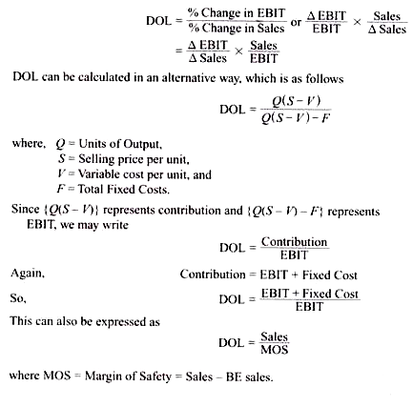
It is an interesting fact that a change in the volume of sales leads to a proportionate change in the operating profit of a firm due to the ability of the firm to use fixed operating costs. The value of degree of operating leverage should be greater than 1. If it is equal to 1, it can be said that operating leverage does not exist.
ADVERTISEMENTS:
Example 5.1:
Calculate the degree of operating leverage from the following data:
Sales: 1, 50,000 units at Rs 4 per unit.
Variable cost per unit Rs 2.
ADVERTISEMENTS:
Fixed cost Rs 1, 50,000.
Interest charges Rs 25,000.
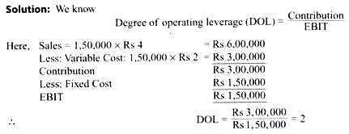

2. Financial Leverage:
Financial leverage is mainly related to the mix of debt and equity in the capital structure of a firm. It exists due to the existence of fixed financial charges that do not depend on the operating profits of the firm. Various sources from which funds are used in financing of a business can be categorized into funds having fixed financial charges and funds with no fixed financial charges. Debentures, bonds, long-term loans and preference shares are included in the first category and equity shares are included in the second category.
ADVERTISEMENTS:
Financing decision goes in favour of employing funds having fixed financial charges because it can be used as a lever. Financial leverage results from the existence of fixed financial charges in the firm’s income stream. With the use of fixed financial charges, a firm can magnify the effect of change in EBIT on change in EPS. Hence financial leverage may be defined as the firm’s ability to use fixed financial charges to magnify the effects of changes in EBIT on its EPS.
The higher the proportion of fixed charge bearing fund in the capital structure of a firm, higher is the Degree of Financial Leverage (DFL) and vice-versa. Financial leverage is computed by the DFL. DEL expresses financial leverage in quantitative terms. The percentage change in the earning per share to a given percentage changes in earnings before interest and taxes is defined as Degree of Financial Leverage (DFL). Therefore
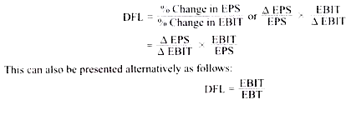
A firm is said to be highly financially leveraged if the proportion of fixed interest bearing securities, i.e. long term debt and preference share capital in the capital structure is higher in comparison to equity share capital. Like operating leverage, the value of financial leverage must be greater than 1. It is to be noted here that if the preference share capital is given in the problem the degree of financial leverage shall be computed by using the following formula
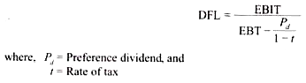
Example 5.2:
Calculate the degree of financial leverage from the following information: Capital structure: 10,000, Equity Shares of Rs 10 each Rs 1, 00,000.
5,000, 11 % Preference Shares of Rs 10 each Rs 50,000.
9% Debentures of Rs 100 each Rs 50,000.
The EBIT of the company is Rs 50,000 and corporate tax rate is 45%.
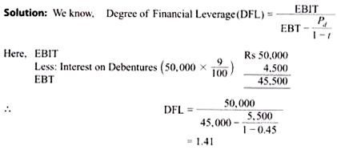

3. Combined Leverage:
A firm incurs total fixed charges in the form of fixed operating cost and fixed financial charges. Operating leverage is concerned with operating risk and is expressed quantitatively by DOL. Financial leverage is associated with financial risk and is expressed quantitatively by DFL. Both the leverages are concerned with fixed charges. If we combine these two we will get the total risk of a firm that is associated with total leverage or combined leverage of the firm. Combined leverage is mainly related with the risk of not being able to cover total fixed charges.
The firm’s ability to cover the aggregate of fixed operating and financial charges is termed as combined leverage. The percentage change in EPS to a given percentage change in sales is defined as Degree of Combined Leverage (DCL). DCL expresses combined leverage in quantitative terms. The higher the proportion of fixed operating cost and financial charges, higher is the degree of combined leverage. Like other two leverages the value of combined leverage must be greater than 1.
DCL can be computed in the following manner:
ADVERTISEMENTS:
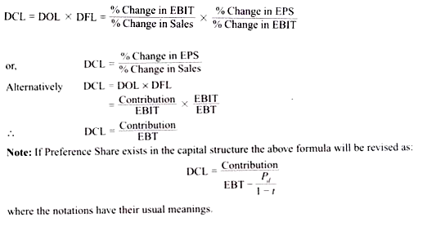
Example 5.3:
X Limited has given the following information:
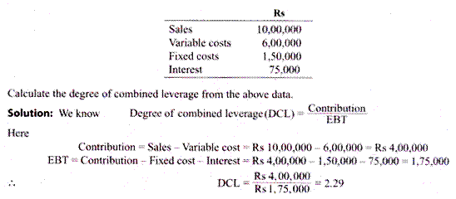

4. Working Capital Leverage:
ADVERTISEMENTS:
Investment in working capital has a significant impact on the profitability and risk of a business. A decrease in investment in current assets will lead to an increase in the profitability of the firm and vice versa. This is due to the fact that current assets are less profitable in comparison to fixed assets. Decrease in investment in current assets also increases the volume of risk. Risk and returns are directly related.
Therefore as risk increases, profitability of firm tends to increase. Thus Working Capital Leverage (WCL) may be defined as the ability of the firm to magnify the effects of change in current assets— assuming current liabilities remain constant—on firm’s Return on Investment (ROI).
Hence WCL may be computed as:

Example 5.4:
From the information given below, compute the working capital leverage.
Total assets: Rs 15, 00,000
Current assets: Rs 5, 00,000
Increase in current assets: Rs 1, 00,000.
