Business Cycle/Trade Cycle
Meaning of Trade Cycle:
A trade cycle refers to fluctuations in economic activities especially in employment, output and income, prices, profits etc. It has been defined differently by different economists. According to Mitchell, “Business cycles are of fluctuations in the economic activities of organized communities. The adjective ‘business’ restricts the concept of fluctuations in activities which are systematically conducted on commercial basis.
The noun ‘cycle’ bars out fluctuations which do not occur with a measure of regularity”. According to Keynes, “A trade cycle is composed of periods of good trade characterised by rising prices and low unemployment percentages altering with periods of bad trade characterised by falling prices and high unemployment percentages”.
Features of a Trade Cycle:
1. A business cycle is synchronic. When cyclical fluctuations start in one sector it spreads to other sectors.
2. In a trade cycle, a period of prosperity is followed by a period of depression. Hence trade cycle is a wave like movement.
3. Business cycle is recurrent and rhythmic; prosperity is followed by depression and vice versa.
4. A trade cycle is cumulative and self-reinforcing. Each phase feeds on itself and creates further movement in the same direction.
5. A trade cycle is asymmetrical. The prosperity phase is slow and gradual and the phase of depression is rapid.
6. The business cycle is not periodical. Some trade cycles last for three or four years, while others last for six or eight or even more years.
7. The impact of a trade cycle is differential. It affects different industries in different ways.
8. A trade cycle is international in character. Through international trade, booms and depressions in one country are passed to other countries.

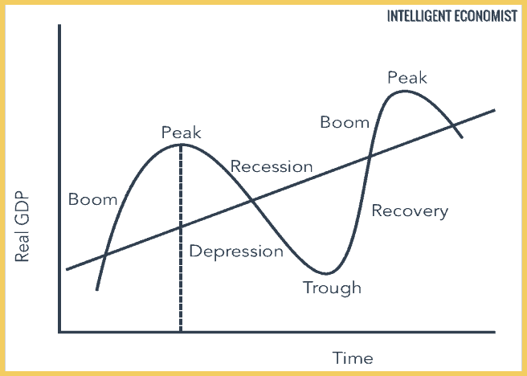

Expansion or Boom: The curve above the trend line represents the expansion phase of the business cycle. The periods of expansion (economic growth where real output increases) follow a period of recessions. The booms characterize fast economic growth, which tends to be inflationary and unsustainable. During this expansion period employment, investment income, wages, profits, demand, and supply are high.

Peak:The peak is the second stage of the trade cycle. This stage is the maximum growth the economy can achieve, and there are no further signs of economic growth. The end of the peak marks the beginning of the contraction of the economy.

Contraction: The period of contraction is often characterized by high unemployment, negative economic growth, and real output fall. If rapid expansion takes place, then the economy can heat up, and the rate of inflation could rise.If the economy continues to fall below the trend line, then economic activity continues to decline.

Trough: The trough is the lowest point in the economy. All indicators of good economic health are at their lowest now. The economic growth rate is negative.
Phases of a Trade Cycle:
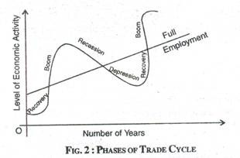

Generally, a trade cycle is composed of four phases – depression, recovery, prosperity and recession.
Depression:During depression, the level of economic activity is extremely low. Real income production, employment, prices, profit etc. are falling. There are idle resources. Price is low leading to a fall in profit, interest and wages. All the sections of the people suffer. During this phase, there will be pessimism leading to closing down of business firms.
Recovery: Recovery denotes the turning point of business cycle form depression to prosperity. In this phase, there is a slow rise in output, employment, income and price. Demand for commodities goes up. There is increase in investment, bank loans and advances. Pessimism gives way to optimism. The process of revival and recovery becomes cumulative and leads to prosperity.
Prosperity: It is a state of affairs in which real income and employment are high. There are no idle resources. There is no wastage of materials. There is rise in wages, prices, profits and interest. Demand for bank loans increases. There is optimism everywhere. There is a general uptrend in business community.
However, these boom conditions cannot last long because the forces of expansion are very weak. There are bottlenecks and shortages. There may be scarcity of labour, raw material and other factors of production. Banks may stop their loans. These conditions lead to recession.
Recession: When the entrepreneurs realize their mistakes, they reduce investment, employment and production. Then fall in employment leads to fall in income, expenditure, prices and profits. Optimism gives way to pessimism. Banks reduce their loans and advances. Business expansion stops. This state of recession ends in depression.

Factors Affecting Trade Cycle

1. Natural Factors: The trade cycle may change due to natural factors, for example, during the periods of heavy or unexpected rainfall; agricultural productivity may be affected. A lack of rainfall could result in a shortage of raw material, and therefore, industrial production is also affected. This shortage can affect the whole economy, particularly those that rely on agriculture as their main component of the Gross Domestic Product (GDP).

2. Wars: During a war, economic growth can slow down because of uncertainty in the market and loss of business confidence and consumer confidence. This loss of confidence reduces spending and investment in the economy.

3. Political Factors: In developing countries, often there is political instability. The new government formulates new policies and abandons the policies of previous governments. This kind of political climate creates uncertainty in the economy and causes business confidence and investment to fall.

4. The Supply of Money: Unplanned changes in the supply of money can cause business fluctuation in an economy. An increase in the supply of money leads to the expansion in aggregate demand. But an excessive increase in credit and money can also set off inflation in the economy. On the other hand, a decrease in the supply of money initiates a recession in the economy.

5. Future Expectation: Expectations about future business is also a major factor in the business cycle. When businesses are optimistic about future expectations, it triggers an expansion in business activities whereas pessimism about profits in the future results in the contraction of business activities.

6. Population Explosion: An abnormal increase in population can be a major factor in the business cycle. When the population increases at a higher rate than an increase in national output, it can become difficult to provide employment. However, an increase in the population also pushes the country’s Production Possibility Curve.

7. International Factors: Most countries of the world are economically interdependent. Any economic fluctuation in big economies like the USA or Japan affect the other economies, like how the housing market crash in the USA resulted in a global recession.

