Bond Mathematics
Concepts of Coupon rate
The coupon rate is the amount of annual interest income paid to a bondholder, based on the face value of the bond. Government and non-government entities issue bonds to raise money to finance their operations.
When a person buys a bond, the bond issuer promises to make periodic payments to the bondholder, based on the principal amount of the bond, at the coupon rate indicated in the issued certificate. The issuer makes periodic interest payments until maturity when the bondholder’s initial investment – the face value (or “par value”) of the bond – is returned to the bondholder.
All types of bonds pay interest to the bondholder. The amount of interest is known as the coupon rate.
When the prevailing market interest rate is higher than the coupon rate of the bond, the price of the bond is likely to fall because investors would be reluctant to purchase the bond at face value now, when they could get a better rate of return elsewhere.
Conversely, if prevailing interest rates fall below the coupon rate the bond is paying, then the bond increases in value (and price) because it is paying a higher return on investment than an investor could make by purchasing the same type of bond now, when the coupon rate would be lower, reflecting the decline in interest rates.
The bonds are fixed income markets instruments which are issued for a particular time period. At a time of issuance of the bond the issuer of the bond (example government) promises to return back the amount of the bond noted as face value to the purchaser of the bond or investor after the particular number of years promised and noted as tenor. After the bond tenor ends the principal value of the bond or the face value is returned back along with that year’s interest. When bonds are issued they are issued in the primary market Since they are financial products they are traded in the secondary market . So for example a government bond which is issued in 2016 may have a maturity of 10 years which means it is implied that the investor will be getting back the money from the government in 2026 Now let us say the investor who has purchased a bond in 2016 requires the money in 2020. At that time he goes to the secondary market and sells the bonds. The second purchaser of the bonds in 2020 may hold the bond till 2026 the date on which the government has promised to return the money. So the original maturity of the first purchaser was 10 years and for the second purchaser it is six years these six years is denoted by the term residual maturity the tenor of the bond is very important to understand the liquidity of the bonds . Bonds which are having higher tenor and traded after they are issued will command higher price since the demand for these bonds are high. However since the residual maturity decreases over time the demand for those bonds decreases and the liquidity of those bonds decreases along with the price.
Yield
Yield is the bond's coupon yield divided by its current market price. If the current market price changes, the current yield will also change. Current yield matters if you plan to sell your bond before maturity. But if you buy a new bond at par and hold it to maturity, your current yield when the bond matures will be the same as the coupon yield.
Yield to maturity (YTM) is the overall interest rate earned by an investor who buys a bond at the market price and holds it until maturity. Mathematically, it is the discount rate at which the sum of all future cash flows (from coupons and principal repayment) equals the price of the bond. YTM is often quoted in terms of an annual rate and may differ from the bond’s coupon rate. It assumes that coupon and principal payments are made on time. It does not require dividends to be reinvested, but computations of YTM generally make that assumption. Further, it does not consider taxes paid by the investor or brokerage costs associated with the purchase.
Yields are dependednt upomn macroeconomic factors like interest rates, inflation, etc. As inflation rises the interest rates rise. So the bondholders are needed to be paid more returns to make them invested, As a result the yields increases. This is known as the hardening of yields. Yields are an indicator of anticipated inflation by the market. Central banks may take note of the rising yields and adjust their monetary policies accordingly.
Yields are inversely related to the market prices. If yields harden i.e rises the bond prices fall which makes investing in the bond markets less attractive. It triggers a selloff.
Calculation of yield :
Example :
- Consider a bond of FV Rs 100/- and coupon rate 10%. The market price is Rs 110/-. The yield is determined by the following way
Interest received = 10/-
Market price = 110/-
Yield = 10/110 *100% = 9.09%
- Consider a bond of FV = 100/- and coupon rate = 10%. Market price = 95/- Yield is calculated as :
Interest received = 10/-
Market price = 95/-
Yield = 10/95*100% = 10.52%
- Consider a bond of FV = 100/- and coupon rate = 10%. Current Yield is 12 %. Market price is calculated as :
Interest received = 10/-
Yield = 12%
Market price = 10/12*100= 83.33
- Consider a bond of face value 100/- and coupon rate 10%. Current Yield is 8%> Market price may be calculated as :
Interest received = 10/-
Yield = 8%
Market price = 10/8*100=125/-

Duration
Duration is one of the fundamental characteristics of a fixed-income security (e.g., a bond) alongside maturity, yield, coupon, and call features. It is a tool used in the assessment of the price volatility of a fixed-income security.
Since the interest rate is one of the most significant drivers of a bond’s value, duration measures the sensitivity of the value fluctuations to changes in interest rates. The general rule states that a longer duration indicates a greater likelihood that the value of a bond will fall as interest rates increase.
Duration is commonly used in the portfolio and risk management of fixed-income instruments. Using interest rate forecasts, a portfolio manager can change a portfolio’s composition to align its duration with the expected level of interest rates. The 3 different types of duration are :
1 Macaulay duration (named after Canadian Fredrick Macaulay) is a weighted average of the times until the cash flows of a fixed-income instrument are received.
2.Modified duration metric is a more precise measure of price sensitivity. It is primarily applied to bonds, but it can also be used with other types of securities that can be considered as a function of yield.
3. Effective duration is a measure of the duration for bonds with embedded options (e.g., callable bonds). Unlike the modified duration and Macaulay duration, effective duration considers fluctuations in the bond’s price movements relative to the changes in the bond’s yield to maturity (YTM). In other words, the measure takes into account possible fluctuations in the expected cash flows of a bond.
Macaullay Duration
Macaulay Duration of a bond is a measure of the time taken to recover the initial investment in present value terms. In simplest form, duration refers to the payback period of a bond to break even, i.e., the time taken for a bond to repay its own purchase price. Duration is expressed in number of years.
Calculation :
First, each of the future cash flows is discounted to its respective present value for each period. Since the coupons are paid out every six months, a single period is equal to six months and a bond with two years maturity will have four time periods.
Second, the present values of future cash flows are multiplied with their respective time periods (these are the weights). That is the PV of the first coupon is multiplied by 1, PV of second coupon by 2 and so on.
Third, the above weighted PVs of all cash flows is added and the sum is divided by the current price (total of the PVs in step 1) of the bond. The resultant value is the duration in no. of periods. Since one period equals to six months, to get the duration in no. of year, divide it by two. This is the time period within which the bond is expected to pay back its own value if held till maturity.
More formally, duration refers to:
The weighted average term (time from now to payment) of a bond's cash flows or of any series of linked cash flows.
The higher the coupon rate of a bond, the shorter the duration (if the term of the bond is kept constant).
Duration is always less than or equal to the overall life (to maturity) of the bond.
Only a zero coupon bond (a bond with no coupons) will have duration equal to its maturity.
Duration is useful primarily as a measure of the sensitivity of a bond's market price to interest rate (i.e., yield) movements. It is approximately equal to the percentage change in price for one percent change in yield.
For example the duration is the approximate percentage by which the value of the bond will fall for a 1% per annum increase in market interest rate. So, a 15-year bond with a duration of 7 years would fall approximately 7% in value if the interest rate increased by 1% per annum. In other words, duration is the elasticity of the bond's price with respect to interest rates.
Illustration:
Taking a bond with par value of Rs 100 having 2 years maturity, and 10% coupon, and current price of ₹101.79, the cash flows will be (prevailing 2 year yield being 9%):
Time period (half year) | 1 | 2 | 3 | 4 | Total
Inflows (₹) | 5 | 5 | 5 | 105
PV at a yield of 9% | 4.78 | 4.58 | 4.38 | 88.05 | 101.79
PV* time | 4.78 | 9.16 | 13.14 | 352.20 | 379.28

Duration in number of periods = (Total PV*Time)/Current market price = 379.28/101.79 = 3.73
Duration in years = Duration in periods / nos of periods in 1 year = 3.73/2 = 1.86 years

Aid to calculation : Discount rate is 9 % annually. Since coupon is given half yearly applied rate is 9/2 = 4.5%. 5/(1.045)^1=4.78, 5/(1.045)^2=4.58, 5/(1.045)^3=4.38, (100+5)/(1.045)^4=88.05, here at the end of 4th year we receive both principal (100) and interest (5), i.e, 100+5=105. 4.78*1=4.78, 4.58*2=9.16, 4.38*3=13.14, 88.05*4=352.20
Modified Duration
Modified duration (MD) is a modified version of Macaulay Duration. It refers to the change in value of the security to one per cent change in interest rates (Yield). Example Taking a bond having 2 years maturity, and 10% coupon, and current price of ₹101.79, the cash flows will be (prevailing 2 year yield being 9%),
Modified Duration = Mac.Duration in years / ( 1 +disc rate of period/100) = MD = 1.86/(1+0.09/2) = 1.78
PV01
PV01 describes the actual change in price of a bond if the yield changes by one basis point (equal to one hundredth of a percentage point). It is the present value impact of 1 basis point (0.01%) (1%=100 bps) movement in interest rate. It is often used as a price alternative to duration (a time measure). Higher the PV01, the higher would be the volatility (sensitivity of price to change in yield).
Illustration
From the modified duration (given in the illustration 1), we know that the security value will change by 1.78% for a change of 100 basis point (1%) change in the yield. In value terms that is equal to 1.78*(101.79/100) = ₹ 1.81.
Hence the PV01 = 1.81/100 = ₹0.018, which is 1.8 paise. Thus, if the yield of a bond with a Modified Duration of 1.78 years moves from say 9% to 9.05% (5 basis points), the price of the bond moves from ₹101.79 to ₹101.70 (reduction of 9 paise, i.e., 5x1.8 paise).
Illustration 2: Taking a bond with par value of Rs 100 having 4 years residual maturity, and 10% coupon, and current price of ₹ 95, discount rate being 9%:
Time period (half year) | 1 | 2 | 3 | 4 | Total
Inflows (₹) | 10 | 10 | 10 | 110
PV at a yield of 9% | 9.17 | 8.41 | 7.72 | 77.95 | 102.98
PV* time | 9.17 | 16.82 | 23.16 | 311.80 | 360.95

Duration in number of periods = (Total PV*Time)/Current market price = 360.95/95 = 3.79
Duration in years = Duration in periods / nos of periods in 1 year = 3.79/1 = 3.79 years
Modified Duration = Duration in years / ( 1 + discount int. rate/100) = 3.79/1.09 = 3.47 years
Aid to calculation : Discount rate is 9 % annually. 10/(1.09)^1=9.17, 10/(1.09)^2=8.41, 10/(1.09)^3=7.72, (100+10)/(1.09)^4=77.95, here at the end of 4th year we receive both principal (100) and interest (10), i.e, 100+10=110.
Convexity
Calculation of change in price for change in yields based on duration works only for small changes in yields. This is because the relationship between bond price and yield is not strictly linear. Over large variations in yields, the relationship is curvilinear i.e., the reduction in option free bond price is less than the change calculated based only on duration for yield increase, and increase in option free bond price will be more than the change calculated based only on duration for yield decrease. This is measured by a concept called convexity, which is the change in duration of a bond due to change in the yield of the bond.
As the yield on a bond changes so too does its duration. A bond’s convexity measures the sensitivity of a bond’s duration to changes in yield. Duration is an imperfect way of measuring a bond’s price change, as it indicates that this change is linear in nature when in fact it exhibits a sloped or “convex” shape.
A bond is said to have positive convexity if duration rises as the yield declines. A bond with positive convexity will have larger price increases due to a decline in yields than price declines due to an increase in yields.
Positive convexity can be thought of as working in the investor’s favor, since the price becomes less sensitive when yields rise (prices down) than when yields decline (prices up). Bonds can also have negative convexity, which would indicate that duration rises as yields increase and can work against an investor’s interest.
Yield curve Analysis
A yield curve is a way to measure bond investors' feelings about risk, and can have a tremendous impact on the returns you receive on your investments. It's a graphical representation of the yields available for bonds of equal credit quality and different maturity dates.
In general, short-term bonds carry lower yields to reflect the fact that an investor's money is at less risk. The thinking behind this is that the longer one commit funds, the more he should be rewarded for that commitment owing to the credit risk.
When bond investors expect the economy to grow at a normal pace, without significant changes in the rate of inflation or major interruptions in available credit, the yield curve slopes upward from left to right on the graph as maturities lengthen and yields rise.
An upward slope yield curve indicates that the economy may normally be functioning. The steeper the curve is, the impression is that the economy is normal and not in a recession like a scenario anytime soon.
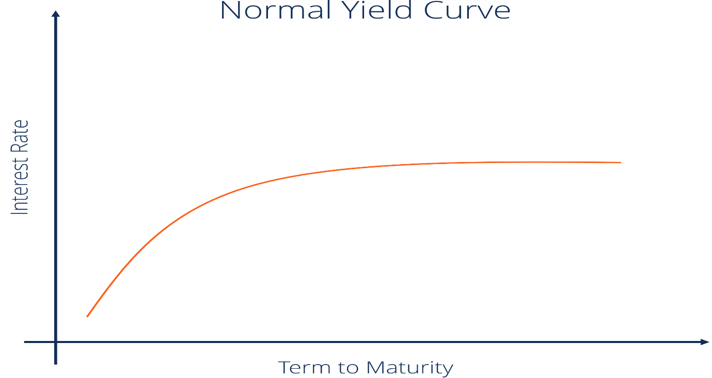

Steep curve : A steep yield curve is generally found at the beginning of a period of economic expansion. After a bout of depression, there is a sudden increase in demand of capital leading to rise in interest rates and inflation. The bond buyers hence demand higher interest in the fear of getting locked down to a low interest rates when an inflation is imminent.
Both the normal and steep curves are based on the same general market conditions. The only difference is that a steeper curve reflects a larger difference between short-term and long-term return expectations.
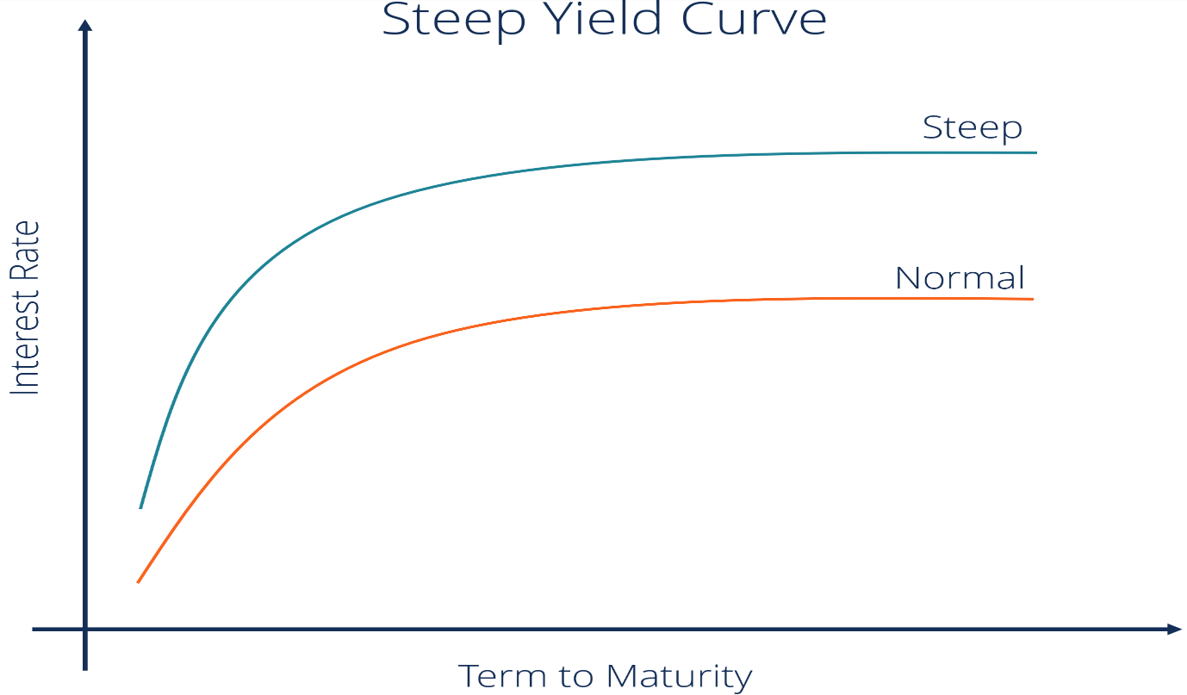

Inverted curve :
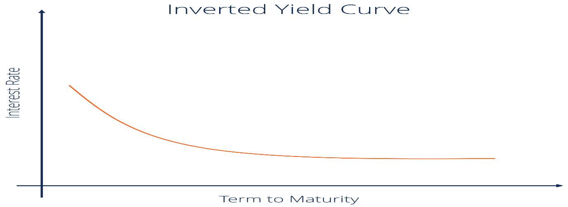
When long-term investors believe that this is their last chance to lock in current rates before they fall even lower, they become slightly less demanding of lenders. since lower interest rates generally mean slower economic growth, an inverted yield curve is often taken as a sign that the economy may soon stagnate. So when the yield curve starts to shift toward an inverted shape, it is perceived as a leading indicator of an economic downturn.
An inverted yield curve occurs when short-term debt instruments carry higher yields than long-term instruments of the same credit risk profile.
Inverted yield curves are unusual since longer-term debt should carry greater risk and higher interest rates, so when they occur there are implications for consumers and investors alike.
When short-term interest rates exceed long-term rates, market sentiment suggests that the long-term outlook is poor and that the yields offered by long-term fixed income will continue to fall.
In a growing economy, investors also demand higher yields at the long end of the curve to compensate for the opportunity cost of investing in bonds versus other asset classes, and to maintain an acceptable spread over inflation rates.
Flat yield curve :
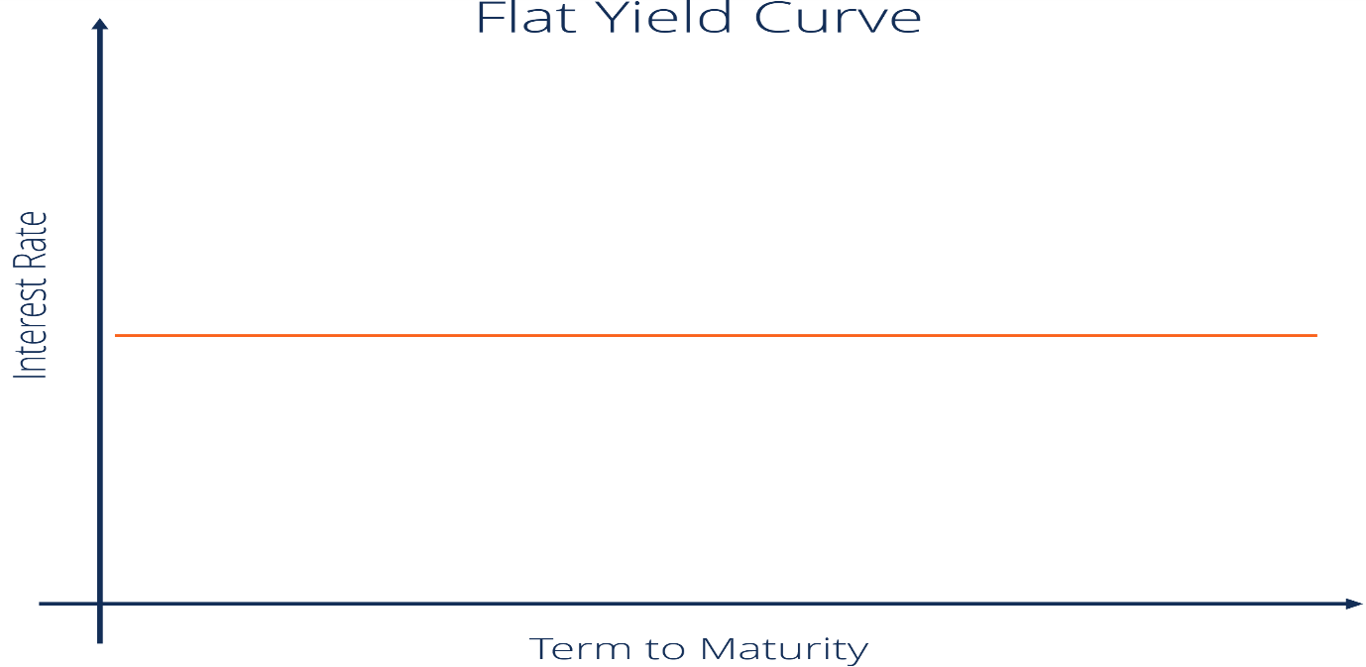
A flat curve happens when all maturities have similar yields. This means that the yield of a 10-year bond is essentially the same as that of a 30-year bond. A flattening of the yield curve usually occurs when there is a transition between the normal yield curve and the inverted yield curve.
Humped
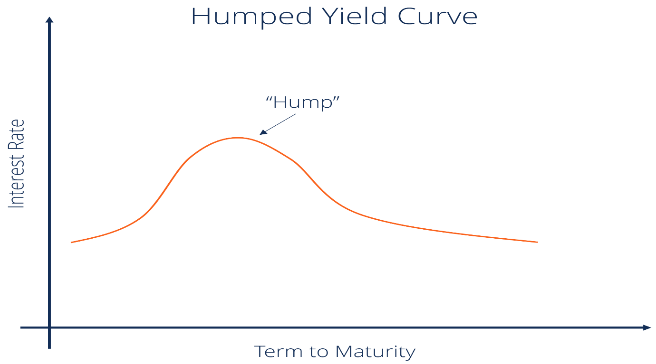
A humped yield curve occurs when medium-term yields are greater than both short-term yields and long-term yields. A humped curve is rare and typically indicates a slowing of economic growth.
DETERMINANTS TO THE VALUE OF BOND
Market conditions
Ratings
The residual maturity a bond
Prevailing Interest Rate
Liquidity in the market
Demand and supply
Monetary policy
Fiscal policy
Other markets and alternative investment destinations
Risk aversion
Access to money markets by institutions
Economic conditions
Relationship between bond price and yields
The yield and bond price have an important but inverse relationship. When the bond price is lower than the face value, the bond yield is higher than the coupon rate. When the bond price is higher than the face value, the bond yield is lower than the coupon rate. So, the bond yield calculation depends on the price of the bond and the coupon rate of the bond. If the bond price falls, the yield rises, and if the bond price rises, the yield falls. Let us understand why this is the case:
1. When interest rates fall, it causes a fall in the value of the related investments. However, bonds that have been issued will not be affected in such a way. They will keep paying the same coupon rate as issued from the beginning, which will now be at a higher rate than the prevailing interest rate. This higher coupon rate makes these bonds attractive to investors willing to buy these bonds at a premium.
2. Conversely, when interest rates rise, newer bonds will pay investors better interest rates than existing bonds. Here, the older bonds are less attractive and will drop their prices as compensation and sell at a discounted price
Examples of the inverse relationship between bond price and yield
Example 1
There is a 10-year bond with a price of Rs 5000 and a coupon amount of Rs 200. The yield on this bond is calculated as per the formula below
● Yield = interest on bond / market price of the bond x 100
● So, yield = (200/5000) x 100% = 4%
Suppose the price of the bond increases from Rs 5000 to Rs 5500 due to strong investor demand. So, the bond now trades at a price of 10% above the issue price. However, the coupon amount remains the same at Rs 200.
● Now the yield changes to (200/5500) x 100% = 3.64%
So, the bond price has gone up, which causes the yield on the bond to decrease.
Example 2
Now suppose the price on the same bond considered above decreases.
● Initial bond price = Rs 5000
● Coupon = Rs 200
● Bond price falls to Rs 4300
● Coupon remains Rs 200
● Now yield is (200/4300) x 100% = 4.65%

When the yield increases it means the expectation of return of the investors from the bond market also increases. This is a result of the higher inflation, interest rate and the corresponding interest rates that are getting paid from other markets so when the yield increases either the corporate or government has to pay a higher return to the investor or a lower price. In either way a lower price and a higher yield are synonymous to each other. If the yield is not increased or if the market price of the instrument is not decreased the bond investors will prefer to sell their investment portfolio and move on to other markets example commodities and equity so that they may earn a higher return on investment. When the bond holders start selling, the market goes down and to arrest such a decrease in market the corporates have to increase the returns to prevent people from moving away from the bond market.
Bond Pricing Models
Bond pricing depends upon several factors like coupon rate, face value, residual maturity and discount rate. Bonds will have a number of periods to maturity. These are typically annual periods, but may also be semi-annual or quarterly. The number of periods will equal the number of coupon payments. What makes the bond return different from other instruments is that their returns are fixed. So over the period of time the amount received by the investors remain constant. However several factors like inflation are not constant. This eats away into the income from interest received from the bonds. Over time the value of returns decrease. So the bond pricing models factor in these factors.
- Bond prices are intrinsically linked to the interest rate environment in which they trade - with prices falling as interest rates rise.
- Bond prices are also greatly influenced by the creditworthiness of the issuer, from the federal government down to a junk bond issuer on the verge of default.
- Bond prices and yields can be calculated in several different ways, depending on the type of bond and the definition of yield you're using.
- Benchmarks exist to track bond yields and serve as a relative measure of price performance.
Ceteris paribus, all else held equal:
- A bond with a higher coupon rate will be priced higher
- A bond with a higher par value will be priced higher
- A bond with a higher number of periods to maturity will be priced higher
- A bond with a higher yield to maturity or market rates will be priced lower
There are two models : Discounted Cash Flow model and Yield based models.
Discounted Cash Flow Method :
Bond valuation, in effect, is calculating the present value of a bond’s expected future coupon payments. The theoretical fair value of a bond is calculated by discounting the future value of its coupon payments by an appropriate discount rate.
The discount rate used is the yield to maturity, which is the rate of return that an investor will get if they reinvest every coupon payment from the bond at a fixed interest rate until the bond matures. It takes into account the price of a bond, par value, coupon rate, and time to maturity.
Calculating the value of a coupon bond factors in the annual or semi-annual coupon payment and the par value of the bond.
The present value of expected cash flows is added to the present value of the face value of the bond as seen in the following formula:
Vcoupons​=∑(1+r)tC​
Vface value​=(1+r)TF​
C=future cash flows, that is, coupon payments
r=discount rate, that is, yield to maturity
F=face value of the bond
t=number of periods
T=time to maturity​
A zero-coupon bond makes no annual or semi-annual coupon payments for the duration of the bond. Instead, it is sold at a deep discount to par when issued. The difference between the purchase price and par value is the investor’s interest earned on the bond.
To calculate the value of a zero-coupon bond, we only need to find the present value of the face value. Carrying over from the example above, the value of a zero-coupon bond with a face value of ₹1,000, YTM of 3%, and two years to maturity would be ₹1,000 / (1.03)², or ₹942.59
Yield Based Models
Bonds are priced to yield a certain return to investors. A bond that sells at a premium (where price is above par value) will have a yield to maturity that is lower than the coupon rate. Alternatively, the causality of the relationship between yield to maturity and price may be reversed. A bond could be sold at a higher price if the intended yield (market interest rate) is lower than the coupon rate. This is because the bondholder will receive coupon payments that are higher than the market interest rate, and will, therefore, pay a premium for the difference.

Factors affecting yields

Economic Standing
The current state of the economy can have an influence on corporate bond yields. Bond yields might fall in a rising economy as a result of increased demand for the securities. On the other hand, during recessions, investors may view bonds as riskier, which would raise yields.
1. Rate of Interest
Inflation risk causes central banks to boost targeted interest rates. Whenever the risk-free rate of interest increases, corporate bond yields need to rise in parallel to adapt. Higher yields result in lower costs, which makes the economy even more subject to unexpected events. Therefore, in the event that the economy enters a recession and profits decline, yields might increase as expenses rise.
2.Supply and Demand
The bond yield swings according to the bond’s present value in the secondary market, which is affected by demand and supply patterns. For example, the yield will be less than the coupon rate if the bond’s present price on the market is more than its nominal value.
3.Inflation
Profit margins become thinner by rising wages brought on by inflation, leaving them more open to slowdowns in economic development. Additionally, inflation drives up overall economic prices. As prices grow, so does people’s capacity to pay for them, which enhances credit risk and puts a price increase on corporate bond yields.
4.Credit Risk
Credit risk, or default risk, is a company-specific characteristic that isn’t always related to economic circumstances but nonetheless demonstrates a company’s standing in the marketplace. Several agencies provide credit ratings with the objective of identifying and classifying credit risk.
While there are numerous methods that can be used for analysing and evaluating credit risk, interest-coverage ratios, and capitalization ratios are two common measurements. Corporate bonds issued by companies with greater credit risk will have higher interest rates to offset the added risk.
5.Time To Maturity: Prices of long-term bonds have more chances to fluctuate depending on interest rates. They cannot be traded once they are closer to their maturity date. Bond valuation declines faster if the interest rate rises for the bonds with longer maturity periods compared to those with short maturity periods. This is also referred to as the bond duration factor.
6.Bond Structure: Bond structure makes the pricing structure of the bonds different. For instance, a floating rate interest bond fluctuates with the change in interest rates compared to a fixed coupon rate bond. Moreover, call and Put options change the bond's price as it determines maturity. A call option allows the issuer to redeem a bond before it matures, while a put option allows the bondholder to demand repayment before maturity. The call options on bonds increase the bond issuer’s flexibility, potentially leading to higher yields.

Investment horizon and Bond Holding period
1. Short-term investment horizon
This investment time frame,is typically best for individuals in their later years, preparing for retirement. It may also be appropriate for individuals who are strongly averse to risk or need to access a significant amount of cash in the near future. A short investment horizon usually doesn’t exceed a period of three years. For these risk-averse investors, bonds maturing in short term are purchased. This matches with the time horizon. As a result the surety of principal upon maturity is there. Also as the bonds near maturity, interest of traders decreases and so does the liquidity and the volatility.
2. Medium-term investment horizon
Investors who are less risk-averse and not looking for cash for retirement or a large purchase are better suited to a medium-term investment horizon. This usually means a period of three to ten years. Investors with this type of investment horizon are somewhere in the middle between low and high risk, meaning a conservative and diversified portfolio is best, mixing investments in both stocks and bonds. The ratio of stocks to bonds should be determined by the individual’s specific wants and needs. Investors wishing to invest for a medium term are willing to take more risk in expectation of higher return and hence prefer the bonds which have a maturity of 10 years or more.
3. Long-term investment horizon
Finally, for investors willing to take big risks for big rewards and who have the time to wait for the payoff or to recoup losses after risky endeavors, long-term investment horizons are often the way to go. In most cases, the portfolio of the long-term investor includes a significant amount of risky investments with potentially high yields. The remainder of the portfolio should then be a mix of stocks and bonds, with the ratio leaning more heavily towards stocks.
Hedging in the debt markets
Hedging refers to the use of strategies in minimization of risk. Risks may be of different types . Risk reward relationship is directly proportional.
Debt market are used as places where diversification may be taking place to avoid the risk in the equity market hedging is required so debt markets are a natural choice for hedging the risk offered by the equity markets however the debt markets are also not free from risk there are different types of risk in debt markets or the money markets some of them are credit risk reinvestment risk interest rate risk inflation risk and so on
Credit risk in debt market arises when the private corporations issue instruments like commercial papers ncds, corporate bonds etc. The private corporations are placed to invest as they do not have the guarantee of the government. The private corporations are subject to market risks, business risks and hence they are able to give back the money only when they are having a high liquidity. So if the investor has invested in the private corporations through their CP or NCD there exist a risk in where the private corporations may not be able to give back their money in time or give the interest the investor needs to take care before investing the hedging may be taken place if the rating of the private corporations are taken into account before investing the private corporations with sound financial systems has a better credibility of returning the funds. Hence they obtain a higher or a stronger rating like AAA but the interest rate or the returns offered by the triple a rated corporates are always lower than the lower rated corporates when an investor is investing in city for more than three or five years he should be aware that the rating changes from year to year so it is the obligation of the Investor to keep a watch on the rating every year and continue his investment or withdraw his investment if the rating is changing and he will be taking the decision accordingly
Liquidity risk refers to a situation where an investor is not able to sell the instruments in the market. Liquidity risk may result when an investor who has once bought a debt instrument from a private corporation when the private corporation was in a very sound financial condition however the finance condition has deteriorated so much that there are no takers for that instrument hence the investor is not able to convert his asset into cash this is liquidity risk here again liquid risk may be taken care of by keeping a close eye on the rating of the corporate if the rating decreases and if the market is not ready to buy this type of securities then immediately the investor who is holding the securities should be coming out of his portfolio at whatever price he may best get
Interest rate refers to the ongoing rate of return that is obtained from the different asset classes like equity commodities etc. As the market changes the returns of the equities also changes it may happen that interest rate received by the equity investors is higher than the debt investors. However the debt investors are already locked in a fixed return this type of risk is known as interest rate risk wherein the market interest rates are giving higher return than the bond interest rates one of the preferred ways of hedging is using frbs or floating rate bonds. In that case the rate of return varies with the market so when the market return is very high the investor may expect to get a higher rate of return than the fixed interest bonds and when the market rates are low the investor should be expecting to get lower returns
Reinvestment risk is applicable only in case of debt markets the debt market instruments have a fixed term or maturity and till that term the investor will continue enjoying a fixed rate of return which has been declared at the time of issuance of the debt market instrument on an investor continue to enjoy a fixed rate of return however the market interest rate may go on falling after a particular. Win Off the date instrument occurs the entire fund is given back to the investor if the investor do not have any other short term plans he is most likely to reinvest again in the available securities assuming that the investors will not migrate to a different asset class we can understand that the investor will reinvest the entire amount in the gate market which is giving a lower return now thus the investor is getting a lower return as compared to the return he was enjoying for several years in the past the preferred way of hedging is utilization of FRB or the floating rate bonds in which the interest rate provided by the bond also changes with the market and the investor is psychologically adapted to understand what is the interest rate he is expected to get and there will be no sudden decrease of the interest income that is payable to the investor
Inflation risk refers to the probability of loss in case of an investment which is getting a fixed rate of return but the inflation is eating away into his extra income. Since the inflation cannot be controlled or predicted beyond the particular time it becomes difficult to take decisions whether the bond should be invested or it should not be interested the bonds offer stability and a fixed rate of return however if the inflation is getting away into the return the net real income available to the investors becomes very low. As a result the investors stands to lose whatever return he is getting from the debt market an ideal risk mitigation strategy is use of IIB or the inflation indexed bonds. In this case the coupon rates on the returns of the bonds are related to the inflation if the inflation increases the coupon rate increases in a similar manner and if it decreases the coupon rate also decreases in a similar manner this results in the investor receiving a same fixed real rate of return irrespective of the inflation going up or down

