
CHAPTER 2

Audit Planning,

Procedures and Documentation

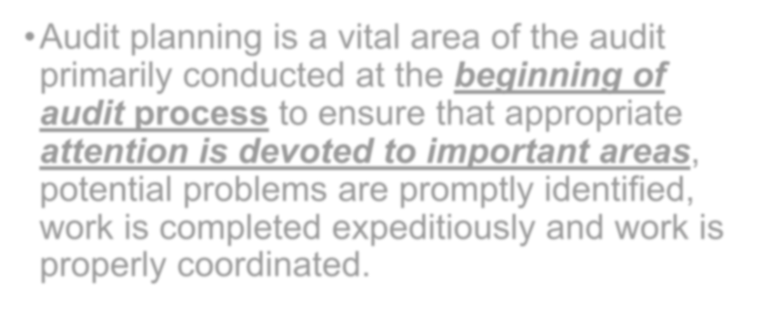

- Audit planning is a vital area of the audit primarily conducted at the beginning of audit process to ensure that appropriate attention is devoted to important areas, potential problems are promptly identified, work is completed expeditiously and work is properly coordinated.

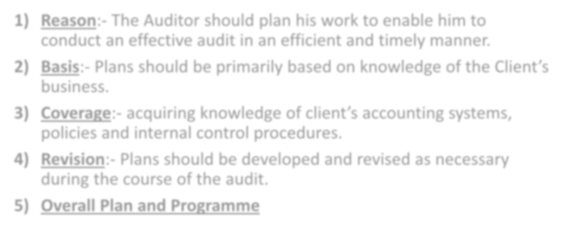

- Reason:- The Auditor should plan his work to enable him to conduct an effective audit in an efficient and timely manner.
- Basis:- Plans should be primarily based on knowledge of the Client’s
business.
- Coverage:- acquiring knowledge of client’s accounting systems,
policies and internal control procedures.
- Revision:- Plans should be developed and revised as necessary during the course of the audit.

Overall Plan and Programme

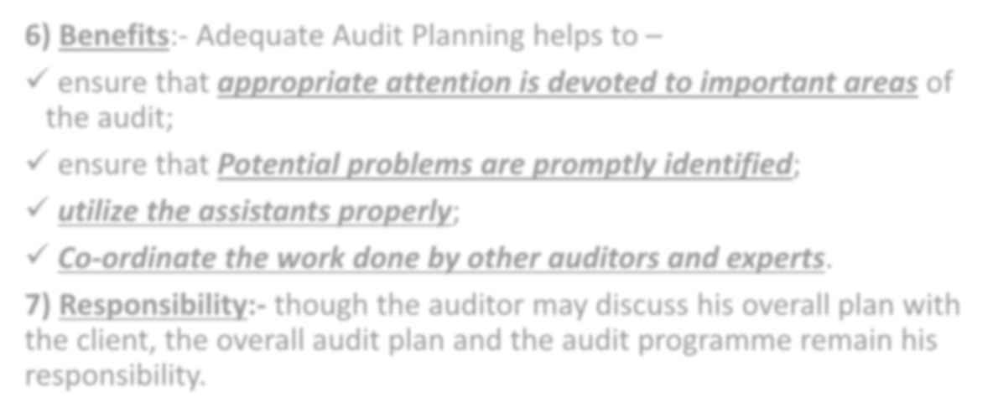

- Benefits:- Adequate Audit Planning helps to –
- ensure that appropriate attention is devoted to important areas of the audit;
- ensure that Potential problems are promptly identified;
- utilize the assistants properly;
- Co-ordinate the work done by other auditors and experts.
- Responsibility:- though the auditor may discuss his overall plan with the client, the overall audit plan and the audit programme remain his responsibility.

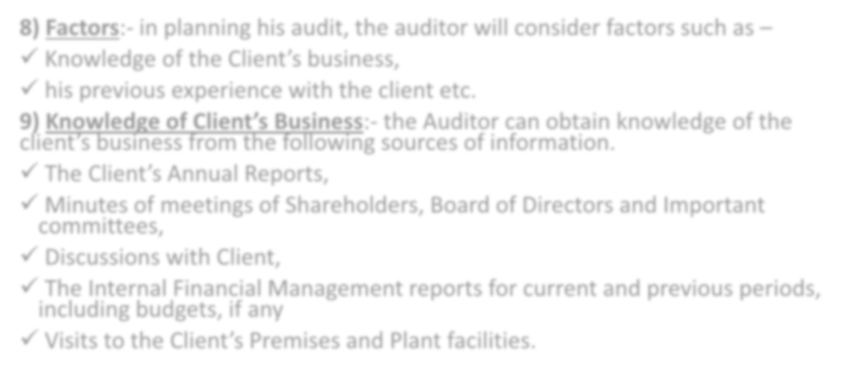

- Factors:- in planning his audit, the auditor will consider factors such as –
- Knowledge of the Client’s business,
- his previous experience with the client etc.
- Knowledge of Client’s Business:- the Auditor can obtain knowledge of the
client’s business from the following sources of information.
- The Client’s Annual Reports,
- Minutes of meetings of Shareholders, Board of Directors and Important
committees,
- Discussions with Client,
- The Internal Financial Management reports for current and previous periods, including budgets, if any
- Visits to the Client’s Premises and Plant facilities.

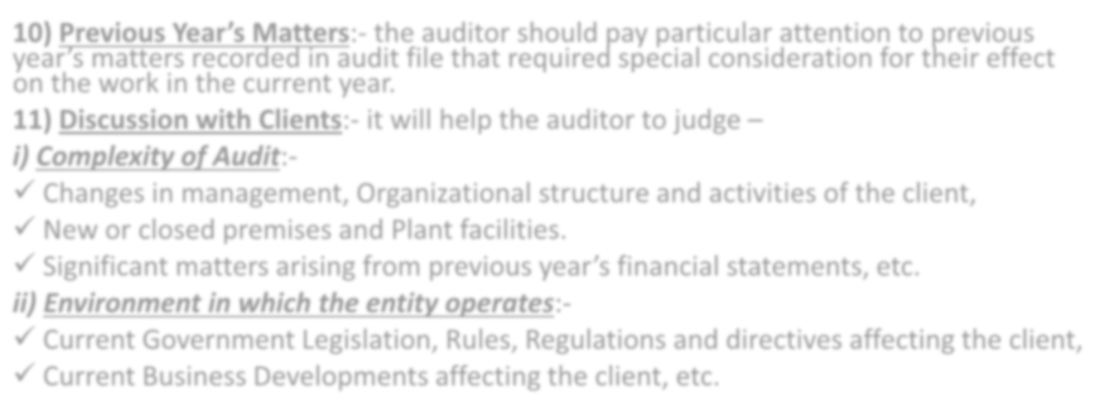

- Previous Year’s Matters:- the auditor should pay particular attention to previous year’s matters recorded in audit file that required special consideration for their effect on the work in the current year.
- Discussion with Clients:- it will help the auditor to judge –
- Complexity of Audit:-
- Changes in management, Organizational structure and activities of the client,
- New or closed premises and Plant facilities.
- Significant matters arising from previous year’s financial statements, etc.
- Environment in which the entity operates:-
- Current Government Legislation, Rules, Regulations and directives affecting the client,
- Current Business Developments affecting the client, etc.



- Overall Audit Plan / Approach:- The Following matters help the Auditor in Developing the overall Audit Plan:-
  - The terms of his engagement and any Statutory Responsibilities,
  - The Accounting Policies adopted by the client and changes in those policies,
  - The Identification of Significant Audit areas,
  - The Setting of Materiality Levels (like where major amounts are involved) for Audit purposes.
  - The Degree of reliance he expects to be able to place on Accounting system and Internal Control.
  - The Involvement of Experts, etc.

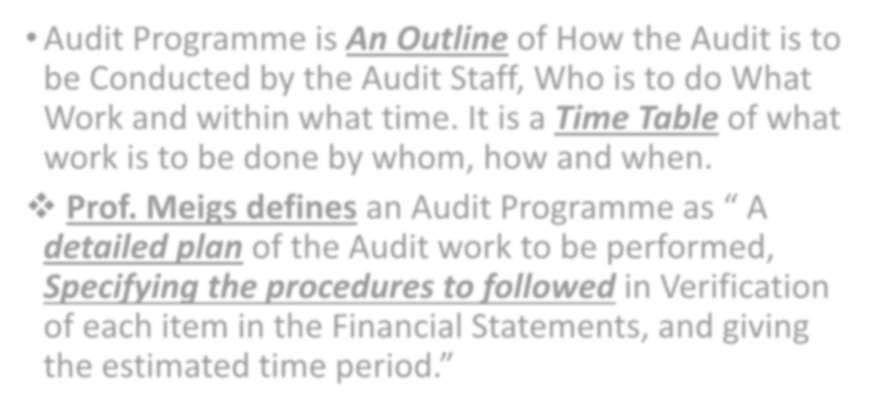

Audit Programme is An Outline of How the Audit is to be Conducted by the Audit Staff, Who is to do What Work and within what time. It is a Time Table of what work is to be done by whom, how and when.
- Prof. Meigs defines an Audit Programme as “ A detailed plan of the Audit work to be performed, Specifying the procedures to followed in Verification of each item in the Financial Statements, and giving

the estimated time period.”

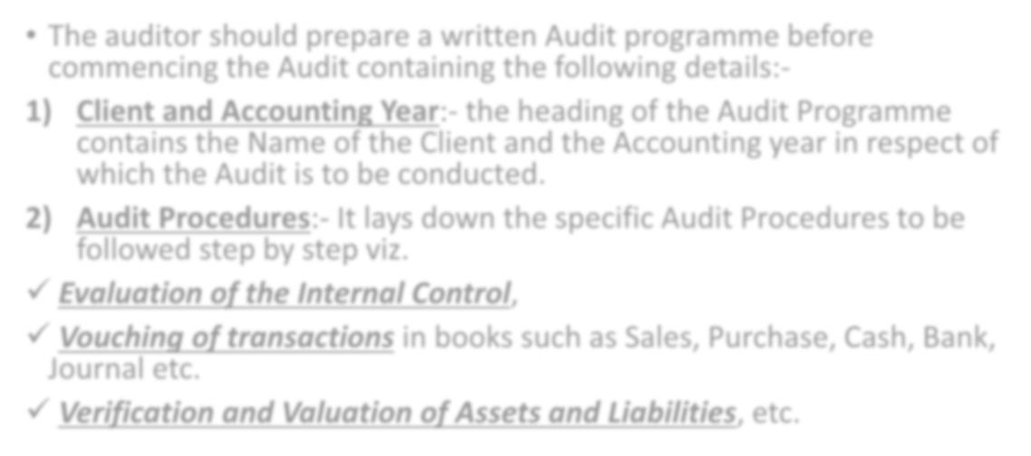

- The auditor should prepare a written Audit programme before commencing the Audit containing the following details:-
- Client and Accounting Year:- the heading of the Audit Programme contains the Name of the Client and the Accounting year in respect of which the Audit is to be conducted.
- Audit Procedures:- It lays down the specific Audit Procedures to be followed step by step viz.
  - Evaluation of the Internal Control,
  - Vouching of transactions in books such as Sales, Purchase, Cash, Bank, Journal etc.
  - Verification and Valuation of Assets and Liabilities, etc.

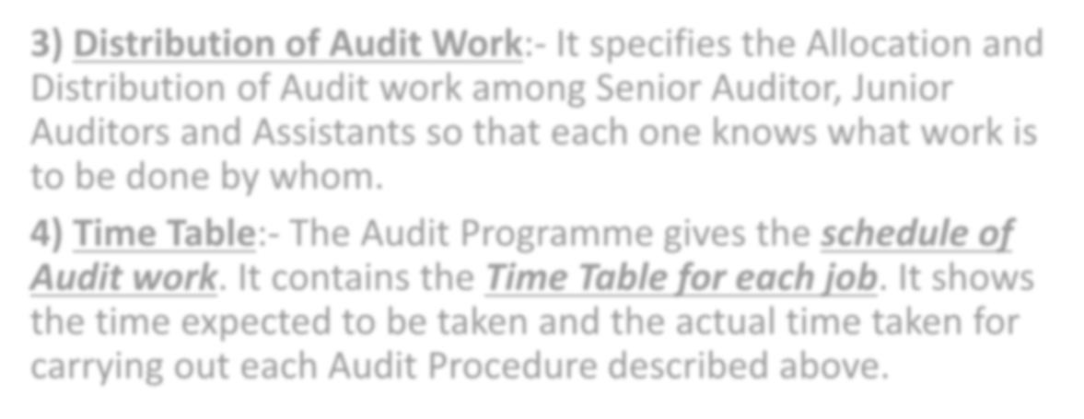

- Distribution of Audit Work:- It specifies the Allocation and Distribution of Audit work among Senior Auditor, Junior Auditors and Assistants so that each one knows what work is to be done by whom.
- Time Table:- The Audit Programme gives the schedule of Audit work. It contains the Time Table for each job. It shows the time expected to be taken and the actual time taken for carrying out each Audit Procedure described above.

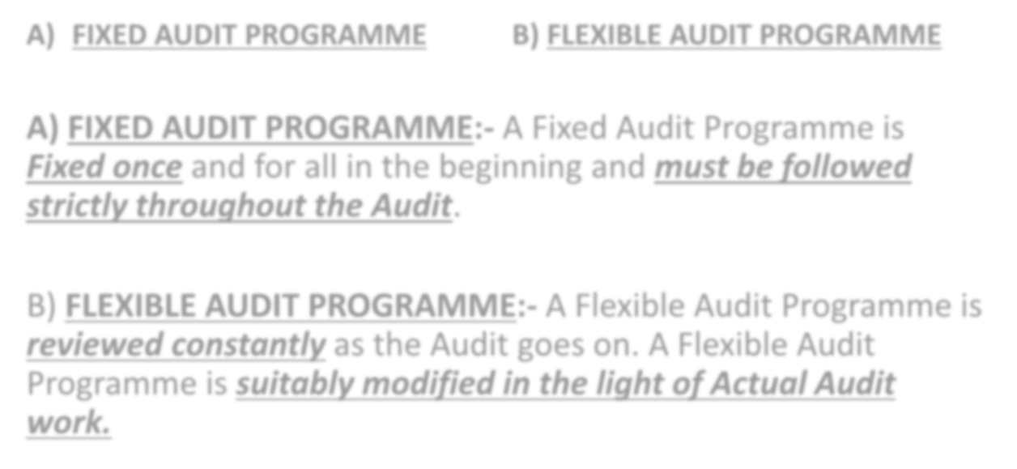

FIXED AUDIT PROGRAMME B) FLEXIBLE AUDIT PROGRAMME

- FIXED AUDIT PROGRAMME:- A Fixed Audit Programme is Fixed once and for all in the beginning and must be followed strictly throughout the Audit.

- FLEXIBLE AUDIT PROGRAMME:- A Flexible Audit Programme is reviewed constantly as the Audit goes on. A Flexible Audit Programme is suitably modified in the light of Actual Audit work.

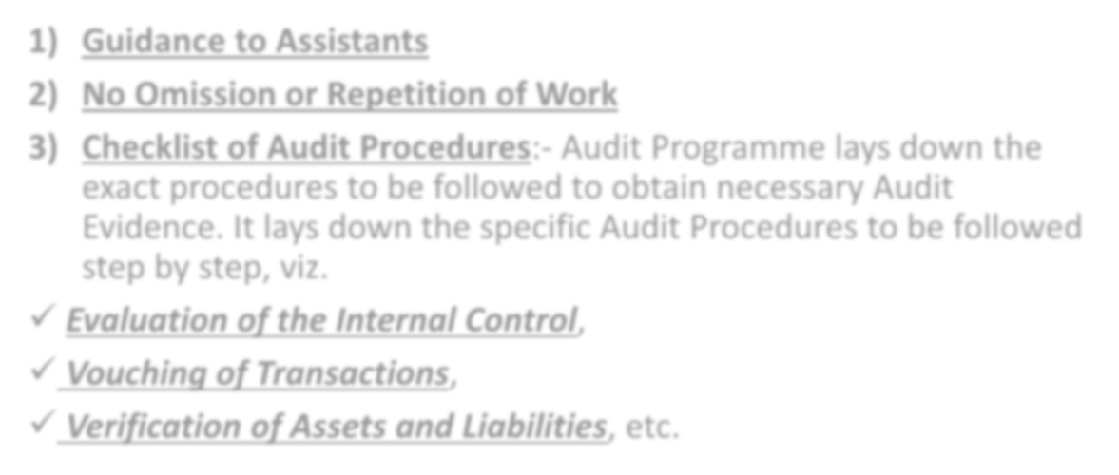

Guidance to Assistants
  - No Omission or Repetition of Work
  - Checklist of Audit Procedures:- Audit Programme lays down the exact procedures to be followed to obtain necessary Audit Evidence. It lays down the specific Audit Procedures to be followed step by step, viz.
- Evaluation of the Internal Control,
- Vouching of Transactions,
- Verification of Assets and Liabilities, etc.

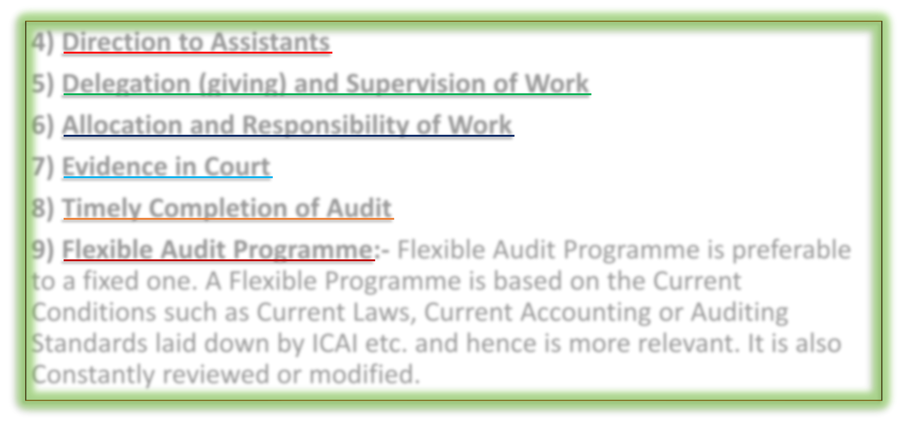

Direction to Assistants
  - Delegation (giving) and Supervision of Work

Allocation and Responsibility of Work
  - Evidence in Court

Timely Completion of Audit
  - Flexible Audit Programme:- Flexible Audit Programme is preferable to a fixed one. A Flexible Programme is based on the Current Conditions such as Current Laws, Current Accounting or Auditing Standards laid down by ICAI etc. and hence is more relevant. It is also Constantly reviewed or modified.

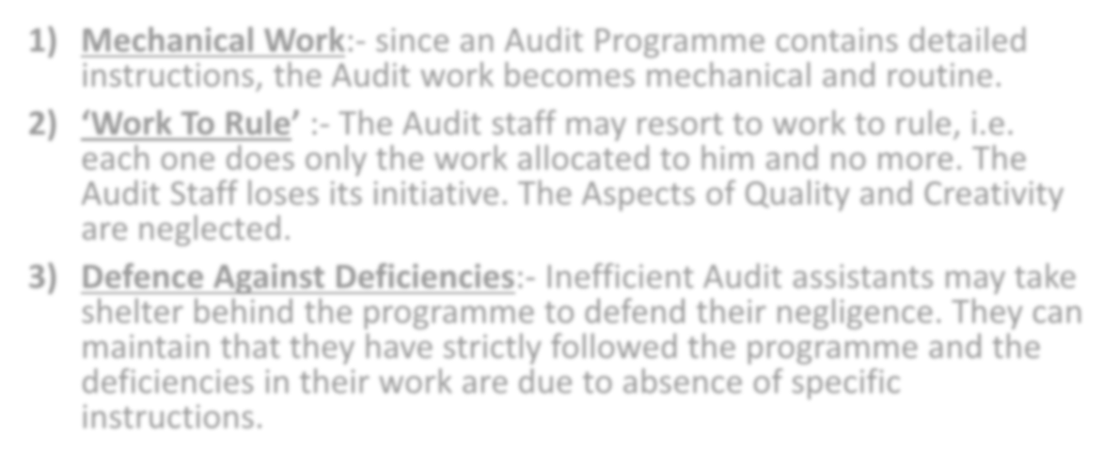

- Mechanical Work:- since an Audit Programme contains detailed instructions, the Audit work becomes mechanical and routine.
- ‘Work To Rule’ :- The Audit staff may resort to work to rule, i.e. each one does only the work allocated to him and no more. The Audit Staff loses its initiative. The Aspects of Quality and Creativity are neglected.
- Defence Against Deficiencies:- Inefficient Audit assistants may take shelter behind the programme to defend their negligence. They can maintain that they have strictly followed the programme and the deficiencies in their work are due to absence of specific instructions.

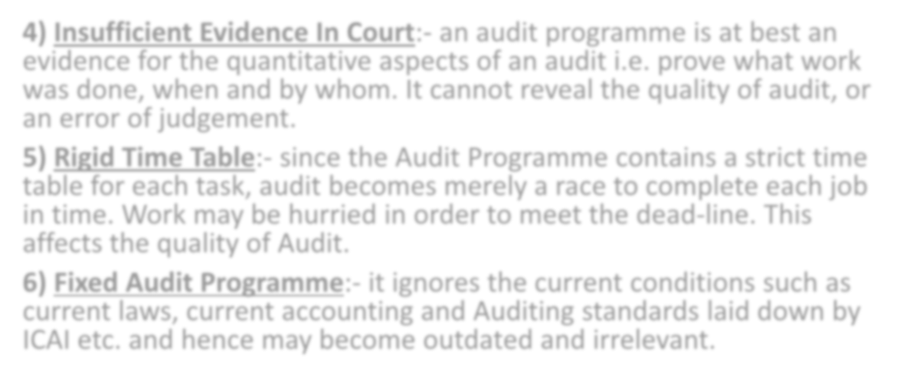

- Insufficient Evidence In Court:- an audit programme is at best an evidence for the quantitative aspects of an audit i.e. prove what work was done, when and by whom. It cannot reveal the quality of audit, or an error of judgement.
- Rigid Time Table:- since the Audit Programme contains a strict time table for each task, audit becomes merely a race to complete each job in time. Work may be hurried in order to meet the dead-line. This affects the quality of Audit.
- Fixed Audit Programme:- it ignores the current conditions such as current laws, current accounting and Auditing standards laid down by ICAI etc. and hence may become outdated and irrelevant.



- Audit Evidence means All of the Information used by the Auditor in arriving at the conclusions on which Auditor’s opinion is based.
- Auditor needs to obtain evidence in respect of the following

Basic matters:-
- Internal Controls,

Transactions during the year,
- Balances of Assets and Liabilities at the end of year.
Such Evidence must be Sufficient, Relevant and Reliable.

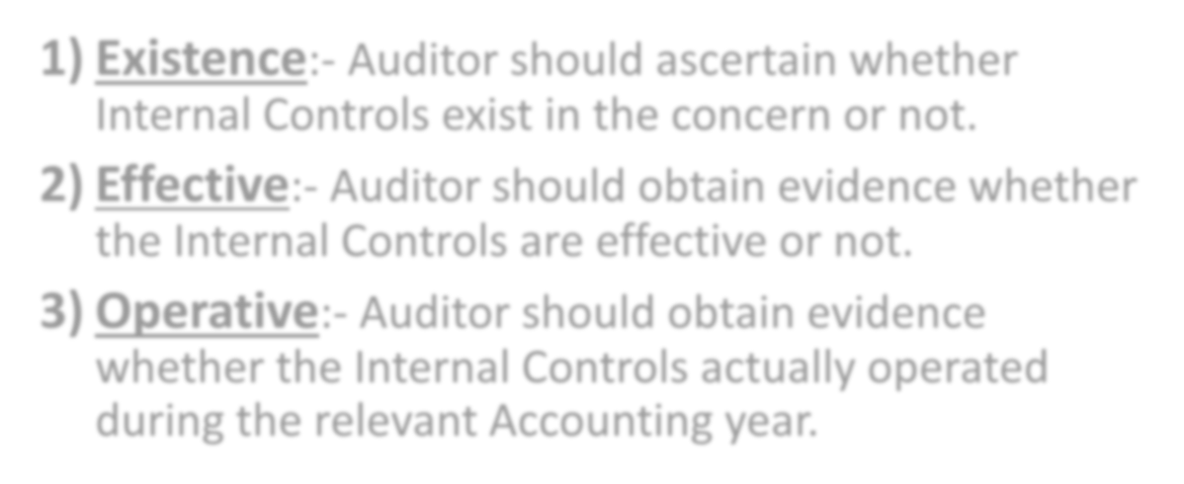

Existence:- Auditor should ascertain whether Internal Controls exist in the concern or not.
- Effective:- Auditor should obtain evidence whether the Internal Controls are effective or not.

Operative:- Auditor should obtain evidence whether the Internal Controls actually operated during the relevant Accounting year.

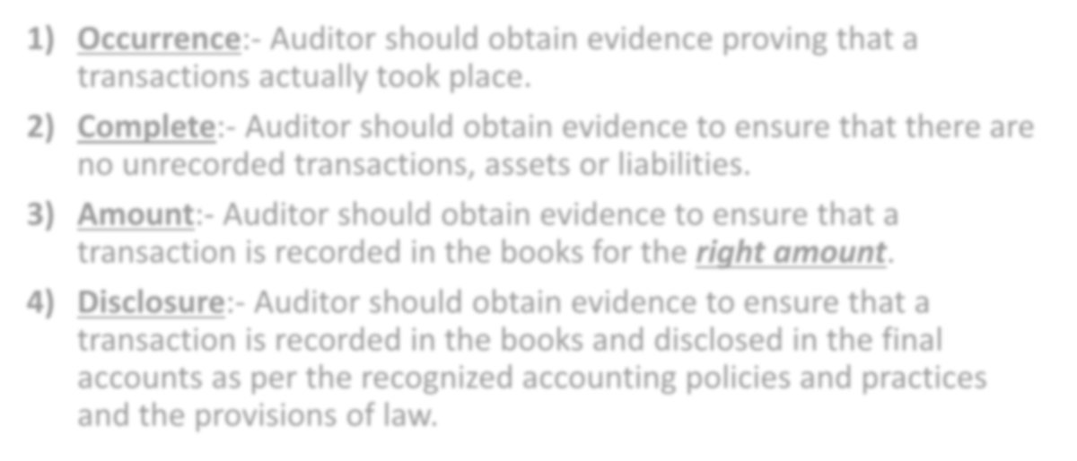

- Occurrence:- Auditor should obtain evidence proving that a transactions actually took place.
- Complete:- Auditor should obtain evidence to ensure that there are no unrecorded transactions, assets or liabilities.
- Amount:- Auditor should obtain evidence to ensure that a transaction is recorded in the books for the right amount.
- Disclosure:- Auditor should obtain evidence to ensure that a transaction is recorded in the books and disclosed in the final accounts as per the recognized accounting policies and practices and the provisions of law.

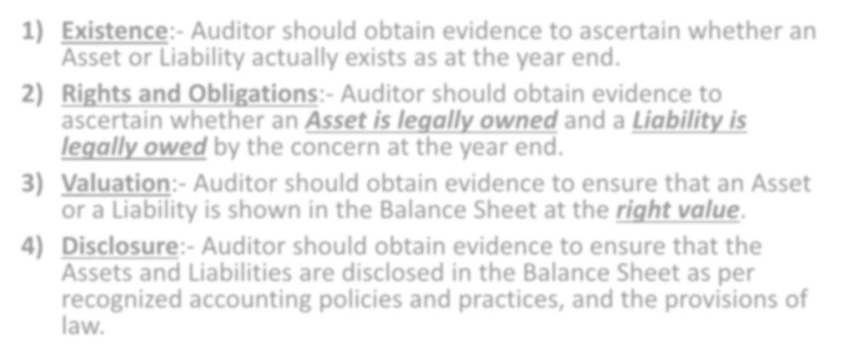

- Existence:- Auditor should obtain evidence to ascertain whether an Asset or Liability actually exists as at the year end.
- Rights and Obligations:- Auditor should obtain evidence to ascertain whether an Asset is legally owned and a Liability is legally owed by the concern at the year end.
- Valuation:- Auditor should obtain evidence to ensure that an Asset or a Liability is shown in the Balance Sheet at the right value.
- Disclosure:- Auditor should obtain evidence to ensure that the Assets and Liabilities are disclosed in the Balance Sheet as per recognized accounting policies and practices, and the provisions of law.



  - AUDIT EVIDENCE MUST BE

- Sufficient 2) Relevant 3) Reliable

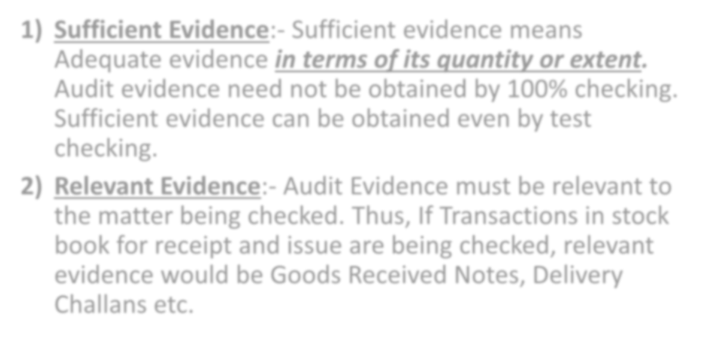

  - Sufficient Evidence:- Sufficient evidence means Adequate evidence in terms of its quantity or extent. Audit evidence need not be obtained by 100% checking. Sufficient evidence can be obtained even by test checking.
  - Relevant Evidence:- Audit Evidence must be relevant to the matter being checked. Thus, If Transactions in stock book for receipt and issue are being checked, relevant evidence would be Goods Received Notes, Delivery Challans etc.



  - Reliable Evidence:- No evidence can be 100% reliable or conclusive. It is said that audit evidence is normally persuasive (convincing or substantial) rather than conclusive in nature. Auditor must see whether the evidence obtained is reliable or not. Reliability of Audit evidence depends upon:-
- Its Source:- whether the evidence is Internal (e.g. Pay Rolls prepared by the concern itself) or External (e.g. Confirmation by Debtors); AND
- Its Nature:- whether the evidence is Verbal (e.g. Explanations from
client’s staff), Visual (e.g. Physical Verification of stock) or Documentary
(e.g. Supporting documents such as bills attached to vouchers).



  - Audit Procedures means the Steps taken to obtain Audit Evidence.
  - Audit Procedures can be classified basically into:-
- Compliance Procedures (regarding Internal Controls)
- Substantive Procedures (regarding Transactions
& Balances of Assets and Liabilities)

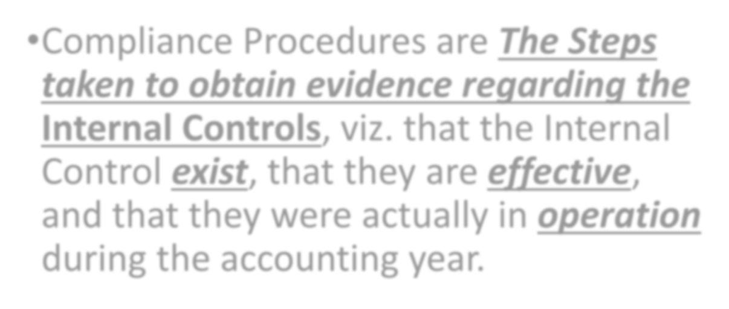

  - Compliance Procedures are The Steps taken to obtain evidence regarding the Internal Controls, viz. that the Internal Control exist, that they are effective, and that they were actually in operation during the accounting year.

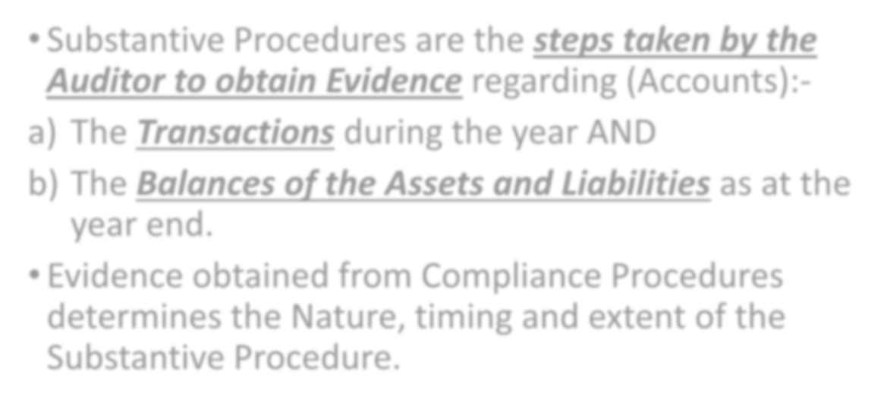

  - Substantive Procedures are the steps taken by the Auditor to obtain Evidence regarding (Accounts):-
  - The Transactions during the year AND
  - The Balances of the Assets and Liabilities as at the year end.

Evidence obtained from Compliance Procedures determines the Nature, timing and extent of the Substantive Procedure.

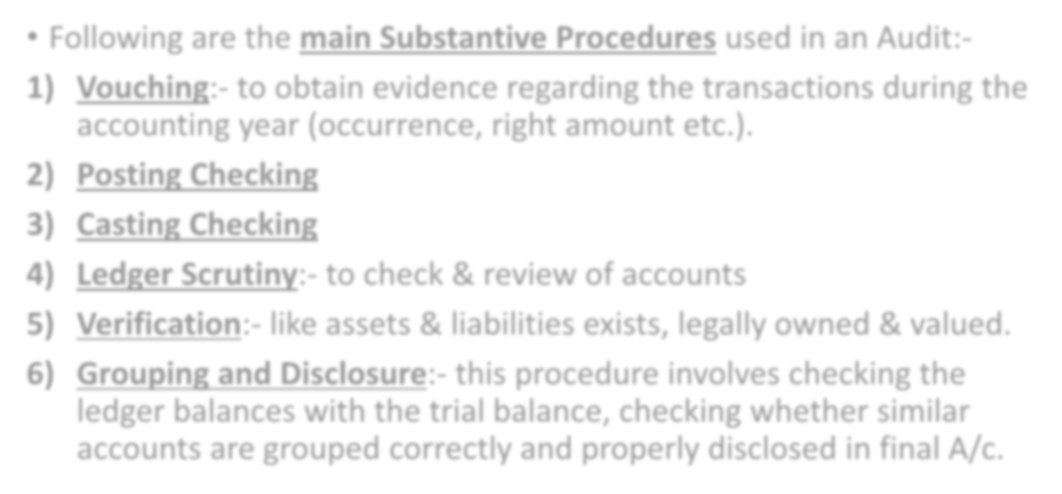

  - Following are the main Substantive Procedures used in an Audit:-
    - Vouching:- to obtain evidence regarding the transactions during the accounting year (occurrence, right amount etc.).

Posting Checking
    - Casting Checking
    - Ledger Scrutiny:- to check & review of accounts
    - Verification:- like assets & liabilities exists, legally owned & valued.
    - Grouping and Disclosure:- this procedure involves checking the ledger balances with the trial balance, checking whether similar accounts are grouped correctly and properly disclosed in final A/c.

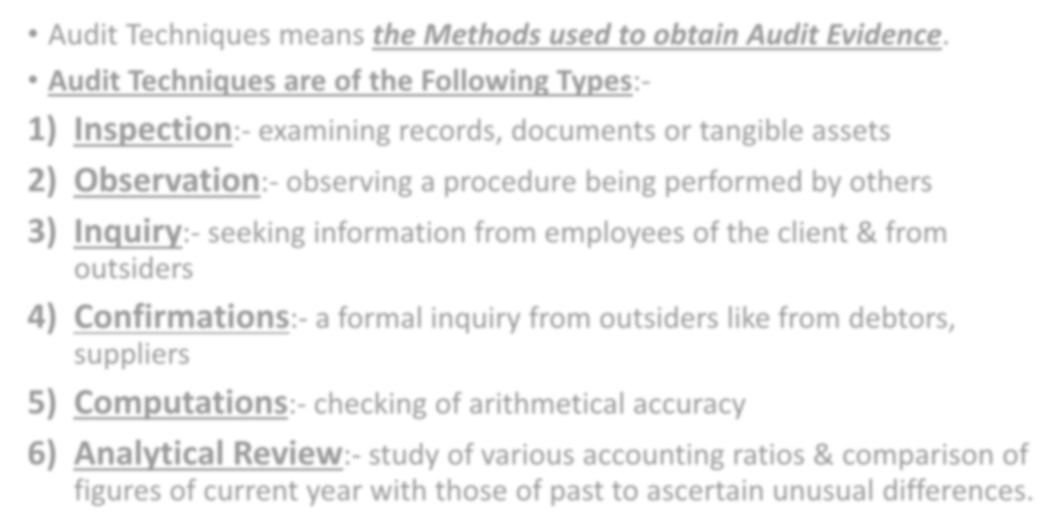

- Audit Techniques means the Methods used to obtain Audit Evidence.

Audit Techniques are of the Following Types:-
- Inspection:- examining records, documents or tangible assets
- Observation:- observing a procedure being performed by others
- Inquiry:- seeking information from employees of the client & from outsiders
- Confirmations:- a formal inquiry from outsiders like from debtors, suppliers
- Computations:- checking of arithmetical accuracy
- Analytical Review:- study of various accounting ratios & comparison of figures of current year with those of past to ascertain unusual differences.

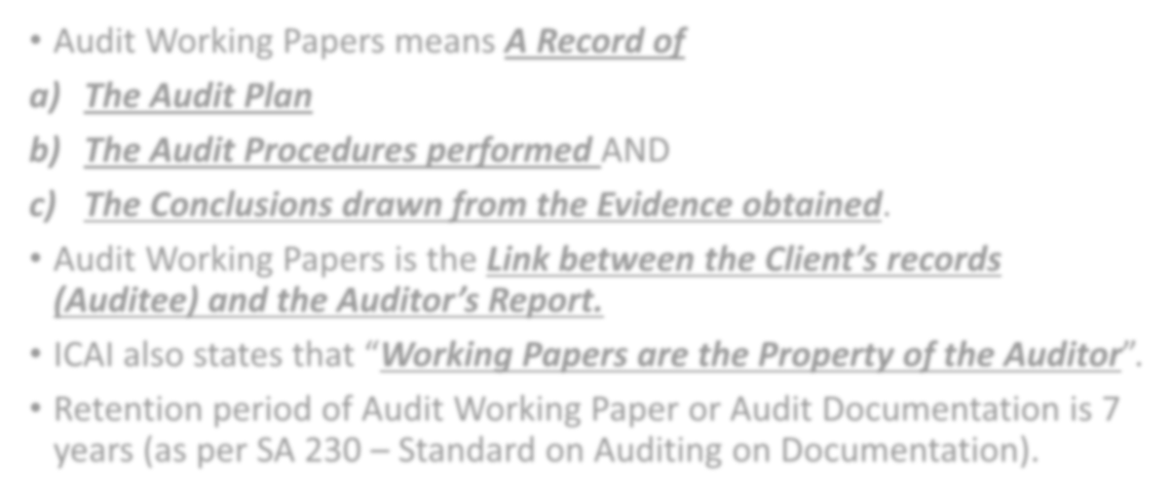

  - Audit Working Papers means A Record of
- The Audit Plan
- The Audit Procedures performed AND
- The Conclusions drawn from the Evidence obtained.
  - Audit Working Papers is the Link between the Client’s records (Auditee) and the Auditor’s Report.
  - ICAI also states that “Working Papers are the Property of the Auditor”.
  - Retention period of Audit Working Paper or Audit Documentation is 7 years (as per SA 230 – Standard on Auditing on Documentation).

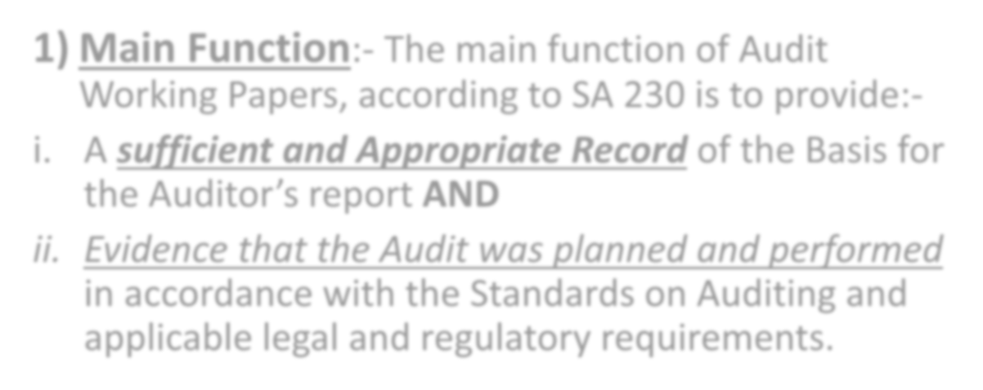

Main Function:- The main function of Audit Working Papers, according to SA 230 is to provide:-
- A sufficient and Appropriate Record of the Basis for

the Auditor’s report AND
- Evidence that the Audit was planned and performed in accordance with the Standards on Auditing and applicable legal and regulatory requirements.

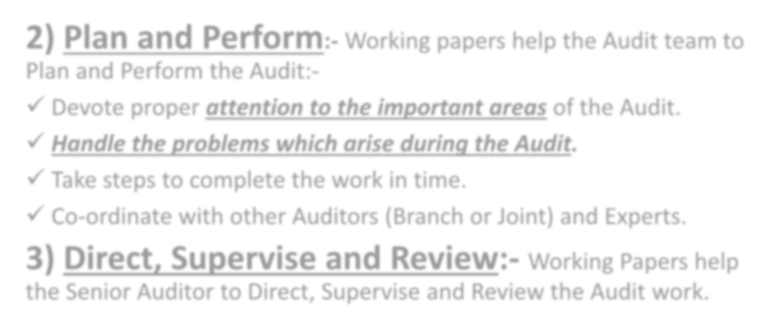

  - Plan and Perform:- Working papers help the Audit team to Plan and Perform the Audit:-
- Devote proper attention to the important areas of the Audit.
- Handle the problems which arise during the Audit.
- Take steps to complete the work in time.
- Co-ordinate with other Auditors (Branch or Joint) and Experts.
  - Direct, Supervise and Review:- Working Papers help the Senior Auditor to Direct, Supervise and Review the Audit work.



  - Record Evidence:- Working papers prove that –
- Audit was Conducted with due care and efficiency.
- Audit was properly planned.
- A Proper Audit Programme was prepared.
- Reliable Audit evidence was obtained through Vouching, Verification etc.
- The Accounting and Internal Control system was relied upon after due study and evaluation.
- The Audit Report was prepared on the basis of Sufficient Audit Evidence.

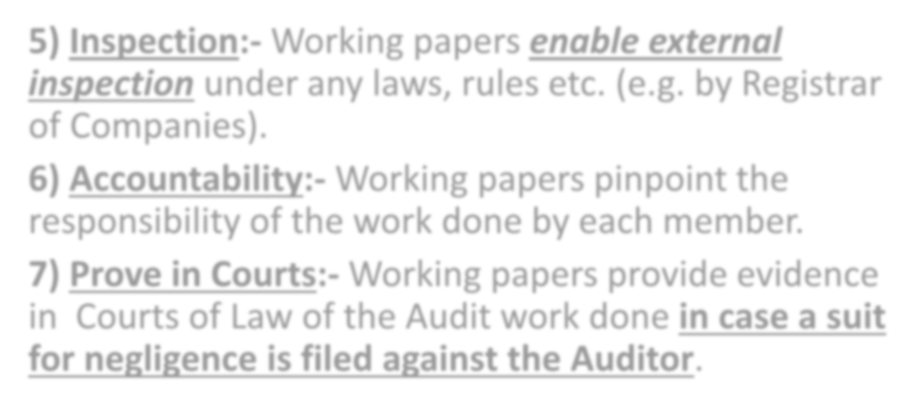

  - Inspection:- Working papers enable external inspection under any laws, rules etc. (e.g. by Registrar of Companies).

Accountability:- Working papers pinpoint the responsibility of the work done by each member.
  - Prove in Courts:- Working papers provide evidence in Courts of Law of the Audit work done in case a suit for negligence is filed against the Auditor.

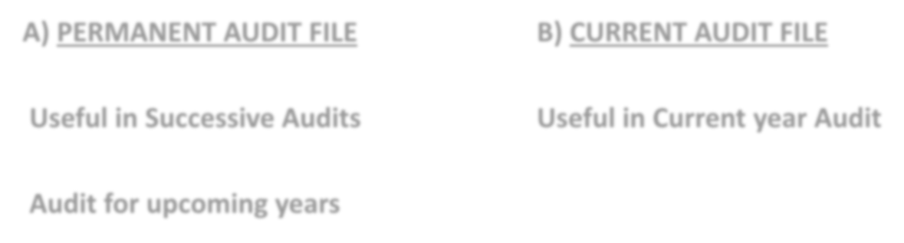AUDIT WORKING PAPERS SHOULD BE DIVIDED BETWEEN

A) PERMANENT AUDIT FILE B) CURRENT AUDIT FILE

Useful in Successive Audits Useful in Current year Audit

Audit for upcoming years



- A Permanent Audit File, which is useful in Successive Audits, contains the following details:-
- Memorandum and Articles of Association of the Company or the Partnership Deed case of a Firm, The Trust Deed in case of a Trust.
- Study and Evaluation of Internal Control System by way of Questionnaires, flow charts etc.
- Description of Accounting Policies and System.
- Copies of Audited Accounts of earlier years.
- Analysis of Ratios, Trends etc. in earlier years.
- Letters to management by the Auditor containing observations on earlier Audits.
- Communication with the previous Auditor and his reply.
- Notes on Discussions with the client in respect of –
- Nature of Business, Management, Organisation and Activities.
- Laws, Rules, Regulations etc. applicable to the client.



- A Current (Temporary) Audit File contains the following details pertaining to the Audit of the
Current Year:-
- Letter of Appointment for the Current year and its Acceptance.
- Documents obtained from the client before commencement of Audit. e.g. Organisation Chart, List of Authorised Officers, List of places of Business, List of Books, Internal Control Manual and Internal Auditor’s reports, List of Products, List of Relatives etc.
- Audit Plan.
- Audit Programme.
- Analysis of Transactions and Balances.
- Evidence of review and supervision of the work of the assistants.
- Copies of Correspondence with the Joint or Branch Auditors and experts.
- Extracts of Important Resolutions from Minute Books.
- Letters of Confirmation from Parties, Banks, Lenders etc.
- Certificate (representations) from management regarding Closing stock, Verification of
Fixed Assets, Value of Current Assets and so on.

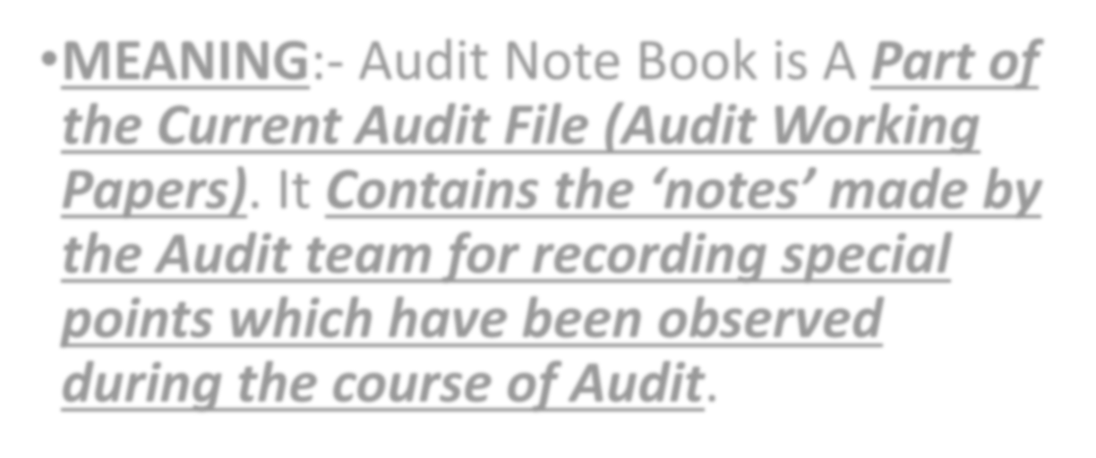

  - MEANING:- Audit Note Book is A Part of the Current Audit File (Audit Working Papers). It Contains the ‘notes’ made by the Audit team for recording special points which have been observed during the course of Audit.

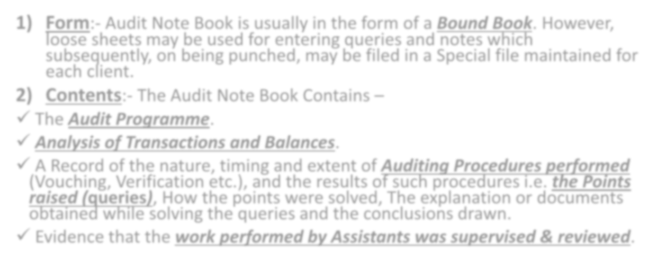

- Form:- Audit Note Book is usually in the form of a Bound Book. However, loose sheets may be used for entering queries and notes which subsequently, on being punched, may be filed in a Special file maintained for each client.
- Contents:- The Audit Note Book Contains –
- The Audit Programme.
- Analysis of Transactions and Balances.
- A Record of the nature, timing and extent of Auditing Procedures performed (Vouching, Verification etc.), and the results of such procedures i.e. the Points raised (queries), How the points were solved, The explanation or documents obtained while solving the queries and the conclusions drawn.
- Evidence that the work performed by Assistants was supervised & reviewed.

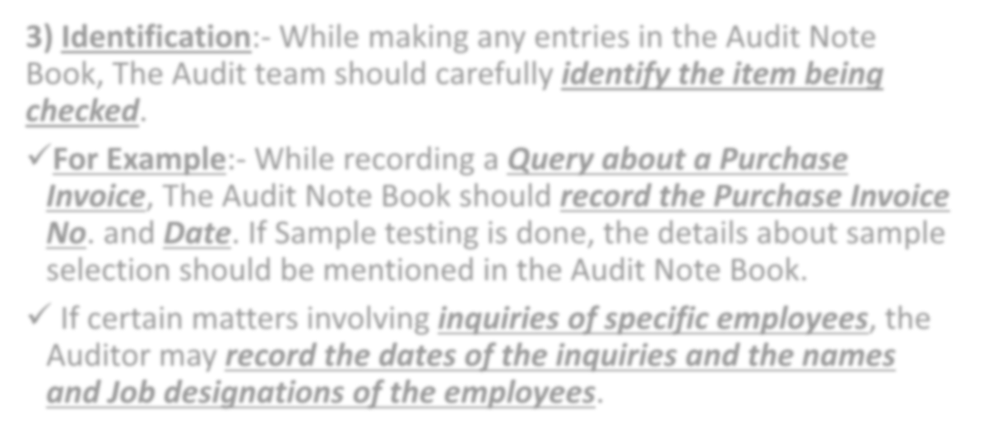

- Identification:- While making any entries in the Audit Note Book, The Audit team should carefully identify the item being checked.
- For Example:- While recording a Query about a Purchase Invoice, The Audit Note Book should record the Purchase Invoice No. and Date. If Sample testing is done, the details about sample selection should be mentioned in the Audit Note Book.
- If certain matters involving inquiries of specific employees, the Auditor may record the dates of the inquiries and the names and Job designations of the employees.

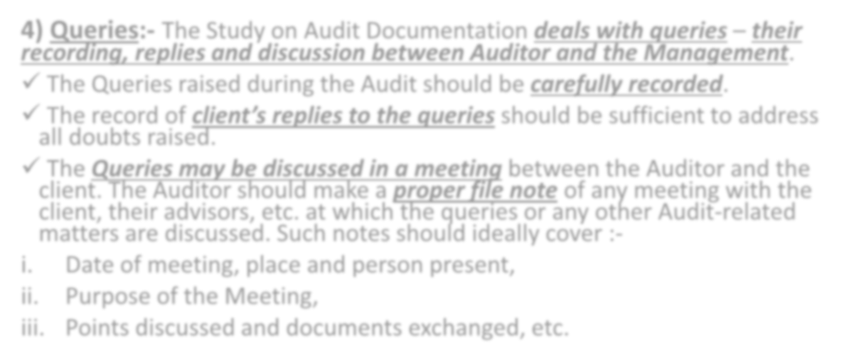

- Queries:- The Study on Audit Documentation deals with queries – their recording, replies and discussion between Auditor and the Management.
- The Queries raised during the Audit should be carefully recorded.
- The record of client’s replies to the queries should be sufficient to address all doubts raised.
- The Queries may be discussed in a meeting between the Auditor and the client. The Auditor should make a proper file note of any meeting with the client, their advisors, etc. at which the queries or any other Audit-related matters are discussed. Such notes should ideally cover :-
- Date of meeting, place and person present,
- Purpose of the Meeting,
- Points discussed and documents exchanged, etc.

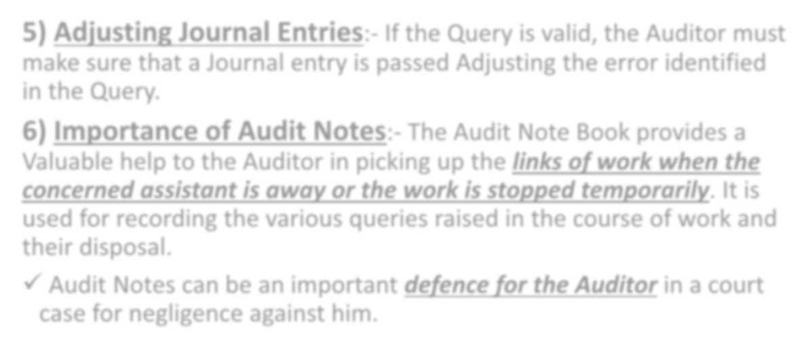

- Adjusting Journal Entries:- If the Query is valid, the Auditor must make sure that a Journal entry is passed Adjusting the error identified in the Query.
- Importance of Audit Notes:- The Audit Note Book provides a Valuable help to the Auditor in picking up the links of work when the concerned assistant is away or the work is stopped temporarily. It is used for recording the various queries raised in the course of work and their disposal.
- Audit Notes can be an important defence for the Auditor in a court case for negligence against him.

