Unit 3 Corporate Governance and Shareholders Rights
Contents to be covered in Unit 3
- Rights of shareholders
- Challenges of exercising shareholders rights
- Corporate Governance and Related Party Transactions
- Role of Investor Association in securing shareholders rights
- Role of Institutional investors in Corporate Governance
Who is a shareholder?
- A shareholder, also referred to as a stockholder, is a person, company, or institution that owns at least one share of a company’s stock, which is known as equity.
- Because shareholders are essentially owners in a company, they reap the benefits of a business’ success. These rewards come in the form of increased stock valuations, or as financial profits distributed as dividends.
- Conversely, when a company loses money, the share price invariably drops, which can cause shareholders to lose money, or suffer declines in their portfolios’ value

Common Shareholders’ Main Rights
- Voting Power on Major Issues. Voting power includes electing directors and proposals for fundamental changes affecting the company such as mergers or liquidation.
- Ownership in a Portion of the Company. When business thrives, common shareholders own a piece of something that has value. Common shareholders have a claim on a portion of the assets owned by the company. As these assets generate profits and as the profits are reinvested in additional assets, shareholders see a return as the value of their shares increases as stock prices rise.
- The Right to Transfer Ownership. The right to transfer ownership means shareholders are allowed to trade their stock on an exchange. The right to transfer ownership might seem mundane, but the liquidity provided by stock exchanges is important. ﻿
- An Entitlement to Dividends. Along with a claim on assets, investors also receive a claim to any profits the company pays out in the form of a dividend. Management of a company essentially has two options with profits: they can be reinvested back into the firm (thus, one hopes, increasing the company’s overall value) or paid out in the form of a dividend.
- Opportunity to Inspect Corporate Books and Records. Shareholders have the right to examine basic documents such as company bylaws and minutes of board meetings
- The Right to Sue for Wrongful Acts. Suing a company typically takes the form of a shareholder class-action lawsuit.﻿ For example, Worldcom faced a firestorm of shareholder class-action suits in 2002 when it was discovered that the company had grossly overstated earnings giving shareholders and investors an erroneous view of its financial health.
- Pre-Emptive Right
- All the stakeholders shall have the right to subscribe to the capital stock of the company, unless the same is denied in Articles of Incorporation.
- Minority shareholders Protection:
- In case of oppression or mismanagement of the affairs of the company by the
- Majority shareholders, minority shareholders enjoy protection and right to relief from oppression
Additional rights of shareholder
- Additional rights of the shareholders towards the company are agreed to in the shareholders agreement.
- Shareholders’ agreements(SHA) are generally signed by all shareholders of the company at the time the agreement is entered into, and are entered into for the benefit of the members.
- As a result, these agreements are not regulated by the Act, and there is therefore no legally prescribed procedure to alter their provisions. Instead, the shareholders’ agreement will usually provide that all members who are a party to the document must give their consent to amend it.
Matters that are usually covered in a shareholders’ agreement
- dividend policy;
- which decisions by the directors require shareholders’ consent;
- provisions for protecting the minority shareholders;
- restrictive covenants (i.e. what a shareholder is prevented from doing after ceasing to be a shareholder of the company);
- issuing and transferring shares;
- rights and obligations that are specific to certain directors (for example, the personal right to remain appointed as a director).
Additional rights as per SHA
- The right to be employed by the company
- Right to confidentiality in respect of information provided by a shareholder
- Detailed rights and obligations protecting the interests of minorities
- ‘drag along’ and ‘tag along’ rights in the event of a proposed sale
- Termination,forced sale and other exit provisions
Tag along’ rights
Tag-along (piggy-back) rights
- In the case of a voluntary transfer, the selling shareholder must ensure the terms of the offer to purchase its shares is also extended to the other shareholders in proportion to their respective share ownership. Tag-along rights exist to protect minority shareholders so, if a majority shareholder sells its shares, it gives the other shareholders the right to join the transaction.
Thus, piggy-back rights protect minority shareholders by giving them the right, but not the obligation, to sell shares together with a majority or stronger shareholder. This protects minority shareholders from being forced to accept a deal on lesser terms or being forced to remain a shareholder in the company after a majority sale
Drag along’ rights
- Drag-along rights
- Drag-along rights enable a majority shareholder to force minority shareholders to join in the sale of a company. The shareholder doing the dragging must give minority shareholders the same price, terms and conditions as any other seller.
- A company merger or acquisition normally triggers a drag-along right because buyers usually seek complete control of a company. Drag-along rights help to eliminate minority owners and allows for the sale of 100% of a company's securities to a potential buyer. Drag-along rights are meant to protect the majority shareholder. However, drag-along rights also benefit minority shareholders because they require the price, terms, and conditions for the sale of shares to be identical for all shareholders, which can enable minority shareholders to realise sales terms that may otherwise be unattainable.

Challenges of exercising sharehodlers rights
- One share-one vote
- Confidential voting
- Majority requirements
- Authorisation of stock
- Anti-takeover provisions
- Shareholder access to the board
- Under OSOV those with the most invested in the company have the most control, and as they benefit from the success and suffer from the loss they should be able to utilise their engagement correctly. OSOV is the most reliable method to make this possible, largely because if an individual wishes to use their vote they can do in a fair manner, ensuring that their vote is counted. However there is clear argument that those who are “interested primarily in monetary returns” should have less of a right to vote than others.
- Equitable treatment to shareholders
- Insider trading
- Information asymmetry between dominant shareholders and minority shareholders
- Shareholders need to be informed of the rules & voting procedures that govern general shareholder meetings
- Transactions should occur at transparent manner
- Lack of awareness of the rights, leads towards passive approach towards voting by the small shareholders
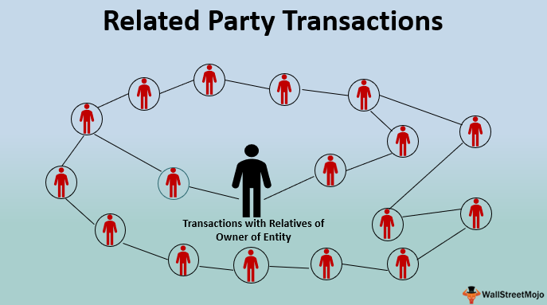



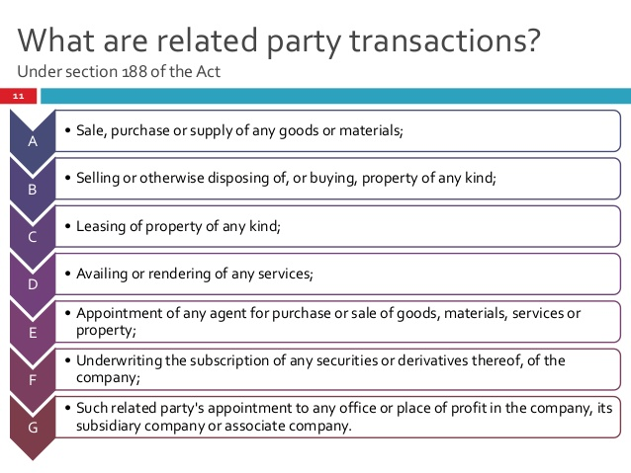
Types of RPT’s
- Financial provisions through provisions of loans, guarantees and collateral
- Asset sales and purchases between related parties
- The sale, purchase or supply of any goods, materials or services in ordinary course of business
- Bailouts
Abusive RPT’s
- RPTs are neither intrinsically good or bad. They can have legitime purposes in promoting the company’s own long-term value creation and success.
- But they can also be subject to abuse, by executive management or controlling owners, in a way that can negatively affect the company and its minority shareholders and its creditors
- OECD reports on RPT guide to identify abusive RPT’s
Criteria for assessing an Abusive RPT
- Who are the parties on either side of the transaction
- What asset is being transferred
- How is the asset priced?
- What compensation is involved?
- Are any of the parties in a conflict of interest?
- Why is the asset being transferred? Why now
Outcome of an Abusive RPT
- Damage to shareholders value
- Tarnish the company’s reputation with investors,both domestic and foreign,
- Undermine investor confidence in the integrity of the financial market as a whole
LEGAL FRAMEWWORK GOVERNING RPT’S IN INDIA
- Companies Act
- Accounting Standards
- Income Tax Act 1961
- Listing Agreement
- SEBI
Related parties
- A director or his relative (Relative means a member of the same HUF, husband, wife, father, step father, mother, step mother, son, step son, son’s wife, daughter, daughter’s husband, brother, step brother, sister, step sister)
- Key managerial personnel or his relative
- A firm in which a director, manager, or relative is a partner
- A private company in which a director, manager, or relative is a member or director
- A public company in which a director or manager is a director and holds along with his relatives more than 2% of its paid-up capital
- Any body corporate whose board of directors, MD or manager is required to act in accordance with the advice, directions or instructions of a director or manager (NA in cases when these directions are followed in professional capacity)
- Any person on whose advice, directions or instructions a director or manager is required to act (NA when this is done in professional capacity)
- Holding, Subsidiary or Associate of such company
How does SEBI govern related parties and related party transactions?
- The SEBI Clause 49 also states certain regulatory requirements for related party transactions. It defines related party transaction as a transaction which includes transfer of resources/services/obligation
- It includes close family members of directors or key managerial personnel, private company in which directors or key managerial personnel plus their relatives have control or significant influence
Every related party transaction which is material has to be approved by the shareholders by passing a special resolution and all related parties shall not be allowed to vote on such resolutions
Important Pointers
- The turnover or net worth for the purpose of calculation under Companies Rules 2014 shall be based on the audited financial statements
- If the transaction is in the ordinary course of business and done on an arm’s length basis it shall not require the approval of the board or the company.
- No member shall vote on the special resolution if such member is a related party.
- Details of every contract entered into shall find its reference in the Board’s report along with justification about the same
- Ratification of the transaction may be done by the Board or the shareholders within three months. If the same is not done, then the contract will be voidable at the option of the Board.
- If the contract is with anyone related to the director, or is authorized by any other director, the directors concerned shall make good to the company for losses if any caused to the company.
- Penalties outlined under Sec 188 are:
- Listed Company: Imprisonment upto 1 year; Fine ranging from Rs. 25000 to Rs. 500000 or both
- Any other company: Fine ranging from Rs. 25000 to Rs. 500000
Governance and disclosure practices to mitigate the risks of abusive related party transactions
- 1. Formal Board policies with regard to the monitoring of RPTs:
- 2. The board should follow a formalized process to evaluate the alignment of the RPT with the company’s interests and disclose it. This should among others include an overview of the factors they take into consideration when determining whether to approve a RTP or not
- 3. Policy on conflicts of interest
- 4.It should be mandatory for companies to disclose their definition of what constitutes a material related party transaction
- 5. Formal valuation of related party transactions
- 6. Role of the Board:
- 7. Role of shareholders in the approval of material RPTs:
- 8. Advice from independent experts
- 9. Companies should disclose their procedures to ensure that interested shareholders in a related party transaction cannot exercise their voting rights on the respective transaction
- 10. Companies should provide shareholders with full disclosure on the details of each new RPT
Role of Investor Education in Securing Shareholders Rights
- The concept of investor protection has to be looked at from different angles taking into account the requirements of various kinds of investors .
- (i) investors in equity
- (ii) large institutional investors
- (iii) Foreign Investors
- (iv) investors in debentures and
- (v) small investors/deposit holders etc
Rights of Investor as a individual shareholders
- To receive the share certificates, on allotment or transfer (if opted for transaction in physical mode) as the case may be, in due time
- - To receive copies of the Annual Report containing the Balance Sheet, the Profit & Loss account and the Auditor‟s Report
- - To participate and vote in general meetings either personally or through proxy
- - To receive dividends in due time once approved in general meetings
- To receive corporate benefits like rights, bonus, etc. once approved
- - To apply to Company Law Board (CLB) to call or direct the calling of an Annual General Meeting
- - To inspect the minute books of the general meetings and to receive copies thereof
- - To proceed against the company by way of civil or criminal proceedings
- - To apply for the winding up of the company
- - To receive the residual proceeds
Rights of Investors as a group shareholders
- To requisition an Extra-ordinary General meeting –
- To demand a poll on any resolution –
- To apply to CLB to investigate into the affairs of the company –
- To apply to CLB for relief in cases of oppression and/or mismanagement
- To receive interest on redemption of debentures in due time
- To receive a copy of the trust deed on request
- To apply for winding up of the company if the company fails to pay its debts
- To approach the debenture trustee with your grievance
Investors Grievance and Redressal Mechanism
- – The general grievances of the investors have against companies can be listed as under:
-Furnishing inadequate information or making misrepresentation in prospectus, application forms, advertisements and rights offer documents - Delay/ non-receipt of refund orders, allotment letters and share certificates/ debenture certificates/ bonds - Delay/ non-receipt of share certificate/ debenture certificates after transfer - Delay in listing of securities with stock exchanges
- Delay/ non-receipt of share certificate/ bonds/ debentures after endorsement of part payment/ call money –
- Delay/ non-receipt of share certificate/ bonds/ debentures after sub division or consolidation
- - Delay/ non-receipt of letter of offer of rights issue –
- Delay/ non-receipt of bonus shares/right shares –
- Delay/ non-receipt of notices for meetings/ annual reports
- - Delay/ non-receipt of interest warrants and dividend warrants –
- Fixing unduly high premium on shares - Difficulties in sending odd lots - Obtaining undue benefits by company insiders - Delay/ default in payment of interest and repayment of deposits
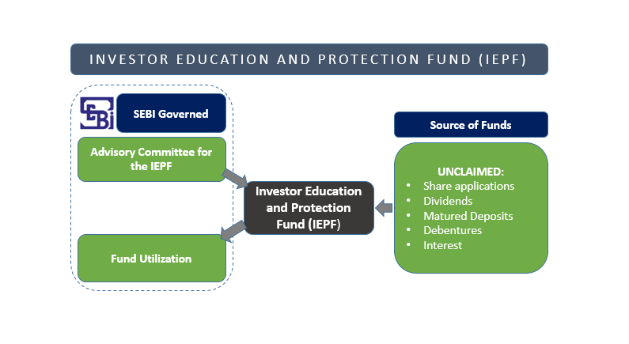
Investors Education and Protection Fund
- The investors associations registered with SEBI, the stock exchanges and professional bodies also conduct investor education programmes from time to time to appraise the investors of the changes in the law and regulations and the methods of protecting themselves against malpractices and delays cropping up in the market. This is further supplemented by the journals and magazines in the field of corporate investment as well as newspaper articles which highlight the newly emerging problems, pitfalls and the methods to protect.
Investor Education and Protection Fund (Awareness and Protection of investors) Rules, 2001 (IEPF Rules)
- The activities related to investors education, awareness and protection for which the financial sanction can be provided under IEPF.
- (i) Activities stipulated under Rules - Education programme through Media
- - Organizing Seminars - Proposals for registration of Voluntary Associations or Institution or other organizations engaged in Investor Education and Protection activities –
- Proposals for projects for Investors and Protection including research activities and proposals for financing such projects
- - Coordinating with institutions engaged in Investor Education, awareness and Protection activities
- IEPF Website Launched by Ministry of Corporate Affairs -www.iepf.gov.in
Role of Investors Association in Securing Shareholders Rights
- AWOKE INDIA FOUNDATION
- BHOPAL STOCK INVESTORS ASSOCIATION
- CITIZENS AWARENESS GROUP
- CONSUMER GUIDANCE SOCIETY OF INDIA
- FEDERATION OF CONSUMER ASSOCIATIONS, WEST BENGAL
- INVESTOR EDUCATION AND WELFARE ASSOCIATION
- INVESTORS GRIEVANCES FORUM
- INTERACT FOUNDATION
- THE BOMBAY SHAREHOLDERS’ ASSOCIATION
Role of Institutional Investors in Corporate Governance
- Institutional investors are financial institutions that accept funds from third parties for investment in their name but on such parties behalf.
- They include pension funds,mutual funds and insurance companies
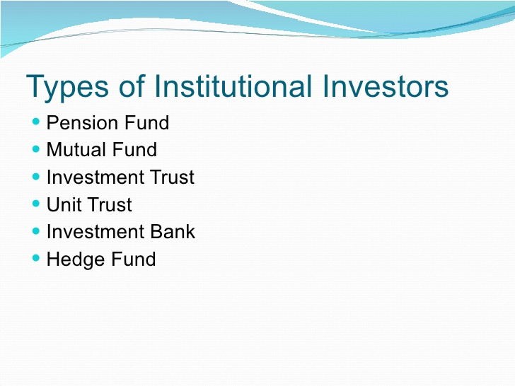
Responsibilities of Institutional shareholders
- Holding additional meetings with management specifically to discuss the shareholders concerns.
- Meeting with the chairman,senior independent director or with all independent directors
- Making a public statement in advance of the AGM or an EGM
- Submitting resolutions at shareholders meetings
Tools used by Institutional investors
- One to one meetings
- Voting
- Focus lists
- Corporate governance rating system

OECD principles of corporate governance for Institutional Investors
- Principle1.Institutional investors should publicly disclose their policy on how they will discharge their stewardship responsibilities
- Principle 2. They should have a policy on managing conflict of interest in relation to stewardship which should be publicly disclosed
- Principle 3.Institutional investors should monitor their investee companies
- Principle 4.Institutional investors should establish clear guidelines on when and how they will escalate their stewardship activities.
- Principle 5.Institutional investors should be willing to act collectively with other investors where appropriate
- Principle 6.Institutional Investors should have a clear policy on voting and disclosure of voting activity
- Principle 7.Institutional investors should report periodically on their stewardship and voting activities.
- 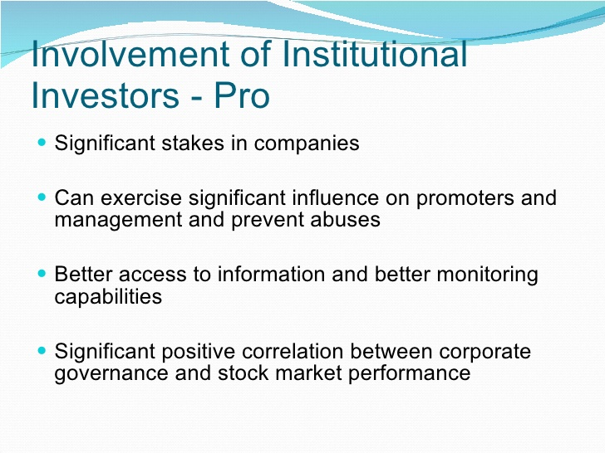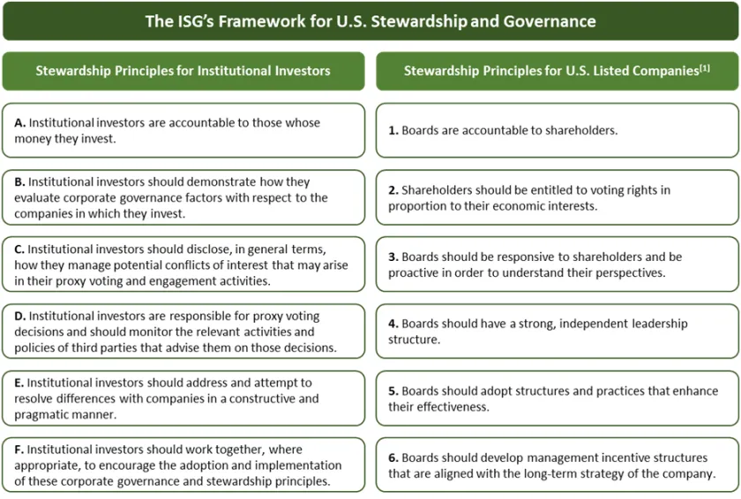
Barriers to effective governance by institutional investors
- a) business relationships of investors with firms in which they invest
- b) extensive government regulations that constrain the activities of these investors
c) limitations on their ability to process the information required to monitor firms
Overcoming challenges by Institutional Investors
- Institutional investors are dominant market players, but it is difficult to fit them into any particular category. This poses a challenge for regulators, who must take into account all the many different ways institutional investors operate, and interact, with the capital markets.
It is clear, however, that professionally-managed institutions can help ensure that our capital markets function as engines for economic growth. Institutional investors are known to improve price discovery, increase allocative efficiency, and promote management accountability. They aggregate the capital that businesses need to grow, and provide trading markets with liquidity – the lifeblood of our capital markets
- Institutional investors also have an important role in monitoring corporate governance issues. In recent years, these issues have included, among others, majority voting, splitting the Chairman and CEO roles, and focusing on the quality and diversity of Boards of Directors, as well as compensation structures and concerns about the runaway growth in executive pay.
Clearly, institutional investors have a great deal of power in the capital markets. And, as Franklin Delano Roosevelt wrote, on another April night in Georgia – “great power involves great responsibility.” The responsibility of institutional investors stems, in large part, from their stewardship of assets that belong to others

