Module 1
Introduction To Fixed Income Markets

Introduction to Fixed Income securities
Fixed-income securities are debt instruments issued by a government, corporation or other entity to finance and expand their operations. They provide investors a return in the form of fixed periodic payments and the eventual return of principal at maturity. These debt instruments comprise ways to achieve a diversified portfolio. For many investors, particularly retirees, fixed-income investments are a secure, low-risk way to generate a steady flow of income. In most cases, as long as they’re held to maturity, these types of debt instruments will provide a guaranteed return on your investment because the payments of fixed-income securities are known in advance.
Fixed-Income securities are debt instruments that pay a fixed amount of interest, in the form of coupon payments, to investors. The interest payments are commonly distributed semi annually, and the principal is returned to the investor at maturity. Bonds are the most common form of fixed-income securities. The face value is the amount the investor will receive when the bond matures.
Fixed income securities yield guaranteed returns on investments. They act as a liability for the organisation launching them in the market. Returns on fixed-income investments are generated periodically, and the interest payable on these securities remain constant, irrespective of market fluctuations.
The final value of the fixed income security at the time of maturity is calculated before it is issued. It is made known to the investor at the time of investment. This type of market investment tool is a popular choice for individuals who do not want to be exposed to risks and instead want secure returns on their investment, with additional yields.
Bonds are assigned different credit ratings based on the financial viability of the issuer. Credit ratings are part of a grading system performed by credit-rating agencies. These agencies measure the creditworthiness of corporate and government bonds and the entity's ability to repay these loans. Credit ratings are helpful to investors because they define the risks involved in investing.
Examples of fixed income securities:
Issued by government : Treasury Bills, Cash Management Bills, Government bonds, State Developmental Loans, Municipal Bonds
Issued by corporates: Certificate of Deposit (CD), Commercial Power (CP), Debentures (NCD)

Advantages and Disadvantages of Fixed-Income Securities
Advantages
- Fixed-income securities provide steady interest income to investors throughout the life of the bond
- Fixed-income securities are rated by credit rating agencies
- Fixed-income securities usually have less price volatility than stocks
- Treasury fixed-income securities are backed by the full faith and credit of the issuing government
Disadvantages
- The issuer can default on making the interest payments or paying back the principal
- Fixed-income securities typically have a lower rate of return than many other investments including stocks
- Inflation risk can be an issue if prices rise by a faster rate than the interest rate on the fixed-income security
- Market interest rates may rise higher than the rate on a fixed-income security
Investment perspective
Fixed income bonds are ideal for individuals looking for the safest tools to invest. People wary of stock market fluctuations and looking for stable investments to spend their hard-earned money should opt for Mutual Funds dealing in fixed income securities.
It can also be chosen by an avid investor looking to earn secure returns, as well as aiming to diversify his/her portfolio. Such schemes ensure a person has a stable flow of dividend during market downswing when other assets of substantially higher values do not yield adequate returns.
The older section of the society can also choose such securities while looking for alternative sources of investing. Most types of fixed income securities fulfil their essential requirement criteria of low risk and stable returns.
Capital gains under fixed income securities are subject to taxation as per the Income Tax Act of India, 1963. 20% deduction (after adjustments made for indexation) is made in case of long term gains, while short term capital gains are taxable as per the income of the investor.
Mutual Funds investing in fixed income bonds tend to be actively managed to ensure highest returns for investors with guaranteed stability.
The investment strategies of such Mutual Funds differ according to their respective maturity period. In case of a short-term investment scheme, money market instruments and debt funds are targeted from the list of fixed income securities. ETFs are optimal for a longer tenure.These funds are generally highly liquid, satisfying the investor's cash requirements as and when demanded.

The debt markets are an important source of liquidity. The instruments act as collaterals for borrowing and lending transactions. They provide huge funds but for a short period. Their growth has provided an alternative source of raising finances in comparison to banking channel.

Debt markets are of central importance to economic activity. The bond market is vital for economic activity because it is the market where interest rates are determined. Interest rates are important on a personal level, because they guide our decisions to save and to finance major purchases (such as houses, cars, and appliances, to give a few examples). From a macroeconomic standpoint, interest rates have an impact on consumer spending and on business investment.

Difference between equity and debt : equity represents ownership of the company but debt represents the obligation of the company. Equity is rewarded by dividends, which represents the participation in profits of the company but debt is made attractive by the interest rates known as coupon rates. Equity is not repayable by the company to shareholders unless winding up of company, whereas debt is repayable or redeemable after its maturity let known since inception.

Growth of Debt Markets
The first borrowing was made in 1867 for the purposes of railway construction. Apart from that a rise in public debt was also encountered during the first world war. Interest rate of bonds varied in India from time to time. In 1857 it came down to 5% and gradually to 4% in 1871. Traditionally debt markets have been used and overused by governments for funding the deficits.
In the post independence period the public sector banks and financial institutions, which account for 75-80% of financial intermediation, contributed significantly to the development process, especially by way of captive investments in government securities and substantial lending to the public sector entities. Large statutory pre-emptions and borrowing from the RBI enabled the government to meet its borrowing requirements to finance large fiscal deficits. Interest rates on government debt were administered and kept below the market level.
In the early 1980s, however, state-owned non-financial enterprises were permitted to access financial markets for their financing needs, mainly through bonds by way of special borrowing allocations. These bonds were essentially guaranteed by governments and generally funded by government-owned financial institutions and provident funds. Special borrowing allocations were discontinued in the mid-1990s.
The need for the funding of long term infrastructure development for economic development was felt by the government. Thus was a need to raise increased amounts from the market. Also it was felt that financial institutions and corporations should be given an opportunity to raise funds from a competitive market without any specific borrowing allocations and dependence on commercial banks.
However, with economic liberalization ushered in the 1990s, the financial markets also started undergoing changes. The private sector started becoming active with huge inflows of FDIs and FIIs. Simultaneously the technological revolution was catching up in India. Towards the end of the decade, settlement systems ,national financial networks were put in place by RBI. The FRBM Act 2003 restricted government borrowings. This helped RBI in better inflation control as govt debt was manageable and provided private sector more room to participate. With advent and development of CCIL in early part of 2000 decade, settlements became seamless with exchanges giving counter guarantees.
The government securities market is the overwhelming part of the overall debt market in terms of both outstanding securities and trading volumes. Nearly 80% of the INR 7,500 billion of outstanding debt securities as at end-March 2001 was accounted for by government securities. Their yields serve as a benchmark for the financial markets.
The system of primary dealers (PDs) in government securities was instituted in the mid-1990s, adapting to India’s situation similar structures in advanced financial markets to widen and deepen the markets. Primary dealers have been playing an important role in the absorption of government securities in primary issues and providing two-way quotes in secondary markets.
With extensive growth of RTGS and NEFT transactions increased hugely. Slowly sophisticated instruments like derivatives, swaps, IRS, FRA, started being traded in exchanges.
The pandemic had posted a lot of challenges but the debt market is showing signs of improvement. A 75% rise in bond issuing is recorded in H1 FY 2021. After few quarters of net outflows, debt mutual funds are showing net inflows. Corporate bond outstanding in Sep 2020 was 34.1 lakh crore which was 33% of systemic bank credit, against 24% in Sep 2010.
Features of Fixed Income Markets

Evolution an recent developments in the last decade:
In a growing economy, increasing debt levels are common. The growth is being driven by capital investments primarily by the government, followed by private investments. There has been huge growth of corporate debt and government bond outstanding.
According to the data compiled by Moneycontrol, the outstanding amount of government securities (G-Secs) and corporate bonds has seen a growth of over 165 % in the last 10 years.

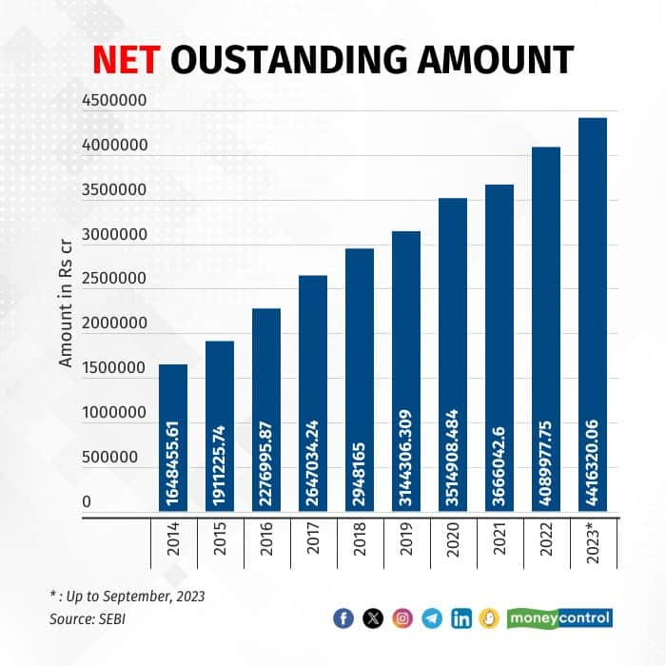

In the last 10 years, regulators have announced various reforms to increase retail participation in the bond market, such as the RBI Retail Direct Scheme, a reduction in the minimum investment in corporate bonds from Rs 10 lakh to Rs 1 lakh, permission to sell G-Secs by online bond platforms to retail investors, and online bond platform.
To enhance retail participation the RBI Retail Direct scheme was announced by the apex bank on February 5, 2021, to encourage retail participation in the G-Secs market.
The RBI announcement said that as part of continuing efforts to increase retail participation in G-Secs and to improve ease of access, it had decided to move beyond the aggregator model and provide retail investors online access to the G-Secs market — both primary and secondary — along with the facility to open their gilt securities account (‘Retail Direct’) with the RBI.
According to the RBI data, the total number of registrations stood at 114,715 as of November 20, 2023, since inception. The data further shows that most investment done by retail investors is in Treasury bills (T-bills), at Rs 2,135.67 crore since inception.
Further, several initiatives, such as the introduction of non-competitive bidding in primary auctions, permitting stock exchanges to act as aggregators/facilitators for retail investors, and allowing the odd-lot segment in the NDS-OM secondary market, were also taken over the years.
SEBI, in a circular on October 28, 2022, announced the reduction in the face value of debt security and non-convertible redeemable preference shares issued on a private placement basis to Rs 1 lakh from the current Rs 10 lakh with effect from January 1, 2023. If the face value and trading lot are reduced, more investors can participate, which in turn will enhance liquidity in the corporate bond market.
In 2023 SEBI put a cap on the International Securities Identification Number (ISIN) for debt securities issued on a private placement basis maturing in a financial year to boost liquidity in the corporate bond market. SEBI said that a maximum of 14 ISINs maturing in any financial year will be allowed for an issuer of debt securities.
As per SEBI data, corporate bonds outstanding in 2014 were Rs 16.49 lakh crore, which increased to Rs 44.16 lakh crore in 2023.
Similarly, government borrowings through G-Secs increased to Rs 15.43 lakh crore in FY24 from Rs 5.79 lakh crore in FY14.
Between 2014 and 2023, the yield on the 10-year government bond moved in the range of approximately 4.96 % to 9.11 %. Currently, the 10-year bond yield is around 7.018 %.
With the advent of new technologies, mobile penetration, social media influence, and government and regulator support, retail participation in debt markets has been increasing phenomenally. The accessibility of mutual funds for small investors has also increased.
Features of fixed income markets
  - Huge in size
  - Government is the dominant player
  - RBI is the regulator of fixed income markets in India
  - Instruments are debt in nature, implying issuer have the obligation of repaying the capital
  - All instruments have fixed maturity and available for trading only till maturity.
  - Instruments have fixed interest rates associated with them.
  - Objective of issuance of the instruments vary from economic development and liquidity adjustment to business expansion.
  - Macroeconomic fundamentals like inflation, interest rates, etc affect the market.
  - RBI uses this market for controlling inflation and liquidity.
  - High liquidity
  - Collateral free borrowing
  - Statutory requirements of banks may be met through these markets
  - Tenure of market instruments extend from 1 day to 50 years.
Importance of Fixed Income Markets
- Provides liquidity to banks, government
- Provides alternative investment destination and portfolio diversification
- Indicator of anticipated inflation
- Stable income source
- Largest investment destination for pension funds and insurance companies
- Extremely long duration investment
- Source of raising funds for corporates
- SLR requirements of banks may be met through Fixed Income Markets
Benefits of fixed income products
- Debentures Through the debentures the private corporations are able to raise funds without diluting their stakeholding.In this manner the investors benefit by getting a regular interest and avoiding risk so the stability of return plus assurance of interest and getting back the funds back is an advantage.
- Bonds. Bonds are issued by the government for a longer priod, ranging from five years to 50 years. Bonds are utilised mainly for raising funds for long term projects of the government which is beneficial to the society. Since the issuer is the government it is the strongest secured instrument available in any debt or money market The bonds assure a stable return and have high liquidity in the secondary market thus providing a very good opportunity for diversification of investment
- Call money markets. Banks are the main players in the call money markets where because of tiding over temporary liquidity, the banks borrow from each other for one day or two days without any collateral security. This provides liquidity to the banking sector whereas they do not have to worry about providing security since it is monitored by RBI
- Treasury Bills. Treasury bills are issued by Govt for appearance of 91 days, 182 days, and 364 days. In case of Treasury bills, government uses the funds raised from the investors in tiding over temporary liquidity adjustment. The investors on the other hand benefit by a secured investment along with liquidity by selling those treasury bills.
- Commercial Papers Commercial papers are short term instruments in the money market which are issued by the private corporations to tide over their temporary liquidity requirements and short term investment needs. The commercial papers are generally issued by highly rated corporates so the investors benefit by getting a higher returns than the government treasury bills also since the corporates are highly rated the safety and security is also assured to the investor.
Regulatory framework in the Indian debt markets
The issue and trading of fixed income securities by each of these entities are regulated by different bodies in India. For example: Government Securities and issues by Banks and Institutions are regulated by the RBI. The issue of nongovernment securities comprising basically of Corporate Debt issues is regulated by SEBI.
RBI: it regulates and also facilitates the government bonds and other securities on behalf of the government. Further, RBI also regulates the debt securities issued by financial institutions and NBFCs.
The RBI plays a crucial role in the regulation of fixed income securities, particularly government bonds. It issues and manages government securities, such as treasury bills and bonds, to meet the borrowing requirements of the Indian government. RBI sets the guidelines for the issuance, auction, and redemption of government securities.
SEBI:SEBI regulates all corporate bonds, both PSU and private sector. Further , any debt security listed on a stock exchange either by government or financial institutions are also regulated by SEBI in addition to the RBI.
SEBI is the primary regulatory authority for the securities market in India. It formulates rules and regulations to govern the issuance, trading, and settlement of fixed income securities. SEBI ensures that issuers comply with disclosure norms, pricing guidelines, and other requirements to protect the interests of investors.
SEBI and RBI work to protect the interests of investors in the fixed income market. They monitor market activities, investigate potential fraud or market manipulation, and take action against entities engaging in unfair practices.
SEBI employs market surveillance systems to monitor trading activities in the fixed income securities market and ensure market integrity and stability. This helps detect any unusual or suspicious trading patterns and facilitates timely intervention if required
MCA: The Ministry of Corporate Affairs regulates the unlisted debt securities issued by a corporate.
The list of some of the major regulations for the debt market is as under:
RBI :
- Master Direction on Money Market Instruments: Call/ Notice Money Market, Commercial Paper, Certificates of Deposit and Non-Convertible Debentures (originalmaturityupto one year).
- Master Direction - NonBankingFinancialCompanies Acceptance of Public Deposits (Reserve Bank) Directions, 2016 (Updated as on February 22,2019).
- RBI Guidelines onPrivate Placement of NCDs for NBFCs.
SEBI :
- Securities and Exchange Board of India (Issue and Listing of Debt Securities) Regulations, 2008.
- SEBI(IssueandListing of Debt Securities by Municipalities) Regulations, 2015.

Compliance Requirements and management controls
Management Controls The management should put in place appropriate controls and procedures in respect of their dealing in the markets, covered by the handbook. It should be ensured that the staff members who deal in the market and the other support staff follow the controls and procedures so laid down. The management should periodically review the controls and procedures.
1 Organisation of the dealing department
1.1 The fundamental principle of maintenance of internal controls is the functional segregation of the front office and back office and settlement functions. However, in view of the increasing volume and complexity of the transactions, it may be a good practice to segregate the functions of the dealing department as under: Function Responsible for Front office Mid-Office Dealing Risk management, accounting and management information Back office Confirmations, settlement and reconciliation
1.2 Since there may be an overlap of the mid-office and back office functions, the managements of individual institutions may lay down any other level of segregation that it thinks fit. Back-office and mid-office have been used interchangeably in this handbook.
1.3 Personnel in back office functions and mid-office functions should be functionally segregated from those in the front office. Persons who conclude trades must not be involved in the confirmation or settlement of trades.
2 It is Know your counterparty a good practice to conduct basic due diligence and “know your counterparty” checks before dealing. These checks should show a basic understanding of who the counterparty is and why the counterparty is dealing in the product. For derivatives transactions, firms should, in spirit of “duty of care” be satisfied that the company is aware of the risks involved in using those products and the person dealing is authorized by the company for executing those transactions.
3 Recording of conversations
3.1 Experience has shown that recourse to tapes proves invaluable to the speedy resolution of differences and disputes. Members who do not tape all their front office conversations should review this matter and introduce the system as soon as possible. When initially installing recording equipment, or taking on new clients or counterparties, firms should inform them that conversations will be recorded.
3.2 Tapes should be kept for at least three months. Tapes relating to disputed / unconfirmed transactions should be retained until the disputes have been settled / confirmed.
3.3 Management should ensure that access to the recording equipment, whether in use or in store, is strictly controlled so that they cannot be tampered with.
3.4 Off-Premise Dealing
3.4.1 As a practice, participants should deal only from their normal place of dealing i.e. from their respective dealing rooms/office as the case may be.
3.4.2 However, there may be occasions when the dealer may have to deal from other than his normal place of dealing. Management may lay down the guidelines, including the staffs that are authorized to deal from outside the normal place of dealing. The back office should inform the management about such off-premises deals. Management should satisfy themselves of the need for such dealing.

3.4.3 The dealer / official should, prior to dealing, inform the counterparty about dealing off-premises. The fact that the deal has been done off the premises should also be recorded in the deal confirmation and/or other relevant records.
3.5 Dealing Hours The dealing hours will be from 9:00 a.m. to 5:30 p.m. from Monday to Friday and from 9:00 a.m. to 1:00 p.m. on Saturday or as prescribed by RBI. NDS also has the same timings for trading sessions. Deals done outside these hours should be reported to the management and management should satisfy themselves about the necessity of concluding such deals outside the prescribed hours.
3.6 Rate Scan
3.6.1 Market Players shall not deal at rates, which are not market related. Management should ensure that proper procedures, including the periodicity of taking rate scans, are in place to ensure this. Management should set up the “rate-bands” within which the actual traded rates should fall.
3.6.2 A proper procedure to monitor the deals, which are outside the rate-bands, should be laid down. Usually this would be because of extraordinary volatility, or because the amount of the deal is small and transactional costs have been loaded into the price.
3.6.3 The back-office should report these exceptions to the management and management must satisfy itself that the exceptions are for legitimate and comprehensible reasons.
3.7 Conflicts of Interest
3.7.1 It is possible that dealers may wish to make personal investments in the products, which the institution is dealing in or in the products covered by this handbook. Management should formulate a “Personal Investment Policy” and ensure adherence to the same.
3.7.2 While framing the Personal Investment Policy the management may take into consideration the rules and regulations laid down by any statutory authority in respect of insider trading.
3.8 Rotation of dealers Dealers should not be kept too long on the same desk. Management should formulate suitable policy for rotation of dealers. Further a system of an annual compulsory leave of 15 days or longer may be introduced so that no dealer remains on the job continuously.
3.8 Confirmations Firms should ensure that they have a process in place, which at the minimum ensures the following:
3.8.1 Deals recorded by the trader are confirmed independently by the back-office. All confirmations should include the date of the deal, the name of the counterparty and all other details of the deal. It is a good practice to also confirm all settlement details, even when some of these details do not change with each and every deal. .
3.8.2 The back office must respond promptly to confirmations received for which they do not have a corresponding trade. It is proper to first check with the front office to ensure that no deal has been missed. They should then promptly advise the back office of the counterparty of the absence of the trade.
3.8.3 A discrepancy between a confirmation and significant details of the trade, and even the existence of a trade, should be brought to the attention of the management. Management should satisfy themselves of the genuineness and accuracy of the trade. It is important that discrepancies should be promptly sorted out within a few minutes of the deal.

Risks associated with Fixed Income Markets and Mitigation strategies

  - Credit Risk
Credit risk is the most common risk that is associated with the debt market credits refers to the risk or the probability of incurring a loss when the counterparty is unable to repay the debt e.g if a corporate borrows money by issuing debentures and after three years if he is not in a position to repay the debt or repay the principal amount of the debentures then the investor of the debenture stands to incur a loss This is known as the credit risk credit risk is applicable only in case of corporates the credit risk is minimum in case of the government securities example bonds treasury bills etc under credit risk case highest in case of the corporate which are having low rating home.

To counter the credit risk, the Companies Act 2013 has mandated that the company sets aside some of the funds every year which is supposed to be repayable to the debenture holders upon maturity However, it is always prudent to invest in securities issued by corporations having high credit rating there are credit rating agencies like CRISIL, CARE, IKRA etc who are constantly monitoring the corporates The corporates approach these credit trading agencies for their rating the rating is usually given in form of alphabets example AAA or A+++

Mitigation strategy : Credit risk can be mitigated by investing in highly rated bonds. However it is to be remembered that those debentures or instruments having lower rating will be giving higher returns also. It is very important to have a knowledge of the finances of the company along with the credit rating that the company . The risk profile of the investors should also be taken into account by the investors themselves if they are ready to take risk for a longer. They may go for the lower rated bonds or debentures

  - Market risk
Market risk refers to the risk which is arising from the market movements. In a market there are buyers and sellers having different viewpoints that influences the price movements. According to the perception of demand and supply the prices moves upwards or downwards This may affect any investor either favourably or unfavourably .If the market moves in an unfavourable way which results in a loss or mark to market loss of that investor the probability of such loss is known as market risk. Since market is predictable to some extent but not completely we need to keep a watch on the factors that may affect the markets.

The mitigation strategies in case of market risk is to observe the market and not to be overwhelmed by emotional factors or biases. If the market is moving in an unfavourable direction the trader should be putting a stop loss and should limit their losses. Market risk may arise in case of any instrument at any point of time so keeping a watch on the market continuously or reading reports or advices of the experts will help in reducing the market risk

  - Liquidity risk
Liquidity risk arises when an investor is not able to sell his instruments and recover his investment. This may happen in case of those instruments eg debentures or private corporations who have lost the favour of the market when a investor goes to offload his investment ; probably at that time it has lost the favour of the market and he is not able to find buyers for that instrument. Liquidity risk results in lowering of prices and lower valuation of the portfolio of investors. In short he cannot convert his assets back into cash.

Mitigation strategies of liquidity risk involves keeping a close watch on the market, not to venture out to buy products or instruments which are not favoured by the market. It is always preferred to buy government backed securities because they always have high liquidity or which can be sold very easily in the market. If an investor is going for risky investment eg debentures of lower rating he/she should be watching the market or the demand of the securities. If he finds that the prices or the volume of those instruments are going down immediately he should take a decision to offload his investment and come out of the market

  - Inflation risk.
Fixed income securities are known for providing fixed rate of interest which is determined by the coupon rate an investor is assured of the fixed rate of return at the time when he invest in the fixed income instruments however the inflation away into his savings or the returns let us consider a situation where a bond is providing 10% return every year in the first year if the inflation is 5% the net return to the investor will be 5% if the inflation increases to 6% in the second year the net return will be 4% which means 10% minus 6%, and in the third year if the inflation again increases to 7% the net return to the investor becomes 3% in case of inflation risk the external factors are playing into the investors incurring loss.

The mitigation strategies for inflation risk may be investment into IIBs or inflation indexed bonds. In case of inflation indexed bonds the bonds provide returns as per as the inflation. So there is no fixed rate of return from the IIBs i.e if the inflation goes up by 1% the return from the bond also goes up from by 1%. So in our example above if inflation is going from 5% to 6% and then to 7% the returns of the bonds will also be going from 10% to 11% and 12%. Inflation risk can also be mitigated by portfolio diversification if we find that the portfolio is having inflation sensitive bonds we will be more interested to shift to up those instruments which are less inflation sensitives or equity markets

  - Interest Rate risk
Interest rate risk refers to the situation where the interest rates of the markets are going up whereas the bonds are giving a fixed rate of return. By virtue of the nature of the debt market instruments, the issuer will be providing a fixed rate of interest. However this rate is decided and locked as per prevailing market rates. The market returns may go down in which case the investment into the bonds becomes profitable. However when the market goes up say for example in case of rising interest rates when the central bank increases the interest rates the returns from the market instruments will be going up. So a bond which is issued at 10% if the market raise goes up to 11% the bond will be going on giving a return of 10% whereas other market instruments will be giving a return of 11% This loss or the probability of this loss is known as interest rate risk.

Mitigation strategies will be investing in FRBs or floating rate bonds. In case of floating rate bonds they are benchmarked to a particular index when the interest rate increases or decreases the index also shows an upward or downward movement. Hence the FRBs which are linked to those indexes will also give a return upwards or downwards as per as the market movements. Investment in two FRBs becomes pertinent when the volatility of the interest rate is very high in a situation when it is not easy to predict whether the market interest rate will be going up or going down it is always preferable to go for FRBs rather than fixed rate instruments.

  - Re-investment risk.
Reinvestment risk refers to the risk or the probability of making a loss when after a long. An existing investment is reinvested after maturity Now an existing instrument probably is enjoying a rate of 10% In a scenario when the interest rates are decreasing gradually after several years it will be found that the market rates are less than 10%. When it matures and the proceeds requires reinvestment it will be reinvested at the prevailing market rates which is let us say 7% now the difference of 3% in the earnings is a loss to the investor and his cash flow gets affected. These type of probabilities of losses are termed under reinvestment risk.

Reinvest risk can be mitigated through investment into FRBs where interest rates of the prevailing times are captured so the investor always have an idea of the prevailing market rates cash flows are not disturbed to such extent. Similarly, reinvestment risk can also be mitigated by investing in shorter term maturities and not investing into long term or far ended instruments like bonds.

  - Downgrade risk
Downgrade risk means the actions of a bond issuer—usually a corporation or government—have created a higher likelihood of a downgrade, which would indicate that rating agencies are no longer confident in the organization's creditworthiness. Default risk means that analysts worry an organization is at risk of not being able to meet its debt obligations. The two are related because a default risk can often cause a downgrade. They are caused by lowered confidence in a company's prospects or by increased risk that a bond issuer won't be able to repay its debts. Downgrades lead to negative media coverage for the downgraded companies or governments and make it harder for them to borrow money.
While the downgrading of the companies is depending upon the performance of the companies risk mitigation may be done by keeping a close watch on the ratings that is issued annually to the companies also keeping a close watch on the market developments or the news that is coming up related to the companies
  - Sovereign Risk
Sovereign risk refers to the risk that is associated with the country so an international trader who is looking towards investing in different bonds of different governments will choose a bond which is stable safe and will have high liquidity In case of sovereign risk safety is more important than prices or profitability. The fluctuation of the volatility and the liquidity risk associated with the sovereign risk is an important matter of concern.
Risk mitigation can be done very easily by following the sovereign ratings of different countries. So a country with has a better management of finances lesser date will find the interest of the investors

Recent developments in Fixed Income Markets

In a much-awaited move, Bloomberg announced that it will add Indian bonds to its Emerging Market indices from January 31, 2025.
Talks of the inclusion of Indian bonds in the Bloomberg EM index has been going around since JPMorgan Chase & Co announced its inclusion in its benchmark in September last year.
The inclusion combined with the one in the JP Morgan EM index, will result in a rush of foreign flows into the country.
Currently, the total assets under management under index funds that track the Bloomberg Bond Index is about $3 trillion. India is likely to have a 0.6-0.8 percent index weight, meaning $10-15 billion will probably be directed towards Indian treasuries.
All the index funds adjust their portfolios to reflect the change in the index, here too, all index funds tracking the Bloomberg Bond index will adjust their portfolios to make way for Indian bonds – only sovereign bonds. This means they will buy these Indian government securities, thus ploughing funds into Indian treasury bond market.
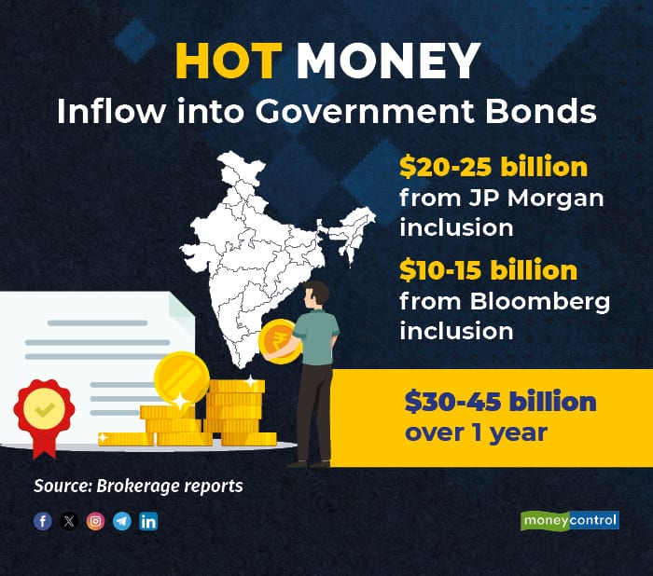
When a country's bonds are included in leading global indices, investors looking to diversify their portfolios will be attracted to these new entrants. The inclusion also acts as a confidence booster among global investors who benchmark their portfolios as per these indexes. The additional funds may ensure a cap on treasury yields, so there won’t be pressure on yields to rise even if local credit demand picks up in a big way, or if the government were to borrow more.
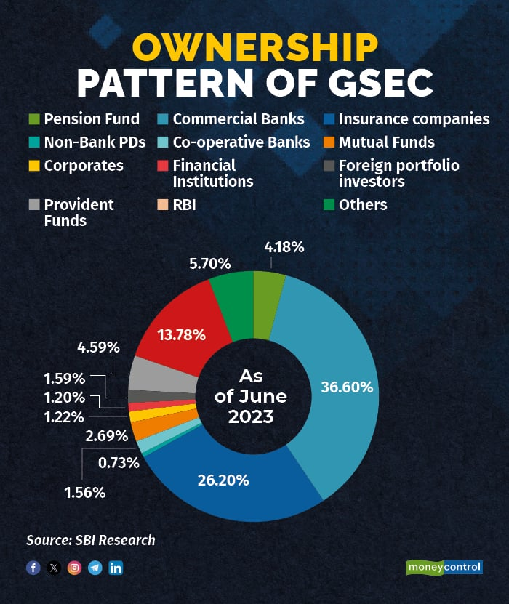

Cash flow impacts on issuers and investors

Cash flow refers to the inflow or the outsole of money from different activities in case of investment cash flow it affects both the investors as well as the companies who are issuing the debt instruments.

Issuers: In case of issuers there are two type of issuers one is the government and others are the private corporations In case of government the cash flow is managed by RBI and depending upon the liquidity conditions of the government and the need of expenses the cash flow is taken care of by RBI. Now in case of private corporations the private corporations get a huge amount of money when they issue the debentures. The debentures are generally longer term instruments than the commercial papers, which are issued generally for one year. In case of debentures the company gets the funds and have to deploy the funds so that there should not be any opportunity cost. Any cash lying idle with the company which has been collected through issue of debentures but not put into any productive purpose say for example capacity expansion or due to business reasons which are waste on its resources the issuer have to pay annually the interest. There is an outflow burden to the company every year and on the year of its maturity the debentures has to be repaid back whether the company is making profit or loss . In order to prevent any instances where the company is not in a position to gather cash in the year of maturity the law demands that the company sets aside some funds every year so that the strain on the resources or liquidity is lesser in the year of maturity companies who are confident of their liquidity management or repaying back the amounts issued as debentures and having higher ratings owing to better management of its balance sheets.

Investors: In case of investors the investor parts away his money at the time when he is buying the bonds or debentures or money market instruments now this money is locked for a particular amount of time if there is a liquidity branch in between the investors have an escape route that is going to the secondary market to sell their investments in the secondary market the prices may be higher than the issuing price or lower than the issuing price in case of investors selling in the secondary market he recovers almost the entire interest or investment however if he plans to hold the investment till his maturity then the cash flow or rather the cash inflow to him is the interest that the company pays to him annually and on the year of maturity he will be getting the funds so for investors it is prudent to locked into those instruments which have a period during which the investor does not require that amount of funds.

Different Fixed Income Indices in India
Nifty Fixed Income indices offer independent and comprehensive benchmarks for the fixed income market in India, covering universe of fixed income assets including government securities, T-bills, corporate bonds of different credit rating categories, commercial papers, certificate of deposits and overnight rate. All Nifty indices follow a well-defined, market relevant and rules-based framework that helps us provide transparent, replicable and market representative indices. An index measures the price performance of a basket of securities using a standardized metric and methodology.
Indexes in financial markets are often used as benchmarks to evaluate an investment's performance against.
List of Fixed Income Indices
- An index measures the price performance of a basket of securities using a standardized metric and methodology.
- Indexes in financial markets are often used as benchmarks to evaluate an investment's performance against.
G-sec Indices

The Indices have a base date of 3rd September, 2001 and a base value of 1000
The Index seeks to measure the performance of most liquid Government of India bonds across 6 distinct duration buckets
Based on a well-defined, market relevant and rules-based framework, the index is a transparent and objective indicator of Indian G-sec market performance.
The index is rebalanced and reconstituted on a monthly basis
SDL Indices

Nifty 10 Year SDL Index seeks to measure the performance of a portfolio of State Development Loans (SDLs) with residual maturity of about 10 years. The index contains SDLs issued by top 14 states selected every year based on their primary issuance volume during previous year. The index captures the total return, including price return and coupon return on the underlying SDL portfolio.
Nifty 5 Year SDL Index :With three states/UTs reviewed monthly, the index adequately represents the dynamics of the 5 year maturity bucket of the SDL market. Most liquid SDL based on the composite liquidity score of each of the selected three states/UTs to be included in the index. Each state/UT that is part of the index is given equal weight. The index is rebalanced and reconstituted every month

NIFTY Corporate Bond Indices
Nifty AAA Corporate Bond Indices, Nifty AA Category Corporate Bond Indices, Nifty AA+ Corporate Bond Indices, Nifty AA Corporate Bond Indices, Nifty AA- Corporate Bond Indices, Nifty A Corporate Bond Indices, Nifty Banking & PSU Bond Indices
Money Market Indices
- Certificate of Deposit Indices
- Commercial Papers Indices
- T-Bills Index Series
- Nifty 1D Rate Index
Target Maturity Indices
- Nifty BHARAT Bond Index Series, Nifty CPSE Bond PLUS SDL SEP 2024 50:50 Index, Nifty PSU Bond PLUS SDL APR 2026 50:50 Index, etc
Fixed Income Aggregates
- The indices have a base date of 03rd September, 2001 and a base value of 1000
- The Index seeks to measure the performance of aggregate debt portfolio
- Based on a well-defined, market relevant and rules-based framework, the indices are transparent and objective indicator of corporate bond market performance.

