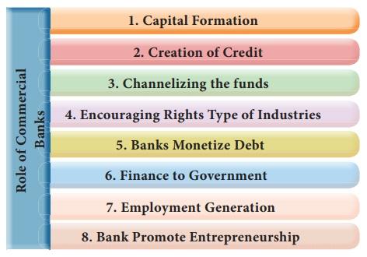

1. Capital Formation
Banks play an important role in capital formation, which is essential for the economic development of a country. They mobilize the small savings of the people scattered over a wide area through their network of branches all over the country and make it available for productive purposes.
Now -a-days, banks offer very attractive schemes to induce the people to save their money with them and bring the savings mobilized to the organized money market. If the banks do not perform this function, savings either remains idle or used in creating other assets,(eg.gold) which are low in scale of plan priorities.

2. Creation of Credit
Banks create credit for the purpose of providing more funds for development projects. Credit creation leads to increased production, employment, sales and prices and thereby they bring about faster economic development.

3. Channelizing the Funds towards Productive Investment
Banks invest the savings mobilized by them for productive purposes. Capital formation is not the only function of commercial banks. Pooled savings should be allocated to various sectors of the economy with a view to increase the productivity. Then only it can be said to have performed an important role in the economic development.

4. Encouraging Right Type of Industries
Many banks help in the development of the right type of industries by extending loan to right type of persons. In this way, they help not only for industrialization of the country but also for the economic development of the country. They grant loans and advances to manufacturers whose products are in great demand. The manufacturers in turn increase their products by introducing new methods of production and assist in raising the national income of the country. Sometimes, sub-prime lending is also clone. That is how there was an economic crisis in the year 2007-08 in the US.

5. Banks Monetize Debt
Commercial banks transform the loan to be repaid after a certain period into cash, which can be immediately used for business activities. Manufacturers and wholesale traders cannot increase their sales without selling goods on credit basis. But credit sales may lead to locking up of capital. As a result, production may also be reduced. As banks are lending money by discounting bills of exchange, business concerns are able to carryout the economic activities without any interruption.

6. Finance to Government
Government is acting as the promoter of industries in underdeveloped countries for which finance is needed for it. Banks provide long -term credit to Government by investing their funds in Government securities and short-term finance by purchasing Treasury Bills. RBI has given ₹ 68,000 crores to the government of India in the year 2018-19, this is 99% the RBI's surplus.

7. Employment Generation
After the nationalization of big banks, banking industry has grown to a great extent. Bank’s branches are opened frequently, which leads to the creation of new employment opportunities.

8. Banks Promote Entrepreneurship
In recent days, banks have assumed the role of developing entrepreneurship particularly in developing countries like India by inducing new entrepreneurs to take up the well-formulated projects and provision of counseling services like technical and managerial guidance.
Banks provide 100% credit for worthwhile projects, which is also technically feasible and economically viable. Thus commercial banks help for the development of entrepreneurship in the country.
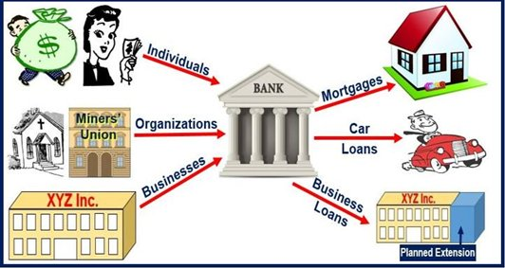
FUNCTIONS OF BANKING COMPANIES:

SOURCES OF FUNDS FOR A BANK:
- Internal sources and
- External Sources
Internal sources of bank funds Cash from operations is the main internal source. The Net Profit for this purpose will have to be adjusted for non-cash items, such as:
- Depreciation: Depreciation does not result in the outflow of cash and, therefore, net profit will have to be increased by the amount of depreciation or development rebate charged in order to find out the real Cash generated from operations.
- Amortization of intangible assets: The amount written off should, therefore, be added back to profits to find out the cash from operations.
- Gains from the sale of fixed assets: Since the sale of fixed assets is taken as a separate source of fund, it should be deducted from net profit.
- Interests on long-term loans: Since such interest is to be shown as separate source * cash, it should be added back to net profit.
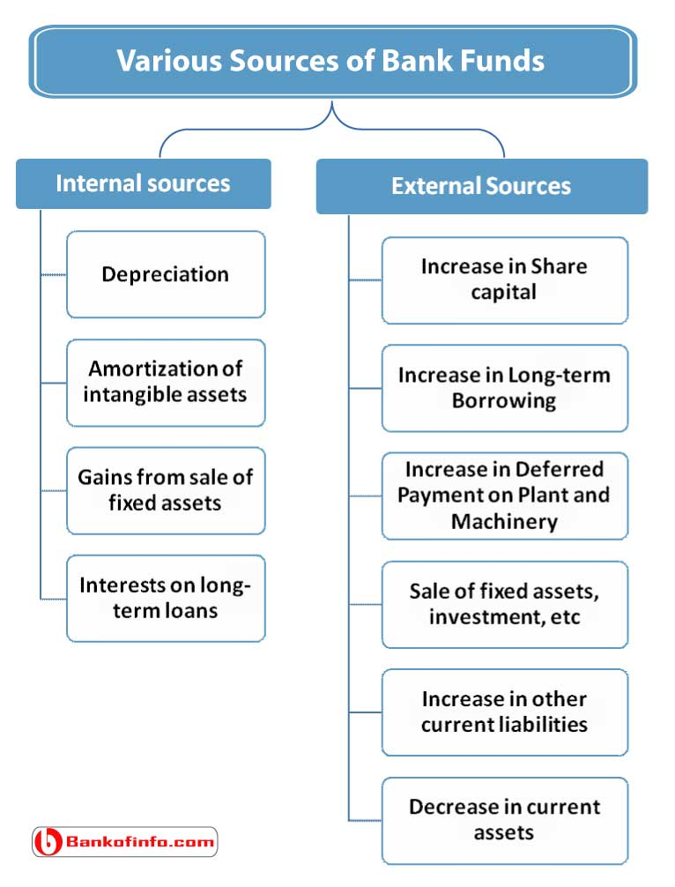

External sources of bank funds
There are a number of external sources of funds. Funds may be secured either by an increase in liabilities or a decrease in assets as explained below:
- Increase in Share capital: The amounts to be raised by the issue of new shares or by calling the unpaid amount on the already issued shares are to be shown separately for equity shares and preference shares.
- Increase in Long-term Borrowing: Long-term borrowing such as the issue of debenture, loans from different banks are sources of cash. They should be shown separately.
- Increase in Deferred Payment on Plant and Machinery: Plant and machinery may be purchased on a deferred payment basis. The number of such arrangements should, therefore, be shown as a source of funds during the concerned period.
- Sale of fixed assets, investment, etc.: It results in the generation of cash and, therefore, is a source of cash.
- Increase in other current liabilities: Increase in other current liabilities, such as creditors, bills
- payable, outstanding expenses show that cash to the extent of increase in these liabilities has not gone out of the business though taken into account while finding out cash from operations. Such an increase, therefore, has to be taken as a separate source of cash.
- The decrease in current assets: Decrease in current assets such as debtors, bills receivable, etc., show that cash has been realized too that extent and, therefore, it is shown as a separate source of cash.
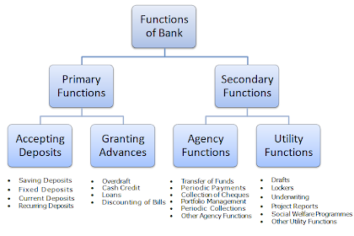
https://kalyan-city.blogspot.com/2011/04/functions-of-banks-important-banking.html

A. Primary Functions of Banks

The primary functions of a bank are also known as banking functions. They are the main functions of a bank

.
These primary functions of banks are explained below.

1. Accepting Deposits

The bank collects deposits from the public. These deposits can be of different types, such as :-
- Saving Deposits
- Fixed Deposits
- Current Deposits
- Recurring Deposits

a. Saving Deposits

This type of deposits encourages saving habit among the public. The rate of interest is low. At present it is about 4% p.a. Withdrawals of deposits are allowed subject to certain restrictions. This account is suitable to salary and wage earners. This account can be opened in single name or in joint names.

b. Fixed Deposits

Lump sum amount is deposited at one time for a specific period. Higher rate of interest is paid, which varies with the period of deposit. Withdrawals are not allowed before the expiry of the period. Those who have surplus funds go for fixed deposit.

c. Current Deposits

This type of account is operated by businessmen. Withdrawals are freely allowed. No interest is paid. In fact, there are service charges. The account holders can get the benefit of overdraft facility.

d. Recurring Deposits

This type of account is operated by salaried persons and petty traders. A certain sum of money is periodically deposited into the bank. Withdrawals are permitted only after the expiry of certain period. A higher rate of interest is paid.

2. Granting of Loans and Advances

The bank advances loans to the business community and other members of the public. The rate charged is higher than what it pays on deposits. The difference in the interest rates (lending rate and the deposit rate) is its profit.
The types of bank loans and advances are :-
- Overdraft
- Cash Credits
- Loans
- Discounting of Bill of Exchange

a. Overdraft

This type of advances are given to current account holders. No separate account is maintained. All entries are made in the current account. A certain amount is sanctioned as overdraft which can be withdrawn within a certain period of time say three months or so. Interest is charged on actual amount withdrawn. An overdraft facility is granted against a collateral security. It is sanctioned to businessman and firms.

b. Cash Credits

The client is allowed cash credit upto a specific limit fixed in advance. It can be given to current account holders as well as to others who do not have an account with bank. Separate cash credit account is maintained. Interest is charged on the amount withdrawn in excess of limit. The cash credit is given against the security of tangible assets and / or guarantees. The advance is given for a longer period and a larger amount of loan is sanctioned than that of overdraft.

c. Loans

It is normally for short term say a period of one year or medium term say a period of five years. Now-a-days, banks do lend money for long term. Repayment of money can be in the form of installments spread over a period of time or in a lumpsum amount. Interest is charged on the actual amount sanctioned, whether withdrawn or not. The rate of interest may be slightly lower than what is charged on overdrafts and cash credits. Loans are normally secured against tangible assets of the company.

d. Discounting of Bill of Exchange

The bank can advance money by discounting or by purchasing bills of exchange both domestic and foreign bills. The bank pays the bill amount to the drawer or the beneficiary of the bill by deducting usual discount charges. On maturity, the bill is presented to the drawee or acceptor of the bill and the amount is collected.

B. Secondary Functions of Banks ↓

The bank performs a number of secondary functions, also called as non-banking functions.
These important secondary functions of banks are explained below.

1. Agency Functions

The bank acts as an agent of its customers. The bank performs a number of agency functions which includes :-
- Transfer of Funds
- Collection of Cheques
- Periodic Payments
- Portfolio Management
- Periodic Collections
- Other Agency Functions

a. Transfer of Funds

The bank transfer funds from one branch to another or from one place to another.

b. Collection of Cheques

The bank collects the money of the cheques through clearing section of its customers. The bank also collects money of the bills of exchange.

c. Periodic Payments

On standing instructions of the client, the bank makes periodic payments in respect of electricity bills, rent, etc.

d. Portfolio Management

The banks also undertakes to purchase and sell the shares and debentures on behalf of the clients and accordingly debits or credits the account. This facility is called portfolio management.

e. Periodic Collections

The bank collects salary, pension, dividend and such other periodic collections on behalf of the client.

f. Other Agency Functions

They act as trustees, executors, advisers and administrators on behalf of its clients. They act as representatives of clients to deal with other banks and institutions.

2. General Utility Functions

The bank also performs general utility functions, such as :-
- Issue of Drafts, Letter of Credits, etc.
- Locker Facility
- Underwriting of Shares
- Dealing in Foreign Exchange
- Project Reports
- Social Welfare Programmes
- Other Utility Functions

a. Issue of Drafts and Letter of Credits

Banks issue drafts for transferring money from one place to another. It also issues letter of credit, especially in case of, import trade. It also issues travellers' cheques.

b. Locker Facility

The bank provides a locker facility for the safe custody of valuable documents, gold ornaments and other valuables.

c. Underwriting of Shares

The bank underwrites shares and debentures through its merchant banking division.

d. Dealing in Foreign Exchange

The commercial banks are allowed by RBI to deal in foreign exchange.

e. Project Reports

The bank may also undertake to prepare project reports on behalf of its clients.

f. Social Welfare Programmes

It undertakes social welfare programmes, such as adult literacy programmes, public welfare campaigns, etc.

g. Other Utility Functions

It acts as a referee to financial standing of customers. It collects creditworthiness information about clients of its customers. It provides market information to its customers, etc. It provides travellers' cheque facility.

