Unit-2 Corporate Governance-conceptual framework
Topics Covered
- Introduction, need, scope
- Evolution of corporate governance
- Developments in India
- Elements of good corporate governance
Corporate Governance
Governance’ means the process of decision making and the process by which decisions are implemented’
- ‘governance’ word comes from
- Latin word, ‘gubernare’ means ‘ to steer’
- Definitions
- Cadbury Report(UK1992) “Corporate Governance is the system by which companies are directed and controlled
- Sir Adrian Cadbury (1993)
“……..To do with Power and Accountability, who exercises power, on behalf of whom, how the exercise of power is controlled”
OECD definition “Corporate governance involves a set of relationships between a company’s management, its board, its shareholders and other stakeholders also the structure through which the objectives are set, and the means of attaining those objectives and monitoring performance are determined”

Features of Corporate Governance
Transparency: BOD should release all relevant information to stakeholders
Accountability: The CEO and the BOD must be made accountable for their actions
Equity: The rights of various groups have to be acknowledged and respected
Discipline: Commitment
Responsibility
Based on ethics
Universal application
Systematic
1.Transparency : This means that the Board of Directors must release all relevant information to the stakeholders. They must show all the necessary financial and operational data to the stakeholders. They must not hide any important information or maintain any secrecy.
2.Protection of Shareholders' Rights : The Board of Directors must protect the rights of the stakeholders. They must protect all the stakeholders, especially the minority stakeholders.
3.More Powers to CEO : The CEO must be given more powers so that he can approve the companies plans and strategies independently.
4.Accountability : The CEO and the Board of Directors must be made accountable for their actions to the stakeholders and to the entire society
5.Based on Ethics : Corporate governance is based on ethics, moral principles and values. So, the Board of directors must avoid unfair practices, cheating, exploitation, etc.
6.Universal Application : Corporate governance has universal application. That is, it is used by companies all over the world. It is given a legal recognition in many countries. All companies must use corporate governance voluntarily.
7.Systematic : Corporate governance is very systematic. It is based on laws, procedures, practices, rules, etc. All these laws are made to increase the wealth of the shareholders and to protect the rights of all the stakeholders of the company
Need/Objectives of Corporate Governance
1.Changing ownership structure:
Pattern of ownership changed, with institutional investors and mutual funds becoming largest investors
2.Importance of social responsibility:
Rights of various stakeholders need to be protected
3.Growing number of scams:
Misuse and misappropriation of public money happening regularly
4.Indifference on the part of shareholders:
Many companies, shareholders are inactive
5. Globalisation:
Rules and regulations of different countries need to be followed
6.Hostile Takeovers:
Check on the efficiency of managements
7.Huge increase in the top management compensation:
Justification needed
8.Greater expectations of society on the corporate sector
Better quality, reasonable price, less pollution
Benefits of Corporate Governance
- 1.Benefits to Business:
- Takes care of all stakeholders
- Avoids disturbing ethics
- Increases transparency
- Creates good image to organisation
- Maintains corporate social responsibility
- 2.Benefits to organisation
- Investors will be ready to invest in the company
- Customers will become loyal
- Lenders will be ready to provide finance
- Suppliers will supply materials
- Employees will respect the organisation
- Government gives privileges
- Society respects the organisation
- 3.Benefits to Various parties involved
- Investor get good return on investment
- Lenders get timely payment back
- Suppliers get money on time
- Customers get good product and fair price
- Employees get good salary and security
- Government get tax
- Shareholders get good dividend
- Society enjoys socio economic development
Scope of Corporate Governance
- To set high standard of business ethics
- To have a right balance, competence to set strategies and lead the organisation
- To increase the market confidence on the firm
- To make decision making process transparent
- To generate accurate information
- To create code of conduct with commitment
- To improve economic efficiency of the firm
- To enhance long term value of the firm
- To attract ,employ and retain talented staff
- To elevate the reputation of the firm

Evolution Of Corporate Governance
- Focus on Corporate Governance arose around 1970 in USA aftermath of Watergate scandal.
- Investigations revealed the existence of widespread political contributions and bribing of government officials
- Fraud & Corrupt Practices Act 1977 passed in USA
- Late 1980,s in United states & United Kingdom various corporate failures & scandals led shareholders & banks to express concern about safety of their investments.
- The major companies collapsed were wallpaper group Coloroll and Asil Nadir's Polly Peck ,Robert Maxwell’s Mirror Group,Bank of Credit & Common International
With a view to prevent the recurrence of such failures Cadbury committee under Sir Adrian Cadbury was set up by Financial Reporting Council, London Stock Exchange and the accountancy profession in May1991
- The Committee on the Financial Aspects of Corporate Governance, forever after known as the Cadbury Committee Cadbury Committee Report was the milestone in the history of the concept of Corporate Governance.
The report was submitted in 1992
Developments of CG-International Perspective
Cadbury Committee on Financial Aspect of CG(1992)
Green bury Committee on directors remuneration(1995)
Hampel Committee o CG(1998)
Organisation for Economic Cooperation & Development (OECD) Principles of CG(199)
Euro Shareholders CG guidelines(2000)
Cadbury Committee on Financial Aspect of CG(1992)
- Objective of the Cadbury Committee
‘to help raise the standards of corporate governance and the level of confidence in financial reporting and auditing by setting out clearly what it sees as the respective responsibilities of those involved and what it believes is expected of them’
- The central components of the voluntary code, the Cadbury Code, are:
1.There must be clear division of responsibilities at the top. Position of Chairman of the Board be separated from that of Chief Executive, or that there be a strong independent element on the board;
2. The majority of the Board be comprised of outside directors;
3. Remuneration committees for Board members be made up in the majority of non-executive directors; and
4. Board should appoint an Audit Committee including at least three non-executive directors.
The provisions of the Code were given statutory authority to the extent that the London Stock Exchange required listed companies to 'comply or explain'; that is, to enumerate to what extent they conform to the Code and, where they do not, state exactly to what degree and why. Over the years this become the cornerstone of UK corporate governance practice
Greenbury Report
The Greenbury Report released in 1995
The committee established by the United Kingdom Confederation of British Industry on corporate governance
Chairmanship: Sir Richard Greenbury
It followed in the tradition of the Cadbury Report and addressed a growing concern about the level of director remuneration.
Recommendations • Remuneration committee. • Disclosure and Approval provision. • Remuneration policy. • Service contracts and compensation
Hampel Report
The Hampel Report in 1998 was designed to be a revision of the corporate governance system in the UK. Chairperson:Sir Ronald Hampel
The task was to check whether the Cadbury code's original purpose was being achieved or not
Hampel found that there was no need for a revolution in the UK corporate governance system.
The Report aimed to combine, harmonise and clarify the Cadbury and Greenbury recommendations.
- Hampel Report relied more on broad principles and a 'common sense' approach which was necessary to apply to different situations rather than Cadbury and Greenbury's 'box-ticking' approach.

Evolution of Corporate Governance in India
- Corporate governance concept emerged in India after the second half of 1996 due to economic liberalization and deregulation of industry and business.
- There was also need for greater accountability of companies to their shareholders and customers. The report of Cadbury Committee on the financial aspects of corporate Governance in the U.K. has given rise to the debate of Corporate Governance in India
- The “corporate governance concept” dwells in India from the Arthshastra time. Instead of CEO at that time there were kings and subjects. Today, corporate and shareholders replace them but the principles still remain same, unchanged i.e. good governance.
- Raksha, Vriddhi, Palana and Yogakshema
Corporate Governance in India
1.The Confederation of Indian Industries is set up a taskforce in 1996under Rahul Bajaj, a reputed industrialist.
In April 1998, the CII released the code called“Desirable Corporate Governance”
Confederation of Indian Industries (CII)
The main recommendations were:
- The board should meet minimum six times a year
- Board should be comprise of professionally competent and independent non executive directors
- No person should hold directorships in more than 10 companies
- While reappointing of board members, companies should provide attendance record of the directors
- Non-executive directors should not be passive members, should actively participate in the meetings
- Appointment of audit committee

Kumar Mangalam Birla Committee Report
- The CII code was well received by corporate sector and some progressive companies also adopted it, it was felt that under Indian conditions a statutory rather than a voluntary code would be more meaningful.
- Consequently the second major initiative was undertaken by the Securities and Exchange Board of India (SEBI)
- SEBI set up a committee under the chairmanship of Kumar Mangalam Birla in 1999 with the objective of promoting and raising of standards of good corporate governance.
- Major Recommendations of Kumar Mangalam BirlaCommittee
- Optimum Combination of Executive & Non-executive members in the Board of Directors
- Setting up of Audit Committee
- Setting up of Remuneration Committee & disclosure of remuneration
- Stringent disclosure during IPO
- Declaration of quarterly result
- Dispatching a copy of Balance Sheet to all shareholders
- The recommendations were accepted and included in Clause 49 of Listing Agreement.

.Naresh Chandra Committee Report:
Appointed by Ministry of Finance & Company Affairs in 2002.
Examine and recommend amendments to the law involving auditor & Client Relationship and Independent directors.
Main recommendations
Financial & non financial disclosures & independent auditing
Narayana Murthy Committee
Appointed by SEBI in 2003
“Corporate Governance is beyond the realm of Law. It stems from the mindset of management and can not be regulated only by Law. It is about integrity, openness and accountability”
The Indian Companies Act of 2013 introduced some progressive and transparent processes which benefit stakeholders, directors as well as the management of companies.
- Investment advisory services provide concise information to the shareholders about these newly introduced processes and regulations, which aim to improve the corporate governance in India.
- The top management that consists of the board of directors is responsible for governance. They must have effective control over affairs of the company in the interest of the company and minority shareholders.
- Corporate governance ensures strict and efficient application of management practices along with legal compliance in the continually changing business scenario in India.
- Corporate governance was guided by Clause 49 of the Listing Agreement before introduction of the Companies Act of 2013.
- As per the new provision, SEBI has also approved certain amendments in the Listing Agreement so as to improve the transparency in transactions of listed companies
- and giving a bigger say to minority stakeholders in influencing the decisions of management.
- These amendments have become effective from 1st October 2014.
Few New Provision for Directors and Shareholders
- One or more women directors are recommended for certain classes of companies
- Every company in India must have a resident directory
- The maximum permissible directors cannot exceed 15 in a public limited company. If more directors have to be appointed, it can be done only with approval of the shareholders after passing a Special Resolution
- The Independent Directors are a newly introduced concept under the Act. A code of conduct is prescribed and so are other functions and duties
- The Independent directors must attend at least one meeting a year
- Every company must appoint an individual or firm as an auditor. The responsibility of the Audit committee has increased
- Filing and disclosures with the Registrar of Companies has increased
- Top management recognizes the rights of the shareholders and ensures strong co-operation between the company and the stakeholders
- Every company has to make accurate disclosure of financial situations, performance, material matter, ownership and governance
Different Areas to understand status of CG in India
- Managing the dominant shareholders and promoters
- Public Sector Undertakings
- Multinational Companies
- Family business groups
Emerging trends in Corporate Governance
- Women on Corporate Boards
- Social Media Governance
- Protection of Whistle blowers
- Active participation of shareholders
- Different mix of directors and skills sought
Issues/Challenges in Corporate Governance
- Duties of Directors
- Composition & Balance of Board- Boards dominated by a single senior executive.
- Remuneration & Rewards of directors
- Board’s responsibility for risk management & internal control
- Shareholders rights & responsibilities
- Corporate social responsibility & business ethics
- Reliability of Financial Reporting & Auditing



Elements of Good Corporate Governance
- Concept of good governance is developed by World Bank which redefined it in 1997 as a necessary precondition for development.
- Main elements of good governance are:
1.Transaparency:
Corporates should provide the information in easily understandable forms and media.It should be easily available and directly accessible to the stakeholders.
2.Accountability:
An organisation is accountable to those who will be affected by its decisions or actions as well as applicable rules of law
3.Rule of Law
Good governance requires fair legal frame works,enforced by regulatory body.
4. Responsiveness:
The organisations’s process must be designed to serve the best to stakeholders
5.Consensus oriented:
Requires consultation to understand the different interest of the stakeholders to reach a consensus – best to all stakeholders
6.Equity & Inclusiveness:
Organisation should provide equal opportunity for all stakeholders to maintain, enhance and improve their well being
7.Effectiveness & Efficiency:
Good governance means, organisation should produce favourable results.All the resources- human,financial, technological must be utilised effectively and efficiently.
8.Participation:
There should be participation by everyone,freedom of expression at the best interest of the organisation.
Best Practices for Corporate Governance
- Build a strong, qualified board of directors and evaluate performance
- Define roles and responsibilities
- Emphasize integrity and ethical dealing
- Evaluate performance and make principled compensation decisions
- Engage in effective risk management

Four P’s of Corporate Governance
- Corporate Governance is critical for making competitive enterprises, improving industrial performance creating jobs and sustainable development.
- Today’s scenario, 4 P’s are critical for corporate sustainability
- People
- Purpose
- Process
- Performance

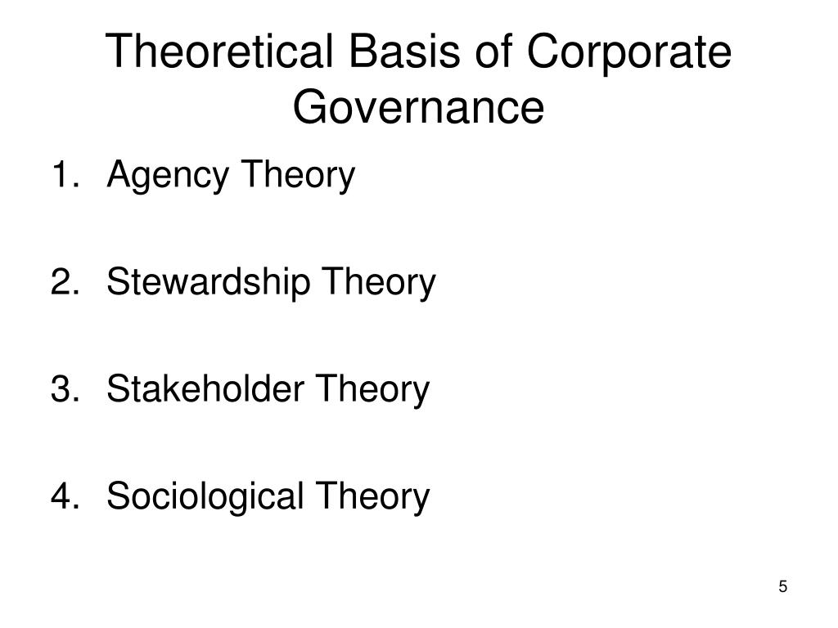
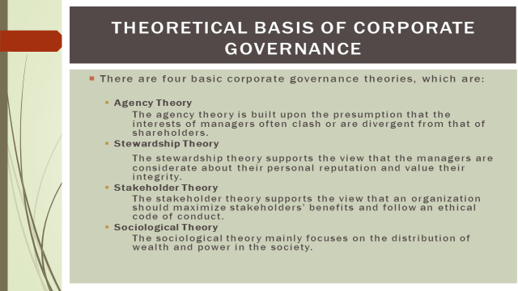

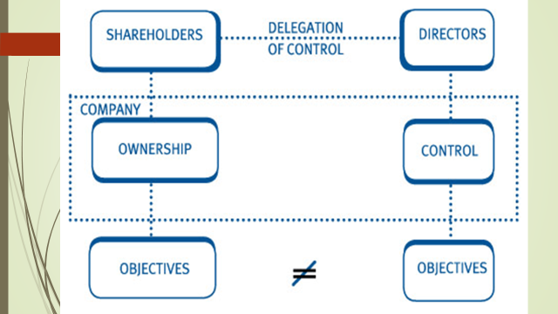
Agency Theory of Corporate Governance
- Agency theory is the branch of financial economics that looks at conflicts of interest between people with different interests in the same assets.
- This most importantly means the conflicts between:shareholders and managers of companies shareholders and bond holders.
- The theory explains the relationship between principals, such as a shareholders, and agents, such as a company's managers.
- The theory attempts to deal with two specific problems:
- how to align the goals of the principal so that they are not in conflict (agency problem), andthat the principal and agent reconcile different tolerances for risk.
COSTS OF SHAREHOLDER-MANAGEMENT CONFLICT
Agency costs are defined as those costs borne by shareholders to encourage managers to maximize shareholder wealth rather than behave in their own self-interests.
- There are three major types of agency costs:
- (1) expenditures to monitor managerial activities, such as audit costs;
- (2) expenditures to structure the organization in a way that will limit undesirable managerial behaviour, such as appointing outside members to the board of directors or restructuring the company's business units and management hierarchy;
- (3) opportunity costs which are incurred when shareholder-imposed restrictions, such as requirements for shareholder votes on specific issues, limit the ability of managers to take actions that advance shareholder wealth.
MECHANISMS FOR DEALING WITH SHAREHOLDER-MANAGER CONFLICTS
- The optimal solution lies between the extremes, where executive compensation is tied to performance, but some monitoring is also undertaken.
- In addition to monitoring, the following mechanisms encourage managers to act in shareholders' interests:
- performance-based incentive plans
- direct intervention by shareholders
- ,the threat of firing
- the threat of takeover
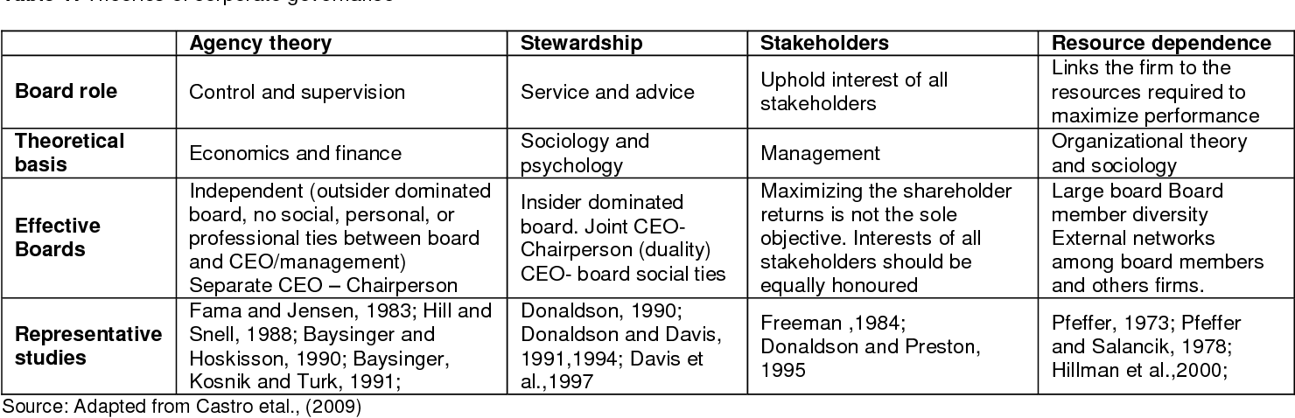
Practicing Framework Of Corporate Governance
- Supervisory Board/Committee/Team
- Audit Committee
- Internal Audit
- Statutory Audit
- Disclosure of Information
- Risk Management Framework
- Internal Control Framework
- Whistle blower policy
Role & Functions of Chairman
- To act as representative of the company
- To ensure that policies and practices are in place
- To see it that directors make good decision
- To act firmly in times of crisis
- To upgrade the competence of director so as to meet the current and future needs of the company.
Role & Functions of CEO
- Present the company to major investors, media and the government
- Provide leadership and direction to all executive directors
- Assist the executive directors in formulating strategies proposals that have to be endorsed by the board
- Be a source of inspiration, leadership and direction to all the employees, customers and suppliers
- Take firm decision when situation demands
RESPONSIBILITIES OF THE BOARD OF DIRECTORS
- Establish corporate values and governance structures for the company;
- Ensure that all legal and regulatory requirements are met and complied with fully and in a timely fashion;
- Establish long-term strategic objectives for the company;
Establish clear lines of responsibility and a strong system of accountability and performance measurement
- Hire the chief executive officer, determine the compensation package, and periodically evaluate the officer’s performance;
- Ensure that management has supplied the board with sufficient information for it to be fully informed and prepared to make the decisions that are its responsibility, and to be able to adequately monitor and oversee the company’s management;
- Meet regularly to perform its duties;
- Acquire adequate training.
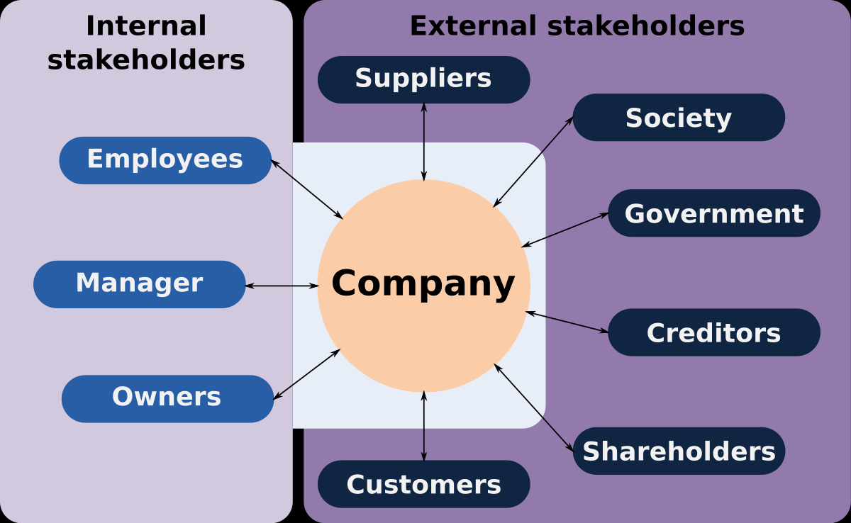

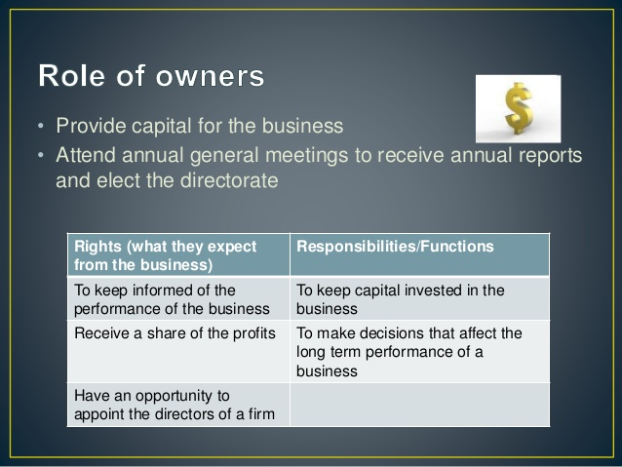
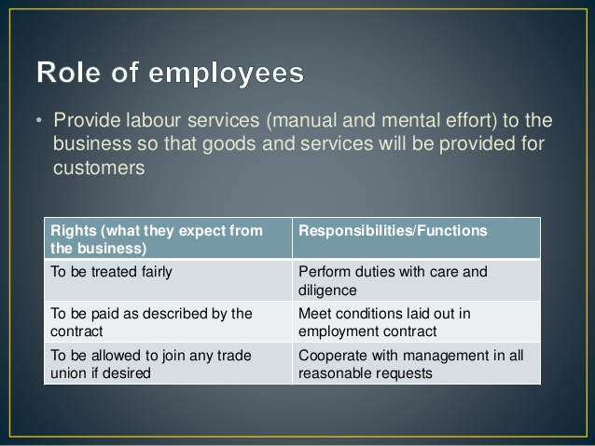
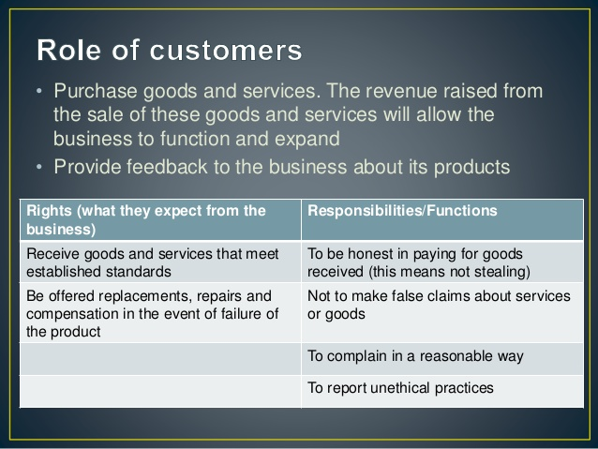
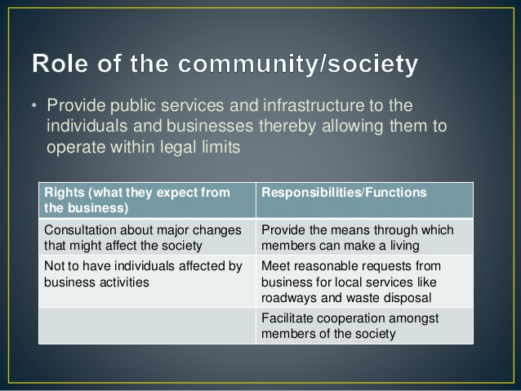

FIVE GOLDEN RULES OF CORPORATE GOVERNANCE
- Align Business Goals: appropriate goals, arrived at through the creation of a suitable stakeholder participation in decision making model
- Strategic management: an effective strategy process which incorporates stakeholder value
- Organisation: an organisation suitably structured to give effect to the good corporate governance
- Reporting: reporting systems structured to provide transparency and accountability
CASESTUDY:
KINGFISHER AIRLINES LOSES LICENSE TO FLY
- Details:
The financially troubled Kingfisher Airlines lost its flying permit after a deadline to renew its suspended license expired. The Directorate General of Civil Aviation (DGCA) has suspended Kingfisher Airlines license to fly till further orders pursuant to Clause 15 (2) of Schedule XI of the Aircraft Rules, 1937, after the airline failed to deliver a viable financial and organizational revival plan.
The debt-ridden carrier was grounded since October 2012 after repeated strikes by workers over unpaid wages. Kingfisher owes various public sector banks $1.4bn ( 870m) in debts and has been trying to raise funds after lenders refused to give fresh loans.
JUDGEMENT
The airline now owes money to staff, airports, tax authorities and its lenders and may have to be liquidated
CASE LAW:
SAHARA TOLD TO REPAY $3 BILLION TO SMALL INVESTORS.,
- Details:
Unlisted conglomerate Sahara, one of India’s biggest business groups was ordered by the Supreme Court of India after a prolonged legal battle with capital markets regulator SEBI to refund 174 billion rupees raised by dubious means from 22 million small investors. From 2008-11, they received 174 billion rupees through what is known as an optionally fully convertible debentures. The Sahara was also asked to pay 15 percent interest to the investors of the fund which has been illegally raised from the public without resorting to proper legal procedure.
JUDGEMENT
The Supreme Court, whose order reaffirmed an earlier ruling that the fundraising did not meet the rules, ordered two unlisted Sahara group firms to refund money they had raised with the interest within three months. The judgment closed a much exploited loophole of the corporate fundraising laws in India and underscored an increasing assertiveness by India’s judiciary and regulators as businesses and financial markets expand at a fast pace in Asia’s third-largest economy
CONCLUSION
https://studycafe.in/2018/12/corporate-governance.html
- It is essential that good governance practices must be effectively implemented and enforced preferably by self-regulation and voluntary adoption of ethical code of business conduct and if necessary through relevant regulatory laws and rules framed by Government or its agencies such as SEBI, RBI.
- The effective implementation of good governance practices would ensure investors confidence in the corporate companies which will lead to greater investment in them ensuring their sustained growth. Thus good corporate governance would greatly benefit the companies enabling them to thrive and prosper.

