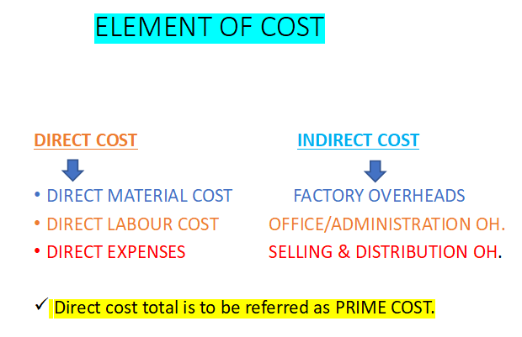

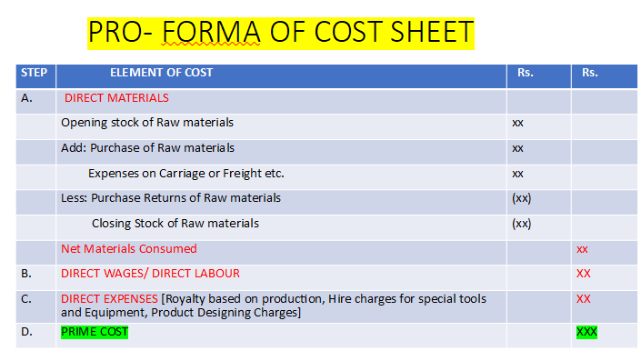
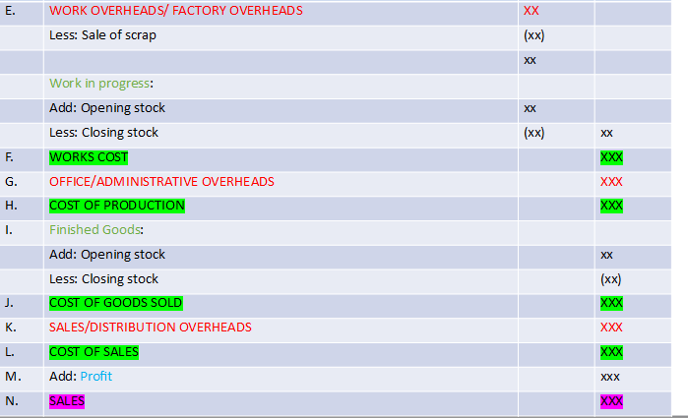

Prime Cost per Unit =$\frac{TotalPrimeCost}{TotalUnitsProduced}$

Work Cost Per Unit = $\frac{TotalWorkCost}{TotalUnitsProduced}$

Cost of Production Per Unit = $\frac{TotalCostofProduction}{TotalUnitsProduced}$

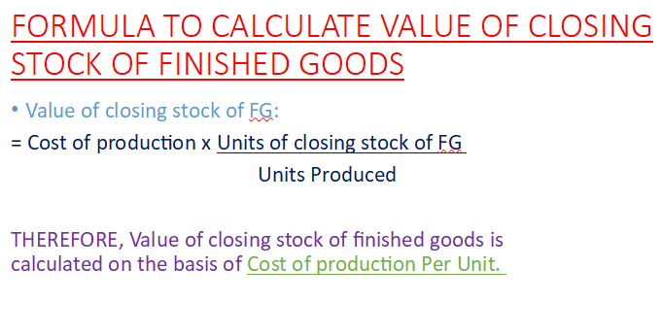

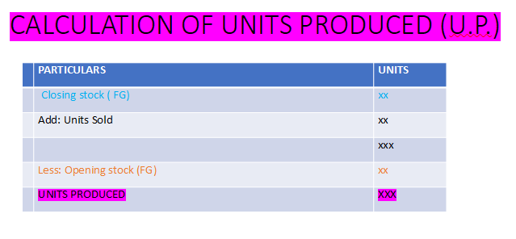

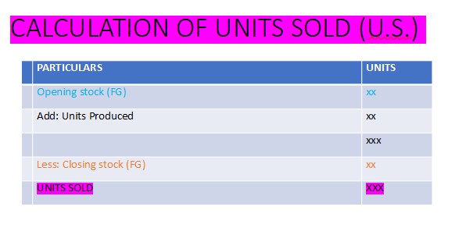

Prime Cost

Types of Cost Sheet
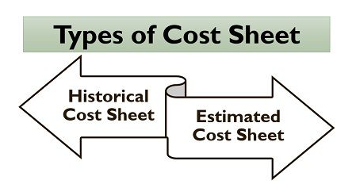

Historical Cost Sheet
The statement of cost which records all those expenses or costs that have already been incurred by the organization, i.e., the actual cost born (direct or indirect) on the business operations in a particular period, is called a historical cost sheet.

Estimated Cost Sheet
It is a cost statement which is prepared in advance before the actual production of goods or services take place. It is made to predict or determine the cost which will be incurred by the organization, the potential or profitability of the product or service and to fix a suitable selling price.
This type of cost sheet is usually prepared at the time of filling tenders or taking contracts to quote an appropriate price of the goods or service.

Advantages of Cost Sheet
Cost sheet is an essential statement for the organization engaged in the production of goods or services. Following are some of the benefits of preparing a cost sheet:
- A cost sheet provides per unit cost of a product or service which the organization incurs at every stage of business operation, which helps the management to analyze and control such overheads.
- It also helps in deciding the selling price of a product or service based on the cost incurred and profit expected out of it.
- The cost managers or production managers study the past figures of the company’s cost sheet to ensure the efficiency of business operations and for eliminating the non-productive expenses.
- It also acts as a base for comparing the actual cost incurred, with that of the estimated or budgeted cost, to find out any deviations and take the necessary corrective actions.

