Subject: Consumer Behaviour
Module 2: PSYCHOLOGICAL DETERMINANTS & CONSUMER BEHAVIOUR

1. Motivation – Types & Theories – Maslow.
2. Attitude – Characteristics – Theories – Tricomponent.
3. Multiattitude Model.
4. Cognitive dissonance.
5. Personality - Facets of personality.
i. Theories – Freud & Jung.
ii. Personality traits & consumer behaviour.
iii. Self-Concept.

Note : examples are must and write of your own

- Motivation
You should realize that, the starting point in the purchase decision making process is the recognition of a need or buying motive. Why a person acts? The answer is, “As he experiences a need”. Motivation is of crucial importance in contributing to consumer decision making process. To understand why and how consumers buy, marketers must first grasp motivation. Motivation is related to expectations, needs, and wants. Individual purchases an article as a consequence of certain mental and economic forces creating desires or wants, which he understands can be satisfied by the articles offered for purchase. A Marketer should identify the motives that prompt or move consumers to purchases so that he can offer a complete article satisfying their needs. A need must be aroused or stimulated before it becomes a motive.
The study of Motivation refers to all the processes that drive in a person to perceive a need and pursue a definite course of action to fulfil that need. Motivation is the driving force within individuals that impels them to action. This driving force is produced by a state of uncomfortable tension, which exists as the result of an unfulfilled need. We all have needs, wants and desires. The drive to reduce need-inducted tension results in behaviour that we anticipate will satisfy needs and thus bring a more comfortable state.

Model of the Motivation Process:

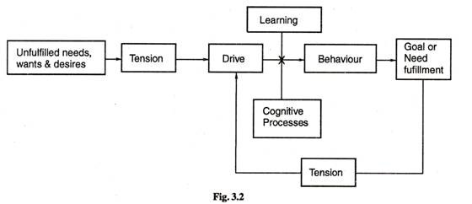

The motivational process is the steps that you take to get motivated. It is a process, that when followed produces incredible results. It is amazing what you can do if you are properly motivated, and getting properly motivated is a matter of following the motivational process. Like any other process it takes a little work and foresight and planning on your part. However, the return on your investment of time is significant, and it is important when needing extra motivation that you apply the motivational process.
In the initiation a person starts feeling lacking something . There is an arousal of need so urgent, that the bearer has to venture in search to satisfy it. This leads to creation of tension, which urges the person to forget everything else and cater to the aroused need first. This tension also creates drives and attitudes regarding the type of satisfaction that is desired. This leads a person to venture into the search of information. This ultimately leads to evaluation of alternatives where the best alternative is chosen. After choosing the alternative, an action is taken. Because of the performance of the activity satisfaction is achieved which than relieves the tension in the individual.

Need, Goals and Motives in Motivation
Needs:
Every individual has needs, they are innate and acquired. Innate needs are also called physiological needs or primary needs which include food, water, air, shelter etc. Acquired needs are those needs that we learn from our surroundings / environment or culture. These may include need for power, for affection, for prestige, etc. These are psychological in nature; therefore they are also called as secondary needs.
Goals:
Goals are the end result of motivated behaviour. As in the above diagram every individual’s behaviour is goal-oriented. All behaviour is goal-orientated. Goals are the sought-after results of motivated behaviour. The form of direction that behaviour takes – the goal that is selected – is a result of thinking process and previous learning. There are two types of goals: generic and product-specific. A generic goal is a general category of goal that may fulfil a certain need; a product-specific goal is a specifically branded or labelled product that the individual sees as a way to fulfil a need.
Arousal of Motives:
The arousal of any particular set of needs at a specific moment in time may be caused by internal stimuli found in the individual’s physiological condition, by emotional or cognitive processes or by stimuli in outside environment. A consumer has a variety of needs but only some of them are aroused at any given time and given top-of-mind priority. Motives become aroused by the consumer’s psychological condition (they get hungry), their emotional state (frustrated), cognitive processes (they read an ad that made them think about their needs), or by events occurring in their general surroundings (the weather becomes cold).
- Physiological arousal e.g. basic needs like hunger, thirst arouse motives
- Emotional arousal e.g. feeling frustrated, feeling happy
- Cognitive arousal e.g. exposed to some stimulus / ad, post which it made them think and act. sometimes random thoughts can lead to a cognitive awareness of needs e.g. an advertisement that provides reminders of home might trigger instant yearning to speak with one’s parents
- Environmental arousal e.g. cold weather –need for warm clothing.

Types of Motives
- Physiological and Psychological/Psychogenic motives
Physiological needs are the most basic needs that every human being cannot survive without. They are vital for the survival of every human being. They include; water, food/ ability to satisfy hunger, sleep, shelter.
The psychological need is more about an emotional connection to the product, such as status. The remaining steps of the consumer purchase decision process involve the information search, evaluation of alternatives, purchase decision, and post-purchase evaluation.

2. Conscious and Unconscious motives
Conscious motives – Are the motives we are aware of and these can be both primary and secondary. People might or might not know what motivates them to buy a specific brand. Buying a luxury suit motivated by the need to look like peers at the workplace is very conscious choice of product.
People are unconscious about some of motives because they don’t want to confront the true reason for their purchase. Market researchers can discover the conscious values that govern their category. But research is rarely directed at the unconscious. The failure of New Coke is an example of a market disaster that resulted from a failure to assess unconscious associations and emotions of an impulse purchase brand. All the taste tests, focus groups and surveys indicated that people were ready, even eager, for a change in Coke. However, no one thought to look at people’s associations and automatic emotional reactions to the brand and how a change would be perceived from that perspective. The New Coke debacle could have been avoided by measuring unconscious reactions.
3. Positive and negative motivation:
Motivation can be positive or negative. Positive goals are often referred to as approach objects, in which behaviour is directed towards. Negative goals can be referred to as avoidance objects, in which behaviour is directed away. An example of positive motivation in marketing is a print ad for Rolex, which uses the line “Live For Greatness”. The positive goal here may be to obtain something prestigious, stylish to impress others.

- Rational and Emotional motivation:
Emotional buying motives influence a person to purchase certain goods or services not because of its rationality, but because of his emotions. Emotional buying motives are related with motives to maintain health, security, better living, power, satisfaction of ego needs, maintaining of good image in the society, acquisitiveness, curiosity, love and affection, habits of purchasing or collection of certain goods, desire to achieve economy, desire to do some creative activity, cautiousness, desire to be praised by others, desire to be seen good and attractive to be seen, etc. Emotional buying motives are motives of self-preservation, affection, utility, fashion, prestige, comfort, vanity, admiration, health, habit, monetary, feeling, convenience, curiosity, urge to create or develop hobby, relaxation, sense organ’s gratification (touch, taste, smell, sight, hearing), jealously, etc.
Rational motives are reasons to purchase based on facts or logic. Rational motives include factors such as saving time or money or obtaining the highest quality or greatest value. Rational buying motives may influence many purchases, but they are especially important for expensive purchases.

Maslow's hierarchy of needs
Created by psychologist Abraham Maslow, Maslow’s hierarchy of needs posits that humans have universal needs they must fulfil. These can range from physiological and safety needs to more abstract ones such as love, esteem or self-fulfilment. While popularly portrayed as a pyramid, research indicates that the fulfilment of one need is not necessarily dependent on another. This gives marketers the opportunity to appeal to each need individually and to each customer looking to fulfil them.
Maslow’s needs provide poles around which you can organize your marketing efforts. You can specifically target your marketing to appeal to someone’s need for esteem, love and fulfilment, or simply their need to survive. While there may be some variation across cultures, studies show that these needs persist globally. The universality of Maslow’s hierarchy of needs gives you limitless options to use it for your marketing efforts, and especially for your buyer personas.

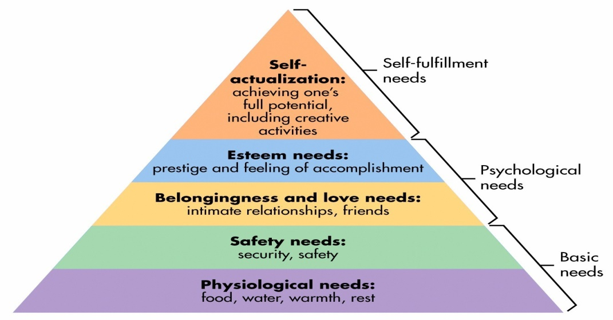

Maslow saw human needs in the form of a hierarchy, ascending from the lowest to the highest, and he concluded that when one set of needs is satisfied, this kind of need ceases to be a motivator.
As per his theory these needs are:
(i) Physiological needs: These are important needs for sustaining the human life. Food, water, warmth, shelter, sleep, medicine and education are the basic physiological needs which fall in the primary list of need satisfaction. Maslow was of an opinion that until these needs were satisfied to a degree to maintain life, no other motivating factors can work.
(ii) Security or Safety needs: These are the needs to be free of physical danger and of the fear of losing a job, property, food or shelter. It also includes protection against any emotional harm.
(iii) Social needs: Since people are social beings, they need to belong and be accepted by others. People try to satisfy their need for affection, acceptance and friendship.
(iv) Esteem needs: According to Maslow, once people begin to satisfy their need to belong, they tend to want to be held in esteem both by themselves and by others. This kind of need produces such satisfaction as power, prestige status and self-confidence. It includes both internal esteem factors like self-respect, autonomy and achievements and external esteem factors such as states, recognition and attention.
(v) Need for self-actualization: Maslow regards this as the highest need in his hierarchy. It is the drive to become what one is capable of becoming; it includes growth, achieving one’s potential and self-fulfilment. It is to maximize one’s potential and to accomplish something.

As each of these needs is substantially satisfied, the next need becomes dominant. From the standpoint of motivation, the theory would say that although no need is ever fully gratified, a substantially satisfied need no longer motivates. So if you want to motivate someone, you need to understand what level of the hierarchy that person is on and focus on satisfying those needs or needs above that level. Maslow’s need theory has received wide recognition, particularly among practicing managers. This can be attributed to the theory’s intuitive logic and ease of understanding. However, research does not validate this theory. Maslow provided no empirical evidence and other several studies that sought to validate the theory found no support for it.
An evaluation of the need hierarchy and its marketing applications
The hierarchy offers a highly useful framework for marketers trying to develop appropriate advertising appeals for their products. It is adaptable in two ways: -
• It enables marketers to focus their advertising appeals on a need level that is likely to be shared by a large segment of the target audience.
• It facilitates product positioning or repositioning.
Segmentation and promotional applications
Maslow’s need hierarchy is readily adaptable to market segmentation and the development of advertising appeals.
• Individuals buy health foods, medicines and low-fat products to satisfy physiological needs.
• Buying insurance, preventive medical services and home security systems to satisfy security needs.
• Almost all personal care and grooming products, as well as clothes are purchased to satisfy social needs.
• High – tech products, big cars, expensive furniture’s are purchased to fulfil ego and esteem needs
• Post graduate college education, hobby-related products, and exotic and physically challenging adventure trips are sold as ways of achieving self-fulfilment
Advertisements can also use the need hierarchy for positioning products – that is, deciding how the products should be perceived by prospective consumers. The key to positioning is to find a niche – an unsatisfied need – that is not occupied by a competing product or brand.

- Attitude
Consumer attitude may be defined as a feeling of favourableness or unfavourableness that an individual has towards an object. As we, all know that an individual with a positive attitude is more likely to buy a product and this result in the possibility of liking or disliking a product.
Consumer attitude basically comprises of beliefs towards, feelings towards and behavioural intentions towards some objects.
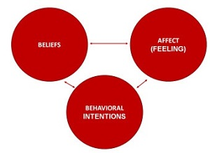
Belief plays a vital role for consumers because; it can be either positive or negative towards an object. For example, some may say tea is good and relieves tension, others may say too much of tea is not good for health. Human beliefs are not accurate and can change according to situations.
Consumers have certain specific feelings towards some products or brands. Sometimes these feelings are based on certain beliefs and sometimes they are not. For example, an individual feels uneasy when he thinks about cheese burst pizza, because of the tremendous amount of cheese or fat it has.
Behavioural intentions show the plans of consumers with respect to the products. This is sometimes a logical result of beliefs or feelings, but not always. For example, an individual personally might not like a restaurant, but may visit it because it is the hangout place for his friends.

Characteristics of Attitude
Attitudes have several important characteristics or properties; namely, they have an object; direction, intensity, and degree; have structure, and are learned.
- Attitudes Have an Object:
By definition, attitudes must have an object. That is, they must have a focal point whether it is abstract concept, such as “ethical behaviour”. Or a tangible item, such as a motorcycle. The object can be a physical thing, such as a product, or it can be an action, such as buying a refuse bin. In addition, the object can be either one item, such as a person, or a collection of items such as asocial group; it also can be either specific.
- Attitudes Have Direction, Degree and Intensity:
An attitude expresses how a person feels toward an object. It expresses direction-the person is either favourable or unfavourable toward, or for or against the object; degree- how much the person either likes or dislikes the object; and intensity-the level of sureness or confidence of expression about the object, or how strongly a person feels about his or her conviction. The direction, degree, and intensity of a person’s attitude toward a product have been said to provide marketers with an estimate of his or her readiness to act toward, or purchase, the product.
- Attitude Are Learned:
They develop from our personal experiences with reality, as well as from information from friends, salespeople, and news media. They are also derived from both direct and indirect experiences in life. Thus, it is important to recognize that learning precedes attitude formation and change, and that principles of learning can aid marketers in developing and changing consumer attitudes.
HOW ATTITUDES ARE LEARNED
1. When we speak of the formation of an attitude, we refer to the shift from having no attitude toward a given object to having some attitude toward it.
2. Consumers often purchase new products that are associated with a favourably viewed brand name.
a) Their favourable attitude toward the brand name is frequently the result of repeated satisfaction with other products produced by the same company.
3. In terms of classical conditioning, an established brand name is an unconditioned stimulus that through past positive reinforcement resulted in a favourable brand attitude.
a) A new product, yet to be linked to the established brand, would be the conditioned stimulus.
4. Sometimes attitudes follow the purchase and consumption of a product.
5. In situations in which consumers seek to solve a problem or satisfy a need, they are likely to form attitudes (either positive or negative) about products on the basis of information exposure and their own cognition (knowledge and beliefs).
6. In general, the more information consumers have about a product or service, the more likely they are to form attitudes about it, either positive or negative.
7. Consumers are not always ready or willing to process product-related information.
8. Consumers often use only a limited amount of the information available to them.
9. Research suggests that only two or three important beliefs about a product dominate in the formation of attitudes and that less important beliefs provide little additional input
- Attitudes Have Consistency
1. Attitudes are relatively consistent with the behaviour they reflect.
a) Attitudes are not necessarily permanent; they do change.
b) We should consider situational influences on consumer attitudes and behaviour.

- Attitudes Occur Within a Situation
1. Consumer attitudes occur within, and are affected by, the situation.
a) By “situation,” we mean events or circumstances that, at a particular time,
Influence the relationship between an attitude and behaviour.
b) A specific situation can cause consumers to behave in ways seemingly inconsistent with their attitudes.
2. Consumers can have a variety of attitudes toward a particular object, each tied to a specific situation or application.
a) This can cause consumers to behave in ways seemingly inconsistent with their attitudes.
3. It is important when measuring attitudes that we consider the situation in which the behaviour takes place, or the relationship between attitudes and behaviour could be misinterpreted.

Models of Attitude
Tri-component Model
According to tri-component model, attitude consists of the following three components.
- The cognitive component: The cognitive component consists of a person’s cognitions, i.e., knowledge and perceptions (about an object). This knowledge and resulting perceptions commonly take the form of beliefs, images, and long-term memories. A utility function representing the weighted product of attributes and criteria would be used to develop the final ranking and thus choice. This model represents the process used by individuals with a strong Thinking Cognitive Style.
- The affective component: The affective component of an attitude comprises of the consumers emotions or feelings (toward an object). These emotions or feelings are frequently treated by consumer researchers as primarily evaluative in nature; i.e., they capture an individual’s direct or global assessment of the attitude-object, which might be positive, negative, or mixed reaction consisting of our feelings about an object. Buying of any product or service would be accomplished on the basis of how each product/service makes the decision maker feel. The product that evokes the greatest positive (pleasurable) affective response would thus be ranked first. The affective response may be derived through association (i.e., category attributes) or directly attributed to the interaction between the product or service and the decision maker. It is believed that the manner in which the product/service affirms or disaffirms the self-concept of the decision maker has a strong impact to the decision maker’s affect response to the candidate.
- The conative component: The last component is conative component, which consists of a person’s intention or likelihood towards a particular product. It usually means the actual behaviour of the person or his intention.

Multi Attitude Models
Multi attitude models portray consumers’ attitudes with regard to an attitude “object” as a function of consumer’s perceptions and assessment of the key attributes or beliefs held with regard to the particular attitude “object”. The three models, which are very popular, are: the attitude-toward-object model, the attitude-toward-behaviour model, and the theory of- reasoned-action model.
- Attitude toward object model: The attitude-toward object model is suitable for measuring attitudes towards a product or service category or specific brands. This model says that the consumer’s attitude toward a product or specific brands of a product is a function of the presence or absence and evaluation of certain product-specific beliefs or attributes. In other words, consumers generally have favourable attitudes toward those brands that they believe have an adequate level of attributes that they evaluate as positive, and they have unfavourable attitudes towards those brands they feel do not have an adequate level of desired attributes or have too many negative or undesired attributes. For instance, you may like BMW cars.
- Attitude toward behaviour model: This model is the individual’s attitude toward the object itself. The crux of the attitude-towards-behaviour model is that it seems to correspond somewhat more closely to actual behaviour than does the attitude-toward-object model. So taking on from liking a BMW, we may say you are not ready to buy/drive one because you believe that you are too young/old to do so.
- Theory of reasoned-action-model: This model represents a comprehensive integration of attitude components into a structure that is designed to lead to both better explanations and better predictions of behaviour. Similar to the basic tricomponent attitude model, the theory-of-reasoned-action model incorporates a cognitive component, an affective component, and a conative component.

Theories of Attitude
- Congruity Theory :
The Congruity theory predicts that if there are two contradicting people, sets of information, or concepts on which a judgment must be made by a single observer, the observer will experience pressure to change his or her judgment on one of the sides. However, if the two sets of information are similar or congruent, then there will be no problem, and the observer will not experience pressure of any form. Osgood’s Congruence Theory describes the element of communication within the internal struggle of consistency. The moment a person receives a convincing form of communication, but has a negative attitude towards the source of this communication, he or she will be motivated to revise both attitudes to some extent in order to restore consistency. A feature of Osgood’s Congruence Theory is that it focuses on communication and persuasion. The congruence theory is therefore about situations in which the source makes a statement about a concept, and how the public has a certain attitude towards the source about the concept. This is an attitude of either being associative (positive) or dissociative (negative). The theory furthermore poses that incongruence is unpleasant, and the audience will always be motivated to change their attitude.
Consumer researchers have focused on building a theoretical understanding of the processes involved in consumers’ comprehension and memory of ads, while advertising practitioners have been applying this knowledge, so that creative efforts can be optimized. Practitioners hope to increase the amount of attention given to an advertisement and hence, the degree to which the information being presented is processed. For example a person holds a positive attitude towards a sports person and a negative attitude towards a brand of sports shoes. Then he or she sees an ad showing that sportsman endorsing the sports shoes that he feels is not good. The consumer then has inconsistent attitudes. He is in a state of incongruity which causes uncomfortable tension. The congruity theory predicts that the person may reduce his favourable attitude towards the sport person or become favourable to the shoe brand. This model would predict the movement of two attitudes towards the centre.

- Balance Theory
Balance theory describes the structure of people’s opinions about other individuals and objects as well as the perceived relation between them. The central notion of balance theory is that certain structures between individuals and objects are balanced, whereas other structures are imbalanced, and that balanced structures are generally preferred over imbalanced structures. Specifically, balance theory claims that unbalanced structures are associated with an uncomfortable feeling of negative affect, and that this negative feeling leads people to strive for balanced structures and to avoid imbalanced structures. An example for a balanced structure is when your best friend also likes your favourite rock band; an example for an imbalanced structure is when your best friend dislikes your favourite rock band. According to balance theory, the first case makes you feel good, whereas the second case creates an uncomfortable tension.

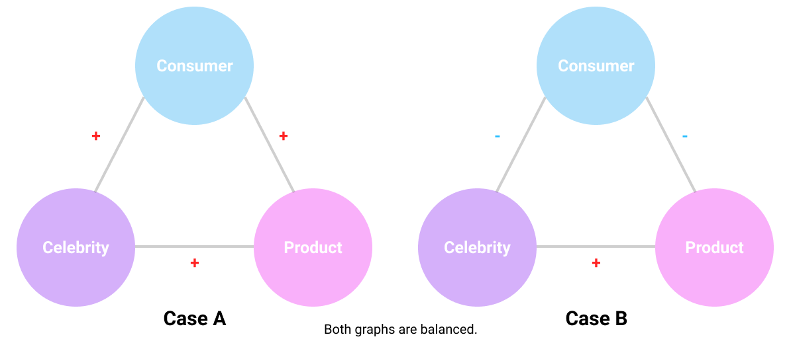

Consumer behaviourists and advertising practitioners have been looking to celebrity endorsements as a method to positively affect consumers’ attitudes towards products. This powerful market strategy came about by building upon existing social psychology theories, including the Balance theory. The three nodes in this model include the consumer, the product and the celebrity. If a consumer has a positive connection with a celebrity online (eg. follows the celebrity on social media as a fan), and if they perceive that said celebrity likes a product (as emphasized on their social media page), the said person will tend to like the product more, therefore achieving psychological balance.

Before the celebrity endorsement, there is no positive connection between the consumer and the product, but there is a positive connection between the consumer and the celebrity. After the celebrity endorsement, the positive connection between the celebrity and the product becomes public. When the user sees the positive connection between the product and celebrity, it is likely that they will also like the product (Case A). Based on the balance theory, having either 3 positive edges or two negative edges maintains psychological balance. Therefore, the balance theory also works in the case that the consumer already dislikes a product (negative connection). If a celebrity endorses this disliked product, it is likely that the consumer will develop a negative connection with the celebrity as well (Case B).

- Cognitive Dissonance
Cognitive dissonance is an internal conflict that people have when their differing beliefs and opinions collide. A marketer who can resolve such conflicts may help consumers choose their brand's products. If you're a marketer, understanding cognitive dissonance can be a significant factor in helping you create effective brand messaging. In marketing, one of the most widely studied concepts is consumer behaviour since its knowledge immensely supports the company to plan and also implement marketing strategies. By having a better understanding of the elements shaping consumer behaviour, marketers are able to have a better position to estimate how consumers will respond to these strategies. Hence, marketers and psychologists examine consumers' attitudes and responses resulting in purchases in terms of their beliefs, tendencies and feelings. In that sense, the cognitive dissonance theory is a phenomenon related to attitude change and therefore it is quite significant to understand.

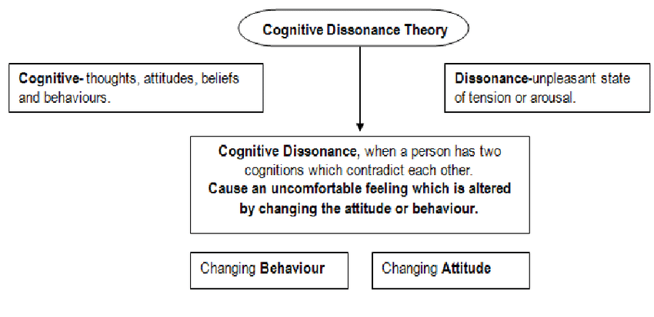

Causes of cognitive dissonance
1. Forced Compliance behaviour
When someone is forced or made to do something publicly which they don’t want to do then a distance is created between their cognition. This distance is between their cognition and their behaviour. For example, a common reaction of people is: I did not want to do this, but I have to do it, or I did it.
This forced compliance happens when a person performs an action which is inconsistent with his beliefs. The behaviour cannot be altered because it was in the past, and that is why distance should be reduced by re-evaluating what they have done and their attitude. This theory has also been tested experimentally.
- Decision Making
Decision making is everywhere in everyone’s life. Decisions are the one which promotes dissonance. For example, if you have to decide whether you want to go travelling to a particular country abroad or if you want to invest the money in savings, then you may experience a dissonance. If you go on the tour and spend money, then you would have beautiful memories and experience of a lifetime but have no savings, and if you save the money, you would have a bright future but no experience and no memories. Both alternatives have advantages and disadvantages. The point here to understand is that making one decision can cut off the possibility that you may enjoy the benefits of the alternative which you did not choose. Nevertheless, it assures you that you have to learn to accept the disadvantages of the alternative that you have chosen. People have multiple ways to minimize their dissonance, which is aroused by making a decision.
One of the common ways to reduce our dissonance is to increase the attractiveness of the alternative that is chosen and reduce the attractiveness of the rejected choice. This is known as spreading the alternatives apart.
3. Effort
It may be the case that those goals are valued more, which require a lot of effort to achieve. This is because dissonance may be caused.
If we spend a lot of effort to achieve something minimal and evaluate it in a negative light, then it doesn’t make sense and doesn’t add up. We could spend many years into an effort to achieving something. Then it turns out to be very insignificant and rubbish and later to avoid dissonance and when it is produced you try to convince that you did not spend a lot of years or a lot of effort or that effort was quite enjoyable.
It is, in fact, more comfortable, to persuade ourselves and convince that what we have achieved is worthwhile and that is what many people do. They validate that something the achievement of which has cost them a lot. This is the method of reducing the dissonance, which is called justification of effort.

If we put the effort in achieving for carrying out the task and if the task turns out bad or negative, then we experience effort dissonance. To minimize this dissonance, people are motivated to think that the task turned out well, and it required a lot of justified efforts.

Factors influencing Cognitive dissonance
There are multiple factors which determine the dissonance degree which people experience. These include how highly they value their beliefs and the degree of inconsistency of their ideas.
Following are a few factors which can influence the strength of dissonance:
- The relevancy of cognitions that is the things which involve beliefs which are valued highly typically result in a much stronger dissonance.
- The more personal cognitions. These are the beliefs about the self, and they tend to result usually in higher amounts of dissonance.
- The ratio of dissonant thoughts and consonant thoughts, also known as the ratio of clashing ideas and harmonious thoughts, respectively.
- The higher the strength of dissonance, the more pressure to overcome the uncomfortable feelings.

How can you resolve Cognitive Dissonance?
- Changing the existing beliefs
The change is done primarily to introduce a consonant in two elements. The individual can alter or eliminate the behaviour when one of the dissonant elements is, in fact, behaviour. However, this mode of reducing dissonance usually presents problems for many people since it is difficult for them to alter their well-learned responses. One of the common examples of this is giving up smoking or drinking.

2. Addition of new beliefs
Having new beliefs will help people to cope up with the dissonance, and the difference does not affect them much. This new information, more often than not, is precisely the opposite of their belief. For example, smoking will cause lung cancer. Serve that information by adding the word research, and it will have more effect like Research suggests that smoking causes lung cancer. The earlier sentence, although declarative, may not appeal to many users. The second sentence, on the other hand, appeals to almost all of the smokers.

3. Minimizing the importance of cognitions
A person may have an attitude that living for today is way better than saving for tomorrow. He could tell himself that life is too short to be filled with smoking. There is but very little pleasure in smoking. The smoker can convince himself that smoking is not essential and perhaps one of the least pleasurable things he can do. It would slowly decrease the importance of his dissonant cognition. The importance of smoking should be reduced according to the smoker. Only then can he go beyond his dissonance.
Everyone experiences cognitive dissonance on some level. The level to which it affects you may vary depending on how strong your beliefs are and how your reaction to the dissonance feelings. It is important to remember that change is the only constant thing.

Why is it important for marketers?
In marketing, cognitive dissonance relates to consumers' expectations, feelings about brands and internal logic when deciding to buy something. Marketers try to be aware of potential conflicts or expectations that might affect buying decisions. For a marketer, if cognitive dissonance involves purchasing their product, they typically want to resolve the conflict in favour of what they're trying to sell. It is important in not only acquiring new consumers, but also retaining the existing ones by satisfying their expectations and providing value as a positive brand image, which is a crucial role for marketers. In order to implement a successful strategy for both new and existing consumers, marketers first must fully understand the factors leading them to make the purchase. This is where the cognitive dissonance theory takes part. For example, a person who is experiencing a conflict between his beliefs and behaviours might be open to being 'the new consumer' for a company.

How to resolve cognitive dissonance in marketing
Marketers can seek to resolve cognitive dissonance in consumers through a variety of strategies. Sometimes, those strategies involve resolving anxiety, boosting consumer confidence or differentiating their product from competitors' products. Here are five steps to using cognitive dissonance in marketing:

1. Encourage consumer beliefs
Appealing to consumers' strongly held beliefs is one tactic that a marketer can use to overcome potential cognitive dissonance. By reinforcing an internal belief, a campaign can resolve potential challenges regarding consumer decisions. The belief could be one of self-image, such as appealing to a person's view of themselves as smart and then positioning a company's product as a suitable choice for a savvy consumer.

2. Use a consistent tone
If the tone of a marketing campaign is consistent with consumer expectations, it may have a positive effect on the customer. For example, if a brand typically uses a friendly, casual tone in its marketing materials, creating an upbeat advertising campaign may appeal to consumers and help them overcome any cognitive dissonance. Logos, colours and messaging can all contribute to the tone of a campaign.

3. Include relevant facts
Providing consumers with factual information about those appeals to their beliefs is another way you can attempt to resolve cognitive dissonance. Testimonials, independent studies and the opinion of experts are all methods that a company can use in its marketing campaigns. This tactic appeals to the rational decision-making side of consumers and may convince them that a particular company's brand is the right choice.

4. Appeal to emotions
Marketers typically want consumers to have positive emotions associated with their products. They may also want to address any doubts or anxiety that consumers have. An emotional appeal can allow them to counter rational decision-making that might be an obstacle to a consumer's purchasing actions. For instance, a campaign might seek to make a consumer feel more positive about a product by highlighting its unique features. This may lead consumers to disregard feelings of anxiety over price and purchase the product.

Personality
To understand a buyer needs and convert them into customers is the main purpose of the consumer behaviour study. To understand the buyer habits and his priorities, it is required to understand and know the personality of the buyer.
Personality signifies the inner psychological characteristics that reflect how a person reacts to his environment. Personality shows the individual choices for various products and brands. It helps the marketers in deciding when and how to promote the product. Personality can be categorized on the basis of individual traits, likes, dislikes etc.
Though personality is static, it can change due to major events such as death, birth or marriage and can also change gradually with time. By connecting with the personality characteristics of an individual, a marketer can conveniently formulate marketing strategies.

Theories of personality
- Psychoanalytic Theory
Definition: The Psychoanalytic Theory is the personality theory, which is based on the notion that an individual gets motivated more by unseen forces that are controlled by the conscious and the rational thought.
Sigmund Freud is closely related to the psychoanalytic theory. According to him, the human behaviour is formed through an interaction between three components of the mind, i.e. Id, Ego and Super Ego.

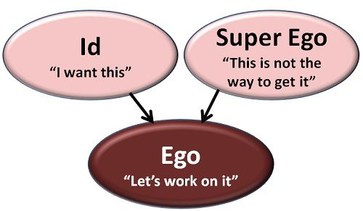

Id: Id is the primitive part of the mind that seeks immediate fulfilment of needs. The biological needs are the basic needs such as hunger, thirst etc. Id is the unconscious part of the mind; that act instantaneously without giving much thought to what is right and what is wrong.
Example: If your Id passed through a boy playing with a ball, the immediate urge to get that ball will drive you to snatch it by any means, this is irrational and may lead to the conflict between the boys. Thus, Id is the source of psychic energy, a force that is behind all the mental forces.

Super-Ego: The Super-Ego is related to the social or the moral values that an individual inculcates as he matures. It acts as an ethical constraint on behaviour and helps an individual to develop his conscience. As the individual grows in the society, he learns the cultural values and the norms of the society which help him to differentiate between right and wrong.
Example: If the super-ego passed that boy playing with a ball, it would not snatch it, as it would know that snatching is bad and may lead to a quarrel. Thus, super ego act as a restriction on your behaviour and guides you to follow the right path. But if the Id is stronger than super-ego, you will definitely snatch the ball by any means.

Ego: Ego is the logical and the conscious part of the mind which is associated with the reality principle. This means it balances the demands of Id and super-ego in the context of real life situations. Ego is conscious and hence keeps a check on Id through a proper reasoning of an external environment.
Example: If you pass through the same boy playing with the ball, your ego will mediate the conflict between the Id and super-ego and will decide to buy a new ball for yourself. This may hurt you Id, but the ego would take this decision to reach to a compromise situation between the Id and super-ego by satisfying the desire of getting a ball without committing any unpleasant social behaviour.
Hence, these are the fundamental structures of the mind, and there is always a conflict between these three. The efforts to attain the balance between these define the way we behave in the external environment.

The Psychoanalytic Theory and Consumer Behaviour,
The psychoanalytic theory is a concept also used by the marketing people. In today’s world, the continuity of existing brands, and the success of new brands are highly dependent on existing consumer’s preferences. Sometimes, brands find a target customer to sell their product and start or expand their business.
The role of the unconscious mind of the consumer takes an important role. Brands position themselves into a consumer’s mind while the consumer is unaware of this action. For example, let's assume that you go shopping for a red t-shirt which is your favourite colour. Then you see the section of a trendsetter textile brand, finally, you buy a yellow t-shirt. When you buy it you think that the colours that this brand chose for the creation is better than your favourite colour. Or, let's assume you go shopping to buy a frozen pizza of Super fresh as usual. Then, you see the Torku (Turkish farmer cooperative brand) frozen pizza and think as Torku’s pizza should be healthier than Super fresh, you can buy Torku’s product even if you haven’t tasted before. In the end, there is the same reason for these two different examples under the buying behaviour of consumers: the unconscious mind.
Marketers know that consumers tend to relate personality-like traits to different products and brands. Consumers buy products of a brand if they match their personality styles with it.
Marketers use colours to position the brands in the consumer mind. For instance, green means fresh, red means passion, anger, yellow means optimism, white means purity, and blue means trust, cleanliness. Thus, we see the colours white, green, and blue on toothpaste. We all remember the product signal white now; the strategy was to show to women consumers instant whitener toothpaste. The interesting part was that the colour selection was the as dominant colour of pink, and the other colours as blue, and white. At the product’s advertisement, there were lots of girly and shiny objects too. It seems that they try to reach women consumers by pink colour assigned to the women, in the end, it worked!
The alcohol and tobacco brands use the unconscious mind of consumers too. Even if, the consumer knows that alcohol and tobacco harm the body, they still use it. People drink alcohol in an event, or a nightclub while having fun with their friends. The cigarette can occur when drinking alcohol. Oppositely, people may consume alcohol and cigarette when they are upset and want to have fun and remove negative ideas from their minds.

2. Social Personality Theory
Some social-psychologists have forwarded the view that, social relationships are fundamental to the formations and development of personality. On the basis of their orientations in relating to others, individual consumers tend to develop methods to cope with their anxieties, Consumers have consequently been classified into three personality groups using what is called the `CAD model' where CAD is an acronym that stands for compliance, aggression and detachment. The CAD model considers all consumers as having one of three basic orientations so that they may be described as belonging to one of the following categories of individuals:
i) Compliant Individuals: These individuals tend to move toward others. Compliant people have a need for love, affection, approval and the desire to be appreciated. They are essentially conformists.
ii) Aggressive Individuals: They tend to move against others. Their interpersonal orientations display the ability to manipulate others. Such individuals also appear to have a need to achieve success, to excel, to gain admiration and to be in a power position.
iii) Detached Individuals: This category of persons tends to move away from others. Their relationships emphasise the need for self-reliance, independence, and freedom.

Application of Social Personality Theory
It has been found that individuals having different personality types tend to use different products and brands. The CAD model was, in fact, developed for the specific purpose of studying buying behaviour and it emphasises the effect of social influences on the personality. Thus, studies have shown that compliant types have been found to prefer known products and brands while aggressive types have been found to prefer specific brands out of a desire to be noticed like razor, after shave lotion. In contrast, detached types appear to have the least awareness of brands.
The CAD approach is used by marketers to predict which consumers may be more or less prone to group influence. The most important application of social-psychological theory is its emphasis on the social nature of consumption. In fact you will see this in advertising copy in which social interaction is stressed more than the products themselves. Advertising for personal care products, for instance, emphasises the fear of offending others. Social interaction is also highlighted in the case of products advertised for occasions for being together.

3. Trait theory
Traits are the features of an individual or tendency of an individual in a particular manner. Traits help in defining the behaviour of consumers. According to the Trait theorists, an individual’s personality make-up stems out of the traits that he possesses, and the identification of traits is important.

Following are the few of the most common traits −

Outgoing
Sad
Stable
Serious
Happy go lucky
Relaxed
Self-assured
Practical
Imaginative

Traits must be measured
- Consumer Innovativeness: The degree to which consumers are receptive to new products, new services, or new practices. Innovativeness is also defined as the degree to which individuals adopt new ideas faster than other members in a system. Consumer innovativeness remains an important concept in understanding the adoption of new products, and predicts consumers' innovative buying behaviour using innovativeness as a personality trait.

- Consumer materialism: Materialism refers to the attachment people have towards material possessions. When looking at materialism as personality trait, advertisers differentiate between consumers who identify themselves and other on the basis of material goods possessed by them. It is necessary to note that apart from the group of consumers who are attached to material goods, there are certain groups of people for whom possession of material goods is secondary.

- Consumer Ethnocentrism: The tendency of customers' preference to their local brands over the foreign ones is known as consumer ethnocentrism, and it is an important issue in international marketing. consumer ethnocentrism has a positive influence on domestic product judgements and willingness to buy domestic products.

- Carl Jung theory of personality
Jung’s theory on personality types shows the various behavioural patterns and attitude. Using the theory, you can delve deeper into your own mind and comprehend your thoughts and feelings.
According to Jung there are two mutually exclusive attitudes – extraversion and introversion.
“Each person seems to be energized more by either the external world (extraversion) or the internal world (introversion).”
The introvert is more comfortable with the inner world of thoughts and feelings, so they will see the world in terms of how it affects them. While the extrovert feels more at home with the world of objects and other people, and is more concerned with their impact upon the world. Introverts are more comfortable living alone and being by themselves. They depend on their “me time” to recharge; they become immersed in their inner world and run the risk of losing touch with their surroundings or their outer world.
Carl Jung also described the four function of human personality which is:
- Sensation: A mental condition or physical feeling resulting from stimulation of a sense organ or from internal bodily change, as cold or pain. A state of excited feeling or interest caused among a number of persons or throughout a community, as by some rumour or occurrence
- Thinking: Thinking is a core function in human personality. This function mostly uses logic and reasons and focus and less emotion. Thinking means that when a person observes anything around himself and around the environment and thinks about that thing and which he wants to explore more.
- Feeling: Jung defined feeling as “primarily a process that takes place between the ego and a given content. It is like something you want to express. For example, Happiness, sadness, excitements, etc. are the feeling which a person can feel.
- Intuition: This is the last function of human’s personality. It refers to the ability to understand something quickly without the conscious reasoning. It is that psychological function which transmits perceptions in an unconscious way.

Personality traits and consumer behaviour /Marketing
Brands try their best to have personalities, but the personality of the consumer drives many marketing decisions. To study the impact to personality on consumer behaviour it is important to study the five big models.
The Big Five Personality Traits
The big five personality traits - Openness, Conscientiousness, Extroversion, Agreeableness, and Neuroticism. These are the five personality traits that provide the foundation for personality. Individuals receive a score for each one, with the higher scores indicating which elements of the personality are the most dominant.

The Five Factor Model

Table that lists key features of the Big 5 Traits
Big 5 Trait | Definition | Key Features
Openness | The tendency to appreciate new art, ideas, values, feelings, and behaviours | - Fantasy prone  - Open to feelings  - Open to new and different ideas  - Open to various values and beliefs
Conscientiousness | The tendency to be careful, on-time for appointments, to follow rules, and to be hardworking. | - Competent  - Orderly  - Dutiful  - Achievement oriented  - Self-disciplined  - Deliberate
Extraversion | The tendency to be talkative, sociable, and to enjoy others; the tendency to have a dominant style. | - Gregarious (sociable)  - Warm  - Assertive  - Active  - Excitement-seeking  - Positive emotionality
Agreeableness | The tendency to agree and go along with others rather than to assert one’s own opinions and choices. | - Trusting  - Straightforward  - Altruistic  - Compliant  - Modest  - Tender-minded
Neuroticism | The tendency to frequently experience negative emotions such as anger, worry, and sadness, as well as being interpersonally sensitive. | - Anxious  - Angry  - Depressed  - Self-consciousness  - Impulsive  - Vulnerable

Applying the Big Five Personality Traits to Improve Marketing Strategy
Identifying consumers
- Finding consumers to target. Certain personality types have a tendency towards certain types of products, making them a natural fit for a specific brand.
- Recognising the “right” consumers. Being able to see consumer personalities sheds light on lifestyle preferences, which can enable brands to better identify which consumers are likely to be more responsive to their messages.
Categorising consumers
- Identifying specific tendencies and behaviours. Patterns of decision making and shopping habits can be identified to categorise consumers.
- Enabling segmenting of customers into personality types, as opposed to more generic categories. With this kind of insight it’s much simpler to ensure that the right message is getting to the right person.
Targeting consumers
- Refining messaging- where marketing messaging has been defined with the personality traits of the target consumer in mind it is likely to have a much more significant impact. Mass campaigns are not as efficient as those that use customised messages.
- Enabling the use of more quantitative techniques to target consumers. For example, targeting women who react to celebrity endorsements are willing to shop online and have an affinity with fitness and the outdoors provides a lot more to work with than “women in London aged between 20 and 35.”
- Promoting a deeper understanding of the consumer. Personality insights tend to result in more creative marketing and brand management, based on deeper insights into a potential target audience.
- Personalising the brand. Numerous studies suggest that consumers relate to brands as they would another person. Stronger and more long-term relationships can be built with consumers where brand personality has been refined according to the traits of the target audience.

Self-Concept
Self-concept is defined as the way, in which we think, our preferences, our beliefs, our attitudes, our opinions arranged in a systematic manner and also how we should behave and react in various roles of life. Self-concept is a complex subject as we know the understanding of someone’s psychology, traits, abilities sometimes are really difficult. Consumers buy and use products and services and patronize retailers whose personalities or images relate in some way or other to their own self-images

Traditionally, individuals are considered to be having a single self-image which they normally exhibit. Such types of consumers are interested in those products and services which match or satisfy these single selves. However, as the world became more and more complex, it has become more appropriate to think of consumers as having multiple selves.

The below are some of the major aspects of Self-concept
- Self-Concept is organized
We all have various views about ourselves. We all may think we are kind, calm, patient, selfish, rude and what not. It doesn’t matter what perception you have about yourself, but the one perception that facilitates all these insights is organized self-concept. When a person believes in something that matches his self-concept he sticks to his view and does not agree to change the same and even if does, it takes a lot of time.
- Self-Concept is learned
It is believed that self-concept is learned and no person is born with a self-concept. It develops as and when we grow old. Our self-concept is built when we meet people socially and interact with them. We are the ones who shape or alter our self-concept and its quite natural that we may have a self-concept different for ourselves as compared to what people think about us. For example − If an individual thinks, he is very generous and helpful, it may not necessarily be the case with others. Others may see him as a selfish person.
- Self-Concept is Dynamic
Our self-concept in life is not constant and it may change with instances that take place in our lives. When we face different situations and new challenges in life, our insight towards things may change. We see and behave according to the things and situations. Thus, it is observed that self-concept is a continuous development where we let go things that don’t match our self-concept and hold on those things that we think are helpful in building our favourable perception. Self-concept is the composite of ideas, feelings, emotions and attitudes that a person has about their identity and capabilities.

Four views of the development of self-concept
- Self –Appraisal /Self image
A person’s self-image is based on how they see themselves, while self-concept is a more comprehensive evaluation of the self, largely based on how a person sees themselves, values themselves, thinks about them, and feels about them.

- Reflective Appraisal /looking glass self
The looking-glass self describes the process wherein individuals base their sense of self on how they believe others view them. Using social interaction as a type of “mirror,” people use the judgments they receive from others to measure their own worth, values, and behaviour. The looking-glass self-definition states that a person's thoughts and feelings about themselves are formed based on the responses of others and their perception of how they appear to others. For example, a person may believe that they are very attractive because another person complimented their shirt or hair. Alternatively, a person may believe that they are unattractive because another person made a negative comment about their choice in shoes. The looking-glass self has a major impact on the development of one's self-image.

- Social comparison

Social comparison occurs when we learn about our abilities and skills, about the validity of our opinions, and about our social status by comparing our own attitudes, beliefs, and behaviours with those of others. These comparisons can be with people that we know and interact with, with those that we read about or see on TV or with anyone else that we view as important.

Social comparison occurs primarily on dimensions upon which there is no objectively correct answer and thus on which we can rely only on the beliefs of others for information. Answers to questions such as “What should I wear to the formal?” or “What kind of music should I have at my wedding?” are frequently determined at least in part by using the behaviour of others as a basis of comparison. We also use social comparison to help us determine our skills or abilities—how good we are at performing a task or doing a job, for example. When a student looks at another student’s paper to see what grade he or she got, or when we join a tennis club to compare our performance and progress with those of others, we are using social comparison to evaluate our abilities.

- Biased scanning
This theory suggests that a person, who aspires to be for example lawyer, will scan the environment for information to find out which one confirms his aspirations and filter out information that contradicts it. Thus perceptual scanning is biased towards seeing ourselves as we would like to be.

Role of Self-Concept in Marketing Product Image and Branding
Self-concept shapes the process of creating a product image and designing a branding strategy to a considerable extent. To be more specific, it helps make the said product or service not only desirable but also vital for the successful functioning of the target population. Therefore, it is crucial that the brand personality of a particular product align with the self-concept of the target audience. In a certain way, the specified task implied dealing with a range of obstacles, mainly due to the fact that appealing to the unique self-concept of every potential customer is barely possible.

To appeal to the target population successfully, it is crucial to realize how potential customers see themselves, as well as what their ideal image of themselves is. Thus, the basis for creating a successful marketing campaign that will brand the required product as an essential attribute to the specified image will become a possibility.

Determining the Consumer Behaviour
When considering the reasons for analysing the self-concept of the target population, one must mention that the specified process will help define the types of consumer behaviour that can be observed in the target market.

