I. Polity and governance
- Ministries of Government of India
- Autonomous government bodies
II. Ministry of Home Affairs
- Enforcement Organizations
- Internal Security
- Police
III. Communal tensions
Review of latest episodes of communal tensions
IV. The tensions in J&K
- Background, Political players
- Update on the current situation
V. Review of any three Central Government projects and policies

I. POLITY AND GOVERNANCE
Introduction
India is the largest democracy in the world! It is difficult at the same time crucial to maintaining law and order. The Indian Government is shaped by the Constitution of India. The Indian constitution is a comprehensive document containing details with the objective of providing stable and fair governance to its people. Indian constitution is the lengthiest written constitution among the all constitution of the world.
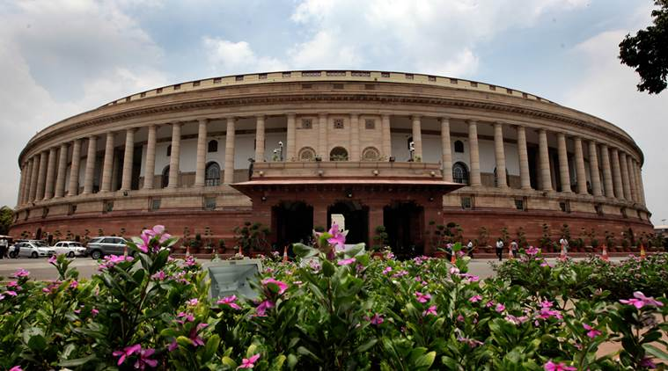
Note: The idea to frame the constitution of India was first suggested by M.N Roy.
Polity versus Governance - What's the difference?
Indian Polity
- Parliament and State Legislatures -structure, function, conduct of business, powers and privileges and issues arising out of these
- The Structure, Organization and functioning of executive and the judiciary -Ministries and departments of the government , pressure groups and formal /informal associations and their role in polity.
- The Salient features of Representation of People’s act
Governance
- Appointments to various Constitutional posts, powers, functions and responsibilities of various constitutional bodies.
- The Statutory, Regulatory and various Quasi-Judicial bodies.
- The government Policies and interventions for development in various sectors and issues arising out of their design and implementation.
- Important aspects of governance, transparency and accountability, e- governance, application models, success, limitations and potential citizen charters, transparency and accountability and institution and other measures.
II. MINISTRIES OF GOVERNMENT OF INDIA
Narendra Modi government: Full list of portfolios and ministers
The 17th Lok Sabha of India came into being on May 30, 2019 with the oath-taking ceremony of India's 16th Prime Minister Narendra Modi along with the Council of Ministers. Modi has dropped 28 out of the 71 ministers from the previous team, while 23 fresh faces have been included in the new Cabinet.
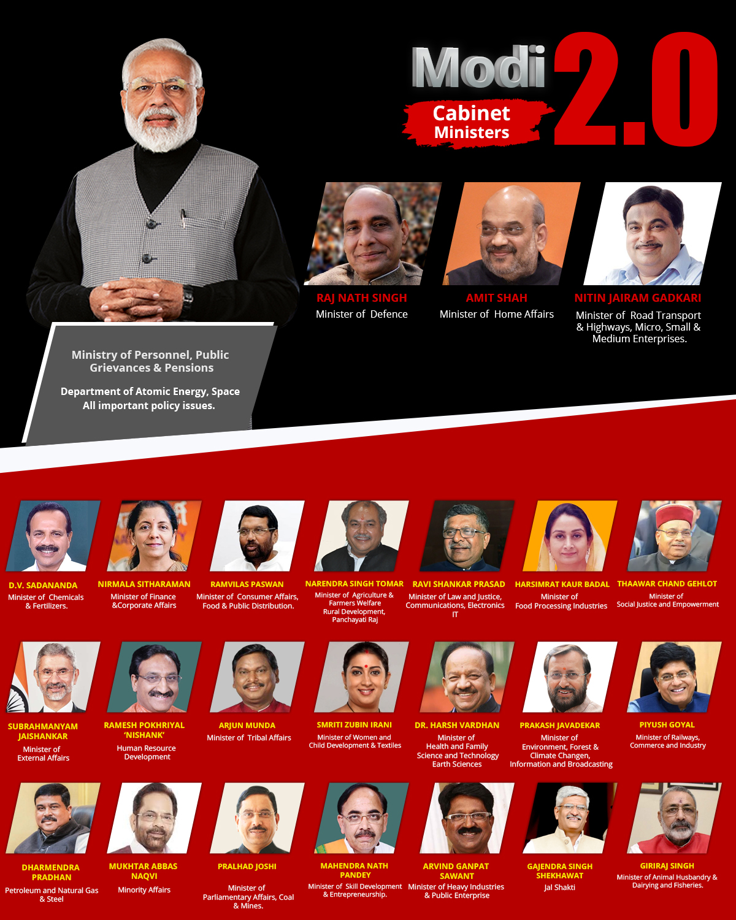
Prime Narendra Modi's image used in the poster above was clicked by India Today's Group Photo Editor (Bandeep Singh who tweets at @junglelight). The poster has been illustrated by Deepak Verma.
Here is a list of portfolios of current Cabinet Ministers, Ministers of State (Independent Charge) and Ministers of State.

Union Council of Ministers

Prime Minister
Shri Narendra Modi | Prime Minister and also in-charge of:  Ministry of Personnel, Public Grievances and Pensions; Department of Atomic Energy; Department of Space; and All important policy issues; and All other portfolios not allocated to any Minister.
Cabinet Ministers
Sr. No. | Name | Ministers
1 | Rajnath Singh | Minister of Defence.
2 | Amit Shah | Minister of Home Affairs.
3 | Nitin Jairam Gadkari | Minister of Road Transport and Highways; and Minister of Micro, Small and Medium Enterprises.
4 | D.V. Sadananda Gowda | Minister of Chemicals and Fertilizers.
5 | Nirmala Sitharaman | Minister of Finance; and Minister of Corporate Affairs.
6 | Ram Vilas Paswan | Minister of Consumer Affairs, Food and Public Distribution.
7 | Narendra Singh Tomar | Minister of Agriculture and Farmers Welfare; Minister of Rural Development; and Minister of Panchayati Raj.
8 | Ravi Shankar Prasad | Minister of Law and Justice; Minister of Communications; and Minister of Electronics and Information Technology.
9 | Harsimrat Kaur Badal | Minister of Food Processing Industries.
10 | Thaawar Chand Gehlot | Minister of Social Justice and Empowerment.
11 | Dr. S. Jaishankar | Minister of External Affairs.
12 | Ramesh Pokhriyal 'Nishank' | Minister of Human Resource Development.
13 | Arjun Munda | Minister of Tribal Affairs.
14 | Smriti Irani | Minister of Women and Child Development; and Minister of Textiles.
15 | Dr. Harsh Vardhan | Minister of Health and Family Welfare; Minister of Science and Technology; and Minister of Earth Sciences.
16 | Prakash Javadekar | Minister of Environment, Forest and Climate Change; and Minister of Information and Broadcasting.
17 | Piyush Goyal | Minister of Railways; and Minister of Commerce and Industry.
18 | Dharmendra Pradhan | Minister of Petroleum and Natural Gas; and Minister of Steel.
19 | Mukhtar Abbas Naqvi | Minister of Minority Affairs.
20 | Pralhad Joshi | Minister of Parliamentary Affairs; Minister of Coal; and Minister of Mines.
21 | Dr. Mahendra Nath Pandey | Minister of Skill Development and Entrepreneurship.
22 | Arvind Sawant | Minister of Heavy Industries and Public Enterprise.
23 | Giriraj Singh | Minister of Animal Husbandry, Dairy and Fisheries.
24 | Gajendra Singh Shekhawat | Minister of Jal Shakti.
Ministers of State (Independent Charge)
1 | Santosh Kumar Gangwar | Minister of State (Independent Charge) of the Ministry of Labour and Employment.
2 | Rao Inderjit Singh | Minister of State (Independent Charge) of the Ministry of Statistics and Programme Implementation; and Minister of State (Independent Charge) of the Ministry of Planning.
3 | Shripad Yesso Naik | Minister of State (Independent Charge) of the Ministry of Ayurveda, Yoga and Naturopathy, Unani, Siddha and Homoeopathy (AYUSH); and Minister of State in the Ministry of Defence.
4 | Dr. Jitendra Singh | Minister of State (Independent Charge) of the Ministry of Development of North Eastern Region; Minister of State in the Prime Minister's Office; Minister of State in the Ministry of Personnel, Public Grievances and Pensions; Minister of State in the Department of Atomic Energy; and Minister of State in the Department of Space.
5 | Kiren Rijiju | Minister of State (Independent Charge) of the Ministry of Youth Affairs and Sports; and Minister of State in the Ministry of Minority Affairs.
6 | Prahalad Singh Patel | Minister of State (Independent Charge) of the Ministry of Culture; and Minister of State (Independent Charge) of the Ministry of Tourism.
7 | Raj Kumar Singh | Minister of State (Independent Charge) of the Ministry of Power; Minister of State (Independent Charge) of the Ministry of New and Renewable Energy; and Minister of State in the Ministry of Skill Development and Entrepreneurship.
8 | Hardeep Singh Puri | Minister of State (Independent Charge) of the Ministry of Housing and Urban Affairs; Minister of State (Independent Charge) of the Ministry of Civil Aviation; and Minister of State in the Ministry of Commerce and Industry.
9 | Mansukh L. Mandaviya | Minister of State (Independent Charge) of the Ministry of Shipping; and Minister of State in the Ministry of Chemicals and Fertilizers.
Ministers of State
1 | Faggansingh Kulaste | Minister of State in the Ministry of Steel.
2 | Ashwini Kumar Choubey | Minister of State in the Ministry of Health and Family Welfare.
3 | Shri Arjun Ram Meghwal | Minister of State in the Ministry of Parliamentary Affairs; and Minister of State in the Ministry of Heavy Industries and Public Enterprises.
4 | General (Retd.) V. K. Singh | Minister of State in the Ministry of Road Transport and Highways.
5 | Krishan Pal | Minister of State in the Ministry of Social Justice and Empowerment.
6 | Raosaheb Danve | Minister of State in the Ministry of Consumer Affairs, Food and Public Distribution.
7 | G. Kishan Reddy | Minister of State in the Ministry of Home Affairs.
8 | Purushottam Rupala | Minister of State in the Ministry of Agriculture and Farmers Welfare.
9 | Ramdas Athawale | Minister of State in the Ministry of Social Justice and Empowerment.
10 | Sadhvi Niranjan Jyoti | Minister of State in the Ministry of Rural Development.
11 | Babul Supriyo | Minister of State in the Ministry of Environment, Forest and Climate Change.
12 | Sanjeev Kumar Balyan | Minister of State in the Ministry of Animal Husbandry, Dairying and Fisheries.
13 | Dhotre Sanjay Shamrao | Minister of State in the Ministry of Human Resource Development; Minister of State in the Ministry of Communications; and Minister of State in the Ministry of Electronics and Information Technology.
14 | Anurag Thakur | Minister of State in the Ministry of Finance; and Minister of State in the Ministry of Corporate Affairs.
15 | Suresh Angadi | Minister of State in the Ministry of Railways.
16 | Nityanand Rai | Minister of State in the Ministry of Home Affairs.
17 | Ratanlal Kataria | Minister of State in the Ministry of Jal Shakti; and Minister of State in the Ministry of Social Justice and Empowerment.
18 | V. Muraleedharan | Minister of State in the Ministry of External Affairs; and Minister of State in the Ministry of Parliamentary Affairs.
19 | Renuka Singh Saruta | Minister of State in the Ministry of Tribal Affairs.
20 | Som Parkash | Minister of State in the Ministry of Commerce and Industry.
21 | Rameswar Teli | Minister of State in the Ministry of Food Processing Industries.
22 | Pratap Chandra Sarangi | Minister of State in the Ministry of Micro, Small and Medium Enterprises; and Minister of State in the Ministry of Animal Husbandry, Dairying and Fisheries.
23 | Kailash Choudhary | Minister of State in the Ministry of Agriculture and Farmers Welfare.
24 | Debasree Chaudhuri | Minister of State in the Ministry of Women and Child Development.

III. AUTONOMOUS GOVERNMENT BODIES
Introduction
Autonomous body refers to those body which has sole right and power to establish their own laws and code of conduct. These body are free from an external pressure, thus they can act independently.
In India autonomous body are given freedom to set their own laws but such laws must be in accordance with the Constitution and existing laws of the land.
Autonomous Organisation’s or Institution’s work on their own as a result there is a greater chance of success because any organisation wants a degree or level of freedom which in this case exist.
Types of government bodies
The government of India is a parliamentary democracy, which means that the executive branch of government is liable to the legislative branch. It is said that democracy is not only about numbers and votes, it is also about institutions and their independence. To further the goal of democracy and executing various functions different types of bodies are created by government with particular mandates.
Constitutional Bodies
The Constitutional bodies are commonly executive in nature, with the power of advising the government. It guaranteeing active functioning of the government is the main objective behind the establishment of these bodies. While some are permanent agencies, there are a few ad hoc bodies as well, which are established for a fixed term. The constitutional bodies not only support the principles of the Constitution but also serve the government machinery to run efficiently. These are the bodies which are stated in constitution of India are considered as more powerful and independent autonomous government bodies.
Some Important constitutional Bodies with Articles:
Article76: Attorney General of India
Article 148: Comptroller and Auditor General of India
Article 165: Advocate General of India
Article 243-I: State Finance Commission
Article 243-M: State Election Commission
Article 243ZD: District Planning Committee
Article 243ZE: Metropolitan Planning Committee
Article 263: Inter-state Council
Article 280: Finance Commission
Article 279A: Goods and Service Tax Council
Article 306: Interstate Trade and Commerce Commission
Article 315: UPSC and SPSC
Article 324: Election Commission
Article 338: National Commission for Scheduled Castes
Article 338A: National Commission for Scheduled Tribes
Article 338B: National Commission for Backward Classes
Article 337: Scheduled Area and Scheduled Tribes Commission
Article 340: Backward Classes Commission
Article 344: Official Language Commission and Official Language Committee of Parliament
Article 350B: Special Officer for Linguistic Minorities
Statutory Bodies
Statutory bodies are established by acts which Parliament and State Legislatures can pass. It made through the power of central government. It is passed in Sansad then it is formed. These bodies are entities shaped by an Act of Parliament or state legislatures and set up by the government to consider the data and make judgments in some area of activity. Statutory bodies are normally set up in countries which are ruled under parliamentary democracy form of political setup.
Some Important Statutory Bodies
- National Human Rights Commission
- National Commission for Women
- National Commission for Minorities
- National Commission for Backward Classes
- National Commission for Protection of Child Rights
- Central Vigilance Commission
- Central Information Commission.
- National Law Commission
- National Green Tribunal
- National Consumer Disputes Redressal Commission
- Armed Forces Tribunal
Non Statutory and Non Constitutional body
Non constitutional body which does not find its name in the constitution of India. Hence, it cannot derive power from constitution of India. These are bodies which are formed by executive resolution or action, which means that they are formed by government’s action only.
Planning Commission of India
For Example: Planning Commission was established by an executive decision of Government of India in 1950 in accordance with article 39 of the constitution which is a part of directive principles of state policy. Advisory Planning Board constituted in 1946 under the chairmanship of K.C Neogi gave recommendations for the establishment of the Planning Commission. The Planning Commission is a non-constitutional and non-statutory body and is responsible to formulate five years plan for social and economic development in India.
Some Important Non Statutory and Non Constitutional body
- Planning Commission of India
- National Development Council
- National Human Rights Commission
- State Human Rights Commission
- Central Information Commission
- State Information Commission
- Central Vigilance Commission
- Central Bureau of Investigation
- Lokpal and Lokayuktas

Name of the Non-constitutional body | Composition
National Development Council | The NDC is composed of the following members.  1. Prime minister of India  2. All Union cabinet ministers (since 1967).  3. Chief ministers of all states.  4. Chief ministers/administrators of all union territories.  5. Members of the Planning Commission.
National Human Rights Commission | It is a multi-member body consisting of a chairman and four members.
State Human Rights Commission | It is a multi-member body consisting of a chairperson and two Members
Central Information Commission | The Commission consists of a Chief Information Commissioner and not more than ten Information  Commissioners
State Information Commission | The Commission consists of a State Chief Information Commissioner and not more than ten State Information Commissioners
Central Vigilance Commission | CVC is a multi-member body consisting of a Central Vigilance Commissioner (chairperson) and not more than two vigilance commissioners.
Central Bureau of Investigation | The CBI is headed by a Director. He is assisted by a special director or an additional director. Additionally, it has a number of joint directors, deputy inspector generals, superintendents of police  and all other usual ranks of police personnel
Lokpal | Lokpal to consist of a Chairperson and upto eight members and not less than 50% of the members to be from SCs, STs, OBCs, minorities and women
Lokayukta | Varies from state to state

Regulatory Bodies
A regulatory agency is a public authority or government agency accountable for exercising autonomous authority over some area of human activity in a regulatory or supervisory capacity. There are a lot of regulatory bodies in India. These bodies have a significant role in structuring various sectors. Every sector in India has its own regulatory bodies.

Sr. No. | Regulatory Body | Sector | Established On | Headquarter
1 | RBI- Reserve Bank Of India | Banking And Finance Monetary Policy | 1st April,1935 | Mumbai
2 | SEBI – Securities and Exchange Board of India | Securities ( Stock) & Capital Market | 12th April,1992 | Mumbai
3 | IRDAI- Insurance Regulatory and development Authority | Insurance | 1999 | Hyderabad
4 | PERDA- Pension Fund Regulatory and Development Authority | Pension | 23rd August,2003 | New Delhi
5 | NABARD- National Bank For Agriculture and Rural Development | Financing Rural Development | 12th July,1982 | Mumbai
6 | SIBDI- Small Industries Development Bank Of India | Financing Micro Small and largest Scale Enterprises | 2nd April,1990 | Lucknow
7 | NHB – National Housing Bank | Financing Housing | 9th July,1988 | New Delhi
8 | CBFC – Central Board Of Film Certification | Film/TV Certification & Censorship | 1951 | Mumbai
9 | FSDC- Financial Stability and Development Council | Financial Sector Development | 2010 | New Delhi
10 | FSSAI- Food Safety and Standards Authority Of India | Food | 2011 | New Delhi
11 | BIS – Bureau Of India | Standards And Certification | 23rd Dec,1986 | New Delhi
12 | ASCI – Advertising Standards Council Of India | Advertising | 1985 | Mumbai
13 | BCCI – Board Of Control For Cricket In India | Cricket | 1928 | Mumbai
14 | AMET – Association Of Mutual Funds | Mutual Funds | 22nd August,1995 | Mumbai
15 | EEPC – Engineering Export Promotional Council Of India | Trade and Investment | 1955 | Kolkata
16 | EICI – Express Industry Council Of India | Trade | 1997 | Mumbai
17 | FIEO – Federation Of Indian Export Organisation | Export | 1965 | Mumbai
18 | INSA – Indian National Ship Owners Association | Shipping | 1979 | Mumbai
19 | ICC – Indian Chemical Council | Manufacturing | 1938 | Mumbai
20 | ISSDA – Indian Stainless Steal Development Association | Growth And Development | 1989 | Haryana
21 | MAIT – Manufacturers Association For Information Technology | IT | 1982 | New Delhi
22 | NASSCOM -National Association Of Software and Service Companies | IT | 1st March,1988 | Mumbai
23 | OPPI -Organisation Of Plastic Processors Of India | Manufacturing | 1984 | Mumbai
24 | PEPC – Projects Exports Promotion Council Of India | Trade | 1984 | Mumbai
25 | TEMA – Telecom Equipment Manufacturer Association Of India | Telecom | 1990 | New Delhi
26 | TRAI- Telecom Regulatory Authority Of India | Telecommunication & Tariffs | 20th Feb,1997 | New Delhi

IV. MINISTRY OF HOME AFFAIRS
ABOUT THE MINISTRY
The Ministry of Home Affairs (MHA) discharges multifarious responsibilities, the important among them being - internal security, border management, Centre-State relations, administration of Union Territories, management of Central Armed Police Forces, disaster management, etc. Though in terms of Entries 1 and 2 of List II – ‘State List’ – in the Seventh Schedule to the Constitution of India, ‘public order’ and ‘police’ are the responsibilities of States, Article 355 of the Constitution enjoins the Union to protect every State against external aggression and internal disturbance and to ensure that the Government of every State is carried on in accordance with the provisions of the Constitution. In pursuance of these obligations, the Ministry of Home Affairs continuously monitors the internal security situation, issues appropriate advisories, shares intelligence inputs, extends manpower and financial support, guidance and expertise to the State Governments for maintenance of security, peace and harmony without encroaching upon the constitutional rights of the States.
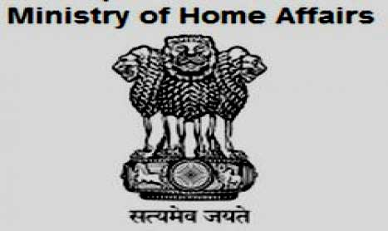
DEPARTMENTS OF MHA
Department Of Border Management
Department of Border Management, dealing with the management of borders, including coastal borders, strengthening of border guarding and creation of related infrastructure, border areas development, etc
Department of Internal Security
Department of Internal Security, dealing with the Indian Police Service, Central Police Forces, internal security and law & order,insurgency, terrorism, Naxalism, activities of inimical foreign agencies, terrorist financing, rehabilitation, grant of visa and other immigration matters, security clearances,"Protection of Human Rights Act and also matters relating to National integration and Communal Harmony and Ayodhya", etc
Department Of J & K Affairs
Department Jammu & Kashmir Division deals with the Constitutional provisions with respect to the State of Jammu and Kashmir, administration of the Armed Forces(J&K) Special Powers Act,1990 (21 of 1990) and all matters relating to the State of Jammu and Kashmir, including Counter-terrorism within Jammu and Kashmir and coordination in respect of subjects/matters specifically allotted to any other Ministry/Department like coordination with Ministry of Defence as regards manning and managing the line of control between India and Pakistan, but excluding those with which the Ministry of External Affairs is concerned. The Division also coordinates with various Ministries/Departments, primarily concerned with development and welfare activities in Jammu and Kashmir.
Department Of Home
Dealing with the notification of assumption of office by the President and Vice-President, notification of appointment/resignation of the Prime Minister, Ministers, Governors, nomination to Rajya Sabha/Lok Sabha, Census of the population, registration of births and deaths, etc
Department Of Official Language
Dealing with the implementation of the provisions of the Constitution relating to official languages and the provisions of the Official Languages Act, 1963.
Department Of States
Dealing with Centre-State relations, Inter-State relations, administration of Union Territories, Freedom Fighters’ pension, Human rights, Prison Reforms, Police Reforms, etc.
The Department of Internal Security, Department of States, Department of Home, Department of Jammu and Kashmir Affairs and Department of Border Management do not function in watertight compartments. They all function under the Union Home Secretary and are inter-linked. There is a designated Secretary for Department of Border Management and Internal Security also.
V. ENFORCEMENT ORGANIZATIONS
Introduction
Enforcing law is an important function of the Government to maintain internal security of the country. The Ministry of Home Affairs (MHA) ensures the internal security through various organizations. It also extends manpower and financial support, guidance and expertise to the State Governments for the maintenance of security, peace and harmony. In this section, information related to various enforcement organizations, internal security agencies and police forces is provided. Details of various online services such as reporting crimes and lodging complaints etc. are available. You can also find schemes, forms and documents related to this section.
Enforcement and division of Ministry of Home Affairs
1. Administration division
The Division is responsible for handling all administrative matters, allocation of work among various Divisions of the Ministry and monitoring of compliance of furnishing information under the Right to Information Act, 2005 and matters relating to Secretariat Security Organisation.
2. Border management-I division
Management of International Borders
3. Border management-II division
The Division deals with matters relating to coordination and concerted action by administrative, diplomatic, security, intelligence, legal, regulatory and economic agencies of the country for the management of international borders, border areas development programme, coastal security and establishment of Land Ports Authority of India for setting up of Integrated Check Posts.
4. Centre state division
Centre-State Matters: The Division deals with Centre-State relations, including working of the constitutional provisions governing such relations, the appointment of Governors, the creation of new States, nominations to Rajya Sabha/Lok Sabha, Inter-State boundary disputes, over-seeing the crime situation in States, the imposition of President's Rule.
5. Coordination & international cooperation division
The Unit deals with intra-Ministry coordination work, Parliamentary matters, public grievances (PGs), publication of Annual Report of the Ministry, Record Retention Schedule, Annual Action Plan of the Ministry, custody of classified and non-classified records of the Ministry, furnishing of various reports of SCs/STs and Persons with Disabilities, etc.
6. Counter terrorism and counter radicalization division
The Division deals with matter relating to terrorism, counter-terrorism, radicalization, counter-radicalization, UAPA, NIA Act, FICN, FATF.
7. Cyber and information security division
Division deals with matters relating to Cyber Security, Cyber Crime, National Information Security Policy & Guidelines (NISPG) and implementation of NISPG, NATGRID etc.
8. Disaster management division
The Division is responsible for response, relief and preparedness for natural calamities and man-made disasters (except drought and epidemics). The Division is also responsible for legislation, policy, capacity building, prevention, mitigation and long-term rehabilitation.
9. Finance division
The Division is responsible for formulating, operating and controlling the budget of the Ministry under the Integrated Finance Scheme.
10. Foreigners division
The division deals with all matters relating to visa, immigration, citizenship, overseas citizenship of India, acceptance of foreign contribution and hospitality.
11. Freedom fighters & rehabilitation division
The Division frames and implements the Freedom Fighters Pension Scheme and the schemes for rehabilitation of migrants from former West Pakistan/East Pakistan and provision of relief to Sri Lankan and Tibetan refugees. It also handles work relating to Enemy Properties and residual work relating to Evacuee Properties.
12. Internal security-I division
Division deals with matters relating to administrative and financial matters of IB & NATGRID, Official Secret Act, Sikh militancy, SGPC Board, Protection of Human Rights Act and also matters relating to national integration and communal harmony and Ayodhya.
13. Internal security-II division
"Division deals with all matters concerning letters of request for mutual legal assistance in criminal matters; National Security Act, 1980 and representations there under; administration of Narcotics Control Bureau; providing central assistance to victims of terrorist, communal and Naxal violence".
14. Jammu & kashmir division
The Division deals with constitutional matters including Article 370 of the Constitution of India and general policy matters in respect of J&K and terrorism/militancy in that State. It is also responsible for implementation of the Prime Minister's Package for J&K.
15. Left wing extremism division
This Division was created w.e.f. October 19, 2006 in the Ministry, to effectively address the Left Wing Extremist insurgency in a holistic manner. The LWE Division implements security related schemes aimed at capacity building in the LWE affected States. The Division also monitors the LWE situation and counter-measures being taken by the affected States. The LWE Division coordinates the implementation of various development schemes of the Ministries/Departments of Govt. of India in LWE affected States. The States of Chhattisgarh, Jharkhand, Odisha, Bihar, West Bengal, Andhra Pradesh, Telangana, Maharashtra, Madhya Pradesh, Uttar Pradesh and Kerala are considered LWE affected, although in varying degrees.
16. North east division
The Division deals with the internal security and law & order situation in the North-Eastern States, including matters relating to insurgency and talks with various extremist groups operating in that region.
17. AGMU cadre management
The Division deals with all legislative and constitutional matters relating to Union territories, including the National Capital Territory of Delhi. It also functions as the cadre controlling authority of the Arunachal Pradesh-Goa-Mizoram and Union Territory (AGMU) cadre of Indian Administrative Service (IAS)/Indian Police Service (IPS) as also Delhi-Andaman and Nicobar Island Civil Service (DANICS)/Delhi-Andaman and Nicobar Island Police Service (DANIPS). Besides, it is responsible for overseeing the crime and law and order situation in UTs.
18. Women safety division
MHA has set up a new ‘Women Safety Division’ on May 28, 2018 to strengthen measures for safety of women in the country and instill greater sense of security in them through speedy and effective administration of justice in a holistic manner and by providing a safer environment for women. The new Division is responsible for policy formulation, planning, coordinating, formulating and implementing projects/schemes to assist States/Union Territories to achieve this objective, as also prison reforms, anti human trafficking and related subjects. This, inter-alia, includes increased use of IT and technology in criminal justice system and enabling a supportive eco-system for forensic sciences and crime & criminal records.
The subject matters dealt in the Women Safety Division include:
- Coordination and implementation of projects being undertaken in MHA for enhancement of safety of women in the country (Emergency Response Support System, Safe City projects etc);
- IT interventions for increasing efficiency in delivery of criminal justice (Crime and Criminal Tracking Network and Systems-CCTNS, Inter-operable Criminal Justice System-ICJS, Investigations Tracking System for Sexual Offences-ITSSO, National Database on Sexual Offenders-NDSO etc);
- All matters relating to Directorate of Forensic Science Services and its affiliated Central Forensic Science Laboratories, Lok Nayak Jayaprakash Narayan National Institute of Criminology and Forensic Sciences and administrative and financial matters relating to Central Forensic Science Laboratory of CBI;
- Crime statistics;
- All matters relating to National Crime Records Bureau;
- Crimes against women and children, members of scheduled castes, scheduled tribes, elderly persons and other vulnerable groups, but excluding crime against minorities;
- All matters relating to Trafficking in Persons and Smuggling of Migrants; and the two protocols of United Nations Convention against Transnational Organized Crime (UNCTOC) namely, the ‘Protocol to Prevent, Suppress and Punish Trafficking in Persons, especially Women and Children’ and the ‘Protocol against the Smuggling of Migrants by Land, Sea and Air’, excluding legislative, rehabilitation, welfare and other promotional aspects specifically dealt with by the Ministry of Women and Child Development;
- All matters relating to Prison Reforms, Correctional Administration, Prisons/Prisoners legislation, Identification of Prisoners/Convicted and Suspected persons legislation, Repatriation of Prisoners Act, 2003, Transfer of Sentenced Persons agreements and matters related thereto.
- Poisons Act, 1919.
VI. POLICE
POLICE-I DIVISION
Introduction
Police-I Division functions as the cadre controlling authority in respect of Indian Police Service (IPS). Domestic and foreign trainings for police personnel are also coordinated in this division. The police personnel in recognition of their service are awarded Medals like President/Police Medals for Meritorious/ Distinguished service/ Gallantry, Prime Ministers award for life saving. This division has the administrative and financial control of few Central Police Organisations. These are Sardar Vallabhbhai Patel National Police Academy, Hyderabad, North Eastern Police Academy, Shillong and Bureau of Police Research & Development, New Delhi.
Subject Allotted
1. Cadre Management of the Indian Police Service
The Cadre management of the Indian Police Service includes appointment of the IPS officers through Regular Recruitment and by induction of State Police Officers on promotion. The IPS Officers are given basic training in SVPNPA and after successful completion of their training they are confirmed in-service. They are also allocated to various state cadres by this division. The strength and composition of each state IPS cadre is reviewed at stipulated intervals. The officers at the level from DIG to DG are empanelled for facilitating appointments on Central deputation. This division also maintains the ACRs of IPS Officers and deals with their service and vigilance matters.
2. Award of Medals to the Police Personnel
In order to recognize the outstanding service rendered by the Police personnel, they are awarded medals like Presidents Police Medals for Gallantry/Meritorious and Distinguished service, Prime Ministers life saving award.
3. Training of Police Personnel
The Government of India attaches great importance to Police Training. The officers belonging to the Indian Police Service are trained in SVPNPA, Hyderabad. The Bureau of Police Research and Development (BPR&D) coordinates domestic training for police personnel and issues advisories on the subject to the states from time to time. The police personnel are also provided foreign training and are sent to countries like Japan, Singapore, USA and Italy to acquaint themselves with modern techniques of crime prevention, detection and investigation. Countries like USA are sending the teams of their trainers to India to impart police training to Indian Police personnel. This division is also interacting with the foreign countries for the purpose of mutual capacity building. The officers belonging to Nepal, Bhutan and other SAARC countries are being trained in our police training institutions.
4. Management of Training and Police Research Institutes
Police-I division exercises Administrative control over Central Police Research and Training Institutes namely, Sardar Vallabhbhai Patel National Police Academy, Hyderabad, North Eastern Police Academy, Barapani, Shillong. Administrative and financial matters of Bureau of Police Research & Development, New Delhi.
Police-II
Introduction
The Police-II Division deals with the personnel, financial, administrative, parliamentary, audit and court matters relating to various Central Armed Police Forces (CAPFs). It also deals with the deployment of CAPFs, the Air assets of MHA as well as the Medical Wing of the CAPFs.
The other major tasks dealt with by this Division include:
- Raising of Battalions in CAPFs
- Re-organisation and re-structuring of CAPFs and IB
- Policy matters relating to reservations in services for SC/ST/OBC, Physically challenged persons, women, etc.
- Policy and schemes for recruitment of CAPFs personnel; Deputation/absorption of CAPFs personnel in other organisations
- Policies relating to re-settlement and rehabilitation and welfare of ex-CAPFs personnel, widow/NOKs(next of kin) of CAPFs personnel laying down their lives in various operations
- Matters relating to canteen facilities to CAPFs
- Matters relating to pensioner benefits to CAPFs personnel
- Matters relating to Welfare and Rehabilitation Board(WRB) for CAPFs
- Deployment of police personnel to UN Peace Keeping Missions, etc.
The Central Armed Police Forces dealt with by this Division include:
- Assam Rifles (AR)
- Border Security Force (BSF)
- Central Industrial Security Force (CISF)
- Central Reserve Police Force (CRPF)
- Indo-Tibetan Border Police (ITBP)
- National Security Guards (NSG)
- Sashastra Seema Bal (SSB)
1. Assam Rifles (AR)
Objective/purpose
To guard the Indo-Myanmar border and conduct Counter Insurgency operations in the North East.
Role
Nominated as the Border Guarding force and the Lead Intelligence Agency for the Indo-Myanmar border and mandated to undertake Counter Insurgency operations in the North Eastern States and other areas as deemed necessary under the operational control of the Army.
Capability
- Border Guarding
- Counter Insurgency Operations.
- Aid to Civil authorities
- Undertake defensive operations and Rear Area Security during conventional War.
2. Border Security Forces (BSF)
Objective/purpose
To be a Force of Excellence in guarding the Borders of India through highly professional, credible and efficient Border Management.
Role :
Security & guarding of the Border of India and matter connected therewith”.
Task:
- Promote a sense of security among the people living in the border areas.
- Prevent trans-border crimes, unauthorized entry into or exit from the territory of India.
- Prevent smuggling and any other illegal activities.
- Help civil administration in maintenance of public order.
Capability
BSF is well capable of guarding 6386.36 Km (2289.66 Km –Indo Pak Borders, 4096.7 Km Indo-BD Borders) of the International Borders (IB) and 237.2 Km of the Line of Control (LC). In addition, BSF is capable & efficient enough to take on other challenges effectively like Counter-Insurgency/Anti-Militancy/Anti-Naxal Operations, Election Duties, Law & Order Duties, UN Peace Keeping Missions, Disaster Management and National/ International level functions and any other tasks assigned by the Government of India.
Mission
- To maintain sanctity of the Border of India through eternal vigilance
- To inculcate a sense of security by harnessing co-operation of the Border Population.
- To effectively deal with Internal Security Challenges whenever so tasked by the Govt.
- To achieve an effective combat capability by absorbing leading-edge technology, state-of-the-art training and user-friendly equipment.
- To evolve and implement a growth-oriented Personnel Management System aimed at instilling core values to satisfy the social, economic and psychological needs of the Force personnel.
- To effectively assist Civil Administration in Disaster Management and provide succour to the people.
- To effectively promote core values of Human Rights, pride and dedication to duty in the Force.
3. Central Industrial Security Force (CISF)
CISF came into existence in the year 1969 and is today perhaps the largest Industrial Security Force in the world with a sanctioned strength of more than 1.30 lakhs.
Objective/purpose
To provide security and consultancy to the Public Sector and Private Sector under takings and also to provide security to the VIPs.
Role & task
CISF provides physical security to critical infrastructure units of the country. Its main tasks include crime prevention & control, protection of employees and provision of security to the buildings. It also provides fire protection to industrial under takings.
Capability
CISF is a premier multi-skilled security agency of the country, mandated to provide security to all public sector undertakings & private sector undertakings. CISF is currently providing security cover to 307 units. The services provided by CISF include:
Fire protection Service
CISF is also one of the largest Fire Protection Service providers in the country. It provides fire protection cover to 83 Industrial Undertakings. In the present year CISF has been inducted into Ratnagiri Gas & Thermal Power Station Ltd., Rajiv Gandhi Thermal Power Project, Hissar, Haryana, a major unit in the Power Sector and CISF has been inducted there w.e.f. 18.06.2010 and 10.06.2010 respectively.
Consultancy
CISF launched its consultancy services in December 2001. CISF is providing security & Fire consultancy to Public & Private Sector under takings. It is a testimony to the level of professional competence and standing acquired by the force over the decades that its services are being sought for consultancy by the private sector also. Over the year, the CISF has provided Consultancy Services to 76 different organizations including those in the private sector. Amongst its prominent clients are some of the renowned business houses and organizations of India including TISCO Jamshedpur, SEBI HQrs, Mumbai, Vidhan Sabha Bangalore, Andhra Pradesh Assembly, Hyderabad and many more.
These Consultancy Services are ISO:9001:2008 Certified for its Quality Management Services in the field of Security & Fire Protection.
The details of consultancy services provided are given below:-
- Government Sector – 33
- Public Sector Undertaking - 12
- Private Sector - 31
4. Central Reserve Police Force (CRPF)
CRPF came into existence as the Crown Representative’s Police on July 27, 1939 at Neemuch (MP) to assist the princely States in maintenance of law & order. The Force was re-named as Central Reserve Police Force by an Act of parliament on December 28, 1949, which was made applicable retrospectively w.e.f. August 15, 1947.
Objective/purpose
The Central Reserve Police Force was constituted under the nomenclature of Crown Representative Police, on 27 July 1939 at Neemuch under the provisions of Indian (Foreign Jurisdiction) order 1937, for deployment in princely states to help the rulers to contain political unrest and activities of Praja Mandals that were agitating for self-rule in these states. President colour to the Force was presented on 19th March 1950.
Role & Task
The mission of the CRPF is to be enable the government to maintain rule of law, public order and internal security effectively and efficiently to preserve national integrity and promote social harmony and development by upholding supremacy of the constitution of country. In performing these tasks with utmost regard for human dignity and freedom of citizens of India, the force endeavours to achieve excellence in management of internal security and national calamities by placing service and loyalty above self.
Group of Ministers (GoM) set in wake of the security lacunae brought to light by Kargil war, redefined role of CRPF to be main force for counter insurgency duty in addition to its present duty.
Capability
This is main striking force of the country dealing with internal security duties, including anti naxal operation and counter insurgency duties in J&K and North East, besides varied Law and order problems.
5. Indo-Tibetan border police (ITBP)
Objective/purpose
Indo-Tibetan Border Police was conceived on October 24, 1962 in the wake of Chinese aggression for reorganizing the frontier intelligence and security set-up along the Indo-Tibetan Border from Ladakh to Kumaon hills. In pursuance of Govt. recommendation “One Border One Force” in the year 2004, guarding the entire India China Border has been assigned to ITBP as such. ITBP has replaced Assam Rifles in Sikkim and Arunachal Pradesh.
Role & task
- Role-
- Keep constant vigil on the border.
- Control trains-border traffic and crime.
- Security to IB check posts and border population.
- Security cover to sensitive installations and VPs.
- Perform counter Insurgency Operations and internal security duties.
- Perform wartime role with Army.

Task-
- Border Management.
- Counter Insurgency Operations and Internal Security duties.
- Security of vital installations, vulnerable points and VIPs.
- Lead intelligence agency.
- Disaster Management.
- BADP & Civic Action.
- Selection & Training of officers of UN Peace Keeping Mission.
- Kailash Mansarovar Yatra Security.
Capability
ITBP is a border guarding Force specially trained to operate in high altitude mountainous terrain. ITBP Border out Posts are of the height up to 18750 feet where the temperature dips down minus 40 degree Celsius. ITBP Battalions are organized almost similar to that of infantry Battalion with similar fire power.
6. National security guard (NSG)
Objective/purpose
Terrorism, both national and international raised its head in the West during the seventies. It manifested in many forms including hijacking of aircraft, taking of hostages, assassination of dignitaries and others. The normal law and order machinery and the defence forces of the West were found wanting to deal with the menace. Specially equipped and trained Forces like SAS of UK, DELTA Force of USA and GSG-9 of West Germany were raised abroad. The need for creating a Special Force for executing surgical operations based on tactical intelligence was felt in India too.
NSG was conceptualized and created after studying and analyzing Special Force like SAS in the United Kingdom, GIGN in France, GSG-9 in Germany, Shar-et-matkal in Israel and DELTA in the USA. Accordingly, NSG was raised on 16th Oct, 1985 as a Federal Contingency Force under the MHA. It consists of selected and highly motivated personnel from the Army as well as the Para Military Force. 53% of the personnel are drawn from the Army while the Para Military Forces like BSF, CRPF and ITBP contribute 47%.
Role &task
Role
NSG is a task oriented Force and has two complementary elements in the form of the Special Action Group (SAG) comprising Army personnel and the Special Ranger Group (SRG) comprising personnel drawn from the Central Armed Police Forces (CAPFs)/State Police Organizations. NSG is a 100% deputationist Force with 53% of its manpower drawn from the Army and 47% from CAPFs /State Police Organizations. NSG Commandos are trained in high risk tasks like counter hijacking and counter-terrorist operations. They are also assigned the task of providing mobile security protection to designated high risk VIPs. The primary task of the Force is to engage and neutralize terrorist threats in specific situations and to undertake counter hijack and hostage rescue mission.
Tasks
- Neutralization of specific terrorist threat in any given area building vital installations etc.
- Engaging terrorists in specific situation in order to neutralize them.
- Handling hijack situation involving piracy in the air, on land and water.
- Rescue of hostage in kidnap situations.
Additional Tasks
- Mobile Security covers to nominated high risk individuals.
- Provision of Sky Marshals on designated flights of Indian registered carriers.
- Anti-sabotage check of venue of visit/public meeting of VVIPs.
- Post blast studies.
- Establishment and functioning of National Bomb Data Centre.
Capability
The National Security Guard has the capability of maintaining two Task Forces at varying degree of readiness to tackle any terrorist or hijack situation in the country.
7. Sashastra seema bal (SSB)
SSB came into existence under the name “Special Service Bureau” under MEA in early 1963 in the wake of Indo-China conflict and later placed under Prime Minister Secretariat on 01.01.1956. SSB came under Cabinet Secretariat on 01.09.1965.
Objective/purpose
SSB is the newest Border Guarding Force of Union of India entrusted with the guarding of Indo-Nepal and Indo-Bhutan Borders. It is guarding Indo-Nepal since 2001 and Indo-Bhutan Border since 2004.
Its earlier aim was to build morale of People and inculcate a spirit of resistance in border population in the then NEFA, North Assam, North Bengal, hills of Uttar Pradesh, Himachal Pradesh and Jammu & Kashmir (Ladakh). The area of operation was extended to other border areas in Manipur, Tripura, Jammu & Kashmir, Meghalaya, Sikkim, Rajasthan, Gujarat, Mizoram, West Bengal and Nagaland between 1965-1991.
Role & Task
Mandated to guard Indo-Nepal border and Indo-Bhutan Border, the objectives/tasks of SSB as under;-
- To promote a sense of security among people living in the border areas.
- To prevent trans-border crimes & unauthorized entry into or exit from the territory of India.
- To prevent smuggling and any other illegal activities.
- To act as Lead Intelligence Agency for Indo-Nepal and Indo Bhutan borders, performing the task of intelligence gathering and sharing.
- To undertake civic action programme in its area of operation.
Apart from above, SSB also performs duties like Internal Security/Law & Order/Election duties etc. assigned by Government of India from time to time.
Capability
SSB is capable of performing border guarding duties on Indo-Nepal & Indo-Bhutan border. It is also performing the duties of Lead Intelligence Agency for both the borders. Besides this, SSB is trained to perform various Internal Security/Law & Order/Election duties as assigned by Ministry of Home Affairs from time to time.
SSB personnel besides being trained in performing Border Guarding duties are also trained in Commando, Counter Insurgency & Jungle Warfare and Intelligence tradecraft.
VII. COMMUNAL TENSIONS
Review of latest episodes of communal tensions
Introduction
Communalism usually refers to a system that integrates communal ownership and federations of highly localized independent communities. A prominent libertarian socialist, Murray Bookchin, defines the communalism political philosophy that he developed as "a theory of government or a system of government in which independent communes participate in a federation", as well as "the principles and practice of communal ownership". The term 'government' in this case does not imply an acceptance of a state or top-down hierarchy.
Communalism is a political philosophy spanning three phases of growth. In the first phase of this ideology there is a belief that people who follow the same religion have common secular (political, economic, social) interests. The second stage provides that the social, economic and political interests of the followers of one religion are dissimilar from the interests of the followers of another religion. The third stage of communalism is reached when the interests of the followers of different religions are seen to be mutually incompatible.
Communalism is an ideology on which all the communal violence is based. Thus, all the communal riots are based on this philosophy that the interests of a group of people following different religions cannot be the same. It works on the basis of fear mongering among the people. Leaders in order to propagate their own self-interest create the fear of the “other” community.
Tall claims of providing secular governance of the Congress lie shattered as the country finds itself shaken again by the recent devastating example of communal violence in Assam. Looking at history Congress doesn't fare any better than the Bharatiya Janata Party in preventing communal riots. Here are some of the major events that took place under the Congress rule
Most horrible Communal riots under UPA government
1. 2006 Aligarh riots: Riots broke out on April 5 between Hindus and Muslims over Ram Navami celebrations. Five people were killed due to the violence
2. 2008 Dhule riots: In October 2008, 4 people were left dead as Hindu and Muslim communities clashed. The incident left over 200 people injured that included 113 policemen.
3. 2010 Deganga riots: The Deganga riots had begun on on Monday September 6 and continued for several days. 24 people were hurt and several houses and properties got destroyed when clashes broke out between Hindu and Muslim communities in the Basirhat sub-division of North 24 Parganas, about 150 km from Kolkata.
4. 2011 Bharatpur riots: On 14 September, clashes broke between Gujjars and Meo Muslims in Bharatpur Rajasthan. Eight people were killed and 23 were injured. Top BJP and Congress leaders of the region were involved in the riots.
5. 2012 Assam riots: Kokrajhar has sadly been witness to communalism even in the past. In 2012, July 20, riots broke out in Kokrajhar which later spread out to the lower regions of Assam. 77 people were reported to have been killed. Around, 79,000 people from about 500 villages had to take shelter in 128 relief camps. The riots took place between Bodo community and Bengali speaking Muslims of the region. The clashes have their roots in the mid-nineties and peace still evades the region as the riots continue to happen even today.
6. 2013 Muzzafarnagar riots: During the months of August and September, riots broke out in Muzaffarnagar district in Uttar Pradesh that resulted in nearly 62 deaths of which 42 victims were Muslims and 20 Hindus. The riot between Hindu Jats and Muslims was said to have been triggered by a sexual harassment incident but in reality was an outcome of intensive communal campaigning in the state by Hindu right wing groups.
Note
Since 1967, 15 major incidences of communal violence took place out of which ten happened under the Congress or Congress' ally ruled region.
In the year 2013, 479 incidents of communal violence took place with 107 people dead injuring 1,647 people including 200 policemen injured.
In 2012, there were 640 incidents of communal violence with 93 deaths. The violence left 2,067 people injured.
Though the ruling Congress party has had no political alliance with religious fundamentalist groups, it has consistently failed to maintain peace and stability in the country.
The Rise of Narendra Modi
According to the data compiled by the National Crime Records Bureau (NCRB), officials in the Ministry of Home Affairs said 336 cases relating to offences promoting enmity between different groups on the bases of religion, race, and place of birth were registered in 2014, which shot up to 475 in 2016, an increase by over 41 per cent.
Among the states where incidents of communal violence took place, UP topped the list with 162 cases in 2016, 155 in 2015 and 133 in 2014. A closer analysis shows a sizeable jump in such cases in UP in 2016 —the election year.
In Maharashtra, 270 communal incidents were reported in the last three years, 68 of which took place in 2016, 105 in 2015 and 97 in 2014. MP stood third with 205 such cases in three years 57 in 2016, 92 in 2015 and 56 in 2014.
In the Union Territories, including Delhi, these incidents dipped from 18 in 2014 to just one in 2016.
Incidentally, Bihar, which did not report any such incident in 2014, saw eight such incidents in 2016, an increase of 800 per cent.
As per data shared by the Ministry of Home Affair, at least 111 people were killed and 2,384 others injured in 822 communal incidents in the country in 2017. Uttar Pradesh, which recently witnessed Kasganj riot, reported 195 communal incidents - the highest in the country. Karnataka, which is all set for elections later this year in 2018, is second in the list, reporting 100 communal incidents in the last year in which nine people were killed and 229 injured.
Here are states that witnessed most communal riots in 2017.
UP communal violence
Uttar Pradesh, the state headed by Yogi Adityanath, witnessed 195 communal incidents, in which 44 people were killed and 542 others were injured.
After his swearing-in as the chief minister, Adityanath stated that UP will witness no communal riots under his government. However, the number of incidents have been on the rise. In 2016, UP had 162 incidents and 29 deaths.
Party in Power: BJP
Karnataka communal violence
Karnataka witnessed 100 communal in 2017, in which 9 people were killed and 229 injured.
Party in Power: Congress
Rajasthan
Vasundhara Raje's state saw 91 incidents of riot. 12 people were killed and 175 injured.
Party in Power: BJP
Bihar
Communal incidents - 85. These riots killed 3 people and 321 were injured.
Party in Power: Nitish Kumar-led JD(U)
Madhya Pradesh
There were 60 incidents of riots in Madhya Pradesh, in which nine people were killed and 191 injured.
Party in Power: BJP
West Bengal
Mamata Banerjee's state saw 58 incidents of communal violence, in which nine people were killed and 230 injured.
Party in Power: TMC
Gujarat
Gujarat has witnessed 50 riots, in which eight people were killed and 125 others were injured.
According to the government report in 2016, 86 people were killed and 2,321 others were injured in 703 incidents of communal violence while in 2015, there were 97 deaths and 2,264 people were injured due to 751 incidents of riots.
The number of communal incidents have been gradually increasing in Uttar Pradesh, Bihar and Rajasthan, while they have gone down in Karnataka.
Deadliest communal riots/incidents over the last few years
- Saharanpur, Uttar Pradesh, July 25, 2014.
- Ballabgarh, Haryana, May 25, 2015.
- North Karnataka (Mudhol, Chikkodi, Surpur, Dharwad, Koujalagi, Belgaum), September 23-28, 2015.
- Nadia, West Bengal, May 5, 2015.
- Malda, West Bengal, January 3, 2016.
- Hazinagar, West Bengal, October 12, 2016.
- Dhulagarh, West Bengal December 13, 2016.
- Saharanpur, Uttar Pradesh, May 5, 2017.
- Baduria, West Bengal, July 4, 2017.
- Muzaffarnagar, Uttar Pradesh, September 7, 2017.
- Bhima Koregaon, Pune, Maharashtra, January 1, 2018.
- Kasganj, Uttar Pradesh, January 26, 2018.

IV. THE TENSIONS IN JAMMU AND KASHMIR BACKGROUND
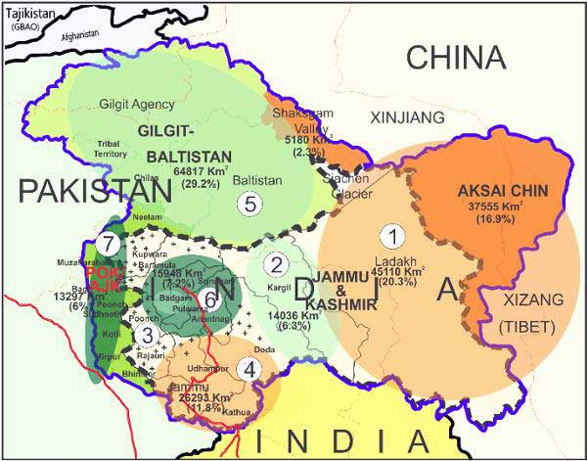
Every problem of present has to do with its past, in the case of the state of Jammu and Kashmir it is exactly the same. The Kashmir issue is not just an issue between India and Pakistan but it has many other dimensions to it. A relatively simple problem in the past, has turned into a big monster due to the negligence and carelessness by the successive governments ruling in the state.
When it comes to the state of Jammu and Kashmir, the state has always enjoyed a secular environment with a distinct history of Hindu, Muslims, Mughals, Afghans and lastly the Sikhs under Maharaja Ranjit Singh and his successive generations from 1340AD- 1947AD respectively. However, Jammu and Kashmir, remained a princely state ruled by Jamwal Rajput Dogra Dynasty from 1846 -1947 and like all the other princely states Kashmir too enjoyed only a partial autonomy, as the real control was with the British.
However the real, Issue begun during the time of partition of British India (1947), the ruler of Kashmir Maharaja Hari Singh, the great-grandson of Maharaja Gulab Singh decided not to merge either with India and Pakistan and have an Independent status for his state. Hari Singh tried to negotiate with both the respective governments and offered a “Standstill Agreement” to both the Dominion on August 12, 1947 via identical communications sent by then prime ministers of Jammu and Kashmir to the governments of India and Pakistan.
Initially Pakistan accepted the offer sent an official communique to J&K Prime-Minister on August 15, 1947. It Read,” The Government of Pakistan agrees to have Standstill Agreement with Jammu and Kashmir for the continuation of existing agreements…”. India on the other hand, advised the Maharaja to send his authorized representatives to Delhi for further discussions on the offer. Moreover, Indian suggested to conduct a plebiscite so as to confirm with the aspirations of the Kashiri populace. With prominent leaders like Sheikh Abdullah and cherishing many other values like secularism, Democracy and Pan-India nationalism, India was confident to win the plebiscite which was to be held in 1947.
However, the Dynamics changed totally with the Pakistan’s attack on Kashmir in October 1947, by directly sponsoring a tribal militant attack and thus violating the Standstill Agreement but capturing a large chunk of the whole area with the help of Pashtun Raiders. This forced the king to seek the help of Governor General Lord Mountbatten for assistance. India assured the help, but only on the condition that the Maharaja would sign the Instrument of Accession in 1947 and a plebiscite to be conducted once the situation normalized, however this never happened. India successfully drove out tribal raiders from Kashmiri Occupation, however one chunk of Kashmir was retained by Pakistan which was perpetuated as “Azad Kashmir” or “Pakistan occupied Kashmir (POK)”.
So in 1948, UN Security Council passed on the “Resolution 47” and set up a commission for India and Pakistan (UNCIP) on April 21, 1948. This resolution was non-binding, but clearly stated a 3 pronged guidelines on handling the Kashmir issue, the 3 points are as follows :-
- Pakistan has to vacate all occupied territory in state and handover the vacated territory to India.
- India has to remove all its forces leaving aside enough to maintain law and order.
- India to conduct a plebiscite in the state of Jammu and Kashmir.
However all the following procedures were never followed? Pakistan always claimed Kashmir Valley to be a part of it and thus resulted for 3 wars in 1947, 1965 and 1971 and a slight proxy conflict in Kargil Area in 1998. Moreover, Pakistan was not the only party in the conflict. Situations worsened after 1962 Indo-China war, when Pakistan ceded the Trans-Karakoram section of Kashmir (Saksham Valley) and the capturing of Aksai-Chin.
Internally, within Kashmir, Mostly during the time 1953-1974, the congress party exercised a major influence in the politics of the state. A national conference government minus (Sheikh Abdullah) remained in power and thus later merged with the Congress. In the meanwhile Indira Gandhi reached an Agreement with Sheikh Abdullah and thus the latter become the Chief Minister of Kashmir in ’74. Meanwhile his son Farooq Abdullah became the CM in 1982, but was soon dismissed by then governor, which led to the resentment within the Kashmiris, and so the confidence that the Kashmiris developed, received a great setback. Furthermore, the feeling that the Centre was intervening in politics of the state further strengthened the national Conference power during the mid-1980.
Furthermore, post late 1970’s following the rise of Islamic Revolution in Middle East added a fuel to the building fire in this Region. In 1987 Assembly elections, the official results showed a massive victory for the national conference-Congress Alliance and thus Farooq Abdullah again turned out to be the CM, However it was believed that the election were totally rigged and didn’t reflected the choice of the Kashmiris and so supplementing this feeling of resentment that the democratic process was being manipulated and the Ideology of Islamic Revolution, soon generated a political crisis which worsened with the rise of insurgency in 1989. By this time, the insurgents received a full economic and a military support of Pakistan and the terrorist drove out all the Hindu population which infamously known as “Kashmiri Pandits Exodus”. So the people’s sympathy no longer remained the Indian union as it was during the earlier years from 1947- 1980’s.
Post 1990, then Prime Minister of India V.P Singh, introduced the Armed Forces Special Powers Act (ASFPA), and so on the state remained under Presidents Rule in numerous occasion and throughout the period J&K faced violence at the hands and also through the Army Action.
Many renowned defence and political analyst also state the fact that more than 5lakh Hindus were being forced to either live in refugee camps, Concentration Areas and were forced to move out to other states from their native place and their citizenship not being returned because of articles 35A, but none of them decided to be terrorists which again proves another matter of fact.
It was only in 2002, Jammu and Kashmir had a fair election in 2002. The national conference failed to win a majority and was replaced by the People’s Democratic Party (PDP) and Congress party coalition.
Furthermore, the BJP in 2015, formed a coalition with PDP led Mehbooba Mufti after the death of Mufti Mohammed Sayeed and has taken many stringent steps to stop the insurgent activities and has given the Army and its Special Operatives a free hand to ensure that the area is cleaned of Various terrorist insurgents and local militants operating with the help of Kashmiris Locals and Various Separatists Organizations such as Hurriyat Conference led by Mirwaiz Umar Farooq and Syed Ali Shah Geelani.

Article 370 and Article 35A: The important topics to understand
Article 35A is a provision incorporated in the Constitution giving the Jammu and Kashmir Legislature “A carte blanche” to decide who all are ‘permanent residents’ of the State and confer on them special rights and privileges in public sector jobs, acquisition of property in the State, scholarships and other public aid and welfare. The provision mandates that no act of the legislature coming under it can be challenged for violating the Constitution or any other law of the land.
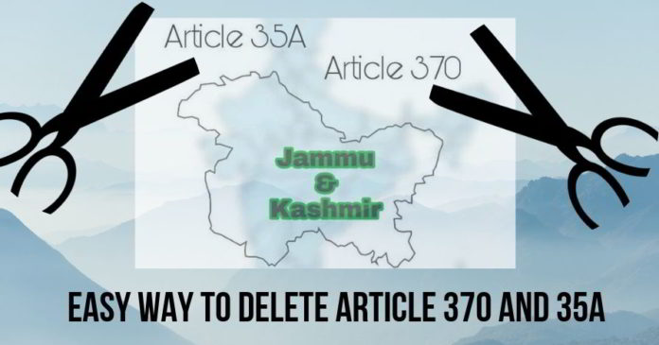
Image Source: www.pgurus.com
The article was incorporated into the Constitution in 1954 by an order of the then President Rajendra Prasad on the advice of the Jawaharlal Nehru Cabinet. The controversial Constitution (Application to Jammu and Kashmir) Order of 1954 followed the 1952 Delhi Agreement entered into between Nehru and the then Prime Minister of Jammu and Kashmir Sheikh Abdullah, which extended Indian citizenship to the ‘State subjects’ of Jammu and Kashmir.
It matters because, the parliamentary route of lawmaking was bypassed when the President incorporated Article 35A into the Constitution. Article 368 (i) of the Constitution empowers only Parliament to amend the Constitution
Furthermore when we talk about article 370, the article is a “Temporary Provision” which grants a special autonomous to Jammu and Kashmir under the part XXI of the Indian constitution , which deals with "Temporary, Transitional and Special provisions", the state of Jammu & Kashmir has been accorded special status under Article 370. All the provisions of the Constitution which are applicable to other states are not applicable to J&K. For example, till 1965, J&K had a Sadr-e-Riyasat for governor and prime minister in place of chief minister.
According to this article, the Parliament can only amend laws on Defence, foreign affairs, finance and communications, whereas for all other subjects the parliament needs the state’s acceptance for applying other laws. Thus the state's residents live under a separate set of laws, including those related to citizenship, ownership of property, and fundamental rights, as compared to other Indians. As a result of this provision, Indian citizens from other states cannot purchase land or property in Jammu & Kashmir. Under Article 370, the Centre has no power to declare financial emergency under Article 360 in the state. It can declare emergency in the state only in case of war or external aggression. The Union government cannot declare emergency on the grounds of internal disturbance or imminent danger unless it is made at the request or with the concurrence of the state government.
However, if the history is taken under consideration Sheikh Abdullah didn’t wanted any temporary set of provisions, but he wanted a “Total Autonomy” under these Set of provisions.
Furthermore, when we take a close look at some of the cases related to these provisions, there are many interesting cases which are as follows:-
- We the Citizens v/s The Union of India
A writ petition filed by NGO We the Citizens challenges the validity of both Article 35A and Article 370. It argues that four representatives from Kashmir were part of the Constituent Assembly involved in the drafting of the Constitution and the State of Jammu and Kashmir was never accorded any special status in the Constitution. Article 370 was only a ‘temporary provision’ to help bring normality in Jammu and Kashmir and strengthen democracy in that State, it contends. The Constitution-makers did not intend Article 370 to be a tool to bring permanent amendments, like Article 35A, in the Constitution.
The petition said Article 35 A is against the “very spirit of oneness of India” as it creates a “class within a class of Indian citizens”. Restricting citizens from other States from getting employment or buying property within Jammu and Kashmir is a violation of fundamental rights under Articles 14, 19 and 21 of the Constitution. Thus In-short, demanding the abrogation of the unjust and unconstitutional amendment.
Dr. Charu Wali Khanna v/s The Union of India
Dr Charu Wali Khanna vs The Union of India is another case in which the article 35A proved Discriminatory on the grounds of gender discrimination. Dr Khanna, a Kashmiri Pandit has claimed an Ancestry evidence and has submitted the evidence. She sought to build a home in J&K to re-establish her roots but being married a non-permanent resident, she could not buy property, because of the clauses mentioned in the article 35A section 6, which deemed to be discriminatory against all the state subjects who are married to the citizens residing outside Jammu and Kashmir and also restrict the children of the subjects, by denying the a permanent resident status.
Furthermore, the Article also considers these subjects illegitimate to vote even in the local Elections.
Dr Khanna filed the writ petition after the J&K Government refused to identify her as a permanent resident as she did not have any documentary evidence.
She has taken additional ground with regards to the property rights of females. Currently the case was being heard by a 3 judge Supreme Court Bench and various discussion were being considered and Chief Justice during 2017-2018 CJI Deepak Misra had Quoted that the “if the Article proves to be violated against the Right to Equality, then the case would be examined by a 5 judge constitutional Bench. Right now the last hearing was held at August 2018 under a 3 judge bench.
Radhika Gill vs The Union of India
Radhika Gill vs Union of India is a case which has various petitioners. Radhika is a descendant of sweepers, who were brought from Punjab to Jammu in late 1950s when the sweepers of Jammu municipality had gone on indefinite strike. Around 200 odd sweepers were brought to Jammu then.
Radhika is the third generation of this sweeper community and she claims they too should be declared as the permanent residents of State. She has challenged Article 35-A and section 6. Besides the petitioners have challenged various provisions of BOPEE act which debars a candidate, not a permanent resident, from appearing in the examination. The petitioners have also challenged the laws of service commission which debars their appointment within the state.
So with all these cases and also considering the sensitivity of these cases, the Jammu and Kashmir government hired senior advocates including FS Nariman, Shekher Naphade, K Vishwanathan and Rakesh Dwivedi. The J&K Officials said they were appointed to defend these cases because they are experts relating to constitutional matters.
In the last hearing on May 14, 2018, the three judge bench of the Supreme Court listed the case for next hearing on August 6 and observed the ‘pleadings from all angles shall be completed in the meantime.’
In all these cases, initially the notices were not issued except for the We the Citizens and the Radhika Gill case. But on the last hearing in Supreme Court, the lawyers of opposite party were directed to file the reply, specifically dealing with all these contentions raised in petitions.
“The reply has not been filed till date.”
Political Players in this scene
Sheikh Abdullah

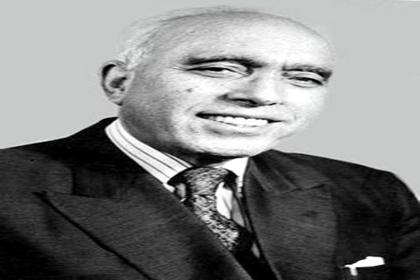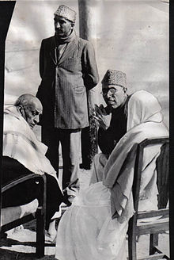
He founded Kashmir’s first political party called the Muslim Conference in 1925, which was Renamed as the National Conference in 1938. He took numerous movements to fight for the rights in Kashmiri Region and was responsible to win a Semi-Autonomous status of Jammu and Kashmir.
After the Maharaja Hari Singh signed an ‘Instrument of Accession’ with the Government of India, Sheikh Abdullah took over as the Prime Minister of the State of J&K (the head of the government in the State was then called Prime Minister) in March 1948.
Sheikh Abdullah was against Jammu and Kashmir joining Pakistan. However, he took a pro-referendum stance and delayed the formal accession to India. Although he took a pro-Indian stance, but it was later realized that his penultimate goal was to ensure the independence of the state of Kashmir as an independent nation. The pro-Indian authorities dismissed the state government and arrested Prime Minister Sheikh Abdullah in 1953 and was released by Nehru in 1964, which received an enthusiastic support from the Kashmiri Audience. He was dispatched to Pakistan and Algeria to gain the goodwill of Pakistan and Algeria, but by then the relations were deteriorated and his tour was seen as seditious by the Indian Government and again he arrested in 1968 and subsequently released following the signing of 1975 accords between Indira Gandhi and the JKNC, furthermore he won the 1975 elections with the help of congress coalition and remained as the CM until his death on 1982.
Mufti Mohammed Sayeed :-
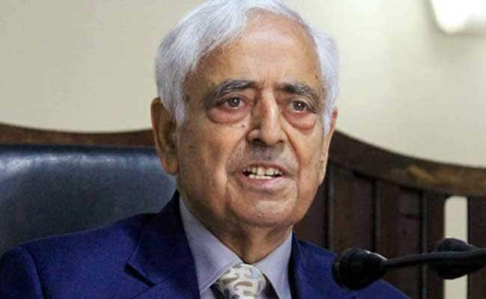
Mufti Mohammad Sayeed started his political career in the late 1950s when he joined the Democratic National Conference (DNC). Sayeed held his first formal post under the membership of the DNC when he was appointed as the District Convener of the party. In 1962, Sayeed was elected from Bijbehara to the state legislative assembly. He retained this seat in the succeeding elections five years later.
A few years later, Mufti Mohammad Sayeed fell out with the party leaders and joined the Indian National Congress (INC). He was considered as one of the few leaders in Jammu & Kashmir who made the INC a major political force in the state and the main opposition to the DNC. Mufti Mohammad Sayeed became a cabinet minister in the Congress government in 1972.However, in 1986, Sayeed’s association with the Congress came to an end in 1987 when he joined Jan Morcha, which was led by V. P. Singh. Subsequently, he went on to become the first Muslim Union Home Minister in 1989.
However, his third daughter, Rubaiya Sayeed came in news within five days of Mufti’s swearing in as the Union Home Minister in 1989. She was kidnapped by the militant outfit Jammu Kashmir Liberation Front (JKLF) and freed only after the Central Government released five of its compatriots. This episode changed the political dynamics in the state completely. Many of the Leaders within the V.P. Singh’s coalition frowned upon this incident and believed that they would have never killed her as doing so would led to a loss of trust within the Kashmir’s populace.
Farooq Abdullah :-
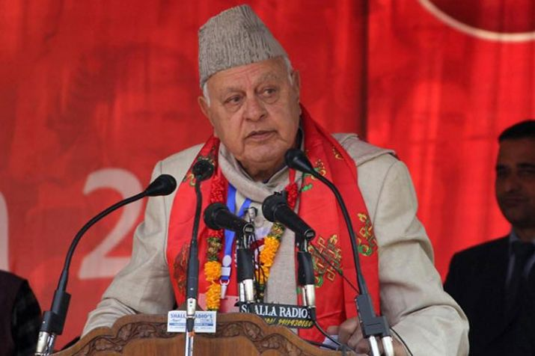
Son of Sheikh Abdullah, Farooq Abdullah was always considered a controversial figure in Indian politics as he repeatedly made demands for the greater autonomy of the state as the solution of long withstanding problem in the state.
He served as the JKNC president in multiple occasion from 1982-2002 and 2009-present. He also served as the CM in 3 occasions 1982, 1986, and 1996. He also has served as the Union minister in UPA coalition as the Union minister of New and Renewable Energy after defeating his sister Khalida Shah. He lost in the 2014 election, which replaced him by Mehbooba Mufti. At present he is controversially known to make statements on Kashmir’s autonomy and support towards the separatists.
Mehbooba Mufti
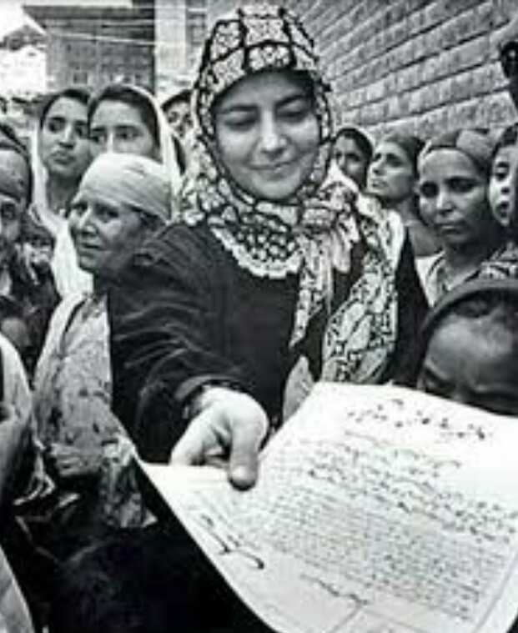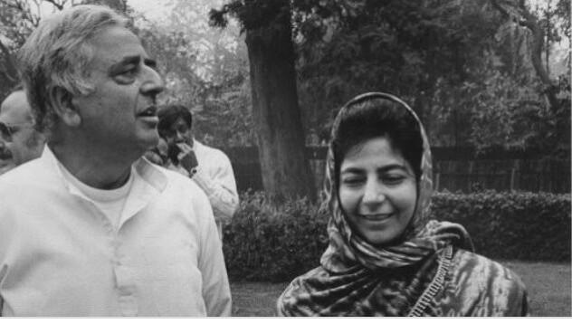
Daughter of Mufti Mohammed Sayeed, she is known to be the first woman Chief Minister of J&K elected on April 2016. She came into the limelight when she won the 1996 Assembly Elections on a congress ticket from Bijbehara constituency, but lost in 1999 elections against Omar Abdullah( son of Farooq Abdullah), but quickly made her mark as a fierce opposition leader. She became the party’s Vice president after the JKNC split from the Congress. She won the Lok Sabha seat multiple times in 2002 (Anant Nag by-elections), 2004 and 2014 Lok Sabha elections.
She welcomed prime minister’s decision to celebrate the festival of Diwali with the flood affected people in the state. She has been continuously criticized for the continuous mismanagement of the situation erupted after the flood hit the state. Moreover her stance on the separatists was widely unaccepted by the BJP and thus led to a split in the coalition.
Syed Ali Shah Geelani

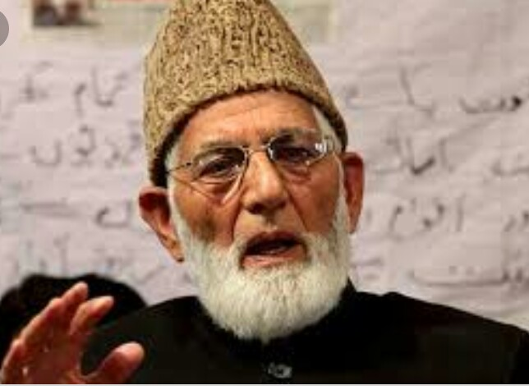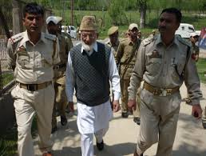
A Kashmiri separatist Hurriyat leader, He served as the chairman of All Parties Hurriyat Conference, a conglomerate of separatist parties in Jammu and Kashmir. He was an MLA from the Sopore constituency of Jammu and Kashmir three times (1972, 1977 and 1987). Geelani, in general, has taken the position that Kashmir must have the right of self-determination, but specifically advocates the position of union with Pakistan. He has been seen as close to the Pakistani government, but has not shied away from criticizing that country's policies in the past.
He was particularly critical of the Kargil episode, saying that while Pakistan had been supporting "the indigenous struggle of the people of Jammu and Kashmir, morally, diplomatically and politically ... this does not mean Pakistan can take a decision on our behalf".
Geelani has been repeatedly arrested by Indian authorities, who say that he is responsible for inciting violence [EPA]. Geelani was long seen as the driving force behind both militant and political policy.
Present political scenario:-
Post 2015, the BJP-PDP Coalition, Initially which worked smoothly were really successfully in bringing down the whole militant activities in the whole Kashmir region. However, various separatists’ organization such as the Hurriyat conference and the others, brought down a total stopover over the functioning of the government and the Army. And post 2016, following the URI Attack and the Surgical Strikes, The BJP took a more tougher stance on the Handling the problem and the Talks with these organization, It further maintained that the Army had a full charge over fixing the terrorist infestation in the whole J&K border area.
Furthermore, the BJP had maintained a very tough stance that the Article 370 and 35A must be abolished and thus, it routinely emphasizes that they are working over the removal of this article which grants a special status to Jammu and Kashmir.
Furthermore, the BJP and PDP had several differences over the talks with the separatists and handling the Stone Pelters problem which was handled in a very stringent way, by the BJP and so on, just after 21/2 years of the coalition, the coalition was severed off by the BJP and reinstated a governor’s rule led by Satya pal Malik.
Moreover, in the governor’s rule, the Army, CBI and the ED had laid a massive crackdown over the various properties which were owned by these separatists and seized the various assets which were being held by them. Furthermore in these recent years, post 2016 Surgical Strikes, the army and the government had successfully wiped off these terrorists from the area and right now as we speak the terrorists only exists in 3 districts surrounding the border Areas which are routinely cleaned by the Army’s specialized units like the RR, NSG and the PARA SF.
Furthermore, repeated controversies are being triggered by both of the political elements like NDA, J&K elements such as PDP, National conference wherein the BJP asserted itself into the abrogation of the Article 370 and 35A and on the other half Mehbooba Mufti quoting “If you scrap article 370, then your relation with Jammu and Kashmir is Over” and so on other volatile statements.
Furthermore, BJP President Amit Shah and Minister of state in the PMO Jitendra Singh, have repeatedly emphasized for the abrogation of the articles 35A and 370, which are repeatedly deemed as unjust by the various citizens especially the Kashmiri Pandits and the Kashmiri citizens who forcefully ousted during the past years due to the various exodus conducted by these elements and due to the Wahabi Islamization promoted by the Separatists and Pakistani agencies.
Just recently the BJP President Amit Shah has being reinstated as the Union minister of Home affairs in the NDA 2 2019 Regime , he is very well known to have a very extreme views on the separatists and in past was the state home minister during Narendra Modi’s Gujarat Government. This also supplements the previous statements of the Abrogation of the both Laws under the article 370 and 35A. This again that the centre is Hell Bound towards the issue of Jammu and Kashmir and there are more tough times to come in the Area.
Furthermore, various reports are emerging from the media that the NDA2 government is working towards the implementation of the de-limitation process, which tends to distribute the seats and governing powers equally and not towards the Kashmir Ghats and thus, ensuring the smooth abrogation of the respective articles 370 and 35A. It also working towards shifting the autonomy of the Kashmiri populace. Moreover, the BJP has ensured its most brutal measure towards Pakistan and thus has successfully stopped the infiltration of the Terrorist from Pakistan. It also has Extended the Governors Rule by more than 6 months, thus ensuring President Rule till the end of 2019.
V. REVIEW OF ANY THREE CENTRAL GOVERNMENT PROJECTS AND POLICIES
Introduction
Indian Government, at all levels, announces Welfare Schemes for a cross section of the society from time to time. These schemes could be either Central, State specific or a joint collaboration between the Centre and the States.
1. Swachh Bharat Abhiyan
Prime Minister of India, Narendra Modi launched the Swachh Bharat Abhiyan or Clean India Mission on the birth anniversary of Mahatma Gandhi on October 2, 2014 at Rajghat in New Delhi. The PM roped in prominent personalities from the film industry, sports, media, business and other celebrities to promote the initiative,
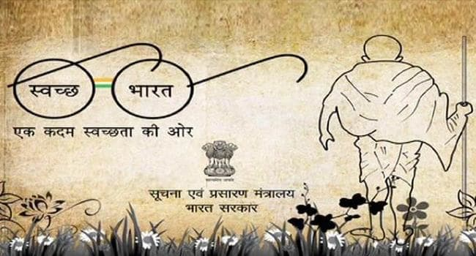
Imoprartant facts of Swachh Bharat Abhiyan
1. The national campaign led by the Government of India is covering 4041 statutory towns across India and aims to make the streets, roads and infrastructure clean by October 2, 2019 (Mahatma Gandhi's 150th birth anniversary)
2. The mission is estimated to cost around 62,009 crore rupees, of which 14,623 crore rupees will be borne by the Union Government
3. The urban component of the mission is being implemented by the Union Ministry of Urban Development and is India's biggest ever cleanliness drive. Around three million government employees and school and college students of India participated in the event in its initial phase. However, the rural component of the mission will be implemented by Union Ministry of Drinking Water and Sanitation
4. The mission was started by Prime Minister Modi, who, on December 25, 2014, nominated nine famous personalities for the campaign. They took up the challenge and nominated nine more people. Thereafter, it has been carried forward with people from all walks of life joining it. The nine public figures selected by Modi to propagate the mission include:
Comedian Kapil Sharma, Former captain of Indian cricket team Sourav Ganguly, Former IPS officer Kiran Bedi, Padmanabha Acharya, Nagaland Governor Sonal Mansingh, classical dancer Ramoji Rao of Eenadu group and Aroon Purie of the India Today group.
5. The goal also includes the elimination of open defecation, conversion of insanitary toilets to pour flush toilets, eradicating of manual scavenging and Municipal Solid Waste Management (MSWM).
Major components of the goal:
Construction of individual sanitary latrines for households below the poverty line with subsidy (80 percent) where demand exists
- Conversion of dry latrines into low-cost sanitary latrines
- Construction of exclusive village sanitary complexes for women providing facilities for hand pumping, bathing, sanitation and washing on a selective basis where there is not adequate land or space within houses and where village panchayats are willing to maintain the facilities
- Setting up of sanitary marts
- Total sanitation of villages through the construction of drains, soakage pits, solid and liquid waste disposal
- Intensive campaign for awareness generation and health education to create a felt need for personal, household and environmental sanitation facilities.
This would cover 1.04 crore households, provide 2.5 lakh seats of community toilets, 2.6 lakh seats of public toilets and solid waste management facility for all towns.
6. History: With effect from April 1, 1999, the Government of India restructured the Comprehensive Rural Sanitation Programme and launched the Total Sanitation Campaign (TSC).
To give a fillip to the TSC, effective June 2003, the government launched an incentive scheme in the form of an award for total sanitation coverage, maintenance of a clean environment and open defecation-free panchayat villages, blocks and districts, called Nirmal Gram Puraskar.
Effective April 1, 2012, the TSC was renamed to Nirmal Bharat Abhiyan (SBA). On October 2, 2014 the campaign was relaunched as Swachh Bharat Abhiyan
7. A Swachh Bharat Run was organised at the Rashtrapati Bhavan on October 2, 2014. According to a statement from the Rashtrapati Bhavan, around 1500 people participated and the event was flagged off by President Pranab Mukherjee. Participants in the run included officers and their families.
2. Goods and Services Tax (GST)
he Goods and Services Tax (GST) has been one of the key things that has caught the attention of the market given its implications on earnings of companies. In a meeting on May 18, the GST Council broadly approved the GST rates for goods at nil rate, 5 per cent, 12 per cent, 18 per cent and 28 per cent to be levied on certain goods.
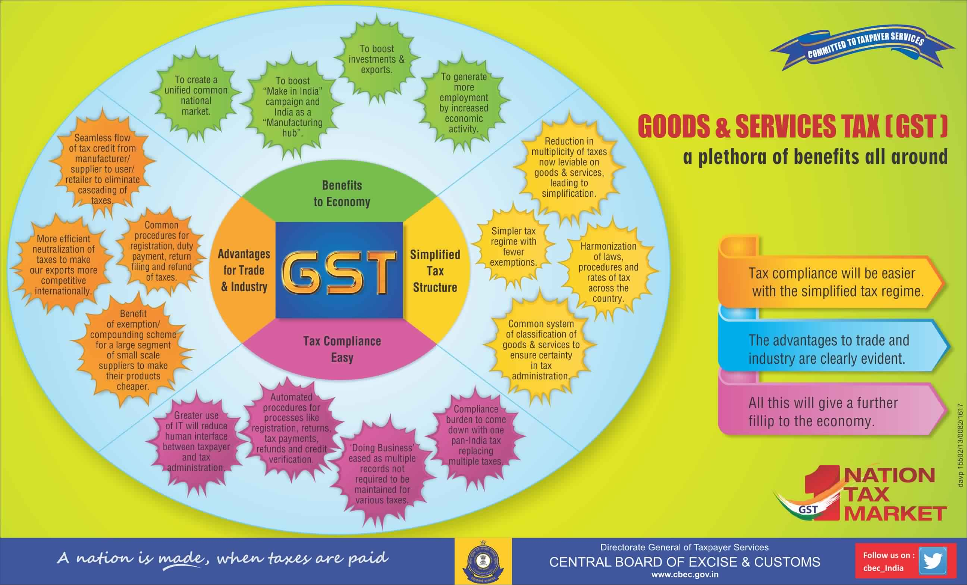
GST rates for goods simplified:
There are five tax slabs -- 5 per cent, 12 per cent, 18 per cent, 28 per cent and 28 per cent plus cess -- under the GST Act. In the 14th GST Council meeting held on May 18 in Srinagar, GST rates in the nil, 5 per cent, 12 per cent, 18 per cent and 28 per cent categories were approved.
Goods falling under Nil category
Fresh meat, fish chicken, eggs, milk, butter milk, curd, natural honey, fresh fruits and vegetables, flour, besan, bread, prasad, salt, bindi. Sindoor, stamps, judicial papers, printed books, newspapers, bangles, handloom etc. will have no tax imposition.
Goods falling under 5 per cent
Items such as fish fillet, cream, skimmed milk powder, branded paneer, frozen vegetables, coffee, tea, spices, pizza bread, rusk, sabudana, kerosene, coal, medicines, stent, and lifeboats will fall under the 5 per cent category.
Goods falling under 12 per cent
Frozen meat products , butter, cheese, ghee, dry fruits in packaged form, animal fat, sausage, fruit juices, namkeen, Ayurvedic medicines, tooth powder, agarbatti, colouring books, picture books, umbrella, sewing machine, and cellphones will attract 12 per cent tax.
Goods falling under 18 per cent
Most items are under this tax slab which includes flavoured refined sugar, pasta, cornflakes, pastries and cakes, preserved vegetables, jams, sauces, soups, ice cream, instant food mixes, mineral water, tissues, envelopes, tampons, note books, steel products, printed circuits, camera, speakers and monitors.
Goods falling under 28 per cent
Under this highest category will fall chewing gum, molasses, chocolate not containing cocoa, waffles and wafers coated with chocolate, pan masala, aerated water, paint, deodorants, shaving creams, after shave, hair shampoo, dye, sunscreen, wallpaper, ceramic tiles, water heater, dishwasher, weighing machine, washing machine, ATM, vending machines, vacuum cleaner, shavers, hair clippers, automobiles, motorcycles, aircraft for personal use, and yachts.
3. Make In India
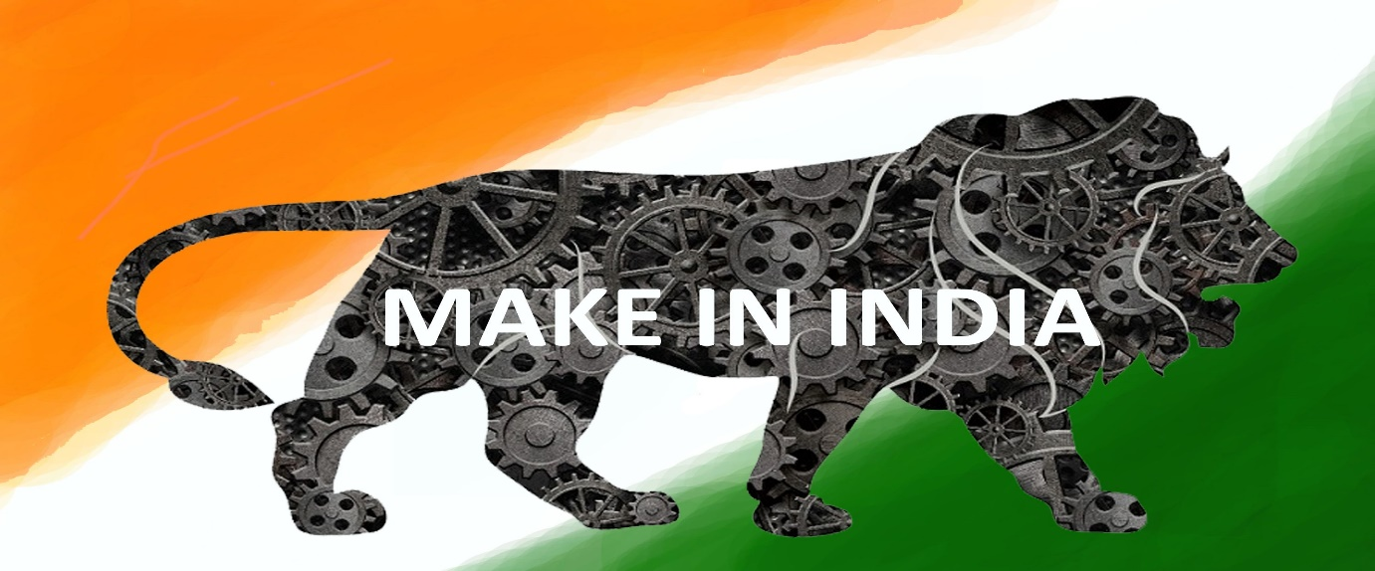
India, in the last decade had relied more on service sector rather than manufacturing for economic growth. As a result proportion of manufacturing sector in GDP has stagnated to 15-16% and shrunk by 0.7% in financial year 2013-2014 showing a negative growth. For the growth of any country to emerge as the Developed country or move closer to it, Manufacturing contribution to GDP needs to be much more significant. Hence, with this, The NDA-1 government launched the “Make in India” on 25 Sep-2014, to boost its efforts to increase the production in the manufacturing sector, by advocating the manufacturing of local goods in the country.
Moreover, the initiative proved to be fruitful in many areas such as Defense, technology and other sectors, but various experts say that there are various cons to the initiative, so here are the following pros and cons of the Make in India initiative:-
Pros:-
- Prime Minister Modi emphasized on the development of labour intensive manufacturing sector. So, this campaign will generate a lot of employment opportunities in Manufacturing, number expected to be around 100 million jobs by 2022.
- With the open invitation given to the entire world to manufacture their products in India, the various restrictions opposed over the entrepreneurs will be lifted and aspiring businessmen from all over the globe could invest in India with no stress at all. Moreover, Foreign investment will bring technical expertise and creative skills along with foreign capital. The concomitant credit rating upgrade will further woo investors.
- Moreover, the “Make in India” initiative creates a policy framework to ease foreign investment, ease of business and management of intellectual property. This helps industries to establish their manufacturing bases in India. In turn, this helps create employment in India. Industries tend to develop a support ecosystem around them, thus empowering small businesses. Exports from such industries help in contributing to our foreign exchange reserve. Most importantly, such an initiative helps bring critical knowledge about manufacturing and production into the Indian population.
- Moreover, when it comes to Defense, India is the sixth biggest defence spender. India is also one of the largest importers of conventional defence equipment and spends around 30% of its total defense budget on capital acquisitions. 60% of defence related requirements are currently met through imports. The ‘Make in India’ initiative by the Government is focusing its efforts one increasing indigenous defence manufacturing and becoming self-reliant. The opening up of the defence sector for private sector participation is helping foreign original equipment manufacturers (OEMs) enter into strategic partnerships with Indian companies and leverage opportunities in the domestic market as well as global markets.
- India’s focus on indigenous manufacturing in the defence space is paying off as the Ministry of Defence over the last two years unveiled several products manufactured in India like the HAL Tejas Light Combat Aircraft, the composites Sonar dome, a Portable Telemedicine System (PDF) for Armed Forces, Penetration-cum-Blast (PCB) and Thermobaric (TB) ammunition specifically designed for Arjun tanks, a heavyweight torpedo called Varunastra manufactured with 95% locally sourced parts and medium range surface to air missiles (MSRAM).
The Defence Acquisition Council (DAC) under Ministry of Defence, cleared defence deals worth more than INR 82,000 crore under ‘Buy and Department of Industrial Policy and Promotion Make (Indian)’ and ‘Buy Indian’ category. The deals include the procurement of Light Combat Aircraft (LCA), T-90 Tanks, Mini-Unmanned Aerial Vehicles (UAV) & light combat helicopters.
- Export-oriented growth model will improve India’s Balance of Payments and help in accumulating foreign exchange reserves (which is very important given the volatility in the global economy with multiple rounds of Quantitative Easing announced by major economies).
- Moreover, in agriculture and food processing initiative ,MoUs for investment worth of Rs. 90,191 crore (US$13.56 billion) were signed during 'World Food India 2017' in November, 2017.Moreover, the food processing industry registered a growth rate of 14% during the fiscal year 2015-16.
Cons
- From a theoretical perspective, Make in India will tend to violate the theory of comparative advantage. If it is not economically feasible to manufacture a commodity in India, it is best to import the same from a country which enjoys comparative advantage in its production. International trade, after all, is welfare augmenting.
- Make in India will lead to an unsustainable focus on export promotion measures. One such measure is artificially undervaluing the rupee. This will have devastating consequences for the import bill.
- Dr. Raghuram Rajan also made a point that, India, unlike China, does not have the time advantage as it undertakes a manufacturing spree. The essential question is – Is the world ready for a second China?
- A relative neglect of the world economic scenario may not augur well for Make in India. With the US and Japan economies yet to recover from their economic crises and with the EU floundering, one needs to be wary about the demand side of Make in India. The points of the former RBI governor to Make for India should be put to good use.
Complex processes have proved to be hurdles in getting procedural and regulatory clearances especially for new entrepreneurs. This also reflects in World Bank’s “Ease of Doing Business” report which ranked India at 134 out of 190 countries in 2013. However, the steps taken by NDA Government under the leadership of Prime Minister Modi has helped India to improve this rank by few notches to current 77th rank in 2019 .

Bibliography:-

www.makeinindia.org
www.pratiyogitadarpan.in
www.thebusinessline.in
www.Thenewindianexpress.com
www.iimcal.ac.in/make-india-academic-perspective-prof-partha-priya-dutta.

Sunil Kumar Gupta, Make in India : A Compendium of Business Opportunities & Laws in India, Parragon Publishers, 2015.
Chetan Bhagat, Making India Awesome: New Essays and Columns, Rupa Publications, 2015.
Naman Vinod, Make in India: Pradhanmantri Narinder Modi Ka Naya Prayaas, Hind Pocket Books, 2015.
Can “Make in India” make jobs? The challenges of manufacturing growth and high–quality job creation in India by Russell A. Green Will Clayton, fellow, International Economics, James A. Baker, Institute for Public Policy Rice University, (http://bakerinstitute.org. 2014).
http://www.mapsofindia.com/myindia/business/make-in-india-call-getssmart-response-fromhttp://www.livemint.com/Politics/n
timesofindia.indiatimes.com, Modi switching to capitalist economy: DMK - The Times of India

