ISSUES AND CHALLENGES OF BANKING SECTOR IN INDIA
The banking industry is undergoing a radical shift, one driven by new competition from FinTechs, changing business models, mounting regulation and compliance pressures, and disruptive technologies.
The emergence of FinTech/non-bank startups is changing the competitive landscape in financial services, forcing traditional institutions to rethink the way they do business. As data breaches become prevalent and privacy concerns intensify, regulatory and compliance requirements become more restrictive as a result. And, if all of that wasn’t enough, customer demands are evolving as consumers seek round-the-clock personalized service.
These and other banking industry challenges can be resolved by the very technology that’s caused this disruption, but the transition from legacy systems to innovative solutions hasn’t always been an easy one. That said, banks and credit unions need to embrace digital transformation if they wish to not only survive but thrive in the current landscape.

1. Increasing Competition
The threat posed by FinTechs, which typically target some of the most profitable areas in financial services, is significant. Goldman Sachs predicted that these startups would account for upwards of $4.7 trillion in annual revenue being diverted from traditional financial services companies.
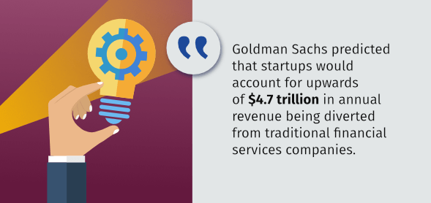
These new industry entrants are forcing many financial institutions to seek partnerships and/or acquisition opportunities as a stop-gap measure; in fact, Goldman Sachs, themselves, recently made headlines for heavily investing in FinTech. In order to maintain a competitive edge, traditional banks and credit unions must learn from FinTechs, which owe their success to providing a simplified and intuitive customer experience.

2. A Cultural Shift
From artificial intelligence (AI)-enabled wearables that monitor the wearer’s health to smart thermostats that enable you to adjust heating settings from internet-connected devices, technology has become ingrained in our culture — and this extends to the banking industry.
In the digital world, there’s no room for manual processes and systems. Banks and credit unions need to think of technology-based resolutions to banking industry challenges. Therefore, it’s important that financial institutions promote a culture of innovation, in which technology is leveraged to optimize existing processes and procedures for maximum efficiency. This cultural shift toward a technology-first attitude is reflective of the larger industry-wide acceptance of digital transformation.

3. Regulatory Compliance
Regulatory compliance has become one of the most significant banking industry challenges as a direct result of the dramatic increase in regulatory fees relative to earnings and credit losses since the 2008 financial crisis. From Basel’s risk-weighted capital requirements to the Dodd-Frank Act, and from the Financial Account Standards Board’s Current Expected Credit Loss (CECL) to the Allowance for Loan and Lease Losses (ALLL), there are a growing number of regulations that banks and credit unions must comply with; compliance can significantly strain resources and is often dependent on the ability to correlate data from disparate sources.

Major Banking Regulations
Basel III | Published in 2009, Basel III is a regulatory framework for banks established by the Basel Committee on Banking Supervision. Basel III risk-weighted capital requirements dictate the minimum capital adequacy ratio that banks must maintain.
Dodd-Frank Act | Passed during the Obama administration, the Dodd-Frank Wall Street Reform and Consumer Protection Act placed regulations on the financial services industry and created programs to prevent predatory lending.
CECL | Created by the Financial Accounting Standards Board, the CECL is an accounting standard that requires all institutions that issue a credit to estimate expected losses over the remaining life of the loan, rather than incurred losses.
ALLL | The ALLL is a reserve that financial institutions establish based on the estimated credit risk within their assets.
Faced with severe consequences for non-compliance, banks have incurred additional cost and risk (without a proportional enhancement to risk mitigation) in order to stay up to date on the latest regulatory changes and to implement the controls necessary to satisfy those requirements. Overcoming regulatory compliance challenges requires banks and credit unions to foster a culture of compliance within the organization, as well as implement formal compliance structures and systems.
Technology is a critical component in creating this culture of compliance. Technology that collects and mines data, performs in-depth data analysis, and provides insightful reporting is especially valuable for identifying and minimizing compliance risk. In addition, technology can help standardize processes, ensure procedures are followed correctly and consistently, and enable organizations to keep up with new regulatory/industry policy changes.

4. Changing Business Models
The cost associated with compliance management is just one of many banking industry challenges facing financial institutions to change the way they do business. The increasing cost of capital combined with sustained low-interest rates, decreasing return on equity, and decreased proprietary trading are all putting pressure on traditional sources of banking profitability. In spite of this, shareholder expectations remain unchanged.
This culmination of factors has led many institutions to create new competitive service offerings, rationalize business lines, and seek sustainable improvements in operational efficiencies to maintain profitability. Failure to adapt to changing demands is not an option; therefore, financial institutions must be structured for agility and be prepared to pivot when necessary.

5. Rising Expectations
Today’s consumer is smarter, savvier, and more informed than ever before and expects a high degree of personalization and convenience out of their banking experience. Changing customer demographics play a major role in these heightened expectations: With each new generation of banking customers comes a more innate understanding of technology and, as a result, an increased expectation of digitized experiences.
Millennials have led the charge to digitization, with five out of six reporting that they prefer to interact with brands via social media; when surveyed, millennials were also found to make up the largest percentage of mobile banking users, at 47%. Based on this trend, banks can expect future generations, starting with Gen Z, to be even more invested in omnichannel banking and attuned to technology. By comparison, Baby Boomers and older members of Gen X typically value human interaction and prefer to visit physical branch locations.
This presents banks and credit unions with a unique challenge: How can they satisfy older generations and younger generations of banking customers at the same time? The answer to this banking industry challenge is a hybrid banking model that integrates digital experiences into traditional bank branches. Imagine, if you will, a physical branch with a self-service station that displays the most cutting-edge smart devices, which customers can use to access their bank’s knowledge base. Should a customer require additional assistance, they can use one of these devices to schedule an appointment with one of the branch’s financial advisors; during the appointment, the advisor will answer any of the customer’s questions, as well as set them up with a mobile AI assistant that can provide them with additional recommendations based on their behavior. It might sound too good to be true, but the branch of the future already exists, and it’s helping banks and credit unions meet and exceed rising customer expectations.
Investor expectations must be accounted for, as well. Annual profits are a major concern — after all, stakeholders need to know that they’ll receive a return on their investment or equity and, in order for that to happen, banks need to actually turn a profit. This ties back into customer expectations because, in an increasingly constituent-centric world, satisfied customers are the key to sustained business success — so, the happier your customers are, the happier your investors will be.

6. Customer Retention
Financial services customers expect personalized and meaningful experiences through simple and intuitive interfaces on any device, anywhere, and at any time. Although customer experience can be hard to quantify, customer turnover is tangible and customer loyalty is quickly becoming an endangered concept. Customer loyalty is a product of rich client relationships that begin with knowing the customer and their expectations, as well as implementing an ongoing client-centric approach.
In an Accenture Financial Services global study of nearly 33,000 banking customers spanning 18 markets, 49% of respondents indicated that customer service drives loyalty. By knowing the customer and engaging with them accordingly, financial institutions can optimize interactions that result in increased customer satisfaction and wallet share, and a subsequent decrease in customer churn
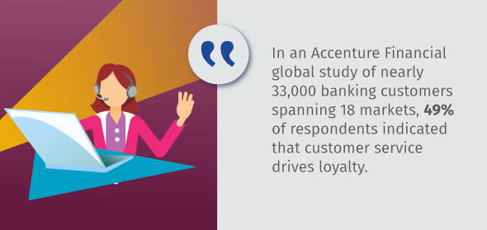
Bots are one new tool financial organizations can use to deliver superior customer service. Bots are a helpful way to increase customer engagement without incurring additional costs, and studies show that the majority of consumers prefer virtual assistance for timely issue resolution. As the first line of customer interaction, bots can engage customers naturally, conversationally, and contextually, thereby improving resolution time and customer satisfaction. Using sentiment analysis, bots are also able to gather information through dialogue, while understanding context through the recognition of emotional cues. With this information, they can quickly evaluate, escalate, and route complex issues to humans for resolution.

7. Outdated Mobile Experiences
These days, every bank or credit union has its own branded mobile application — however, just because an organization has a mobile banking strategy doesn’t mean that it’s being leveraged as effectively as possible. A bank’s mobile experience needs to be fast, easy to use, fully-featured (think live chat, voice-enabled digital assistance, and the like), secure, and regularly updated in order to keep customers satisfied. Some banks have even started to reimagine what a banking app could be by introducing mobile payment functionality that enables customers to treat their smartphones like secure digital wallets and instantly transfer money to family and friends.

8. Security Breaches
With a series of high-profile breaches over the past few years, security is one of the leading banking industry challenges, as well as a major concern for bank and credit union customers. Financial institutions must invest in the latest technology-driven security measures to keep sensitive customers safe, such as:
- Address Verification Service (AVS): AVS “checks the billing address submitted by the card user with the cardholder’s billing address on record at the issuing bank” in order to identify suspicious transactions and prevent fraudulent activity.
- End-to-End Encryption (E2EE): E2EE “is a method of secure communication that prevents third-parties from accessing data while it’s transferred from one end system or device to another.” E2EE uses cryptographic keys, which are stored at each endpoint, to encrypt and decrypt private messages. Banks and credit unions can use E2EE to secure mobile transactions and other online payments so that funds are securely transferred from one account to another, or from a customer to a retailer.
- Authentication:
  - Biometric authentication “is a security process that relies on the unique biological characteristics of an individual to verify that he is who he says he is. Biometric authentication systems compare a biometric data capture to stored, confirmed authentic data in a database.” Common forms of biometric authentication include voice and facial recognition and iris and fingerprint scans. Banks and credit unions can use biometric authentication in place of PINs, as it’s more difficult to replicate and, therefore, more secure.
  - Location-based authentication (sometimes referred to as geolocation identification) “is a special procedure to prove an individual’s identity and authenticity on appearance simply by detecting its presence at a distinct location.” Banks can use location-based authentication in conjunction with mobile banking to prevent fraud by either sending out a push notification to a customer’s mobile device authorizing a transaction, or by triangulating the customer’s location to determine whether they’re in the same location in which the transaction is taking place.
  - Out-of-band authentication (OOBA) refers to “a process where authentication requires two different signals from two different networks or channels… [By] using two different channels, authentication systems can guard against fraudulent users that may only have access to one of these channels.” Banks can use OOBA to generate a one-time security code, which the customer receives via automated voice call, SMS text message, or email; the customer then enters that security code to access their account, thereby verifying their identity.
  - Risk-based authentication (RBA) — also known as adaptive authentication or step-up authentication — “is a method of applying varying levels of stringency to authentication processes based on the likelihood that access to a given system could result in its being compromised.” RBA enables banks and credit unions to tailor their security measures to the risk level of each customer transaction.

9. Antiquated Applications
According to the 2017 Gartner CIO Survey, over 50% of financial services CIOs believe that a greater portion of business will come through digital channels, and digital initiatives will generate more revenue and value.

However, organizations using antiquated business management applications or siloed systems will be unable to keep up with this increasingly digital-first world. Without a solid, forward-thinking technological foundation, organizations will miss out on critical business evolution. In other words, digital transformation is not just a good idea — it’s become imperative for survival.
While technologies such as blockchain may still be too immature to realize significant returns from their implementation in the near future, technologies like cloud computing, AI, and bots all offer significant advantages for institutions looking to reduce costs while improving customer satisfaction and growing wallet share.
Cloud computing via software as a service and platform as a service solutions enable firms previously burdened with disparate legacy systems to simplify and standardize IT estates. In doing so, banks and credit unions are able to reduce costs and improve data analytics, all while leveraging leading-edge technologies. AI offers a significant competitive advantage by providing deep insights into customer behaviors and needs, giving financial institutions the ability to sell the right product at the right time to the right customer. Additionally, AI can provide key organizational insights required to identify operational opportunities and maintain agility.

10. Continuous Innovation
Sustainable success in business requires insight, agility, rich client relationships, and continuous innovation. Benchmarking effective practices throughout the industry can provide valuable insight, helping banks and credit unions stay competitive. However, benchmarking alone only enables institutions to keep up with the pack — it rarely leads to innovation. As the cliché goes, businesses must benchmark to survive, but innovate to thrive; innovation is a key differentiator that separates the wheat from the chaff.
Innovation stems from insights, and insights are discovered through customer interactions and continuous organizational analysis. Insights without action, however, are impotent — it’s vital that financial institutions be prepared to pivot when necessary to address market demands while improving upon the customer experience.
Financial service organizations leveraging the latest business technology, particularly around cloud applications, have a key advantage in the digital transformation race: They can innovate faster. The power of cloud technology is its agility and scalability. Without system hardware limiting flexibility, cloud technology enables systems to evolve along with your business.

How Hitachi Solutions Can Help
With so many banking industry challenges to contend with, charting a clear path forward can seem like an overwhelming task — but with the right team to support your efforts, digital transformation is attainable. The financial services team at Hitachi Solutions has been helping banks and credit unions unlock digital experiences through the power of the Microsoft platform since 2004. With a wide variety of products and services tailored to the financial services industry, such as Engage for Banking and Retail Banking Sales Insights, we’re familiar with the unique issues financial institutions face and have developed the technology to resolve them.
From data science expertise to business intelligence, AI, and beyond, Hitachi Solutions is here to help your organization tackle banking industry challenges and embrace digital transformation.

OVERVIEW OF THE LEGAL FRAMEWORK BACKING BANKING SECTOR OF INDIA
Banking Regulation Act, 1949
Different types of banks, such as commercial banks, cooperative banks, rural banks, and private sector banks exist in India. The Reserve Bank of India (RBI) is the governing body for regulating and supervising the banks. Banking Regulation Act, 1949 is an Act that provides a framework for regulating the banks of India. The Act came into force on 16th March 1949. This Act gives RBI the power to control the behavior of banks. This Act was passed as Banking Companies Act, 1949. It did not apply to Jammu and Kashmir until 1956. This Act monitors the day-to-day operations of the bank. Under this Act, the RBI can license banks, put ​​regulation over shareholding and voting rights of shareholders, look over the appointment of the boards and management, and lay down the instructions for audits. RBI also plays a role in mergers and liquidation.

Objectives of the Banking Regulation Act, 1949
The objectives of the Banking Regulation Act are stated below:
- To meet the demand of the depositors and provide them security and guarantee.
- To provide provisions that can regulate the business of banking.
- To regulate the opening of branches and changing of locations of existing branches.
- To prescribe minimum requirements for the capital of banks.
- To balance the development of banking institutions.

Important provisions of the Banking Regulation Act, 1949
Some important provisions of the Act are stated below:

Definitions
The Act has defined some terms such as banking, banking company, branch office, etc. A banking company means a company that conducts banking business in India. Banking means to accept for lending or investment of deposits of money from the public which can be repaid on demand. Subsidiary banks have the same meaning as given under the State Bank of India (Subsidiary Banks) Act, 1959. A secured loan or advance means an advance or a loan secured against the security of assets.

Business which can be undertaken by the banking companies
Under Section 6(1), a banking company may be involved in the business of borrowing or lending money; buying or selling bills of exchange, promissory notes, coupons, drafts, bills of lading, railway receipts, warrants, debentures; buying or selling of foreign exchange; dealing stock, funds, shares, debentures, bonds; carrying on agency business such as clearing and forwarding of goods; conducting the business of guarantee and indemnity, etc.

Prohibition of trading
Trading is prohibited under Section 8 of this Act.
No banking company shall directly or indirectly deal in the buying or selling, or bartering of goods except when it is selling the goods kept in its security. The bank should also not engage in any trade or buy, sell or barter goods except for bills of exchange received due to collection or negotiation.

Management of bank
The bank should not employ or be employed by the managing partner as stated under Section 10 of the Act.
The bank should also not employ a person who has been adjudicated insolvent or whose remunerations depend on the profits of the company. At least 51% of the total members of the board must have professional experience in matters such as accountancy, agriculture, rural economy, banking, cooperation, economics, finance, law, small-scale industry, etc. The term of the office of the director should not be more than eight years.

Minimum paid-up capital and reserves
Section 11 states that if a banking company is incorporated outside India then the total value of its paid-up capital should be more than fifteen lakhs and if it has a place of business in Calcutta or Bombay or both, then it should be more than twenty lakhs.
The banking company must deposit twenty percent of its profit for the year. If the company is incorporated in India and if it has branches in different states, then the paid-up capital is five lakhs of rupees, and if the place of business is situated in the city of Bombay or Calcutta or both, then ten lakhs of rupees must be the minimum paid-up capital. If the company has all its branches in the same state none of which is situated in the city of Bombay or Calcutta, then the paid-up capital must be one lakh rupees concerning its principal place of business, plus ten thousand rupees in respect of each of its other branches situated in the same district in which it has its principal place of business, plus twenty-five thousand rupees in respect of each branch situated elsewhere in the state otherwise than in the same district.
The subscribed capital of the company should not be less than one-half of the authorised capital, and the paid-up capital should not be less than one-half of the subscribed capital. The banking company cannot create any charge on unpaid capital. The company shall transfer every year at least twenty percent of its profits to the Reserve Fund. The banking company must inform RBI of the appropriation of the Reserve Fund within twenty-one days from the date of appropriation.

Offenses and punishment under the Banking Regulation Act, 1949
Various provisions are mentioned in the Act which states that a person will be liable for imprisonment and fine if he does any act which is in contravention with the Act. It is stated under Section 46 as below:
- A person will be liable for imprisonment of up to three years and a fine which may extend up to one crore rupees if he has misrepresented any facts or presented the wrong acts intentionally.
- A person will be liable to a fine of up to twenty lakh rupees and up to fifty thousand rupees in case of a continuing offence if he fails to produce the documents or books or refuses to answer the questions asked by the inspection officer.
- All the directors of the banking company will be held liable and will be imposed a fine of twice the amount of the deposits made with the banking company if the banking company has illegally received any deposit.
- The directors or the secretary will be punished if the company has caused a default or the default occurred due to the negligence of the director.

Shortcomings of the Banking Regulation Act, 1949
The Banking Regulation Act has less scope on public sector banks. The amendments in the Act are not enough to leverage the stressed assets in the financial system. There are no strict provisions for non-performing assets (NPA), and this gives a chance to the defaulters to escape from the situation. Some provisions of this act can hamper the working of the banks.

Amendments to the Banking Regulation Act, 1949

Banking Laws (Application To Co-operative Societies) Act, 1965
Initially, the Banking Regulation Act was passed as Banking Companies Act, 1949. But with the introduction of the Banking Laws (Application To Co-operative Societies) Act, the word Companies was omitted and the word Regulation was added to the title of the Banking Regulation Act, 1949. The Act also added a new Section called Section 56 as Part V after Part IV in the Banking Regulation Act. This section will apply to co-operative societies subjected to some modifications.

Banking Regulation (Amendment) Act, 2020 (Act 39 of 2020)
This Act came into force on September 29, 2020. The Banking Regulation Act will not be applied to a cooperative society whose main business is providing long-term financial support for agricultural development. The amendment also mentioned that the societies should not use the words ‘bank’, ‘banker’, or ‘banking’ in their name or connection with their business. A cooperative bank may issue equity shares, preference shares, or special shares on face value or at a premium to its members or to any other person residing within its area of operation after obtaining prior approval from the Reserve Bank of India.
After the amendment, RBI may suspend the Board of Directors of a multi-cooperative bank for five years to protect the depositors. This amendment omitted some provisions like granting of unsecured loans or advances to its directors, and to private companies where the bank’s directors or chairman is an interested party, opening a new place of business, or changing the location of the cooperative bank outside of the city, town or village in which it is currently located without permission from RBI, etc.

BFSI
BFSI stands for the Banking, Financial Services, and Insurance sector. Fundamentally, it represents a major portion of the multi-billion dollar Indian economy comprising all Banking, Insurance, and Non-Banking Financial Institutions. The latter is known as the NBFCs. Also, the BFSI industry largely refers to financial service firms such as Broking, and Asset Management.
India, as a business destination, fosters all the positives for the BFSI sector to flourish at an appreciable pace. Interdependent factors of government policy, active public/private involvement, robust regulatory measures, and technological evolution have spurred the BFSI sector to register strong numbers in recent years.
RECENT DEVELOPMENTS IN BFSI
1.BANKING
India is set to become the third-largest domestic banking sector by 2050. Historically Indian banking has benefited from high savings rates and growth in savings as well as disposable income growth. The Banking industry in India has historically been one of the most stable systems globally, despite global upheavals. The government has consistently strived to promote financial inclusion through various initiatives targeted to bring the country's underbanked population under the banking spectrum.
Bank accounts opened under GoI Pradhan Mantri Jan Dhan Yojana are over 450 Mn with deposits of over ~$22 Bn in beneficiary accounts.
Investments stood as the 2nd largest component in the assets side of the total banks’ balance sheets after loans and advances, driven primarily by Government securities. As of 2020, the capital adequacy amongst Indian banks remained above regulatory requirements with RBI also further relaxing the leverage ratio for banks to boost lending.
RBI has taken steps to enable mobile payments key enablers to growth, by removing the transaction limit of $745 and allowing banks to set their own limits. Recovery of stressed assets improved during 2019-20 through the IBC, 2016 and Securitisation and Reconstruction of Financial Assets and Enforcement of Security Interests (SARFAESI) Act, 2002.
The Top 5 banks in India banking assets are ~$ 1.3 Tn: State Bank of India, ICICI Bank, Punjab National Bank, Bank of Baroda, and Bank of India .

1.A SOVEREIGN GREEN BONDS AND THEMATIC FUNDS.
Government of India has a taken a number of measures including the announcements in the Union Budget 2022-23. Sovereign green bonds and thematic funds for blended finance in areas including climate action were announced in the Union Budget 2022-23.

1.B THE RBI AND IFSC’S MOU
The International Financial Services Centres Authority (IFSCA) and the Reserve Bank of India (RBI) have entered into a Memorandum of Understanding (MoU) for collaboration in the field of regulation and supervision of regulated entities in their respective jurisdictions.
The MoU facilitates technical cooperation and exchange of information.
The IFSCA, being a unified regulator responsible for development and regulation of financial products, financial services and financial institutions in the International Financial Services Centre(s) (IFSC) established in India, is, inter-alia, entrusted with the responsibility of regulation and supervision of authorized banks and non-banking financial institutions operating in such IFSCs.
The RBI is the central bank and monetary authority of India carrying on, inter-alia, the regulation and supervision of banks and non-banking financial institutions as well as undertaking other functions and exercising powers in accordance with various statutes
The MoU opens up avenues for cooperation between the two regulators, thereby strengthening the safety, stability and soundness of respective financial ecosystems and nurturing environments conducive to optimal business development and economic growth.
2. INSURANCE
India is the 10th largest Life Insurance market globally. India is ranked 11th in global insurance business. Government schemes and financial inclusion initiatives shall have helped in driving the adoption & penetration across all segments. The government’s flagship initiative for crop insurance (PMFBY) has led to significant growth in the premium income for crop insurance, and now covers over 55 mn farmer applications year-on-year. Even during the COVID-19 lockdown period, nearly 70 lakh farmers have benefited from it, and claims worth INR 87.4 bn ($1.2 bn) were transferred to the beneficiaries.
AB PM-JAY is an entitlement-based scheme under Ayushman Bharat and is fully funded by the Government. It is the largest health assurance scheme in the world and aims at providing a health cover of INR 500,000 ($6,900) per family per year for secondary and tertiary care hospitalization to over 107 mn vulnerable families (approximately 500 mn beneficiaries).

The insurance regulator IRDAI has also undertaken various initiatives towards boosting insurance penetration, such as permitting insurers to conduct video-based KYC, launching standardized insurance products and allowing insurers to offer rewards for low-risk behavior.
Going forward, general insurance companies will be key beneficiaries of the opening-up of economies, especially with improved trade activity increasing demand for motor and health insurance. Strong growth in the automotive industry over the next decade is expected to boost the motor insurance market. Meanwhile, the life insurance sector will benefit from a steep yield curve, with low short-term rates and higher long-term rates.

Digital issuance and online channels are expected to witness continued growth, the share of web aggregators within digital insurance has been constantly increasing and web-aggregators currently originate 30-40% of digital insurance.
2.1 INSURANCE FOR ALL
Insurance Regulatory and Development Authority of India (IRDAI) has committed to enable ‘Insurance for All’ by 2047, where every citizen has an appropriate life, health and property insurance cover and every enterprise is supported by appropriate insurance solutions and also to make the Indian insurance sector globally attractive. To attain this objective, efforts are being made towards creating a progressive, supportive, facilitative and a forward looking regulatory architecture to foster a conducive and competitive environment leading to wider choice, accessibility and affordability to policyholders. This reform agenda taken up by IRDAI derives inspiration from the Government of India’s vision of financial inclusion and strong emphasis on accelerating reforms. The focus of IRDAI is to strengthen the three pillars of the entire insurance ecosystem viz. insurance customers (policyholders), insurance providers (insurers) and insurance distributors (intermediaries) by · making available right products to right customers; · creating robust grievance redressal mechanism; · facilitating ease of doing business in the insurance sector; · ensuring the regulatory architecture is aligned with the market dynamics; · boosting innovation, competition and distribution efficiencies while mainstreaming technology and moving towards principle based regulatory regime. Towards this objective, amendments to various regulations were proposed and were placed for stakeholder comments. This was followed by a series of discussions and interactions with insurers, intermediaries (including individual agents, corporate agents, brokers, insurance marketing firms,.) and experts. A careful evaluation of comments and suggestions was carried out. The amendments to regulations were also placed before the Insurance Advisory Committee (an advisory committee for consultations formed under the IRDA Act 1999).

FINTECH
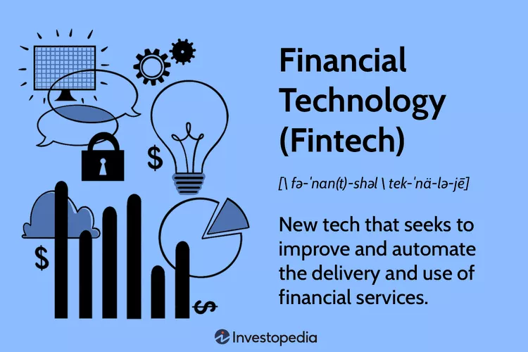

Financial technology (better known as Fintech) is used to describe new tech that seeks to improve and automate the delivery and use of financial services. ​​​At its core, fintech is utilized to help companies, business owners, and consumers better manage their financial operations, processes, and lives by utilizing specialized software and algorithms that are used on computers and, increasingly, smartphones. Fintech, the word, is a combination of "financial technology."
When fintech emerged in the 21st century, the term was initially applied to the technology employed at the back-end systems of established financial institutions. ​Since then, however, there has been a shift to more consumer-oriented services and therefore a more consumer-oriented definition. Fintech now includes different sectors and industries such as education, retail banking, fundraising and nonprofit, and investment management, to name a few.
Fintech also includes the development and use of cryptocurrencies, such as Bitcoin. While that segment of fintech may see the most headlines, the big money still lies in the traditional global banking industry and its multi-trillion-dollar market capitalization.
Fintech refers to the integration of technology into offerings by financial services companies in order to improve their use and delivery to consumers.
It primarily works by unbundling offerings by such firms and creating new markets for them.
Startups disrupt incumbents in the finance industry by expanding financial inclusion and using technology to cut down on operational costs.
Fintech funding is on the rise but regulatory problems exist.
Examples of fintech applications include robo advisors, payments apps, peer-to-peer (P2P) lending apps, investment apps, and crypto apps, among others.

FINTECH IN INDIA
India is amongst the fastest growing Fintech markets in the world. India has the highest FinTech adoption rate globally of 87% which is significantly higher than the global average rate of 64%.Indian FinTech industry’s market size is $50 Bn in 2021 and is estimated at ~$150 Bn by 2025.As of July 2022, India has 23 Fintech companies, which have gained ‘Unicorn Status’ with a valuation of over $1 Bn.
The Fintech revolution in India is the culmination of years of effort in laying the groundwork towards developing key enablers through important initiatives:
Jan Dhan Yojana: Jan Dhan Yojana: The world’s largest financial inclusion initiative, “Jan Dhan Yojna”, has helped in new bank account enrollment of over 450 Mn beneficiaries for direct benefits transfer and accessibility to a host of financial services applications such as remittances, credit, insurance, and pensions enabling FinTech players to build technology products to penetrate the large consumer-base in India.
Financial Literacy: Some of the recent initiatives towards improving financial literacy in India include setting up the National Centre for Financial Education and implementation of the Centre for Financial Literacy project by the RBI. These steps aim to promote financial education across India for all sections of the population.
E-RUPI: e-RUPI is a person & purpose specific digital payments instrument to allow for contactless & cashless payment solutions and shall play an important role in making the Direct Benefits Transfer more seamless & effective. The solution is being adopted for cashless payments for Covid-19 vaccination.
India Stack: IndiaStack is a set of APIs that allows governments, businesses, startups and developers to utilise a unique digital Infrastructure to solve India’s hard problems towards presence-less, paperless, and cashless service delivery. The India Stack has been the driving force behind the accelerated evolution of Fintechs. It is one of the most important digital initiatives undertaken globally, aimed at putting up a public digital infrastructure based on open APIs to promote public and private digital initiatives and has played a catalytic role in India’s digital foundation and evolution.
GROWTH DRIVERS
Volume of Funds
High volume of funding from venture capital, private equity and institutional investors driving innovation in the sector.
India stack
Open API platforms i.e. Aadhar, UPI, Bharat Bill Payments, GSTN
Technological Innovation
Implementation of new business models driven by technologies such as Artificial Intelligence and Machine Learning
Increasing internet & smartphone penetration
India already has the 2nd highest number of smartphone users globally and is the 2nd largest Internet user market. ~1 Bn Internet Users by 2026. The number of households with internet connections with an increase by 46%, reaching 233 Mn households by 2026, compared to 160 Mn in 2021
Favorable Demographics
68% of India’s population is young and 55% of its population is in the age group of 20-59 (working population) in the year 2020 and is estimated to reach 56% of the total population by 2025. By 2030, India will add 140 Mn middle-income and 21 Mn high-income households which will drive the demand and growth of Indian FinTech space.
Financial Inclusion Initiatives
Financial inclusion programmes such as PMJDY, DAY-NRLM, Direct Benefit Transfer, Atal Pension Yojana among others have accelerated the digital revolution and brought more citizens, especially in rural areas, within the ambit of digital financial services
CROWDFUNDING

Crowdfunding is the use of small amounts of capital from a large number of individuals to finance a new business venture. Crowdfunding makes use of the easy accessibility of vast networks of people through social media and crowdfunding websites to bring investors and entrepreneurs together, with the potential to increase entrepreneurship by expanding the pool of investors beyond the traditional circle of owners, relatives, and venture capitalists.
Crowdfunding has created the opportunity for entrepreneurs to raise hundreds of thousands or millions of dollars from anyone with money to invest. Crowdfunding provides a forum to anyone with an idea to pitch it in front of waiting investors.
One of the more amusing projects to receive funding was from an individual who wanted to create a new potato salad recipe. His fundraising goal was $10, but he raised more than $55,000 from 6,911 backers.Investors can select from hundreds of projects and invest as little as $10. Crowdfunding sites generate revenue from a percentage of the funds raised.

Types of Crowdfunding
The two most traditional uses of the term reflect the type of crowdfunding done by start-up companies looking to bring a product or service into the world and by individuals who experienced some type of emergency. Many individuals affected by a natural disaster, hefty medical expense, or another tragic event such as a house fire have received an amount of financial relief they wouldn't otherwise have had access to thanks to crowdfunding platforms.
However, in recent years, some crowd funding such as Patreon and Substack have extended the reach of crowdfunding to offer a way for creative people—artists, writers, musicians, or podcasters—to sustain their creative work by receiving a steady source of income.

Popular Crowdfunding Websites
Crowdfunding websites such as Kickstarter, Indiegogo, and GoFundMe attract hundreds of thousands of people hoping to create, or support, the next big thing.

GoFundMe
As of 2021, GoFundMe is the largest crowdfunding platform. Since GoFundMe was founded in 2010, the site has raised over $15 billion through more than 100 million donors. GoFundMe is the site most popular for individuals seeking to recover from a medical expense or disaster such as a house fire, natural disaster, or unexpected emergency expense. Start-up companies tend to use Kickstarter.

Kickstarter
Kickstarter is another popular choice. As of May 29, 2022, since it was founded in 2009, Kickstarter has successfully funded over 220,000 projects, with more than $6.6 billion pledged across all Kickstarter projects.
Kickstarter is the most popular crowdfunding site for aspiring businesses hoping to raise capital and reach a larger audience. In fact, unlike GoFundMe, Kickstarter can only be used for creating projects that can be shared with others.
Additionally, Kickstarter cannot be used to raise funds to donate to a charity or cause, projects can't offer incentives like equity, revenue sharing, or investment opportunities, nor can any project involve the site's list of prohibited items such as "any item claiming to diagnose, cure, treat, or prevent an illness or condition," political fundraising, drugs or alcohol, or any contests, coupons, gambling, and raffles.

Indiegogo
Indiegogo started as a crowdfunding site initially focused exclusively on raising money for independent films but began accepting projects from any category a year after its launch in 2008.
Indiegogo is seen as a less strict and more flexible platform than Kickstarter, as it gives backers control over whether they want fixed or flexible models—this is probably the most significant difference between the two crowdfunding platforms. Kickstarter releases funds only after the campaign has reached its funding goal, whereas Indiegogo allows the campaigner to receive funding pro-rata, or wait until their target is hit.
As a campaigner, it might be easier and less risky to go with flexible funding (i.e., receiving funds as they come); however, regardless of the amount raised, campaigners must still deliver on any promises made. For a backer, fixed funding is more attractive as it is associated with much less of a risk.
Crowdfunding platform fees range from 5% to 12%. Look out for punitive fee structures before choosing a crowdfunding platform.

Advantages and Disadvantages of Crowdfunding
The most obvious advantage of crowdfunding for a start-up company or individual is its ability to provide access to a larger and more diverse group of investors/supporters. With the ubiquity of social media, crowdfunding platforms are an incredible way for businesses and individuals to both grow their audience and receive the funding they need.
Furthermore, many crowdfunding projects are rewards-based; investors may get to participate in the launch of a new product or receive a gift for their investment. For instance, the maker of a new soap made out of bacon fat may send a free bar to each of its investors. Video games are a popular crowdfunding investment for gamers, who often receive advance copies of the game as a reward.
Equity-based crowdfunding is growing in popularity because it allows startup companies to raise money without giving up control to venture capital investors. In some cases, it also offers investors the opportunity to earn an equity position in the venture.
Potential disadvantages of crowdfunding include the possible damage to you or your company's reputation caused by "resorting" to crowdfunding, the fees associated with the crowdfunding site, and, at least on some platforms, if you don't reach your funding goal, any finance that has been pledged will be returned to your investors and you will receive nothing.
Access to funding you otherwise might not qualify for from traditional sources
- Great way to interact with potential consumers
- Ability to gauge public opinion on your product
Must follow the rules/fees of the crowdfunding platform
- In some cases, if you don't reach your funding goal, any finance that has been pledged will be returned to your investors
- Possible damage to your start-up company's reputation

Examples of Crowdfunding
Many of the products and businesses crowdfunded on Kickstarter became very successful and lucrative endeavors. For instance, Oculus VR, an American company specializing in virtual reality hardware and software products, was funded through the site. In 2012, founder Palmer Luckey launched a Kickstarter campaign to raise money to make virtual reality headsets designed for video gaming available to developers. The campaign crowdfunded $2.4 million, ten times the original goal of $250,000. In March 2014, Facebook, now Meta (META), acquired Oculus VR for $2.3 billion in cash and stock.
Another example of a company that rose to success through the help of Kickstarter campaigns is M3D, a company founded by two friends that manufacture small 3D printers. David Jones and Michael Armani raised $3.4 million for their Micro 3D printer on the crowdfunding site in 2014. The tiny 3D printer, which comes with a variety of durable 3D inks, is now available at Staples, Amazon.com, Inc. , Brookstone, and elsewhere.
In April 2019, Critical Role, a weekly live-streamed tabletop roleplaying game featuring a group of prominent voice actors, raised $4.7 million in just 24 hours for its latest animated special “The Legend of Vox Machina.” No other 2019 Kickstarter campaign raised that amount over their entire 30- to 60-day raising period.

BLOCKCHAIN
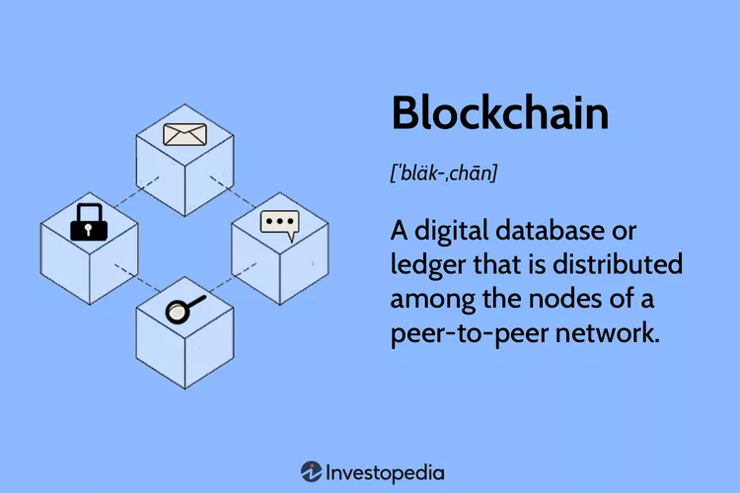

A blockchain is a distributed database or ledger that is shared among the nodes of a computer network. As a database, a blockchain stores information electronically in digital format. Blockchains are best known for their crucial role in cryptocurrency systems, such as Bitcoin for maintaining a secure and decentralized record of transactions. The innovation with a blockchain is that it guarantees the fidelity and security of a record of data and generates trust without the need for a trusted third party.
One key difference between a typical database and a blockchain is how the data is structured. A blockchain collects information together in groups, known as blocks, that hold sets of information. Blocks have certain storage capacities and, when filled, are closed and linked to the previously filled block, forming a chain of data known as the blockchain. All new information that follows that freshly added block is compiled into a newly formed block that will then also be added to the chain once filled.
A database usually structures its data into tables, whereas a blockchain, as its name implies, structures its data into chunks (blocks) that are strung together. This data structure inherently makes an irreversible timeline of data when implemented in a decentralized nature. When a block is filled, it is set in stone and becomes a part of this timeline. Each block in the chain is given an exact timestamp when it is added to the chain.

How Does a Blockchain Work?
The goal of blockchain is to allow digital information to be recorded and distributed, but not edited. In this way, a blockchain is the foundation for immutable ledgers, or records of transactions that cannot be altered, deleted, or destroyed. This is why blockchains are also known as a distributed ledger technology (DLT).
First proposed as a research project in 1991, the blockchain concept predated its first widespread application in use: Bitcoin, in 2009. In the years since, the use of blockchains has exploded via the creation of various cryptocurrencies, decentralized finance (DeFi) applications, non-fungible tokens (NFTs), and smart contracts.

Transaction Process
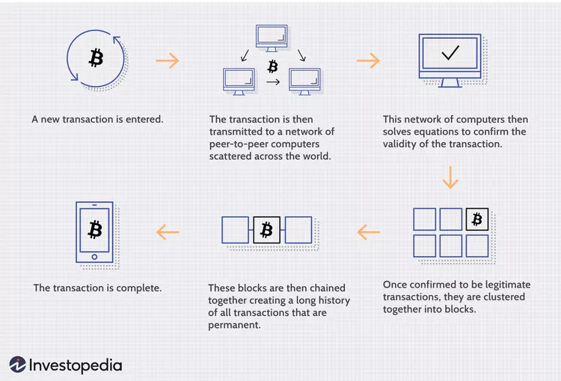

Blockchain Decentralization
Imagine that a company owns a server farm with 10,000 computers used to maintain a database holding all of its client’s account information. This company owns a warehouse building that contains all of these computers under one roof and has full control of each of these computers and all of the information contained within them. This, however, provides a single point of failure. What happens if the electricity at that location goes out? What if its Internet connection is severed? What if it burns to the ground? What if a bad actor erases everything with a single keystroke? In any case, the data is lost or corrupted.
What a blockchain does is to allow the data held in that database to be spread out among several network nodes at various locations. This not only creates redundancy but also maintains the fidelity of the data stored therein—if somebody tries to alter a record at one instance of the database, the other nodes would not be altered and thus would prevent a bad actor from doing so. If one user tampers with Bitcoin’s record of transactions, all other nodes would cross-reference each other and easily pinpoint the node with the incorrect information. This system helps to establish an exact and transparent order of events. This way, no single node within the network can alter information held within it.
Because of this, the information and history (such as of transactions of a cryptocurrency) are irreversible. Such a record could be a list of transactions (such as with a cryptocurrency), but it also is possible for a blockchain to hold a variety of other information like legal contracts, state identifications, or a company’s product inventory.
To validate new entries or records to a block, a majority of the decentralized network’s computing power would need to agree to it. To prevent bad actors from validating bad transactions or double spends, blockchains are secured by a consensus mechanism such as proof of work (PoW) or proof of stake (PoS). These mechanisms allow for agreement even when no single node is in charge.

Transparency
Because of the decentralized nature of Bitcoin’s blockchain, all transactions can be transparently viewed by either having a personal node or using blockchain explorers that allow anyone to see transactions occurring live. Each node has its own copy of the chain that gets updated as fresh blocks are confirmed and added. This means that if you wanted to, you could track Bitcoin wherever it goes.
For example, exchanges have been hacked in the past, where those who kept Bitcoin on the exchange lost everything. While the hacker may be entirely anonymous, the Bitcoins that they extracted are easily traceable. If the Bitcoins stolen in some of these hacks were to be moved or spent somewhere, it would be known.
Of course, the records stored in the Bitcoin blockchain (as well as most others) are encrypted. This means that only the owner of a record can decrypt it to reveal their identity (using a public-private key pair). As a result, users of blockchains can remain anonymous while preserving transparency.

