Canada Trip Checklist
2014-11-21 pmfournierLeave a comment
I plan on flying to Canada soon (from New York City), so I’ve been doing research on the various requirements for this international flight. I’ve found a few resources online, but they all seemed to be missing some items, so I’m collecting everything here. The first part of the post consists in notes about specific topics. The second part is the checklists that I’m going to use to make sure I don’t forget anything. I plan on updating these as I discover new information.
Some of the resources I’ve been consulting:
- AOPA page on traveling to Canada
- AOPA / COPA guide to cross-border operations

Preparation / equipment / Documents

Check that all passengers and crew have appropriate travel documents and visas
This generally means having passports. However for citizens of countries other than US and Canada, one of the most important issues is that entering the USA, the visa waiver program is generally not available on private airplanes. These travelers, who normally do not need a visa to enter the US, may need to apply for a visa in advance when traveling by private plane. There is a procedure for a corporation owning a private plane to obtain authorization from the DHS for its passengers to enter under the visa waiver.
I haven’t found information about Canada’s policy regarding third party country citizens which normally don’t require a visa. I’m inclined to think they would be able to enter without problem.

File required departure Customs & immigration paperwork
This may apply if there are passengers who are non US citizens on board. Aliens traveling to the United States with a visa are used to this. Until recently, I-94 forms had to be returned to USCBP prior to leaving the United States to prove that the visitor had not overextended their stay. Now that I-94’s are electronic, departures are recorded automatically using the passenger manifest when flying commercial. For other modes of departure, a stamp of an entry in another country is a good proof of departure to show the USCBP agent at the next entry if they question the length of the previous trip. Unfortunately, when traveling to Canada by private aircraft, customs may not always show up to stamp the passport. It is very common for them to clear a flight by phone. Therefore this can be an issue. It looks like the best bet is to try to keep some record of the trip (credit card bills showing purchases in another country for example). A bit more info on the FAQ tab at this site.

Have English Proficient rating on certificate
This is an ICAO requirement for international travel. For US pilots who don’t have it, it’s easy to get it.

Have radiotelephone operator license
Another requirement for international travel. For US pilots, these can be obtained from the FCC.

Statement for children traveling without both parents
Some sources recommend a notarized statement providing authorization from the parents who are not present for the child to travel.

Insurance
Ensure that the aircraft damage insurance covers the destination country. Some countries, such as Canada, require a minimum liability insurance:
- 2300 lbs or less: $100,000
- 2300-5000 lbs: $500,000
These figures come from Canadian Aviation Regulations 606.02 (8).

CBP Fees and Decal
US CBP requires the payment of yearly fees for each aircraft entering the country. The proof of payment is a sticker applied to the airframe. Typically, this decal would be purchased in advance, received by mail and applied to the aircraft for the trip and the following ones in the same calendar year.
It is my understanding that it is not strictly required to have this decal in advance. It can be purchased when meeting with CBP. However, not all offices carry these decals, so it is possible one may have to pay the fee but not receive the decal in exchange, making it necessary to pay again at the next trip. As of this writing, the fee is $27.50.

12 inch Registration Marks
These are required to enter the ADIZ. I haven’t found written evidence they are required to simply cross the border.

Authorization to use the airplane
This is probably overkill for most cases, but if the owner is not on board, some sources recommend having a notarized letter from the owner allowing the use of the aircraft.

Permanent Certificate of Registration
Temporary certificates are apparently not good for international travel without additional paperwork.

Radio Station License
These can be obtained from the FCC. Flight clubs can get one license for the fleet. A copy should be on board.

Extra Fuel Tanks
If this is ferry flight for which extra tanks are installed, then extra paperwork will be needed.

Flight plan
A flight plan should be filed if the border is crossed. Don’t forget to open it. In the US, VFR flight plans are opened with the FSS, typically once in flight. In Canada, at a controlled airport, ground control can open it.

Flight following
As of this writing, VFR flights to and from the continental US are obligated to be talking with ATC and squawking a discrete transponder code when crossing the border. This is described in a NOTAM under location “FDC”. Aircraft without a radio or transponder will need a waiver from the FAA.

Inform customs of delays
Customs want an estimate of the arrival time that’s as precise as possible. The FSS can relay delays to the customs while in flight, ensuring they are not too angry at you when you arrive.

HAVE an EAPIS Account
In addition to noticing customs, private flights leaving or entering the US are required to file a passenger manifest in advance in EAPIS. Account creation and approval can incur delays so better make sure an account is created in advance.

CHECKLIST: PREflight
- EAPIS … FILED
  - applies to both departure from and arrival into the US
- Customs … ADVISED
- Flight plan … FILED
- Travel documents for every pax & crew … ON BOARD
- Airworthiness certificate … ON BOARD
- Aircraft registration certificate … ON BOARD
- Operating limitations … ON BOARD
- Weight and balance information … ON BOARD
- Airframe ID Plate … PRESENT
- Paperwork for extra fuel tanks (if applicable) … ON BOARD
- Proof of insurance coverage … ON BOARD
- Notarized child custody authorization … ON BOARD
- Notarized aircraft use authorization … ON BOARD
- Aircraft radio station license … ON BOARD
- Pilot license, medical and radio operator license … ON BOARD

Checklist – After Takeoff
- Flight plan … OPEN
- Flight following … ESTABLISH
- Discrete transponder code … OBTAIN
- Arrival delays … REPORT TO CUSTOMS VIA FSS

Checklist – After Landing
- Flight plan … CLOSE
- Customs … CLEAR
Canada Trip Checklist

Effective Rudder Use
2014-11-12 pmfournierLeave a comment
In this video [free PilotWorkshops account required], instructor and pilot examiner Wally Moran reminds us that the rudder is more than just for steering the airplane on the ground. But he also describes its use from angles which I hadn’t heard before:
- In shallow turns, the rudder should be used only for entering and exiting the turn, just like the ailerons.
- During a climb, absence of use of the rudder means we are probably using the ailerons to correct for p-factor, causing us to climb in a slip, which means additional drag.
- The rudder should be used any time the throttle or ailerons are used.
Seeing the video got me thinking about my own use of the rudder and how I could improve. I was glad to see that the additional awareness made me start noticing adverse yaw in turns on random Youtube videos. Hopefully that critical eye will kick in when I’m the one flying as well.
On the front of uncoordinated use of the rudder, there’s room for precision as well, and I liked this couple of exercises proposed by Flight Chops instructor Dennis, rolls on a point and fish tails. Seems like a good way to get more familiar with the rudder and with a new plane.
But there’s the trap of using too much rudder too. Boldmethod has this well illustrated article on the dangers of skidding, in which I learned a lot about the aerodynamics of skids and slips.
It’s easy to forget about the rudder. But the more I read about it, the more I feel like knowing it better opens a lot of doors to understanding the way an aircraft flies. A lack of precision with the rudder will probably not prevent the plane from flying, but I’m here to learn, and I want to be a precise pilot, so I’ll definitely keep on practicing.

Notes to self:
- Try Dennis’ exercises on all planes I fly.
- Pay close attention to how the nose of the plane behaves when I climb, turn, and vary the throttle.
- Don’t use the rudder to tighten a turn at low altitudes.
Effective Rudder Use

The Emergency Engine Icing Manoeuver
2014-11-11 pmfournierLeave a comment
It’s well known that carburetor engines can get icing and how to operate the carburetor heat to reverse or prevent the phenomenon.
Injection systems are more resilient, but not completely immune to icing. According to Skybrary, one of three types of engine ice, impact ice, affects both types.
Recently, I was reading the classic Weather Flying in which Robert Buck describes a drastic manoeuver which he has accomplished twice to get rid of carburetor ice when carb heat would not work. He leaned the mixture until the engine backfired, dislodging the ice.
In other words, if all else fails, just blow it up. Well, why not. I was fascinated by the crude effectiveness of the approach, but I was curious about how it worked. According to Dan Thomas: “The lean mixture is slow to burn and there may be a bit still burning at the top of the exhaust stroke where there’s a bit of overlap between the closing of the exhaust and opening of the intake, and the flame sets off the charge in the induction system.” He continues to say he’s never succeeded in obtaining a backfire in that way.
Bob Buck doesn’t say why the carb heat didn’t work. Could there be atmospheric conditions where applying carb heat will melt the ice only for it to re-form as impact ice somewhere else?
In any case, reports of successful use of the manoeuver are scarce. I’m also unsure whether it’s possible at all in an injection engine. I certainly hope I never need to try, but if comes to that, I’m glad to have yet another tool in my bag.
The Emergency Engine Icing Manoeuver

The R-100
2014-11-06 pmfournierLeave a comment
It all started with a street sign. Before I even started training for my pilot’s license in Saint-Hubert, Canada, I thought it was quite strange that a street that led to the airport was called Rue du R-100 (“R-100 Street”). What in the world was R-100?
I spent the better part of a year going to the airport regularly to train for my private pilot’s license, yet no one ever spoke about this R-100. I didn’t even know it was related to aviation although its location close to the airport should have tipped me off.
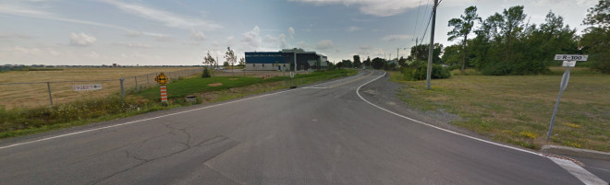Rue du R-100 sign, Saint-Hubert, Quebec, Canada, as seen from Google Street View. Seriously, it looks more like a highway number than a street name. But it the panel says “Street”!?! The airport is on the left.
Years later, while exploring some random aviation history site, it hit me like a punch to the face. The R-100 was a formidable airship commissioned by the British government in the hopes of establishing a long distance airship passenger service. The project was later scrapped due to the crash of the R-100’s sister ship, the R-101, but not before the R-100 made a trip across the Atlantic which completely captured the Canadian public and wrote a memorable chapter in Canadian aeronautical history. It arrived in Saint-Hubert, Quebec on August 1st 1930.
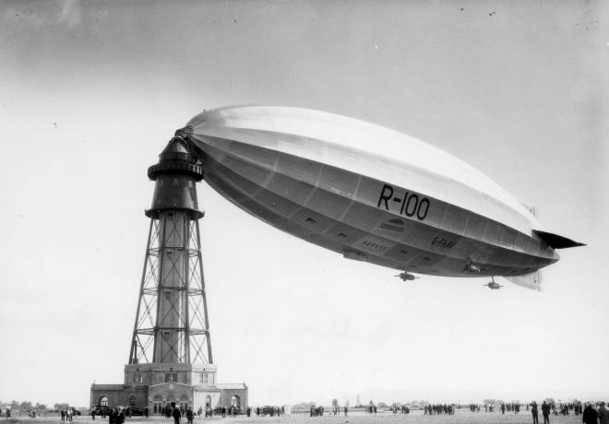The R-100 at Saint-Hubert in August 1930
In preparation for this visit, the Saint-Hubert airport was built in 1928. It was the first airport in the Montreal region and the most modern in Canada. Its centerpiece was the airship mooring mast, but it also had runways for airplanes. The local train facilities were expanded in anticipation of the additional passengers this marvel would bring.
And it did. The population was in awe of the airship. For the 12 days that it was moored in Saint-Hubert, it’s said that 100,000 people visited daily. It took almost 40 years for the Montreal region to see such crowds again, at the Expo 67. But to this day, no other event has brought as many visitors to the south shore of Montreal. It was truly the happening of the century. Quebecois folk signer La Bolduc even recorded a song about the visit (video below).
Today, the R-100 is largely forgotten. The mooring mast was demolished as early as 1938. Apart from the street, a motel remains the only visible reminder of the event.
R-100 Motel, Saint-Hubert, Quebec, Canada, as seen from Google Street View
Even today, airships are a rare sight in Canada. There are currently only 4 registered airships in the country, all of which are experimental. Occasionally, one will be brought in from the United States, like this Fido branded blimp for a publicity campaign in 1996, moored in Saint-Hubert. A Goodyear blimp also visited in 2007.
Airliners.net Photo ID 0059458: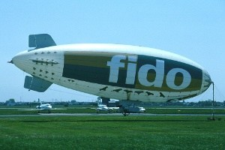
Click photo for large version
In the 2000s, when I frequently visited Saint-Hubert airport, there was nothing to point out that I was flying at one of the most important landmarks in Candian aviation history. Saint-Hubert is a regional, general aviation airport which, like many of its kind, tends to suffer from aging infrastructure and is regularly threatened of closure. Yet, it remains the busiest general aviation airport in Canada (2012 statistics).
The R-100’s visit to Saint-Hubert was an extreme example of how the population can get interested and excited in aviation. To me, it acts as a reminder that mobilizing the community remains a great way to help preserve general aviation.
The R-100

Hidden Airliner Rooms
2014-11-06 pmfournierLeave a comment
As passengers, it’s easy to forget that there’s more in these large aircraft than meets the eye in terms of space. Boeing and Airbus planes have large rooms, even entire floors, which are rarely seen by the general public. I’m sure a lot of people would be suprised to hear that a boeing 777 has 3 floors.
Here’s a layout that shows the complexity of the areas in the forward part of the Airbus A380, including its flight crew rest area.
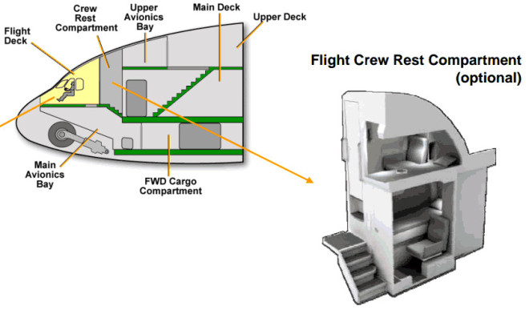Layout of forward section of A380
In this post, I share a few notes about some of these areas which we generally don’t get to see.

Avionics Bay
Avionics bays house racks of equipment which contain most of the actual avionics and flight computer electronics. In Boeings and Airbuses, they tend to be under the cockpit. This video shows a tour of a Boeing 777’s avionics bay. It’s particularly fascinating in that it shows how you can descend from the main cabin to the lower level through a hatch, and from there make your way to the forward cargo hold or to the outside, through a hatch close to the nose landing gear.
This is a similar video for the Airbus A330 where they actually walk from the avionics bay to the forward cargo hold.
Recently there have been worries about the easy access to these areas. In Airbuses, the access hatch for the main avionics bay is normally located in the cockpit. But for Boeings it is located slightly aft of the cockpit inside the main cabin which, some say, is a security issue.

Tail Cone Compartment
The tail cone compartment is located at the back of the airplane. In this video of a 737, it can be accessed through a hatch on the bottom of the airplane. It is an unpressurized compartment and the video shows the curved pressure bulkhead.

Main Landing Gear Bay
It’s just amazing the amount of pipes in there.

Crew rest quarters
Crew rest quarters are areas often located above the main cabin, where the crew can rest. These have beds which are sometimes larger and more comfortable than what is found even in first class. Crew rest quarters have gotten more press recently as some planes offer huge spaces and some airliners come up with strikingly good looking designs.
As for pilots, they can have their own resting quarters located very close to the cockpit on some planes.
Here’s the rest area for the flight attendants in a 777.
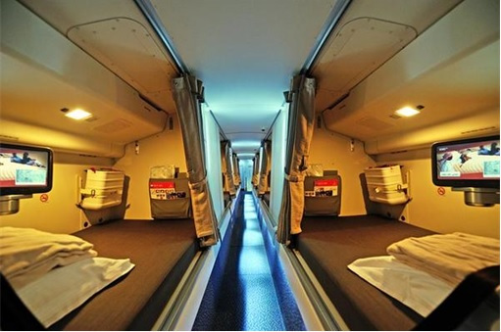
But what is fascinating about it is how they managed to make the walkway fit between the overhead baggage compartments.
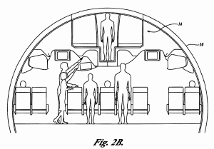Source: Boeing patent ￼￼￼http://www.google.com/patents/US6619589
But there’s more… normal access to the compartment is by a staircase, but there’s also an emergency exit under one of the bunks…
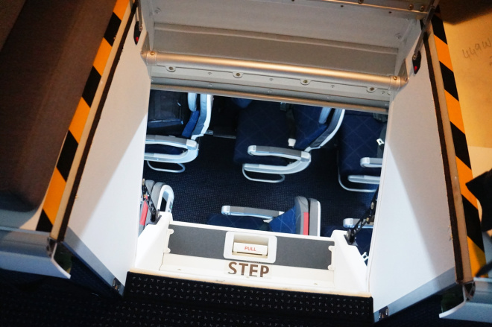Source: http://airwaysnews.com/blog/2013/04/27/speciaal-delivery-flight-event-american-airlines-boeing-777-300er-part-two-aircraft-acceptance-handover-event-and-delivery/
Which brings you down to the main cabin through a (fake) overhead baggage compartment in row 35. Looks like a lot of fun to use.
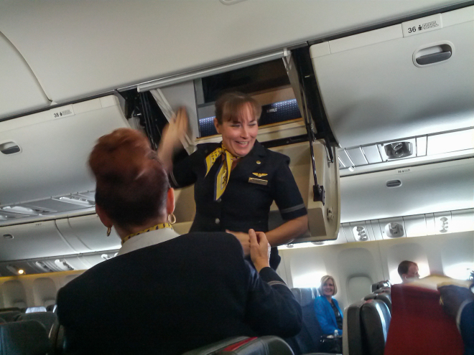
Core77 has a really interesting post about the design of crew rest quarters which seem to be getting more and more luxurious in the new planes.

Tailcone exit
This is a unique feature of the DC-9/MD-80 family of aircraft, but still one of my favorites. On those airplanes, one of the exits is located in the tailcone of the aircraft. It can be used for emergencies, with an inflatable slide.
But it can also be used as a regular exit without jettisoning the tailcone or inflating the slide.
Perris Skydiving in California got the interesting idea of using the convenient location of this exit to perform massive parachute jumps.

Cargo hold
Cargo holds are hardly secret. What is less known is that large airliners typically have two cargo areas: the forward and the rear cargo bays. They are separated by the main landing gear bay. They are pressurized, but the ventilation and heating depends on the specific airplane. This picture shows how cramped it is down there when filed with standard aviation containers.
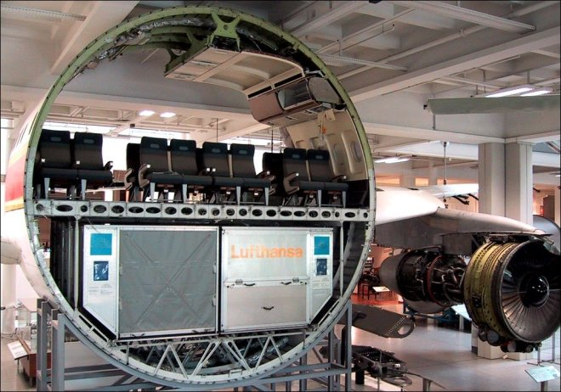
A similar cargo bay, empty.
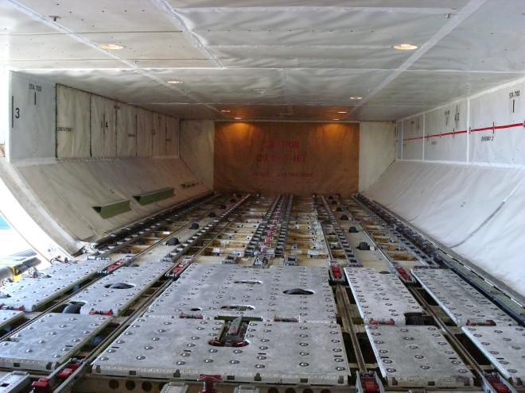

Conclusion
Of course, now I want to visit all these spaces, board an airliner through the underbelly hatch and climb all the way up to the crew rest quarters. In fact, I wouldn’t mind a red eye on one of those bunks.
I can keep dreaming… in my economy seat.
Hidden Airliner Rooms

Ground-Controlled Approach
2014-10-27 pmfournierLeave a comment
Today most instrument approaches are performed with ILS-like equipment, GPS or NDB. In the middle of the 20th century however, it was common to use a very different type of approach, the Ground Controlled Apprach (GCA). In this type of approach, a controller would guide the pilot down to the runway by issuing countless verbal course and glide slope corrections all through the approach. A special type of radar, the Precision Approach Radar (PAR) was used by the controller to locate the airplane on the approach. A special radar display with a “top view” for the course and a “side view” for the glide slope was use such as in the image below.
A modern precision approach radar display
Today, a few GCAs remain, but most have shut down. In the US, they seem to be limited to some military facilities. Jeff Van West has a fascinating article about how he tried out the GCA at a military base in Maine in 2008. But that facility has now closed…
Here’s a vintage educational video about PAR which shows how the equipment worked and how pilot and controller would communicate. (4:40: explanation of the PAR radar display; 17:03: beginning of the PAR guidance)
The FAA’s Airports and Facilities Directory’s list of abbreviations includes PAR and GCA, but I have yet to find an airport entry that uses them. Anyone know of still active GCAs?
Ground-Controlled Approach

Mountain Waves
2014-10-27 pmfournierLeave a comment
Mountain waves are different from ridge turbulence. Both originate around hills and mountains, but where ridge turbulence is a fairly local phenomenon, mountain waves can affect airfraft flying tens of thousands of feet above the mountain tops. This vintage drawing from the FAA shows the structure of a wave.
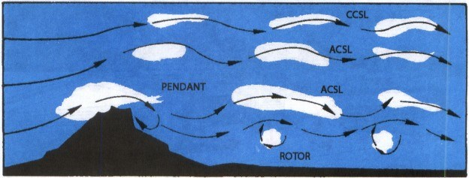Mountain wave Source: FAA Aviation Weather book
Robert Buck explains in Flying the Weather that on the downwind side of a mountain, successive waves of rising and descending air extend upward, as high as 10 times the height of the mountain. Sometimes clouds are visible at the crest of the waves.
The clouds don’t move in the wind’s direction, instead they constantly form and dissipate as air passes through them, as can be seen in this video.
Mountain waves cause two types of turbulence: relatively gentle upward and downward drafts in the upper sections, and potentially much more violent turbulence in the rotor section below. Located under the waves, and at altitudes lower than the mountain top, the rotors are particularly hazardous. They can cause severe turbulence, including downdrafts which exceed maximum aircraft climb rates, as well as wind shear strong enough to cause structural damage.
Characteristic lenticular clouds are useful in detecting mountain waves, but without sufficient moisture in the air, they will not form.

