Composition In photography
composition in photography refers to how various elements within a photograph are arranged and combined to create visually pleasing and impactful images. While there are no strict rules set in stone, there are several commonly practiced guidelines that photographers use to enhance their compositions. Here are some important principles of composition in photography:
- Rule of Thirds: Divide the image into a grid of nine equal sections (using two horizontal and two vertical lines), and place the key elements of the photo along these lines or at their intersections. This creates a more balanced and visually interesting composition.
- Balance: Achieve balance in your composition by distributing visual weight evenly across the frame. It can be achieved using elements of different sizes, colors, or textures. There are two main types of balance: symmetrical (where objects are evenly distributed) and asymmetrical (where different objects have different visual weight but still achieve a harmonious balance).
- Leading Lines: Utilize lines within the frame to guide the viewer's eye towards the main subject or points of interest. These lines can be horizontal, vertical, diagonal, or curving, and they add a sense of depth and direction to the composition.
- Framing: Use elements in the foreground to frame the main subject of the photograph. This could include archways, windows, branches, or any other objects that create a natural frame within the image. Framing draws attention to the subject and adds depth to the composition.
- Symmetry and Patterns: Including symmetrical elements or patterns in your composition can create a sense of order and visual harmony. Symmetry can be found in architecture, nature, or man-made objects and can be used to create compelling images.
- Depth of Field: Experiment with shallow or deep depth of field to create a three-dimensional effect in your composition. A shallow depth of field can blur the background and draw attention to the subject, while a deep depth of field keeps everything in focus and creates a sense of depth.
- Simplify and Eliminate Distractions: Remove any elements from the frame that do not contribute to the main subject or message of the photograph. Simplifying the composition helps to create a stronger visual impact and ensures that the viewer's attention is focused on the intended subject.

Tips for Landscape photography
1. Plan Your Shots: Research locations, weather conditions, and best times to capture stunning landscapes.
2. Use a Tripod: A stable platform reduces camera shake and allows for long exposures.
3. Find the Golden Hour: Shoot during sunrise or sunset for soft, warm lighting.
4. Use the Right Lens: Wide-angle lenses are great for landscapes, capturing more of the scene.
5. Frame with Foreground: Include interesting foreground elements to add depth to your composition.
6. Pay Attention to Composition: Follow rules like the rule of thirds and leading lines for balanced images.
7. Adjust Aperture: Use a small aperture (high f-number) for a deep depth of field to keep everything in focus.
8. Use Filters: Graduated ND filters can balance exposure in high-contrast scenes, and polarizers reduce reflections and enhance colors.
9. Bracket Your Shots: Take multiple exposures at different settings to ensure you capture the best exposure.
10. Master Exposure: Learn to use manual mode and histogram to control exposure.
11. Experiment and Practice: Don't be afraid to try new techniques and keep practicing to improve your skills.

Exposure modes
“Exposure modes” refer to those modes used to control only the triad of settings that determine exposure—aperture, ISO, and shutter speed. There are four exposure modes: Programmed Auto/Program (P), Shutter Priority (S/Tv), Aperture Priority (A/Av), and Manual (M).

Equipments in lightning
1) Soft box/ Cream light : A soft box can be square, rectangular, or octagonal. Softboxes are probably the most popular studio modifier. This is because of the soft, diffused light they provide. This flattering quality of light works so well for most genres of photography. You can use it for everything from portraits to food.
2) Umbrella
An umbrella is another common modifier. It doesn’t always produce the best studio lighting results compared to other modifiers. They come in silver or white.
The light is shot into the umbrella to reflect it into the scene. This helps you create a larger and, thus, softer light source.
The problem with umbrella lighting is that the light tends to spill. So umbrellas can be harder to work with.
3) Shoot Through Umbrella
A shoot-through umbrella is made of translucent material. You also shoot into this umbrella to achieve softer light. But it won’t give you the directionality of a regular umbrella.
Some of these function almost like a softbox, like this translucent Neewer umbrella. This is a preferred modifier used by famed portrait photographers like Annie Leibovitz. They use it for the incredibly soft light it provides.
In the case of creative portrait photography, this can be very flattering. But the lighting might be too flat with other photos, such as food or products.
4) Beauty dish: is a great modifier for portrait, beauty, and fashion photography. A beauty dish will help you sculpt facial features and create beautiful catchlights. And it illuminates light from all angles due to its unique shape. For easier storage, you can buy a collapsible beauty dish, such as the Fovitec collapsible beauty dish. With a beauty dish, the light wraps around the subject. It creates both beautiful shadows and highlights.
5) Snoot
A snoot is a very specific modifier. It allows you to create a very focused beam of light. It is most useful for tabletop photography when you want to shine a focused light on a very specific area. Examples would be background light or highlighting the filling of a burger.
6) Reflectors: Silver and gold reflectors in a variety of shapes and sizes. Their purpose is to affect the shadows in a scene. The gold will add a bit of warmth to your scene. The silver will create a brighter scene than can be created with a white bounce card. You can place the reflector opposite the light to bounce some fill light onto your subject. It can also be placed in the lap of a portrait subject to soften shadows under the eyes and chin.
7) Diffusers: In addition to using the correct modifier, you may also further need to diffuse your light source. When purchasing a reflector kit, a diffuser will usually be included.
8) Gobos and Flags
Gobo stands for “go-between.” It is placed in front of a light source to change its shape. It can be used to narrow the light or otherwise create a pattern. For example, you may need to cut down some of the light hitting a burger bun, creating a patch of glare. This is known as a “hotspot.” You can buy a set of flags or a gobos kit. But they can be a bit on the pricey side. You can instead make your own by cutting out shapes from a piece of black cardboard or foam core. You can attach a wooden skewer to create a handle. And then you can hold it where you need it to affect the light.
9) Honey comb grid
Honeycomb gird is an accessory ory added to reflector, beauty dish, snoot or other modifiers to narrow the light beam so as to stop the light from spilling everywhere. A grid is used to control the direction of light coming from the soft box or any other modifier. This allows the photographer to precisely hit the light only where it’s required and avoid unnecessary light spill.
10) A soft spot
In photography, a "soft spot" refers to an area in an image where the focus is intentionally soft or blurry. This technique is often used for artistic purposes, creating a dreamy or ethereal effect in the photo. Photographers achieve this softness by adjusting the depth of field, using a wide aperture to produce a shallow depth of field. By selectively focusing on the main subject while allowing the surrounding areas to be blurred, the soft spot draws attention to the subject and adds a sense of depth to the composition. Soft spots can be found in various types of photography, such as portraits, nature, still life, and even abstract photography, as it allows for creative interpretation and visual storytelling.
11) Parabolic umbrella
A parabolic umbrella is a specialized type of umbrella designed with a parabolic shape. It typically consists of a dome-shaped canopy made of fabric and a central pole for support. The unique feature of a parabolic umbrella is its curved surface, which resembles a paraboloid shape. This design allows the umbrella to focus and concentrate incoming light or heat towards a specific focal point.
Parabolic umbrellas are commonly used in photography and lighting setups. They are used as light modifiers to create a more focused and directed light source. By positioning a flash or continuous light source at the focal point of the umbrella, the light is reflected and dispersed in a controlled manner, resulting in a softer, more flattering light for photography or video. The parabolic shape helps to create a more even and efficient spread of light, reducing harsh shadows and producing a more pleasing lighting effect.

What is Exposure triangle?
In photography, the exposure triangle explains the relationship between shutter speed, ISO and aperture. Whether you’re shooting old school film or with a mirrorless, these three factors are at the center of every exposure.
Understanding the exposure triangle, also called the photographic triangle, will help you determine how a picture will look before you take it. And while saving film in today’s digitally dominated world is probably not your first priority, knowing how aperture, shutter speed, and ISO work together to compose your image will make you a smarter, more efficient photographer.
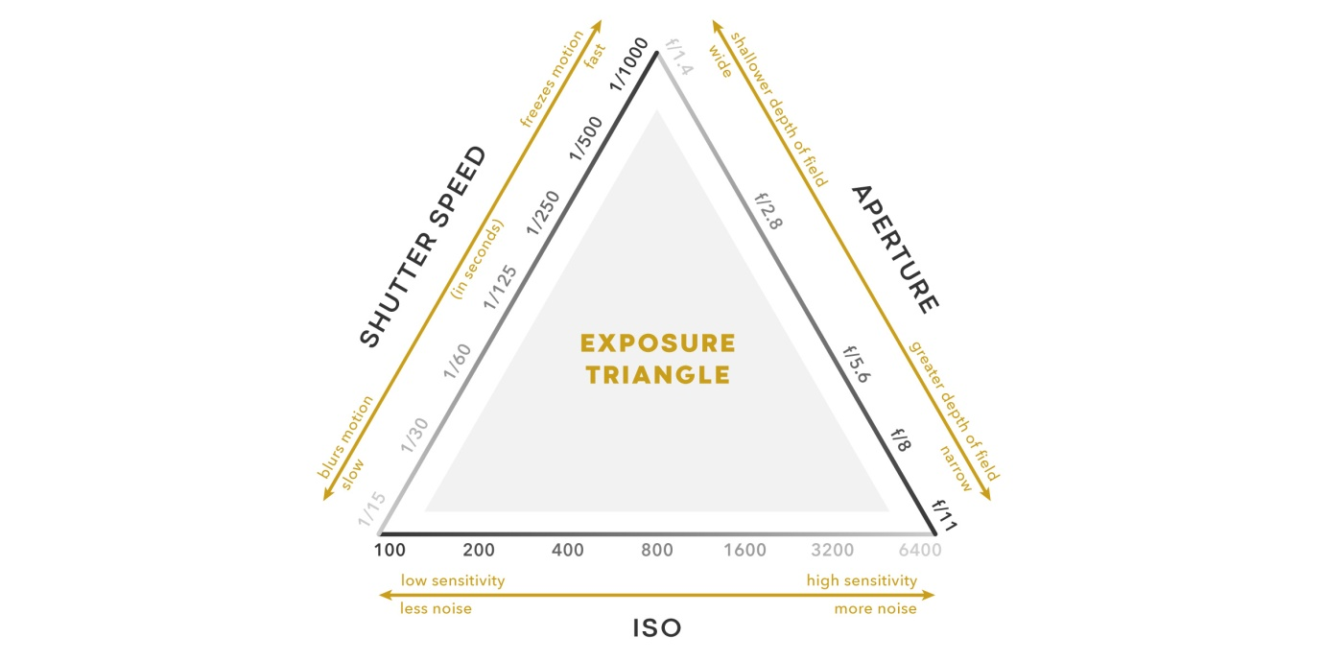
Let’s take a quick look at each of the three values in the exposure triangle:

1. Aperture
Like the iris of your eye, the aperture blades on the lens of a camera control how much light is let into the camera lens. The amount of light that reaches your camera’s image sensor will determine what the exposure looks like.
Each aperture setting on the lens is referred to as an f-stop, a fraction that indicates the diameter of the lens opening. Aperture also determines the depth of field and sharpness. Every lens has a “sweet spot” or “critical focus,” usually between f/4 and f/11.

2. Shutter Speed
While aperture determines how wide the lens opening is, shutter speed determines how long the lens stays open for, letting the specific amount of volume of light into the sensor determined by the aperture. A faster shutter speed, like 1/1000th of a second, has the effect of freezing motion, while a slower shutter speed, like 1/60th, will blur motion in a scene.

3. ISO
ISO is the international standard of measurement that determines how sensitive a photographic film emulsion or digital sensor is to light. When increasing the ISO it allows you to work with less light, however if the ISO is increased often times there will be more noise and less detail within your video. In other words, when increasing your ISO it will bring light into dark images, but as a result can diminish the quality of the shot. At lower ISOs the degree of your camera’s signal is significantly large when compared to the noise, this means that the noise generally remains inconspicuous. When shooting on your device, it is best to keep your ISO low in order to avoid noise; however, your determined ISO level is ultimately dependent upon the surrounding environment and lighting conditions. For example, if you are shooting in a low-light setting you will need a higher ISO to properly expose the photo and brighten up the film. On the other hand, when you are in a very bright setting and trying to capture footage, a lower ISO would be appropriate in order to avoid noise getting into your photo or video.

