Portfolio Management

What Is Portfolio Management?
Portfolio management is the art and science of selecting and overseeing a group of investments that meet the long-term financial objectives and risk tolerance of a client, a company, or an institution.
Portfolio management requires the ability to weigh strengths and weaknesses, opportunities and threats across the full spectrum of investments. The choices involve trade-offs, from debt versus equity to domestic versus international and growth versus safety.

Understanding Portfolio Management
Professional licensed portfolio managers work on behalf of clients, while individuals may choose to build and manage their own portfolios. In either case, the portfolio manager's ultimate goal is to maximize the investments' expected return within an appropriate level of risk exposure.
Portfolio management may be either passive or active in nature.
- Passive management is a set-it-and-forget-it long-term strategy. It may involve investing in one or more exchange-traded (ETF) index funds. This is commonly referred to as indexing or index investing. Those who build Indexed portfolios may use modern portfolio theory (MPT) to help optimize the mix.
- Active management involves attempting to beat the performance of an index by actively buying and selling individual stocks and other assets. Closed-end funds are generally actively managed. Active managers may use any of a wide range of quantitative or qualitative models to aid in their evaluations of potential investments.

KEY TAKEAWAYS
- Portfolio management involves building and overseeing a selection of investments that will meet the long-term financial goals and risk tolerance of an investor.
- Active portfolio management requires strategically buying and selling stocks and other assets in an effort to beat the broader market.
- Passive portfolio management seeks to match the returns of the market by mimicking the makeup of a particular index or indexes.

Key Elements of Portfolio Management

Asset Allocation
The key to effective portfolio management is the long-term mix of assets. Generally, that means stocks, bonds, and "cash" such as certificates of deposit. There are others, often referred to as alternative investments, such as real estate, commodities, and derivatives.
Asset allocation is based on the understanding that different types of assets do not move in concert, and some are more volatile than others. A mix of assets provides balance and protects against risk.

Rebalancing captures gains and opens new opportunities while keeping the portfolio in line with its original risk/return profile.
Investors with a more aggressive profile weight their portfolios toward more volatile investments such as growth stocks. Investors with a conservative profile weight their portfolios toward stabler investments such as bonds and blue-chip stocks.

Diversification
The only certainty in investing is that it is impossible to consistently predict winners and losers. The prudent approach is to create a basket of investments that provides broad exposure within an asset class.
Diversification is spreading risk and reward within an asset class. Because it is difficult to know which subset of an asset class or sector is likely to outperform another, diversification seeks to capture the returns of all of the sectors over time while reducing volatility at any given time.
Real diversification is made across various classes of securities, sectors of the economy, and geographical regions.

Rebalancing
Rebalancing is used to return a portfolio to its original target allocation at regular intervals, usually annually. This is done to reinstate the original asset mix when the movements of the markets force it out of kilter.
For example, a portfolio that starts out with a 70% equity and 30% fixed-income allocation could, after an extended market rally, shift to an 80/20 allocation. The investor has made a good profit, but the portfolio now has more risk than the investor can tolerate.
Rebalancing generally involves selling high-priced securities and putting that money to work in lower-priced and out-of-favor securities.
The annual exercise of rebalancing allows the investor to capture gains and expand the opportunity for growth in high potential sectors while keeping the portfolio aligned with the original risk/return profile.

Active Portfolio Management
Investors who implement an active management approach use fund managers or brokers to buy and sell stocks in an attempt to outperform a specific index, such as the Standard & Poor's 500 Index or the Russell 1000 Index.
An actively managed investment fund has an individual portfolio manager, co-managers, or a team of managers actively making investment decisions for the fund. The success of an actively managed fund depends on a combination of in-depth research, market forecasting, and the expertise of the portfolio manager or management team.
Portfolio managers engaged in active investing pay close attention to market trends, shifts in the economy, changes to the political landscape, and news that affects companies. This data is used to time the purchase or sale of investments in an effort to take advantage of irregularities. Active managers claim that these processes will boost the potential for returns higher than those achieved by simply mimicking the holdings on a particular index.
Trying to beat the market inevitably involves additional market risk. Indexing eliminates this particular risk, as there is no possibility of human error in terms of stock selection. Index funds are also traded less frequently, which means that they incur lower expense ratios and are more tax-efficient than actively managed funds.

Passive Portfolio Management
Passive portfolio management, also referred to as index fund management, aims to duplicate the return of a particular market index or benchmark. Managers buy the same stocks that are listed on the index, using the same weighting that they represent in the index.
A passive strategy portfolio can be structured as an exchange-traded fund (ETF), a mutual fund, or a unit investment trust. Index funds are branded as passively managed because each has a portfolio manager whose job is to replicate the index rather than select the assets purchased or sold.
The management fees assessed on passive portfolios or funds are typically far lower than active management strategies.
https://www.edupristine.com/blog/all-about-portfolio-management

What is a Portfolio?
A portfolio can be defined as different investments tools namely stocks, shares, mutual funds, bonds, cash all combined together depending specifically on the investor’s income, budget, risk appetite and the holding period. It is formed in such a way that it stabilizes the risk of nonperformance of different pools of investments.

What is Portfolio Management?

Portfolio Management is defined as the art and science of making decisions about the investment mix and policy, matching investments to objectives, asset allocation for individuals and institutions, and balancing risk against performance. (Source: Investopedia).
Simply put it, someone has given you their hard earned money and you need to help them increase the capital in the best of diversified ways. This should be in a way in which the risk-return ratio is aptly maintained considering the profits in mind and the holding period of investments.
Portfolio management refers to managing an individual’s investments in the form of bonds, shares, cash, mutual funds etc so that he earns the maximum profits within the stipulated time frame. It is the art of managing the money of an individual under the expert guidance of portfolio managers.
It is the detailed SWOT analysis (strengths, weaknesses, opportunities, and threats) of an investment avenue, which could be in the form of debt/equity, domestic/international, with the goal of maximizing return at a given appetite for risk.

Types of Portfolio Management
There are majorly four types of portfolio management methods:
- Discretionary portfolio management: In this form, the individual authorizes the portfolio manager to take care of his financial needs on his behalf.
- Non discretionary portfolio management: Here the portfolio manager can merely advise the client what is good or bad, correct / incorrect for him, but the client reserves the full right to take his own decisions.
- Passive portfolio management: It is the form which involves only tracking the index.
- Active portfolio management: This includes a team of members who take active decisions based on hard core research before investing the corpus into any investment avenue. (e.g. close ended funds).

Objectives of Portfolio Management
- It is aptly put as the customization of the investment needs catered by the portfolio managers as per the defined requirements.
- Portfolio management helps in providing the best options for investments to individuals as per the defined criterions of their income, budget, age, holding period and risk taking capacity.
- This is mainly done by the Portfolio managers who understand the investors’ financial needs and accordingly suggest the investment policy that would have maximum returns with minimum risks involved. Aptly put, it is risk reduction through diversification.
- This is the method preferred by those who believe in having liquidity in investments so that one can get the money back when needed.
- Some of the portfolio management schemes are also done for tax saving purposes.
- It helps the investors maintain the purchasing power.

Who would opt for Portfolio management?
- Limited knowledge: It is opted by someone who would like to invest in different investment avenues like stocks, metals, other commodities but does not have the knowledge of doing it.
- Limitation of time: People who would be from a different work profile may not have the time to set and track their portfolio and hence would hand it over to learn and experienced hands.

How Portfolio Management takes place practically?
The actual method of Portfolio Management is different from that we do it academically. The investors carry out a market survey in terms of the different schemes and their performances in the past, the fund managers involved their experiences and risk-reward ratio and accordingly select the fund in which they would chip in their money.
- It is initiated with a contract between the investor and the company that would have different portfolio schemes. These could be purely stock/shares oriented or may have a blend of different investment avenues.
- Once the contract is in place, verifying the fee structure, time frame, risk exposure and the kind whether discretionary or nondiscretionary is decided.
- After all this is in place, the fund manager plays his role. The portfolio is structured on the basis of the agreed terms and then churns the portfolio at regular intervals.
- The report of the performance of the portfolio is periodically sent to the investors.
- There are certain computer-software that are used by the managers to keep a track of the developments in the portfolio.
- The fund manager takes decisions on the basis of the hardcore research that is company specific as well as market-related done by the team of the portfolio managers.

Example of Portfolio Management
Say the investor has Rs 1,00,000 to start with and the manager has to distribute this across the different investment options. So the portfolio manager according to the risk-taking capacity and the kind of returns calculated provides a portfolio structured in tandem with that.
So for example, the portfolio could include real estate, fixed deposits with banks, mutual funds, shares, and bonds. There shall be bifurcation across these five units of the total corpus provided.
Thereby, depending on the security and the return from these avenues the bifurcation is done.
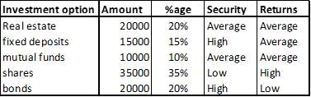
On the other hand, the portfolio could be stock specific as well. Thereby, the bifurcation is done across researched stocks in the markets.
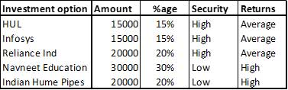
Hence, depending on the requirements of the investors, the fund manager takes appropriate decisions and allocates the funds.
https://www.managementstudyguide.com/portfolio-management.htm

Portfolio Management - Meaning and Important Concepts
It is essential for individuals to invest wisely for the rainy days and to make their future secure.

What is a Portfolio ?
A portfolio refers to a collection of investment tools such as stocks, shares, mutual funds, bonds, cash and so on depending on the investor’s income, budget and convenient time frame.
Following are the two types of Portfolio:
- Market Portfolio
- Zero Investment Portfolio

What is Portfolio Management ?
The art of selecting the right investment policy for the individuals in terms of minimum risk and maximum return is called as portfolio management.
Portfolio management refers to managing an individual’s investments in the form of bonds, shares, cash, mutual funds etc so that he earns the maximum profits within the stipulated time frame.
Portfolio management refers to managing money of an individual under the expert guidance of portfolio managers.
In a layman’s language, the art of managing an individual’s investment is called as portfolio management.

Need for Portfolio Management
Portfolio management presents the best investment plan to the individuals as per their income, budget, age and ability to undertake risks.
Portfolio management minimizes the risks involved in investing and also increases the chance of making profits.
Portfolio managers understand the client’s financial needs and suggest the best and unique investment policy for them with minimum risks involved.
Portfolio management enables the portfolio managers to provide customized investment solutions to clients as per their needs and requirements.

Types of Portfolio Management
Portfolio Management is further of the following types:
- Active Portfolio Management: As the name suggests, in an active portfolio management service, the portfolio managers are actively involved in buying and selling of securities to ensure maximum profits to individuals.
- Passive Portfolio Management: In a passive portfolio management, the portfolio manager deals with a fixed portfolio designed to match the current market scenario.
- Discretionary Portfolio management services: In Discretionary portfolio management services, an individual authorizes a portfolio manager to take care of his financial needs on his behalf. The individual issues money to the portfolio manager who in turn takes care of all his investment needs, paper work, documentation, filing and so on. In discretionary portfolio management, the portfolio manager has full rights to take decisions on his client’s behalf.
- Non-Discretionary Portfolio management services: In non discretionary portfolio management services, the portfolio manager can merely advise the client what is good and bad for him but the client reserves full right to take his own decisions.

Who is a Portfolio Manager ?
An individual who understands the client’s financial needs and designs a suitable investment plan as per his income and risk taking abilities is called a portfolio manager. A portfolio manager is one who invests on behalf of the client.
A portfolio manager counsels the clients and advises him the best possible investment plan which would guarantee maximum returns to the individual.
A portfolio manager must understand the client’s financial goals and objectives and offer a tailor made investment solution to him. No two clients can have the same financial needs.
https://groww.in/p/portfolio-management/

Portfolio Management
To make the most of one’s investment portfolio investors must participate actively in portfolio management. By doing so, they will not only be able to cushion their resources against market risks but will also be able to maximise their returns successfully.
In this article [hide]

What is Portfolio Management?
Portfolio management’s meaning can be explained as the process of managing individuals’ investments so that they maximise their earnings within a given time horizon. Furthermore, such practices ensure that the capital invested by individuals is not exposed to too much market risk.
The entire process is based on the ability to make sound decisions. Typically, such a decision relates to – achieving a profitable investment mix, allocating assets as per risk and financial goals and diversifying resources to combat capital erosion.
Primarily, portfolio management serves as a SWOT analysis of different investment avenues with investors’ goals against their risk appetite. In turn, it helps to generate substantial earnings and protect such earnings against risks.

Objectives of Portfolio Management
The fundamental objective of portfolio management is to help select best investment options as per one’s income, age, time horizon and risk appetite.
Some of the core objectives of portfolio management are as follows –
- Capital appreciation
- Maximising returns on investment
- To improve the overall proficiency of the portfolio
- Risk optimisation
- Allocating resources optimally
- Ensuring flexibility of portfolio
- Protecting earnings against market risks
Nonetheless, to make the most of portfolio management, investors should opt for a management type that suits their investment pattern.

Types of Portfolio Management
In a broader sense, portfolio management can be classified under 4 major types, namely –
- Active portfolio management
In this type of management, the portfolio manager is mostly concerned with generating maximum returns. Resultantly, they put a significant share of resources in the trading of securities. Typically, they purchase stocks when they are undervalued and sell them off when their value increases.
- Passive portfolio management
This particular type of portfolio management is concerned with a fixed profile that aligns perfectly with the current market trends. The managers are more likely to invest in index funds with low but steady returns which may seem profitable in the long run.
- Discretionary portfolio management
In this particular management type, the portfolio managers are entrusted with the authority to invest as per their discretion on investors’ behalf. Based on investors’ goals and risk appetite, the manager may choose whichever investment strategy they deem suitable.
- Non-discretionary management
Under this management, the managers provide advice on investment choices. It is up to investors whether to accept the advice or reject it. Financial experts often recommended investors to weigh in the merit of professional portfolio managers’ advice before disregarding them entirely.

Who Should Opt for Portfolio Management?
The following should consider portfolio management –
- Investors who intend to invest across different investment avenues like bonds, stocks, funds, commodities, etc. but do not possess enough knowledge about the entire process.
- Those who have limited knowledge about the investment market.
- Investors who do not know how market forces influence returns on investment.
- Investors who do not have enough time to track their investments or rebalance their investment portfolio.
To make the most of the managerial process, individuals must put into practice strategies that match the investor’s financial plan and prospect.

Ways of Portfolio Management
Several strategies must be implemented to ensure sound investment portfolio management so that investors can boost their earnings and lower their risks significantly.
Typically, professionals use these following ways to manage investment portfolio –
- Asset allocation
Essentially, it is the process wherein investors put money in both volatile and non-volatile assets in such a way that helps generate substantial returns at minimum risk. Financial experts suggest that asset allocation must be aligned as per investor’s financial goals and risk appetite.
- Diversification
The said method ensures that an investors’ portfolio is well-balanced and diversified across different investment avenues. On doing so, investors can revamp their collection significantly by achieving a perfect blend of risk and reward. This, in turn, helps to cushion risks and generates risk-adjusted returns over time.
- Rebalancing
Rebalancing is considered essential for improving the profit-generating aspect of an investment portfolio. It helps investors to rebalance the ratio of portfolio components to yield higher returns at minimal loss. Financial experts suggest rebalancing an investment portfolio regularly to align it with the prevailing market and requirements.
Once investors have selected a suitable strategy, they must follow a thorough process to implement the same so that they can improve the portfolio’s profitability to a great extent.

Processes of Portfolio Management
Steps | Process of Investment Portfolio Management | Description
Step 1 – | Identification of objectives | For a capable investment portfolio, investors need to identify suitable objectives which can be either stable returns or capital appreciation.
Step 2 – | Estimating the capital market | Expected returns and associated risks are analysed to take necessary steps.
Step 3 – | Decisions about asset allocation | To generate earnings at minimal risk, sound decisions must be made about the suitable ratio or asset combination.
Step 4 – | Formulating suitable portfolio strategies | Strategies must be developed after factoring in investment horizon and risk exposure.
Step 5 – | Selecting of profitable investment and securities | The profitability of assets is analysed by factoring in their fundamentals, credibility, liquidity, etc.
Step 6 – | Implementing portfolio | The planned portfolio is put to action by investing in profitable investment avenues.
Step 7 – | Evaluating and revising the portfolio | A portfolio is evaluated and revised regularly to evaluate its efficiency.
Step 8 – | Rebalancing the composition of the portfolio | Portfolio’s composition is rebalanced frequently to maximise earnings.
The fact that effective portfolio management allows investors to develop the best investment plan that matches their income, age and risks taking capability, makes it so essential. With proficient investment portfolio management, investors can reduce their risks effectively and avail customised solutions against their investment-oriented problems. It is, thus, one of the inherent parts of undertaking any investment venture.

What is fundamental analysis?
Fundamental analysis is a method of evaluating the intrinsic value of an asset and analysing the factors that could influence its price in the future. This form of analysis is based on external events and influences, as well as financial statements and industry trends.
Fundamental analysis is one of two major methods of market analysis, with the other being technical analysis. While technical traders will derive all the information they need to trade from charts, fundamental traders look at factors outside of the price movements of the asset itself.

Examples of fundamental analysis
There are various tools and techniques that can be used for fundamental analysis, but they have been categorised into two types of fundamental analysis: top-down analysis and bottom-up analysis. Top-down analysis takes a broader view of the economy, starting with the entire market before narrowing down into a sector, industry and finally a specific company. Conversely, bottom-up analysis starts with a specific stock and widens out to consider all the factors that impact its price.
Most fundamental analysis is used for evaluating share prices, but it can be used across a range of asset classes, such as bonds and forex.
The tools that traders might choose for their fundamental analysis vary depending on which asset is being traded. For example, share traders might choose to look at the figures in a company’s earnings report: revenue, earning per share (EPS), projected growth or profit margins. While forex traders may choose to assess the figures released by central banks that allow insight into the state of a country’s economy.

Pros and cons of fundamental analysis

Pros of fundamental analysis
Fundamental analysis helps traders and investors to gather the right information to make rational decisions about what position to take. By basing these decisions on financial data, there is limited room for personal biases.
Rather than establishing entry and exit points, fundamental analysis seeks to understand the value of an asset, so that traders can take a much longer-term view of the market. Once the trader has determined a numerical value for the asset, they can compare it to the current market price to assess whether the asset is over- or under-valued. The aim is to then profit from the market correction.

Cons of fundamental analysis
Fundamental analysis can be time consuming, it requires multiple areas of analysis which can make the process extremely complicated.
As fundamental analysis takes a much longer-term view of the market, the results of the findings are not suitable for quick decisions. Traders looking to create a methodology for entering and exiting trades in the short-term might be better suited to technical analysis.
It is also important to consider the best and the worst-case scenario. While fundamental analysis provides a more well-rounded view of the market, it is possible for negative economic, political or legislative changes to surprise markets.
https://www.ig.com/en/glossary-trading-terms/fundamental-analysis-definition#:~:text=Fundamental%20analysis%20is%20a%20method,financial%20statements%20and%20industry%20trends.
https://www.investopedia.com/terms/f/fundamentalanalysis.asp

Fundamental Analysis

What Is Fundamental Analysis?
Fundamental analysis (FA) is a method of measuring a security's intrinsic value by examining related economic and financial factors. Fundamental analysts study anything that can affect the security's value, from macroeconomic factors such as the state of the economy and industry conditions to microeconomic factors like the effectiveness of the company's management.
The end goal is to arrive at a number that an investor can compare with a security's current price in order to see whether the security is undervalued or overvalued.
This method of stock analysis is considered to be in contrast to technical analysis, which forecasts the direction of prices through an analysis of historical market data such as price and volume.

KEY TAKEAWAYS
- Fundamental analysis is a method of determining a stock's real or "fair market" value.
- Fundamental analysts search for stocks that are currently trading at prices that are higher or lower than their real value.
- If the fair market value is higher than the market price, the stock is deemed to be undervalued and a buy recommendation is given.
- In contrast, technical analysts ignore the fundamentals in favor of studying the historical price trends of the stock.

Understanding Fundamental Vs. Technical Analysis

Understanding Fundamental Analysis
All stock analysis tries to determine whether a security is correctly valued within the broader market. Fundamental analysis is usually done from a macro to micro perspective in order to identify securities that are not correctly priced by the market.
Analysts typically study, in order, the overall state of the economy and then the strength of the specific industry before concentrating on individual company performance to arrive at a fair market value for the stock.
Fundamental analysis uses public data to evaluate the value of a stock or any other type of security. For example, an investor can perform fundamental analysis on a bond's value by looking at economic factors such as interest rates and the overall state of the economy, then
studying information about the bond issuer, such as potential changes in its credit rating.
For stocks, fundamental analysis uses revenues, earnings, future growth, return on equity,
profit margins, and other data to determine a company's underlying value and potential for future growth. All of this data is available in a company's financial statements (more on that below).

Fundamental analysis is used most often for stocks, but it is useful for evaluating any security, from a bond to a derivative. If you consider the fundamentals, from the broader economy to the company details, you are doing fundamental analysis.

Investing and Fundamental Analysis
An analyst works to create a model for determining the estimated value of a company's share price based on publicly available data. This value is only an estimate, the analyst's educated opinion, of what the company's share price should be worth compared to the currently trading market price. Some analysts may refer to their estimated price as the company's intrinsic value.
If an analyst calculates that the stock's value should be significantly higher than the stock's current market price, they may publish a buy or overweight rating for the stock. This acts as a recommendation to investors who follow that analyst. If the analyst calculates a lower intrinsic value than the current market price, the stock is considered overvalued and a sell or underweight recommendation is issued.
Investors who follow these recommendations will expect that they can buy stocks with favorable recommendations because such stocks should have a higher probability of rising over time. Likewise stocks with unfavorable ratings are expected to have a higher probability of falling in price. Such stocks are candidates for being removed from existing portfolios or added as "short" positions.
This method of stock analysis is considered to be the opposite of technical analysis, which forecasts the direction of prices through an analysis of historical market data such as price and volume.

Quantitative and Qualitative Fundamental Analysis
The problem with defining the word fundamentals is that it can cover anything related to the economic well-being of a company. They obviously include numbers like revenue and profit, but they can also include anything from a company's market share to the quality of its management.
The various fundamental factors can be grouped into two categories: quantitative and qualitative. The financial meaning of these terms isn't much different from their standard definitions. Here is how a dictionary defines the terms:
- Quantitative – "related to information that can be shown in numbers and amounts."¹﻿
- Qualitative – "relating to the nature or standard of something, rather than to its quantity."²﻿
In this context, quantitative fundamentals are hard numbers. They are the measurable characteristics of a business. That's why the biggest source of quantitative data is financial statements. Revenue, profit, assets, and more can be measured with great precision.
The qualitative fundamentals are less tangible. They might include the quality of a company's key executives, its brand-name recognition, patents, and proprietary technology.
Neither qualitative nor quantitative analysis is inherently better. Many analysts consider them together.

Qualitative Fundamentals to Consider
There are four key fundamentals that analysts always consider when regarding a company. All are qualitative rather than quantitative. They include:
- The business model: What exactly does the company do? This isn't as straightforward as it seems. If a company's business model is based on selling fast-food chicken, is it making its money that way? Or is it just coasting on royalty and franchise fees?
- Competitive advantage: A company's long-term success is driven largely by its ability to maintain a competitive advantage—and keep it. Powerful competitive advantages, such as Coca-Cola's brand name and Microsoft's domination of the personal computer operating system, create a moat around a business allowing it to keep competitors at bay and enjoy growth and profits. When a company can achieve a competitive advantage, its shareholders can be well rewarded for decades.
- Management: Some believe that management is the most important criterion for investing in a company. It makes sense: Even the best business model is doomed if the leaders of the company fail to properly execute the plan. While it's hard for retail investors to meet and truly evaluate managers, you can look at the corporate website and check the resumes of the top brass and the board members. How well did they perform in prior jobs? Have they been unloading a lot of their stock shares lately?
- Corporate Governance: Corporate governance describes the policies in place within an organization denoting the relationships and responsibilities between management, directors and stakeholders. These policies are defined and determined in the company charter and its bylaws, along with corporate laws and regulations. You want to do business with a company that is run ethically, fairly, transparently, and efficiently. Particularly note whether management respects shareholder rights and shareholder interests. Make sure their communications to shareholders are transparent, clear and understandable. If you don't get it, it's probably because they don't want you to.
It's also important to consider a company's industry: customer base, market share among firms, industry-wide growth, competition, regulation, and business cycles. Learning about how the industry works will give an investor a deeper understanding of a company's financial health.

Financial Statements: Quantitative Fundamentals to Consider
Financial statements are the medium by which a company discloses information concerning its financial performance. Followers of fundamental analysis use quantitative information gleaned from financial statements to make investment decisions. The three most important financial statements are income statements, balance sheets, and cash flow statements.

The Balance Sheet
The balance sheet represents a record of a company's assets, liabilities and equity at a particular point in time. The balance sheet is named by the fact that a business's financial structure balances in the following manner:
Assets = Liabilities + Shareholders' Equity
Assets represent the resources that the business owns or controls at a given point in time. This includes items such as cash, inventory, machinery and buildings. The other side of the equation represents the total value of the financing the company has used to acquire those assets. Financing comes as a result of liabilities or equity. Liabilities represent debt (which of course must be paid back), while equity represents the total value of money that the owners have contributed to the business - including retained earnings, which is the profit made in previous years.

The Income Statement
While the balance sheet takes a snapshot approach in examining a business, the income statement measures a company's performance over a specific time frame. Technically, you could have a balance sheet for a month or even a day, but you'll only see public companies report quarterly and annually.
The income statement presents information about revenues, expenses and profit that was generated as a result of the business' operations for that period.

Statement of Cash Flows
The statement of cash flows represents a record of a business' cash inflows and outflows over a period of time. Typically, a statement of cash flows focuses on the following cash-related activities:
- Cash from investing (CFI): Cash used for investing in assets, as well as the proceeds from the sale of other businesses, equipment or long-term assets
- Cash from financing (CFF): Cash paid or received from the issuing and borrowing of funds
- Operating Cash Flow (OCF): Cash generated from day-to-day business operations
The cash flow statement is important because it's very difficult for a business to manipulate its cash situation. There is plenty that aggressive accountants can do to manipulate earnings, but it's tough to fake cash in the bank. For this reason, some investors use the cash flow statement as a more conservative measure of a company's performance.

Fundamental analysis relies on the use of financial ratios drawn from data on corporate financial statements to make inferences about a company's value and prospects.

The Concept of Intrinsic Value
One of the primary assumptions of fundamental analysis is that the current price from the stock market often does not fully reflect a value of the company supported by the publicly available data. A second assumption is that the value reflected from the company's fundamental data is more likely to be closer to a true value of the stock.
Analysts often refer to this hypothetical true value as the intrinsic value. However, it should be noted that this usage of the phrase intrinsic value means something different in stock valuation than what it means in other contexts such as options trading. Option pricing uses a standard calculation for intrinsic value, however analysts use various complex models to arrive at their intrinsic value for a stock. There is not a single, generally accepted formula for arriving at the intrinsic value of a stock.
For example, say that a company's stock was trading at $20, and after extensive research on the company, an analyst determines that it ought to be worth $24. Another analyst does equal research but determines that it ought to be worth $26. Many investors will consider the average of such estimates and assume that intrinsic value of the stock may be near $25. Often investors consider these estimates highly relevant information because they want to buy stocks that are trading at prices significantly below these intrinsic values.
This leads to a third major assumption of fundamental analysis: In the long run, the stock market will reflect the fundamentals. The problem is, nobody knows how long "the long run" really is. It could be days or years.
This is what fundamental analysis is all about. By focusing on a particular business, an investor can estimate the intrinsic value of a firm and find opportunities to buy at a discount. The investment will pay off when the market catches up to the fundamentals.
One of the most famous and successful fundamental analysts is the so-called "Oracle of Omaha," Warren Buffett, who champions the technique in picking stocks.

Criticisms of Fundamental Analysis
The biggest criticisms of fundamental analysis come primarily from two groups: proponents of technical analysis and believers of the efficient market hypothesis.

Technical Analysis
Technical analysis is the other primary form of security analysis. Put simply, technical analysts base their investments (or, more precisely, their trades) solely on the price and volume movements of stocks. Using charts and other tools, they trade on momentum and ignore the fundamentals.
One of the basic tenets of technical analysis is that the market discounts everything. All news about a company is already priced into the stock. Therefore, the stock's price movements give more insight than the underlying fundamentals of the business itself.

The Efficient Market Hypothesis
Followers of the efficient market hypothesis (EMH), however, are usually in disagreement with both fundamental and technical analysts.
The efficient market hypothesis contends that it is essentially impossible to beat the market through either fundamental or technical analysis. Since the market efficiently prices all stocks on an ongoing basis, any opportunities for excess returns are almost immediately whittled away by the market's many participants, making it impossible for anyone to meaningfully outperform the market over the long term.

Examples of Fundamental Analysis
Take the Coca-Cola Company, for example. When examining its stock, an analyst must look at the stock's annual dividend payout, earnings per share, P/E ratio, and many other quantitative factors. However, no analysis of Coca-Cola is complete without taking into account its brand recognition. Anybody can start a company that sells sugar and water, but few companies are known to billions of people. It's tough to put a finger on exactly what the Coke brand is worth, but you can be sure that it's an essential ingredient contributing to the company's ongoing success.
Even the market as a whole can be evaluated using fundamental analysis. For example, analysts looked at fundamental indicators of the S&P 500 from July 4 to July 8, 2016. During this time, the S&P rose to 2129.90 after the release of a positive jobs' report in the United States. In fact, the market just missed a new record high, coming in just under the May 2015 high of 2130.82.³﻿ The economic surprise of an additional 287,000 jobs for the month of June⁴﻿ specifically increased the value of the stock market on July 8, 2016.
However, there are differing views on the market's true value. Some analysts believe the economy is heading for a bear market, while other analysts believe it will continue as a bull market.
https://corporatefinanceinstitute.com/resources/knowledge/trading-investing/fundamental-analysis/

What is Fundamental Analysis?
In accounting and finance, fundamental analysis is a method of assessing the intrinsic value of a security by analyzing various macroeconomic and microeconomic factors. The ultimate goal of fundamental analysis is to quantify the intrinsic value of a security. Its intrinsic value can then be compared to its current market price to help with investment decisions.

Unlike technical analysis that concentrates on forecasting a security’s price movements, fundamental analysis aims to determine the “correct price” (true value) of a security. By knowing the right price, an investor can make an informed investment decision. A security can be overvalued, undervalued, or fairly valued.
Components of Fundamental Analysis
Fundamental analysis consists of three main parts:
- Economic analysis
- Industry analysis
- Company analysis
Fundamental analysis is an extremely comprehensive approach that requires a deep knowledge of accounting, finance, and economics. For instance, fundamental analysis requires the ability to read financial statements, an understanding of macroeconomic factors, and knowledge of valuation techniques. It primarily relies on public data, such as a company’s historical earnings and profit margins, to project future growth.

Top-down vs. Bottom-up Fundamental Analysis
Fundamental analysis can be either top-down or bottom-up. An investor who follows the top-down approach starts the analysis with the consideration of the health of the overall economy. By analyzing various macroeconomic factors such as interest rates, inflation, and GDP levels, an investor tries to determine the overall direction of the economy and identifies the industries and sectors of the economy offering the best investment opportunities.
Afterward, the investor assesses specific prospects and potential opportunities within the identified industries and sectors. Finally, they analyze and select individual stocks within the most promising industries.

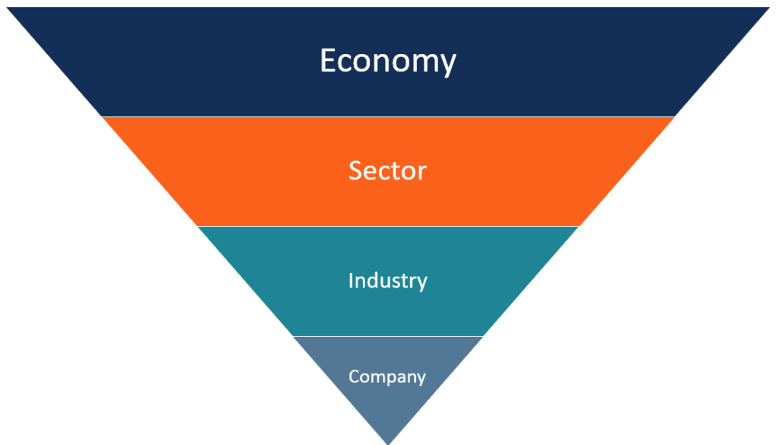Figure 1. Top-down approach

Alternatively, there is the bottom-up approach. Instead of starting the analysis from the larger scale, the bottom-up approach immediately dives into the analysis of individual stocks. The rationale of investors who follow the bottom-up approach is that individual stocks may perform much better than the overall industry.
The bottom-up approach is primarily concentrated on various microeconomic factors such as a company’s earnings and financial metrics. Analysts who use such an approach develop a thorough assessment of each company to gain a better understanding of its operations.

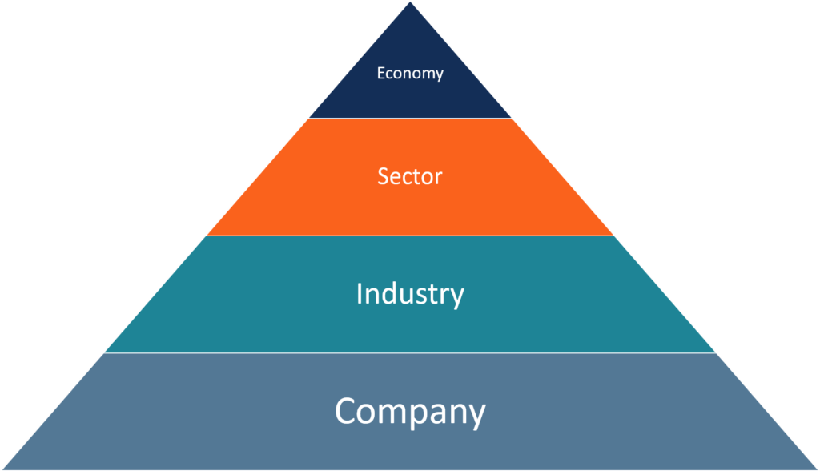Figure 2. Bottom-up approach

Additional Resources
CFI is the official provider of the global Financial Modeling & Valuation Analyst (FMVA)™ certification program, designed to help anyone become a world-class financial analyst. To keep learning and advancing your career, the additional resources below will be useful:
- Comparable Company Analysis
- Economic Indicators
- Technical Analysis – A Beginner’s Guide
- Valuation Methods
https://www.investopedia.com/ask/answers/difference-between-fundamental-and-technical-analysis/#:~:text=Fundamental%20analysis%20evaluates%20securities%20by,future%20trends%20in%20stock%20prices.

Difference between Fundamental and Technical Analysis
The following table illustrates the key points of difference between fundamental analysis and technical analysis.
Parameters | Technical analysis | Fundamental analysis
Purpose | Determining security or market’s prospective patterns by analysing historical price movements and volumes of trade. | Understanding a security’s fundamentals via its financial performance, management, and overall market conditions.
Usage | Investors typically use it for short-term trading. | Market participants predominantly utilise it for long-term investment.
Buy and sell signal | Support and resistance, moving averages, trend lines, and momentum-based indicators. | Overvalued and undervalued stocks.
Irrespective of the few points of fundamental analysis vs technical analysis, it is most fruitful for investors to use both for developing a more comprehensive idea.
https://groww.in/p/difference-between-fundamental-and-technical-analysis/

https://www.investopedia.com/terms/p/portfoliomanagement.asp#:~:text=Portfolio%20management%20is%20the%20art,a%20company%2C%20or%20an%20institution.

