INDIAN ETHOS IN MANAGEMENT
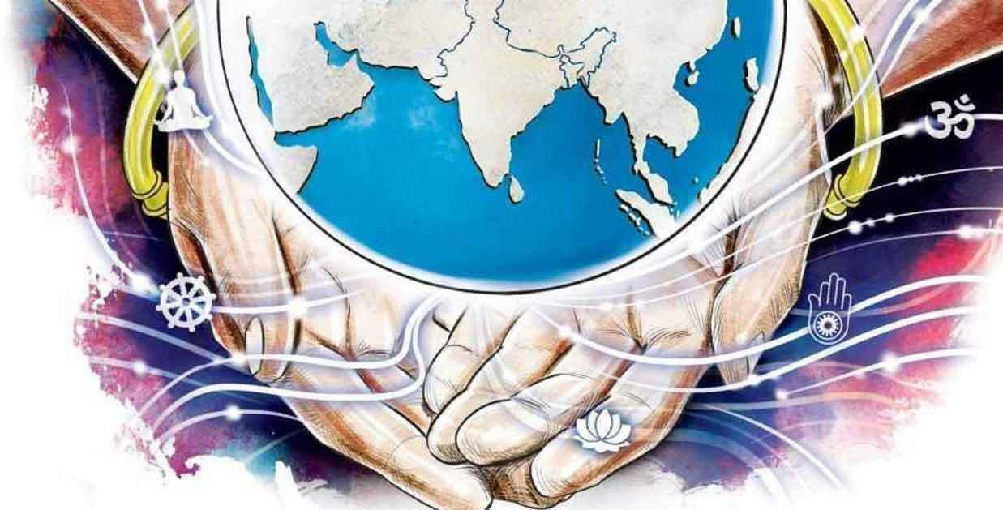


MEANING OF ETHOS:
"Ethos" is a Greek word meaning "Character" and is used to describe the guiding beliefs or ideals that characterize a community, nation or ideology. Oxford defines ethos as the characteristic spirit and beliefs of community and its people which distinguishes one culture from another. Ethos can simply mean the disposition, character or fundamental values peculiar to a specific person, people or culture.
According to Oxford Advanced Learner’s Dictionary, “Ethos are the moral ideas and attitudes that belong to a particular group or society”.
Ethos results from the lessons, beliefs, values that are within individuals, depending on the various kinds of experiences they face in their day to day life. Ethos is an important factor as far as management is concerned. Management involves managing people. People behave and respond according to their ethos.

Thus, the managers of the multinational corporations (MNC's) should understand the ethos of a particular nation and try to manage accordingly. This will result in positive productive and stress-free workforce.

MEANING OF INDIAN ETHOS:
Ethos is a set of beliefs, ideas, etc., about social behaviour and relationship of a person or group and Indian Ethos is all about what can be termed as “National ethos”. Indian ethos refers to values, beliefs or ideals that are drawn from Indian customs and traditions.
India is a land of diversity. It has multi lingual, multi-cultural states where various sects and communities live together in harmony. They have different cultural norms, beliefs and procedures. And yet, at the core, they seem rooted in the common belief.
Indian ethos refers to the principles of self-management and governance of society, entity or a system by wisdom as revealed and brought-forth by great scriptures like Vedas, Upanishads, Gita, Mahabharata, Bible and Quran. This wisdom has evolved through the old practices of Indian mystics, philosophers and religious ‘Gurus’, and is now found to have profound implications for self- management and good governance of a stormy society and business environment, or even a politically divided world.

FEATURES:
- Balance or Equilibrium: Balance or equilibrium is a stable state of Indian thought, i.e., balance between desire and desirelessness, spiritual and secular values, subjective and materialistic world.

- Divinity of Human Being: Indian ethos focuses on the existence of human being as truth. There is nothing more perfect than the supreme soul. Every human being reflects the divine. All humans must realise that they are the spirit, the divine. You are not a human being who sometimes goes through a spiritual experience. Instead you are the spirit going through a human experience.
"Paraspar Devo Bhava"- it means regard the others as a divine being. Have a strong steady and inextinguishable faith that you and all others around you are divine. Hence, the basic idea of Indian Ethos is to manifest the divinity within people around you.

Dignity of Work:
Dignity of work is much important as far as Indian ethos is concerned. It believes that no work is great or small. Each work whether it is a Peon's

job or General Manager's job is of equal importance, worthy and honourableThusit lays emphasis on treating everyone equally. If this concept is applied in business organisations, all employees will get due respect and there would be no problems between labour and management.

Ananda or Bliss:
Ananda means happiness or bliss. Literally, 'aa' means 'from all sides' and 'nanda' means 'joy' or 'happiness'. Thus, literally speaking, 'ananda' means 'joy from all sides'. The ultimate objective of human life is attainment of eternal happiness or bliss. And this is possible when the human realises the difference between material/sensual pleasures which are temporary and lasting happiness or bliss which leads to enlightenment and salvation or moksha.
Moksha can be achieved by fulfilling Purusharthas or four chief goals of human life. They are:
  - Dharma (Righteousness)
  - Artha (Wealth)
  - Kama (Desire)
  - Moksha (Salvation)

- Balance of Personal and Work Life: Indian ethos focuses on the concept that if you are good then the world is also good for you. So, every individual should have an effective management and balance of personal and work life in the organisation.

- Equanimity: Equanimity is a state of mental or emotional stability wherein people accept pleasure and pain, joy and sorrows as a part of life. Everything in life comes in duality, whether it is day and night, summer and winter, mind and matter created by God, or the pleasure and pain, success and failures experienced by man. It is so because both the things are incomplete without each other. The problem is that, inspite of knowing this; people seek and pursue one side of the coin only. We hi tend to forget that both pleasure and pain are part of life and we must accept both with equanimity.
- Importance to Character: The Indian ethos gives much importance to character not to the knowledge. It is the character, which is the real power and wealth.
- Cosmic or Pure Consciousness: The divine element, which is an inner part of an individual, is a part of cosmic or pure consciousness. It gives a base for mutual trust, cooperative, teamwork and common good.

Know Yourself: (Who am I?)

Before you start to manage resources and others, what is very important according to the Indian ethos is to manage yourself and that will be possible only if you know yourself. Be aware of your strengths and weaknesses and your reactions to your environment. Be aware that you and all others are a part of the Divine spirit and all of us have divine qualities.



Unique Work Culture:
According to Indian Ethos, work must be offered to the supreme power or God, because the energy which enables us to perform work is given by that power or God. Hence, Work is considered as worship,
Yoga Karmashu Kaushalam:
Yoga means excellence at work. Kaushalam means doing work with devotion and without any attachment. One must keep in mind that one is a mere instrument of God performing the task and he must do it with complete devotion and dedication.
Thus, the kind of work culture required is "divine" work culture characterized by purity, self control etc. as against a "demonic" work culture characterized by egoism, delusion, etc.

- Whole-Man Approach: Indian ethos is based on Indian scripture like- Shruties of Gita and Upanishad and Smruties of Puranas. Indian thought provides the whole-man approach through knowledge of creation, cosmos and internal relation between spiritual and materialistic life. Vasudhaiva Kutumbakam is derived from Sanskrit words - 'vasudha' meaning the

earth', 'aiva' meaning 'is' and 'kutumbakam' meaning 'family'. Thus, Vasudhaiva Kutumbakam is a Sanskrit phrase meaning that the whole world is one single family.The idea of Vasudhaiva Kutumbakam is India's contribution to world peace and it is based on the prayer "Loka Samastu Sukhino Bhavantu "meaning "Let the entire world be happy".

- Holistic Approach to Management: Holistic Approach to Management is based on the principle that we all are one and we all are interconnected with each other.
Thus, we should follow the golden rule which states that 'Do unto others as you want others to unto you, which means you should treat others as you would like to be treated by them.
Moreover, we must strive towards perfection in our work as well as for the welfare of the world. This holistic approach if applied in management will lead to the proper functioning of the enterprise and the greatest good for the entire environment.

- Duty and Responsibility: Indian ethos rarely talks of rights and prevails ages. It always emphasises only on the duties and responsibilities of human beings.
- Work in Worship: Indian ethos works with the fact that all work is worthy and honourable. ‘Work is worship’ is the guiding principle for all effort as advocated in the Indian ethos.
- Excellence at Work: According to Indian ethos, total quality management can be assured through excellence at work, through self-motivation and self-development.
- Work Results and Detachment/ Concept of Nishkama Karma: Nishkama Karma or selfless or desireless action is an action performed without any expectation of fruits or results. Nishkama karma is a concept of Bhagwad Gita. This concept advocates that an individual should perform his duties in life without any desire for fruits or without any attachment to fruits. It is 'duty' ought to be performed for the sake of duty'. One has a right to perform one's duty but had no claim or control over the result.
- Knowledge: Indian ethos deals with two types of knowledge:
- Knowledge of creation
- Knowledge of creator

- Co-operation and Collaboration/ Work with Team Spirit:Accepting the divinity in all creation, humans must nurture one another. By co- operationrespect and feeling of fellowshipall of us can enjoy the highest

goodboth material and spiritualThusthe idea is to inculcate team spirit and work as a TEAM.

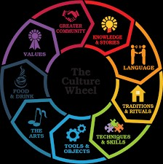

NEED AND RELEVANCE OF INDIAN ETHOS
- Elucidate Motivation: Concept of motivation can be explained holistically by Indian ethos. Considering motivations as internal, every human being has the same divine soul with immense potentialities within. Indian scriptures bring infinite expansions of the mind, breaks down all the barriers and brings out the God in man. Motivation is to be internal and not external. Such motivation involves the inner beauty and does not promote any greed in an individual to have more and more in return for his work.
- Maintain Holistic Universe: Modern science has accepted that in this holistic universe, all minds and matters are interconnected at a deeper level. The basic unity of life cannot be broken. Love, sacrifice therefore emerges as the only means for a meaningful living. On the basis of this holistic vision, Indians have developed work ethos of life. This helps in living life to the fullest.

- Welfare: Indian ethos teaches welfare of all (yagna spirit). “Atmano Mokharth Jagat Hitay Cha” (serve your personal interest but do not forget others). This philosophy is needed in modern times.

Development of a Value -based Management System:
The time has come for the corporate companies to develop leaders who display ethical values and beliefs and adopt a value-based approach towards corporate management.This is possible by inculcating various principles of Indian ethos in the staff.

- Evenness of Mind: Indian ethos helps in evenness of mind. Means are equally important as the ends. Thus, society acceptable values are to be followed in determining the objectives as well as in the process of achieving these objectives.

- Unique Work Culture: Indian ethos helps in development of unique work culture. Work is considered as duty or Sadhana and there is no difference between Karma(work) and Dharma(religion). The term Dharma does not indicate any particular religion. Dharma is a duty to be performed in a given situation. Thus, Dharma is possible through Karma only.

Self Development and Self Management:
Managers must first understand how to manage themselves and then learn to manage others. Continuous investment in self development - of employees is necessary to ensure all round prosperity and happiness and helping one reach his/her true potential. It helps to improve efficiency, brings peace and equanimity and enables humans to handle the complexities of life.

- Provides Concentration: Vedanta provides the ways and means of controlling the mind. It helps to concentrate, increase efficiency, productivity and prosperity. It is not religion of resignation and retirement. One cannot renounce their action. As the Gita says “You have to be a man of action, do not run away from your action or Karma but the same should be according to your Dharma”. The second aspect, is while doing the Karma; do not be tempted by worldly pleasures, materialism and the results. One has to be man of action, working in a spirit of renunciation. Renunciation does not mean living a life of isolation or living in a forest. One has to face the world and should not run away from your action. Do not get attached to anything.

- Self-Development: Integrated human personality of self-developed manager can assure best and competent management of any enterprise,

involving collective works and efforts. The refined or higher consciousness will adopt holistic attitude. It will bring out the divine in man. It will achieve perfection or excellence in whatsoever sector of work. One shall achieve peace, harmony and prosperity within and without, i.e., in the internal world and in the external world simultaneously.

Stress Management:
By following the principles of Indian ethospeople can learn to work in the spirit of Nishkama karmaThis will reduce stress of the expected results of workMoreover, by practising yoga and meditation, humans will lead to a stress-free and balanced life.

Social Sensitivity:
Indian concepts makes humans have a more sensitive approach to social responsibilities, values and governance. Believing in the principle of divinity of all creations, makes one respect all forms of life. Moreover, the concept of Dharma enables an individual in performing actions in a righteous way, keeping in mind the effect of your actions on all beings.

Humanising the Organisation:
Application of Indian ethos in management helps in humanising the organisation. It leads to improvements in three aspects of human organisation. That is:
  - It leads to improvement in interpersonal relations.
  - It leads to improvement in man - - machine equation where man is the prime concern.
  - It leads to spiritual and mental growth of individuals. An in-depth study of Indian ethos helps in self - examination of one's

Self-Introspection:
Own thoughts, feelings, emotions, sensations and passions. It will help an individual to understand what are his strengths and weaknesses. This will promote self-awareness.

Brain - stilling/Meditation:
For rational and enduring decisions, silent mind is a necessity. This silent mind can be achieved by practicing meditation. Brain - stilling or meditative silence is the most reliable method to discover solutions to problems.

Intuition:
Intuition is the act of coming to direct knowledge or certainty without reasoning or inferring. It is immediate cognition by the inner mind and

when fully developed is efficient and effective for taking prompt and sound decisionsIntuition skills enables one to cope with confidence the fluctuating environment and rapid changes. Faith is prerequisite to develop and realize the power of intuition.

- Establishes Value System: Many of the present ills are the results of decline in our value system and loss of character. Forces of intense competition in the technology driven era of globalisation have taken a heavy toll of traditional values. People need to re-imbibe the sanatan values of honesty, integrity, compassion, care and cooperation.
There is again a need to establish conduct, based on truth and non-violence, peace, and harmony. One needs to promote a secular ethos that entails ‘sarva dharm-sambhav’. That alone will promote enshrined in our ancient maxim of ‘Vasudhaiv Kutumbakam’. That will be India’s unique contribution towards enrichment of content of globalisation which today has its focus only on trade and commerce.

HISTORY
Formally, the body knowledge which derives its solution from the rich and huge Indian system of ethos is known as Indian Ethos in Management (IEM). Indian ethos is more vital to modern management than any other management theory for simple reason that it takes into account a ‘whole’ man approach (mentioned earlier) rather than approaching “man” in a partial fashion. Each and every situation can be met effectively if one takes time to reflect over it. Reflection with a tranquil mind helps in drawing out solutions from within. Such guidance from within helps a manager look at the perceived problem situation in a creative manner. It leads to a more coherent and complete understanding.
The silent ideas and thoughts of Indian Ethos in Management revealed by Indian’s ancient scriptures are:

- Archet Dana Manabhyam: Worship people not only with material things but also by showing respect to their enterprising divinity within.
- Atmano Mokshartham Jagat Hitaya Cha: All work is an opportunity for doing well to the world and thus gaining materially and spiritually in our lives.
- Atmana Vindyate Viryam: Strength and inspiration for excelling in work comes from the Divine, God within, through prayer, spiritual reading and unselfish work.
- Yadishi Bhavana Yasya Siddhi Bhavati Tadrishi: As we think, so we succeed, so we become. Attention to means, ensure the end.

- Yogah Karmashu Kaushalam, Samatvam Yoga Uchyate: He who works with calm and even mind achieves the most.
- Parasparam Bhavatantah Shreyah Param Bhavapsyathah: By mutual cooperation, respect and fellow felling, all of us enjoy the highest good both material and spiritual.
- Paraspar Devo Bhava: Regard the other person as a divine being. All of us have the same consciousness though our packages and containers are different.
- Tesham Sukhm Tesham Shanti Shaswati: Infinite happiness and infinite peace come to them who see the Divine in all beings.

PRINCIPLES PRACTICED BY INDIAN COMPANIES

- Subtle, intangible subject and gross tangible objects are equally important. One must develop one’s third eye, Jnana Chakshu, the eye of wisdom, visions, insight and foresight.
- Holistic approach indicating unity between the Divine (the Divine means perfection in knowledge, wisdom and power), individual self and the universe.
- Inner resources are much more powerful than outer resources. Divine virtues are inner resources. Capital, materials and plant and machinery are outer resources.
- Immense potential, energy and talents for perfection, as a human being has the spirit within his heart.
- Yogah karmasu kaushalam, which means excellence at work through self- motivation and self-development with devotion and without attachment.
- Karma yoga (selfless work) offers double benefits, private benefit in the form of self-purification and public benefit.
- Cooperation is a powerful instrument for team work and success in any enterprise involving collective work.

- Honesty: Indian companies follow the principle of honesty in business dealings. Indian executives are honest and truthful in all their dealings and they do not deliberately mislead deceive others by or misrepresentations, overstatements, partial truths, selective omissions, or any other means.

- Transparency: Indian companies follow the principle of Transparency in business dealingsThe management emphasizes internal and external transparency in disclosure of information. Adequate, timely and accurate information should be disclosed to whoever asks for it.

- Accountability and Responsibility: Indian companies follow
the principle of Accountability and Responsibility. Every member of the Board

and management should be held accountable and responsive for their decisions and actions. Moreover, the board should communicate to the company's shareholders and other stakeholders, at regular intervals, as regards to how the company is achieving its business purpose and meeting its other responsibilities.

- Equitable Treatment of all Stakeholders: Indian companies believe in equitable treatment of all stakeholders such as Customers, Employees, Suppliers, Shareholders, Government, Society etc and fulfill its responsibilities towards all stakeholders.

- Harmony: Indian companies follow the principle of harmony in work cultureThey promote co-operation and team spirit in the organisation. There will be humbleness, humility and respect for all. Thus, in shortit will lead to creation of harmonious work culture in the organisation.

- Fairness and Integrity: Indian companies follow the principle of fairness in their business dealings. The Board should be free of any influence from Management or any particular group of stakeholder. All business decisions are made keeping mind the interest of the companyIntegrity should be a fundamental requirement in an organization.

- Dignity of Work: Dignity of work is much important as far as Indian ethos is concerned. It believes that no work is great or small. Each work whether it is a Peon's job or General Manager's job is of equal importance, worthy and honourableThus, it lays emphasis on treating everyone equally. If this concept is applied in business organisations, all employees will get due respect and there would be no problems between labour and management.

- Holistic Approach to Management: Holistic Approach to Management is based on the principle that we all are one and we all are interconnected with each other.

Thus, we should follow the golden rule which states that 'Do unto others as you want others to unto youwhich means you should treat others as you would like to be treated by them.

Moreover, we must strive towards perfection in our work as well as for the welfare of the world. This holistic approach if applied in management will lead to the proper functioning of the enterprise and the greatest good for the entire environment.

- Co operation and Collaboration/ Work with Team Spirit: Accepting the divinity in all creation, humans must nurture one another. By co-operation,

respect and feeling of fellowship, all of us can enjoy the highest good, both material and spiritual. Thus, the idea is to inculcate team spirit and work as a TEAM:

T-Together.

E- Everyone.

A- Achieves.

M - More.

REQUISITES

- Humanising the Organisation: Looking at the three aspects of humane organisations, i.e., inter personal relations, man-machine equation where man is the prime concern and inner management through mental and spiritual growth of individuals.
- Management Attitude: Top management having firm belief in value- oriented holistic management. Profit is earned through service and satisfaction of all stakeholders employees, customers, shareholders and citizens. Fulfillment of social responsibility must be ensured.
- Interiorising Management: Self-management or management by consciousness. When the soul manages the other four members of the human being, namely, the body, mind, intellect and the heart, the conflict these four have amongst themselves can be resolved. This is called management by consciousness. The objective of self management is to first know and manage oneself and then manage others.
- Brain-Stilling: For rational and enduring decisions, silent mind is a necessity. A perfect Mounum(calm mind enjoying tranquillity) is necessary. Brain-stilling or meditative silence is the most reliable method to discover solutions to problems which seem to be difficult to tackle by reason and intellect, because through this, one can come into contact with the inner mind or higher consciousness, called Chetana.
- Self-Introspection: Embark upon self-study, self analysis and selfcriticism to locate areas of friction and disharmony, a self examination of one’s own feelings, thoughts, emotions, sensations and passions and a desire to reduce and subdue the ego.
- Stepping-back (For a While): Never decide anything, never speak a word and never throw yourself into action without stepping-back. The stepping- back from a situation for a while enables one to control and master a situation.

- Role of Intuition: Intuition is the act of coming to direct knowledge or certainty without reasoning or inferring. It is immediate cognition by the inner mind and when fully developed, is efficient and effective for taking prompt and sound decisions. Intuition skills enable one to cope with confidence the fluctuating environment and rapid changes. Faith is a prerequisite to develop and realise the power of intuition.
- Self-Dynamising Meditation: A dynamic meditation helps in transformation of lower consciousness into higher consciousness and hence is called transforming meditation. Through meditation, one reaches a higher level of consciousness with a silent and calm mind, which offers guidance in the form of intuitions to tackle a multitude of problems. This is called consciousness approach to management.

ELEMENTS OF INDIAN ETHOS

- Ego Sublimation rather than Ego Assertion:
Controlling one's ego is the prime teaching of Indian ethos. Instead of working in isolation, we should always prefer working in a group. This helps in creating a peaceful atmosphere. For example, if the leader in a project is understanding and down to earth, people working under him will be able to find quick and easy solutions to their problemsOn the other hand, if the leader is egoistic it may affect the productivity of the entire group. Thus, this principle teaches us to control our ego and focus on 'WE aspect rather than 'I' aspect in the organisation.

- Sacrificing spirit rather than fighting spirit:
One should believe in following the principle of sacrificing. Sacrificing means working for the benefits of others rather than for one's own self. If we follow the fighting spirit, people will become self-centered which will lead to more conflicts between them.

- Team achievement rather than individual achievement:
This principle advocates that we should work as a team rather than working on individual basis. Accepting the divinity in all creations, humans must nurture one another. By co-operation, respect and feelings of fellowship, all of us can enjoy the highest good, both material and spiritual. Thus, the idea is to inculcate team spirit and work as TEAM:

T-Together E - Everyone A - Achieves M-More

- Spiritual attainment rather than Materialistic Prosperity: Happiness attained through materialistic prosperity is only for short term and will not last forever. On the other hand, working with a spiritual aspect will help to calm the mind and increase concentration and focus on the work assigned. For example, a person with spiritual attainment will be more focused and calm at work. On the other hand, a person running behind materialistic prosperity will always be disturbed and will not be able to generate good results.

- Self-Control rather than Outer Control:
This principle advocates to bring changes in yourself rather than changing the world. Instead of trying to control others, we should learn to control ourselvesThis will help us to boost the confidence level and face challenging tasks.

- Concept of Duties rather than concept of Rights:
A right is an individual's entitlement to something. Duty refers to responsibilities and obligations that a person owes to something or someone. Thus, one should never misuse the power given to them and perform all the duties wholeheartedly with utmost dedication.

- Yielding rather than dominating:
The managed should never try to dominate his employees. This will hamper the superior - subordinate relationship and create an unhealthy environment. Thus, the must be humble in their behaviour. They must respect all the employees and work with co-operation.

- Concern for this age world and improvement:
Identifying the change and accepting that change is vital for the success of the organisation. Thus, an organisation should continuously try to make improvements in its products, process, technologies etc. and work as per latest trend.

- Respect for and search for all truth whatever be its source Indians believe in humility and respect for all. Indians are humble in their behaviour. They have respect for every individual, caste or religion.

Dignity of work is much important as far as Indian ethos is concerned. It believes that no work is great or small. Each work whether it is a peon's job or General Manager's job is of equal importance, worthy and honourable. Thus, it lays emphasis on treating everyone equally.

If this concept is applied in business organisations, all employees will get due and there would be no problems between labour and management.

ROLE OF INDIAN ETHOS IN MANAGERIAL PRACTICES:

Indian Ethos in Management refers to the values and practices that the culture of India (Bharatheeya Sanskriti) can contribute to service, leadership and management. These values and practices are rooted in Sanathana Dharma (the eternal essence), and have been influenced by various strands of Indian philosophy.
Indian ethos for management means the application of principles of management as revealed in our ancient wisdom brought forth in our sacred books like our Gita, Upanishads, Bible and Quran.
The ancient Indian Education was basically aimed at personal growth of individual. Our education system is the oldest in the world and is having some qualities which are not there anywhere else in the world and we are proud of this. The aim of ancient Indian Education System was not only to give theoretical knowledge but to make an individual humble so that he can get ‘Mukti’. The ultimate aim of human society of that age was the achievement of absolute i.e. ‘Brahma’ it was prevailing in the entire visible world. A man should engage himself in ‘Karmopasna’ i.e. work is worship and thus purity his inner senses and gain the absolute. The main aim of all the education during ancient period was to make the student useful and pious member of society. This was the second aim of education. This was achieved by proper development of moral feelings. It was believed that mere intellectual knowledge was not enough to become a learned fellow; in addition, the student must be pure in his life, thoughts and habits. This was the third main characteristic of Hindu Educational System. This was realized by encouraging self- confidence, fostering self-respect and self-restraint. Graduate students were highly inspired during convocation address to be useful member of the society. A graduate student was not to lead a self-centered life rather he was constantly remained of his obligations to the society. Social life in villages was very stable and well-ordered as education transformed people and made them conscious of their social duties and civic responsibilities. During the ancient period, Aryans evolved a peculiar system for promoting the progress of different art forms and professions. In the society, a particular caste was restricted to a particular occupation. Eventually, this system has resulted in general progress and happiness of society. In the ancient system of education this was one of the most important aims. People were very much conscious of their culture.
The role of Indian Ethos in Managerial Practices are as follows:

- Planning:
Application of Indian Ethos can help in planning the VisionMission, Goals and Objectives of the organisationIt can assist the manager as regards to what they want to achieve in the long run. Moreover, principles of Indian Ethos will give a

proper direction to the manager and help him to perform all the activities in a righteous manner.

- Recruitment and Selection of Employees:
In most of the organisations, recruitment and selection of employees is done on the basis of recommendations, references of the current employee without giving due importance to the performanceThis often results in discouragement among employees.

Howeverapplication of Indian Ethos will help in recruitment and selection of employees in a fair and just mannerEmployees will be appointed purely on the basis of merit and performance. 3. Improvement of Employer - Employee Relationship:

In most of the organisations, relationship between employer and employee are not very cordial and comfortable. However, principles of Indian Ethos like Divinity of all soulsDignity of work and Humility and respect for all will help to improve the employer-employee relationship in the organisation.

- Responsibility and Accountability:
In most of the organisations employees have a very casual approach towards their workThey are not willing to put in their hard work. Howeverapplication of Indian ethos will inculcatea sense of responsibility and accountability in the mind of employees and they will work with utmost dedication.

- Training and Development:
In most of the organisations, training and development is not given due importanceEven expense allocation for training is very lessThis ultimately results in less productivity from the workforce. However, application of Indian Ethos will lead to development of a proper training policy and employees will be given training in a fair and just mannerThis will ultimately increase the productivity of the workforce

- Performance Appraisal:
Performance appraisal means evaluation of performance of an employeeApart from this, it also involves activities like promotions and transfers. However, in many organisations, performance appraisal is done in a biased manner i.e. appraisal is not done on the basis of actual performance. This often results in faulty promotions and transfers of employees.

However, application of Indian Ethos will help in conducting proper performance appraisal thereby resulting in fair promotions and transfers.

- Workers Participation in Management:
Traditionally, workers were not involved in the decision making process of the organisationHowever, nowadays, by adopting the principle of Respect and Humility for all, most of the organisations promote workers participation in management. This also motivates the workers to work more efficiently in the organisation

- Grievance Redressal Systems:
Most of the times high level managers do not attend to the problems of employees customers. This leads to sense of dissatisfaction among employees/workersHowever, an organisation that follows Indian ethos will try to redress all the grievances of the employees / customers.

- Promotes harmonious work culture:
Adoption of Indian Ethos will promote co-operation and team spirit in the organisation. There will be humbleness, humility and respect for all. Thus, in short, it will lead to creation of harmonious work culture in the organisation.

BASIC PRINCIPLES OF INDIAN KNOWLEDGE SYSTEM (IKS):
  - Immense potential, energy and talents for perfection as human being has the spirit within his heart.
  - Holistic approach indicating unity between the Divine (the Divine means perfection in knowledge, wisdom and power), individual self and the universe.
  - Subtle, intangible subject and gross tangible objects are equally important. One must develop one’s Third Eye, Jnana Chaksu, the Eye of Wisdom, Vision, Insight and Foresight. Inner resources are much more powerful than outer resources. Divine virtues are inner resources. Capital, materials and plant & machinery are outer resources.
  - Karma Yoga (selfless work) offers double benefits, private benefit in the form of self Purification and public benefit.
  - Yogah Karmasu Kaushalam: Excellence at work through self-motivation and

Self development with devotion and without attachment. Co-operation is a powerful instrument for team work and success in any enterprise involving collective work. Principles of IEM are universally applicable. IEM can help develop an effective and holistic management pattern which will assure all round growth in productivity, marketing and profitability. This will help in synchronizing private and public benefits and encourage individuals to lead an enriched quality of life together with worldly achievements. The best form of management has to be holistic and value driven which is the objective of IEM.
- Creates strong relation: Organizations following Indian ethos consider humanity as supreme. This provides a strong bond with internal as well as external customers, resulting in an improved performance.
- Inward considerations: Indian ethos focuses on ‘if a person is good then the whole world is good’. Any organization which follows the above ethical thought automatically get converted into an ethical organization with less conflicts and hindrances.
- Avoids unethical aspects: As Indian ethos is a principle derived from Upanishads, Bhagwat Gita and Puranas, where the performance is always ethical
- Balanced values: Indian ethos promotes a person to live a life of materialism and spirituality by maintaining a balance between spiritual values and secular values.
- Improves performance: Indian ethos impacts the performance of business by emphasising on the concept like sacrificing individual desires in favour of social benefits, preferring long-term benefits.
- Improves quality: Self-motivation and self-development helps a lot in development of business and its quality
- Helps in problem solving
- Develops self-reliability

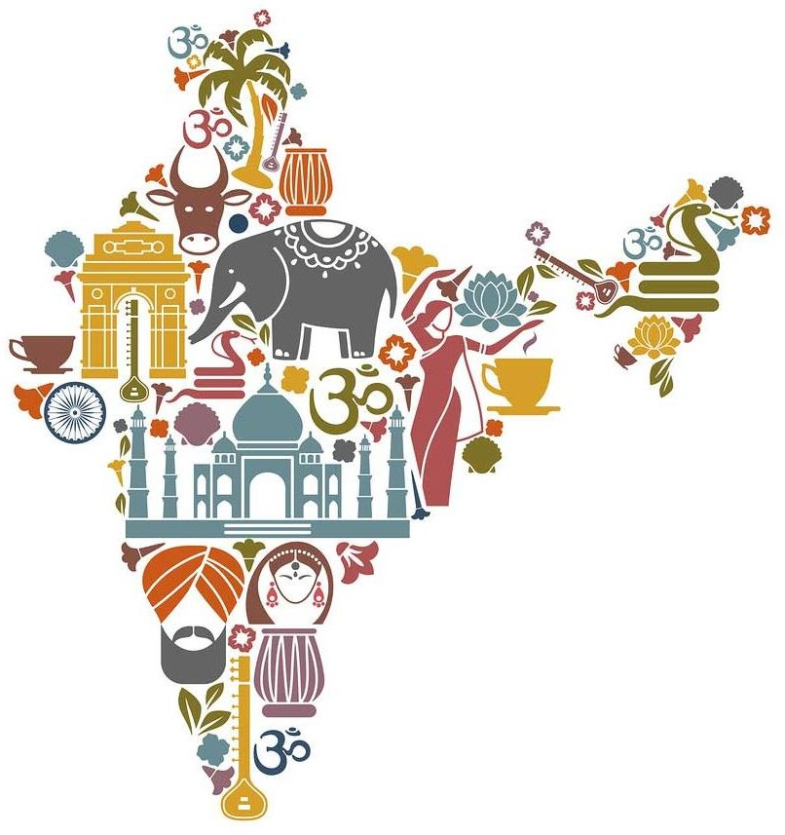

ETHICS VS. ETHOS
The main difference between ethics and ethos is that ethics refer to a set of moral principles while ethos refers to the character or customs or a set of attitudes and values. Ethics is derived from the word ethos.
The two words ethos and ethics are linguistically linked as they share the same etymology. However, in the present world, these two words are used distinctly.

ETHICS
The word “ethics” comes from the Greek word “ethos” which means “character” or “custom.” Therefore, ethics combines the meaning of the word ethos with the wider meaning of the word ethics. Ethics refers to the set of moral principles or a system of moral values for a particular society or an institution. Merriam Webster defines ethics as “the discipline dealing with what is good and bad and with moral duty and obligation.”

Hence, ethics differ according to the individual, his social background, etc. However, ethics defines what are morally good and acceptable from a majority of society.
For instance, the ethics in a certain society is originated with an alliance to their customs, traditions and religious beliefs as well. Hence, in this instance, ethos directly influences the formation of ethics. However, ethics in a general sense are those that are accepted universally; moral ethics, etc.


ETHOS
Ethos is a Greek word that has meaning such as “Character” or “Custom”. Originally, this word was used by Aristotle to describe a man’s character or personality; a combination of passion and caution. However, at present, ethos refers to the guiding beliefs and values that distinguish a person, society or institution from others. According to Merriam Webster, ethos refers to the ‘the distinguishing character, sentiment, moral nature, or guiding beliefs of a person, group, or institution’.
Thus, ethos mainly refers to the core set of attitudes, beliefs, and values that gives an identity to a person, community, institution, etc. For instance, the character identity of a certain individual in a society is a manifestation of that person’s outlook in life developed through his social traditions, customs, and religious beliefs as well.
Another situation is when the business values of a certain institution can be distinguished from another; here, it is their attitudes and aspirations that contribute to formulating their business ethos. Hence, ethos can be explained as the characteristic spirit of a culture, era, or community as manifested by the attitudes and aspirations of its members.

 | Ethics |  | Ethos
 | 1. Ethics is a set of principles that guides the behaviour of an individual as regards to what is  right or wrong, good or bad, etc. |  | 1 Ethos is character or fundamental value of a person, people, culture  and movement.
 | 2 It differentiates between right and wrong, good and bad, moral  and immoral etc. |  | 2 It is based on customs and traditions.
 | 3 Ethics are derived from  Shastras. |  | 3 Ethos are derived from culture.
 | 4 Ethics are universal in nature. |  | 4 Ethos are culture -specific in  nature. i.e. it is based on culture of a particular country/region.
 | 5 Ethics determines functions  such as paap, punya, swarg, narak, conduct or misconduct. |  | 5 It determines cultural behaviour or culture.
 | 6 Examples : Truth, Non- violence, Donation, Kindness |  | 6 Examples : welcome, pranam, respect to elders, love to  youngsters.

Ethics and ethos are etymologically linked words. Moreover, ethics can be identified as being derived from the Greek word ethos. Nevertheless, the difference between ethics and ethos is that ethics refer to a set of moral principles while ethos refers to the character or customs or a set of attitudes and values.

**********

