CHAPTER 1
INTRODUCTION TO AUDITING



The Person who conducts the Audit is known as Auditor.
- An Auditor has to be a Qualified Chartered Accountant.
- Therefore, An audit generally means to Check the Accounts.
- Primary Objective of an Auditor is to check the Financial Statement i.e. Profit and Loss A/c AND Balance Sheet and to Comment on the Financial Statement whether the financial statement are showing true and fair view or not (Proper and Accurate recording of Transactions which has been occurred).

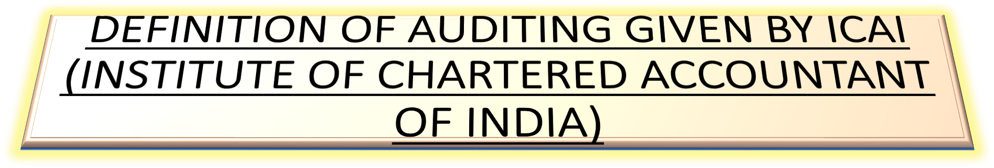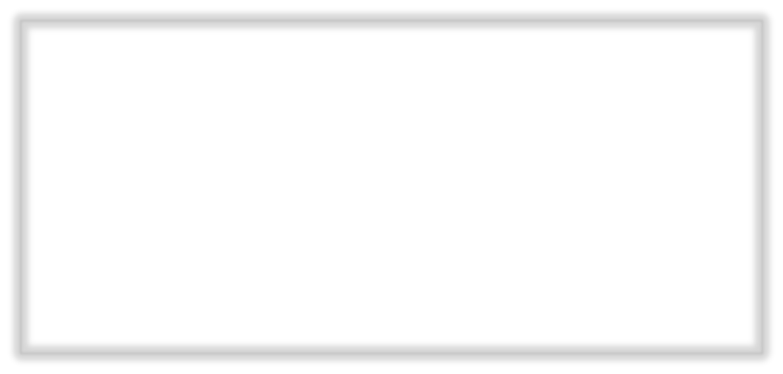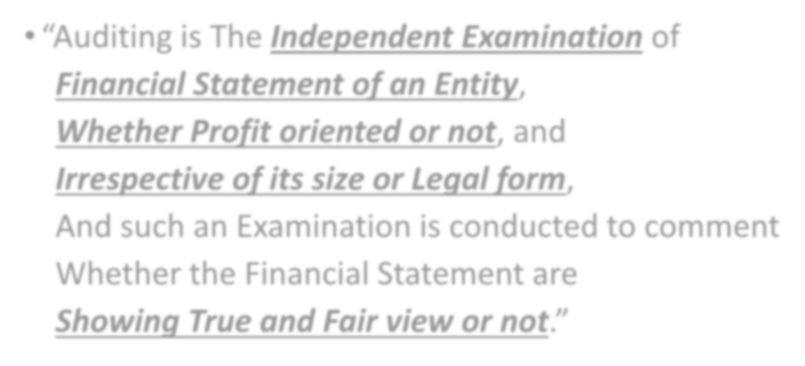

  - “Auditing is The Independent Examination of

Financial Statement of an Entity, Whether Profit oriented or not, and Irrespective of its size or Legal form,
And such an Examination is conducted to comment Whether the Financial Statement are

Showing True and Fair view or not.”

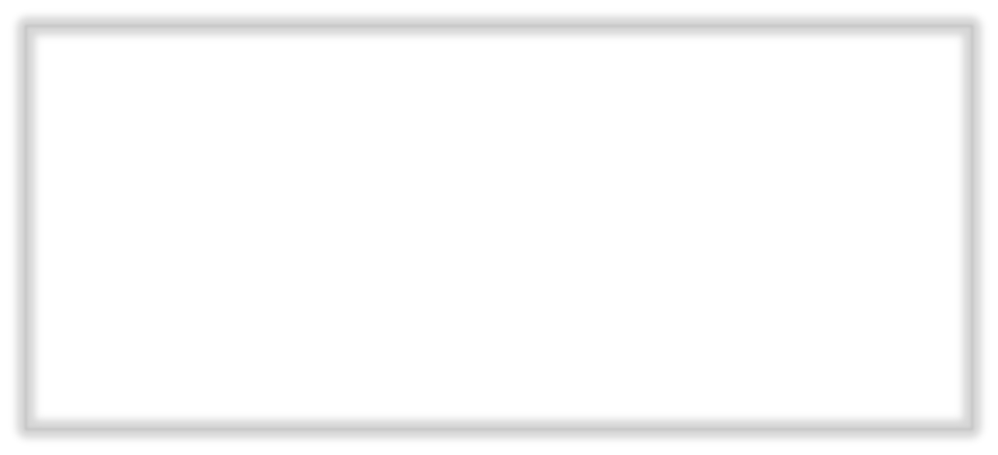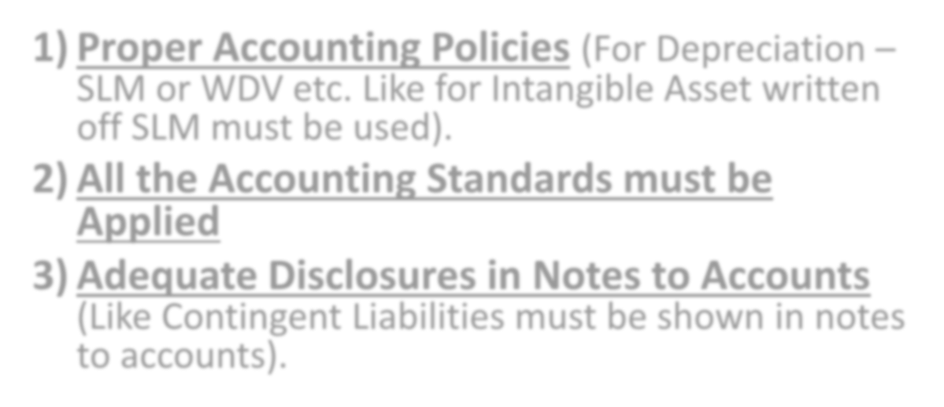

- Proper Accounting Policies (For Depreciation – SLM or WDV etc. Like for Intangible Asset written off SLM must be used).
- All the Accounting Standards must be Applied
- Adequate Disclosures in Notes to Accounts (Like Contingent Liabilities must be shown in notes to accounts).

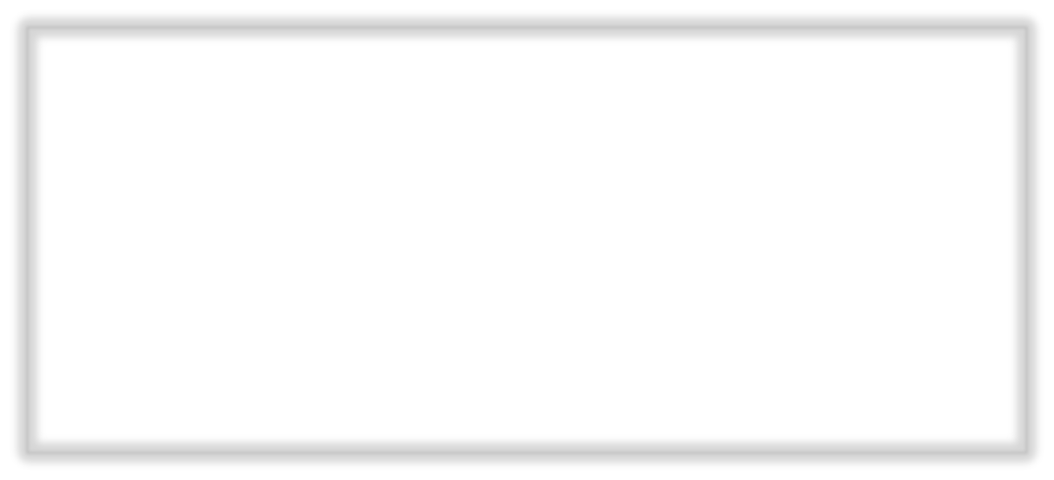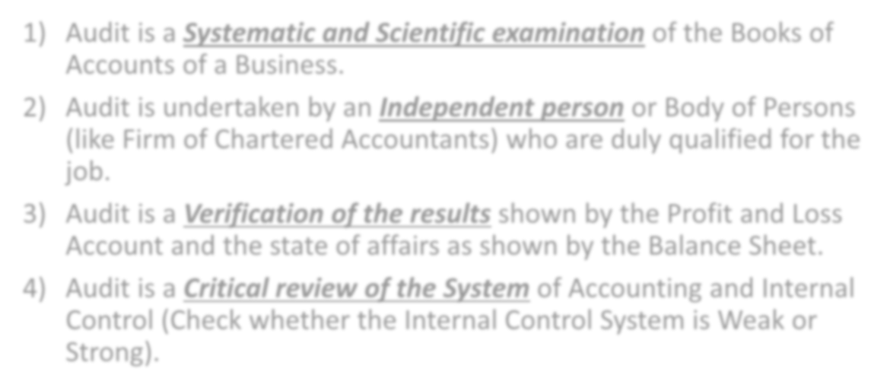

- Audit is a Systematic and Scientific examination of the Books of Accounts of a Business.
- Audit is undertaken by an Independent person or Body of Persons (like Firm of Chartered Accountants) who are duly qualified for the job.
- Audit is a Verification of the results shown by the Profit and Loss Account and the state of affairs as shown by the Balance Sheet.
- Audit is a Critical review of the System of Accounting and Internal Control (Check whether the Internal Control System is Weak or Strong).

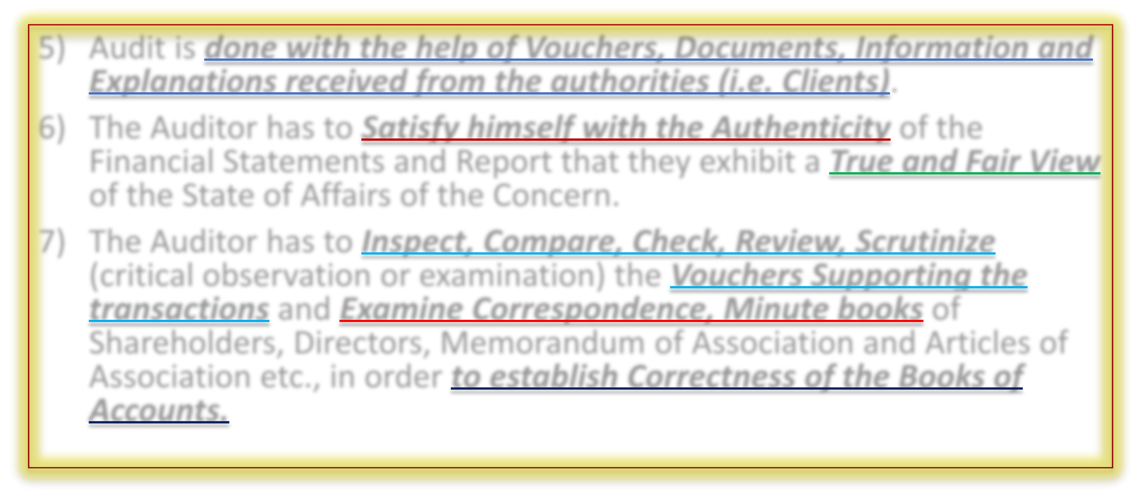

- Audit is done with the help of Vouchers, Documents, Information and Explanations received from the authorities (i.e. Clients).
- The Auditor has to Satisfy himself with the Authenticity of the Financial Statements and Report that they exhibit a True and Fair View of the State of Affairs of the Concern.
- The Auditor has to Inspect, Compare, Check, Review, Scrutinize (critical observation or examination) the Vouchers Supporting the transactions and Examine Correspondence, Minute books of Shareholders, Directors, Memorandum of Association and Articles of Association etc., in order to establish Correctness of the Books of Accounts.

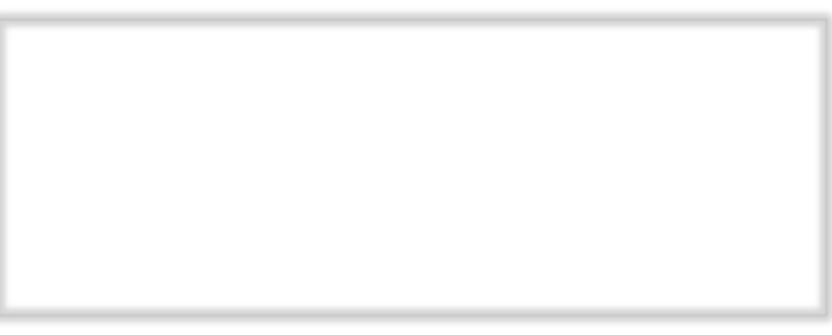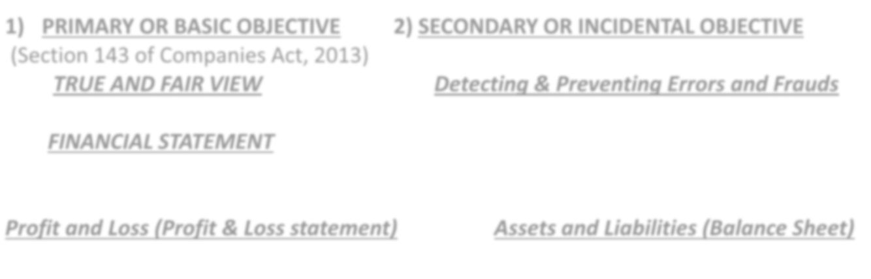

- PRIMARY OR BASIC OBJECTIVE 2) SECONDARY OR INCIDENTAL OBJECTIVE
(Section 143 of Companies Act, 2013)
TRUE AND FAIR VIEW Detecting & Preventing Errors and Frauds

FINANCIAL STATEMENT

Profit and Loss (Profit & Loss statement) Assets and Liabilities (Balance Sheet)

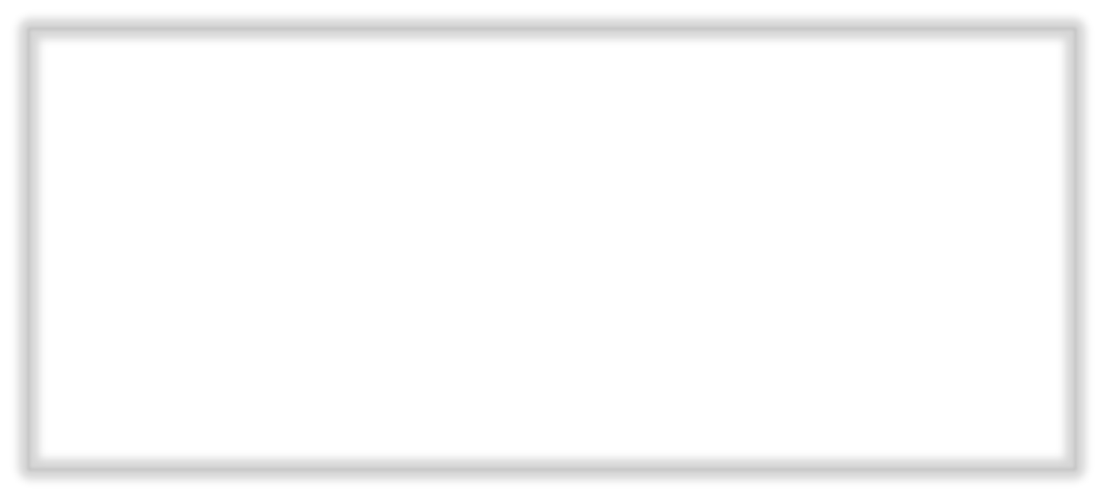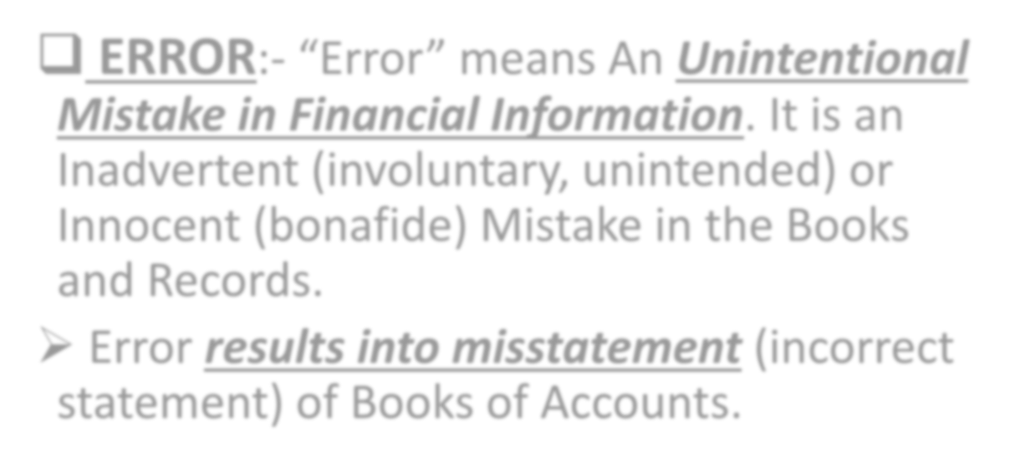

  - ERROR:- “Error” means An Unintentional Mistake in Financial Information. It is an Inadvertent (involuntary, unintended) or Innocent (bonafide) Mistake in the Books and Records.
- Error results into misstatement (incorrect statement) of Books of Accounts.

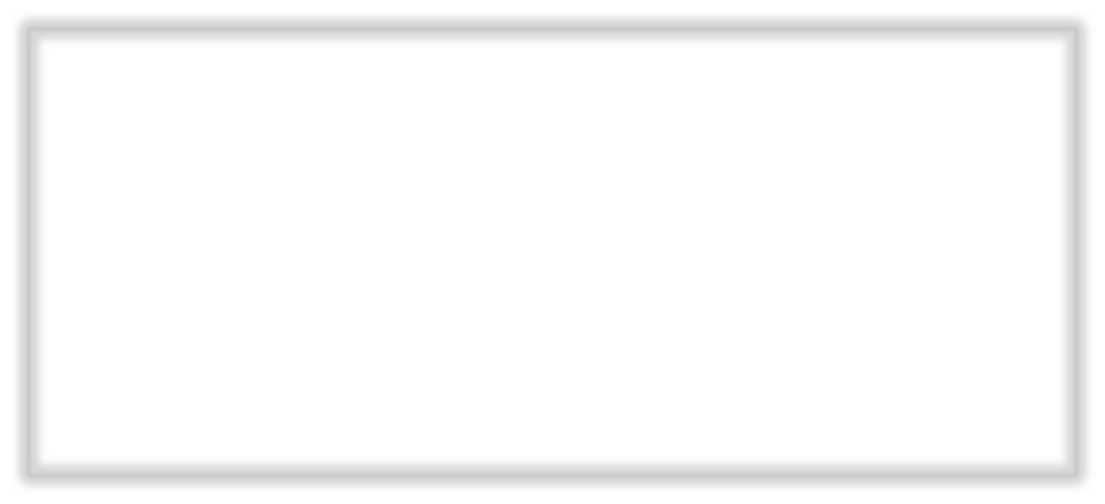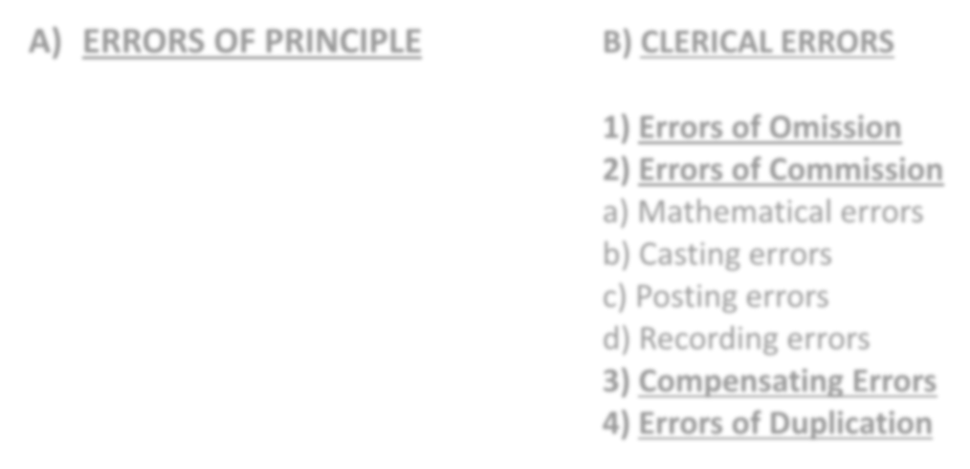

- ERRORS OF PRINCIPLE B) CLERICAL ERRORS

  - Errors of Omission
  - Errors of Commission
    - Mathematical errors
    - Casting errors
    - Posting errors
    - Recording errors
  - Compensating Errors
  - Errors of Duplication

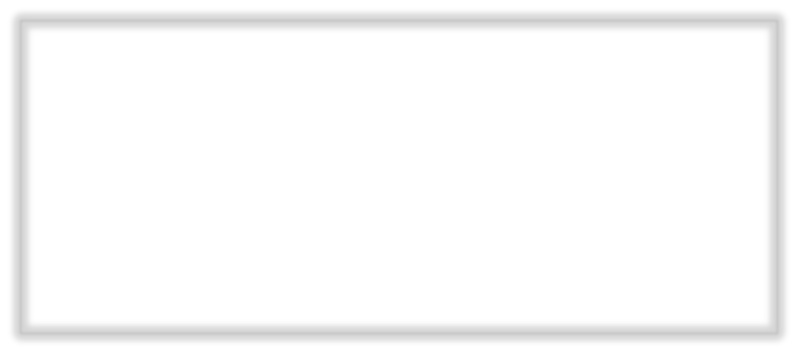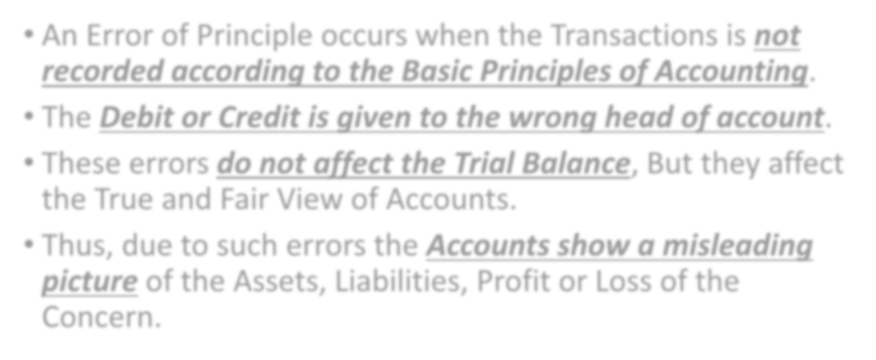

- An Error of Principle occurs when the Transactions is not recorded according to the Basic Principles of Accounting.
- The Debit or Credit is given to the wrong head of account.
- These errors do not affect the Trial Balance, But they affect the True and Fair View of Accounts.
- Thus, due to such errors the Accounts show a misleading picture of the Assets, Liabilities, Profit or Loss of the Concern.

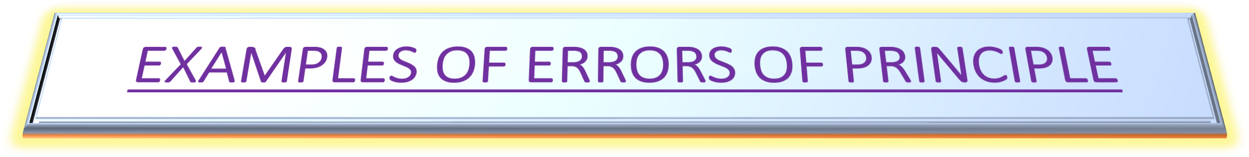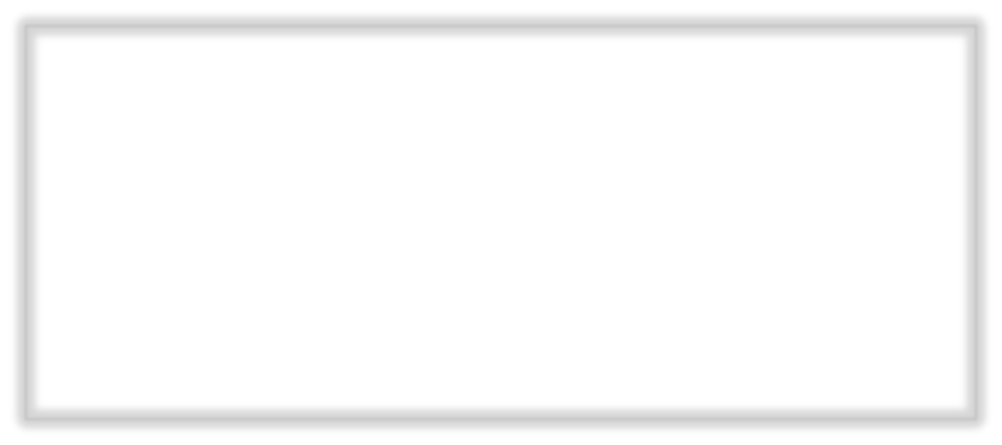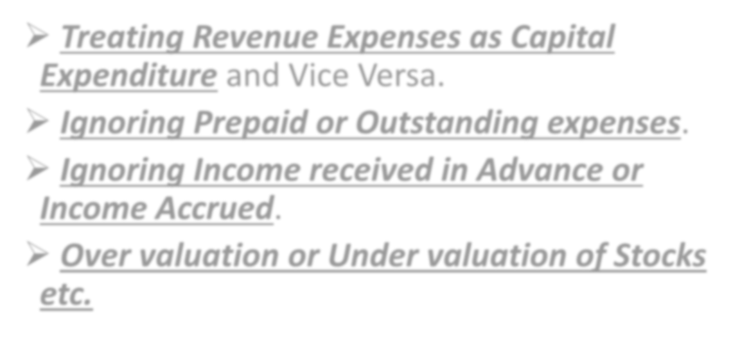

- Treating Revenue Expenses as Capital Expenditure and Vice Versa.

Ignoring Prepaid or Outstanding expenses.
- Ignoring Income received in Advance or Income Accrued.

Over valuation or Under valuation of Stocks etc.

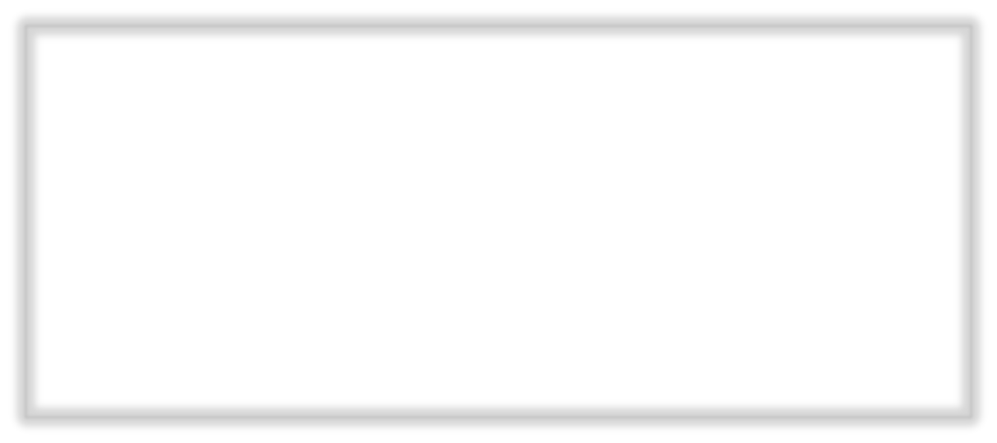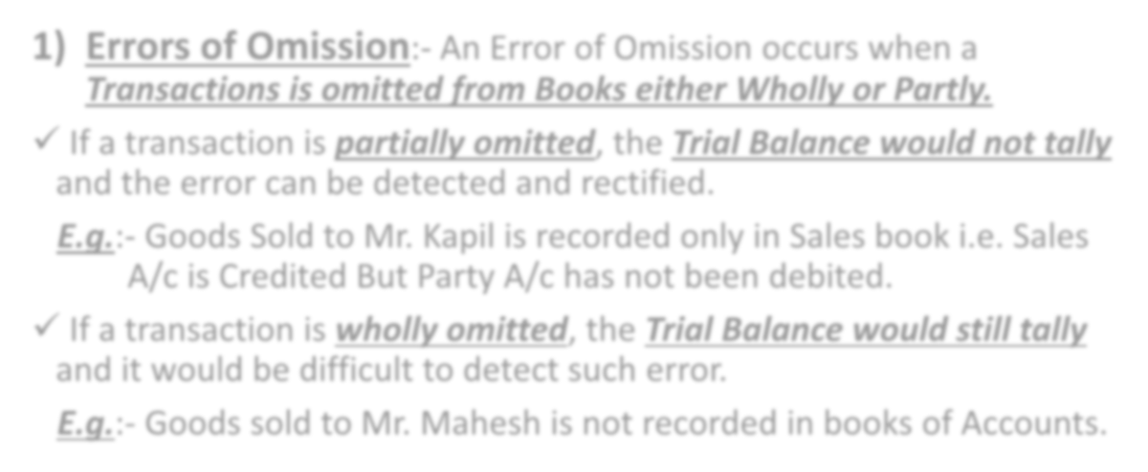

- Errors of Omission:- An Error of Omission occurs when a
Transactions is omitted from Books either Wholly or Partly.
- If a transaction is partially omitted, the Trial Balance would not tally
and the error can be detected and rectified.
E.g.:- Goods Sold to Mr. Kapil is recorded only in Sales book i.e. Sales A/c is Credited But Party A/c has not been debited.
- If a transaction is wholly omitted, the Trial Balance would still tally
and it would be difficult to detect such error.
E.g.:- Goods sold to Mr. Mahesh is not recorded in books of Accounts.

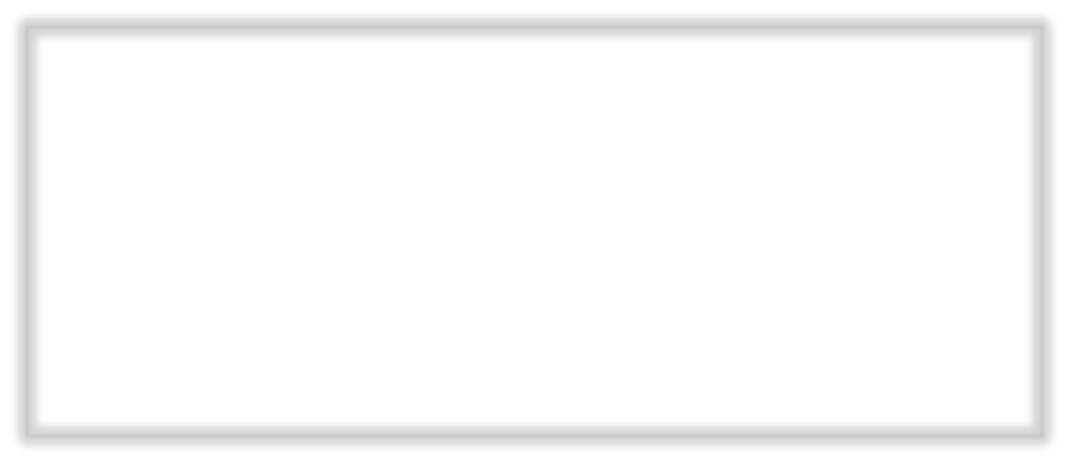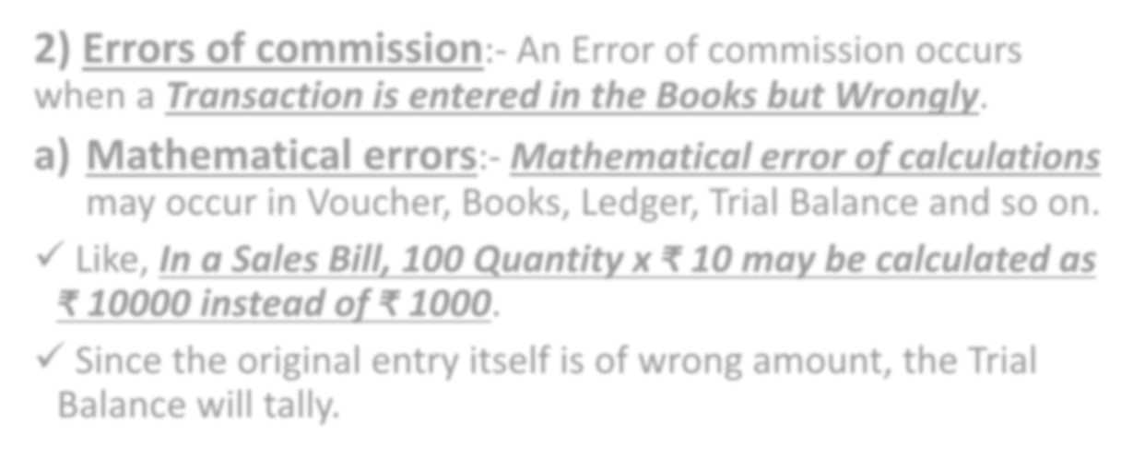

- Errors of commission:- An Error of commission occurs when a Transaction is entered in the Books but Wrongly.
  - Mathematical errors:- Mathematical error of calculations
may occur in Voucher, Books, Ledger, Trial Balance and so on.
- Like, In a Sales Bill, 100 Quantity x ₹ 10 may be calculated as
₹ 10000 instead of ₹ 1000.
- Since the original entry itself is of wrong amount, the Trial Balance will tally.

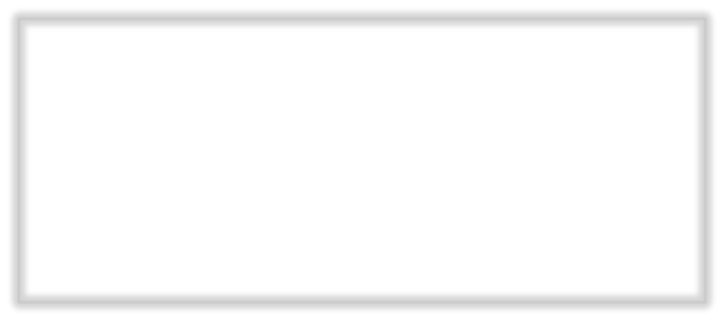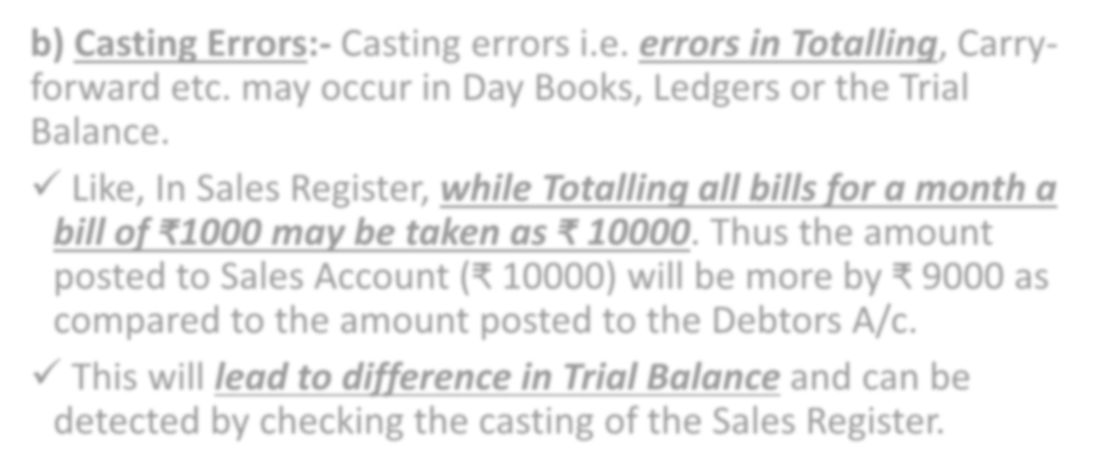

  - Casting Errors:- Casting errors i.e. errors in Totalling, Carry- forward etc. may occur in Day Books, Ledgers or the Trial Balance.
- Like, In Sales Register, while Totalling all bills for a month a bill of ₹1000 may be taken as ₹ 10000. Thus the amount posted to Sales Account (₹ 10000) will be more by ₹ 9000 as compared to the amount posted to the Debtors A/c.
- This will lead to difference in Trial Balance and can be detected by checking the casting of the Sales Register.

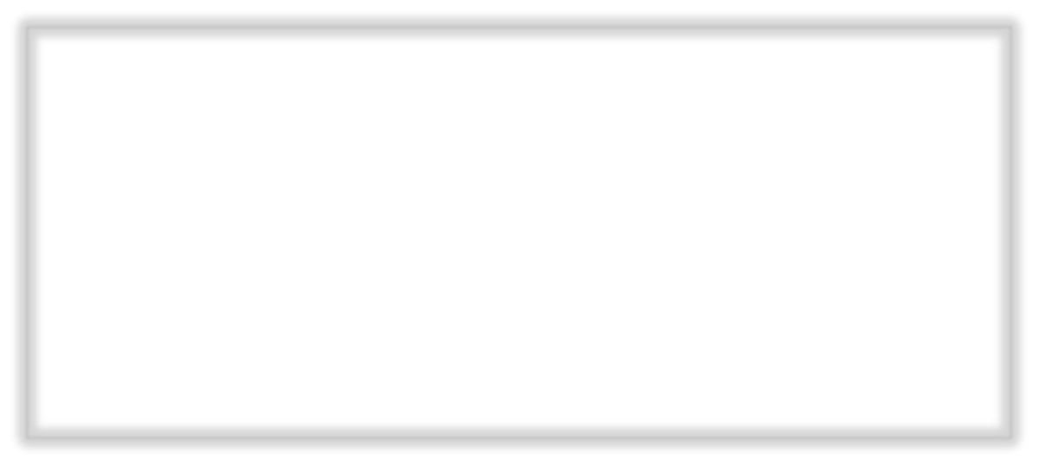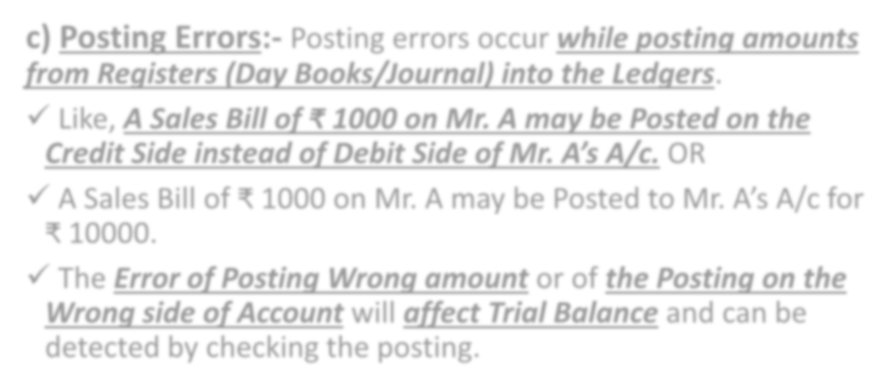

  - Posting Errors:- Posting errors occur while posting amounts from Registers (Day Books/Journal) into the Ledgers.
- Like, A Sales Bill of ₹ 1000 on Mr. A may be Posted on the Credit Side instead of Debit Side of Mr. A’s A/c. OR
- A Sales Bill of ₹ 1000 on Mr. A may be Posted to Mr. A’s A/c for
₹ 10000.
- The Error of Posting Wrong amount or of the Posting on the Wrong side of Account will affect Trial Balance and can be detected by checking the posting.

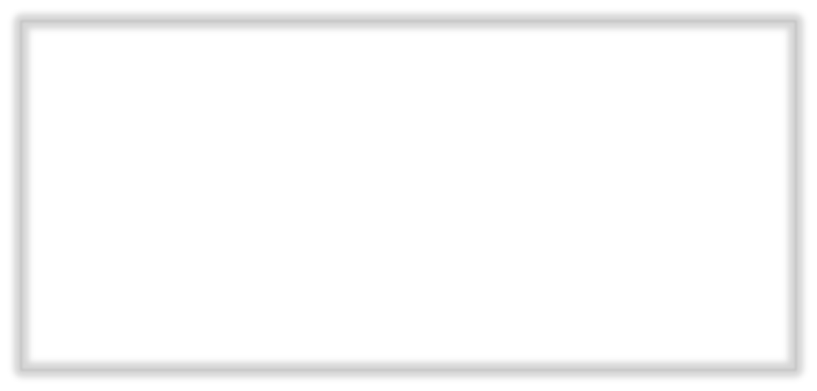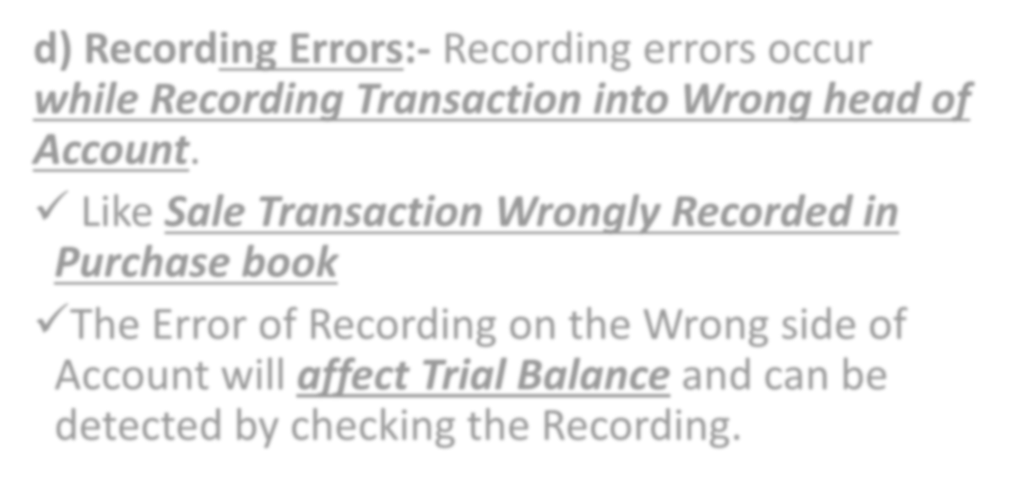

  - Recording Errors:- Recording errors occur while Recording Transaction into Wrong head of Account.

Like Sale Transaction Wrongly Recorded in Purchase book

The Error of Recording on the Wrong side of Account will affect Trial Balance and can be detected by checking the Recording.

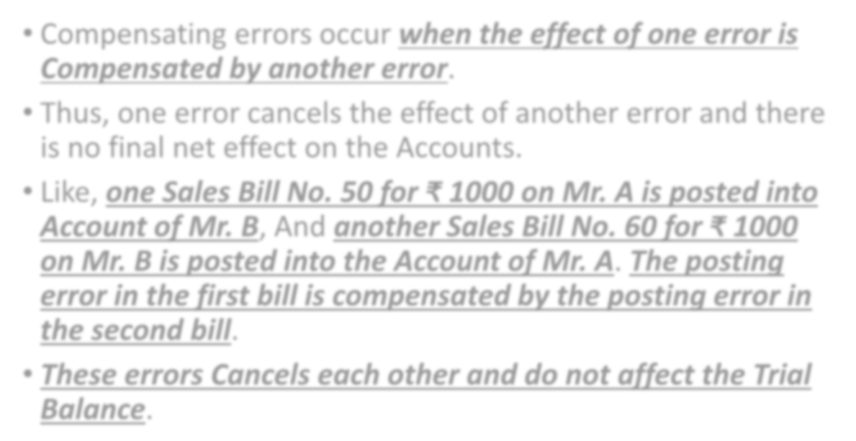

- Compensating errors occur when the effect of one error is Compensated by another error.
- Thus, one error cancels the effect of another error and there is no final net effect on the Accounts.
- Like, one Sales Bill No. 50 for ₹ 1000 on Mr. A is posted into Account of Mr. B, And another Sales Bill No. 60 for ₹ 1000 on Mr. B is posted into the Account of Mr. A. The posting error in the first bill is compensated by the posting error in the second bill.
- These errors Cancels each other and do not affect the Trial Balance.



- Errors of Duplication occur when a Transaction is recorded Twice in the Books of Original Entry.

The Posting is also done Twice.
- Like, A Sales Bill for ₹ 1000 on A may be

Recorded Twice in the Sales Register.
- Such an error would not affect the Trial Balance.

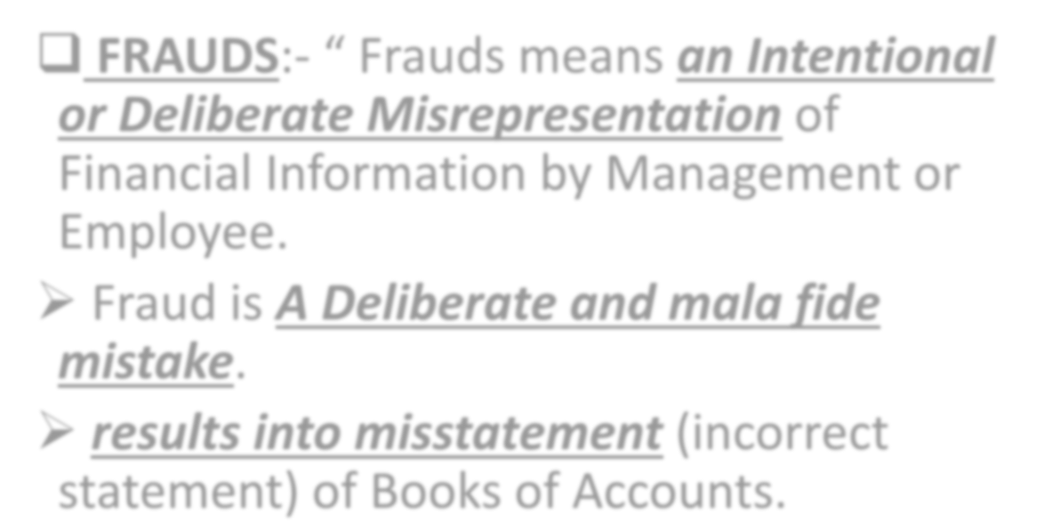

  - FRAUDS:- “ Frauds means an Intentional or Deliberate Misrepresentation of Financial Information by Management or Employee.
- Fraud is A Deliberate and mala fide mistake.
- results into misstatement (incorrect statement) of Books of Accounts.

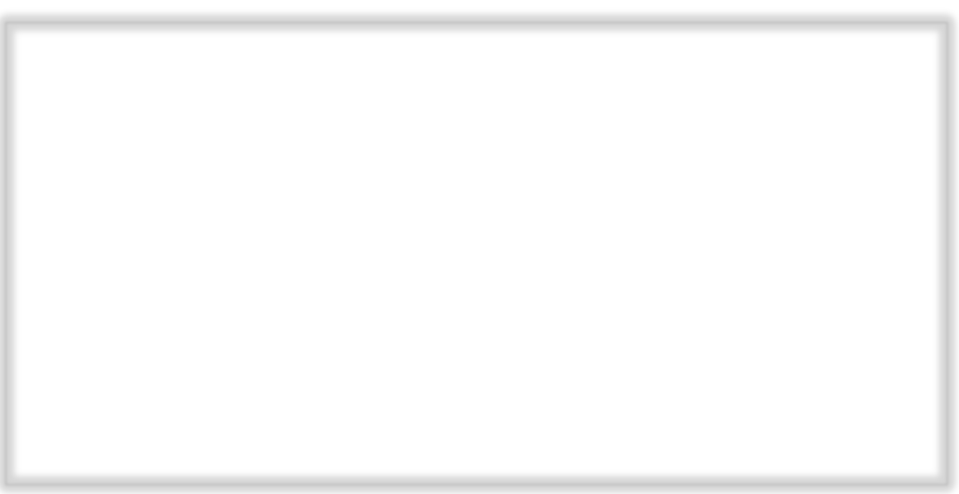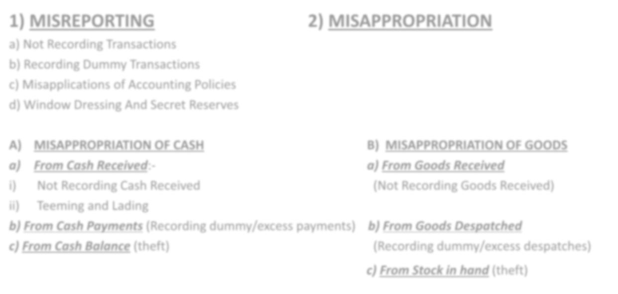

1) MISREPORTING 2) MISAPPROPRIATION
- Not Recording Transactions
- Recording Dummy Transactions
- Misapplications of Accounting Policies
- Window Dressing And Secret Reserves

- MISAPPROPRIATION OF CASH B) MISAPPROPRIATION OF GOODS
  - From Cash Received:- a) From Goods Received
- Not Recording Cash Received (Not Recording Goods Received)
- Teeming and Lading
  - From Cash Payments (Recording dummy/excess payments) b) From Goods Despatched
  - From Cash Balance (theft) (Recording dummy/excess despatches)
c) From Stock in hand (theft)

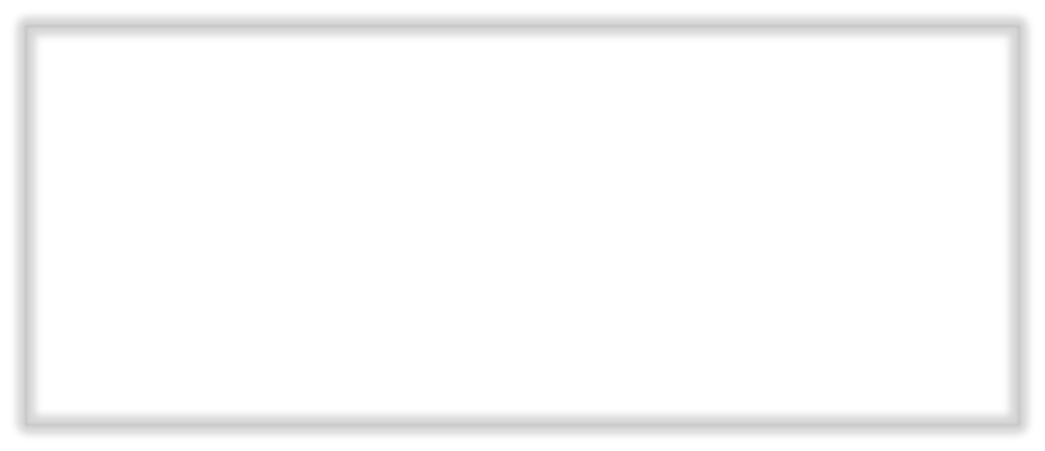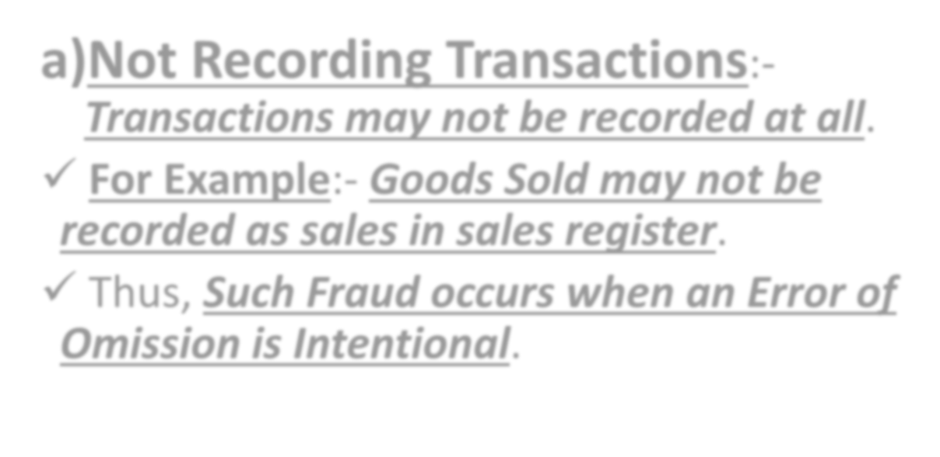

    - Not Recording Transactions:-

Transactions may not be recorded at all.
- For Example:- Goods Sold may not be recorded as sales in sales register.

Thus, Such Fraud occurs when an Error of Omission is Intentional.

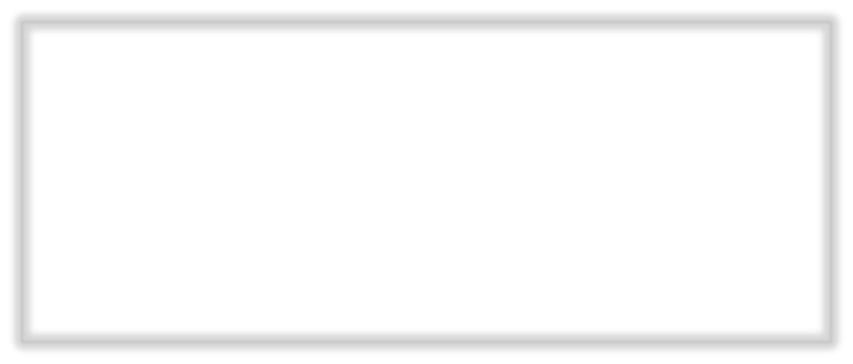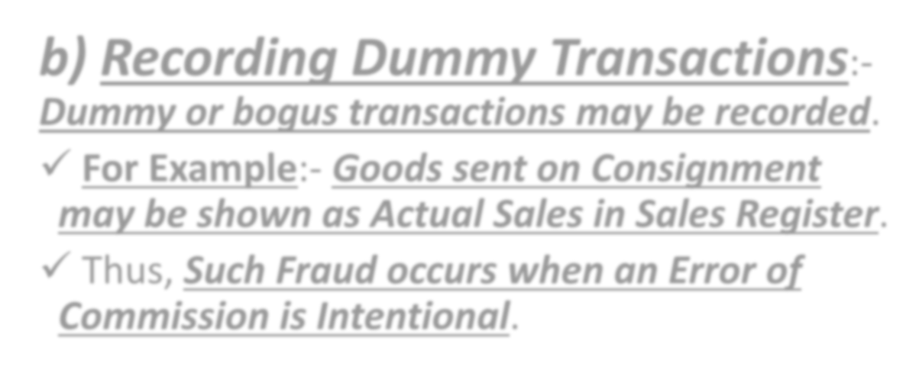

    - Recording Dummy Transactions:-

Dummy or bogus transactions may be recorded.
- For Example:- Goods sent on Consignment may be shown as Actual Sales in Sales Register.

Thus, Such Fraud occurs when an Error of Commission is Intentional.



    - Misapplications of Accounting Policies:- Accounting policies may be applied wrongly.
- For Example:- Treating Revenue Expenses as Capital Expenditure and Vice Versa.

Thus, Such Fraud occurs when an Error of Principle is Intentional.

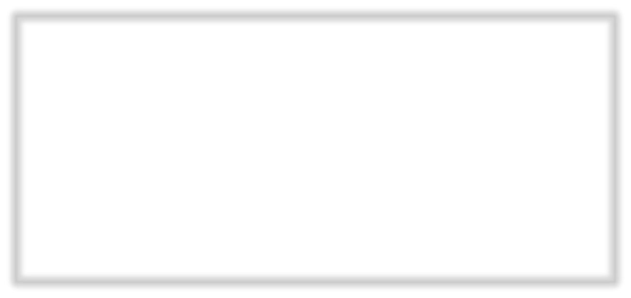

Window Dressing And Secret Reserves:-
- Window Dressing:- In Window Dressing, The Accounts are made in such a way as to show a much better condition than the Actual condition. The profits and net worth are Overstated in the Final Accounts.
- It can be done by:- Overstatement of Assets or

Understatement of Liabilities.

For Example:- Recording New Fixed Asset purchased in the Books at a Higher Cost. OR Income received in Advance is treated as Income instead of liabilities.

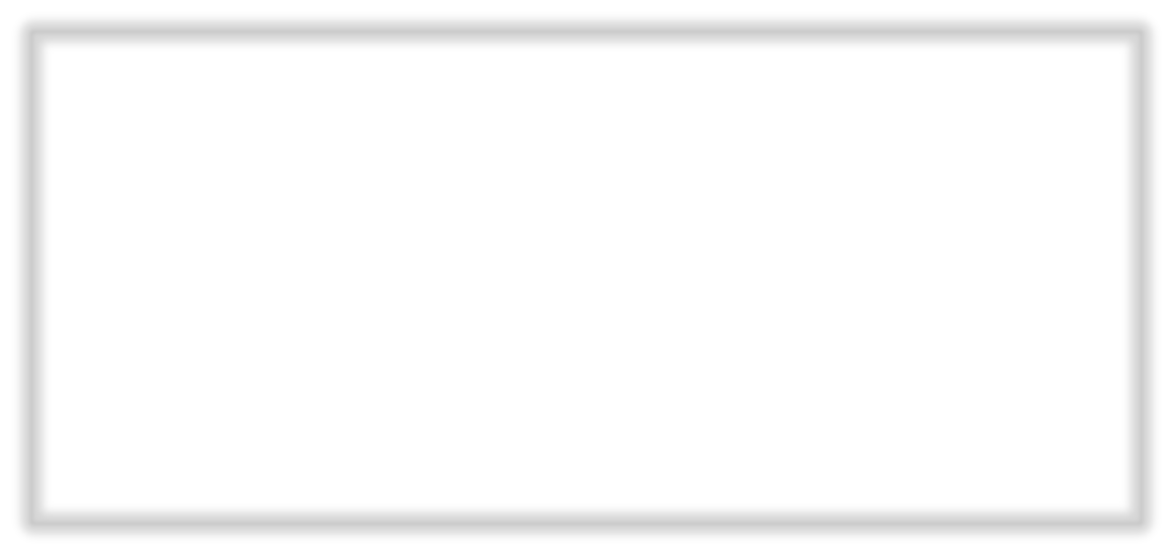

  - Secret Reserves:- Secret Reserve means part of profits secretly reserved for future use. Secret Reserve are those reserves which are not shown on the face of the Balance Sheet.
- Eric Kohler defines Secret Reserve as: “The Amount by which the Net Worth has been deliberately understated – a hidden reserve. Such a condition exists where the Assets are omitted or Undervalued or Where Liabilities are Overstated.”
- For Example:- Omitting to record new Fixed Assets in the Books. OR Receipt from Sale price is treated as a Deposit from Debtor i.e. Capital Receipt.

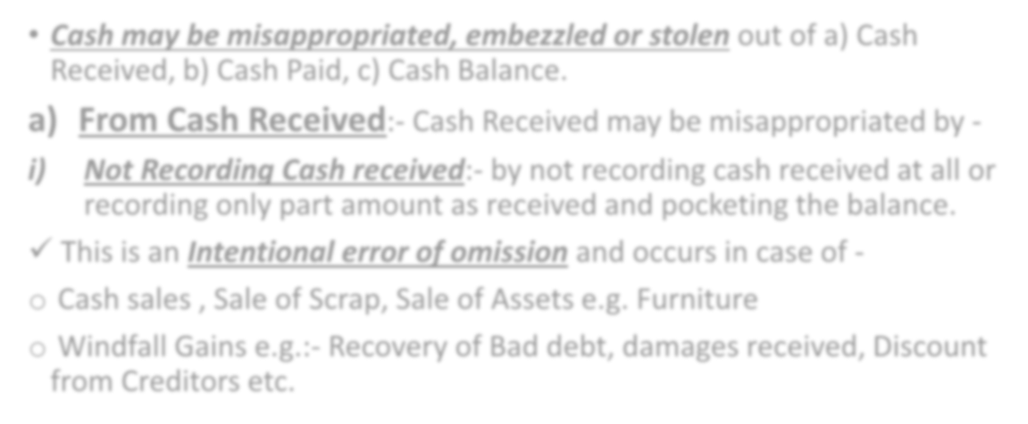

- Cash may be misappropriated, embezzled or stolen out of a) Cash Received, b) Cash Paid, c) Cash Balance.
- From Cash Received:- Cash Received may be misappropriated by -
- Not Recording Cash received:- by not recording cash received at all or recording only part amount as received and pocketing the balance.
- This is an Intentional error of omission and occurs in case of -
- Cash sales , Sale of Scrap, Sale of Assets e.g. Furniture
- Windfall Gains e.g.:- Recovery of Bad debt, damages received, Discount from Creditors etc.

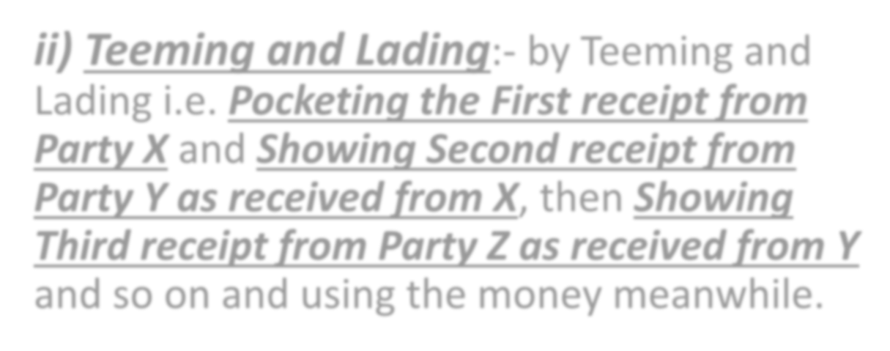

- Teeming and Lading:- by Teeming and Lading i.e. Pocketing the First receipt from Party X and Showing Second receipt from Party Y as received from X, then Showing Third receipt from Party Z as received from Y and so on and using the money meanwhile.

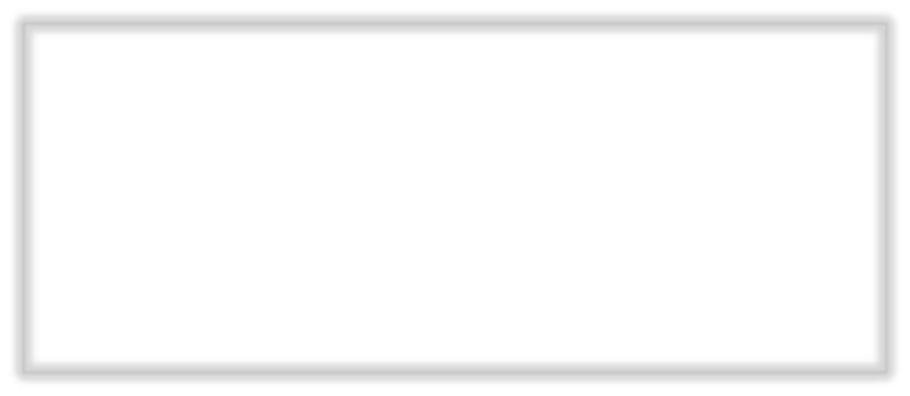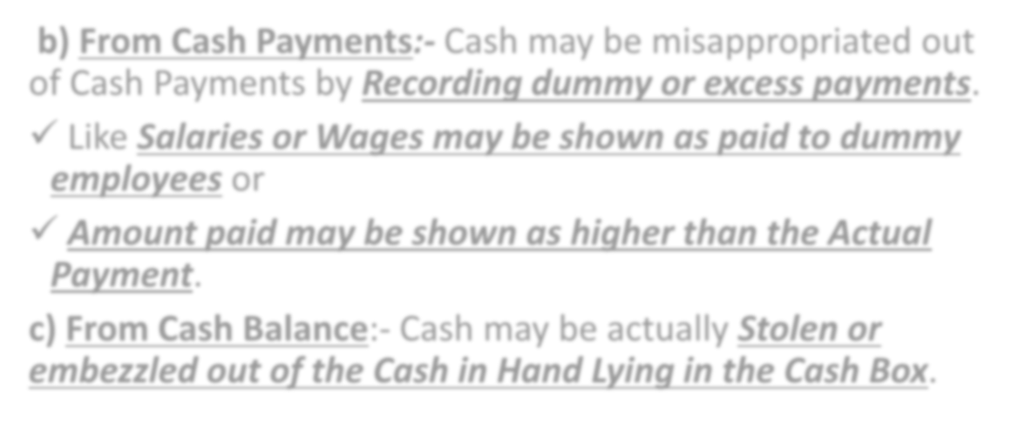

- From Cash Payments:- Cash may be misappropriated out of Cash Payments by Recording dummy or excess payments.

Like Salaries or Wages may be shown as paid to dummy employees or
- Amount paid may be shown as higher than the Actual Payment.
- From Cash Balance:- Cash may be actually Stolen or embezzled out of the Cash in Hand Lying in the Cash Box.

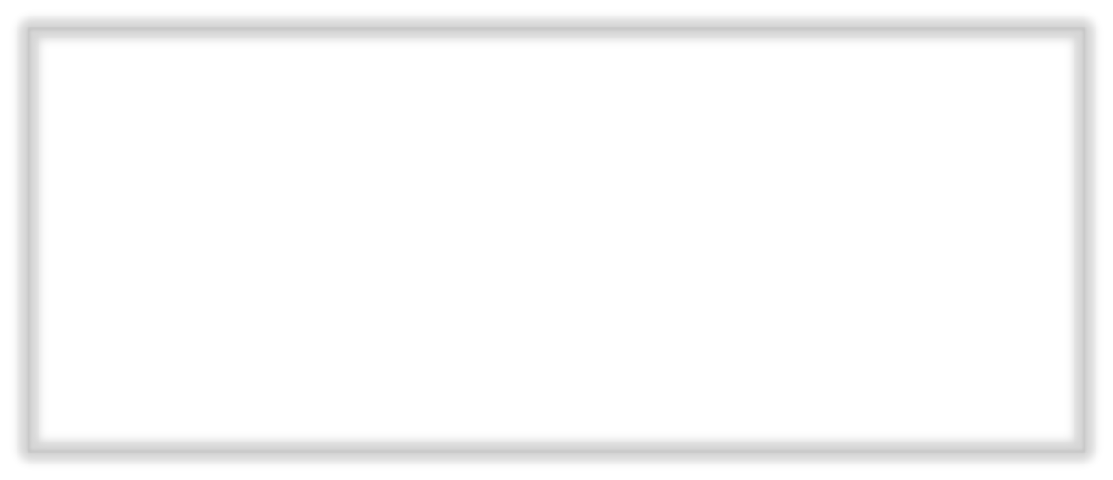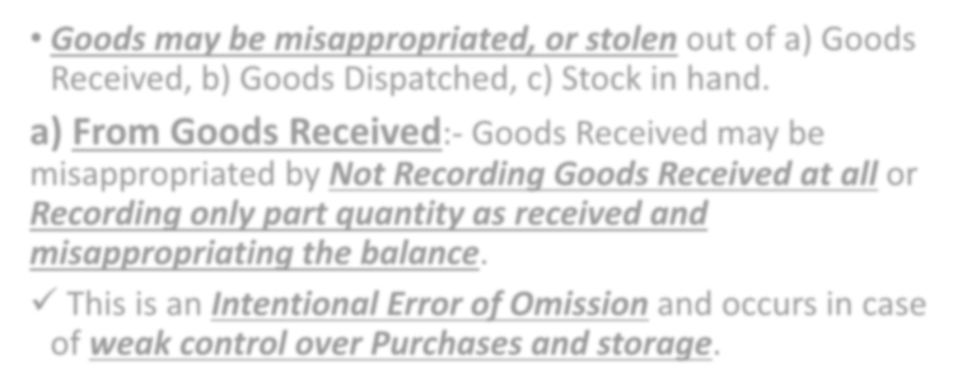

- Goods may be misappropriated, or stolen out of a) Goods Received, b) Goods Dispatched, c) Stock in hand.
- From Goods Received:- Goods Received may be misappropriated by Not Recording Goods Received at all or Recording only part quantity as received and misappropriating the balance.
- This is an Intentional Error of Omission and occurs in case of weak control over Purchases and storage.

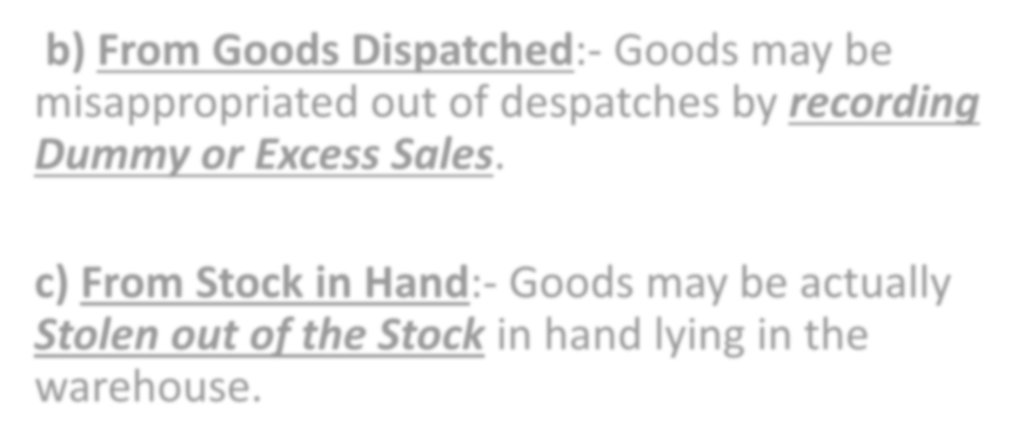

- From Goods Dispatched:- Goods may be misappropriated out of despatches by recording Dummy or Excess Sales.

- From Stock in Hand:- Goods may be actually Stolen out of the Stock in hand lying in the warehouse.



- Window Dressing:- In Window Dressing, The Accounts are made in such a way as to show a much better condition than the Actual condition. The profits and net worth are Overstated

in the Final Accounts.
- It can be done by:- Overstatement of Assets or

Understatement of Liabilities.

For Example:- Recording New Fixed Asset purchased in the Books at a Higher Cost. OR Income received in Advance is treated as Income instead of liabilities.

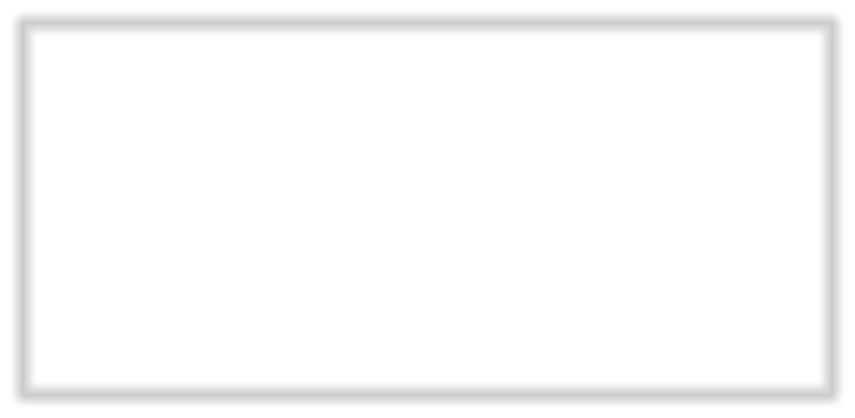

- Mislead Investors & Lenders:- A Company want to mislead investors into buying its Shares by showing a better picture of its Net Worth.
- The Banks may give larger Loans based on the Higher Net worth
Shown in the Accounts.
- The Concern may be taken over by another concern for a higher price.
- Hide Losses:- In order to able to pay dividends to the Shareholders.
- Higher Commission:- Done by the Directors themselves so as to earn more Commission based on the Higher Profits shown in the Books of the Company.

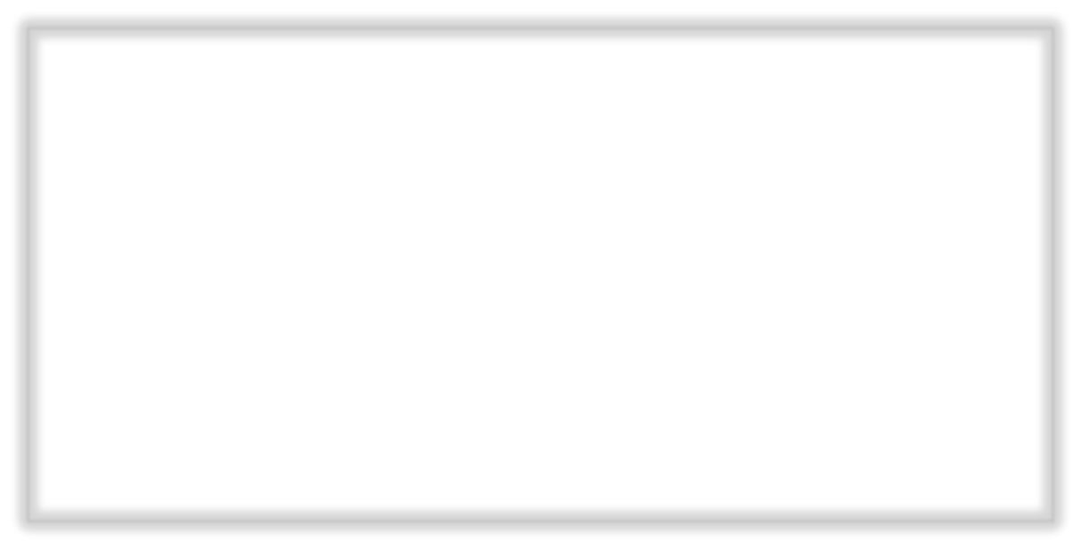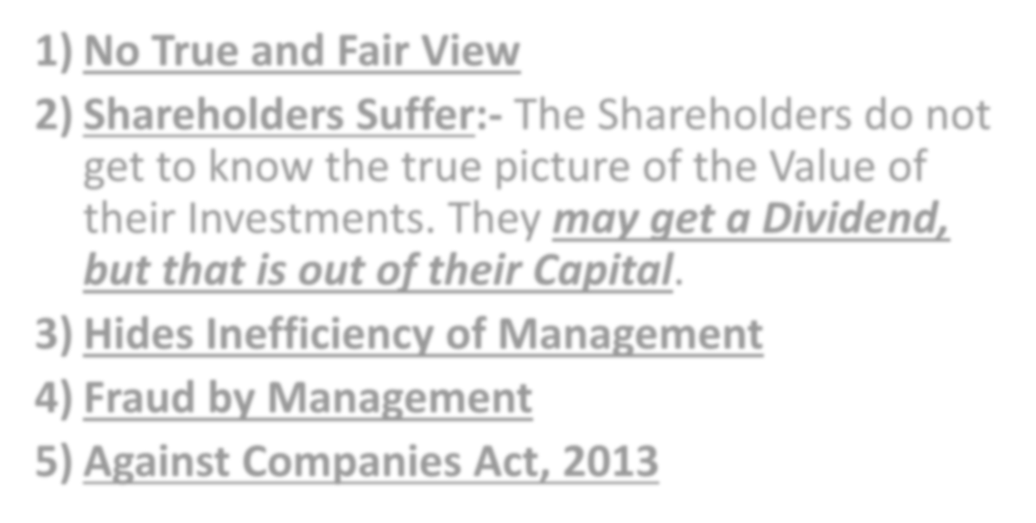

- No True and Fair View
- Shareholders Suffer:- The Shareholders do not get to know the true picture of the Value of their Investments. They may get a Dividend, but that is out of their Capital.

Hides Inefficiency of Management
- Fraud by Management

Against Companies Act, 2013



  - Secret Reserves:- Secret Reserve means part of profits secretly reserved for future use. Secret Reserve are those reserves which are not shown on the face of the Balance Sheet.
- Eric Kohler defines Secret Reserve as: “The Amount by which the Net Worth has been deliberately understated – a hidden reserve. Such a condition exists where the Assets are omitted or Undervalued or Where Liabilities are Overstated.”
- For Example:- Omitting to record new Fixed Assets in the Books. OR Receipt from Sale price is treated as a Deposit from Debtor i.e. Capital Receipt.

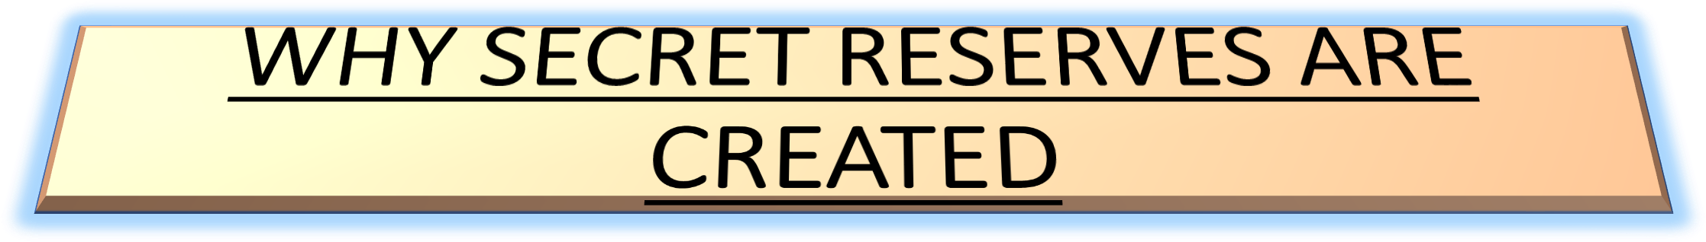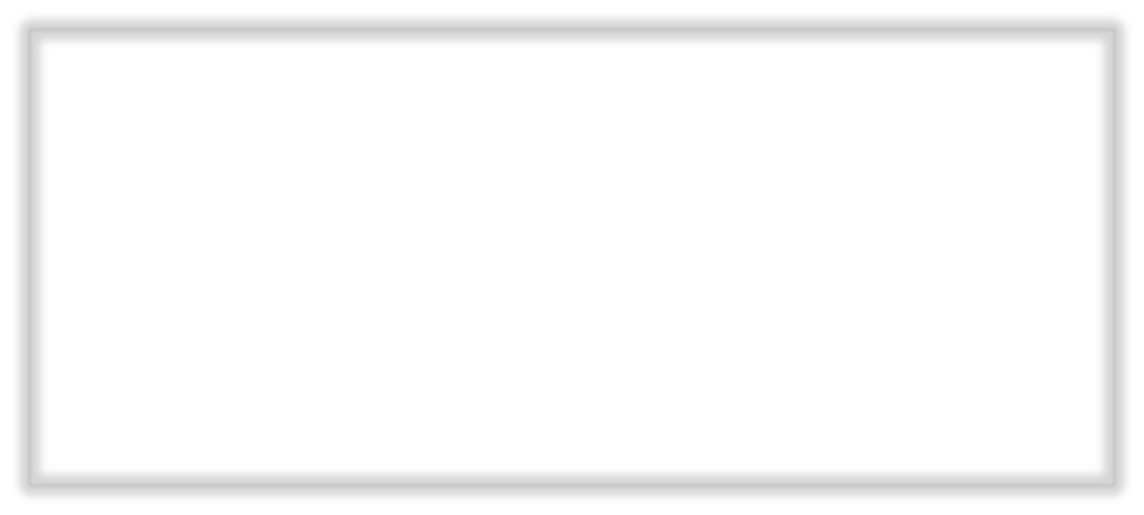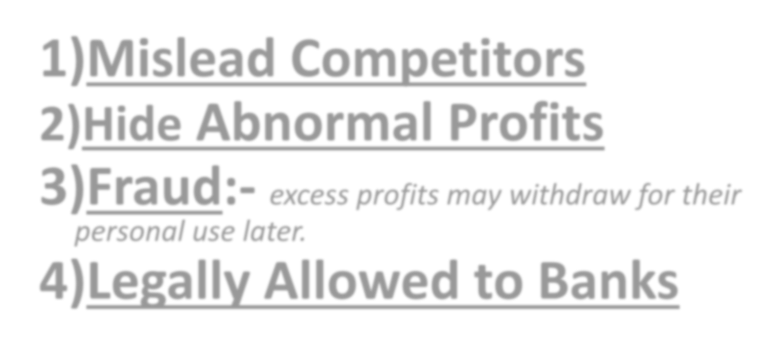

Mislead Competitors
- Hide Abnormal Profits 3)Fraud:- excess profits may withdraw for their
personal use later.

4)Legally Allowed to Banks

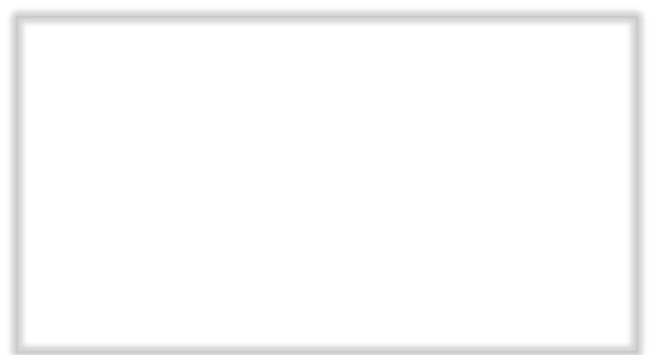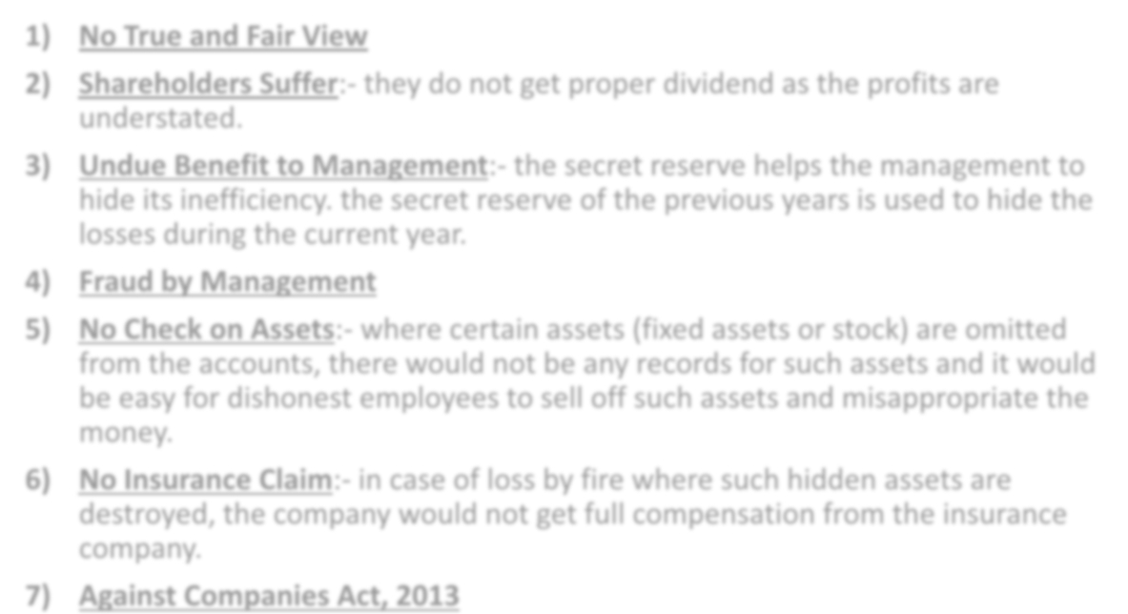

- No True and Fair View
- Shareholders Suffer:- they do not get proper dividend as the profits are understated.
- Undue Benefit to Management:- the secret reserve helps the management to hide its inefficiency. the secret reserve of the previous years is used to hide the losses during the current year.
- Fraud by Management
- No Check on Assets:- where certain assets (fixed assets or stock) are omitted from the accounts, there would not be any records for such assets and it would be easy for dishonest employees to sell off such assets and misappropriate the money.
- No Insurance Claim:- in case of loss by fire where such hidden assets are destroyed, the company would not get full compensation from the insurance company.
- Against Companies Act, 2013



- Disclose in Audit Report:- to report whether the accounts give a true and fair view.
- Report to Central Government:- an offence involving fraud (amount of fraud 1 crore or more) is being or has been committed against the company by officers or employees of the company.
- Check Articles of Association:- He should study the Articles of Association of the company to verify the provision regarding reserves contained therein.
- Verify Income:- He should verify whether all the income has been properly brought in, recorded and reported in the books.
- Verify Assets and Liabilities



- Verify Provisions:- He should examine whether the provisions of any liability is lower or higher than the amount considered reasonable and necessary in the opinion of the directors. The Excess Provisions, if any, should be treated and disclosed as a reserve.
- Verify Closing Stock:- He should verify the value of the Closing Stock. He should see that there is no change in the basis of valuation of the Closing Stock. If there is any such change, its effect on the profit for the year should be disclosed.
- Disclose change in method of Accounting:- like method of charging depreciation.
- Prevent Omission of Assets and Liabilities
- Disclose Bad Debts

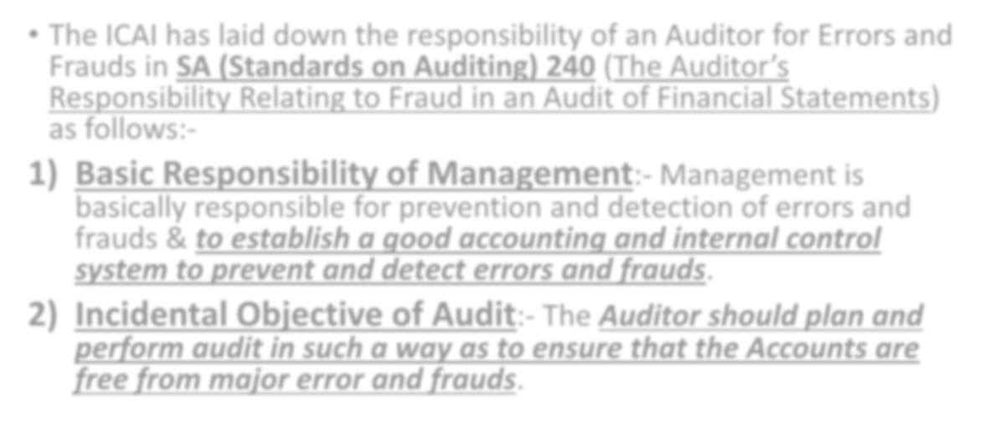

  - The ICAI has laid down the responsibility of an Auditor for Errors and Frauds in SA (Standards on Auditing) 240 (The Auditor’s Responsibility Relating to Fraud in an Audit of Financial Statements) as follows:-
- Basic Responsibility of Management:- Management is basically responsible for prevention and detection of errors and frauds & to establish a good accounting and internal control system to prevent and detect errors and frauds.
- Incidental Objective of Audit:- The Auditor should plan and perform audit in such a way as to ensure that the Accounts are free from major error and frauds.

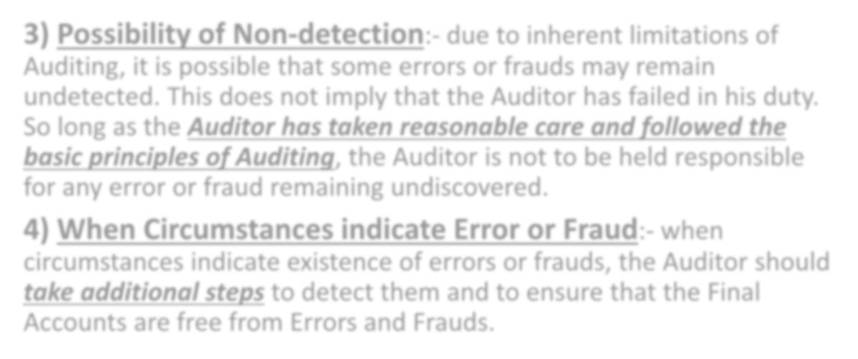

- Possibility of Non-detection:- due to inherent limitations of Auditing, it is possible that some errors or frauds may remain undetected. This does not imply that the Auditor has failed in his duty. So long as the Auditor has taken reasonable care and followed the basic principles of Auditing, the Auditor is not to be held responsible for any error or fraud remaining undiscovered.
- When Circumstances indicate Error or Fraud:- when circumstances indicate existence of errors or frauds, the Auditor should take additional steps to detect them and to ensure that the Final Accounts are free from Errors and Frauds.

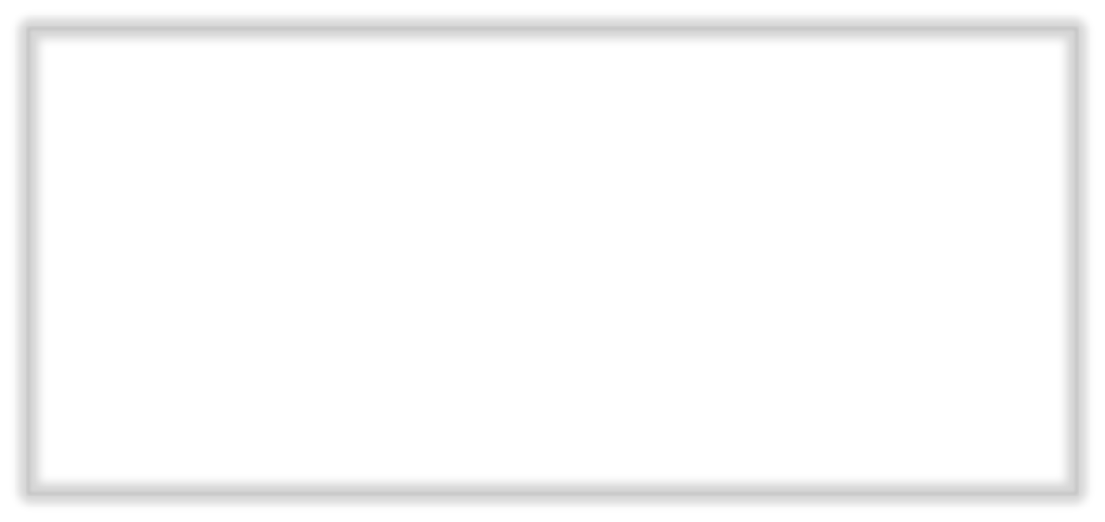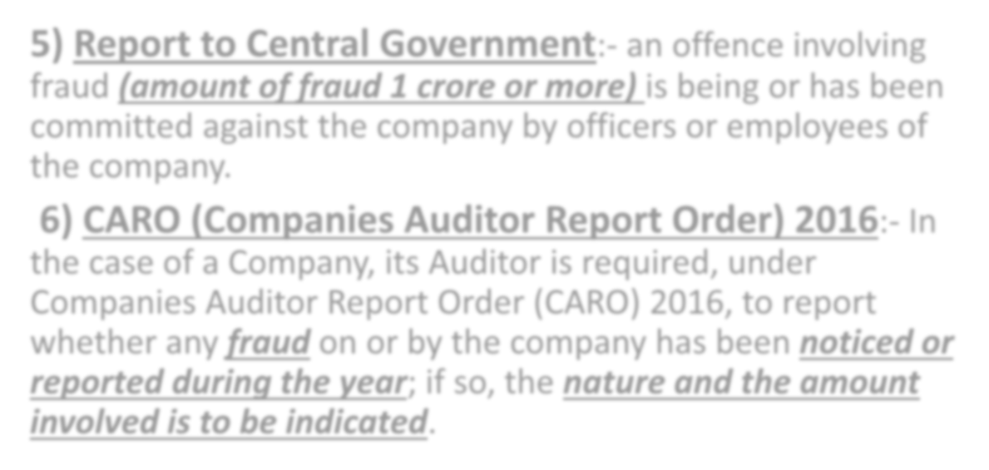

- Report to Central Government:- an offence involving fraud (amount of fraud 1 crore or more) is being or has been committed against the company by officers or employees of the company.
- CARO (Companies Auditor Report Order) 2016:- In the case of a Company, its Auditor is required, under Companies Auditor Report Order (CARO) 2016, to report whether any fraud on or by the company has been noticed or reported during the year; if so, the nature and the amount involved is to be indicated.



- Assurance of True and Fair Accounts
- True and Fair Balance Sheet
- True and Fair Profit and Loss Account
- Tally with Books:- the income tax officer can start with the figure of audited book profit, make adjustments and compute the taxable income. An outside user need not go through the entire books.
- As per Law:- Schedule VI of the Companies Act, 2013
- As per Standard Accounting and Auditing Practices
- Disclose All Material Facts



- Detection and Prevention of Errors and Frauds
- Moral Check on Employees
- Advice on System, Taxation, Finance:- The Auditor can advise the client about the Accounting System, Internal Control, Internal Check, Internal Audit, Taxation, Finances etc.
- Facilitates Comparison:- Audited Accounts of different years facilitate comparison over a period to determine trend in Sales etc.



- An Auditor cannot check each and every transactions
- Audit evidence is not conclusive in nature:- like confirmation by a debtor is not a conclusive evidence that the amount will be collected.
- An Auditor cannot be expected to discover deeply laid frauds
- Audit cannot assure the user of accounts about the future profitability, Prospects or the efficiency of the management
- An Auditor has to rely upon experts:- Auditor may have to rely on experts in related fields such as Lawyers, engineers, Valuers etc. for estimating contingent liabilities, Valuation of Fixed Assets etc.

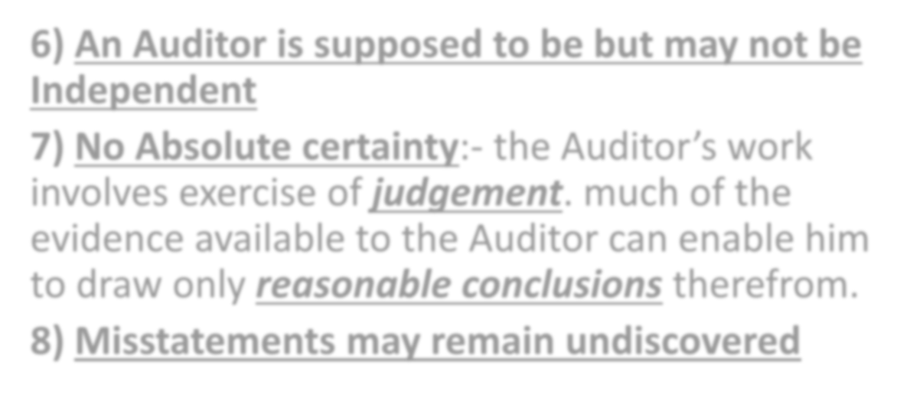

- An Auditor is supposed to be but may not be Independent
- No Absolute certainty:- the Auditor’s work involves exercise of judgement. much of the evidence available to the Auditor can enable him to draw only reasonable conclusions therefrom.

Misstatements may remain undiscovered

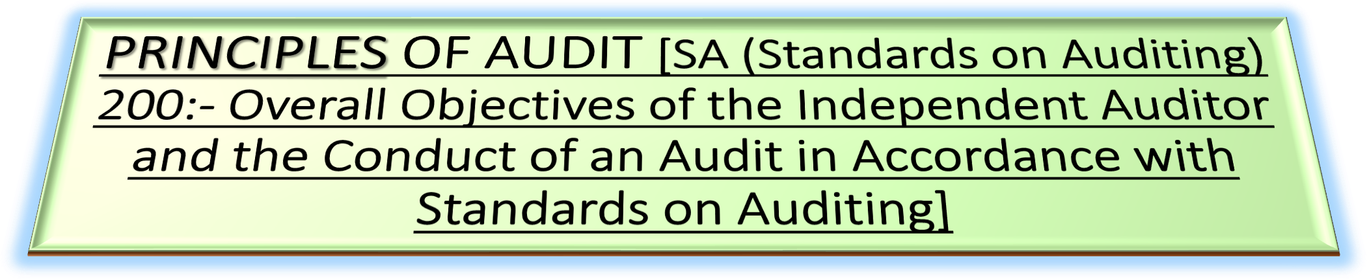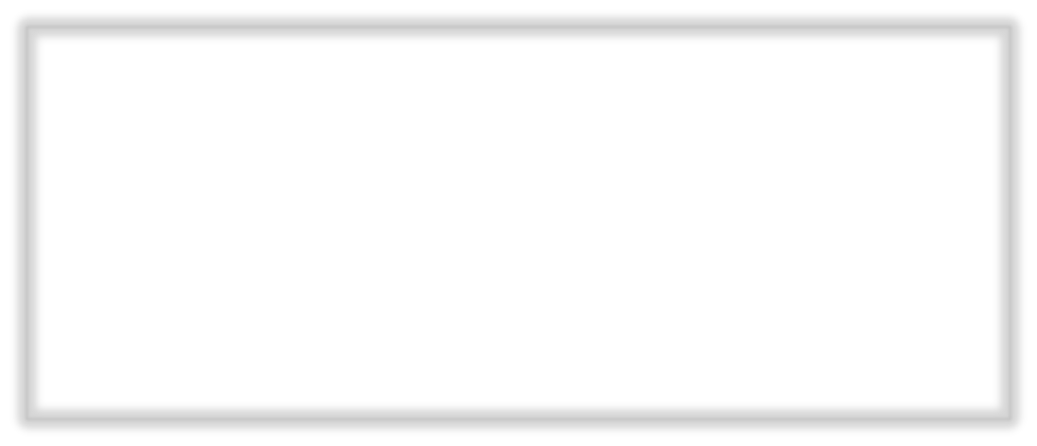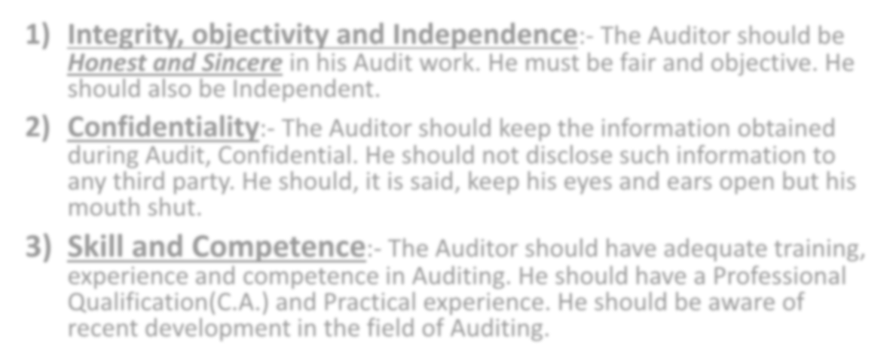

- Integrity, objectivity and Independence:- The Auditor should be Honest and Sincere in his Audit work. He must be fair and objective. He should also be Independent.
- Confidentiality:- The Auditor should keep the information obtained during Audit, Confidential. He should not disclose such information to any third party. He should, it is said, keep his eyes and ears open but his mouth shut.
- Skill and Competence:- The Auditor should have adequate training, experience and competence in Auditing. He should have a Professional Qualification(C.A.) and Practical experience. He should be aware of recent development in the field of Auditing.



- Materiality:- Information is Material if its Misstatement could influence economic decisions of the user. Material matters are important for the True and Fair View.
- Work Performed by Others:- The Auditor should carefully direct, supervise and review the work of his Assistants.
- He should satisfy himself that work done by an Internal Auditor is reliable.
- He should satisfy himself that work done by an Expert (Lawyer, Valuer, etc.) is reliable.
- Documentation:- The Auditor should document matters which are important in providing evidence that the Audit was carried out in accordance with the basic principles.

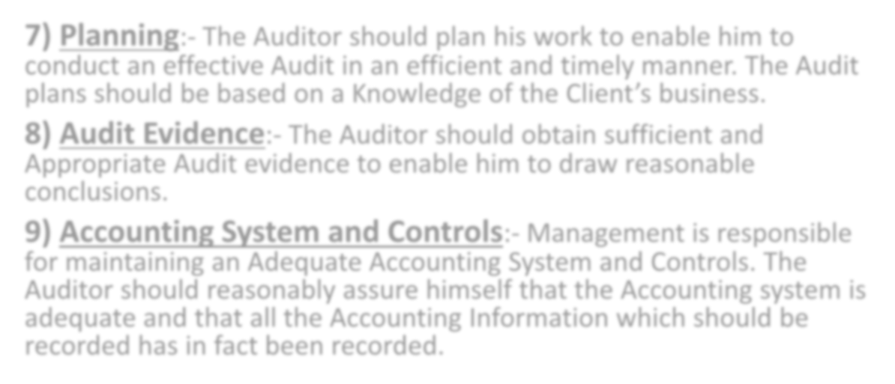

- Planning:- The Auditor should plan his work to enable him to conduct an effective Audit in an efficient and timely manner. The Audit plans should be based on a Knowledge of the Client’s business.
- Audit Evidence:- The Auditor should obtain sufficient and Appropriate Audit evidence to enable him to draw reasonable conclusions.
- Accounting System and Controls:- Management is responsible for maintaining an Adequate Accounting System and Controls. The Auditor should reasonably assure himself that the Accounting system is adequate and that all the Accounting Information which should be recorded has in fact been recorded.

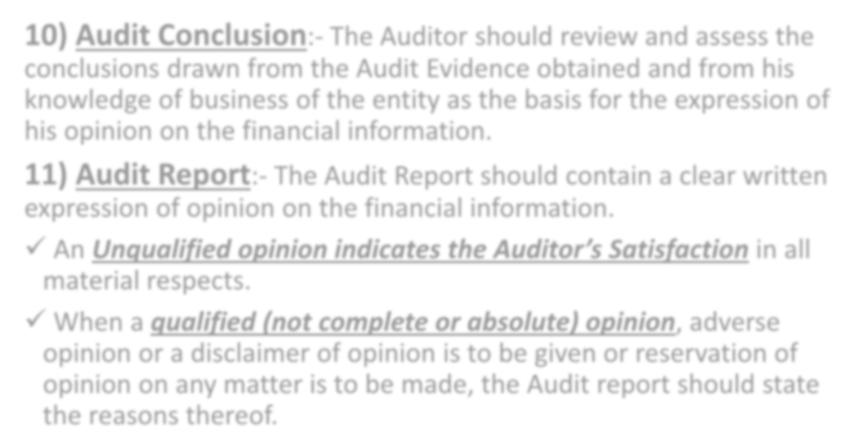

- Audit Conclusion:- The Auditor should review and assess the conclusions drawn from the Audit Evidence obtained and from his knowledge of business of the entity as the basis for the expression of his opinion on the financial information.
- Audit Report:- The Audit Report should contain a clear written expression of opinion on the financial information.
- An Unqualified opinion indicates the Auditor’s Satisfaction in all material respects.
- When a qualified (not complete or absolute) opinion, adverse opinion or a disclaimer of opinion is to be given or reservation of opinion on any matter is to be made, the Audit report should state the reasons thereof.

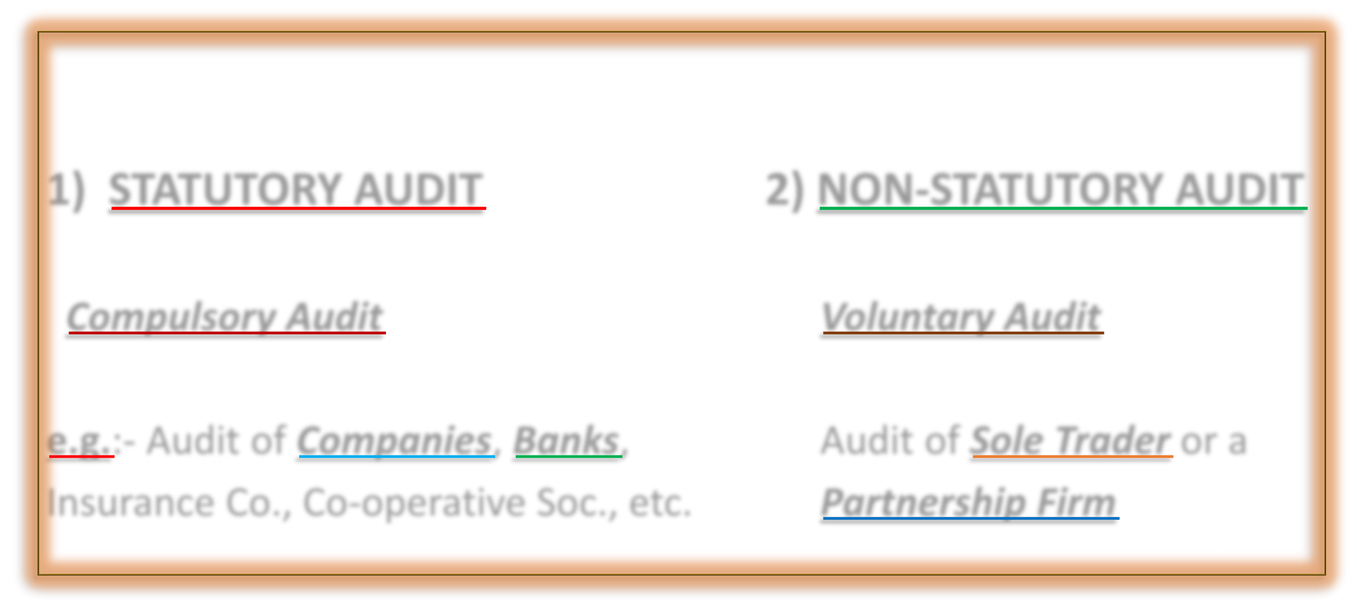

1) STATUTORY AUDIT 2) NON-STATUTORY AUDIT

Compulsory Audit Voluntary Audit

e.g.:- Audit of Companies, Banks, Audit of Sole Trader or a Insurance Co., Co-operative Soc., etc. Partnership Firm

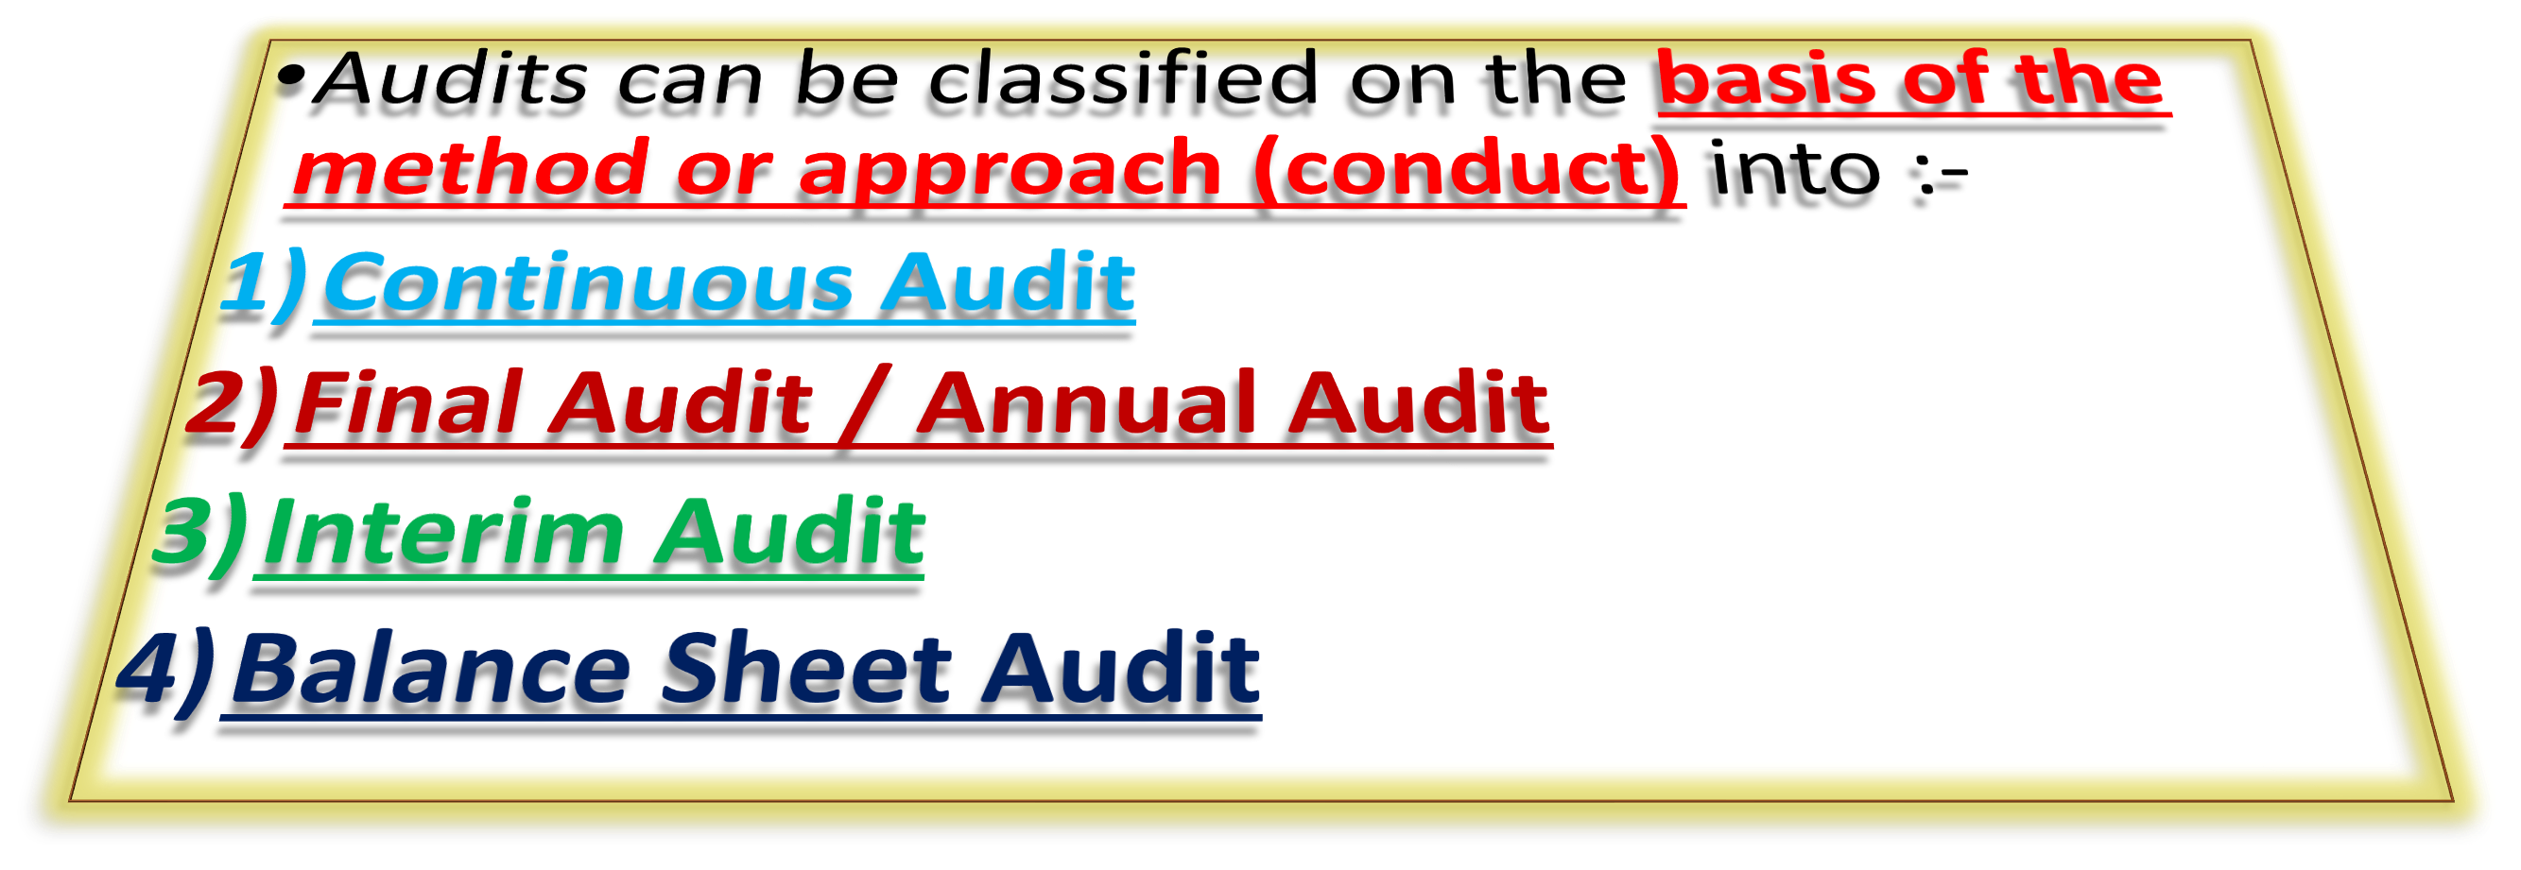

  - 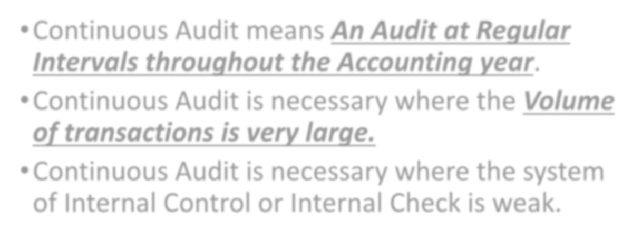Continuous Audit means An Audit at Regular Intervals throughout the Accounting year.
  - Continuous Audit is necessary where the Volume of transactions is very large.
  - Continuous Audit is necessary where the system of Internal Control or Internal Check is weak.



- Quick Preparation of Final Accounts
- Early Dividend to Shareholders:- The Company can prepare Interim Accounts and pay even Interim Dividends to the Shareholders.
- Up-to-date Accounts for Banks / Investors:- for taking decisions regarding Loans and Investment.
- Check on Employees
- Prevent Errors and Frauds
- Familiarity with Client’s Business
- Thorough Audit
- Utilisation of Audit staff

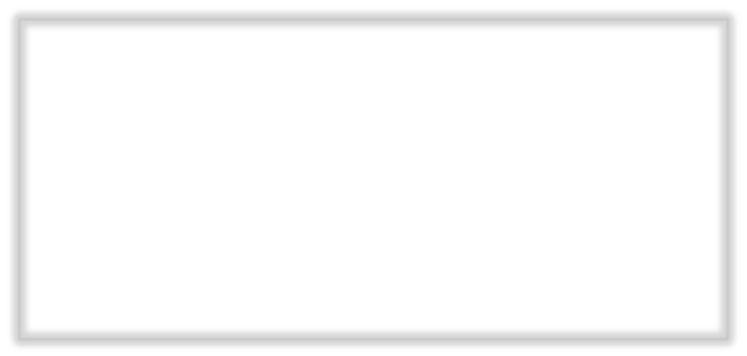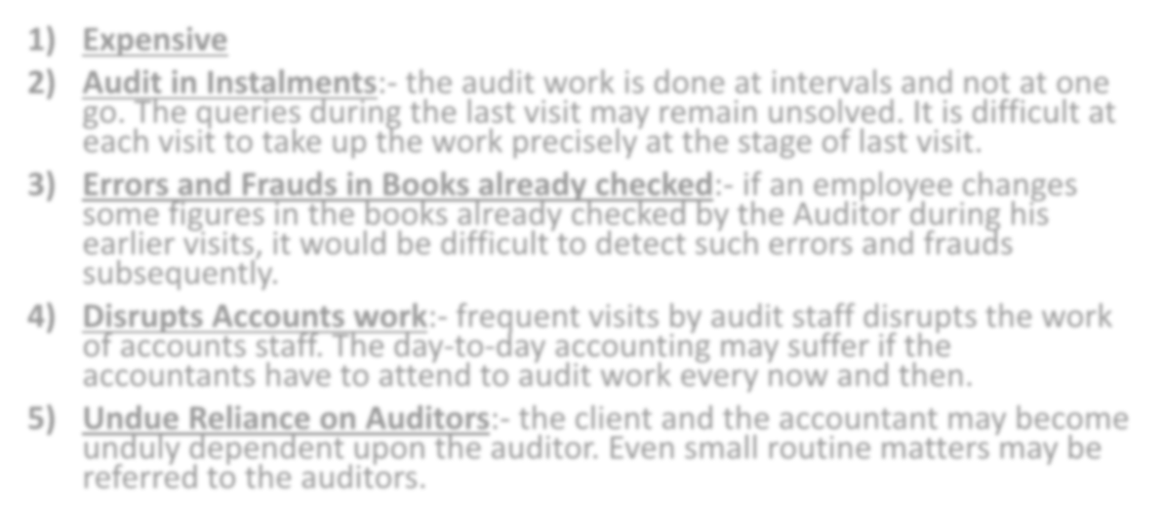

- Expensive
- Audit in Instalments:- the audit work is done at intervals and not at one go. The queries during the last visit may remain unsolved. It is difficult at each visit to take up the work precisely at the stage of last visit.
- Errors and Frauds in Books already checked:- if an employee changes some figures in the books already checked by the Auditor during his earlier visits, it would be difficult to detect such errors and frauds subsequently.
- Disrupts Accounts work:- frequent visits by audit staff disrupts the work of accounts staff. The day-to-day accounting may suffer if the accountants have to attend to audit work every now and then.
- Undue Reliance on Auditors:- the client and the accountant may become unduly dependent upon the auditor. Even small routine matters may be referred to the auditors.

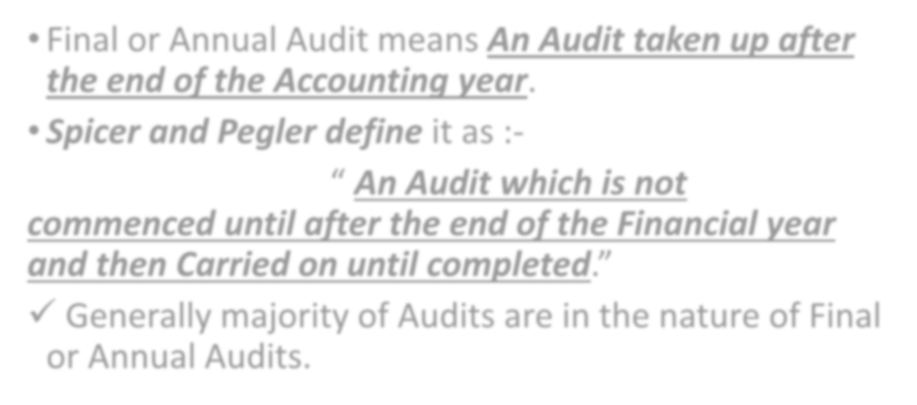

  - Final or Annual Audit means An Audit taken up after the end of the Accounting year.
  - Spicer and Pegler define it as :-

“ An Audit which is not commenced until after the end of the Financial year and then Carried on until completed.”
- Generally majority of Audits are in the nature of Final or Annual Audits.

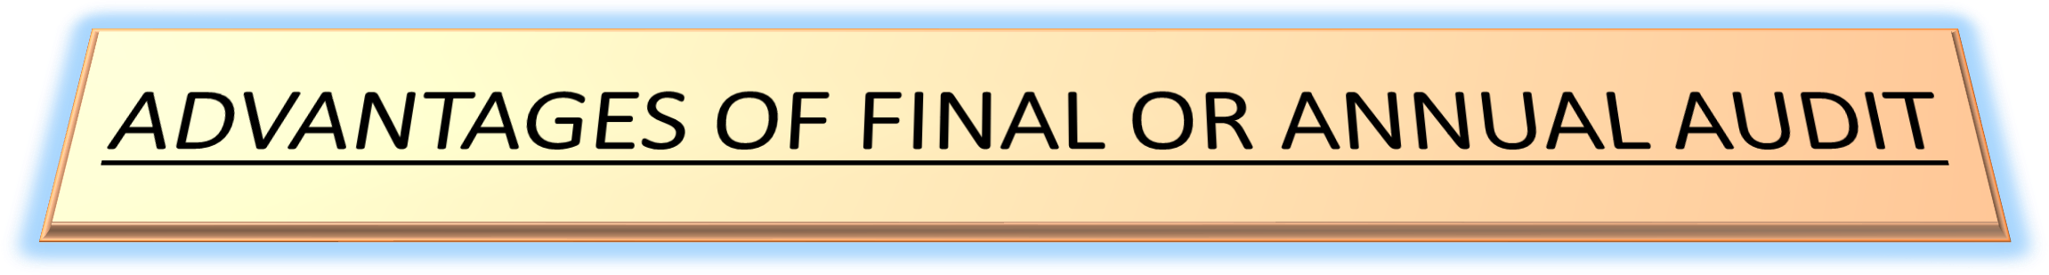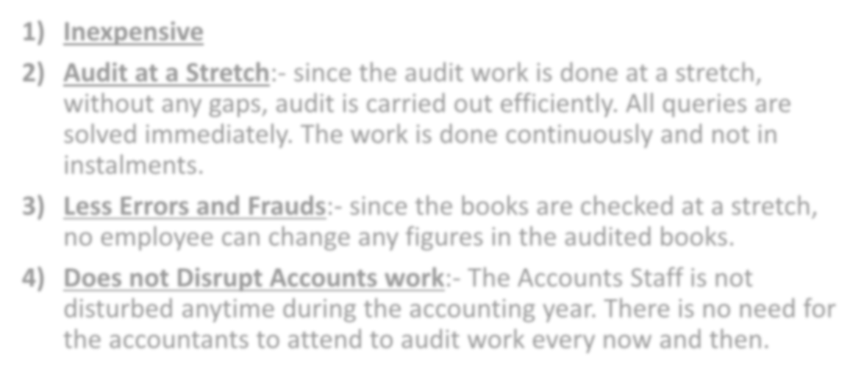

- Inexpensive
- Audit at a Stretch:- since the audit work is done at a stretch, without any gaps, audit is carried out efficiently. All queries are solved immediately. The work is done continuously and not in instalments.
- Less Errors and Frauds:- since the books are checked at a stretch, no employee can change any figures in the audited books.
- Does not Disrupt Accounts work:- The Accounts Staff is not disturbed anytime during the accounting year. There is no need for the accountants to attend to audit work every now and then.

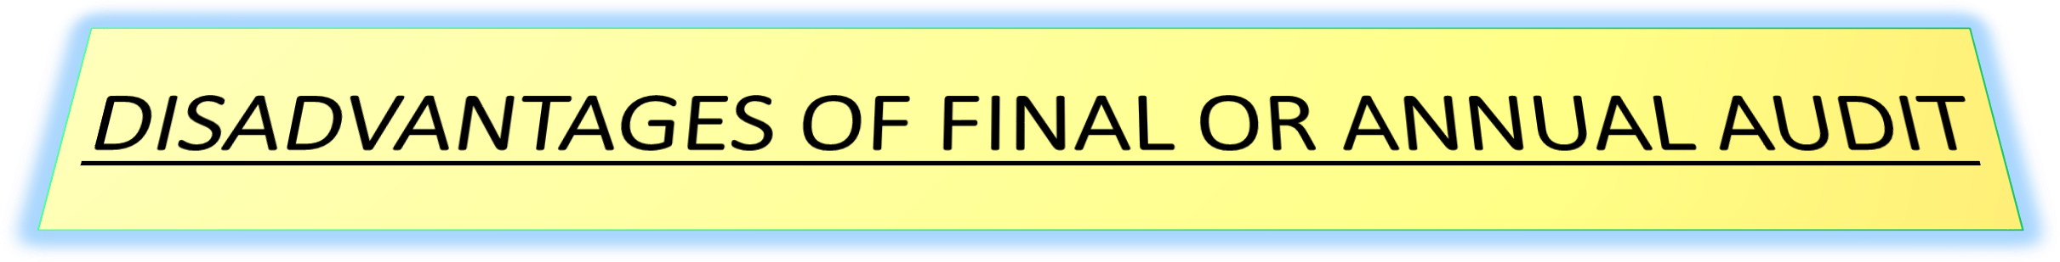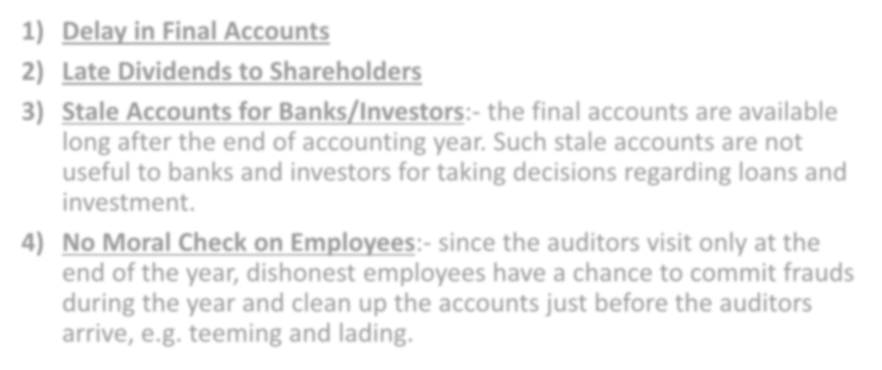

- Delay in Final Accounts
- Late Dividends to Shareholders
- Stale Accounts for Banks/Investors:- the final accounts are available long after the end of accounting year. Such stale accounts are not useful to banks and investors for taking decisions regarding loans and investment.
- No Moral Check on Employees:- since the auditors visit only at the end of the year, dishonest employees have a chance to commit frauds during the year and clean up the accounts just before the auditors arrive, e.g. teeming and lading.

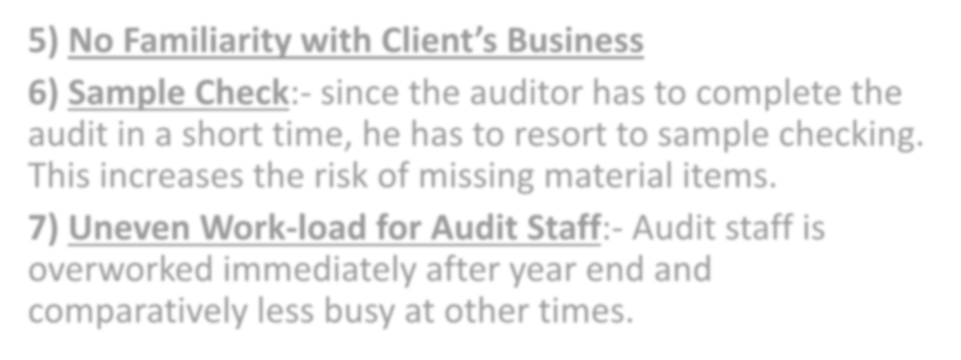

- No Familiarity with Client’s Business
- Sample Check:- since the auditor has to complete the audit in a short time, he has to resort to sample checking. This increases the risk of missing material items.
- Uneven Work-load for Audit Staff:- Audit staff is overworked immediately after year end and comparatively less busy at other times.

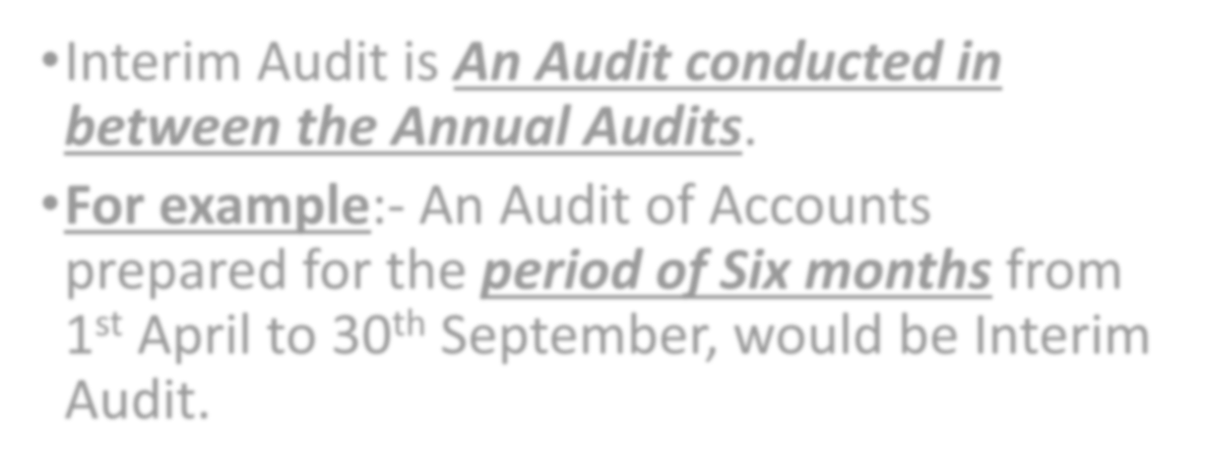

  - Interim Audit is An Audit conducted in between the Annual Audits.
  - For example:- An Audit of Accounts prepared for the period of Six months from 1st April to 30th September, would be Interim Audit.

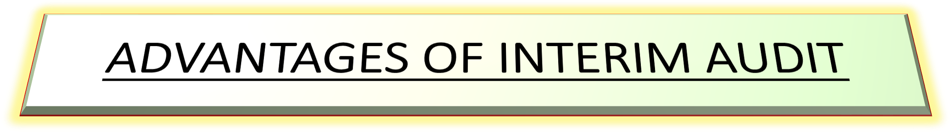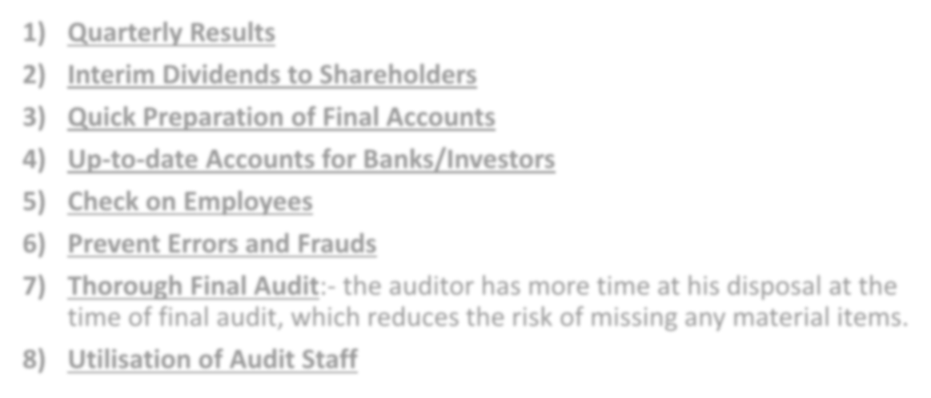

- Quarterly Results
- Interim Dividends to Shareholders
- Quick Preparation of Final Accounts
- Up-to-date Accounts for Banks/Investors
- Check on Employees
- Prevent Errors and Frauds
- Thorough Final Audit:- the auditor has more time at his disposal at the time of final audit, which reduces the risk of missing any material items.
- Utilisation of Audit Staff

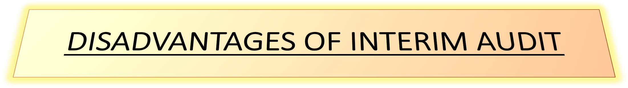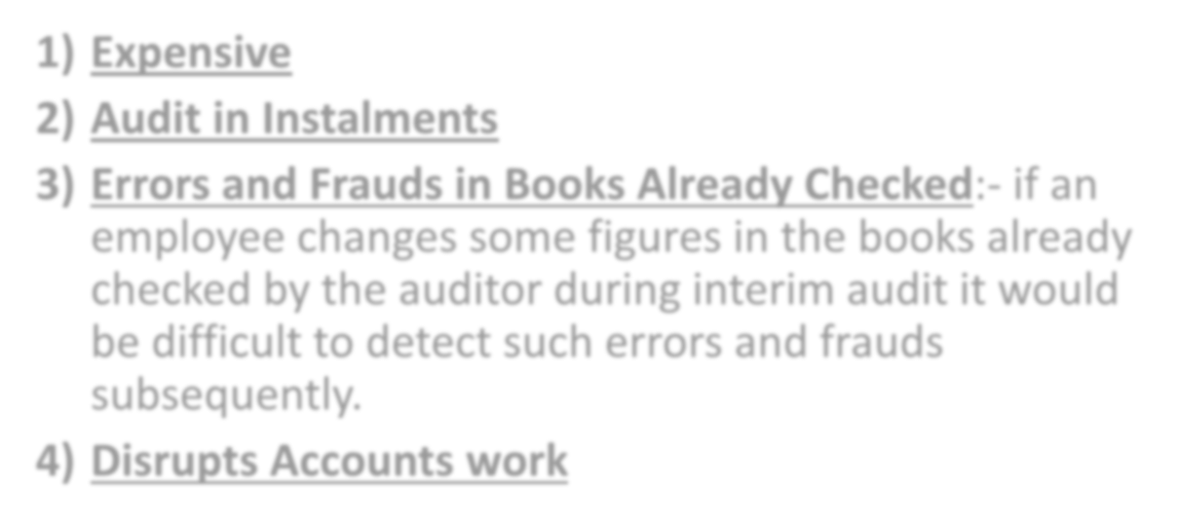

Expensive
- Audit in Instalments
- Errors and Frauds in Books Already Checked:- if an employee changes some figures in the books already checked by the auditor during interim audit it would be difficult to detect such errors and frauds subsequently.

Disrupts Accounts work

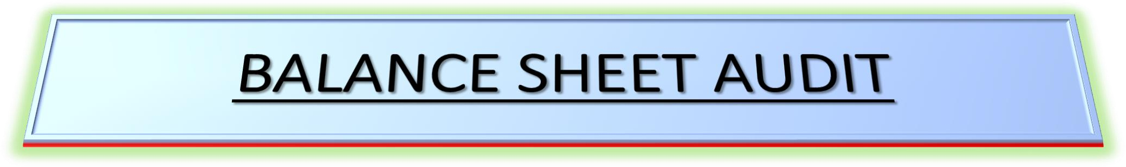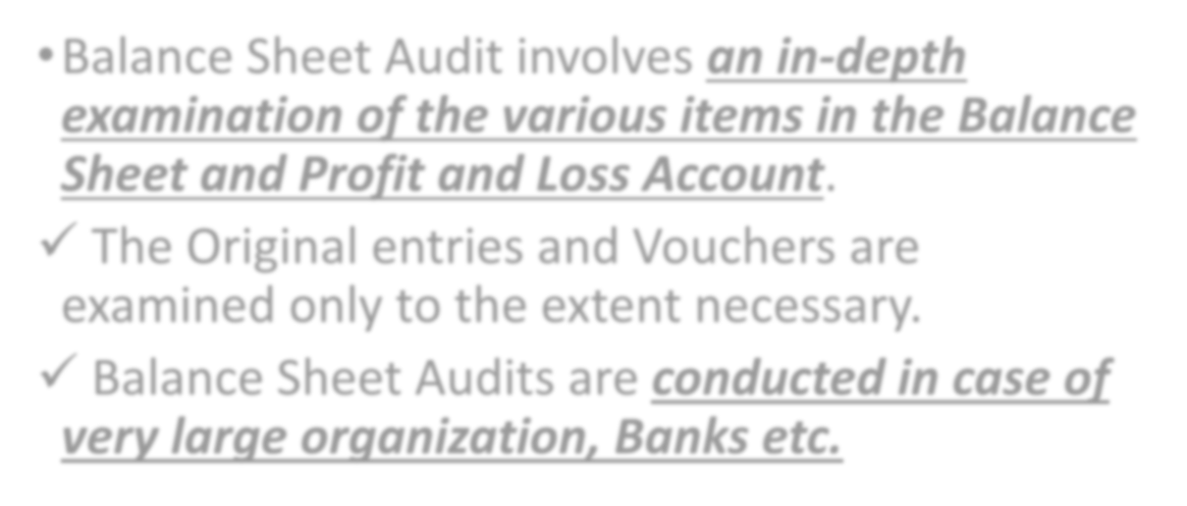

  - Balance Sheet Audit involves an in-depth examination of the various items in the Balance Sheet and Profit and Loss Account.

The Original entries and Vouchers are examined only to the extent necessary.
- Balance Sheet Audits are conducted in case of very large organization, Banks etc.

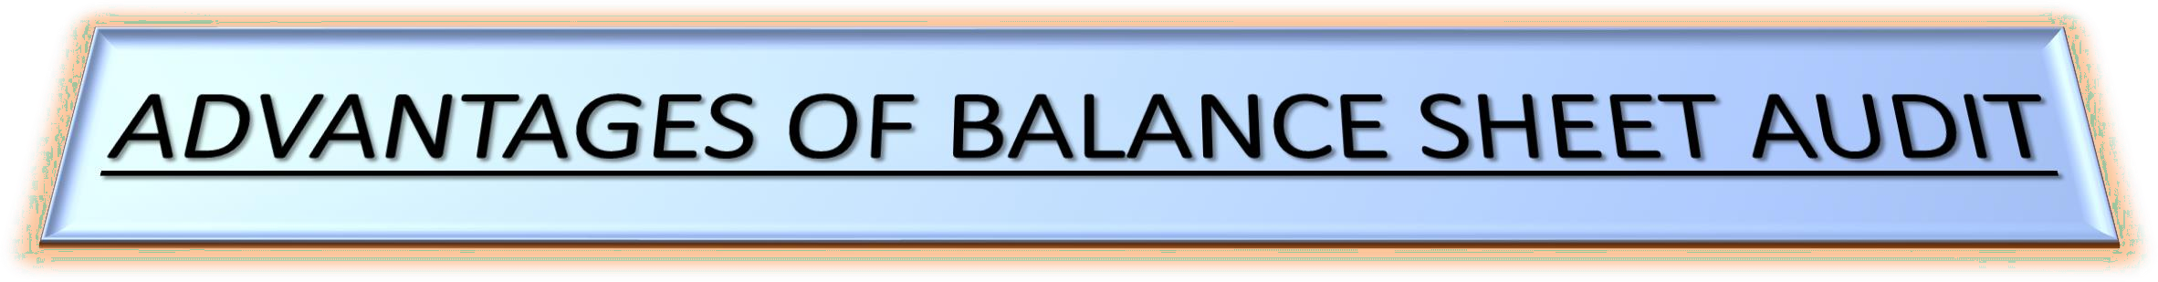

- No Change in accounts:- Balance Sheet Audit commences after the completion of books of accounts and preparation of the Balance Sheet. Therefore changes in the accounts are not possible once the verification process is started.
- No interruptions:- there is no interruption from the Accounts Department. Checking can be done smoothly without any breaks in between.
- No loose links:- there are no loose links because audit is conducted in a continuous flow, which reduces the chances of missing the verification of any aspect.

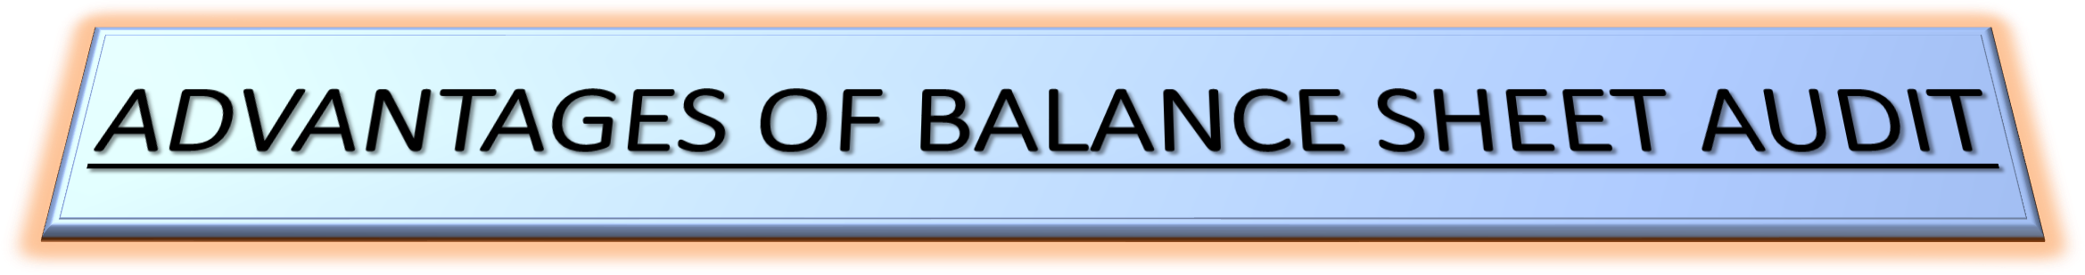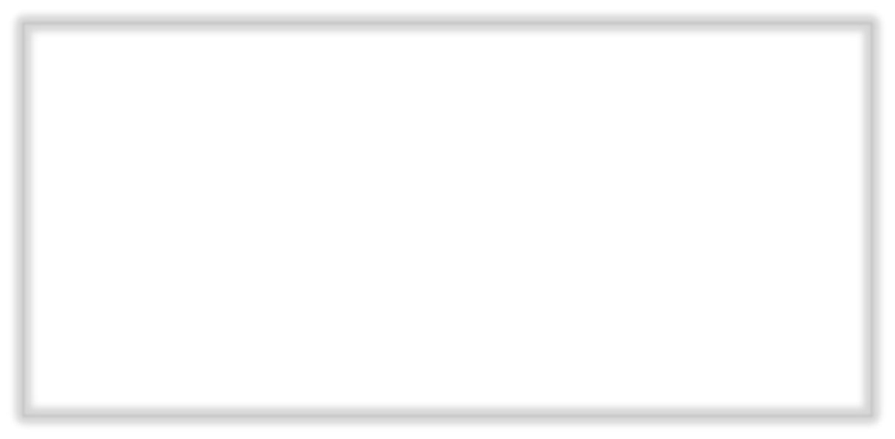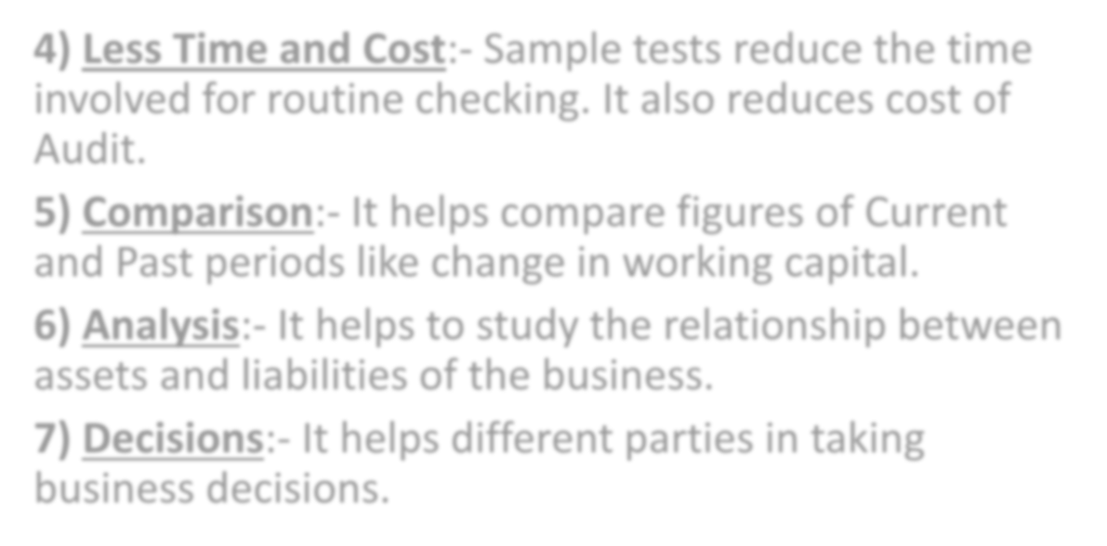

- Less Time and Cost:- Sample tests reduce the time involved for routine checking. It also reduces cost of Audit.
- Comparison:- It helps compare figures of Current and Past periods like change in working capital.
- Analysis:- It helps to study the relationship between assets and liabilities of the business.
- Decisions:- It helps different parties in taking business decisions.

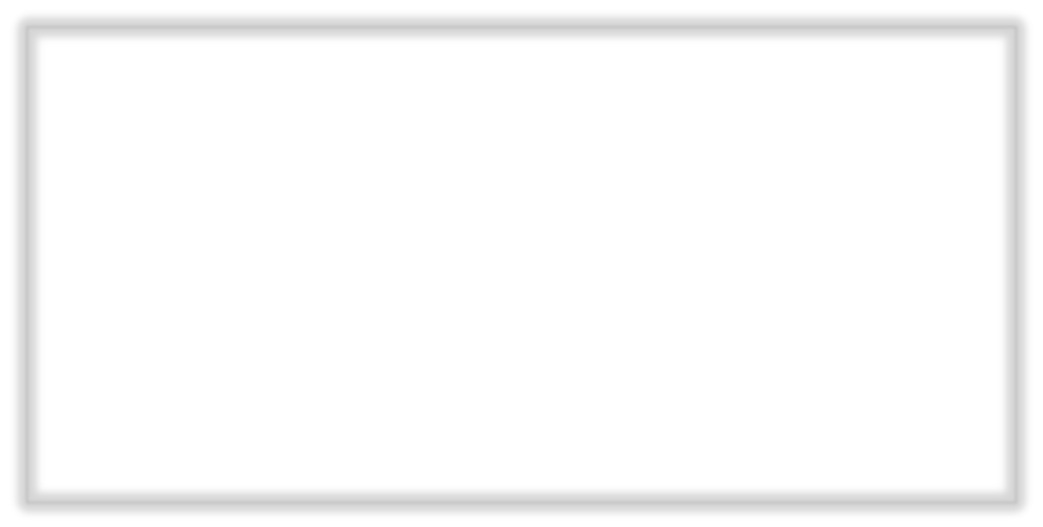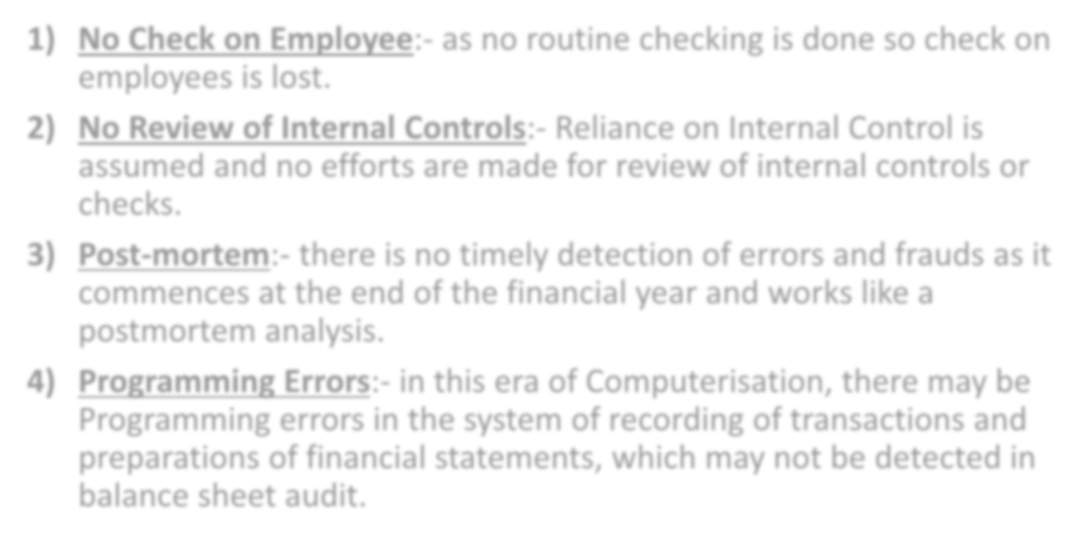

- No Check on Employee:- as no routine checking is done so check on employees is lost.
- No Review of Internal Controls:- Reliance on Internal Control is assumed and no efforts are made for review of internal controls or checks.
- Post-mortem:- there is no timely detection of errors and frauds as it commences at the end of the financial year and works like a postmortem analysis.
- Programming Errors:- in this era of Computerisation, there may be Programming errors in the system of recording of transactions and preparations of financial statements, which may not be detected in balance sheet audit.

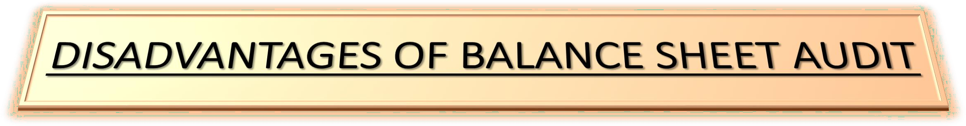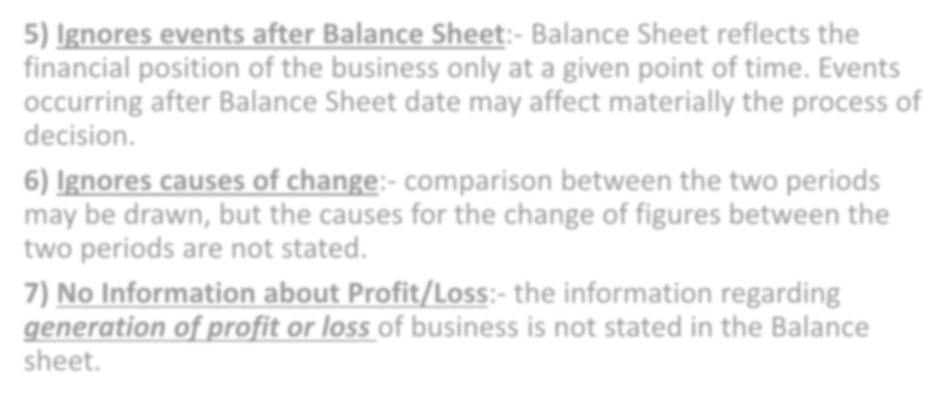

- Ignores events after Balance Sheet:- Balance Sheet reflects the financial position of the business only at a given point of time. Events occurring after Balance Sheet date may affect materially the process of decision.
- Ignores causes of change:- comparison between the two periods may be drawn, but the causes for the change of figures between the two periods are not stated.
- No Information about Profit/Loss:- the information regarding generation of profit or loss of business is not stated in the Balance sheet.

