
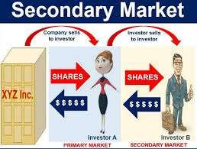

Equity Markets
Unit 2- Secondary Markets




Contents…..

- Definition and functions of stock Exchanges
- Evolution and Growth of Stock Exchanges in India
- NSE, BSE, SME Exchanges and Overseas Stock Exchanges
- Role of SEBI
- Recent Development in Stock Exchanges
- Stock Market Indices
- Disinvestments, FDI & Foreign Portfolio Investment (FPI)

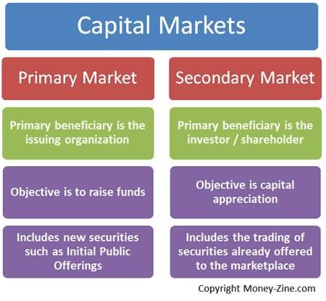

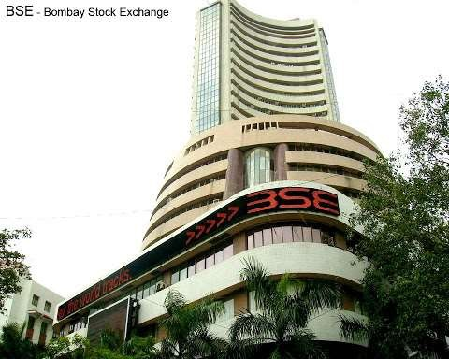

What is Stock Exchange?

Stock Exchange (also called Stock Market or Share Market) is one important
constituent of capital market.
Stock Exchange is an organized market for the purchase and sale of industrial and financial security. It is convenient place where trading in securities is conducted in systematic manner i.e. as per certain rules and regulations.
It performs various functions and offers useful services to investors and borrowing companies. It is an investment intermediary and facilitates economic and industrial development of a country

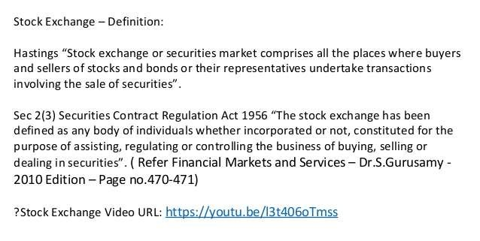

Features of Stock Exchange

- Market for securities : Stock exchange is a market, where securities of corporate
bodies, government and semi-government bodies are bought and sold.
- Deals in second hand securities : It deals with shares, debentures bonds and such securities already issued by the companies. In short it deals with existing or second hand securities and hence it is called secondary market.
- Regulates trade in securities : Stock exchange does not buy or sell any securities on its own account. It merely provides the necessary infrastructure and facilities for trade in securities to its members and brokers who trade in securities. It regulates the trade activities so as to ensure free and fair trade

Features of Stock Exchange

- Allows dealings only in listed securities : In fact, stock exchanges maintain an official list of securities that could be purchased and sold on its floor. Securities which do not figure in the official list of stock exchange are called unlisted securities. Such unlisted securities cannot be traded in the stock exchange.
- Transactions effected only through members : All the transactions in securities at the stock exchange are effected only through its authorised brokers and members. Outsiders or direct investors are not allowed to enter in the trading circles of the stock exchange. Investors have to buy or sell the securities at the stock exchange through the authorised brokers only.
- Association of persons : A stock exchange is an association of persons or body of
individuals which may be registered or unregistered.

Features of Stock Exchange

- Recognition from Central Government : Stock exchange is an organised market. It requires recognition
from the Central Government.
- Working as per rules : Buying and selling transactions in securities at the stock exchange are governed by the rules and regulations of stock exchange as well as SEBI Guidelines. No deviation from the rules and guidelines is allowed in any case.
- Specific location : Stock exchange is a particular market place where authorised brokers come together daily (i.e. on working days) on the floor of market called trading circles and conduct trading activities. The prices of different securities traded are shown on electronic boards. After the working hours market is closed. All the working of stock exchanges is conducted and controlled through computers and electronic system.
- Financial Barometers : Stock exchanges are the financial barometers and development indicators of
national economy of the country. Industrial growth and stability is reflected in the index of stock exchange

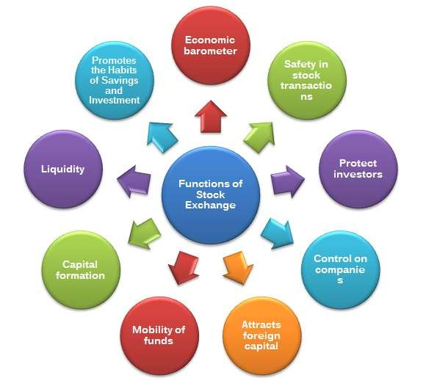

Functions Of Stock Exchange

- 1.Providing Liquidity and Marketability to Existing Securities • The basic function of a Stock Exchange is to provide liquidity and marketability to existing securities. • It is a ready market for conversion of securities into cash and vice versa. • It gives the chance to investors to disinvest and reinvest.
- 2.Pricing of Securities • Pricing of securities is the main function of a Stock Exchange. • Stock Exchange fixes prices for shares trading on it. • Share prices on a Stock Exchange are determined by the forces of demand and supply
- 3.Safety of Transactions • Existing legal framework in Stock Exchange provides safety of transactions. • Stock Exchange provides a safe and fair deal in securities market

Functions Of Stock Exchange

- 4.Contributes to Economic Growth • Stock Exchange contributes to economic growth. • Through the process of disinvestment and reinvestment, savings will turn into investment avenues. • This leads to capital formation and economic growth.
- 5.Spreading of Equity Cult • Stock Exchange develops the habit of equity cult among the Public. • Stock Exchange encourages people to save and invest in securities.
- 6.Providing Scope for Speculation • Stock Exchange gives scope for speculation
within the limits of the law. • Stock Exchange encourages the speculative activity in
a restricted and controlled manner

Functions Of Stock Exchange

- 7.Improves the Company’s Performance • Stock Exchange improves the company’s
performance. • Because the prices of the best companies will be high in the Stock Market.
- 8.Helps in Raising New Capital • The new companies and existing companies need capital for their activities. • The Stock Exchanges are helpful in raising capital both by new and old companies.
- 9.Clearing House of Business Information • According to the instructions of the Stock Exchanges, all the listed companies have to provide financial statements, annual reports and other reports to the exchange. • Stock Exchange supplies this information to all the investors and public.
- 10. Economic Barometer • Stock Exchange is an economic barometer of the country.
Economic conditions of the country are known through the stock indices.

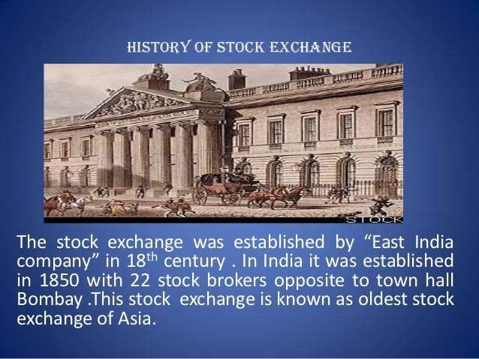

Evolution & Growth of Stock Exchanges in India

- One of the oldest stock markets in Asia, the Indian Stock Markets have more
than 200 years old history.
- 18th Century-East India Company was the dominant institution and by end of the century, business in its loan securities gained full momentum
- 1830's-Business on corporate stocks and shares in Bank and Cotton presses started in Bombay. Trading list by the end of 1839 got broader.

Evolution & Growth of Stock Exchanges in India

- 1850's-Rapid development of commercial enterprise saw brokerage business
attracting more people into the business
- 1862-63-The number of brokers increased to about 200 to 250.
- 1875-“The Bombay Stock Exchange" was established in Bombay
- 1908“-The Calcutta Stock Exchange Association" was formed
- 1920- "The Madras Stock Exchange" was transacted with 100 brokers

Evolution & Growth of Stock Exchanges in India

- Most of the regional Exchanges were in a miserable state till 1957 when they
applied for recognition under Securities Contracts (Regulations) Act, 1956
- The Exchanges that were recognized under the Act
- Bombay, Calcutta ,Madras,Ahmedabad,Delhi,Hyderabad,Bangalore,Indore
Stock Exchanges.

Evolution & Growth of Stock Exchanges in India

- Post 1957, following stock exchanges got the recognition.
- Cochin Stock Exchange (1980)Uttar Pradesh Stock Exchange Association Limited (at Kanpur, 1982)Pune Stock Exchange Limited (1982) Gauhati Stock Exchange Limited (1984) Kanara Stock Exchange Limited (at Mangalore, 1985) Magadh Stock Exchange Association (at Patna, 1986)Saurashtra Kutch Stock Exchange Limited (at Rajkot, 1989)Coimbatore Stock Exchange Meerut Stock Exchange.
- Many more stock exchanges were established during 1980'

Evolution & Growth of Stock Exchanges in India

- This age-old trading mechanism in the Indian stock markets used to create many
functional inefficiencies.
- Lack of liquidity and transparency, long settlement periods and benami transactions
are a few examples that adversely affected investors.
- In order to overcome these inefficiencies, OTCEI was incorporated in 1990 under the Companies Act 1956. OTCEI is the first screen based nationwide stock exchange in India created by UTI, ICICI, IDBI,SBICapital Markets,IFCI, General Insurance Corporation and its subsidiaries and Canra Bank Financial Services
- NSE was incorporated in November 1992. In April 1993, it was recognized as
a stock exchange.

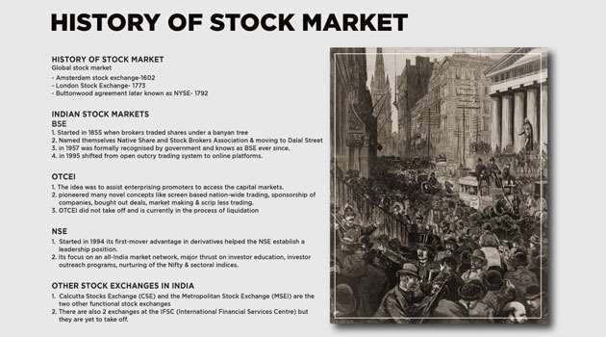

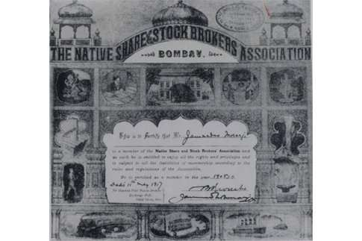

The Bombay Stock Exchange or BSE

- The Bombay Stock Exchange or BSE is an Indian stock exchange which is
located at Dalal Street, Mumbai.
- It was established in the year 1875 and founded by Premchand Roychand,
one of the influential businessmen in the 19th century.
- He was famously known as the Big Bull, the Bullion King or the Cotton King.
- He was also the founder of Stock Brokers Association, known as BSE and the Native Share

The Bombay Stock Exchange or BSE

- Bombay Stock Exchange Ltd is now synonymous with Dalal Street, however, it was not
always so.
- The very first venue of the earliest stock broker meetings was held in the 1850s under
banyan trees, in-front of the Town Hall, where Horniman Circle is presently situated.
- A year later, the brokers moved to another venue, at the junction of Meadows Street which is now called Mahatma Gandhi Road. With an increase in the number of brokers, they had to shift from one place to another, this would end to overflowing the streets.
- Last, in the year 1874, the brokers found a permanent place which they can call their own. It was known as Dalal Street or Broker’s Street.

The Bombay Stock Exchange or BSE

- The Bombay Stock Exchange or BSE is the oldest stock exchange in Asia. On 31st August 1957, The Bombay Stock Exchange became the first stock exchange that was recognized by the Government of India under the Securities Contracts Regulation Act.
- In 1980, the exchange moved to the Phiroze Jeejeebhoy Towers at Dalal Street, Fort area. In 1986, it developed the S&P BSE SENSEX index, giving the BSE a means to measure the overall performance of the exchange. In 2000, the BSE used this index to open its derivatives market, trading S&P BSE SENSEX futures contracts. The development of S&P BSE SENSEX options along with equity derivatives followed in 2001 and 2002, expanding the BSE's trading platform.

The Bombay Stock Exchange or BSE

- Historically an open outcry floor trading exchange, the Bombay Stock Exchange switched to an electronic trading system developed by CMC Ltd. in 1995. It took the exchange only 50 days to make this transition. This automated, screen-based trading platform called BSE On-Line Trading (BOLT) had a capacity of 8 million orders per day. Now BSE has raised capital by issuing shares and as on 3 May 2017 the BSE share is traded in NSE.

Features of Bombay Stock Exchange

- It is the first securities market in India based in Mumbai, India. The securities that are listed at the BSE include stocks, stock options, stock futures, index options, index futures, and weekly options.
- The SENSEX is the benchmark index of the BSE that consists of the 30 companies that are financially sound and well established from around 12 different sectors which help in measuring Bombay Stock Exchange’s overall performance.
- It has helped in the development of the capital marke tof India and helped in the
growth of the corporate sector of India.

Functions of Bombay Stock Exchange

Price Determination
- Economical Contribution
- Marketability and Liquidity

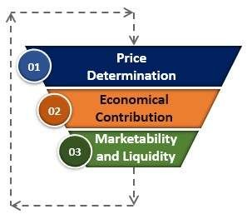

Functions of Bombay Stock Exchange

- 1 – Price Determination
- The price determination in the secondary market depends upon the demand and supply of the securities. Bombay Stock Exchange helps in the process of valuation by constantly valuing all the listed securities. Such share prices can be easily tracked through the index that is popularly known as SENSEX

Functions of Bombay Stock Exchange

Economical Contribution
- Since the Bombay Stock Exchange deals with the securities that are listed and these securities are sold and re-sold continuously that allows the funds to keep moving instead of remaining idle which results in boosting the economy.

Functions of Bombay Stock Exchange

3 – Marketability and Liquidity
- They provide high liquidity as the listed securities can be sold at any point in time converting it into the cash. It works continually and the investor can sell and purchase the security simply according to their wish

Importance of BSE

- It is easy to sell and buy securities in the financial market if the security is listed on
the BSE thereby meeting the needs of liquidity for the potential investors.
- It is easy to raise the funds by issuing equity and debt securities through BSE as it is
a trusted source from where the securities are traded in the financial market.
- They provide an open platform for speculation within a legal framework. Bombay Stock Exchange is the best platform for healthy speculative trading which helps in fulfilling the requirement of liquidity of an investor.

Importance of BSE

- The securities exchange board of India governs the functions of BSE. Therefore the transactions that occur at the Bombay Stock Exchanges are regulated and governed strictly within the legal framework. Therefore it gives an assurance to the investor that there are dealing in a safe place and their money is not wasted.
- They provide education about the benefits of doing investment in the stock market
and ensures that there is the smooth functioning of the transactions.
- The securities that are listed on it can be kept as collateral by an investor while
availing the loans from banks and other financial institutions.

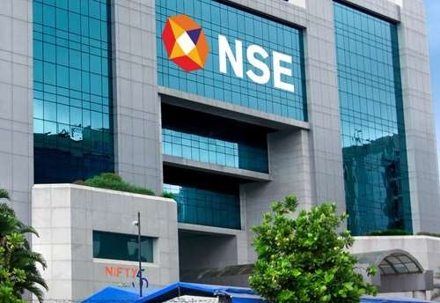

National Stock Exchange of India Ltd.

- The National Stock Exchange of India Ltd. (NSE) is an Indian stock exchange located at Mumbai, Maharashtra, India. National Stock Exchange (NSE) was established in 1992 as a demutualized electronic exchange. It was promoted by leading financial institutions on request of the Government of India. It is India’s largest exchange by turnover. In 1994, it launched electronic screen-based trading. Thereafter, it went on to launch index futures and internet trading in 2000, which were the first of its kind in the country. Mr. Vikram Limaye is the MD and CEO of NSE.

NSE

- NSE was established as a result of the recommendations made by High Powered Study Group on Establishment of New Stock Exchanges. The group was set up by the government to provide a solution to making stock market participation simple and accessible to all. This was in the aftermath of the Harshad Mehta stock market scam that took place in 1992.

NSE

- Headquartered in Mumbai, NSE offers companies a platform to raise capital. It also provides investors with access to asset classes like equities, debt, and derivatives as well as currencies and mutual fund units. It allows for new listings, initial public offers (IPOs), debt issuances and Indian Depository Receipts (IDRs) by overseas companies raising capital in India. NSE offers trading, clearing and settlement services in equity, equity derivatives, debt and currency derivatives segments. It was the first stock exchange in India to offer electronic trading facility.

NSE

- Benchmark index: The benchmark index of NSE is S&P CNX Nifty (Nifty50) introduced by the exchange in 1996. Nifty50 comprises of top 50 and largest most actively traded stocks on NSE. Nifty50 is nothing but the calculated weighted average of the performance of 50 companies from various sectors. The base period for the Nifty index is November 03, 1995. The base value of the index has been set at 1000, with a base capital of Rs2.06 lakh cr.

Functions of NSE

- Establishing a nationwide trading facility for equities, debt and other hybrid
instruments
- Ensuring equal access to investors across the nation through an appropriate
communication network
- Providing a fair, efficient and transparent securities market to investors using
electronic trading systems
- Enabling shorter settlement cycles and book entry settlements systems
- Meeting the current international standards of securities markets

Functions of NSE

- NSE successfully fulfilled these functions by establishing the first electronic stock market of India. NSE was instrumental in creating National Securities Depository Limited (NSDL), the first depository in India, allowing investors to hold and trade securities electronically. This not only made investing simple, but also provided increased transparency. The price information that was earlier available only to a handful of traders present at the exchange, was now widely disseminated and available to everyone at their finger-tips

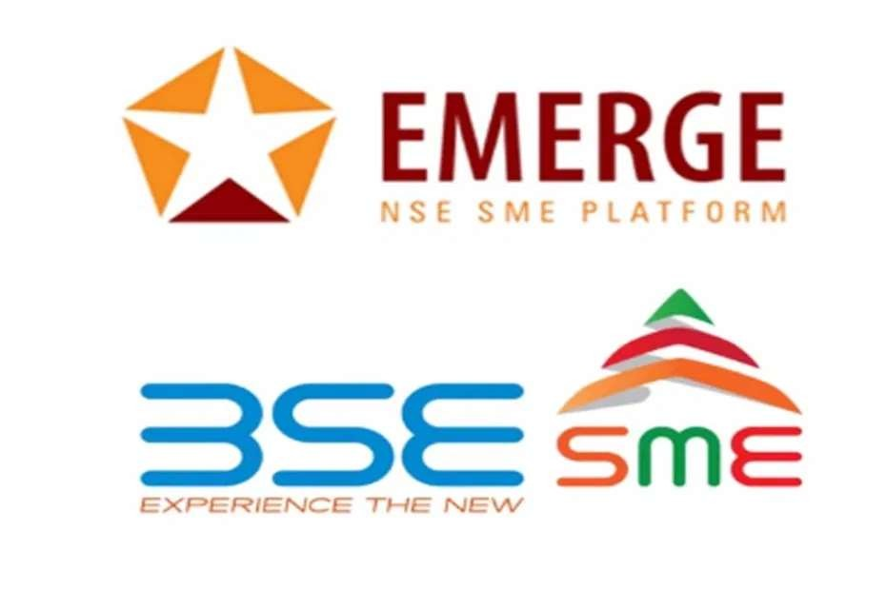

SME exchange

- SME exchange is a type of stock exchange. It is dedicated to trading the shares of small and medium scale enterprises (SMEs). Otherwise, find it difficult to get listed in the main exchanges
- What Is SME?
- SME stands for “SMALL AND MEDIUM ENTERPRISE”.
- MSME stands for “MICRO SMALL AND MEDIUM ENTERPRISE”.
- Micro, small OR medium companies are broadly classified in 2 sectors –
Manufacturing Sector and Service Sector.

SME exchange

- Both BSE and NSE exchange has set up a platform by which the small and medium enterprises can get their shares listed. That is called the SME exchange.
- SME Exchange full form is a “small and medium exchange”.
- The name of the SME exchange for the Bombay Stock Exchange is BSE SME Exchange and the name of the SME Exchange for National Stock Exchange is Emerge.

SME exchange

- In the year 2011 SEBI has launched the SME platform to allow small and medium
enterprises to raise capital.
- In February 2012 the first-ever SME IPO on BSE SME exchange was floated
- Listing Requirement for SMEs
- In the case of normal stock exchange, there are thousands of companies listed. However,
the number of listings on the SME exchange is limited, as awareness is just
increasing. Furthermore, the SME stock exchanges have entry restrictions such as positive net worth and cash flows for two years before the process of listing. In addition, companies, which had once applied for winding up or restructuring, are not permissible to list on the exchange. These restrictions help protect investors from additional risk and ensure that listed SMEs are legitimate.

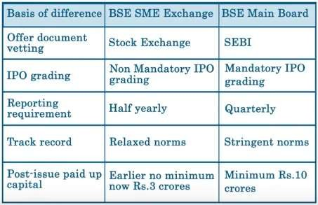

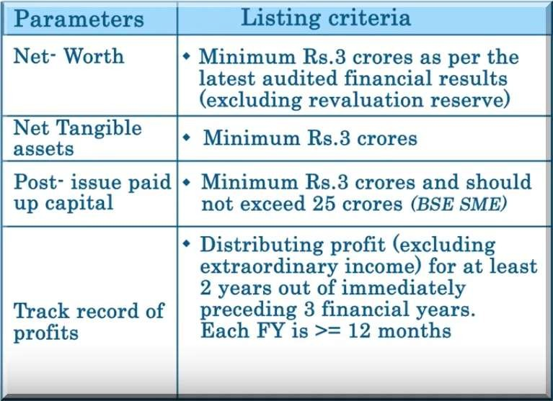

How Stock Market Listing Helps SME Companies?

- To raise fresh capital.
- Increase network.
- The leveraging ratio gets more attractive and the capacity to raise debt increases.
- It enhances visibility and credibility.
- Widens the capital base and increases working capital.
- It can raise funds at low cost and comparatively relaxed norms and compliance.

Trading in SME Stock Exchange

- Trading on the SME stock exchange is almost like buying and selling on the BSE or NSE. It does not necessitate any extra procedures. Nevertheless, some trading rules are different. The SME exchange has a larger size than normal lot size– the least number of shares you can buy or sell in each transaction. You are not permitted to trade amounts lower than Rs 1 lakh. Also, the lot size varies according to the price of the stocks. For instance, on the NSE Emerge, if the stock price is found to lower than Rs 14, then the lot size is 10,000. Nevertheless, if the stock price is observed between Rs 120-Rs 150, then the lot size is found to fall to 1,000.

Liquidity in SME Exchange

- Some caution should be exercised while trading on the SME exchanges in India. First of all, investors should be aware that the risk factor is quite high during the process of investing in small and medium-sized companies. While they are competent of giving really great returns they also have a higher than average probability of being affected. Hence, it is important to be well researched. Also, liquidity is lower in the SME exchanges, when compared to the regular exchange. Some orders may not find a matching buyer/seller right away. Hence, its important for investors in the SME stock exchange to be long-term investors.

OVER THE COUNTER EXCHANGE OF INDIA (OTCEI)
- Incorporated in 1990, setup to aid enterprising promoters in raising finance for new
projects.
- To provide investors with a transparent efficient mode of trading.
- OTCEI introduced a screen based nation wide trading
- OTCEI introduced many novel concepts to the Indian capital markets such as screen-based nationwide trading, sponsorship of companies, market making and scrip less trading.
- The first Indian stock exchange to introduce nationwide computerized screen based
trading

OVER THE COUNTER EXCHANGE OF INDIA
- Over the Counter Exchange of India was started in 1992 after the role models of NASDAQ ( National Association of Securities Dealers Automated Quotation) and JASDAQ (Japanese Association of Securities Dealers Automated Quotation).
- The OTCEI was started with the objective of providing a market for the smaller companies that could not afford the listing fees of the of the large exchanges and did not fulfill the minimum capital requirement for listing.



OVER THE COUNTER EXCHANGE OF INDIA
- Over the Counter Exchange of India (OTCEI) It was sponsored by the country’s premier financial institutions such as UTI, ICICI,IDBI, SBI Capital Markets , IFCI, GIC and its subsidiaries and canbank Financial services.
- The exchange was set up to aid enterprising promoters in raising finance for
new projects in a cost effective manner

OVER THE COUNTER EXCHANGE OF INDIA
- Trading takes place through a network of computers of over the counter (OTC) dealers located at several places, linked to a central OTC computer using telecommunication links.
- It was the first exchange in the country to introduce the practice of market making, that is , dealers in securities providing two-way quotes (bid prices and offer prices of securities)

Features of OTCEI

- It is a nation-wide stock exchange.
- Its operational areas cover entire India. It is a ringless stock exchange.
- The trading ring(i.e., trading place)commonly found in a traditional stock exchange is not found in the OTCEI.
- It is a computerized stock exchange

Advantages of OTCEI

- It helps the investors to have easy and direct access to the stock exchange
- It helps investors to get fair prices for their securities
- It provide safety to the investors
- It provide computerized trading system
- It provide investors a convenient,effcient and transparent mode of investment

Types of Members in Stock Exchange

- BROKER: He is one acts as a intermediary on behalf of others. A broker in a stock exchange ,is a
commission agent who transacts business in securities on behalf of non members.
- JOBBER: He is not allowed to deal with the public directly .He deals with brokers who are engaged with the investors . Thus, the securities is bought by the jobber from members and sells to members who are operating on the stock exchange as broker.
- DIFFERENCES BETWEEN A JOBBER AND A BROKER
- A broker deals with the jobber on behalf of his clients. in other words, a broker is a middleman between a jobber and clients A broker is merely an agent, buying or selling securities on behalf of his clients A broker gets only commission for his dealings The broker deals in all types of securities • A jobber is an independent dealer in securities, purchasing or selling securities on his own account • A jobber deals only with the brokers
,does not deal with the general public • A jobber earns profit from his operations i.e., buying and selling activities • Each jobber specializes in certain group of securities

Types of Members in Stock Exchange

- Tarawaniwalas: They are like jobbers. They handle transactions on a commission basis for their brokers. They buy and sell securities on their own accounts and may act as brokers on behalf of the public.
- Sub brokers: Agents of stock brokers. They are employed by brokers to
obtain business. They are also known as remisiers.
- Arbitrageurs: They buy securities in one market and sell the same in another
market to get opportunistic profit.

SPECULATOR

- SPECULATION AND SPECULATOR • SPECULATION : It is the transaction of members to buy or sell securities on stock exchange with a view to make profits to anticipated raise or fall in price of securities. • SPECULATOR : The dealer in stock exchange who indulge in speculation are called speculator . They do not take delivery of securities purchased or sold by them , but only pay or rescue the difference between the purchase
price and sale price . The different types of speculators are • BULL • BEAR
  - STAG • LAME DUCK

SPECULATOR

- BULL {TEJIWALA} He is speculator who expects the future raise in price of securities he buys the securities to sell them at future date at the higher price. He is called as bull because his activities resembles as a bull , as the bull tends to throw its victims up in the air through its horns. In simple the bull speculator tries to raise the price of securities by placing a big purchase orders.
- BEAR {MANDIWALA} He is speculator who expects future fall in prices , he does an agreement to sell securities at future date at the present market rate . He is called as bear because his altitude resembles with bear , as the bear tends to stamp its victims down to earth through its paws . In simple the bear speculator forces of prices of securities to fall through his activities.

SPECULATOR

- STAG {DEER} He operates in new issue of market . He is just like a bull speculator . He applies large number of shares in the issue market only by paying , application money , allotment money. He is not a genuine investor because , he sells the allotted securities at the premium and makes profit. In simple he is cautious in his dealings . He creates an artificial rise in prices of new shares and makes profits.
- LAME DUCK He is speculator when the bear operator finds it difficult to deliver the securities to the consumer on a particular day as agreed upon , he struggles as a lame duck in fulfilling his commitment . This happens when the prices do not fall as expected by the bear and the other party is not willing to postpone the settlement to the next period.

Categories of shares traded

- Stock classification is the process of grouping stocks for ease of understanding. In India both BSE (Bombay Stock Exchange) and NSE (National Stock Exchange) classifies stocks. More or less the classification of stocks is similar on both platforms.
- This stock classification was done to handle the stocks based on trading characteristics of Indian shares on the exchange platform and are known as grades. Mainly there are seven grades of stocks namely, A, B, T, S, TS & Z. All other stocks which fail the characteristics of any one of these grades were kept in others. These grades are scores of stocks on the basis of their size, liquidity and exchange compliance.

Categories of shares traded in BSE

Category A group stocks – highly liquid stocks
- The stocks fall in the category of A ‘Group’ are the most liquid counters among all the stocks listed on the BSE.
- The market rates group A stocks as excellent in all aspects and they also
show comparatively high traded volume during trading.
- Settlement of group A stocks trades is done under the normal rolling settlement process.

Categories of shares traded in BSE

Category B group stocks – stocks that are left behind
- B Group comprises stocks that don’t fall in any of the other groups.
- These counters see normal volumes and settle under the rolling system
- There are little lesser liquidity in those shares.
- There are Category B1 &B2 shares too.

Categories of shares traded in BSE

- Category S group stocks – small and medium stocks
- The stocks of ‘S Group’ fall under the BSE’s Indonext segment.
- The BSE Indonext comprises small and medium companies that have a listing in the regional Stock Exchange.
- Generally, the turnover of S grade companies is rupees 5 crore and tangible assets
of rupees 3 crore.
- Apart from the small size of the company, the other risk that comes with investing
in them is low liquidity

Categories of shares traded in BSE

T group stocks – the stocks in trade-to-trade
- The stocks fall under T group follows trade-to-trade settlement system of the exchange.
- Each trade in this group is seen as a separate transaction and there is no
netting-out of trades as in the rolling system
- The traders who buy shares of this category or sell the script of this group, have to pay the amount or deliver the shares by T+2 days.

Categories of shares traded in BSE

- Z group stocks – caution to retail investors
- The companies of Z grade stocks have not complied with the exchange’s listing
requirements that have failed to redress investor’s complaints..
- The stocks of Z category are the riskiest scripts. Not much information is available
to such companies in the public domain.
- These companies have low media coverage that keeps them relatively hidden from
public scrutiny that makes such scripts more vulnerable to insider trading.
- Z Group companies already have a poor score in redressing investor complaints.
Category Z shares are not appealing to investor.

Categories of shares traded in BSE

Other classification
- Category G:Retail investors trade in government securities like long-dated GOI bonds on the exchange. Instruments of government securities come in Group G.
- Category F:The exchange also facilitates trading in fixed income securities, like company deposits and non convertible debnetures. These instruments form F Group

Categories of shares traded in BSE

- SLB group stocks
- SLB stands for Securities Lending & Borrowing and is a scheme introduced by
SEBI in 2007 for short sellers.
- This scheme facilitates the borrowing of securities by a short seller in the market
and helps in the settlement process.
- In short selling, you can sell stocks without actually holding them.
- Both the retailer and institutional investor participates in short sell and SLB scheme.

Groups based on market capitalization

- Large-cap stocks – The market capitalization value of large-cap company’s
share is more than 10 billion rupees.
- Mid-cap stocks – The second group is the stocks of companies with a market capitalization in between two and ten billion rupees comes under the mid-cap.
- Small cap stocks – The last group in this segment is that of small cap. These are stocks of companies whose market capitalization lies in between rupees 300 million and rupees 2 billion

Categories of shares traded in NSE

Listed Shares:
- Listed means they are listed in the National stock Exchange.

Permitted Shares:
- Permitted means it is listed in other stock exchanges, but permitted to be traded in National Stock Exchange.

Overseas Stock Exchanges

- 1) New York Stock Exchange
- 2) NASDAQ
- 3) Tokyo Stock Exchange
- 4) Shanghai Stock Exchange
- 5) Honk Kong Stock Exchange
- 6) London Stock Exchange
- 7) EURONEXT
- 8) Shenzen Stock Exchange
- 9) Toronto Stock Exchange



New York Stock Exchange

- The New York Stock Exchange (NYSE, nicknamed "The Big Board")[is an American stock exchange at 11 Wall Street in the Financial District of Lower Manhattan in New York City. Established in the year1792.
- It is by far the world's largest stock exchange by market capitalization of its listed companies at US$30.1 trillion as of February 2018. The NYSE trading floor is located at 11 Wall Street and is composed of 21 rooms used for the facilitation of trading. An additional trading room, located at 30 Broad Street, was closed in February 2007. The main building and the 11 Wall Street building were designated National Historic Landmarks in 1978.

NASDAQ

- The Nasdaq Stock Market was created by the National Association of Security Dealers (NASD) to enable investors to quickly and electronically trade securities over a computerized system. The Nasdaq's first trading day was Feb. 8, 1971. The main indexes that track the Nasdaq's performance are the Nasdaq Composite and the Nasdaq-100, although several smaller indexes track different parts of the market's performance as well.
- The Nasdaq was created by the NASD when the association decided to build the first all-electronic stock exchange in 1971

Tokyo Stock Exchange

- he Tokyo Stock Exchange, abbreviated as Tosho or TSE/TYO, is a stock exchange located in Tokyo, Japan. It is the third largest stock exchange in the world by aggregate market capitalization of its listed companies, and the largest in Asia.
- Market cap: US$5.67 trillion (Feb. 2019)
- No. of listings: 2,292
- Location: Tokyo, Japan
- Indices: Nikkei 225; TOPIX
- Currency: Japanese yen

Shanghai Stock Exchange

- The Shanghai Stock Exchange(SSE) is located in the city of Shanghai, China and is one of the two stock exchanges plying autonomously in the People’s Republic of China. Although its foundation traces back to 1866, it was adjourned after the Chinese Revolution in 1949. However, The Shanghai Exchange in its contemporary outlook was laid down in 1990.
- Currently, Shanghai SSE is the world’s fourth-largest stock exchange with a combined market capitalization f US$ 5.01 trillion. The most interesting fact is that the absolute market cap of the SSE is constructed out of formerly state-run insurance companies & commercial banks

Honk Kong Stock Exchange

- The Hong Kong Stock Exchange (SEHK) is located in Hong Kong and is the world’s fifth-largest stock exchange on the basis of market capitalization. It consists of 2,315 listed companies with a wholesome market capitalization of HK$29.9 trillion.
- ts origin can be traced back to the mid-1800s and since then it has gone through a series of mergers and agglomeration with other exchanges. Some of the gigantic and eminent companies listed under the Hong Kong Stock Exchange are China Mobile, and HSBC Holdings & Petro China

London Stock Exchange

- The London Stock Exchange (LSE) is based in London and is the sixth- largest stock exchange in the world. It was established in 1571 and is the oldest stock exchange in the world. It has more than 3,000 listed companies with a combined market capitalization of $4.59 trillion.
- LSE is also the maiden source of benchmark prices, equity-market liquidity and market data in Europe. Some of the massive companies listed under the LSE are Barclays, British Petroleum and GlaxoSmithKline.

EURONEXT

- The Word EURONEXT is an acronym for European New Exchange Technology and has its corporate address at La Défense in Greater Paris. EURONEXT was established in 2000 by the consolidation of the exchanges in Amsterdam, Paris, and Brussels.
- Over the years, it amalgamated with multiple exchanges, most particularly the New York Stock Exchange. It steers financial markets in Amsterdam, London, Brussels, Lisbon, Oslo, Dublin, and Paris. It has around 1,500 listed companies leading to a market capitalization worth €4.1 trillion. EURONEXT provided the segments which are equities, warrants, exchange-traded, bonds, commodities, funds and certificates, derivatives, indices, and foreign exchange trading platforms.

Shenzen Stock Exchange

- The Shenzhen Stock Exchange (SZSE) is oriented in the city
of Shenzhen, China and was founded on December 1, 1990. It is the 8th largest stock exchange in the world and has approximately 1,300 listed companies with a combined market capitalization of $3.92 trillion.
- Most of the companies under this SZSE are corporate firms of companies in which the Government Of China has a controlling interest. The Shenzhen Stock Exchange had introduced the “ChiNext Board” in 2009 comprising of high-tech & high-growth startups, quite similar to NASDAQ.

Toronto Stock Exchange

- The Toronto Stock Exchange (TSX) is situated in Toronto, Canada. It was introduced in 1852 and is held and wielded as a subsidiary of the TMX Group. It is the ninth-largest exchange in the world and has 2,207 listed companies with a combined market capitalization of $2.3 trillion.
- The financial instruments include equities, investment trusts, exchange- traded funds, bonds, commodities, futures, options, and other products. It is also to be noted that mining and oil and gas companies are listed in more numbers under the Toronto Stock Exchange compared to other stock exchanges around the world.

Frankfurt Stock Exchange

- Frankfurt Stock Exchange is the world's 10th largest stock exchange by
market capitalization.
- Established: 1585
- Market cap: US$ 1,776 billion (July 2015)
- Location: Frankfurt, Hesse, Germany
- Currency: Euro
- Owner: Deutsche Börse, Börse Frankfurt Zertifikate AG

Merger of FMC with SEBI

- The Forward Markets Commission regulated commodities market since
1953
- FMC oversaw the commodities market for over 60 years, but it lacked powers which led to wild fluctuations and alleged irregularities remaining untamed in this market segment. Also, the commodities market faced challenges with respect to speculative activities and illegal activities like 'dabba trading' flourishing in this segment.

Merger of FMC with SEBI

- The merger talks between the two regulatory bodies was first mooted in 2003, and continued in next few years before the Rajan committee in 2009 reiterated consolidation of all financial sector regulators under one umbrella. In the events before the outbreak of NSEL crisis came to light, Justice BN Srikrishna-led FSLRC recommended unified regulation. But the fallout of NSEL prompted finance ministry to bring FMC under its fold in that same year.

Merger of FMC with SEBI

- The merger is aimed at streamlining the regulations and curb wild speculations in the commodities market, while facilitating further growth there. “The merger will increase economies of scope and economies of scale for the government, exchanges, financial firms and stakeholders,

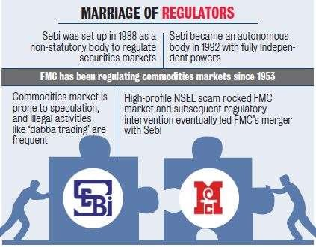

Securities Exchange Board of India

Established in 1988, got regulatory power in 1992
Objectives of SEBI
1.To provide degree of protection to investors 2.To promote fair dealings by the issuer
- To develop and promote code of conduct to intermediaries
- To provide for the matters connecting to the above

Objectives of SEBI

- Protect interest of investors & promote the development of market
- Promote investor education and training
- Prohibiting insider trading
- Regulating acquisition and takeover of companies

Role of SEBI

- SEBI acts as a watchdog for all the capital market participants and its main purpose is to provide such an environment for the financial market enthusiasts that facilitate efficient and smooth working of the securities market.
- To make this happen, it ensures that the three main participants of the financial market are taken care of, i.e. issuers of securities, investor, and financial intermediaries.
- Issuers of securities
- These are entities in the corporate field that raise funds from various sources in the market. SEBI makes sure that they get a healthy and transparent environment for their needs.

Role of SEBI

Investor
- Investors are the ones who keep the markets active. SEBI is responsible for maintaining an environment that is free from malpractices to restore the confidence of general public who invest their hard earned money in the markets.

Financial Intermediaries
- These are the people who act as middlemen between the issuers and investors. They make the financial transactions smooth and safe.

Functions of SEBI:

- SEBI primarily has three functions-
- Protective Function
- Regulatory Function
- Development Function

Protective Functions

- As the name suggests, these functions are performed by SEBI to protect the interest
of investors and other financial participants.
- It includes-
- Checking price rigging
- Prevent insider trading
- Promote fair practices
- Create awareness among investors
- Prohibit fraudulent and unfair trade practices

Regulatory Functions

- These functions are basically performed to keep a check on the functioning of the business in the financial
markets.
- Designing guidelines and code of conduct for the proper functioning of financial intermediaries and
corporate.
- Regulation of takeover of companies
- Conducting inquiries and audit of exchanges
- Registration of brokers, sub-brokers, merchant bankers etc.
- Levying of fees
- Performing and exercising powers
- Register and regulate credit rating agency

Development Functions

- SEBI performs certain development functions also that include but they are
not limited to-
- Imparting training to intermediaries
- Promotion of fair trading and reduction of malpractices
- Carry out research work
- Encouraging self-regulating organizations
- Buy-sell mutual funds directly from AMC through a broker

Securities Exchange Board of India

- Calling for information and conducting enquiries of the organisations
connected with capital market
- Concentrate on the activities like pricing of securities, eligibility norms of the company
- Checking on prospectus, issue of shares and post issue obligations
- Checking all the guidelines on issue of shares followed by companies

Recent Developments in Stock Market

- SEBI Act 1992
- Screen Based Trading
- Reduction in Trading Cycle
- Equity Derivatives Trading
- NSCCL-1996
- Market Infrastructure

Recent Developments in Stock Market

- Research in Securities Market
- Testing & Certification
- Demutualisation
- Dematerialisation
- Globalisation
- Volatility Index
- ASBA
- Direct Market Access

Indices/Stock Market Index

- A stock index, or stock market index, is an index that measures a stock market, or a subset of the stock market, that helps investors compare current price levels with past prices to calculate market performance. It is computed from the prices of selected stocks (typically a weighted arithmetic mean).
- There are thousands of companies listed on stock markets, making it almost impossible to monitor each company. This is why stock market indices are created. Market indices bring together a select group of company stocks and regularly measures them to show the performance of the overall market or a certain segment of the market.

Indices/Stock Market Index

- In short, an index helps investors understand the health of the stock market, enables them to study the market sentiment and makes it easy to compare the performance of an individual stock.
- The Sensex and Nifty-50 are two popular benchmark indices that largely reflect the performance of Bombay Stock Exchange (BSE) and National Stock Exchange (NSE). To understand how each sector of the stock market is doing, there are sectoral indices such as Nifty Bank. Nifty Auto etc.

Indices/Stock Market Index

- From among the stocks listed on the exchange, some similar stocks are selected and grouped together to form an index. This classification may be on the basis of the industry the companies belong to, the size of the company, market capitalization or some other basis. For example, the BSE Sensex is an index consisting of 30 stocks. Similarly, the BSE 500 is an index consisting of 500 stocks.NIFTY is an index consisting of 50 stocks
- The values of the grouped stocks are used to calculate the value of the index. Any change in the price of the stocks leads to a change in the index value. An index is thus indicative of the changes in the market.

Indices/Stock Market Index

- Some of the important indices in India are:
- Benchmark indices – BSE Sensex and NSE Nifty
- Sectoral indices like BSE Bankex and CNX IT
- Market capitalization-based indices like the BSE Smallcap and BSE Midcap
- Broad-market indices like BSE 100 and BSE 500

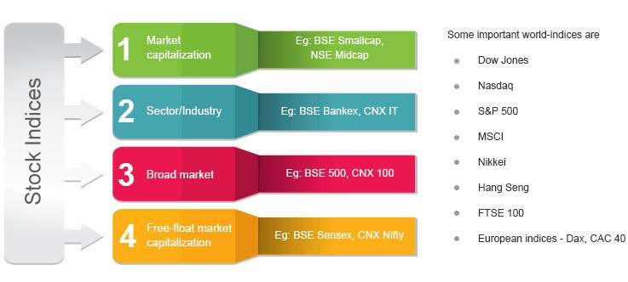

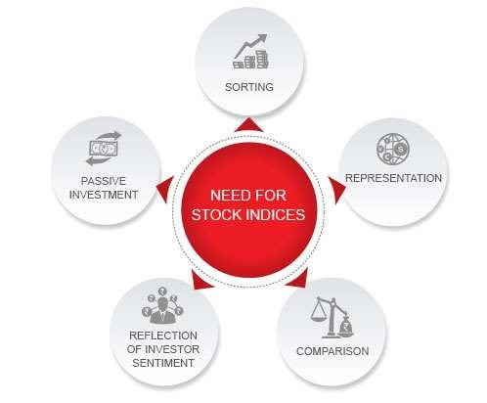

HOW ARE STOCK INDICES FORMED?

- An index consists of similar stocks. This could be on the basis of industry, company size, market capitalization or another parameter. Once the stocks are selected, the index value is calculated. This could be a simple average of the prices of the components. In India, the free-float market capitalization is commonly used instead of prices to calculate the value of an index.
- The two most common kinds of indices are – Price-weighted and market
capitalization-weighted index

What is stock weightage?

- Every stock has a different price. So, a 1% change in one stock may not equal a similar change in another stock’s price. So, the index value cannot be a simple total of the prices of all the stocks. Here is where the concept of stock weightage comes into play. Each stock in an index has a particular weightage depending on its price or market capitalization. This is the amount of impact a change in the stock’s price has on index value.

Market-cap weightage

- Market-cap weightage
- Market capitalization is the total market value of a company’s stock. This is calculated by multiplying the share price of a stock with the total number of stocks floated by the company. It thus takes into consideration both the size and the price of the stock. In an index using market-cap weightage, stocks are given weightage on the basis of their market capitalization in comparison with the total market-capitalization of the index. For example, if stock A has a market capitalization of Rs. 10,000 while the index it is part of has a total m-cap of Rs. 1,00,000, then its weightage will be 10%. Similarly, another stock with a market-cap of Rs. 50,000, will have a weightage of 50%.
- .

Market-cap weightage

- The point to remember is that market capitalization changes every day as the stock price fluctuates. For this reason, a stock’s weightage too changes every day. However, it is usually a marginal change. Also, the market capitalization- weightage method gives more importance to companies with higher m-caps.
- In India, most indices use free-float market capitalization. In this method, instead of using the total shares listed by a company to calculate market capitalization, only the amount of shares publicly available for trading are used. As a result, free-float market capitalization is a smaller figure than market capitalization

Price weightage

Price weightage
- In this method, an index value is calculated on the basis of the company’s stock price, and not market capitalization. Stocks with higher prices have greater weightages in the index than stocks with lower prices. The Dow Jones Industrial Average in the US and the Nikkei 225 in Japan are examples of price-weighted indices.
- There are also other kinds of weightages like equal-value weightage or fundamental weightage. However, they are rarely used by public indices.

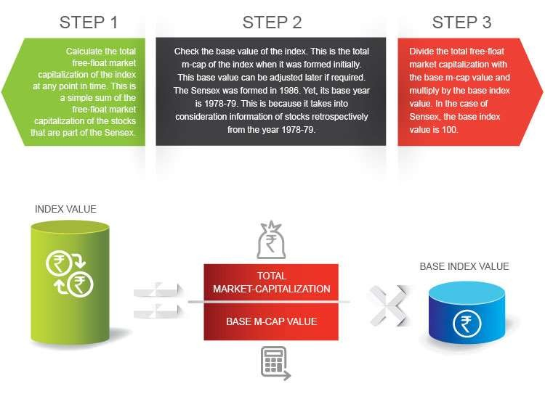

Market-Capitalization Weighting

- Market-Capitalization Weighting based indices weight constituent stocks by its market capitalization (often shortened to "market-cap"), or its stock price by its number of shares outstanding, divided by the total market capitalization of all the constituents in the index.
- A market-cap weighted index can also be thought of as a liquidity-weighted index since the largest-cap stocks tend to have the highest liquidity and the greatest capacity to handle investor flows; portfolios with such stocks could have very high investment capacity

Free-float adjusted Market-Capitalization Weighting
- Free-float adjusted Market-Capitalization Weighting based indices adjust market-cap index weights by each constituent's shares outstanding for closely or strategically held shares that are not generally available to the public market. Such shares may be held by governments, affiliated companies, founders, and employees. Foreign ownership limits imposed by government regulation could also be subject to free-float adjustments. These adjustments inform investors of potential liquidity issues from these holdings that are not apparent from the raw number of a stock's shares outstanding. Free-float adjustments are complex undertakings, and different index providers have different free-float adjustment methods, which could sometimes produce different results

Types of indices by coverage

- Stock market indices may be classified and segmented by the index coverage set of stocks. The coverage of an index is the underlying group of stocks, typically grouped together with some rationale from their underlying economics or underlying investor demand, that the index is trying to represent or track

Types of indices by coverage

- Country Coverage indices represents the performance of the stock market of a given nation—and by proxy, reflects investor sentiment on the state of its economy. The most regularly quoted market indices are national indices composed of the stocks of large companies listed on a nation's largest stock exchanges, such as the S&P 500 Index in the United States, the Nikkei
225 in Japan, the DAX in Germany, the NIFTY 50 in India, and the FTSE 100 in the United Kingdom

Types of indices by coverage

- Regional Coverage indices represents the performance of the stock market of a given geographical region. Some examples of these indices are the FTSE Developed Europe Index, and the FTSE Developed Asia Pacific Index.
- Global Coverage indices represents the performance of the global stock market. The FTSE Global Equity Index Series includes over 16,000 companies.

Types of indices by coverage

- Exchange-based Coverage indices may be based on exchange, such as
the NASDAQ-100 or groups of exchanges, such as the Euronext 100 or OMX
Nordic 40.
- Sector-based coverage indices track the performance of specific sectors of the market. Some examples include the Wilshire US REIT Index which tracks more than 80 real estate investment trusts and the NASDAQ Biotechnology Indexwhich consists of approximately 200 firms in the biotechnology industry.
- Other indices may track companies of a certain size, a certain type of management,
or more specialized criteria such as in fundamentally based indexes

Foreign direct Investment(FDI)

- A Foreign Direct Investment (FDI) is an investment in by foreign investors in the foreign based
company. Mainly there are two types of FDI,
- 1. FDI-Green Field Investment (a fresh company is established in a foreign country-)
- 2. Portfolio Investment (shares of a foreign company are purchased or ownership acquired in
a foreign company).

- FDI represents investment made in India by setting up branches,units or subsidiaries by the overseas bodies.

- In India,government policy on FDI inflows is fair, liberal and favourable for large scale direct
foreign investment in various sectors.

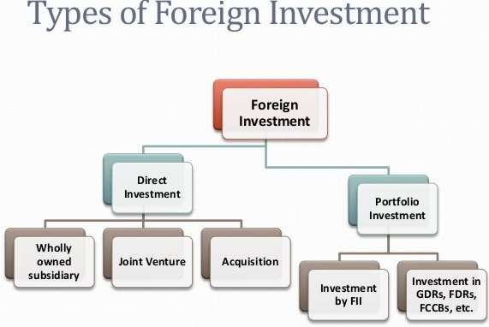

Implications of FDI inflows on Indian Industries
- Positive implications:
Beneficial to industrial sector
Foreign technology and professional skills Optimum utilisation of resources Expansion of automobile sector
- Negative implications:
Not beneficial to industrial expansion
No contribution in removing regional disparities Not available on priority sectors
Limited contribution in exports

Foreign Investment Promotion Board

- FIPB stands for Foreign Investment Promotion Board which was constituted by the
government of India in 1991 and reconstituted in 1996.
- The government of India has set up the FIPB the only agency in India that deals with foreign investments and other investments in India, the main motive of this board is to carry out promotional activities to boost foreign investment and promote industries in India to attract investments from around the globe.
- The Foreign Investment Promotion Board (FIPB) is being replaced by the Foreign Investment Facilitation Portal (FIFP) to speed up the FDI inflow and to increase the transparency in the FDI approvals in the country. FIFP replaced FIPB in May, 2017

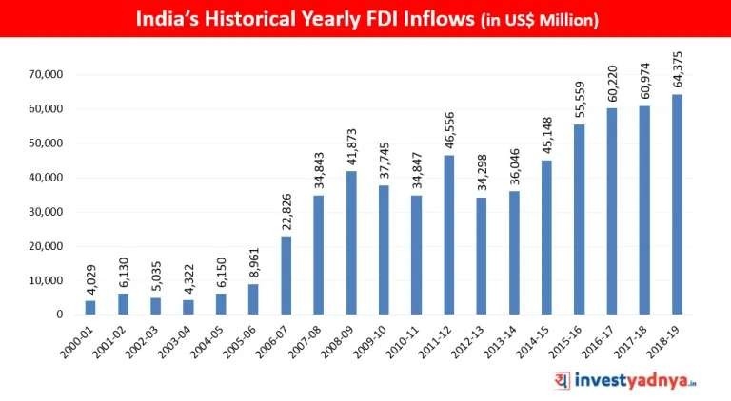

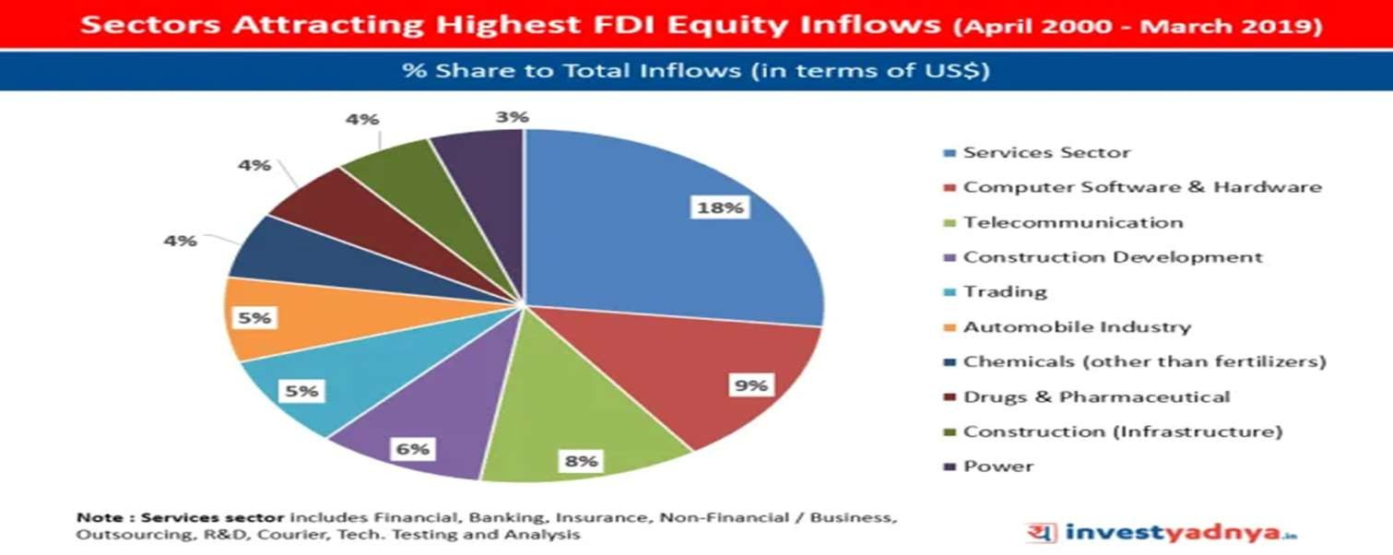

Disinvestment

- Investment refers to the conversion of money or cash into securities, debentures,
bonds or any other claims on money.
- Disinvestment involves the conversion of money claims or securities into money or
cash.
- Disinvestment can be simply defined as the action of the organization’s (Or
Government’s) Selling or Liquidating an Asset or Subsidiary.
- It is commonly referred to as Divestment or Divestiture • Government organization will typically disinvest an Asset either as a strategic move for the company or for raising resources to meet general / specific needs.

Disinvestment - Objectives

- To reduce the financial burden on government.
- To improve public finances
- To introduce, competition and market discipline
- To increase growth of the firm
- To encourage wider share of ownership

IMPORTANCE OF DISINVESTMENT

- 1.It will generate money to reduce fiscal deficit.
- 2. Govt. Can utilizes these funds for welfare of public.
- 3. It will improve efficiency and abilities of organisation.
- 4. Lose making PSU's will make profit.
- 5. Private sector have huge money to invest so it will improve infrastructure,
technical efficiency.
- 6. It will change the attitude of lazy employees and will improve their efficiency

MERITS OF DISINVESTMENT

- 1.In private sector the decision making process is quick.
- 2. Decisions are linked with the competitive market changes.
- 3. Better corporate governance.
- 4. Transparency
- 5. The market participation in capital of PSUs through stock exchanges
would enable the market to discover the latent worth of PSUs

DEMERITS OF DISINVESTMENT

- 1.Loss of public interest
- 2. There would be chances of Assets striping by the strategic partner.
- 3. The Government’s policy on Disinvestment includes the disposal of both Profit making, as well as Potentially viable PSUs
- 4. Private monopolies
- 5. Loss of regular source of income to the government

Types of Disinvestment

- From a government point of view, the disinvestment strategy can be of the following types:
- Minority Disinvestment: The Government wishes to retain managerial control over the company by maintaining the majority stake (equal to or more than 51 percent). Because public sector enterprises cater to the citizens, the Government needs to be able to influence company policies to further the interests of the general public.
- The Government generally auctions the minority stake to potential institutional investors or
announces an offer for sale (OFS) inviting participation by the public
- Some examples of minority disinvestment via Offer for Sale include recent issues of Power Grid Corporation of India Ltd., Rural Electrification Corporation Ltd., NTPC Ltd. NHPC Ltd. etc.

Types of Disinvestment

- Majority Disinvestment/Strategic Disinvestment: The Government gives up the majority stake in such a form of disinvestment. Such a decision is based on strategic grounds and policies of the Government. Typically, majority disinvestments are done in the favor of other public sector enterprises. For example, Chennai Petroleum Corporation Limited, formerly known as Madras Refineries Limited is a group company of Indian Oil Corporation after disinvestment by the Government. The idea is the consolidation of resources in a company which ultimately leads to operational efficiency.
- These strategic partners could be other Central Public Sector Enterprises (CPSEs) themselves, a few examples being BRPL/MRL to Indian Oil Corporation Ltd. (IOC) and KRL to BPCL.

Types of Disinvestment

- Complete Disinvestment/Privatization: 100 percent sale of Government stake in a PSU leads to the privatization of the company, wherein complete ownership and control are passed onto the buyer
- Complete disinvestment or privatization is a form of majority disinvestment wherein 100% control of the company is passed on to a buyer i.e government of India completely disinvests from that PSU.
- Example of this includes 18 hotel properties of India Tourism Development Corporation (ITDC).
Read more on Groww: https://groww.in/blog/disinvestment-in-india-objectives-and-
importance/

Disinvestment v/s Divestment

- Divestment and disinvestment are terms used interchangeably. However,
there is a slight point of difference between the two.
- Disinvestment in an asset, or division, or stake is typically carried out without the intent of reinvesting capital back into the same
entity. Divestment, on the other hand, is generally done temporarily to deal with say, tight finances, or social/political pressures that may arise as a result of certain business activities.

National Investment Fund (NIF)

- National Investment Fund (NIF), originally formed in 2005, received all the proceeds of disinvestment of CPSEs. NIF was set up as a permanent fund and professionally managed to meet the two-fold objective of – promoting social welfare schemes (75 percent of the fund corpus) and meet capital requirements of productive PSUs (25 percent of the fund corpus). However, after having exhausted the fund following the financial crisis of 2008 toward social welfare, the fund was re-aligned in 2013 to the disinvestment policy of the Government.

National Investment Fund (NIF)

- NIF presently exists as a ‘Public Account’ under the Government Accounts and is
withdrawn/invested only for pre-approved purposes of:
- Participate in rights issues of listed CPSE to maintain majority control
- Subscription to CPSE allotment of preferred equity to maintain Government shareholding of 51 percent
- Recapitalization of PSBs and public sector financial institutions as and when the need arises for
capital infusion
- Capital infusion in metro projects
- Investment in development institutions such as NABARD, Exim Bank, RRBs, etc.
- Meet the CAPEX requirements of Indian Railways

Foreign Portfolio Investment(FPI)

- The Foreign Exchange Management Act 2000 defines Foreign Portfolio Investment as buying and selling of shares, convertible debentures of Indian companies, and units of domestic mutual funds at any of the Indian stock exchanges
- It is the passive holding of securities such as foreign stocks, bonds, or other financial assets ,none of which entails active management or control of the securities issues by the investor,

FPI

- 1. FPI denotes all those investors or investment companies that are not
located within the territory of the country in which they are investing.
- 2. In economics foreign portfolio investment is the entry of funds into a country where foreigners make purchases in the country’s stock and bond markets, sometimes for speculation
- 3. Foreign Portfolio Investment (FPI): passive holdings of securities and other financial assets, which do NOT entail active management or control of the securities's issuer

FPI

- 4. FPI is positively influenced by high rates of return and reduction of risk through geographic diversification. The return on FPI is normally in the form of interest payments or non-voting dividends.
- 5. “SEBI’s definition of FPIs presently includes foreign pension funds, mutual funds, charitable/endowment/university funds etc. as well as asset management companies and other money managers operating on their behalf.”

Advantages of FPI

- Enhanced flows of equity capital
- FIIs have a greater appetite for equity than debt. It improve capital structures. Managing uncertainty and controlling risks.
- FPI inflows help in financial innovation and development of hedging instruments. Improving capital markets.
- FPIs as professional bodies of asset managers and financial analysts enhance competition and efficiency of financial markets. Equity market development aids economic development.
- FPIs can help in the process of economic development. Improved corporate governance.
- FPIs constitute professional bodies, improve corporate governance.

Disadvantages of FPI

- Problems of Inflation
- Hot Money
- Political Risk represented by the possibility of change in the political environment resulting in change in
investment norms and repatriation regulations.
- Emerging markets which are the beneficiaries of most FPI traditionally suffer from low retail participation
which results in inadequate liquidity which results in price volatility.
- Due to the unpredictable nature of such funds there is a tendency to shift from one market to another at short intervals. Volatility arising out of FPI inflows and outflows has adverse effects on the host country economy.
- Emerging economics tend to have depreciation prone currencies. This exposes the foreign investor to exchange rate risk on both principal and returns.

