Module 5 --- Consumer behaviour

Consumer Decision Making Process
Consumer decision making process involves the consumers to identify their needs, gather information, evaluate alternatives and then make their buying decision. The consumer behaviour may be determined by economic and psychological factors and are influenced by environmental factors like social and cultural values.
The consumer decision making behavior is a complex procedure and involves everything starting from problem recognition to post-purchase activities. Every consumer has different needs in their daily lives and these are those needs which make than to make different decisions.
Decisions can be complex, comparing, evaluating, selecting as well as purchasing from a variety of products depending upon the opinion of a consumer over a particular product. This renders understanding and realizing the basic problem of the consumer decision making process for marketers to make their products and services different from others in the marketplace.

Reasons behind Consumer Decisions:
In the present world, a consumer has a lot of options while taking any decision. But basically the consumer has five decision dimensions.
1. What to buy?
The decision to buy any product is the most important task. Until and unless if a decision is made a consumer cannot buy anything. The consumer has also to make the choice of the product available in the market. After taking any decision consumers buy a product. Then the consumer takes a decision about which brand to buy. This can be attached with the price and features of the product.

2. How much to buy?
The next decision the consumer has to make is to how much of the product to be purchased. It depends on the type of the product to be purchased and then the purchases can be made. The quantity to be purchased by the consumer depends on the availability and frequency of use of the product.

3. Where to buy?
Another decision the consumer has to make is where the product should be bought. Consumers usually will go to a place where the services offered are excellent. Also the other factors like prices and outlets are being decided by the consumers. The consumer expects a discount on the product. So, consumers usually go to such places where availability of the product quantity and quality can be decided by just looking at the other brands of the same product to be purchased. Many products have different features and therefore after thoroughly examining the purchase is made.

4. When to buy?
The consumer also has to decide the time when the purchase has to be made. This also is influenced by the availability of the products. Usually the purchase made by a consumer is very high during the festive season, due to large volume of discount. This not only ensures the consumer that they can get a product at a discount price. It is also influenced by opening times, sale and clearance period, transportation etc., for the goods purchased.

5. How to buy?
Under this the consumer has to decide whether to pay cash or by credit payment. Also the consumer expects the goods purchased to be delivered by the retailer. Also the installment facility on line purchased option may boost the sale of the products. If this part is handled with utmost care, the revenue for the retailer will go up. So, all the facility the consumer needs if available, there is no problem to dispatch the goods. The sale will go up automatically of course the proper paper work is done, depending on which the sale is made.
Every day we are involved in taking decisions related to the various aspects of our lives. Usually such decisions are taken automatically without the involvement of any particular decision making process.
For instance say a housewife goes to purchase a mid-priced range of tea, her decision making merely involves making a selection from the various brands of tea like Taj Mahal, Tata Tea, Red label, Yellow Label and so on. The process by which a person is required to make a choice from various alternative options is referred to as decision making.

Consumer Decision Making Process
Consumer decision making process involves the consumers to identify their needs, gather information, evaluate alternatives and then make their buying decision. The consumer behavior may be determined by economic and psychological factors and are influenced by environmental factors like social and cultural values.
The consumer decision making behavior is a complex procedure and involves everything starting from problem recognition to post-purchase activities. Every consumer has different needs in their daily lives and these are those needs which make than to make different decisions.
Decisions can be complex, comparing, evaluating, selecting as well as purchasing from a variety of products depending upon the opinion of a consumer over a particular product. This renders understanding and realizing the basic problem of the consumer decision making process for marketers to make their products and services different from others in the marketplace.

5 Stages of Consumer Decision Making Process
Need Recognition
Need recognition occurs when a consumer exactly determines their needs. Consumers may feel like they are missing out something and needs to address this issue so as to fill in the gap. When businesses are able to determine when their target market starts developing these needs or wants, they can avail the ideal opportunity to advertise their brands.
An example who buys water or cold drink identifies their need as thirst. Here; however, searching for information and evaluating alternatives is missing. These consumer decision making steps are considered to be important when an expensive brand is under buying consideration such as cars, laptops, mobile phones, etc.

Information Search
The information search stage in the buyer decision process tends to change continually as consumers require obtaining more and more information about products which can satisfy their needs. Information can also be obtained through recommendations from people having previous experiences with products.
At this level, consumers tend to consider risk management and prepare a list of the features of a particular brand. This is done so because most people do not want to regret their buying decision. Information for products and services can be obtained through several sources like:
- Commercial sources: advertisements, promotional campaigns, sales people or packaging of a particular product.
- Personal sources: The needs are discussed with family and friends who provided product recommendations.
- Public sources: Radio, newspaper and magazines.
Evaluation of Alternatives
This step involves evaluating different alternatives that are available in the market along with the product lifecycle. Once it has been determined by the customer what can satisfy their need, they will start seeking out the best option available. This evaluation can be based upon different factors like quality, price or any other factor which are important for customers. They may compare prices or read reviews and then select a product which satisfies their parameters the most.

Purchase Decision
When all the above stages have been passed, the customer has now finally decided to make a purchasing decision. At this stage, the consumer has evaluated all facts and has arrived at a logical conclusion which is either based upon the influence from marketing campaigns or upon emotional connections or personal experiences or a combination of both.

Post Purchase Behaviour
The purchase of the product is followed by post-purchase evaluation which refers to analyzing as to whether the product was useful for the consumer or not. If the product has matched the expectations of the customer, they will serve as a brand ambassador who can influence other potential consumers which will increase the customer base of that particular brand. The same is true for negative experiences; however, it can halt the journey of potential customers towards the product

Types of CDM
1. Extended Decision-Making
Extended Decision-Making occurs when consumers are buying a rather expensive product. What do you do when thinking about purchasing a designer handbag for a four-figure price? Of course, you spend some time doing in-depth research about the handbag, before making your final purchase decision. Since it is a high-end handbag, the economic risk of buying it is much higher than if you would buy an average bag. Simply put, you would not necessarily purchase a designer fashion item on a daily basis. Therefore you spend more time evaluating the looks and the use of the product, and how you will feel about it after purchasing it. You might even ask your family and friends for advice, or read product reviews online before committing to investing.

2. Limited Decision-Making
Speaking of Limited Decision-Making, consumers are faced with limited decision making. This essentially means that there is a limiting variety or availability of this product on the market.
For example, you really fancy this pair of sunglasses with white frames and yellow-tinted lenses. However, there are only two brands out there that offer this style of sunglasses. Brand “X” offers their sunglasses for 195,-. Yes, that is a lot for a single pair of sunglasses. But the other sunglasses available, by the brand “Z”, costs 365,-, which is far more expensive than those sold by brand “X”.
Since you do not have a lot of options (and because you desperately want to own this stylish pair of sunglasses with yellow-tinted lenses), you decide to spend your money on brand “X” anyway, if you have the budget, of course (even though they are pretty expensive).

3. Habitual Buying Behavior
Habitual Buying Behaviour plays a big role in our daily routine. We do not put a lot of thought or research into buying a product that is incredibly cheap and available in masses, at the same time. For instance, you frequently buy a new pair of socks. Either because you always misplace them or because you always end up having holes in them. What you do is, you continue buying the one pair of socks that costs the least amount of money, since you keep running out of socks. It has literally become a habit of yours.

4. Variety-Seeking Buying Behaviour
You display this type of purchase behaviour when there are visible differences between products within the existing brands. You, as a consumer, might want to try out a similar product of various brands out of curiosity.
To give you a concrete example, you may feel the urge to buy a plain, white t-shirt in slightly different designs at multiple stores. Just because you might not want to wear the exact same white t-shirt every day - you want to switch things up every now and then. The t-shirt is very affordable at all places, so buying 3 or 5 of them should not be a problem at all.

Models or 4 Views of Consumer Decision Making
The changing market environment provides the impetus for a careful study of consumer decision making or buyer behaviour. The term ‘model’ generally refers to a general ‘view’ or perspective as to when and why individuals behave as they do. In buying and consuming a variety of goods and services, consumers are pursuing sets of motives.
Though need satisfaction is the underlying motive source of all consumption activity, an understanding of needs and processes that influence the formation and satisfaction of such needs will help the marketer to devise suitable marketing programmes.
Here we will examine the various models of consumers in terms of the following four views:
1. An Economical View or Model:
Traditionally, economics has been considered to be the mother discipline of marketing. Economists believe that consumers derive some utility (a feeling of satisfaction) from consuming a particular product and so their consumption activity will be directed towards pursuing maximisation of utility. That’s why if given a certain amount of purchasing power, and a set of needs and tastes, a consumer will allocate his expenditure over different products at given prices rationally so as to maximise utility. Economists also postulate that the utility from the consumption of a certain product diminishes as the quantity of the product consumed increases (based on the Principle of Diminishing Marginal Utility).According to this model it is also possible to make a number of predictions about the behaviour of buyers in terms of the price effect, income effect and substitution effect. While these predictions are useful, questions are being raised on the assumption of rationality in the behaviour of buyers. The criticism by consumer researchers is based on a number of reasons. They argue that in reality, the consumer may not be- (a) aware of the various product alternatives or (b) in a position to evaluate all the advantages and disadvantages related to the various product alternatives so as to rank them accordingly. Thus in the absence of all the possible sufficient, and accurate information, it will not be possible for the consumer to make the so called rational or perfect decision. It has been criticised that the economic view is too idealistic and simplistic. It is being argued that consumers in reality behave very differently and do not maximise their decisions in terms of economic considerations such as price-quantity relationships, marginal utility or indifference curves. Very often the consumer will settle down for a ‘satisfactory’ decision and not necessarily the best one though it will be a ‘good enough’ decision.

2. The Passive View or Model:
Unlike the rational economic view of man, the passive view portrays the consumer as someone who is basically carried away by the promotional and self-oriented efforts of the marketer. As per the passive view, consumers are perceived to be impulsive who take irrational purchase decisions and are influenced by the promotional offers of the marketers. The passive model is criticized as it fails to take a pragmatic view of the consumers. It is argued that in a buying situation, the consumer will be involved in a decision making process wherein he seeks information on the product, evaluates all the alternative brands and then makes a selection based on the brand which provides him maximum satisfaction. At times the consumer’s purchase decision is also based on emotions or moods. So it is wrong to assume that the consumer will be passive while taking purchase decisions.

3. A Cognitive View or Model:
As a consumer, man is usually involved in thinking and problem solving. He is constantly involved in an active search for goods and services which will not only satisfy his needs but enrich his life also. As per the cognitive view consumers are involved in an information seeking and processing method. They try to gather all the necessary information from various sources, such as a trusted friend, or an expert and so on. Once he feels that he has sufficient information, so as to make a ‘satisfactory choice decision’, he will cease to gather more information and will ultimately decide on his purchase intention. This model of man as a thinker, views consumer as an information processor. And all the focus is on the processes by which consumers seek and evaluate information about the concerned brands and the respective retail outlets. The advertisement on Panasonic can work as a cognitive appeal to customers seeking information for purchasing high end television. The ad provides information on the technology benefits in terms of V-Real Technology, Advanced Smart Sound Speaker System and HDAVI control offered by the Panasonic brand of TV Series. Thus according to the cognitive model of consumer, the above mentioned ad will make the consumer think on the benefits of Panasonic. The consumer will finally take the purchase decision based on his satisfaction of the information received.In other words the problem solving view or model of consumer talks of a person who in the absence of the total information or knowledge of all the available product alternatives, would actively seek ‘satisfactory information and thereby attempt to make satisfactory decisions accordingly.

4. An Impulsive or Emotional View of Consumer:
Another aspect of consumer decision making is that they can be emotional or impulsive while taking purchase decisions. Very often, we, as consumers are involved in purchases made on impulse or on a whim. For such emotional buying, the consumer may not undergo the usual process of carefully searching, evaluating and then deciding on the brand or outlet to purchase from Rather he is more likely to purchase the product (brand) based on a whim or an impulse. Such consumer decisions are said to be ’emotionally driven’. For emotional or impulse purchases, in the absence of a search for pre-purchase information, it is the mood and feelings of the consumer which will decide on the emotional purchase decision. Emotional decisions could be rational to some extent also. That is, the consumer may take an emotional decision to purchase a product but he will be rational while deciding or choosing one brand over another. This type of behaviour is displayed while making purchases of apparel, gifts, selecting holiday destinations or toys (for children). In all the above situations, the final decision may be made on the basis of emotion. Advertisers are projecting, their products or services in a way to appeal to the emotions of the particular target market. Such emotional appeals can be seen in the advertisements of Johnson and Johnson baby products, Huggies diaper, Wipro Baby Soft, Fisher Price toys and so on. Related to consumers emotions and feeling is the ‘mood’ of the person. Mood may be defined as a feeling state or state of the mind. The basic difference between an emotion and a mood is that the former is a response to a particular environment, while mood is an unfocused, pre-existing state-already present, when the consumer gets motivated or experiences a positive feeling about an advertisement, or the retail outlet or brand or a product. Moods play an important role in consumer decision making. Very often it is the mood of the consumer which influences his decisions related to when to shop, where to shop, in whose company to shop etc. It has been observed that even within the shopping environment, the interior decor, and the attitude of the sales persons, the type of services provided etc. could affect the shopper’s mood and influence the consumer’s decision on how long to shop and on how often to go to that shop. Realising this now retailers and dealers are creating a positive store image. This is likely to have a positive impact and influence on the consumer’s mood and decision to purchase.

Consumer Dogmatism
Dogmatism is an extent to which a person reacts to relevant information on its own merits, carefree (regardless) by the irrelevant factors in the situation. Consumer dogmatism is a personality trait that measures the degree of rigidity that an individual display (expresses) towards the unfamiliar and towards information that is contrary to their own perceptions or beliefs.
The person, who is highly dogmatic, approaches the unfamiliar defensively and with much more discomfort and uncertainty (ambiguity). Highly dogmatic consumers are often known as Closed-Minded whereas the low dogmatic consumers are known as Open-Minded. The highly dogmatic consumer is more likely to choose an established product, rather than innovative, product alternatives, where as a low dogmatic consumer would prefer innovative products over established or traditional alternatives.
In order to make the non-innovators or we can say potentially reluctant consumers to accept the innovation the marketers use authoritative figure such as celebrities and experts for their new product’s advertising. However, low dogmatic consumers often prefer innovative changes, and seem to be more receptive to the advertisements.
Exploring dogmatism in a target segment is useful to marketers. Permission marketing requires involvement of the consumer. And if the brand is able to communicate effectively to the target segmented consumers, there might be chances that their word of mouth will take over, affecting the brand positively.
This type of approach is more effective than a visibility campaign which directly attacks the dogmatic perception or beliefs of the consumer. Certain advertisements can become counter-productive if they generate or create opposite arguments in the psyche of dogmatic consumers. Due to this the consumers may feel that the brand is trying to force itself on the consumers through advertising like a blitzkrieg.
Marketers, particularly those such as highly advanced commodities, always seem to be concerned about regulating consumer reactions to unusual and unique products or qualities. Consumer dogmatism refers to one’s ability to react to pertinent information and appraise a product or service on its own merits without being influenced by extraneous considerations. Individuals who are not dogmatic are called “low-dogmatic individuals.” They prefer cutting-edge products or items above tried-and-true choices and are extremely open to advertising that emphasizes realistic distinctions, benefits of the products, and other types of product description and advertisements that place a greater emphasis on documentation than on other factors such as influencer marketing. Individuals that are extremely dogmatic are called high-dogmatic individuals. They mostly prefer and pick well-known brands, are extremely responsive to new product or service advertisements, and for their new products, marketers turn to superstars and their expertise.

Examples:
1. A Bournvita advertisement from the 1960s.
After viewing this ad, I’m not sure I’m going to keep Bournvita in my kitchen. And how a chocolate drink I enjoy is only linked to my father’s contentment if my mother prefers it to Milo or Horlicks. I would say, amazing logic and advertising

2. An advertisement for a home appliance that reads, “Train her to be an excellent housewife.”
You can’t reconfigure a culture any better than this to believe that females are solely supposed to be at home and that doing housework is just a portion of their existence. Such statements will only reinforce society’s subliminal belief that women really shouldn’t leave the house and should only be seen as nurturing and supportive housewives, thus encouraging dogmatism. Women can also be ferocious and bold.
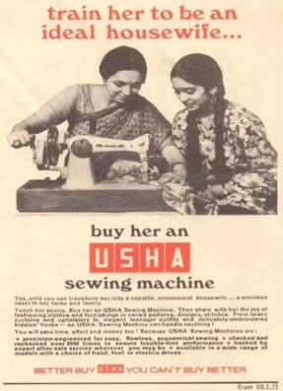

3.The concept of a detergent commercial is centred on females who are in charge of doing the laundry.
They clearly want to advertise their detergent, but why do they want to promote the image that males are immature and that washing clothes is a woman’s job? We appreciate the irresponsible part (it was included for humour), but why is it that a woman is accountable for the stains and worn-out t-shirts that men wear? This is an example of an advertisement that promotes women’s dogmatism.

Advantages and Disadvantages
The benefits of dogmatism include the freedom from seeking and validating the truth as well as the assurance of duty. One will accept a set of norms and a mind-set in the hopes that it is the correct one. The demerits of dogmatism in marketing have the problem of being scientifically and psychologically unsound. It has an impact on people and is impersonal and insensitive.

Threshold Effect in Consumer Behaviour
Threshold effect is the cumulative effect of repeated advertising over a period of time when the effect of the advertisement is found in the form of customer recognition which is seen through an increase in sales. This phenomenon is observed when sales surpass a certain quantitative limit which is called the threshold; hence the name threshold effect.
The expenditure incurred by a company till this point is considered as an approximate for estimating further advertising budgets. Threshold effect is the point when the customer recognition or awareness of a particular brand or product is recognised or increased. A company’s aim would be to reduce this threshold i.e. to reduce the cost and the time period before which the customer starts recognising the brand or product. One has to careful about the threshold effect while marketing or advertising about any product or brand. Sometimes it so happens that the threshold is never reached and the customer fails to recognise the brand. If a little more money was spent in print or other media for advertising about the product, the threshold effect can be overcome, resulting in awareness about the brand in the customers’ minds. Unless awareness is attained, a company cannot expect to sell its products because this is the first stage in any customer purchasing model, like AIDA (Awareness – Interest – Desire – Action).

Types of Threshold
Absolute threshold
The "absolute threshold" is an important concept in psychology because it helps to understand the limits of human perception and sensory abilities. It's also important in the fields of marketing and product design, as it can be used to determine the minimum level of stimulation necessary to grab the attention of consumers or to design products that are easy to use and detect. For example, companies may use the absolute threshold for sound to determine the minimum volume necessary for a product's alarm to be heard and noticed by the user. In consumer behaviour, the absolute threshold is important because it helps to understand the minimum level of stimulation necessary to grab the attention of consumers. For example, companies may use the absolute threshold for sound to determine the minimum volume necessary for a product's alarm to be heard and noticed by the user or to design products that are easy to use and detect. Marketing and advertising campaigns also use the absolute threshold to determine the minimum level of stimulation necessary to grab the attention of consumers. For example, they may use a specific colour, shape, or sound that is just above the threshold to make sure their message is noticed.

Differential threshold
The differential threshold in marketing is the point at which customers notice changes in price, features or other aspects of your product or service. There will be times when a business wants consumers to notice a change in what they offer, while other times, a company is trying to sneak something by its customers. Understanding what a differential threshold, or the Just Noticeable Difference (JND) is, will help you decide how to make changes to your products or services. If you change the colour of your packaging from very light blue to light blue, customers might not notice. If you change the colour of your packaging from light blue to red, your customers will notice because you’ve reached the differential threshold. There are a number of changes you can make to your business that will positively affect your sales. You might add features or new services. You might improve your warranty or customer service. You might increase the quantity of what you offer, such as with a food product. If you make tiny changes, even if you advertise them, they might not be enough to make customers care (or even notice). Consider holding focus groups or doing some test marketing using certain vendors or specific distribution channels, such as an online store or a test mailing. Instead of making just one change, make several variations of the change to see at which point customers notice and sales volumes change.

Diffusion in Consumer behaviour
- Explain pointers from lectures

- Identification of adopter’s categories
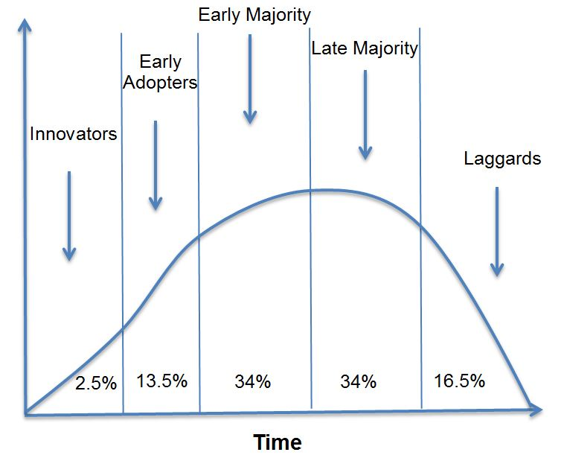

This classification of consumers relates to their willingness to take risks and to switch purchase behaviours relative to particular product categories. For example, a consumer may be an innovator or early adopter of technology products, but perhaps be in the late majority for household furniture. Therefore, these categories are relevant to particular products, not necessarily the consumer themselves – but obviously some people are more risk takers whereas others are more conservative, so there would be some correlation of behaviours across related product categories.

Innovators
Keep in mind that these adopter categories primarily relate to a mind-set, as well as the consumer’s lifestyle and product interest level. Consumers who are classified as innovators are less reliant upon the word of mouth persuasion of others. They are generally more adventurous and more willing to take risks. Relative to the particular the product category, they would tend to have a higher level of knowledge, confidence and interest in the product.
Early adopters
Early adopters also have some of the similar characteristics to innovators. However, they are more reliant upon word-of-mouth and the reassurance of other people’s purchase – which helps reduce their purchase risk. This means that they would be somewhat influenced by the innovator (who has already made a purchase). They will also conduct their own research in addition to word-of-mouth discussion, and also like innovator, they will have a high level of interest in the product category. Opinion leaders – those consumers viewed as experts by other consumers – are typically found among early adopters, as they tend to have better social networks and connections than innovators (as innovators tend to make their purchase decisions irrespective of others). Therefore, early adopters, as opinion leaders, are a foundation to gaining widespread adoption of the new product. Usually the shift of the product life cycle from the introduction to the growth phase is driven by the transition from purchases by innovators to purchases by the early adopters.

Early majority
Early adopters then substantially influence the early majority – which essentially moves the new product to the mainstream consumer. The early majority relies heavily upon positive word-of-mouth, as they tend to be more cautious purchasers and will look to rely upon social influence to help “justify” their decision – both for the product itself and for the particular brand selected. Therefore, at this stage of the market’s development, we have a shift towards market share stabilization as the word-of-mouth impact is now suggesting/recommending certain brand preferences for this particular new product category.

Late majority
The late majority are those consumers that are generally reluctant to change their purchase behaviours, but tend to do so if they feel that they are out of step with what everybody else is doing (that is, outside social norms). It is not until they see the product widespread – in retailers and in people’s homes/possession – that they eventually decide to start buying the product. Typically, the late majority will support the purchases in the decline phase of an alternative/substitute product life cycle, while providing the final growth in the late stage of the growth phase of the PLC (PRODUCT LIFE CYCLE). Because of this behaviour, some of these consumers are “forced” to adopt the new product, as the existing product solutions are being withdrawn from the market (as it is in the decline stage of the PLC).

Laggards
Final mind-set is laggards – which are consumers that may not even adopt the product at all. They are very conservative in their actions (or are quite elderly people) who prefer not to change purchase behaviour. For example, some of these consumers may still have a VCR/video player that they have maintained for many years. They may be troubled by adopting new technology and learning new things or simply have a preference for stability. Either way, laggards are generally not an overly attractive target and usually not worth the effort to try and persuade their thinking. From a marketing perspective, it is just worth considering that there is a proportion of consumers that are prone to avoid new product and any form of innovation.

Adoption in consumer behaviour
It is interesting how consumers learn about products for the first time and decide whether to adopt them. The adoption process for a new product is the mental process through which an individual passes from first learning about an innovation to final adoption” and adoption is the decision by an individual to become a regular user of the product. A new product is a good, service, or idea perceived by some potential customers as new. Though most buyers of a product have some common needs, they are not alike in all respects.
Purchasers in the initial stages of a product’s life are considerably different from those who make their purchases later. Some of their demographic characteristics may vary, their buying behaviour may be distinct, and their purchasing motives may differ.
To describe the various types of buyers who purchase a product over the course of its life cycle, the marketing experts proposed an adoption process.
To build an effective strategy for market penetration (a measure of how much a product or service is being used by target customers compared to the total estimated market for that product or service), management must understand the consumer adoption process. Philip Kotler defines adoption as an individual’s decision to become a regular user of a product.
Stages of the Consumer Adoption Process
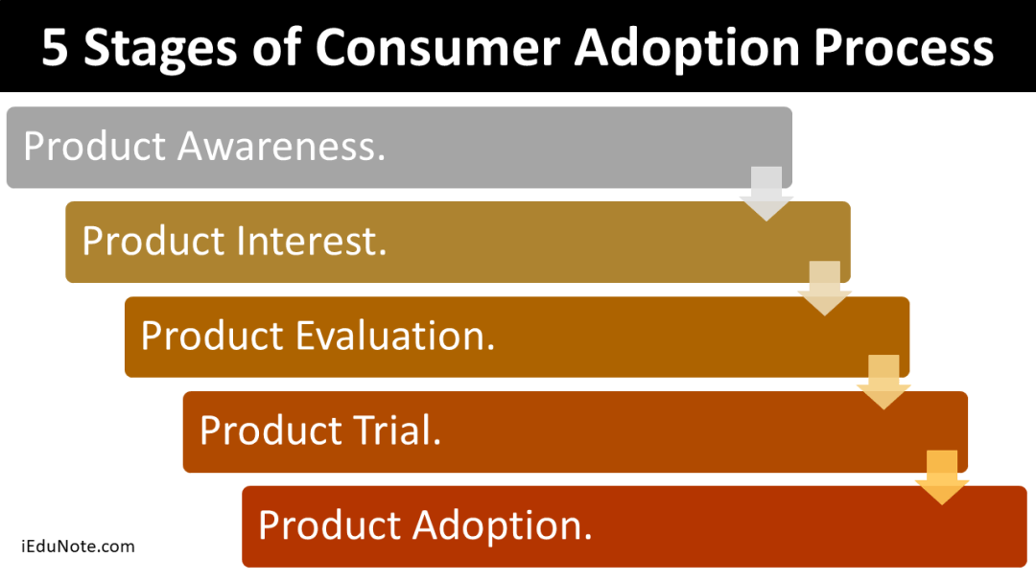

1.Product Awareness
The consumer becomes aware of the new product but lacks information about it. Initially, the consumer must become aware of the new product. Awareness leads to interest, and the customer seeks information about the new product. Whether an innovation is continuous or not, people are either little aware or aware of it initially. The innovator, therefore, has to inform the adopters about the innovation. In the awareness stage, individuals become aware that the product exists, but they have little information about it and are not concerned about getting more. Adopters may be informed through advertising, publicity, or any other effort of the marketer.

2. Product Interest
The consumer seeks information about the new product. Once the information has been gathered, the consumer enters the evaluation stage and considers buying the new product. By this time, the innovation is introduced. It is now the time for the decision-makers to determine whether the innovation relates to their needs. They enter the interest stage when they are motivated to get information about its features, uses, advantages, disadvantages, price, or location. Interest may or may not spark, depending on whether the decision-makers perceive the innovation as a relevant, feasible alternative to existing items.

3. Product Evaluation
Next, in the trial stage, the consumer tries the product on a small scale to improve its value estimate. The consumer considers whether trying the new product makes sense.
Adopters of the innovations have to establish some evaluation measures to compare the new product with existing ones.
During the evaluation stage, individuals consider whether the product will satisfy certain critical criteria for meeting their specific needs. The potential adopters consider the innovation’s benefits and determine whether to try it.
4. Product Trial
The consumer tries the new product on a small scale to improve their estimate of its value. If the consumer is satisfied with the product, they enter the adoption stage, deciding to use the new product thoroughly and regularly. At this stage, the potential adopters examine, test, or try the innovative product to determine its usefulness. In this stage, they use or experience the product for the first time, possibly by purchasing a small quantity, taking advantage of a free sample or demonstration, or borrowing the product from someone. During this stage, potential adopters determine the product’s usefulness under the specific conditions they need. The trial stage for innovations is complex. Successful introduction depends greatly on the new product’s characteristics, benefits, and perceived risks. Effective communication is the key to achieving trial by consumers.

5. Product Adoption
The consumer decides to make full and regular use of the new product. The new product is a good, service, or idea perceived by some potential customers as new. Individuals move into the adoption stage when choosing that specific product when they need a product of that general type. Here the buyers purchase the new product and can be expected to use it to solve problems. So, this final stage of the process is indicated most directly by sales, but the innovation’s visibility is also a success measure.
Factors Affecting the Adoption Process
The three important factors affecting the adoption process are people’s readiness to try new products, personal influence, and innovation characteristics.

- People’s Readiness
People differ in their readiness to accept new products, services, opinions, and ideas. Some people always prefer adopting new market offers. Those who are venturesome and enjoy taking risks, are younger in age, have higher social status, and have favourable financial positions will be innovators. Those who are guided by respect are treated as opinion leaders and consider them cautious about adopting early. The deliberate persons are usually the early majority. Those who are sceptical and follow the majority adopt once a large number of people try the product. Those who are tradition-bound, have insular attitudes, and are suspicious usually accept a product when the masses use it.To understand adopter categories and locate the innovators and early adopters, a marketer should undertake an extensive study based on potential customers’ demographic, psychographic, and media characteristics.

- Personal Influence
Since we are social and human beings, we are always subject to interpersonal influence in our decisions. The degree of personal influence varies according to the buying situation and the individual in question. There are some buying situations where we are influenced more by others. Again, personality type determines the susceptibility of interpersonal influence. The submissive type of person is more influenced by others than the aggressive type of person. In complex buying situations, particularly while buying expensive items, personal influence works more than in simple buying situations and in buying small items.

Opinion leader in Consumer behaviour
Refer pointers from lecture

