UNIT 3

STANDARD COSTING

- Standard costing is a Costing Technique, which helps the management in Cost control.
- Standard Costing helps the management to determine in advance the cost.

- What is Standard ??
- CIMA Terminology defines Standard as - "a Predetermined measurable quantity set in defined conditions against which actual performance can be compared, usually for an element of work, operation or activity.

- What is Standard Costing ?
- Standard Costing is defined by ICWA, LONDON:- “The Preparations of Standard Costs and Applying them to measure the Variations of Actual Costs from Standard Costs and Analysing the Causes of Variations with a view to maintain Maximum efficiency in Production.”

- Standard Costing is possible in industries where production is repetitive in nature.
- Standard Cost is determined before starting the production.

- There are 3 steps of Standard costing
1. Preparation of standard cost and using them
2. Comparing Standard with Actual
3. Analysis of Variance as to their causes and point of of incidence ( why & where they rise)

Need for Standard Costing
1. Comparison and analysis of data.
2. Facilitates budget
3. Better economy, efficiency, & productivity
4. Data available to take managerial decisions
5. Yard- stick to judge performance
6. Cost control
7. For Management by exception.

Points to be considered for Standard Costing
1. It requires High degree of technical skill.
2. Standard set should neither be to high, nor too less.
3. Actual Cost cannot be eliminated even though standards are set
4. Standards need timely revision.

VARIANCE

- A variance is the difference between the standards and the actual performance

- When the actual results are better than the expected results, there will be a Favourable variance (F) / Credit variance/ Positive
- If the actual results are worse than the expected results, there will be an Adverse variance (A)/ Debit Variance / Unfavourable/ Negative

COST VARIANCE
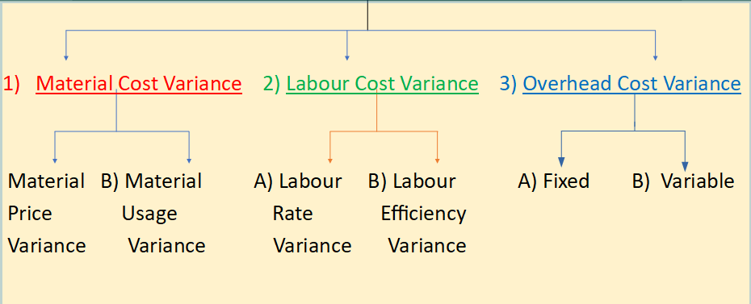
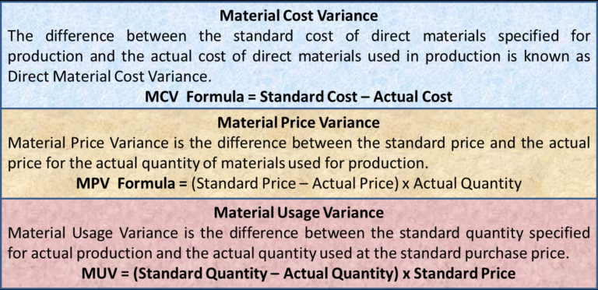
1. Material Cost Variance (MCV) = Standard Cost – Actual Cost
MCV = (SQ X SP) – (AQ X AP)
2. Material Price Variance (MPV) = (SP – AP) X AQ
3. Material Usage Variance (MUV) = (SQ – AQ) X SP

4. Standard Quantity for Actual Output =
$\frac{StandardInput}{Standardoutput}×AO$

LABOUR VARIANCE
Labour Cost Variance is the difference between the Standard Cost of Labour specified for the Output achieved and the Actual Cost of direct labour used.
1. Labour Cost Variance (LCV) = Standard Cost – Actual Cost
LCV = (SH X SR) – (AH X AR)

2. Labour Efficiency (Time) Variance = (SH – AH) X SR

3. Labour Rate Variance (LRV) = (SR – AR) X AH

4.Standard Hours for Actual Output = $\frac{StandardHours}{StandardOutput}×AO$

Q1) Material
From the following particulars calculate:
(i) Material Cost Variance
(ii) Material Price Variance
(iii) Material Usage Variance
 | Standard | Actual
Material | 1,000 kg | 900 kg
Price | Rs. 12 per kg | Rs. 16 per kg
Q2)
Calculate Material Variances from the following
Standard - For 90 kgs of Finished output
Material - 135 kgs @ 12 per kg
Actual Production - 81,000 kgs
Material used - 1,24,000 kgs
Cost of Material used - Rs14,75,600
Q3) A manufacturing concern which has adopted standard costing furnishes the following
(1) Standard Materials for 70 kg. finished products, 100 kg
(2) Standard price of material 1 per kg.
(3) Actual output 2,10,000 kg.
(4) Actual material used 2,80,000 kg.
(5) Cost of material 2,52,000
Calculate : (1) Material usage variance (2) Material price variance (3) Material cost variance
Q4)
( Material)
The standard material cost for 200 units of output is
Material | kg | Rate per kg
A | 50 | 12
B | 100 | 9
C | 100 | 10
The Actual cost for 8000 units is as follows:
Material | kg | Rate
A | 2100 | 28350
B | 3750 | 30750
C | 4150 | 46480

Calculate material cost variance, material price variance and material usage variance.

Q5)
(Material)
From the following particulars calculate
(i) Material Cost Variance
(ii) Material Price Variance
(iii) Material Usage Variance
Material | Standard |  | Actual
 | Units | Price per unit | Units | Price per unit
A | 600 | Rs 3 | 640 | Rs 4
B | 800 | Rs 5 | 960 | Rs 4.5
C | 1000 | Rs 4 | 840 | Rs 5

Q6 )
(Labour)
From the following Info. Calculate
1) Labour cost Variance
2) Labour Rate variance
3) Labour efficiency variance
 | Standard | Actual
No of hours per unit | 360 | 400
Rate per hour | 1.5 | 1.4

Q7)
(Labour)
From the following information calculate
(a)Labour Cost Variance
(b) Labour Rate Variance and
(c) Labour Efficiency Variance
Standard Hours for 4 units | - 24 hours
Standard Rate | - Rs 18 per unit
Actual Production | 1,800 units
Actual Hours | 10,500 hours
Actual Rate | - Rs 3.10 per hours

Q8)

(Labour)
From the following information, calculate Labour Variances.
Standard for 10 units | 5 hours
Standard Rate per unit | Rs 15
Actual Production | 1,60,000 units
Actual Hours Worked | 85,000 hours
Actual Rate Per Hour | Rs 29.8

Q9 )

(Material + Labour)
Calculate material and labour variances from the following data:
For 5 units of Product A, the Standard Data are :
 | Material | 40 kg. | @ Rs | 25.00 per kg.
 | Labour | 100 hours | @ Rs | 2.50 per hour.
Actual data are :
Actual Production - 1000 Units.
 | Material | 7840 kg | @ Rs | 27.00 per kg
 | Labour | 19,800 hours | @ Rs | 2.60 per hour

Q10)

Standard for a unit of production
Material - 2 kgs @ Rs. 5 per kg
Labour - 4 hours @ Rs. 6 per hour
Actual Production - 4,00,000 units
Actual Material Used – 7,90,000 kgs
Actual Hours Worked - 15,80,000 hours
Actual Rate - For Material – Rs. 5.20 per kg
- For Labour - Rs. 6.40 per hour
Calculate all the Material & Labour Variance

