3.1 Production Function

Production is the result of co-operation of four factors of production viz., land, labour, capital and organization.
This is evident from the fact that no single commodity can be produced without the help of any one of these four factors of production.
Therefore, the producer combines all the four factors of production in a technical proportion. The aim of the producer is to maximize his profit. For this sake, he decides to maximize the production at minimum cost by means of the best combination of factors of production.
The producer secures the best combination by applying the principles of equi-marginal returns and substitution. According to the principle of equi-marginal returns, any producer can have maximum production only when the marginal returns of all the factors of production are equal to one another. For instance, when the marginal product of the land is equal to that of labour, capital and organisation, the production becomes maximum.

Meaning of Production Function:
In simple words, production function refers to the functional relationship between the quantity of a good produced (output) and factors of production (inputs).
“The production function is purely a technical relation which connects factor inputs and output.” Prof. Koutsoyiannis
Defined production function as “the relation between a firm’s physical production (output) and the material factors of production (inputs).” Prof. Watson
In this way, production function reflects how much output we can expect if we have so much of labour and so much of capital as well as of labour etc. In other words, we can say that production function is an indicator of the physical relationship between the inputs and output of a firm.
The reason behind physical relationship is that money prices do not appear in it. However, here one thing that becomes most important to quote is that like demand function a production function is for a definite period.
It shows the flow of inputs resulting into a flow of output during some time. The production function of a firm depends on the state of technology. With every development in technology the production function of the firm undergoes a change.
The new production function brought about by developing technology displays same inputs and more output or the same output with lesser inputs. Sometimes a new production function of the firm may be adverse as it takes more inputs to produce the same output.
Mathematically, such a basic relationship between inputs and outputs may be expressed as:
Q = f( L, C, N )
Where Q = Quantity of output
L = Labour
C = Capital
N = Land.
Hence, the level of output (Q), depends on the quantities of different inputs (L, C, N) available to the firm. In the simplest case, where there are only two inputs, labour (L) and capital (C) and one output (Q), the production function becomes.
Q =f (L, C)

Definitions:
“The production function is a technical or engineering relation between input and output. As long as the natural laws of technology remain unchanged, the production function remains unchanged.” Prof. L.R. Klein
“Production function is the relationship between inputs of productive services per unit of time and outputs of product per unit of time.” Prof. George J. Stigler
“The relationship between inputs and outputs is summarized in what is called the production function. This is a technological relation showing for a given state of technological knowledge how much can be produced with given amounts of inputs.” Prof. Richard J. Lipsey
Thus, from the above definitions, we can conclude that production function shows for a given state of technological knowledge, the relation between physical quantities of inputs and outputs achieved per period of time.

Features of Production Function:
Following are the main features of production function:

1. Substitutability:
The factors of production or inputs are substitutes of one another which make it possible to vary the total output by changing the quantity of one or a few inputs, while the quantities of all other inputs are held constant. It is the substitutability of the factors of production that gives rise to the laws of variable proportions.

2. Complementarity:
The factors of production are also complementary to one another, that is, the two or more inputs are to be used together as nothing will be produced if the quantity of either of the inputs used in the production process is zero.
The principles of returns to scale is another manifestation of complementarity of inputs as it reveals that the quantity of all inputs are to be increased simultaneously in order to attain a higher scale of total output.

3. Specificity:
It reveals that the inputs are specific to the production of a particular product. Machines and equipment’s, specialized workers and raw materials are a few examples of the specificity of factors of production. The specificity may not be complete as factors may be used for production of other commodities too. This reveals that in the production process none of the factors can be ignored and in some cases ignorance to even slightest extent is not possible if the factors are perfectly specific.
Production involves time; hence, the way the inputs are combined is determined to a large extent by the time period under consideration. The greater the time period, the greater the freedom the producer has to vary the quantities of various inputs used in the production process.
In the production function, variation in total output by varying the quantities of all inputs is possible only in the long run whereas the variation in total output by varying the quantity of single input may be possible even in the short run.

3.2 Law of Variable Proportions
The law of variable proportions states that as the quantity of one factor is increased, keeping the other factors fixed, the marginal product of that factor will eventually decline. This means that upto the use of a certain amount of variable factor, marginal product of the factor may increase and after a certain stage it starts diminishing. When the variable factor becomes relatively abundant, the marginal product may become negative.
Assumptions: The law of variable proportions holds good under the following conditions:
- Constant State of Technology: First, the state of technology is assumed to be given and unchanged. If there is improvement in the technology, then the marginal product may rise instead of diminishing.
- Fixed Amount of Other Factors: Secondly, there must be some inputs whose quantity is kept fixed. It is only in this way that we can alter the factor proportions and know its effects on output. The law does not apply if all factors are proportionately varied.
- Possibility of Varying the Factor proportions: Thirdly, the law is based upon the possibility of varying the proportions in which the various factors can be combined to produce a product. The law does not apply if the factors must be used in fixed proportions to yield a product.
Illustration of the Law: The law of variable proportion is illustrated in the following table and figure. Suppose there is a given amount of land in which more and more labour (variable factor) is used to produce wheat.
Units of Labour | Total Product | Marginal Product | Average Product
1 | 2 | 2 | 2
2 | 6 | 4 | 3
3 | 12 | 6 | 4
4 | 16 | 4 | 4
5 | 18 | 2 | 3.6
6 | 18 | 0 | 3
7 | 14 | -4 | 2
8 | 8 | -6 | 1
It can be seen from the table that upto the use of 3 units of labour, total product increases at an increasing rate and beyond the third unit total product increases at a diminishing rate. This fact is shown by the marginal product which is the addition made to Total Product as a result of increasing the variable factor i.e. labour.
It can be seen from the table that the marginal product of labour initially rises and beyond the use of three units of labour, it starts diminishing. The use of six units of labour does not add anything to the total production of wheat. Hence, the marginal product of labour has fallen to zero. Beyond the use of six units of labour, total product diminishes and therefore marginal product of labour becomes negative. Regarding the average product of labour, it rises up to the use of third unit of labour and beyond that it is falling throughout.
Three Stages of the Law of Variable Proportions: These stages are illustrated in the following figure where labour is measured on the X-axis and output on the Y-axis.
Stage 1. Stage of Increasing Returns: In this stage, total product increases at an increasing rate up to a point. This is because the efficiency of the fixed factors increases as additional units of the variable factors are added to it. In the figure, from the origin to the point F, slope of the total product curve TP is increasing i.e. the curve TP is concave upwards upto the point F, which means that the marginal product MP of labour rises. The point F where the total product stops increasing at an increasing rate and starts increasing at a diminishing rate is called the point of inflection. Corresponding vertically to this point of inflection marginal product of labour is maximum, after which it diminishes. This stage is called the stage of increasing returns because the average product of the variable factor increases throughout this stage. This stage ends at the point where the average product curve reaches its highest point.
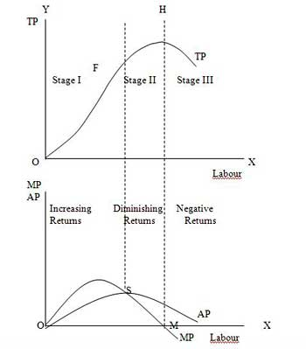
Stage 2. Stage of Diminishing Returns: In this stage, total product continues to increase but at a diminishing rate until it reaches its maximum point H where the second stage ends. In this stage both the marginal product and average product of labour are diminishing but are positive. This is because the fixed factor becomes inadequate relative to the quantity of the variable factor. At the end of the second stage, i.e., at point M marginal product of labour is zero which corresponds to the maximum point H of the total product curve TP. This stage is important because the firm will seek to produce in this range.
Stage 3. Stage of Negative Returns: In stage 3, total product declines and therefore the TP curve slopes downward. As a result, marginal product of labour is negative and the MP curve falls below the X-axis. In this stage the variable factor (labour) is too much relative to the fixed factor.

Importance and Applicability of the Law of Variable Proportion:
The Law of Variable Proportion has universal applicability in any branch of production. It forms the basis of a number of doctrines in economics. The Malthusian theory of population stems from the fact that food supply does not increase faster than the growth in population because of the operation of the law of diminishing returns in agriculture.
Ricardo also based his theory of rent on this principle. According to him rent arises because the operation of the law of diminishing return forces the application of additional doses of labour and capital on a piece of land. Similarly the law of diminishing marginal utility and that of diminishing marginal physical productivity in the theory of distribution are also based on this theory.
The law is of fundamental importance for understanding the problems of underdeveloped countries. In such agricultural economies the pressure of population on land increases with the increase in population. This leads to declining or even zero or negative marginal productivity of workers. This explains the operation of the law of diminishing returns in LDCs in its intensive form. Ragnar Nurkse have suggested ways to make use of these disguisedly unemployed labour by withdrawing them and putting them in those occupations where the marginal productivity is positive.

3.3 Law of Returns to Scale and Returns to Scale
In the long run all factors of production are variable. No factor is fixed. Accordingly, the scale of production can be changed by changing the quantity of all factors of production.

Definition:
“The term returns to scale refers to the changes in output as all factors change by the same proportion.” Koutsoyiannis
“Returns to scale relates to the behaviour of total output as all inputs are varied and is a long run concept”. Leibhafsky
Returns to scale are of the following three types:
1. Increasing Returns to scale.
2. Constant Returns to Scale
3. Diminishing Returns to Scale

Explanation:
In the long run, output can be increased by increasing all factors in the same proportion. Generally, laws of returns to scale refer to an increase in output due to increase in all factors in the same proportion. Such an increase is called returns to scale.
Suppose, initially production function is as follows:
P = f (L, K)
Now, if both the factors of production i.e., labour and capital are increased in same proportion i.e., x, product function will be rewritten as.
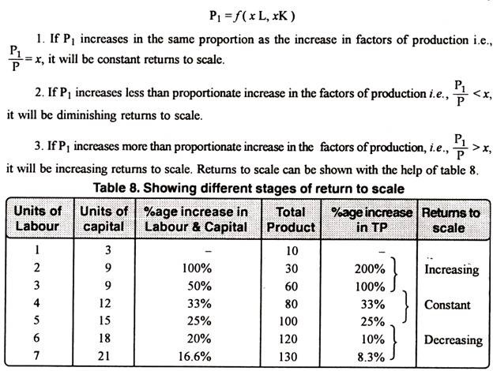
The above stated table explains the following three stages of returns to scale:

1. Increasing Returns to Scale:
Increasing returns to scale or diminishing cost refers to a situation when all factors of production are increased, output increases at a higher rate. It means if all inputs are doubled, output will also increase at the faster rate than double. Hence, it is said to be increasing returns to scale. This increase is due to many reasons like division external economies of scale. Increasing returns to scale can be illustrated with the help of a diagram 8.

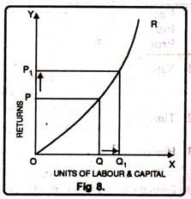
In figure 8, OX axis represents increase in labour and capital while OY axis shows increase in output. When labour and capital increases from Q to Q₁, output also increases from P to P₁ which is higher than the factors of production i.e. labour and capital.

2. Diminishing Returns to Scale:
Diminishing returns or increasing costs refer to that production situation, where if all the factors of production are increased in a given proportion, output increases in a smaller proportion. It means, if inputs are doubled, output will be less than doubled. If 20 percent increase in labour and capital is followed by 10 percent increase in output, then it is an instance of diminishing returns to scale.
The main cause of the operation of diminishing returns to scale is that internal and external economies are less than internal and external diseconomies. It is clear from diagram 9.
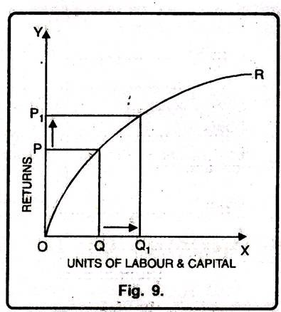
In this diagram 9, diminishing returns to scale has been shown. On OX axis, labour and capital are given while on OY axis, output. When factors of production increase from Q to Q₁ (more quantity) but as a result increase in output, i.e. P to P₁ is less. We see that increase in factors of production is more and increase in production is comparatively less, thus diminishing returns to scale apply.

3. Constant Returns to Scale:
Constant returns to scale or constant cost refers to the production situation in which output increases exactly in the same proportion in which factors of production are increased. In simple terms, if factors of production are doubled output will also be doubled.
In this case internal and external economies are exactly equal to internal and external diseconomies. This situation arises when after reaching a certain level of production, economies of scale are balanced by diseconomies of scale. This is known as homogeneous production function. Cobb-Douglas linear homogenous production function is a good example of this kind. This is shown in diagram 10. In figure 10, we see that increase in factors of production i.e. labour and capital are equal to the proportion of output increase. Therefore, the result is constant returns to scale.

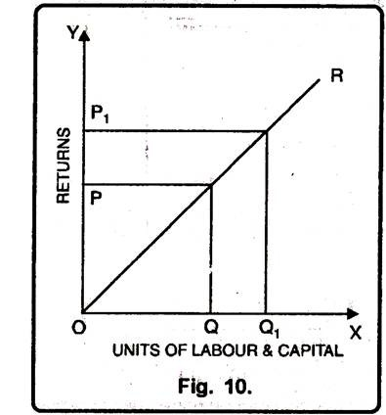

3.4 Cost-Output Relation during Short Run or Short Run Cost Curves
Time element plays an important role in price determination of a firm. During short period two types of factors are employed. One is fixed factor while others are variable factors of production. Fixed factor of production remains constant while with the increase in production, we can change variable inputs only because time is short in which all the factors cannot be varied.
Raw material, semi-finished material, unskilled labour, energy, etc., are variable inputs which can be changed during short run. Machines, capital, infrastructure, salaries of managers and technical experts are included in fixed inputs. During short period an individual firm can change variable factors of production according to requirements of production while fixed factors of production cannot be changed.

The cost-output relation during short period can be studied with the help of short run cost curves based on short run costs as given below:

A. Short Run Total Costs:
Short run total costs of a firm are of following types:

(1) Total Costs: Those costs which are incurred by a firm in the production of any commodity on the basis of total fixed cost and total variable cost.
Total costs are calculated on the basis of the following formula:
Total cost (TC) = Total fixed cost (TFC) + Total variable cost (TVC)
Total costs change due to change in the total variable costs only during short period because total fixed costs (TFC) remain constant.

Short run total costs can be seen from the following table:
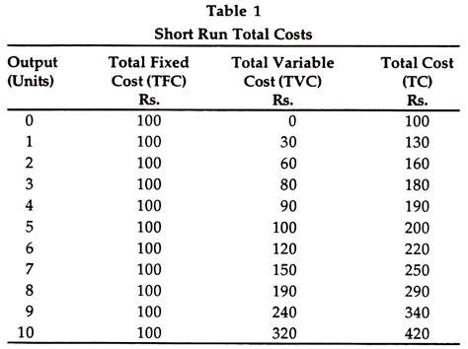
The table reveals that total fixed cost remain constant when the production is zero or its is increasing while total variable cost is zero when production is zero and it changes with the change in output and total cost is the aggregate of total fixed cost and total variable cost.

(2) Total Fixed Cost (TFC): Those costs which remain constant when the output is zero as well as it is increasing are called total fixed costs. Such costs are borne by the firm whether there is production or not. These costs are not concerned with the production of a commodity. Plant, land and building, machinery, tools, equipment, implements, contractual rent, insurance fee, maintenance cost, property tax, interest on the capital, manager’s salary, etc., are the items which are included in total fixed costs.
These costs are borne even there is zero production during short period. The Table 1 shows when production is zero the total fixed cost is Rs. 100 and when it is 10 units even then it is Rs. 100. Hence, total fixed costs remain constant. These costs are also known as supplementary costs, general costs, indirect costs and overhead costs.

(3) Total Variable Costs (TVC): Those costs which vary with the production of a commodity during short period and they have direct relation with the change in production. When production is zero these costs will be zero and when production increases they will move in the same direction. These costs are incurred on raw material, direct wages and expenses on energy or power. Variable costs are also called prune costs or direct costs. Total variable costs show an increasing trend as shown in Diagram 1.
Thus, total costs are the summation (aggregates) of total fixed costs and total variable costs. All these costs are related to short run production. They are shown in the Diagram 2 on the basis of the Table 2.
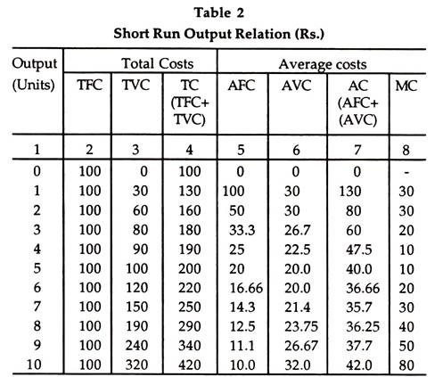
The Diagram 2 shows TC, TFC and TVC. TFC is parallel to OX-axis and it remains constant whether production is zero or it is 10 units. TVC starts from zero production where it is zero and goes on increasing with the increase in output. TC is the total of TFC and TVC. When production is zero total cost is equal to TFC and it increases with increase in production. The difference between TVC and TC is equivalent to TFC which remains constant.
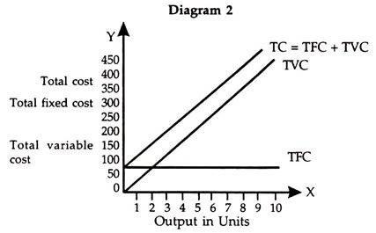

B. Average Costs or Per Unit Costs:
During short period average costs or per unit costs can be divided into following categories:
(1) Average fixed costs (AFC)
(2) Average variable costs (AVC)
(3) Average Costs (AC)
(4) Marginal Cost (MC).

(1) Average Fixed Cost (AFC):
The average fixed cost is the total fixed cost divided by the volume of output. There is an inverse relation between output and average fixed cost. With the increase in output average fixed cost decreases and with the decrease in output the average fixed cost will increase. The shape of average fixed cost curve becomes rectangular hyperbola with the increase in output.
It is calculated from the following formula:
AFC = TFC/Q
Q is volume of output AFC and TFC are average fixed cost and total fixed cost.

(2) Average Variable Cost (AVC):
The average variable cost is total variable cost divided by the volume of output. Average variable cost falls with the increase in output, reaches at its minimum and then starts rising. By the operation of law of increasing returns the AVC decreases, and by the operation of constant returns leads to constancy in AVC and the law of diminishing returns leads to increase in AVC. The shape of AVC is U-shaped because of the operation of the laws of returns during short period.
The AVC is calculated by the formula given below:
AVC = TVC/Q
AVC and TVC are average variable cost and total variable cost while Q is the volume of output.

(3) Average Cost (AC):
Average cost is also called average total cost (ATC) during short period because it is the aggregate of AFC and AVC. AC can be calculated from total cost (TC) divided by the volume of output or by aggregating AVC and AFC.
The following is the formula of calculating AC:
AC = TC/Q
AC and TC are average cost and total cost while Q is the volume of output.
Another formula for the calculation of AC is as given under:
AC = AFC + AVC
The AC curve decreases with the increase in output and remains constant up to a point and thereafter it increases with the increase in output. Its shape is U-shaped because of the operation of the laws of return during short period.

(4) Marginal Cost (MC):
It is an addition to total cost by producing an additional unit of output. It can be calculated as the change in total cost divided by an additional unit change in the output.
The formula for its calculation is as given below:
MC = ΔTC/ΔQ
MC= TC_{n} -TC_{n-1}
MC is marginal cost, ΔTC is change in TC and ΔQ is change in the volume of output while TC_{n} is the last value while TC_{n-1} is the last but one value.
For example, if the total cost (TC) of 5 units of a commodity is Rs. 550 and 6 units of a commodity is Rs. 600, then the marginal cost of 6th units is Rs. 50.
It can be calculated on the basis of the above formula as given under:
MC = ΔTC/ΔQ = 50/1 = 50 or Rs. 50
The MC cost changes with the change in AVC and it is independent of fixed cost. In the beginning the MC falls, reaches at its minimum and thereafter continuously rises. MC is also U- shaped. The MC curve cuts the AC and AVC curves at their minimum points.
The cost-output relation during short period can be seen from Table 2.
The table reveals the trends in total costs (TFC and TVC), average cost (AFC and TVC) and MC. TFC remains constant and TVC goes on increasing and consequently TC is also increasing. AFC is decreasing, but it is positive. AVC decreases, remains constant and thereafter increases. AC also decreases, remains constant and shows an increasing trend. MC increases, remains constant and thereafter shows an increasing trend.
On the basis of the Table 2 we can show the costs and output relation during short period in the following diagram:
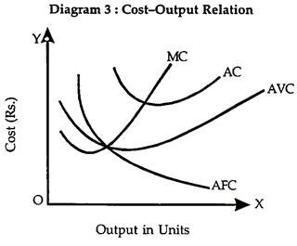
The diagram shows AC, AFC, AVC and MC on OY-axis and units of output on OX-axis. AC, MC and AVC are U-shaped curves. The U-shaped curves are on account of the operation of the laws of return during short period. AFC curve shows a decreasing trend. MC curve passes through the minimum points of AC and AVC curves.
There is a close relationship between AC and MC as given below:
(1) AC and MC fall in the beginning but MC falls more rapidly than AC and MC is below AC or AC is greater than MC (AC>MC).
(2) When AC rises, MC also rises but it rises more rapidly than the AC and MC is greater than AC (MC>AC).
(3) When AC is minimum it is equal to AC. The MC curve cuts the AC curve at its minimum point.
The relation between AC and MC can be seen from the following diagram during short period:
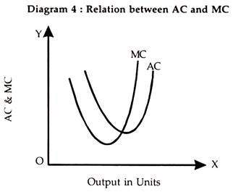
The diagram shows AC and MC on OY-axis and volume of output on OX-axis.

Cost-Output Relation during Long Run or Long Run Cost Curves
Long period gives sufficient time to business managers to change even the scale of production. All the factors of production are variable. All the costs are variable costs and there is no fixed cost. The supply of goods can be adjusted to their demands because scale of production and factors of production can be changed. In the long run we can study the long run average cost curve and long run marginal cost curve.

I. Long Run Average Cost (LAC): In the long run, all the factors of production are variable and the firm has a variety of choices to select the size of the plants and the factors of production to be employed. Various short run average cost curves represent the various sizes of the plants available to a firm. We can get the long run average cost curve with the help of all the short run average cost curves. The long run average cost curve envelopes all the short run average cost curves in it. It is also called an ‘Envelope Curve’ or ‘Planning Curve’.
The long run average cost curve is also a flat U-shaped curve as shown in the following diagram:
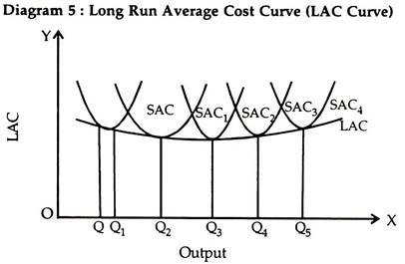
The diagram shows long run cost on OY-axis and output on OX-axis. SAC, SAC₁, SAC₂, SAC₃ and SAC₄ are short run average cost curves which represent the different size of plants. LAC has been drawn by combining all those points of least cost of producing the corresponding output. The least per unit cost of production is OQ, OQ₁, OQ₂, OQ₃, OQ₄, and OQ₅ respectively.

II. Long Run Marginal Cost (LMC): The long run marginal cost is an addition to the long run total cost when an additional unit of a commodity is produced. It is calculated as the short run marginal cost is calculated. Long run marginal cost curve is also U-shaped but the fall and rise in the marginal cost curve is not sharp but it is gradual.
The LAC and LMC can be seen from the following diagram:
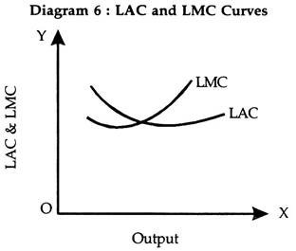
The diagram shows that LAC and LMC are shown on OY- axis while output is shown on OX-axis. The shape of LAC and LMC are U-shaped. The relation between LAC and LMC is the same as is between short run average cost (SAC) and short run marginal cost (SMC) curves. The LMC curve cuts the LAC curve from its minimum point.

Why LAC Curve is U-Shaped?
In the short run SAC curve is U-shaped because the laws of return operate but in the long run LAC is also U-shaped because the laws of return of scale operate, namely, law of increasing returns to scale, law of constant returns to scale and the law of diminishing returns to scale.
As the level of output is expanded or scale of operation is increased by the large firm they will enjoy economies of scale but if these firms produce beyond their installed capacity then they might get diseconomies of scale. Economies of scale bring down the fall in unit cost and diseconomies results into rise in it.

What is Isoquant and Isocost Line in Production Theory?
A firm’s bank objective is profit maximisation. If, in the short run, its total output remains fixed (due to capacity constraint) and if it is a price-taker (i.e., cannot fix the price or change price on its own as in a purely competitive market) its total revenue will also remain fixed. Therefore, the only way to maximise profit is to minimise cost. Thus, profit maximisation and cost minimisation are the two sides of the same coin.
Moreover, supply depends on cost of production. The decision to supply an extra unit depends on the marginal cost of producing that unit. Perhaps the most important determinant of the firm’s price-output decision in any market is its cost of production.
The firm’s cost, in its turn, depends on two key factors, viz.:
(1) The technical relation between inputs and output (i.e., how outputs vary as inputs vary), and
(2) Factor prices (i.e., the price of labour or the wages, the price of capital or the interest rate and so on).
The long-run production function of a firm involving the usage of two factors, say, capital and labour is represented by equal-product curve or isoquant. This curve is also known as a producer’s indifference curve. An isoquant traces out the combinations of any two inputs which yield the same level of output.
This combinations must be the most efficient ones — i.e., any point on an isoquant shows the minimum quantities of the inputs required to produce a given output. Isoquants are typically drawn as being convex to the origin because of the assumed substitutability of inputs.
Isoquants:
An isoquant is a locus of points showing all the technically efficient ways of combining factors of production to produce a fixed level of output. It is also known as the equal product curve. In case of two variable factors, labour and capital, an isoquant appears as a curve on a graph the axes of which measure quantities of the two factors. The curve shows the efficient alternative techniques of production or alternative combinations of two factors that can produce a fixed level of output.
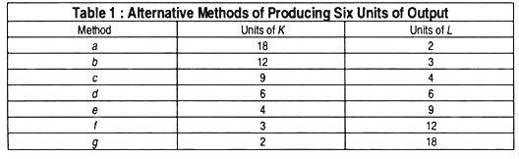
Table 1 illustrates, by using hypothetical numbers, seven alternative methods of producing six units of output. These alternatives are shown also in Fig. 5, as represented by the curve Q = 6. Thus, the firm could choose combination a (18_{K} + 2_{L}), combination g (2_{K} + 18_{L}) or any other combination shown in Table 1.
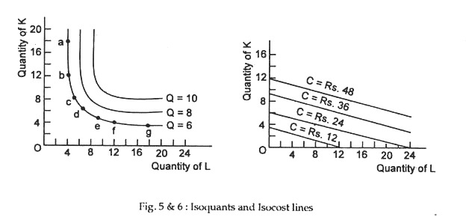
Fig. 5 shows two other isoquants, each corresponding to particular (fixed) level of output, viz., Q = 8 and Q = 10. Each curve shows the alternative combinations of labour and capital that would produce 8 and 10 units of output, respectively. We could draw as many isoquants as we like.
Isocost Lines:
An isoquant shows what a firm is desirous of producing. But, the desire to produce a commodity is not enough. The producer must have sufficient capacity to buy necessary factor inputs to be able to reach its desired production level. The capacity of the producer is shown by his monetary resources, i.e., his cost outlay (or how much money he is capable of spending) on capital and labour, the prices of which are taken as constant, i.e.’, given in the market place.
So, like the consumer the producer has also to operate under a budget (resource) constraint. This is picturised by his budget line called isocost line. To find the least cost combination of inputs to produce a given output, we need to construct such equal cost lines or isocost lines.
An isocost line is a locus of points showing the alternative combinations of factors that can be purchased with a fixed amount of money. In fact, every point on a given isocost line represents the same total cost. To construct isocost lines we need information about the market prices of the two factors. For example, suppose, the price of labour is Re. 1 per unit and the price of capital is Rs. 4 per unit.
Then an outlay of Rs. 36 could buy 9_{K} + 0_{L}, 36_{L} + 0_{K}, or other combinations such as 5_{K} + 16_{L}. All these and other various combinations are shown in Fig. 2 by isocost line C = Rs. 36. Isocost lines C = Rs. 12, C = Rs. 24 and C = Rs. 48 show the alternative combinations of capital and labour that can be purchased or hired by spending Rs. 12, Rs. 24 and Rs. 48, respectively.
These lines are straight lines because factor prices are constant and they have a negative slope equal to the factor-price ratio, i.e., the ratio of labour price to capital price (i.e., the wage ratio -5- the rate of interest).
Cost Minimisation:
Here, the firm seeks to minimise its cost of producing a given level of output. To find the least-cost combination of factors for fixed level of output we combine Fig. 5 and Fig. 6 in Fig. 7. Suppose, the producer wants to produce six units of output. He could do so using the combination represented by points A, B or C in Fig. 3.
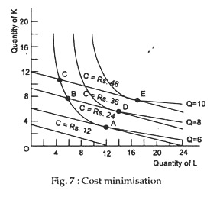
For example, the cost would be Rs. 48 at C, Rs. 36 at B and Rs. 24 at A. The cheapest method is at A, where the isoquant for output of six (Q = 6) is tangent to an isocost line (C = Rs. 24). In Fig. 3 the firm tries to find out the least expensive factor combination along its isoquant. It looks for that factor combination that is on the lowest of the isocost lines. Where the isoquant touches (but does not cross) the lowest isocost line is the least cost position.
The tangency point shows that optimisation in production is reached when factor prices and marginal product are proportional, with equalised marginal product per rupee. The minimum-cost points are A, D and E. Each such point shows the equilibrium factor combination for maximising output subject to cost constraint, i.e., subject to fixed factor prices and fixed outlay (on resources).
We may now speak a few words about the slopes of isoquant and an isocost line. The slope of an isoquant gives the marginal rate of technical substitution (MKTS) defined as the increase in the quantity of one factor that is required to replace a unit decrease in another factor, when output is held constant along any isoquant. It is also known as the desired rate of factor substitution, i.e., the rate at which the producer wants to substitute one factor by the other.
MKTS is, in fact, the ratio of the marginal products of the factors. To see this, consider an example. Assume that output is such that the MP_{L} and the MP_{K} are both equal to 2 (units of output), i.e., MP_{K} = MP_{L}. If the firm is to maintain the same level of output while reducing capital by one unit, it needs to replace one unit of capital by one unit of labour. If at another point on the same isoquant, the MP_{L} = 2, while the MP_{K} = 1, the firm needs to replace a unit of capital with only half unit of labour.
An isocost line shows the alternative quantities of two factors viz., capital and labour that can be purchased or hired with a fixed sum of money. Its slope is given by the ratio of the prices of the two factors. It is known as the actual rate of factor substitution, the rate at which the firm can substitute labour by capital in the market place.
Thus, in Fig. 3, given the prices of labour and capital at Re 1 and Rs. 4 per unit, respectively, the slope of C = Rs. 12 is determined by drawing the line joining points 3K + 0L (which represents outlay of Rs. 12 entirely on capital) and 12L + OK (Rs. 12 spent entirely on labour). All the isocost lines in the diagram have the same slope because the relative prices of labour and capital are the same. If labour were relatively more expensive, the isocost lines would be steeper in Fig. 2.
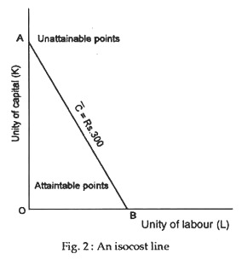
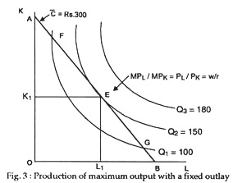
Conclusion:
Cost minimisation occurs when an isoquant is just tangent to (but does not cross) an isocost line. When this happens the ratio of the prices of factors is the same as the ratio of their marginal products. Symbolically
MP_{L}/MP_{K} = P_{L}/P_{K}

