CHAPTER 4

PROCESS COSTING


- 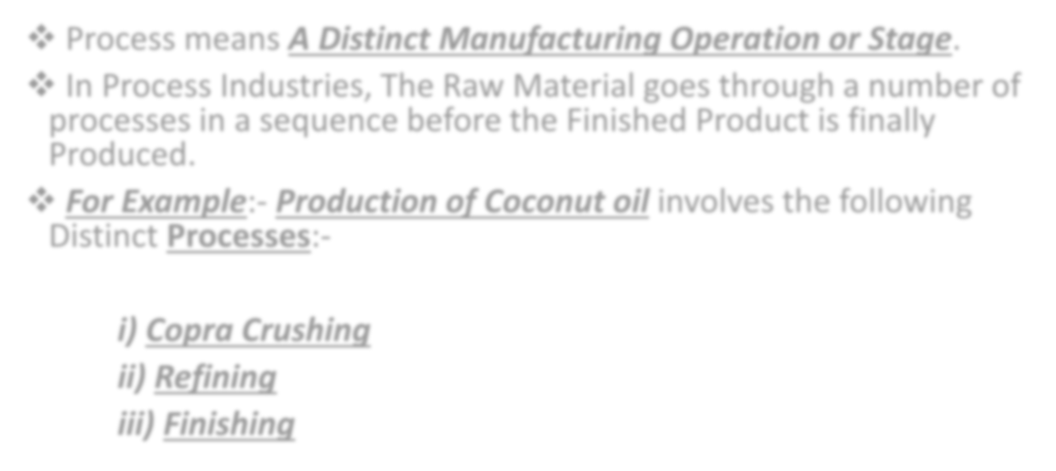Process means A Distinct Manufacturing Operation or Stage.
- In Process Industries, The Raw Material goes through a number of processes in a sequence before the Finished Product is finally Produced.
- For Example:- Production of Coconut oil involves the following Distinct Processes:-

Copra Crushing
  - Refining

Finishing


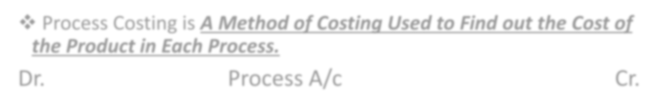

- Process Costing is A Method of Costing Used to Find out the Cost of the Product in Each Process.
Dr. Process A/c Cr.
Particulars | Units | Rate | ₹ | Particulars | Units | Rate | ₹
To Input/ Basic Material Introduced | xx | xx | xx | By Sale of Residue ( Normal Loss) | xx | xx | xx
To Materials |  |  | xx | By Abnormal Loss | xx | xx | xx
To Labour/ Wages |  |  | xx | By Transfer to Next  Process/Finished Goods | xx | xx | xx
To Expenses |  |  | xx
To Overheads |  |  | xx
To Abnormal gain | xx |  | xx
 | xx |  | xx |  | xx |  | xx

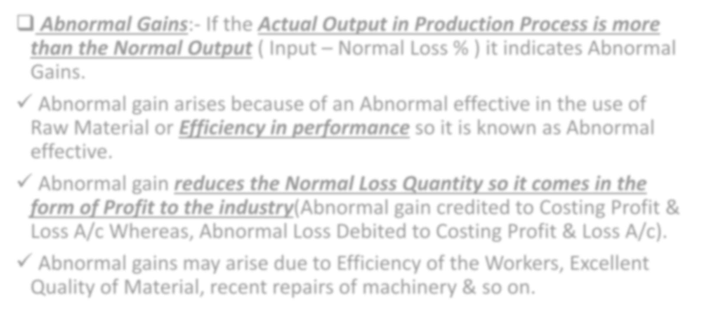


- Abnormal Gains:- If the Actual Output in Production Process is more than the Normal Output ( Input – Normal Loss % ) it indicates Abnormal Gains.
- Abnormal gain arises because of an Abnormal effective in the use of Raw Material or Efficiency in performance so it is known as Abnormal effective.
- Abnormal gain reduces the Normal Loss Quantity so it comes in the form of Profit to the industry(Abnormal gain credited to Costing Profit & Loss A/c Whereas, Abnormal Loss Debited to Costing Profit & Loss A/c).
- Abnormal gains may arise due to Efficiency of the Workers, Excellent Quality of Material, recent repairs of machinery & so on.


- 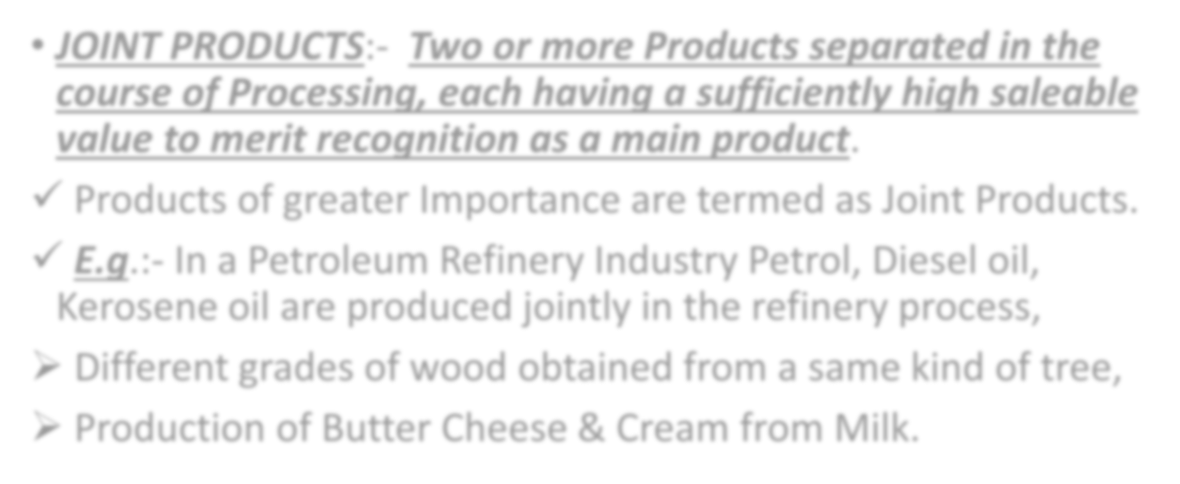JOINT PRODUCTS:- Two or more Products separated in the course of Processing, each having a sufficiently high saleable value to merit recognition as a main product.
- Products of greater Importance are termed as Joint Products.
- E.g.:- In a Petroleum Refinery Industry Petrol, Diesel oil, Kerosene oil are produced jointly in the refinery process,
- Different grades of wood obtained from a same kind of tree,
- Production of Butter Cheese & Cream from Milk.



BY-PRODUCTS:- By-products are Products of relatively small value which emerge incidentally in the course of manufacturing the main product.
- It’s a Subsidiary or Secondary product arises as a result of manufacture of the main product.
- E.g:- By-Products are molasses in the manufacture of sugar,
- Glycerin obtained in the manufacture of soap,
- Fruit oil recovered during the peeling(remove a thin outer covering or part) of Processed fruit.
- Straw from grain harvesting, Ash from fuel combustion etc.




No. | PARTICULARS | Process I | Process II | Process III
1) | Input (given) | xx | xx | xx
2) | Normal Loss % (given) | % | % | %
3) | Normal Loss (1x2) | xx | xx | xx
4) | Normal Output (1-3) | xx | xx | xx
5) | Actual Output (given) | xx | xx | xx
6) | Abnormal Loss (4-5) | xx | xx | xx
7) | Abnormal Gain (5-4) | xx | xx | xx




No. | PARTICULARS | Process I  ₹ | Process II  ₹ | Process III  ₹
1) | Cost of Process (Only Debit side total) | XX | XX | XX
2) | Less:- Normal Loss Value | XX | XX | XX
3) | Net Cost ( 1-2) | XX | XX | XX
4) | Normal Output | XX | XX | XX
5) | Cost Per Unit (CPU) (3/4) | XX | XX | XX


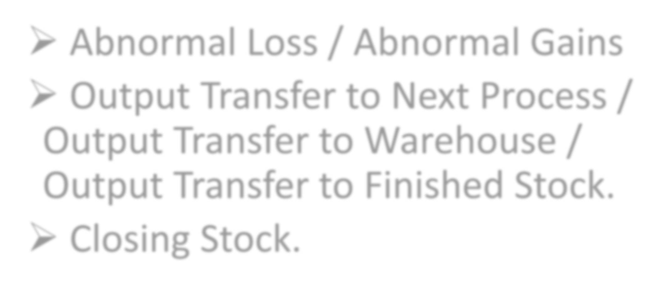Abnormal Loss / Abnormal Gains
- Output Transfer to Next Process / Output Transfer to Warehouse / Output Transfer to Finished Stock.

Closing Stock.

