
MODULE 4 ^{FYBCOM} GOODWILL

The term Goodwill is difficult to define but easy to explain. It is an intangible fixed asset having a realizable value.
Basic features of Goodwill:
- asset of a business but intangible.
- It helps the business to earn profit more than it’s normal profit.
- It is created by variety of factors.

CLASSES OF GOODWILL
LOCAL : A retail shopkeeper in a busy market centre.
THE PERSONAL REPUTATION OF THE GOODWILL : Accountant or a Doctor thru his skills , influence and personality.
THE REPUTATION OF THE GOODS SOLD : A well advertised brand of a good having a high standard of quality.
THE ABSENCE OF COMPETITION : Absolute or partial monopoly.
FACTORS/CAUSES GIVING RISE TO GOODWILL:
- Location: A particular location can give an immense advantage to a business. Ex: Fort Area or Nariman Point
- Owner or Manager: The personality, reputation , contacts or skills of the owner plays an important role in creating goodwill . Ex: Professionals like Doctors, Architects, Lawyers, CA etc
- Nature of Business : If a concern enjoys monopoly, it is able to earn high profits due to absence of competition giving rise to Goodwill.

METHODS OF VALUATION OF GOODWILL
No. of Years Capitalization Annuity
Purchase Method Method
Average Future Super Super Future
Method Maintainable Profit Profit Maintainable
Profit Method Method Profit

A. AVERAGE PROFIT METHOD
- Goodwill = No. of Year’s Purchase * Average Profit /Weighted Average Profit
- Average Profit= Total Profit
No. of Years
OR
Weighted Average Profit = Total Profit (Product)
Total Weight

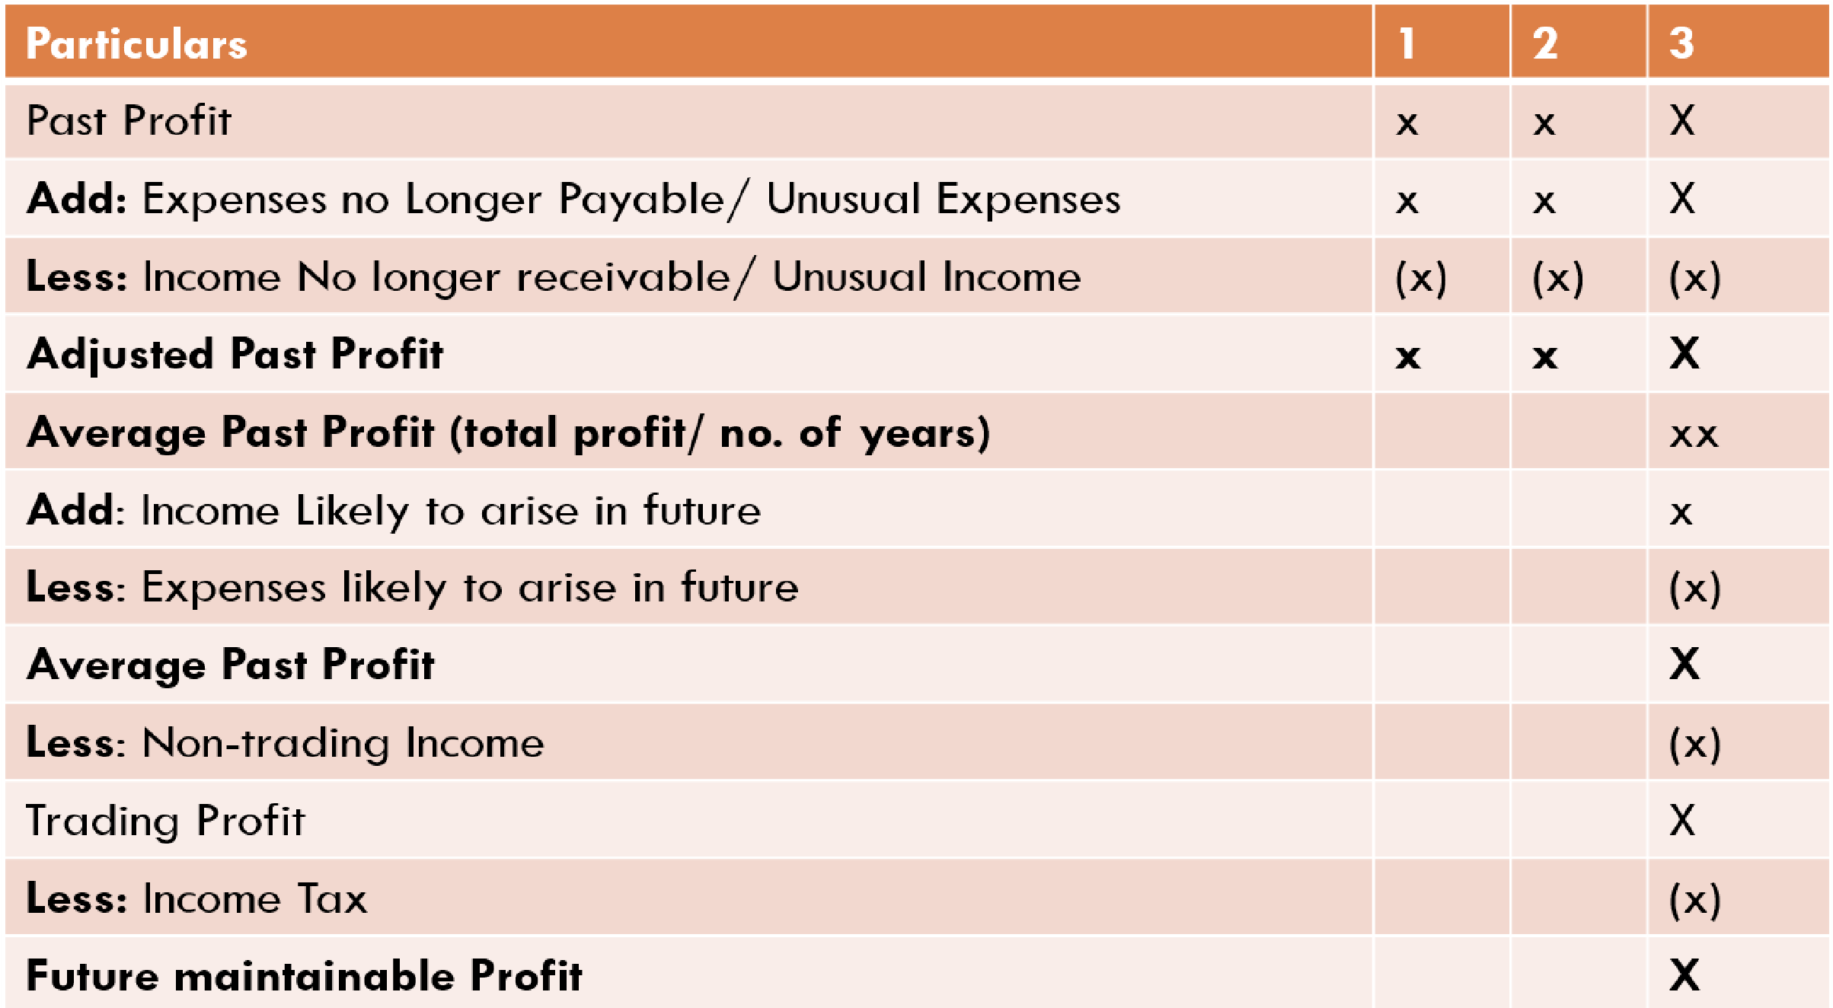
B. FUTURE MAINTAINABLE PROFIT METHOD
- Goodwill = No. of Years Purchase * Future Maintainable Profit
- Future Maintainable Profit Method =

SUPER PROFIT METHOD
- Goodwill = No. of year Purchase * Super Profit
- Super Profit = FMP – Normal Profit
- FMP = as above
- Normal Profit= Average Capital Employed*Normal rate of Return (NRR)
- NRR = Rate of Risk + Rate of Return
OR
NRR= Dividend per share * 100
Market Price Per Share
Calculation of Average Capital Employed
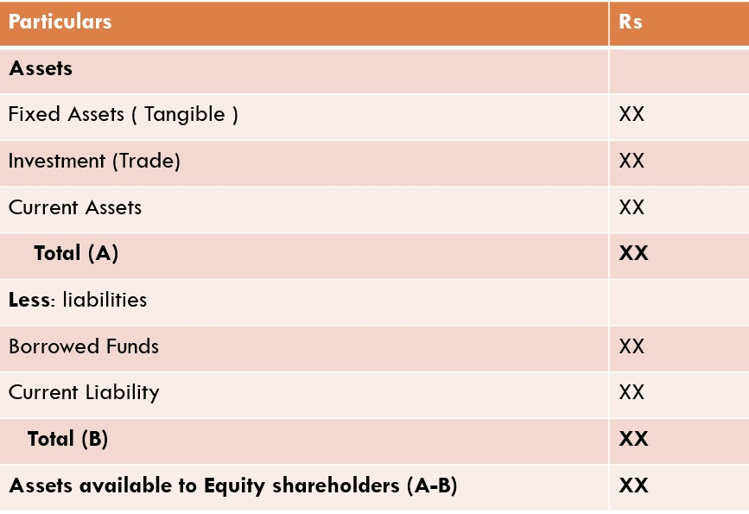

A. SUPER PROFIT METHOD
Goodwill = Super Profit
NRR

B. FUTURE MAINTAINABLE PROFIT METHOD
❑Goodwill = FMP - Average Capital Employed
NRR



Goodwill = Super Profit * Annuity Rate

