Module 1. PRODUCTION INVENTORY MANAGEMENT

Production Management: Objectives, Scope
Production Planning &Control: Steps, Importance
Production Systems: Concept, Types - Continuous and Intermittent.
Productivity: Concept, Factors Influencing Productivity, Measures for improving Productivity.
Principles of good plant layout, Types of layout
Inventory Management- Objectives, Inventory Control Techniques.
Scientific Inventory Control System – Importance

MEANING OF PRODUCTION

Since the primary purpose of economic activity is to produce utility for individuals, we count as production during a time period all activity which either creates utility during the period or which increases ability of the society to create utility in the future.
Business firms are important components (units) of the economic system.
They are artificial entities created by individuals for the purpose of organising and facilitating production. The essential characteristics of the business firm is that it purchases factors of production such as land, labour, capital, intermediate goods, and raw material from households and other business firms and transforms those resources into different goods or services which it sells to its customers, other business firms and various units of the government as also to foreign countries.

Definition of Production:
According to Bates and Parkinson:
“Production is the organised activity of transforming resources into finished products in the form of goods and services; the objective of production is to satisfy the demand for such transformed resources”.
According to J. R. Hicks:
“Production is any activity directed to the satisfaction of other peoples’ wants through exchange”. This definition makes it clear that, in economics, we do not treat the mere making of things as production. What is made must be designed to satisfy wants.

PRODUCTION MANAGEMENT: MEANING, DEFINITION, FUNCTION AND SCOPE

Meaning of Production Management:
Production Management refers to the application of management principles to the production function in a factory. In other words, production management involves application of planning, organizing, directing and controlling the production process.
The application of management to the field of production has been the result of at least three developments:
(i) First is the development of factory system of production. Until the emergence of the concept of manufacturing, there was no such thing as management as we know it. It is true that people operated business of one type or another, but for the most part, these people were owners of business and did not regard themselves as managers as well,
(ii) Essentially stems from the first, namely, the development of the large corporation with many owners and the necessity to hire people to operate the business,
(iii) Stems from the work of many of the pioneers of scientific management who were able to demonstrate the value, from a performance and profit point of view, of some of the techniques they were developing.

Definition of Production Management:
It is observed that one cannot demarcate the beginning and end points of Production Management in an establishment. The reason is that it is interrelated with many other functional areas of business, viz., marketing, finance, industrial relation policies etc.
Alternately, Production Management is not independent of marketing, financial and personnel management due to which it is very difficult to formulate some single appropriate definition of Production Management.
The following definitions try to explain main characteristics of production management:
(i) In the words of Mr, E.L. Brech:
“Production Management is the process of effective planning and regulating the operations of that section of an enterprise which is responsible for the actual transformation of materials into finished products.” This definition limits the scope of production management to those activities of an enterprise which are associated with the transformation process of inputs into outputs. & the definition does not include the human factors involved in a production process. It lays stress n materialistic features only.

(ii) Production Management deals with decision-making related to production process. So that the resulting goods and services are produced in accordance with the quantitative specifications and demand schedule with minimum cost.
According to this definition design and control of the production system are two main functions of production management.

(iii) Production Management is a set of general principles for production economies, facility design, job design, schedule design, quality control, inventory control, work study and cost and budgetary control. This definition explains the main areas of an enterprise where the principles of production management can be applied. This definition clearly points out that production management is not a set of techniques.

It is evident from above definitions that production planning and its control are the main characteristics of production management. In the case of poor planning and control of production activities the organization may not be able to attain its objectives and may result in loss of customer’s confidence and retardation in the progress of the establishment.

In short, the main activities of production management can be listed as:
(i) Specification and procurement of input resources namely management, material, and land, labour, equipment and capital.

(ii) Product design and development to determine the production process for transforming the input factors into output of goods and services.

(iii) Supervision and control of transformation process for efficient production of goods and services.

FUNCTIONS OF PRODUCTION MANAGEMENT
The definitions discussed above clearly shows that the concept of production management is related mainly to the organizations engaged in production of goods and services. Earlier these organizations were mostly in the form of one man shops having insignificant problems of managing the productions.
But with development and expansion of production organizations in the shape of factories more complicated problems like location and lay out, inventory control, quality control, routing and scheduling of the production process etc. came into existence which required more detailed analysis and study of the whole phenomenon.
This resulted in the development of production management in the area of factory management. In the beginning the main function of production management was to control labour costs which at that time constituted the major proportion of costs associated with production.
But with development of factory system towards mechanization and automation the indirect labour costs increased tremendously in comparison to direct labour costs, e.g., designing and packing of the products, production and inventory control, plant layout and location, transportation of raw materials and finished products etc. The planning and control of all these activities required more expertise and special techniques.
In modern times production management has to perform a variety of functions, namely:
(i) Design and development of production process.
(ii) Production planning and control.
(iii) Implementation of the plan and related activities to produce the desired output.
(iv) Administration and co-ordination of the activities of various components and departments responsible for producing the necessary goods and services.
However, the responsibility of determining the output characteristics and the distribution strategy followed by an organization including pricing and selling policies are normally outside the scope of Production Management.

SCOPE OF PRODUCTION MANAGEMENT
The scope of production management is indeed vast. Commencing with the selection of location, production management covers such activities as acquisition of land, constructing building, procuring and installing machinery, purchasing and storing raw materials and converting them into saleable products. Added to the above are other related topics such as quality management, maintenance management, production planning and control, methods improvement and work simplification and other related areas.

IMPORTANCE OF PRODUCTION MANAGEMENT

The importance of production management to the business firm:
- Accomplishment of firm's objectives: Production management helps the business firm to achieve all its objectives. It produces products, which satisfy the customers' needs and wants. So, the firm will increase its sales. This will help it to achieve its objectives.
- Reputation, Goodwill and Image: Production management helps the firm to satisfy its customers. This increases the firms reputation, goodwill and image. A good image helps the firm to expand and grow.
- Helps to introduce new products: Production management helps to introduce new products in the market. It conducts Research and development (R&D). This helps the firm to develop newer and better quality products. These products are successful in the market because they give full satisfaction to the customers.
- Supports other functional areas: Production management supports other functional areas in an organisation, such as marketing, finance, and personnel. The marketing department will find it easier to sell good-quality products, and the finance department will get more funds due to increase in sales. It will also get more loans and share capital for expansion and modernisation. The personnel department will be able to manage the human resources effectively due to the better performance of the production department.
- Helps to face competition: Production management helps the firm to face competition in the market. This is because production management produces products of right quantity, right quality, right price and at the right time. These products are delivered to the customers as per their requirements.
- Optimum utilisation of resources: Production management facilitates optimum utilisation of resources such as manpower, machines, etc. So, the firm can meet its capacity utilisation objective. This will bring higher returns to the organisation.
- Minimises cost of production: Production management helps to minimise the cost of production. It tries to maximise the output and minimise the inputs. This helps the firm to achieve its cost reduction and efficiency objective.
- Expansion of the firm: The Production management helps the firm to expand and grow. This is because it tries to improve quality and reduce costs. This helps the firm to earn higher profits. These profits help the firm to expand and grow.

The importance of production management to customers and society:
- Higher standard of living: Production management conducts continuous research and development (R&D). So they produce new and better varieties of products. People use these products and enjoy a higher standard of living.
- Generates employment: Production activities create many different job opportunities in the country, either directly or indirectly. Direct employment is generated in the production area, and indirect employment is generated in the supporting areas such as marketing, finance, customer support, etc.
- Improves quality and reduces cost: Production management improves the quality of the products because of research and development. Because of large-scale production, there are economies of large scale. This brings down the cost of production. So, consumer prices also reduce.
- Spread effect: Because of production, other sectors also expand. Companies making spare parts will expand. The service sector such as banking, transport, communication, insurance, BPO, etc. also expand. This spread effect offers more job opportunities and boosts economy.
- Creates utility: Production creates Form Utility. Consumers can get form utility in the shape, size and designs of the product. Production also creates time utility, because goods are available whenever consumers need it.
- Boosts economy: Production management ensures optimum utilisation of resources and effective production of goods and services. This leads to speedy economic growth and well-being of the nation.

The concept of production management and its functions

Concept of Production management refers to the application of management and principles to the production function in a factory. In simple words production management involves planning, organizing, directing and controlling in the production process.

Definition of Production Management
“It is also called operations management, planning, and control of industrial processes to ensure that they move smoothly at the required level.
Production “Management deals with decision–making related to the production process. So that the resulting goods and services are produced in accordance with the quantitative specifications and demand schedule with minimum cost”.

The main activities of production management can be listed as:
(i) Procurement of input resources namely material, and land, labor, equipment, and capital.
(ii) Product design and development to determine the production process for transforming the input factors into the output of goods and services.
(iii) Supervision and control of the transformation process for the efficient production of goods and services.

CHARACTERISTICS OF PRODUCTION MANAGEMENT

1. Production Management is the process of effective planning
It helps in regulating the operations of that section of an enterprise which is responsible for the actual transformation of materials into finished products.

2. Related to the production process.
Goods and services are produced in accordance with the quantitative specifications and demand schedule with minimum cost.

3. Production Management is a set of general principles for production
Production management has a set of certain principles like economies, facility design, job design, schedule design, quality control, inventory control, work-study and cost, and budgetary control.

FUNCTIONS OF PRODUCTION MANAGEMENT

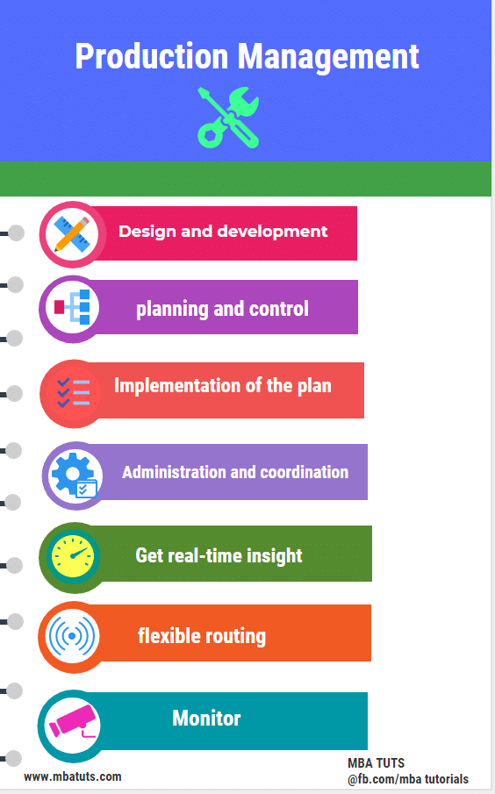

In modern times production management has to perform a variety of functions.
(i) Design and development of the production process.
(ii) Production planning and control.
(iii) Implementation of the plan and related activities to produce the desired output.
(iv) Administration and coordination of the activities of various components and departments responsible for producing the necessary goods and services.
v) Get real-time insight into the production.
vi) Improve performance with flexible routing.
vii) Monitor production costs with ease.

OBJECTIVE OF PRODUCTION MANAGEMENT
Production management is ‘a process of planning, organizing, directing and controlling the activities of the production function. It combines and transforms various resources used in the production subsystem of the organization into value added product in a controlled manner as per the policies of the organization’.
E.S. Buffa defines production management as follows:
‘Production management deals with decision-making related to production processes so that the resulting goods or services are produced according to specifications, in the amount and by the schedule demanded and out of minimum cost’.
The objective of the production management is ‘to produce goods services of right quality and quantity at the right time and right manufacturing cost’.

1. RIGHT QUALITY
The quality of product is established based upon the customer’s needs. The right quality is not necessarily best quality. It is determined by the cost of the product and the technical characteristics as suited to the specific requirements.

2. RIGHT QUANTITY
The manufacturing organization should produce the products in right number. If they are produced in excess of demand the capital will block up in the form of inventory and if the quantity is produced in short of demand, leads to shortage of products.

3. RIGHT TIME
Timeliness of delivery is one of the important parameter to judge the effectiveness of production department. So, the production department has to make the optimal utilization of input resources to achieve its objective.

4. RIGHT MANUFACTURING COST
Manufacturing costs are established before the product is actually manufactured. Hence, all attempts should be made to produce the products at pre-established cost, so as to reduce the variation between actual and the standard (pre-established) cost.

PRODUCTION PLANNING AND CONTROL: MEANING, CHARACTERISTICS AND OBJECTIVES

MEANING:
Production planning and control is an important task of Production Manager. It has to see that production process is properly decided in advance and it is carried out as per the plan. Production is related to the conversion of raw materials into finished goods. This conversion process involves a number of steps such as deciding what to produce, how to produce, when to produce, etc. These decisions are a part, of production planning. Merely deciding about the task is not sufficient.
The whole process should be carried out in a best possible way and at the lowest cost. Production Manager will have to see that the things proceed as per the plans. This is a control function and has to be carried as meticulously as planning. Both planning and control of production are necessary to produce better quality goods at reasonable prices and in a most systematic manner.
Production planning is the function of looking ahead, anticipating difficulties to be faced and the likely remedial steps to remove them. It may be said to be a technique of forecasting ahead every step in the long process of production, taking them at a right time and in the right degree and trying to complete the operations at maximum efficiency. Production control, on the other hand, guides and directs flow of production so that products are manufactured in a best way and conform to a planned schedule and are of the right quality. Control facilitates the task of manufacturing and see that everything goes as per the plans.
Goldon B. Carson:
“Production planning and control involves generally the organization and planning of the manufacturing process. Specifically, it consists of the planning of the routing, scheduling, dispatching and inspection, co-ordination and the control of materials, methods, machines, tooling and operating times. The ultimate objective is the organization of the supply and movement of materials and labour, machine utilization and related activities, in order to bring about the desired manufacturing results in terms of quantity, time and place.”
James L. Lundy:
“Basically, the production control function involves the co-ordination and integration of the factors of production for optimum efficiency. Overall sales orders or plans must be translated into specific schedules and assigned so as to occupy all work centres but overload none. The job can be done formally in which case elaborate charting and filing techniques are used ; or it can be done informally, with individuals’ thoughts and retention there of supplanting tangible aids.”
Charles A. Koepke:
“Production planning and control is the coordination of a series of functions according to a plan which will economically utilize the plant facilities and regulate the orderly movement of goods through the entire manufacturing cycle, from the procurement of all materials to the shipping of finished goods at a predetermined rate.”

CHARACTERISTICS OF PRODUCTION PLANNING AND CONTROL
The forgoing discussion brings out the following traits of production planning and control:
1. It is the planning and control of manufacturing process in an enterprise. The questions like—what is to be manufactured? When it is to be manufactured? How to keep the schedule of production etc.? —are decided and acted upon for getting good results.
2. All types of inputs like materials, men, machines are efficiently used for maintaining efficiency of the manufacturing process.
3. Various factors of production are integrated to use them efficiently and economically.
4. The manufacturing process is organized in such a way that none of the work centres is either overworked or under worked. The division of work is undertaken very carefully so that every available element is properly utilized.
5. The work is regulated from the first stage of procuring raw materials to the stage of finished goods.

OBJECTIVES OF PRODUCTION PLANNING AND CONTROL:
Planning of production precedes control. Whatever is planned needs to be controlled. The ultimate objective of both planning and control is to use various inputs in an efficient way and to have a proper control over various targets and schedules fixed earlier.
The following details will bring out the objectives of production planning and production control:
Production Planning:
1. To determine the requirements for men, materials and equipment.
2. Production of various inputs at a right time and in right quantity.
3. Making most economical use of various inputs.
4. Arranging production schedules according to the needs of marketing department.
5. Providing for adequate stocks for meeting contingencies.
6. Keeping up-to-date information processes.
Production Control:
1. Making efforts to adhere to the production schedules.
2. Issuing necessary instructions to the staff for making the plans realistic.
3. To ensure that goods produced according to the prescribed standards and quality norms.
4. To ensure that various inputs are made available in right quantity and at proper time.
5. To ensure that work progresses according to the predefined plans.

Production planning and control is a predetermined process that plans, manages and controls the allocation of human resource, raw material, and machinery to achieve maximum efficiency.
Production planning is a sequence of steps that empower manufacturers to work smarter and optimize their production process in the best possible manner. This helps manufacturer’s work smarter by efficiently managing internal resources to meet customer demand.

OBJECTIVES OF PRODUCTION PLANNING AND CONTROL (PPC)
Having a reliable Production Planning and Control software in your company makes it easy to:
- Ensure cost-efficient production process
- Promote timely delivery of goods
- Minimize production time
- Improve customer satisfaction
- Coordinate with departments about production, to ensure things are on the same page
- Ensure the right man is assigned the right work
Production planning is the core of any manufacturing unit. It includes material forecasting, master production scheduling, long term planning, demand management and more. The PPC process kicks off with demand forecasting of a product, and thereafter designing the production plan according to the demand to move it forward.
Production planning is a strategy to plan a chain of operations that supports manufacturers to be at the right place, at the right time so that they can achieve the maximum efficiency from their resources.
Now, let’s straightway talk about the steps involved in Production Planning and Control. As per the British Standards Institute, there are four stages or essential elements in the process of production planning and control. These are as follows:

1. Routing
Routing determines the path from which the raw materials flow within the factory. Once, the sequence is followed, raw materials are transformed into finished goods.
Setting up time for every step is important to measure the overall duration of the production process. Simply saying, routing in manufacturing states the sequence of work and operations. Routing throws light on the quantity and quality of materials to be used, resources involved (men, machine, and material), the series of operations and place of production.
Routing manages “How”, “What”, “How much”, & “Where” to produce in a manufacturing company. It systematizes the process and nurtures optimum utilization of resources to get the best results.

2. Scheduling
Scheduling is the second step that emphasizes on “When” the operation will be completed. It aims to make the most of the time given for completion of the operation.
As per Kimball and Kimball, scheduling is defined as –
“The determination of the time that should be required to perform the entire series as routed, making allowance for all factors concerned.”
Organizations use different types of schedules to manage the time element. These include Master Schedule, Operation Schedule, Daily Schedule and more.

3. Dispatching
The third step ensures that operations are done successfully and everything is loaded on the software. Dispatching includes the release of orders, in accordance with the scheduled charts.
Here are the points that encapsulate “Dispatching”
- Issue of materials or fixtures that are important for the production
- Issue of orders or drawings for initiating the work
- Maintain the records from start to end
- Initiate the control procedure
- Cascade the work from one process to another

4. Follow-up
Also known as expediting, follow-up is the final step that finds faults or defects, bottlenecks and loopholes in the entire production process. In this step, the team measures the actual performance from start till the end and then compares it with the expected one.
Expediters or stock chasers are responsible for performing follow-up process. It is quite obvious that any of the processes may undergo break-downs or machine failure. Follow-up promotes smooth production by eliminating these defects.

TYPES OF PRODUCTION SYSTEM:
The types of production system are grouped into two categories, namely:
1. Intermittent production system
2. Continuous production system
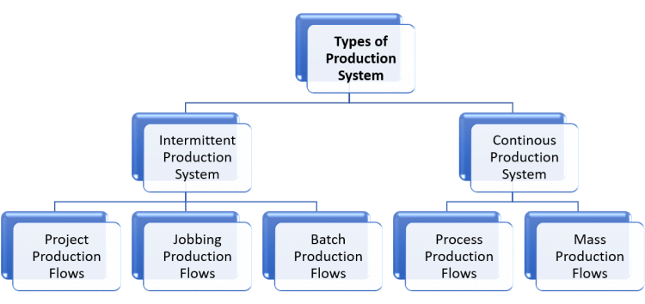

1. Intermittent production system:
Intermittent means something that starts and stops at irregular intervals (time intervals). In the intermittent production system, goods are produced according to customer orders. These products are produced on a small scale. The production flow is intermittent (irregular). In other words, the production flows are not continuous.
In this types of production system, large varieties of products are produced. These products are of different sizes. The design of these products keeps changing. It keeps changing based on product design and size. Therefore, this system is very flexible.
The following are examples of the intermittent production system:
(i) The work of a goldsmith is based exclusively on the frequency of customer orders. The goldsmith manufactures goods (ornaments) on a small scale according to the requirements of his client. Here, ornaments are not made continuously.
(ii) Similarly, a tailor’s work is also based on the number of orders he receives from his clients. The tailor sews the garments for each client independently according to measurement and size. Products (sewn clothing) are manufactured on a limited scale and is proportional to the number of orders received from customers. Here, sewing is not done continuously.

Characteristics of an intermittent production system are listed below:
(i) The production flow is not continuous. It is intermittent.
(ii) Wide varieties of products are produced.
(iii) The production volume is small.
(iv) General-purpose machines are used. Different types of products can be produced by the use of these machines.
(v) The sequence of operations continues to change according to the product design.
(vi)The quantity, size, shape, design, etc. Product depends on customer orders.

The types of intermittent production system include:
- Project production flows,
- Jobbing production flows, and
- Batch production flows.

i. Project production flows:
Here, in the project’s production flows, the company accepts a single complex order or contract. The order must be completed within a certain period of time and at an estimated cost. Consider making a boat. Such products are never manufactured in large quantities. Labor, facilities and other resources focus on these products. Therefore, each product can be treated as a project, which requires the sequencing of certain activities, either in series or simultaneously. PERT/CPM or network analysis is a useful technique to plan and control such projects.
Examples of project production flows mainly include the construction of airports, roads, buildings, shipbuilding, dams, etc.
Characteristics of project production flows:
1. A resource requirement varies with the production phases.
2. Many agencies are involved and their jobs are interrelated.
3. Generally. Delays take place at the end of the project.
4. As routing and programming changes, inspection is required.

ii. Jobbing production flows:
In the job production flows, the company accepts a contract to produce one or a few units of a product strictly according to the specifications given by the customer. The product is produced within a certain period and at a fixed cost. This cost is fixed at the time of signing the contract.
Examples of such job production flows include services provided by clothing workshops, repair shops, manufacturers of special machine tools, etc.
Characteristics of jobbing production flows:
1. The production of items takes place in small batches.
2. Items are manufactured according to customer specifications.
3. Highly skilled labor is needed for specialized jobs
4. There is a disproportionate manufacturing cycle time.

iii. Batch production flows:
In batch production flows, the production schedule is decided according to specific orders or is based on demand forecasts. Here, the production of items takes place in lots or lots. A product is divided into different jobs. All jobs in a production batch must be completed before starting the next production batch.
Examples of batch production flows include, manufacture of drugs and pharmaceuticals, medium and heavy machinery, etc.
Characteristics of batch production flows batch instruction:
1. Products are manufactured and stored until demand arises.
2. General-purpose machines and equipment are installed.
3. There is a possibility of major work in progress.
4. You need detailed production planning and control.

2. Continuous production system:
Continuous means something that operates constantly without irregularities or frequent stops. In the continuous production system, goods are constantly produced according to the demand forecast. The goods are produced on a large scale for storage and sale. They are not produced at the customer’s request. Here, the inputs and outputs are standardized together with the production process and the sequence.
The following are examples of the continuous production system.
(i) The production system of the food industry is based solely on the demand forecast. Here a large-scale food production takes place. It is also a continuous production.
(ii) Similarly, the production and processing system of a fuel industry is also based solely on the demand forecast. Crude oil and other raw sources are continuously processed on a large scale to obtain a usable form of fuel and
offset global energy demand.

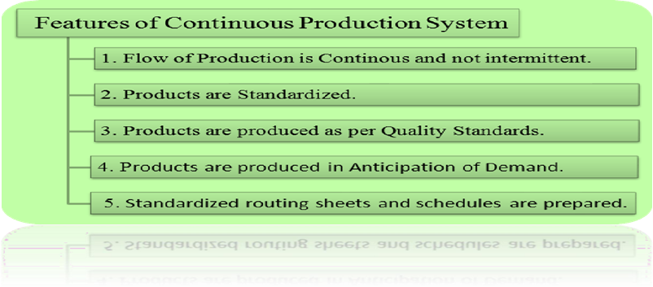

The characteristics of a continuous production system are listed below:
(i) The production flow is continuous. It is not intermittent
(ii) The products are standardized.
(ii) Products are produced with predetermined quality standards.
(iv) Products are produced in anticipation of demand.
(v) Standardized roadmaps and schedules are prepared.
The types of continuous production systems include:
1. Mass production flows
2. Process production flows.
1. Mass production flows:
Here, the company produces different types of large-scale products and stores them in warehouses until they are demanded in the market. Products are produced with the help of a single operation or use a series of operations.
E.g. Mass production is the production of toothpaste, soaps, pens, etc.
Characteristics of mass production flows:
1. Continuous production flow, depends on market demand.
2. Here, there is limited work in progress.
3. Supervision is easy: few instructions are necessary.
4. The material is mainly handled by machines.
5. The flow of materials is continuous with little or no glue.
2. Production processes:
Here, a single product is produced and stored in warehouses until it is demanded in the market. The flexibility of these plants is almost nil because only one product can be produced.
Examples of production process flows include steel, cement, paper, sugar, etc.
Characteristics of process production flows:
1. Highly mechanized system for material handling.
2. Low skilled labor and skilled technicians are required.
3. Very little work in progress, since the flow of material is continuous.
4. Production planning and programming can be decided in advance.
5. The complete production system is designed to produce a single item.

TYPES OF PRODUCTION SYSTEM
- Basic 2 types of production system -
  - Intermittent production system
  - Continuous production
And they are further divided into sub types as –

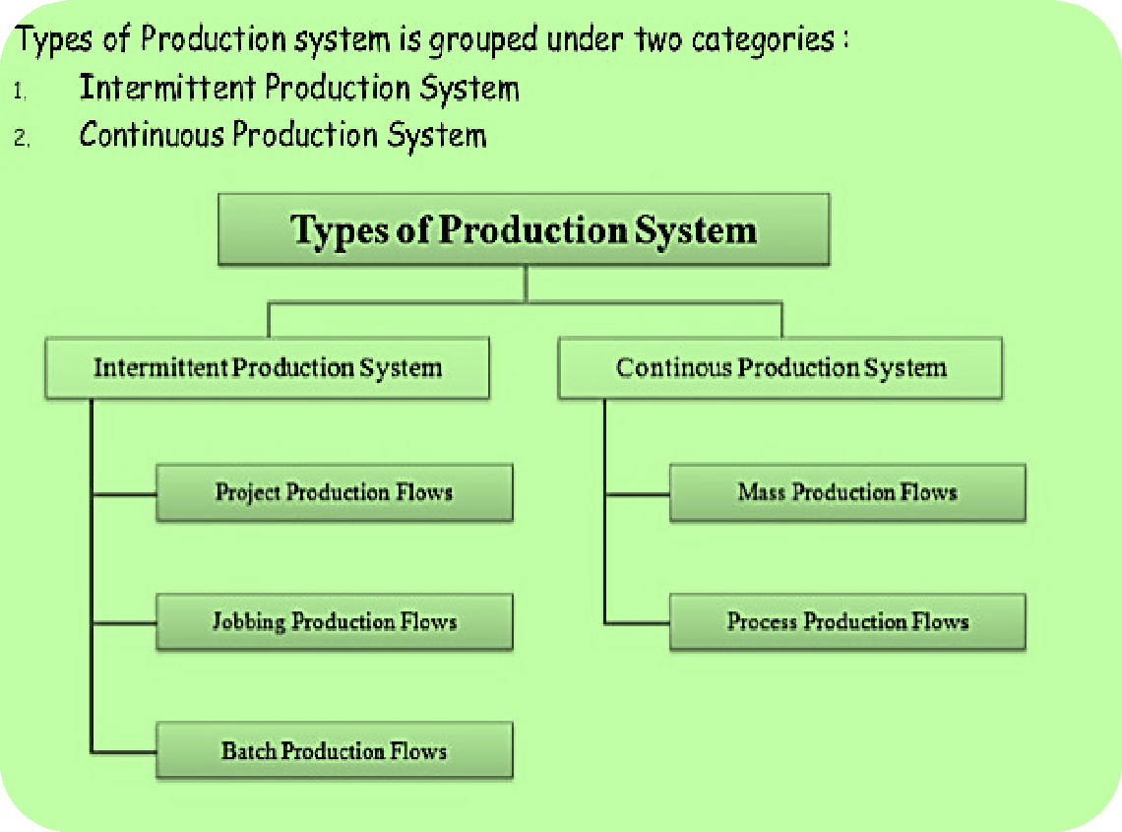

- INTERMITTENT PRODUCTION SYSTEM: -
  - Intermittent means something that starts and stops at irregular intervals (time intervals).
  - In other words, the production flows are not continuous.
  - Goods are produced according to customer orders.
  - The quantity, size, shape, design, etc. Product depends on customer orders.

- Examples of the intermittent production system:-
The work of a goldsmith and a tailor’s is based exclusively on the frequency of customer orders. Here, ornaments or clothes are not made continuously.

THE TYPES OF INTERMITTENT PRODUCTION SYSTEM -:

i) Project production
Aii) Job shop production and Aiii) Batch production flows.
Ai) PROJECT PRODUCTION:
  - The company accepts a single complex order or contract.
  - The order must be completed within a certain period of time and at an estimated cost.
  - Consider manufacturing of ships, or flyovers or bridges or highways etc.
  - Such products are never manufactured in large quantities.
  - Labour, facilities and other resources focus on these products.
  - Therefore, each product can be treated as a project, which requires the sequencing of certain activities, either in series or simultaneously.
  - Examples - construction of airports, roads, buildings, shipbuilding, dams, etc.


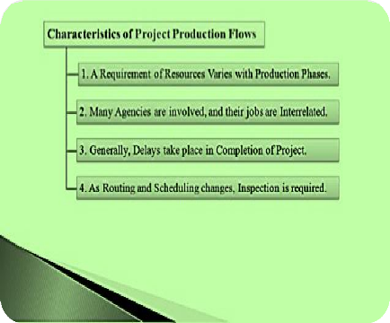

Aii). JOB SHOP PRODUCTION:
  - In the job production flows, the company accepts a contract to produce one or a few units of a product strictly according to the specifications given by the customer.
  - The product is produced within a certain period and at a fixed cost. This cost is fixed at the time of signing the contract.
  - Examples -services provided by clothing workshops, repair shops, manufacturers of special machine tools, etc.
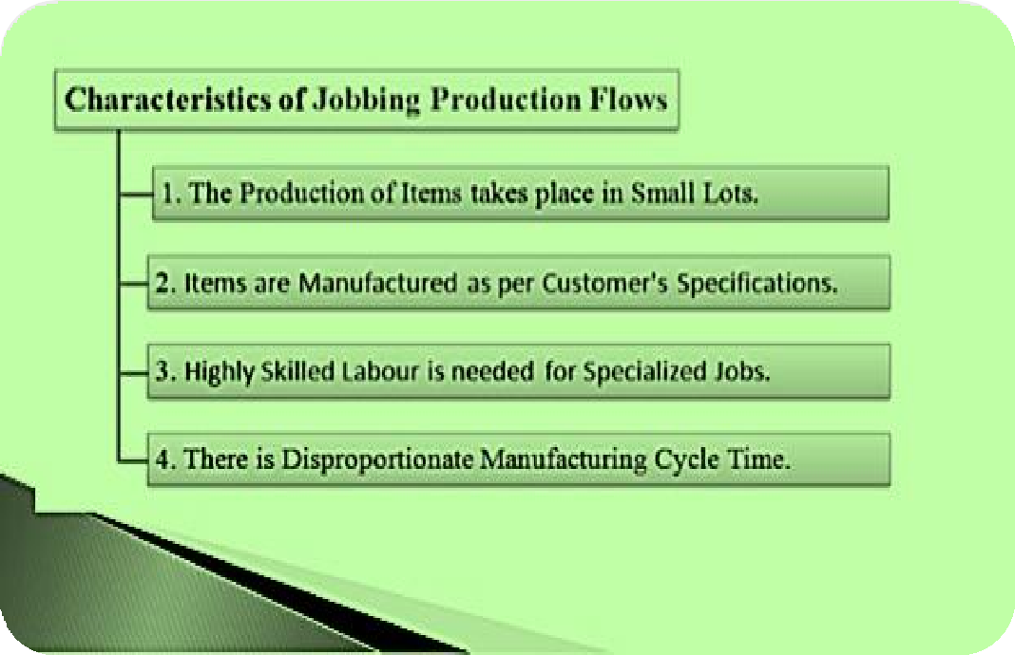

iii) BATCH PRODUCTION FLOWS:
  - In batch production flows, the production schedule is decided according to specific orders or is based on demand forecasts.
  - Here, the production of items takes place in lots or lots.
  - A product is divided into different jobs.
  - All jobs in a production batch must be completed before starting the next production batch.
  - Example - manufacturing of drugs and pharmaceuticals, medium and heavy machinery, etc.

- CONTINUOUS PRODUCTION SYSTEM:
  - Continuous means something that operates constantly without irregularities or frequent stops.
  - Goods are constantly produced according to the demand forecast. The goods are produced on a large scale for storage and sale.
  - They are not produced at the customer’s request.
  - Here, the inputs and outputs are standardized together with the production process and the sequence.
  - Examples -
(i) Food industry is based solely on the demand forecast. Here a large-scale food production takes place. It is also a continuous production.

  - (ii) Fuel industry is also based solely on the demand forecast. Crude oil and other raw sources are continuously processed on a large scale to obtain a usable form of fuel and
offset global energy demand.


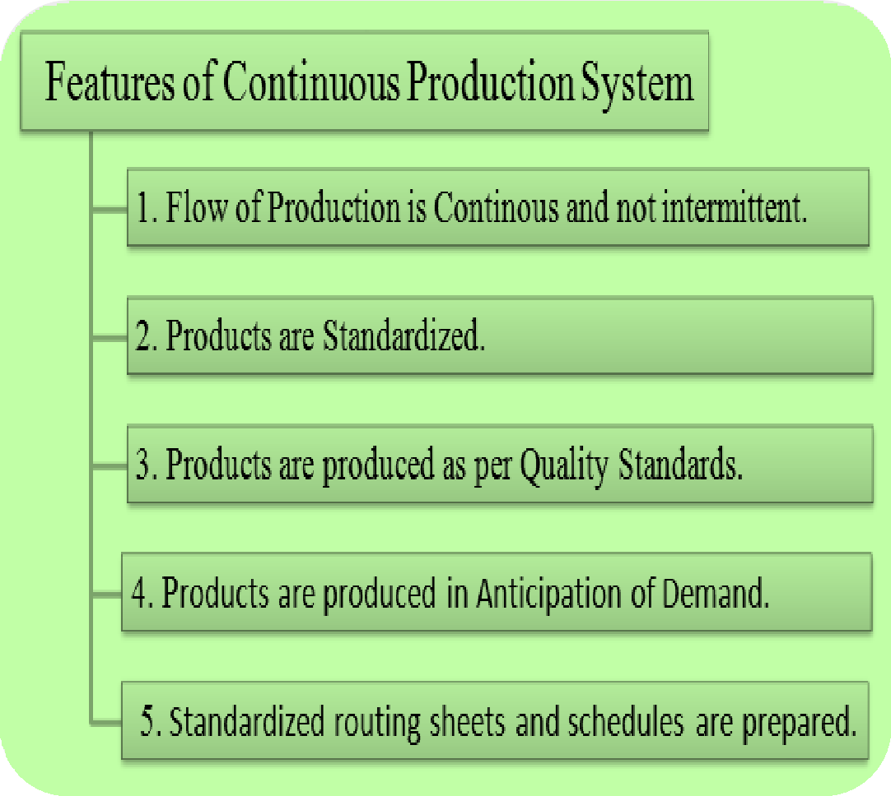

SUB TYPES OF CONTINUOUS PRODUCTION SYSTEMS

- MASS PRODUCTION FLOWS:
Here, the company produces different types of large-scale products and stores them in warehouses until they are demanded in the market.


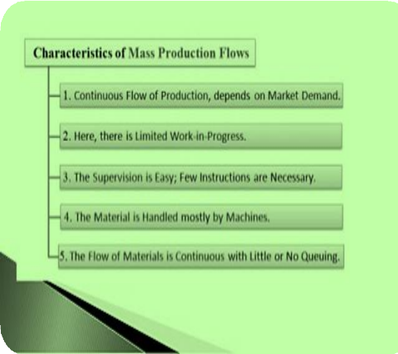

B –ii) PROCESS PRODUCTION PROCESSES:


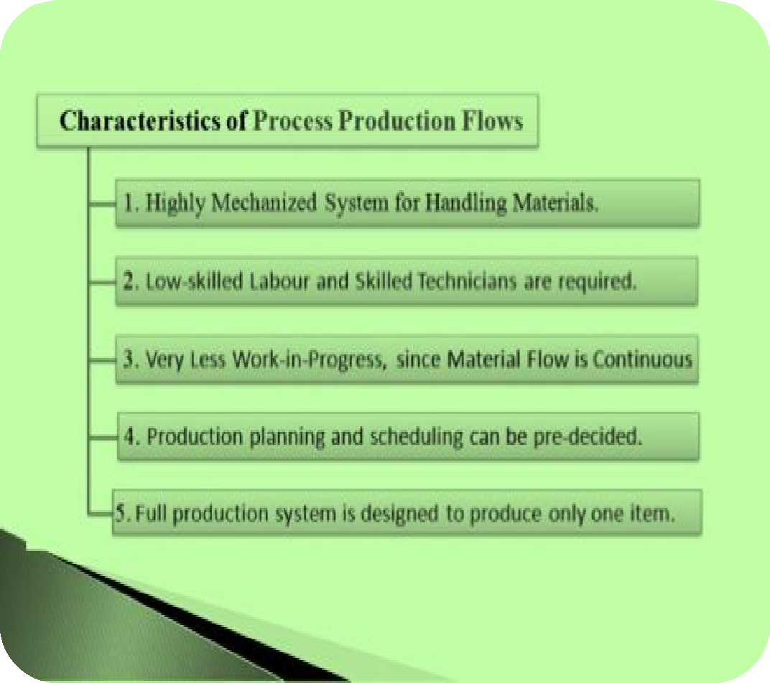
Here, a single product is produced and stored in warehouses until it is demanded in the market.

The flexibility of these plants is almost nil because only one product can be produced.
Examples -Production system at steel, cement, paper, sugar, plant etc.
Now let's distinguish intermittent and continuous production system.
1. Nature of product:
- In intermittent production system, goods are produced based on customer orders and not for stocking.
- In continuous production system, goods are produced based on demand forecast and for stocking.
2. Flexibility of process:
- In intermittent production system, production process is flexible. The product design goes on changing.
- In continuous production system, production process is not flexible. It is standardized. The same product is manufactured continuously.
3. Scale of production:
- In intermittent production system, goods are produced on a small scale, so there is no economies of scale.
- In continuous Production System, goods are produced on a large scale, so there are economies of large-scale production.
4. Per unit cost:
- In intermittent production system, cost per unit may be higher because production is done on a small-scale.
- In continuous production system, cost per unit may be lower because production is done on large-scale.
5. Range of products:
- In intermittent production system, wide ranges of products are manufactured.
- In continuous production system, normally one particular type of product is manufactured.
6. Instructions:
- In an intermittent production system, many detailed instructions must be provided depending upon the customer's specification.
- In continuous production system, single set of instructions is sufficient for operation. Here, there is no need to repeat the instructions.
- Staff :
- Intermittent production system requires staff with high technical skills and abilities.
- Continuous production system requires more managerial skills and less technical skills.
8. Storage of final products:
- In an intermittent production system, there is no need to store and stock the final products, because items are produced as per customer's orders.
- In a continuous production system, there is a need to store and stock the final products until they are demanded in the market.
9. Location change:
- In an intermittent production system, change in location is easy.
- In a continuous production system, change in location is difficult.
10. Capital invested:
- In an Intermittent production system, capital invested is small.
- In a continuous production system, capital invested is very huge.

FACTORS AFFECTING PRODUCTIVITY IN AN ORGANIZATION
The various decisions with respect to the factors are mentioned below:

1. Man Power:
Selection i.e. selection of right man for a specific job Applying well known saying division of labour. Training i.e. consideration of training requirements whether to be imparted training in the plant itself or to be sent for training outside the unit to other plants within the country or abroad or training institutes. Number of personnel required i.e. man power requirement planning in each of the departments of required skill.

2. Equipment and Machines:
The number of machine tools, their capacity and accessories required, replacement policy of the organization and maintenance schedules etc.

3. Input Materials:
i. Appropriate quality of materials
ii. Material requirement planning (M.R.P.)
iii. Substitute of materials being used
iv. Inspection of input materials at various points
v. Cost of materials procurement and handling up to stores.

4. Time:
Time is significant for the following reasons:
i. Inspection of input materials i.e. raw material and semi-finished or finished items required for assembly.
ii. Time for inspection of finished products.
iii. Production time (total time of manufacturing).
iv. Time for repair and maintenance of machines and equipment.

5. Floor Area or Space:
i. Total area covered by the administrative block, production shop and inspection & quality control departments etc.
ii. Location of different departments and shops etc.
iii. Other space covered by plant layout.

6. Power or Energy:
i. Maintenance of equipment for saving energy
ii. Use of renewable energy devices
iii. Use of biogas, photovoltaic cells, solar energy and other non-conventional techniques.

7. Finance:
Finance is required to maintain all the above requirements. The management should be for minimum rather optimum finance.

8. Movement of Man and Materials:
i. The required motion of manpower within the plant
ii. The motion of raw material semi-finished and finished products/items within the plant.

What is productivity? Explain the factors influencing the productivity.
- Productivity is computed by dividing average output per period by the total costs incurred or resources (capital, energy, material, personnel) consumed in that period. Productivity is a critical determinant of cost efficiency.
- Productivity is an average measure of the efficiency of production. It can be expressed as the ratio of output to inputs used in the production process, i.e. output per unit of input. When all outputs and inputs are included in the productivity measure it is called total productivity.
- Outputs and inputs are defined in the total productivity measure as their economic values. The value of outputs minus the value of inputs is a measure of the income generated in a production process.
- It is a measure of total efficiency of a production process and as such the objective to be maximized in production process.
- Productivity measures that use one or more inputs or factors, but not all factors, are called partial productivities. A common example in economics is labor productivity, usually expressed as output per hour. At the company level, typical partial productivity measures are such things as worker hours, materials or energy per unit of production

IMPORTANT FACTORS THAT AFFECT PRODUCTIVITY:
- Technical factors: Productivity largely depends on technology. Technical factors are the most important ones. These include proper location, layout and size of the plant and machinery, correct design of machines and equipment, research and development, automation and computerization, etc. If the organization uses the latest technology, then its productiveness will be high.
- Production factors: Productivity is related to the production-factors. The production of all departments should be properly planned, coordinated and controlled. The right quality of raw-materials should be used for production. The production process should be simplified and standardized. If everything is well it will increase the productiveness.
- Organizational factor: Productivity is directly proportional to the organizational factors. A simple type of organization should be used. Authority and Responsibility of every individual and department should be defined properly. The line and staff relationships should also be clearly defined. So, conflicts between line and staff should be avoided. There should be a division of labor and specialization as far as possible. This will increase organization's productiveness.
- Personnel factor: Productivity of organization is directly related to personnel factors. The right individual should be selected for suitable posts. After selection, they should be given proper training and development. They should be given better working conditions and work-environment. They should be properly motivated; financially, non-financially and with positive incentives. Incentive wage policies should be introduced. Job security should also be given. Opinion or suggestions of workers should be given importance. There should be proper transfer, promotion and other personnel policies. All this will increase the productiveness of the organization.
- Finance factor: Productivity relies on the finance factors. Finance is the life-blood of modem business. There should be a better control over both fixed capital and working capital. There should be proper Financial Planning. Capital expenditure should be properly controlled. Both over and underutilization of capital should be avoided. The management should see that they get proper returns on the capital which is invested in the business. If the finance is managed properly the productiveness of the organization will increase.
- Management factor: Productivity of organization rests on the management factors. The management of organization should be scientific, professional, future-oriented, sincere and competent. Managers should possess imagination, judgment skills and willingness to take risks. They should make optimum use of the available resources to get maximum output at the lowest cost. They should use the recent techniques of production. They should develop better relations with employees and trade unions. They should encourage the employees to give suggestions. They should provide a good working environment, and should motivate employees to increase their output. Efficient management is the most significant factor for increasing productiveness and decreasing cost.
- Government factor: Productivity depends on government factors. The management should have a proper knowledge about the government rules and regulations. They should also maintain good relations with the government.
- Location factor: Productivity also depends on location factors such as Law and order situation, infrastructure facilities, nearness to market, nearness to sources of raw-materials, skilled workforce, etc.

WAYS TO INCREASE PRODUCTIVITY IN THE WORKPLACE
There’s nothing more important to a small business than its employees. If your employees are happy, their productivity will increase, and that’s exactly what you need to help your business grow.
Making small changes to habits will drastically improve the levels of productivity and office efficiency in your business. This will allow you to get more quality work done in a shorter period of time as well as reduce the amount of time spent on unnecessary tasks.
Here are eight top tips on how to get the most out of your employees and ensure that their productivity is kept to a maximum:
1. Be Efficient
Consider how your business is currently operating, and be open to the potential of changing the way you work. Remember that it’s equally as important to make short-term and long-term lists as it is to prioritise tasks, especially in a small business.
Is there a better way that staff members could structure their day to enable them to achieve their daily goals? Provide each member of staff with a plan and encourage each to make a list to ensure he or she completes prioritised jobs on time and stays on task all day, resulting in efficient working.

2. Delegate
Delegation comes with an element of risk, but increased responsibility is important for improving the morale and job satisfaction of your staff. Give responsibilities to qualified employees that have a proven track record with success in a certain field, and trust that they will perform the tasks well.
If you allow employees the chance to gain skills and leadership experience, it will benefit your company and provide your employees with a sense of achievement and direction in their own careers.

3. Reduce Distractions
Social media can be a huge productivity killer, but it isn’t practical to have a no-phone policy. Instead, try to keep employees focused and engaged while allowing them breathing room.
Encourage employees to turn off their mobiles but take regular breaks during which they can be free to check their phones. This will ensure that the time spent at their desk is more productive.

4. Have the Right Tools and Equipment
Providing employees with the right tools and equipment is important so they can perform their duties efficiently and on time. There’s nothing more counterproductive than spending time waiting for paperwork to print because you haven’t got a fast printing device.
High-quality, modern programs and equipment make a massive difference not only to the workforce but also to how your company is perceived. Save time and effort by using equipment such as an MFP, which can work as printer, scanner, copier and fax machine.

5. Improve workplace conditions
A comfortable working temperature is between 68 and 70 degrees F (20-21 C). An environment that’s too hot or too cold distracts from concentration, as employees will spend more time walking around to get their coats or an electric fan. Ensure both heating and air-conditioning systems are in working order for when the relevant season comes around.

6. Offer Support and Set Realistic Goals
A common problem for managers is having no clear, strong sense of whether their employees are high-performing or not.
Do your employees need an incentive to stay on track? Help them by offering goals that are achievable. Provide clear direction to supervisors and employees to help clarify expectations. This will help to increase their productivity, as they will have a clear focus and clear goals.

7. Practice Positive Reinforcement
Encourage, motivate and reward. Tell employees they are doing a good job and give constructive criticism. Most importantly, offer personal incentives for doing the job well – could they get a free holiday or a free takeout coffee for performing above and beyond their roles?
You should clearly indicate success of one employee to other staff to cultivate a sense of fulfilment to motivate others. When you motivate your employees to work harder and receive rewards in return, they’re more likely to put increased productivity high up on their to-do list.

8. Ensure Employees Are Happy
A stressful workplace will not yield results. Workers that constantly operate under highly stressful conditions are found to be less productive and have higher levels of disengagement and absenteeism … They need to be happy!
Showing employees how much the company appreciates, respects and values them on a personal level is gratifying – and often overlooked.
If you want your staff to work to the best of their ability, try out a few of these tips and enjoy the benefits.

WHAT IS PLANT LAYOUT?
Plant layout is the overall arrangement of the production process, store-room, stock-room, tool-room, material handling equipment, aisles, racks and sub-stores, employee services and all other accessories required for facilitation of the production in the factory.
It encompasses production and service facilities and provides for the most effective utilization of the men, materials and machine’ constituting the process, it is a master blueprint for coordinating all operations performed inside the factory.
Plant Layout Definition
According to F G. Moore, “A good layout is one which allows materials rapidly and directly for processing. This reduces transport handling, clerical and other costs down per unit, space requirements are minimized and it reduces idle machine and idle man time.”
OBJECTIVES OF PLANT LAYOUT
A good plant layout strives to attain the following objectives:
- Minimization of material handling.
- Elimination of bottlenecks through the balancing of plant capacities.
- High material turnover through a shorter operating cycle.
- Effective utilization of installed capacity so that the returns on the investments may be maximized.
- Effective utilization of cubic space in the factory area.
- Effective utilization of manpower resources through the elimination of idle time.
- Elimination, improvement or confinement of objectionable operations e.g., operations with bad odour, vibrating operations etc.
- Elimination of physical efforts required by operative workers.
- Avoidance of industrial accidents.
- Better working conditions for the employees like lighting, ventilation, control of noise and vibrations etc.
- Decency and orderliness inside the plant area.
- Better customer services through cheaper and better product supplies according to the delivery promises.

FACTORS AFFECTING THE PLANT LAYOUT DECISION
The decision of the plant layout is affected by the following factors:
- Type of production: The layout for an engineering unit will be quite different from that of a flour factory, similarly layout of a paper mill will be different from a tool room and layout of an engine assembly line is different from the toy-making facility.
- Production System: The plant layout in a continuous production system will be totally different from the intermitted production system.
- Scale of Production: The plant layout and material handling equipment in the large scale organization will be different from that in the small scale manufacturing activity.
- Type of Machines: The use of single-purpose and multipurpose machines substantially affects the plant layout. Similarly, noisy and vibrating machines require special attention in the plant layout decision.
- Type of building facilities: The plant layout in a single storey building will be different from that in a multi-storey building.
- Availability of Total Floor Area: The allocation of space for machines, workbenches sub stores, aisles, etc is made on the basis of the available floor area. Use of overhead space is made in case of shortage of space.
- Possibility of Future Expansion: Plant layout is mad in the light of the future requirements and installation of additional facilities.
- Arrangement of Material Handling Equipment: The plant layout and the material handling services are closely related and the latter has a decisive effect on the arrangement of the production process and plant services.
TYPE OF PLANT LAYOUT
The popular types of plant layout are:
- Process layout
- Product layout
- Combined layout
- Project layout
- Group Layout
Process Layout
This type of layout is also called functional layout. All machines performing a similar type of operations are grouped at one location in the process layout e.g., all lathes, milling, machines, cutting machines etc. in the engineering shop are clustered in their like groups. Thus all forging will be done in one area and all the lathes will be placed in another area.
In this layout, several products may share a machine to make its full use. The sequential arrangement of the machine group is generally, but not necessarily made on the basis of labor operations.
In this type of layout, the process rather than the product has dominating role. The product is given secondary consideration and is moved for the purpose of operations to the process section with like machines stationed at a particular point. This type of layout is more suitable to job order type of production.
The typical arrangement of the machines in the process layout will be as under:
Advantages of Process Layout
- It eliminates the duplication of machines and enables the optimum use of installed capacity.
- It facilitates flexibility in production. It is more flexible than a line layout. Different products can be made without changes in the arrangements of the machine.
- The production capacity is not arranged in rigid sequence and fixed rated capacity with line balancing.
- The breakdown of one machine does not interrupt the entire production flow.
- Specialization in supervision becomes possible.
- Individual incentive schemes can be developed.
Disadvantages of Process Layout
- Due to a lack of straight-line sequence of production, it is impossible to maintain the line balancing in production. So the problems of bottleneck and waiting and the idle capacity.
- The cost of material handling increases due to long routing and backtracking between the processes.
- The processing time is prolonged which reduce the inventory turnover and increases the investments in inventories.
- The inspection cost increases. Due to frequent changes in the machine set up, inspection is required at each stage of the process.
- The cost of supervision increases due to specialist supervisors and more number of supervisors are required at each process unit.
- The production planning and control become difficult due to complexities arising in routing, scheduling, dispatching and follow-up.
- It is not possible to implement the group incentive schemes on the basis of the quantity of the products manufacturing.
- More space is required for internal storing, a reservoir of materials and provision for the expansion of the particular process section.

Product layout
In this type of layout, the machines are arranged in the sequence as required by the particular product. All machines as required to balance the particular product line are arranged in a sequential line but not necessarily in the straight line. It is also known as “ the product line layout.”
In this layout, one product goes through all the machines lined up, in the order required by its manufacture. The best-known example of this type of layout is seen in motor car production. To make this layout successful, the workload on the various machines must be balanced. The process of getting even loading at each stage of production is called line balancing.
In this type of layout, the product is dominating over the process, in the sense that the product is given the primary importance and the process machine must remain present at a point where the product needs its services.
Thus, unlike the process layout, the process is given secondary importance in relation to the product. Product layout is more suitable for continuous flow-production with few items of production. It does not require frequent changes in machine set up.
The typical arrangement of the machines in the product with separate independent product lines for Product A and Product B will be as shown in the following figure:
Advantages of Product layout
- Reduced material handling cost due to straight-line production flow.
- Mechanization of material handling between fixed points.
- Line balancing may eliminate bottlenecks and idle capacity.
- Shorter operating cycle due to shorter and speedy movement of materials.
- Maximum utilization of machine and labour capacity through developing a proper balance between them.
- Effective control over production with reduced supervision by generalist’s supervisor. By reducing the manufacturing to simple steps we can often use less skilled labour.
- Effective quality control with reduced inspection points. It does not require frequent changes in machine set-up.
- Effective production planning and control. Unlike process layout, the routing, scheduling, dispatching and follow up are relatively easier.
- Maximum use of space due to straight production flow and reduced need of interim storing.
- It facilitates the implementation of group incentive schemes for the workers.
- It is relatively easy to control.
Disadvantages of Product layout
- The duplication of machines and equipment necessitates the increased investments in them sometime resulting in idle capacity.
- The production flow is regulated through the straight line sequence and fixed rated capacity, and thus makes it highly inflexible.
- The breakdown of one single machine in the line interrupts the entire production flow.
- Unlike process layout, the benefits of specialized supervision is not possible.
- As the entire production is the result of the joint efforts of all operations in the line, it is difficult to implement individual incentive schemes.
- They are less flexible than others. Any change in product requires rebalancing the line.
Combined Layout
Generally pure process or pure product layout is not found in practice. Both process and product layouts are mutually exclusive. Proper compromise reaping the benefits of both the layouts is possible to some extent. So efforts are made to have the combined layout incorporating the benefits of process and product layout.
Combined layout is developed as under:
- Product layout for the main product with a process layout for joint or by-product tapping the idle capacity of product layout along with marginal investments required in process layout.
- To diversify the production with a view to tap the idle capacity of the product layout. Products with a complete negative correlation with the product line can make the maximum use of idle capacity of the product layout.
- In the product layout, some process may be segregated from the product line e.g., objectionable, hazardous, requiring special treatment and repetitive performance etc.

Project Layout
The manufacturing operation require the movements of men, machines and materials. Generally few inputs tend to be static while the others are moving.
In the product layout and process layout generally the machines have fixed installations and the operators are static in terms of their specified work stations.
It is only the materials which move form operation to operation for the purpose of processing. But where the product is large in size and heavy in weight, it tends to be static, e.g., shipbuilding.
In such a production system, the product remains static and the men and machines move performing the operations on the product. The production characteristics are sufficient enough to treat it as a separate type of layout, viz. static product layout.
Group Layout
Here an attempt is made to introduce some of the advantages of a line layout into a situation where pure line layout is not practicable. Here machines are placed in groups.
Each machine group makes maximally of parts which require similar treatment. This layout lies between process layout and line layout. It is easier to control than a strictly process layout and has more flexibility into the manufacturing system as regards the batch size variations and the differing operations sequences.
PRINCIPLES OF GOOD PLANT LAYOUT
According to Muther there are six basic principles of “best layout”.

1. Principle of Overall Integration:
According to this principle the best layout is one which provides integration of production facilities like men, machinery, raw materials factors which result in the best compromise.

2. Principle of Minimum Distance:
According to this principle, the movements of men and materials should be minimized.

3. Principle of Flow:
According to Muther, the best layout is one which arranges the work station for each operate process in same order or sequence that forms treats or assembles the materials.

4. Principle of Cubic Space Utilization:
According to this, the best layout utilizes cubic space i.e. space available both in vertical and horizontal directions is most economically and effectively utilized.

5. Principle of Satisfaction and Safety:
According to this principle, best layout is one which provides satisfaction and safety to all workers.

6. Principle of Flexibility:
In automotive and other allied industries where models of products change after sometime, the principle of flexibility provides adoption and rearrangements at a minimum cost and least inconvenience.

INVENTORY MANAGEMENT
Definition: Inventory management is an approach for keeping track of the flow of inventory. It starts right from the procurement of goods and its warehousing and continues to the outflow of the raw material or stock to reach the manufacturing units or to the market, respectively. The process can be carried out manually or by using an automated system.
When the goods arrive at the premises, inventory management ensures receiving, counting, sorting, arrangement, storage and maintenance of these items, i.e. stock, raw material, components, tools, etc., efficiently.
To see how this whole system functions, we should first understand the flow of inventory in an organization. The same has been represented in the following diagram:
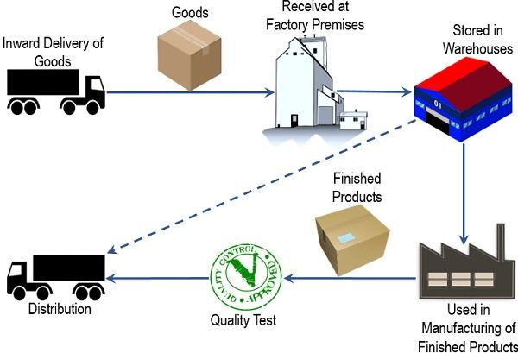
Here, the goods which are stored in the warehouse can be utilized in the following two ways:
- Direct distribution in the market i.e., to the wholesalers, dealers, retailers or customer; or
- Sent to the production units for manufacturing of finished goods.
There are many inventory management techniques available for organizations to choose from. Some of the most common ones are EOQ (economic order quantity), ABC analysis, just-in-time management, EQR model, VED analysis, LIFO (last in last out) and FIFO (first in first out).

Content: Inventory Management
- Objectives
- Types
- Process
- Importance
- Challenges Faced
- Conclusion

INVENTORY MANAGEMENT OBJECTIVES
Inventory management is performed to simplify the operational activities. Some of the primary objectives for which it is carried out are as follows:
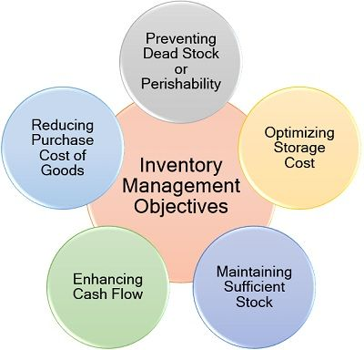
- Preventing Dead Stock or Perishability: With an optimal inventory level, the chances of wastage in the form of goods spoilage or dead stock.
- Optimizing Storage Cost: It reduces the chances of maintaining excessive stock, even the requirements are pre-determined, which ultimately cuts done the unnecessary warehousing costs.
- Maintaining Sufficient Stock: Now, the production department need not worry about the shortage of raw material or goods because of its constant supply.
- Enhancing Cash Flow: Inventory has a significant impact on the cash flow of the company. With effective inventory management, the organization can ensure sufficient liquid cash to enhance its operational efficiency.
- Reducing the Inventories’ Cost Value: When there is a constant purchase of goods or stock, the organization can ask for discounts and other benefits to decrease the purchase price.

TYPES OF INVENTORY MANAGEMENT
While installing an inventory management system, the organization has to consider the various aspects like cost, budget, utility and accessibility. However, it can be classified into the following types:
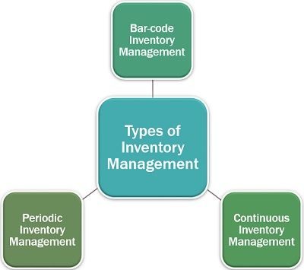

Bar-code Inventory Management
The barcode system is its automated and simplified version. The management can find out the stock remaining with just one click on a computer device. The scanned barcodes enable the software to maintain a track of all the purchases and the flow of inventory.

Continuous Inventory Management
It links the barcode and radio frequency identification with the accounting inventory system, inventory received, and point of sales systems along with the production system, to trace the path of inventory movement. It is mostly beneficial for accounting purpose. This is also termed as perpetual inventory management.

Periodic Inventory Management
It is a manual process, which is used for determining the closing inventory value, for putting it up in the ledger at the end of a financial year. Depending on the organizational need, it can also be analyzed quarterly. However, it is a time-consuming way, since the inventory has to be physically counted.

Inventory Management Process
Since it is a process of identifying and resolving inventory-related obstacles. Given below is the step by step method of improving the organization’s inventory management system:
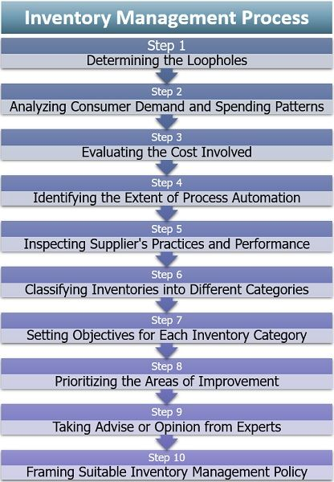
Step 1: Determining the Loopholes
The foremost step is to evaluate the inventory requirement and the actual stock of the goods. Also, the reasons for this gap between the demand and inventory should be ascertained.

Step 2: Analyzing Consumer Demand and Spending Patterns
The market demand forecasting holds equal importance. This is because it helps the organization to estimate the production quantity, which ultimately leads to the maintenance of adequate inventory.

Step 3: Evaluating the Cost Involved
Its implementation involves different types of expenses such as warehousing, maintenance, transport, bulk discounts and supply chain costs. Each of these should be well analyzed.

Step 4: Identifying the Extent of Process Automation
It is not possible for every organization to completely automate the inventory management process. However, the management can recognize those particular areas where there are possibilities of automation.

Step 5: Inspecting Supplier’s Practices and Performance
The next step is to find out the suppliers’ inventory management practices since this strategy cannot be implemented solely. If the supplier is resistant to change and tends to proceed with the traditional means, the organization needs to look for alternative vendors.

Step 6: Classifying Inventories into Different Categories
The goods have to be segregated into various categories depending upon the product type, customer class, maintenance cost or profit margin.

Step 7: Setting Objectives for Each Inventory Category
To efficiently manage and track the performance of the applied technique for each category, it is essential to set individual goals. It not only provides a base for benchmarking but also identifies the problems and issues faced in each of these categories.

Step 8: Prioritizing the Areas of Improvement
Now, that we are aware of the problems, the next step is about finding out the density of each issue and its impact. The concerns which can be resolved immediately needs to be addressed first. And then, the ones which are complex and requires restoration should be considered.

Step 9: Taking Advice or Opinion from Experts
Designing an appropriate inventory management system is the task of the personnel who specialize in the field. Thus, at this stage, the organization needs to hire consultants or experts for advice and opinion on current technology and problem fixation within the desired budget.

Step 10: Framing Suitable Inventory Management Policy
The last step is to implement a satisfactory inventory management strategy for the desired change. This improvement should be incorporated as an inventory management policy to deal with the changes in demand and add value to customer experience.

IMPORTANCE OF INVENTORY MANAGEMENT
The evolving technology and changing consumer preference have significantly brought forward the need for a robust inventory management system. Given below are some of the most prominent reason for which it is considered beneficial for every business entity:
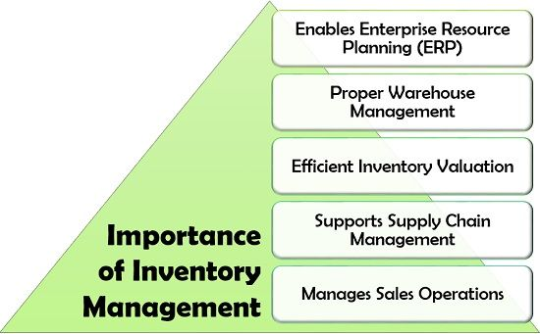

1. Enables Enterprise Resource Planning (ERP)
The ERP software accommodates and links the different business operations. These are inventory procurement, warehousing, production, human resource, finance, marketing and sales to one another. In this process, inventory management contributes its part of providing the necessary data.
2. Proper Warehouse Management
The barcode system, LIFO and FIFO techniques provide a clear picture of the past and present inventory available with the company to optimize the warehousing functions.
3. Efficient Inventory Valuation
It provides for proper evaluation of the different types of inventory, i.e., stock in hand, opening and closing stocks, raw material, finished goods, etc. This data is also used to prepare the cost sheet.
4. Supports Supply Chain Management
Being a segment of supply chain management, it is responsible for streamlining all the warehousing operations and flow of raw material or stock.
5. Manages Sales Operations
Sales, as we know, is a continuous process which depends upon the production of goods or services. If there is inefficient inventory management in the organization, the chances of unavailability of raw material for manufacturing may arise.

Challenges Faced in Inventory Management
Inventory management has become an inevitable part of significant business entities. Also, many small organizations have adopted the concept to keep track of their stock and raw material.
But while practically implementing it, the companies have to deal with the following limitations:
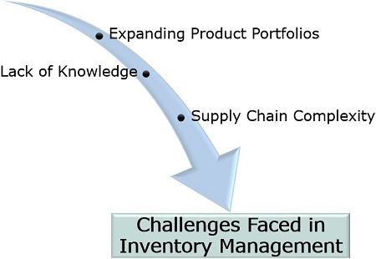
- Lack of Knowledge: The personnel at the receiving and warehousing departments may lack the required expertise and adequate knowledge of segregating the regular and seasonal goods out of the whole stock.
- Expanding Product Portfolios: The customers’ demand and requirements for a wide range of products have tremendously increased the inventory size, making it difficult to manage, manually.
- Supply Chain Complexity: The organization, at times, fail to track the stock or goods during the supply chain process. Moreover, it is not necessary that the business partners also maintain an inventory management system, creating hurdles.

Conclusion
Inventory management is a useful method for simplifying all the warehousing activities of the organization. With this technique, the company can now access and determine its stock and inventory with efficiency to smoothen all the business operations.
It has also proved to be a valuable tool for maintaining the working capital requirement.

INVENTORY MANAGEMENT TECHNIQUES
That being said, inventory management is only as powerful as the way you use it.
Its well worth the extra time and money to have inventory management set up by the experts who made the software. Work with them to make sure you’re utilizing the proper techniques and features to get the most bang for your buck.
Let’s take a look at some inventory-control techniques you may choose to utilize in your own warehouse.

1. Economic order quantity.

Economic order quantity, or EOQ, is a formula for the ideal order quantity a company needs to purchase for its inventory with a set of variables like total costs of production, demand rate, and other factors.

The overall goal of EOQ is to minimize related costs. The formula is used to identify the greatest number of product units to order to minimize buying. The formula also takes the number of units in the delivery of and storing of inventory unit costs. This helps free up tied cash in inventory for most companies.

2. Minimum order quantity.

On the supplier side, minimum order quantity (MOQ) is the smallest amount of set stock a supplier is willing to sell. If retailers are unable to purchase the MOQ of a product, the supplier won’t sell it to you.
For example, inventory items that cost more to produce typically have a smaller MOQ as opposed to cheaper items that are easier and more cost effective to make.

3. ABC analysis.

This inventory categorization technique splits subjects into three categories to identify items that have a heavy impact on overall inventory cost.
- Category A serves as your most valuable products that contribute the most to overall profit.
- Category B is the products that fall somewhere in between the most and least valuable.
- Category C is for the small transactions that are vital for overall profit but don’t matter much individually to the company altogether.

4. Just-in-time inventory management.

Just-in-time (JIT) inventory management is a technique that arranges raw material orders from suppliers in direct connection with production schedules.
JIT is a great way to reduce inventory costs. Companies receive inventory on an as-needed basis instead of ordering too much and risking dead stock. Dead stock is inventory that was never sold or used by customers before being removed from sale status.

5. Safety stock inventory.
Safety stock inventory management is extra inventory being ordered beyond expected demand. This technique is used to prevent stockouts typically caused by incorrect forecasting or unforeseen changes in customer demand.

6. FIFO and LIFO.
LIFO and FIFO are methods to determine the cost of inventory. FIFO, or First in, First out, assumes the older inventory is sold first. FIFO is a great way to keep inventory fresh.
LIFO, or Last-in, First-out, assumes the newer inventory is typically sold first. LIFO helps prevent inventory from going bad.
7. Reorder point formula.
The reorder point formula is an inventory management technique that’s based on a business’s own purchase and sales cycles that varies on a per-product basis. A reorder point is usually higher than a safety stock number to factor in lead time.

8. Batch tracking.
Batch tracking is a quality control inventory management technique wherein users can group and monitor a set of stock with similar traits. This method helps to track the expiration of inventory or trace defective items back to their original batch.

9. Consignment inventory.
If you’re thinking about your local consignment store here, you’re exactly right. Consignment inventory is a business deal when a consigner (vendor or wholesaler) agrees to give a consignee (retailer like your favorite consignment store) their goods without the consignee paying for the inventory upfront. The consigner offering the inventory still owns the goods and the consignee pays for them only when they sell.

10. Perpetual inventory management.

Perpetual inventory management is simply counting inventory as soon as it arrives. It’s the most basic inventory management technique and can be recorded manually on pen and paper or a spreadsheet.

11. Dropshipping. Dropshipping is an inventory management fulfillment method in which a store doesn’t actually keep the products it sells in stock. When a store makes a sale, instead of picking it from their own inventory, they purchase the item from a third party and have it shipped to the consumer. The seller never sees our touches the product itself.

12. Lean Manufacturing.
Lean is a broad set of management practices that can be applied to any business practice. It’s goal is to improve efficiency by eliminating waste and any non value-adding activities from daily business.

13. Six Sigma.
Six Sigma is a brand of teaching that gives companies tools to improve the performance of their business (increase profits) and decrease the growth of excess inventory.

14. Lean Six Sigma.
Lean Six Sigma enhances the tools of Six Sigma, but instead focuses more on increasing word standardization and the flow of business.

15. Demand forecasting.
Demand forecasting should become a familiar inventory management technique to retailers. Demand forecasting is based on historical sales data to formulate an estimate of the expected forecast of customer demand. Essentially, it’s an estimate of the goods and services a company expects customers to purchase in the future.

16. Cross-docking.
Cross-docking is an inventory management technique whereby an incoming truck unloads materials directly into outbound trucks to create a JIT shipping process. There is little or no storage in between deliveries.

17. Bulk shipments.
Bulk shipments is a cost efficient method of shipping when you palletize inventory to ship more at once.

IMPORTANCE OF SCIENTIFIC INVENTORY CONTROL SYSTEM
Scientific inventory control system makes use of sophisticated computer programmes to control inventory. The scientific inventory control system results in the reduction of stock as well as substantial decline in critical shortages of inventory. The main purpose of scientific inventory control is to make available the right level of inventory for production as well as for distribution of goods, which in turn brings cost advantages to the firm.
The importance of scientific inventory control system is explained as follows:
1. Continuity in Production Operations
2. On-time Delivery of Goods in the Market
3. Protection against Fluctuations in Demand
4. Protection against Fluctuations in Output
5. Effective Use of Working Capital
6. Facilitates Cost Reduction
7. Reduction in Risk of Obsolescence
8. Reduces Administrative Work-loa
9. Check against Loss of Materials
10. Facilitates Cost Accounting Activities
11. Avoids Duplication in Ordering
12. Competitive Advantage to the Firm

Reference
- Chase R.B., Jacobs F.R., Operations Management for Competitive Advantage, The Mc Graw Hill
- R.Johnson, “Spacecraft for Multi- Floor Layout Planning, Management Science 28, No.4(April 1982), PP407-17
- M.S. Sommers and J.B. Kernan, “A Behavioral Approach to Planning, Layout and Display,” Journal of Retailing, Winter 1965-66, PP 21-27.

Module 2. QUALITY MANAGEMENT
Introduction to Quality: Dimensions of Quality,
Cost of Quality: Types – Internal Failure Cost, External Failure Cost, Appraisal Cost, Prevention Cost
Quality Circle: Features.
Quality Management Tools:
TQM – Importance,
Six Sigma – Process,
ISO 9000– Certification Procedure,
Kaizen – Process
Service Quality Management: Importance, SERVQUAL Model, Measures to improve service quality.

INTRODUCTION TO QUALITY
Meaning: Quality
Quality can be interpret as "Customer's expressed and implied requirements are met fully".
Quality is the most important aspect of any activity production, marketing, finance, human resources, and so on. Quality is vital not only in manufacturing units, but also in any service industry.
John Bank defines "Quality is fully satisfying agreed customer requirements at the lowest internal cost."
This is a core statement from which some eminent definitions of quality have been derived. They include: "the totality of features and characteristics of a product or service that bears on its ability to meet a stated or implied need" [ISO, 1994], "fitness for use" [Juran, 1988], and "conformance to requirement" [Crosby, 1979].
It is important to note that satisfying the customers' needs and expectations is the main factor in all these definitions. Therefore it is an imperative for a company to identify such needs early in the product/service development cycle.
Quality management is focused not only on product quality, but also the means to achieve it. Quality management therefore uses quality assurance and control of processes as well as products to achieve more consistent quality.
Investopedia defines quality management as "the act of overseeing all activities and tasks needed to maintain a desired level of excellence. This includes creating and implementing quality planning and assurance, as well as quality control and quality improvement."
DIMENSIONS OF QUALITY
Before we discuss on dimensions of quality, we must discuss three aspects associated with definition of quality: quality of design, quality of conformance, and quality of performance.
1. Quality of Design:
Quality of design is all about set conditions that the product or service must minimally have to satisfy the requirements of the customer. Thus, the product or service must be designed in such a way so as to meet at least minimally the needs of the consumer. However, the design must be simple and also less expensive so as to meet the customers' product or service expectations. Quality of design is influenced by many factors, such as product type, cost, profit policy, demand of the product, availability of parts and materials, and product reliability.
2. Quality of Conformance:
Quality of conformance is basically meeting the standards defined in the design phase after the product is manufactured or while the service is delivered. This phase is also concerned about quality is control starting from raw material to the finished product. Three broad aspects are covered in this definition, viz. defect detection, defect root cause analysis, and defect prevention. Defect prevention deals with the means to deter the occurrence of defects and is usually achieved using statistical process control techniques. Detecting defects may be by inspection, testing or statistical data analysis collected from process. Subsequently, the root causes behind the presence of defects are investigated, and finally corrective actions are taken to prevent recurrence of the defect.

3. Quality of Performance:
Quality of performance is how well the product functions or service performs when put to use. It measures the degree to which the product or Service satisfies the customer from the perspective of both quality of design and the quality of conformance. Meeting customer expectation is the focus when we talk about quality of performance. Automobile industry conduct test drive of vehicles to collect information about mileage, oil consumption. Bulbs are life tested to understand its reliability during useful life. Customer survey is conducted to find customer’s perception about service delivered. If product or service does not live up to customer expectation, then adjustments are needed in the design or conformance phase.
Garvin (1984) also provides discussion of eight critical dimensions of product quality.
The summarized key points concerning these dimensions of quality is provided below.
1. Performance (will the product do the intended job in field?)
This we have already discussed. It talks about evaluation of product or service performance with respect to certain specific functions and determine how well it performs from customer’s perspective.
2. Reliability (how often the product can fail within a stipulated time?)
It talks about probability of not failing of components of say automobiles or airbus while on service for a specified time period. Less the reliability, more the chances of repair or replacement.
3. Durability (how long can the product last?)
This is the effective life of the product or longevity before it is declared as unfit for use. Repair is not possible after this phase of life.
4. Serviceability (how easy is it to repair the product?)
Customer's view on quality is also influenced by how quickly and economically a repair or routine maintenance activity can be accomplished. This is mentioned as serviceability.
For example: how long did it take to correct an error in your credit card statement by the bank?
5. Aesthetics (how appealing does the product look like?)
This is all about visual appeal of the product, often taking into account factors, such as style, color, shape, packaging, tactile characteristics, and other sensory features.
6. Features (value or what does the product can actually do?)
Customers tend to purchase products that have more value added features. This can be beyond basic criteria to enter into the market. A spreadsheet package may come with built-in statistical quality control features while its competitors did not in the same price range. Feature may also be definite as addition or secondary characteristics attached and supplements primary functionary of a product. Thus, car stereo is a feature of an automobile whose primary function is transportation.

7. Perceived Quality (what is the customer’s feeling about the product after intended use?)
This is all about impression of a customer after using the product and/or service. This dimension is directly influenced by any failures of the product that are highly visible to the public or the way customer is treated when a quality-related problem with a product is addressed. Customer loyalty and repeated business are closely related with perceived quality. For example, if you make regular business trips by a particular airline, which almost always arrives late with few incidence of luggage lost in transit, you will probably prefer not fly on that carrier and prefer its competitor. So you will rate this dimension very low for such carrier.
8. Conformance to Standards (is the product made exactly as the designed
Conformance to standards is basically meeting the standards defined in the design phase after the product is manufactured or while the service is delivered. This phase is also concerned about quality is control starting from raw material to the finished product. Three broad aspects are covered in this definition, viz. defect detection, defect root cause analysis, and defect prevention. Defect prevention deals with the means to deter the occurrence of defects and is usually achieved using statistical process control techniques. Detecting defects may be by inspection, testing or statistical data analysis collected from process. Subsequently, the root causes behind the presence of defects are investigated, and finally corrective actions are taken to prevent recurrence of the defect.
COST OF QUALITY (COQ)
Definition: Cost of quality
Cost of quality (COQ) is defined as a methodology that allows an organization to determine the extent to which its resources are used for activities that prevent poor quality, that appraise the quality of the organization’s products or services, and that result from internal and external failures. Having such information allows an organization to determine the potential savings to be gained by implementing process improvements.
TYPES OF COST OF POOR QUALITY
Quality costs are categorized into four main types
- Appraisal costs
- Internal failure costs
- External failure costs
- Prevention costs
WHAT IS COST OF POOR QUALITY (COPQ)?
Cost of poor quality (COPQ) is defined as the costs associated with providing poor quality products or services.
There are four categories:
Appraisal costs are costs incurred to determine the degree of conformance to quality requirements.
Internal failure costs are costs associated with defects found before the customer receives the product or service.
External failure costs are costs associated with defects found after the customer receives the product or service.
Prevention costs are incurred to prevent or avoid quality problems. These costs are associated with the design, implementation, and maintenance of the quality management system.
1. Appraisal costs:
Appraisal costs are associated with measuring and monitoring activities related to quality. These costs are associated with the suppliers’ and customers’ evaluation of purchased materials, processes, products, and services to ensure that they conform to specifications.
They could include:
Verification: Checking of incoming material, process setup, and products against agreed specifications
Quality audits: Confirmation that the quality system is functioning correctly
Supplier rating: Assessment and approval of suppliers of products and services
2. Internal failure costs:
Internal failure costs are incurred to remedy defects discovered before the product or service is delivered to the customer. These costs occur when the results of work fail to reach design quality standards and are detected before they are transferred to the customer.
They could include:
Waste: Performance of unnecessary work or holding of stock as a result of errors, poor organization, or communication
Scrap: Defective product or material that cannot be repaired, used, or sold
Rework or rectification: Correction of defective material or errors
Failure analysis: Activity required to establish the causes of internal product or service failure
3. External failure costs:
External failure costs are incurred to remedy defects discovered by customers. These costs occur when products or services that fail to reach design quality standards are not detected until after transfer to the customer.
They could include:
Repairs and servicing: Of both returned products and those in the field
Warranty claims: Failed products that are replaced or services that are re-performed under a guarantee
Complaints: All work and costs associated with handling and servicing customers’ complaints
Returns: Handling and investigation of rejected or recalled products, including transport costs

4. Prevention costs:
Prevention costs are incurred to prevent or avoid quality problems. These costs are associated with the design, implementation, and maintenance of the quality management system. They are planned and incurred before actual operation, and they could include:
Product or service requirements: Establishment of specifications for incoming materials, processes, finished products, and services
Quality planning: Creation of plans for quality, reliability, operations, production, and inspection
Quality assurance: Creation and maintenance of the quality system
Training: Development, preparation, and maintenance of programs

QUALITY CIRCLE: FEATURES
INTRODUCTION OF QUALITY CIRCLES
The concept of Quality Circle (QC) was first popularized in Japan in early 1960s. Dr. Ishikawa Kaoru (1915-89) is known as the 'Father of QC' for his role in launching Japan's quality movement in 1960s.
Meaning
Quality circle is a people building philosophy based on the premise that an employee doing a particular job is biggest expert of that field and thus is in a better position to identify, analyse and resolve the work related problems through their innovative and unique ideas.
In fact, it is a practical application of McGregor’s Theory ‘Y’ that if given the right environment and decision making power, people will enjoy and take pride in their work thus leading to enrichment of their work life.
By solving their work related problems, the employees reduce the rejection rate, rework and thus their mental tensions are reduced, enabling them to work with total commitment and dedication.
It is a voluntary group of employees, who are doing the same or similar type of job, meet together on a regular’ basis to identify, analyze and solve their work related problems leading to improvement in their work, performance and- enrichment of their work life. The number of circle members could vary from 5 to 15 but the ideal size of a circle is 7 or 8 members. The number of members should be such that the circle is effective.
FEATURES OF QUALITY CIRCLES
The key features of quality circles are as under:
1. People Building Philosophy – A quality circle is a homogeneous group. The number of employees in a quality circle is between six to ten and they generally come from a particular area. It consists of small group of persons who normally work at the same place and perform similar work. Every member and the management have the sincere desire to help others to grow and develop. They must look out for the development and growth of everyone working in the organization.
2. Voluntary Group – No coercion or pressure is brought on any member to join or not to join. Nor can any member be barred from joining quality circles. Quality circles are voluntary associations of persons having common cause. Members must understand that quality circles are formed for their benefit—they are completely free to take or not to take advantages of it.
3. Participative Program – Quality circles represent collective effort. Every one working in the organisation must get a chance to say what is in his mind. Everyone should have interest and value for the projects chosen for quality circles. The circle as a whole should receive recognition for any achievements accomplished by it.
4. Supportive Management – Quality circles need the encouragement to grow and mature. Management must be willing to give support, advice and also some commitment in the beginning. Members normally meet once in a week for about one hour in consultation with the manager. Each quality circle is managed by an elected leader and the manager/supervisor may act as the leader.
5. To Improve the Performance – Collective and participative efforts must result in the improvement of quality, productivity and performance. Cost and wastage must be reduced as a result of quality circles. The whole organisation must gain both quantitatively as well as qualitatively.
6. Enrichment of Work life – Apart from team culture and attitudinal changes, the quality circles must result in improved working environment, happier relations and greater job satisfaction.
7. To Identify and Resolve Work Related Problems – Members of quality circles identify their problems through brainstorming sessions. Then they start analyzing the problems through statistical quality control techniques and problem solving methods. A unique feature of Quality Circles is that they do not pass on the decision without interacting with other levels of functional agencies.
8. The focus is on quality related problems.

IMPORTANT OBJECTIVES QUALITY CIRCLE
The important objectives of quality circles are:
(i) To develop, enhance and utilize human resources effectively;
(ii) To improve quality of products/services, productivity and reduce cost of production per unit of output;
(iii) To satisfy the workers’ psychological needs for self-urge, participation, recognition etc., with a view to motivating them. Accomplishment of this objective will ensure enhancement of employee morale and commitment;
(iv) To improve various supervisory skills like leadership, problem solving, inter-personal and conflict resolution;
(v) To utilize individual imaginative, creative and innovative skills through participation, creating and developing work interest, including problem solving techniques etc. Achievement of these objectives effectively requires the use of certain techniques.
(vi) To make use of the knowledge and skills of the workers.
(vii) To develop good relations between workers and managers and create cordial industrial relations.

TOTAL QUALITY MANAGEMENT
TQM or Total Quality Management is a structured management approach based on the belief that an organization’s continuous effort can contribute to its long-term success. When every member is dedicated to improving the quality of work, it seamlessly aligns the overall objectives of a company.
Management consultants W. Edwards Deming, Armand V. Feigenbaum and Joseph M. Juran jointly developed the TQM concept. They helped Japanese industries rebuild their businesses post World War II. TQM was developed to solve the manufacturing industries’ problems but over time it’s become a universal management framework that benefits all kinds of businesses. The approach is beneficial for everybody involved—the organization, its employees and the customers/clients.
The concept of TQM was made popular by Dr. W.E.Deming in 1960s in Japan.
According to Business Dictionary.com "TQM is a holistic approach to long-term success that views continuous improvement in all aspects of an organization as a process and not as a short-term goal. It aims to radically transform the organization through progressive changes in the attitudes, practices, structures, and systems."
Total quality management uses a PDCA cycle (Plan, Do, Check, Act) for continuous control and improvement of business outcomes.
1. PLANNING PHASE
This is the most crucial phase of TQM; it requires individuals to list down action items for various challenges or problems. Employees need to get to the root of the problem(s) and find solutions through adequate research and data collection.
2. DOING PHASE
In this phase, employees find a solution to the problems they’ve identified. They devise strategies that address a problem’s source. A solution’s or strategy’s effectiveness depends upon how well someone has defined a problem and identified the root cause.
3. CHECKING PHASE
This phase is reserved for analysis. People check for a solution’s effectiveness by monitoring the progress that’s been made. Assessed data becomes an input for the subsequent step in the PDCA cycle.
4. ACTING PHASE
People document their results after meeting their goals. They use the cycle’s results to identify and address challenges in other fields, therefore standardizing the TQM method.

ELEMENTS OF TOTAL QUALITY MANAGEMENT
What is TQM without the successful implementation of its underlying factors? Here are the core elements or principles that influence the success of TQM:
1. CUSTOMER FOCUS
Businesses should understand their target markets or customers. By identifying customers’ needs, organizations can allocate their resources for initiatives or strategies that’ll improve customer satisfaction. They can find new ways to exceed customer expectations. When in doubt, remember Bill Gates’ words of wisdom, “Your most unhappy customers are your greatest source of learning.”
2. LEADERSHIP
Good leaders build effective teams and give people a sense of direction. In addition to motivating, leaders provide guidance on setting personal goals that align with an organization’s mission and vision. Positive leadership boosts productivity and efficiency. Strong leaders help people stay driven, find meaning in their work and concentrate on larger goals.
3. PROCESS APPROACH
Organizations achieve their desired business results when related activities and resources are properly managed. Toyota Motors for example, made its assembly line more efficient by keeping just enough inventories open in order to fulfill customers’ orders. TQM emphasizes the need for improving efficiency, effectiveness and consistency to speed up production process, delivery and/or performance.
4. SYSTEM APPROACH
TQM creates a standardized system that helps identify, understand and manage interrelated processes that contribute to an organization’s success. It stresses the importance of several independent processes including the quality of products, employee satisfaction, consumer satisfaction and better utilization of resources.
5. APPROACH TO DECISION-MAKING
TQM facilitates a factual approach in decision-making. Decisions are based on data collected from in-depth research and analysis. Facts, figures and statistics can help anyone understand the product/service and marketplace in detail. Businesses make clear decisions based on objective data.
6. FOCUS ON SOLUTIONS
People often make the mistake of remedying a problem in the short-term. Instead of eradicating the source of the problem, they treat symptoms. For example, if an organization faces problems with shipping goods, managers should figure out whether the problem is related to the entire shipping process.

IMPORTANCE OF TOTAL QUALITY MANAGEMENT
Quality can be defined as an attribute that differentiates a product or service from its competitors. Total quality management makes an organization stand apart from the rest. Let’s look at some of the other advantages of TQM that drive customer satisfaction and business success.
1. COST REDUCTION & INCREASED PROFITABILITY
TQM helps reduce total quality costs. In other words, it aims to produce superior quality products and services so that no additional costs are borne later. Many companies like Motorola implemented TQM techniques to reduce manufacturing costs, saving billions of dollars.
2. ENHANCED PRODUCTIVITY
Some organizations offer superior quality resources, high-end infrastructure and excellent technology—all of which are instrumental in motivating employees. With improved standards of work and better working conditions, employees are encouraged to maximize their output.
3. LESSER REDUNDANCY
Every organization aims at improving productivity and profitability. TQM uses a systematic approach to reduce any duplication of tasks, therefore saving time and fully utilizing available resources.
4. IMPROVED INNOVATION PROCESS
As we’ve already established, TQM includes a research phase. Organizations collect data about any current challenges or problems to devise effective solutions. Some organizations rely on unique strategies to get to the root of a problem. For example, businesses often use the A/B testing method to compare two versions of the same strategy and implement the one that produces better results.
5. CONTINUAL IMPROVEMENT
TQM tools like progress-trackers help businesses monitor their employees’ performance at all times. There are internal as well as external gains from continuous improvement. External gains include better product quality, increased market share and productivity. Internal gains include effective teamwork, increased job satisfaction and better workplace culture.
6. EFFECTIVE COMMUNICATION
TQM techniques push individuals to collaborate and support each other for the greater benefit of an organization. Increased teamwork and cross-functional collaboration prompt everyone to strive for continuous improvement. For example, clear communication enables a production chain that functions seamlessly because everyone is on the same page.
7. HOLISTIC APPROACH TO MANAGEMENT
Many organizations struggle with low employee engagement. TQM helps workplaces bring behavioral changes by facilitating self-development, teamwork and improved employee engagement. Individuals show more interest in their roles because the organization prioritizes their well-being and job satisfaction.

8. INCREASED GOODWILL
Organizations can establish quality standards for goods/services using TQM. Internal stakeholders (employees and investors) get lucrative incentives and profitable return on investment. External stakeholders (customers and clients) get superior quality products and services. The result: positive brand image and goodwill in the long-run.

CONCLUSION
With increased competition and globalization, total quality management has become a common practice of modern-day businesses. Individuals (especially managers and leaders) use this tool to improve a product’s design, ensure increased revenue, eliminate wastage and defects, and enhance the market image. Most of all, they help employees find meaning in their work, in addition to encouraging collaboration and teamwork.
Harappa Education’s Managing Teamwork course is designed to help you understand your team’s goals and expectations. You’ll not only learn to collaborate with multiple stakeholders but also encourage cross-functional collaboration among team members.
The Bruce Tuckman Model will guide you through the various stages of team formation and growth. The GRIN Framework will help you understand the fundamental characteristics of an effective team. The quality or success of an organization depends on its employees. So, build an employee-first culture and master the art of continuous improvement!

SIX SIGMA
The term Six Sigma refers to a set of quality-control tools that businesses can use to eliminate defects and improve processes to help boost their profits. It was developed by a scientist in the 1980s while he was working at Motorola.
Six Sigma is a management ideology that focuses on statistical improvements to a business process and advocates for qualitative measurements of success over qualitative markers. As such, Six Sigma practitioners are business people who use statistics, financial analysis, and project management to achieve improved business functionality.
FEATURES OF SIX SIGMA
The main characteristics of Six Sigma are:
1. Problem Solving Approach:
It adopts a structured approach towards problem solving. The most commonly used version of the problem solving methodology is known as DMAIC (Define-Measure-Analyz - Improve-Control), an acronym for the phases of Six Sigma improvement.
In DMAIC methodology, a team defines a problem and works to find a solution linked to its underlying causes, establishing practices to ensure that the solution is permanent.

2. Tools to Improve Process Capability:
A number of tools are used by Quality Managers to help them in studying and improving the process capability of their production. Managers employing the Six Sigma use tools such as histograms, Pareto Analysis, Process Control Charts. Correlation and Benchmarking for establishing better understanding and to help in problem solving.
3. Customer Focus:
It has a very strong customer focus. The targets are set keeping in mind the requirements of the customers. The customer focus is fundamental to the Six Sigma approach.The quality improvement and control standards are based on the explicit customer requirements. Some industries and businesses which deal in delivering critical value to the customers and involve great risk in terms of health and security have to strive to accomplish near perfect process capability and go for Six Sigma.
4. Based on Factual Data:
The Six Sigma approach is absolutely facts and data driven. Accurate data is always needed in a suitable and systematic format to arrive at the right decisions. Great importance is given to making decisions on the basis of verifiable data rather than on assumptions and speculations.
5. Financially Driven Approach:
The approach is financially driven with the selection of projects being based solely on the concrete financial outcomes that they are expected to generate. There is emphasis on the achievement of specific and quantifiable targets.
6. Team Based:
Six Sigma is team based and the structured nature of this approach requires extreme discipline within the organization which includes time management and pro-active leadership but the real challenge lies in the ability to plan and execute projects which deliver specified financial benefits.
7. Roles of Team Members:
Six Sigma involves a lot of training depending on the role of an individual in the Quality Management team. The roles in Six Sigma teams are assigned based on the ranks in Karate, such as:
Black Belt: The person possessing this belt has achieved the highest skill level and is an experienced expert in various techniques. He has completed a thorough internal training program and has work experience of several projects. The black belt holder is usually given the role of team leader, the person who is responsible for execution and scheduling.
Master Black Belt: A person who is available for consultations by the team. He acts like a coach for more complex and technical projects. He is not a direct member of the team. The Master Black Belt is available to answer procedural questions and to resolve the technical issues that come up.
Green Belt: He/she has strong knowledge and skills of the Six Sigma approach, but typically does not have experience with advanced statistical tools. Green Belts may lead simple projects under the guidance of a Black Belt or may work as a team member on a large project team.
Yellow Belt: A Yellow Belt is trained in the general Six Sigma concepts and basic tools. A company deploying Six Sigma may choose to designate project team members as Yellow Belts after completing a required training course, or may use the designation for employees responsible for data collection for a Green Belt or Black Belt project.
8. Continuous Improvement:
Six Sigma is all about continuous improvement. Like all other quality improvement initiatives, its ultimate aim is to refine the processes within the organization leading to the improvement of the quality of the produced output.
STEPS OR PROCESS OF SIX SIGMA
The Six Sigma Methodology comprises five data-driven stages — Define, Measure, Analyze, Improve and Control (DMAIC). When fully implemented, DMAIC standardizes an organization’s problem-solving approach and shapes how it ideates new process solutions.
1. Define
The “Define” stage seeks to identify all the pertinent information necessary to break down a project, problem or process into tangible, actionable terms. It emphasizes the concrete, grounding process improvements in actual, quantifiable and qualifiable information rather than abstract goals.
Examples of terms in the Define stage include:
Project scope charter, including budget, focus and driving motivation
Voice of customer (VoC) research
Value stream maps
Project timeline
2. Measure
In the “Measure” phase, organizations assess where current process capabilities are. While they understand they need to make improvements and have listed those improvements concretely in the Define phase, they cannot go about tweaking and tailoring changes until they have a data-backed baseline.
In other words, the Measure phase initiates two activities:
Measure the current process or activity
Use those current data sets to establish a process capability baseline, which process improvement data will be compared to
3. Analyze
The “Analyze” phase examines the data amassed during the Measure stage to isolate the exact root causes of process inefficiencies, defects and discrepancies. In short, it extracts meaning from your data. Insights gleaned from Analyzation begin scaffolding the tangible process improvements for your team or organization to implement.
4. Improve
The “Improve” initiates formal action plans meant to solve the target root problems gleaned from your Analyzations. Organizations directly address what they’ve identified as problem root causes, typically deploying a Design of Experiment plan to isolate different variables and co-factors until the true obstacle is found.
5. Control
In the final phase, “Control,” Six Sigma teams create a control plan and deploy your new standardized process. The control plan outlines improved daily workflows, which result in critical business process variables abiding by accepted quality control variances.
Each of these five phases creates a repeatable template to improve your business’ process capabilities. When the five stages are fully implemented, organizations can measure both the effectiveness and efficiency of critical manufacturing business processes. Measurements are tracked in a control chart, lending you quantifiable, comparable process-control data that leverage a competitive advantage.
EXAMPLE OF SIX SIGMA
MICROSOFT
Microsoft (MSFT) is one of the largest software producers in the world. In order to improve the reliability and availability of its networks worldwide, Microsoft implemented Six Sigma methodologies to use a robust data-driven process to help eradicate any defects in their systems and data centers to systematically reduce IT infrastructure failures.
The company first established standards for all of its hardware and software to create a baseline measurement for detecting defects. Microsoft used root-cause analysis, including collecting data from past high-priority incidents, server failures, and recommendations from product group members and customers. Using the historical data, Microsoft established baseline standards from which to measure going forward.8
Large amounts of data were collected on a daily and weekly basis from various servers. Data analysis and reporting identified the defects and remediation steps for each defect were then established. The incidents were prioritized based on how severe the defects impacted the business and the company's underlying services.
Using Six Sigma methodologies, the teams executed eradication initiatives of the defects. As a result, remediation of defects improved by 40% within the first year. The mean or average time between server failures improved from 18 days to 125 days. As a result of Six Sigma, Microsoft improved the availability of its servers, boosted customer productivity, and increased customer satisfaction.
ISO 9000 - CERTIFICATION PROCEDURE
ISO is the International Organization for Standardization (popularly called as ISO). It is located in Switzerland. It is established to develop common international standards worldwide. The term ISO 9001 refers to a set of quality management standards.

ISO 9000 - Quality Management
The ISO 9000 family addresses various aspects of quality management and contains some of ISO's best known standards. The standards provide guidelines for companies and organizations so as to ensure that their products and services consistently meet customer's requirements and that quality is continuously improved.
Currently, the ISO 9000 family contains these standards:
ISO 9001:2015: Quality Management Systems -Requirements.
ISO 9000:2015: Quality Management Systems - Fundamentals and Vocabulary (definitions)
ISO 9004:2018: Quality Management Quality of an Organization Guidance to Achieve Sustained Success. (Continuous improvement)

PROCEDURE TO OBTAIN ISO CERTIFICATION
An Indian company can obtain ISO 9001:2015 certification from an accredited agency recognized by ISO.
The following is the procedure to obtain ISO 9001 certification:
1. Evaluation of Existing Quality Procedures:
The Company wishing to obtain ISO 9001 certification should evaluate its existing quality procedures. This is because; a company cannot expect to get itself ISO certified, if it does not fulfill certain minimum standards of quality.
The company can appoint an ISO steering team to evaluate the existing quality procedures prevailing within the firm.
2. Initiating Corrective Action:
If the company (ISO steering team) finds deficiencies in the existing quality procedures, then there is a need to correct such deficiencies. Such correction is required so as to conform to ISO series standards.
The corrective action may include:
Investigating causes of non-conforming products and identifying corrective action to prevent recurrence.
- Analyzing processes, records, customer complaints, etc., to detect and to eliminate potential causes of non-conforming products.
- Applying controls to ensure that corrective actions are taken and their effective implementation.
- Implementing changes in procedures, as corrective actions require.
- Initiate preventive action to eliminate potential problems.
3. Preparation of Quality Assurance Programme:
Company should prepare a quality assurance programme. This programme would involve details regarding the various areas, departments, or products that require observance of quality control, training to be provided to the employees and other activities, which are required to maintain high quality standards.
4. Preparation of Quality Manual:
Company must also prepare a quality manual. The quality manual would provide guidelines to the employees of the firm so as to maintain quality standards.
The quality manual may include details in respect of;
Purchase procedures.
Quality control procedures.
Maintenance and repairs of plant and machinery.
Procedures relating to handling and storage of inventory.
Procedures relating to packaging and delivery. Procedures relating to servicing of product, etc.
5. Selection of Certification Agency:
The company must select an agency to provide ISO 9001 certification. The company may select Bureau of India’s Standards (BIS) or a foreign accredited agency. Most Indian exporters prefer to appoint a foreign agency (although the expenses are more), as a certification by a reputed foreign agency carries more weight in the international markets.
The company should make an application to the accredited agency along with necessary documents which includes quality manual, undertaking to pay the required fees, etc.
6. Pre-assessment Meeting:
Company's representative would hold a pre-assessment (pre inspection) meeting with the certification agency. The pre assessment meeting is required to analyse the quality manua of the firm and to appraise the quality standards being adopted by the firm. The firm may also come to know of any specific arrangements required by the agency before certification.
7. Preliminary Visit:
The accredited agency, normally, arranges for a preliminary visit to the firm and notifies the company of any significant omissions or deviations from the prescribed requirements, s that any suitable modifications or changes can be made price to the assessment visit.
8. Actual Assessment Visit:
The actual assessment visit is a practical evaluation to check that the company's systems are functioning effectively. If there are any discrepancies, which indicate a systems failure, the company is given a period to rectify the deficiencies, Corrective action programmes are also agreed upon for rectifying any discrepancies detected.
9. Certification:
If the assessment agency is satisfied with the quality systems of the company, then it would certify or grant ISO 9001: 2008 certification to the firm. The firm can use the ISO 9001: 2008 in their advertisements, products packages, letterheads, etc.
10. Surveillance:
The accredited agency's registrar normally performs periodic surveillance to assure that the certified company's quality system is being maintained. Agencies may undertake a complete review of the firm's quality systems of the certified firms. If the firm fails to maintain the quality system, the agency's registrar will suspend or cancel the registration or certification.
KAIZEN – PROCESS
Kaizen is a Japanese word meaning continuous improvement. It's made up of two characters in Japanese: kai, which means 'change,' and zen, which means 'good.' It's used to describe a company culture where everyone, from the CEO to the front desk clerk, regularly evaluates his or her work and thinks of ways to improve it. The concept is that small steps on a regular basis will lead to large improvements over time.
Kaizen is a Japanese term meaning "change for the better" or "continuous improvement." It is a Japanese business philosophy regarding the processes that continuously improve operations and involve all employees. Kaizen sees improvement in productivity as a gradual and methodical process.
The concept of kaizen encompasses a wide range of ideas. It involves making the work environment more efficient and effective by creating a team atmosphere, improving everyday procedures, ensuring employee engagement, and making a job more fulfilling, less tiring, and safer.

KAIZEN PROCESS
The following are the steps in the Kaizen Process.
1. Define the Problem:
The management must identify the problems facing the organisation. After identifying the problems, the management must clearly define the problems in terms of the root causes of the problem, duration (how long the problems persisted), the number of persons affected by problem and so. Problem definition of the problem may lead to effective solution.
The problems must be prioritized on the basis of their importance and urgency. The more urgent and the more important problems must be listed first followed by others. This will enable the organisation to focus on urgent and important problems that needs to be sorted out first.
For instance, a company may have a dicey situation wherein there are two major problems:
- Growing complaints of employees.
- Growing Complaints of Customers
In this tricky situation, it would be advisable to prioritize complaints of the employees, because, the complaints of the customers cannot be easily resolved when employees are dissatisfied.

2. Document the Current Situation:
The management must analyze the current situation in terms of organisation structure, superior-subordinate relationships, employee selection procedures, training policies and practices, the production facilities, corporate culture, technology, production processes, and so on. A proper analysis of the current situation may enable the management to have a re-look at the causes of the problem.
3. Visualize the Ideal Situation:
The management must visualise the ideal situation so that the problem can be solved. For instance, the employees' problem can be resolved through several ways such as:
- Re-designing personnel policies with reference to promotion, compensation, training, and so on.

- Improvements in communication system at all levels.

- Developing a committed and dedicated work-culture.

- Recognizing and rewarding suggestions, and so on.

4. Define Measurement Targets: There is a need to define measurement targets at which the outcomes or results can be compared.
For instance, the measurement target for customers' complaints can be stated as follows: 'Reduction in Customer complaints from the current level of 50 per month to 10 in the first month of implementation and finally to near zero at the end of three month period.
5. Initiate Brainstorming Sessions for Solutions: The management needs to generate ideas to develop effective solution to the problem. As far as possible, multiple solutions need to be generated. This can be done through various techniques such as:
- Obtaining suggestions from the employees.
- Analysis of solutions for similar problem and the success rate of the solutions adopted by the company in the past.
- Analysis of solutions adopted by other organisations in the past and their success rate.
- Organising brainstorming sessions involving representatives of the management and the employees.
6. Develop Kaizen Plan:
There is a need to prepare a Kaizen plan to bring continuous improvements in the organisation at all levels and in all departments.
The plan must indicate:
- The areas or activities where kaizen can be applied.
- The persons responsible for implementation of solutions.
- The period within which the solutions needs to be implemented. The process of implementation of solutions, including approvals of top management, wherever required.
- The amount of funds that can be utilized for improvements during the plan period, etc. Once the solution is selected, and the plan is prepared to implement the solution, the management needs to implement.

7. Implement Plan:
Once the solution is selected, and the plan is prepared to implement the solution, the management needs to implement the solution.
Implementation of the solution would involve:
- Arrangement of resources
- Directing the employees
- Motivating the employees
8. Measurement of Outcomes: The management must measure the outcomes of the solution. The actual outcome needs to be recorded and compared against the set targets. The comparison is required to find out whether the organisation is on the right track to achieve the Kaizen success.
9. Review: The actual outcome of the kaizen changes are compared against the set targets. If there are deviations, the management must analyse or review the deviations to find out the causes of not achieving the desired results. For instance, in the case of customer complaints, the management should find out whether or not the complaints have reduced at a negligible level or zero.
10. Changes in the Solution and Plan: If the problem cannot be resolved through the current solution, the management may adopt another most feasible solution. Also, the kaizen plan needs to be analysed and if required, the plan itself may be changed.
SERVICE QUALITY MANAGEMENT
It is a combination of two words, Service and Quality where we find emphasis on the availability of quality services to the ultimate users. The term quality focuses on standard or specification that a service generating organisation promises. We can’t have a clear-cut boundary for quality. Sky is the limit for quality generation. Scientific inventions and innovations make the ways for the generation of quality. More frequency in innovations, less gap in the process of quality up-gradation
MEANING OF SERVICE QUALITY
Service - An act of helpful activity
Quality- An essential or distinctive characteristic, property, or attribute.
Management- The act or manner of managing; handling, direction, or control.
Service quality is generally viewed as the output of the service delivery system, especially in the case of pure service systems. Moreover, service quality is linked to consumer satisfaction.
Although there is no consensus in the research community about the direction of causality relating quality and satisfaction, the common assumption is that service quality leads to satisfied customers.

For example – customers leaving a restaurant or hotel are asked if they were satisfied with the service they received. If they answer “no,” one tends to assume that service was poor.
Service Quality Management is a measure of how products and services supplied by a company meets and surpasses consumer expectation.
Service Quality Management is the process of managing the quality of services delivered to a customer according to his expectations is called Service Quality Management. It basically assesses how well a service has been given, so as to improve its quality in the future, identify problems and correct them to increase customer satisfaction.
The Service Quality Model or SERVQUAL Model was developed and implemented by the American marketing gurus Valarie Zeithaml, A. Parasuraman and Leonard Berry in 1988. It is a method to capture and measure the service quality experienced by customers.
Initially, emphasis was on the development of quality systems in the field product quality. Over time, it became more and more important to improve the quality of related services. Improved service quality could give organisations a competitive edge. In addition, service in general became more important, and as a result, the SERVQUAL Model had a serious impact in the eighties. Back then, measuring service was abstract and not easily quantifiable.
SERVICE QUALITY MANAGEMENT: IMPORTANCE
Service quality management is undertaken to improve the quality of services on a continuous basis to enhance customer satisfaction and loyalty. It is to be noted that service firms must consider the trade-off between incremental costs involved in service quality improvement and the incremental revenues. It makes no business sense to improve quality dimensions when the customers are not willing to pay extra for the added quality dimensions.
IMPORTANCE OF SERVICE QUALITY MANAGEMENT (SQM)
The importance of service quality management is stated as follows:
1. Customer Satisfaction:
SQM leads to improvement in the quality of services. Therefore, SQM leads to customer satisfaction. Customer satisfaction takes place when service performance meets customer expectation. At times, SOM may lead to customers delight. Customers delight takes place when service performance is much more than customer expectations.
2. Corporate Image:
SQM helps to improve the image of the organisation. Due to good quality services, the organisation may get higher performance. On account of higher performance, the image of the organisation improves in the mind of various stakeholders -customers, employees, shareholders, and others.
3. Competitive Advantage:
SQM enables a firm to gain competitive advantage. SOM ensures continuous improvement in quality of services provided to the customers. SQM also involves lowering down the internal costs. Therefore, customers can get quality services at lower price. Therefore, the service firm can easily face competition in the market.
4. Customer Loyalty:
SQM leads to customer loyalty due to quality services. Customer loyalty takes place on account of:
Repeat order for services by the satisfied customers. Recommendations by the satisfied customers to others.

5. Reduction in Service Costs:
SQM leads to reduction in service costs. For instance, SQM places lot of emphasis on training and development of employees. Training helps to improve knowledge, attitudes and skills.
Apart from training, SQM places emphasis on recognition and rewards for the competent and committed employees. Therefore, trained and motivated make every possible effort to reduce internal costs, which in turn improves the productivity of services.
6. Social Benefits:
SQM can lead to social benefits as well. For instance, SQM ensures a disciplined and dedicated work culture in the organization. The discipline of the employees has a spread effect.
For instance, if an educational institution inculcates discipline in the minds of students; the students in their later years can influence others (who are related or connected with them at the work place or at some other place) to be committed and dedicated.
Employees are a part of the social community. Disciplined employees may work for social welfare as well. The social community would benefit due to efforts of discipline of the dedicated employees, and therefore, some of the problems faced by the society such as corruption, communal hatred, etc., may be reduced to a great extent.
7. Efficiency:
Efficiency is the ratio of returns to costs. A service organisation would be more efficient when it gets higher returns at lower costs than before. SQM helps to reduce internal costs, and at the same time the organisation is likely to get higher returns due to the efforts of trained and motivated employees.
8. Expansion of Business:
SQM facilitates expansion of business. Due to higher performance, and corporate image, a service organisation can enter into new markets. This means a service organisation can expand from local level to regional level, and from regional level to national level and even at international level.
9. Economies of Scale:
SQM may also generate economies of scale. The service organisation may adopt latest technology for its operations. The use of technology reduces the need for more manpower as it expands. Therefore, the service firm may get economies of large operations.
10. Organisational Objectives:
SQM enables the service organisation to achieve organisational objectives such as:
Increase in profits
Increase in sales turnover
SERVQUAL MODEL: 10 DIMENSIONS
The first studies according to the SERVQUAL Model, were carried out exclusively for the services of a telecommunications, a banking and a maintenance company. The previously mentioned researched surveyed consumers and their perceptions of the experienced service quality of these three organizations From the original questionnaire of almost 100 items, 25 finally remained that were considered important by the consumers regarding customer service. In the end, this resulted in the following ten dimensions that still play an important role in the SERVQUAL Model:
1. Reliability
2. Responsiveness
3. Competence
4. Access
5. Courtesy
6. Communication
7. Credibility
8. Security
9. Knowing the customer
10. Tangibles
The reliability depends on to what extent the service is accurate and honest.
Responsiveness is about promptly and adequately responding to customer questions or complaints.
Competence relates to the expertise an organization has and the access determines if a customer can quickly and efficiently contact the right department.
Courtesy is the trying to be polite to customers and communication is about clear, honest and prompt information for clients.
Credibility is about to what extent the organization’s message is believable and reliable.
Security is meant to add trust to the service and proper access for the consumer.
Knowing the customer includes a personal approach and responding well to customers’ needs and wishes.
The tangibles are tangible information; that what is visible to the customers in the form of for instance the visibility of staff (work clothes / uniform), the decoration and cleanliness of an office building and all other facilities.

THE FIVE GAPS OF SERVQUAL MODEL
The correspondence between the client and the service-providing association, just as the association’s inner correspondence, is of fundamental significance for the degree of nature of the assistance.
It is acceptable when firms realize the patterns of their clients. Consequently, the SERVQUAL Model recognizes five gaps that can emerge between the client’s necessities and the help that an organization offers.
1. Knowledge Gap
A gap emerges when a firm’s information on consumer needs is not enough, keeping them from precisely moving toward customers.
Also known as the management perception gap. When the organization’s assumptions of customer perception are different from the customers, this gap arises. This occurs as a result of insufficient and careless research. It hints towards a problem with market understanding.
Causes- Lack of quality marketing, poorly interpreted information, unfocused research on customer needs, Too much miscommunication between frontline employees and top-level management.
For example- If a coffee brand misreads customer need for affordable coffee and instead markets itself as very expensive. While there are people who will buy it, coffee is an everyday need for the majority of people and hence they prefer an affordable brand over an expensive one.
2. Standards Gap
The firm has framed its thought regarding what the client anticipates from its administration. In the event that this thought isn’t right from the beginning and doesn’t relate to what clients expect, there is a huge danger that the firm will interpret it wrongly into a quality approach and comparing rules.
It is also known as the quality specification gap. Service design and performance standards are required to fill this gap.
Causes- Absence of proper goal, insufficient planning, absence of quality service, not estimating the feasibility of the service, overall inadequate approach towards task standardization.
For example- The majority of hotels do not clean the rooms on the day of check out. They do not take into consideration late checkouts. Hence ignoring the expectations of the customer.
3. Delivery Gap
A gap can likewise happen when the firm offers a service that is not the same as what the customer had anticipated. This additionally includes off-base usage. For example, in the manner in which workers complete strategy.
This gap is also known as the service delivery gap. Hence customer experience with a particular service or product must be taken into account for improvement. This is usually done in form of feedbacks.
Causes- Ineffective recruitment, role conflict, could not match demand and supply, lack of teamwork, employee0technology fit ineffective, inadequate planning.
For example- Many times while delivering food, the orders are wrong or the packaging is not proper.
4. Communications Gap
This gap occurs when the organization promises services that they are not capable to deliver. The communications that the firm sends out can create wrong expectations. It is the difference between consumer experience and expectations.
It is also known as the market communication gap. As the majority of the communication is done by the marketing team, this is often a fault on their part.
The firms often exaggerate the results they deliver and this, in turn, leaves the customer unhappy and dissatisfied.
Causes- failure to manage consumer demand, failure to perform promised services, poor communication, over-estimating on behalf of the marketing team.
For example- Various fairness creams promise a lighter skin tone in 5-6 weeks but often fail to mention extra precautions like scarves and hats that need to be worn to shield from the sun.
5. Satisfaction Gap
This is a combination of knowledge gap and communication gap. It is the overall difference between the perceived service by the customer and the experience of the customer with the service and the firm.
Unless customer satisfaction is kept intact, the firm is at risk of losing credibility and reputation in the market. Also known as perceived service quality gap.
Causes- online information, reviews, feedbacks by other customers, word of mouth, cultural background, personality, and other various factors can cause a satisfaction gap between the consumer and the provider.
While there are various solutions to filling these gaps, the first and foremost step is effective communication. The majority of the problem can be solved if the organization is clear with its agenda and communicates the same clearly with its consumers.
Another way to fill the gap is to ensure proper feedback is taken from the customers and those pointers implemented for better customer service.
MEASURES TO IMPROVE SERVICE QUALITY
Quality service is a basic element of a successful business. But r businesses struggle to improve service and retain their customer A bad experience due to poor service quality customers.
Quality of service can never be 100% right. There is always a room to improve the quality of services. Therefore, to retain customers and to enhance customer satisfaction, a service provider must adopt the following measures to improve the quality of services;
1. Competent Staff: The quality of service largely depends on the quality of employees providing the service to the customers when there are committed and competent employees, a service provider will be in a position to provide enhanced quality of services.

The committed and competent staff display the following qualities:
- Know about the services their organisation offers and can help the customer, or direct them to someone who can help
- Listen to and understand their customer's circumstances and requirements.
- Are customer focused - friendly, polite and are easily approachable. Can communicate in a clear and simple manner.
- A service firm must undertake the following activities to make the employees committed and competent:
- Selection of the right employees with the help of scientific selection procedures.
- Training to the employees to improve knowledge attitudes, skills and social behaviour.
- Motivate the employees to perform effectively with the help of monetary and non-monetary incentives.
2. Benchmarking: Benchmarking is a process of measuring the performance of a company's products, services, or processes against those of another business considered to be the best in the industry, or "best in class."
The point of benchmarking is to identify internal opportunities for improvement. By studying companies with superior performance, listing down what makes such superior performance possible, and then comparing those practices with your practices will enable you to make quality improvements in your practices or processes.
For instance, a software company can benchmark against successful companies like TCS, Infosys, and Wipro. After analyses of the service standards and practices of highly successful firms, the service provider may be able to incorporate such standards and practices, if possible, so as to improve the quality of services.
3. Personalized Feedback from Customers: Great customer service plays a vital role in retaining customers and ensuring higher returns to the firm. When customers receive personalized service, they take note of it. In a recent study, over 80 percent of customers believe that customer service is a representation of how a business values them. By offering personalized service on a consistent basis, it sets a standard of care which the customers appreciate.
Personalised service includes knowing customers by their name, recognising and rewarding loyal customers, rewarding customers for the suggestions, providing priority in appointments or reservations, etc.
Personalised services gives competitive advantage to the service provider. Research shows that a majority of customers are willing to pay more for a product if they receive better customer service before, during and after a purchase.
For instance, a 5 star hotel can provide good service before the booking of room by providing clear information for reservation and hotel services, good hospitality during the stay, and after the stay may provide free shuttle services to the airport.
It is not just enough to provide great customer service, but it also important that the service provider obtain sincere an personalized feedback from the customers, especially, the loy customers, on one-to-one basis. Personalised feedback will enable the service provider to obtain vital inputs from the customers to improve the quality of service.
4. Customer Friendly Technology: A service provider mou provide customer friendly technology which will raise the perception of the quality of services in the minds of the customers. For instance, when banks provide customer friendly technology such as ATMs, the customers will be satisfied, and develop a good corporate image of the service provider
Customer friendly technology enables the customers complete the tasks with comfort, but it also improves the perception about the quality of services. This will make the customer loyal to the service provider.
5. Customer Service Standards: A service provider must lay down customer service standards. The CSS refer to the quality of service, which a firm provides to its customers. The company; management sets quantitative and qualitative guidelines for customer service. For instance, Domino's Pizza has set standard for delivery within 30 minutes of placing the order.
Systematically set CSS, if adhered to will generate custome satisfaction, and the perception of quality of service will improve in the minds of the customers.
6. Customer Service Agents: Nowadays, professional firms appoint customer service agents to provide certain elements of services. The CSA needs to have good communication skills they need to communicate clearly and professionally with the customers. Effective communication with the customer’s n only satisfies the customers, but the customers may provide inputs relating to improvement in service quality.
CSA talks to customers on behalf of the service providers, CS often answers queries, resolve problems, provide information and perform certain aspects of the services professionally.
For instance, in an airline, CSA is responsible for making sure that the passengers' luggage is safely loaded in the right aircraft at the right time.
7. Customer Relationship Management: A service provider must develop and enhance CRM. Philip Kotler states CRM is concerned with managing detailed information about individual customer and all customer touch points to maximise customer loyalty.
A service provider may adopt the following techniques to improve CRM:
Data Warehousing and Mining.
Loyalty programmes.
Priority customers programmes.
After-purchase-service to customers.
Satisfaction surveys, etc.
8. Employees Involvement: There must be involvement of all employees in quality improvement. The top management is involved in setting quality standards, but there must be scope for even the lowest level employees to make suggestions for quality improvements.
Everyone in the company is responsible for providing quality services, and for further improvement in quality services wherever possible. Companies must set up quality improvement teams and encourage the formation of quality circles. The quality improvement teams and quality circles can make vital recommendations to improve the quality of customer service
9. Obtaining Quality Certification: A service provider can obtaining quality certification such as ISO 9000 series certification. Quality certification makes the employees more conscious about the quality of products/services.
10. Marketing Research: The service provider may undertake marketing research to identify customer requirements. The marketing research may be conducted offline and/or online.
The findings of marketing research may enable the firm to take effective decisions such as:
Design of services, including quality standards
Pricing of services
Promotion of services
Delivery of services.

Reference:
https://nptel.ac.in/content/storage2/courses/110101010/downloads/mod1/Module%20I-Lec3.pdf
https://asq.org/quality-resources/cost-of-quality
https://www.economicsdiscussion.net/human-resource-management/quality-circle/quality-circle
https://www.investopedia.com/terms/s/six-sigma.asp
https://www.marketing91.com/servqual/

Module 3. INDIAN FINANCIAL SYSTEM
Indian Financial Market: Structure, Primary Market – IPO Procedure
Dematerialization: Process, Role of Depositories: NSDL and CDSL
SEBI: Functions of SEBI, Investors protection measures of SEBI.
Stock Exchange – Functions, Speculators.
BSE, NSE – History, Functions, index,
Foreign Stock Exchanges – NYSE
Credit Rating: Advantages, Credit Rating Agencies in India - CRISIL, CARE, and ICRA

INTRODUCTION: INDIAN FINANCIAL SYSTEM
The Indian Financial System is one of the most important aspects of the economic development of our country.
This system manages the flow of funds between the people (household savings) of the country and the ones who may invest it wisely (investors/businessmen) for the betterment of both the parties.
The financial system of a country mainly aims at managing and governing the mechanism of production, distribution, exchange and holding of financial assets or instruments of all kinds.
INDIAN FINANCIAL SYSTEM – AN OVERVIEW
The services that are provided to a person by the various Financial Institutions including banks, insurance companies, pensions, funds, etc. constitute the financial system.
FEATURES OF INDIAN FINANCIAL SYSTEM
- It plays a vital role in the economic development of the country as it encourages both savings and investment.
- It helps in mobilizing and allocating one’s savings.
- It facilitates the expansion of financial institutions and markets.
- Plays a key role in capital formation.
- It helps form a link between the investor and the one saving.
- It is also concerned with the Provision of funds.
- Financial System mobilizes & allocates fruitfully the scare resources of a country.
- Financial System is well integrated set of subsystems.
- Formal System comes under preview of Ministry of Finance, the RBI, the SEBI & other regulatory bodies.
- Informal System consists of Individual Moneylenders, Indigenous Bankers, Partnership firms of local brokers & pawnbrokers, Non-bank financial institutions such as Finance, Investment & Chit funds companies.

COMPONENTS OF FINANCIAL SYSTEM
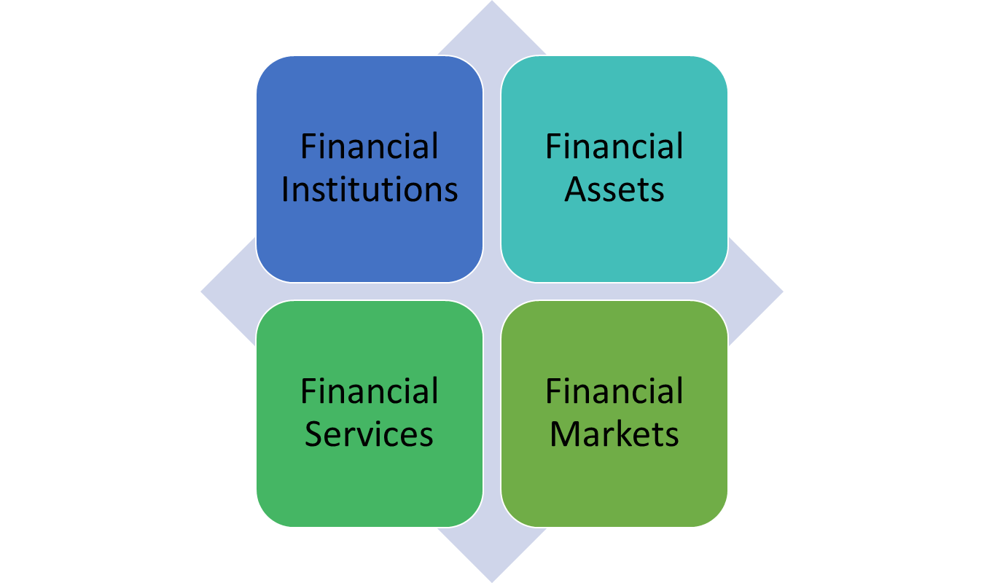

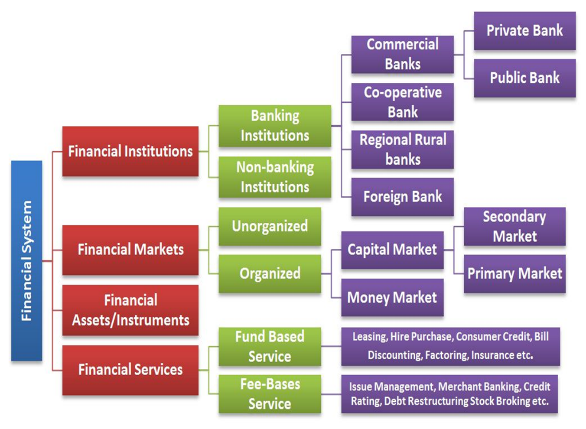

FINANCIAL MARKETS
Meaning:
A set of markets & institutions to facilitates the exchange of assets & risk.
The marketplace where buyers and sellers interact with each other and participate in the trading of money, bonds, shares and other assets is called a financial market.
The financial market can be further divided into four types:
1. Capital Market – Designed to finance the long term investment, the Capital market deals with transactions which are taking place in the market for over a year.
The capital market can further be divided into three types:
(a)Corporate Securities Market
(b)Government Securities Market
(c)Long Term Loan Market
2. Money Market – Mostly dominated by Government, Banks and other Large Institutions, the type of market is authorized for small-term investments only. It is a wholesale debt market which works on low-risk and highly liquid instruments. The money market can further be divided into two types:
(a) Organized Money Market
(b) Unorganized Money Market
3. Foreign exchange Market – One of the most developed markets across the world, the Foreign exchange market, deals with the requirements related to multi-currency. The transfer of funds in this market takes place based on the foreign currency rate.
4. Credit Market – A market where short-term and long-term loans are granted to individuals or Organizations by various banks and Financial and Non-Financial Institutions is called Credit Market

FUNCTIONS OF FINANCIAL MARKETS
To mobilize Savings
To make provision of money & monetary assets
To provide a payment system
To facilitate pooling of funds
To provide mechanism for temporal transfer of resources.

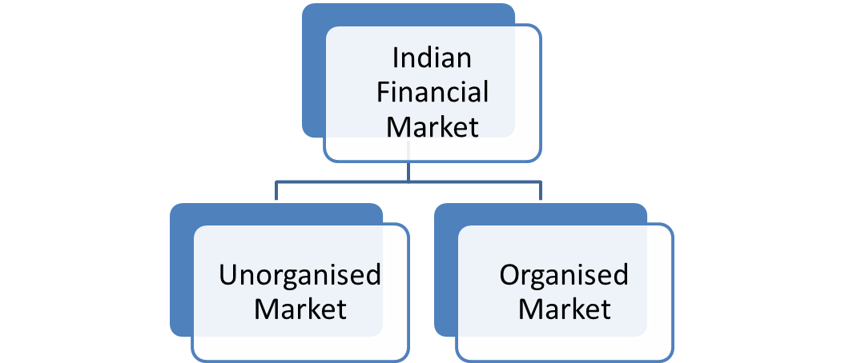

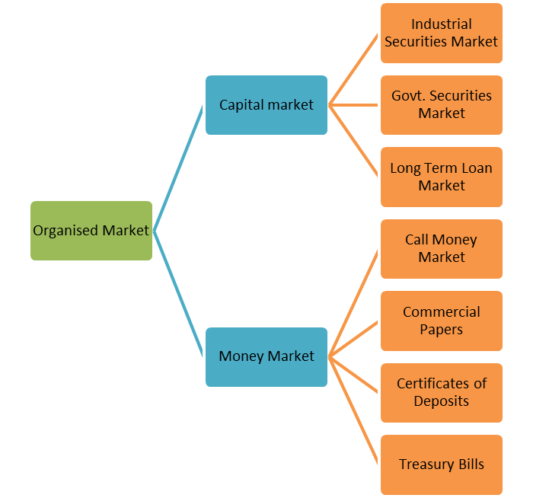

MONEY MARKET
Financial instruments with short term maturity up to 1 year, used as tools for raising capital by the issuer are known as money market instruments. These are debt securities that offer a fixed interest rate and are generally unsecured.
There is no collateral backing up the security, and the risk of non-repayment is theoretically high.
However, money market instruments have a high credit rating ensuring that issuers don’t default, which makes them a go-to avenue for investors looking for options to park their money for the short term and earn fixed returns on the same.
FEATURES OF MONEY MARKET
- High Liquidity
- Secure Investment
- Fixed Returns
PURPOSE OF MONEY MARKET
- Maintains Liquidity in the Market
- Provides Funds at a Short Notice
- Utilization of Surplus Funds
- Aids in Financial Mobility
- Helps in monetary policy
INSTRUMENTS OF MONEY MARKET
- Treasury Bills (T-Bills)
- Commercial Papers
- Certificates of Deposits (CD)
- Repurchase Agreements
- Banker’s Acceptance

- Treasury Bills (T-Bills):
Treasury bills or T- Bills are issued by the Reserve Bank of India on behalf of the Central Government for raising money. They have short term maturities with highest upto one year.
Currently, T- Bills are issued with 3 different maturity periods, which are, 91 days T-Bills, 182 days T- Bills, 1 year T – Bills. T-Bills are issued at a discount to the face value. At maturity, the investor gets the face value amount. This difference between the initial value and face value is the return earned by the investor. They are the safest short term fixed income investments as they are backed by the Government of India.

- Commercial Papers:
Large companies and businesses issue promissory notes to raise capital to meet short term business needs, known as Commercial Papers (CPs). These firms have a high credit rating, owing to which commercial papers are unsecured, with company’s credibility acting as security for the financial instrument. Corporate, primary dealers (PDs) and All-India Financial Institutions (FIs) can issue CPs. CPs have a fixed maturity period ranging from 7 days to 270 days. However, investors can trade this instrument in the secondary market. They offer relatively higher returns compared to that from treasury bills.

- Certificates of Deposits (CD):
CDs are financial assets that are issued by banks and financial institutions.
They offer fixed interest rate on the invested amount.
The primary difference between a CD and a Fixed Deposit is that of the value of principal amount that can be invested. The former is issued for large sums of money ( 1 lakh or in multiples of 1 lakh thereafter). Because of the restriction on minimum investment amount, CDs are more popular amongst organizations than individuals who are looking to park their surplus for short term, and earn interest on the same. The maturity period of Certificates of Deposits ranges from 7 days to 1 year, if issued by banks. Other financial institutions can issue a CD with maturity ranging from 1 year to 3 years.

- Repurchase Agreements:
Also known as repos or buybacks, Repurchase Agreements are a formal agreement between two parties, where one party sells a security to another, with the promise of buying it back at a later date from the buyer. It is also called a Sell-Buy transaction.The seller buys the security at a predetermined time and amount which also includes the interest rate at which the buyer agreed to buy the security. The interest rate charged by the buyer for agreeing to buy the security is called Repo rate. Repos come-in handy when the seller needs funds for short-term, s/he can just sell the securities and get the funds to dispose. The buyer gets an opportunity to earn decent returns on the invested money.

- Banker’s Acceptance:
A financial instrument produced by an individual or a corporation, in the name of the bank is known as Banker’s Acceptance. It requires the issuer to pay the instrument holder a specified amount on a predetermined date, which ranges from 30 to 180 days, starting from the date of issue of the instrument. It is a secure financial instrument as the payment is guaranteed by a commercial bank.
Banker’s Acceptance is issued at a discounted price, and the actual price is paid to the holder at maturity. The difference between the two is the profit made by the investor.
CAPITAL MARKET
Capital market is a market for both debt and equity securities in India.
It is the market where business enterprises, including companies and governments, can raise long-term funds.
It can be said that the capital market is a market where the money is provided to the borrowers for more than a year.
The Indian capital market includes both the stock or the share market and the bonds market.
Share or stock market is the market where equities are traded, whereas, the bond market is the market where debt securities are traded.
The Capital Market is regulated by Securities and Exchange Board of India (SEBI) that overlook the market in their jurisdiction ensuring that the investors are protected against fraud apart from other duties.
The regulatory bodies lay down specific rules and regulations that must be adhered to safeguard the investors’ interest.

FEATURES OF CAPITAL MARKET
1. Link between Savers and Entrepreneurial Borrowers:
Capital market is a crucial link between saving and investment process. The capital market transfers money from savers to entrepreneurial borrowers.

2. Deals in Long Term Investment:
Capital market provides funds for long and medium term. It does not deal with channelizing saving for less than one year.

3. Utilizes Intermediaries:
Capital market makes use of different intermediaries such as brokers, underwriters, depositories etc. These intermediaries act as working organs of capital market and are very important elements of capital market.

4. Dealing in marketable and non-marketable securities:
Capital market deals in both marketable and non- marketable securities. Marketable securities are those which can be transferred e.g. shares, debentures etc. Non- marketable securities are those which cannot be transferred e.g. term deposits with banks, loans and advances of banks and financial institutions.

5. Determinant of Capital Formation:
Capital market’s actions determine the rate of capital formation in a market. Capital market offers attractive opportunities to people who have surplus funds so that they invest more and more in the capital market and are invited to save more for profitable opportunities. This way it accelerates the rate of capital formation in the economy

6. Government Rules and Regulations:
The capital market operates freely but under the guidance of government policies. These markets function within the framework of government rules and regulations.
Example: the stock exchange works under the regulations of SEBI (Securities Exchange Board of India) which is a government body.

7. Provides Liquidity:
As the instruments may be convertible into cash in the capital market. As per the need, of the investor can convert their investment into the liquid form. This is how capital markets provide liquidity.

8. Includes Primary Market And Secondary Market:
Capital market of two types of primary market and secondary market. The primary market is concerned with the issue of new securities. Here securities are issued for the first time. Secondary market is concerned with the existing securities. Securities already traded is traded secondary market.

9. Accurate Timely Information:
Capital market provides accurate information to the investors. The information must be provided timely. So that investor can make the decision of investment whether to invest in a company or not. Variety of Instruments

10. Capital market has a variety of instrument:
Some instruments are at high risk and some instruments are low risk. This instrument can be debentures, Equity shares preferential Shares. As per the risk-taking ability of an investor can choose between in these instruments.

FUNCTIONS OF CAPITAL MARKET
1. Mobilization of Savings: Capital market is an important source for mobilizing idle savings from the economy. It mobilizes funds from people for further investments in the productive channels of an economy. In that sense it activate the ideal monetary resources and puts them in proper investments.
2. Capital Formation: Capital market helps in capital formation. Capital formation is net addition to the existing stock of capital in the economy. Through mobilization of ideal resources it generates savings; the mobilized savings are made available to various segments such as agriculture, industry, etc. This helps in increasing capital formation.
3. Provision of Investment Avenue: Capital market raises resources for longer periods of time. Thus it provides an investment avenue for people who wish to invest resources for a long period of time. It provides suitable interest rate returns also to investors. Instruments such as bonds, equities, units of mutual funds, insurance policies, etc. definitely provides diverse investment avenue for the public.
4. Speed up Economic Growth and Development: Capital market enhances production and productivity in the national economy. As it makes funds available for long period of time, the financial requirements of business houses are met by the capital market. It helps in research and development. This helps in, increasing production and productivity in economy by generation of employment and development of infrastructure.
5. Proper Regulation of Funds: Capital markets not only helps in fund mobilization, but it also helps in proper allocation of these resources. It can have regulation over the resources so that it can direct funds in a qualitative manner.
6. Service Provision: As an important financial set up capital market provides various types of services. It includes long term and medium term loans to industry, underwriting services, consultancy services, export finance, etc. These services help the manufacturing sector in a large spectrum.
7. Continuous Availability of Funds: Capital market is place where the investment avenue is continuously available for long term investment. This is a liquid market as it makes fund available on continues basis. Both buyers and seller can easily buy and sell securities as they are continuously available. Basically capital market transactions are related to the stock exchanges. Thus marketability in the capital market becomes easy.

PRIMARY MARKET
The primary market mainly deals with new securities that are issued in the stock market for the first time.
Thus it is also known as the new issue market.
The main function of the primary market is to facilitate the transfer of the newly issued shared from the companies to the public.
The main investors in this type of market are financial institutions, banks, HNIs, etc.
Primary Market accelerates the process of capital formation.
It makes arrangements which facilitates the procurement of long term funds by companies through fresh issue of shares & debentures.
Securities are issued directly to investors.
FUNCTIONS OF PRIMARY MARKET
1. Origination – Origination refers to the identification, assessment, and processing of newly issued securities.
2. Underwriting – The banking institution acts as a middleman between securities issuing companies and investors. Underwriters example, JP Morgan, Goldman Sachs, Morgan Stanley, etc.
3. Distribution – Distribution is selling securities to investors.
Primary markets deal with new and initial issues of a particular security. Any issue of new securities by company’s first float over the primary market
The primary market always comes before the secondary market with regards to the turn of transactions
The primary market has no physical existence like secondary markets exist in the form of stock exchanges
METHODS OF RAISING FUNDS IN PRIMARY MARKET
1. Public Issue – This term occurs when a company issues new securities through IPOs.
2. Rights issue – Rights issue is for the existing shareholders to purchase additional new securities.
3. Private Placement – This term refers to generating capital through selected investors.
4. Preferential Allotment – Shares are allotted to the investor on a preference basis.
Secondary Market
Meaning:
It is the market where the trading of the securities actually takes place, thus it is also referred to as the stock market.
Here the buying and selling of securities take place.
The existing investors sell the securities and new investors by the securities.

FUNCTIONS OF SECONDARY MARKET
1. Regular information about the value of security
2. Offers liquidity to the investors for their assets
3. Continuous and active trading
4. Provide a Market Place
5. Secondary markets provide liquidity to investors
6. Secondary markets enable the investors to check the price of various financial instruments, including shares and bonds along with their interest rates
7. The secondary market acts like an intermediary as it helps determine the price of securities during a transaction
8. Secondary market assists in mobilizing and channelizing the savings of investors

Distinguish Between Primary Market and Secondary Market
Primary Market | Secondary Market
Securities are initially issued in a primary market. After issuance, such securities are listed in stock exchanges for subsequent trading. | Trading of already issued securities takes place in a secondary market.
Investors purchase shares directly from the issuer in the primary market. | Investors enter into transactions among themselves to purchase or sell securities. Issuers are thus not involved in such trading.
The stock issue price in a primary market remains fixed. | Prices of the traded securities in a secondary market vary according to the demand and supply of the same.
Sale of securities in a primary market generates fund for the issuer. | Transactions made in this market generate income for the investors.
Issue of security occurs only once and for the first time only. | Here, securities are traded multiple times.
Primary markets lack geographical presence; it cannot be attributed to any organisational set-up as such. | A secondary market, on the contrary, has an organisational presence in the form of stock exchanges.

INITIAL PUBLIC OFFER (IPO)
An initial public offering (IPO) refers to the process of offering shares of a private corporation to the public in a new stock issuance.
Companies must meet requirements by exchanges and the Securities and Exchange Board of India (SEBI) to hold an initial public offering (IPO).
IPOs provide companies with an opportunity to obtain capital by offering shares through the primary market.
Companies hire investment banks to market, gauge demand, and set the IPO price and date, and more.
MERITS OF INITIAL PUBLIC OFFER
- Simple Method
- Economical
- Decentralization
- Direct sale to investors
- Convenient to Stable Companies
DEMERITS OF INITIAL PUBLIC OFFER
- Lacks Certainty
- Time Consuming
- Investors’ psychology is not favorable

PROCEDURE IN IPO
  - In India, it is the Securities and Exchange Board (SEBI) that regulates the process of an IPO and companies hoping to issue shares through an IPO have to first register with SEBI.
  - A company must submit the necessary documents with the SEBI which then is analysed and is approved only when the SEBI is convinced.
  - While SEBI evaluates the application, the company is required to prepare its prospectus, stating that the approval from SEBI is pending.
  - On getting the approval from SEBI, the company is required to determine the share price of the shares to be issued and disclose the number of shares it plans to issue.
  - The company must decide between the two types of IPO issues
    - Fixed Price IPO is one where the company decides in advance the price of the shares
    - Book Building IPO is where the company provides a range of prices and there is a bid for shares within that price range.
  - The shares are made public once the company decides the type of IPO they want to go with. The interested investors submit their applications and once the company receives the subscriptions from the public, it allots the shares
  - The company now lists the shares on the stock market and post the issuance in the primary market, it gets listed in the secondary market. These are then open for trading on a daily business.

Dematerialization
Dematerialization is the process of converting your physical shares and securities into digital or electronic form.
The basic agenda is to smoothen the process of buying, selling, transferring and holding shares and also about making it cost-effective and foolproof.
All your securities are stored in an electronic form instead of physical certificates.
Two depositories called Central Depository Services India Limited (CDSL), and National Securities Depository Limited (NSDL) is registered with the Securities and Exchange Board of India also known as SEBI.
The introduction of dematerialization allowed for accounts to be updated automatically and swiftly.
Dematerialization (DEMAT) is the move from physical certificates to electronic bookkeeping.
DEMAT accounts are required by some trading institutions due to the fact they are the most accurate form of record keeping.
Dematerialization was designed to offer more security, as well as increased speed, to financial trades. It has become the norm in bookkeeping for financial institutions.
A depository is responsible for holding the securities of a shareholder in electronic form.
PROCESS OF DEMATERIALIZATION
An investor who wishes to avail of demat facility have to follow the following procedures:
1. Opening a Demat Account:
Investor must open a demat account with a depository participant (DP). The DP is the link between the Depository and the owner of security. In other words, DP is the agent of the depository. (Banks, clearing houses of recognized stock exchanges, and non-banking financial companies are eligible to become DP).
On opening the account, the DP provides Client Identification Number to the investor, along with booklets of demat request form (DRF-for converting the physical shares in demat form) and delivery instructions by client (for transfer after sale of shares).
2. Submission of DRF and Share Certificates:
The demat account holder must submit the DRF properly filled in, and also the physical share certificates. The share certificates must be rubber stamped (available with the DP) with the words 'Surrendered for Demat',
3. Forwarding of DRF and Share Certificates:
The DP forwards the DRF and the share certificates to the Transfer Agent (appointed by the company to look after share related matters) or the Company's Registrar. A second copy of DRF is forwarded by DP to its depository- either NSDL or CDSL.
4. Confirmation from Depository:
The depository sends a confirmation letter to the company's registrar or the share transfer agent regarding the receipt of Demat Request Form.
5. Verification and Updating the Records:
The transfer agent or the company's registrar checks the shareholder's records, and the signature. If the signatures and other details are correct, then the physical share certificates are cancelled and entries are made in the company's records regarding demat of shares. The transfer agent substitutes the name of depository as the registered owner in place of the name of the original shareholder. It is to be noted that now-a-days, no meeting of share transfer committee is required for transferring of shares in demat form.
6. Recording by Depository:
The depository records in its books, the name of the shareholder as the beneficial owner. In other words, the
Depository credits the account of the investor with the number of shares. Subsequent entries in depository books are made by means of "book entry on receipt of intimation from the DP.
7. Updating of Records by DP: The depository informs its DP regarding demat clearance by the company’s transfer agents. The DP accordingly updates the records of the demat account holder.
8. Confirmation to Demat Account Holder:
The confirmation relating to demat of shares is sent by the DP to the demat account holder. The DP sends periodic statements to the demat account holder regarding the position of his account.
9. Operation of Demat Account:
The demat account holder can operate his account for the purpose of trading. If the account holder sells the shares from his account, then he has to fill up the delivery instructions by clients ‘form, submit it to the DP, which accordingly debits the account.
If the account holder buys the shares, the shares are accordingly credited to his account, through the depository. In case, bonus shares or new shares are allotted by companies, then the account of the accountholder gets credited through the depository.
Benefits of Dematerialization
- You can conveniently manage your shares and transactions from anywhere.
- Stamp duty is not levied on your electronic securities.
- Holding charges levied are nominal.
- Risks involved with physical securities such as theft, loss, forgery or damage are eliminated.
- You can buy securities in odd lots and buy a single security.
- Due to the elimination of paperwork, the time required for completing a transaction gets reduced.

DEPOSITORIES
A Depository refers to a place or entity that holds financial securities in a dematerialized form.
A bank, organization, or any institution holding and assisting in security trading is referred to as a depository.
Depository accounts hold securities in the same way that bank accounts hold funds.
A depository can also be a place where something is held for safekeeping or storage.
Hence, a depository can be an institution, a building, or a warehouse, that enables individuals and businesses to deposit any valuable asset for safeguarding.
A depository transfer securities with our physically handling security.
A depository acts as the custodian of securities of investors.
It keeps record of all transactions relating to purchase & sale of DMAT securities of investors / shareholders.
It facilitates safe keeping of securities of account holders.
Depositories are integral institution in Indian Capital market & their functionality can be compared to banking entities.
The money deposited in a depository is used for investing in some other securities and lending to other people or businesses; thus, providing liquidity in the exchange market.
NSDL & CDSL are two larger Indian Depositories & are duly registered with SEBI.
Functions of DEPOSITORIES
- Serves as a link between public companies and investors/shareholders
- Eliminates risk related to owning physical financial securities
- Allows the provision of loans of mortgages to interested parties
- Reduced paperwork and accelerates the process of transferring securities.
- Facilitates dematerialization of securities.

TYPES OF DEPOSITORIES
- NSDL : National Securities Depositories Ltd
First Depository Company started in India.
Sponsored by UTI, NSE, SBI, HDFC & Citibank.
A public limited company.
Governed by its bye laws & business operations are regulated by its business rules,
Registered with SEBI in 1996
Paid up capital of Rs. 300Cr.

- CDSL : Central Depository Services Ltd
Second largest depository in India.
Approved by SEBI on 8th February 1999.
Promoted by BSE, BOI, SBI, BOB & HDFC Bank.
Has wide network of DPs offering DMAT services.
OBJECTIVES OF DEPOSITORIES
- To support investors & brokers in the capital market of the country.
- To speed up the trend of shifting the script less trading.
- To use innovative technology system to promote depository system.
- To ensure the safety & soundness of Indian Capital Market by developing settlement solutions that increase efficiency & reduce cost.
- To make a major trust in the individual investor’s participation in the depository system & Indian Capital Market.
ROLE OF DEPOSITORIES (NSDL AND CDSL)
I. BENEFITS TO THE INVESTORS
- Quick transfer of shares
- Less paperwork since the seller only submits the delivery instructions to the depository participant
- No risk of bad delivery loss or theft or misplacement
- Less costly because of no payment of stamp duty
- Quick receipt of payments
- Dividends are easily credited to the bank account
- Banks can give provide loans on demat securities
- A complete consolidated record of the demat shares is available to the clients on regular basis
II. BENEFITS TO COMPANIES
- Accurate data of the shareholders is maintained
- Less investor complaints with reference to share delivery
- Quick correspondence with the members
- Less expenditure on stationery and paperwork
- Due to transparency and investors’ confidence companies can raise more funds
- Secretarial work is reduced
SEBI: SECURITY EXCHANGE BOARD OF INDIA
- Securities and Exchange Board of India (SEBI) is a statutory regulatory body entrusted with the responsibility to regulate the Indian capital markets. It monitors and regulates the securities market and protects the interests of the investors by enforcing certain rules and regulations.
- SEBI was founded on April 12, 1992, under the SEBI Act, 1992. Headquartered in Mumbai, India, SEBI has regional offices in New Delhi, Chennai, Kolkata and Ahmedabad along with other local regional offices across prominent cities in India.
- The objective of SEBI is to ensure that the Indian capital market works in a systematic manner and provide investors with a transparent environment for their investment. To put it simply, the primary reason for setting up SEBI was to prevent malpractices in the capital market of India and promote the development of the capital markets.
OBJECTIVES OF SEBI
- To monitor the activities of the stock exchange.
- To safeguard the rights of the investors.
- To curb fraudulent practices by maintaining a balance between statutory regulations and self-regulation.
- To define the code of conduct for the brokers, underwriters, and other intermediaries.
FUNCTIONS AND ROLE OF SEBI
- To protect the interests of Indian investors in the securities market.
- To promote the development and hassle-free functioning of the securities market.
- To regulate the business operations of the securities market.
- To serve as a platform for portfolio managers, bankers, stockbrokers, investment advisers, merchant bankers, registrars, share transfer agents and other people.
- To regulate the tasks entrusted on depositors, credit rating agencies, custodians of securities, foreign portfolio investors and other participants.
- To educate investors about securities markets and their intermediaries.
- To prohibit fraudulent and unfair trade practices within the securities market and related to it.
- To monitor company take-overs and acquisition of shares.
- To keep the securities market efficient and up to date all the time through proper research and developmental tactics.
INVESTORS PROTECTION MEASURES BY SEBI
SEBI has framed rules and regulations to protect the interest of investors. Various investor protection measures are undertaken by SEBI.
1. Investor Education and Protection Fund (IEPF): The Government of India has set up IEPF is for promotion of investors' awareness and protection of the interests of investors. SEBI along with stock exchanges play an important role in the implementation of this fund. A company which has completed seven years in the business should hand over all the unclaimed fund dividends, matured deposits, and debentures, share application money etc. to the Government through IEPF.
2. Investor Awareness Programme: The programme is regularly organized by SEBI to educate and create awareness among the investors. The programme covers major areas like portfolio management, mutual funds, tax provisions, Investor Protection Fund, Investors' Grievance Redressal system of SEBI. It also conducts workshops on derivatives, stock exchange trade, Sensex, etc. SEBI has advertised the Investor Awareness Programme across all formats like print media, radio, television, and the internet.
3. Regulation of Mutual Funds: SEBI regulates the working of mutual funds to protect the interest of investors. SEBI has laid down rules and regulations to be followed by mutual funds in India. SEBI is instrumental in the setting up of Association of Mutual Funds in India (AMFI) in 1995. AMFI is the association of SEBI registered Mutual Funds in India. It was set up to regulate the working of mutual funds in India.
4. Investor Grievance Cell: SEBI has set up investors' grievance cell to handle investors' grievances. SEBI handles complaints against brokers, issuers of capital, and other agencies connected with issue or management of securities.

5. Due-diligence Certificate by Merchant Bankers: SEBI has made it mandatory for merchant bankers to attach diligence certificate with the prospectus for extending their accountability to the investors. The diligence certificate gives a detailed position of the issue of shares. The investor can file a case of incorrect statement in the prospectus on erring companies.
6. Representatives for Allotment Process: To avoid any malpractice in allotment process, SEBI has appointed its representatives to look into allotment process which protects the interest of the investors and also boosts the confidence of individual investors.
7. Credit Rating for Convertible Debt Instruments: No issuer company shall make a public issue or right issue of convertible debt instruments, unless the following conditions are satisfied as on the date of filing draft offer document with SEBI and also on the date of filing a final offer document with ROC / Designated Stock Exchange: Credit rating is obtained from at least one credit rating agency registered with SEBI and disclosed in the offer document.
8. IPO Grading: SEBI has laid down regulations regarding IPO grading. No unlisted company shall make an IPO of equity shares or any other security which may be converted into equity shares at a later date, unless the following conditions are satisfied:
The unlisted company has obtained grading for IPO from at least one credit rating agency.
Disclosures of all grades obtained, have been made in the offer document.
9. Promoters’ Contribution: SEBI has framed regulations regarding promoters' contribution to protect the interest of the investors. At times, greedy promoters come up with public issue to cheat investors.
SEBI regulations are:
In a public issue by an unlisted company, the promoters shall contribute not less than 20% of the post-issue capital. In case of public issues by listed companies the promoters shall participate either to the extent of 20% of the proposed issue or ensure post issue shareholding to the extent of 20% of the post-issue capital.The minimum promoters' contribution shall be locked-in for a period of 3 years.
9. Underwriting of Securities: The lead merchant bankers (who are managing the issue) shall satisfy themselves about the ability of the underwriters to discharge their underwriting obligations.
The lead merchant banker shall:
Incorporate a statement in the offer document that the underwriters' assets are adequate to meet their underwriting obligations.
Obtain underwriters' written consent before including their names as underwriters in the final offer document.
10. Redressal of Investor Grievances by Lead Manager: The lead merchant banker shall actively associate himself with post-issue activities, namely, allotment, refund, despatch, etc. and shall monitor redressal of investor grievances arising therefrom.
11. Restriction on Further Issue of Capital: No company shall make any further issue of capital in any manner (bonus shares, rights issue, public issue, etc.), during the period commencing from the submission of offer document to SEBI, till the securities referred to in the said offer document have been listed or application moneys refunded on account of non-listing or undersubscription, etc. (unless full disclosures regarding the total capital to be raised from such further issues are made in the draft offer document).
STOCK EXCHANGE
- A stock exchange is a marketplace where securities, such as stocks and bonds, are bought and sold.
- Bonds are typically traded Over the Counter (OTC), but some corporate bonds can be traded on stock exchanges.
- Stock exchanges allow companies to raise capital and investors to make informed decisions using real-time price information.
- Exchanges can be a physical location or an electronic trading platform.
- Though people are typically familiar with the image of the trading floor, many exchanges now use electronic trading.
- A stock market is a place where people buy/sell shares or stocks of publicly listed companies.
- NSE and BSE are the two major stock exchanges in India.
- An individual has to mandatorily open a trading account to trade in the stock market.
- There are different market participants like retail investors, domestic institutions and foreign institutional investors
- Indian stock market is governed by SEBI.
- There are different financial intermediaries like stock broker, banks, depository participants etc.
- DEMAT account or dematerialized account allows holding shares in electronic form instead of taking physical possession of certificates.

TYPES OF STOCK EXCHANGE
1. Bombay Stock Exchange (BSE):
It was established in 1875 in Mumbai at Dalal Street.
It renowned as the oldest stock exchange not just in Asia and is the ‘World’s 10th largest Stock Exchange’.
The estimated market capitalisation of Bombay Stock Exchange as of April stands at $ 4.9 Trillion and has around 6000 companies publicly Bombay Stock exchange listed under it.
2. National Stock Exchange (NSE):
The NSE was established in 1992 in Mumbai and is accredited as the pioneer among the demutualized electronic stock exchange markets in India.
This stock exchange market was established with the objective to eliminate the monopolistic impact of the Bombay Stock exchange in the Indian stock market.
The estimated market capitalization of National Stock Exchange as of March 2016 was US$ 4.1 trillion and was acclaimed as the 12th largest stock exchange in the world.
FEATURES OF STOCK EXCHANGE
It’s an organized market.
It enjoy Private status with government control.
It operates as per well-defined rules & regulations.
It facilitates orderly marketing of securities.
It operates as per securities Contract Regulation Act, 1956
Sensitive to political & economic events.
It Acts as a nerve center of economy.
It facilitates fund raising by business enterprises.

FUNCTIONS OF STOCK EXCHANGE
The functions of stock exchange depend upon its actions and services. The following are the functions or services of stock exchanges:
1. Acts as a Clearing House of Securities:
The stock exchange acts as a clearing house of securities. It performs the work of arranging for delivery and payment of securities. It facilitates easy and quick clearance of transactions between the buyers and sellers of securities (shares, debentures, etc.) on the stock exchange.
2. Regulation and Control of Contracts:
Every recognized stock exchange, subject to the previous approval of the Securities and Exchange Board of India (SEBI), make bye-laws for the regulation and control of contracts. (Contracts refer to purchase and sale control relating to trading of shares.)
The bye-laws may provide for various issues relating to securities contracts. For instance, the bye-laws may provide for the opening and closing of markets and the regulation of trading hours on the stock exchange.
3. Listing of Securities:
The stock exchanges facilitate listing of securities (shares and debentures) issued by public limited companies. The companies that issue shares to the public can get their shares listed on one or more stock exchanges in the country. The listing of shares is done through the listing agreement. The listing agreement is signed by the issuing company and the concerned stock exchange. Listing of shares enables companies to raise long term funds through the issue of shares. The listing of securities also facilitates trading of the listed securities.
4. Suspension of Securities from Trading:
A stock exchange may suspend or withdraw certain listed securities from trading. The suspension or delisting of securities is done, when a particular listed company does not follow the rules and regulations. However, before taking action, the stock exchange provides a reasonable opportunity by a notice in writing, stating the reasons, to show cause against the proposed action.
5. Settlement of Claims or Disputes:
A stock exchange may prescribe the procedure for the settlement of claims or disputes between the buyer and seller of securities it monitors the settlement of claims or disputes. It may also prescribe procedure for the settlement of disputes through arbitration.
6. Imposes Fines and Penalties: A stock exchange may impose fines and penalties on its broker members, who do not follow its rules and regulations. The fines and penalties are imposed in order to maintain discipline in the working of its members. Before imposing fines and penalties, the stock exchange gives a reasonable opportunity to its members to correct discrepancies.
7. Registration of Brokers: The stock exchange registers the brokers for membership. Such registration is required for the purpose of trading of securities on the exchange. Membership fees must be paid by brokers to become members of the stock exchange. The membership fees include entrance fees, annual subscription fees, and membership security deposit. Apart from registration with stock exchange, brokers also needs to register with SEBI.
8. Maintaining Records:
Every recognized stock exchange and its members must maintain such books of account and other documents as prescribed by the Central Government. The books of account and other documents may be inspected by SEBI. The relevant books of account and other documents must be preserved for a period of five years.
9. Filing of Periodical Returns with SEBI: Every recognized stock exchange furnishes to the SEBI such periodical returns relating to its affairs.
10. Framing Rules and Regulations for its Members:
A recognized stock exchange may make rules or amend any rules made by it to provide for all or any of the following matters, namely:
(a) The restriction of voting rights to members only in respect of any matter placed before the stock exchange at any meeting;
(b) The regulation of voting rights in respect of any matter placed before the stock exchange at any meeting so that each member may be entitled to have one vote only, irrespective of his share of the paid-up equity capital of the stock exchange;
(c) The restriction on the right of a member to appoint another person as his proxy to attend and vote at a meeting of the stock exchange;
(d) Such incidental, consequential and supplementary matters as may be necessary to give effect to any of the matters specified in clauses (a), (b), and (c) as listed above.

SPECULATORS IN STOCK MARKET
Speculators are sophisticated investors or traders who purchase assets for short periods of time and employ strategies in order to profit from changes in its price.
Speculators are important to markets because they bring liquidity and assume market risk.
Conversely, they can also have a negative impact on markets, when their trading actions result in a speculative bubble that drives up an asset's price to unsustainable levels.
A speculator is an individual or firm that, as the name suggests, speculates – or guesses – that the price of securities will go up or down and trades the securities based on their speculation.
Speculators are also people who create fortunes and start, fund, or help to grow businesses.
Speculation concerns attempting to make a profit from a security's price change and is more vulnerable to market fluctuations.
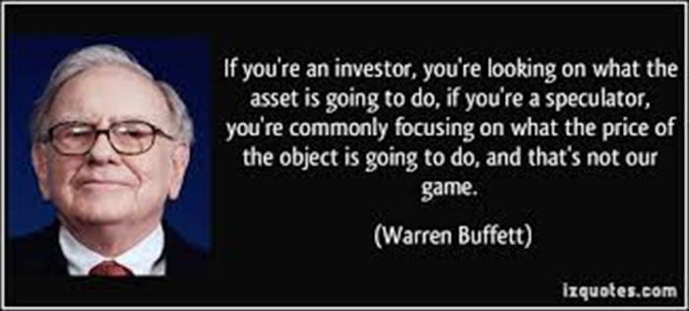
The speculators are classified into four categories such as
1. Bull
2. Bear
3. Stag
4. Lame Duck.
1. BULL
A Bull is a speculator who anticipates rise in the price of securities.
He buys securities with a view to sell them in future at a higher price and thereby earns profits.
In case the prices of securities fall, he loses. He has the option to carry forward the transaction to the next settlement by paying a charge termed, ‘Contango’.
In India, a bull is also known as Tejiwala.
He is said to be a bull because just like a bull which tries to throw its victim up in the air, he expects to profit from increase in share prices.
2. BEAR
A Bear is a speculator, who anticipates fall in the price of securities.
He sells- securities for future delivery. He sells securities which he does not possess with the hope to buy the securities at a lower price before the date of delivery.
In India, a bear is also known as Mandiwala.
3. STAG
A stag is bullish in nature.
A stag applies for securities of a new company with the idea of selling them at a premium after allotment.
His profit is the excess of the price at which he sells his allotment over the amount paid by him while applying.
He expects that the prices of securities that he applies for would increase.
4. LAME DUCK
This refers to the condition of a bear who is not able to meet his commitments.
A bear sell securities which he does not hold, with the expectation that prices are going to fall.
His intention is to buy them at a lower price later and profit from the difference.
On the fixed date he may not be able to deliver the security as it may not be available in the market.
The buyer may not be inclined to carry forward the transaction.
In such a case, the bear is said to be struggling like a lame duck.

BSE – BOMBAY STOCK EXCHANGE
The full form of BSE is the Bombay Stock Exchange. The BSE is the oldest stock exchange of Asia which was established in the year 1875 as Native Shares and Stock Broker’s Association and is the first exchange in India that was recognized as the exchange in the year 1957 under the Securities Contract (Regulation) Act by the government. Since then it is playing a pivotal role in the development of the capital market of the country.
HISTORY OF BSE – BOMBAY STOCK EXCHANGE
The Bombay Stock Exchange was established in the year 1875 and is also called the Stock Exchange Mumbai. Before establishing the BSE, the group of the five stockbrokers was there who used to conduct the different meetings in front of the Mumbai town hall under a banyan tree.
But gradually, over time, the number of brokers in the meeting increases, and because of this, the venue of the meeting used to change frequently. After a few decades, in 1874, the group of brokers moved to Dalal Street for their meetings and made it their permanent location.
It was then established in the year 1875 as Native Shares and Stock Broker’s Association in the following year, thereby providing it an official organization. After decades of its working, it became the first exchange in India that was recognized as the exchange in 1957 under the Securities Contracts (Regulation) Act by the government.
After some years of its recognition, in the year 1986, a tool was developed to measure the Bombay stock exchange’s overall performance known as the SENSEX, which is the stock market index consisting of the 30 well established as well as financially sound companies that are listed on the Bombay stock exchange.
In 1995, the Bombay stock exchange switched to the electronic trading system known as BOLT (BSE On-Line Trading). Also, it became the first stock exchange in the world, which introduced an internet trading system at a centralized level.
FEATURES OF BSE
The following are the features of the Bombay Stock Exchange:
1. It is the largest and the first securities market in India based in Mumbai, India. The securities that are listed at the BSE include stocks, stock options, stock futures, index options, index futures, and weekly options.
2. The SENSEX is the benchmark index of the BSE that consists of the 30 companies that are financially sound and well established from around 12 different sectors, which help measure the Bombay Stock Exchange’s overall performance.
3. It has helped in the development of India’s capital market and helped in the growth of India’s corporate sector.
FUNCTIONS OF BSE
The following are the main functions of the Bombay Stock Exchange:
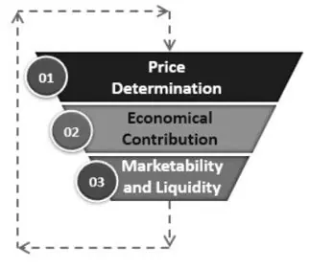

1. Price Determination
The price determination in the secondary market depends upon the demand and supply of the securities. Bombay Stock Exchange helps in the process of valuation by constantly valuing all the listed securities. Such share prices can be easily tracked through the index that is popularly known as SENSEX.
2 .Economical Contribution
Since the Bombay Stock Exchange deals with the securities listed and these securities are sold and re-sold continuously, it allows the funds to keep moving instead of remaining idle, which boosts the economy.
3. Marketability and Liquidity
They provide high liquidity as the listed securities can be sold at any point in time, converting it into cash. It works continually, and the investor can sell and purchase the security simply according to their wish.

IMPORTANCE OF BSE
The following are the main importance of the Bombay Stock Exchange:
1. It is easy to sell and buy securities in the financial market if the security is listed on the BSE, thereby meeting potential investor’s liquidity needs.
2. It is easy to raise funds by issuing equity and debt securities through BSE as it is a trusted source from where the securities are traded in the financial market.
3. They provide an open platform for speculation within a legal framework. Bombay Stock Exchange is the best platform for healthy speculative trading, which helps fulfill the requirement of liquidity of an investor.
BENEFITS OF BSE
The following are the benefits of the Bombay Stock Exchange:
1. The securities exchange board of India governs the functions of BSE. Therefore the transactions that occur at the Bombay Stock Exchanges are regulated and governed strictly within the legal framework. Therefore it gives an assurance to the investor that there are dealing in a safe place, and their money is not wasted.
2. They provide education about the benefits of investing in the stock market and ensures that there is the smooth functioning of the transactions.
3. The securities listed on it can be kept as collateral by an investor while availing the loans from banks and other financial institutions
Conclusion
BSE is the abbreviation used for the Bombay Stock Exchange. As the name implies, It is the stock exchange that was established in the year 1875. The benchmark index of the BSE is SENSEX that consists of the 30 companies that are financially sound and well established, which helps in measuring the Bombay Stock Exchange’s overall performance.

NATIONAL STOCK EXCHANGE OF INDIA LTD. (NSE)
HISTORY OF NSE – NATIONAL STOCK EXCHANGE
The National Stock Exchange of India Ltd. (NSE) is an Indian stock exchange located at Mumbai, Maharashtra, India. National Stock Exchange (NSE) was established in 1992 as a demutualized electronic exchange. It was promoted by leading financial institutions on request of the Government of India. It is India’s largest exchange by turnover. In 1994, it launched electronic screen-based trading. Thereafter, it went on to launch index futures and internet trading in 2000, which were the first of its kind in the country. Mr. Vikram Limaye is the MD and CEO of NSE.
NSE was established as a result of the recommendations made by High Powered Study Group on Establishment of New Stock Exchanges. The group was set up by the government to provide a solution to making stock market participation simple and accessible to all. This was in the aftermath of the Harshad Mehta stock market scam that took place in 1992.
Headquartered in Mumbai, NSE offers companies a platform to raise capital. It also provides investors with access to asset classes like equities, debt, and derivatives as well as currencies and mutual fund units. It allows for new listings, initial public offers (IPOs), debt issuances and Indian Depository Receipts (IDRs) by overseas companies raising capital in India. NSE offers trading, clearing and settlement services in equity, equity derivatives, and debt and currency derivatives segments. It was the first stock exchange in India to offer electronic trading facility.
FUNCTIONS OF NSE
The NSE was set-up with an express objective to fulfil the following functions:
1. Establishing a nationwide trading facility for equities, debt and other hybrid instruments
2. Ensuring equal access to investors across the nation through an appropriate communication network
3. Providing a fair, efficient and transparent securities market to investors using electronic trading systems
4. Enabling shorter settlement cycles and book entry settlements systems
5. Meeting the current international standards of securities markets

DIFFERENCE BETWEEN BSE AND NSE
The following are the main differences between BSE and NSE:
NSE stands for the National Stock Exchange, which is the largest stock exchange of the country and was founded in 1992, whereas BSE stands for the Bombay Stock Exchange, which is the oldest stock exchange of the country and was founded in the year 1875.
The benchmark index of the NSE is Nifty, which consists of 50 companies that are most actively traded, whereas the benchmark index of the BSE is SENSEX, which is the stock market index consisting of the 30 well established as well as financially sound companies that are listed on the Bombay Stock Exchange.
FOREIGN STOCK EXCHANGES – NYSE
The New York Stock Exchange (NYSE) is the largest securities exchange in the world, hosting 82% of the S&P 500, as well as 70 of the biggest corporations in the world. It is a publicly-traded company that provides a platform for buying and selling over nine million corporate stocks and securities a day.
HISTORY OF THE NEW YORK STOCK EXCHANGE
In 1792, the NYSE was established at 68 Wall Street where 24 brokers and merchants outlined the rules for trading securities in the Buttonwood Agreement. The organization was initially named New York Stock & Exchange Board. It became the New York Stock Exchange in 1863. At that time, only male traders took part in the NYSE. It was only in 1967 when a female trader named Muriel Siebert was allowed to participate in trading.
In 1971, NYSE became a not-for-profit corporation, and in 2006, a publicly-traded company. It was also during this time when traders and the public started using an electronic system to trade stocks. In 2007, NYSE merged with Euronext, and in 2008, NYSE acquired the American Stock Exchange. The Intercontinental Exchange later purchased the NYSE for $8.2 billion.
FUNCTIONS OF NEW YORK STOCK EXCHANGE
1. It provides a central marketplace for investors to buy and sell stock.
2. It enables companies to list their shares and raise capital from interested investors.
3. The NYSE provides a location where its members can trade stock in listed companies. Historically, traders called out their buy or sell orders to each other on the exchange trading floor. When a buyer and a seller agreed on a price, a trade would occur. Transactions would then be reported on the exchange, providing transparency and enabling efficient market operations.
4. The NYSE also acts as a gateway for companies that want to raise money by selling stock. Companies that want to list their stock on the NYSE have to meet both the U.S. Securities and Exchange Commission’s disclosure requirements for publicly traded companies and the specific listing requirements the NYSE imposes. Young companies often seek to have their initial public offerings on the NYSE in order to gain the prestige of having their shares traded alongside those of many of the top companies in the world.
CREDIT RATING AGENCY
- A credit rating is a quantified assessment of the creditworthiness of a borrower in general terms or with respect to a particular debt or financial obligation.
- Credit ratings determine not only whether or not a borrower will be approved for a loan or debt issue but also the interest rate at which the loan will need to be repaid.
- A credit rating or score can be assigned to any entity that seeks to borrow money an individual, a corporation, a state or provincial authority, or a sovereign government.
- A credit rating agency (CRA, also called a ratings service) is a company that assigns credit ratings, which rate a debtor's ability to pay back debt by making timely principal and interest payments and the likelihood of Default.
- An agency may rate the creditworthiness of issuers of debt obligations, of debt instruments and in some cases, of the servicers of the underlying debt but not of individual consumers.
- Credit rating agencies are agencies which provide ratings to represent objective analyses and independent assessments of companies, entities or countries that issue such debt securities.
- These ratings are an indication to the buyers of this debt how likely they are to be paid back.
FEATURES CREDIT RATING AGENCY
1. Credit Rating is an impartial assessment by an independent agency.
2. The rating are expressed in code numbers.
3. Credit Rating is always for a specific security.
4. A Credit rating is not a onetime evaluation. (Ongoing Appraisal)
5. Credit Rating Agency publish information & data collected from reliable sources.

FUNCTIONS CREDIT RATING AGENCY
- Collection of Financial Information of issuer of Debt Securities.
- Supplying information to members of the public
- Provide reliable base for assessing risk & return in debt securities
- Maintain pressure on firms for financial discipline
- Provide assistance to institutional investors
- Guidance to investors.
CREDIT RATING AGENCIES - ADVANTAGES
Credit rating can be defined as the opinion expressed by an independent rating agency about the credit quality of the issuer of a debt instrument. Credit rating of a debt security essentially reflects the probability of timely payment of interest and repayment of principal amount by a borrower.
Advantages of Credit Rating Agencies
Credit rating offers benefits to the investors as well as to the company whose instrument is being rated. The benefits are as follows:
(A) Benefits to the Investors:
Potential and present investors are benefited by credit rating in several ways. The main benefits to the investors are as follows:
1. Investment Decision:
Credit rating of an instrument gives an idea to the investors about the credibility of the issuer company, and the risk factor attached to a particular instrument, which in turn enables the potential investors to decide whether or not to invest in such companies. Naturally, higher the rating, the more would the willingness to invest in such instruments.
2. Benefits of Rating Reviews:
The rating agency undertakes periodic review of rating assigned to a particular instrument, which in turn would enable the present investors to decide whether or not to hold on to the instrument or to dispose it, if possible.
For instance, if the instrument is downgraded, then the investor may decide to dispose it off, and if the rating is maintained or upgraded, he may decide to hold on to the instrument till the date of further revision or maturity.

3. Assurance of Safety:
Credit rating provides assurance to the investors of safety of instrument and minimum risk of bankruptcy, when the instrument is being rated high by the rating agency. Companies which have received higher rating for their instruments would make efforts to maintain financial discipline, which protects the firm from bankruptcy, and as such the investors would be at an advantage.
4. Clarity of Investment Proposal:
The rating agencies assigns rating symbols to the instrument, which can be easily understood by investors, which in turn helps them to understand the investment proposal of an issuer firm.
For instance, AAA (Triple A), assigned by CRISIL for debentures ensures highest safety, whereas, debentures rated 'D' are in default or expected to default on maturity.
5. Choice of Instruments:
Credit rating enables an investor to select particular instrument(s) from several alternatives available. Such decision of choice of instrument(s) depends upon the risk factor attached to instrument(s) and portfolio mix plan of the investor.
6. Saving of Time and Effort:
Credit ratings enable an investor to save time and effort in the financial strength of an issuer company. This is because; the investor can rely upon the rating done by professional rating agency in order to take investment decision. He need not waste his time and effort to collect and analyze the financial information about credit standing of the issuer company.
(B) Benefits to Company:
The credit rating is beneficial to the company whose instruments are being rated. The main benefits are as follows:
1. Corporate Image:
Credit rating helps to enhance corporate image of a firm. Naturally, higher the credit rating creates confidence and trust in the minds of the investors about the firm, and as such the firm enjoys a good corporate image in the market.

2. Lower Cost of Borrowing:
Firms that have obtained higher credit rating for their debt instruments would be in a position to obtain funds at lower costs from the market. In other words, higher ratings would enable the firm to quote lower interest rates on fixed deposits, debentures and other debt securities, and investors would be accept lower interest rates as they may prefer low risk instruments.
Also, a company with higher rating for its instruments can reduce the cost of public issue to raise funds, as it need not spend heavily on advertising and other means of promotion to attract investors.
3. Wider Audience for Borrowing: A company with higher rating for its instruments can approach a wider audience for the purpose of borrowing. It can approach financial institutions, banks, investing public and even other firms. This is because; the credit ratings are easily understood not only by the financial institutions and banks, but also by the general public.
Benefits for Non Popular Firms:
4. Credit rating is beneficial to the so called not-so popular firms, such as closely held companies. If the credit rating is good, the investing public would rely on the credit rating, even though the firm may not be properly known to them.
5. Credit Rating as Marketing Tool: Credit rating not only helps to develop a good image of the firm among the investors, but also among the customers, dealers, suppliers, and others. In other words, higher credit rating can act as a marketing tool to develop confidence in the minds of customers, dealers, suppliers, and others.
6. Growth and Expansion:
Credit rating enables a firm to grow and expand. This is because; better credit rating would enable a firm to obtain the funds easily for growth and expansion of business.

CRISIL
CRISIL stands for Credit Rating Information Services of India Limited.
CRISIL is the first credit rating agency in India, established in January 1987, and commenced its operations w.e.f. 1st January 1988.
It was promoted by the erstwhile ICICI Ltd., UTI and other financial institutions.
In India, CRISIL is the largest credit rating agency. It has a market share of more than 60%. It is a full service rating agency offering its services in manufacturing, service, financial and SME sectors.
CRISIL is a global analytical company providing ratings, research, and risk and policy advisory services. The world's largest rating agency Standard & Poor's now holds majority stake in CRISIL
ROLE OF CRISIL
The role of CRISIL can be divided into two groups:
I. Specific Roles
II. General Roles
I. Specific Roles:
1. Ratings:
CRISIL Ratings has rated/assessed over 61,000 entities in India. Its rating capabilities span the entire range of debt instruments and it has worked across the corporate strata, from large corporates in the country to the SMEs.
2. Research:
Under Research, CRISIL Global Research & Analytics serves global investment banks and financial institutions with high end research, risk, analytics, and equity and credit research services.
Its credit research supports 80 per cent of the global structured finance market, and over 60 per cent of the global credit markets The company's equity research covers over 90 per cent of the global trading volumes and 88 per cent of the global market capitalization.
In India, CRISIL Research is an independent and integrated research house and provides growth forecasts, profitability analysis, emerging trends, expected investments, industry structure and regulatory frameworks.

3. Advisory:
CRISIL Infrastructure Advisory is a division of CRISIL Risk and Infrastructure Solutions (CRIS) Limited, a wholly owned subsidiary of CRISIL Limited. It helps shape policy and establish viable frameworks to improve the risk profile of infrastructure projects. It works with government agencies in enhancing their capacity, capabilities and internal financial viability, and support implementation of infrastructure improvement initiatives.
4. Risks Management:CRISIL Risk Solutions (CRS), a division of CRISIL, provides a range of risk management tools, analytics and solutions to financial institutions, banks, and corporates, in India, and across the world.
II. General Roles:
The general roles of CRISIL are as follows:
(a) It supplies credit rating information to public.
(b) It provides the basis for investment.
(c) It imposes good discipline on corporate borrowers.
(d) It facilitates formulation of public policy.
(e) It protects investor interests.
CARE
CARE stands for Credit Analysis and Research Limited. CARE Ratings commenced operations in April 1993. Over the years, it has established itself as the second-largest credit rating agency in India. With the rating volume of debt of around 92 lakh crore (as on March 31, 2017), CARE Ratings is proud of its rightful place in the
ROLE OF CARE IN INDIAN CAPITAL MARKETS
Capital Market, both primary and secondary segments, play a vital role in economic development because of its linkages with the banking systems and investment communities (including foreign capital flows). The vibrancy of capital market comes from its volume and varieties of trades of financial instruments, its liquidity and ability to raise capital by attracting fresh investments, which are derivatives of sound investor confidence and transparency.
CARE Ratings is committed to play a key role by providing professional, insightful and independent informed opinion through Role towards Investors:
The credit rating of CARE for debt instruments (such as debentures, bonds, asset-backed securities, etc.) is a highly-valued credit risk opinion, which helps the investors to effectively monitor and manage investments based on their respective risk-return policies.
1. Role towards Issuers of Capital:
It also imparts the issuers with financial flexibility for wider access to funds at a market-determined cost related to their credit risk. It can also provide a helping hand for establishing business relationships (including collaborations) and awarding contracts to the counter parties.
CARE undertakes grading of financial products, such as IPO Grading and Equi-Grade have proved to be valuable means for primary and secondary market development respectively. IPO Grading, through its opinion on fundamentals, works as one of the important inputs to form long-term equity investment decision for public offerings.
2. Role towards Regulators:For the regulators, rating services of CARE facilitate in determining the eligibility criteria and entry barriers for different types of securities, to monitor financial soundness of borrowers and to promote overall efficiency in the debt market. The Equi-Grade product can also be useful to the stock exchanges for investor education and improve liquidity in the secondary market. Thus, services of CARE Ratings increase the transparency, leading to a healthy development of the capital market.

ICRA
ICRA stands for Investment Information and Credit Rating Agency. ICRA Limited (formerly Investment Information and Credit Rating Agency of India Limited) was set up in 1991 by leading financial/ investment institutions, commercial banks and financial services companies as an independent and professional investment
Information and Credit Rating Agency.
Today, ICRA and its subsidiaries together form the ICRA Group of Companies (Group ICRA). ICRA is a Public Limited Company, with its shares listed on the Bombay Stock Exchange and the National Stock Exchange.
Alliance with Moody's Investors Service
The international Credit Rating Agency Moody's Investors Service is ICRA's largest shareholder. The participation of Moody's is supported by a Technical Services Agreement, which entails Moody's providing certain high-value technical services to ICRA. Specifically, the agreement is aimed at benefiting ICRA's in-house research capabilities, and providing it with access to Moody's global research base. The agreement also envisages Moody's conducting regular training and business seminars for ICRA analysts on various subjects to help them better understand and manage concepts and issues relating to the development of the capital markets in India. Besides this formal training programme, the agreement provides for Moody's advising ICRA on Rating-products strategy, and the Ratings business in general.
SERVICES OF ICRA
The services of ICRA include the following:
Provide information and guidance to institutional and individual investors/creditors;
Enhance the ability of borrowers/issuers to access the money market and the capital market for tapping a larger volume of resources from a wider range of the investing public
Assist the regulators in promoting transparency in the financial markets;
Provide intermediaries with a tool to improve efficiency in the funds raising process.

References:
https://www.wallstreetmojo.com/full-form-of-bse/
https://corporatefinanceinstitute.com/resources/knowledge/trading-investing/new-york-stock-exchange-nyse/
https://www.paisabazaar.com/mutual-funds/money-market-instruments
https://tavaga.com/tavagapedia/primary-market
https://www.angelbroking.com/knowledge-center/demat-account/what-is-dematerialisation
https://corporatefinanceinstitute.com/resources/knowledge/finance/depository

Module 4. RECENT TRENDS IN FINANCE
Mutual Funds- Advantages and Limitations, Types, Factors responsible for growth of mutual funds – Systematic Investment Plan.
Commodity Market: Categories,
Derivatives Market: Types, Participants, Types of Derivative Instruments.
Start-up Ventures –Concept, Sources of Funding,
Micro Finance – Importance, Role of Self Help Groups.
Financial Services: concept, Characteristics, Merchant Banking, leasing
E-wallet – Advantages, Problems

MUTUAL FUND
A mutual fund is a type of financial vehicle made up of a pool of money collected from many investors to invest in securities like stocks, bonds, money market instruments, and other assets. A mutual fund has a common objective. Generally they are run by AMC (Asset Management Companies) who place a professional to manage the pool of money. The investment may be in equity or debt instruments. The investment is made keeping in mind the objective of the fund in view. The profits generated are distributed amongst the investors after deducting the charges. Mutual funds are denoted in units and valued as per (daily) NAV Net asset value

The first modern-day mutual fund, Massachusetts Investors Trust, was created on March 21, 1924. In India the first company that dealt in mutual funds was the Unit Trust of India. It was set up in 1963 as a joint venture of the Reserve Bank of India and the Government of India. The objective of the UTI was to guide small and uninformed investors who wanted to buy shares and other financial products in larger firms. The first non UTI mutual fund was set up in Nov, 1987. Soon Canara Bank, PNB, Indian Bank, LIC & GIC set up their own MFs In 1993 the AUM was Rs 44000 crores. 11 private players were allowed between 1993 to 1996.Subsequently observing the growth in MF industry regulations were spelled out by SEBI Regulation Act, 1996. In 1999 dividends received from MFs were declared tax exempt to increase the volume of MFs. Thereafter the growth was steady. Global economic crisis hit financial markets in 2009. As returns nosedived, people’s confidence was shaken in MFs. Situation tightened with SEBI abolishing entry load. In order to popularize MFs in tier 2 and tier 3 cities, SEBI began undertaking a series of initiatives to stabilize the industry, investor confidence and penetration of MFs. From 2014, foreign inflows increased and again MFs became attractive investments. Today MFs are managing assets in the tune of Rs 23 lakh crores. This figure may look attractive but considering annual domestic savings of 20-30 lakh crores, a lot more opportunities are in the way.
CHARACTERISTICS OF A MUTUAL FUNDS
Main characteristics of a mutual funds are:
1. Managed by a qualified expert
2. Open ended and close ended funds according time frames of investment
3. Investments possible in both lump sum and SIP route
4. No fixed returns
5. Operate with huge IT infrastructural support, fast acting by market information
6. Pooling of investment
7. MF investments are valued by NAVs and expressed in units. They change daily as per market.
8. Regulated by SEBI
9. Charges are deducted upfront and include fund manager’s fees, marketing expenses, transaction cost, regulatory costs, distributor’s fees etc. Expense ratio is declared to make it transparent.
10. Variety of investment options
11. No TDS is deductible. ELSS schemes give tax deductions also.
12. Withdrawal and reinvestment options.
13. Transparent
ADVANTAGES OF MUTUAL FUNDS
1. Expert’s guidance and decisions, close monitoring, fast churning of portfolios and disciplined investment
2. Liquidity. It's very easy to sell off (at any valuation) and receive money fast.
3. Investment risk minimized through diversification by investing in a range of companies/sectors
4. Flexibility of investing ( SIP or lumpsum), investing in very small amounts possible (Rs 500)
5. Less cost for bulk transactions
6. Transparent Before investing possible to get idea about fund performance, expense ratio, fund manager
7. Safe investment as it is overseen by SEBI, AMFI
8. Receiving maturity proceeds and investment from bank very easy and hassle free with no conditionalities
DISADVANTAGES / LIMITATIONS OF MUTUAL FUNDS
1. MFs are subject to market risks, so financial planning may go wrong.
2. Change in fund manager/ resignation may disrupt performance and efficiency
3. Exit load and lock in periods are barriers to liquidity
4. Expenses may be higher and substantial for small investments
5. Diversification may dilute your profit earning capacity.
TYPES OF MUTUAL FUNDS
Well, depending on the objective of investments, mutual funds have following types:
1. Equity Funds
- In equity funds, the funds are mainly invested in stocks.
- Returns are higher in it, but so are the risks involved.
- Equity funds can be rewarding because the long-term capital gains are exempted from tax.
2. Debt Funds
- In debt funds, the funds are mainly invested in government or corporate securities & bonds.
- Here investments can be short- term or long term, and you will get the fixed returns with lower risk.
- To save on tax in long-term investments, you can avail the indexation benefits.

3. Balanced Funds
Balanced funds generate high income from equity as well as steady returns, which ultimately helps in balancing the risk factor from equity.
4. Index Funds
- Index funds are designed to replicate the portfolio of the market index.
- You don’t need to aggressively monitor them.
- The risk involved is proportionate to the index fluctuations.
5. Gilt Funds
- Investment is completely in government securities, where there is no risk involved by default.
- The value of gilt funds units is dictated by the market volatility.
- Here, the risk- return ratio is the same as in equity funds.
6. Global Funds
- In global funds, the funds are invested in the assets outside of India.
- It adds an additional layer in the domestic diversification
- It is for those investors, who know the international market very well, understand the risks involved.
7. Fund of Funds
- Here the funds are invested in mutual funds directly, instead of assets.
- Your investment is diversified in mutual funds instead of market instruments.
- The returns will be an average of all the funds.

8. Equity or growth funds
These invest predominantly in equities i.e. shares of companies. The primary objective is wealth creation or capital appreciation. They have the potential to generate higher returns and are best for long term investments. Equity Funds are either Active or Passive. In an Active Fund, a fund manager scans the market, conducts research on companies, examines performance and looks for the best stocks to invest. In a Passive Fund, the fund manager builds a portfolio that mirrors a popular market index, say Sensex or Nifty Fifty
Examples would be
“Large Cap” funds which invest predominantly in companies that run large established business
“Mid Cap funds” which invest in mid-sized companies. funds which invest in mid-sized companies.
“Small Cap” funds that invest in small sized companies
“Multi Cap” funds that invest in a mix of large, mid and small sized companies.
“Sector” funds that invest in companies that are related to one type of business. For e.g. Technology funds that invest only in technology companies
“Thematic” funds that invest in a common theme. For e.g. Infrastructure funds that invest in companies that will benefit from the growth in the infrastructure segment
Tax-Saving Funds

9. Debt Funds
A debt fund is a Mutual Fund scheme that invests in fixed income instruments, Government Securities or Bonds, Commercial Papers and Debentures, Bank Certificates of Deposits and Money Market instruments like Treasury Bills, Commercial Paper, etc. that offer capital appreciation. Debt funds are also referred to as Fixed Income Funds or Bond Funds. Debt funds investing in money markets are needed to be registered with RBI.
A few major advantages of investing in debt funds are low cost structure, relatively stable returns, relatively high liquidity and reasonable safety. Government Securities or Bonds, Commercial Papers and Debentures, Bank Certificates of Deposits and Money Market instruments like Treasury Bills, Commercial Paper, etc.
Debt funds are ideal for investors who aim for regular income, but are risk-averse. Debt funds are less volatile and, hence, are less risky than equity funds. They give a better return than bank FDs and are more tax efficient.
Examples would be Liquid Funds, Short Term, Floating Rate, Corporate Debt, Dynamic Bond, Gilt Funds, etc.
Investors looking for short term risk free investments prefer these funds. However it is advisable to check the offer document and inquire in which instruments the investments are being made.
10. Hybrid Funds / Balanced Funds
These invest in both Equities and Debt instrument (60- 40 ratio), thus offering the best of both, growth potential as well as income generation. The equity part takes care of the earnings and the debt part diversifies the risk. The debt investments are primarily in bonds and G-Secs. Tax treatment will be as per the percentage investment in equity markets. Examples would be Aggressive Balanced Funds, Conservative Balanced Funds, Pension Plans, Child Plans and Monthly Income Plans, etc.
Benefits of these funds are:
Taxation benefits with this investment scheme, fund managers have the option to migrate between debt and equity without presenting investors with a tax liability. If investors were to move between the funds themselves, they would be subject to taxation under capital gains. This could have resulted in a high taxation amount of about 30% if investors chose to move out from debt funds within 36 months of investing in it.
Risk reduction investing solely in equity funds can be extremely risky. For instance, during the financial crisis of 2008, there was a 50% decline in the NIFTY index from 6000 levels to 2500 levels, leading equity fund investors to incur sizable losses. Thus, in hybrid funds, the debt instruments help to balance out the risk presented by equity funds.
Rebalancing of funds there are times when the equity market is overvalued in comparison to the debt market and vice versa. In this case, with hybrid funds, investors can move between the two asset classes.
Diversification of investment portfolio these funds are excellent options when it comes to diversifying one’s investment portfolio. Since these funds help to maximize returns and yet provide a safety net against market-related risks, they present investors with the perfect option to limit their investment liabilities.
Protection from inflation since a portion of hybrid funds consists of debt assets, they can act as an inflation hedge. Especially if the investment includes international bonds, they can help to protect investors from inflation by giving them access to countries that have not been affected by it. Therefore, the diversity in one’s portfolio makes for a cushion against the sustained rise in market prices.
Apart from these, these funds also allow investors to withdraw money from the funds periodically without any alteration to asset allocation.
11. ELSS Funds
An ELSS is an Equity Linked Savings Scheme, that allows an individual or HUF a deduction from total income of up to Rs. 1.5 lacs under Sec 80C of Income Tax Act 1961.
Thus if an investor was to invest Rs. 50,000 in an ELSS, then this amount would be deducted from the total taxable income, thus reducing her tax burden.
These schemes have a lock-in period of three years from date of units allotment. After the lock-in period is over, the units are free to be redeemed or switched. ELSS offers both growth and dividend options. Investors can also invest through SIP, and investments up to ₹ 1.5 lakhs, made in a financial year are eligible for tax deduction
12. Index Funds
Index Funds are passive mutual funds that mimic popular market indices. The Fund Manager doesn’t play an active role in selecting industries and stocks to build the fund’s portfolio but simply invests in all the stocks that make up the index to be followed. The weightage of the stocks in the fund closely matches the weightage of each of the stock in the index. This is passive investment i.e the fund manager simply copies the Index while building the fund’s portfolio and tries to maintain the portfolio in sync with its index at all times.
For example, if an index fund follows the BSE Index as the replicating index and if it has a 20% weightage in let's say Stock A, then the index fund will also invest 20% of its assets in Stock A. If the weight of a stock within the index changes, the fund manager must buy or sell units of the stock to have its weight in the portfolio aligned to that of the index. While passive management is easier to follow, the fund doesn’t always produce the same returns as that of the index due to tracking error.
Tracking error occurs because it is always not easy to hold the securities of the index in the same proportion and transaction costs are incurred by the fund in doing so. Despite tracking error, index funds are ideal for those who don’t want to take the risk of investing in mutual funds or individual stocks but would like to gain from exposure to the broader market.
13. Open ended funds:
These funds are introduced to investors as a NFO. Thereafter it continues to remain as an investment destination. Investors can invest at any date after the fund is launched. Similarly the investors are free to redeem the investments at their choice of time and quantum. The number of outstanding units goes up or down every time the fund house sells or repurchases the existing units.The fund values the investment portfolio daily/ weekly and any fresh investments/redemptions are done at prevailing NAVs.
These funds thus provide high liquidity to the investors. Open ended funds provide a track record of performance and hence investors are able to choose according to historical returns.
These funds continue for many years and are rarely discontinued. However, an open-ended fund is not obliged to keep selling new units all the time. For instance, if the management thinks that it cannot manage a large-sized fund optimally, it can stop accepting new subscription requests from investors. However, it has to repurchase the units at all times.
The fund manager and trustees are able to ascertain the success of the investment from the returns, valuation and size of the AMC. SIP is available for open ended schemes.

.
14. Close ended funds
The mutual fund is launched through a New Fund Offer which can be open for a maximum of 30 days. The funds are then traded in the open market like shares. The price of the fund is regulated by demand and supply as it is possible to trade the fund at a price that is above or below its real value. Units are allotted according to the decided NAV to investors investing through the NFO. They can be traded at premiums or discounts to their NAVs. The units can be redeemed only after the maturity of the fund which is typically between 3 to 7 years. SEBI allows redemption before maturity if the funds are listed on a stock exchange or the fund house allows the investor to sell the units to the fund house through periodic repurchase at the Net Asset Value related prices.
Advantages of close ended funds are:
Stability: Redemption of the fund is only allowed on the expiry of the maturity period. This helps the portfolio managers to build a steady asset base and devise the right investment strategy. Investment in a close-ended mutual fund means that there is no unexpected inflow outflow of investment due to the stable asset base.
Enhanced flexibility: These funds can be liquidated as per the norms of the fund house. The investors are allowed to sell these units based on the real-time prices available during the trading day.
Maximum possible returns: By staying committed to the mutual fund, they enhance their chances of taking home the maximum possible returns offered by the fund.
Unique Portfolio: These funds allow the fund manager to create a unique portfolio that can give great returns. Due to the extended lock-in period, the fund manager can explore undervalued equity and debt instruments which would otherwise not feature in the portfolio.
Limitations: The performance of a close-ended mutual fund depends on the investment style and skills of the fund manager, the sector in which the investment is made, and the prevailing market conditions, etc
Close ended funds are ideal for investors looking to invest long term and in a lump sum. However before investing, track record of AMC, similar funds’ performance and risk profile.
15. Interval Funds
Interval funds are a type of mutual fund, where the units can be purchased or sold during a particular predetermined time period only. They may invest in both debt and equity securities, but they are mostly observed to park money in debt instruments. Interval schemes combine the features of closed-end funds and open-ended funds. The units may be traded on the stock exchange or may be open for sale or redemption during pre-decided periods at NAV-related prices.
Interval schemes typically invest in illiquid assets, and are best-suited for entities looking for unconventional assets. Investments are generally made in assets like forestry tracts, commercial property and business loans, among others. Investors with short-term financial goals and low-to-moderate risk tolerance are often advised this route for wealth creation.
Advantages: The returns on interval funds are often more than that of open-ended mutual funds. Retail investors will be provided access to institutional-grade alternative investments with low minimums. Periodic offers may be made by the fund to the investor to repurchase shares at NAV.
Limitations: They are highly illiquid in nature, given that their units can only be redeemed at specified time intervals. The expense ratio of interval schemes is generally more than other MFs.
Some of the interval schemes available in the market include: Aditya Birla Sun Life Quarterly Interval Fund - Series IV-Direct Plan (G), IDFC Yearly Series Interval Fund - Series I (G), Kotak Quarterly Interval Fund - Series I - Direct Plan (D), Axis Yearly Interval Fund - Series 1-Regular Plan (G),
16. Money Market Mutual Funds (MMMFs)
These MFs are investing in money market instruments. They hence are required to be registered with RBI as well apart from SEBI. They are investing for short periods. They are categorized as open ended debt MFs. They invest in TREPS, CDs, CPs, T-bills, GSecs with residual maturity less than 1 year. They earn from interest from bonds and capital appreciation. The primary aim of money market funds is to minimize the fluctuation of the Net Asset Value (NAV) of the fund.
Advantages: 1.Risk very low. 2. Better returns than Bank deposits 3. Highly liquid 4. Investors do not need to stay invested for long.
Limitations: 1. STCG makes taxation rate higher and post-tax returns are less 2. Reinvestment risk 3.Credit risk of investment in CPs 4.Since residual maturity is 1 year or less, scope of high capital appreciation is less.
Investors having surplus cash parked in bank accounts, prefer these MFs for short term ( 3 months to 1 year) risk free investments earning more returns than bank deposits or liquid funds.
17. Offshore Mutual Funds
Offshore funds, also called international funds, are mutual fund schemes that invest in international markets. These schemes invest in equities of a foreign country or region, or fixed income securities of foreign countries.
In India there are country specific schemes, region-specific schemes, and thematic schemes. For example, there are funds that invest in the US, Brazil or Europe. Apart from this, there are theme based funds investing in sectors such as consumption, energy, gold and real estate
The investors in INDIA invest in Indian Rupees in these MFs either through distributor or directly (branch/online). The MFs then can invest it directly in foreign capital markets or invest in foreign MFs, i.e. in the form of fund of funds, also called a feeder route.
International mutual funds are usually treated as a non-equity scheme for taxation, whereby they are taxed like the general debt mutual funds.
Advantages: 1. Taking advantage of the economic development of foreign countries when domestic markets are not performing. 2. Inflation being low in developed countries, real returns are not affected much. 3. Favorable exchange rates 4. Participate in growth stories of famous international companies like Apple, Walmart, etc. 5.Fund Managers fees are relatively lower.
Disadvantages: 1. Exchange rate risks. 2. Regulatory compliances may change. 3. Returns can also be impacted by the market fluctuations, tax laws, policies, and other developments in both the offshore country and home country. 4. Political risks: tension between home country and foreign country
International investment inflows to India are collected and managed by offshore authorities as the fund managers who are based in India are not allowed to manage offshore mutual funds as per the guidelines issued by the RBI and SEBI. As a result, many asset managers who were employed to handle the offshore funds of Indian investors had to move to offshore sites. This posed a challenge in the way of growth of offshore funds in India. Industry experts suggest that the above challenge can be curbed by adopting 2 solutions. The first one where funds houses should be permitted to manage offshore mutual funds from India itself without any tax being levied on them. The second solution is to allow overseas investors to invest in offshore funds set up in India directly. This has been approved by RBI in November 2015
Domestic MF news: The asset under management (AUM) of local funds stood at ₹14.8 lakh crore at the end of March. Of this, 65% was contributed by pure equity funds, 19% by index funds and ETFs and the remaining by balanced funds and arbitrage funds. Insurers’ portfolio value was ₹12.3 lakh crore in March, which was 13.1% of the total institutional holding. Foreign investors investing in India are investing in domestic mutual funds.
18. TAX SAVING FUNDS
Current income tax structure
An Equity Linked Saving Scheme (ELSS) is a tax saving mutual fund scheme that helps investors to save taxes under Section 80C of the Income Tax Act. It has better returns potential with SEBI mandate of minimum 80% investment in equity & equity related instruments. Ideal for seeking long term capital appreciation in spite of 10% Long Term Capital Gains (LTCG) Tax. ELSS has a lock-in period of three years
Advantage of ELSS
a. ELSS funds are the only tax-saving funds within the Rs 1.5 lakh limit which has the additional advantage of giving equity-linked returns.
b. Investing into ELSS allows you dual benefits – you get capital appreciation and tax benefits.
c. ELSS has the shortest lock-in period of three years when compared to other tax-saving instruments like PPF and NSC.
d. Since they are equity market linked, ELSS funds can bring in good returns over the long term, especially if retained after the lock-in period is over.
e. Good investment funds for those with moderate to high risk-appetite.
f. Dividends from ELSS funds are tax-free during the investment period.
g. Profits from sale of ELSS fund units are considered long-term capital gains
The best way of investing into ELSS funds is through monthly SIPsReasons that make ELSS the attractive choice for tax saving instrument:
1. Lowest lock in period of 3 years. In comparison, Tax Saving Bank FDs have a lock in period of 5 years, PPF have lock in period of 15 years and life insurance policies usually have a tenor of 20 years.
2. Returns are equity linked and hence give highest returns in comparison to other instruments
3. The capital gain if below Rs 1 lakh will not attract any taxes. This can be matched only with PPF & LIC
4. Investment may be done through SIPs
5. No commitment to invest regularly for long periods as in case of PPF & insurance premiums.
Limitations: 1. Market risk of the equity market does not guarantee capital protection. 2. Lock in period .So even when you see the market in a bearish sentiment investments in ELSS can be withdrawn. 3. Confusion in choosing among the options.
Investment guidelines:
To understand if an ELSS is performing well, you need to look at its parameters such as past returns, expense ratio and financial ratios. You may start with analyzing the fund’s performance over the last five years. A good fund shows stable performance and offers consistent returns. Look how well the fund performed when the markets were subdued.
A top-performing fund is not impacted much by the market turbulence. The returns generated by the fund must be backed by its expense ratio. A higher expense ratio indicates that there are frequent changes in the fund’s constitution, which is not a good indication.

19. Exchange Traded Funds
Exchange Traded Funds are essentially Index Funds that are listed and traded on exchanges like stocks. Until the development of ETFs, this was not possible before. Globally, ETFs have opened a whole new panorama of investment opportunities to Retail as well as Institutional Money Managers. They enable investors to gain broad exposure to entire stock markets in different Countries and specific sectors with relative ease, on a real-time basis and at a lower cost than many other forms of investing.
Characteristics: 1. Buying / Selling ETFs is as simple as buying / selling any other stock on the exchange. 2. ETFs allow investors to take advantage of intraday movements in the market, which is not possible with open-ended Funds. 3. With ETFs one pays lower management fees. As ETFs are listed on the Exchange, distribution and other operational expenses are significantly lower, making it cost effective. These savings in cost are passed on to the investor. 4. ETFs have lower tracking error due to in-kind creation and redemption. 5. Due to its unique structure, the long-term investors are insulated from short term trading in the fund.
For Retail or Wholesale Investors with a long-term horizon, it allows diversification of portfolio with one single investment. It insulates them from short term trading activity of other investors in the Fund as ETFs have a unique in-kind creation / redemption mechanism. Lower costs of ETFs enhance net returns in the long term. For FIIs, Institutions and Mutual Funds, it allows easy Asset Allocation, Hedging and Equitizing Cash at a low cost. For Arbitrageurs, it provides ease with low Impact Cost to carry out arbitrage between the Cash and the Futures market. For investors with a shorter term horizon, ETFs provide access to liquidity due to the ability to trade during the day and at values near to NAV.
20. Cash Equalization:
Investors typically seek exposure to equity markets, but often need time to make investment decisions. ETFs provide a "Parking Place" for cash that is designated for equity investment. Because ETFs are liquid, investors can participate in the market while deciding where to invest the funds for the longer-term, thus avoiding potential opportunity costs.
Hedging Risks: ETFs are an excellent hedging vehicle because they can be borrowed and sold short. The smaller denominations in which ETFs trade relative to most derivative contracts provides a more accurate risk exposure match, particularly for small investment portfolios.
ETFs are beneficial over Index Futures in many situations:
1. When investors cannot or prefer not to trade Index Futures.
2. When cash flows are small and investors do not have enough capital to invest in index futures, as the minimum investment amount required in index futures is very large as compared to ETFs.
3. For longer-term horizons, Index Futures need to be rolled over every month /quarter which has its own risk and costs
4. If regulations prevent investors from investing in Futures;
5. Taxation issues: With Index Futures investors can avail of only short-term capital gains while with ETFs, investors can avail long-term capital gains.
6. If the discount in ETFs is greater than the discount in futures

21. Fixed maturity plans (FMPs)
Fixed maturity plans (FMPs), commonly referred to as FMPs, are a class of debt funds that primarily invest in fixed income instruments such as a certificate of deposit or bonds that lock in the yields that are currently available. This is done to eliminate interest rate fluctuation faced by debt markets.
Fixed maturity plans are close-ended mutual fund schemes with a pre-defined maturity. The tenure varies from 30 days to 5 years. The most commonly available tenures range from thirty days to 180 days, 370 days and 395 days.
Characteristics:
1. Fixed Tenure. FMPs are invested for a fixed period. The investment is done at the time of NFO. Investors get a fair idea about their returns after a fixed period. No premature redemption is allowed.
2. Close ended. They cannot be invested at any time apart from NFO. SIP is not available. There is an option though, where unit holders who have units held in Demat mode, can sell their units on the stock exchange which have units of a fixed maturity plan scheme listed. This way, they can exit the fixed maturity plan ahead of its tenure.
3. Investment Strategy. FMPs invest in commercial papers (CP), certificate of deposits (CD), corporate bonds, money market instruments, government-issued securities, and non-convertible debentures (NCD) of high rated and reputed companies. The instruments chosen have tenure matching the maturity period of FMPs
4. Interest rate risks. Since they are held for a period matching the debt instruments, they continue to receive fixed interest rates.
5. Credit Risk is low as instruments chosen have either sovereign guarantee or highly rated corporates.
6. Tax implications. These investments are in the debt market. If the plans are held for more than 3 years, it qualifies as LTCG. So investors can benefit from indexation to leverage their tax liability against inflation.
Risks:
1 Credit risk. Although lowest among other asset classes, the corporate bonds do carry an element of risk, especially when held for a long period.
2. Reinvestment risk. Since these funds are held for a fixed tenure with debt instruments proving fixed returns, there is no intermediate change, although there may be a decrease in market returns. When they mature, the prevailing rates may be lower than invested rates and thus remain reinvestment risks.
3. Liquidity risks. The instruments invested before may go out of market and holding them may risk illiquidity.
FMPs are comparable to FDs .Both are made for a fixed period in mind. FMPs provide better returns than FDs and tax benefits in the form of indexation are available. However, FDs are more liquid than FMPs and carry negligible risks such as credit risks and liquidity risk.

22. SIP (Systematic Investment Plan)
Mutual Fund SIP accounts stood at 4.02 CRORE! And the total amount collected through SIP during June 2021 was ₹ 9,156 crore
Systematic Investment Plan (SIP) is an investment plan (methodology) offered by Mutual Funds wherein one could invest a fixed amount in a mutual fund scheme periodically, at fixed intervals – say once a month, instead of making a lump-sum investment.
The SIP installment amount could be as little as ₹500 per month. SIP is similar to a recurring deposit where you deposit a small /fixed amount every month. Advantage over FD is that SIP may continue as long as you wish. FDs give a fixed interest however SIP may give higher returns depending upon market performance.
SIP is a very convenient method of investing in mutual funds through standing instructions to debit your bank account every month, without the hassle of having to write out a cheque each time. ECS also ensures that the same day NAV is received irrespective of the time when it is credited to the MF account.
SIP has been gaining popularity among Indian MF investors, as it helps in Rupee Cost Averaging and also in investing in a disciplined manner without worrying about market volatility and timing the market. Systematic Investment Plans offered by mutual funds are easily the best way to enter the world of investments over the long term.
Common sense suggests that “Buying low and selling high” is perhaps the best way to get good returns on your investments. But this is easier said than done, even for the most experienced investors. There are many factors at play when it comes to any market - debt or equity, and all of them are inextricably linked.
SIP is a simpler approach to long term investing is disciplining and committing to a fixed sum for a fixed period and sticking to this schedule regardless of the conditions of the market.
RUPEE COST AVERAGING
Rupee cost averaging, as this practice is called, in a way ensures that you automatically buy more units when the NAV is low and fewer when the NAV is high…e.g., an SIP of ₹1000 gets you 50 units when the NAV is Rs. 20, but gets you 100 units when the NAV is Rs.10. The average cost for buying those 150 units would be Rs. 2000/150 units i.e. ₹ 13.33.
However, please remember that the Rupee cost averaging does not assure profit, nor does it protect one against investment losses in declining markets. It merely ensures disciplined & regular investment in stock markets, which helps overcome the natural impulse to stop investing in a falling or a depressed market or investing a lot, when markets are buoyant and euphoric.
THE POWER OF COMPOUNDING
There is a great advantage with long-term investments, namely, compounding which is considered one of the greatest mathematical discovery.
To put it in simple words, compounding is when the interest (or income) you earn is reinvested in the original corpus and accumulated corpus continues to earn (& grow). Every time this happens, your investment keeps growing, paving the way for a systematic accumulation of money, multiplying over time.
To illustrate, a small amount of ₹1000 invested every month at an interest rate of 8% for 25 years would give you ₹ 9.57 Lakh! That means your investment of just ₹ 3 Lakh would have grown three times over!
STARTING EARLY PAYS WELL
To get the best out of your investments, it is very important to invest for the long-term, which means that you should start investing early, in order to maximize the end returns.
Let’s understand this better through an illustration –
Let's assume that two friends, both aged 25, decide to invest ₹ 2000 every month for a period of 5 years and earn 8% p.a. on a monthly compounding basis. The only difference is that while one starts investing promptly at the age of 25 itself, the other starts investing 10 years later at the age of 35 years. Both decide to hold on to their investments till they turn 60. So while both of them would accumulate principal investment of ₹1.2 Lakh over a period of 5 years, the investment of the person who started early at the age of 25 appreciates to over ₹ 14 Lakh, the investment of the second person who started later grows to only about ₹ 6 Lakh.
SIP also gives advantage of tax saving if investments are done through ELSS funds.
Limitations: 1. Quantum of investment low. So at time of requirement does not provide huge liquidity.2. Missed opportunity of investing much at the right time.

COMMODITY MARKET
A commodity market is a market that trades in the primary economic sector rather than manufactured products, such as cocoa, fruit and sugar. Hard commodities are mined, such as gold and oil. Futures contracts are the oldest way of investing in commodities.

What Is a Commodity Market?
A commodity market is a marketplace for buying, selling, and trading raw materials or primary products. Commodities are often split into two broad categories: hard and soft commodities. Hard commodities include natural resources that must be mined or extracted—such as gold, rubber, and oil, whereas soft commodities are agricultural products or livestock—such as corn, wheat, coffee, sugar, soybeans, and pork.
There are hard commodities, which are generally natural resources, and soft commodities, which are livestock or agricultural goods.
Spot commodities markets involve immediate delivery, while derivatives markets entail delivery in the future.
Investors can gain exposure to commodities by investing in companies that have exposure to commodities or investing in commodities directly via futures contracts.
The major U.S. commodity exchanges are ICE Futures U.S. and the CME Group, which holds four major exchanges: the Chicago Board of Trade, the Chicago Mercantile Exchange, the New York Mercantile Exchange, and the Commodity Exchange, Inc.

How Commodity Markets Work
Commodities markets allow producers and consumers of commodity products to gain access to them in a centralized and liquid marketplace. These market actors can also use commodities derivatives to hedge future consumption or production. Speculators, investors, and arbitrageurs also play an active role in these markets. Certain commodities, such as precious metals, have been thought of to be a good hedge against inflation, and a broad set of commodities as an alternative asset class can help diversify a portfolio. Because the prices of commodities tend to move in opposition to stocks, some investors also rely on commodities during periods of market volatility.
In the past, commodities trading required significant amounts of time, money, and expertise, and was primarily limited to professional traders. Today, there are more options for participating in the commodity markets.

Are Commodities a Good Investment?
Like any investment, commodities can be a good investment but also come with risks. An investor needs to understand the markets of the commodity they wish to trade in, for example, the fact that oil prices can fluctuate based on the political climate in the Middle East. The type of investment also matters; ETFs provided more diversification and lower risks where futures are more speculative and the risks are higher because of margin requirements. That being said, commodities are seen as a hedge against inflation, and gold, in particular, can be a hedge against a market downturn.

How Do Commodities Market Work?
For spot markets, buyers and sellers exchange cash for immediate delivery of the physical product. In derivatives markets, buyers and sellers exchange cash for the right to future delivery of that product. Oftentimes, derivatives holders will roll over or close out their positions before delivery can happen. Forwards trade over-the-counter and are customized between counterparties. Futures and options are listed on exchanges and have standardized contracts that are more highly regulated.

What Are Some Examples of Commodities?
There are several commodities available. Energy products include crude oil, natural gas, and gasoline. Precious metals include gold, silver, and platinum. Agricultural products include wheat, corn, soybeans, and livestock. Other commodities you can trade are coffee, sugar, cotton, and frozen orange juice.
Derivatives Market:
The Derivatives Market is meant as the market where exchange of derivatives takes place. Derivatives markets are markets that are based upon another market, which is known as the underlying market. Derivatives markets can be based upon almost any underlying market, including individual stock markets (e.g. the stock of company XYZ), stock indices (e.g. The Nasdaq 100 stock index), and currency markets (i.e. the forex markets).Derivatives markets take many different forms, some of which are traded in the usual manner (i.e. the same as their underlying market), but some of which are traded quite differently (i.e. not the same as their underlying market).
DERIVATIVE MARKET AND FINANCIAL RISK:
a. Derivatives play a vital role in risk management of both financial and non-financial institutions. But, in the present world, it has become a rising concern that derivative market operations may destabilize the efficiency of financial markets.
b. In today's world the financial and non- financial firms are using forward contracts, future contracts, options, swaps and other various combinations of derivatives to manage risk and to increase returns.
c. It is true that growth of the derivatives market reveals the increasing market demand for risk management instruments in the economy.
d. But, the major concern is that, the main components of Over the Counter (OTC) derivatives are interest rates and currency swaps. So, the economy will suffer surely if the derivative instruments are misused and if a major fault takes place in the derivatives market.
e. HEDGING: One of the key features of financial markets is extreme volatility. Prices of foreign currencies, petroleum and other commodities, equity shares and instruments fluctuate all the time, and pose a significant risk to those whose businesses are linked to such fluctuating prices. To reduce this risk, modern finance provides a method called hedging. Derivatives are widely used for hedging.
MEANING OF DERIVATIVE:
Derivatives are one type of securities whose price is derived from the underlying assets or derivatives are products whose value is derived from one or more basic variables called underlying assets or base. In simpler form, derivatives are financial security such as an option or future whose value is derived in part from the value and characteristics of another underlying asset. Derivative contracts can be standardized and traded on the stock exchange. Such derivatives are called exchange- traded derivatives. Or they can be customized as per the Over- the-counter (OTC) derivatives.
Derivative includes:
(a) A security derived from a debt instrument, share, loan, whether secured or unsecured, risk instrument or contract for differences or any other form of security;
(b) A contract which derives its value from the prices, or index of prices, of underlying securities. The primary objectives of any investor are to bring an element of certainty to returns and minimize risks. Derivatives are contracts that originated from the need to limit risk. Value of these derivatives is determined by the fluctuations in the underlying assets. These underlying assets are most commonly stocks, bonds, currencies, interest rates, commodities and market indices.
As Derivatives are merely contracts between two or more parties, anything like weather data or amount of rain can be used as underlying assets. The Derivatives can be classified as Future Contracts, Forward Contracts, Options, Swaps and Credit Derivatives. Futures, options, and swaps are complicated instruments. However, they have found their way into the risk management options of just about every major financial institution.
Derivatives are used for the following:
• Hedge or mitigate risk in the underlying, by entering into a derivative contract whose value moves in the opposite direction to their underlying position and cancels part or all of it out.
• Create option ability where the value of the derivative is linked to a specific condition or event (e.g. the underlying reaching a specific price level)
• Obtain exposure to the underlying where it is not possible to trade in the underlying.
• Provide leverage (or gearing), such that a small movement in the underlying value can cause a large difference in the value of the derivative.
• Speculate and make a profit if the value of the underlying asset moves the way they expect (e.g. moves in a given direction, stays in or out of a specified range, reaches a certain level)
• Switch asset allocations between different asset classes without disturbing the underlying assets, as part of transition management
• Avoid paying taxes. For example, an equity swap allows an investor to receive steady payments, e.g. based on LIBOR rate, while avoiding paying capital gains tax and keeping the stock.
Advantages of Derivatives:
1. They help in transferring risks from risk averse people to risk oriented people.
2. They help in the discovery of the future as well as current prices.
3. They catalyze entrepreneurial activity.
4. They increase the volume traded in markets because of participation of risk averse people in greater numbers.
5. They increase savings and investment in the long run.
Types of Derivative:
In broad terms, there are two groups of derivative contracts, which are distinguished by the way they are traded in the market:
1. Over-the-counter: (OTC) derivatives are contracts that are traded (and privately negotiated) directly between two parties, without going through an exchange or other intermediary. Products such as swaps, forward rate agreements, exotic options – and other exotic derivatives – are almost always traded in this way. The OTC derivative market is the largest market for derivatives, and is largely unregulated with respect to disclosure of information between the parties, since the OTC market is made up of banks and other highly sophisticated parties, such as hedge funds. Reporting of OTC amounts is difficult because trades can occur in private, without activity being visible on any exchange. According to the Bank for International Settlements, who first surveyed OTC derivatives in 1995, reported that the "gross market value, which represent the cost of replacing all open contracts at the prevailing market prices, increased by 74% since 2004, to $11 trillion at the end of June 2007 (BIS 2007:24)." Positions in the OTC derivatives market increased to $516 trillion at the end of June 2007, 135% higher than the level recorded in 2004. The total outstanding notional amount is US$708 trillion (as of June 2011). Of this total notional amount, 67% are interest rate contracts, 8% are credit default swaps (CDS), 9% are foreign exchange contracts, 2% are commodity contracts, 1% are equity contracts, and 12% are other. Because OTC derivatives are not traded on an exchange, there is no central counterparty. Therefore, they are subject to counterparty risk, like an ordinary contract, since each counterparty relies on the other to perform.
2. Exchange-traded derivatives:
(ETD) are those derivatives instruments that are traded via specialized derivatives exchanges or other exchanges. A derivatives exchange is a market where individual’s trade standardized contracts that have been defined by the exchange. A derivatives exchange acts as an intermediary to all related transactions, and takes initial margin from both sides of the trade to act as a guarantee. The world's largest derivatives exchanges are the Korea Exchange (which lists KOSPI Index Futures & Options), Eurex, and CME Group. For a better conceptual understanding derivatives and the most common types of derivatives are classified as forward contracts, future contracts, options contract and swap contracts. These are the most commonly used types of derivatives:
A. Forward Contracts:
A forward contract is an agreement between two parties – a buyer and a seller to purchase or sell something at a later date at a price agreed upon today. Forward contracts, sometimes called forward commitments, are very common in everyone's life. Any type of contractual agreement that calls for the future purchase of a good or service at a price agreed upon today and without the right of cancellation is a forward contract.
B. Future Contracts: Market in standardized contracts for future delivery of various goods. A futures contract is an agreement between two parties – a buyer and a seller – to buy or sell something at a future date. The contact trades on a futures exchange and is subject to a daily settlement procedure. Future contracts evolved out of forward contracts and possess many of the same characteristics. Unlike forward contracts, futures contracts trade on organized exchanges, called future markets. Future contacts also differ from forward contacts in that they are subject to a daily settlement procedure. In the daily settlement, investors who incur losses pay them every day to investors who make profits. It arose in the mid-1800s in Chicago and institutionalized an ancient form of contracting called forward contracting. In 1842, the Chicago Board of Trade was founded.In1871, Fire destroyed all records.
C. Options Contracts: Options are contractual obligations Derive their value from some underlying asset .Options are of two types – calls and puts. Calls give the buyer the right but not the obligation to buy a given quantity of the underlying asset, at a given price on or before a given future date. Puts give the buyer the right, but not the obligation to sell a given quantity of the underlying asset at a given price on or before a given date. In options on future contracts, the contractual obligations call for delivery of one futures contract.
D. Binary contracts: Binary contracts are contracts that provide the owner with an all-or-nothing profit profile.
E. Warrant: Apart from the commonly used short-dated options which have a maximum maturity period of 1 year, there exists certain long-dated options as well, known as warrant. These are generally traded over-the-counter.
F. Swaps: Swaps are private agreements between two parties to exchange cash flows in the future according to a prearranged formula. They can be regarded as portfolios of forward contracts. The 1st major swap occurred in August of 1981. The World Bank issued $290 million in Eurobonds and swapped the interest and principal on these bonds with IBM for Swiss francs and German marks.
The two commonly used swaps are interest rate swaps and currency swaps.
1. Interest rate swaps: These involve swapping only the interest related cash flows between the parties in the same currency.
2. Currency swaps: These entail swapping both principal and interest between the parties, with the cash flows in one direction being in a different currency than those in the opposite direction.
FORWARD MARKETS V/S FUTURE MARKETS:
a. Forward Contract transaction in which two parties agree in advance on the terms of a trade to be executed later whereas future contract is trade in an organized exchange.
b. Forward contracts are non-standardized contract terms whereas future contracts are standardized contract terms
c. Forward contracts are more flexible as compared to future contracts.
d. Forward contracts are difficult to find a trading partner but in case of future contracts, contracts guaranteed by exchange.
START-UP VENTURE
Startups are companies or ventures that are focused on a single product or service that the founders want to bring to market. These companies typically don't have a fully developed business model and, more crucially, lack adequate capital to move onto the next phase of business.
Venture capital (VC) is a form of private equity and a type of financing that investors provide to startup companies and small businesses that are believed to have long-term growth potential. Though it can be risky for investors who put up funds, the potential for above-average returns is an attractive payoff.

FEATURES OF START-UP
“A start up is a temporary organization used to search for a repeatable & scalable business model.” – Steve Blank
A startup is a young company founded by one or more entrepreneurs to develop a unique product or service and bring it to market.
By its nature, the typical startup tends to be a shoestring operation, with initial funding from the founders or their friends and families.
A startup is an entrepreneurial venture in search of enough financial backing to get off the ground.
The first challenge for a startup is to prove the validity of the concept to potential lenders and investors.
Startups are always risky propositions but potential investors have several approaches to determining their value.

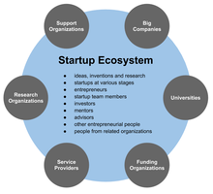
The size and maturity of the Startup Ecosystem is where a startup is launched and where it grows to have an effect on the volume and success of the startups. The startup ecosystem consists of the individuals (entrepreneurs, venture capitalists, angel investors, mentors, advisors); institutions and organizations (top research universities and institutes, business schools and entrepreneurship programs and centers operated by universities and colleges, non-profit entrepreneurship support organizations, government entrepreneurship programs and services, Chambers of commerce, business incubators and business accelators and top-performing entrepreneurial firms and startups. A region with all of these elements is considered to be a "strong" startup ecosystem.

SOURCES OF FUNDING.
- Venture Capital
- Bootstrapping
- Crowdfunding
- Bank Loans
- Contribution from Family & Friends
- Angel Investors
- Debt Financing
- Government Funds
- Funding from Foreign Company

STARTUP INDIA SCHEME
- Startup India was a campaign that was first addressed by the PM Narendra Modi on 15th August 2015 at Red Fort, New Delhi.
- This campaign was introduced under the Government of India as an initiative to develop over 75 startup support hubs in the country.

STARTUP INDIA SCHEME
Date of launching | 16th January 2016
Government Ministry | Ministry of Commerce and Industry
Department | Department for Promotion of Industry and Internal Trade
Launched by | Arun Jaitley (Former Finance Minister of India)
Organized by the Department for promotion of industry and internal trade, the major objective of Startup India is to discard some of the restrictive States Government policies which include:
- License Raj
- Land Permissions
- Foreign Investment Proposals
- Environmental Clearances
- The Startup India scheme is based majorly on three pillars which are mentioned below:
- Providing funding support and incentives to the various start-ups of the country.
- To provide Industry-Academia Partnership and Incubation.
- Simplification and Handholding.

Who is eligible to apply under the Startup India scheme?
- An entity is eligible to apply when:
- It is incorporated as a private limited company or partnership firm or a limited liability partnership in India
- It has less than 10 years of history i.e. less than 10 years have elapsed from the date of its incorporation/registration
- The turnover for all of the financial years, since the incorporation/ registration has been less than INR 100 crores
Startup India Benefits
- To reduce the patent registration fees.
- Improvement of the Bankruptcy Code ensuring a 90-day exit window.
- To provide freedom from mystifying inspections and capital gain tax for the first 3 years of operation.
- To create an innovation hub under the Atal Innovation Mission.
- Targeting 5 lakh schools along with the involvement of 10 lakh children in innovation-related programs.
- To develop new schemes that will provide IPR protection to startup firms.
- To encourage entrepreneurship throughout the country.
- To promote India as a start-up hub across the world.

Government Measures to Promote Startup Culture in the Country
- As part of the “Make in India” initiative, the government proposes to hold one Start-Up fest at the national level annually to enable all the stakeholders of the Start-up ecosystem to come together on one platform.
- Launch of Atal Innovation Mission AIM – to promote Entrepreneurship through Self-Employment and Talent Utilization (SETU), wherein innovators would be supported and mentored to become successful entrepreneurs. It also provides a platform where innovative ideas are generated.
- Incubator set up by PPP – To ensure professional management of Government-sponsored or funded incubators, the government will create a policy and framework for setting-up of incubators across the country in public-private partnerships. The incubator shall be managed and operated by the private sector.
- 35 new incubators in existing institutions. Funding support of 40% shall be provided by the Central Government, 40% funding by the respective State Government and 20% funding by the private sector for establishment of new incubators.
- 35 new private sector incubators. A grant of 50% (subject to a maximum of INR 10 crore) shall be provided by the Central Government for incubators established by the private sector in existing institutions.
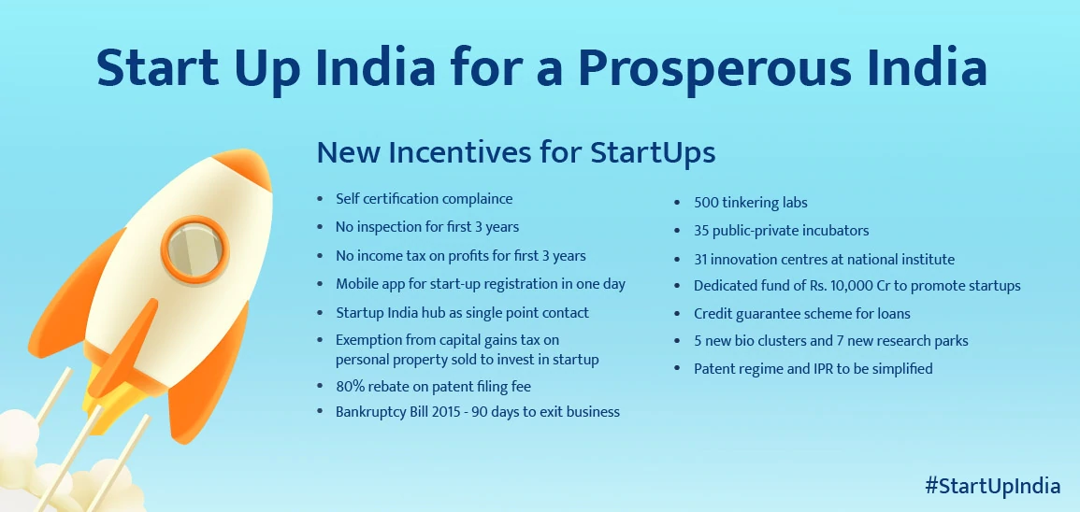
MICRO FINANCE
- “Micro Finance is a vehicle for facilitating provision of thrift, credit & other financial services of small amounts to the poor for enabling them to raise their income levels & improve their living standards.”
- Microfinance is a term for financial services that are offered to individuals of lower socioeconomic backgrounds or those who lack access to traditional financial services.
- Microfinance includes a number of services, such as savings accounts, checking accounts, fund transfers, micro insurance, and microcredit.
- Microfinance Models
- Two models outline how microfinance is operated:
- Banking for individual entrepreneurs and small businesses revolved around relationship-based banking.
- Services for a group, where multiple individuals come together to form a group to collectively apply for a loan.

History of Microfinance
- Upon the creation of microcredit by Bangladeshi social entrepreneur Muhammad Yunus in 1983, microfinance was simultaneously created.
- In 1983, Yunus established Grameen Bank in Bangladesh.
- The goal of Grameen Bank was to initially provide small loans to entrepreneurs.
- Yunus’ vision for microcredit was inspired when he witnessed women who made bamboo stools in Bangladesh making two cents a day.
- He decided that if the women were able to fall back on a loan, they would be able to improve their margins and gain a more substantial profit.
- After issuing them a loan of $27, following the group model, the women were able to repay the loan and keep their business running.
- Microfinance’s aspect of a savings account can also tie into microcredit; creditors may choose to include a loan covenant.
- The loan covenant states that the borrower must set aside a portion of profits in a savings account with the financial institution to be held as collateral until the loan is paid.
- Thus, it provides some protection for creditors, and if the loan is repaid, the borrower would’ve earned savings interest on the money that was deposited in the savings account.
- In 2006, Yunus received the Nobel Peace Prize for his efforts with Grameen Bank.
- The bank currently oversees 12,500 operational locations and employs about 22,000 individuals.
- Furthermore, there are currently 10,000 microfinance institutions.

Area of Micro Finance
- Micro Finance & Individuals / Households
- Micro Finance & Women
- Micro Finance & Social Interventions
- Micro Finance & the Economy

Micro finance is a general term to describe financial services to low-income individuals or to those who do not have access to typical banking services. Microfinance is also the idea that individuals are capable of lifting themselves out of poverty if given access to some of the financial services. The two main mechanisms for the delivery of financial services to such clients are:
• Relationship-based banking for individuals entrepreneurs and small business; and
• Group-based models, where several for individual entrepreneurs come together to apply for loans and other services as a group.
"Microfinance is the supply of loans, savings, and other basic financial services to the poor." As these financial services usually involve small amounts of money - small loans, small savings, etc. - the term "microfinance" helps to differentiate these services from those which formal banks provide.
FEATURES OF MICROFINANCE:
- Loans under microfinance programmes are of very small amounts.
- Micro finance targeted rural & urban households.
- Credit under micro finance follows thrift.
- Transparency in operations & low transaction cost.
- Shorter repayment period.
- Simple, quick & liberal procedure for processing & delivery of credit.
- No collateral security required for loans.
- Stress on honesty & fair approach on the part of the borrower.
- Need based loan disbursements.
- Motivation & encouragement for prompt repayment by borrowers

IMPORTANCE OF MICROFINANCE:-
Microfinance institutions are those which provide credit and other financial services and products of very small amounts to poor in rural, semi-urban and urban areas for enabling them to raise their income and improve their standard of living.
1. Credit to Rural Poor: Usually the rural sector depends on non-institutional agencies for their financial requirements. Micro financing has been successful in taking institutionalized credit to the doorstep of the poor and have made them economically and socially sound.
2. Poverty Alleviation: Due to microfinance poor people get employment. It also helps them to improve their entrepreneurial skills and encourages them to exploit business opportunities. Employment increases income level which in turn reduces poverty.
3. Women Empowerment: Normally more than 50% of SHGs are formed by women. Now they have greater access to financial and economical resources. It is a step towards greater security for women. Thus microfinance empowers poor women economically and socially.
4. Economic Growth: Finance plays a key role in stimulating sustainable economic growth. Due to microfinance, production of goods and services increases which increases GDP and contributes to economic growth of the country.

5. Mobilization of Savings: Microfinance develops saving habits among people. Now poor people with meager income can also save and are bankable. The financial resources generated through savings and micro credit obtained from banks are utilized to provide loans and advances to its members. Thus microfinance helps in mobilization of savings.
6. Development of Skills: Micro financing has been a boon to potential rural entrepreneurs. SHGs encourage its members to set up business units jointly or individually. They receive training from supporting institutions and learn leadership qualities. Thus microfinance is indirectly responsible for development of skills.
7. Mutual Help and Cooperation: Microfinance promotes mutual help and cooperation among members. The collective efforts of the group promote economic interest and help in achieving socio-economic transition.
8. Social Welfare: With employment generation the level of income of people increases. They may go for better education, health, family welfare etc. Thus micro finance leads to social welfare or betterment of society.
Microfinance Institutions: A microfinance institution (MFI) is an organization that provides microfinance services. MFIs range from small non- profit organizations to large commercial banks. In the 1990s, many of these institutions transformed themselves into formal financial institutions in order to access and on-lend client savings, thus enhancing their outreach.
Profitability and Sustainability of MFIs: Some worry that an excessive concern for profit in microfinance will lead MFIs away from poor clients to serve better -off clients who want larger loans. It is true that programs serving very poor clients are somewhat less profitable than those reaching better-off clients, but this may say more about managers' objectives than an inherent conflict between serving the very poor and profitability. Microfinance programs like
Bangladesh Rural Advancement Committee and ASA in Bangladesh have already demonstrated that very poor clients can be reached profitably both institutions had profits of more than 4% of assets in 2000."There are cases where microfinance cannot be made profitable, for example, where potential clients are extremely poor and risk-averse or live in remote areas with very low population density. In such settings, microfinance may require continuing subsidies. Whether microfinance is the best use of these subsidies will depend on evidence about its impact on the lives of this client
ROLE AND FUNCTIONS OF MICROFINANCE PROGRAMMES:
Microfinance programs have generally targeted poor women. By providing access to financial services only through women-making women responsible for loans, ensuring repayment through women, maintaining savings accounts for women, providing insurance coverage through women- microfinance programs send a strong message to households as well as to communities.
1. Poverty reduction tools: Microfinance can be a critical element of an effective poverty reduction strategy. Improved access and efficient provision of savings, credit, and insurance facilities in particular can enable the poor to smooth their consumption, manage their risks better, build their assets gradually, and develop their microenterprises. Microfinance is only a means and not an end. The ultimate goal is to reduce poverty.

2. Self-Employment: Poverty reduction through self-employment has long been a high priority for the Government of India. Microfinance is an experimental tool in its overall strategies. Most poor people manage to optimize resources over time to develop their enterprises. Financial services could enable the poor to leverage their initiative, accelerating the process of generating incomes, assets and economic security.
3. SHG-bank linkage programme: Indian microfinance is dominated by the operational approach Self-help Groups (SHGs). SHG is a small voluntary association of 10 – 20 poor people from the same socio – economic background who come together for the purpose of addressing their common socio economic problems through self -help & mutual help. Savings collection Loans SHG comprises mostly 90% of Women. NGO played a key role.
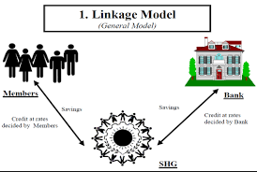
- SHG is a silent revolutionary concept. For credit delivery system.
- SHG is a voluntary association of the poor formed, with the common goal of social & economic empowerment.
- 1996: RBI made linkage of SHG with banks as a priority sector activity.
- 1999: GOI has been supporting the programme by making special budgetary provision.
- Commercial banks, Cooperative Banks & RRBs.
- NABARD: Refinance & promotional support.

Credit Linkage of SHG with bank.
- SHG was formed & financed by banks.
- SHG formed by NGO / Govt. agencies but financed by banks.
- SHG was formed by banks & NGO, using NGO / formal agencies as financial intermediaries.

NEED FOR SHG
- To mobilize the resources of the individual member for their collective economic development.
- To uplift their standard of living.
- To create the habit of saving.
- To assist the member financially.
- For Development of Entrepreneurship.
- To develop linkages with institutions of NGOs.
- To act as a media for socio economic development of the village.
- To organize training for skill development.
- To gain self-confidence, mutual understanding.
- To build up teamwork.
- To develop leadership qualities.
- To identify problems & find solutions in the group.

FUNCTIONS OF SHG
- Formation of Group
- Registration
- Management
- Meeting
- Common Place & Fixed Day
- Members Register
- Savings
- Accounts
- Resolution & Authorisation
- Internal Lending
- Training

BENEFITS OF MICRO FINANCE TO SHG MEMBERS
- Regular saving habits.
- Easy availability of small loans.
- Creation of productive assets.
- Financial Discipline.
- Unity & Cooperation among members.
- Improvement in financial position.
- Development of Leadership & Entrepreneurship.
BENEFITS OF MICRO FINANCE TO BANKS
- Reduction of transaction cost due to group deposits & finance.
- Less Paperwork.
- Loan recovery improves due to peer pressure.
- Banks have a huge scope of expansion of their business due to the growing SHG- Bank Linkage Programme.

Financial Services
‘Financial services’ can be defined as “activities, benefits and satisfactions , connected with the sale of money, that offer to users and customers , financial related value”
Financial services can be defined as services offered by financial and banking institutions like loans, insurance etc.
Financial services are concerned with the design and delivery of financial instruments and advisory services to individuals and businesses within the area of Banking and related Institutions, personal financial planning, investment, real assets, insurance etc.It involves provision of a wide variety of fund assets based and non fund based advisory services and includes all kinds of Institutions which provide intermediate financial assistance and financial transactions to both individuals and corporate customers.
FEATURES OF FINANCIAL SERVICES
- Financial services are intangible.
- Financial services are customer oriented.
- The production and delivery of financial services are simultaneous functions therefore are inseparable.
- They are perishable in nature and cannot be restored
- They are dynamic in nature as a financial services vary with the changing requirement of the customer and the socio economic environment must be dynamic socio economic changes and disposable income
- Financial services are proactive in nature and help to visualize the Expectations of the market.
- They act as a link between the investors and borrowers.
- They add in distribution of risks.
TYPES OF FINANCIAL SERVICES-
1. Capital market services- it consists of term lending institutions which mainly provide long term funds.

2. Money market services - it consists of commercial banks, Financial Institutions, cooperative banks which provide short term funds.

3. Retail services- are the services provided to individuals for direct consumption.

4. Wholesale service - these are the services provided to corporate institutions which may be directly or indirectly converted into retail services

5. Fund based services - refers to services that are used to acquire assets or funds for a customer it consists of
- Primary market activities
- secondary market activities
- foreign exchange activities
- specialized Financial Services
Important fund based services include
- leasing
- hire purchase
- factoring
- forfeiting
- mutual funds
- bill discounting
- credit financing
- Housing Finance
- venture capital

6. Fee based services - when Financial Institutions operate in specialized fields to earn income in form of fees, Commission, brokerage or dividends it is called fee based services.
They include -
- Issue management.
- Portfolio management.
- corporate counseling
- merchant banking
- credit rating
- Stock Broking
- capital restructuring
- bank guarantee
- letter of credit
- Debt restructuring

TYPES OF FINANCIAL ACTIVITIES
- Fund based activities
- Underwriting or investment in shares debentures bonds acceptor of new issue primary market activities
- Dealing in secondary market activities.
- Participating in money market instruments like discounting bills treasury bills certificate of deposits.
- Dealing in foreign exchange activities
- Fee based activity
- Managing the capital issue in accordance with SEBI guidelines enabling promoters to market their shares
- Making arrangements for placement of capital and Debt instruments with investment institutions,
- Arrangement of funds from Financial Institutions for clients project cost or working capital
- Assisting in getting all government and other clearances.
- Modern activities
- Rendering project advisory services right from the preparation of the project report till raising funds.
- Planning for memorandum and article of association and assisting for their smooth carry out.
- Acting as Trustee to the debenture holder.
- Recommending changes in managing structure and style.
- Structuring of financial collaboration joint ventures by identifying partners and preparing joint venture agreements.
- Rehabilitation and restructuring sick industries.
- Hedging of the risks by using swaps and other derivative products.
- Managing the portfolio of large public sector companies.
- Undertaking risk management Services example insurance and buyback options.
- Advising clients
- Promoting credit rating agencies.
- Minimizing cost of debt and determining debt equity ratio
- Undertaking capital market services
- Clearing services
- Registration and transfers
- Safe custody of securities
- Collection of income on securities
MERCHANT BANKING
DEFINITION OF MERCHANT BANKER:
The notification of the Ministry of finance banker defines a merchant as “any person who is engaged in the business of issue management either by making arrangements regarding selling, buying or subscribing to securities as manager, consultant, advisor or rendering corporate advisory services in relation to such issue management”.
Following are the services provided by the merchant bankers:
1. Project Counseling: Starting from the initial phase, i.e. preparing an application to obtain sponsors, the project is managed by a team of specialists from a merchant banking firm.
2. Issue Management: Another service offered by merchant banks in marketing corporate securities such as corporate shares or bonds by giving them to the public. In addition to this, the pricing is also decided by Merchant bankers.
3. Underwriting of the public issue: In this, an underwriter guarantees that in case an under subscription occurs, all the liabilities would be borne by him.
4. Managing debt and equity offerings: It is one of the main services offered by a merchant bank. The service includes assisting businesses in obtaining funding from the market.
5. Managing portfolio: Under this service, the securities are maintained efficiently. This ensures good returns are obtained from them along with reduced risks.
6. Loan syndication: Merchant bankers help their clients to raise syndicated loans from various financial institutions like banks.
7. Financial advisory services and corporate counseling: Merchant banking firms assist you in taking care of your corporation's finances. In addition to it, corporate counseling services are given to help businesses thrive.
8. Corporate restructuring / reorganization techniques: When one company takes over the other, a merchant bank acts as a mediator in the companies' negotiation process. A fee is charged for the merchant banks’ service, ensuring that it takes place without any hassle.
In India Grind lays Bank was authorized to carry merchant banking services and obtained a license form Reserve Bank of India in 1967.Grindlays which started with management of capital issues, recognised the needs of an emerging class of entrepreneurs for diverse financial services ranging from production planning and systems design to market research.. Apart from meeting the needs of small-scale units, it provided management consultancy services to large and medium sized companies. Following Grind lays Bank, Citibank set up its merchant banking division in 1970.The division took up the task of assisting new entrepreneurs and existing units in the evaluation of new projects and raising funds through borrowing and equity issues. Management consultancy services were also offered. Merchant bankers are permitted to carry-on activities of primary dealers in government securities. Consequent to the recommendations of Banking Commission in 1972, that Indian banks should offer merchant banking services as part of the multiple services they could provide their clients, State Bank of India started the Merchant Banking Division in 1972. In the initial years the SBIs objective was to render corporate advice and assistance to small and medium entrepreneurs. The commercial banks that followed State Bank of India were Central Banks of India, Bank of India and Syndicate Bank in 1977: Bank ofBaroda, Standard Chartered Bank and Mercantile Bank in 1978, and United bank of India. United Commercial Bank, Punjab National Bank, Canara bank and Indian overseas Bank in late „70s and early „80s. Among the development banks, ICICI started merchant banking activities in 1973, followed by IFCI (1986) and IDBI (1991).

LEASING:
DEFINITION AND MAIN FEATURES
A lease is a contract whereby the owner of an asset (the lessor) grants to another person (the lessee) exclusive right to use the asset for an agreed period of time, in return for the payment of a rent (called lease rental). Capital assets like land buildings, equipment, machinery, vehicles are the usual assets which are generally acquired on lease basis. The lessor remains the owner of the asset, but the possession and economic use of the asset is vested in the lessee.
As there is no separate statute in India to govern the contracts of leasing, which is akin to a contract of bailment, the provisions of the Indian Contract Act apply to it. According to Section 146 of the Indian Contract Act, 1872 bailment is “the delivery of goods by one person to another person for some purpose, upon a contract that they shall, when the purpose is accomplished, be returned or otherwise disposed of according to the directions of the person delivering them.” The person delivering the goods is called the bailor and the person to whom they are delivered is called the bailee.
Since an equipment lease transaction falls in the category of a bailment contract, the obligations of the lessor and the lessee are similar to those of the bailor and the bailee (unless expressly specified otherwise in the lease agreement) as given in the Indian Contract Act. Briefly, these may be stated as follows:
1) The lessor has the duty to deliver the asset to the lessee, to legally authorize the lessee to use the asset and to leave the asset in peaceful possession of the lessee during the lease period.
2) The lessor has the obligation to pay the lease rentals as specified in the lease agreement, to protect the lessor’s title, to take reasonable care of the asset, and to return the leased asset at the expiry of the lease period.

Main Elements of Leasing The essential features of a leasing contract are as follows:

a) A Valid Contract of Leasing: A leasing arrangement is undertaken by entering into a valid contract between the lessor and the lessee. Both the parties must be competent to contract. The lessor must have clear and undisputed title to the assets to be leased. The agreement must satisfy the essentials of a valid contract as per the Indian Contract Act.
b) Delivery of Goods: The movable property, generally termed as ‘goods’ must be delivered by the lessor to the lessee. Delivery of the goods may be either actual delivery or constructive delivery. In the former case physical possession of the goods is handed over to the lessee, but in the latter case, there is no change in the physical possession, but some instruction or direction is given to the possessor of the goods to hold the same on behalf of the lessee rather than the lessor.

c) Purpose: Goods are delivered to the lessee with the specific purpose of using them for his specified lawful activity throughout the lease period.
d) Consideration: The lessee undertakes to pay to lessor regularly lease rental, as consideration for the use of the goods.
e) Return of the Goods: The goods must be returned to the lessor exactly in the same form, after the lease period is over.
f) Ownership: The lessor, after handing over possession of the leased asset, remains owner of the asset throughout the lease period and even thereafter.
g) Methodology: The prospective lessee identifies the equipment to be leased and its supplier and enters into a lease arrangement with a leasing company. He furnishes certain particulars, such as his name, address, details about his business, name and address of the guarantor, if any, description of the equipment (model, make, size, specification etc.), the name and address of the supplier and the price quoted by the supplier, place of installation, duration of the lease, etc.

E-WALLET
Definition: E-wallet is a type of electronic card which is used for transactions made online through a computer or a smartphone. Its utility is the same as a credit or debit card. An E-wallet needs to be linked with the individual’s bank account to make payments.
Descriptions: E-wallet is a type of pre-paid account in which a user can store his/her money for any future online transaction. An E-wallet is protected with a password. With the help of an E-wallet, one can make payments for groceries, online purchases, and flight tickets, among others.
E-wallet have mainly two components, software and information. The software component stores personal information and provides security and encryption of the data. The information component is a database of details provided by the user which includes their name, shipping address, payment method, amount to be paid, credit or debit card details, etc.
For setting up an E-wallet account, the user needs to install the software on his/her device, and enter the relevant information required. After shopping online, the E-wallet automatically fills in the user’s information on the payment form. To activate the E-wallet, the user needs to enter his password. Once the online payment is made, the consumer is not required to fill the order form on any other website as the information gets stored in the database and is updated automatically.

ADVANTAGES OF ELECTRONIC WALLETS:
- It offers more solace for certain buyers –
Right when you’re passing on an electronic wallet, you will confine the number of cards you pass on when you travel. You now don’t have the essential to pass on a huge load of cash with you by a similar token. You ought to just tap your device to the portion holder, or have your phone checked, to pay for the things you are purchasing. That suggests you’re finished passing on a pocketful of things any spot you go.
- It offers induction to various kinds of cards –
Electronic wallets regularly store MasterCard and check cards. They can be used for a wide collection of cards, regardless, if the provider is suitable for the wallet you are using. That infers you can store rewards cards, relentlessness cards, and even coupons inside your electronic wallet, allowing you to acknowledge indeed a paperless lifestyle.
- It offers more prominent security –
If you have a wad of cash in your pocket that gets lost, you have zero options open to you to recover your resources. Losing your Visas suggests you should contact each credit expert to drop each card, by then have another issue. With an electronic wallet, the information is taken care of through an untouchable provider. It’s rushed behind your mystery expression or biometrics. Whether you lose your contraption, you’ll really move toward your e-wallet once you get another device.
- It might be used everything thought about retailers and online stores –
Electronic wallets have gotten comprehensively recognized in the past couple of years. Most territories that recognize cards as a portion elective will allow you to pay with your electronic wallet. Disregarding the way that there are as yet a couple of regions that are using more settled getting ready progressions, which confines something or organization access, the number of retailers who give portion access in this manner continues extending each year.
- It anticipates that customers should endorse each trade –
Electronic wallets work like a check card while beginning a trade. They anticipate that you should incorporate your PIN to support portion. For contraptions with biometrics, an installment would require your remarkable imprint to favor it. That gives you another layer of assurance from unapproved purchases or the financial risks related to misrepresentation.
- It may offer permission for new rewards –
Various electronic wallets offer inspiration to ask clients to use them as opposed to traditional portion procedures. You may find limits apply to explicit purchases, for instance, fuel, food, or travel. A couple of associations may work with your e-wallet to offer unequivocal cutoff points moreover. That suggests you can put aside money without changing your methods of overseeing cash. You’re just changing how you pay for those things.

- It could help you with your spending plan –
Various electronic wallets can help you track your methods of overseeing cash. Some may create reports that show you unequivocal orders of consumption. You can similarly distribute fixed monetary designs to unequivocal cost arrangements to ensure that you’re not spending more than you should on explicit things. If you have a top-notch thing to purchase, regardless, you can impair this component to acquire sure there’s adequate money available to make the portion.
DISADVANTAGES OF ELECTRONIC WALLETS:
- It isn’t totally open far and wide –
The amount of retailers that recognize portions from an electronic wallet depends upon the veritable wallet you pick. In December 2016, just 36% of retailers recognized Apple Pay. 34% of retailers recognized PayPal as a sort of portion. Just 25% of retailers recognized Master Pass. Around 2 million retailers in North America at present offer induction to some sort of compact portion through an electronic wallet.
- It really anticipates that you should pass on something –
But an electronic wallet offers more convenience for certain customers, it doesn’t totally discard the essential of passing on something with you. If you don’t have your PDA with the remainder of your belongings, by then you have no genuine method to complete a trade. Since these wallets don’t store your ID and other required things, you’re really constrained to pass on a standard wallet or bag with you moreover.
- It requires your contraption to have a charge –
There’s also the burden that an electronic wallet anticipates that you should have a charged device to have it work. On the off chance that you’re passing on a traditional wallet, you won’t need to worry about how much battery life is left on your phone.
- It doesn’t clear out your security perils –
The security of your PDA or PDA is dependent upon the settings you use. If you don’t have your device guaranteed with some sort of mystery word, by then someone could take your contraption and perhaps access the resources in your monetary equilibrium or Visas. There are positive security inclinations to consider which make an e-wallet a significant advancement, anyway it requires the able organization of it to intensify them.
- It may charge you more to manage portions –
Countless electronic wallets that offer a prizes program will charge you a cost to move those prizes. You may be expected to deal with portions considering a specific objective to get to these favorable circumstances moreover. While using the PayPal charge program, for example, customers get 1% cashback when their trade is a standard imprint credit trade. Using a PIN through modernized wallet exploits since you’re changing how the retail store treats the trade. In case you consume $900 consistently, you’d lose over $100 consistently for the convenience of this portion method.
- It could engage in stupid spending –
Exactly when money is electronically-based instead of something real, a couple of individual’s fights with their methods of overseeing cash. The money doesn’t feel authentic, so genuine arranging doesn’t occur. If you are as of now endeavoring to keep a monetary arrangement with a traditional wallet, by then an electronic wallet may fuel that issue.

Reference:
https://www.youtube.com/watch?v=Jnv7zwzahJk&list=RDCMUCxv9T8da7658T9R8LQT_3PQ&index=3
Microfinance - Overview, Models, History, Pros and Cons (corporatefinanceinstitute.com)
https://bbamantra.com/financial-services/
https://www.geeksforgeeks.org/advantages-and-disadvantages-of-electronic-wallets/

