What is inventory management?
Inventory management is a systematic approach to sourcing, storing, and selling inventory—both raw materials (components) and finished goods (products).
In business terms, inventory management means the right stock, at the right levels, in the right place, at the right time, and at the right cost as well as price.
Entrepreneurs, founders, and independent brands now live in a native commerce world where small-to-medium businesses compete against global conglomerates.
We’ve put together this definitive guide to inventory management to level the playing field and help you grow your brand with speed, scalability, and smart insights. You’ll find everything you need from inventory control basics to best practices and formulas to advanced automation processes.

Inventory management definition
As a part of your supply chain, inventory management includes aspects such as controlling and overseeing purchases — from suppliers as well as customers — maintaining the storage of stock, controlling the amount of product for sale, and order fulfillment.
Naturally, your company’s precise inventory management meaning will vary based on the types of products you sell and the channels you sell them through. But as long as those basic ingredients are present, you’ll have a solid foundation to build upon.
Small-to-medium businesses (SMBs) often use Excel, Google Sheets, or other manual tools to keep track of inventory databases and make decisions about ordering.
However, knowing when to reorder, how much to order, where to store stock, and so on can quickly become a complicated process. As a result, many growing businesses graduate to an inventory management app, software, or system with capabilities beyond manual databases and formulas.
With these systems, the procedures of inventory management extend beyond basic reordering and stock monitoring to encompass everything from end-to-end production and business management to lead time and demand forecasting to metrics, reports, and even accounting.

Discover how QuickBooks Commerce can transform your inventory management system
Powerful inventory and order management software
Start a Free Trial

Retail inventory management
Retail is the broadest catch-all term to describe business-to-consumer (B2C) selling. There are essentially two types of retail separated by how and where a sale takes place.
- First, online retail (eCommerce) where the purchase takes place digitally.
- Second, offline retail where the purchase is physical through a brick-and-mortar storefront or a salesperson.
Wholesale, on the other hand, refers to business-to-business (B2B) selling. Knowing the differences and best practices of retail and wholesale is critical to success.
Most businesses maintain stock across multiple channels as well as in multiple locations. The diversity of retail inventory management adds to its complexity and drives home its importance to your brand.

Importance of inventory management
For any goods-based businesses, the value of inventory cannot be overstated, which is why inventory management benefits your operational efficiency and longevity.
From SMBs to companies already using enterprise resource planning (ERP), without a smart approach, you’ll face an army of challenges, including blown-out costs, loss of profits, poor customer service, and even outright failure.
From a product perspective, the importance of inventory management lies in understanding what stock you have on hand, where it is in your warehouse(s), and how it’s coming in and out.
Clear visibility helps you:
- Reduce costs
- Optimize fulfillment
- Provide better customer service
- Prevent loss from theft, spoilage, and returns
In a broader context, inventory management also provides insights into your financial standing, customer behaviors and preferences, product and business opportunities, future trends, and more.

Inventory management program
Before digging into strategies, techniques, and processes, let’s take a look at some of the inventory management basics for beginners: namely, the terminology and formulas you’ll need.

Inventory management formulas
If you’re new to inventory, you’ll probably come across a lot of formulas that might seem confusing at first. However, with a little bit of homework, these formulas can be very useful for keeping stock levels optimized.
Here’s an overview of some of the most common inventory formulas…

1. Economic order quantity (EOQ) formula
Your EOQ is the optimum number of products you should purchase to minimize the total cost of ordering or holding stock. Figuring out your EOQ can potentially save you a significant amount of money.
EOQ = √(2DK / H), or the square root of (2 x D x K / H)
Where:
D = Setup or order costs (per order, generally includes shipping and handling)
K = Demand rate (quantity sold per year)
H = Holding or carrying costs (per year, per unit)
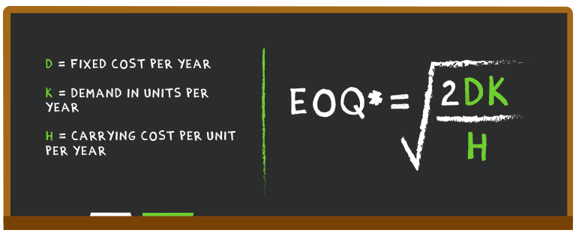
Compute the economic order quantity for a product using the calculator below:

Calculating this manually for a whole inventory can be time-consuming and prone to human error.

The good news is that we've made working out your EOQ easy.
Download free EOQ calculator

2. Days inventory outstanding (DIO) formula
Days inventory outstanding (DIO), also known as days sales of inventory (DSI), refers to the number of days it takes for inventory to turn into sales. The average inventory days outstanding varies from industry to industry, but generally a lower DIO is preferred.
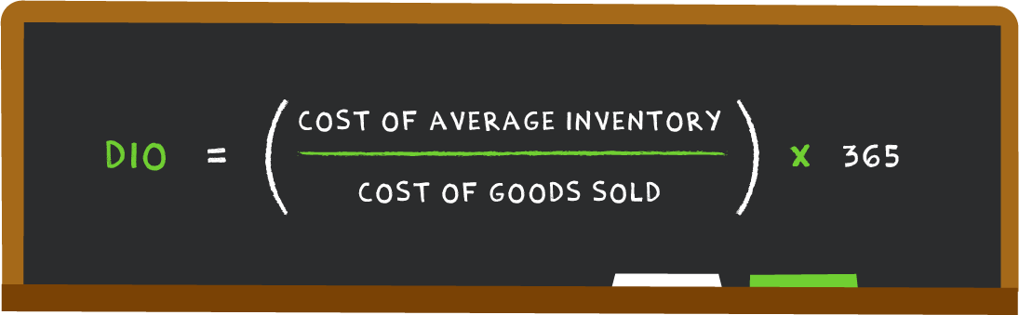
Determining whether your DIO is high or low depends on the average for your industry, your business model, the types of products you sell, etc.

3. Reorder point formula
The reorder point formula answers the age-old question: When is the right time to order more stock?
Calculating your reorder point takes three steps:
- Determine your lead time demand in days
- Calculate your safety stock in days
- Sum your lead time demand and your safety stock
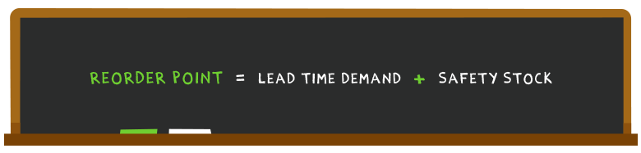
Calculate your product's reorder point using the calculator below:

Lead time in daysTime it takes for a purchase order from a supplier to arrive
×
Average daily usageAverage number of units of a product you sell per day

+
Safety stockAdditional inventory that to mitigate risk of stockouts
Start by adding your data above

Know exactly when it’s time to place an order for a
new shipment of products.
Download free ROP calculator

4. Safety stock formula
As we touched upon earlier, safety stock acts as an emergency buffer you can break out when it looks like you’re on the verge of selling out. You want to have enough safety stock to meet demand, but not so much that increased carrying costs end up straining your finances.
While this sounds like common sense, the trick is to decide on how much safety stock to carry:
- Multiply your maximum daily usage by your maximum lead time in days
- Multiply your average daily usage by your average lead time in days
- Calculate the difference between the two to determine your safety stock
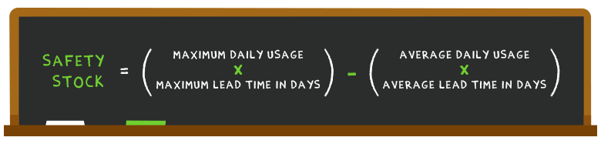
https://www.tradegecko.com/inventory-management#:~:text=Inventory%20management%20is%20a%20systematic,cost%20as%20well%20as%20price.

You're Probably Losing Money By Not Using These 8 Inventory Management Techniques
I used to dread the word “inventory.” As a part-time cashier in high school, the word inventory only meant one thing: lots and lots of counting. It’s common for businesses to reconcile their inventory at the end of the year by counting up all their physical product and making sure it matches what's on the books. For big companies like the one I used to work for, this requires everyone's help.
These days, I understand just how important solid inventory management is. Inventory is a placeholder for money. You paid money for your inventory, and you’ll get that money back (and then some) when you sell it.
Holding inventory ties up a lot of cash. That's why good inventory management is crucial for growing a company. Just like cash flow, it can make or break your business.

What is inventory management?
Inventory management is the act of keeping track of a company’s stocked goods and monitoring their weight, dimensions, amounts, and location. The goal of inventory management is to minimize the cost of holding inventory by helping business owners know when it’s time to replenish products, or buy more materials to manufacture them.

Why inventory management is important
Effective inventory management is essential for ensuring a business has enough stock on hand to meet customer demand. If inventory management is not handled properly it can result in a business either losing money on potential sales that can’t be filled, or wasting money by stocking too much inventory. An inventory management system can also help you prevent a number of other mistakes:

Inventory management saves you money

1. Avoid spoilage
If you’re selling a product that has an expiry date, like food or makeup, there’s a very real chance it will go bad if you don’t sell it in time. Solid inventory management helps you avoid unnecessary spoilage.

2. Avoid dead stock
Dead stock is stock that can no longer be sold, but not necessarily because it expired—it could have gone out of season, out of style, or otherwise become irrelevant. By managing your inventory better, you can avoid dead stock.

3. Save on storage costs
Warehousing is often a variable cost, meaning it fluctuates based on how much product you’re storing. When you store too much product at once or end up with a product that’s difficult to sell, your storage costs will go up. Avoiding this will save you money.

Inventory management improves cash flow
Not only is good inventory management more cost-efficient, it improves cash flow in other ways, too. Remember, inventory is product that you’ve likely already paid for with cash (checks and electronic transfers included) and you’re going to sell it for cash, but while it’s sitting in your warehouse it’s definitely not cash. Try paying your landlord in dog collars or iPhone cases.
This is why it’s important to factor inventory into your cash flow management. Inventory directly affects sales (by dictating how much you can sell) and expenses (by dictating what you have to buy), and both of these elements factor heavily into how much cash you have on hand. In short, better inventory management leads to better cash flow management.
When you have a solid inventory system you’ll know exactly how much product you have, and based on sales you can project when you’ll run out and make sure you replace it on time. Not only does this help ensure you don’t lose sales (critical for cash flow), but it also lets you plan ahead for buying more so you can ensure you have enough cash set aside.
Money spent on inventory is money that is not spent on growth. Manage it wisely.

8 essential inventory management techniques
Inventory management is a highly customizable part of doing business. The optimal system is different for each company.
However, every business should strive to remove human error from inventory management as much as possible, which means taking of advantage inventory management software. If you run your business with Shopify, inventory management is already built in.
Regardless of the system you use, the following eight techniques to will help you improve your inventory management—and cash flow.

1. Set par levels
Make inventory management easier by setting “par levels” for each of your products. Par levels are the minimum amount of product that must be on hand at all times. When your inventory stock dips below the predetermined levels, you know it’s time to order more.
Ideally, you’ll typically order the minimum quantity that will get you back above par. Par levels vary by product and are based on how quickly the item sells and how long it takes to get back in stock. Although setting par levels requires some research and decision-making up front, having them set will systemize the process of ordering. Not only will it make it easier for you to make decisions quickly, it will allow your staff to make decisions on your behalf.
Remember that conditions change over time. Check on par levels a few times throughout the year to confirm they still make sense. If something changes in the meantime, don’t be afraid to adjust your par levels up or down.

2. First-In First-Out (FIFO)
“First-in, first-out” is an important principle of inventory management. It means your oldest stock (first-in) gets sold first (first-out), not your newest stock. This is especially important for perishable products so you don’t end up with unsellable spoilage.
It’s also a good idea to practice FIFO for non-perishable products. If the same boxes are always sitting at the back, they’re more likely to get worn out. Plus, packaging design and features often change over time. You don’t want to end up with something obsolete that you can’t sell.
In order to manage a FIFO system, you’ll need an organized warehouse. This typically means adding new products from the back, or otherwise making sure old product stays at the front. If you’re working with a warehousing and fulfillment company they probably do this already, but it's a good idea to call them to confirm.

3. Manage relationships
Part of successful inventory management is being able to adapt quickly. Whether you need to return a slow selling item to make room for a new product, restock a fast seller very quickly, troubleshoot manufacturing issues, or temporarily expand your storage space, it’s important to have a strong relationship with your suppliers. That way they’ll be more willing to work with you to solve problems.
In particular, having a good relationship with your product suppliers goes a long way. Minimum order quantities are often negotiable. Don’t be afraid to ask for a lower minimum so you don’t have to carry as much inventory.
A good relationship isn’t just about being friendly. It’s about clear, proactive communication. Let your supplier know when you’re expecting an increase in sales so they can adjust production. Have them let you know when a product is running behind schedule so you can pause promotions or look for a temporary substitute.

4. Contingency planning
A lot of issues can pop up related to inventory management. These types of problems can cripple unprepared businesses. For example:
- Your sales spike unexpectedly and you oversell your stock
- You run into a cash flow shortfall and can't pay for product you desperately need
- Your warehouse doesn’t have enough room to accommodate your seasonal spike in sales
- A miscalculation in inventory means you have less product than you thought
- A slow moving product takes up all your storage space
- Your manufacturer runs out of your product and you have orders to fill
- Your manufacturer discontinues your product without warning
It’s not a matter of if problems arise, but when. Figure out where your risks are and prepare a contingency plan. How will you react? What steps will you take to solve the problem? How will this impact other parts of your business? Remember that solid relationships go a long way here.

5. Regular auditing
Regular reconciliation is vital. In most cases, you’ll be relying on software and reports from your warehouse to know how much product you have stock. However, it’s important to make sure the facts match up. There are several methods for doing this.

Physical inventory
A physical inventory is the practice is counting all your inventory at once. Many businesses do this at their year-end because it ties in with accounting and filing income tax. Although physical inventories are typically only done once a year, it can be incredibly disruptive to the business, and believe me, it’s tedious. If you do find a discrepancy, it can be difficult to pinpoint the issue when you’re looking back at an entire year.

Spot checking
If you do a full physical inventory at the end of the year and you often run into problems, or you have a lot of products, you may want to start spot checking throughout the year. This simply means choosing a product, counting it, and comparing the number to what it's supposed to be. This isn’t done on a schedule and is supplemental to physical inventory. In particular, you may want to spot check problematic or fast-moving products.

Cycle counting
Instead of doing a full physical inventory, some businesses use cycle counting to audit their inventory. Rather than a full count at year-end, cycle counting spreads reconciliation throughout the year. Each day, week, or month a different product is checked on a rotating schedule. There are different methods of determining which items to count when, but, generally speaking, higher-value items will be counted more frequently.

6. Prioritize with ABC
Certain products need more attention than others. Using an ABC analysis lets you prioritize your inventory management by separating out products that require a lot of attention from those that don’t. Do this by going through your product list and adding each product to one of three categories:
- High-value products with a low frequency of sales
- Moderate value products with a moderate frequency of sales
- Low-value products with a high frequency of sales
Items in category A require regular attention because their financial impact is significant but sales are unpredictable. Items in category C require less oversight because they have a smaller financial impact and they're constantly turning over. Items in category B fall somewhere in-between.

7. Accurate forecasting
A huge part of good inventory management comes down to accurately predicting demand. Make no mistake, this is incredibly hard to do. There are countless variables involved and you’ll never know for sure exactly what’s coming—but you can try to get close. Here are a few things to look at when projecting your future sales:
- Trends in the market
- Last year’s sales during the same week
- This year's growth rate
- Guaranteed sales from contracts and subscriptions
- Seasonality and the overall economy
- Upcoming promotions
- Planned ad spend
If there's something else that will help you create a more accurate forecast, be sure to include it.

8. Consider dropshipping
Dropshipping is almost an ideal scenario from an inventory management perspective. Instead of having to carry inventory and ship products yourself—whether internally or through third-party logistics—the manufacturer or wholesaler takes care of it for you. Basically, you completely remove inventory management from your business. Even if you just want to use dropshipping to test new inventory before investing in a big order, it can be a great addition to your business.
Many wholesalers and manufacturers advertise dropshipping as a service, but even if your supplier doesn’t, it may still be an option. Don’t be afraid to ask. Although products often cost more this way than they do in bulk orders, you don't have to worry about expenses related to holding inventory, storage, and fulfillment. You can test out dropshipping today, with Oberlo, for free.

Take control of your inventory
Remember that with an effective inventory management system in place, you can help reduce costs, keep your business profitable, analyze sales patterns and predict future sales, and prepare the business for the unexpected. With proper inventory management system in place, a business has a better chance for profitability and survival.
It’s time to take control of your inventory management and stop losing money. Choose the right inventory management techniques for your business, and start implementing them today.
https://www.shopify.in/blog/inventory-management
https://www.tradegecko.com/inventory-management/techniques-process

Inventory Management Techniques
Selecting the right inventory management techniques for your business is no easy task. The faster your business grows, the more difficult managing your inventory becomes.
That’s why setting the right foundation from the start is so critical.
In this guide, we outline techniques, processes, and best practices for inventory management.

Inventory management techniques
- Bulk Shipments
- ABC Inventory Management
- Backordering
- Just in Time (JIT)
- Consignment
- Dropshipping and Cross-docking
- Cycle Counting
In this section we will explore the most common inventory management techniques used by businesses of all sizes — along with the inventory holding costs and potential profits of the most prominent.
Keep in mind that you’ll probably need a mix of different techniques to develop the most comprehensive strategy for your business.

1. Bulk shipments
This method banks on the notion that it is almost always cheaper to purchase and ship goods in bulk. Bulk shipping is one of the predominant techniques in the industry, which can be applied for goods with high customer demand.
The downside to bulk shipping is that you will need to lay out extra money on warehousing the inventory, which will most likely be offset by the amount of money saved from purchasing products in huge volumes and selling them off fast.

Pros of bulk shipments
- Highest potential for profitability
- Fewer shipments mean lower shipping costs
- Works well for staple products with predictable demand and long shelf lives

Cons of bulk shipments
- Highest capital risk potential
- Increased holding costs for storage
- Difficult to adjust quickly when demand fluctuates
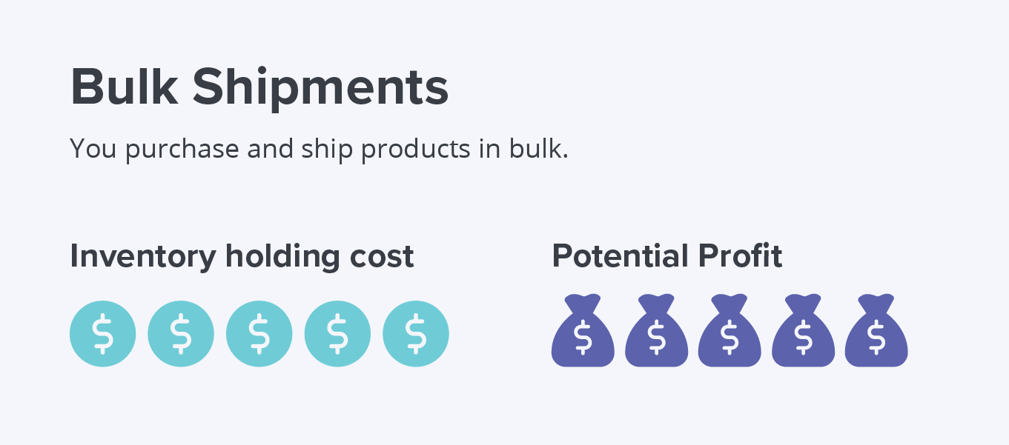

2. ABC inventory management
ABC inventory management is a technique that’s based on putting products into categories in order of importance, with A being the most valuable and C being the least. Not all products are of equal value and more attention should be paid to more popular products.
Although there are no hard-and-fast rules, ABC analysis leans on annual consumption units, inventory value, and cost significance. Categories typically look something like:
Category A

Items of high value (70%)
and small in number (10%)
Category B

Items of moderate value (20%)
and moderate in number (20%)
Category C

Items of small value (10%)
and large in number (70%)
The key is to operate each category separately, particularly when selective control, allocation of funds, and human resources are required.

Pros of ABC inventory management
- Aids demand forecasting by analyzing a product’s popularity over time
- Allows for better time management and resource allocation
- Helps determine a tiered customer service approach
- Enables inventory accuracy
- Fosters strategic pricing

Cons of ABC inventory management
- Could ignore products that are just starting to trend upwards
- Often conflicts with other inventory strategies
- Requires time and human resources
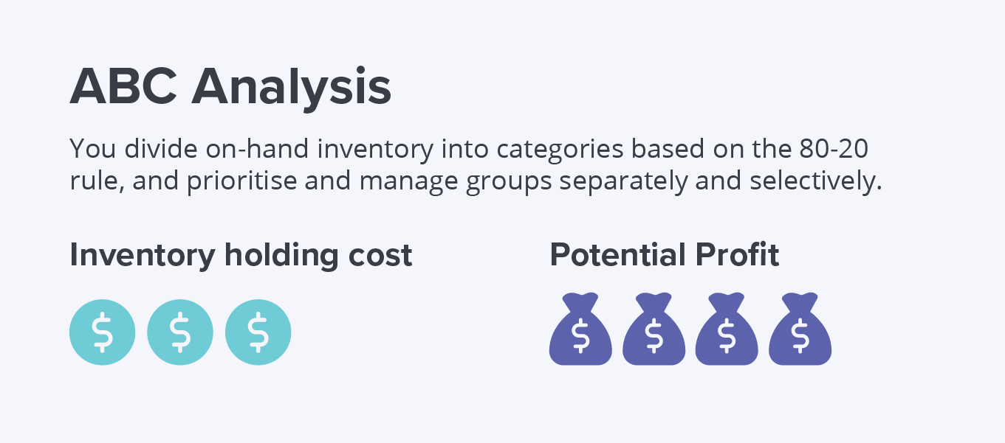

3. Backordering
Backordering refers to a company’s decision to take orders and receive payments for out-of-stock products. It’s a dream for most businesses but it can also be a logistical nightmare … if you’re not prepared.
When there’s just one out-of-stock item, it’s simply a case of creating a new purchase order for that one item and informing the customer when the backordered item will arrive. When it’s tens or even hundreds of different sales a day, problems begin to mount.
Nonetheless, enabling backorders means increased sales, so it’s a juggling act that many businesses are willing to take on.
As a general rule, the bigger the item value (physically and monetarily), the more “delivery tolerance” you get from customers.
If you’re a small retailer, it may not be feasible to risk overstocking. In this case, you might consider labeling the item’s “Buy now” button as “Pre-order” or “Get yours when it comes back in stock.” This creates a reasonable expectation for customers that it will take a bit longer to arrive.
Alternatively, some businesses run with a “no-stock” approach which involves taking only backorders until they’ve generated enough sales to then place a large bulk in order with a supplier.

Pros of backordering
- Increased sales and cash flow
- More flexibility for small businesses
- Lower holding costs and lower overstock risk

Cons of backordering
- Higher risk of customer dissatisfaction
- Longer fulfillment times
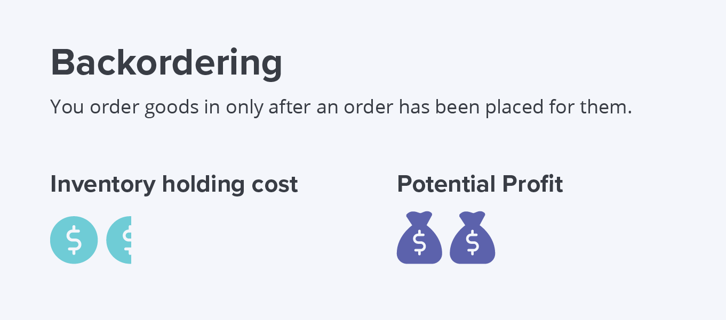

4. Just in Time (JIT)
Just In Time (JIT) inventory management lowers the volume of inventory that a business keeps on hand. It is considered a risky technique because you only purchase inventory a few days before it is needed for distribution or sale.
JIT helps organizations save on inventory holding costs by keeping stock levels low and eliminates situations where deadstock - essentially frozen capital - sits on shelves for months on end.
However, it also requires businesses to be highly agile with the capability to handle a much shorter production cycle.
If you’re considering adopting a Just in Time inventory management strategy, ask yourself the following:

- Are my suppliers reliable enough to get products to me on time every time?
- Do I have a thorough understanding of customer demand, sales cycles, and seasonal fluctuations?
- Is my order fulfillment system efficient enough to get orders to customers on time?
- Does my inventory management system offer the flexibility needed to update and manage stock levels on the fly?

Pros of JIT
- Lower inventory holding costs
- Improved cash flow
- Less deadstock

Cons of JIT
- Problems fulfilling orders on time
- Minimal room for errors
- Risk of stockouts
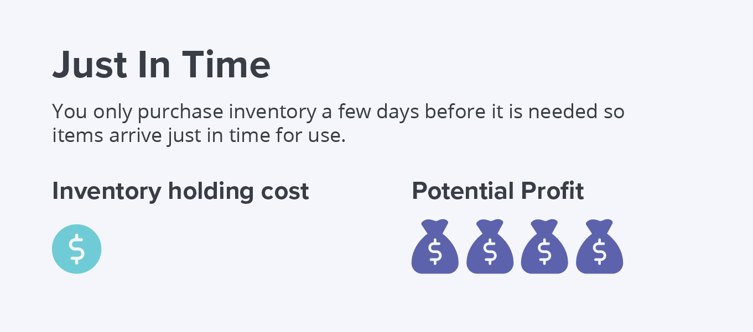

5. Consignment
Consignment involves a wholesaler placing stock in the hands of a retailer, but retaining ownership until the product is sold, at which point the retailer purchases the consumed stock. Typically, selling on consignment involves a high degree of demand uncertainty from the retailer’s point of view and a high degree of confidence from the wholesaler’s point of view.
For retailers, selling on consignment can have several benefits, including the ability to:
- Offer a wider product range to customers without tying up capital
- Decrease lag times when restocking products
- Return unsold goods at no cost
While most of the risk in selling on consignment falls on the wholesaler, there are still a number of potential advantages for the supplier:
- Test new products
- Transfer marketing to the retailer
- Collect useful information about product performance
If you consider selling on consignment — as either a retailer or wholesaler — set terms clearly regarding the:
- Return, freight, and insurance policies
- How, when, and what customer data is exchanged
- Percentage of the purchase price retailer will be taking as sales commission
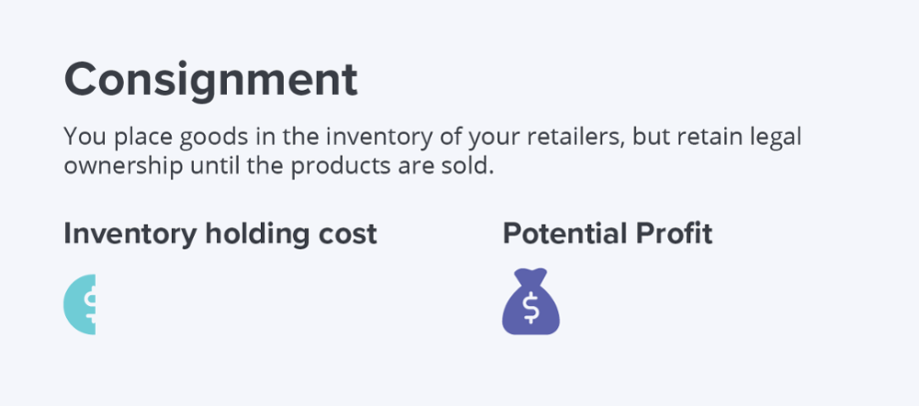

6. Dropshipping and cross-docking
This inventory management technique eliminates the cost of holding inventory altogether. When you have a dropshipping agreement, you can directly transfer customer orders and shipment details to your manufacturer or wholesaler, who then ships the goods.
Similar to dropshipping, cross-docking is a practice where incoming semi-trailer trucks or railroad cars unload materials directly onto outbound trucks, trailers, or rail cars.
Essentially, it means you move goods from one transport vehicle directly onto another with minimal or no warehousing. You might need staging areas where inbound items are sorted and stored until the outbound shipment is complete. Also, you will require an extensive fleet and network of transport vehicles for cross-docking to work.
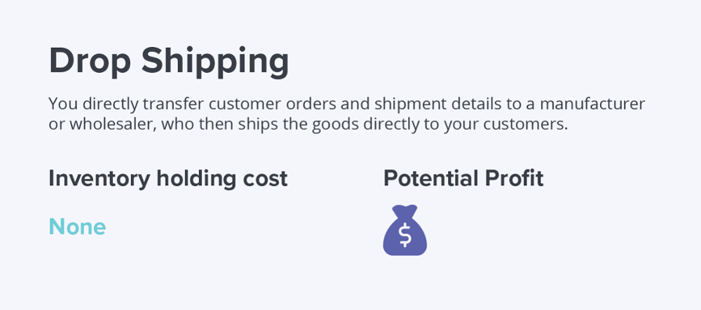
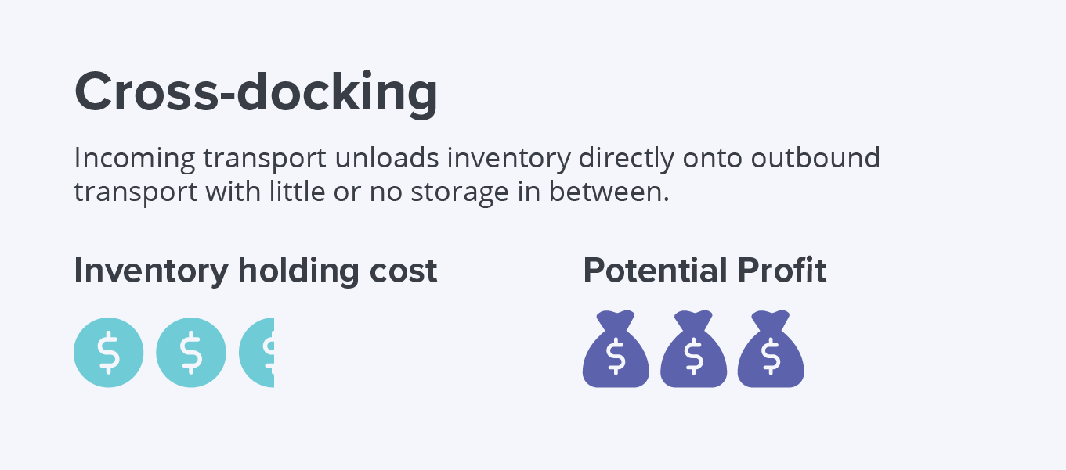

7. Inventory Cycle counting
Cycle counting or involves counting a small amount of inventory on a specific day without having to do an entire manual stocktake. It’s a type of sampling that allows you to see how accurately your inventory records match up with what you actually have in stock.
This method is a common part of many businesses’ inventory management practices, as it ultimately helps ensure that customers can get what they want, when they want it, while keeping inventory holding costs as low as possible.

Pros of cycle counting
- More time- and cost-efficient than doing a full stocktake
- Can be done without disrupting operations
- Keeps inventory holding costs low

Cons of cycle counting
- Less comprehensive and accurate than a full stocktake
- May not account for seasonality
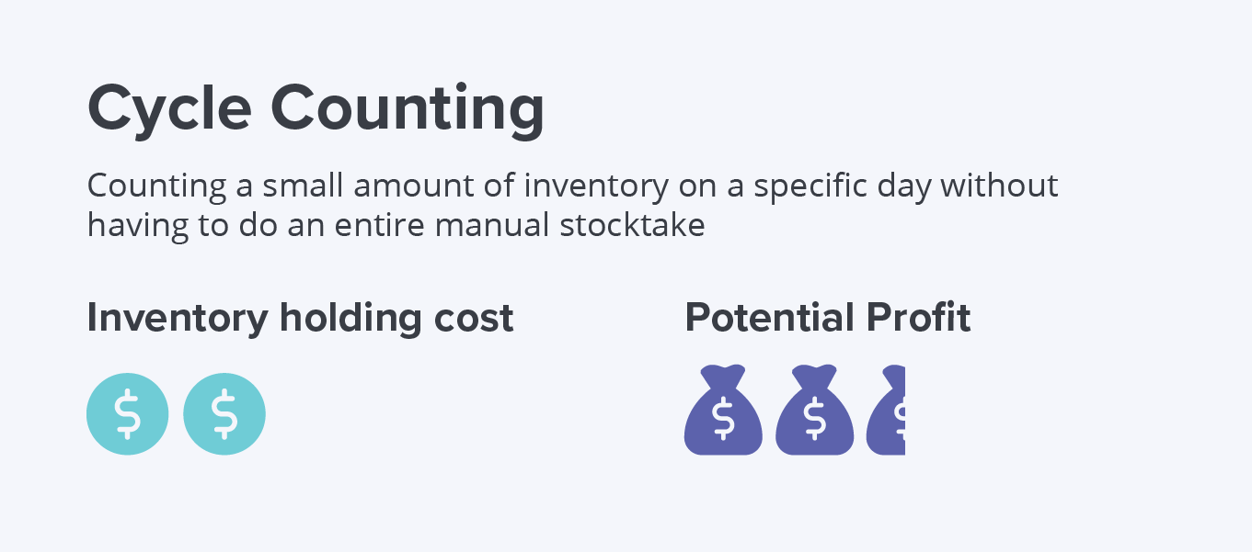

Best practices for conducting an inventory count
How often you do a cycle count and how much stock you count will depend on the types of products you sell and the resources at your disposal. For example, you might do an ABC inventory analysis to determine your class A products, and do a cycle count on your most high-value items more frequently than your other items.
Regardless of your specific approach to inventory counts, here are some best practices to follow:
- Count one category at a time – Ideally, you want to be able to cycle through your entire inventory on a period basis. It’s best to focus on one category at a time so you can count efficiently during business hours and not be impeded by operational downtime.
- Choose count categories based on seasonality – The aim of inventory counting is to be able to rectify any disparities in inventory as and when they happen. It’s best to count products when they’re at their peak to ensure you can fix any issues immediately.
- Mix up your cycle count schedule – It’s an unfortunate reality that inventory shrinkage is sometimes due to staff theft, so aim to vary your schedule to deter employees from “gaming the system.”

Types of inventory cycle count procedures
There are three main types of inventory cycle counts that you can use:
- Control group cycle counting – This type of cycle counting focuses on counting the same items many times over a short period. The repeated counting reveals errors in the count technique, which can then be rectified to design an accurate count procedure.
- Random sample cycle counting – If your warehouse has a large number of similar items, you might randomly select a certain number of items to be counted during each cycle count. This helps reduce the disruption of any one category at once, meaning you can carry out a count during business hours.
- ABC cycle counting – As mentioned above, ABC cycle counting uses the ABC inventory management technique and Pareto principle to classify items in A, B or C categories based on value. With this approach, A items are counted more frequently than B and C items.

Inventory cycle counting in the real world
IKEA is a great example of a business that uses both a sophisticated inventory management system and sporadic cycle counts to optimize inventory.
Using the company’s proprietary inventory system, on-site logistics managers can view their store’s stock levels and monitor any discrepancy in expected sales (unique to each store) versus inventory levels.
For example, let’s say that IKEA’s MALM bed frame has been selling much slower than expected. In this case, the logistics manager can manually check and confirm the stock of the bed frame. This means logistics managers only need to cycle count if the system catches a discrepancy.
https://www.investopedia.com/terms/e/economicorderquantity.asp#:~:text=Economic%20order%20quantity%20(EOQ)%20is,shortage%20costs%2C%20and%20order%20costs.

Economic Order Quantity – EOQ Definition
By WILL KENTON
Reviewed By JANET BERRY-JOHNSON
Updated Feb 10, 2020

What Is Economic Order Quantity (EOQ)?
Economic order quantity (EOQ) is the ideal order quantity a company should purchase to minimize inventory costs such as holding costs, shortage costs, and order costs. This production-scheduling model was developed in 1913 by Ford W. Harris and has been refined over time.¹﻿ The formula assumes that demand, ordering, and holding costs all remain constant.

KEY TAKEAWAYS
- The EOQ is a company's optimal order quantity that minimizes its total costs related to ordering, receiving, and holding inventory.
- The EOQ formula is best applied in situations where demand, ordering, and holding costs remain constant over time.

Formula and Calculation of Economic Order Quantity (EOQ)
The formula for EOQ is:
- \begin{aligned} &Q = \sqrt{ \frac{2DS}{H} }\\ &\textbf{where:}\\ &Q=\text{EOQ units}\\ &D=\text{Demand in units (typically on an annual basis)}\\ &S=\text{Order cost (per purchase order)}\\ &H=\text{Holding costs (per unit, per year)}\\ \end{aligned}​Q=H2DS​​where:Q=EOQ unitsD=Demand in units (typically on an annual basis)S=Order cost (per purchase order)H=Holding costs (per unit, per year)​﻿
Volume 75%

1:31

Economic Order Quantity (EOQ)

What the Economic Order Quantity Can Tell You?
The goal of the EOQ formula is to identify the optimal number of product units to order. If achieved, a company can minimize its costs for buying, delivery, and storing units. The EOQ formula can be modified to determine different production levels or order intervals, and corporations with large supply chains and high variable costs use an algorithm in their computer software to determine EOQ.
EOQ is an important cash flow tool. The formula can help a company control the amount of cash tied up in the inventory balance. For many companies, inventory is its largest asset other than its human resources, and these businesses must carry sufficient inventory to meet the needs of customers. If EOQ can help minimize the level of inventory, the cash savings can be used for some other business purpose or investment.
The EOQ formula determines a company's inventory reorder point. When inventory falls to a certain level, the EOQ formula, if applied to business processes, triggers the need to place an order for more units. By determining a reorder point, the business avoids running out of inventory and can continue to fill customer orders. If the company runs out of inventory, there is a shortage cost, which is the revenue lost because the company has insufficient inventory to fill an order. An inventory shortage may also mean the company loses the customer or the client will order less in the future.

Example of How to Use EOQ
EOQ takes into account the timing of reordering, the cost incurred to place an order, and the cost to store merchandise. If a company is constantly placing small orders to maintain a specific inventory level, the ordering costs are higher, and there is a need for additional storage space.
Assume, for example, a retail clothing shop carries a line of men’s jeans, and the shop sells 1,000 pairs of jeans each year. It costs the company $5 per year to hold a pair of jeans in inventory, and the fixed cost to place an order is $2.
The EOQ formula is the square root of (2 x 1,000 pairs x $2 order cost) / ($5 holding cost) or 28.3 with rounding. The ideal order size to minimize costs and meet customer demand is slightly more than 28 pairs of jeans. A more complex portion of the EOQ formula provides the reorder point.

Limitations of Using EOQ
The EOQ formula assumes that consumer demand is constant. The calculation also assumes that both ordering and holding costs remain constant. This fact makes it difficult or impossible for the formula to account for business events such as changing consumer demand, seasonal changes in inventory costs, lost sales revenue due to inventory shortages, or purchase discounts a company might realize for buying inventory in larger quantities.

https://mosimtec.com/types-of-logistic-costs/

4 Types of Logistics Costs You Should Keep Track Of
MOSIMTEC > Insights > 4 Types of Logistics Costs You Should Keep Track Of

Logistics are the heart of your organization’s business process. While the typical supply chain used to be small and simple, our global economy has forced to evolve and build out sprawling networks of supply chains that live independent of geographic boundaries.
Expanded supply chains can help reduce the cost of procuring raw materials and, ultimately, lessen the overall manufacturing cost.
However, they have disadvantages too.
The more complex the supply chain, the more potential inventory issues you may run into (inaccurate forecasting, over or understocking, late delivery, inefficient warehouse practices etc.).
In this article, we’ll discuss four areas of logistical costs that many businesses have a blind-spot for — with actionable tips on how measuring on forecasting.
Don’t Have Time to Read This Post? Get the PDF Version
GET MY PDF

1. Inventory Management Cost
Inventory is a common contributor to supply chain logistics costs.
Managing the number of units you have in production vs demand has a direct impact on your bottom line. Stock too many units, and you’re eating into cash flow that could be used elsewhere. Stock too little, and you’re losing out on business.
Bottlenecks in your supply chain management (SCM) can exist simply as a result of not being able to effectively track large amounts of data in real time – with so many moving parts, that can exist over multiple countries, it can be near impossible to get a birds-eye view of your entire inventory.
Blind sports in your inventory management can lead to:
- Poor forecasting
- Shipping delays & misdirection errors
- Escalating production costs
- Wasted or obsolete inventory
- Low rate of inventory turnover
- Volatile and variable overhead costs
- Data-entry errors (for tracking)
- Lost customers
The costs incurred by these issues can start to add up quickly – and to make matters worse, many of these issues aren’t easy to identify based on historical data alone.
If you’re a medium to large-sized business and manually tracking inventory through spreadsheets (like Excel) the problems can be magnified – the sheer volume of data needing to be tracked can be time-consuming and lead to errors in reporting.
And if you’re not using accurate data (let’s be honest – human error is a thing) then how are you going to accurately track sales trends, cost of goods sold, best selling items and many other critical metrics?
Scalability, accuracy and total visibility are key here – especially if your business is growing rapidly.
So how do you resolve inventory issues?
Research shows that healthcare companies are making great strides in using predictive models to better manage their supply chains, with simulations offering new insights into classifications and strategies that support decision-making.

2. Warehousing Cost
Properly measuring performance data is key to managing your warehousing costs – you can start by asking yourself the following questions:
- How often are you measuring (tracking) performance?
- What is your picking accuracy?
- What is your shrinkage rate for inventory?
- Is the percentage of customers retained increasing year-over-year?
Simply put, what gets tracked gets managed.
And when you combine a lack of warehouse measurements with poor demand planning, it can lead to having excess inventory (value) tied up in your supply chains.
This can be a result of poor forecasting, unexpected seasonal shifts in demand, product recalls, and more. Whatever the cause — your company needs a way to manage and track these fluctuations as they come about.
And even if inventory forecasting is on point — your warehouse operations might be bleeding your business dry (too many warehouse staff, not enough machinery, inefficient placement of inventory, liability issues, etc.).
Companies have successfully used the following strategies for resolving warehouse issues:

3. Transportation Mode Shifting Cost
Transportation costs related to mode-shifting and fulfillment are another key area of logistic costs – with an increasing strain on businesses from online shopping (and the expectation to have these products delivered in a timely fashion).
Every global supply chain needs to deal with mode-shifting in some form, but it’s becoming more difficult for businesses to keep these processes visible across transportation and distribution touchpoints.
When inventory isn’t managed well (as detailed above) an undue burden is placed on the transportation leg of the supply chain. For example, if a product isn’t available when a customer orders it you might need to expedite shipping (from ground to air) in order to guarantee that the product arrives on schedule.
And as the supply chains grow (with ever-increasing fuel costs) the types of indirect costs associated with these inefficiencies becomes more taxing on your bottom line.

4. Distribution Costs
Distribution costs include moving inventory through your distribution channels – a common source of inefficiency.
Vendor efficiency, vehicle utilization, scheduling, and throughput times can all be massive contributors to your logistics costs. Naturally, this area of supply chain optimization is ripe for tracking across vendor touchpoints due to high variability in costs.
In fact, more variability means that it’s more difficult for your business to track and manage data, in order to make informed decisions. And when you can’t track data, your customer service suffers too. Irate clients may want to know the status of their orders, and you won’t be in a position to provide that.

Unpacking the Many Types of Logistics Costs With Simulation
In truth, these logistics costs are just the tip of the iceberg. But regardless of what costs you assess, you’ll need some method of putting your insights into action.
Predictive modeling and supply chain simulation offer a different approach by using historical data and algorithms to create models – this can give you insight into key business drivers and opportunities to reduce total costs and make your finished products more attractive.
Inventory management simulations like these allow you to take a granular approach to inventory planning and gain visibility into potential demand, resource utilization, and how the supply chain will perform across ever-changing conditions.
Even marginal improvements can result in big savings for larger supply chains over the long term.
Research published in Supply Chain Dive found that the number of companies using predictive analytics raised 76% from 2017 to 2019.
Early forecasting of the variability in your supply chain is the way the logistics world is moving towards – with early adopters gaining a clear advantage over their competition. Establishing good cost accounting practices in this area will give you an edge over those that struggle to adapt.

https://www.mbaknol.com/logistics-management/total-cost-approach-to-logistics/#:~:text=Total%20cost%20approach%20to%20logistics%20is%20the%20key%20to%20managing,the%20cost%20of%20each%20activity.&text=So%20the%20main%20costs%20which,Customer%20service%20level%20costs

Total Cost Approach to Logistics
Total cost approach to logistics is the key to managing the logistics function. Management should strive to reduce the total cost of logistics rather than the cost of each activity. So logistics must be viewed as an integrated system rather than the individual system, because reduction in one cost invariably lead to increase the cost of other components. Effective management and real cost savings can be accomplished only by viewing logistics as an integrated system and minimizing its total cost given the firms customer service objectives. So the main costs which are involved in logistics function are:
- Customer service level costs
- Transportation costs
- Warehousing costs
- Order processing and information costs
- Lot quantity costs
- Inventory carrying costs

Customer Service Level Costs
Most business people find it difficult, if not impossible to measure this cost. The cost associated with alternative customer service levels is the cost of lost sales( not only the margin lost by not meeting current sales demand, but the present value of all future contributions to profit forfeited when a customer is lost due to poor availability, long lead times, or other service failures).
By comparing total logistics system costs, management can make knowledgeable judgment about the likelihood of recovering, through increased sales, the increase in total system costs brought about by an increase in customer service levels. Of course, management could also reduce spending in some other to component of the marketing mix — promotion, for example — in order to maintain profits with a similar sales volume. Likewise, with decrease in customer service levels, management can improve profitability or increase expenditures for other components of the marketing mix in an effort to maintain or improve market position. At the end the goal is to determine the least total cost method of logistics while keeping customer service objectives in mind.

Transportation Costs
Costs associated with the transportation function can be identified in total and be segments (i.e. inbound, outbound, by vendor, by customer, by mode, by carrier, by product, or by channel). This detail is necessary to determine the incremental costs associated with changes in the logistics system. If transportation costs are not currently available in any other form, management can determine them at a relatively low cost by sampling product flows and auditing freight bills (for common carriers) or corporate accounting records (for private fleets).

Warehousing Costs
Warehousing costs are all the expenses that can be eliminated or that must be increased as a result of a change in the number of warehousing facilities. Warehousing costs should be separated into two distinct categories:
- Throughput Costs: These costs are associated with selling product in a given market by moving it into and out of a warehouse in that market, and the fixed costs associated with the facility. Example is charges that public warehouses assess for moving product into and out of their facilities, and the costs of leased and owned facilities for the movement of the goods.
- Storage Costs: Warehousing costs related to inventory storage should be included in inventory carrying costs. These warehousing costs change with the level of inventory held in a specific warehouse and tend to be negligible in a company- owned or leased warehouse.
Throughput costs should be included instead in warehousing costs so that the increments can be easily added or subtracted when the logistics system configuration system changes.

Order Processing and Information Costs
Order processing and information costs include the cost of order transmittal, order entry, order processing, related handling costs, and associated internal and external communication costs. When establishing these costs management should remember to include in the analysis only those costs that will change with decision being made.

Lot Quantity Costs
Lot quantity costs are those production related or purchasing/acquisition costs that will change as a result of a change in the logistics system. Generally it consists of production preparation costs, capacity lost due to changeover, materials handling, scheduling and expediting. The lot quantity costs associated with purchasing are the costs of buying in various quantities.

Inventory Carrying Costs
Conceptually inventory carrying costs are the most difficult costs to determine next to the costs of lost sale. Inventory carrying costs should include only those costs that vary with the level of inventory stored and that can be categorized into 4 costs.
- Capital costs
- Inventory service costs
- Storage space costs
- Inventory risk costs.
https://www.investopedia.com/terms/a/abc.asp

Activity-Based Costing (ABC)

What Is Activity-Based Costing (ABC)?
Activity-based costing (ABC) is a costing method that assigns overhead and indirect costs to related products and services. This accounting method of costing recognizes the relationship between costs, overhead activities, and manufactured products, assigning indirect costs to products less arbitrarily than traditional costing methods. However, some indirect costs, such as management and office staff salaries, are difficult to assign to a product.
Volume 75%

1:43

Activity-Based Costing (ABC)

How Activity-Based Costing (ABC) Works
Activity-based costing (ABC) is mostly used in the manufacturing industry since it enhances the reliability of cost data, hence producing nearly true costs and better classifying the costs incurred by the company during its production process.

KEY TAKEAWAYS
- Activity-based costing (ABC) is a method of assigning overhead and indirect costs—such as salaries and utilities—to products and services.
- The ABC system of cost accounting is based on activities, which are considered any event, unit of work, or task with a specific goal.
- An activity is a cost driver, such as purchase orders or machine setups.
- The cost driver rate, which is the cost pool total divided by cost driver, is used to calculate the amount of overhead and indirect costs related to a particular activity.
ABC is used to get a better grasp on costs, allowing companies to form a more appropriate pricing strategy.
This costing system is used in target costing, product costing, product line profitability analysis, customer profitability analysis, and service pricing. Activity-based costing is used to get a better grasp on costs, allowing companies to form a more appropriate pricing strategy.
The formula for activity-based costing is the cost pool total divided by cost driver, which yields the cost driver rate. The cost driver rate is used in activity-based costing to calculate the amount of overhead and indirect costs related to a particular activity.
The ABC calculation is as follows:
- Identify all the activities required to create the product.
- Divide the activities into cost pools, which includes all the individual costs related to an activity—such as manufacturing. Calculate the total overhead of each cost pool.
- Assign each cost pool activity cost drivers, such as hours or units.
- Calculate the cost driver rate by dividing the total overhead in each cost pool by the total cost drivers.
- Divide the total overhead of each cost pool by the total cost drivers to get the cost driver rate.
- Multiply the cost driver rate by the number of cost drivers.
As an activity-based costing example, consider Company ABC that has a $50,000 per year electricity bill. The number of labor hours has a direct impact on the electric bill. For the year, there were 2,500 labor hours worked, which in this example is the cost driver. Calculating the cost driver rate is done by dividing the $50,000 a year electric bill by the 2,500 hours, yielding a cost driver rate of $20. For Product XYZ, the company uses electricity for 10 hours. The overhead costs for the product are $200, or $20 times 10.

Activity-based costing benefits the costing process by expanding the number of cost pools that can be used to analyze overhead costs and by making indirect costs traceable to certain activities.

Requirements for Activity-Based Costing (ABC)
The ABC system of cost accounting is based on activities, which are any events, units of work, or tasks with a specific goal, such as setting up machines for production, designing products, distributing finished goods, or operating machines. Activities consume overhead resources and are considered cost objects.
Under the ABC system, an activity can also be considered as any transaction or event that is a cost driver. A cost driver, also known as an activity driver, is used to refer to an allocation base. Examples of cost drivers include machine setups, maintenance requests, consumed power, purchase orders, quality inspections, or production orders.
There are two categories of activity measures: transaction drivers, which involves counting how many times an activity occurs, and duration drivers, which measure how long an activity takes to complete.
Unlike traditional cost measurement systems that depend on volume count, such as machine hours and/or direct labor hours to allocate indirect or overhead costs to products, the ABC system classifies five broad levels of activity that are, to a certain extent, unrelated to how many units are produced. These levels include batch-level activity, unit-level activity, customer-level activity, organization-sustaining activity, and product-level activity.

Benefits of Activity-Based Costing (ABC)
Activity-based costing (ABC) enhances the costing process in three ways. First, it expands the number of cost pools that can be used to assemble overhead costs. Instead of accumulating all costs in one company-wide pool, it pools costs by activity.
Second, it creates new bases for assigning overhead costs to items such that costs are allocated based on the activities that generate costs instead of on volume measures, such as machine hours or direct labor costs.
Finally, ABC alters the nature of several indirect costs, making costs previously considered indirect—such as depreciation, utilities, or salaries—traceable to certain activities. Alternatively, ABC transfers overhead costs from high-volume products to low-volume products, raising the unit cost of low-volume products.

Mission Based Costing in logistics
27th August 2020 0 By INDIAFREENOTES
“Mission” is a set of customer service goals to be achieved by the system within the specific market/product context. A successful achievement of defined mission involves a large input from various activity centres of the firm. Hence the logistics costing should be able to identify the total costs of meeting a desired mission. This is referred as Mission Based Costing.
Essentially Mission Based Costing seeks to identity unique costs that are generated as a result of
Specific logistics activities aimed to achieve certain objectives in a specific customer/market. There is no point in incurring additional costs if the additional benefits do not justify the same.

Functional Inputs to Logistical Management
There are four stages in implementing an effective Mission Based Costing.
- Define the customer service segment This is required as all customers do not have the same service requirements
- Identify factors that produce variations in the cost of service: for example – reducing the frequency of delivery .will reduce the costs.
- Identify the specifies specific resources used to support customer segments.
- Attribute activity cost by customer type or segment.
https://indiafreenotes.com/mission-based-costing-in-logistics/

SCM - Performance Measures

Advertisements
Ad by Valueimpression

Previous Page
Next Page
Supply chain performance measure can be defined as an approach to judge the performance of supply chain system. Supply chain performance measures can broadly be classified into two categories −
- Qualitative measures − For example, customer satisfaction and product quality.
- Quantitative measures − For example, order-to-delivery lead time, supply chain response time, flexibility, resource utilization, delivery performance.
Here, we will be considering the quantitative performance measures only. The performance of a supply chain can be improvised by using a multi-dimensional strategy, which addresses how the company needs to provide services to diverse customer demands.

Quantitative Measures
Mostly the measures taken for measuring the performance may be somewhat similar to each other, but the objective behind each segment is very different from the other.
Quantitative measures is the assessments used to measure the performance, and compare or track the performance or products. We can further divide the quantitative measures of supply chain performance into two types. They are −
- Non-financial measures
- Financial measures

Non - Financials Measures
The metrics of non-financial measures comprise cycle time, customer service level, inventory levels, resource utilization ability to perform, flexibility, and quality. In this section, we will discuss the first four dimensions of the metrics −

Cycle Time
Cycle time is often called the lead time. It can be simply defined as the end-to-end delay in a business process. For supply chains, cycle time can be defined as the business processes of interest, supply chain process and the order-to-delivery process. In the cycle time, we should learn about two types of lead times. They are as follows −
- Supply chain lead time
- Order-to-delivery lead time
The order-to-delivery lead time can be defined as the time of delay in the middle of the placement of order by a customer and the delivery of products to the customer. In case the item is in stock, it would be similar to the distribution lead time and order management time. If the ordered item needs to be produced, it would be the summation of supplier lead time, manufacturing lead time, distribution lead time and order management time.
The supply chain process lead time can be defined as the time taken by the supply chain to transform the raw materials into final products along with the time required to reach the products to the customer’s destination address.
Hence it comprises supplier lead time, manufacturing lead time, distribution lead time and the logistics lead time for transport of raw materials from suppliers to plants and for shipment of semi-finished/finished products in and out of intermediate storage points.
Lead time in supply chains is governed by the halts in the interface because of the interfaces between suppliers and manufacturing plants, between plants and warehouses, between distributors and retailers and many more.
Lead time compression is a crucial topic to discuss due to the time based competition and the collaboration of lead time with inventory levels, costs, and customer service levels.

Customer Service Level
The customer service level in a supply chain is marked as an operation of multiple unique performance indices. Here we have three measures to gauge performance. They are as follows −
- Order fill rate − The order fill rate is the portion of customer demands that can be easily satisfied from the stock available. For this portion of customer demands, there is no need to consider the supplier lead time and the manufacturing lead time. The order fill rate could be with respect to a central warehouse or a field warehouse or stock at any level in the system.
- Stockout rate − It is the reverse of order fill rate and marks the portion of orders lost because of a stockout.
- Backorder level − This is yet another measure, which is the gauge of total number of orders waiting to be filled.
- Probability of on-time delivery − It is the portion of customer orders that are completed on-time, i.e., within the agreed-upon due date.
In order to maximize the customer service level, it is important to maximize order fill rate, minimize stockout rate, and minimize backorder levels.

Inventory Levels
As the inventory-carrying costs increase the total costs significantly, it is essential to carry sufficient inventory to meet the customer demands. In a supply chain system, inventories can be further divided into four categories.
- Raw materials
- Work-in-process, i.e., unfinished and semi-finished sections
- Finished goods inventory
- Spare parts
Every inventory is held for a different reason. It’s a must to maintain optimal levels of each type of inventory. Hence gauging the actual inventory levels will supply a better scenario of system efficiency.

Resource Utilization
In a supply chain network, huge variety of resources is used. These different types of resources available for different applications are mentioned below.
- Manufacturing resources − Include the machines, material handlers, tools, etc.
- Storage resources − Comprise warehouses, automated storage and retrieval systems.
- Logistics resources − Engage trucks, rail transport, air-cargo carriers, etc.
- Human resources − Consist of labor, scientific and technical personnel.
- Financial resources − Include working capital, stocks, etc.
In the resource utilization paradigm, the main motto is to utilize all the assets or resources efficiently in order to maximize customer service levels, reduce lead times and optimize inventory levels.

Finanacial Measures
The measures taken for gauging different fixed and operational costs related to a supply chain are considered the financial measures. Finally, the key objective to be achieved is to maximize the revenue by maintaining low supply chain costs.
There is a hike in prices because of the inventories, transportation, facilities, operations, technology, materials, and labor. Generally, the financial performance of a supply chain is assessed by considering the following items −
- Cost of raw materials.
- Revenue from goods sold.
- Activity-based costs like the material handling, manufacturing, assembling rates etc.
- Inventory holding costs.
- Transportation costs.
- Cost of expired perishable goods.
- Penalties for incorrectly filled or late orders delivered to customers.
- Credits for incorrectly filled or late deliveries from suppliers.
- Cost of goods returned by customers.
- Credits for goods returned to suppliers.
In short, we can say that the financial performance indices can be merged as one by using key modules such as activity based costing, inventory costing, transportation costing, and inter-company financial transactions.
https://www.tutorialspoint.com/supply_chain_management/supply_chain_management_performance_measures.htm
Roll-on/roll-off (RORO or ro-ro) ships are cargo ships designed to carry wheeled cargo, such as cars, trucks, semi-trailer trucks, trailers, and railroad cars, that are driven on and off the ship on their own wheels or using a platform vehicle, such as a self-propelled modular transporter. This is in contrast to lift-on/lift-off (LoLo) vessels, which use a crane to load and unload cargo.
RORO vessels have either built-in or shore-based ramps or ferry slips that allow the cargo to be efficiently rolled on and off the vessel when in port. While smaller ferries that operate across rivers and other short distances often have built-in ramps, the term RORO is generally reserved for large oceangoing vessels. The ramps and doors may be located in the stern, bow, or sides, or any combination thereof.
Types of RORO vessels include ferries, cruiseferries, cargo ships, barges, and RoRo service for air deliveries. New automobiles that are transported by ship are often moved on a large type of RORO called a pure car carrier (PCC) or pure car/truck carrier (PCTC).
Elsewhere in the shipping industry, cargo is normally measured by the metric tonne, but RORO cargo is typically measured in lanes in metres (LIMs). This is calculated by multiplying the cargo length in metres by the number of decks and by its width in lanes (lane width differs from vessel to vessel, and there are several industry standards). On PCCs, cargo capacity is often measured in RT or RT43 units (based on a 1966 Toyota Corona, the first mass-produced car to be shipped in specialised car-carriers and used as the basis of RORO vessel size. 1 RT is approximately 4m of lane space required to store a 1.5m wide Toyota Corona) or in car-equivalent units (CEU).
The largest RORO passenger ferry is MS Color Magic, a 75,100 GT cruise ferry that entered service in September 2007 for Color Line. Built in Finland by Aker Finnyards, it is 223.70 m (733 ft 11 in) long and 35 m (114 ft 10 in) wide, and can carry 550 cars, or 1270 lane meters of cargo.^{[1]}
The RORO passenger ferry with the greatest car-carrying capacity is Ulysses (named after a novel by James Joyce), owned by Irish Ferries. Ulysses entered service on 25 March 2001 and operates between Dublin and Holyhead. The 50,938 GT ship is 209.02 m (685 ft 9 in) long and 31.84 m (104 ft 6 in) wide, and can carry 1342 cars/4101 lane meters of cargo.^{[2]}
https://en.wikipedia.org/wiki/Roll-on/roll-off
https://www.marineinsight.com/types-of-ships/what-are-ro-ro-ships/
https://www.globalsecurity.org/military/systems/ship/lash.htm

Lighter Aboard Ship (LASH) Ships
The Lighter Aboard Ship (LASH) is a single-decked vessel with large hatches, wing tank arrangements, and a clear access to the stern. The LASH has a gantry crane with a cargo handling capacity of approximately 450 LT. The function of this crane is to convey barges or lighterage from the stowed location aboard the ship to the stern region and to lower the barges or lighterage into the water. Some LASH ships are equipped with container gantry cranes for the handling of the onboard complement of containers. Different classes of LASH ships have capacities ranging from 64 to 89 barges or a mixture of LASH barges and military lighterage.
LASH ships stow their lighters vertically in cells and on top of the hatch covers. Each LASH ship is equipped with a 500-LTON (480-MTON) gantry crane to lift the lighters at the stern of the ship and stow them athwartships throughout the ship. A 35-LTON (31-MTON) gantry crane located forward is used to load containers and stow them athwartships. Three to four lighters normally can be loaded onto or discharged from the ship in one hour. A LASH ship can normally load or discharge its lighters in about 20 hours. The container crane is capable of handling approximately sixteen 20-foot (6-m) containers an hour.
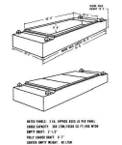
LASH lighters are thin-skinned boxes with water-tight hatch covers. The lighter can carry up to 371 LTON (340 MTON) of cargo at a maximum draft of just over 8 feet (2.4 m). Some lighters are equipped for easy ventilation and provide for smoke detection and fire extinguishing. The lighters are not ac- cessible during transit in the mother ship. The LASH lighter, with covers installed, floats at a draft of just less than 2 feet (61 cm). Each of the hatch covers weighs approximately 6,000 pounds (2,722 kg). The shallow draft allows the barge to be drawn by deck winches very close to the unprepared river bank. By keeping the mooring cables taut, the "drift" caused by strong river current is eliminated. As the barge is loaded, the shoreside edge of the hull will settle firmly its full length on the river bank. The settling will add stability to the barge and aid in loading. Should high and low tidal conditions be expected along coastlines, it is necessary to prevent the lighter from settling on shore.
Ships of the type with open stern walls are in common usage for transporting cargo lighters from one location to another. These ships are generally of a dual hull design that includes a system of ballast tanks that permit the ship to operate in a partially submerged or a fully floating mode. A first layer of lighters can be loaded on such ships by initially partially submerging the ship, floating the lighters into the cargo hold through the open stern wall, securing the lighters in place and then raising the ship to its floating position by evacuating the ballast tanks. The lighters are subsequently unloaded in the reverse manner when the ship reaches its destination. The lighters used in connection with such ships generally have a cargo carrying capacity of up to about 350 tons and a combined maximum weight including cargo of up to about 500 tons. Ships of this type typically carry about twenty or thirty lighters and are commonly used in inland waterways, but not generally used as ocean-going vessels.
The desirability of providing lateral support for lighters on the decks of lighter-transport ships has been recognized. A conventional technique for providing such lateral support includes providing the bottom of the lighters with guide rails or keels which are supported against trestles fixed such as by welding to the deck of the lighter-transport ship and which project upwardly therefrom. The bottom keel of the lighter and the trestle thereby support the lighter in the lateral direction on the deck of the ship. Moreover, the sides of the lighter are fastened to the deck of the ship by means of diagonal rigging screws as is well known in the art.
However, since the trestles project upwardly from the deck of the lighter-transport ship, the use of wheeled loading vehicles on the deck constituting the load space of the ship is severely restricted. Furthermore, it is well known that lighter-transport ships are frequently used to carry containers and/or other loads on cargo platforms. Since the trestles would otherwise constitute an obstruction to the loading of the deck, special detachable adapters have been designed which are fitted on the trestles so that a plane base is provided for the containers or cargo platforms. It will be appreciated, however, that the use of such adapters is inconvenient and time-consuming. Moreover, such adapter structures are cumbersome so that their handling and storage create problems.
In order to laterally support lighters provided with rails on their bottoms, the loading deck of a lighter-transport ship can be provided with channels situated beneath and opening onto the upper surface of the deck which are adapted to receive the rails of the lighters, and cover plates associated with the channels for selectively closing the same. The cover plates are removed from the channels to open the same when lighters are supported on the deck so that the rails are received within the channel. The cover plates are shifted over the channels to close the same when wheeled loading vehicles are moved on the deck.
Ocean-going transport systems have been provided wherein cargo is loaded in lighters which are floated to a ship. The lighters are lifted from the water and deposited in the cargo hold of the ship by a crane carried on the ship and subsequently unloaded in the reverse manner when the ship reaches its destination. The ocean-going cargo ships employed with such systems generally have a cargo handling capacity of about 90 to about 100 lighters and are of conventional hull design with entirely enclosed cargo holds and hatch covers for sealing such cargo holds.
For example, U.S. Pat. No. 3,390,657 describes a gantry crane adapted for operation on a vessel to lift lighters and transport them from an outboard loading position astern the vessel to and through a hatch and into a cargo hold, the crane being located for travel on spaced rails extending longitudinally along opposite sides of the ship. The ship is disclosed as having spaced cantilevered stern beams which provide a platform on which the crane may travel to an outboard position for lifting a floating lighter from the water. The crane is used to lift the lighter out of the water vertically upward to a position above the cargo hatches of the ship and to transport the lighter to a particular cargo hatch and lower it into the cargo hold for storage. U.S. Pat. Nos. 3,469,716 and 3,515,086 describe a sea-going transport system that includes in combination with a gantry crane mounted on the deck of a ship a guide system for restraining swinging movement of lighters being transported from a floating position adjacent the stern of the ship to a storage position in the cargo hold of the ship. The guide system described in these patents includes a pair of lead-in stern guides pivotally depending from a pair of parallel spaced cantilevered stern beams which project horizontally from the stern of the ship, and a guide-rail-guide-carriage arrangement mounted on the legs of the gantry crane and adapted for restraining swinging movement U.S. Pat. No. 3,515,085 describes a load frame assembly for use with a sea-going transport system which includes a collapsible member for each ropefall of the hoisting system to maintain tension in the ropefalls when the lighter is tossed by sea swells. U.S. Pat. No. 3,536,204 describes an anchoring device for securing a traveling ship-board crane to the deck of the ship.
It would be advantageous to provide a system for transporting lighters from a floating position adjacent the stern of a ship to a storage location aboard said ship or for transporting such lighters from said storage location to said floating position that would be suitable for use with ships of the open stern wall type. Such a system would necessarily include guide members for restraining the swinging movement of the lighters when loading and unloading such lighters using the crane of the systems. However, such guide members would have to be designed in such a manner so as to also permit the loading and unloading of lighters by floating such lighters into or out of the cargo hold. It would be advantageous if such a system were of a simplified design and construction relative to the transport systems designed for use with conventional ocean-going cargo vessels.

What Is Supply Chain And Logistics Network Modeling?

Did your company design its supply chain and logistics network?
When a company is designing its new logistics network, it will take into account all the location elements such as customer market, labor pool, quality of life requirements, and government incentives. When these elements have been analyzed, it is possible to create models which give companies more of an insight into the choices that they make.
There are a number of modeling techniques, which can be used, each coming with its own benefits and pitfalls. This article will look at the different types of modeling techniques that can be used to support the decisions made.

Modeling Techniques
The use of modeling techniques is important to companies who are deciding upon their new logistics network. The various modeling techniques can allow companies to look at a comparison of the functioning, cost efficiency, and customer service efficiency of the various logistics networks that have been proposed. Companies can look at the various modeling techniques and decide which one offers them the best insight into their network options.

Optimization Modeling
The optimization model is derived from the precise mathematical procedures that offer the best or optimum solution based on the mathematical formula used. This model is based on mathematical formula only.
This means that there is no subjective input to the model, only assumptions and data. The optimization model looks at data such as the level of customer service to be obtained, the number and location of distribution centers, the number of manufacturing plants, the number of distribution centers assigned to a manufacturing plant, and the inventories that must be maintained.
One optimization model that has been used for logistics networks is the model using linear programming, sometimes referred to as LP. This is particularly useful for linking supply and demand limitations of manufacturing plants, distribution centers, and market areas.
Given the goal of minimizing costs, linear programming can define the optimum facility distribution pattern, based on the constraints identified. However, as this uses mathematical formulas, there is no allowance for any subjective input.

Simulation Models
A simulation model is defined as creating a model that is based on the real world. When the model has been created, you can perform experiments on the model to see how changes made to the model can affect the overall cost of the logistics network.
For example, by changing the constraints on the network, it is possible using a simulation model to see how this affects the cost-effectiveness of the overall network.
For a simulation model to be effective, you need to collect significant amounts of data on transportation, warehousing, labor costs, material handling, and inventory levels, so that when you make changes to the constraints, the model accurately reflect the changes. However, the changes to the simulation model will not produce the optimum logistics network, as produced by the optimization model; it will just evaluate the changes that were made to the model. This type of model is very useful when companies have made general decisions on the network and want to see what the overall effect of any changes will be.

Heuristic Model
Similar to simulation models, heuristic models do not generate an optimum solution for a logistics network.
A heuristic model is used to reduce a large problem to a more manageable size. It has to be understood that heuristic models do not guarantee a solution and that a number of heuristic models may contradict or give different answers to the same question and still be useful to the overall creation of a logistics network.
Heuristic models are often referred to a "rule of thumb" which can be useful in creating a logistics network.
For example, a heuristic model can be used to consider the best site for a distribution center that is at least ten miles from the market area, fifty miles from a major airport, and more than three hundred miles from the next closest distribution center. A heuristic model will look at all areas that fit within the parameters defined and finds the areas best suited.
https://www.thebalancesmb.com/logistics-network-modeling-2221320

