CHAPTER 2

STANDARD COSTING



- Standard is defined by Chartered Institute of Management Accountant (CIMA):- “A Predetermined Measurable quantity Set in defined Conditions Against Which Actual Performance can be Compared, usually for an element of Work, Operation or Activity.”



- Standard Costing is defined by ICWA, LONDON:- “ The Preparations of Standard Costs and Applying them to measure the Variations of Actual Costs from Standard Costs and Analyzing the Causes of Variations with a view to maintain Maximum efficiency in Production.”

COST VARIANCE (Difference in Standard & Actual Cost)

- Material Cost Variance 2) Labour Cost Variance 3) Overhead Cost Variance

  - Material B) Material A) Labour B) Labour
Price Usage Rate Efficiency Variance Variance Variance Variance


    -  Material Cost Variance is the difference between the Standard Cost of Material specified for the Output achieved and the Actual Cost of direct material used.
    - FORMULA FOR CALCULATING MATERIAL COST VARIANCE (MCV):-
- Material Cost Variance (MCV) = Standard Cost – Actual Cost
OR
MCV = (SQ X SP) – (AQ X AP)
Where; SQ = Standard Quantity, AQ = Actual Quantity SP = Standard Price, AP = Actual Price




- Material Price Variance (MPV) = (SP – AP) X AQ
- Material Usage Variance (MUV) = (SQ – AQ) X SP
Where; SQ = Standard Quantity,
SP = Standard Price,
AQ = Actual Quantity
AP = Actual Price



a)
b)
AO = Actual Output
SQ = On the Basis of Actual Output:-
Standard Quantity for Actual Output = Standard Input x AO
Standard Output
- VERIFICATION:-
MCV = MPV + MUV


    -  Labour Cost Variance is the difference between the Standard Cost of Labour specified for the Output achieved and the Actual Cost of direct labour used.
    - FORMULA FOR CALCULATING LABOUR COST VARIANCE (LCV):-
- Labour Cost Variance (LCV) = Standard Cost – Actual Cost
OR
LCV = (SH X SR) – (AH X AR)
Where; SH = Standard Hour, AH = Actual Hour SR = Standard Rate, AR = Actual Rate

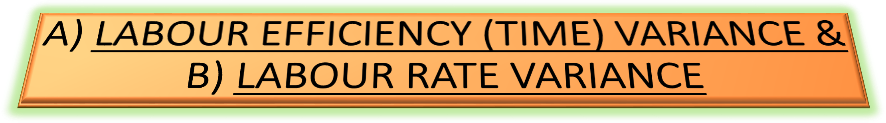


- Labour Efficiency (Time) Variance (LEV) = (SH – AH) X SR
- Labour Rate Variance (LRV) = (SR – AR) X AH
Where; SH = Standard Hour,
SR = Standard Rate,
AH = Actual Hour
AR = Actual Rate



a)
b)
AO = Actual Output
SH = On the Basis of Actual Output:-
Standard Hours for Actual Output = Standard Hours x AO
Standard Output
- VERIFICATION:-
LCV = LEV + LRV

