Definitions - Concepts of relationship Management

Introduction:
Relationship management helps organizations and business to maintain a certain level of engagement with its audience and it can happen between two businesses or a business and its customers. This relationship that is maintained with the partners and customers is more than transactional and it helps in building the brand loyalty for the specific business. Mostly relationship building happens on the customer level but when there are partners and clients establishing relationship with them is significant as well. The task of managing relationships on a professional level is not an easy task. Studying the mentalities of people overall and their reactions to different products or advertisements or social media interactions may be different each time. This is why companies and businesses hire relationship managers to take care of relationship management. It is important that the company remains connected to their customers so it can understand the needs of their customers.
The same applies for their business partners too. Improvising and changing according to the demands of the customers and clients help businesses to hold on to them thereby continuing to uphold the sale of their products and services. Relationship management also ensures that while the company is capturing newer markets and making more customers it doesn‘t lose the older ones.
Customer relationship management takes care of building a bond of trust be- tween the organisation and the existing customers. Communicating with them usually involves sales reports and data using which the business maintains the interest of the customers in the company and the products or services that it deals in. Customer relationship management also comprises of post-sale support and at times marketing techniques. There are different ways an organi- sation can choose to communicate with their customers which include social media platforms, newsletters, post-sale surveys, advertisements, tutorials, campaigns, emails, messages etc. This helps in keeping their customers close

Definitions of CRM:
CRM is an information industry term for methodologies, software and usually Internet capabilities that help an enterprise manage customer relationships in an organized way.

―Customer Relationship Management is a comprehensive approach for creating, maintaining and expanding customer relationships‖.

CRM is an integrated approach to identifying, acquiring and retaining customers. By enabling organizations to manage and coordinate customer interactions across multiple channels, departments, lines of business and geographies, CRM helps organizations maximize the value of every customer interaction and drive superior corporate
performance.

CRM is a discipline as well as a set of discrete software and technologies which focuses on automating and improving the business process associated with managing customer relationships in the areas of sales, marketing, customer services and support. CRM software applications facilitate the coordination of multiple business functions (such as sales, marketing, customer services, and support) and also coordinate multiple channels of communication with the customer face to face, call centres and the Web – so that organizations can accommodate their customers‘ preferred channels of interaction.

Concepts of Relationship Management:

The purpose of CRM
The focus [of CRM] is on creating value for the customer and the company over the longer term. When customers value the customer service that they receive from suppliers, they are less likely to look to alternative suppliers for their needs. CRM enables organisations to gain competitive advantage‘ over competitors that supply similar products or services.

What does CRM involve?
CRM involves the following (3):
- Organisations must become customer focused
- Organisations must be prepared to adapt so that it take customer needs into account and delivers them
- Market research must be undertaken to assess customer needs and satisfaction.

Benefits of CRM:
Benefits of CRM include (8):
- Reduced costs, because the right things are being done (ie., effective and efficient operation)
- Increased customer satisfaction, because they are getting exactly what they want (ie. meeting and exceeding expectations)
- Ensuring that the focus of the organisation is external
- Growth in numbers of customers
- Maximisation of opportunities (eg. increased services, referrals, etc.)
- Increased access to a source of market and competitor information
- Highlighting poor operational processes
- Long term profitability and sustainability

History and Evolution of CRM

Customer Relationship Management is a concept that became very popular during the 1990s. It offered long-term changes and benefits to businesses that chose to use it. The reason for this is because it allowed companies to interact with their customers on a whole new level. While CRM is excellent in the long-term, those who are looking for short term results may not see much progress.
One of the reasons for this is because it was difficult to effectively track customers and their purchases. It is also important to realize that large companies were responsible for processing tremendous amounts of data. This data needed to be updated on a consistent basis. In the last few years, a number of changes have been made to customer relationship management that has allowed it to advance. These capabilities have allowed CRM to become the system that was once

envisioned by those who created it. However, the biggest problem with these newer systems is the price. A number of personalized Internet tools have been introduced to the market, and this has driven down the cost of competition. While this may be a bane for vendors who are selling expensive systems, it is a bonanza for small companies that would otherwise not be able to afford CRM programs. The foundation for CRM was laid during the 1980s.

Transactional Vs Relationship Approach
Transactional Approach: Transactional marketing is a business strategy that focuses on single, "point of sale" transactions. The emphasis is on maximizing the efficiency and volume of individual sales rather than developing a relationship with the buyer.
Relationship Approach: Customer relationship management (CRM) is a process in which a business or other organization administers its interactions with customers, typically using data analysis to study large amounts of information.
A comparison of transactional marketing and relationship marketing in tabular form is given below:

TRANSACTIONAL MARKETING VS RELATIONSHIP MARKETING
Meaning
The marketing strategy used to generate the highest possible sales in the shortest possible  time | The marketing strategy used to establish long-term relationships with customers
Objective
Generate sales | Develop a connection with the customer
Duration
Short-term | Long-term
Interaction with customers
Limited or no interaction with customers | High degree of interaction with customers
Relationship with customers
Short and disruptive | Long-lasting
Aim
Make a sale | Become the first choice company in the  market
Promotional strategies
Incentives; discounts | Exceptional customer service; loyalty  programs

The Ladder of Loyalty
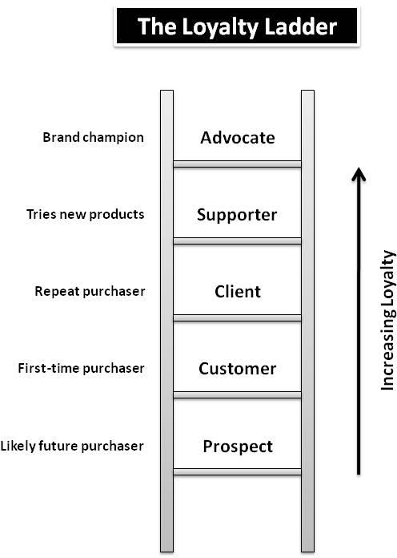
The ladder of loyalty shows the different stages through which a prospect becomes a customer, a client and finally a partner.

Prospect
The prospect is an individual in a retail market or an organization in the business market, which fulfils the requirement of the marketer‘s definition of target. For example, a cellular service provider may segment the market and target executives in blue chip companies with a special offer.

Customer
The prospect becomes a customer when s/he gets attracted by the offering of the marketer and buys the product / service.

Client
A customer becomes a client when s/he purchases the product or service more than once. While a customer may make the initial purchase as a trial or test, the client is one who does a repeat purchase. It is likely that the trial was a satisfactory experience for the client.

Supporter
A client becomes a supporter when he satisfies with the offering and recommends it to his friend, relatives and acquaintances. This positive Word – Of – Mouth (WOM) has tremendous positive impact as it helps the company get new customer. WOM is a most influential source of information in converting prospects into customer.

Advocate
An advocate is a supporter who, in addition to referrals that gives increases sales, proactively works with the company to improve its product and services. While developing new products software companies regularly depend on the feedback from the lead users of their clients during the Beta test phase. So is a case in new product development situation in several industrial firms, who set up the prototype in their client‘s premises for usage and feedback, which helps in improvement. In these situation, the level of interaction between the customer and the company is at a much higher plane. There is sharing of vital information and the comfort level as well as the confidence between the parties is high.

Partner
An advocate becomes a partner when they become actively involved in the decisions of the company. Any relationship that attempts to develop customer value through partnering activities is likely to create greater bonding between customers and marketers. In many cases, there are joint investments resulting in a structural bonding. Examples include the kind of relationship that exist between Procter and Gamble and Wal Mart, the world‘s largest retailers. This relationship is characterized by genuine partnership. Wal-Mart shares the scanner data from its checkout counters in its over 4,500 stores through satellite. This information gives the movement of P & G‘s products, the status of stocks in its outlets and helps the joint teams comprising of P&G and Wal Mart executives to plan replenishments. It helps P&G plan its production, better management of its production runs and keep its inventories low as it no longer depends on sales forecasts but actual sales data. Overall, it reduces the selling costs to P&G. Wal Mart gains as it does not have to keep inventories, gets faster replenishments, incurs low cost and is able to pass on the saving to the customers, thus, reinforcing its image of ‗Everyday Low Prices‘ among its customers.

CRM Success Factors:
While clear intention fuels the power of CRM, there are several other success factors to consider. We will focus on five of the most important here. Organizations that implements CRM with a strong return on investment share these characteristics.

- Strong internal partnership around the CRM strategy. We said earlier that CRM is
a way of doing business that touches all areas of your organization. This means that you and your management peers need to firm strong internal partnerships around CRM. If you and your organization are early on the road to CRM implementation, now is the time to bring your CRM needs to the table, and to be open to listening to the CRM needs of the other areas. You may find that you have requirements that are, atleast potentially, in conflict. Resist the temptation to go to the war for what you need.
If your organization has gone off the partnership road with CRM, then now is the time to come back together and rebuild partnership with the area that is currently hampioning CRM. Let them know that you appreciate what they have done. Let them know what data you have to offer and help them understand how you plan to use the data you request from them.

Employees at all levels and all areas accurately collect information for the CRM
system. Employees are most likely to comply appropriately with your CRM systemwhen they understand what information is to be capture and why it is important, they are also more likely to trust and use CRM data when they know how and why it was collected.

- CRM tools are customer – and employee – friendly. CRM tools should be integrated into your systems as seamlessly as possible, making them a natural part of the customer service interaction. A major manufacturer of speciality pet foods
redesigned the pop – up screens for its toll – free consumer phone line. In the original design, the final pop-up screen prompted the representative to ask the caller‘s name
and address. Yet, representatives had found that it was easier and felt more natural toask,
―What‘s your name?‖ and ―Where are you calling from?‖ and ―What‘s your pet‘s name?‖ at the start of the call.

- Report out only the data you use, and use a data you report. Just because your CRM tool can run a report doesn‘t mean it should. Refer back to your CRM strategy, and then run the data you will actually use. And share that data with your team.

- Don’t go high – tech when low – tech will do. At Harley – Davidson outside of Milwaukee, WI during the summer they often leave open the big metal doors to the manufacturing facility to let in any breeze and the cooler evening air. Unfortunately, open doors occasionally let in other things, including skunks. A team met to consider the problem and possible solutions. After discussing the pros and cons of screens, half-doors, or keeping the doors shut, they came upon ideal solution. When a skunk wanders in, just leave it alone and wait till it wanders back out. Skunks may be Harley fans, but they never stay long. Organizations that successfully implement their CRM look for the simplest solution when implementing their CRM strategy.

LEVEL OF SERVICE
Now you understand that the power of CRM lies in its ability to help you create, maintain, and expand customer relationship. You‘re excited and ready to begin delving into the process of creating your own CRM strategy, whether at the organization level or as it applies to your specific area or department. Before you do that, we‘d like you to take a more in – depth look at who your current customers are and what their relationships with you look like. Our model, the Customer Service / Sales Profile, will help you to do three things.
First, it will show you what kind of customer relationships you‘re trying to create. Is your success based in initial, stand-alone transactions? Or does the nature of your product or service put customers in partnership with you over longer periods of time? How important is it for you to have satisfied customers acting as a word – of – mouth advocates for you in the market place Second, the Customer Service / Sales Profile will help you identify strengths in your current CRM practices. Even in cases where there‘s no formal CRM strategy, if you‘re still in business, you must be doing some thing right, may be several or many things. Knowing what right practices have evolved naturally will help you create the greatest possible improvement with the least amount of expense.

Third, because this process creates a visual image of your customer relationship, you will find it helpful in communicating to others throughout the organization. Knowing your current profile and the desired profile will naturally help you focus your energy and attention.

The Three Levels of Service / Sales: There are three service / sales levels to the Customer Service / Sales Profile model.

Level 3: Customer Advocates
…………………………………… Level 2:
Repeat Customers
…………………………………… Level 1:

The three level of service / sales levels

Level 1 is initial transactions. At this level you are focused on discrete, initial interactions or stand-alone sales. This is the foundation for every business or organization. Yet, we know that the more money, time, and energy you must invest in getting customers to come to you in the first place, the harder it is to be profitable just working at this level. As we noted in Chapter 1, it‘s not unusual for customers to actually cost you money the first time they do business with you. Just consider the acquisition costs for you customers. As you can see, in order for our Nature Retreat Center to be profitability at level 1, they need to:
- Identify customers at risk of leaving, never to return, and find out how they can woo them back.
- Look for ways to teach new customers more about what the Nature Retreat Center offers and how it works so that there are fewer avoidable service issues.
- Give staff tools and training on ways to turn the interaction into revenue – generating opportunities while at the same time making guests feel well served.

It will be important for the Nature Retreat Center to focus on this improvement. When initial transactions run smoothly, with the minimum of fuss or error, it provides a strong foundation for future business.
Level 2 represents repeat customers. At this level you‘re focus on getting customers to return for a second, third or fourth time. Customers may come back for the same purchase – like the loyal Carivou Coffee customer, cordially known by the staff as the ―extra large, skil latte with Carivou cookie‖. Or the customer may turn to you for a variety of products and services – like a car insurance customers who comes back to a agent for home owner‘s, this ability, and life insurance. Repeat customers develop greater economy and emotional ties with you. And they bring with them and expectation that you will value those ties. The top level of model is customer advocates. Level 3 represent those customers who are not just satisfied and willing to do business with you again. These customers actively tell others about their positive experience they spread the good word. You might even consider them to be active participants on your marketing team. As you can see, each level builds upon the level before without quality initial
transactions, customers won‘t want to do business with you again. And it‘s the customer who seems himself or herself in a positive relationship with you who can provide the strongest advocacy for you and your product and services.

Five level of Customer Relationship Management
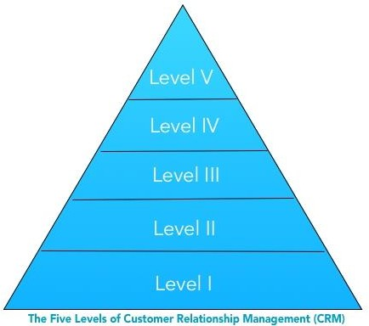

CRM Level I - Training Wheels still on:
  - You use Microsoft Outlook (or maybe Google g-mail) to send out mass emails, like an e- Newsletter.
  - Phone Calling Lists with names and phone numbers are also kept in Microsoft Excel Spreadsheets.
CRM Level II - Entry Level Internship:
  - Now we're getting some place. You implemented a Small Business Low-Cost CRM and use an outside e-Mail Service for mass emails.
CRM Level III - Average Sales Productivity:
- You invested in a top-rated CRM with lots of features that you don't use.
- Reps have minimal training, You may have a couple of plugin add-on services.
CRM Level IV - Top Performing Teams:
- The company spent a significant amount of time planning and implementing your CRM system.
- You trained your team as part of the roll-out and have a training program each quarter. You implemented a top-rated CRM.
CRM Level V - World-Class Sales Teams
- Your Top Executives are active CRM leaders for the company.
- You fully trained your team as part of the roll-out and have an on-going training program each month. You implemented a top-rated CRM that you are using to its full potential.

SERVICE- LEVEL AGREEMENTS

It is just a new-age term for the age- old telecom contract,‖ writes Julie Bort in her article, ― SLA Savvy, Five Secrets for Making Sure You Get the Most from Your Service-Level Agreements‖ (Network World, September 27, 1999). And she‘s right. However, today service level agreements cover much more than telecommunications. SLAs can also be found in IT (information technology), ASP (application service providers), and ISP (Internet service providers) agreements. And, whether you enter into a formal contract or use the concept in informal contract or use the concept in informal partnership discussion, understanding SLAs can

help you ensure that everyone in your team is on board and contributing to your customer relationship management strategy.

There are three basic types of SLAs:
Customer based SLA: A customer service-level agreement is between a service provider and its external customers.
Service based SLA: Commitment between a service provider and a client (mobile service provider).
Multilevel SLA: Split into the different levels, each addressing different set of customers for the same services, in the same SLA

Customer Life Cycle:

The customer lifecycle has five stages: reach, acquisition, conversion, retention, and loyalty

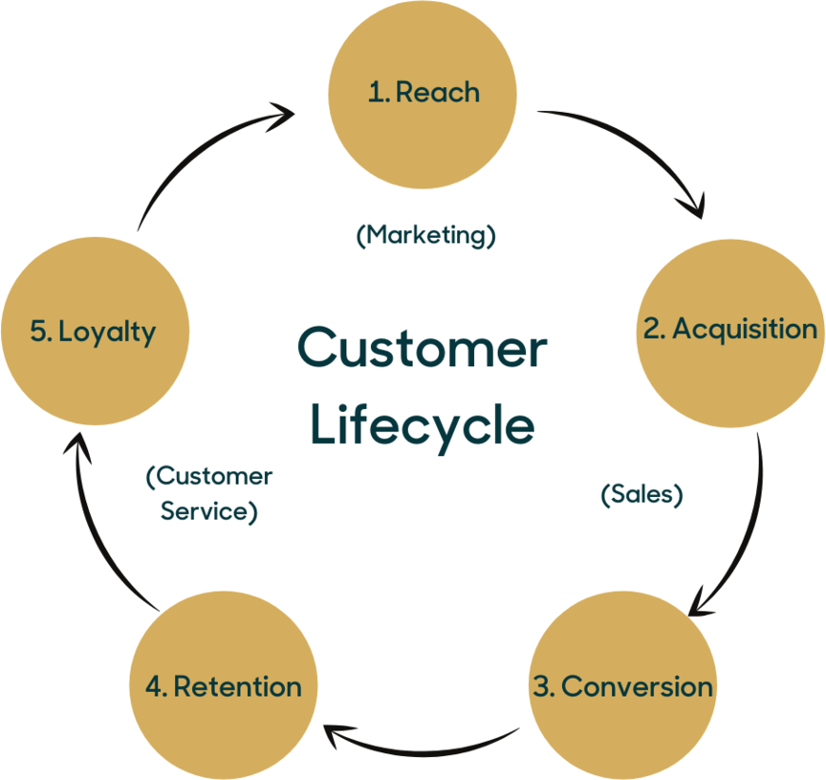

CUSTOMER INFORMATION DATABASE:
The true business of the every company is to make and keep customers‖. The single most important factor for the success of any business enterprise is the customer. Understanding the customer needs and wants is the important factor for selling of our product and services.

CUSTOMER INFORMATION.
The most often used information in a CRM database is the customer information. This can include personal information, such as contact addresses and phone numbers, as well as family size, location, and other demographic information. Many companies also use their CRM database to record purchase information, service calls, customer support needs, and even warranty information. Anything relative to customer interaction can be placed in a CRM database.

- Customer information database includes personal information, such as contact addresses, phone numbers etc.
- It also includes family size, location and other demographic information and geographical location.
- CRM database to record purchase information, service calls, customer support needs, and even warranty information.
- Customer related databases might be maintained in a number functional areas; eg. sales,marketing,logistics and accounts.
- Customer Information Database
- Databases might require quite different operational purposes Eg: Opportunities, campaigns, enquiries, deliveries and billing.
- Customer related data can have a current, past and future perspectives, focusing upon current opportunities, historic sales or potential opportunities etc.
✓

INFORMATION TO BE INCLUDED IN CUSTOMER DATABASE
- Contact names
- Job title and job definitions
- Demographic or psychographic information
- Name of the company
- Address
- Methods of contact
- Buying history
- Sources of lead
- Sources of sale
- Special needs of customers

BENEFITS OF A CUSTOMER DATABASE
By using a customer database to keep in touch with, and market to, your customers, you can:
  - Increase awareness of your brand
  - Enhance marketing opportunities
  - Build and strengthen relationships between you and your customers

  - Build trust in your products and services
  - Increase your profits 6.

DEVELOPING A CUSTOMER INFORMATION DATABASE

Define the database functions
- Strategic CRM: Data about markets, market offering, customers, channels, competitors, performance and potential.
- Operational CRM: Customer related data to help in the everyday running of the business.
- Analytical CRM: Data to support the marketing, sales and services decisions that aim to enhance the value created for and from the customers.
- Collaborative CRM: It includes two subsets of operational and analytical purpose.(OLTP,OLAP)onlineT-transaction, A-analytical processing.

Define the information requirements
- Customer information fields
- Contact data
- Contact history
- Transactional history
- Current pipeline
- Opportunities: It looks forward after sales.
- Products
- Communication preferences

Identify the information sources
- Internal data: market size ,market segmentation, customer profile, customer acquisition channel, competitor product and pricing, customer requirement
- External data:
- Compiled list data:
- Census data: obtained from govt records.
- Modeled data generated by third parties includes variety of sources.

- Secondary and primary data:
- Competition entries
- Subscriptions: customer Subscribe of newsletter or magazine
- Registrations: customers are invite to register their purchase
- Loyalty programs

Maintain the Database
- All new transactions, campaigns and communications are inserted immediately.
- Regularly re duplicates the database.
- Get customers to update their own records.(online purchase)
- Audit the subset of files every year.
- Drip-feed

PROCESS OF ANALYSING CUSTOMER INFORMATION DATABASE
- Extract (information)
- Clean
- Merge &
- Analyze

CUSTOMER PROFILE ANALYSIS
- A good method of identifying and understanding customers is to develop customer profile.
- This approach is similar to that used in market segmentation.
- The marketers creates some basis for dividing the various customer groups.
- The marketer then develops a typical customer profile which helps to analyze and understand consumer behavior.

COMPONENTS OF CUSTOMER PROFILE
- Customer profile analysis : Customer profile that gives an indication of who might typically use their outlet. A customer profile is affected by the macro business environment. A customer

profile is also influenced by the micro-environment, the specific business arena in which the individual market operates.
The perspective of changing consumer profile can be very important to the marketer in order to adequately manage the marketing mix and formulate a marketing strategy. Changing customer profile includes into two categories.
Changing customer demography changing in consumer values and life style.

CUSTOMER LIFE TIME VALUE
  - Customer lifetime value (CLV), lifetime customer value (LCV), or lifetime value (LTV) is the net present value of the cash flows attributed to the relationship with a customer.
  - The use of customer lifetime value as a marketing metric tends to place greater emphasis on customer service and long-term customer satisfaction, rather than on maximizing short-term sales.
  - Building Profitable Customer-Centric Strategies: Maximizing Profit Potential
  - Our high-impact processes for becoming more customer-centric and creating innovative strategies will be valuable only if we can effectively deliver on these profitably.

SELECTION OF PROFITABLE CUSTOMER PROFITABILITY
  - We first understand the key factors that will drive profitability for customer insight initiatives.
  - During the innovation stage, the objective was to creatively generate new sources for capturing intelligence from customers and creating insight that could enhance the way we communicate and sell to customers.
  - As you learn more from customers about their needs and preferences, you have the opportunity to better target your marketing messages, offers and channels, which ultimately leads to reduced marketing expenses and increased conversion rates.

Customer life time value

The key factors that will drive the profitability of customer insight initiatives include these:
  - Reaching high-value customers and prospects
  - Capturing intelligence on a critical mass of customers to justify the fixed costs of setting up and managing the program
.

ELEMENTS OF CRM:
When your company communicates with your customers the process can involve many different people within both organizations using a variety of different methods. The main tool that is used is an order that is communicated by your customer to your sales department. However this is only one of many communications that should be managed. To ensure that your company can provide the best customer service experience possible the use of customer relationship management (CRM) software should be considered.

Customer Knowledge:
The customer service function in your company represents the front office functions that interact with your customers. These are the business processes that allow your company to sell products and services to your customers, communicate with your customers with regards marketing and dealing with the after sales service requirements of your customers. Each interaction with the customer is recorded and stored within the CRM software where it can be retrieved by other employees if needed.

Relationship Strategy
- Communication

Individual Value Proposition
- Sales Force Automation:
The company‗s sales department is constantly looking for sales opportunities with existing and new customers. The sales force automation functionality of CRM software allows the sales teams to record each contact with customers, the details of the contact and if follow up is required. This can provide a sales force with greater efficiencies as there is little chance for duplication of effort. The ability for employees outside of the

sales team to have access to this data ensures that they have the most recent contact information with customers. This is important when customers contact employees outside
of the sales team so that customers are given the best level of customer service.

Campaign Management:
The sales team approach prospective customers in the hope of winning new business. The approach taken by the sales team is often focused in a campaign, where a group of specific customers are targeted based on a set of criteria. These customers will receive targeted marketing materials and often special pricing or terms are offered as an inducement. CRM software is used to record the campaign details, customer responses and analysis performed as part of the campaign.

CRM PROCESS
  - The formation process of CRM refers to the decisions regarding initiation of relational activities for a firm with respect to a specific group of customers or to an individual customer with whom the company wishes to engage in a cooperative or collaborative relationship.

  - It is important that a company be able to identify and differentiate individual customers. In the formation process, there are three important decision areas: defining the purpose (or objectives) of engaging in CRM; selecting parties (or customer partners) for appropriate CRM programs; and developing programs (or relational activity schemes) for relationship engagement with the customer.

CRM process

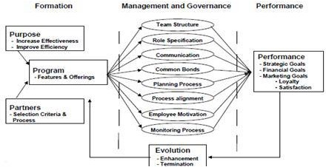

THREE STEPS OF CRM PROCESS
- Acquisition : It comprises enquiry, interaction, exchange, co-ordination and adaptation.
- Customer Interaction Management
- Customer Retention
  - Customer Acquisition
  - Customer acquisition is a broad term that is used to identify the process and procedures used to locate, qualify, and ultimately secure the business of new customers.
  - Customer retention effort is to identify and quality potential customers.
  - Inputs for Acquisition
  - The purpose of customer acquisition an organization is likely to focus its attention on the following:
- The suspects

- The enquiries
- The lapsed customers
- The former customers
- The competitors customers
- The competitors lapsed customer‗s
- The competitor‗s enquiries
- The competitors former customers
- The referrals
- The existing customers

STRATEGIES FOR CUSTOMER ACQUISITION

- Focused Approach:
  - Knower
  - Preferer
  - Indifferent
  - Rejecters
- Providing a Win-Win Platform
- Intimate Forum for Communication
- Attempt to Minimize- ―FUD‖ (Fear, Uncertainty, Doubts)
- Projection Of Benefits And Not Products
- Contextual Application
- Focus On Decision Process

CUSTOMER RETENTION
Customer retention is the activity that a selling organization undertakes in order to reduce customer defections. Successful customer retention starts with the first contact an organization has with a customer and continues throughout the entire lifetime of a relationship. A company‗s ability to attract and retain new customers, is not only related to its product or services, but strongly related to the way it services its existing customers and the reputation it creates within and across the marketplace.

Customer Retention Programs Figure
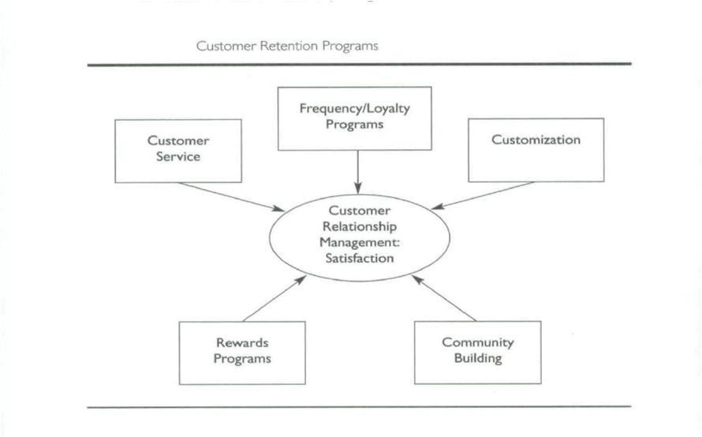

STRATEGIES FOR CUSTOMER RETENTIONS

- People
- Product
- Process
- Organisation
- Setting Satisfactory Service Standards
- Concentration on Competitors
- Customer Analysis
- Cost Analysis
- Concentration on the Paying Ability of Customers
- Knowledge on Purchase Behaviour Pattern

CUSTOMER DEFECTION
Customer defection is the rate at which customers defect or stop the usage of products of a company. Business with high defection rate would be losing their existing customers. In order to overcome this they use another term of customer retention, in simple words it‘s to retain or prevent the existing customers to defect the product.

TYPES OF DEFECTION
  - Price Defectors
  - Product Defectors
• 
  - Market Defectors
  - Technological Defectors
  - Organisational Defectors

STRATEGIES FOR PREVENTION OF DEFECTION

Every customer that you keep represents at least three that you don‘t have to attract. Numerous research studies indicate that the cost of acquiring a new customer usually runs from two to four times the annual cost of keeping an existing customer. Obviously, an effective customer retention strategy translates into profits.
It has been estimated that most companies spend about 98 percent of their time reacting to problems and less than 2 percent preventing them. The first, most important, way to prevent customer defections is to identify and define each problem from the customer‗s vantage point.
This blog suggests several ways to retain customers once you understand the problems and their ramifications.
Superior service and database management provide your best defense against customer defections. Service provides the opportunity to solve customer problems and build partnerships; the database serves as a vehicle to personalize customer communication and enhance your relationships. The Key Points Are
- Analyze Customer Defections and Monitor Declining Accounts
- Address Key Churn Drivers

- Implement Effective Complaint-Handling and Service Recovery Procedures
Increase Switching Costs
  - Generating incremental profits from increased sales to new customers, higher customer retention, selling more to existing customers or winning back lost customers
  - Reducing costs of delivering solutions and servicing customers
  - Capturing intelligence cost-effectively
  - Building the ability to influence customer profitability over time

