CHAPTER 1

MARGINAL COSTING


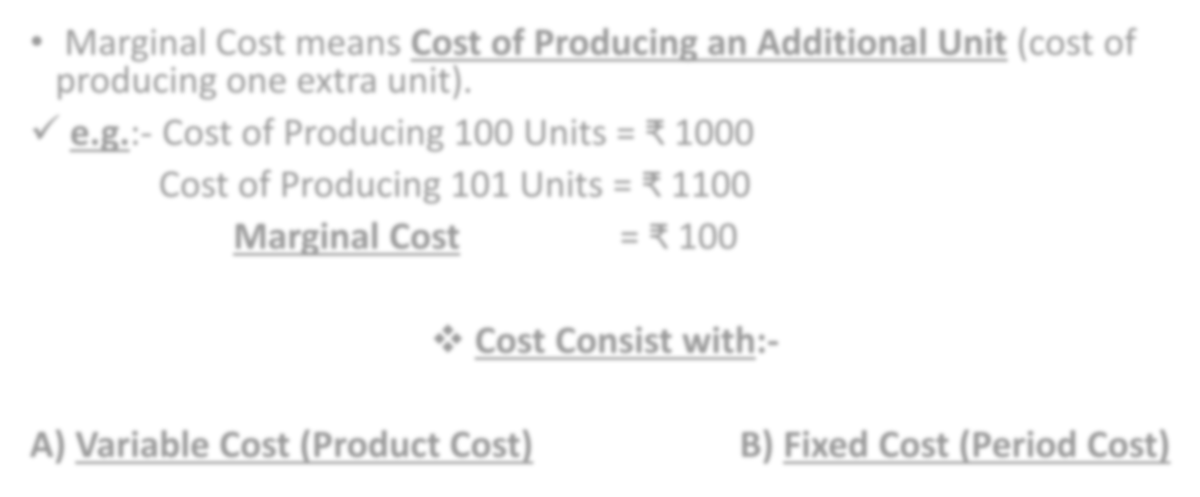
- Marginal Cost means Cost of Producing an Additional Unit (cost of producing one extra unit).
- e.g.:- Cost of Producing 100 Units = ₹ 1000 Cost of Producing 101 Units = ₹ 1100
Marginal Cost = ₹ 100
- Cost Consist with:-
A) Variable Cost (Product Cost)
B) Fixed Cost (Period Cost)

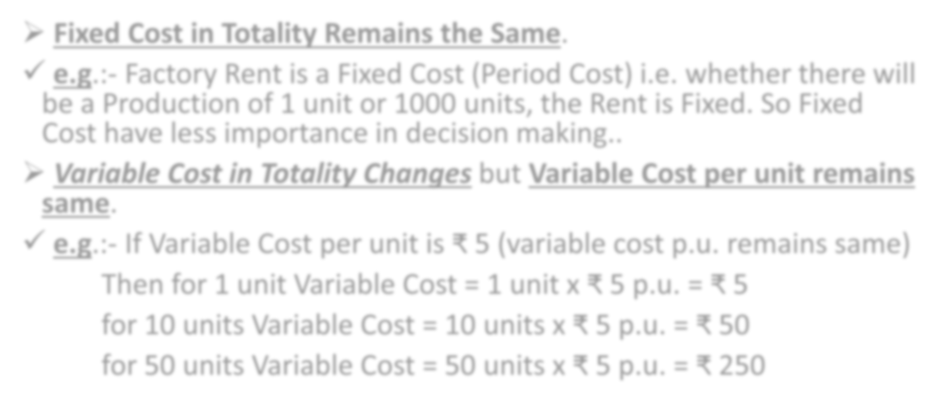

- Fixed Cost in Totality Remains the Same.
- e.g.:- Factory Rent is a Fixed Cost (Period Cost) i.e. whether there will be a Production of 1 unit or 1000 units, the Rent is Fixed. So Fixed Cost have less importance in decision making..
- Variable Cost in Totality Changes but Variable Cost per unit remains same.
- e.g.:- If Variable Cost per unit is ₹ 5 (variable cost p.u. remains same)
Then for 1 unit Variable Cost = 1 unit x ₹ 5 p.u. = ₹ 5 for 10 units Variable Cost = 10 units x ₹ 5 p.u. = ₹ 50 for 50 units Variable Cost = 50 units x ₹ 5 p.u. = ₹ 250

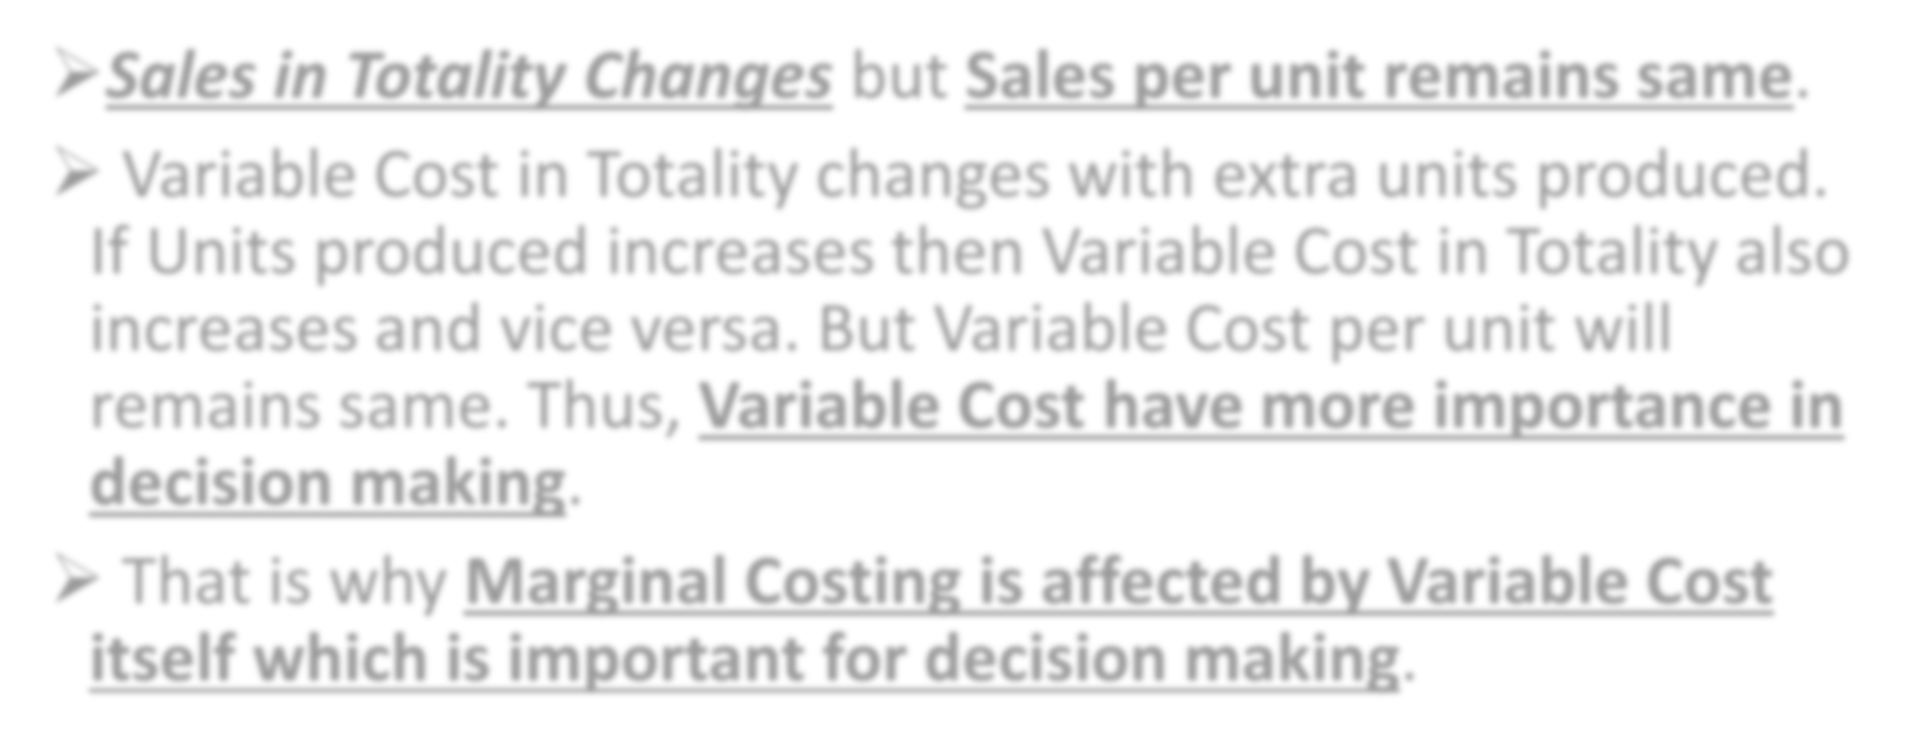

- Sales in Totality Changes but Sales per unit remains same.
- Variable Cost in Totality changes with extra units produced. If Units produced increases then Variable Cost in Totality also increases and vice versa. But Variable Cost per unit will remains same. Thus, Variable Cost have more importance in decision making.
- That is why Marginal Costing is affected by Variable Cost itself which is important for decision making.

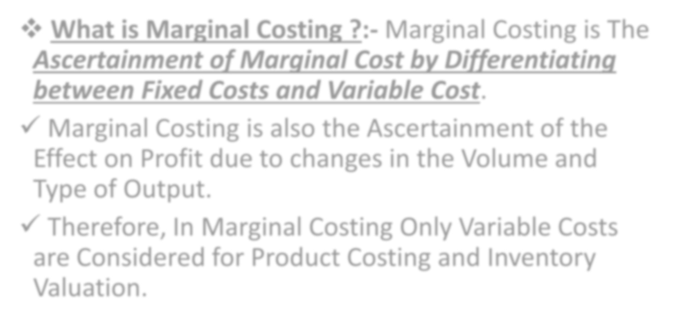

- What is Marginal Costing ?:- Marginal Costing is The Ascertainment of Marginal Cost by Differentiating between Fixed Costs and Variable Cost.
- Marginal Costing is also the Ascertainment of the Effect on Profit due to changes in the Volume and Type of Output.
- Therefore, In Marginal Costing Only Variable Costs are Considered for Product Costing and Inventory Valuation.

STEPS IN CALCULATING PROFIT IN
MARGINAL COSTING
No. | PARTICULARS | ₹
1) | Sales | xx
2) | Less:- Variable Cost | xx
3) | Contribution | xx
4) | Less:- Fixed Cost | xx
5) | Profit | xx



1)
2)
Sales – Variable Cost = Contribution
Contribution – Fixed Cost = Profit
3)
Profit Volume Ratio = Contribution x 100 (for finding answer in %)
Sales
OR
= Change in Profit x 100 Change in Sales


- Break Even Point (In Units) = Fixed Cost
Contribution per unit

- Break Even Point (In ₹ ) = Fixed Cost
Profit Volume Ratio


- Required Sales (In Units) = Fixed Cost + Desired Profit
Contribution per unit

- Required Sales (In ₹) = Fixed Cost + Desired Profit
Profit Volume ratio



- Margin of Safety (In Units) = Actual Sales (in units) – Break Even
Points Sales (in units)

- Margin of Safety (In ₹) = Actual Sales (in ₹) – Break Even Point Sales
(in ₹)

- Profit = Margin of Safety x Profit Volume Ratio

