Keynesian Theory of Income and Employment

John Maynard Keynes was the main critic of the classical macro economics. He in his book 'General Theory of Employment, Interest and Money' out-rightly rejected the Say's Law of Market that supply creates its own demand. He severely criticized A.C. Pigou's version that cuts in real wages help in promoting employment in the economy. He also opposed the idea that saving and investment can be brought about through changes in the rate of interest. In addition to this, the assumption of full employment in the economy is not realistic.

So long as the economy was operating smoothly, the classical analysis of aggregate economy met no serious opposition. However, Great Depression of 1930's created problems of increasing unemployment, reducing national income, declining prices and failing firms increased in intensity. The classical model miserably failed to explain and provide a workable solution for how to escape the depression.

It was at that time when J. M. Keynes wrote his famous book 'General Theory'. In it he presented an explanation of the Great Depression of 1930's and suggested measures for the solution. He also presented his own theory of income and employment. According to Keynes:

"In the short period, level of national income and so of employment is determined by aggregate demand and aggregate supply in the country. The equilibrium of national income occurs where aggregate demand is equal to aggregate supply. This equilibrium is also called effective demand point".

What is Effective Demand?
Effective demand represents that aggregate demand or total spending (consumption expenditure and investment expenditure) which matches with aggregate supply (national income at factor cost).

In other words, effective demand is the signification of the equilibrium between aggregate demand (C+I+G) and aggregate supply (C+S). This equilibrium position (effective demand) indicates that the entrepreneurs neither have a tendency to increase production nor a tendency to decrease production. It implies that the national income and employment which correspond to the effective demand are equilibrium levels of national income and employment.

Unlike classical theory of income and employment, Keynesian theory of income and employment emphasizes that the equilibrium level of employment would not necessarily be full employment. It can be below or above the level of full employment.

Determinants of Income: The determinants of effective demand and so of equilibrium level of national income and employment are the aggregate demand and aggregate supply.

(1) Aggregate Demand: Aggregate demand refers to the sum of expenditure, households, firms and the government is undertaking on consumption and investment in an economy. The aggregate demand price is the amount of money which the entrepreneurs expect to receive as a result of the sale of output produced by the employment of certain number of workers. An increase in the level of employment raises the expected proceeds and a decrease in the level of employment lowers it.

The aggregate demand curve AD (C+I+G+NX{X-M}) would be positively sloping signifying that as the level of employment increases, the level of output also increases, thereby increasing of aggregate demand for goods. The aggregate demand, thus, depends directly on the level of real national income and indirectly on the level of employment.

(2) Aggregate Supply: The aggregate supply refers to the flow of output produced by the employment of workers in an economy during a short period. In other words, the aggregate supply is the value of final output valued at factor cost. The aggregate supply price is the minimum amount of money which the entrepreneurs must receive to cover the costs of output produced by the employment of certain number of workers.

The aggregate supply is denoted by (OS) because a part of this is consumed (C) and the other part is saved (S) in the form of inventories of unsold output. The aggregate supply curve, (C+S) is positively sloped indicating that as the level of employment increases, the level of output also increases, thereby, increasing the aggregate, supply. Thus, the aggregate supply (C+S) depends upon the level of employment through4he economy's aggregate production function.

Determination of Level of Employment and Income: According to Keynes, the equilibrium levels of national income and employment are determined by the interaction of aggregate demand curve (AD) and aggregate supply curve (AS). The equilibrium level of income determined by the equality of AD and AS does not necessarily indicate the full employment level. The equilibrium position between aggregate demand and aggregate supply can be below or above the level of full employment as is shown in the curve below.

Diagram/Figure:

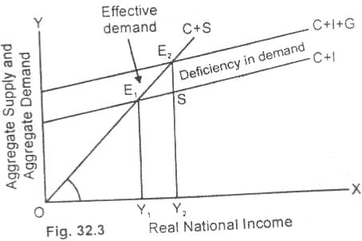

In figure (32.3), the aggregate demand curve (C+l), intersects the aggregate supply curve (OS) at point E¹which is an effective demand point. At point E¹, the equilibrium of national income is OY¹. Let us assume that in the generation of OY¹ level of income, some of the workers willing to work have not been absorbed. It means that E¹ (effective demand point) is an under employment equilibrium and OY¹ is under employment level of income.

The unemployed workers can be absorbed if the level of output can be increased from OY¹ to OY² which we assume is the full employment level. We further assume that due to spending by the government, the aggregate demand curve (C+I+G) rises. As a result of this, the economy moves from lower equilibrium point E¹ to higher equilibrium point E². The OY is now the new equilibrium level of income along with full employment. Thus E² denotes full employment equilibrium position of the economy.

Thus government spending can help to achieve full employment. In case the equilibrium level of national income is above the level of full employment, this means that the output has increased in money terms only. The value of the output is just the same to the national income at full employment level.

Importance of Effective Demand:

The principle of effective demand is the most important contribution of J.M. Keynes. Its importance in macro economics, in brief, is as under:

(i) Determinant of employment. Effective demand determines the level of employment in the country. As effective demand increases employment also increases. When effective demand falls, the level of employment also decreases.

(ii) Say's Law falsified. It is with the help of the principle of effective demand that Says Law of Market has been falsified. According to the concept of effective demand whatever is produced in the economy is not automatically consumed. It is partly saved. As a result, the existence of full employment is not possible.

(iii) Role of investment. The principle of effective demand explains that for achieving full employment level, real investment must equal to the gap between income and consumption. In other words, employment cannot expand, unless investment expands. Therein lies the importance of the concept of effective demand.

(iv) Capitalistic economy. The principle of effective demand makes clear that in a rich community, the gap between income and expenditure is large. If required investment is not made to fill this gap, it will lead to deficiency of effective demand resulting in unemployment.

Criticism on Keynesian Theory:

From mid 1970 onward, the Keynesian theory of employment came under sharp criticism from the monetarists. Milton Frsadman, the Chief advocate of monetarists rejected the Keynesianism as a whole. The monetarists returned back to the old classical theory for the explanation of the rise in general price level and stated that inflation is always and every where a monetary phenomenon.
The monetarists are of the view that J. M. Keynes laid more emphasis on the determinants of aggregate demand and to a greater extent ignored the determinants of aggregate supply. The monetarists encouraged the supply side policy and thus favored free enterprise economy for solving the problems of unemployment and inflation.

J. R. Hicks describes Keyne's 'General Theory' as depression economics. Further, the 'General Theory of Keynes is applicable to the developed economies. The Keynesians concepts are not very useful for policy purposes in less developed countries.

An Outline of the Keynesian Theory of Employment with Flow Chart
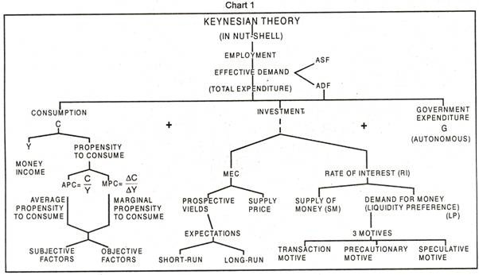
The gist of the Keynesian theory of employment may be laid down in the following propositions:
1. The national income is equal to the volume of total employment since total output equals total income, but depends upon the total employment.
2. Total volume of employment depends upon and originates from the level of effective demand in an economy.
3. Effective demand is composed of two elements (i) the aggregate demand function, and (ii) the aggregate supply function. Effective demand is determined at the equilibrium point of the aggregate demand function and the aggregate supply function.
4. Keynes, however, assumed aggregate supply function to be given in the short period and regarded aggregate demand function as the most significant element in his theory.
5. The aggregate demand function is composed of the consumption function and the investment function. In other words, the aggregate demand determining the rate of spending or the flow of expenditure in an economy consists of the consumption expenditure and the investment expenditure.
6. The consumption function or the consumption expenditure is determined by (i) the size of income and (ii) propensity of the people to consume. Keynes, however, regarded the consumption function to be a stable phenomenon in the short run.
7. The investment function or the inducement to invest, determining the volume of investment in an economy, depends on (i) the marginal efficiency of capital and (ii) the rate of interest. Keynes pointed out that unlike the consumption function the investment function is a highly unstable factor of the aggregate demand.
8. The marginal efficiency of capital is determined by (i) the prospective yields of capital assets, and (ii) the supply prices or the replacement costs of these assets.
Keynes considered marginal efficiency of capital to be a highly fluctuating phenomenon because expectations regarding prospective yields from capital assets are highly influenced by business psychology, business optimism or pessimism.
9. The rate of interest depends on (i) the liquidity preference function, and (ii) the quantity of money. The liquidity preference of the community is determined by three motives, (a) transactions motive, (b) precautionary motive, (c) speculative motive, whiles the supply of money or the quantity of money, is regulated by the monetary authority.
Keynes however, considered the rate of interact as a relatively stable phenomenon.
10. Keynes viewed that investment expenditure or rather the inducement to invest, the main determinant of the level of employment in an economy, depends on the difference between the marginal efficiency of capital and the rate of interest. The greater the difference, the more will be the inducement to invest and vice versa. Since the rate of interest is assumed to be relatively stable in the short run, it is the marginal efficiency of capital that assumes the place of pride. And the instability characteristics of the marginal efficiency of capital are the fundamental cause of the instability of the investment function.
11. The General Theory concludes that in order to increase the level of employment and income in an economy, it is essential to lift the effective demand and, for this, investment expenditure should be increased. Thus, investment and employment go together. And investment expenditure must be high enough to fill the gap which arises between income and consumption as the income increases. Any deficiency in the investment demand leads to unemployment to that extent. Thus, the crucial factor in Keynes’ employment income theory is investment.
12. Keynes’ theory of employment, in essence, contains the logic of an economics of less than full employment or “Depression economics.”

