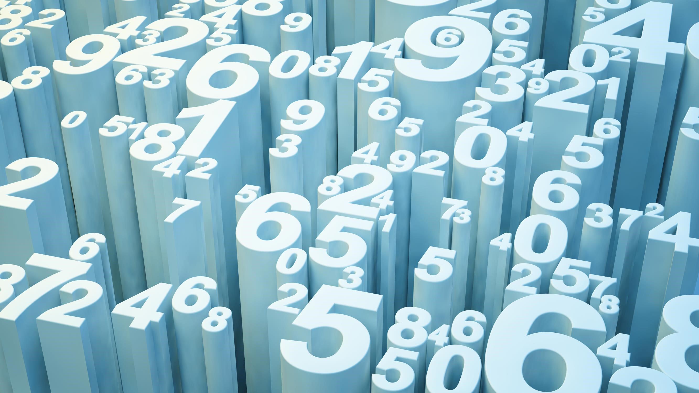











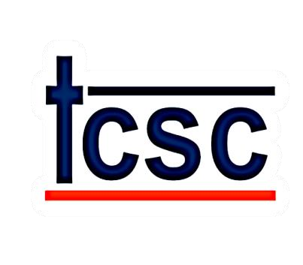
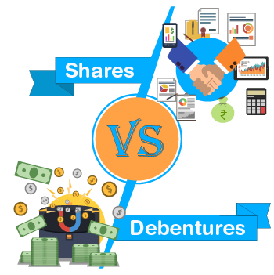
,



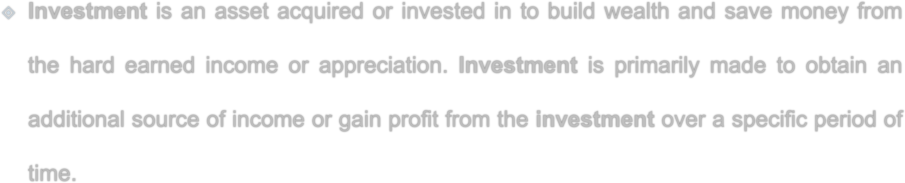
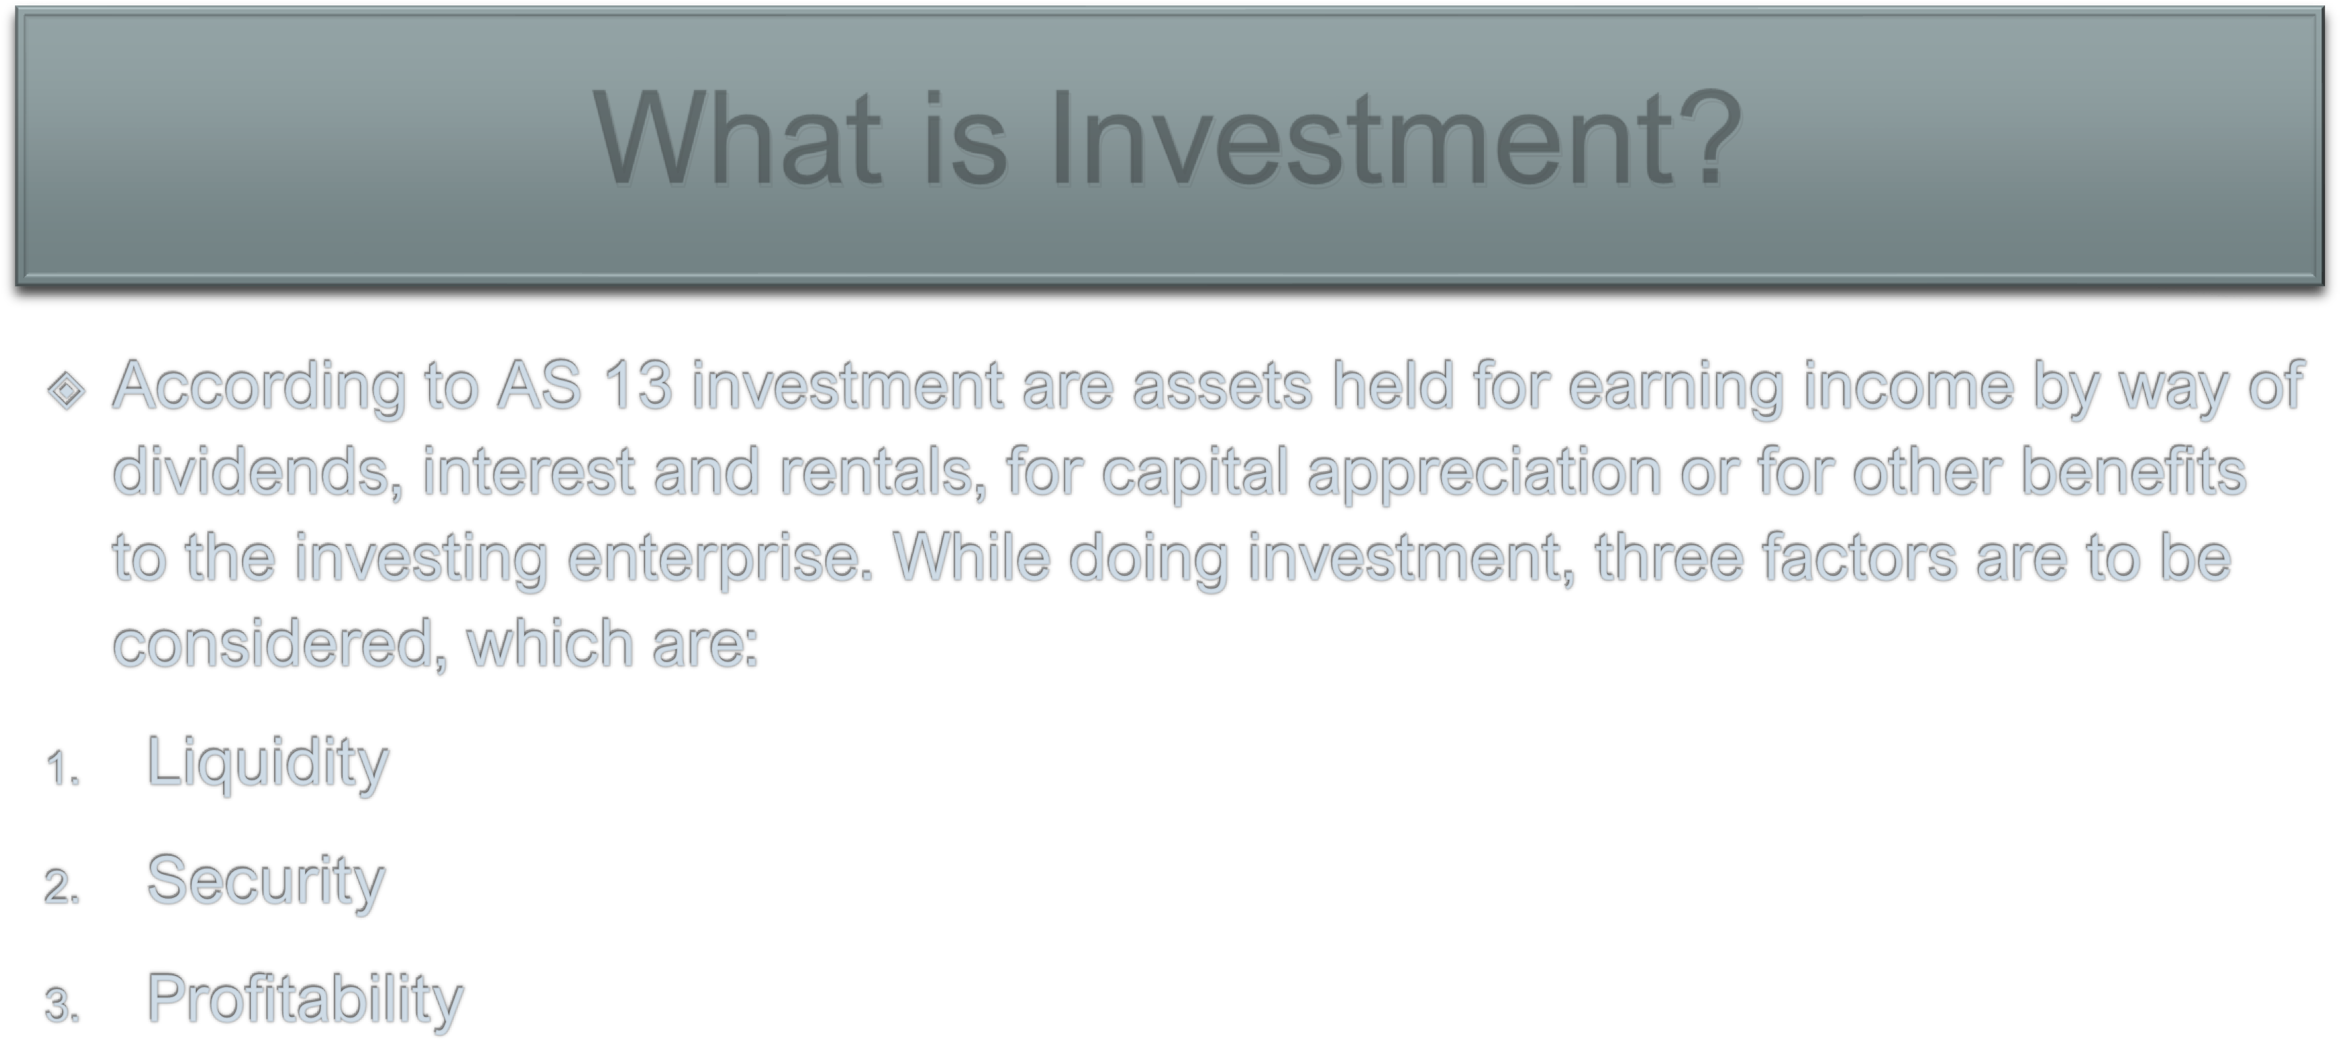

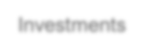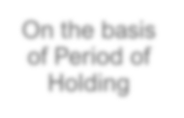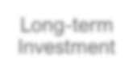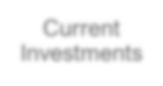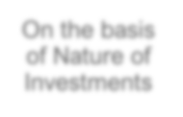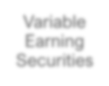
Investments
On the basis
of Period of
Holding
Long
-
term
Investment
Current
Investments
On the basis
of Nature of
Investments
Variable
Earning
Securities
Fixed
Earning
Securities

Bonds
Mutual
Funds
Shares
Debentures

Real
Estate
Gold
Saving /
Certificate
of Deposit
Government
Securities

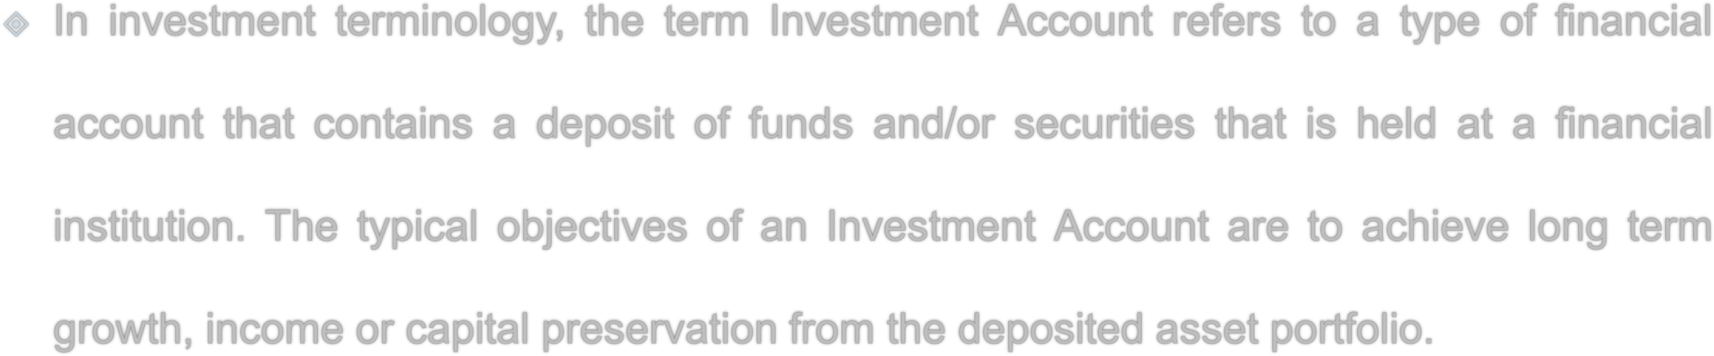
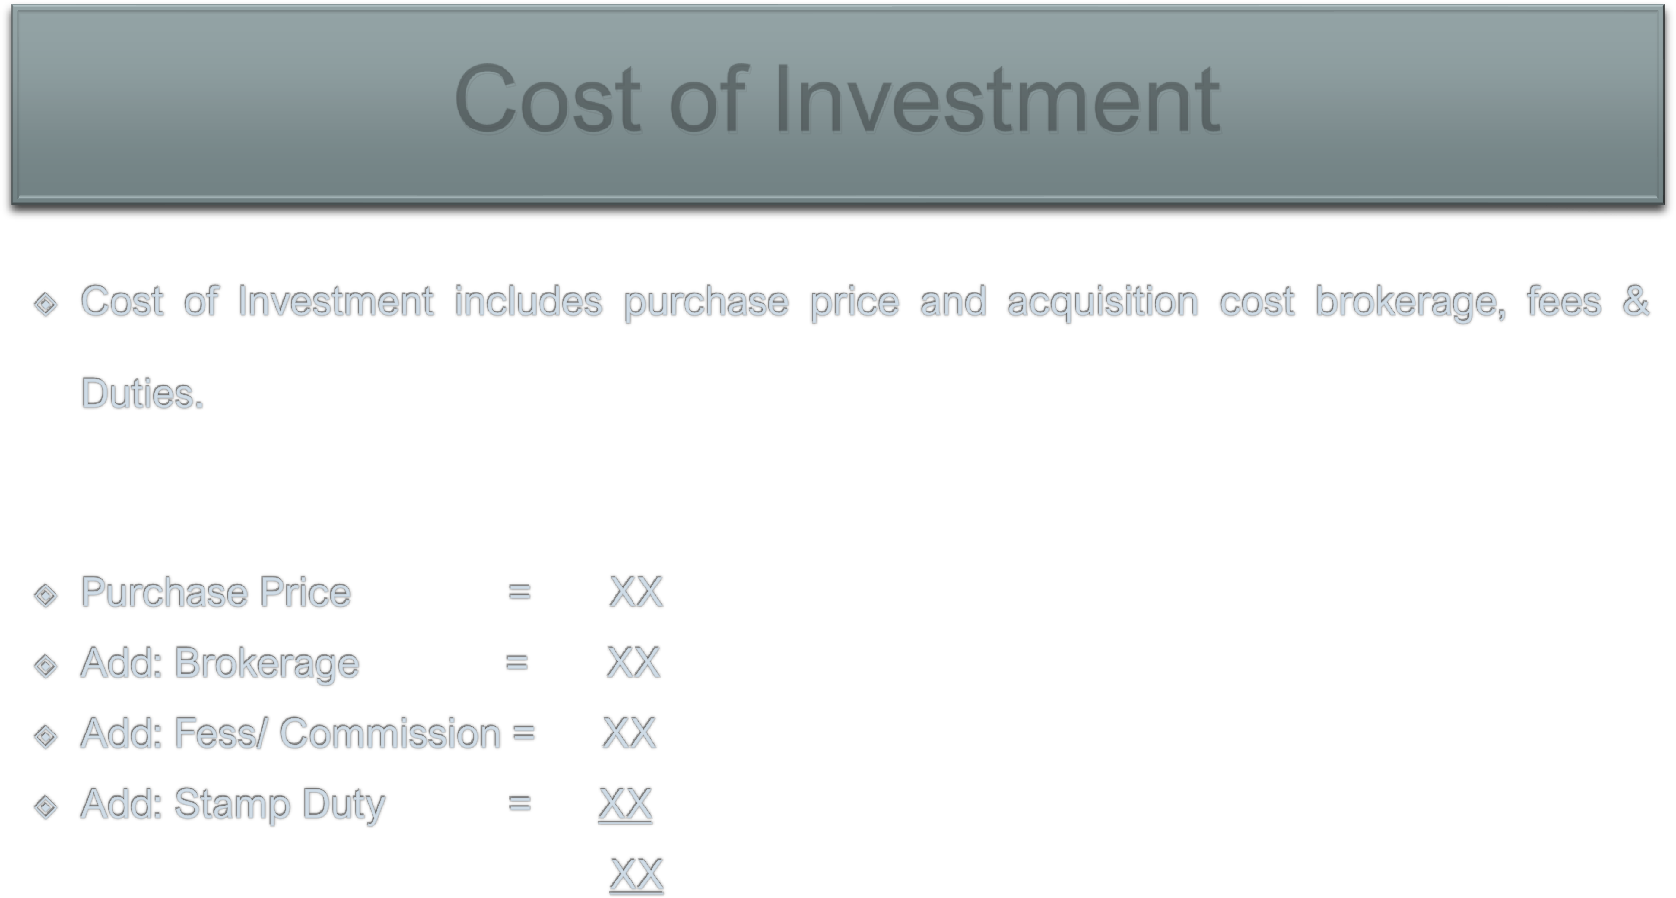
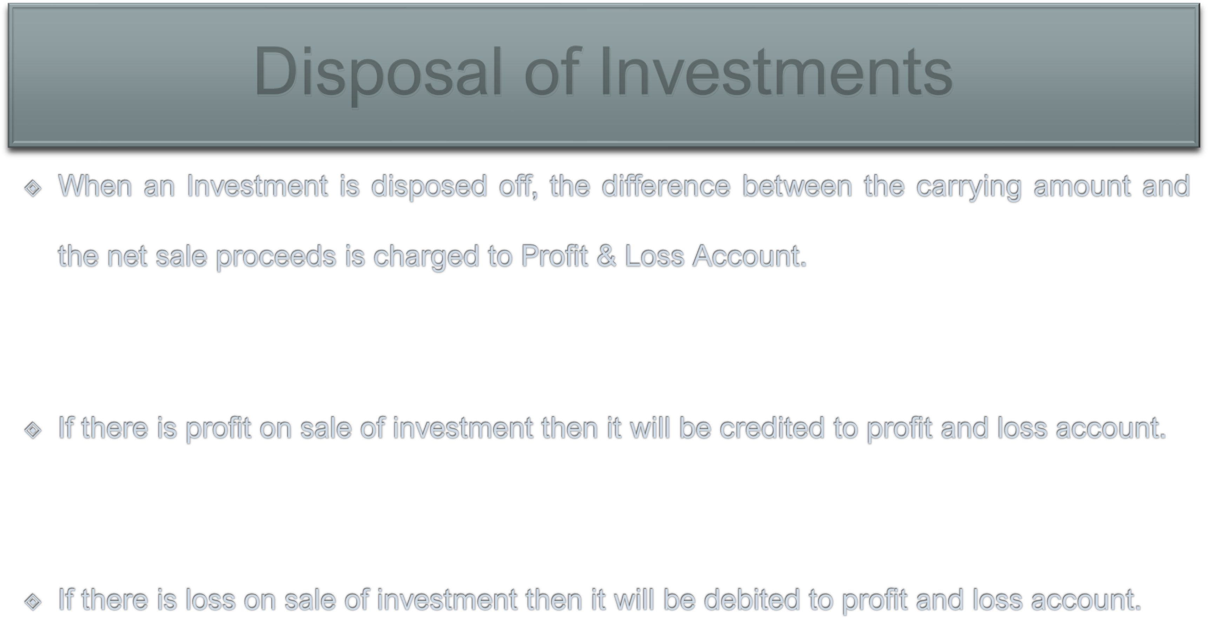
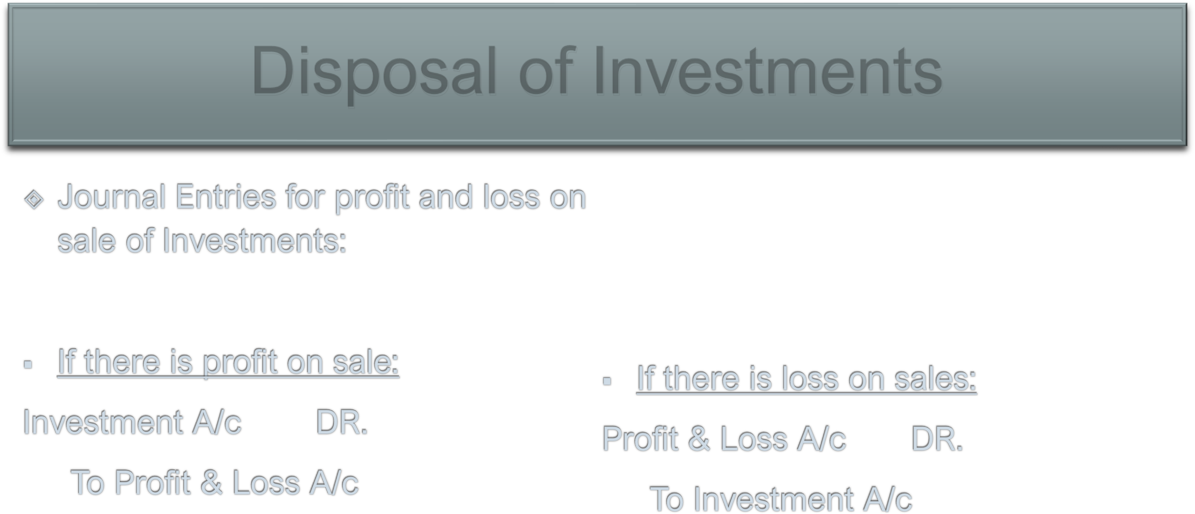
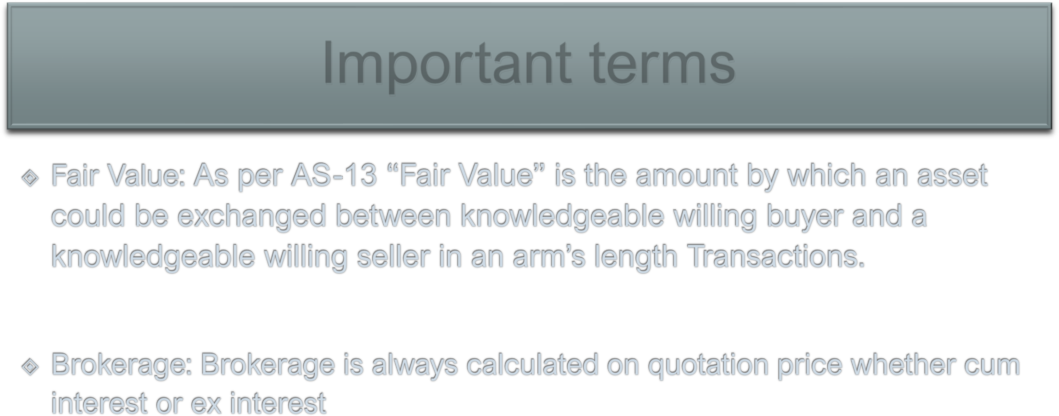
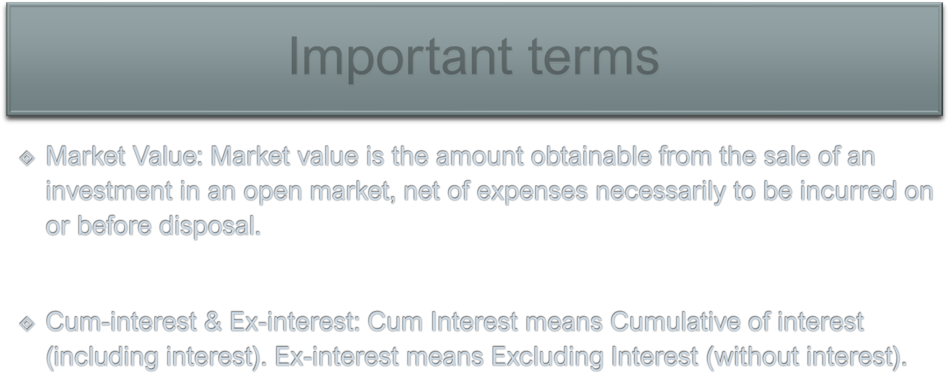



Transaction | Entries
1. Purchase (at Ex-Interest Price) | Investment A/c Dr. (cost = Price)  Interest A/c Dr. (Accrued Interest) To Bank (Price + Interest)
2. Purchase (at Cum-Interest Price) | Investment A/c Dr. (Cost= Price-interest)  Interest A/c Dr. (Accrued Interest)  To Bank A/c (Total price)
3. Sale (at Ex-Interest) | Bank A/c Dr. (Price + Interest)  To Investment A/c (Price)  To Interest (Interest)
4. Sale (at Cum-Interest) | Bank A/c Dr. (Price)  To Investment A/c (Price-Interest) To Interest A/c (Interest)
5. Profit on Sale | Investment A/c Dr. To Profit & Loss A/c

Transaction | Entries
6. Interest received on due date | Bank A/c Dr. To Interest
7. Accrued interest at year-end | Accrued Interest A/c Dr. To Interest
8. Interest transferred to P&L A/c at year end | Interest A/c Dr.  To P&L A/c
9. Valuation at year end | Profit & Loss A/c Dr. To Investment A/c
