CHAPTER 4

INTERNAL AUDIT



- Internal Audit is

A separate component of Internal Control
- Established to determine whether other Internal controls are

Well designed and Properly operated.

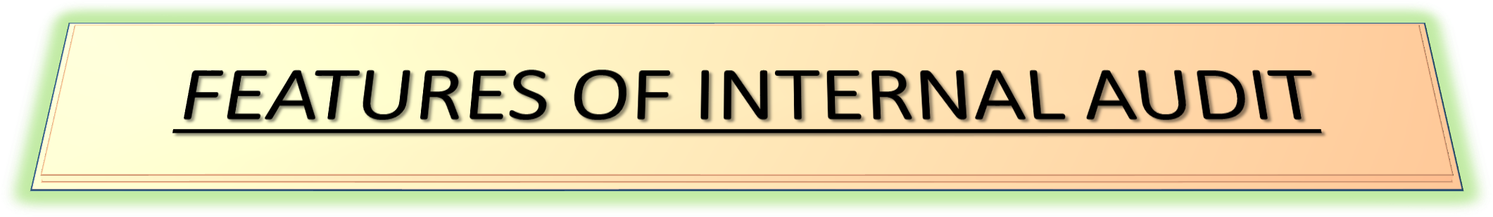

- Internal Auditing is normally done by the Employees of the concern.

It is a Part of the system of Internal Controls.
- It is a Critical review of other Internal Controls i.e. of -
- Accounting Controls and
- Operational Controls.
- The Review is done by Normal Auditing Techniques such as
Vouching, Verification etc.

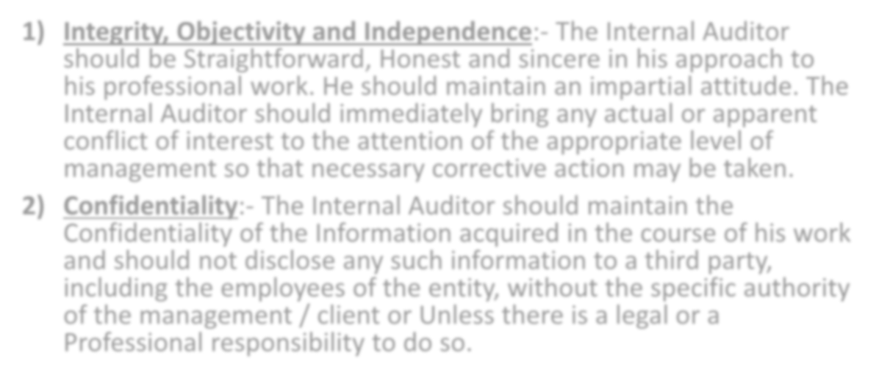

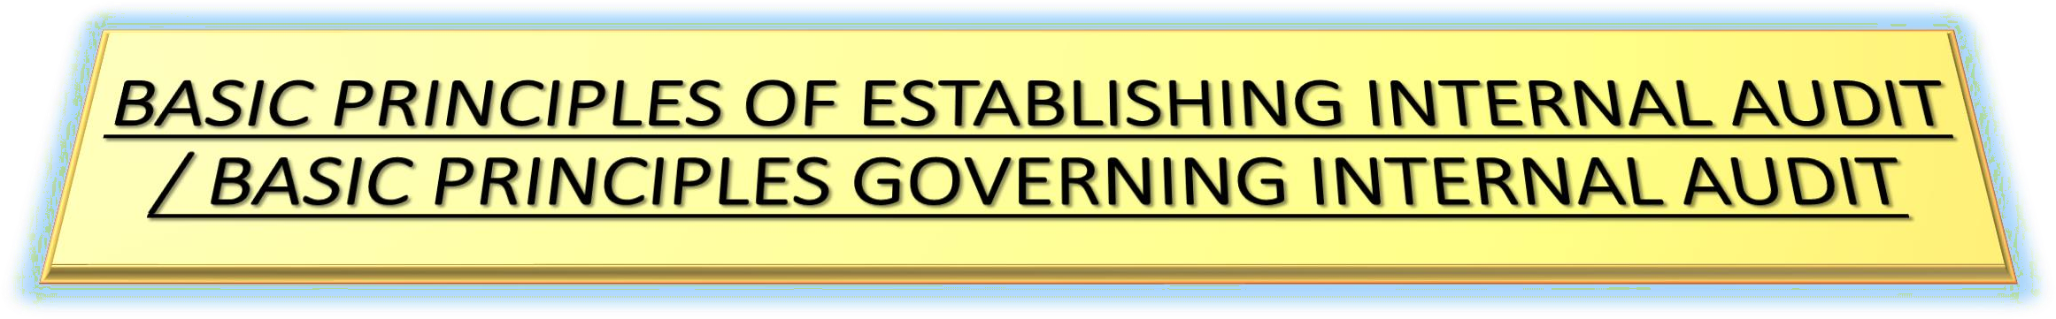
- Integrity, Objectivity and Independence:- The Internal Auditor should be Straightforward, Honest and sincere in his approach to his professional work. He should maintain an impartial attitude. The Internal Auditor should immediately bring any actual or apparent conflict of interest to the attention of the appropriate level of management so that necessary corrective action may be taken.
- Confidentiality:- The Internal Auditor should maintain the Confidentiality of the Information acquired in the course of his work and should not disclose any such information to a third party, including the employees of the entity, without the specific authority of the management / client or Unless there is a legal or a Professional responsibility to do so.

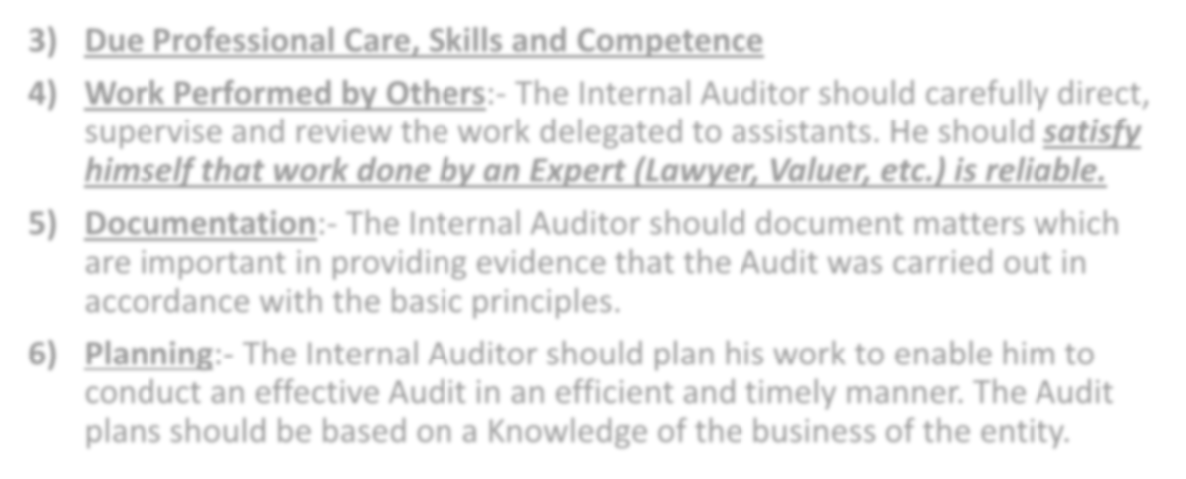

- Due Professional Care, Skills and Competence
- Work Performed by Others:- The Internal Auditor should carefully direct, supervise and review the work delegated to assistants. He should satisfy himself that work done by an Expert (Lawyer, Valuer, etc.) is reliable.
- Documentation:- The Internal Auditor should document matters which are important in providing evidence that the Audit was carried out in accordance with the basic principles.
- Planning:- The Internal Auditor should plan his work to enable him to conduct an effective Audit in an efficient and timely manner. The Audit plans should be based on a Knowledge of the business of the entity.

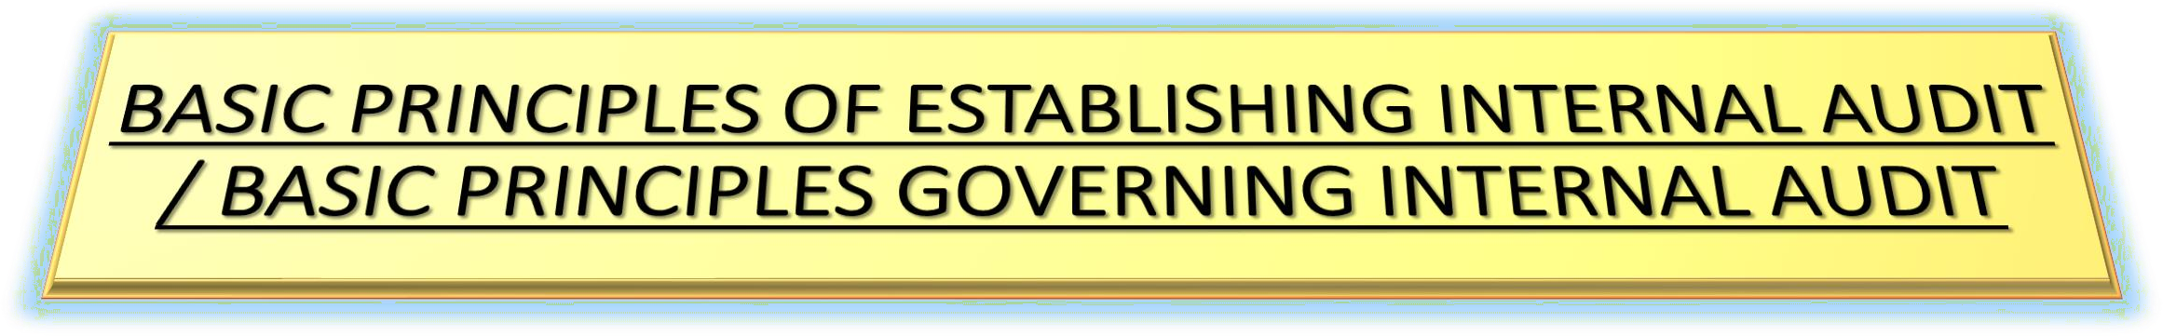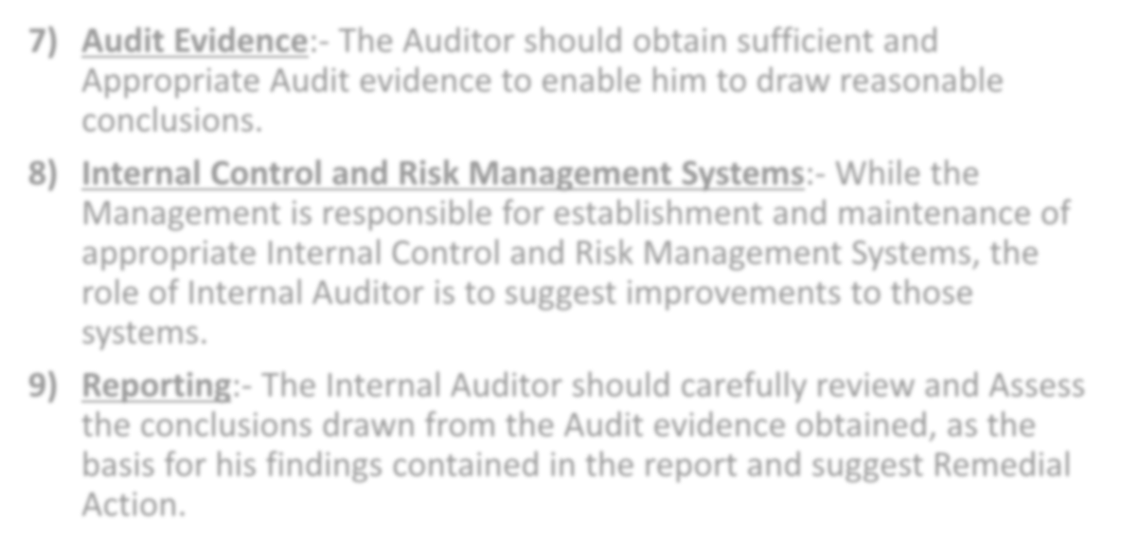

- Audit Evidence:- The Auditor should obtain sufficient and Appropriate Audit evidence to enable him to draw reasonable conclusions.
- Internal Control and Risk Management Systems:- While the Management is responsible for establishment and maintenance of appropriate Internal Control and Risk Management Systems, the role of Internal Auditor is to suggest improvements to those systems.
- Reporting:- The Internal Auditor should carefully review and Assess the conclusions drawn from the Audit evidence obtained, as the basis for his findings contained in the report and suggest Remedial Action.

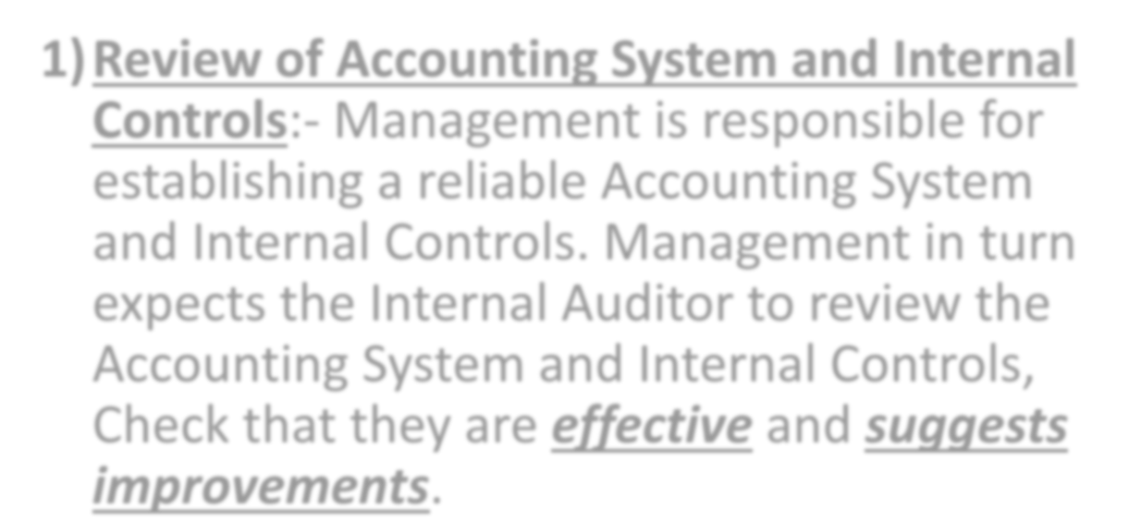

- Review of Accounting System and Internal Controls:- Management is responsible for establishing a reliable Accounting System and Internal Controls. Management in turn expects the Internal Auditor to review the Accounting System and Internal Controls, Check that they are effective and suggests improvements.

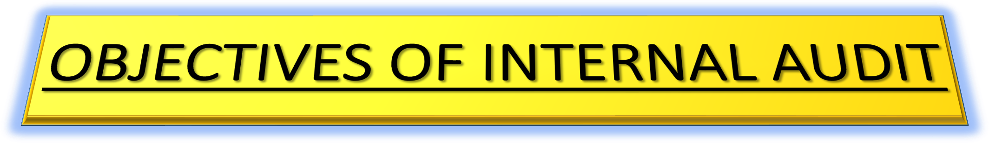

- Examination of Accounting Controls:- Internal Auditor has to review the Operations of Accounting Controls to see that:-
- All transactions are Duly Authorized.
- All transactions are Properly Recorded.
- All transactions are recorded Promptly as soon as they occur.
- The Accounting Policies adopted by the management in respect of Stock Valuation, Depreciation etc. are Implemented.
- The Assets of the Concern are Safeguarded, the Assets are not used or Sold without proper Authorization and are verified regularly.
- Errors and Frauds are Prevented and Detected.
- The Books of Accounts are Complete and Accurate.
- The Final Accounts are Reliable and Ready in time.

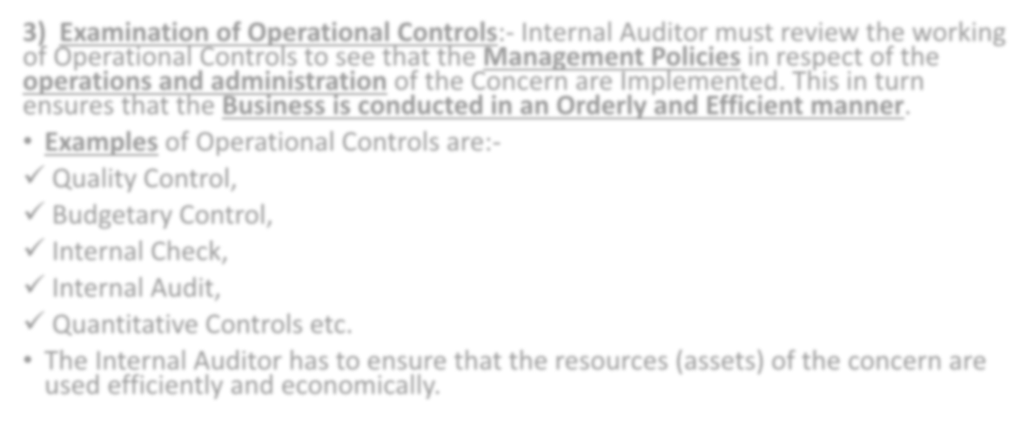

- Examination of Operational Controls:- Internal Auditor must review the working of Operational Controls to see that the Management Policies in respect of the operations and administration of the Concern are Implemented. This in turn ensures that the Business is conducted in an Orderly and Efficient manner.
- Examples of Operational Controls are:-
- Quality Control,
- Budgetary Control,
- Internal Check,
- Internal Audit,
- Quantitative Controls etc.
- The Internal Auditor has to ensure that the resources (assets) of the concern are used efficiently and economically.

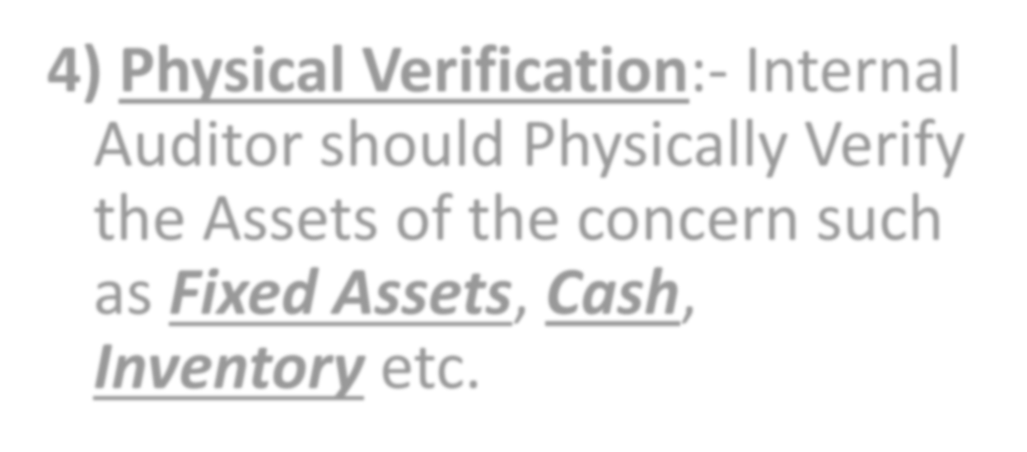

- Physical Verification:- Internal
Auditor should Physically Verify the Assets of the concern such as Fixed Assets, Cash, Inventory etc.

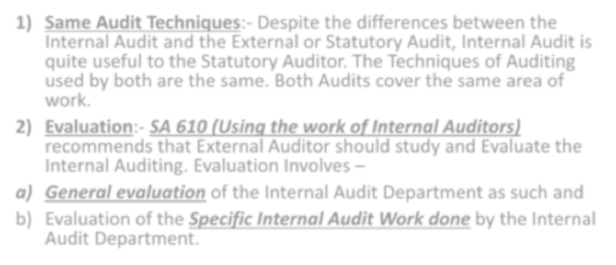


- Same Audit Techniques:- Despite the differences between the Internal Audit and the External or Statutory Audit, Internal Audit is quite useful to the Statutory Auditor. The Techniques of Auditing used by both are the same. Both Audits cover the same area of work.
- Evaluation:- SA 610 (Using the work of Internal Auditors) recommends that External Auditor should study and Evaluate the Internal Auditing. Evaluation Involves –
  - General evaluation of the Internal Audit Department as such and
  - Evaluation of the Specific Internal Audit Work done by the Internal Audit Department.

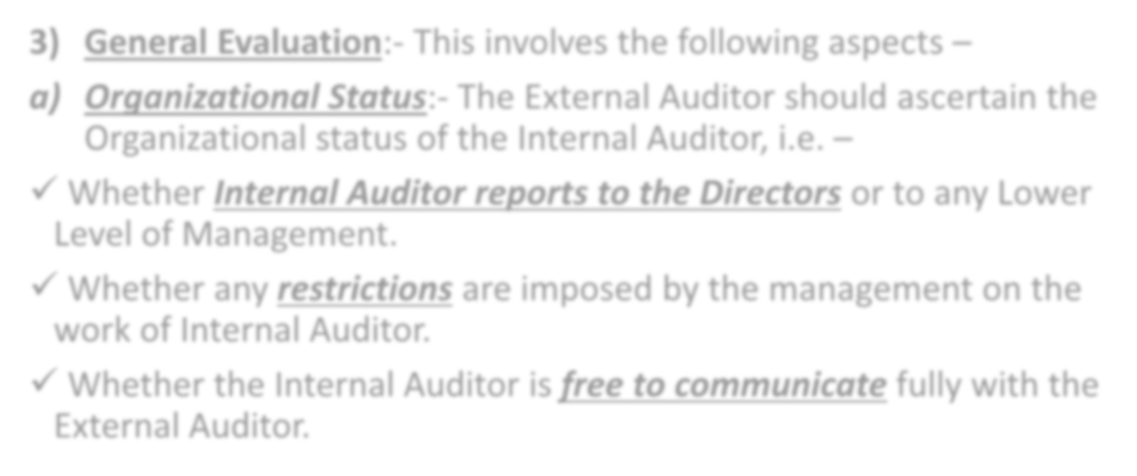

- General Evaluation:- This involves the following aspects –
  - Organizational Status:- The External Auditor should ascertain the Organizational status of the Internal Auditor, i.e. –
- Whether Internal Auditor reports to the Directors or to any Lower Level of Management.
- Whether any restrictions are imposed by the management on the work of Internal Auditor.
- Whether the Internal Auditor is free to communicate fully with the External Auditor.



  - Scope of Work and Follow-up :- The External Auditor should ascertain the scope of work given to the Internal Auditor. He should find out to what extent the management accepts and acts on the reports and recommendations of the Internal Auditor.
  - Qualified Staff:- The External Auditor should ascertain whether the
Internal Audit Staff is competent i.e. Qualified and Experienced.
- Evaluation of Specific Internal Audit Work:- The External Auditor should study the Copies of all Internal Audit reports. He should carefully study the reports to –
- Check the Scope of Work and the Internal Audit Programme.
- Check that work was planned, supervised and reviewed properly.
- check that Sufficient Evidence was obtained.



- Co-ordination:- The External Auditor and the Internal Auditor should work in a coordinated manner. They should regularly meet during the year. The Internal Audit work should be planned in consultation with the external Auditor.
- Reliability and Sample Checking:- Such evaluation helps the External Auditor to judge the reliability of Internal Audit Work. It helps him to decide the extent of sample checking to be done in statutory audit. It helps him to decide what to check, when and how much.
- Responsibility:- The Statutory Auditor is entirely responsible for his Audit work. His responsibility is in no way reduced because he has relied upon the Internal Audit.
- Statutory Requirements:- Statutory Auditor has to report under the Companies Act (CARO 2016). In case of specified companies, whether the Company has an Internal Audit system commensurate with its size and nature of business.



- Use for Management:- According to Standard on Internal Audit (SIA) 1 (Planning an Internal Audit) by the ICAI, Internal Audit helps the management in the following ways –
  - Understand and Assess the risks and the Internal Controls.
  - Identifying areas for systems improvement and strengthening Controls.
  - Ensuring optimum utilization of the resources of the entity, for example, human resources, physical resources, etc.
  - Ensuring Proper and timely Identification of Liabilities, including Contingent Liabilities of the entity.
  - Ensuring Compliance with Internal and External guidelines and policies of the entity as well as the applicable Statutory and Regulatory Requirements.
  - Safeguarding the Assets of the entity.
  - Reviewing and ensuring Adequacy, Relevance, Reliability and Timeliness of
Management Information System.



- Use for Statutory Auditor:- While the External Auditor has Sole Responsibility for his report, much of the work of the Internal Audit function may be useful to him in his examination of the Financial Information. Much of the work of the Internal Auditor may be useful to the External Auditor in determining the nature, timing and extent of his procedures.




- Compulsory Internal Audit:- As per section 138 of the Companies Act, 2013, Following class of companies [prescribed in Rule 13 of Companies (Accounts) Rules, 2014] shall be required to Appoint an Internal Auditor or a Firm of Internal Auditors –
  - Every Listed Company;
  - Every Unlisted Public Company Having –
    - Outstanding Deposits of ₹ 25 Crores or more at any point of time during the preceding financial year; OR
    - Paid up Share Capital of ₹ 50 Crores or more during the preceding financial year; OR
    - Outstanding Loans or Borrowings from Banks or Public Financial Institutions Exceeding ₹ 100 Crores or more at any point of time during the preceding financial year; OR
    - Turnover of ₹ 200 Crores or more during the preceding financial year.

  - Every Private Company Having –
    - Outstanding Loans or Borrowings from Banks or Public Financial Institutions Exceeding ₹ 100 Crores or more at any point of time during the preceding financial year; OR
    - Turnover of ₹ 200 Crores or more during the preceding financial year.

It is Provided that an existing company covered under any of the above criteria (a, b, c) shall Comply with the requirements within 6 months (to Appoint Internal Auditor) of commencement of such section.



- Who Can be Appointed as Internal Auditor:- As per section 138, the Internal Auditor Shall either be a –
- Chartered Accountant (CA),
- Cost Accountant (CWA),
- Other Professional as may be decided by the Board to conduct Internal Audit of the functions and activities of the Companies.
The Internal Auditor may or may not be an Employee of the Company.

