CHAPTER 3

AUDITING TECHNIQUES AND READING OF A LEDGER ACCOUNT

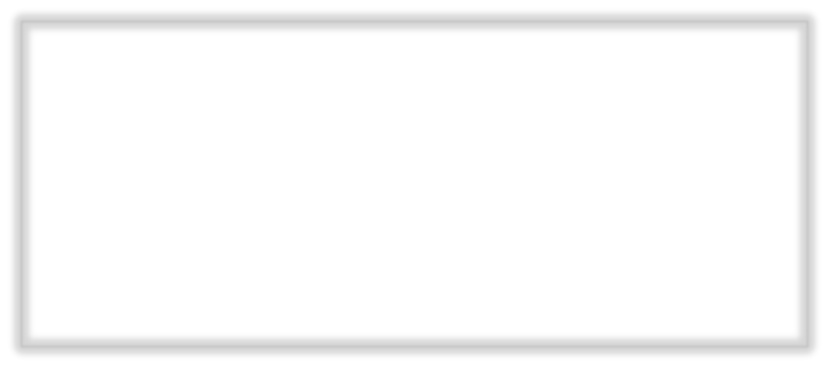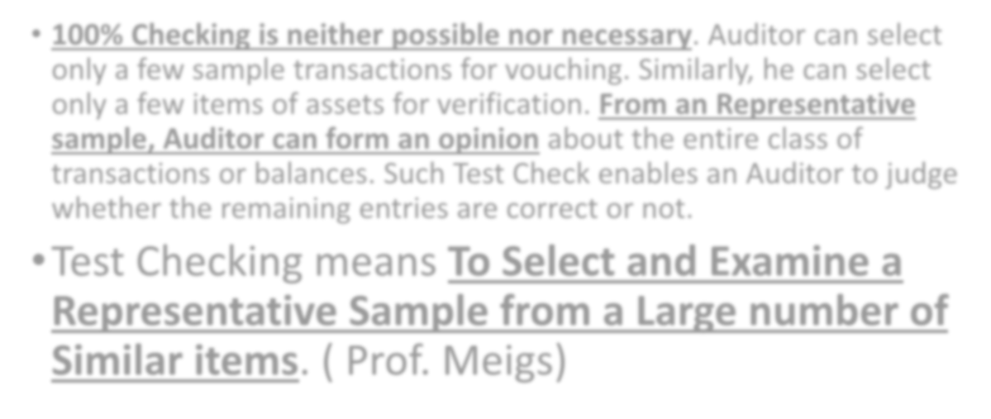

- 100% Checking is neither possible nor necessary. Auditor can select only a few sample transactions for vouching. Similarly, he can select only a few items of assets for verification. From an Representative sample, Auditor can form an opinion about the entire class of transactions or balances. Such Test Check enables an Auditor to judge whether the remaining entries are correct or not.
- Test Checking means To Select and Examine a Representative Sample from a Large number of Similar items. ( Prof. Meigs)

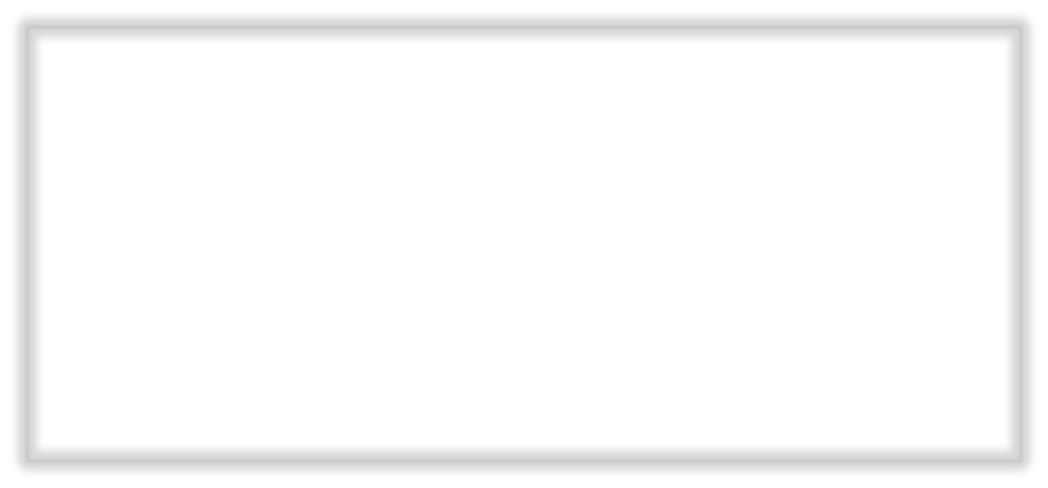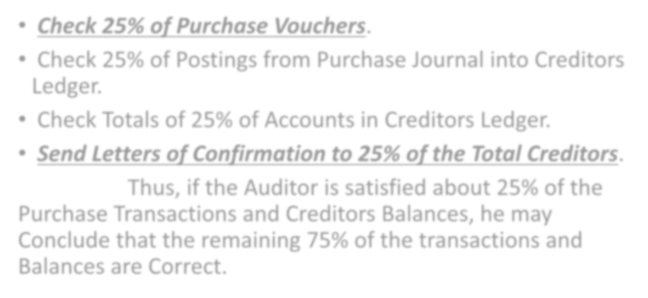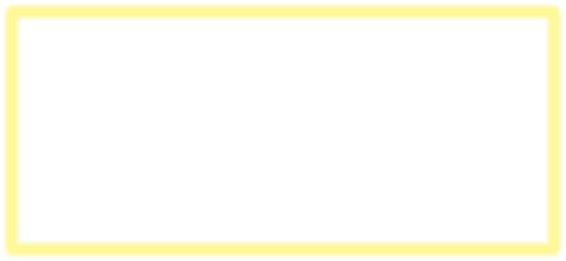

- Check 25% of Purchase Vouchers.
- Check 25% of Postings from Purchase Journal into Creditors Ledger.
- Check Totals of 25% of Accounts in Creditors Ledger.
- Send Letters of Confirmation to 25% of the Total Creditors. Thus, if the Auditor is satisfied about 25% of the
Purchase Transactions and Creditors Balances, he may
Conclude that the remaining 75% of the transactions and Balances are Correct.

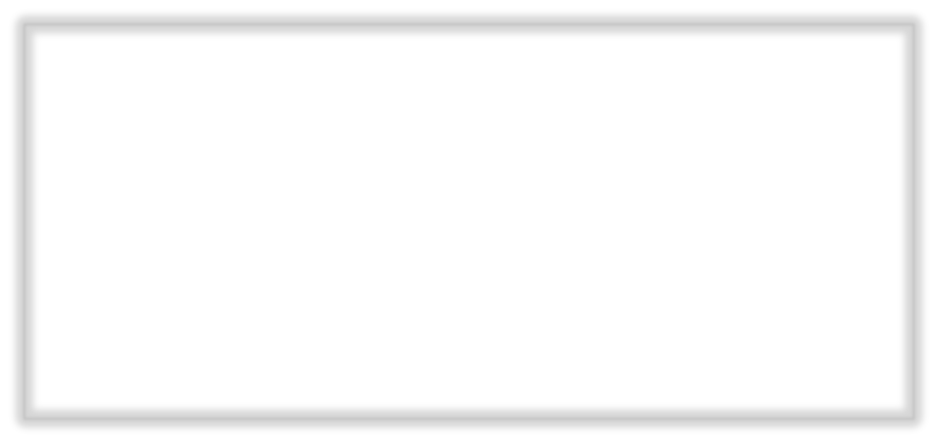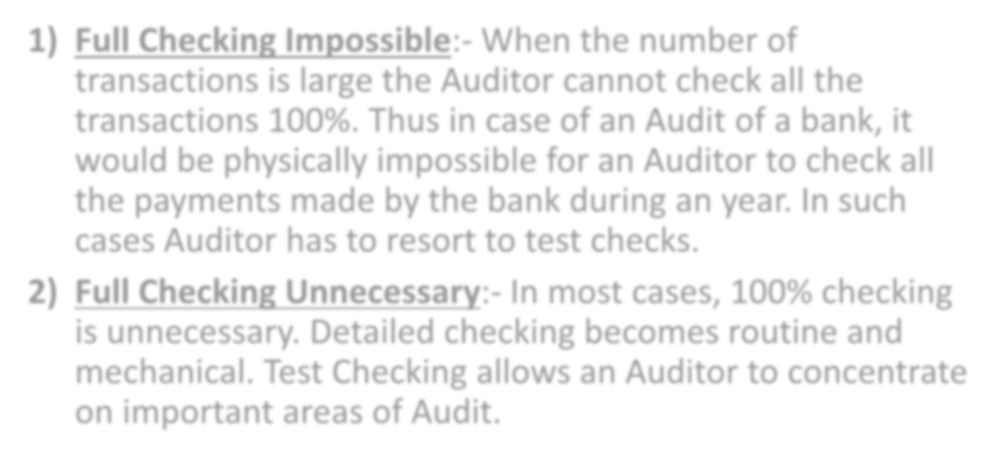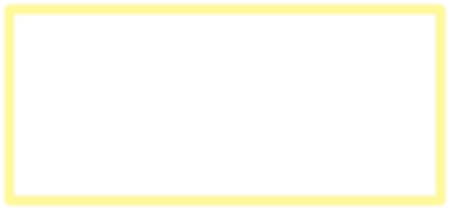

- Full Checking Impossible:- When the number of transactions is large the Auditor cannot check all the transactions 100%. Thus in case of an Audit of a bank, it would be physically impossible for an Auditor to check all the payments made by the bank during an year. In such cases Auditor has to resort to test checks.
- Full Checking Unnecessary:- In most cases, 100% checking is unnecessary. Detailed checking becomes routine and mechanical. Test Checking allows an Auditor to concentrate on important areas of Audit.

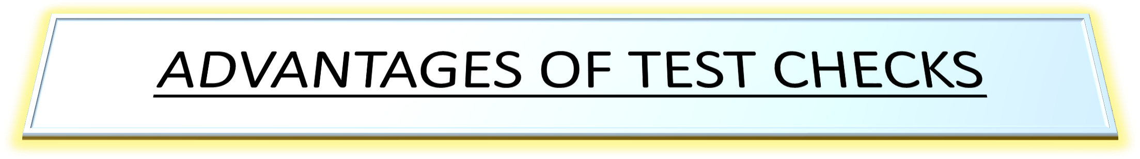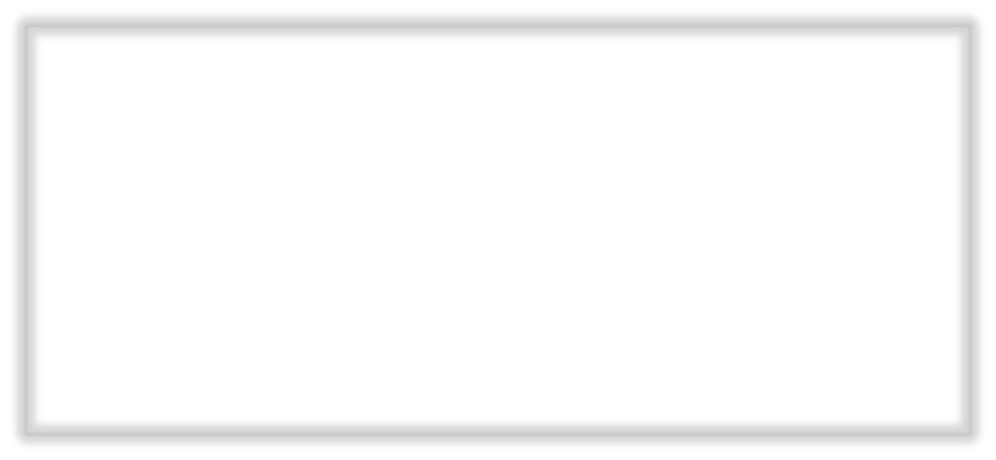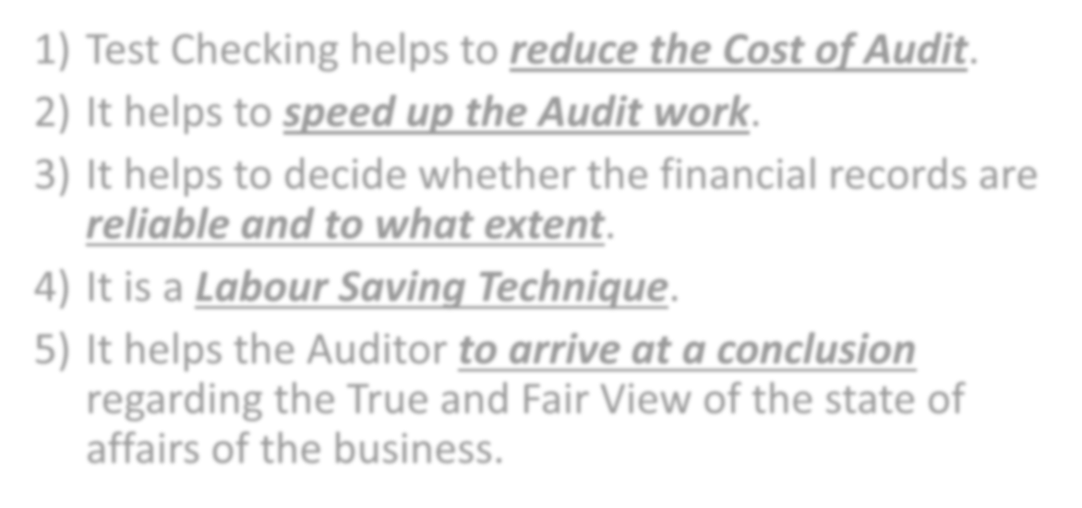

- Test Checking helps to reduce the Cost of Audit.
- It helps to speed up the Audit work.
- It helps to decide whether the financial records are

reliable and to what extent.
- It is a Labour Saving Technique.
- It helps the Auditor to arrive at a conclusion regarding the True and Fair View of the state of affairs of the business.

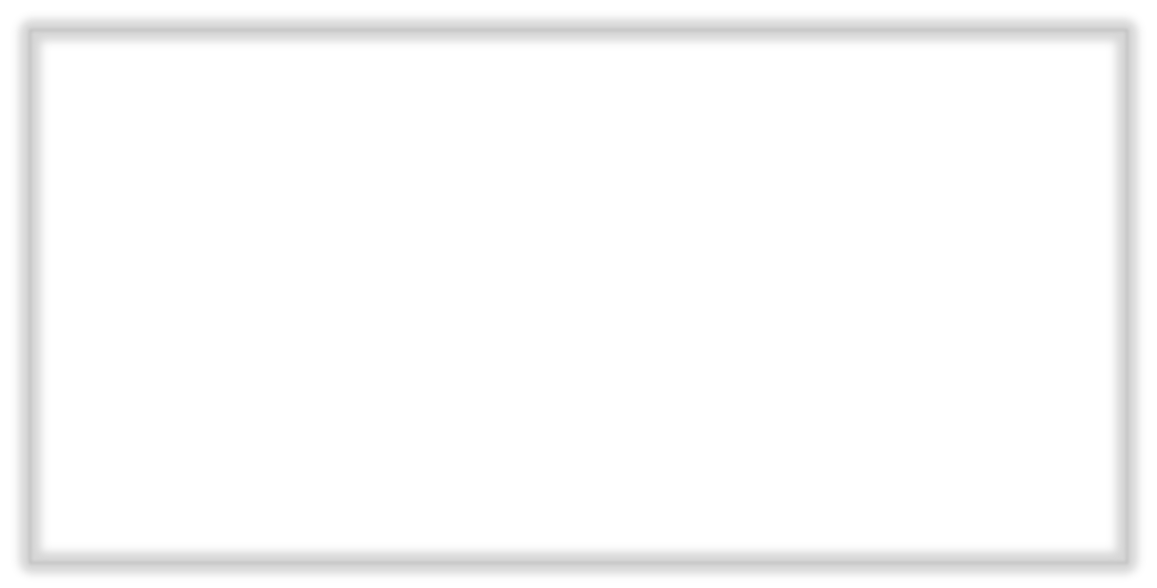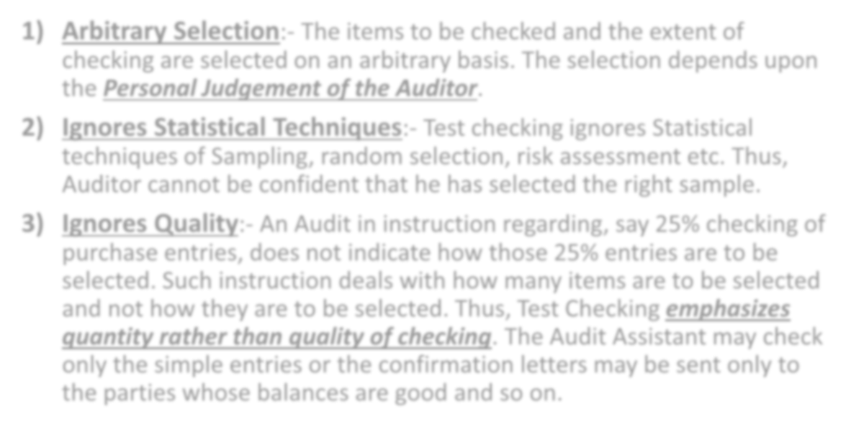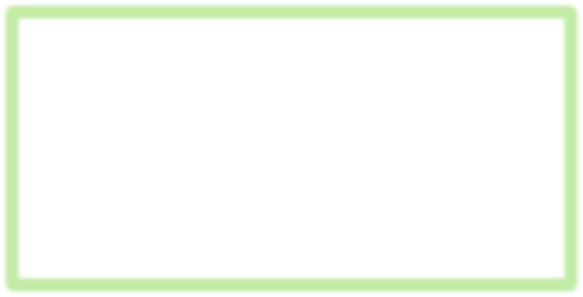

- Arbitrary Selection:- The items to be checked and the extent of checking are selected on an arbitrary basis. The selection depends upon the Personal Judgement of the Auditor.
- Ignores Statistical Techniques:- Test checking ignores Statistical techniques of Sampling, random selection, risk assessment etc. Thus, Auditor cannot be confident that he has selected the right sample.
- Ignores Quality:- An Audit in instruction regarding, say 25% checking of purchase entries, does not indicate how those 25% entries are to be selected. Such instruction deals with how many items are to be selected and not how they are to be selected. Thus, Test Checking emphasizes quantity rather than quality of checking. The Audit Assistant may check only the simple entries or the confirmation letters may be sent only to the parties whose balances are good and so on.

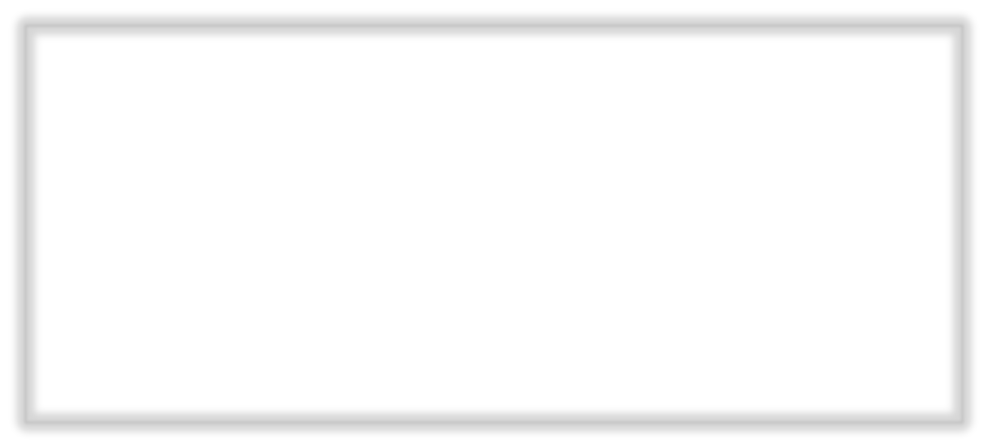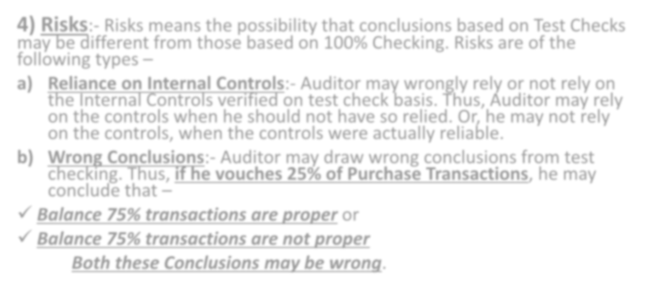

- Risks:- Risks means the possibility that conclusions based on Test Checks may be different from those based on 100% Checking. Risks are of the following types –
- Reliance on Internal Controls:- Auditor may wrongly rely or not rely on the Internal Controls verified on test check basis. Thus, Auditor may rely on the controls when he should not have so relied. Or, he may not rely on the controls, when the controls were actually reliable.
- Wrong Conclusions:- Auditor may draw wrong conclusions from test checking. Thus, if he vouches 25% of Purchase Transactions, he may conclude that –
- Balance 75% transactions are proper or
- Balance 75% transactions are not proper Both these Conclusions may be wrong.

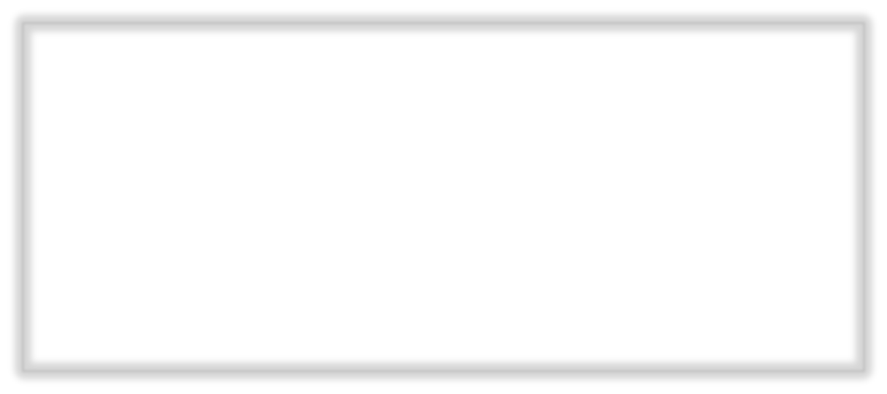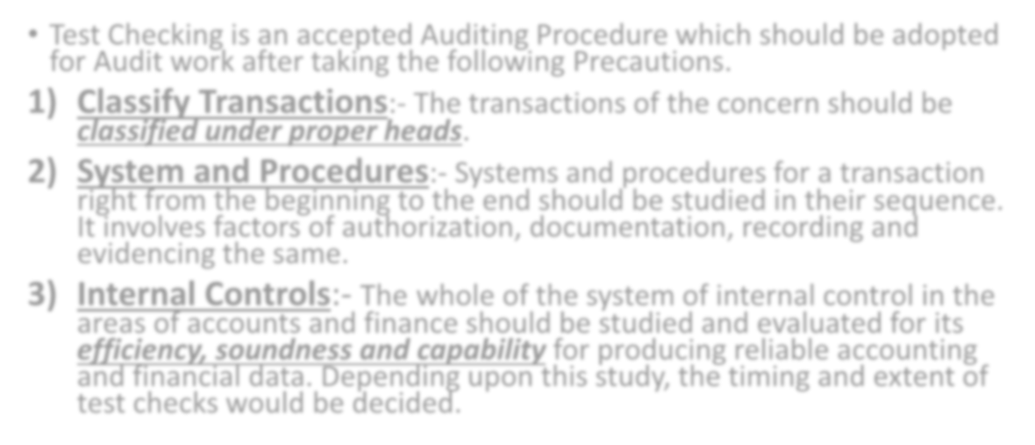

- Test Checking is an accepted Auditing Procedure which should be adopted for Audit work after taking the following Precautions.
  - Classify Transactions:- The transactions of the concern should be
classified under proper heads.
  - System and Procedures:- Systems and procedures for a transaction right from the beginning to the end should be studied in their sequence. It involves factors of authorization, documentation, recording and evidencing the same.
  - Internal Controls:- The whole of the system of internal control in the areas of accounts and finance should be studied and evaluated for its efficiency, soundness and capability for producing reliable accounting and financial data. Depending upon this study, the timing and extent of test checks would be decided.

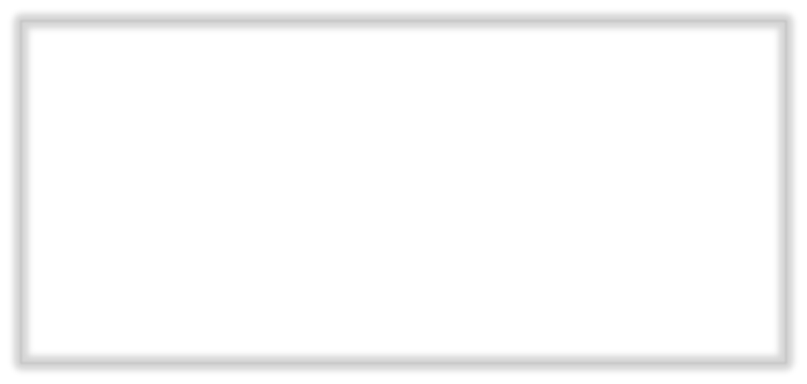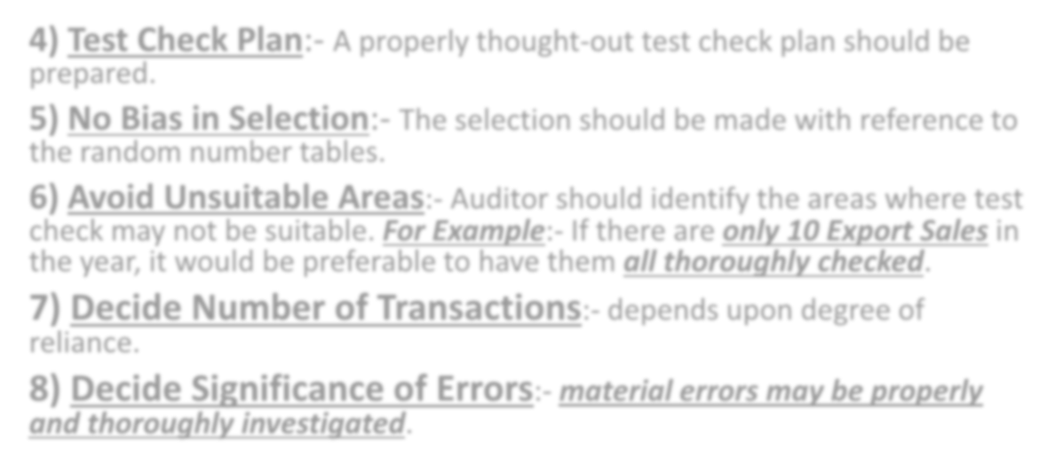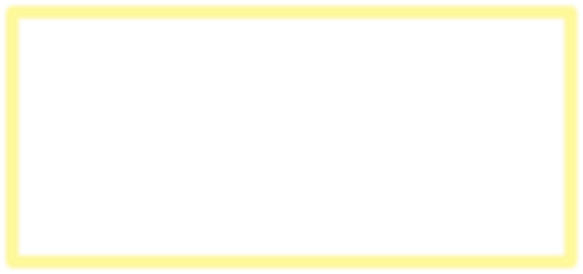

  - Test Check Plan:- A properly thought-out test check plan should be prepared.
  - No Bias in Selection:- The selection should be made with reference to the random number tables.
  - Avoid Unsuitable Areas:- Auditor should identify the areas where test check may not be suitable. For Example:- If there are only 10 Export Sales in the year, it would be preferable to have them all thoroughly checked.
  - Decide Number of Transactions:- depends upon degree of reliance.
  - Decide Significance of Errors:- material errors may be properly and thoroughly investigated.

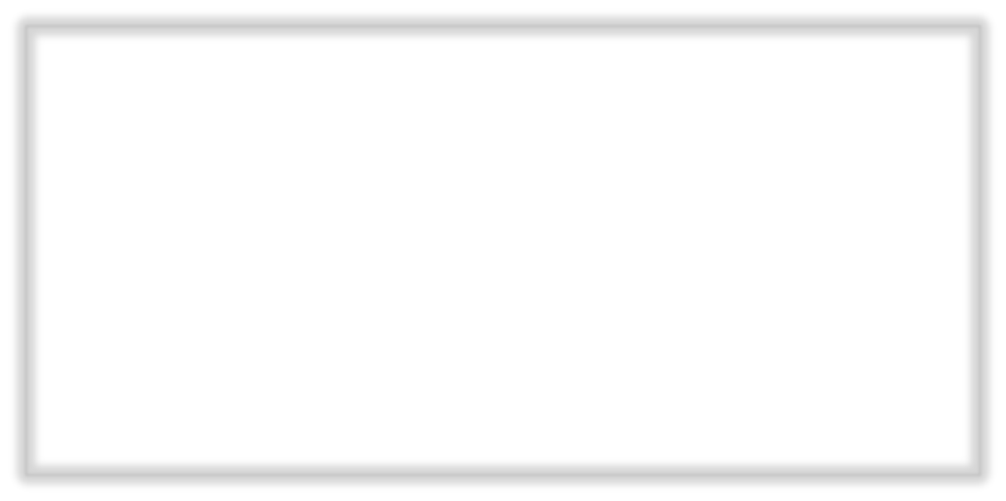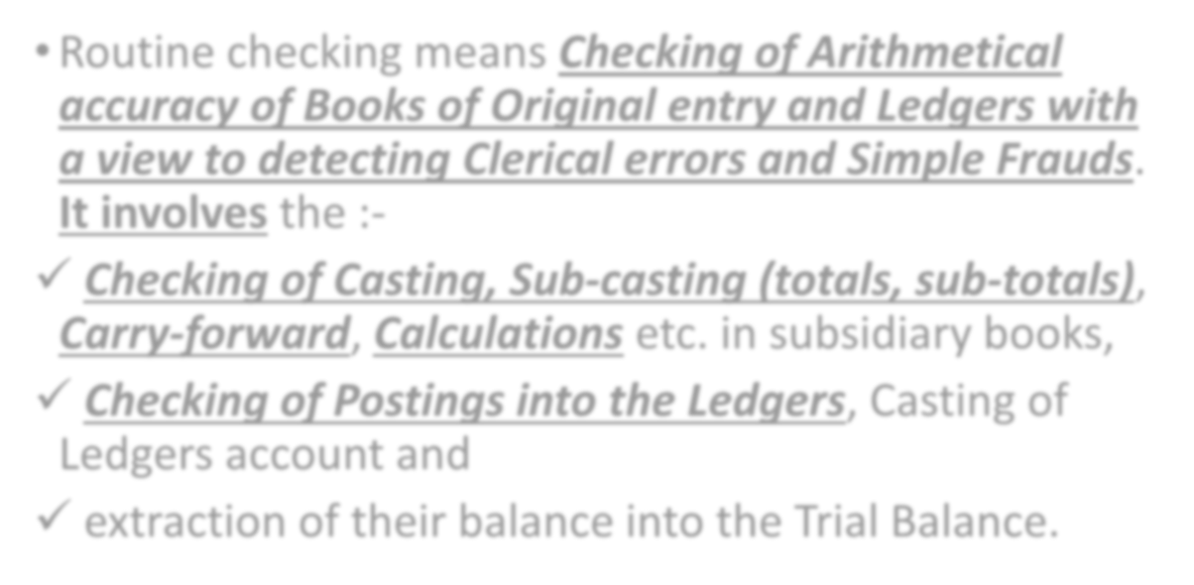

- Routine checking means Checking of Arithmetical accuracy of Books of Original entry and Ledgers with a view to detecting Clerical errors and Simple Frauds. It involves the :-
- Checking of Casting, Sub-casting (totals, sub-totals), Carry-forward, Calculations etc. in subsidiary books,
- Checking of Postings into the Ledgers, Casting of Ledgers account and
- extraction of their balance into the Trial Balance.

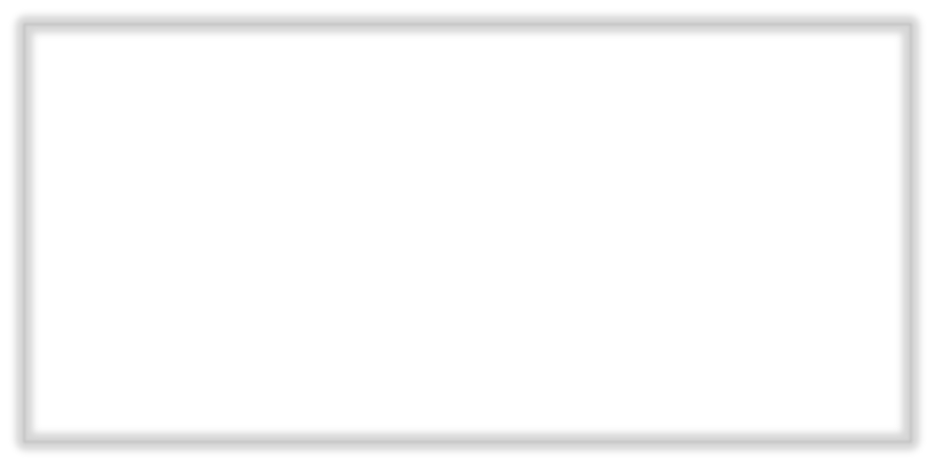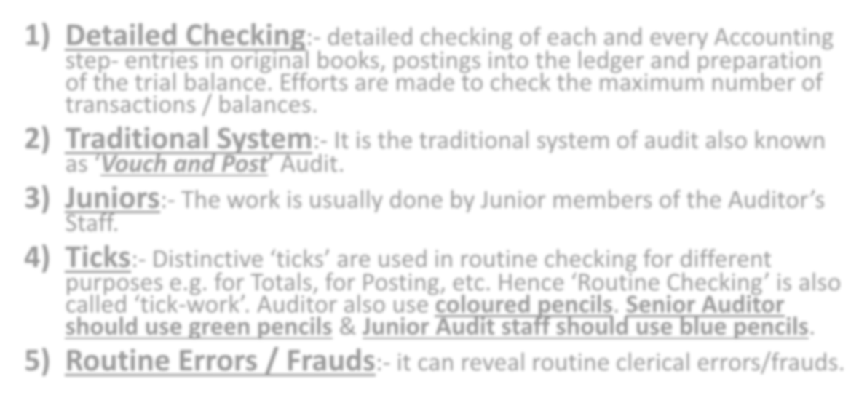

- Detailed Checking:- detailed checking of each and every Accounting step- entries in original books, postings into the ledger and preparation of the trial balance. Efforts are made to check the maximum number of transactions / balances.
- Traditional System:- It is the traditional system of audit also known
as ‘Vouch and Post’ Audit.
- Juniors:- The work is usually done by Junior members of the Auditor’s
Staff.
- Ticks:- Distinctive ‘ticks’ are used in routine checking for different purposes e.g. for Totals, for Posting, etc. Hence ‘Routine Checking’ is also called ‘tick-work’. Auditor also use coloured pencils. Senior Auditor should use green pencils & Junior Audit staff should use blue pencils.
- Routine Errors / Frauds:- it can reveal routine clerical errors/frauds.

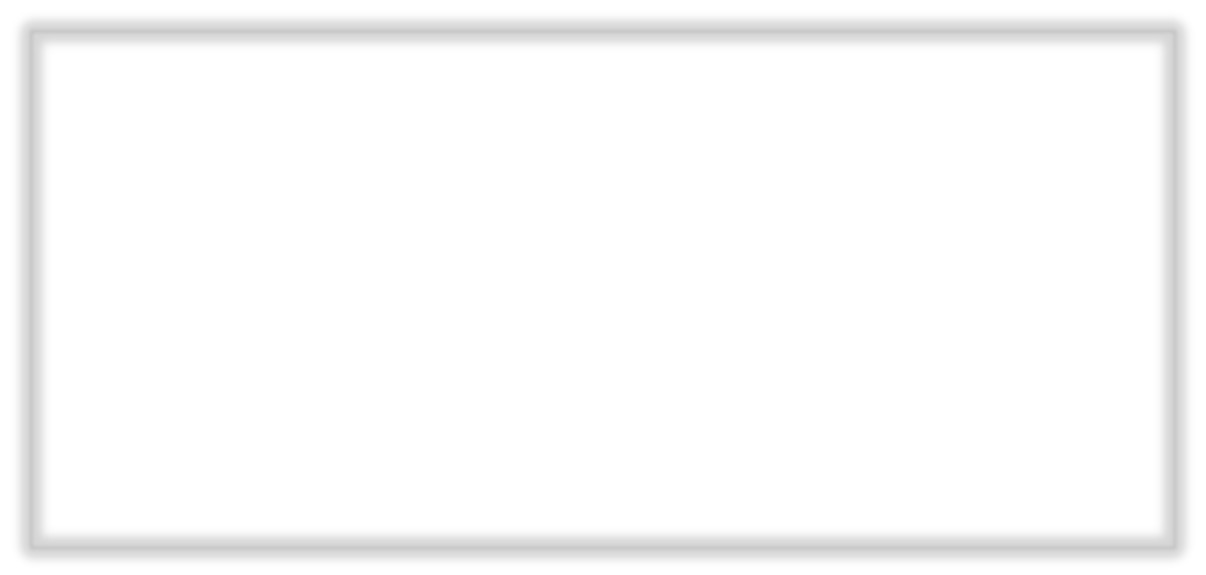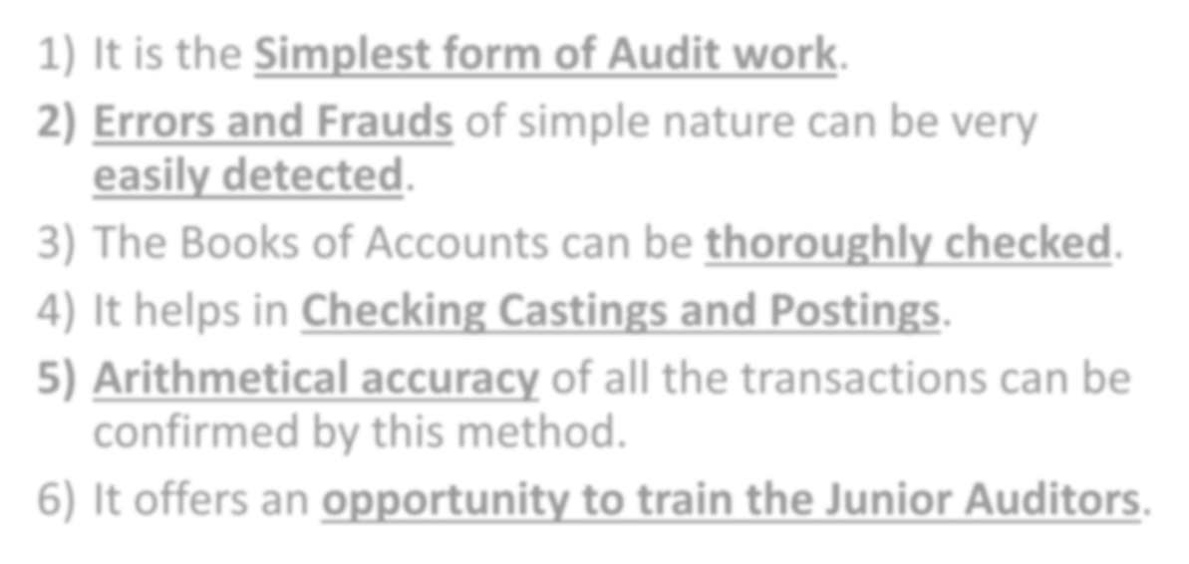

- It is the Simplest form of Audit work.
- Errors and Frauds of simple nature can be very
easily detected.
- The Books of Accounts can be thoroughly checked.
- It helps in Checking Castings and Postings.
- Arithmetical accuracy of all the transactions can be confirmed by this method.
- It offers an opportunity to train the Junior Auditors.

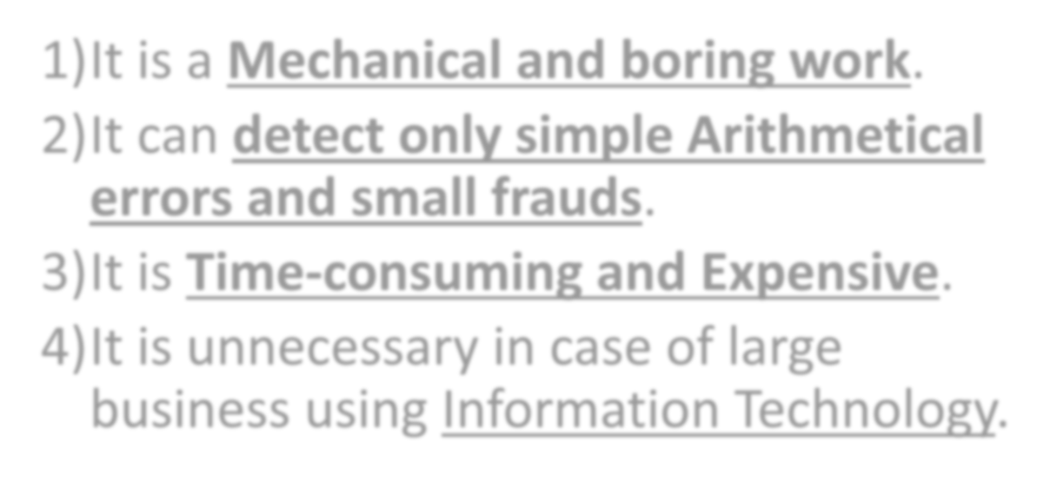

- It is a Mechanical and boring work.

It can detect only simple Arithmetical errors and small frauds.
- It is Time-consuming and Expensive. 4)It is unnecessary in case of large

business using Information Technology.

TYPES OF ‘TICKS’ or ‘CHECK MARKS’

No. | When | Where | How
1. | Posting | On the right hand side of the figure close to the last digit.
2. | Casting of Totaling | On the left hand side of the figure checked.
3. | Carry forward | Same as above with an additional posting tick across the tick like.
4. | Calling over or comparing (completion of entries in books with vouchers) | At the bottom of the figure.
5. | Vouching | On the left side of the figure, the horizontal line covering a part of the figure. Sometimes, the tick mark is put on either side of the figure.
6. | Contras or Transfers | On the Right hand side | 

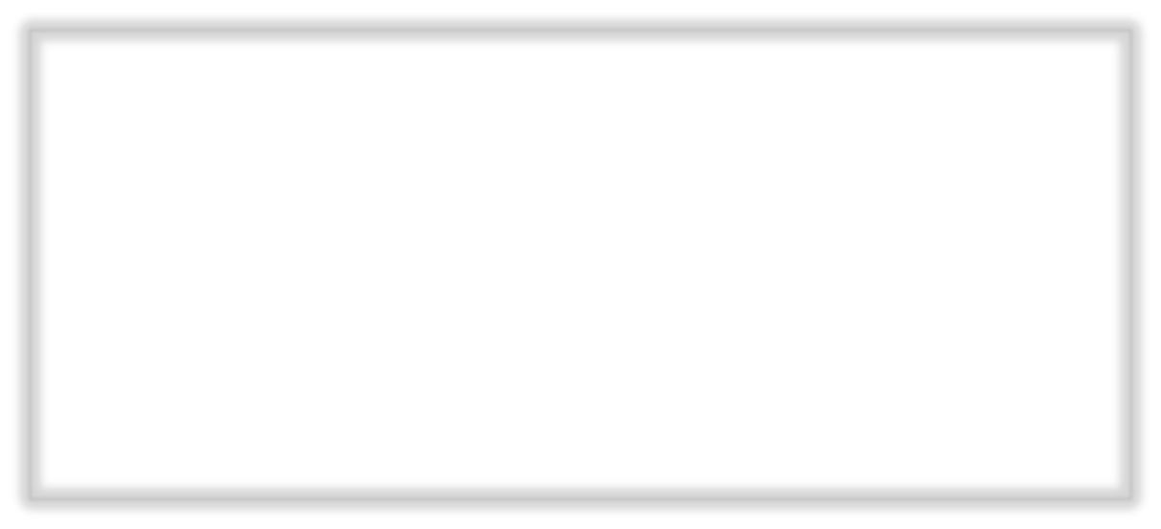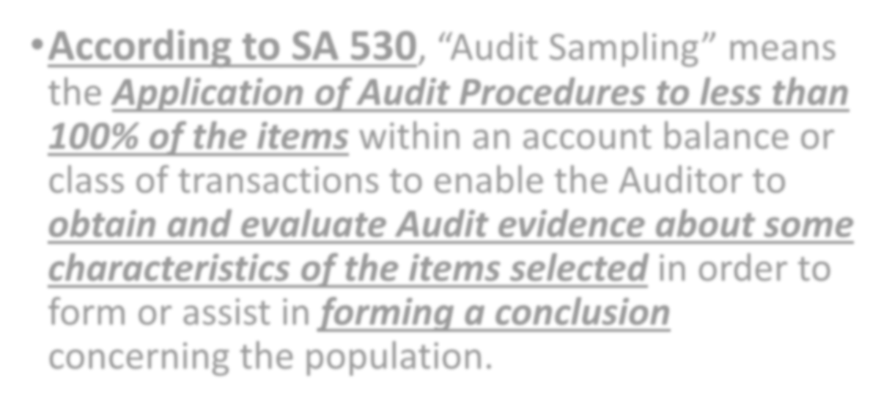

- According to SA 530, “Audit Sampling” means the Application of Audit Procedures to less than 100% of the items within an account balance or class of transactions to enable the Auditor to obtain and evaluate Audit evidence about some characteristics of the items selected in order to form or assist in forming a conclusion concerning the population.

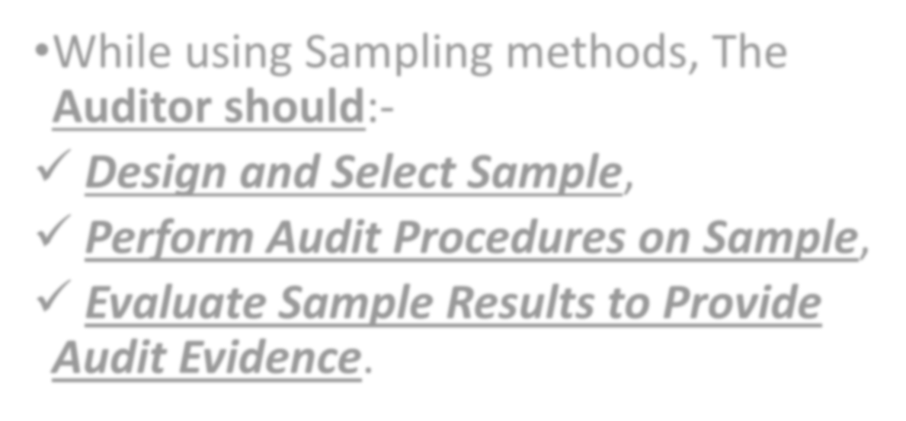

- While using Sampling methods, The

Auditor should:-

Design and Select Sample,
- Perform Audit Procedures on Sample,

Evaluate Sample Results to Provide Audit Evidence.

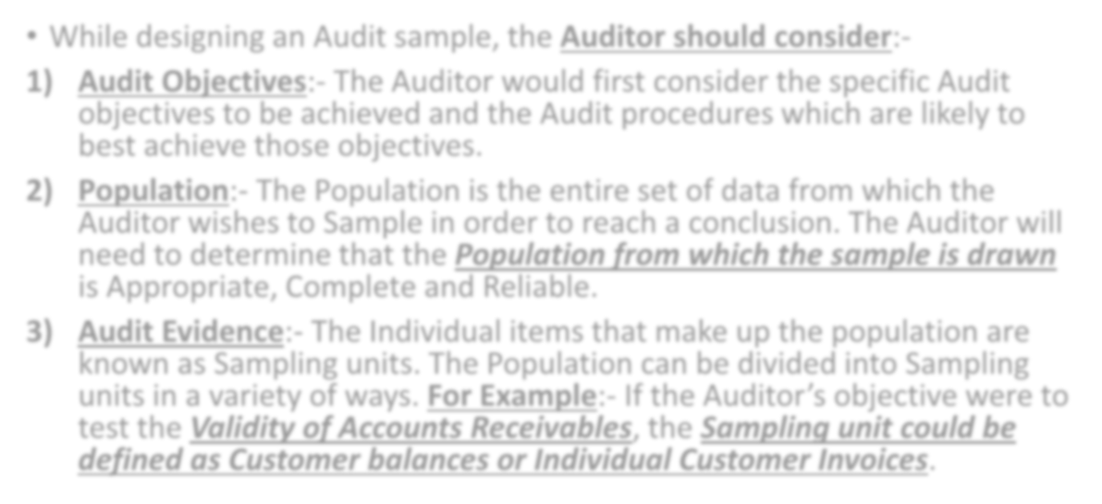

- While designing an Audit sample, the Auditor should consider:-
- Audit Objectives:- The Auditor would first consider the specific Audit objectives to be achieved and the Audit procedures which are likely to best achieve those objectives.
- Population:- The Population is the entire set of data from which the Auditor wishes to Sample in order to reach a conclusion. The Auditor will need to determine that the Population from which the sample is drawn is Appropriate, Complete and Reliable.
- Audit Evidence:- The Individual items that make up the population are known as Sampling units. The Population can be divided into Sampling units in a variety of ways. For Example:- If the Auditor’s objective were to test the Validity of Accounts Receivables, the Sampling unit could be defined as Customer balances or Individual Customer Invoices.

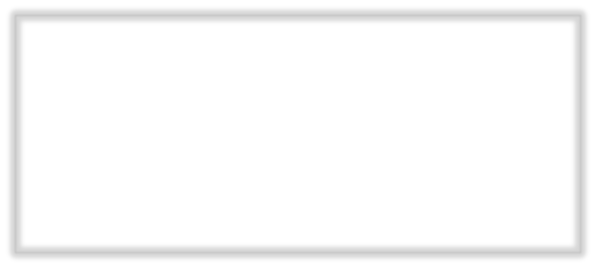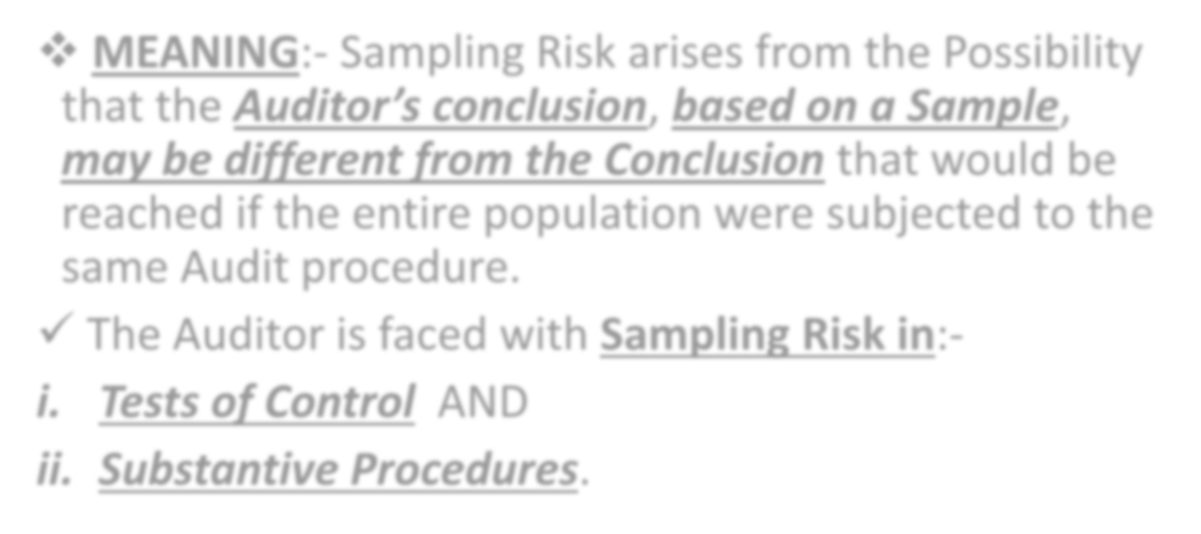

- MEANING:- Sampling Risk arises from the Possibility that the Auditor’s conclusion, based on a Sample, may be different from the Conclusion that would be reached if the entire population were subjected to the same Audit procedure.
- The Auditor is faced with Sampling Risk in:-

Tests of Control AND
- Substantive Procedures.

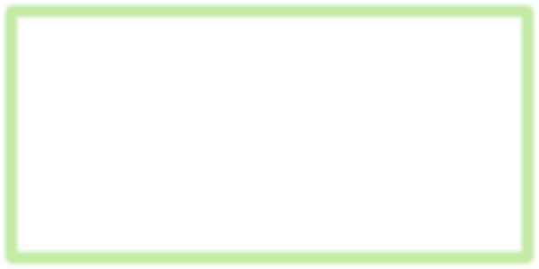

- Sampling Risks in Tests of Control:- The Auditor faces the following Sampling Risk in tests of control (Internal Control) –
- Risk of Under Reliance:- The risk that, although the Sample result does not support the Auditor’s assessment of control risk, The Actual Compliance rate (Internal control) would support such an assessment.
- Risk of Over Reliance:- The risk that, although the sample result supports the Auditor’s Assessment of Control risk, the Actual Compliance rate (Internal Control) would not support such an assessment.



- Sampling Risks in Substantive Procedures:- The Auditor faces the following sampling risk in substantive procedures (Transactions & Balances) –
- Risk of Incorrect Rejections:- The risk that, although the sample result supports the conclusion that a recorded Account balance or class of transactions is materially misstated, in fact it is not materially mis-stated.
- Risk of Incorrect Acceptance:- The risk that, although the Sample result supports the conclusion that a recorded Account balance or Class of transactions is not materially mis-stated, in fact it is materially misstated.

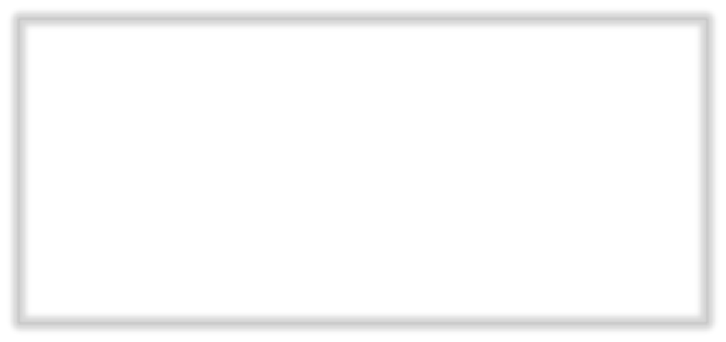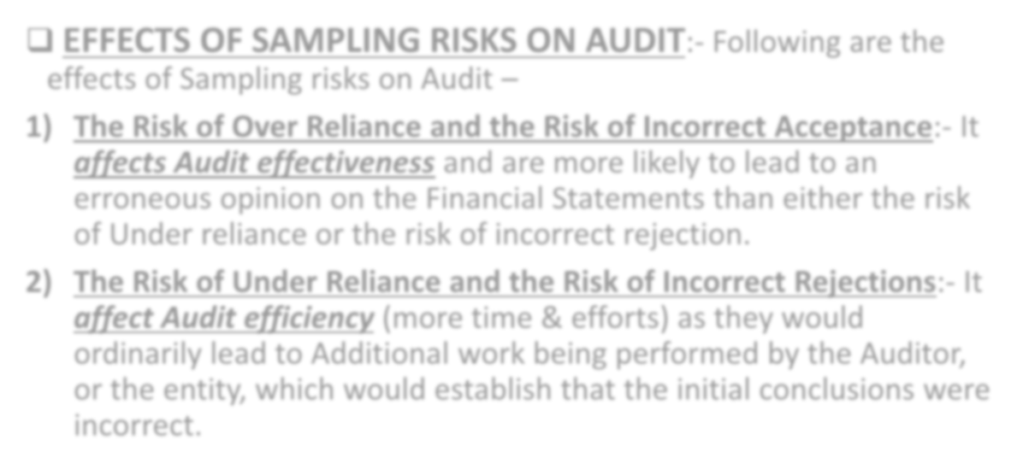

- EFFECTS OF SAMPLING RISKS ON AUDIT:- Following are the effects of Sampling risks on Audit –
  - The Risk of Over Reliance and the Risk of Incorrect Acceptance:- It affects Audit effectiveness and are more likely to lead to an erroneous opinion on the Financial Statements than either the risk of Under reliance or the risk of incorrect rejection.
  - The Risk of Under Reliance and the Risk of Incorrect Rejections:- It affect Audit efficiency (more time & efforts) as they would ordinarily lead to Additional work being performed by the Auditor, or the entity, which would establish that the initial conclusions were incorrect.

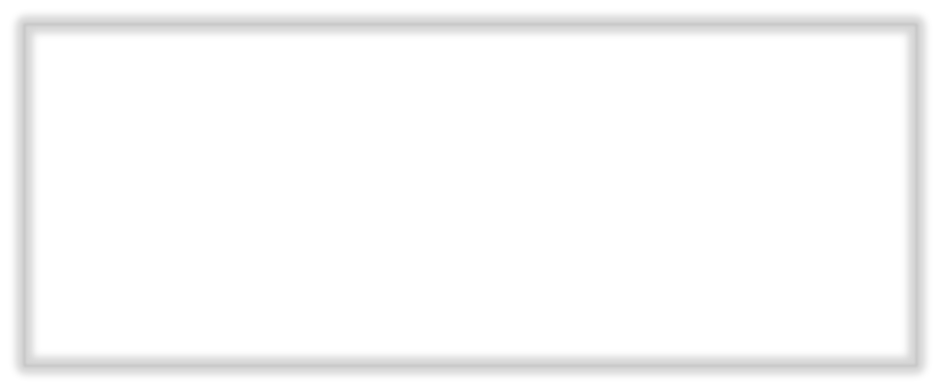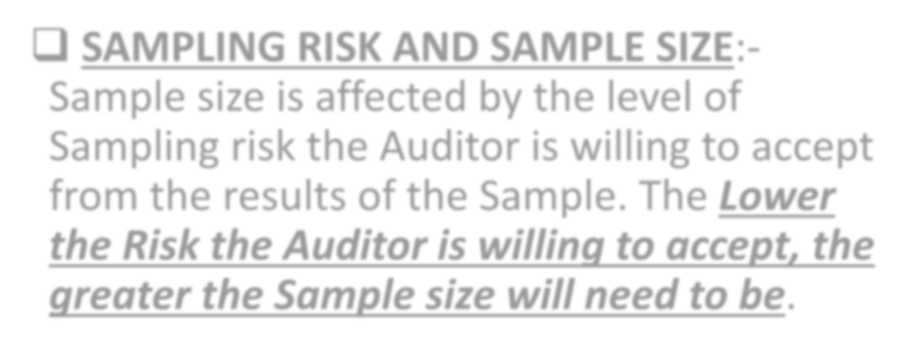

- SAMPLING RISK AND SAMPLE SIZE:- Sample size is affected by the level of Sampling risk the Auditor is willing to accept from the results of the Sample. The Lower the Risk the Auditor is willing to accept, the greater the Sample size will need to be.

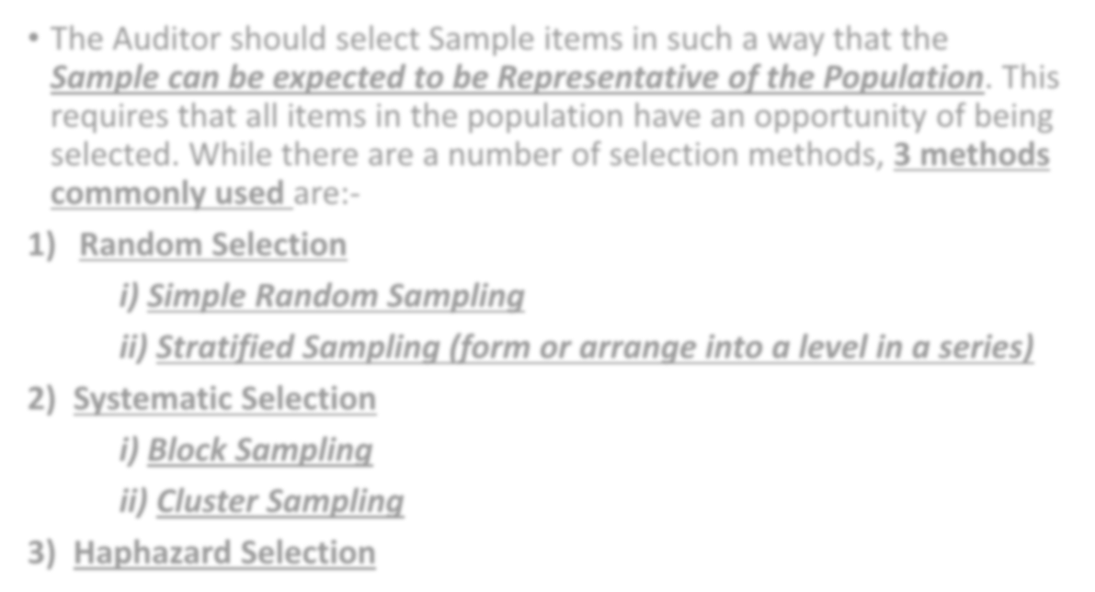

- The Auditor should select Sample items in such a way that the Sample can be expected to be Representative of the Population. This requires that all items in the population have an opportunity of being selected. While there are a number of selection methods, 3 methods commonly used are:-

Random Selection
  - Simple Random Sampling
  - Stratified Sampling (form or arrange into a level in a series)

Systematic Selection
  - Block Sampling
  - Cluster Sampling

Haphazard Selection

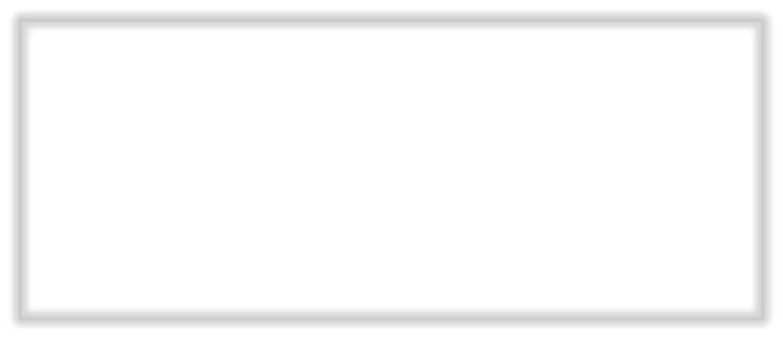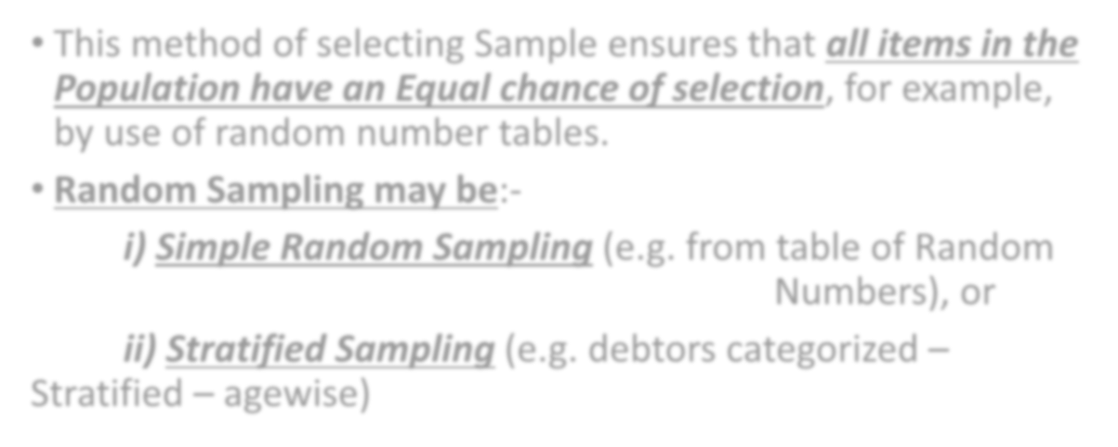

- This method of selecting Sample ensures that all items in the Population have an Equal chance of selection, for example, by use of random number tables.
- Random Sampling may be:-
  - Simple Random Sampling (e.g. from table of Random
Numbers), or
  - Stratified Sampling (e.g. debtors categorized –
Stratified – agewise)

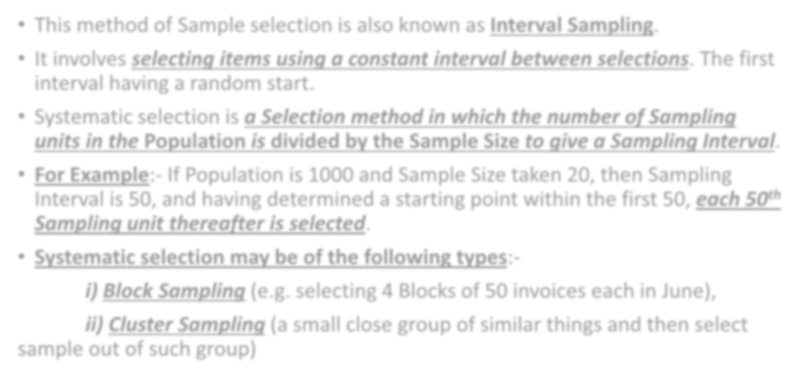

- This method of Sample selection is also known as Interval Sampling.
- It involves selecting items using a constant interval between selections. The first interval having a random start.
- Systematic selection is a Selection method in which the number of Sampling units in the Population is divided by the Sample Size to give a Sampling Interval.
- For Example:- If Population is 1000 and Sample Size taken 20, then Sampling Interval is 50, and having determined a starting point within the first 50, each 50th Sampling unit thereafter is selected.
- Systematic selection may be of the following types:-
- Block Sampling (e.g. selecting 4 Blocks of 50 invoices each in June),
- Cluster Sampling (a small close group of similar things and then select sample out of such group)



- Haphazard selection may be an acceptable alternative to Random Selection, provided the Auditor attempts to draw a representative sample from the entire Population with no intention to either include or exclude specific units.
- When the Auditor uses this method, care needs to be taken to guard against making a selection that is biased, for example, towards items which are easily located, as they may not be representative.

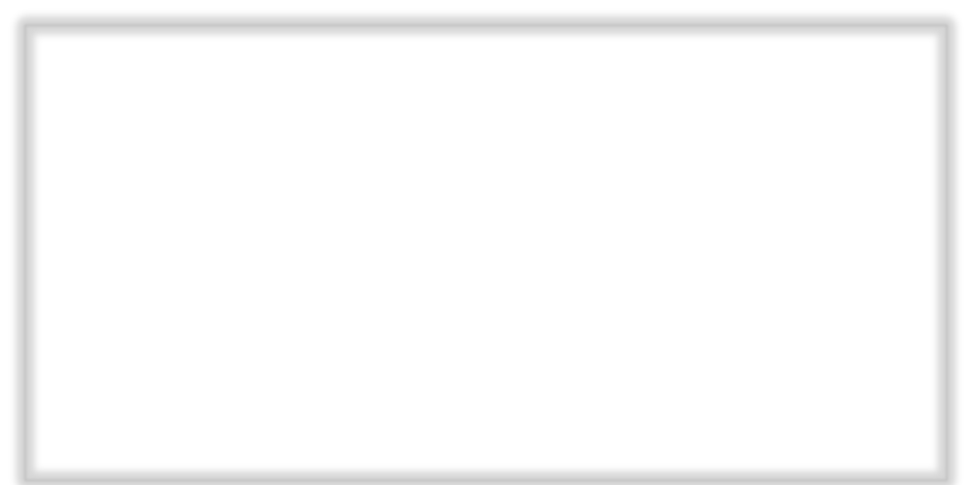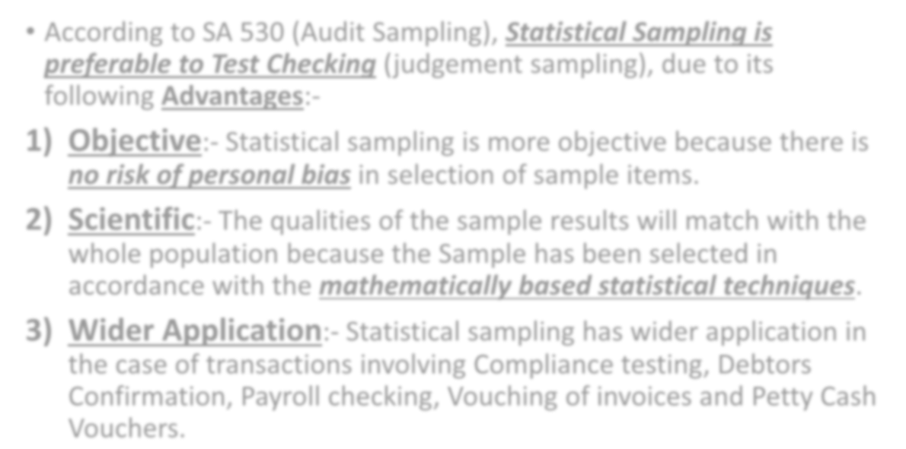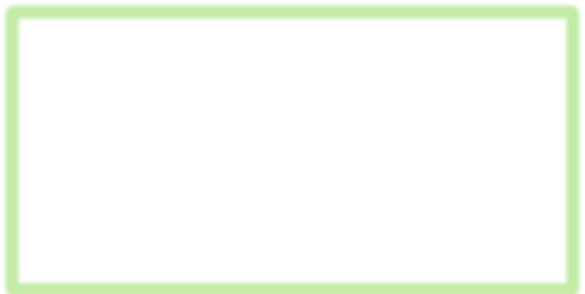

- According to SA 530 (Audit Sampling), Statistical Sampling is preferable to Test Checking (judgement sampling), due to its following Advantages:-
- Objective:- Statistical sampling is more objective because there is
no risk of personal bias in selection of sample items.
- Scientific:- The qualities of the sample results will match with the whole population because the Sample has been selected in accordance with the mathematically based statistical techniques.
- Wider Application:- Statistical sampling has wider application in the case of transactions involving Compliance testing, Debtors Confirmation, Payroll checking, Vouching of invoices and Petty Cash Vouchers.

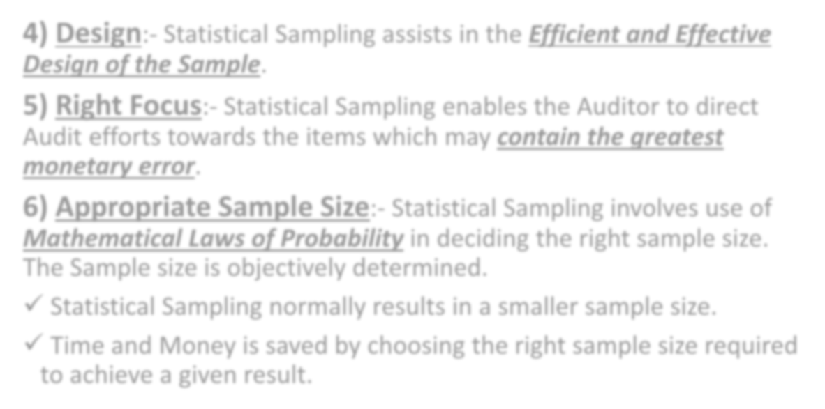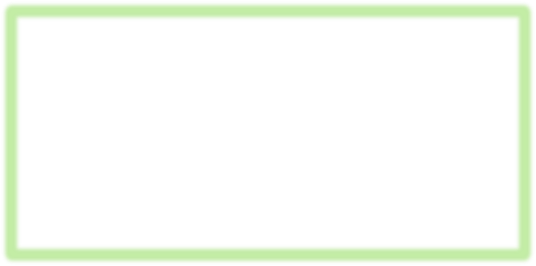

- Design:- Statistical Sampling assists in the Efficient and Effective Design of the Sample.
- Right Focus:- Statistical Sampling enables the Auditor to direct Audit efforts towards the items which may contain the greatest monetary error.
- Appropriate Sample Size:- Statistical Sampling involves use of Mathematical Laws of Probability in deciding the right sample size. The Sample size is objectively determined.
- Statistical Sampling normally results in a smaller sample size.
- Time and Money is saved by choosing the right sample size required to achieve a given result.

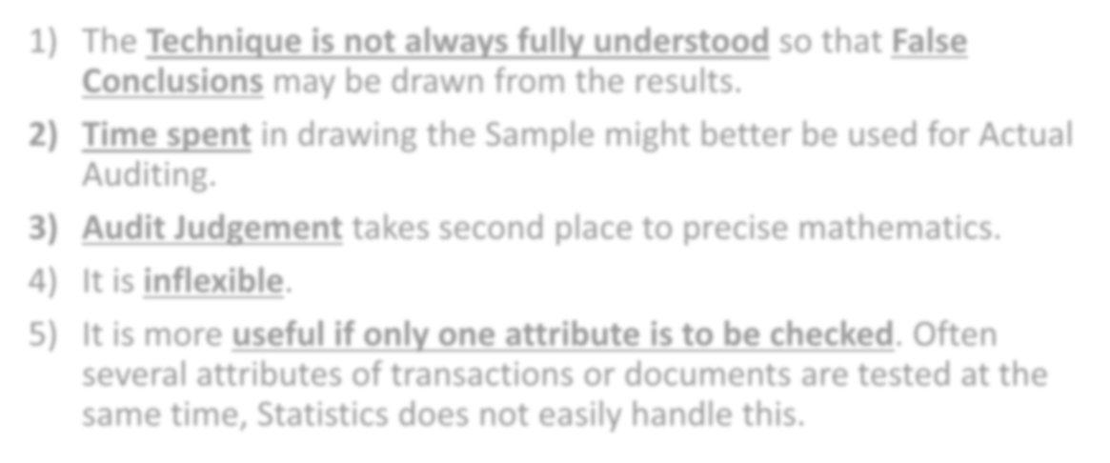

- The Technique is not always fully understood so that False Conclusions may be drawn from the results.
- Time spent in drawing the Sample might better be used for Actual Auditing.
- Audit Judgement takes second place to precise mathematics.
- It is inflexible.
- It is more useful if only one attribute is to be checked. Often several attributes of transactions or documents are tested at the same time, Statistics does not easily handle this.

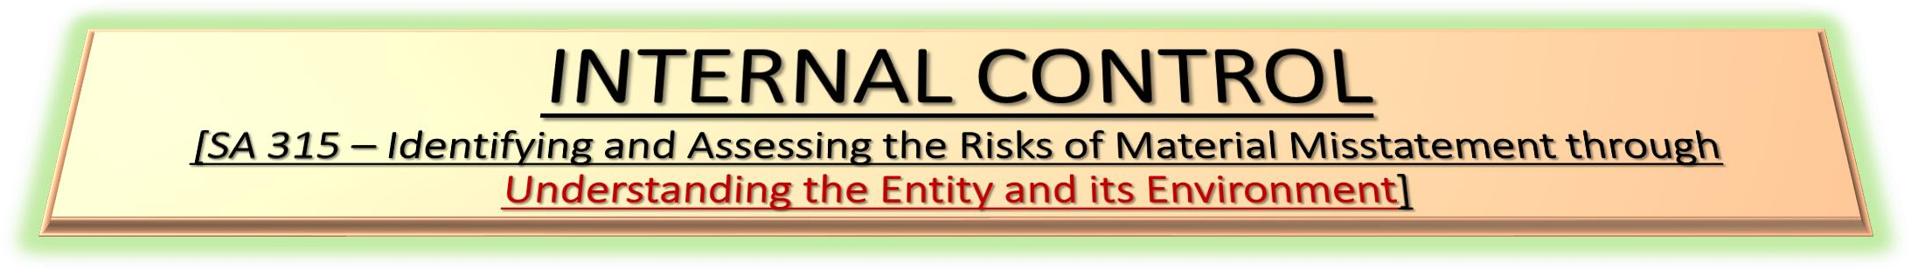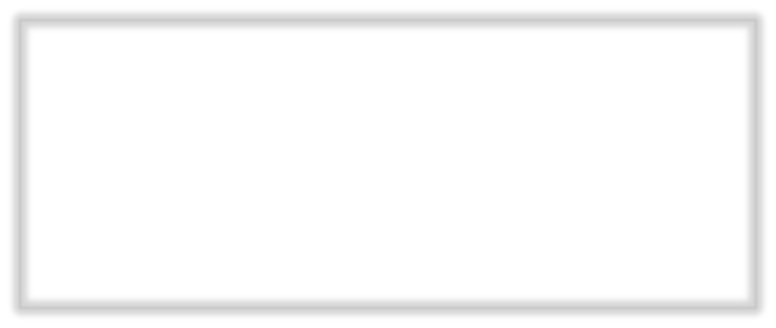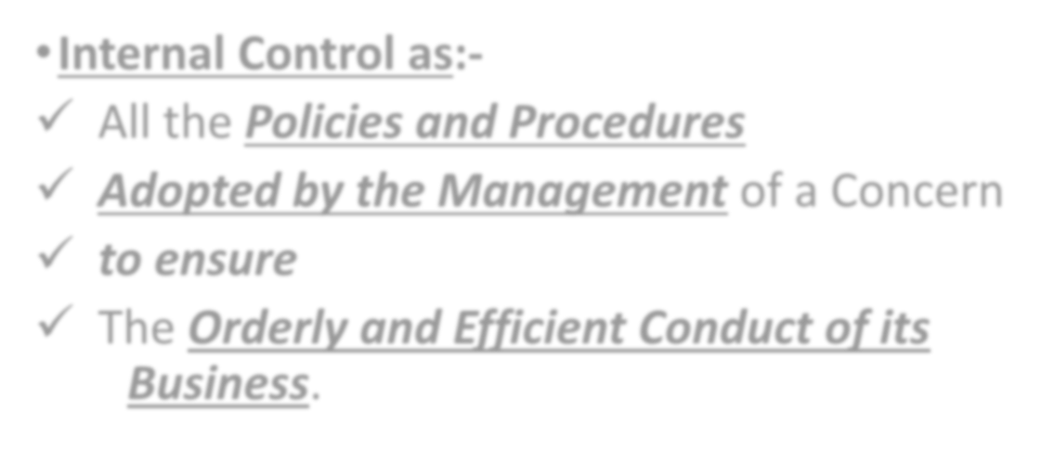

- Internal Control as:-
- All the Policies and Procedures
- Adopted by the Management of a Concern
- to ensure
- The Orderly and Efficient Conduct of its Business.

INTERNAL
CHECK

INTERNAL CONTROL

INTERNAL
AUDIT

PURPOSE OR OBJECTIVES OF INTERNAL CONTROL

1)

Accounting Controls
2) Operational or
Administrative Controls



- Accounting Controls aims to ensure that:-
- All transactions are Duly Authorized.
- All transactions are Properly Recorded.
- All transactions are recorded Promptly as soon as they occur.
- The Accounting Policies adopted by the management in respect of Stock Valuation, Depreciation etc. are Implemented.
- The Assets of the Concern are Safeguarded, the Assets are not used or Sold without proper Authorization and are verified regularly.
- Errors and Frauds are Prevented and Detected.
- The Books of Accounts are Complete and Accurate.
- The Final Accounts are Reliable and Ready in time.

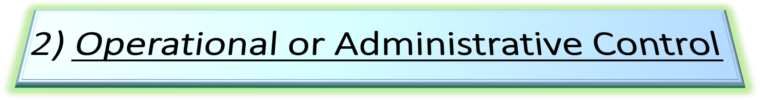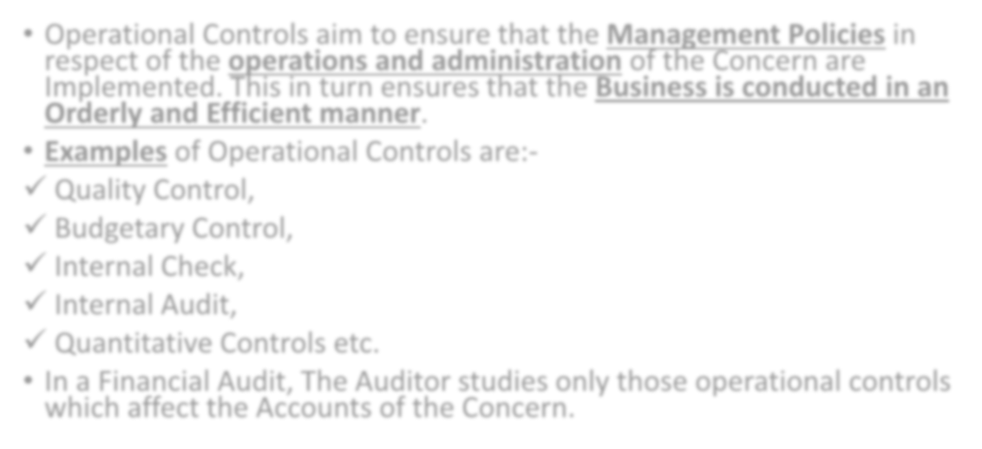

- Operational Controls aim to ensure that the Management Policies in respect of the operations and administration of the Concern are Implemented. This in turn ensures that the Business is conducted in an Orderly and Efficient manner.
- Examples of Operational Controls are:-
- Quality Control,
- Budgetary Control,
- Internal Check,
- Internal Audit,
- Quantitative Controls etc.
- In a Financial Audit, The Auditor studies only those operational controls which affect the Accounts of the Concern.

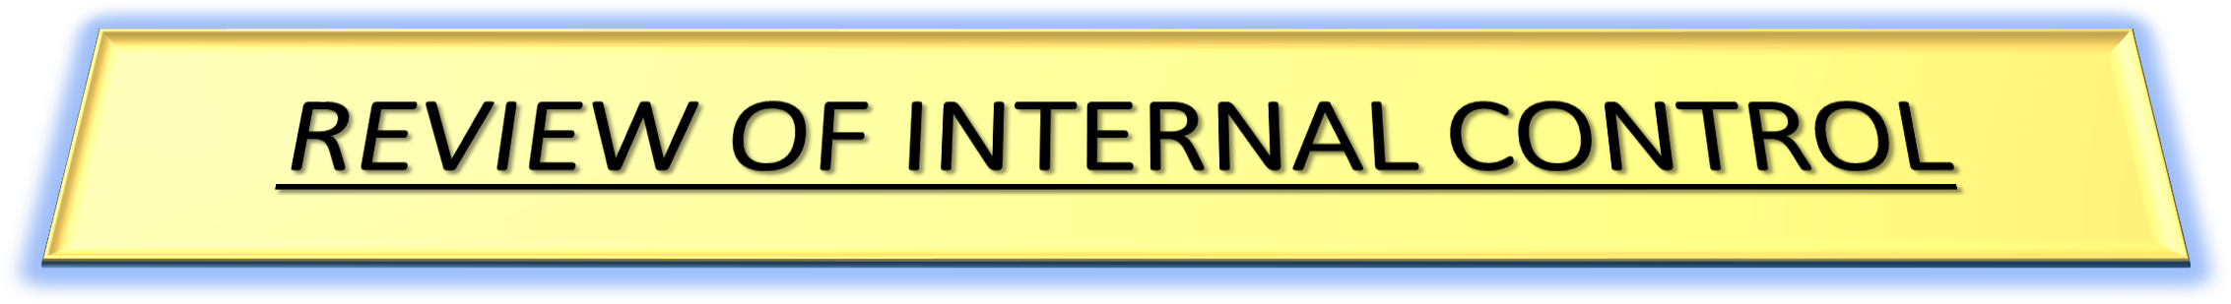

- Why Auditor should Review Internal Controls:- The Auditor’s objective in studying and evaluating Internal Controls is to establish the Reliance he can place thereon in determining the Nature, Timing and extent of his Substantive Audit procedures (checking of transactions & balances).
- How Auditor should Review Internal Controls:- Auditor should review the Internal Controls in the Following manner:-
- The Auditor should Acquaint himself with the important features of the business carried on by the concern (discussion with client).
- He should also find out the basis on which the Control and procedures are laid down by the management. He can always obtain this knowledge by having discussion with the various managers of the Organisation.
- He should also study the Company’s Procedures, Manuals, Organisation Flow charts to ascertain the character, scope and effectiveness of the Control System.

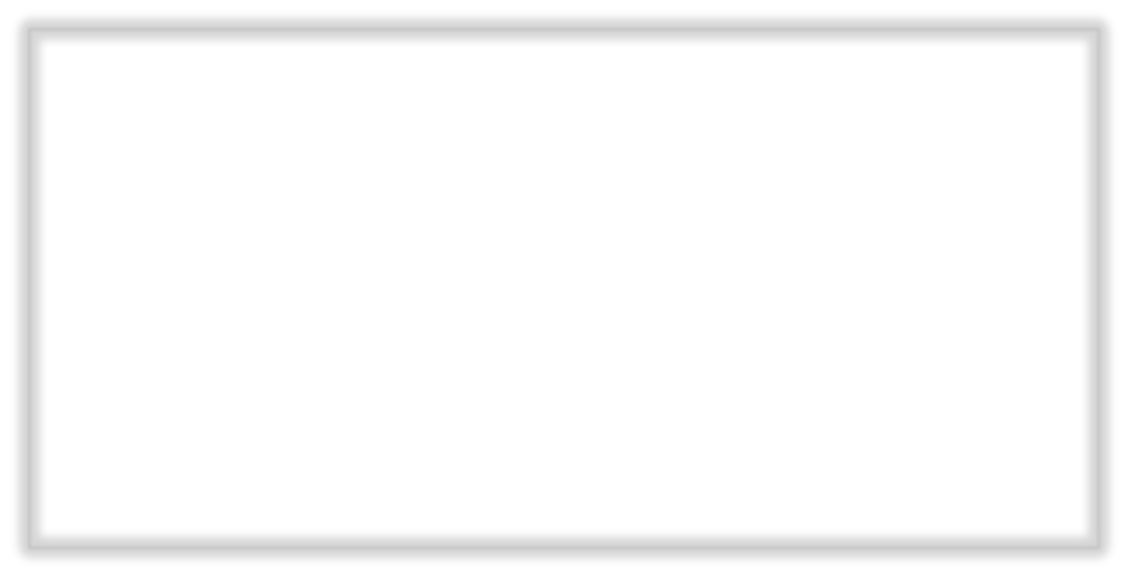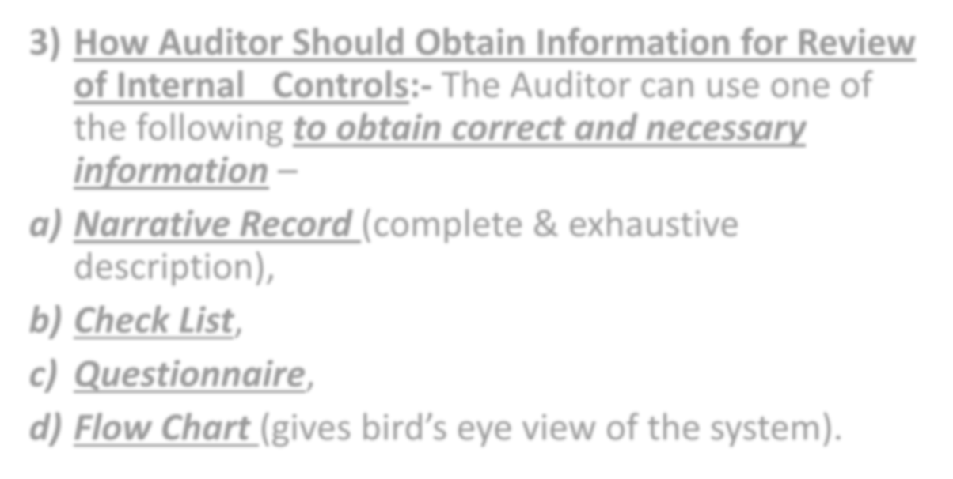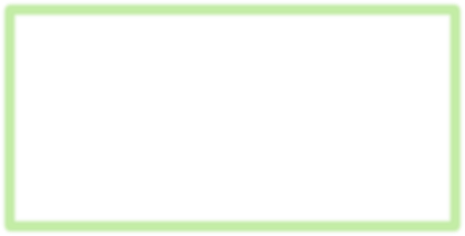

- How Auditor Should Obtain Information for Review of Internal Controls:- The Auditor can use one of the following to obtain correct and necessary information –
  - Narrative Record (complete & exhaustive description),

Check List,
  - Questionnaire,
  - Flow Chart (gives bird’s eye view of the system).

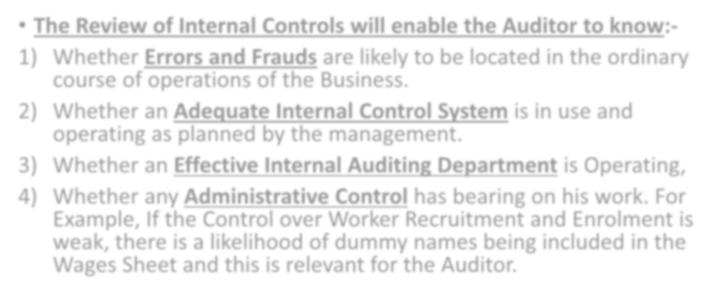

The Review of Internal Controls will enable the Auditor to know:-
    - Whether Errors and Frauds are likely to be located in the ordinary course of operations of the Business.
    - Whether an Adequate Internal Control System is in use and operating as planned by the management.
    - Whether an Effective Internal Auditing Department is Operating,
    - Whether any Administrative Control has bearing on his work. For Example, If the Control over Worker Recruitment and Enrolment is weak, there is a likelihood of dummy names being included in the Wages Sheet and this is relevant for the Auditor.

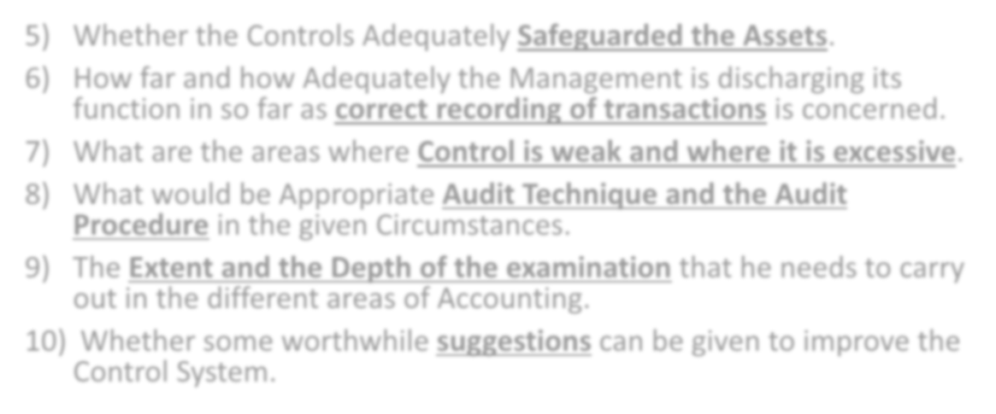

    - Whether the Controls Adequately Safeguarded the Assets.
    - How far and how Adequately the Management is discharging its function in so far as correct recording of transactions is concerned.
    - What are the areas where Control is weak and where it is excessive.
    - What would be Appropriate Audit Technique and the Audit Procedure in the given Circumstances.
    - The Extent and the Depth of the examination that he needs to carry out in the different areas of Accounting.
    - Whether some worthwhile suggestions can be given to improve the Control System.



- Responsibility of Management:- Basically, the Management is responsible for establishing and operating the Internal Control System.
- Auditor’s Duty:- The Auditor’s duty is to Study the System, Check whether the system was actually in operation during the year and evaluate the system to ascertain how much he can rely upon it.
- Need For Evaluation:- An Auditor needs to evaluate the Internal Control System for the Following reasons –
- Establish Reliability of Internal Control:- An Auditor has to ascertain whether he can rely upon the Internal Controls, so that he can be sure that –
- All Transactions are Authorised and Recorded Properly and in time.
- The Assets of the Concern are Safeguarded and Verified Regularly.
- The Accounts are Free from Errors and Frauds.
- The Books of Accounts are Complete and Accurate.



- Decide What, When, How and How Much to Check:- The Study of Internal Control Helps an Auditor to decide the Nature, timing and extent of Vouching, Verification etc. It helps him to decide what to check, when to check, how to check and how much to check. If the Internal Control are Reliable, he can use Test Checks and Concentrate on only the Important areas of Audit.
- Steps in Evaluation:- In order to evaluate the system of Internal Control, The Auditor Should take the Following Steps –
- Understand the System:- In the first stage, the Auditor should understand the System of Internal Control (Walkthrough). He can understand the system with the help of manuals, discussions with managers or the technique of Flow Charts. He can also trace a few transactions through the system to understand the Control Procedures.



- Test Application:- He should check whether the Controls were actually applied in practice. He can check some transaction in depth. Thus, he can take up some Sales transactions and check all the documents right from the Sales order to the receipt from the debtors.
- Evaluate the System:- He should judge, on the basis of above tests, whether he can rely on the system and if so to what extent.
- Communicate Weakness to Management:- The Material Weaknesses in Internal Controls should be communicated to the management by the Auditor. Suggestions can be given to improve the Control System.



- Costs:- Cost of implementing a control procedure may be much more than its benefits.
- Human Error:- A Control Procedure may not prove effective due to human errors. e.g. Carelessness of Employees, Mis-understanding of Instructions, Wrong judgements etc.
- Collusion:- Even if duties are divided among different employees, they may collude (work together fraudulently).
- Misuse:- An employee responsible for a particular function may misuse his Authority.
- Manipulation by Management:- Manipulation and Misappropriation by Top Management will defeat the very purpose of Internal Control.



- Division of Work:- Work relating to Sales and Debtors should be divided among different departments and employees.
- Procedures:- Sales Department should obtain Sales Orders and Issue Despatch orders to the stores. Material should be despatched from the godown only on the basis of such despatch orders and after preparing delivery challans.
- Cross-Check:- The work should be divided in such a way that the Despatch Orders, Delivery Challan, Sales Bill, Receipt for Collection etc. are prepared by different persons and are Automatically checked by another employee.

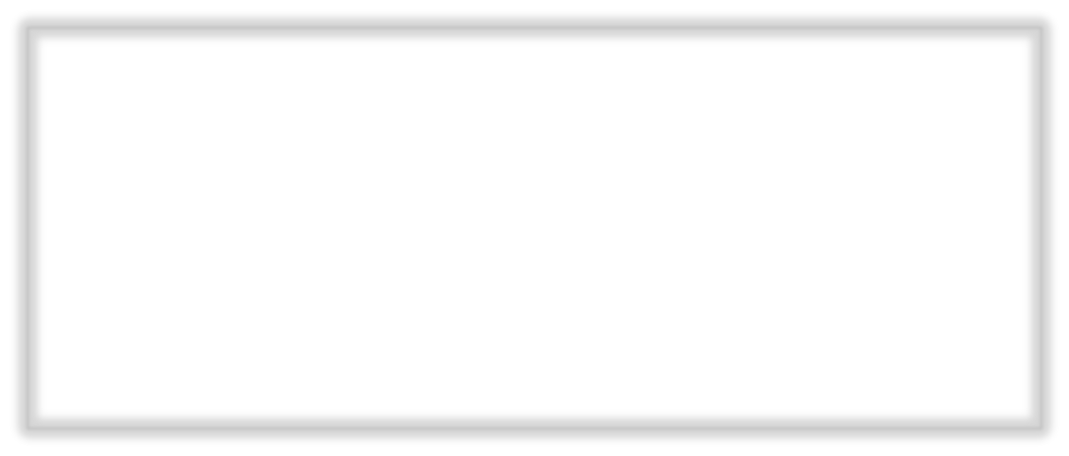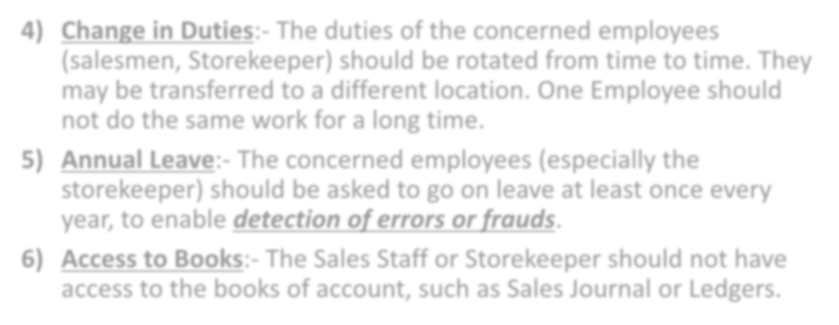

- Change in Duties:- The duties of the concerned employees (salesmen, Storekeeper) should be rotated from time to time. They may be transferred to a different location. One Employee should not do the same work for a long time.
- Annual Leave:- The concerned employees (especially the storekeeper) should be asked to go on leave at least once every year, to enable detection of errors or frauds.
- Access to Books:- The Sales Staff or Storekeeper should not have access to the books of account, such as Sales Journal or Ledgers.

- Proper Recording:- All Goods despatched should be properly recorded i.e. the right quantity should be entered, against the right party and on the right date in the Delivery Challan, Sales Invoice and the Stock Book.
- Prompt Recording:- The Delivery Challans should be recorded in the Stock Book immediately. The Sales Invoices should be recorded in the Sales Journal as soon as Possible. The Postings in the Debtors Ledger should also be in time.
- Accounting Policies:- The Sales should recorded on the basis of the Accounting Policies adopted by the Management e.g. treatment of cut-off transactions, debit notes/credit notes etc.

- 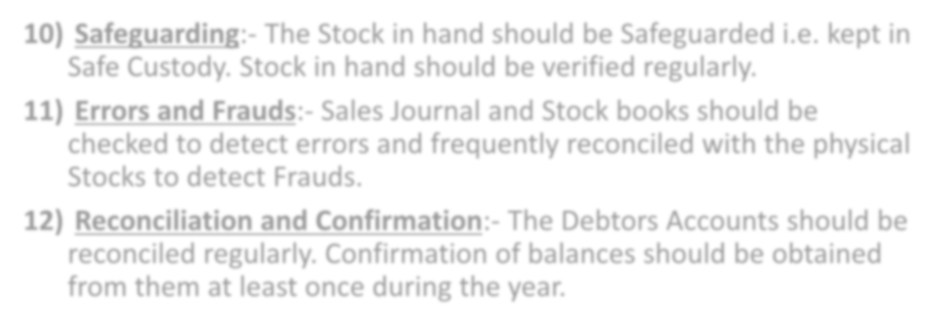 Safeguarding:- The Stock in hand should be Safeguarded i.e. kept in Safe Custody. Stock in hand should be verified regularly.
- Errors and Frauds:- Sales Journal and Stock books should be checked to detect errors and frequently reconciled with the physical Stocks to detect Frauds.
- Reconciliation and Confirmation:- The Debtors Accounts should be reconciled regularly. Confirmation of balances should be obtained from them at least once during the year.

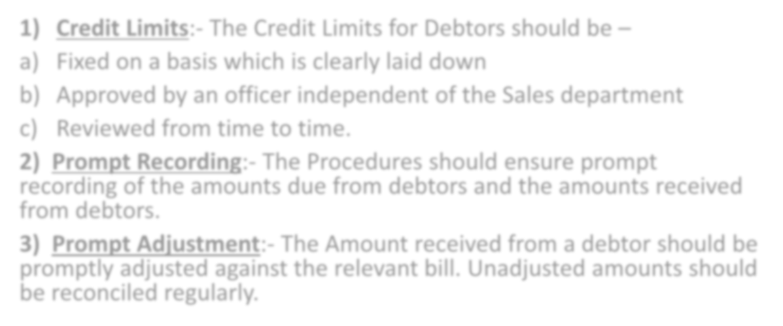

- Credit Limits:- The Credit Limits for Debtors should be –
  - Fixed on a basis which is clearly laid down
  - Approved by an officer independent of the Sales department
  - Reviewed from time to time.
- Prompt Recording:- The Procedures should ensure prompt recording of the amounts due from debtors and the amounts received from debtors.
- Prompt Adjustment:- The Amount received from a debtor should be promptly adjusted against the relevant bill. Unadjusted amounts should be reconciled regularly.

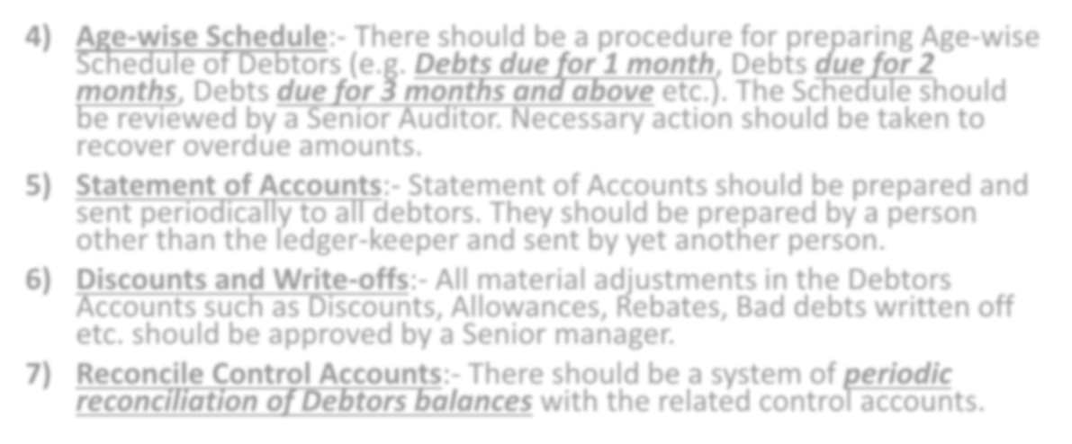

- Age-wise Schedule:- There should be a procedure for preparing Age-wise Schedule of Debtors (e.g. Debts due for 1 month, Debts due for 2 months, Debts due for 3 months and above etc.). The Schedule should be reviewed by a Senior Auditor. Necessary action should be taken to recover overdue amounts.
- Statement of Accounts:- Statement of Accounts should be prepared and sent periodically to all debtors. They should be prepared by a person other than the ledger-keeper and sent by yet another person.
- Discounts and Write-offs:- All material adjustments in the Debtors Accounts such as Discounts, Allowances, Rebates, Bad debts written off etc. should be approved by a Senior manager.
- Reconcile Control Accounts:- There should be a system of periodic reconciliation of Debtors balances with the related control accounts.

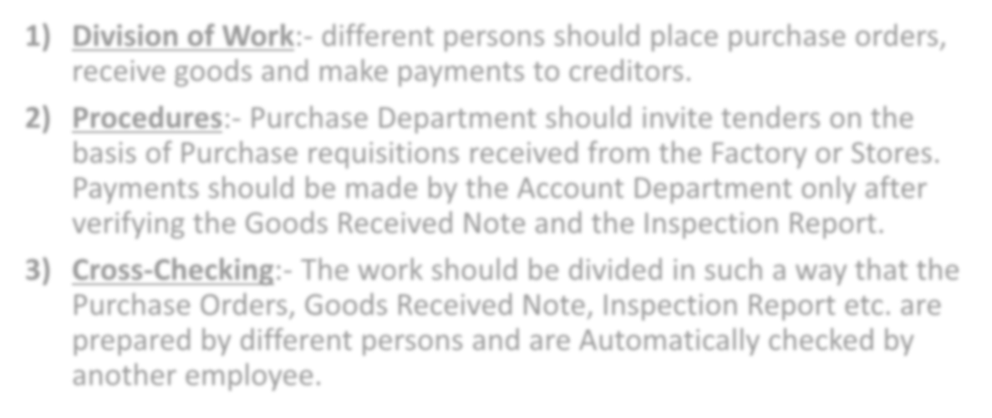

- Division of Work:- different persons should place purchase orders, receive goods and make payments to creditors.
- Procedures:- Purchase Department should invite tenders on the basis of Purchase requisitions received from the Factory or Stores. Payments should be made by the Account Department only after verifying the Goods Received Note and the Inspection Report.
- Cross-Checking:- The work should be divided in such a way that the Purchase Orders, Goods Received Note, Inspection Report etc. are prepared by different persons and are Automatically checked by another employee.

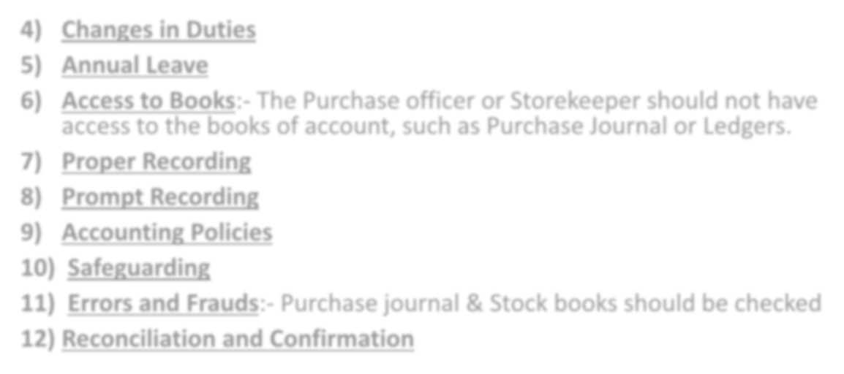

- Changes in Duties
- Annual Leave
- Access to Books:- The Purchase officer or Storekeeper should not have access to the books of account, such as Purchase Journal or Ledgers.
- Proper Recording
- Prompt Recording
- Accounting Policies
- Safeguarding
- Errors and Frauds:- Purchase journal & Stock books should be checked
- Reconciliation and Confirmation



Prompt Recording
- Prompt Adjustment 3)Age-wise Schedule 4)Statement of Account

5)Discounts and Write-backs 6)Reconcile Control Accounts

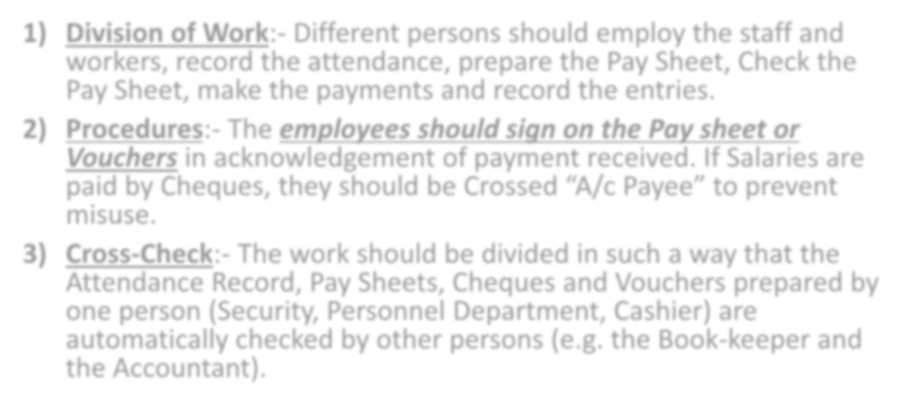

- Division of Work:- Different persons should employ the staff and workers, record the attendance, prepare the Pay Sheet, Check the Pay Sheet, make the payments and record the entries.
- Procedures:- The employees should sign on the Pay sheet or Vouchers in acknowledgement of payment received. If Salaries are paid by Cheques, they should be Crossed “A/c Payee” to prevent misuse.
- Cross-Check:- The work should be divided in such a way that the Attendance Record, Pay Sheets, Cheques and Vouchers prepared by one person (Security, Personnel Department, Cashier) are automatically checked by other persons (e.g. the Book-keeper and the Accountant).

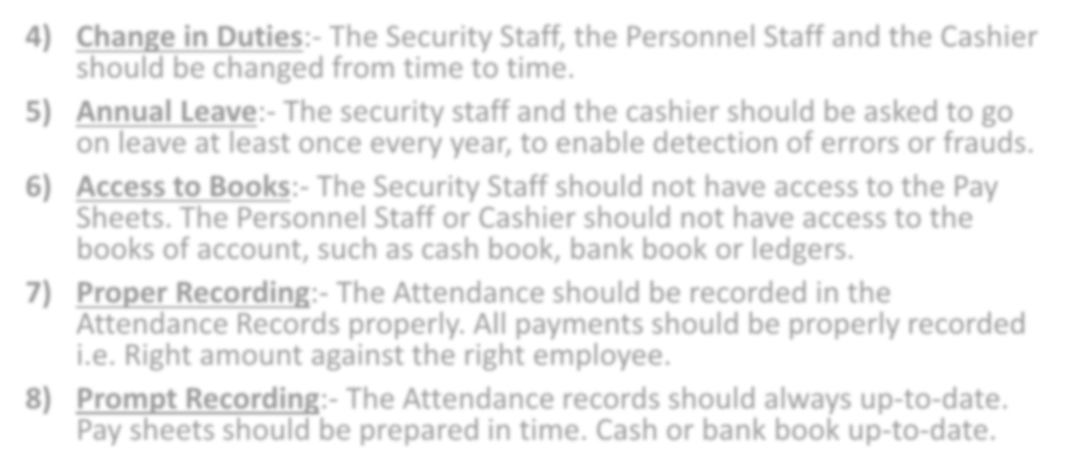

- Change in Duties:- The Security Staff, the Personnel Staff and the Cashier should be changed from time to time.
- Annual Leave:- The security staff and the cashier should be asked to go on leave at least once every year, to enable detection of errors or frauds.
- Access to Books:- The Security Staff should not have access to the Pay Sheets. The Personnel Staff or Cashier should not have access to the books of account, such as cash book, bank book or ledgers.
- Proper Recording:- The Attendance should be recorded in the Attendance Records properly. All payments should be properly recorded
i.e. Right amount against the right employee.
- Prompt Recording:- The Attendance records should always up-to-date. Pay sheets should be prepared in time. Cash or bank book up-to-date.

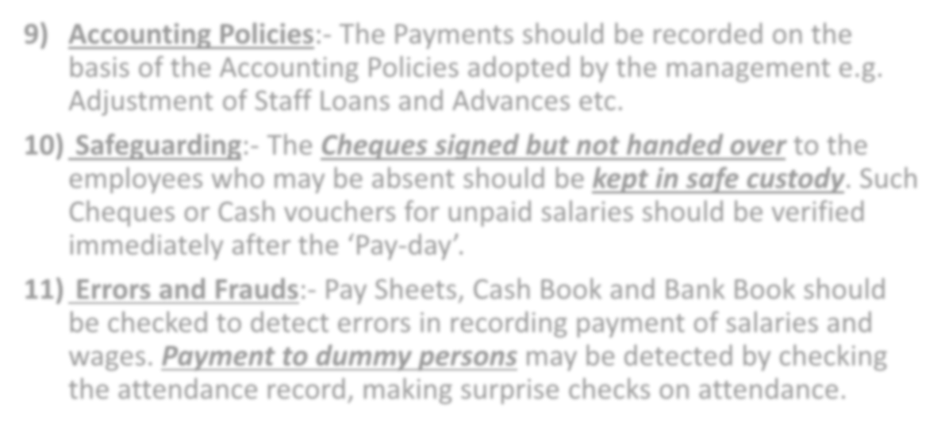

- Accounting Policies:- The Payments should be recorded on the basis of the Accounting Policies adopted by the management e.g. Adjustment of Staff Loans and Advances etc.
- Safeguarding:- The Cheques signed but not handed over to the employees who may be absent should be kept in safe custody. Such Cheques or Cash vouchers for unpaid salaries should be verified
immediately after the ‘Pay-day’.
- Errors and Frauds:- Pay Sheets, Cash Book and Bank Book should be checked to detect errors in recording payment of salaries and wages. Payment to dummy persons may be detected by checking the attendance record, making surprise checks on attendance.

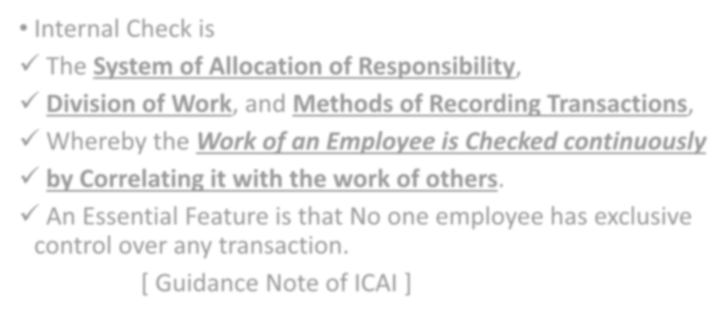

- Internal Check is
- The System of Allocation of Responsibility,
- Division of Work, and Methods of Recording Transactions,
- Whereby the Work of an Employee is Checked continuously

by Correlating it with the work of others.
- An Essential Feature is that No one employee has exclusive control over any transaction.
[ Guidance Note of ICAI ]

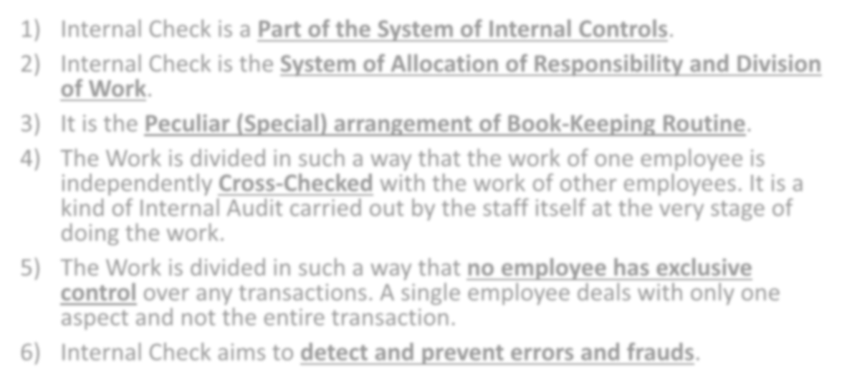

- Internal Check is a Part of the System of Internal Controls.
- Internal Check is the System of Allocation of Responsibility and Division of Work.
- It is the Peculiar (Special) arrangement of Book-Keeping Routine.
- The Work is divided in such a way that the work of one employee is independently Cross-Checked with the work of other employees. It is a kind of Internal Audit carried out by the staff itself at the very stage of doing the work.
- The Work is divided in such a way that no employee has exclusive control over any transactions. A single employee deals with only one aspect and not the entire transaction.
- Internal Check aims to detect and prevent errors and frauds.


READING OF A LEDGER ACCOUNT
Dr. DEBTORS A/C Cr.
DATE | PARTICULARS | ₹ | DATE | PARTICULARS | ₹
1/4/2020 | To Balance b/d | 10000 | 20/4/2020 | By Sales Return | 10000
10/4/2020 | To Credit sales | 100000 | 10/6/2020 | By Cash | 20000
 |  |  | 10/6/2020 | By Discount Allowed | 500
 |  |  | 15/6/2020 | By Bills Receivable | 30000
 |  |  | 25/8/2020 | By Bad Debts | 5000
 |  |  | 30/9/2020 | By Balance c/d | 44500
 |  | 110000 |  |  | 110000

READING OF DEBTORS A/C

- Debtor A/c has a Debit Balance of ₹ 10000 on 1/4/2020. it means earlier period Credit
Sales amount still recoverable.
- New Credit Sales have been made by the Company for ₹ 100000 on 10/4/2020. Credit
Sales Increases the Debtor balance means Current assets of the Company increased by
₹ 100000.
- Debtor returned goods of ₹ 10000 on 20/4/2020 which reduces the debtor balance
that is why it is to be credited.
- Debtor paid his part dues of ₹ 20000 on 10/6/2020 which reduces the debtor balance
that is why it is to be credited.
- Discount allowed to debtors for ₹ 500 on 10/6/2020 for early recovery of cash reduces
the debtor balance that is why it is to be credited.
- Bills Accepted by Debtor for ₹ 30000 on 15/6/2020 which reduces the debtor balance
that is why it is to be credited.
- The unrecovered amount from debtor is ₹ 5000 is to be treated as Bad debts which
reduces the debtor balance that is why it is to be credited.
- The Closing Balance of the Debtors A/c at the end of 30/9/2020 is ₹ 44500 which means remaining debtors i.e. amount to be collected from debtors in future which is to be treated as Current Assets of the Company.

