

CHAPTER 3

CONTRACT

COSTING


- 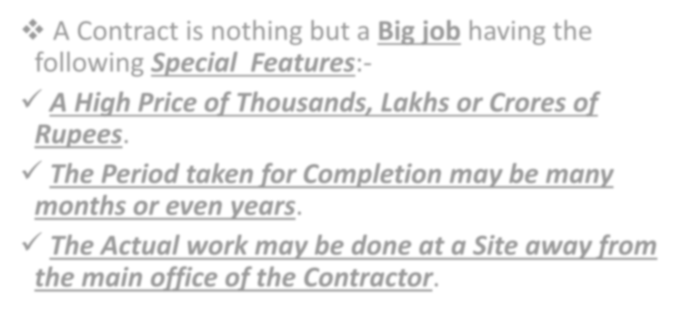A Contract is nothing but a Big job having the following Special Features:-

A High Price of Thousands, Lakhs or Crores of Rupees.
- The Period taken for Completion may be many months or even years.

The Actual work may be done at a Site away from the main office of the Contractor.

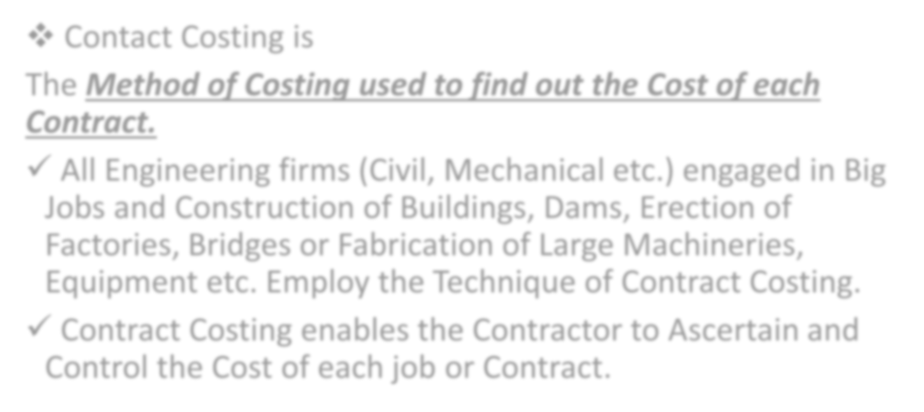

- Contact Costing is
The Method of Costing used to find out the Cost of each Contract.
- All Engineering firms (Civil, Mechanical etc.) engaged in Big Jobs and Construction of Buildings, Dams, Erection of Factories, Bridges or Fabrication of Large Machineries, Equipment etc. Employ the Technique of Contract Costing.
- Contract Costing enables the Contractor to Ascertain and Control the Cost of each job or Contract.



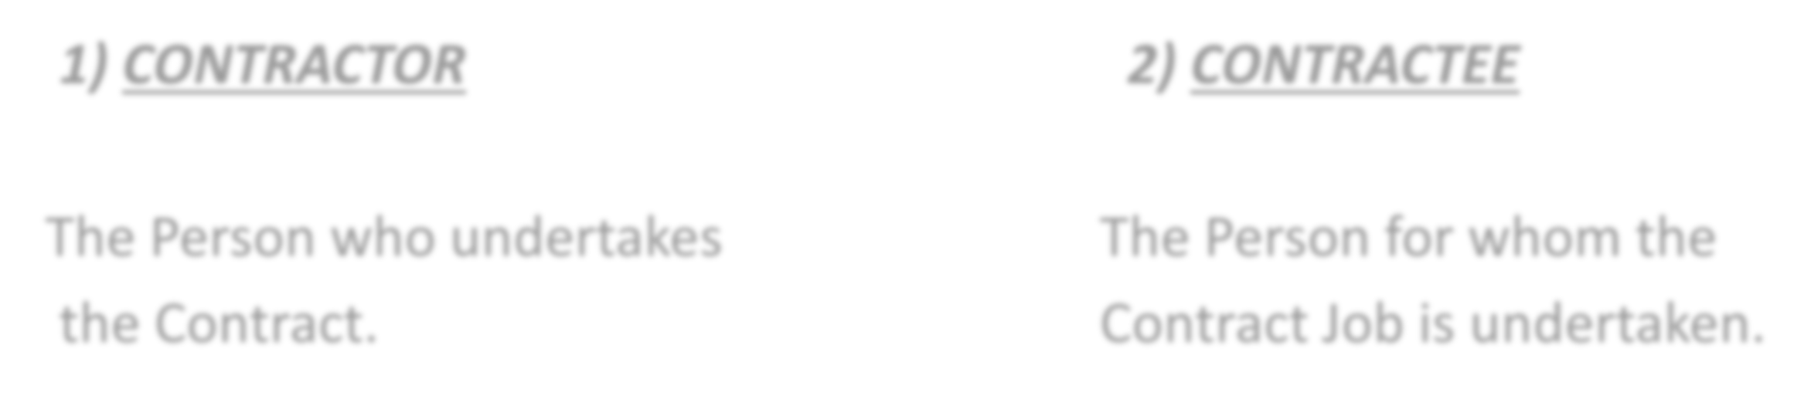
1) CONTRACTOR
2) CONTRACTEE
The Person who undertakes
the Contract.
The Person for whom the
Contract Job is undertaken.



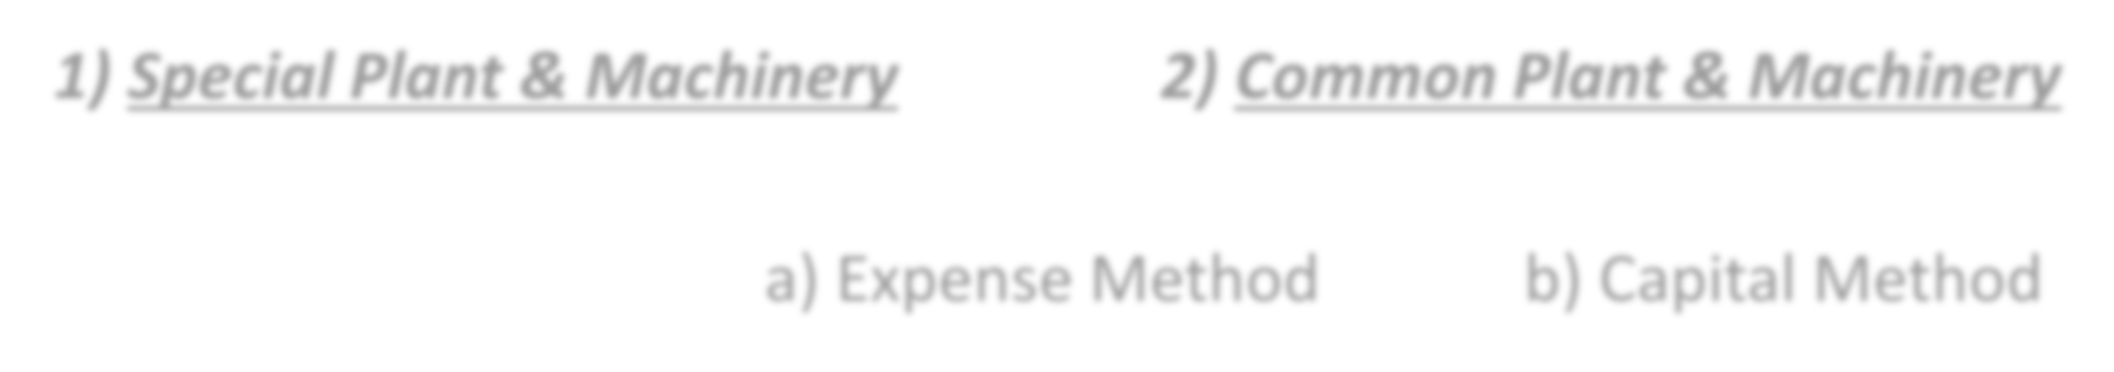
1) Special Plant & Machinery
2) Common Plant & Machinery
a) Expense Method
b) Capital Method

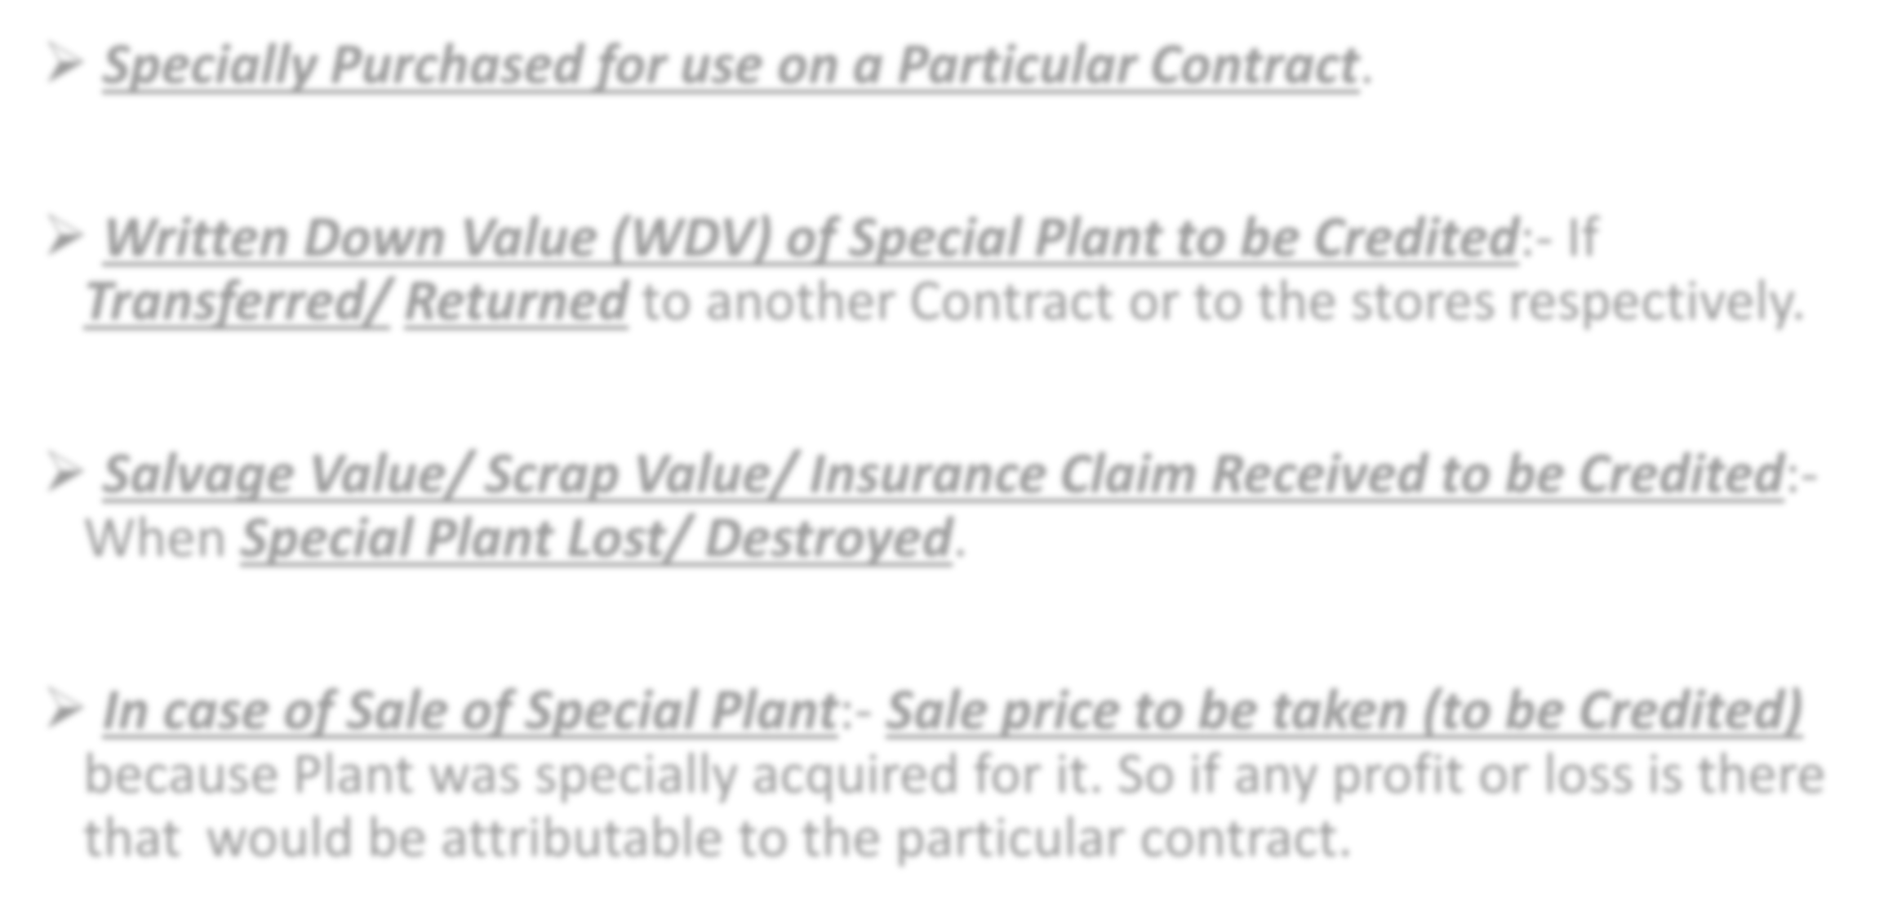

- Specially Purchased for use on a Particular Contract.

- Written Down Value (WDV) of Special Plant to be Credited:- If
Transferred/ Returned to another Contract or to the stores respectively.

- Salvage Value/ Scrap Value/ Insurance Claim Received to be Credited:- When Special Plant Lost/ Destroyed.

- In case of Sale of Special Plant:- Sale price to be taken (to be Credited) because Plant was specially acquired for it. So if any profit or loss is there that would be attributable to the particular contract.

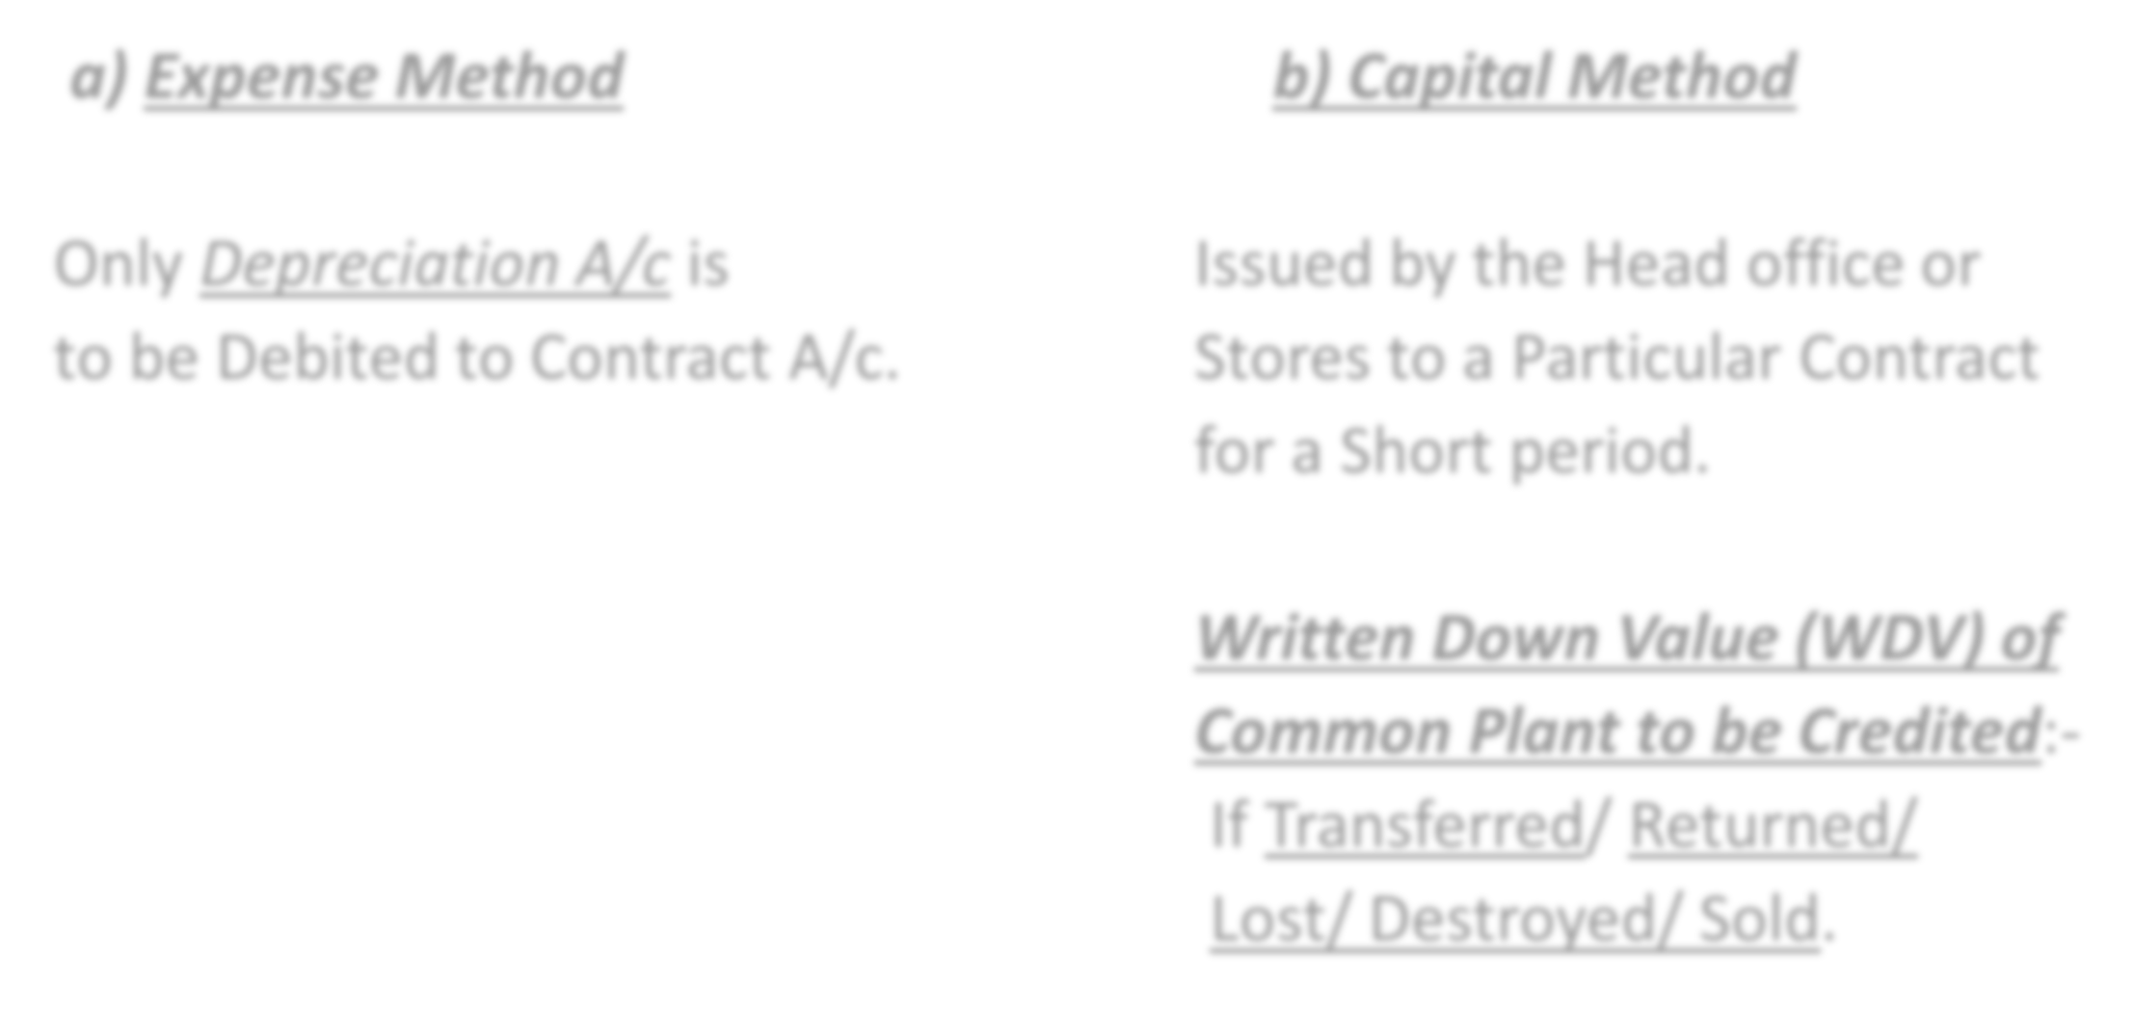

  - Expense Method b) Capital Method

Only Depreciation A/c is Issued by the Head office or to be Debited to Contract A/c. Stores to a Particular Contract
for a Short period.

Written Down Value (WDV) of Common Plant to be Credited:- If Transferred/ Returned/
Lost/ Destroyed/ Sold.


- 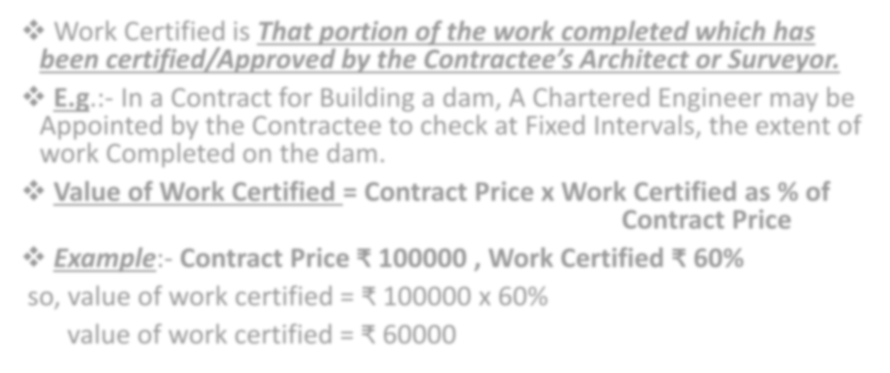Work Certified is That portion of the work completed which has
been certified/Approved by the Contractee’s Architect or Surveyor.
- E.g.:- In a Contract for Building a dam, A Chartered Engineer may be Appointed by the Contractee to check at Fixed Intervals, the extent of work Completed on the dam.
- Value of Work Certified = Contract Price x Work Certified as % of
Contract Price
- Example:- Contract Price ₹ 100000 , Work Certified ₹ 60%
so, value of work certified = ₹ 100000 x 60% value of work certified = ₹ 60000


- 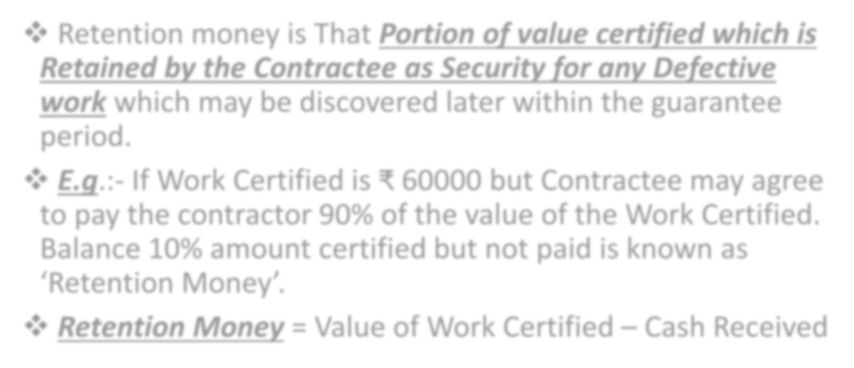Retention money is That Portion of value certified which is Retained by the Contractee as Security for any Defective work which may be discovered later within the guarantee period.
- E.g.:- If Work Certified is ₹ 60000 but Contractee may agree to pay the contractor 90% of the value of the Work Certified.
Balance 10% amount certified but not paid is known as
‘Retention Money’.
- Retention Money = Value of Work Certified – Cash Received



% of Work Certified or = Value of Work Certified x 100
% of Completion Total Contract Price




No. | % of Work Certified or  % of Completion | Transfer to Profit & Loss A/c
1) | 0 - 25% (24.99%) | NIL
2) | 25 – 50% (49.99%) | 1 x Notional Profit x Cash Received  3 Work Certified
3) | 50 – 90% | - x Notional Profit x Cash Received  - Work Certified
4) | Nearing Completion  (Above 90% to Below 100%) | Estimated Profit x Cash Received  Contract Price
5) | 100% Completion | Entire Profit

