Reconciliation of Cost & Financial Accounts

Reconciliation simply means Settling, Resolving, Adjustments, Balancing, Agreement between two data.

RECONCILIATION OF COST AND FINANCIAL ACCOUNTS:
Some items of Income & Expenses appearing in Financial Accounts only : like income such as Dividend received,
Interest received etc. &
Expenses such as Interest paid,
Loss on sale of Fixed Assets etc.

Some items of income & Expenses appearing in Cost Accounts only : like income such as Notional Interest charged to Owner for Drawings,
Notional Rent charged to owner for personal use of business premises etc. & Expenses such as Notional interest on Owner's Capital,
Notional Remuneration to owner for his/her Labour & Management,
Notional Rent to Owner for his/her premises for business etc

So, there are several items of income & expenses which are treated differently in the two sets of accounts viz. Cost Accounts & the Financial Accounts.
The difference in the amounts has to be ascertained & adjusted in order to reconcile the respective profits as per the two accounts.
So, the difference between these two accounts can be settled through reconciliation between the two Accounts i.e. Cost A/c & Financial A/c.

SIMPLE RULE
If Starting Point is From Financial Book
Then , See the other book i.e. Costing Book
If Costing book balance increases As compared to financial books Then “ADD”
If Costing book balance decreases to compared to financial books Then “LESS”

IMPORTANT WORDS TO BE USED FREQUENTLY IN COST BOOKS
-For Overheads:- Over- recovered/ Over- absorbed/ Under- recovered/ Under- absorbed
-For Depreciation: Overcharged/ Undercharged
-In General For Stock Valuation: Undervalued/ Overvalued

Q1)

The Net Profit of a company for the year ended on 31 March 2014 was Rs. 56,600 as shown in Financial Books. The Cost Accounts disclosed a profit of Rs. 59,050 for the same period. On an examination of both the sets of accounts, the following facts were discovered
(a) Goodwill written off in Financial Accounts – Rs. 1,500.
(b) Transfer fees received during the year Rs. 200.
(c) Depreciation charged in financial accounts Rs.750.
(d) Depreciation recovered in cost statements Rs. 1,000.
(e) Opening stock as on 1st April 2013 as per financial records Rs.13,000.
(f) Opening stock as on 1st April 2013 as per cost statement Rs.12,000.
(g) Closing stock as on 31st March 2014 as per financial records Rs. 14,000.
(h) Closing stock as on 31st March 2014 as per cost statement Rs.15,000.
Prepare a Reconciliation statement reconciling the profit as shown by financial and cost books taking (1) Financial profit as the starting point

Q2)
From the following, prepare Reconciliation Statement of M/s. XYZ and Company as on 30-6-2014
(1) Net Profit as per Financial Accounts 40,340.
(2) Income Tax Provision made 30,000.
(3) Materials Purchases of 5,000 units were recorded in cost at standard cost Rs 24 per unit
whereas in Finance it was recorded at actual cost Rs. 22 per unit.
(4) Old Bad debts recovered 20,500.
(5) Loss on sale of furniture was 4,120.

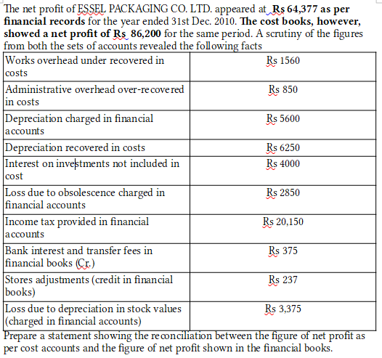
Q3)

Q4 )
R Limited showed a net loss of Rs. 35,400 as per their cost accounts for the year ended 31 st March, 2012.
However, the financial accounts disclosed a net profit of 67,800 for the same period.
The following information were revealed as a result of scrutiny of the figures of cost accounts and financial accounts:
Particulars | Rs
Administrative overhead under recovered in CA | 25,500
Factory overhead over recovered in CA | 1,35,000
Depreciation under charged in Cost Accounts | 26,000
Dividend received | 20,000
Loss due to obsolescence charged in Financial Accounts | 16,800
Income tax provided | 43,600
Bank interest credited in Financial Accounts | 13,600
Value of Opening Stock:
In Cost Accounts | 1,65,000
In Financial Accounts | 1,45,000
Value of Closing Stock:
In Cost Accounts | 1,25,500
In Financial Accounts | 1,32,000
Goodwill written-off in Financial Accounts | 25,000
Notional rent of own premises charged in Cost Accounts | 60,000
Provision for doubtful debts in Financial Accounts | 15,000
Prepare a reconciliation statement by taking costing net loss as base,

Q5)
From the following, prepare a statement of reconciliation and find out profit/loss as per financial
records.
Particulars | Rs
Net loss as per cost records | 1,72,400
Works overhead under-recovered in costing | 3,120
Administrative overheads over-recovered in costing | 1,700
Depreciation in Financial A/C | 11,200
Depreciation in Cost A/c | 12,500
Interest received | 8,750
Obsolescence Loss in Financial A/C | 5,700
Provision for Income Tax | 40,300
Opening Stock:
- Financial Records | 52,600
- Cost Records | 54,000
Closing Stock:
- Financial Records | 52,000
- Cost Records | 49,600
Interest charges in Cost Account only | 6,000
Preliminary Expenses w/off | 950

