TRANSPORTATION STRATEGY FOR SUPPLY CHAINS
Transportation is a key logistics function of supply chains which runs from suppliers through to customers or stores. It involves the movement of product, service/transit time, and cost which are three of five traditional key issues of effective supply chains. It also impacts with the other two issues of movement of information and integration within and among suppliers, customers and carriers.
A transportation strategy, to be effective in supply chain management, is fitting the movement of goods to the corporate supply chain. It is not playing one carrier off against another. Rather it is a way to respond to the dynamics of the business, its customers, suppliers' and operation.
The strategy, regardless of whether you are involved with domestic or international, should recognize—
- Segment. Each shipment does not have the same priority. Products, suppliers, customers, time of the year, and other factors can affect the importance and urgency of transport movements. The strategy cannot be one-dimensional. It should be segmented to reflect urgencies. That can mean mode changes and/or alternative carriers.
- Customer requirements. The supply chain involves continuous and efficient movement of product from vendor to manufacturer to customer. Therefore, the transportation program must reflect and meet customer needs. The time and service aspects of transportation are vital.
- Shipments must move timely. Customers demand their shipments be delivered as they require--on the date needed, by the carrier preferred, in the proper shipping packaging method and complete, both shipped complete and delivered complete and in good order. Being able to have a transportation program with can do this provides customer satisfaction and can give your company a competitive advantage.
- Mode selection. How will products move, by air versus surface? What modes will be used? What roles do transit time play in your supply chain? How will the inventory and service impacts be measured as compared to the freight charges?
- Carrier relationships. Volume creates carrier/forwarder attention. Even if there is no strategy, the number of carriers trying to get business will make firms develop one. Infrequent shipping dictates another approach.
The carrier attention with volume creates a competitive interest in your business. But there is another side to this attention as to freight cannot be divided among many carriers. This cannot be done for two reasons. First, as random, fracturing of the freight impacts negotiating or leverage position. Second, too many carriers hinder the ability to develop carrier relationships needed to meet supply chain requirements. Developing supply chain responsive programs be demands effort by both the carriers and shipper. Transportation must responsive and needs a focus with a carrier--a relationship.
- Measuring/Metrics. It is important to know how well the strategy and carriers are performing. This takes two approaches. One is measuring. Measuring means comparing performance versus agreed standards. What is the actual delivery to customer performance, on a macro basis, carrier and customer by customer basis? A macro measure can hide a problem even if the overall measure is good. And, with supply chain management, this means realizing primary customers and delivery locations. A test of measuring costs is how well the transport spend is being managed. Transport performance metrics can provide a way to view the value of the spend.
- Carrier mergers and alliances and closings. This is an important and difficult issue. Firms should understand what is happening within each mode and align the strategy with carriers who will still be viable in the future—often five years since strategic plans may extend that far. A great strategy with a carrier who is taken over or goes out of business is suddenly not a good strategy.
- Flexibility/Adaptability. Change is happening. It is not a question of whether or not it happens. The only question is how quickly it occurs. The strategy should be able to change. New customers. New products. New businesses. New suppliers. New corporate emphasis. Each of these can dramatically impact the strategy. The times they are a changing--and so will the strategy.
Conclusion. Transportation is a key logistics function and is critical to supply chain performance. To meet the vigorous requirements of the supply chain, the strategy should be dynamic. It must be responsive, both as to service and cost demands.
https://www.ltdmgmt.com/transportation-strategy.php#:~:text=Transportation%20is%20a%20key%20logistics,through%20to%20customers%20or%20stores.&text=A%20transportation%20strategy%2C%20to%20be,one%20carrier%20off%20against%20another.
https://transportgeography.org/?page_id=1731

5.1 – Transportation Modes, Modal Competition and Modal Shift

Author: Dr. Jean-Paul Rodrigue
Transport modes are the means of supporting the mobility of passengers and freight. They are mobile transport assets and fall into three basic types; land (road, rail, pipelines), water (shipping), and air.

1. A Diversity of Modes
Transport modes are designed to either carry passengers or freight, but most modes can carry a combination of both. For instance, an automobile has the capacity to carry some freight while a passenger plane has a bellyhold that is used for luggage and cargo. Each mode is characterized by a set of technical, operational, and commercial characteristics. Technical characteristics relate to attributes such as speed, capacity, and motive technology, while operational characteristics involve the context in which modes operated, including speed limits, safety conditions, or operating hours. The demand for transport and the ownership of modes are dominant commercial characteristics.
- 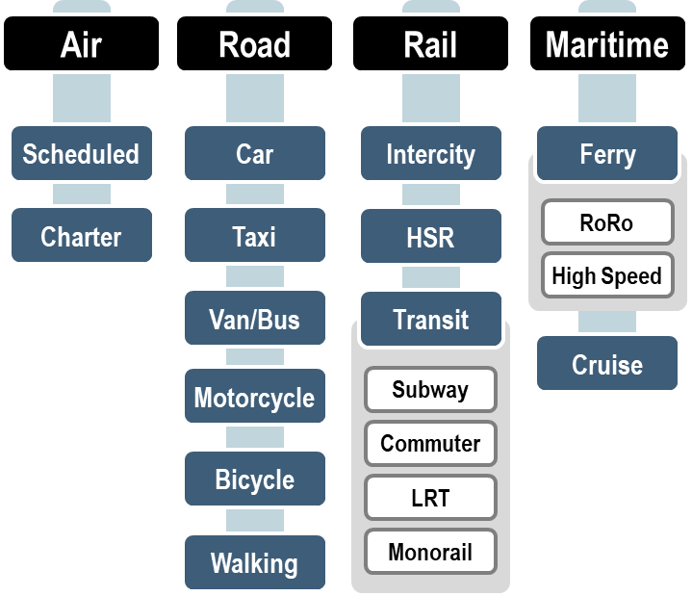Main Passenger Modal Options
- 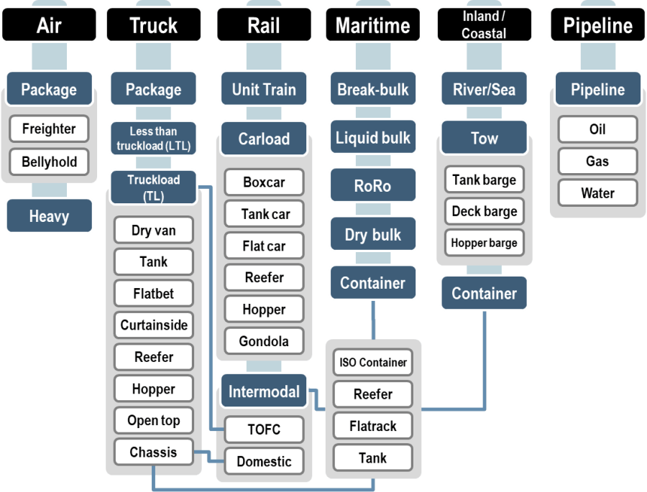Main Freight Modal Options
- 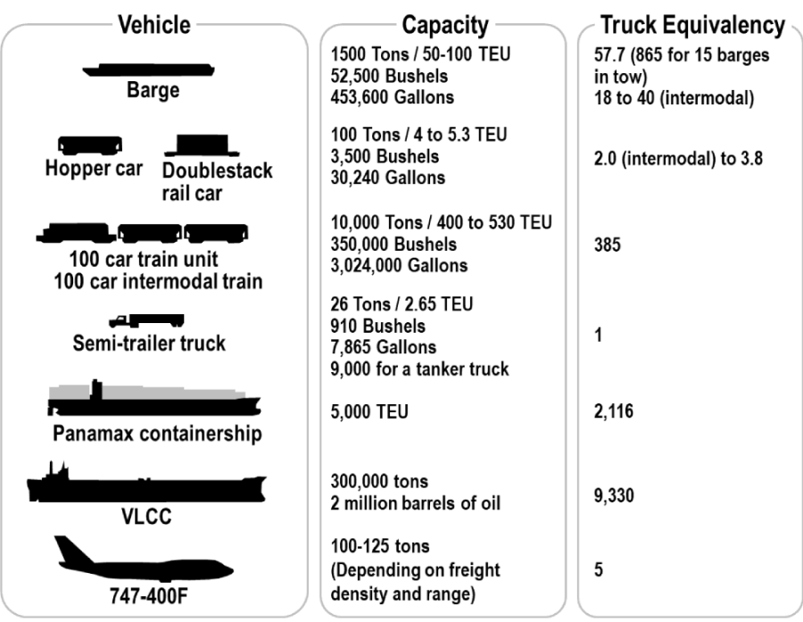Performance Comparison for Selected Freight Modes
- 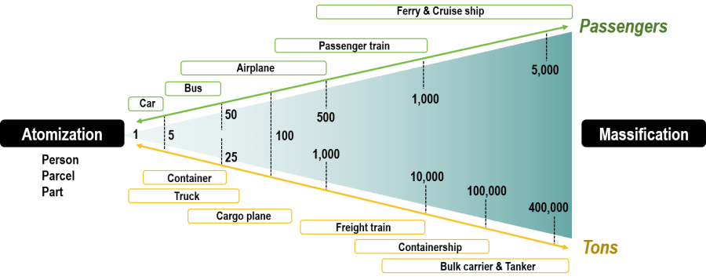Atomization versus Massification in Transportation Modes

a. Road transportation
Road infrastructures are large consumers of space with the lowest level of physical constraints among transportation modes. However, physiographical constraints are significant in road construction with substantial additional costs to overcome features such as rivers or rugged terrain. While historically road transportation was developed to support non-motorized forms of transportation (walking, domestic animals, and cycling at the end of the 19th century), it is motorization that has shaped the most of its development since the beginning of the 20th century.
Road transportation has average operational flexibility as vehicles can serve several purposes but can rarely operate outside roads. Road transport systems have high maintenance costs, both for the vehicles and infrastructures. They are mainly linked to light industries and freight distribution, where rapid movements of freight in small batches are the norm. Yet, with containerization, road transportation has become a crucial link in freight distribution.

b. Rail transportation and pipelines
Railways are composed of a traced path on which wheeled vehicles are bound. In light of recent technological developments, rail transportation also includes monorails and maglev. They have an average level of physical constraints, and a low gradient is required, particularly for freight. Heavy industries are traditionally linked with rail transport systems, although containerization has improved the flexibility of rail transportation by linking it with road and maritime modes. Rail is by far the land transportation mode offering the highest capacity with a 23,000 tons fully loaded coal unit train being the heaviest load ever carried. Gauges, however, vary around the world, often challenging the integration of rail systems.
Pipeline routes are practically unlimited as they can be laid on land or underwater. Their purpose is to move liquids such as petroleum products over long distances in a cost-effective fashion. The longest gas pipeline links Alberta to Sarnia (Canada), which is 2,911 km in length. The longest oil pipeline is the Transiberian, extending over 9,344 km from the Russian arctic oilfields in eastern Siberia to Western Europe. Physical constraints are low and include the landscape and pergelisol in arctic environments. Pipeline construction costs vary according to the diameter and increase proportionally with the distance and with the viscosity of fluids (from low viscosity gas to high viscosity oil). The Trans Alaskan pipeline, which is 1,300 km long, was built under challenging conditions and had to be above ground for most of its path. Pipeline terminals are essential since they correspond to refineries and harbors.
- 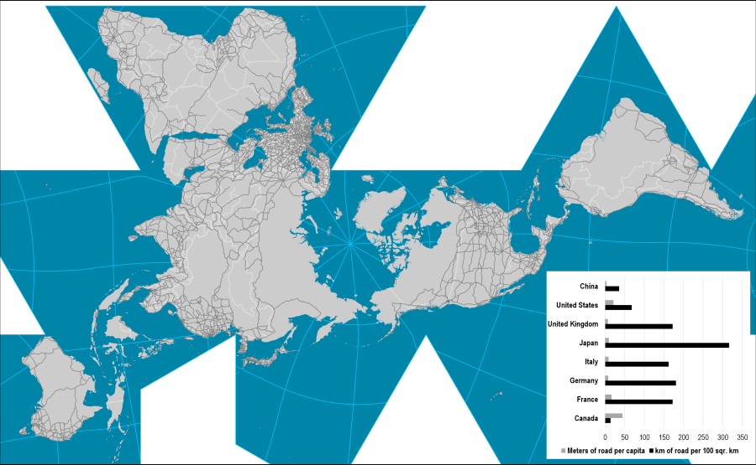World Main Road Network
- 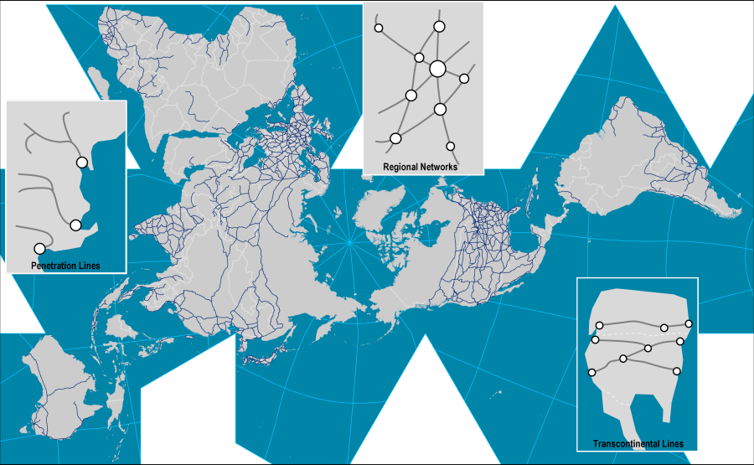World Rail Network and Rail Systems
- 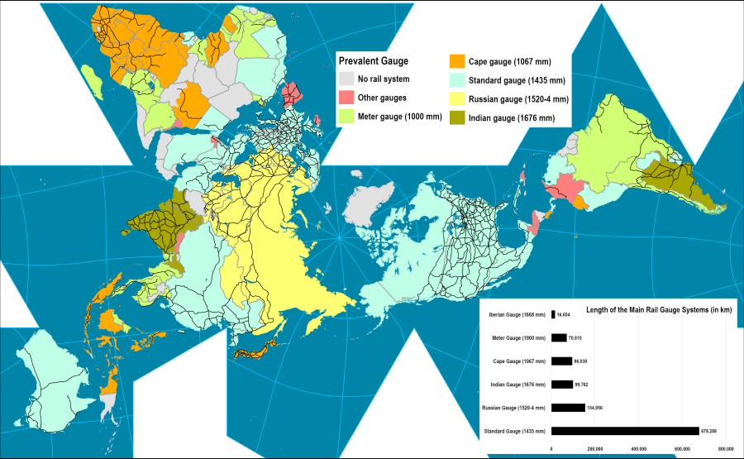Major Gauges of the Global Rail Systems
- 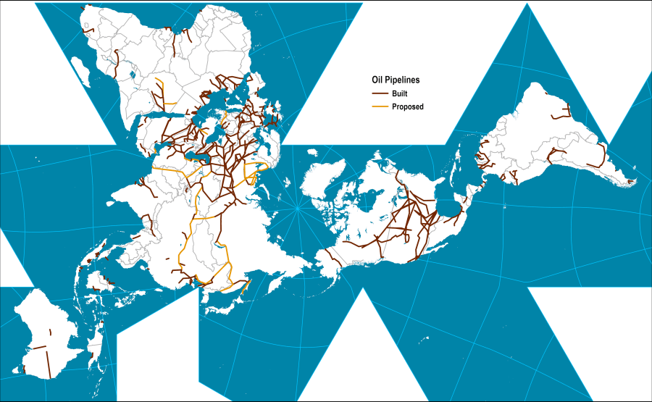Major Oil Pipelines

c. Maritime transportation
With physical properties such as buoyancy and limited friction, maritime transportation is the most effective mode to move large quantities of cargo over long distances. Main maritime routes are composed of oceans, coasts, seas, lakes, rivers, and channels. However, due to the location of economic activities, maritime circulation takes place on specific parts of the maritime space, particularly over the North Atlantic and the North Pacific. The construction of channels, locks, and dredging are attempting to facilitate maritime circulation by reducing its discontinuity, but such endeavors are highly expensive. Comprehensive inland waterway systems include Western Europe, the Volga / Don system, the St. Lawrence / Great Lakes system, the Mississippi and its tributaries, the Amazon, the Panama / Paraguay, and the interior of China.
Maritime transportation has high terminal costs since port infrastructures are among the most expensive to build, maintain, and operate. These high costs also relate to maritime shipping, where the construction, operation, and maintenance of ships is capital intensive. More than any other mode, maritime transportation is linked to heavy industries, such as steel and petrochemical facilities adjacent to port sites. Yet, with containerization, maritime shipping has become the linchpin of globalization, allowing trading a wide range of goods and commodities.

d. Air transportation
Air routes are practically unlimited, but they are denser over the North Atlantic, inside North America and Europe and over the North Pacific. Air transport constraints are multidimensional and include the site (a commercial plane needs about 3,300 meters of runway for landing and take-off), the climate, fog, and aerial currents. Air activities are linked to the tertiary and quaternary sectors, notably finance and tourism, which lean on the long-distance mobility of people. More recently, air transportation has been accommodating growing quantities of high-value freight and is playing an increasing role in global logistics.

e. Intermodal transportation
Intermodalism concerns a variety of modes used in combination so that the respective advantages of each mode are advantaged. Although intermodal transportation applies for passenger movements, such as the usage of the different, interconnected modes of a public transit system, it is over freight transportation that the most significant impacts of intermodalism have been observed. Containerization has been a powerful vector of intermodal integration, enabling maritime and land transportation systems to interconnect.

f. Telecommunications
Cover a grey area in terms of if they can be considered as a transport mode since telecommunications often do not have an apparent physicality. Yet, this physicality is real since they are structured as high capacity networks with very low constraints, which may include the physiography and oceanic masses crossed by fiber optic cables. They provide for the “instantaneous” movement of information (speed of light). Wave transmissions, because of their limited coverage, often require substations, such as for cellular phone and data networks where WiFi connections are of even more limited range. Satellites are often using a geostationary orbit, which is getting crowded.
High network costs and low distribution costs characterize many telecommunication networks, which are linked to the tertiary and quaternary sectors (stock markets, business to business information networks, etc.). Telecommunications can provide a substitution for personal mobility in some economic sectors, but the major impact is related to e-commerce, which has opened a whole range of commercial opportunities.
- 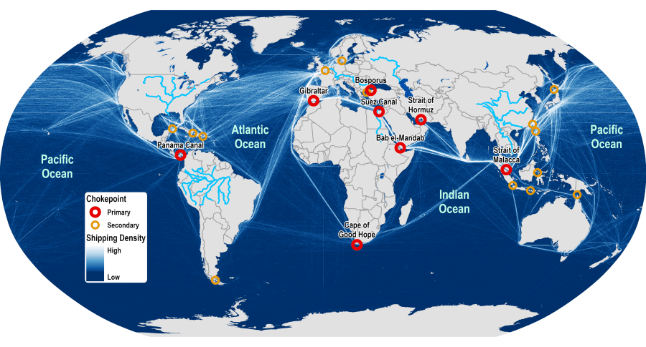Domains of Maritime Circulation
- 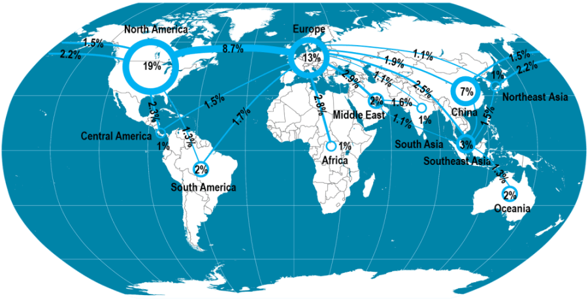Major Air Traffic Flows Between Regions, 2010
- 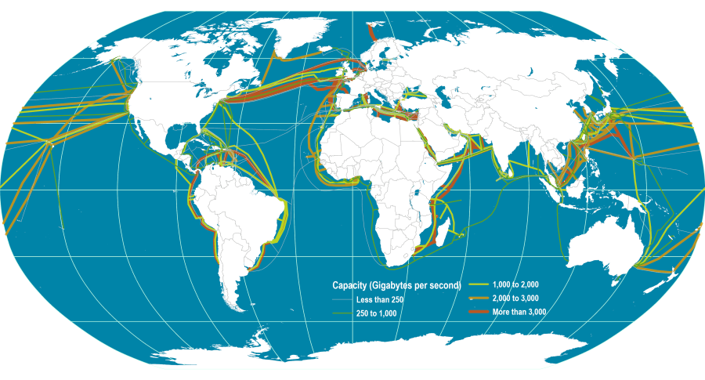Global Submarine Cable Network

2. Modal Competition
Each transportation mode has key operational and commercial advantages and properties. However, contemporary demand is influenced by integrated transportation systems that require flexibility in the respective use of each mode. As a result, modal competition exists at various degrees and takes several dimensions. Modes can compete or complement one another in terms of cost, speed, accessibility, frequency, safety, comfort, etc. There are three main conditions that ensure that some modes are complementing one another:
- Different geographical markets. If different markets are involved, modes will enable a continuity within the transport system, particularly if different scales are concerned, such as between national and international transportation. This requires an interconnection, commonly known as a gateway, where it is possible to transfer from one mode to the other. Intermodal transportation has been particularly relevant to improve the complementarity and connectivity of different geographical markets.
- Different transport markets. The nature of what is being transported, such as passengers or freight, often indicates a level of complementarity. Even if the same market area is serviced, it may not be equally accessible, depending on the mode used. Thus, in some markets, rail and road transportation can be complementary as one may be focusing on passengers and the other on freight.
- Different levels of service. For a similar market and accessibility, two modes that offer a different level of service will tend to complement another with niche services. The most prevailing complementarity concerns costs versus time.
Thus, there is modal competition when there is an overlap in geography, transport markets, and level of service. Cost is one of the most important considerations in modal choice. Because each mode has its price/performance profile, competition between the modes depends primarily upon the distance traveled, the quantities shipped, and their value. While maritime transport might offer the lowest variable costs, road transport tends to be most competitive over short distances and for small bundles of goods. A critical factor is the terminal cost structure for each mode, where the costs (and delays) of loading and unloading a unit impose fixed costs that are incurred independent of the distance traveled.
- 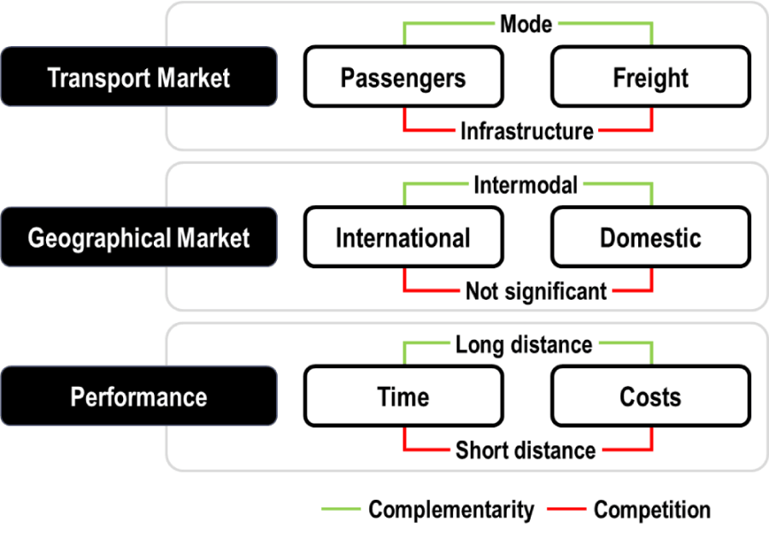Modal Competition and Complementarity
- 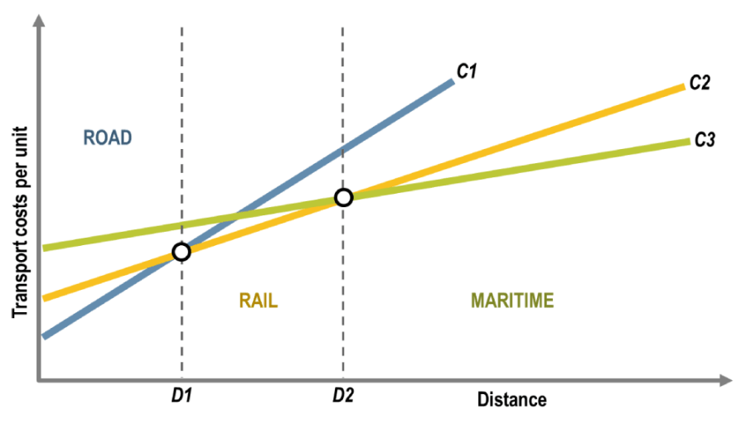Distance, Modal Choice and Transport Cost
- 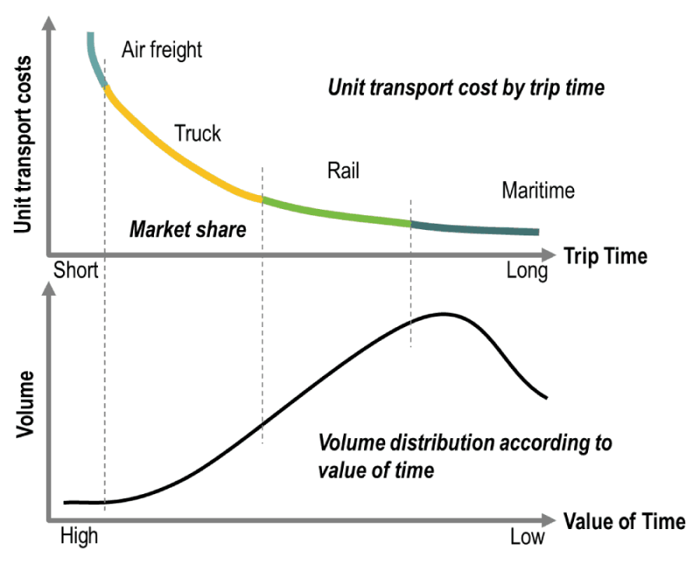Distribution of Freight Demand by Mode
- 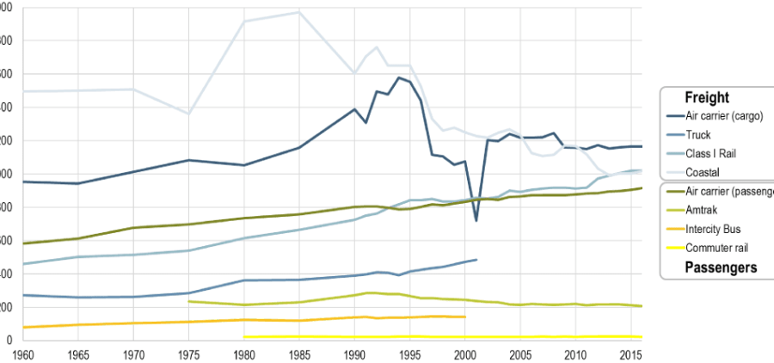Average Length of Haul, Domestic Passenger and Freight Transport, United States, 1960-2016
- 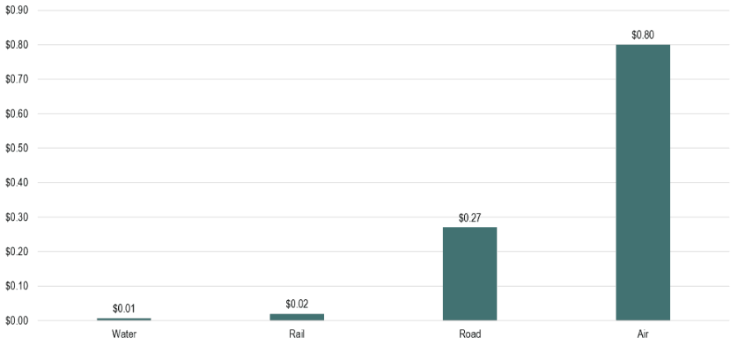Freight Transport Revenue per Ton-Mile
With increasing income levels, the propensity for people to travel rises. At the same time, international trade in manufactured goods and parts has increased. These trends in travel demand act differently upon modes. Those that offer faster and more reliable services gain over modes that might provide a lower cost, but slower, alternative. For passenger services, rail is challenged by the competition of road transport over short distances and aircraft for longer trips. For freight, rail and shipping have been impacted by competition from road and air modes. While shipping, pipelines, and rail still perform well for bulk shipments, competition over the last decades have seen road and air modes capture an important market share of the high revenue-generating goods. Road transportation continues to dominate the passenger and freight transportation markets.
Although intermodal transportation has opened many opportunities for complementarity between modes, transport operators are now competing over many modes in the transport chain. A growing paradigm thus involves supply chain competition with the modal competition component occurring over three dimensions:
- Modal usage. A competition that involves the comparative advantage of using a specific or a combination of modes. Distance remains one of the primary determinants of modal utilization for passenger transportation. However, for a similar distance, costs, speed, and comfort can be significant factors behind the choice of a mode.
- Infrastructure usage. Competition resulting from the presence of freight and passenger traffic on the same itineraries linking the same nodes. Each level of capacity used by a mode is, therefore, at the expense of the other mode.
- Market area. Competition between transport terminals for using new location (terminal relocation or expansion) or capturing new markets (hinterland).
- 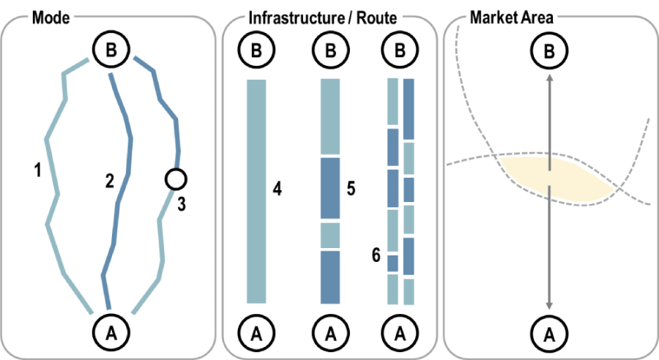Forms of Modal Competition
- 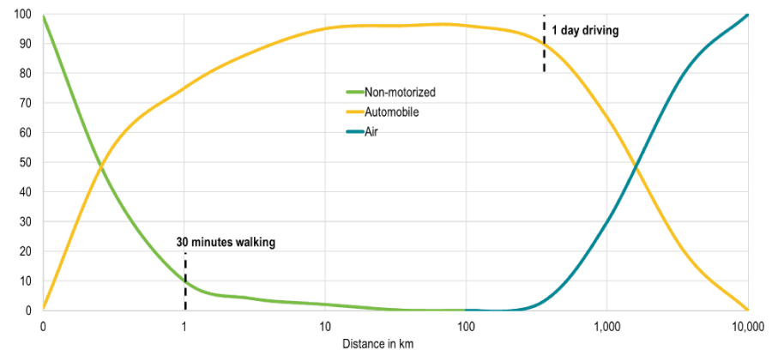Modal Split in the United States by Passenger Travel Distance, 1995
It is generally advocated that a form of modal equality (or modal neutrality) should be part of public policy where each mode would compete based upon its inherent characteristics. Since different transport modes are under different jurisdictions and funding mechanisms, modal equality is conceptually impossible as some modes will always be more advantageous than others. Modal competition is influenced by public policy, particularly over the funding of infrastructure and regulation issues. Roads are usually provided by the public sector, while many other transport infrastructures are financed by the operators using them. This is the case for rail, air and maritime transportation. For instance, in the United States, the Federal Government would finance 80% of the costs of a highway project, leaving the state government to supply the remaining 20%. For public transit, this share is 50%, while for passenger rail, the Federal Government will not provide any funding. Under such circumstances, public policy shapes modal preferences.

3. Modal Shift
The technological evolution in the transport industry aims at adapting transport infrastructures to growing needs and requirements. When a transport mode becomes more advantageous than another over the same route or market, a modal shift is likely to take place.
A modal shift involves the growth in the demand of a transport mode at the expense of another, although a modal shift can involve an absolute growth in both concerned modes.
The comparative advantages behind a modal shift can be in terms of costs, convenience, speed, or reliability. For passengers, this involved a transition in modal preferences as incomes went up, such as from collective (public transit) to individual modes (motorbikes, automobiles) of transportation. For freight, this has implied a shift to faster and more flexible modes when possible and cost-effective, namely trucking and air freight. A modal shift can further be nuanced by time shift, for which the use of the same mode takes place at another time period, likely when there is less congestion. In a situation of congestion, it is thus likely that time shift will be preferred to modal shift, particularly if the time shift is relatively marginal (e.g. a few hours). An individual may delay travel at a later time while a freight delivery can be rescheduled.
There are important geographical variations in modal competition. The availability of transport infrastructures and networks varies enormously, with corridors subject to the highest modal competition level. Corridors have many different modes that, in combination, provide a range of transport services that ensure an efficient commercial environment. Thus, in contrast to the European Union situation, rail freight transport occupies a more significant market share in North America, but passenger rail has a negligible share. In many parts of the world, however, there are only limited services, and some important modes such as rail may be absent altogether. This limits the choices for passengers and shippers and acts to limit accessibility. Passengers and freight are forced to use the only available modes that may not be the most effective to support their mobility. Areas with limited modal choices tend to be among the least developed. On the other hand, advanced economies possess a wide range of modes that can provide services to meet the needs of society and the economy.
All modes are affected by fuel price volatility, from the individual car owner to the corporation operating a fleet of hundreds of aircraft or ships. Different pricing mechanisms are used, namely direct rate adjustments, as in the case of shipping, or indirect adjustments as in the case of airlines, with the reliance on fuel surcharges when energy prices are increasing. In the context of higher energy prices and environmental concerns and therefore, higher input costs for transportation, the following can be expected:
- Higher transport costs increase the friction of distance and constrain mobility. As a major consumer of petroleum, the transport industry must increase rates. Across the board increases cause people to rethink their movement patterns and companies to adjust their supply and distribution chains.
- Because energy costs impact modes differently, a modal shift can be anticipated. Road and air transport are more energy-intensive than the other modes, so energy price increases are likely to impact them more severely than other modes. This could lead to a shift towards water and rail transport in particular.
- Higher fuel prices incite a greater fuel economy across modes and reducing speed.
- 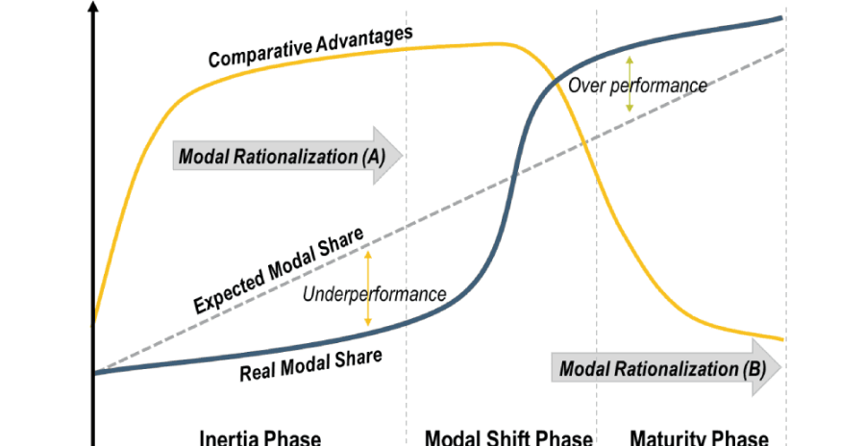Principles of Modal Shift
- 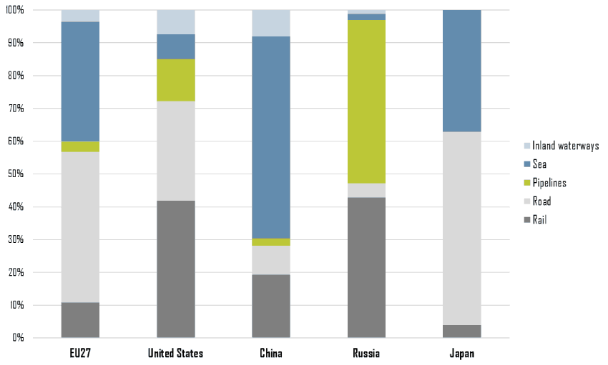Modal Share of Freight Transportation, Selected Countries, 2008 (in % of ton-kms)
- 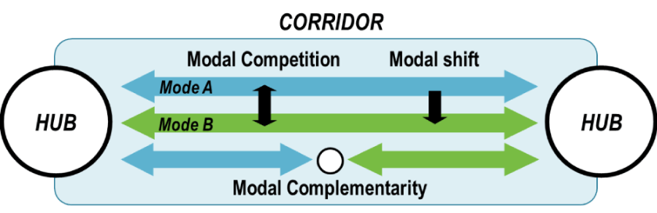Modal Competition, Complementarity and Shift along a Corridor
- 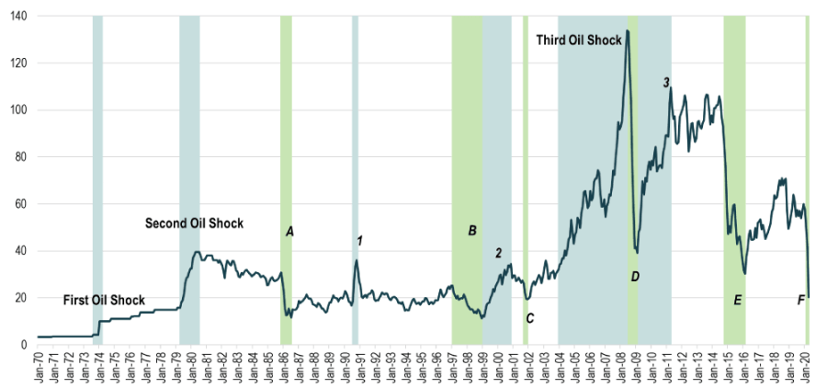West Texas Intermediate, Monthly Nominal Spot Oil Price (1970-2019)

4. Passengers and Freight: Complementarity versus Competition
There is a complementarity between passenger and freight transport systems. With some exceptions, such as buses and pipelines, most transport modes have developed to handle both freight and passenger traffic. In some cases, both are carried in the same vehicle, as in air transport, where about 80% of the freight is transported in the cargo holds of passenger aircraft. In others, different types of vehicles have been developed for freight and passenger traffic, but they both share the same road infrastructure, such as in rail and road traffic. In shipping, passengers and freight used to share the same vessels and often the same terminals. Since the 1950s, specialization has occurred, and the two are now entirely distinct, except for ferries and some RORO services.
- 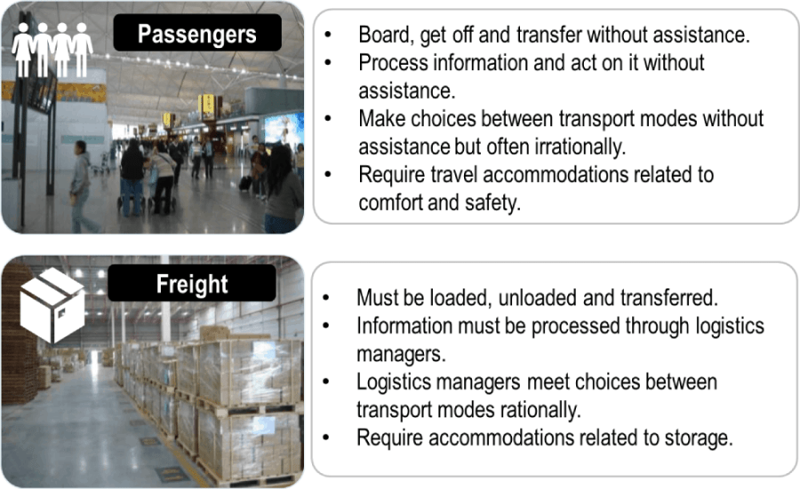Operational Differences between Passengers and Freight Transportation
Sharing freight and passenger modes is not without difficulties, and indeed some of the major problems confronting transportation occur where the two compete for the use of scarce transport infrastructure. For example, trucks in urban areas are seen as a nuisance and a cause of congestion by passenger transport users. Daytime deliveries and double-parked trucks are perceived as a particular nuisance. The poor performance of some modes, such as rail, is seen as the outcome of freight and passengers having to share routes. There are also growing interests expressed at using segments of transit systems to move freight, particularly in central areas. This raises the question as to what extent and under which circumstances freight and passengers are compatible. The main advantages of joint operations are:
- High capital costs can be justified and amortized with a diverse revenue stream.
- Maintenance costs can be spread over a broader base.
- The same modes or traction sources can be used for both freight and passengers, particularly for rail.
The main disadvantages of joint operations are:
- Locations of demand rarely match since the origins and destinations of freight flows are usually quite distinct spatially from passenger traffic.
- Frequency of demand is different for passengers, and the need is for high-frequency service. For freight, it tends to be somewhat less critical.
- Timing of service. Demand for passenger services has specific peaks during the day. For freight, it tends to be more evenly spread throughout the day. Several freight operations prefer night services since they ensure that shipments arrive at their destination in the morning.
- Traffic balance. On a daily basis, passenger flows tend to be in equilibrium, irrespective of the distance involved (e.g. commuting or air transportation). For freight, market imbalances produce empty flows that require the repositioning of assets.
- Reliability. Although freight traffic increasingly demands quality service, delays (diversion from posted schedules) are unacceptable for passengers.
- Sharing routes favor passenger traffic with passenger trains often given priority or trucks excluded from specific areas at certain times of the day.
- Different operational speeds where passengers demand faster service but specific cargo, such as parcel, facing similar requirements.
- Security screening measures for passengers and freight require different procedures.
The ongoing separation of passengers and freight on specific gateways and corridors is consequently a likely outcome, involving a growing divergence of flows, modes, and terminals.

5. A Growing Divergence
Passengers and freight are increasingly divergent activities as they reflect different transportation markets. In several modes and across many regions, passenger and freight transport are being unbundled.

a. Shipping
It has already been mentioned that in the maritime sector, passenger services have become separated from freight operations. The exception is ferry services, where ro-ro ships on high-frequency services adapt to the needs of both passenger and freight market segments. These ferry ships can transport cars, buses, and trucks carrying freight with the respective proportions determined by the demand. Deep-sea passenger travel is dominated by cruise shipping, which has no freight-handling capabilities, and bulk and general cargo ships rarely have an interest or the ability to transport passengers.

b. Rail
Most rail systems improved passenger and freight services, where both segments are maintained. The railways give priority to passengers since rail persists as the dominant mode for inter-city transport in India, China, and much of the developing world. In Europe, national rail systems have prioritized passenger service as a means to expand regional mobility. Significant investments have occurred in improving the comfort of trains and passenger rail stations, but most notable has been the upgrading of track and equipment to achieve higher operational speeds. Freight transport has tended to lose out because of the emphasis on passengers since such systems were optimized for passenger flows. Because of their lower operational speeds, freight trains are frequently excluded from day-time slots, when passenger trains are most in demand. Overnight journeys may not meet the needs of freight customers. This incompatibility is a factor in the loss of freight business by most rail systems still trying to operate both freight and passenger operations.
It is in North America where the separation between freight and passenger rail business is the most extensive. The private railway companies could not compete against the automobile and airline industry for passenger traffic and consequently withdrew from the passenger business in the 1970s. They were left to operate a freight-only system, which has generally been successful, especially with the introduction of intermodality. The passenger business has been taken over by public agencies, AMTRAK in the US, and VIA Rail in Canada. Both are struggling to survive. The major problem is that they have to lease trackage from the freight railways, and thus slower freight trains have priority.

c. Roads
Freight and passenger vehicles still share the roads. The growth of freight traffic is increasing road congestion, and in many cities, concerns are being raised about the presence of trucks. Already, restrictions are in place on truck dimensions and weights in certain parts of cities, and there are growing pressures to limiting truck access to non-daylight hours. Certain highways exclude truck traffic – the parkways in the US, for example. These are examples of what is likely to become a growing trend; the need to separate trucks from passenger vehicle traffic. Facing chronic congestion around the access points to the port of Rotterdam and at the freight terminals at Schiphol airport, Dutch engineers have worked on feasibility studies of developing underground road networks only for freight vehicles.

d. Air transport
Air transport is the mode where freight and passengers are the most integrated. First, they share the same terminal facilities, although there is a specialization with some airports focusing on freight activity. Yet, even here, a divergence is being noted. The growth of all-freight airlines and the freight-only planes operated by some major carriers, such as Singapore Airlines, are heralding a trend. The interests of the shippers, including the timing of the shipments and the destinations, are sometimes better served than in passenger aircraft. The divergence between passengers and freight is also being accentuated by the growing importance of charter and “low-cost” carriers. Their interest in freight is minimal, especially when their business is oriented towards tourism since tourist destinations tend to be lean freight generating locations.
https://www.ruralhealthinfo.org/toolkits/transportation/1/types-of-transportation

Types of Transportation
Rural community members primarily use six types of transportation to move around their environment. Depending on the community, some types of transportation may be more commonly available than others. These include:
- Buses, including those that operate within and between communities
- Passenger train service, including Amtrak or commuter rail lines
- Passenger air service, which can be commercial, private, or semi-private
- Personal vehicles like automobiles, including vans and cars for hire like taxis or ride-sharing services, and golf carts or all-terrain vehicles (ATVs)
- Pedestrian transportation, which includes walking and bicycling
- Boats, which may be personally owned or operated as a ferry service

Buses
Many rural communities use buses as the primary vehicle for their public transportation systems, operating fixed-route service on a regular schedule. Unlike rail systems that can require large investments in infrastructure, local or city bus systems use existing roads and lower-cost bus stops. This allows for more flexibility when designing, scheduling, and changing service routes.
The intercity bus system, which often operates larger charter or coach buses, has historically served as a significant form of transportation in rural areas. Intercity buses can provide critically important links between rural communities as well as transportation to larger, regional transit hubs like airports. However, transportation systems are increasingly focusing on expanding routes between large urban centers instead of smaller rural areas. In addition, many transportation carriers that formerly served smaller communities are reducing services because of low ridership and decreased profitability.

Passenger Train Service
Like intercity buses, passenger trains provide vital transportation links between rural communities. The National Railroad Passenger Corporation, also known as Amtrak, is the primary provider of this service in the continental United States. The state of Alaska also owns the Alaska Railroad, which provides intercity passenger and freight service. While the majority of passenger train riders live in metropolitan areas like the urban Northeast Corridor, trains can provide affordable, accessible transportation for rural residents traveling into cities for medical care, business, employment, and other services.

Passenger Air Service
People living in remote areas or places with very limited ground transportation access, like parts of Alaska, may rely on airplanes to conduct business, deliver goods, transport mail, obtain medical care, and visit friends or family. The federal government provides a subsidy through the Essential Air Service program that is designed to support commercial flights from small communities that would otherwise have limited or no commercial passenger air service. Currently, the program supports 60 rural communities in Alaska and 115 communities in the contiguous United States.

Personal Vehicles
Automobiles are the dominant mode of transportation in rural areas. Research indicates that only 60% of rural counties have public transportation available and of those, 28% have limited service. As such, rural residents are much more reliant on personal vehicles (cars, trucks, and vans) for routine travel needs. According to the Rural Transit Fact Book, over 90% of passenger trips in rural areas occur in automobiles, and over 80% of rural workers commute alone in a private vehicle. Only 4% of rural households report having zero vehicles available to them.
Rural residents are also more likely to continue driving over the age of 75 compared to their urban counterparts. However, for older adults and others who are unable to drive in rural areas, car-dominant communities can be difficult to navigate. In addition, ride-sharing services and commercial taxis may offer limited services in/to rural communities due to cost burdens associated with serving a population that is geographically dispersed. These costs can include longer distances between pick-up locations and longer wait times between passengers, which can increase costs for drivers that may also be passed down to users.
In addition to automobiles, rural residents may use golf carts or ATVs for short trips around their communities, often using sidewalks and bike lanes to safely avoid automobile traffic. These methods can be particularly useful for younger and older residents because they are relatively inexpensive and operate at slower speeds than cars.

Pedestrian Transportation
Biking and walking are becoming increasingly popular forms of transportation and exercise. However, many people living in rural areas may not be able to walk to work or school because of long distances between destinations or concerns about safety. Some rural communities are considering strategies to support pedestrian infrastructure to make it easier and safer for people to walk or bicycle around their community, to other transportation hubs like bus stations, and for recreation. Additionally, bike share programs in rural communities can make biking more affordable and accessible.

Boats
Particularly in some Alaskan communities with limited road access, boats may be an important source of transportation between population centers and services. In other places, ferries may serve as a link between island or river communities. Public and private ferry services are generally designed to carry both passengers and their automobiles. Waterways can also be significant sources of economic activity for rural communities from tourism, shipping, or fishing and harvesting operations.
https://www.goship.com/blog/modes-of-transportation-in-logistics/

What Are The Modes Of Transportation In Logistics?
Logistics is a very diverse and complex industry. It involves many modes of transportation and ways of shipping goods. Sometimes, it may be challenging for a company to choose the right mode of transportation to reach the best result. It can be especially difficult if you are new to domestic or global shipping. However, knowing the differences and benefits of each shipping method will help you define the option that will work best for you.

Different modes of transportation
There are several main transportation modes in the freight shipping industry:
- Ocean
- Air
- Rail
- Road
- Intermodal and Multimodal
All of these modes are extremely important and play a significant role in the industry. However, there are many differences in terms of price, shipped commodities, transit distance, etc. While some modes may be the perfect solution to one business, at the same time may be absolutely useless to another one.

Ocean shipping
Ocean shipping is the most popular way of moving large volumes of goods overseas. Compared to air, the ocean is a much more cost-efficient option yet a rather slow one. This mode of transportation works best for shippers who need to move goods on a distance longer than 400 km. Also, it works for oversized, hazardous, liquids, and weird-shaped freight. Ocean shipping is common among large and mid-sized businesses because they need global shipping on a regular basis. The freight is stacked in containers that are later loaded onto the ships or barges.

Air shipping
Probably the fanciest shipping mode, the air is a reliable and extremely quick way to ship freight. Obviously, extraordinary speed comes at a higher price. Because of its larger cost, the air is mostly used by bigger companies but small businesses often use it too. This option is the perfect solution for retail companies and light industries. Essentially, there are specialized aircraft for hefty cargo but in general, planes are not developed for handling oversized freight of unusual shape.

Over-the-Road Shipping
Over-the-road transportation is the most popular, the most frequently used, and the most in-demand mode of transportation. It works for everyone, from individual shippers to large enterprises. Also, road transport comes with a wide variety of equipment and shipping modes. There are two main types of over-the-road transportation: full truckload (FTL) and less-than-truckload (LTL). FTL shipping means that one shipper takes the entire truck capacity to move the freight when LTL suggests partial use of the trailer by several shippers. There are also various types of trailers that serve different shipping needs: dry van, flatbed, refrigerated, etc. It is easy to get a freight quote from the carrier and choose the needed equipment.

Intermodal and Multimodal
Choosing the right mode of transportation may be difficult, especially if you have a long and complicated route. Intermodal and multimodal can transportation solve this problem, as they are two types of combination transportation modes. Generally, intermodal and multimodal shipping suggest the combination of road, rail, ocean, or air for a single shipment. The only difference between both methods is that intermodal is handled under a single bill, while multimodal goes with separate bills from all the carriers involved. Generally, intermodal and multimodal can be very beneficial to the shipper in terms of price and flexibility.
Ultimately, each mode of transportation has its advantages and drawbacks. Depending on the size and needs of your business, you have a variety of options to choose from.
https://philburn.com/what-are-the-different-modes-of-transportation-in-logistics/

WHAT ARE THE DIFFERENT MODES OF TRANSPORTATION IN LOGISTICS?
March 16, 2017| By Mark Philpott| Posted in Blog| With comments are closed
There are not only a ton of transportation companies in Toronto to choose from, there are various transport methods as well. There are a number of different modes of transportation in the logistics industry, each having its own merits and disadvantages. From road, railway, marine, and air transportation, the method that you select depends on a few factors. For example, industries that need to transport heavy products opt for railway transportation along with road and Maritime transportation. These methods have the ability to accommodate heavier products, making them the ideal choice over air transportation. In this post, we’ll discuss five common types of transportation in the logistics industry: roadway, rail, marine, air, and intermodal transportation. Hopefully, the pros and cons of each method can aid in your decision when looking to transport goods from Atlantic Canada to Toronto and vice versa.

TOP 5 MODES OF TRANSPORTATION IN LOGISTICS

ROAD TRANSPORTATION
There are many advantages to road transportation, especially for companies who rely on fast delivery to retain their customers. If goods are meant to be transported immediately to the Maritimes from Mississauga, for example, your best bet would be ground shipping transportation. Water transport is notoriously slow, and it can be a hassle to book railway transportation.
Maritime trucking to Mississauga and other locations is more cost-effective than other options; with rail transport, if there isn’t a railway that leads to your desired destination, you’ll have to build it, which can be a costly investment. However, there are roads that lead to pretty much everywhere, and are built and paid for by the government; more often than not, you’ll only have to pay a small fee to use them. Roadway transportation to Atlantic Canada from Mississauga can also be cost-effective since it provides door-to-door or warehouse-to-warehouse service. This allows cartage, as well and loading and unloading expenses, to be significantly lower compared to other methods.

RAIL TRANSPORTATION
Railway transportation is arguably the most dependable method of transport to the Maritimes from Toronto and pretty much anywhere else. Unlike road and marine transport, rail is hardly affected by weather conditions. Transport trains will run in rain, fog, snow, and other conditions that would otherwise delay shipments carried by other methods. With fixed schedules that run regularly, railway service is more certain compared to other methods of shipment.
Rail transport also offers huge carrying capacities, which can grow to fit your needs. Unlike trucks or boats, which have a fixed about of space that can’t be exceeded, additional wagons can always be added to trains if you need more room. In addition to all the benefits for you and your company, you’ll also be giving great opportunities to surrounding communities. Rail transport can provide employment opportunities to both skilled and unskilled workers, making it a positive choice for the entire community. The biggest disadvantage, however, is that if there are delays in the transportation, it can actually take much longer to get your freight delivered than with other methods of transportation. With rail transportation, you need to schedule container drop off and pick up at the terminals which could end up taking a long time.

MARINE TRANSPORTATION
Marine transportation is notoriously slow, but that doesn’t matter when a product has a long lead time. This is a great option for those looking to ship bulky items that aren’t in much of a rush. Often cheaper than road transport, ships are usually the main cost that you’ll incur—you won’t have to worry about road tolls and other similar charges. While roadway transportation can easily be delayed by rain or other types of inclement weather, the same conditions may not affect marine transport.
The main disadvantage of marine transport is that it can be difficult to monitor the exact location of the goods in transit, which can be a deal-breaker for some. As you’ve read in our past posts, being able to track freight is a common expectation of consumers who order things from online retailers and can affect their purchase decision. While there are many advantages to marine transport, the downside of the lack of ability to closely track the exact whereabouts of the specified freight can be crucial.

AIR TRANSPORTATION
Air transport is extremely useful for many reasons: it`s convenient, fast, and doesn’t have to compete with natural barriers. While road transport is the quickest way to deliver goods that only have a short distance to travel, air transportation is the fastest option for freight that have a further destination—it’s even regarded as the best mode of transportation for perishable goods for this reason.
In addition, air transportation doesn’t require the infrastructure investment that railways do; airplanes fly freely, which means you don’t need to spend the initial cash building a pathway to your destination for it to get there! The lack of barriers also means that it’s accessible to all areas, regardless the obstruction of land. However, one main disadvantage is that planes can easily be affected by pretty much any type of inclement weather. Whether it’s rain, snow, or high winds, your shipment is likely to get delayed if any weather condition becomes extreme.

INTERMODAL TRANSPORTATION
As you’ve probably noticed through reading this post, each method of transport has its advantages and disadvantages. What if you could combine the pros of each method to create one innovative method? That’s exactly what intermodal transportation is.
Intermodal transportation offers the best of both worlds: it combines various transportation methods to give you the fastest shipping time possible. Not only is this method time-efficient, it’s cost-efficient as well. More shippers are taking advantage of the option to reap the benefits of the cost savings, environmental benefits, and highway safety results. With the lower rates, predictable pricing, standardized transit schedules, and flexibility, intermodal transportation is continuing to rise in popularity.

TRANSPORTATION COMPANY IN TORONTO, ONTARIO
Philburn Logistics Inc. is one of the top freight companies in Mississauga and the GTA. We are an asset-based trucking company operating out of Mississauga and offer both TL and LTL shipping services to all of our clients and ship throughout Ontario and the Maritime Provinces.
If you’re searching for a transportation company in Toronto that can meet all of your needs and more, then Philburn Logistics Inc. is the company for you. Getting your freight to its destination isn’t our only goal—we strive to exceed your expectations and deliver your goods in perfect condition while getting it to its destination on time. While our distribution centre is based in Toronto, we ship throughout the entire province and even as far as Atlantic Canada. If you’d like to take advantage of our exceptional serviced and affordable rates, contact us today.
https://smallbusiness.chron.com/importance-warehousing-logistics-system-74825.html

The Importance of Warehousing in a Logistics System
- Small Business
- Advertising & Marketing
- New Product Marketing
ByAndra PicincuUpdated April 17, 2019

RELATED
- How to Develop a Logistics Support Plan
- What Does the Term Drop Ship Mean?
- Distribution Objectives for a Yogurt Business
- How Do Third Party Logistics Improve Customer Satisfaction?
- How to Deliver Fresh Pastries
Warehousing is a requirement for most businesses that manufacture, import, export or transport goods. You might see it as an unnecessary expense, but it can actually save you money and boost your productivity. The customer journey doesn't end when an order is placed. A warehouse gives you better control over your inventory and ensures that customers will receive their products on time, which ultimately leads to higher profits.

Better Inventory Management
Approximately 8 percent of small businesses don't track their inventory. About 24 percent don't have inventory at all. This often leads to late shipments, delayed order processing and poor customer experience.
Warehouses provide a centralized location for your goods, making it easier to track and manage your inventory. By investing in a warehouse, you'll store, ship and distribute products more efficiently. If something is out of stock, you'll know it right away and provide customers with alternative options rather than leaving them waiting for days or weeks.

More Efficient Packing and Processing
Most warehouses provide the equipment and supplies you need to store, move, package and process orders from customers. Pallet racks, loading docks and packing materials are just a few to mention. This way, you'll have everything in one place, which will save you time and money.
A warehouse enables businesses to pack and grade their goods according to legal requirements and customer needs. The logistical cost is reduced, while flexibility is maximized. This type of facility can be an ideal distribution location, eliminating the need to arrange for pickup and hire employees to manage fulfillment.

Superior Customer Service
More than 63 percent of online customers expect to know the estimated or guaranteed delivery time. Approximately 88 percent would pay more for faster delivery. In fact, delivery speed is one of the first things buyers take into consideration when choosing a shipping carrier.
As a business owner, you want to keep your customer satisfied and engaged. If you fail to deliver their orders on time, your reputation will suffer. This can hurt your revenue and brand image.
Warehousing allows for timely delivery and optimized distribution, leading to increased labor productivity and greater customer satisfaction. It also helps reduce errors and damage in the order fulfillment process. Plus, it prevents your goods from getting lost or stolen during handling.

Ensure Price Stabilization
The demand for goods and services varies from month to month and year to year, depending on customers' income, government policies, employment rates, climatic conditions and other factors. A warehouse allows you to store your products for a later date when the demand is high. This helps ensure price stabilization and reduces revenue losses.
Let's say your company manufactures and distributes sports equipment. If you offer ski accessories, you can store them in your warehouse rather than selling them for next to nothing when the cold season ends. This way, you'll maintain consistent stock levels and maximize your profits.

Improved Risk Management
Warehousing not only protects against price fluctuations but also provides safe storage of perishable products. Depending on your needs and type of business, you can lease a warehouse equipped with refrigerators, freezers and optimal temperature control.
Plants, artwork, candles, food and medications are just a few examples of goods that require cold storage. A warehouse that offers this service will store your goods at the right temperature, preventing spoilage and changes in color and texture. This also helps extend the product’s shelf life and ensures customer satisfaction.
Additionally, the products stored in warehouses are typically insured. This means that you have higher chances to receive compensation from your insurance company in case of damage, fire or theft.
https://bridgewaterlogistics.co.za/the-effectiveness-of-warehousing-in-the-supply-chain-process/

THE EFFECTIVENESS OF WAREHOUSING IN THE SUPPLY CHAIN PROCESS
Apr282017
News
Warehousing and warehouse management are part of the logistics management system, which in itself is part of the supply chain. Warehousing plays a vital role in the supply chain process. A warehouse is a large, spacious place that is used for the storage or accumulation of goods. Storing goods throughout the year and releasing when they are needed creates time utility. Although this is viewed simply to store goods, warehousing plays a fundamental role in the logistics system. Inbound functions assist to prepare for storage as well as outbound functions pack and ship orders, resulting in benefits for both the business and customers.
Storage Facility: This brings higher returns for your business. Manufacturing or the purchasing of goods in bulk always makes sense in a business point of view.
Convenience: Distribution is an important part of any business, customers should never experience out of stock situations. Having one central warehouse that stores all your goods feeding your distribution process will have you constantly in control of the stock available as well as what is needed in the near future. This is called safety stocking, ensuring your business doesn’t run into unexpected problems such as faulty stock or shipment delays.
Additional Revenue: Owning your own storage facility could provide revenue by leasing out warehouse space. The ability to manufacture or buy goods in bulk also allows for greater revenue returns. These are both great ways to save money and expand your business.
Distribution: Warehousing and the placement of the warehouse can directly impact on your distribution. The further away your storage facility or warehousing is situated from your suppliers or manufacturers, the more your distribution costs will rise. Strategic placement of the facility can dramatically affect your transportation costs, in turn affecting your own product. Alternatively, some countries such as Germany use warehouses as their storage and retail facility.
These are just a few of the ways that warehousing can directly affect your business and the supply chain within it. Bridgewater Logistics is an industry specialist in providing affordable warehousing solutions in South Africa that can be used to benefit you in the ways listed above as well as many more ensuring the best for your business.

Material handling is the movement, protection, storage and control of materials and products throughout manufacturing, warehousing, distribution, consumption and disposal. As a process, material handling incorporates a wide range of manual, semi-automated and automated equipment and systems that support logistics and make the supply chain work. Their application helps with:
- Forecasting
- Resource allocation
- Production planning
- Flow and process management
- Inventory management and control
- Customer delivery
- After-sales support and service
A company’s material handling system and processes are put in place to improve customer service, reduce inventory, shorten delivery time, and lower overall handling costs in manufacturing, distribution and transportation.
https://www.mhi.org/fundamentals/material-handling#:~:text=Material%20handling%20is%20the%20movement,%2C%20distribution%2C%20consumption%20and%20disposal.
https://www.thomasnet.com/articles/materials-handling/material-handling-equipment/

Material Handling Equipment (Types, Applications and Suppliers)

Share:

Forklifts are an essential piece of Material Handling Equipment
Image credit: Parilov/Shutterstock.com
Welcome to Thomas' Guide to Industrial Material Handling Equipment.
Below you will find a full write-up of the various types of material handling equipment available, their definitions and applications, and the top suppliers of material handling equipment to evaluate for your situation.

Table of Contents
- What is Industrial Material Handling Equipment?
- Top Suppliers of Industrial Material Handling Equipment
- Types of Material Handling Equipment
  - Storage and Handling Equipment
  - Engineered Systems
  - Industrial Trucks
  - Bulk Material Handling Equipment

What is Industrial Material Handling Equipment?
Industrial material handling equipment encompasses a diverse range of tools, vehicles, storage units, appliances and accessories involved in transporting, storing, controlling, enumerating and protecting products at any stage of manufacturing, distribution consumption or disposal.

Top Suppliers of Industrial Material Handling Equipment
The Supplier Discovery Platform at Thomasnet.com has information on over 500,000 industrial suppliers, manufacturers, distributors and OEMs. We've pulled together the top material handling equipment suppliers and listed them below.
Click the supplier name to go to their full company profile, where you can research their products, add them to shortlists, and send RFIs and other questions.
Table 1 - Suppliers and Material Handling Equipment
Company | Headquarters | Company Type | Annual Sales
A Plus Warehouse Equipment & Supply | Lynn, MA | Distributor | $10 - 24.9M
Warehouse Equipment & Supply Company, Inc. | Birmingham, AL | Distributor | $10 - 24.9M
Lifting Gear Hire | Bridgeview, IL | Service Company | Not Available.
Toolots, Inc. | Cerritos, CA | Distributor | Not Available.
Liftomatic Material Handling, Inc. | Buffalo Grove, IL | Distributor | Under $1 Mil
A Plus Warehouse Equipment & Supply, in Lynn, MA, distributes a variety of warehouse equipment including material handling equipment. Their selection includes storage shelving, racks, bins, conveyors, forklift attachments, hoists, carts, trucks, hoppers, and stackers, among other things.
In Birmingham, AL, Warehouse Equipment & Supply Company, Inc. offers containers and bins, pallet positioners, racks, trucks, lockers, shelving, carts, ramps, wrapping systems, doors, fans, impact barriers, dock products, casters, and shelf decking.
Lifting Gear Hire provides pallet lifters, cranes, booms, trucks, material lifts, and skip pans, as well as hoisting, pulling, rigging, jacking, and safety equipment. The company is based out of Bridgeview, IL.
Toolots, Inc., in Cerritos, CA, supplies pallet jacks, carts, trucks, dollies, forklifts, containers, cabinets, dock equipment, hoists, ladders, platforms, scaffolding, lifting magnets, straps, scales, winches, shelving, wire rope, and accessories. Products come with a year-long warranty for parts and repair.
Finally in Buffalo Grove, IL, Liftomatic Material Handling, Inc. specializes in drum and barrel handling equipment. The types available include forklift mounted, portable, hoist mounted, drum dumping equipment, custom equipment, fork-mounted beams and hooks, and replacement parts and components. They also offer rentals and refurbishment.

Types of Material Handling Equipment
The four main categories of material handling equipment include storage, engineered systems, industrial trucks, and bulk material handling.

Storage and Handling Equipment
Storage equipment is usually limited to non-automated examples, which are grouped in with engineered systems. Storage equipment is used to hold or buffer materials during “downtimes,” or times when they are not being transported. These periods could refer to temporary pauses during long-term transportation or long-term storage designed to allow the buildup of stock. The majority of storage equipment refers to pallets, shelves or racks onto which materials may be stacked in an orderly manner to await transportation or consumption. Many companies have investigated increased efficiency possibilities in storage equipment by designing proprietary packaging that allows materials or products of a certain type to conserve space while in inventory.

Examples of storage and handling equipment include:
- Racks, such as pallet racks, drive-through or drive-in racks, push-back racks, and sliding racks, are a basic but important method of storage, saving floor space while keeping their contents accessible.
- Stacking frames are stackable like blocks, as their name implies. They allow crushable pallets of inventory, such as containers of liquid, to be stacked to save space without damage.
- Shelves, bins, and drawers. Shelves, another basic storage method, are less open than racks. Used with bins and drawers, they’re more able to keep smaller and more difficult to manage materials and products stored and organized. Shelving types can include boltless, cantilever, revolving, and tie-down.
- Mezzanines, a type of indoor platform, help to create more floor space in a warehouse or other storage building for offices or more storage. Typical types include modular, movable, rack supported, building supported, and free-standing versions.
- Work assist tooling enables safe and efficient product handling across numerous industries in applications that require the movement of products, enhancing the efficiency of assembly and manufacturing operations.

Engineered Systems
Engineered systems cover a variety of units that work cohesively to enable storage and transportation. They are often automated. A good example of an engineered system is an Automated Storage and Retrieval System, often abbreviated AS/RS, which is a large automated organizational structure involving racks, aisles and shelves accessible by a “shuttle” system of retrieval. The shuttle system is a mechanized cherry picker that can be used by a worker or can perform fully automated functions to quickly locate a storage item’s location and quickly retrieve it for other uses.

Other types of engineered systems include:
- Conveyor systems come in a variety of types, depending on what they are meant to transport, including vibrating, overhead, chain, vertical, and apron conveyors.
- Automatic Guided Vehicles (AGV) are independent computer-operated trucks that transport loads along a predetermined path, with sensors and detectors to avoid bumping into anything.

Industrial Material Handling Trucks
Industrial trucks (material handling trucks) refer to the different kinds of transportation items and vehicles used to move materials and products in materials handling. These transportation devices can include small hand-operated trucks, pallet jacks, and various kinds of forklifts. These trucks have a variety of characteristics to make them suitable for different operations. Some trucks have forks, as in a forklift, or a flat surface with which to lift items, while some trucks require a separate piece of equipment for loading. Trucks can also be manual or powered lift and operation can be walk or ride, requiring a user to manually push them or to ride along on the truck. A stack truck can be used to stack items, while a non-stack truck is typically used for transportation and not for loading.

There are many types of industrial trucks:
- Hand trucks, one of the most basic pieces of material handling equipment, feature a small platform to set the edge of a heavy object on, and a long handle to use for leverage. Whatever is being moved must be tipped so that it rests on the handle, and is carried at a tilt to its destination.
- Pallet Trucks, also known as pallet jacks, are a type of truck specifically for pallets. They slide into a pallet and lift it up to move it. Pallet trucks come in both manual and electrical types.
- Walkie Stackers transport and lift pallets like a forklift, though they don’t include a place for the operator to ride in. They come in both powered or manual versions.
- Platform trucks are hand trucks low to the ground, with a wide platform for transporting goods.
- Order pickers lift the operator several feet above the ground on a platform so they can retrieve or store goods on high shelves.
- Sideloaders, also known as VNA (Very Narrow Aisle) trucks, are meant to fit in narrow warehouse aisles, as they can load objects from different directions. They’re also good for long, awkward products that need moving.
- Many types of AGV, or automatic guided vehicles, as discussed above, shuttle products along a route automatically, without human guidance.
See more on trucks and carts in our other Thomas' Buying Guide: Types of Trucks and Carts.

Bulk Material Handling Equipment
Bulk material handling refers to the storing, transportation and control of materials in loose bulk form. These materials can include food, liquid, or minerals, among others. Generally, these pieces of equipment deal with the items in loose form, such as conveyor belts or elevators designed to move large quantities of material, or in packaged form, through the use of drums and hoppers.
- Conveyors, as mentioned above, come in a wide variety of types for different types of bulk material.
- Stackers, which are usually automated, pile bulk material onto stockpiles, moving between two points along rails in a yard.
- Reclaimers are the opposite of stackers, retrieving materials from stockpiles, some using bucket wheels to carry the material while others are scraper or portal style.
- Bucket elevators, also known as grain legs, use buckets attached to a rotating chain or belt to carry material vertically.
- Grain elevators are tall buildings specifically for storing grain. They include equipment to convey the grain to the top of the elevator, where it is sent out for processing.
- Hoppers are funnel-shaped containers that allow material to be poured or dumped from one container to another. Unlike a funnel, though, hoppers can hold material until it’s needed, then release it.
- Silos are generally large storage structures for bulk materials, though they don’t necessarily include equipment to convey the material to the top of the structure like grain elevators. Different varieties include tower, bunker, and bag silos.

Conclusion
From top suppliers to the basic types of equipment, this guide is here to help orient you in the field of material handling equipment, so you can continue to grow your business and your bottom line. For more information resources, you can check out Thomas’ informational guides, or if you’re ready to start sourcing, feel free to check out our Supplier Discovery page, which has information on over 5,600 material handling equipment suppliers.
https://www.douglasequipment.com/blog/different-types-material-handling-equipment/

What Are the Different Types of Material Handling Equipment?

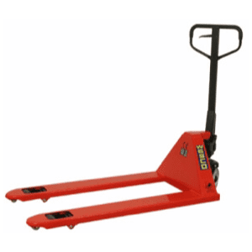
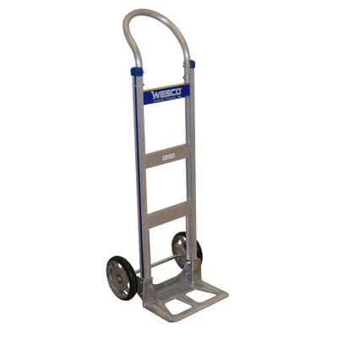

The term ‘material handling equipment’ is a pretty broad one. There’s plenty of situations where it’s critical to move large and often heavy materials in a production environment. Any piece of equipment that helps with this process could be labeled ‘material handling equipment’.
Plenty of items fall under this definition, from tools and storage units to vehicles and major appliances. Anything that deals with the transportation, storage and control at any stage of the processing of materials can be classified as material handling equipment.
We stock all types of material handling equipment from the top manufacturers: Wesco, Morse, B&P Manufacturing, Bluff Manufacturing, EGA Products, Harper Hand Trucks, Hilman Rollers, Little Giant, Lift-Rite, Omni Metal Craft, Presto Lifts, and Raymond Products.

4 Main Categories of Material Handling Equipment
There are 4 main categories of material handling equipment:
- Bulk material handling
- Engineered systems
- Industrial trucks
- Storage and handling equipment

Bulk Handling Material Equipment
The term ‘bulk handling equipment’ refers to the storage, control and transportation of materials by bulk, and in loose form. There are plenty of examples of this application – the handling of food, beverages, liquids, metal items (such as screws and nails) and minerals are just a few.
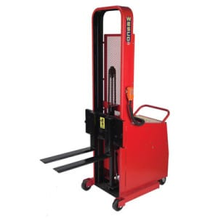In general terms, these pieces of equipment primarily handle these items when they are loose. One example is a conveyor belt that is used to move items from one part of the production process to another. Drums and hoppers may be used as well, to ‘funnel’ these loose items into a stage where they can be more easily manipulated, or packaged.
Conveyor belts are used for horizontal transportation. For vertical transportation, elevators are most commonly used.
Types of bulk handling material equipment
- Bucket and grain elevators
- Conveyor belts
- Hoppers and silos
- Reclaimers
- Stackers

Engineered Systems
An engineered system is one that is typically automated. Such systems are also usually created from a variety of units. When combined, they work to enable both storage and transportation.
An ‘Automated Storage and Retrieval System’ (or a AS/RS for short) is one example of a system that is engineered. This is a large, automated device that comes complete with racks, shelves and aisles. These storage solutions are accessed by a ‘shuttle’ – a mechanized device that’s similar to a cherry picker. This device can be used by the system operator to manually select the items as needed, or the entire system can be computerized and
An AS/RS can be integrated with a production facility’s existing computer network to keep on top of stock control, plus other logistical systems. It can also be integrated with other stages of the production process, so that as much automation can be offered as possible.
Types of engineered systems
- Automated guided vehicles (AGVs)
- Conveyor systems
- Robotic delivery systems

Industrial Trucks
This term is another broad definition that can be applied to many different types of equipment. Such pieces of equipment do have one thing in common, though – they all provide transportation.
The scope of this term can include both small, hand-operated devices, and large-scale motorized vehicles. Some items can be driven, while others – such as pallet trucks – simply add mobility to the materials that are being handled.
Many of these types of trucks have useful characteristics such as forks or a flat surface that can be inserted under pallets or other types of storage platforms. Other trucks need a separate item of equipment to use for lifting.
Trucks have the capability to lift via powered or manual means, and can be ridden upon in a driver’s cab, or simply power-assisted when pushed. Such tucks can also be steered by human intervention, or can be completely automated, following a pre-defined track on the production floor, sunken or raised tracks, or colored strips that are laid out and sensed by optical sensors.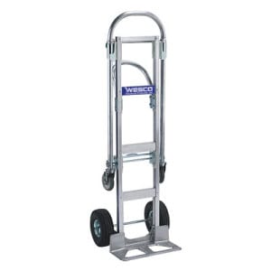 Such automated industrial trucks also have anti-collision technology that senses when an employee or other obstacle is near.
Stacking trucks are used to stacks items, while a non-stacking truck is just used for transportation, and not for product loading.
Types of industrial trucks:
- Automated guided vehicles (AGVs)
- Hand, platform and pallet trucks
- Order pickers
- Pallet jacks
- Side-loaders
- Walking stackers

Storage and Handling Equipment
Equipment that is used for storage usually only encompasses items that are not automated. Storage and handling equipment that is automated falls under the term ‘engineered systems’
Storage equipment is equipment that is used to hold products and materials when they are not being used, or when they are waiting to enter or leave the production process. These periods could be long-term, or short-term in order to allow a suitable build-up of stock or finished items.
Most items that can be described as storage and handling equipment refers to pallets, racking or shelves. Materials are stored in a neat and convenient manner to await transportation, or their entry into the production process if necessary.
Having suitable storage equipment will add to any company’s production efficiency. The efficiency of any production system is maximized by the ease at which each stage of the entire system operates. Any inefficient section creates a bottleneck that will have an effect on all other sections of the system further down the production line.
Space is also at a premium if you run a production environment. The better utilized your available space is, the more items you’ll be able to store. This means you can keep your workflow in operation for much longer without worrying about re-stocking. This helps further increase your efficiency.
Types of storage and handling equipment
- Drive-through or drive-in racks
- Pallet racks
- Push-back racks
- Shelving
- Sliding racks
- Stacking frames

https://www.yourarticlelibrary.com/marketing/marketing-management/packaging-and-branding/what-is-packaging/99721

What is Packaging?
Article shared by : <="" div="" style="margin: 0px; padding: 0px; border: 0px; outline: 0px; font-size: 16px; vertical-align: bottom; background: transparent; max-width: 100%;">

Packaging means the wrapping or bottling of products to make them safe from damages during transportation and storage. It keeps a product safe and marketable and helps in identifying, describing, and promoting the product.
“Packing is the preparation of product or commodity for proper storage and/or transportation. It may entail blocking, bracing, cushioning, marking, sealing, strapping, weather proofing, wrapping, etc.” – Business Dictionary.
Learn about:-

1. Introduction of Packaging 2. Definitions of Packaging 3. Meaning 4. Objectives 5. Important Aspects 6. Need 7. Functions 8. Qualities
9. Kinds 10. Classification 11. Types 12. Test to Check Packaging 13. Kinds of Materials Used 14. Packaging Cost 15. Considerations for Packaging Decision 16. Packaging Policies and Strategies.

What is Packaging: Definitions, Meaning, Importance, Need, Functions, Types and Qualities of Good Packaging

Contents:
- Introduction of Packaging
- Definitions of Packaging
- Meaning of Packaging
- Objectives of Packing and Packaging
- Important Aspects of Packaging
- Need of Packaging
- Functions of Packaging
- Qualities of Good Packaging
- Kinds of Packaging
- Classification of Packaging
- Types of Packages
- Test to Check the Method of Packaging
- Kinds of Materials Used for Packaging
- Packaging Cost
- Considerations for Packaging Decision
- Packaging Policies and Strategies

What is Packaging – Introduction
The history of packaging dates back to the year 1035, when a Persian traveller, visiting markets in Cairo, noted that vegetables, spices and hardware were wrapped in paper for the customers after they were sold. With the passage of time, attempts were made to use the natural materials available, such as, Baskets of reeds, wooden boxes, pottery vases, woven bags etc. However, the use of card board’s paperboard cartons was first done in the 19th century.

The Michigan State University was the first to offer a degree course in “Packaging Engineering” Since then, there has been no looking back. The packaging industry boomed as more than the content, it is the ”packaging” which attracts the attention of the buyer.
There was a revolution in Packaging in the early 20th century due to several modes of packaging designed such as Bakelite closures on bottles, transparent cellophane overwraps and panels on cartons, which increased processing efficiency and improved food safety. As additional materials such as aluminium and several types of plastic were developed, they were incorporated into packages to improve performance and functionality.
Packaging is the science, art, and technology of enclosing or protecting products for distribution, storage, sale, and use. Packaging also refers to the process of design, evaluation, and production of packages.
In short, Packaging can be described as a coordinated system of preparing goods for transport, warehousing, logistics, sale, and end use. Packaging contains, protects, preserves, transports, informs, and sells, in many countries it is fully integrated into government, business, and institutional, industrial, and personal use.

Packing means packing or wrapping goods to look attractive as well as secure safety i.e., (a) holding together the contents (b) protecting product while passing through distribution channels. Again packaging refers to “all the activities involved in designing and producing the container or wrapper for a product” (Stanton).
Recently, term packaging is being used interchangeably to mean both ‘packing’ proper as well as ‘packaging’. Traditionally, ‘packaging’ referred to retail or consumer container and ‘packing’ to transport container. Consumer packaging has significant marketing implications while transport containers are more important from logistics standpoint.
The following materials are generally used for packaging:
(i) Wood

(ii) Metals
(iii) Plastics
(iv) Paper
(v) Glass

(vi) Polyester.
New technology allows for 360 degree shrink-wrapped labels to surround containers with bright graphics and more on-pack information, replacing paper labels glued on to cans and bottles.

What is Packaging – Definitions Provided by Business Dictionary, MacMillan Dictionary and Other Definitions
Packaging means the wrapping or bottling of products to make them safe from damages during transportation and storage. It keeps a product safe and marketable and helps in identifying, describing, and promoting the product.
Different kinds of products need different kinds of packaging, for example, liquid products are packed in barrels and bottles; whereas, solid products are wrapped. The organizations use special containers for fragile products, such as glassware.
The terms packing and packaging are used synonymously but there is a certain amount of difference between the two. Packaging means covering the product itself so that it is protected from damage, leakage, dust, pollution, contamination etc. Examples – Chocolates packaged in thin sheet, milk packaged in sachets etc.
Packing means putting all the packages in a big box, container, chest, crate etc. for the purposes of storage, transportation, handling etc. Moreover the functions of packing and packaging, in the present context have gone beyond the basic expectations of protection of the product.
“Packing is the preparation of product or commodity for proper storage and/or transportation. It may entail blocking, bracing, cushioning, marking, sealing, strapping, weather proofing, wrapping, etc.” – Business Dictionary
“Packing is the activity of putting your possessions into bags, cases, or boxes so that you can take or send them somewhere.” – MacMillan Dictionary
“Packaging refers to the processes (such as cleaning, drying, and preserving) and materials (such as glass, metal, paper or paperboard, plastic) employed to contain, handle, protect, and/or transport an article. Role of packaging is broadening and may include functions such as to attract attention, assist in promotion, provide machine identification (barcodes, etc.), impart essential or additional information, and help in utilization.” – Business Dictionary
“Packaging is the wrapping material around a consumer item that serves to contain, identify, describe, protect, display, promote and otherwise make the product marketable and keep it clean.” – Entrepreneur
“Packaging is the science, art, and technology of enclosing or protecting products for distribution, storage, sale, and use. Packaging also refers to the process of design, evaluation, and production of packages. Packaging can be described as a coordinated system of preparing goods for transport, warehousing, logistics, sale, and end use.”
Packaging:
Until recently packing was being considered as a minor element in the marketing mix of a product. But now it has become an integral part of the product itself. Packages act as the major means-of creating product preference. It is a vehicle by which the brand of a product is carried through the consumer. It is a powerful selling tool. Hence, it has become a highly important area of managerial decisions.
Packing and Packaging:

Packing is the process of covering, wrapping or crating goods into a package. This is done for the purpose of delivering the product.
Packaging involves designing and producing the container or wrapper for a product. The potentialities of packaging, essentially in the field of demand creation, have been widely accepted now. If is often remarked as a silent salesman. Packaging decision may affect production, distribution, research and development, sales, accounting, and finance.
Packaging is an effective selling tool. For example, Gillette Company introduced a package for keeping blades. This packaging has come to be known as – “razor blade dispenser”. This dispensing packaging not only includes space for new blades, which could easily be ejected, but contained space at the bottom of the dispenser in which old and useless blades could be kept.

What is Packaging – Meaning
Packaging is the general group of activities which concentrate in formulating the design of a package, and producing an appropriate and attractive container or wrapper for the product. Packing refers to the wrapping and crating of goods before they are transported or stored.

It is a physical action which provides a handling convenience, e.g., rice, cotton, wheat or any other agricultural produce. It is necessary to prevent flowing out of liquids and is essential to maintain freshness and quality. It can prevent the danger of adulteration.
Packaging is the subdivision of the packing function of marketing. It involves more than simply placing products in containers or covering them with wrappers. Philip Kotler defines packaging as an activity which is concerned with protection, economy, convenience, and promotional considerations.
Packaging obviously is closely related to labelling and branding because the label often appears on the package and the brand is typically on the label. A package defines the space in which a product is contained.
The package contents may be pre-measured, pre-weighted, pre-stored, pre-assembled, and then placed in a specially designed wrapper, box, carton, can, crate, bottle, jar, tube, barrel, or drum for convenient distribution.

What is Packaging – 10 Important Objectives: To Provide Physical Protection, To Enable Marketing, To Convey Message, To Provide Convenience and a Few Others
Packing and packaging are basically done to protect the product. During the present days however these two functions have assumed several additional objectives in addition to protection.
The following are the objectives of packing and packaging:
1. To Provide Physical Protection:
Packaging of objects insures that they are protected against vibration, temperature, shock, compression, deterioration in quality etc. Packing and packaging also protect the products against theft, leakage, pilferage, breakage, dust, moisture, bright light etc.
2. To Enable Marketing:
Packing and packaging play an important role in marketing. Good packing and packaging along with attractive labelling are used by sellers to promote the products to potential buyers. The shape, size, colour, appearance etc. are designed to attract the attention of potential buyers.
3. To Convey Message:
There is so much of information about the product that a manufacturer would like to convey to the users of the product. Information relating to the raw materials used, the type of manufacturing process, usage instructions, use by date etc. are all very important and should be conveyed to the users. Manufacturers print such information on the packages.
4. To Provide Convenience:
Packing and packaging also add to the convenience in handling, display, opening, distribution, transportation, storage, sale, use, reuse and disposal. Packages with easy to carry handles, soft squeezed tubes, metallic containers, conveniently placed nozzles etc. are all examples of this.
5. To Provide Containment or Agglomeration:
Small objects are typically put together in one package for reasons of efficiency and economy. For example, a single bag of 1000 marbles requires less physical handling than 1000 single marbles. Liquids, powders, granular materials etc. need containment.
6. To Provide Portion Control:
In the medicinal and pharmaceutical field, the precise amount of contents is needed to control usage. Medicine tablets are divided into packages that are of a more suitable size for individual use. It also helps in the control of inventory.
7. To Enable Product Identification:
Packing and packaging enable a product to have its own identity. This is done by designing a unique and distinct package through the effective use of colours, shapes, graphics etc. Such identification and distinction are very essential in the present situation of intense competition and product clutter.
8. To Enhance Profits:
Since consumers are willing to pay a higher price for packaged goods, there will be higher profit realization. Moreover packaged goods reduce the cost of handling, transportation, distribution etc. and also cut down wastage and thereby increase profits.
9. To Enable Self-Service Sales:
The present trend in retailing is effective display and self-service sales. Products require effective packing for self-service sales.
10. To Enhance Brand Image:
Attractive packing and packaging in a consistent manner over a long time enhances the brand image of the product.

What is Packaging – Important Aspects: Promotional Aspect, Protectional Aspect, Transport Packaging Protection during Transit and Legal Provisions
In developing the marketing plan for a product, in international market, packaging is an important element. Packaging should be viewed from its promotional and protectional aspects.

(1) Promotional Aspect of Packaging:
Packaging of a product plays an important role in promoting the product in the international markets. With the advent of self-service starts and super markets, the package of a product serves as a ‘silent sales man’. It is capable of performing many of the salesman’s tasks.
When there is no salesman to promote the product in the stores, the package as kept on the shelf must attract the attention of the consumer, describe the product’s and producer’s features, project the confidence and make a favourable overall impression. Good packaging thus leads to improved consumer acceptance because it carries and projects various qualities of the product as well as the manufacturer.
Good packaging must reinforce the integrated marketing concept. Brand names occupy a dominant role in marketing which is popularised through advertisement. But the reminding of brand names and making brands acceptable to customers are achieved through proper packaging.
Packaging must, therefore, support and reinforce the brand identity the company is trying to build. In this way, good packaging creates demand for the product and brings large-scale production and distribution gains.

(2) Protectional Aspect of Packaging:
The second important aspect of packaging is its protectional aspect which it provides to the product, consumer packaging intends to offer better convenience to consumers in use and in storage.
It protects the product from:
(a) Pilferage and adulteration – It cannot be adulterated with any other product unless repacked.
(b) Product loss – Oil, petroleum products etc. are lost if remain exposed.
(c) Contamination by dirt or dust, e.g., clothing, food products.
(d) Moisture gain or loss, e.g., cement or sugar,
(e) Chemical change.
(f) Insect attack, e.g., moth in woolen garments.
It has been estimated that good packaging increases the unit value realisation approximately three times if we are able to develop and bring about retail packs for a large number of exportable items. It also increases the popularity of the product.

(3) Transport Packaging Protection during Transit:
The basic function of transport packaging in international marketing is to ensure that the goods will reach safely in the hands of consumers. To ensure the goods is no excuse for not bothering for damages or pilferage in transit. Good packaging is essential irrespective of the fact whether the goods are insured or not.
Improvements in packaging are needed to avoid transit losses due to environmental hazards, i.e., climate, moisture, etc. and to achieve greater speed in handling and deliveries. The materials used in packaging should be such that protect the goods from the ill-effects of moisture, gas, light, air, etc. so that goods may preserve its attributes, shape, weight, stability, fragility, rigidity, surface finish and durability etc. Thus packaging plays an important role in the storage, preservation, protection and distribution.
The type of packaging which ensures that the goods will be delivered in a good condition to the foreign buyer will vary depending upon the various factors such as-
(a) The product,
(b) The poor of destination,
(c) The length of the journey,
(d) The climate of the place of delivery and place of destination,
(e) Eat and measure to which the goods are subjected during the voyage,
(f) The loss of the importing and exporting countries regarding packaging of goods,
(g) Mode of handling the goods etc.
In many cases, the packaging conditions are specified in the contract itself and therefore the exporter should not be bothered about. He must adhere to the conditions laid down in the contract. Even when the importer has not laid down any condition as to packaging, it is the prime duty of the export to provide transport packaging of the type which may ensure the safe arrival of the shipment in merchandise condition and must adhere to the above factors.

(4) Legal Provisions:
The mandatory provisions as to packaging of the goods imported also have important bearing on the packaging of goods. Most developed countries have enacted comprehensive legislation on the type of containers, both bulk and consumer especially for food items. For example, exports of food products to the USA must conform in all respects to the provisions of the U.S. Foods and Drugs Act.
Similarly, Australia bans the imports of any packing material containing vegetable matter in order to check insect contamination of the country’s wood resources large consignments of Indian goods were repacked at the Australian Port of entry at the exporters’ cost. In 1978, the USA directed that all Indian export consignments in wooden packing’s be first fumigated before they are unloaded at U.S. ports.
The laws of the importing countries may also specify the labelling requirements to be shown on the packages imported. However, these rules may vary from country to country.
These rules require the following information to be shown in the label:
(i) Name and address of the manufacturer/importer;
(ii) Clear description of the product’s composition;
(iii) Net weight or volumetric measurement;
(iv) Duration of the product’s life;
(v) Storage conditions required after the package has been opened;
(vi) Manufacturer’s instructions for use or preparation, if any. Factors to be considered for Package Designing.

What is Packaging – Need
1. Important Element of Marketing Plan:
Packaging is an important element in formulating marketing plan for a product.
2. Silent Salesman:
With the advent of self-service stores and super markets, package has to perform the function of a silent salesman besides traditional function of protecting the product. This means that in the absence of a salesman to promote the product in a sales store, package as kept on the shelf captures the fancy of the customer.
3. Communication with Consumer:
Product package has an important promotional function. It establishes meaningful communication with the consumer.
4. Package Designing:
It is extremely important to know the special attributes of each target market and design the product package accordingly.
5. Convenience:
Consumer packaging offers better convenience and ease to consumer in handling and carrying their products.
6. Protection:
It protects the product from pilferage and adulteration.
7. Increased Value:
It has been estimated that unit value realization can rise approximately three times if able to develop and bring about retail packs for a large number of exportable items.
8. Other Aspects:
(i) It helps increase sales.
(ii) It adds to use of a product.
(iii) It helps in storage.
(iv) It helps in product differentiation.
(v) It helps promote a product.
(vi) It contributes to safety of a product from damage.
(vii) It helps in branding and promoting brand loyalty.
(viii) It may cut marketing costs and thus enhance profit/ profitability of product.
(ix) It helps portability/transportability of product.
(x) It helps publicity.
9. Recent Developments/Trends:
In recent years, producers have made changes in their packaging for a few reasons, viz.:
(a) Maintain sales volume.
(b) Expand market by new packaging.
(c) Use packaging as a means for advertising and sales promotion.
10. Use of Packaging Machines:
i. Integral Part – Packaging machines have now-a-days become an integral part of industries.
ii. Health consciousness, urbanization and even changing habits are some of the factors that have led to growing use of such machines.
iii. Food and Pharma sectors have contributed significantly in growing use of these machines.

What is Packaging – 6 Important Functions: Protection and Preservation, Containment, Communication, Convenience, Economy and Promotion Function
Packaging has a two-dimensional function. First, it must protect the product. Then it has an important promotional role.
Thus, the functions can be categorized into the following headings:

Function # 1. Protection and Preservation:
The basic function of packaging is to protect and preserve the contents during transit from the manufacturer to the ultimate consumer.
i. Most of the damage occurs in the handling process. The more frequently the products are handled in the distribution process, the greater is the need for protection. Damaged goods have to be replaced as they may cause loss and inconvenience to the seller as well as to the purchaser.
ii. Certain products, if exposed, may be lost. Powder, oil and petroleum products are examples.
iii. Pilferage.
iv. Contamination by dirt or dust, for example, clothing.
v. Moisture gain and loss, for example, cement.
vi. Chemical change, for example, metal corrosion.
vii. Insect attack, for example, moths in clothing.

Function # 2. Containment:
Most products must be contained before they can be moved from one place to another. To function successfully, the .package must contain the product. This containment function of packaging makes a huge contribution to protect the environment. A better packaging helps to maintain the quality of the product and reachability of the product in the consumer’s hand without spillages. It gives better image to the organization.

Function # 3. Communication:
A major function of packaging is the communication of the product. A package must communicate what it sells. When international trade is involved and different languages are spoken, the use of unambiguous and readily understood symbols on the distribution package is essential.
It helps in appropriate communication to the consumer about the product, how to use it and other utility information. Packaging protects the interests of consumers. Information includes quantity, price, inventory levels, lot number, distribution routes, size, and elapsed time since packaging, colour, merchandizing and premium data.

Function # 4. Convenience:
i. Properly packed goods require less space.
ii. Easy methods could be suggested to take goods out from a pack and keep the rest intact.

Function # 5. Economy:
Package provides various economies, both to the producers and the consumers.
i. Loss in quantity is prevented thereby avoiding the monetary loss also.
ii. Creates an opportunity to communicate with the customers.

Function # 6. Promotion Function:
i. Self-service – The package must be and capable of performing many of the sales tasks. It must attract attention, describe the products’ features, give consumer confidence and make a favourable overall impression.
ii. Consumer affluence – The prestige of a product is maintained with the help of proper packaging. Good packaging is capable of projecting various qualities of the product as well as that of the manufacturers.
iii. Integrated marketing concept – Brand names now occupy a dominant role in marketing. The brand names are popularized through advertisement but the reminding of brand names and making the brands acceptable to consumers are achieved through packaging.
iv. Innovational opportunity – Packaging is capable of bringing large-scale gains.
Packages also perform a large and increasing variety of other individual, functions.
Some of these functions are:
i. To assemble and arrange the contents in the desired form.
ii. To identify the contents, the brand and the maker. (Product differentiation is perfected through this function).
iii. To provide a suitable product mix including size, weights, prices, grades and packages.
iv. To facilitate retailer’s functions.
v. To facilitate transporting, storing and warehouse handling.
vi. To enable the display of contents.
vii. To encourage repurchase.
viii. To help in complying with legal requirements.
ix. To provide opportunity and space for advertising.

What is Packaging – 14 Essentials/Qualities of Good Packaging
1. Attractive Appearance – That is, attracts customers attraction, creates his interest in product and creates positive image of product.
2. Convenient for Storage and Display including storage in lesser space.
3. Safety of Goods, that is, security or protection of goods from damage, spoilage, breakage, insects, rodents etc.
4. Product Description be shown on Package.
5. Recognizable – Package must be recognizable.
6. Eye-Appeal of package.
7. Transport Economies – Packaging should allow economies in transport.
8. Uniformity and Consistency.
9. Convenience in Transport Handling e.g., provided with hooks, handles, grippers etc.
10. Able to withstand hazards of transport e.g., tilting, throwing, pulling, pushing, rolling etc.
11. Amenable to quick examination of contents; for example in case of export, import by customs authorities.
12. Easy to dispose off after opening of goods.
13. Proper and Adequate Marking.
14. Proper instructions like –
‘This side up’, ‘Fragile’
‘Handle with Care’

What is Packaging – Kinds of Packaging on the Basis of Nature
Kinds or methods of packaging will depend largely on the nature of the contents in terms of their value, physical composition and durability.
The length of the distribution channel, the amount of handling which the container receives, and variations in climatic conditions encountered between the points of manufacture and sales are also to be taken into account.
For example, products in liquid form require containers made of glass or similar materials. For fragile articles, wooden containers are used.
On the basis of nature, packaging is classified into the following:
i. Family packaging – A package of a particular manufacturer, packed in an identical manner is known as family packaging. The shape and colour, the materials used for packaging will be similar for all the products in such cases.
ii. Reuse packaging – Packages that could be used for some other purposes after the goods have been consumed is known as reuse packaging.
iii. Multiple packaging – It is the practice of placing several units in one container. This helps to introduce new products and increase sales.
iv. Transport packaging – The product entering into the trade needs to be packed well enough to protect against loss or damage during handling, transport and storage, for example, fiberboard, wooden crate, etc.
v. Consumer packaging – This packaging holds the required volume of the product for ultimate consumption and is more relevant in marketing, for example, beverages, tobacco, etc.

What is Packaging – Classification
While formulating packaging policies and strategies, it is important for marketers to develop a packaging concept around which these are to be formulated. A packaging concept is a description of product package and the functions it is supposed to perform in respect of that particular product. The conceptualisation of package involves determining package functions and developing an appropriate mix of these functions so as to attain product objective. For example, in case of Zodiac neckties and hand-kerchiefs package visibility was defined as the basic packaging concept and therefore, rigid plastic package was developed.
Classification of Packaging:
1. Family Packaging:
The product of a particular manufacturer when packed in an identical way is known as family packaging. The shape, colour, size etc. of packaging will be similar for all his products. Family brands are made meaningful by using family packaging, also. In such cases packaging methods, material used for packaging the appearance etc. will be one and the same for all the products of a manufacturer.
2. Re-Use Packaging:
Packaging that could be used for some other purposes by the consumers after the packed goods have been consumed is known as re-use packaging. This aspect increases the sales value of the product considerably.
3. Multiple Packaging:
It is the practice of placing several units in one container. This helps to introduce new products and increase the sales.
The various aspects of packaging are now treated as a management activity.
The following are the problems encountered in packaging:
(a) Cost of packaging
(b) Appearance
(c) Kinds of designs
(d) Convenience
(e) Re-use purpose
Inspite of its various advantages, packaging has been subjected to criticism. One among them is that it adds cost. To some extent this complaint holds goods. It is true that packaging expenses definitely increase the price. But the benefits derived are sufficient to compensate the increase in cost. For example some medicines which we buy are to be consumed at once. Their preservation is very important. Only a good package can render this service. So long as the product is capable of absorbing the packaging cost proportionately this criticism cannot be accepted.
In considering some of the more sophisticated uses of packaging the protective aspects of packaging should not be disregarded.
Attention is therefore drawn to the following hazards against which packaging should provide a defence:
1. Insect Attack, e.g. months in clothing.
2. Mould, e.g. in canned foods, paints.
3. Flavour loss or change.
4. Chemical change, e.g. mental corrosion, coffee rancidity.
5. Moisture Gain and Loss – Many products have an optimum moisture content, e.g. cement, ceramic paints, frozen foods.
6. Contamination by Dust or Dirt – Clothing, food and fine machinery are obvious examples of products liable to damage in this way.
7. Pilferage – Loss through pilferage can be quite high-especially if there are many handling points.
8. Product Loss – Liquids and powders are highly susceptible to loss, e.g. powder leakage, liquid evaporation.
9. Damage by Mechanical Handling – Most damage occurs in the handling process and, the more frequently product are handled in the distribution process, the greater is the need for protection. One of the advantages of the liner rain and other container transport development is that they will result in less damage through handling. Damaged goods have to be replaced and are likely to cause loss and inconvenience to seller and purchases. Often slightly damaged products may not be returned, but may inhibit repeat purchase.

What is Packaging – 4 Important Types (With Package Forms and Material Used)
Type # 1. Consumer Package:
It holds the required volume of a product for ultimate consumption and is within the means of a buying household. In other words, the consumer has the option to purchase the pack size which he considers adequate for the consumption of his family over a length of time and which does not involve extra investment during that period.
Type # 2. Bulk Package:
It is the opposite of consumer package. It is either for the industrial consumer’s use or for loose dispensing. The bulk package also often requires an outside package in which it is transported and which is sometimes referred to as a transit package or an outer container.
Type # 3. Industrial Package:
This packaging provides protection to the spare parts, semi-finished and finished products during each phase of the manufacturing process, and also during transportation and storage.
Type # 4. Dual use Package:
It has a secondary usefulness of a package after its original contents have been used. For example, plastic bottles, sacks in which groceries are packed, etc.

Package Forms and Materials Used:
Packages are often selected on prima facie grounds of cost, common industrial practices, type of the product, quality of product, conditions of display, likely consumer appeal.
Packages may be in the form of tin plate cans, cardboard containers, polythene bags, paper or cloth or gunny bags, wooden boxes, teak chests, squeeze bottles, collapsible tubes, aerosol cans, aluminium foils, clear film wrappings, plastic container, etc. Colour may be used to identify sizes, models, flavours and qualities.
The true economy of packaging lies in the total packaging operation—filling, sealing, storing, handling and distribution. The most common packaging materials are metal, glass, wood, paper, cardboard, plastic, cloth, jute and cellophane.
A wide variety of packaging material is used according to the availability, possible shortages, competition, economy, transport worthiness, and shelf life. Packaging involves selection of materials, manufacturing, filling and handling of finished packages.
Consumer problems with packaging:
1. The buyer cannot judge the contents of the package by its mere appearance unless it is transparent.
2. The consumer cannot check the volume of the contents, unless he opens the packet.
3. Packages may be deceptive and contain wrong or misleading information/illustration.
4. Many of the common materials used for packaging are hazardous to human health and pollute the environment.

What is Packaging – Mathematical Tests to Check the Method of Packaging
There are various mechanical tests to check the method of packaging.
They are:
i. Drop test – This test helps to measure the ability of the container to provide protection to its contents and to withstand rough handling.
ii. Vibration test – This test is used to determine the ability of the container to withstand vibration and the protection offered by materials used for interior packing.
iii. Compression test – This test is carried out, generally, on empty containers, to measure the ability of the container to resist external compressive loads applied to faces or applied to diagonally opposite edges or corners.
iv. Inclined impact test – This test helps to study the extent of damage in a way of crushing, breaking, cracking, distortion and shifting during handling, storage and transport which occurs to the container and its contents.
v. Rolling test – This test helps to evaluate the overall strength of the container and the cushioning material provided inside.
vi. Drum test – This test helps to evaluate loaded shipping containers with respect to general overall durability and the protection afforded to the contents against certain hazards of handling and shipment.
Various climatic tests are available to check the effect of various climatic factors on packaging:
i. Rain test – This test is conducted in a simulated rain condition to assess its impact on the test area for two hours.
ii. Sand and dust test – This test evaluates the resistance of a package to the penetration of sand and dust.
iii. Salt spray test – This test evaluates the resistance of a package to corrosion by salt spray and if serves as a general standard for corrosion.
The following points need to be taken into consideration while packaging:
i. Cost of packaging.
ii. Appearance.
iii. Kinds of designs.
iv. Convenience.
v. Reuse.
AIDA Formula:
AIDA formula is applicable in packaging decisions too.
This formula represents the following four basic requirements.
A—Attention, that is, getting the attention of the public.
I—Interest, that is, creating an interest over the product.
D—Desire, that is, and creating desire to purchase the product.
A—Action, that is, compelling the consumers to take action (that is, purchase).
Engineering tests are necessary to know whether the package will withstand handling. Visual tests are done to prove its attractiveness. Dealer tests and consumer tests are also conducted to assure favourable response from these two groups.
In spite of its various advantages, packaging has been subjected to criticisms. One among them is that it adds to cost. It is true that packaging expenses definitely increase the cost. But the benefits derived are sufficient to compensate the increase in the cost.
For example, the medicine which we buy is not consumed at once. Its preservation is very important. Only a good package can render this service.

What is Packaging – Kinds of Materials Used for Packaging
Earthenware – It is an old method of preserving products of liquid nature.
China jars – They are used where protection is required against light and corrosive action.
Wooden boxes – They prevent breakage due to rough handling.
Cardboard containers – These are mostly used in specialist goods which are not bulky.
Straw baskets – These are meant for keeping vegetables.
Gunny bags – Gunny bags are popular for packing goods like rice, grains, sugar, cement, white and colour washing materials, etc. Gunny bags cannot give protection to the goods.
Glass – Glass is used to pack liquid products. It affords protection against the action of most of the chemicals.
Tin containers – Tin containers are used to pack liquid and solid products. They are light and strong.
Plastic containers – Plastic containers are gaining extreme popularity. Plastic containers are used to pack liquid and solid products. It involves low cost, good appearance, convenience and ability for reuse.
Paper bags – Paper bags are used to pack products which are in solid form. They are commendable. But their limitations are that the freshness of the product cannot be preserved.
Cellophane paper – Cellophane is a good substitute for paper as packing material. It protects the contents from moisture, but it cannot protect the products against harmful effects of light.
Cushion materials Cushioning is that part of packaging, which protects the article from damage due to shock and vibration.
The main functions of cushioning materials are:
i. Shock protection against vibration.
ii. Protection against abrasion.
iii. Protection of grease-proof and water-proof barriers at the point of contact with solid blocks.
iv. Protection of moisture vapours barriers at points of contact with sharp edges of the article itself.
v. Protection of small projections.
vi. Filling of void space in the container.

What is Packaging – Packaging Cost
The most important aspect of packaging is the packaging cost.
Packaging cost includes the following:
Material cost – It means the cost of the pack and quality control cost.
Storage and handling cost of empty packages – This includes the handling cost of bulky packages, heavy materials of construction, drums, etc.
Packaging operation cost – This includes the cost involved in operations like cleaning the package, product filling, closing, labeling, unitizing, stenciling, handling cylindrical drums, etc.
Storage of filled packages – This includes the cost incurred to shift the goods from one form of packaging to another.
Transportation cost of filled packages – This involves the transportation cost by sea, air, etc.
Loss and damage cost – It is related to the loss and damage during operation, transportation, delivery, etc.
Insurance cost – It varies depending on the vulnerability of package.
Effect of packages on sales – The package that influences the sales.
Obsolescence cost -This cost is incurred when changes in the packaging materials, packages and labels happen.
Package developmental cost – This includes the evaluation cost, pilot test cost, field testing cost, consumer research cost, feedback cost, final trial cost, etc.

What is Packaging – Considerations for Packaging Decision: Package Design, Package Cost, Package Size and Package Test
A decision taken in respect of packaging of a product is known as packaging decision. When a producer wants to take a decision in respect of packaging of a product, he has four main points for considerations to take the decision.
These considerations are as follows:

(1) Package Design:
The very first decision taken by a producer in regard to packaging of a product is to decide the design of packaging.
Decision of design of packaging includes following five decisions – (i) Which type of material will be used for packaging? (ii) What will be the design of packaging? (iii) What colours will be used on packaging? (iv) What will be the matter printed on packaging? (v) What will be the brand name and trade mark on packaging?
In addition to the decision on above questions, the design of packaging is determined keeping in view the convenience of consumers and middlemen. The design of packaging must be such that it may facilitate the activities of storage, transportation, and distribution. Other factors affecting the decision of design of packaging are — nature of product, cost of packaging, size of packaging, legal restrictions, advertisement, etc.

(2) Package Cost:
While taking any decision on packaging of a product, the cost of package plays an important role. The package must be selected only after considering the cost of package and its effect on the price of product.

(3) Package Size:
Very important decision in respect of packaging is to decide the size of packaging. The size of packaging differs from product to product, producer to producer and time to time. In addition to it, a single product is offered by a single producer to the consumers at a single time in different sizes of packaging. The size of package depends upon the nature of product and the quantity generally purchased by consumers. As different consumers buy a product in different sizes, it is advisable that the product must be packed in the packages of different sizes.

(4) Package Test:
When a package is decided for a product, the efforts are made to test it so that it may be assured that the package will meet the requirements of consumers.
There may be four types of test for this purpose:
(i) Technical Test – Technical test is the test carried out with the purpose of testing whether the package design is proper or not for the safety of product?
(ii) Middlemen Test – This test is carried out with the purpose of testing the suitability of package from the point of view of middlemen.
(iii) Consumer Test – Consumer test of package aims at testing the package with a view whether it will be liked by the consumers or not?
(iv) Appealing Test – This test, tests the package whether it looks attractive or not? If a package is approved in all the four tests, it is finally decided and if a test fails at any stage, it is disapproved.

What is Packaging – Policies and Strategies
A company can follow any one of the following policy options in respect of product packaging.
It can make periodic changes in the product package in order to achieve one or more of the following purposes:
(a) It can be the management’s decision to provide more product protection and make it user friendly. For example- a ‘milkmaid’ condensed milk container is very difficult to open. But the same product called “Mithai Mate” from Amul was introduced with an easy to open aluminium container. Similarly, biscuits in gift packs are packed well, all biscuits are packed separately so as to maintain the crispness.
(b) Sometimes, changes in packaging may be introduced to correct defects in the package itself. For example- leakage in containers after opening, difficulty in opening, and wrong use of the containers for packing after the product is over, (like containers being used for storing lubricating oil). Another example – edible oil used to be packed in aluminium containers which were difficult to open. But now edible oil is available in one kg plastic bags or plastic bottles.
(c) Innovations in packing material may also necessitate product package changes. For example- instead of plastic, aluminium or tin, companies are now using eco – friendly packing materials. Some cities like Ooty have banned the use of plastic by imposing a fine of Rs. 200, due to the environmental problem it creates.
(d) Lastly, a package change may be necessitated due to an innovative promotion program. For example- the Cavincare group did an innovative marketing effort for its ‘Chik’ shampoo. According to the Cavincare group’s Chief Executive Officer, Mr. Ranganathan, the key to success was not manufacturing, but marketing and distribution. His innovate marketing strategy in 1980, to return five shampoo sachets and get one Chik shampoo free, had been an instant success.
1. Family Packaging:
This is a type of packaging strategy in which the various packages of the entire product line closely resemble each other or alternatively major features of the various packages in the entire product line closely resemble each other. For example- Arun Ice-cream’s vanilla and butter scotch flavours come in one packet.
The advantage of this strategy is that a new product in an identical package enjoy the same market reputation and acceptance as the others. Another example of family packaging is the different products of “Cadbury” that are available in a single gift packet. This type of packaging also helps to reduce packaging expenditure.
But its disadvantage is that, if the reputation of the older products is bad then the reputation of the new product will also be affected. Similarly, customers may also feel that slow moving items are being pushed along with the fast moving items in a single pack.
2. Re-Use Packaging:
This packaging is a strategy in which marketers offer products in such a package, which may be reused for other purposes, once the product has been exhausted or taken out. For example- Boost, Horlicks, Bournvita, Nescafe, Jams, etc. are sold in glass jars which can late be used for storing things. Similarly, ice-creams like Joy, Kwality or Arun are also sold in plastic containers which can be reused for other purposes.
Re-use packaging stimulates repeated purchases as it offers an additional benefit for the same price.
3. Multiple Packaging:
Multiple packaging is a strategy in which a number of heterogeneous products used by one consumer are placed in a single package. For example- a facial cream, talcum powder, eyeliner, lipstick, mirror, comb etc. are placed in a single package. This helps the company increase sales and promote new items along with existing items. The company once obtains acceptance for good products, new products, slow moving items, etc. will get promoted at the same time.
4. Ecological Packaging:
This type of packaging has evolved due to environmental pollution ecological packaging includes the following:
(a) Avoidance of plastic for packaging.
(b) Use of containers that decompose over a reasonable period of time.
(c) Use of eco-friendly packaging material, and
(d) Use of light weight packaging material.

