Investment in Fixed Income Markets
Equity Investing versus Fixed Income Investing
The difference between the two most popular investment may be enumerated below
Equity Market | Debt Market
Involves shares of a company | Involves fixed income instruments
No fixed return on investment | Fixed return as per coupon rates
Income is uncertain and volatile | Income is stable and certain
Only private corporations are involved | Government and private corporations are involved
Returns are high as risks are high | Returns are low as risks are low
Perpetual investment means an investor may hold the shares till the time it wishes | All instruments have a maturity date beyond which trading not possible in those instruments
SEBI is the principal regulator | RBI is the principal regulator
Equity market investment is done for growth of portfolio | Debt market investment is done for maintaining stability of portfolio

Portfolio Construction
Portfolio construction is a process of selecting securities optimally by taking minimum risk to achieve maximum returns. The portfolio consists of various securities such as bonds, stocks, and money market instruments.
It is the process of strategically combining a diversified mix of assets to achieve specific investment goals within an acceptable level of risk. It involves several aspects such as establishing the correlation between different assets such as equities, bonds, property and cash, selecting an appropriate benchmark that the portfolio’s performance (and in some cases risk) will be measured against, determining the weights of assets/sectors and individual securities and selecting those securities.
There are several financial principles such as the Modern Portfolio Theory, that investors would use to assist their portfolio construction and it to their own objectives, risk appetite and investment horizon. In addition, other elements of the process such as asset allocation and portfolio rebalancing are also considered.
The portfolio construction process usually involves several key stages. These include:
- Goal Setting – This is the starting point of the process where the investor’s investment objectives, time horizon and risk tolerance levels are determined. There are also additional factors such as liquidity or income requirements, ethical/ESG or in some cases even religious (for example, Islamic Finance) norms that should be considered.
- Benchmarking – Here, investors need to select a yardstick that would help them measure the success of the portfolio. This is typically a market index or a composite. It is very important that the benchmark is in-line with the investment strategy. For example, a global large cap equity portfolio that invests in developed markets may only be looked against the MSCI World Index. On the other hand, portfolios that include some emerging markets might be best compared against the MSCI ACWI (All Country World Index).
- Asset Allocation – This stage is key in striking the right balance between different asset classes such as equity, fixed income and alternative assets, based on the investor’s goals established one step earlier. Asset allocation typically relies on concepts such as the Modern Portfolio Theory and the Black-Litterman Model.
- Security Selection – This stage requires picking up specific investments within each asset class/sector, considering factors such as return potential, valuation, risk and correlation with other holdings. For example, the selection process of the portfolio’s equity portion could be run by evaluating different ratios such as Dividend Yield, as well as analysing the quality of the management, competitive advantages and the market position on the business. .
- Risk Management – This step is also quite important as it sets up the strategy that will control the risk in the portfolio. For example, the level of diversification both in terms of number of holdings (also known as portfolio concentration), their sources of revenue and the correlation between them, and hedging (often using derivatives).
- Rebalancing – Although portfolio rebalancing itself is rather a step in the ongoing monitoring process, the frequency, method of rebalancing and transaction costs are also taken into account during the portfolio construction process.
Portfolio construction is a key in the broader investment management process that requires careful consideration of investment objectives, risk tolerance, and market conditions. While in their core the more traditional methods for building portfolios would rely upon financial theories such as the MPT, the wider process involves expertise in asset allocation, investment selection and risk management. Professional investors are often aided by financial software, which helps them analyse portfolios and compare them against other peers or market indices. The whole process is aimed at delivering an optimal outcome within the pre-determined risk framework.
Asset Allocation Strategies
Strategy # 1 – Strategic asset allocation
This is a fixed asset allocation strategy wherein you determine your equity and debt exposure and then stay fixed on the ratio. With the change in the market, on the ratios getting affected, you need to rebalance your portfolio periodically to ensure that the specified ratio is maintained.
Let us assume that you have chosen 60% equity and 40% debt. Here’s how rebalancing would work -
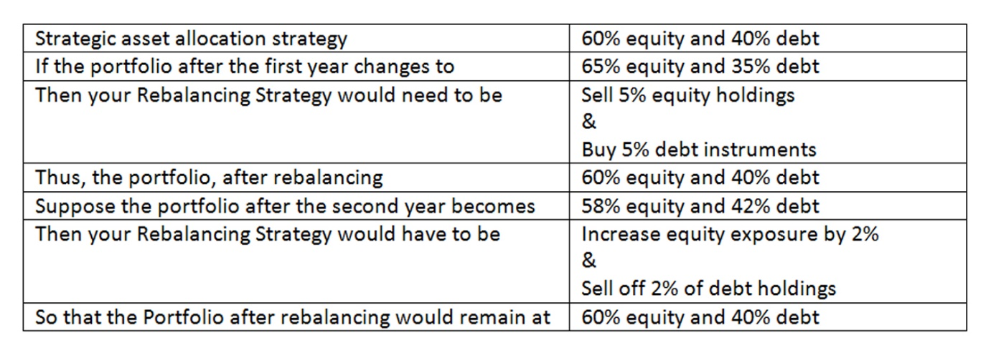
The strategy is also called the buy and hold strategy, as the allocation remains static with rebalancing done only to achieve the desired allocation. The biggest advantage of this strategy is the investment discipline, irrespective of the market condition. Ideally, a portfolio rebalancing should be done once a year.
Strategy #2 – Tactical asset allocation
This is a flexible variant of the strategic allocation strategy that allows you to alter the allocation to cash in on favourable markets. Again, it would help if you decided on a specific asset allocation ratio. After that, if you find conducive market conditions, you can change the ratio to make quick short-term gains.
Say your asset allocation ratio is 60% equity and 40% debt. If the stock market is performing well and the rise is expected to continue for the next few months, you can increase equity exposure. The equity allocation could become 80% with 20% debt. On the other hand, if the equity market is expected to fall or debt is expected to give high returns, you could reduce equity exposure to minimize risks or maximise returns. Your equity allocation would temporarily reduce to 40% from the previous 80%, and the debt allocation will increase from the previous 20%.
Thus, the tactical strategy works on your ability to read and understand market movements and is often called momentum-based strategy. You change your allocation for the short term to maximise returns or minimize risks. However, in a normal situation, the asset allocation is more or less pre-decided.
Strategy #3 – Dynamic asset allocation
The most popular asset allocation strategy is dynamic asset allocation. This is when you don’t have a fixed allocation ratio but invest your money as per market movements. So, in an upward market trend, you would favour higher equity exposure, while in a downward trend, you would be cautious and invest primarily in debt. You can also do the opposite to buy low and sell high. Unlike tactical asset allocation, here, you do not get fixated on the % allocation to each asset. Rather, you take dynamic calls depending on the market situation.
Dynamic asset allocation is suitable for seasoned and proactive investors who keep changing their asset allocation. If you can keep up-to-date with market trends, this strategy might give you attractive returns.
Diversification Techniques
Risk appetite
The first step to understanding diversification is to define your risk appetite. Risk appetite is an investor’s appetite for how much money he or she can afford to lose. If an investor is psychologically well placed not to get very disturbed, seeing high scale variations in their investment during the short term, he or she may be a little high on the risk scale.
Not just psychologically, but one should also be able to afford short term fluctuations financially and have enough liquid money parked somewhere else to help you sail through such situations. This does not mean all investments have a high chance of running into losses. Losses are notional and on paper till investments are redeemed.
Match risk appetite with goals and investments
The second step involves sorting the risk element associated with various investment schemes. Different types of diversification come with different types of investors. For example, a risk-loving investor will diversify differently than a risk-averse investor. Now that you are aware of the risk appetite you have, you can sort it as per your goals by picking securities with diverse risk levels. This proves to be beneficial as even if you face loss in one, the profit from others can compensate for the that.
Building a Portfolio
As mentioned earlier, an investor must first build a portfolio including various investment instruments. This could be anything like options such as stocks and bonds, to cash mutual funds and other categories.
Pick from different industries
Diversification can also constitute of different industries. It might be hard to believe at first but everyone is interested in certain industries or sectors at the back of their mind. It is imperative to take into account and pick securities according to industries in order to mitigate the industry-specific risks.
Research about the fund manager
A successful diversified portfolio always has a major contribution to the skills of the fund manager. It is the manager who makes the decision of when and where to invest.

Tax Implications
Taxable bonds
The interest on taxable bonds is subject to taxation according to the investor's income tax slab rate. The capital gains imposed on taxable bonds depend on the holding period. Suppose an investor holds these types of bonds for more than two years. Any profit they make upon selling these bonds is regarded as long-term capital gains (LTCG) and taxed at 12.5 %. However, if an investor sells them in less than two years, the generated profit is categorised as short-term capital gains (STCG) and is taxed at the applicable tax slab rate.
Tax Saving Bonds
The amount invested as principle amount is deducted from taxable income. However, the interest income generated on these bonds is taxable based on the investor's income tax slab rate. The capital gains are taxed according to the holding tenure (LTCG) because a lock-in period applies to these bonds.
TDS
As per Section 193 of the Income Tax Act, 1961, all interest income generated from bonds will be subject to TDS (Tax Deducted at Source). TDS will be deducted from the interest income at the rate of 10% for all listed and unlisted bonds.
Measurement of fixed income portfolio performance
Portfolio performance measures are a key factor in the investment decision.
There are three popular performance measurement tools that assist with portfolio evaluations—the Treynor, Sharpe, and Jensen ratios.
Portfolio returns are only part of the story—without evaluating risk-adjusted returns, an investor cannot possibly see the whole investment picture.
The Treynor Ratio:
Treynor Measure=(PR−RFR)/β
where:PR=portfolio return
RFR=risk-free rate
β=beta​ implying volatility, >1 implies volatile, < 1 implies less volatile
The Sharpe ratio is defined as:
Sharpe ratio
Sharpe ratio=(PR−RFR​)/SD
where:PR=portfolio return
RFR=risk-free rate
SD=standard deviation​
Jensen Ratio
The Jensen ratio measures how much of the portfolio's rate of return is attributable to the manager's ability to deliver above-average returns, adjusted for market risk. The higher the ratio, the better the risk-adjusted returns. A portfolio with a consistently positive excess return will have a positive alpha, while a portfolio with a consistently negative excess return will have a negative alpha.
Jenson’s alpha=PR−CAPM
where:PR=portfolio return
CAPM=risk-free rate+β
Benchmarking
The best performance indicator measures a portfolio's returns against a benchmark and the risks. You can use only returns as a performance indicator, but this limits your view because risk is not considered.
Mode of Investment in Fixed Income markets
- The largest investors in bonds include central banks; institutional investors, such as pension funds, hedge funds, insurance companies, mutual funds and ETFs, and retail investors, typically by means of indirect investments.
- Primary markets are markets in which issuers first sell bonds to investors to raise capital. Secondary markets are markets in which existing bonds are subsequently traded among investors.
- There are two mechanisms for issuing a bond in primary markets: a public offering, in which any member of the public may buy the bonds, or a private placement, in which only an investor or small group of investors may buy the bonds either directly from the issuer or through an investment bank.
For those seeking more control and direct ownership, direct investment into bonds is also possible. Investors can purchase individual bonds issued by companies or the government through primary market offerings or secondary market trading from platforms
One popular choice is investing in debt mutual funds, which pool money from multiple investors to invest in a diversified portfolio of bonds. Debt mutual funds are managed by professional fund managers, who select bonds based on their credit quality and yield potential.
Another option is investing in debt exchange-traded funds (ETFs), which are listed on stock exchanges and traded like stocks. Debt ETFs allow investors to invest in a basket of bonds that replicate a particular index or a specific bond category.

Impact of US debt market on Indian equity markets
The US debt market is one of the largest markets of the world. The interest rates and the yield are affected by the FED rates. When the federal reserve raises the interest rates the yields rises. If the inflation is high the federal reserve raises the rates. When the rates are raised the liquidity becomes scarce so the financial institutions in the USA do not have enough liquidity to invest in the Indian equity market. In such a situation if they require funds they will prefer to withdraw their investment from the Indian equity markets sell of the shares in the Indian equity markets and transfer the amount for their home country needs
Similarly when the Federal Reserve decreases the rate a huge amount of funds are released the loans become cheaper and the financial institutions are having the liquidity to invest in the emerging markets. Since the risk appetite increases they wishes to take the risk in the Indian Stock Exchange they transfer the funds to India for buying shares in the Indian Stock Exchange as a result the stock exchange which witness FII buying moves upward
Hence the us bond market has a profound impact on the Indian equity markets since due to globalisation the capital markets are witnessing free flow of funds and Indian markets are open to FII investment we find that the inflow and outflow of FII funds due to the liquidity conditions prevealing in the US markets the Indian equity markets are affected
Introduction to ESG investing and sustainable fixed income
Environmental, social and governance (ESG) is a framework used to assess an organization's business practices and performance on various sustainability and ethical issues. It also provides a way to measure business risks and opportunities in those areas. In capital markets, some investors use ESG criteria to evaluate companies and help determine their investment plans, a practice known as ESG investing.
While sustainability, ethics and corporate governance are generally considered to be non-financial performance indicators, the role of an ESG program is to ensure accountability and the implementation of systems and processes to manage a company's impact, such as its carbon footprint and how it treats employees, suppliers and other stakeholders. ESG initiatives also contribute to broader business sustainability efforts that aim to position companies for long-term success based on responsible corporate management and business strategies.
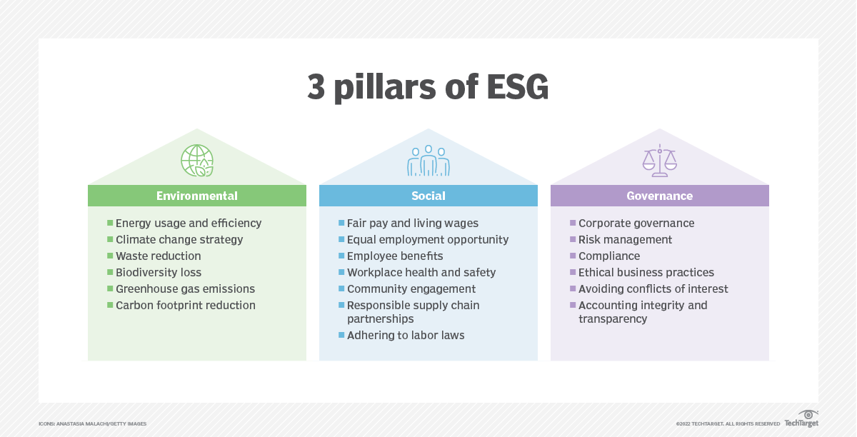

Integration of ESG into fixed income analysis and portfolio management
ESG factors can be incorporated into fixed income investment strategies using three approaches: integration, screening and thematic. Investors select between, or combine, these approaches based on their desired outcomes. This may be to enhance their risk-return profile, avoid specific sectors or drive capital towards particular environmental and/or social goals.
Integration : Integration typically has three steps:
- Investment research: Identifying material ESG factors (at the issuer level, as well as for individual securities) that may impact downside risk (or provide topics for engagement).
- Security valuation: Integrating the material ESG factors into financial analysis and valuation, e.g. through internal credit assessments, forecasted financials and ratios, relative ranking, relative value/spread analysis, and security sensitivity/scenario analysis.
- Portfolio management: Including the ESG analysis in decisions about risk management and portfolio construction, e.g. through sector weightings.
Screening
Screening uses a set of filters to determine which issuers, sectors or activities are eligible or ineligible to be included in a portfolio based on an investor’s preference, values or ethics. For example, a screen might be used to exclude the highest carbon emitters from a portfolio, or to target only the lowest emitters. ESG scores can be obtained from specialist ESG service providers, or by creating a proprietary scoring methodology.

NEGATIVE SCREENING  Avoid the worst performers | NORMS-BASED SCREENING  Use an existing framework | POSITIVE SCREENING  Include the best performers
Excluding certain sectors, companies or projects for poor ESG performance relative to industry peers, or based on specific ESG criteria, e.g. avoiding particular products/services or business practices. | Screening investments against minimum standards of business practice based on international norms. Useful frameworks include UN treaties, Security Council sanctions, UN Global Compact, Universal Declaration of Human Rights and OECD guidelines | Investing in sectors, companies or projects selected for positive ESG performance relative to industry

Thematic
Thematic investing identifies and allocates capital to themes or assets related to certain environmental or social outcomes, such as clean energy, energy efficiency or sustainable agriculture.
Green bonds
Green bonds are a rapidly-growing category of fixed income securities that finance environmental projects. In 2018, global green bond issuance totalled over US$167.6 billion.¹ These might be issued in accordance with various international standards and frameworks for green bonds, including: Green Bond Principles, Green Loan Principles, Climate Bonds Standard or local standards such as Japan’s green bond guidelines and taxonomy. Green bonds have been issued by corporates, sovereigns, supra-nationals, agencies and sub-nationals.
Other types of thematic bonds include social bonds, sustainability bonds and Islamic bonds (sukuk).
ESG incorporation across issuer types

 | ISSUER TYPE
INCORPORATION APPROACH | CORPORATE | SOVEREIGN | SUB-SOVEREIGN
Integration | Integrating material ESG factors into credit research and assessments, forecasted financials/ratios and relative value/spread analysis. | Governance and political factors have long been a part of sovereign credit analysis. Social and environmental factors – such as inequality, climate-related risk and the energy transition – are becoming increasingly relevant.
Screening | Filters are applied to lists of potential investments, ruling issuers in or out of contention for investment based on an investor’s preferences, values or ethics. Filters are typically based on including or excluding particular products, services or practices.
Thematic | Selecting issuers that address sustainability challenges, or securities that fund sustainability projects. These issues might be accredited by specific bond standards (e.g. those for green bonds). | Investing in fixed income securities where the proceeds are used to fund a sustainability project or budget item (e.g. green sovereign bonds)

Case studies on ESG integration
https://digitaldefynd.com/IQ/esg-case-studies/

