Commodity Exchanges
Commodity Exchanges in India
Commodity trade has a long history in India. Commodity trading in India began far earlier than it did in many other countries. Years of foreign domination, droughts, and periods of shortage, as well as government regulations, have all contributed to a decline in commodities trading in India.
In 2016, India had six national commodity exchanges, including the Multi Commodity Exchange (MCX), the National Commodity and Derivatives Exchange (NCDEX), the Indian Commodity Exchange (ICEX), the National Multi Commodity Exchange (NMCE), the ACE Derivatives Exchange (ACE), and the Universal Commodity Exchange (UCX) (UCX). Both the National Stock Exchange (NSE) and the Bombay Stock Exchange (BSE) began trading commodities in 2018.
The former Forward Markets Commission (FMC), which was established in 1953, was the regulatory agency. FMC amalgamated with the Securities and Exchange Board of India, or SEBI, in September 2015. SEBI has forced the withdrawal of various commodity exchanges as a result of this combination.
A commodity exchange, or a commodities exchange, refers to a legal entity that decides and enforces regulations and processes for trading regular commodity contracts and investment products related to this. A commodity exchange is also a physical place in which trading occurs. Nonetheless, most commodity exchanges are in the form of electronic online platforms for trading. The market of commodities is huge, and trillions of dollars are traded daily.
Traders rarely make physical deliveries of commodities via a commodity exchange. Rather, traders trade futures contracts in which parties enter an agreement to purchase or sell a certain amount of any commodity at a fixed price agreed on in advance. This commodity price, according to a contract, remains the same regardless of its current price in the market. The contract which is agreed upon has a date of expiry. The commodity which is most traded in a futures contract is the commodity of crude oil. Commodity exchange meaning becomes clearer if you know that “commodities” which are referred to in exchanges and markets are not necessarily finished products, but usually raw materials.
The modern commodity exchanges of today trade several kinds of investment vehicles. These are used by several investors ranging from investment speculators to commodity producers.
Role and Functions
- Risk Distribution and Hedging
Investors can protect their investments by using commodities as hedging instruments. This minimises risk by distributing it to a large group of investors. For instance, FMCG companies can lock in the input price of raw material by buying futures based on the commodities price today.
This hedging protects investors from inflation when commodity prices spike or fall significantly. During such times, they can purchase commodities at the pre-defined amount.
- Offers Better Investments in Agricultural Environment
Businesses can lose money and fail by not monitoring their production, storage, warehousing, and transportation facilities. The agricultural sector in India is particularly vulnerable to these problems, which result in the spoilage of massive quantities of food grain.
However, well-regulated commodity markets benefit everyone, from farmers to brokers and other stakeholders. These markets encourage better investment opportunities in an agricultural ecosystem, which improves the infrastructure of this sector.
- Plays the Role of a Transparent Aggregator
The farming population is spread across India. . Aggregators must serve as mediators in this situation. However, many aggregators take advantage of this situation by not focusing on transparency and fair pricing. Due to this, farmers are vulnerable to exploitation and cheating.
An organised commodity market reinstalls its faith in the system by maintaining transparency. This can boost the sale of goods and better aggregation. Investments in the agricultural market improve farmers’ finances and their livelihoods.
- Makes Pricing Easy to Anticipate
Commodity markets help manufacturers ensure price stability. However, because this is an elastic market, there are chances of frequent short-term price shifts. Commodity futures ensure more predictability in price changes and allow for fairer price discovery.
- Ensures diversification of portfolios
Investors must make the most of every opportunity available to diversify their portfolios. However, most opt for traditional investments like mutual funds and stocks to attain this goal. Commodity markets, too, offer a plethora of chances for investors to diversify their portfolios.
Moreover, one does not need to invest here physically to participate in commodity trading. Instead, they can invest here with ETFs or future contracts. Finally, it is important to remember that commodity markets allow traders to safeguard their investments during inflation.
- Assists in Reducing Speculative Demand
Speculative demand indicates the demand for any commodity for transaction purposes more than other utilisation. Let’s understand this with the example of gold as a commodity. Much of the demand for gold comes from speculative purposes.
Like cash, speculative demand for gold is very high because gold plays a crucial role in transactions with foreign nations. A robust commodity market helps to absorb this speculative demand and protect the resources necessary for foreign exchange.
Providing a Market Place:
A commodity exchange provides a convenient place where the members can meet at fixed hours and transact business in a commodity according to a certain well established rules and regulations. This type of facility is very important for trading in such commodities as are produced in abundance and cover a very wide field as far as trading therein is concerned.
Regulating Trading:
As organised markets commodity exchanges establish and enforce rules and regulations with a view to facilitating trade on sound lines. The rules define the duties of members and lay down methods for business transaction.
Collecting and Disseminating Market Information:
The buyers and sellers on the commodity exchange enter into deals for settlement in future after making an assessment the trends of price and the prospects of a rise or fall in prices of a commodity. The commodity exchange acts as an association of these traders collecting the necessary information and the relevant statistical data and publishing it for the benefit of traders all over the country.
Grading of Commodities:
Commodities which are traded on the commodity exchanges have, to be graded according to quality. In this manner, the dealers can quickly enter into agreements for the purchase and sale of commodities by description.
Settling Disputes through Arbitration:
The commodity exchange provides machinery for the arbitration of trade disputes.
Services provided by the commodity exchanges
The exchanges provide a ready and continuous market for the purchase and sale of commodities. The producer is enabled to be independent of the middlemen.
2. By providing hedging facilities, the commodity exchanges reduce the effect of fluctuations in price.
3. The commodity exchanges provide the producers an opportunity to transfer their risk to the professional risk-bearers.
4. By providing continuity in the trading of commodities, the commodity exchanges induce bankers and financiers to lend against commodities.
5. The commodity exchanges provide facilities and opportunities for arbitrating and thus equalize the price levels of commodities at various centres.

Trading and Clearing Methods
The most distinguishing feature of commodities trading is the maintenance of margin and mark-to-market settlement. A trader must maintain an initial margin which is 5-10% of the contract value. Further, the broker may demand a maintenance margin to protect against loss in unexpected, adverse scenarios.
Trades in the commodity markets are marked to market. At the end of every trading day, the clearinghouse publishes a settlement price for the commodity. The difference between the settlement price and the contracted future’s price is adjusted. At the expiry of the trade, the difference between the expectations of the contracting parties is settled.
Compared to other financial instruments, the lot size for commodities is substantial. The lot size refers to the quantity of the commodity which is traded in a contract. The lot size of a contract is standardized, and it is determined by the exchange.
A commodity contract can be identified by a combination of the name and lot size of the commodity. Lot sizes are further bifurcated into mini, micro, and standard depending on the commodity quantity. For example, the standard lot size of a gold contract on MCX is 1 kg. Hence, the value of a single contract is quite high and requires a substantial investment.
Trading in commodity derivatives or any financial instrument involves clearing and settlement.
Clearing and Settlement
Clearing is one of the important spokes of any financial transaction, essential for completing the process of buying and selling by different parties. The commodities you buy and sell on any trading day are settled through a clearing corporation. To complete the settlement of trades done on an exchange platform, these clearing corporations collect margins through both the exchange and the broker, deal with payments in the form of pay-in and pay-out as well as the delivery mechanism. Exchanges and clearing corporations carry out their roles and responsibilities independent of each other for smooth operations in the ecosystem.
Clearing refers to the process of accounting to update and reconcile obligations/payments of parties involved in the trade.
Settlement involves matching outstanding buy and sell instructions by transferring ownership of commodities against funds between buyer and seller.

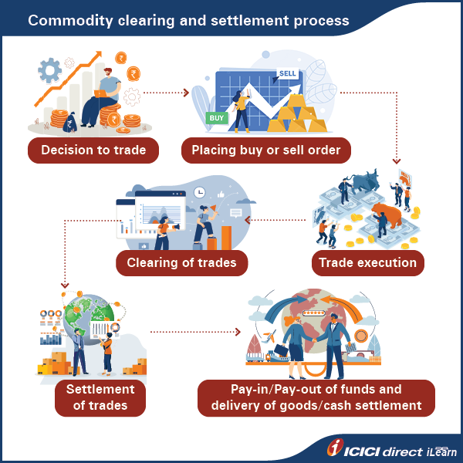

Process of clearing and settlement
- Commodity exchanges transmit trade details to clearing corporations on a real time basis
- Upon receipt of trade details, the clearing corporation/clearing house notifies trading members about obligations
- Clearing members receive communication regarding obligation and pay-in advice of funds
- Clearing banks are instructed to make funds available by pay-in time
- Pay-in of funds for executed trades is carried out by clearing banks by debiting the account of clearing members and crediting the account of the clearing corporation account with the amount due to them
- Pay-out of funds is done based on the instructions of the clearing corporation by clearing banks and credited to the account of clearing members, as applicable
Example:
ABC Limited and XYZ Limited are two clearing members of an exchange. Kabir is a client of ABC Limited and Nimish is client of XYZ Limited.
Clearing members | ABC Limited | XYZ Limited
Name of client | Kabir | Nimish
Trade | Buys 1 kg gold at Rs. 50,000 per 10 grams | Sells 1 kg gold at Rs. 50,000 per 10 grams
Margin required at 10% | 50000*100*10% = Rs. 5,00,000 | 50000*100*10% = Rs. 5,00,000
Market closes at Rs. 50,500 per 10 grams
Profit / Loss | Kabir gains Rs. 50,000 | Nimish loses Rs. 50,000
Clearing process | Pay-out of Rs. 50,000 to Kabir | Pay-in of Rs. 50,000 from Nimish

Thus, on every trading day, till the expiry of the Futures Contract, there is some amount of MTM (Mark-to-Market) gain equal to MTM loss, across members, which needs to be settled.
Entities involved in clearing and settlement
The Indian commodity derivatives ecosystem involves various intermediaries for clearing and settling trades namely, clearing members, clearing corporations, clearing banks, custodial services, warehouse service providers and e-registry service providers, etc.
Delivery process
The commodity market is distinct from the equity market because of delivery of commodities between buyers and sellers. Upon expiry of contracts, commodities are exchanged physically between buyers and sellers thereby making this market quite useful for organisations engaged in use of commodities for their manufacturing process.
The commodity market has adopted three types of deliveries namely, compulsory delivery, sellers’ option and intention matching.
In compulsory delivery, all open positions, upon expiry of contracts, need to be settled physically.
In sellers’ option, sellers will have an edge while selecting delivery location and quantity.
In agricultural and non-agricultural commodities, the penalty for delivery default by seller will be 4% and 3% of the settlement price plus replacement cost respectively.

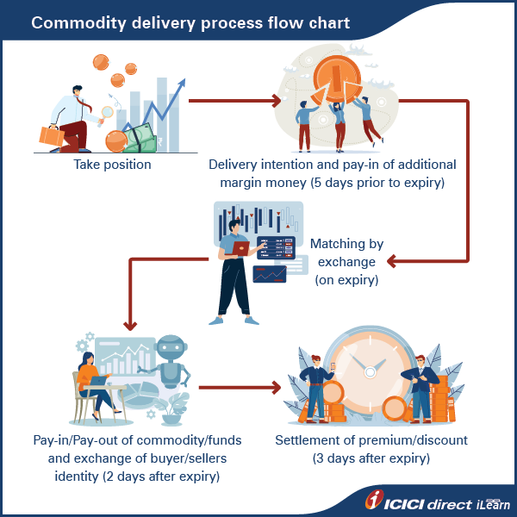

Commodity Futures Market
Futures are a type of derivatives. They are very active in the commodity market. Most of the exchanges facilitate them. A derivative contract, which has a commodity as its underlying, is known as a ‘commodity derivatives’ contract. According to clause (bc) of section 2 of the SCRA, commodity derivative" means a contract:
  - for the delivery of such goods, as may be notified by the Central Government in the Official Gazette, and which is not a ready delivery contract; or
  - (ii) for differences, which derives its value from prices or indices of prices of such underlying goods or activities, services, rights, interests and events, as may be notified by the Central Government, in consultation with the Board, but does not include securities as referred to in sub-clauses (A) and (B) in the definition of Derivatives.
One doesn't need to have the physical commodity to enter into a sell contract in futures market. A seller can enter in futures contract without having goods in his possession. However, most commodity derivatives contracts are based on compulsory delivery settlement logic, which means if a seller has open position at the expiry of such a contract, he has to deliver the goods against his sell position. If he does not possess the commodity, he shall have to purchase it from the open market to fulfil the selling obligation at the time of maturity if he does not square off his sell position by entering into a buy transaction.
Calculation of future commodity prices
The formula for futures pricing is given below:
Futures price = Spot price*(1+rf) – d
Where rf is the risk-free rate and d is the dividend
Here rf is the interest rate that one can earn throughout the year in normal circumstances. However, traders can adjust it proportionately for one, two or three months depending on the expiry of the contract. The adjusted formula looks like this:
Future price = Spot price*[1+rf(X/365)-d]
Here X denotes the number of days to expiry.

Participants in the future markets are :
Hedgers :
Manufacturers, traders, farmers / Farmer Producer Companies (FPCs) / Farmer Producer Organisations (FPOs), processors, exporters, other value chain participants of a commodity
Objective : To reduce risk due to price fluctuations in the spot market Hedging implies taking position in the futures markets that is equal and opposite to the physical market position, such that the overall net market risk is reduced, or eliminated.
Hedging implies taking position in the futures markets that is equal and opposite to the physical market position, such that the overall net market risk is reduced, or eliminated.
Financial Investors:
Traders including day traders, position traders, and market makers who are generally not having an offsetting position in the physical market To anticipate the future price movement and take suitable position in the futures market with an intent to make a profit
Willingly accept price risk in order to profit from price changes.
To anticipate the future price movement and take suitable position in the futures market with an intent to make a profit
Arbitrageurs
To earn riskless profit by buying and selling in different markets at the same time to profit from price discrepancies Aim to earn risk-free profit

Need for financial investors
The financial investor is primarily a price risk taker and plays an important role by contributing to the efficacy of the process of price discovery in futures markets. For effective price discovery, he should have adequate knowledge of the intrinsic factors governing supply and demand of the commodity in the market, capacity to make intelligent appraisal of market conditions, interpret factual data and forecast the futures course of price with some degree of accuracy. Financial investors also add to liquidity and depth of market.
Benefits of commodity future markets
Commodity derivatives market provides various direct and indirect benefits to commodity value chain participants. The key benefits of Commodity derivatives market are as follows:
- Provides a nationwide platform for discovery of prices and enabling physical market participants to hedge their price risk.
- ii. In the absence of futures trading, various value chain participants like small producers and end users lose an invaluable tool for hedging their price risk, getting advance price signals of the commodity and for making informed decision on
- iii. cropping, timing of sales etc. A successful futures contract in any commodity catalyzes the development of marketing infrastructure like warehousing, assaying facilities which in turn facilitates pledge financing through warehousing and banks network.
The major factors affecting movement of prices of commodities include demand and supply for the commodity, seasonality, weather, relevant news, geo-political developments, macro-economic conditions, currency movements, etc. In case of most commodities, the trading prices are also influenced by global factors and may be linked to prices in international stock exchanges
Timings of commodity future markets :
Markets with international linkages : 9 AM to 5 PM, 5 PM to 11.30 pm
Markets without international linkages : 9 AM to 5 PM
Exchanges where future trading takes place : MCX, NCDEX, ICEX, NSE, BSE
All compulsory delivery commodity futures contracts (both agricultural and non-agricultural commodities) have a staggered delivery period, the minimum duration of which is at least five working days. Stock Exchanges have the flexibility to fix a higher duration of staggered delivery period for any commodity futures contract as deemed fit.
Commodities Notified for futures trading :
There are 91 commodities, which have been notified by the Central Government for commodity derivative trading. These commodities fulfil following requirements:
• The commodity should have relatively large demand and supply
• No individual or group of persons acting in concert should be in a position to influence the demand or supply
• Prices should be adequately volatile
• The commodity should be free from substantial control from Govt. regulations in terms of supply, distribution and prices
• The commodity should be capable of standardisation and gradation
• The commodity should have long shelf-life Futures trading can be conducted in any of the notified commodities, meeting the above requirements, subject to the approval /recognition of the regulator.

Commodity Specific Exchanges versus Multi Commodity Exchanges
A commodity specific exchange focuses on trading a single type of commodity, such as: Crude Oil, Rubber, Gold, Diamond, Coffee
This exchange specializes in the specific commodity, offering in-depth knowledge and expertise.
On the other hand, a multi-commodity exchange trades various commodities, like:metals (copper, steel, aluminum, zinc), energy (crude oil, natural gas, electricity), agricultural products (wheat, rice, spices, corn, soybeans)
The multi commodity exchanges provide a category of trading rather than a single item thus single comedy exchanges provide or specialises in a particular commodity whereas the multi commodity exchanges specialises in a range of commodities since there are different different commodities which are getting traded in the multi commodity exchanges. The multi commodity exchanges prefers to categorise them into different sectors like metals energy agricultural products etc. The multi commodity exchanges provides a wide variety of choices to the investors and the margin or the cost to be paid to the exchanges is less and the investors sometimes prefer multi commutate exchanges over the single committee exchange. However single commodity exchanges are simple to understand easy to trade and those traders who are not ready to diversify from one commodity to another commodity category prefer the single committee exchange
This multi commodity exchange provides a broader range of trading options, allowing participants to diversify their portfolios.
Key differences:
- Specialization (single) vs. diversification (multi)
- Market focus and expertise
- Trading options and flexibility
- Risk management strategies

